Night Drive: Low-Poly Night Drive with Lighting from Many Street Lamps
Midterm Report (4.1 Midterm Submission)
Course: Computer Graphics (OpenGL)
Topic 7: Low-poly night drive, clustered/forward+ street lights
Authors: Askaruly Temirlan, Tamerlan Murat
Astana IT University, Astana, 2026
1. Introduction
"Night Drive" is an interactive 3D scene of a night street along which the user drives a car. The scene is built in a low-poly style and is lit by the Moon, two rows of street lamps and the car's headlights. The technical question of Topic 7 is how to keep the frame rate acceptable when the scene contains many light sources.
In ordinary forward rendering, the fragment shader loops over the whole list of lights for every pixel. The cost grows in proportion to the number of lights, although each pixel is actually lit only by the nearest ones. Clustered/forward+ shading removes this waste: the view volume is divided into cells, and a short list of the lights that affect it is built in advance for each cell.
By the midterm, the baseline version is ready: the scene, two cameras, a drivable car, and Blinn-Phong lighting with a full loop over 16 street lamps. This version serves as the reference (baseline) against which the clustered/forward+ implementation will be compared.
2. Literature Review and Background
Lighting model. The classic Phong model [1] splits reflection into ambient, diffuse and specular components. Blinn [2] replaced the reflection vector with the half vector between the light direction and the viewer direction, which is cheaper and gives a more stable highlight. This is the variant used in the project.
Forward and deferred shading. In forward rendering, lighting is computed while each fragment is rasterized, so the cost is proportional to the number of fragments multiplied by the number of lights. Deferred shading moves the lighting computation into a separate pass over a geometry buffer (G-buffer) [3]. It does not depend on geometric complexity, but it needs memory for the G-buffer and works poorly with transparency and multisampling [7].
Tiled and Forward+. Harada, McKee and Yang [4] divide the screen into tiles, select for each tile the lights that intersect it, and then run an ordinary forward pass that loops only over the list of its own tile. The selection is done after a depth pre-pass.
Clustered shading. Olsson, Billeter and Assarsson [5] subdivide the whole view frustum into cells: tiles in x and y plus additional slices in depth. This removes the tiled approach's problem at depth discontinuities, where one light list has to serve both near and far surfaces at once.
OpenGL 3.3 limitation. Compute shaders appeared only in OpenGL 4.3, so in version 3.3 the assignment of lights to cells is done on the CPU, and the result is passed to the fragment shader through a texture buffer or a uniform buffer [6].
Light attenuation. Physically, intensity falls off with the square of the distance. For light selection, the attenuation must reach zero at a finite radius: then it can be asserted that a light does not affect cells beyond that radius. The project uses attenuation with a window function (see Section 4.3).
3. Project Description
3.1 Objective
To develop a low-poly night street scene with a drivable car and to implement clustered/forward+ lighting in it for a large number of street lamps on OpenGL 3.3 Core. To demonstrate a measurable frame-rate gain relative to the full loop over the lights.
3.2 Problem Statement
In the baseline implementation, the fragment shader loops over all street lamps for every pixel, even if a lamp lies beyond its radius of influence and its contribution is zero. For a scene with 16 lamps the losses are moderate, but the cost grows linearly with the number of lights. We need a scheme in which each fragment processes only the lights close to it, and this must be confirmed by measurements.
3.3 Scope
In scope:
- a low-poly scene: road, buildings, lamps, car, and a sky with the Moon and stars;
- a drivable car, a chase camera and a free orbit camera;
- lighting: directional Moon light, point street lamps, spotlight headlights;
- a baseline version with a full loop over the lights (done);
- clustered/forward+ light selection and an increase in the number of lights to hundreds (planned);
- an FPS comparison of the baseline and clustered versions at different numbers of lights (planned).
Out of scope: shadows, textures, collisions, physically based materials, post-processing (bloom, tone mapping), loading external models.
4. Technical Implementation
4.1 Tools and Technologies
Component | Choice
Language | C++14
Graphics API | OpenGL 3.3 Core Profile
Windowing and input | FreeGLUT (3.3 core context, keyboard and mouse handling)
Extension loader | GLEW
Shaders | GLSL 330 core (vertex and fragment)
Math | custom header mathutil.h: vec3, mat4 (column-major), translate, scale, rotateY, lookAt, perspective
Build | CMake 3.10+, shaders are copied next to the executable after the build
Platform | Windows

4.2 Development Process
- Application skeleton. A FreeGLUT window with an OpenGL 3.3 Core context, GLEW initialization, version check, shader loading and compilation with error logs, and the math module.
- Geometry. A cube, a low-poly sphere and star points; all meshes are stored in VAO/VBO with interleaved attributes (position, normal).
- Scene. Procedural placement of buildings and lamps, a road with markings, and a car made of ten boxes.
- Camera and controls. A chase camera, an orbit camera, car kinematics, keyboard and mouse handling.
- Lighting. The Moon, 16 point street lamps and two headlights; toggled with the T and F keys.
- Instrumentation. An FPS counter in the window title and a "BRUTE-FORCE baseline" mode label for later comparisons.

4.3 Algorithms and Techniques
Geometry. The cube consists of 6 faces and 12 triangles, with one normal per face. It is created once, and the size and position of each object are set by the model matrix T · R · S. The sphere (6 stacks by 10 sectors, about 100 triangles after degenerate triangles at the poles are discarded) is built with a flat normal per triangle, which makes the Moon look faceted. The sky contains 600 stars drawn as GL_POINTS on a hemisphere of radius 400 with random but fixed coordinates (seed 7).
Procedural building generation. Buildings are placed along the road on both sides every 12 units along z (24 buildings). Width is 7–10, height 6–22, depth 8–10, and the color is dark blue-gray. The random values come from a linear congruential generator with a fixed seed of 12345, so the scene is reproduced identically on every run.
Cameras. The projection is perspective: 60° field of view, near plane 0.1, far plane 1000. The chase camera sits 9 units behind the car and 4.2 above it, and its target is 4 units ahead. The orbit camera is defined by spherical coordinates around the car and is controlled with the mouse. The stars and the Moon move together with the camera, so they never get closer or farther away during driving.
Lighting model (Blinn-Phong, per fragment). The fragment color is:
C = k_a · c + E + Σ L_i · a_i · ( c · max(N·L_i, 0) + k_s · max(N·H_i, 0)^s )
where c is the material color, E the emission, L_i the light color, a_i the attenuation, H_i the half vector, and s the shininess exponent. The result is clamped to [0, 1] without tone mapping. Normals are transformed to world space by the matrix transpose(inverse(mat3(model))) in the vertex shader.
Light sources.
- Moon: a directional light; its direction is set by azimuth and elevation and is changed with the keyboard.
- Street lamps: 16 point lights (8 per side, spaced 15 units along z, height 5.8). Attenuation with a finite radius of 30:
float pointAtten(float d, float range)
{
float a = 1.0 / (1.0 + 0.09 * d + 0.032 * d * d);
float w = clamp(1.0 - pow(d / range, 4.0), 0.0, 1.0);
return a * w * w;
}
- Headlights: two spotlights with a 28° cutoff angle, cos^12 angular falloff and radius 45; the beam points slightly downward.
Baseline loop over lights. The fragment shader loops over all street lamps:
for (int i = 0; i < MAX_STREET; ++i) {
if (i >= uNumStreet) break;
vec3 toLight = uStreetPos[i] - vWorldPos;
float d = length(toLight);
color += shade(N, V, toLight / d, uStreetColor, pointAtten(d, 30.0));
}
The cost per frame is O(F · L), where F is the number of fragments and L the number of lights. This is the bottleneck that will be removed.
Car dynamics. A simplified kinematic model: acceleration 14, reverse 18, drag 5, braking 25, and speed limited to the range from −8 to 28. Steering is scaled by speed, so the car does not turn in place. The time step is capped at 50 ms so that a pause or a lag does not cause jumps.
Planned clustered/forward+ algorithm.
- Divide the view frustum into a grid of cells (tiles in x and y, slices in depth with a logarithmic step).
- On the CPU, for each light find the cells that its sphere of influence (the attenuation radius) intersects.
- Record for each cell an offset and a count in the list, plus the flat list of light indices itself; pass them to the shader through a texture buffer.
- In the fragment shader, determine the fragment's cell from gl_FragCoord.xy and its depth, and loop only over that cell's list.
4.4 General Map and Scene Architecture
Top view, schematic, not to scale. The z axis points forward (up in the diagram); the car starts at (2.5, 0, −55) and faces +z.
z buildings lamp road(|x|<=5) lamp buildings
+66 ▓▓▓▓▓▓▓▓ ┃ ┆ ┆ ┃ ▓▓▓▓▓▓▓▓
+52.5 ▓▓▓▓▓▓▓▓ ● ┃ ┆ ┆ ┃ ● ▓▓▓▓▓▓▓▓
... (buildings every 12, lamps every 15 along z)
0 ▓▓▓▓▓▓▓▓ ┃ ┆ ┆ ┃ ▓▓▓▓▓▓▓▓
-52.5 ▓▓▓▓▓▓▓▓ ● ┃ ┆ ┆ ┃ ● ▓▓▓▓▓▓▓▓
-55 ┃ ┆ [A] ┃ start
-66 ▓▓▓▓▓▓▓▓ ┃ ┆ ┆ ┃ ▓▓▓▓▓▓▓▓
x≈-27…-15 x=-5.2 x=+5.2 x≈+15…+27
Scene objects.
Object | Count | Parameters
Ground | 1 | plane 400 × 400
Road | 1 | width 10 (|x| ≤ 5), length 140 (z from −70 to 70)
Lane markings | 23 | dashes 0.25 × 3, spaced 6 along z
Street lamps | 16 | pole at x = ±6.5, height 6; lamp at x = ±5.2, y = 5.8, z = −52.5…52.5
Buildings | 24 | 12 on each side, |x| ≈ 15…27
Car | 10 boxes | body 1.8 × 0.6 × 4.0, cabin, 4 wheels, 2 headlights, 2 tail lights
Sky | 600 stars and the Moon | stars at radius 400, Moon at distance 350, diameter 40
A frame takes about 109 draw calls, and the scene contains on the order of 1.4 thousand triangles.
Frame order. Input and car update (dt) → camera computation → upload of uniforms (camera, Moon, lamps, headlights) → unlit sky → ground and road → lamps → buildings → car → buffer swap and FPS update.
Code structure.
File | Contents
src/main.cpp (about 540 lines) | initialization, meshes, scene construction, rendering, input, update loop
src/mathutil.h (87 lines) | vectors and matrices, camera and projection
shaders/scene.vert | vertex and normal transformation
shaders/scene.frag | lighting: Moon, lamps, headlights
CMakeLists.txt | build and shader copying

5. Preliminary Results (Demo)
5.1 Controls
Key | Action
↑ / ↓ | accelerate / reverse
← / → | steer
Space | brake
P / R | pause / return the car to the start
C | chase camera / orbit camera
Mouse (left button held) and wheel | rotate and zoom the orbit camera
T / F | street lamps on/off / headlights on/off
[ ] and − = | Moon azimuth and elevation
The window title shows the team and topic names, FPS, the state of the light sources and the speed.
5.2 Screenshots

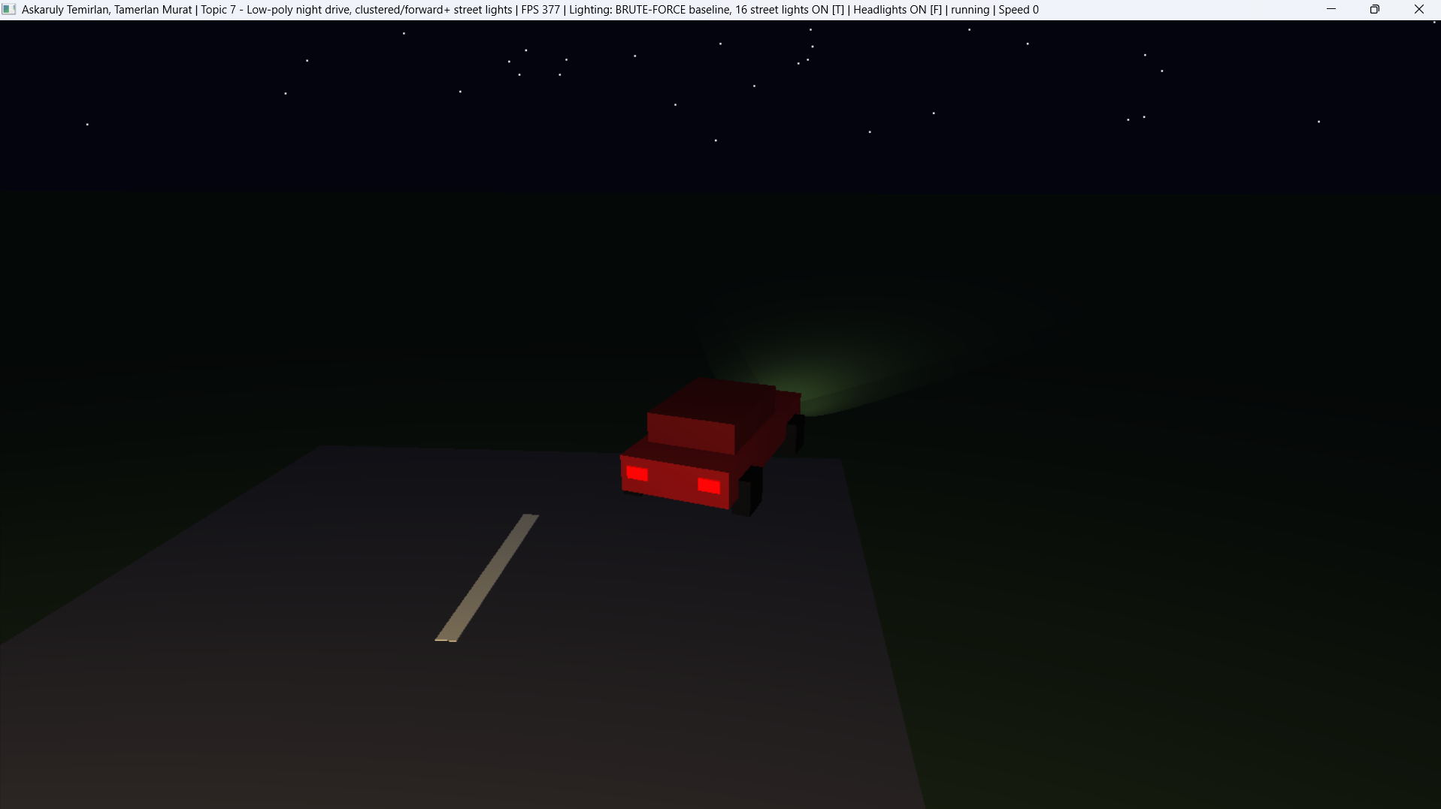
Figure 1. General view of the scene from the chase camera at the start position (car at rest), all light sources on. The window title shows the baseline mode (BRUTE-FORCE, 16 street lights) and FPS 377.
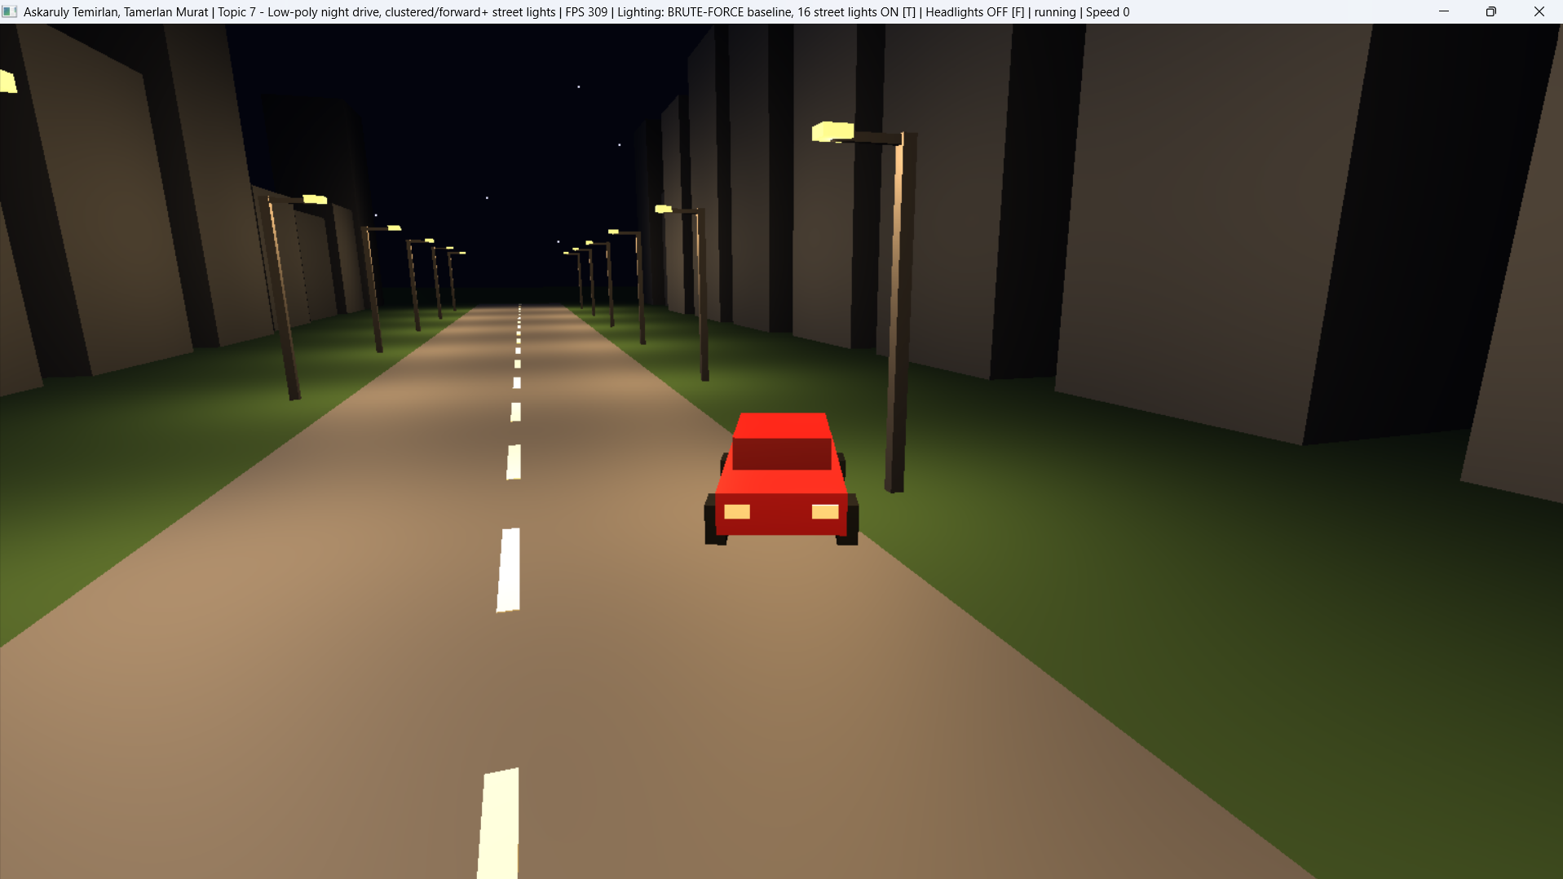
Figure 2. Chase camera: street lamps on, headlights off.
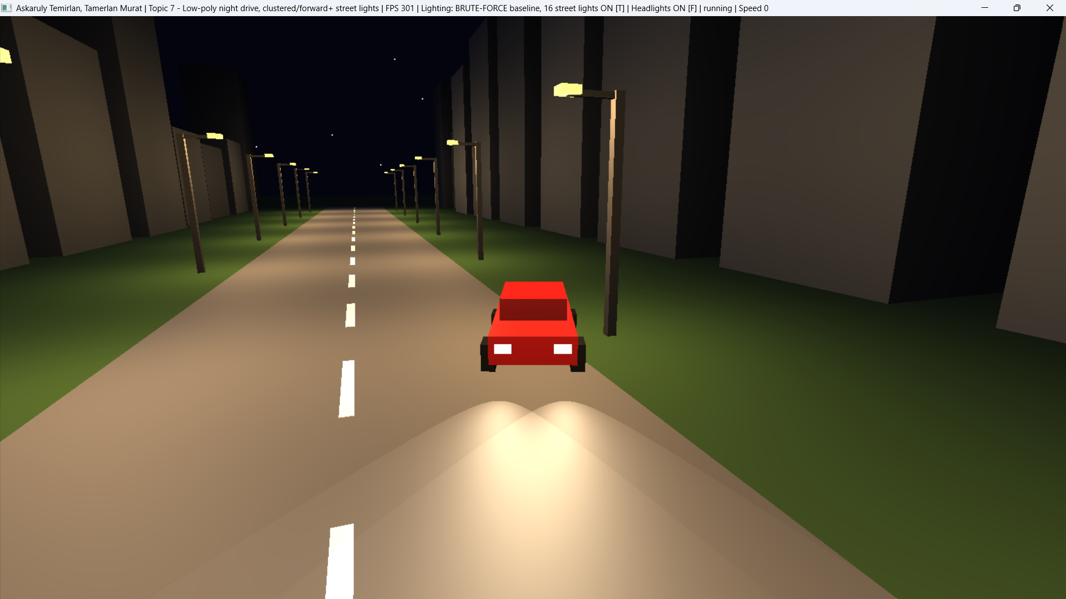
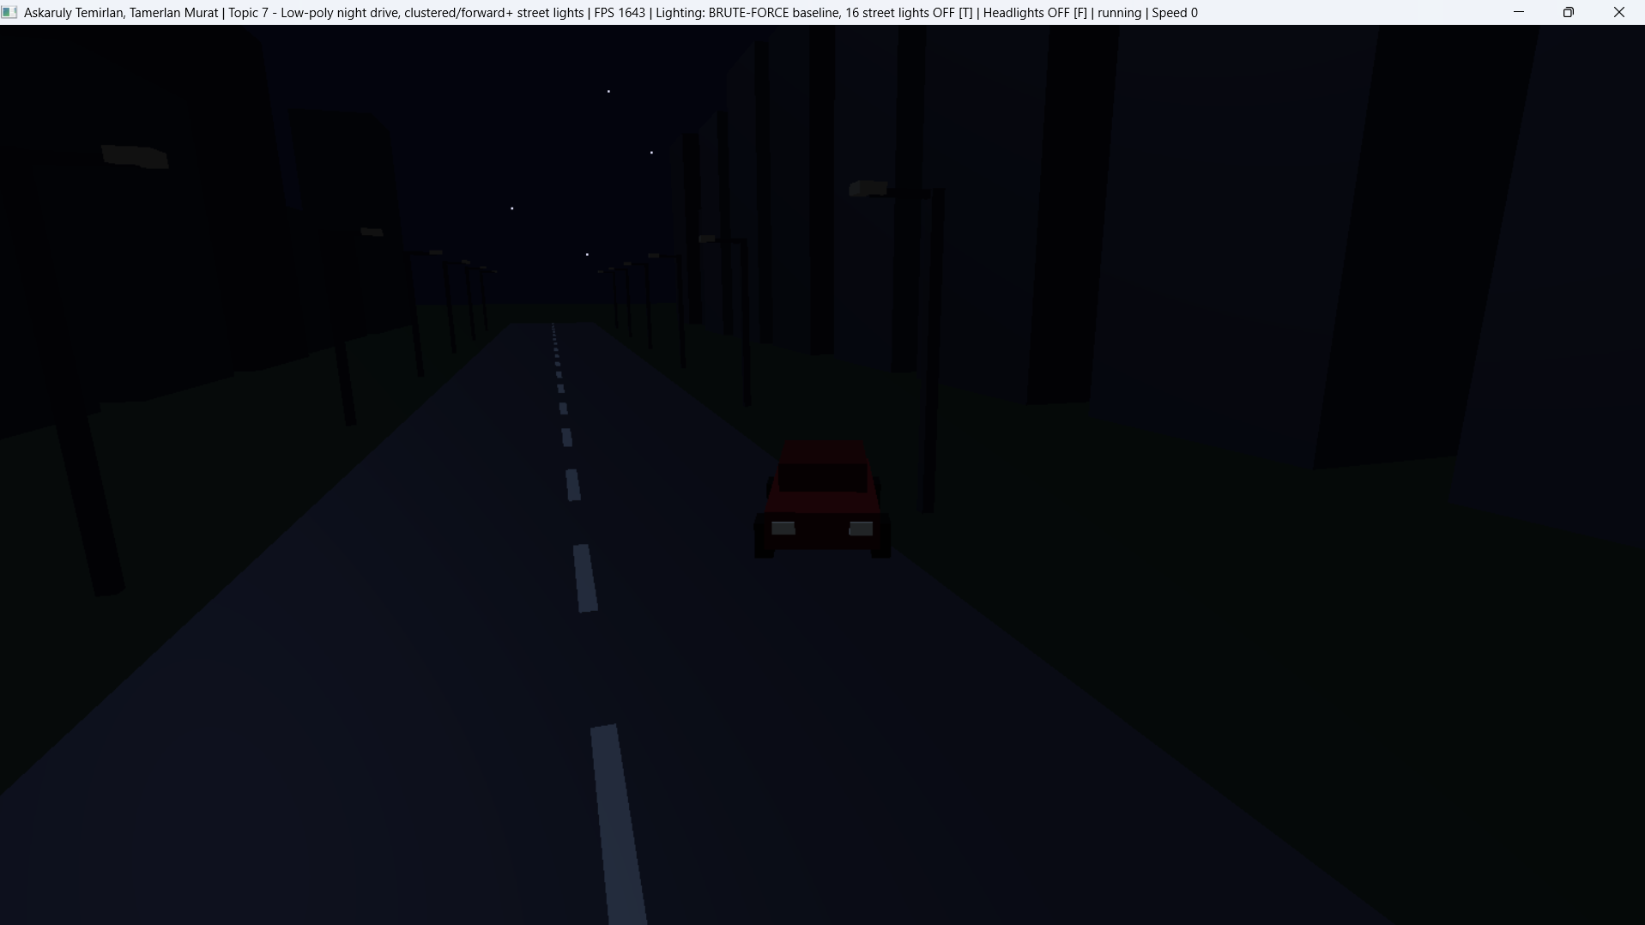
Figure 3. All light sources on (top) and all light sources off (bottom).
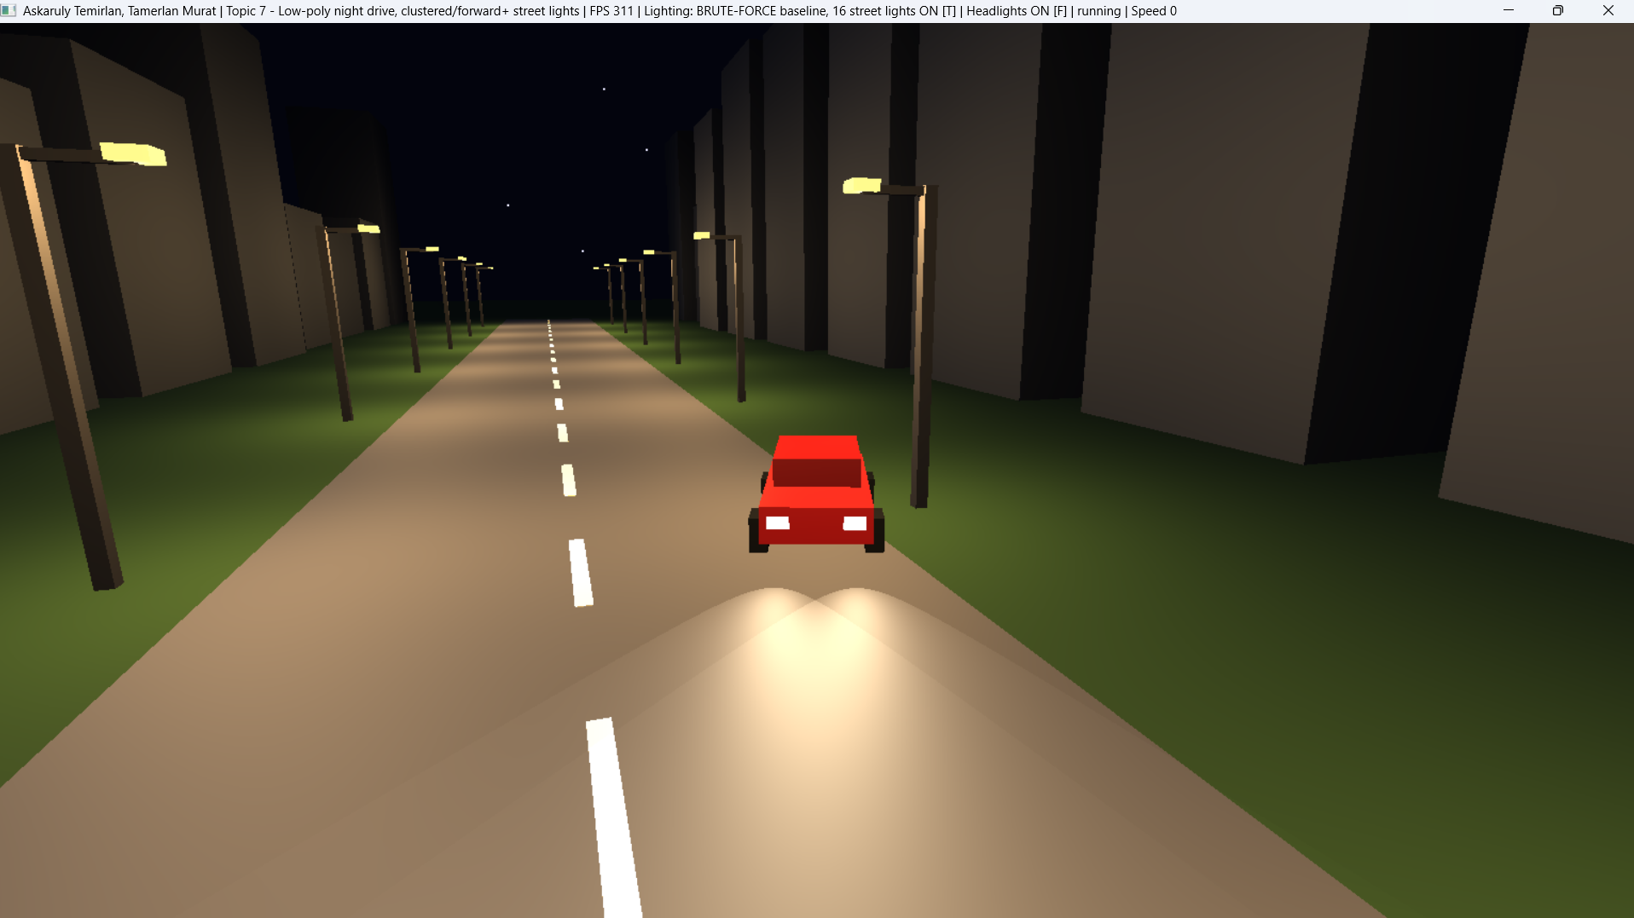
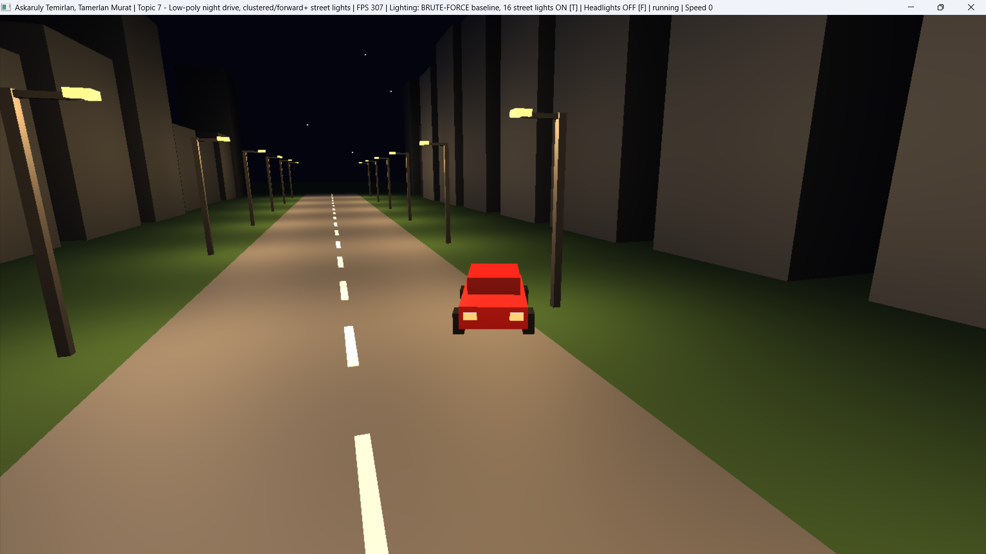
Figure 4. Headlights on (top) and off (bottom), street lamps on in both cases.
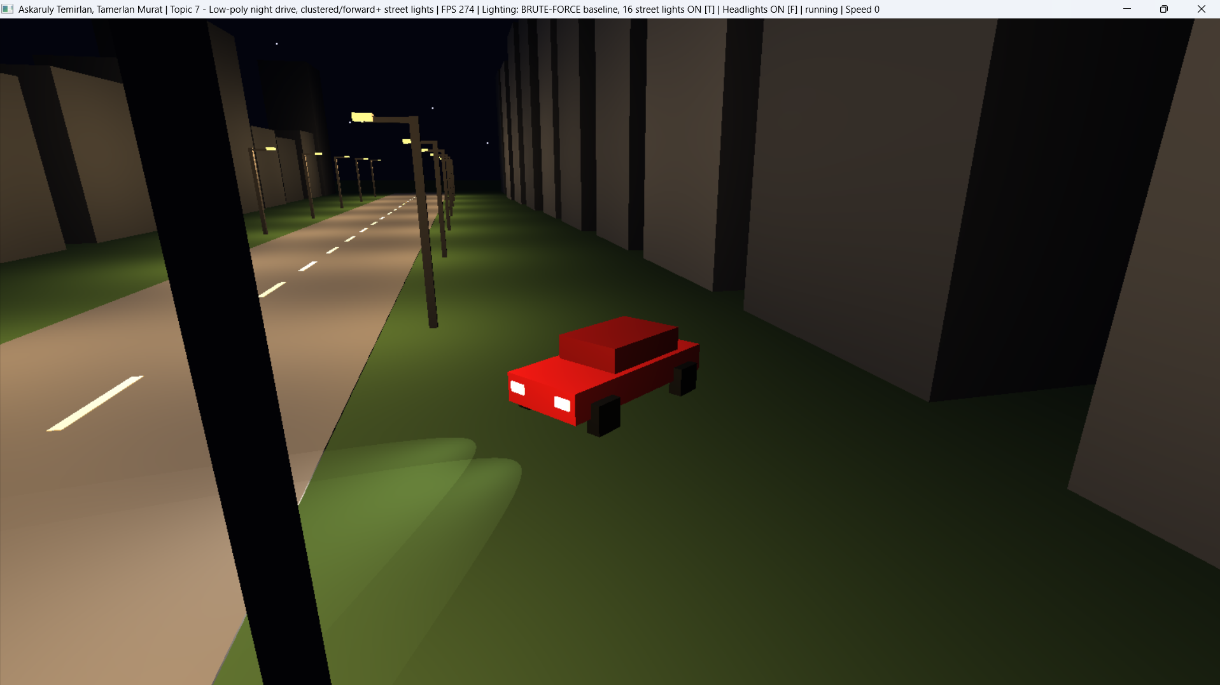
Figure 5. Close-up of the car: the low-poly model, with the glow of the headlights and tail lights.
5.3 Baseline Measurements
Window approx. 1917 × 1050 (maximized), GPU: ________. FPS values are read from the window title after a few seconds of running. The first measurement was taken with the car at rest (Speed 0) in the chase view, in BRUTE-FORCE baseline mode with 16 street lights.
Configuration | Keys | FPS
All light sources on | default | 302
Street lamps only | F | 301
Headlights only | T | 302
All off | T, F | 303

5.4 Known Limitations of the Baseline Version
- The shader loops over all lamps for every fragment, and the number of lights is hard-limited by the constant MAX_STREET = 16.
- The normal matrix inverse is computed in the vertex shader for every vertex; it could be computed once per object on the CPU.
- The final color is clamped without tone mapping, so overexposure is possible under bright light sources.
- There are no shadows or textures.

6. Plan for Further Work
- Replace the uniform array with a light list in a texture buffer and make the number of lamps configurable (hundreds).
- Implement the cell grid and the CPU assignment of lights to cells (Section 4.3).
- Add cell selection and a loop over only that cell's list to the fragment shader.
- Add a debug visualization mode: the number of lights per cell as a color map.
- Measure FPS and frame time for the baseline and clustered versions as the number of lights grows, then prepare charts and conclusions.
7. Conclusion
By the midterm, a working interactive scene has been implemented on OpenGL 3.3 Core: a procedural street, a drivable car, two cameras, and lighting from three types of sources using the Blinn-Phong model. The baseline version with a full loop over 16 lamps is equipped with an FPS counter and will be used as the reference. The next stage is to move to clustered/forward+ light selection and to show the gain on a scene with hundreds of lamps.

References
[1] B. T. Phong. Illumination for Computer Generated Pictures. Communications of the ACM, 18(6), 1975, pp. 311–317. https://doi.org/10.1145/360825.360839
[2] J. F. Blinn. Models of Light Reflection for Computer Synthesized Pictures. ACM SIGGRAPH Computer Graphics, 11(2), 1977, pp. 192–198. https://doi.org/10.1145/563858.563893
[3] T. Saito, T. Takahashi. Comprehensible Rendering of 3-D Shapes. ACM SIGGRAPH Computer Graphics, 24(4), 1990, pp. 197–206.https://doi.org/10.1145/97880.97901
[4] T. Harada, J. McKee, J. C. Yang. Forward+: Bringing Deferred Lighting to the Next Level. Eurographics 2012, Short Papers, pp. 5–8. https://diglib.eg.org/handle/10.2312/conf.EG2012.short.005-008
[5] O. Olsson, M. Billeter, U. Assarsson. Clustered Deferred and Forward Shading. Proc. High-Performance Graphics (HPG), 2012, pp. 87–96. : https://www.cse.chalmers.se/~uffe/clustered_shading_preprint.pdf
[6] Khronos Group. The OpenGL Graphics System: A Specification, Version 3.3 (Core Profile), 2010. https://registry.khronos.org/OpenGL/specs/gl/glspec33.core.pdf
[7] T. Akenine-Möller, E. Haines, N. Hoffman. Real-Time Rendering, 4th ed. CRC Press, 2018.
https://www.realtimerendering.com/

