Normalization

Task 1. Normal Form Violations
Given table: Booking_receipt(booking_id, passenger_full_name, passenger_passport_number, flight_number, departure_airport_name, departure_city, arrival_airport_name, arrival_city, airline_name, seat_numbers, ticket_price).
- 1NF Violation: The seat_numbers attribute contains comma-separated values (e.g., "12A, 12B"), which violates the requirement of data atomicity. Every attribute in a relational database must hold only a single, atomic value.
- 2NF Violation: Under a composite key (booking_id, seat_number), non-key flight-related attributes (flight_number, departure_airport_name, arrival_airport_name, airline_name) depend only on a subset of the candidate key (booking_id), introducing partial dependencies.
- 3NF Violation: Transitive functional dependencies exist among non-key attributes: flight_number → departure_airport_name → departure_city and flight_number → arrival_airport_name → arrival_city. The city is determined by the airport rather than the primary key. Additionally, passenger_passport_number → passenger_full_name

Task 2 & 3. Functional Dependencies and Step-by-Step Normalization

Functional Dependencies (FDs):
- booking_id → flight_number
- flight_number → departure_airport_name, arrival_airport_name, airline_name
- departure_airport_name → departure_city
- arrival_airport_name → arrival_city
- passenger_passport_number → passenger_full_name
- (booking_id, seat_number) → passenger_passport_number, ticket_price

Step 1: 1NF
The non-atomic seat_numbers column is decomposed so that each record represents a single seat. The primary key becomes composite:
- Booking_receipt_1NF(booking_id, seat_number, passenger_full_name, passenger_passport_number, flight_number, departure_airport_name, departure_city, arrival_airport_name, arrival_city, airline_name, ticket_price)

Step 2: 2NF
Partial dependencies are removed by isolating reservation/flight details from seat-specific data:
- Booking_2NF(booking_id, flight_number, departure_airport_name, departure_city, arrival_airport_name, arrival_city, airline_name)
- Ticket_Seat_2NF(booking_id [FK], seat_number, passenger_passport_number, passenger_full_name, ticket_price)

Step 3: 3NF
Transitive dependencies are resolved by separating airports, flights, and passenger records into independent relations.
Final 3NF Relations (Primary Keys underlined, Foreign Keys marked):
- Airports(airport_name, city)
- Flights(flight_number, departure_airport_name [FK], arrival_airport_name [FK], airline_name)
(FK: departure_airport_name, arrival_airport_name → Airports.airport_name)
- Passengers(passenger_passport_number, passenger_full_name)
- Bookings(booking_id, flight_number [FK])
(FK: flight_number → Flights.flight_number)
- Tickets(booking_id [FK], seat_number, passenger_passport_number [FK], ticket_price)
(FK: booking_id → Bookings.booking_id, passenger_passport_number → Passengers.passenger_passport_number)

Task 4. Flights Table 3NF Verification
- Primary Key: flight_id.
- Functional Dependency:
flight_id → {sch_departure_time, sch_arrival_time, departing_airport_id, arriving_airport_id, departing_gate, arriving_gate, airline_id, act_departure_time, act_arrival_time, created_at, updated_at}.
- Conclusion: The Flights table is in 3NF. All non-key attributes are directly and functionally dependent solely on the primary key flight_id. No transitive dependencies exist between non-key attributes because entity details are referenced via foreign key IDs (departing_airport_id, arriving_airport_id, airline_id) rather than storing non-key descriptive columns directly.

Task 5. 3NF Implementation and Sample Data
SQL
CREATE TABLE Airports_3NF (
airport_name VARCHAR(50) PRIMARY KEY,
city VARCHAR(50) NOT NULL
);

CREATE TABLE Flights_3NF (
flight_number VARCHAR(10) PRIMARY KEY,
departure_airport_name VARCHAR(50) NOT NULL REFERENCES Airports_3NF(airport_name),
arrival_airport_name VARCHAR(50) NOT NULL REFERENCES Airports_3NF(airport_name),
airline_name VARCHAR(50) NOT NULL
);

CREATE TABLE Passengers_3NF (
passenger_passport_number VARCHAR(20) PRIMARY KEY,
passenger_full_name VARCHAR(100) NOT NULL
);

CREATE TABLE Bookings_3NF (
booking_id INT PRIMARY KEY,
flight_number VARCHAR(10) NOT NULL REFERENCES Flights_3NF(flight_number)
);

CREATE TABLE Tickets_3NF (
booking_id INT NOT NULL REFERENCES Bookings_3NF(booking_id),
seat_number VARCHAR(10) NOT NULL,
passenger_passport_number VARCHAR(20) NOT NULL REFERENCES Passengers_3NF(passenger_passport_number),
ticket_price DECIMAL(8, 2) NOT NULL,
PRIMARY KEY (booking_id, seat_number)
);

INSERT INTO Airports_3NF VALUES
('ALA', 'Almaty'),
('NQZ', 'Astana');

INSERT INTO Flights_3NF VALUES
('KC101', 'ALA', 'NQZ', 'Air Astana');

INSERT INTO Passengers_3NF VALUES
('N12345678', 'Ivan Ivanov'),
('N87654321', 'Anna Petrova'),
('N11223344', 'John Smith'),
('N55667788', 'Alikhan Omarov'),
('N99887766', 'Elena Kim');

INSERT INTO Bookings_3NF VALUES
(1001, 'KC101'),
(1002, 'KC101'),
(1003, 'KC101'),
(1004, 'KC101'),
(1005, 'KC101');

INSERT INTO Tickets_3NF VALUES
(1001, '12A', 'N12345678', 120.00),
(1002, '12B', 'N87654321', 120.00),
(1003, '14C', 'N11223344', 150.00),
(1004, '01A', 'N55667788', 250.00),
(1005, '15D', 'N99887766', 110.00);
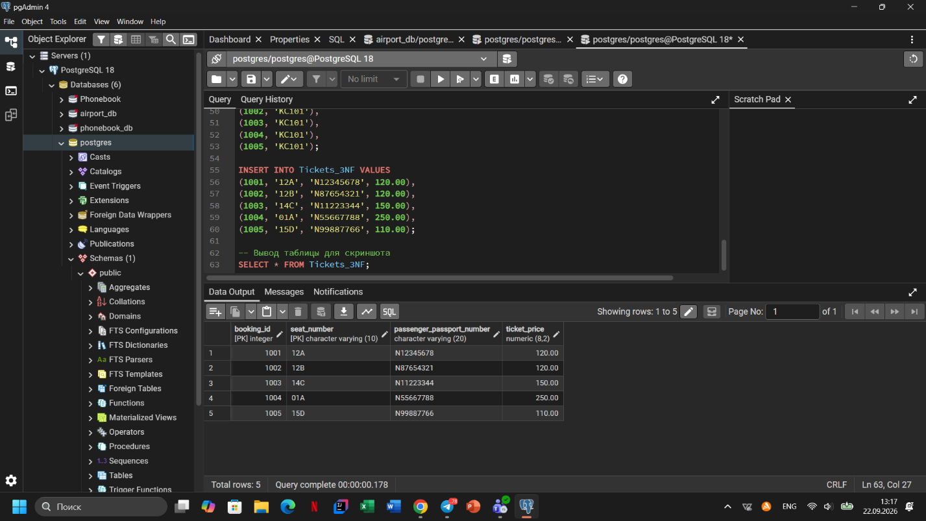

DDL Section
SQL
CREATE TABLE Airline_info (
airline_id INT PRIMARY KEY,
airline_code VARCHAR(30) NOT NULL,
airline_name VARCHAR(50) NOT NULL,
airline_country VARCHAR(50) NOT NULL,
created_at TIMESTAMP NOT NULL,
updated_at TIMESTAMP NOT NULL,
info VARCHAR(50) NOT NULL
);

CREATE TABLE Airport (
airport_id INT PRIMARY KEY,
airport_name VARCHAR(50) NOT NULL,
country VARCHAR(50) NOT NULL,
state VARCHAR(50) NOT NULL,
city VARCHAR(50) NOT NULL,
created_at TIMESTAMP NOT NULL,
updated_at TIMESTAMP NOT NULL
);

CREATE TABLE Passengers (
passenger_id INT PRIMARY KEY,
first_name VARCHAR(50) NOT NULL,
last_name VARCHAR(50) NOT NULL,
date_of_birth DATE NOT NULL,
gender VARCHAR(50) NOT NULL,
country_of_citizenship VARCHAR(50) NOT NULL,
country_of_residence VARCHAR(50) NOT NULL,
passport_number VARCHAR(20) NOT NULL,
created_at TIMESTAMP NOT NULL,
updated_at TIMESTAMP NOT NULL
);

CREATE TABLE Flights (
flight_id INT PRIMARY KEY,
sch_departure_time TIMESTAMP NOT NULL,
sch_arrival_time TIMESTAMP NOT NULL,
departing_airport_id INT NOT NULL REFERENCES Airport(airport_id),
arriving_airport_id INT NOT NULL REFERENCES Airport(airport_id),
departing_gate VARCHAR(50) NOT NULL,
arriving_gate VARCHAR(50) NOT NULL,
airline_id INT NOT NULL REFERENCES Airline_info(airline_id),
act_departure_time TIMESTAMP NOT NULL,
act_arrival_time TIMESTAMP NOT NULL,
created_at TIMESTAMP NOT NULL,
updated_at TIMESTAMP NOT NULL
);

CREATE TABLE Booking (
booking_id INT PRIMARY KEY,
flight_id INT NOT NULL,
passenger_id INT NOT NULL REFERENCES Passengers(passenger_id),
booking_platform VARCHAR(50) NOT NULL,
created_at TIMESTAMP NOT NULL,
updated_at TIMESTAMP NOT NULL,
status VARCHAR(50) NOT NULL,
price DECIMAL(7,2) NOT NULL
);

CREATE TABLE Booking_flight (
booking_flight_id INT PRIMARY KEY,
booking_id INT NOT NULL REFERENCES Booking(booking_id),
flight_id INT NOT NULL REFERENCES Flights(flight_id),
created_at TIMESTAMP NOT NULL,
updated_at TIMESTAMP NOT NULL
);

CREATE TABLE Baggage_check (
baggage_check_id INT PRIMARY KEY,
check_result VARCHAR(50) NOT NULL,
created_at TIMESTAMP NOT NULL,
updated_at TIMESTAMP NOT NULL,
booking_id INT NOT NULL REFERENCES Booking(booking_id),
passenger_id INT NOT NULL REFERENCES Passengers(passenger_id)
);

CREATE TABLE Baggage (
baggage_id INT PRIMARY KEY,
weight_in_kg DECIMAL(4,2) NOT NULL,
created_at TIMESTAMP NOT NULL,
updated_at TIMESTAMP NOT NULL,
booking_id INT NOT NULL REFERENCES Booking(booking_id)
);

CREATE TABLE Boarding_pass (
boarding_pass_id INT PRIMARY KEY,
booking_id INT NOT NULL REFERENCES Booking(booking_id),
seat VARCHAR(50) NOT NULL,
boarding_time TIMESTAMP NOT NULL,
created_at TIMESTAMP NOT NULL,
updated_at TIMESTAMP NOT NULL
);

CREATE TABLE Security_check (
security_check_id INT PRIMARY KEY,
check_result VARCHAR(20) NOT NULL,
created_at TIMESTAMP NOT NULL,
updated_at TIMESTAMP NOT NULL,
passenger_id INT NOT NULL REFERENCES Passengers(passenger_id)
);

ALTER TABLE Airline_info RENAME TO airline;
ALTER TABLE Booking RENAME COLUMN price TO ticket_price;
ALTER TABLE Flights ALTER COLUMN departing_gate TYPE TEXT;
ALTER TABLE airline DROP COLUMN info;

