

**CSCI318**

**Software Engineering Practices & Principle**

**Group Project**

**Group 1**

|  |  |  |  |  |
| --- | --- | --- | --- | --- |
| Members | email address | student number | Contribution | Signature |
| Tam King Chak Michael | michaeltam96@hotmail.com | 5633795 | contributed |  |
| Yeung Chung Hang Tony | Xmenjedi@gmail.com | 5632262 | contributed |  |
| Wong Hoi Kei Gloria | wonghoi0331@gmai.com | 5980446 | contributed |  |

**Section 1 - Overview**

In the beginning, we will explore the evolution of World-Wide Web that how it can change from simple contents to applications. The whole transition of web usage must have benefits to user and clients so it leads to good development.

Since we are discussing about the web evolution. According to Marwa Hussein (2016), he told us that there is three generation in the web evolution. In the web 1.0, visitors only can read in the website where they can browse hypertext document and static information in the website. The visitor can take time in order to wait publisher’s response in case they want to contact publisher for any further discussion if the publisher has provide their contact information. These whole process can show minimal interaction between user and publisher. Many things are created by simple text and few photograph because of limit of internet infrastructure.

In the second generation of web called web 2.0, it can be said to the improvement of web 1.0 which the name is called read-write web in web 2.0. The website is not only provide the information. It become a combine several internet function application such as sharing, data upload and discussion boards..etc.. It is not just a one way communication anymore. So the social networking platform has become more famous in the website that lead to become two-way communication in a online public internet. We can see that the people not only want to read the thing on the website. They want to share and write something with other people in internet and not in a unidirectional way to each other. All these function that provided to user also show and prove that these web has a evolution from content to application.

In the third generation of web called web 3.0, the technologies on server sides and client side has already developed on web 2.0. In this stage, it finally become web evolution. Artificial intelligent is a big role in this stage that web transformed into database. Therefore, it was recognized as semantic web. These all technologies showed in the web 3.0 and the read-write-execute has named in this stage.

After going through the web evolution, we can see that the most important reason that happen is development of technology. In the beginning, the web only show simple contents and minimal interaction because of developing technology. At the old time, we cannot contact our friends in a live time such as whatsapp , facebook. These example can explain why the web was changed. Since the technology is growing slow in the old time so requirement has very high. Not everyone can bear burden because technology need money. However, web become popular in these ten years and growing is very fast. People want more about on that technology. So many company has developed the web to convince all people. They have designed application so that user can use anytime, anywhere, anyhow to browse internet.So it is the reason why web has become from content to application.

The social networking is also the fact of evolution. Sharing has become more famous action in the web. Everyone can write comment , edit page , contact everyone. They can do whatever they want. And this reason, that make more people to learn how they can write the application. More and more people know this knowledge.   
  
  
Therefore, those reasons for web has become from content to application.

**Section 2 - The limitation of early stage web as platform to deliver applications**

Design, construct and implement web front-end are feature of HTML, CSS and JavaScript. In the page(Hugo Di Francesco,2017), he mention that these three elements are related. A page need a main content in order to show main purpose of the website. Hypertext Markup Language fit on this main characteristic of writing ‘what’ content. And need to design all the elements and how to display them such as colour and its font. Therefore we need Cascading Style Sheets in every project. Last thing consider how to interact the user to use your application. JavaScript can do some interaction for the purpose. So a successful web application need a good programmer to use these language. However, there is limitation of web application by comparing to equivalent native application.

When comparing web application and native application with limitation, the software engineering principle and software quality will be useful to compare.

Separation of concern is dominating complexity, separate the issues to concentrate on one at a time “Divide and Conquer”. One of the biggest limitation of web application comparing to native application is the online network required. Although the native application need to be installed via google store or apple store, it can launch everywhere whenever the user want that the internet is not required. Web application is totally different that it need a network connection to run every time. Therefore, concern on environment with software and hardware resource is one of the limitation.

The web application have both good and bad development. So we need to a special case to evaluate the quality of web application developed by vanilla Javascript.

Obviously, vanilla Javascript is lack of modularity. It is a class-less programme language that not allow developer to make their own class which means it cannot divide into simpler pieces to different programmer to do in the same time.

Also, vanilla Javascript has low understandability. The developer need spend most of time to understand this language. However, less time to modification in the project by using it.

Because of lack modularity, timeless is a big problem. Since vanilla Javascript cannot divide into simpler pieces that lead to only one person do the web application in a timeline. The development time become unlimit and the project cannot finish on time.

Since vanilla Javascript has no any framework and libraries to be supported. Many code should be directed against own application in order to provide function. Therefore, the concept may be the same but the method cannot be the same that leads to less opportunity to reuse the code. Reusability is hard to perform in vanilla Javascript.

**Section 3: Evaluating React JS modern web front-end solution**

Programming from zero to a completed project is always a hard job. Programmers need to go through the designing stage, building, reviewing and maintenance. Even with the experienced programmers, they still need to take time to complete the tailor-made parts. Therefore, it is a good idea and development in having and providing existing common practices. Thus, a group of programmer with Facebook team has developed the React JS library in handling the javascript for building the user interface.User Interface is all about how the web page layout, what and where should the users access to fulfill their needs. UI is the tools of grabbing content.

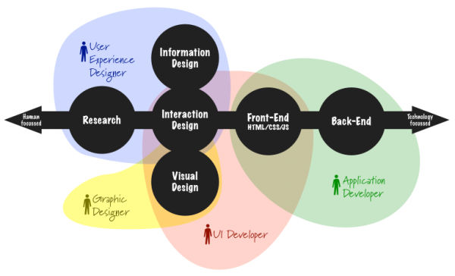

Thus the React JS is doing the job of presenting content to user with different but appropriate layout. It is a modern front-end web development that can build a better web with the following leads in several (software engineering principles and software qualities) aspects.

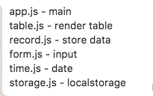

According to the research(Facebook open source 2018), react is a component-based tools. It is built by encapsulated component that can manage their own state, then compose them to make complex User interface. Obviously, the modularity of react can better to present and easy to be divided into modules. For example, the ‘table.js’ is used to render the table. ‘record.js’ is used to store data. ‘form.js’ is used to input the data. ‘time.js’ is used to record the date. Although this is one project, all function can arrange to different developer to design with stringing together as a series way which it is seldomly making any errors.

Since there is high modularity in react for modern front-end web development. In separation of concerns, we can separate different tasks to different developer for the responsibilities. If errors occur, we can find the responsibilities with this part for bugs fixed. Separation of concerns can clearly show task who have responsibilities immediately. It can fulfill modern front-end development. Also, it must save time for bug fixed in order to reduce the risk and cost that coming from the error.

Even the work is separated to different developers, the core and the principle of React doesn’t change. All developers still obey to the rules and regulations that React created. The piece of code, project will maintain to comply with convention, regulations, or custom’s set rule. React do not encounter or involved with the design or creation as per project. It would not affect the creativity in building and designing the programme. As mentioned, React is having a high modularity, programmers picks their needs from the library to fit their perspective project. In terms with the LEGO, each block of code in React is like a brick of lego. Player could build anything they love to and React also does the same thing.

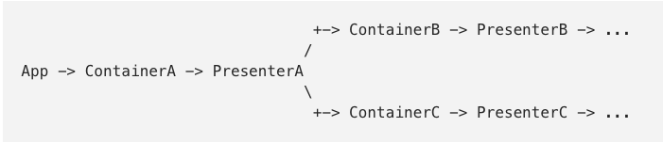

(source from Michael Jewell)

The above picture shows how react is actually working and the flow of it running. Sometimes some containers may produce widely applicable logic such as incorrect password error message. And this time which every project about account is related to this ,and we can reuse that part for these situation. This raises the beneficial of using React JS rather than the other. However, some containers produce hard-coded for their own presenter. Therefore, we need redesign them again every time.

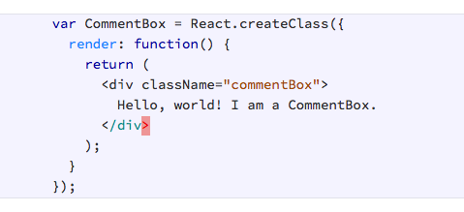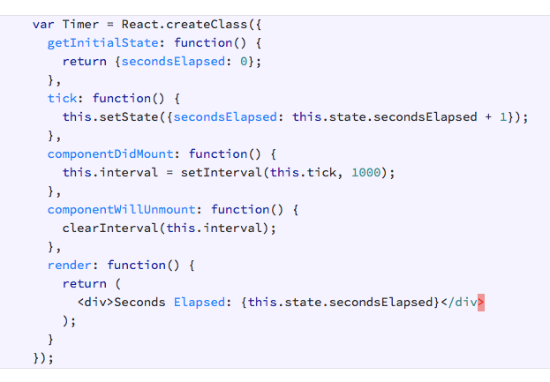

(Source from http://reactkungfu.com/2015/10/the-difference-between-virtual-dom-and-dom/)

Performance is high. Above example is react component which is very stateful. NO matter the state how changes, the component is rerendered.

After that, we can see that modularity, reusability,performance, and separation of concerns can prove react is good tool for modern front-end web development. It can bring a lot of benefits and convince every developer to write the code because of its component based.

Secondly, react is also declarative. It makes it painless to create interactive User interfaces. Design simple views for each state in application, react will efficiently update and render just the right components when data are modified. It also make the code more predictable and easier to maintain and debug.

Timeliness maybe is a challenge in react. Before, we find that modularity is higher than expected. Every developers have different job in the project and clearly showed in the schedule. Although there are bugs need to be fixed, since every part may pass to different person. So they can fix the problem in the same time. It can save most of the time in order to reduce the cost that losing in the moment. Finally, it may meet the timeline.

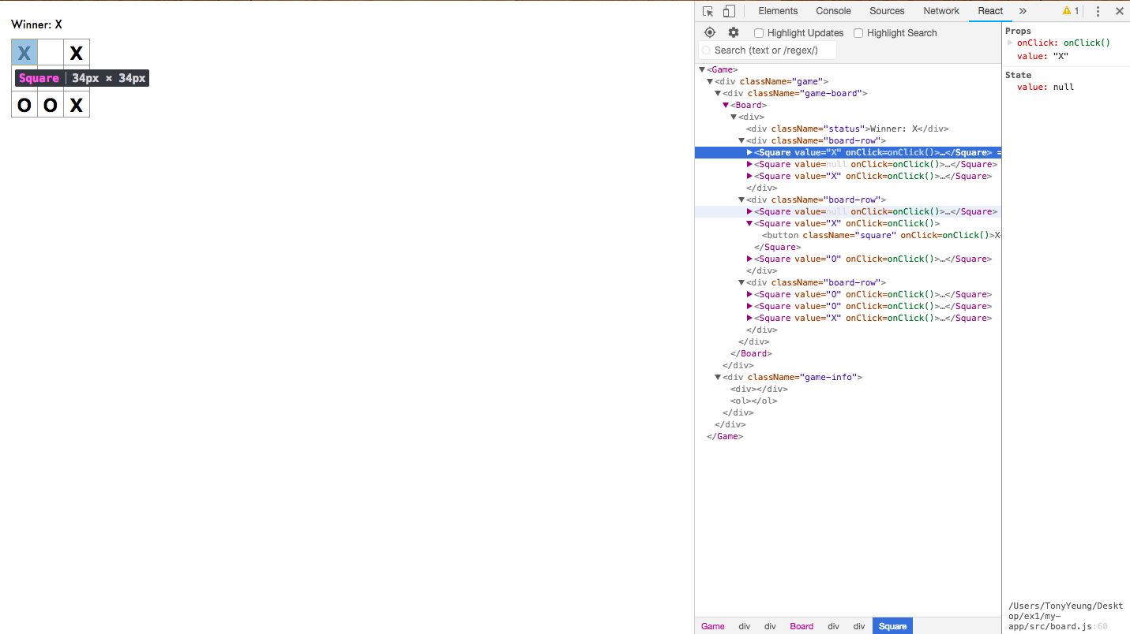Productivity is also high in react. There are many development tool in browser in order to debug and inspect the data. Redux DevTools and react developer tools are the plugin on Chrome. The developer can use inspect element function to check and test data which part occur the problem. These tools can convince developer to check their product with a high efficiency.

Understandability is very important in react. The developer can easily understand the react codes. It can reduce duration to read the codes. Also, it fit in the capitalism society. The money come first. Learning coding need a period of time to implement them. React is easily to understand and can fulfill the modern front-end development.

Maintainability in declarative will have high reparability. With a high modularity, the developer can easy find the problem.

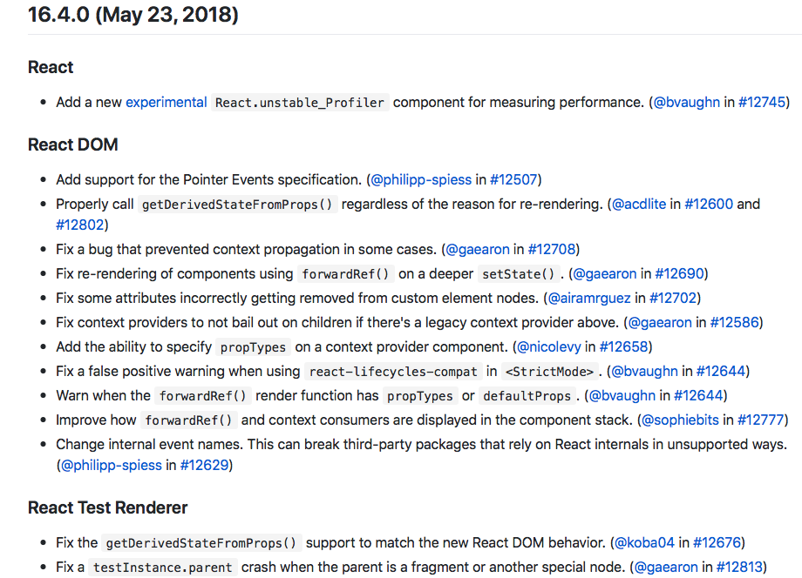

Evolvability is high on React. There are two huge version 15 and 16 in two years. It continuously update with major changes, bug fixed and new features. So React keeps being updated in order to enhance the performance and convince for developer to use the tool.

Portability is high on React. It can run on different platform, different system and different browser. There are a lot of good useful platforms such as react native, react music, react game kit..etc. It can show that react fit modern front-end web development. Also, we can test our react coding on safari, Chrome or firefox. It become more flexible. When we design the front-end of the web application, not only can use simple context and some interactive.

Therefore, all those reasons can prove that reactJS was designed to solve the pains and fulfill and needs of modern front-end web development. Even reusability may not satisfy every user that lead rewrite the code, but the modularity , timeliness , productivity, understandability, reparability and maintainability, evolvability and portability can guarantee most of the user in recent years.

And yet, React is adopting a small learning curve. Which means when comparing, it has a relatively small API so getting up and running will only take for a few weeks to months. This is always a good news for those who are hurry to view the product and meeting the society values. From the rising of IT industry, people concerns in speed. Fast with positive results are always expected. Also with more developers are using React, it has a huge community of support. Programmers exchange ideas and gathered more than 70,000 questions on net with open forum discussion. A beginner in using could also pick up and solve the problem easily. These enhance the attractiveness of joining and using React.

**Section 4: Software design and implementation**

Design and implement a simple Expense Recording web application using ReactJS and ES6.

Requirements:

-Record expense items including date, category, description and amount;

-Support CRUD operations of Create, Retrieve, Update, Delete;

-Store data via local storage or local database

Architectural Design

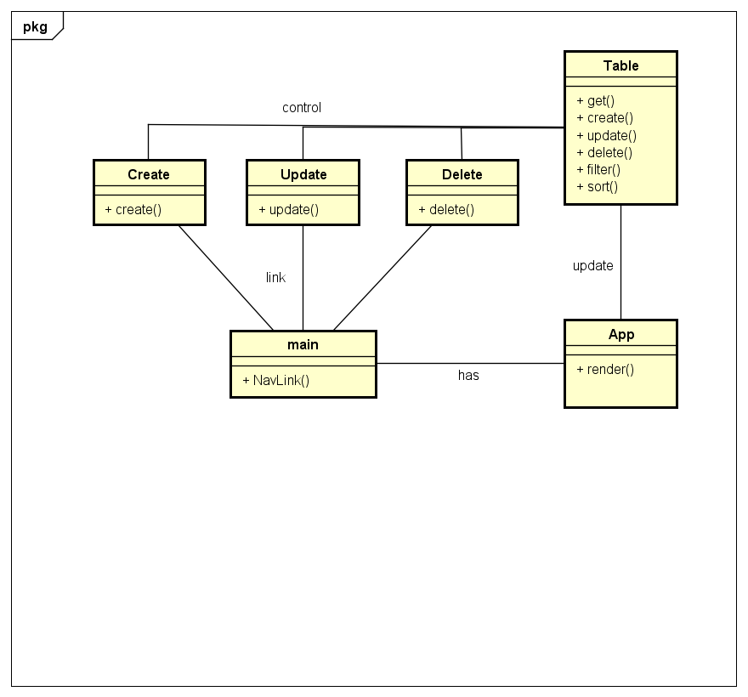

Outline

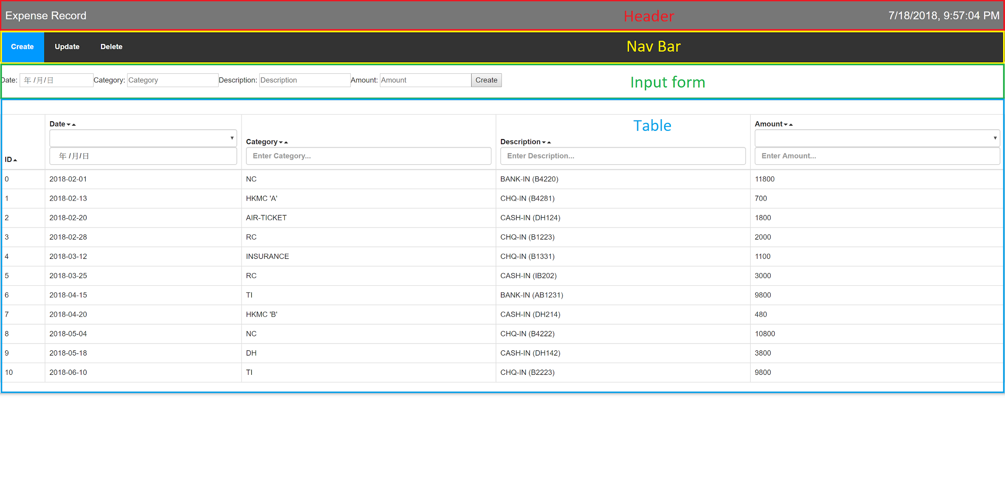

The starting module is the app class, which is the render method of the application, it contains header, navbar, input form and table.

Main class as navigation bar, route of different operations: Create, Update, Delete. Highlighting current operation.

It also used as view content of selected operation, showing depending Create, Update, Delete class.

Table class storing all data inputted from input form, the three operation classes alters data via localstorage and updates state of table class, and table class shows the latest data whenever state updated. It contains filter and sort functions so that it satisfies CRUD operations.

The web application starting on App class, containing main class and the table class. While the main class contains three operation classes, where all of them modify data affecting the table class, so that the table class outputs the data needed.

The input form is common on the three operation classes, they contain ID (Exception in Create class and it is for data management reference), Date, Category, Description, Amount.

Header of table contains filter and sort functions, the user can press the row (arrow visible) to sort and insert option via text field to filter.

**Reference:**

[1] Marwa Hussein.2016. Transition to Web 3.0: E-Learning 3.0 opportunities and challenges.

[<https://www.researchgate.net/publication/291345557_Transition_to_Web_30_E-Learning_30_opportunities_and_challenges>]. Accessed 6 July 2018

[2] Hugo Di Francesco. 2017. In simple terms: code on the backend, frontend and how they interact.et

[<https://hackernoon.com/in-simple-terms-backend-code-frontend-code-and-how-they-interact-2485c5a1bbd2>].Accessed 11 July 2018

[3] Facebook open source. 2018.

[<https://reactjs.org>]. Accessed 14 July 2018

[4] Michael Jewell. 2017. Designing React Components for Modularity, Reusability, and Testability

[<https://medium.com/@mjewell/designing-react-components-for-modularity-reusability-and-testability-edf4a68147e9>]. Accessed 14 July 2018

[5] Samer Buna.2017. React is taking over front-end development. The question is why.

[<https://medium.freecodecamp.org/yes-react-is-taking-over-front-end-development-the-question-is-why-40837af8ab76>]. Accessed 14 July 2018

[6] Jakob.2017. How to become a more productive React Developer.

[<http://blog.jakoblind.no/how-to-become-a-more-productive-react-developer/>]. Accessed 14 July 2018