ECA08 – ANALOG AND DIGITAL COMMUNICATION
CO1 DESIGN TASK ASSIGNMENT
AM-Based Communication Link Design:
From Modulation Selection to Receiver Deployment
Name : Tamizharasi B
Register No : 192412610

Executive Summary
This report designs a low-power educational analog communication link for a 4 kHz voice signal over the 540–1600 kHz RF band. Conventional amplitude modulation (AM) is selected as the primary implementation because it is simple to generate and can be recovered using a low-cost envelope detector. The candidate carrier is 1 MHz, the modulation index is 0.7, and the carrier power is 10 W. The ideal AM bandwidth is 8 kHz, which fits within the stated 20 kHz channel spacing.
MATLAB is recommended because it can generate time-domain waveforms, frequency spectra, receiver outputs and numerical checks in a repeatable way. The supplied .m file creates simulation plots and reports the key power and frequency calculations. The JPG figures included in this report are ready to insert into a Word document; the report itself is fully editable.

Design inputs and assumptions

Parameter | Given value / design assumption
Message | Voice/audio; maximum message frequency = 4 kHz
Available RF band | 540–1600 kHz
Candidate carrier | 1 MHz
Channel spacing | 20 kHz
AM modulation index | m = 0.7
Carrier power | Pc = 10 W
Channel | Additive white Gaussian noise (AWGN) and practical receiver limitations
Prototype | Low-power educational prototype; simulated 10 W figures are theoretical design values, not a recommendation to transmit at 10 W without authorization
Receiver IF | 455 kHz conventional superheterodyne IF (design choice)
Load assumption | 1 Ω normalized load for relating carrier power to amplitude in the illustrative simulation

Software recommendation
Use MATLAB as the primary simulation tool. It is well suited to time-domain signal generation, FFT-based spectrum plots, AM power calculations, envelope recovery and reproducible figures. If MATLAB is unavailable, GNU Octave can run much of the basic script with small compatibility edits; Simulink is optional and not required for this assignment.
Important: simulation results demonstrate the mathematical design. A real RF transmitter requires appropriate authorization, filtering, shielding, and a low-power/attenuated laboratory setup.

STAGE 1 – Interpret the Communication Design Requirement

Basic communication-system block diagram

Transmitter chain | Channel | Receiver chain
Voice source → microphone/audio conditioning → AM modulator + 1 MHz oscillator → RF power amplifier → band-pass filter → antenna | RF path with AWGN, attenuation and possible interference | Antenna → tuned RF preselector/amplifier → mixer + local oscillator → 455 kHz IF filter/amplifier → envelope detector → audio amplifier → speaker

The source converts speech into an electrical message. Conditioning limits the useful message band to 0–4 kHz. The modulator places this message on a 1 MHz carrier. The receiver selects the wanted station, translates it to an intermediate frequency (IF), detects the envelope, and amplifies the recovered audio.

1.2 Why modulation is required
- Practical antennas are more manageable when the signal is transmitted at radio frequency rather than directly at audio frequency.
- Modulation allows different stations to occupy different carrier-frequency channels and share the RF band.
- A tuned receiver can select one station and reject much of the out-of-channel interference.
- Direct baseband transmission over a radio link is inefficient for long-distance broadcasting and does not naturally provide frequency-division station allocation.

1.3 Message and transmission bandwidth

Scheme | Approximate RF bandwidth for fm(max)=4 kHz | Explanation
Conventional AM | 2fm = 8 kHz | Upper and lower sidebands; carrier is also transmitted
DSB-SC | 2fm = 8 kHz | Two sidebands; carrier suppressed
SSB-SC | fm = 4 kHz | Only one sideband transmitted
VSB-SC | Slightly more than 4 kHz; depends on vestige/filter | One full sideband plus a controlled vestige of the other

The message bandwidth is 4 kHz. Conventional AM and DSB-SC require 8 kHz ideally, so they fit within 20 kHz channel spacing with nominal room for transition bands and guard space. SSB-SC is narrower, while VSB bandwidth depends on the chosen vestigial filter.

1.4 Idealized channel count
Available band = 1600 − 540 = 1060 kHz. At 20 kHz spacing, 1060/20 = 53 channel intervals. Therefore, 53 idealized 20-kHz channel slots is the theoretical planning estimate, before edge constraints, guard bands, regulatory assignments and practical filter requirements.

1.5 AM power calculation
For conventional AM with sinusoidal modulation, total transmitted power is Ptotal = Pc(1 + m²/2). Each sideband power is PUSB = PLSB = Pc m²/4.
Given Pc = 10 W and m = 0.7: m² = 0.49; each sideband power = 10 × 0.49/4 = 1.225 W; total sideband power = 2.45 W; total AM power = 10 × (1 + 0.49/2) = 12.45 W. Carrier power is 10 W. The fraction of total power in the sidebands is 2.45/12.45 × 100 ≈ 19.68%.

1.6 Receiver requirements and prototype constraints
- Sensitivity: the receiver should recover usable speech from a weak input signal; a numeric sensitivity target requires a defined audio quality and noise threshold.
- Selectivity: the RF and IF filters should pass the selected channel while attenuating adjacent stations.
- Fidelity: the audio chain should preserve the 0–4 kHz message without excessive distortion.
- Stability: the carrier oscillator and receiver local oscillator should remain sufficiently stable to avoid tuning errors.
- Image rejection: the RF preselector should suppress the image-frequency response before mixing.
- Low-cost implementation: prefer common oscillator, mixer, IF filter and envelope detector blocks; use simulation first and avoid direct high-power transmission.

Stage 1 deliverable – requirement statement
Design a 1 MHz conventional AM voice link for a 0–4 kHz message, m = 0.7 and Pc = 10 W theoretical carrier power. The AM signal occupies 8 kHz ideally and fits within a 20 kHz channel allocation. The receiver must provide adequate sensitivity, selectivity, fidelity, oscillator stability and image rejection. The laboratory prototype should be simulated or conducted through a shielded/attenuated setup.

STAGE 2 – Investigate and Select the Modulation Scheme

2.1 Time- and frequency-domain expressions
Let m(t) be the message signal and Ac cos(2πfct) the carrier.
Scheme | Time-domain expression (single-tone example) | Spectrum components
Conventional AM | sAM(t)=Ac[1 + m cos(2πfmt)]cos(2πfct) | Carrier fc and sidebands fc−fm, fc+fm
DSB-SC | sDSB(t)=Ac m(t)cos(2πfct) | Two sidebands; no transmitted carrier ideally
SSB-SC | Keep only the USB or LSB component of DSB-SC | One sideband only
VSB-SC | Filter DSB-SC so one sideband remains and a vestige of the other is retained | One full sideband plus a partial/vestigial sideband

For conventional AM, expansion gives sAM(t)=Ac cos(2πfct) + (mAc/2)cos[2π(fc+fm)t] + (mAc/2)cos[2π(fc−fm)t]. This explicitly shows the carrier and two sidebands.

2.2 Modulation comparison

Criterion | AM | DSB-SC | SSB-SC | VSB-SC
Bandwidth | 8 kHz | 8 kHz | 4 kHz | Slightly >4 kHz; filter-dependent
Carrier | Transmitted | Suppressed | Suppressed | Often vestigial/carrier arrangement depends on system
Power efficiency | Low/moderate; carrier uses power | Higher than AM | High | Good bandwidth compromise
Detection | Simple envelope detector | Coherent detector | Coherent/product detector | TV-specific vestigial filtering and suitable detection
Complexity | Low | Moderate; carrier recovery needed | Higher filtering and synchronization complexity | Higher filter design complexity
Typical application | Broadcast voice | Carrier-efficient links | Narrowband voice | Analog television video

2.3 Quantitative power advantage
For a fair comparison, conventional AM has 10 W carrier power and 1.225 W in each sideband, giving 12.45 W total. DSB-SC suppresses the carrier and, for the same sideband amplitudes, transmits the 2.45 W sideband total rather than 12.45 W. This is about 80.3% less transmitted power than the stated conventional-AM total, under this same-sideband-amplitude comparison.
SSB-SC transmits only one of the two sidebands. If its retained sideband has the same power as one AM sideband in this example, it transmits about 1.225 W, approximately 90.2% less than 12.45 W. These are illustrative comparisons: actual power depends on the chosen message amplitude, normalization and link-quality target.

2.4 Why VSB is used for analog television

Video signals contain substantial low-frequency content. A very sharp SSB filter near the carrier can be difficult to realize without distortion. VSB transmits one sideband and a small controlled vestige of the other, easing filter design while keeping bandwidth lower than full DSB. Its vestigial filter and receiver equalization/detection are designed for television video, not as the simplest choice for this voice link.

Design Decision 1 – selected modulation

I recommend conventional AM for the educational voice-broadcast prototype because it offers an 8 kHz occupied bandwidth, fits the 20 kHz spacing, and supports a simple envelope detector without carrier synchronization. Although DSB-SC and SSB-SC improve power efficiency, they require more complex coherent detection and/or sideband filtering. For a practical commercial system where power and spectrum efficiency dominate, SSB could be reconsidered.

STAGE 3 – RF Channel Allocation and Transmitter Design

3.1 Example five-channel allocation

Station | Carrier (kHz) | AM lower sideband (kHz) | AM upper sideband (kHz) | Nominal channel slot (kHz)
A | 960 | 956 | 964 | 950–970
B | 980 | 976 | 984 | 970–990
Selected station C | 1000 | 996 | 1004 | 990–1010
D | 1020 | 1016 | 1024 | 1010–1030
E | 1040 | 1036 | 1044 | 1030–1050

The five carriers are separated by 20 kHz. Each AM signal occupies approximately ±4 kHz around its carrier, leaving a nominal 12 kHz gap between adjacent signal edges when the message is limited to 4 kHz. Practical channel masks and filter transition bands still need to be considered.

3.2 Transmitter block diagram and operation

Block | Function
Voice source / microphone | Produces the baseband audio signal
Audio conditioning / low-pass filter | Limits the message to 0–4 kHz and controls amplitude
1 MHz carrier oscillator | Generates a stable RF carrier
AM modulator | Combines the message and carrier using m = 0.7
RF power amplifier | Raises the signal to the designed output power
Output band-pass filter and antenna | Suppresses unwanted components and couples the RF signal to the channel

3.3 Generation and detection summary
- AM: nonlinear/product modulator or multiplier plus carrier; envelope detector at receiver.
- DSB-SC: balanced modulator suppresses the carrier; coherent/product detector needs a synchronized carrier.
- SSB-SC: balanced modulator followed by a sideband-selective filter or phasing method; coherent/product detection is typical.
- VSB-SC: DSB generation followed by a vestigial-sideband filter; receiver filtering and detection/equalization must account for the vestige.

3.4 Spectrum-efficiency and complexity trade-off
The selected AM signal uses 8 kHz within a 20 kHz channel slot, so the nominal bandwidth requirement is met. AM is not the most power-efficient option because the carrier carries no message information, but it is the least complex receiver option. The five-channel plan is a simplified engineering plan, not a legal frequency assignment.

STAGE 4 – Select the AM Receiver Architecture

4.1 TRF and superheterodyne block diagrams

TRF receiver | Superheterodyne receiver
Antenna → tuned RF amplifier(s) → detector → audio amplifier → speaker | Antenna → RF preselector/amplifier → mixer ← local oscillator → fixed IF filter/amplifier → detector → audio amplifier → speaker

A tuned-radio-frequency (TRF) receiver amplifies the selected RF directly. Its tuning and selectivity can change across the band, making consistent performance harder. A superheterodyne receiver converts the selected station to a fixed IF, allowing stable high-gain amplification and filtering. The superheterodyne architecture is recommended.

4.2 IF and image-frequency calculation
Choose IF = 455 kHz, a conventional design choice for AM broadcast receivers. With high-side local-oscillator injection, fLO = fc + fIF = 1000 + 455 = 1455 kHz. The image frequency is on the opposite side of the LO: fimage = fLO + fIF = fc + 2fIF = 1000 + 910 = 1910 kHz. The image lies outside the stated 540–1600 kHz band, which helps the RF preselector reject it. In a real receiver, image response is not eliminated solely by this calculation; RF filter attenuation and component performance matter.

4.3 Receiver parameter evaluation

Parameter | Engineering meaning / design response
Sensitivity | Minimum input level for acceptable recovered audio; establish experimentally with a defined signal-to-noise or distortion target.
Selectivity | 455 kHz IF filter bandwidth should pass the desired AM channel and attenuate adjacent-channel signals.
Fidelity | Audio stages should pass 0–4 kHz with low distortion and suitable gain.
Image rejection | RF preselector rejects the 1.910 MHz image before mixing; IF choice affects image separation.
Oscillator/IF stability | Stable local oscillator and fixed IF response reduce tuning error and improve selectivity.
Detection | Envelope detection is appropriate for conventional AM with no overmodulation.

4.4 Envelope detector condition
Because m = 0.7 < 1, the AM envelope does not cross zero for a single-tone message. This avoids overmodulation and supports envelope detection. A practical detector uses a diode or equivalent rectifier followed by an RC network chosen to smooth the carrier while following the audio envelope.

Design Decision 3 – receiver architecture
I recommend a superheterodyne receiver with a 455 kHz IF because a fixed IF simplifies selectivity and gain, while high-side injection gives a calculated image at 1.910 MHz, outside the specified RF band. It is more complex than TRF but offers better practical selectivity and repeatability.

STAGE 5 – Develop, Verify and Compare the Complete System

5.1 End-to-end design
Voice (0–4 kHz) → audio conditioning → AM modulator (fc = 1 MHz, m = 0.7) → RF amplifier/filter → channel with AWGN → antenna/preselector → mixer and LO (1.455 MHz) → 455 kHz IF filter/amplifier → envelope detector → audio amplifier → speaker.

5.2 MATLAB simulation outputs
The included MATLAB script creates a time-domain AM waveform with its envelope, an FFT spectrum around the carrier, and an idealized envelope-recovery comparison. The plots are generated from the stated frequencies and modulation index. The report also includes ready-to-insert JPG versions.
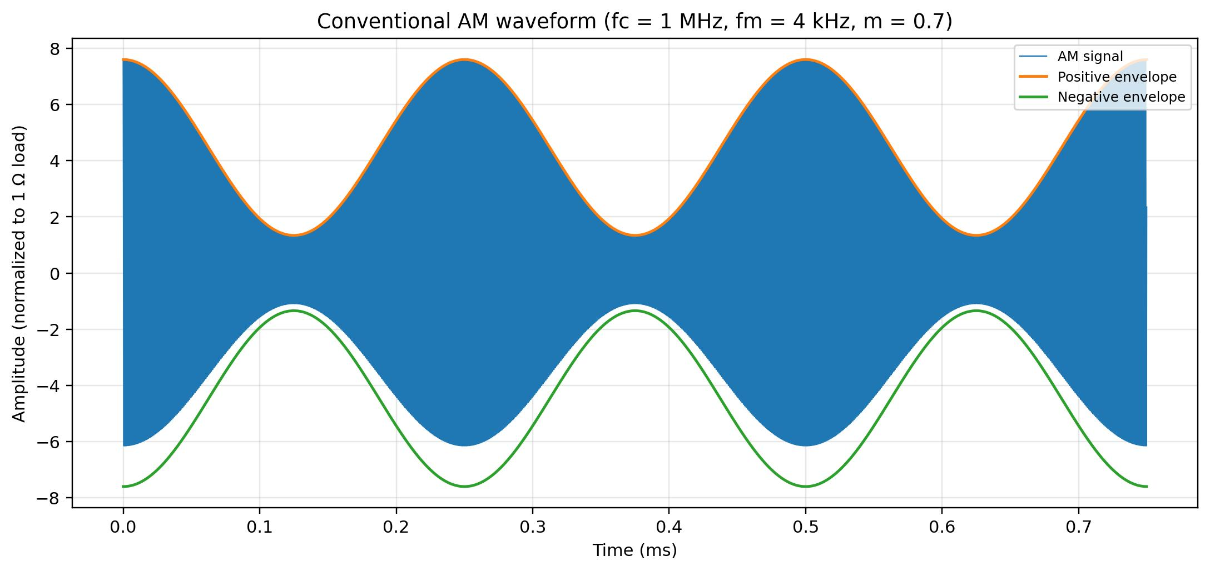
Figure 1. Conventional AM time-domain waveform and envelope.
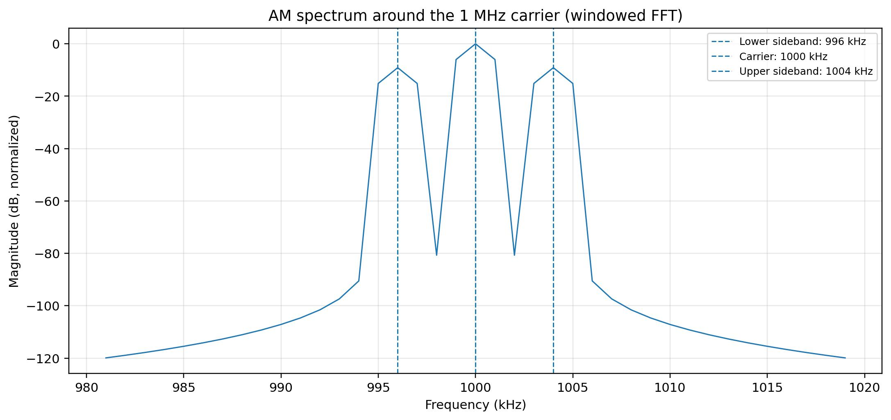
Figure 2. AM spectrum showing carrier at 1000 kHz and sidebands at 996 and 1004 kHz.
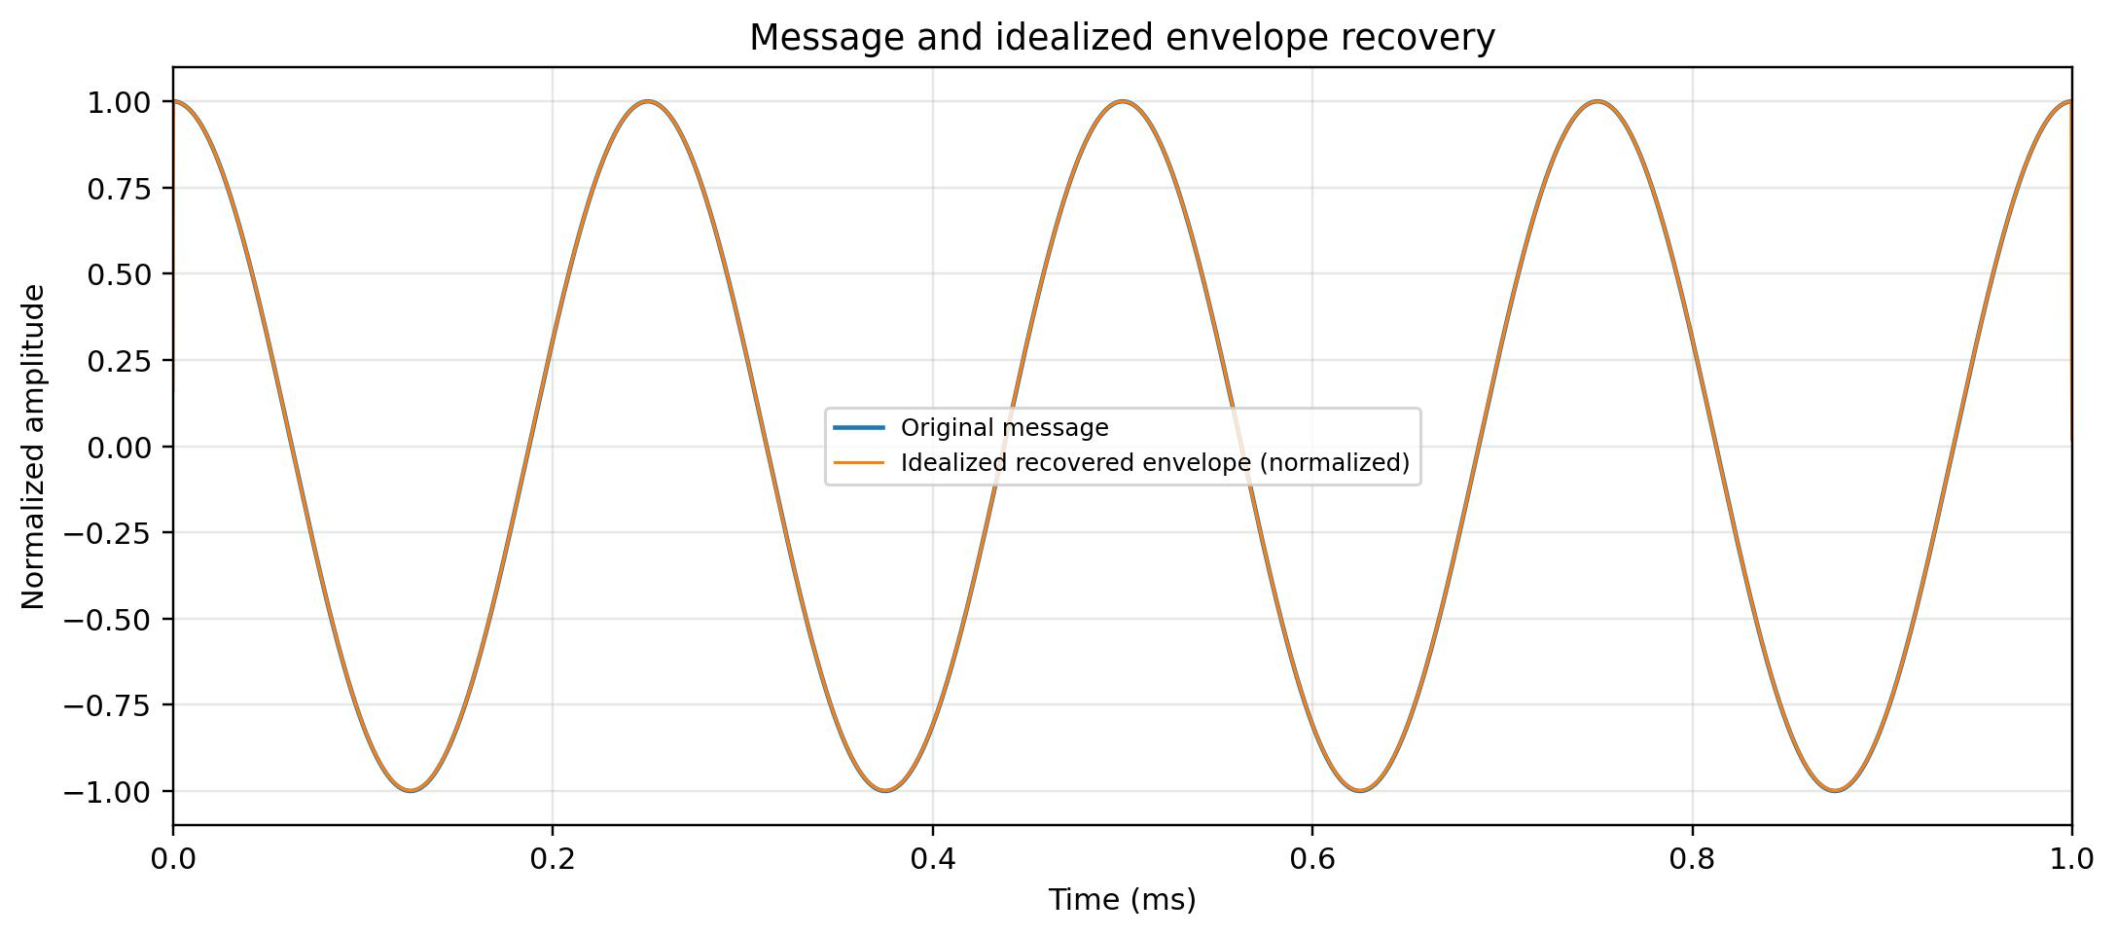
Figure 3. Original message and idealized recovered envelope.
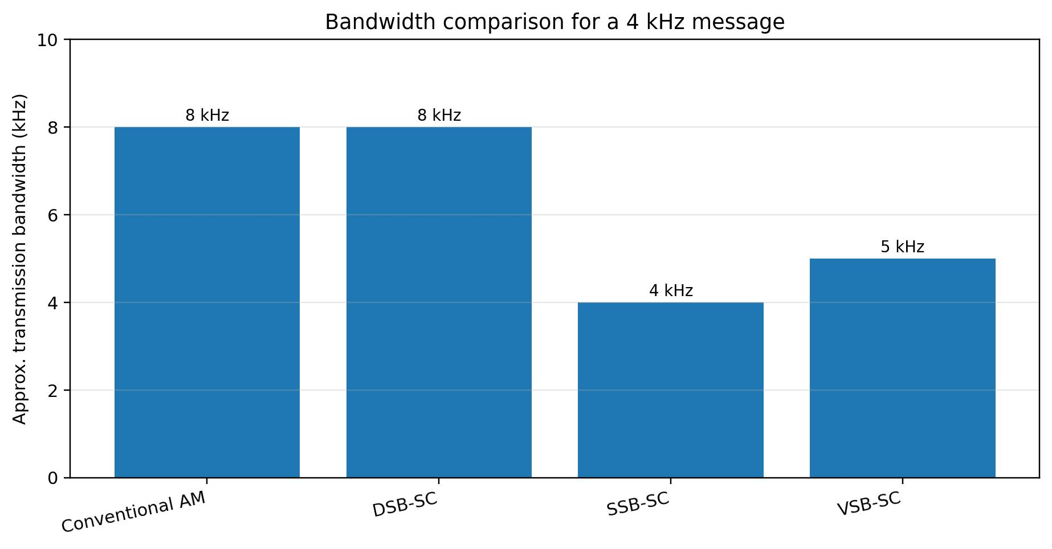
Figure 4. Approximate bandwidth comparison. VSB bandwidth is illustrative and depends on the filter/vestige design.

5.3 Verification table

Check | Calculation / expected result | Status
Message bandwidth | 0–4 kHz; maximum message frequency 4 kHz | Meets requirement
AM bandwidth | 2fm = 8 kHz | Fits within 20 kHz spacing
Modulation index | m = 0.7 < 1 | No overmodulation for sinusoidal test signal
Carrier power | Pc = 10 W (given) | Input specification
Each sideband power | Pc m²/4 = 1.225 W | Verified analytically
Total sideband power | 2 × 1.225 = 2.45 W | Verified analytically
Total AM power | Pc(1 + m²/2) = 12.45 W | Verified analytically
Channel allocation | Example carriers: 960, 980, 1000, 1020, 1040 kHz | 20 kHz separation
IF / image | IF=455 kHz; image=1910 kHz with high-side LO | Image outside stated RF band
Noise | AWGN can lower recovered audio SNR; filtering limits out-of-channel noise | Qualitative unless noise level is specified

5.4 Noise effects and comparison with a rejected alternative
AWGN adds random components to the received signal and can produce audible hiss or distortion. The RF preselector and IF filter reduce out-of-channel noise/interference; they cannot remove all noise that overlaps the wanted channel. An envelope detector is simple but output quality declines as carrier-to-noise ratio becomes low.
DSB-SC is a rejected alternative for this simple prototype. At matched sideband amplitudes it avoids the large carrier-power term, but its receiver needs carrier recovery and coherent detection. AM is therefore selected for ease of implementation, not maximum power efficiency.

5.5 Low-cost laboratory realization
- First validate the signal and spectrum in MATLAB; do not begin with an RF power amplifier.
- For hardware demonstration, use a low-power signal generator or a wired/shielded setup with attenuation and a dummy load.
- Use a stable carrier source, audio low-pass filter, modulator, RF filter and receiver with a 455 kHz IF if available.
- Keep the 10 W figure as the assignment's theoretical carrier-power parameter; do not radiate that power without authorization and proper equipment.

STAGE 6 – Critically Evaluate the Design and Make the Deployment Decision

6.1 Summary comparison

Metric | Conventional AM | DSB-SC / SSB-SC / VSB-SC implication
Bandwidth | 8 kHz; fits 20 kHz channel spacing | DSB-SC 8 kHz; SSB-SC 4 kHz; VSB slightly more than 4 kHz
Power | 12.45 W total from 10 W carrier at m=0.7 | Suppressed-carrier schemes can reduce carrier power; SSB also halves sideband occupancy
Receiver | Envelope detector, low complexity | DSB/SSB need coherent detection; VSB needs specialized filtering/detection
Voice broadcast | Suitable where simplicity and compatibility matter | SSB can be attractive when spectrum/power efficiency dominates
Analog TV | Not the preferred video transmission method | VSB was designed as a bandwidth/filtering compromise for analog TV

6.2 Final engineering decision
WOULD YOU DEPLOY THIS COMMUNICATION SYSTEM? YES — for a low-power educational demonstration, subject to the conditions below.
The design meets the stated message-bandwidth and channel-spacing requirements: a 4 kHz message produces an ideal 8 kHz AM signal, which fits inside a 20 kHz allocation. The power calculation is internally consistent: 10 W carrier, 2.45 W total sidebands and 12.45 W total AM power. The superheterodyne receiver's 455 kHz IF gives an image frequency of 1.910 MHz with high-side injection, outside the stated band.
Deployment is conditional. The assignment describes a low-power educational prototype, while the 10 W carrier is a theoretical parameter. A physical build should use an authorized frequency, appropriately low conducted power, attenuation or shielding, and suitable filtering. The exact receiver sensitivity and noise performance must be measured because no received signal level, channel attenuation or target SNR is specified.
If spectrum and power efficiency become the primary goals, redesign the link using SSB-SC and a coherent receiver, accepting greater implementation complexity. VSB should be considered separately for analog television, not selected merely because it is spectrally efficient for a voice-only link.

6.3 Final specification-verification table

Requirement from assignment | Design response | Verification
4 kHz voice signal | Baseband limited to 0–4 kHz | MATLAB message uses 4 kHz test tone; real speech needs audio conditioning
540–1600 kHz band; candidate 1 MHz | Selected carrier = 1000 kHz | Within specified band
20 kHz spacing | Five-channel example at 20 kHz steps | Nominal AM sidebands do not overlap
m = 0.7 | Used in simulation and calculations | m<1; envelope detection appropriate
Pc = 10 W | Used for theoretical AM power calculation | Ptotal = 12.45 W
AWGN/practical limits | Discussed filtering and SNR impact | Quantitative noise test needs a specified noise level
Transmitter and receiver design | Labelled block descriptions and selected superheterodyne | Architecture justified
Simulation plots | Waveform, spectrum, recovery and bandwidth comparison | JPGs included; MATLAB script supplied

Appendix A – MATLAB code
Save the accompanying file AM_Communication_Link_Simulation.m in the MATLAB working folder and run it. It prints the calculations and saves waveform/spectrum/recovery JPG figures to the current folder.
%% ECA08 CO1 Design Task - Conventional AM Simulation
% Message bandwidth: 4 kHz; carrier: 1 MHz; modulation index: 0.7
% Carrier power: 10 W into a normalized 1-ohm load
clear; clc; close all;

fm = 4e3; % message frequency (Hz)
fc = 1e6; % carrier frequency (Hz)
m = 0.7; % modulation index
Pc = 10; % carrier power (W)
R = 1; % normalized load (ohm)
Ac = sqrt(2*Pc*R); % carrier peak amplitude for Pc = Ac^2/(2R)
fs = 5e6; % sampling frequency, > 2*(fc + fm)
T = 1e-3; % simulation duration (s)
t = 0:1/fs:T-1/fs;

message = cos(2*pi*fm*t);
carrier = Ac*cos(2*pi*fc*t);
sAM = Ac*(1 + m*message).*cos(2*pi*fc*t);

% Power calculations
Pusb = Pc*m^2/4;
Plsb = Pusb;
Ptotal = Pc*(1 + m^2/2);
BW_AM = 2*fm;

fprintf('Message bandwidth = %.1f kHz\\n', fm/1e3);
fprintf('AM transmission bandwidth = %.1f kHz\\n', BW_AM/1e3);
fprintf('Carrier power = %.3f W\\n', Pc);
fprintf('Each sideband power = %.3f W\\n', Pusb);
fprintf('Total sideband power = %.3f W\\n', Pusb+Plsb);
fprintf('Total AM power = %.3f W\\n', Ptotal);

% Figure 1: time waveform and envelope
figure('Color','w');
idx = t < 0.75e-3;
plot(t(idx)*1e3, sAM(idx), 'b'); hold on;
env = Ac*(1 + m*message(idx));
plot(t(idx)*1e3, env, 'r--', 'LineWidth', 1.4);
plot(t(idx)*1e3, -env, 'r--', 'LineWidth', 1.4);
grid on; xlabel('Time (ms)'); ylabel('Amplitude (normalized to 1-ohm load)');
title('Conventional AM waveform: fc=1 MHz, fm=4 kHz, m=0.7');
legend('AM signal','Positive envelope','Negative envelope');
exportgraphics(gcf,'AM_Time_Domain_Waveform.jpg','Resolution',220);

% Figure 2: frequency spectrum
N = length(sAM);
win = hann(N)';
S = fft(sAM.*win);
f = (0:N-1)*(fs/N);
half = 1:floor(N/2);
mag = abs(S(half));
magDB = 20*log10(mag/max(mag) + 1e-8);
figure('Color','w');
plot(f(half)/1e3,magDB,'LineWidth',1);
xlim([(fc-20e3)/1e3 (fc+20e3)/1e3]); ylim([-80 5]);
grid on; xlabel('Frequency (kHz)'); ylabel('Magnitude (dB, normalized)');
title('AM spectrum around 1 MHz carrier');
xline((fc-fm)/1e3,'r--','996 kHz LSB');
xline(fc/1e3,'k--','1000 kHz carrier');
xline((fc+fm)/1e3,'r--','1004 kHz USB');
exportgraphics(gcf,'AM_Spectrum.jpg','Resolution',220);

% Figure 3: simple baseband message and recovered envelope illustration
% Ideal envelope detector output, with DC removed
recovered = abs(hilbert(sAM));
recovered = recovered - mean(recovered);
figure('Color','w');
plot(t*1e3, message,'k','LineWidth',1.2); hold on;
plot(t*1e3, recovered/max(abs(recovered)),'g--','LineWidth',1.1);
xlim([0 1]); grid on;
xlabel('Time (ms)'); ylabel('Normalized amplitude');
title('Message and idealized envelope recovery');
legend('Original message','Recovered envelope (normalized)');
exportgraphics(gcf,'AM_Envelope_Detection.jpg','Resolution',220);

% Design checks
fprintf('Channel allocation example (kHz): 960, 980, 1000, 1020, 1040\\n');
fprintf('For high-side LO injection: LO = fc + IF = 1.455 MHz (IF=455 kHz)\\n');
fprintf('Image frequency = fc + 2*IF = 1.910 MHz\\n');

Appendix B – Notes on interpretation
- The plots are simulation illustrations, not measured hardware results.
- The normalized 1 Ω load is used only to map Pc to carrier amplitude in the script; an actual RF system requires a specified impedance and proper power calibration.
- The VSB bandwidth value in the comparison plot is illustrative because the assignment does not specify a vestigial filter response.
- The 53-slot count is an idealized division of total band span by channel spacing; practical allocations depend on channel-edge rules, guard bands and applicable regulations.

