ECA0801 – ANALOG AND DIGITAL COMMUNICATION
EXPERIMENT 2 – Characteristics Study of Side Band Power and Frequencies in AM Using MATLAB
Objective 1 : To generate an Amplitude Modulated (AM) signal in MATLAB using specified carrier and modulating signal parameters

Software Required : MATLAB

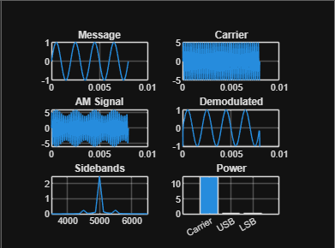

Program Code :

clc;
clear;
close all;

Am = 1;
fm = 500;
Ac = 5;
fc = 5000;
fs = 20*fc;
t = 0:1/fs:4/fm;

m = Am*sin(2*pi*fm*t);
c = Ac*sin(2*pi*fc*t);
mu = Am/Ac;
am = Ac*(1+mu*sin(2*pi*fm*t)).*sin(2*pi*fc*t);

dem = abs(hilbert(am));
dem = dem-mean(dem);

N = length(am);
f = linspace(-fs/2,fs/2,N);
AM_FFT = abs(fftshift(fft(am)))/N;

USB = fc+fm;
LSB = fc-fm;
Pc = Ac^2/2;
Psb = (mu^2*Pc)/4;

figure('Name','AM Modulation','NumberTitle','off');

subplot(3,2,1);
plot(t,m);
title('Message');
grid on;

subplot(3,2,2);
plot(t,c);
title('Carrier');
grid on;

subplot(3,2,3);
plot(t,am);
title('AM Signal');
grid on;

subplot(3,2,4);
plot(t,dem);
title('Demodulated');
grid on;

subplot(3,2,5);
plot(f,AM_FFT);
xlim([fc-3*fm fc+3*fm]);
title('Sidebands');
grid on;

subplot(3,2,6);
bar([Pc Psb Psb]);
set(gca,'XTickLabel',{'Carrier','USB','LSB'});
title('Power');
grid on;

fprintf('mu = %.2f\n',mu);
fprintf('USB = %d Hz\n',USB);
fprintf('LSB = %d Hz\n',LSB);
fprintf('Carrier Power = %.2f W\n',Pc);
fprintf('Each Sideband Power = %.3f W\n',Psb);

OUTPUT :
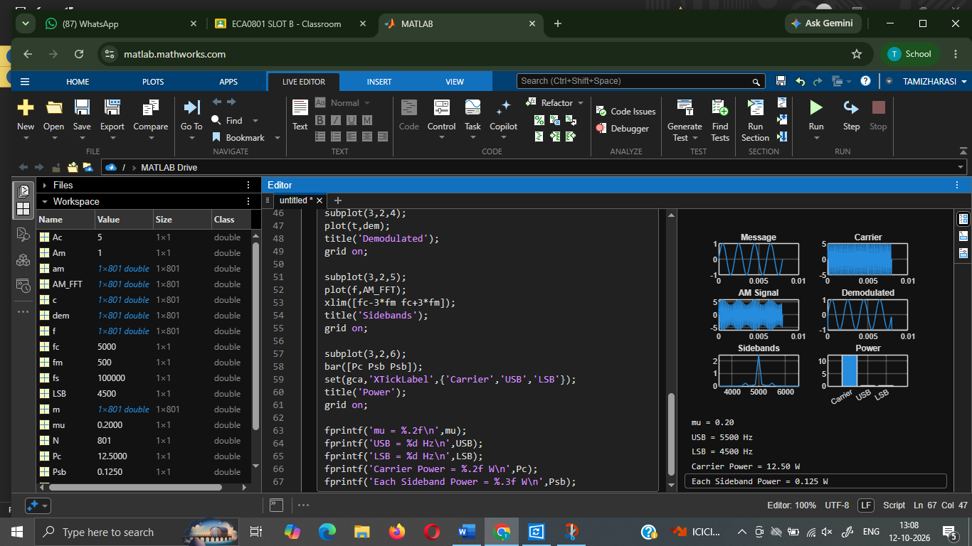

Objective 2 : To determine and verify the upper sideband (USB) and lower sideband (LSB) frequencies of the AM signal using frequency spectrum analysis in MATLAB.

Software Reduired : MATLAB

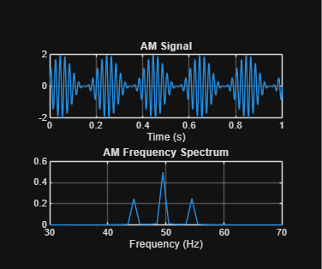
Program code :
clc;
clear;
close all;

fc = 50;
fm = 5;
Ac = 1;
m = 1;
fs = 2000;
t = 0:1/fs:1;

am = Ac*(1+m*sin(2*pi*fm*t)).*sin(2*pi*fc*t);

N = length(am);
f = (-N/2:N/2-1)*fs/N;
F = abs(fftshift(fft(am)))/N;

USB = fc+fm;
LSB = fc-fm;

figure;
subplot(2,1,1);
plot(t,am);
title('AM Signal');
xlabel('Time (s)');
grid on;

subplot(2,1,2);
plot(f,F);
xlim([30 70]);
title('AM Frequency Spectrum');
xlabel('Frequency (Hz)');
grid on;

fprintf('USB = %d Hz\n',USB);
fprintf('LSB = %d Hz\n',LSB);

OUTPUT :
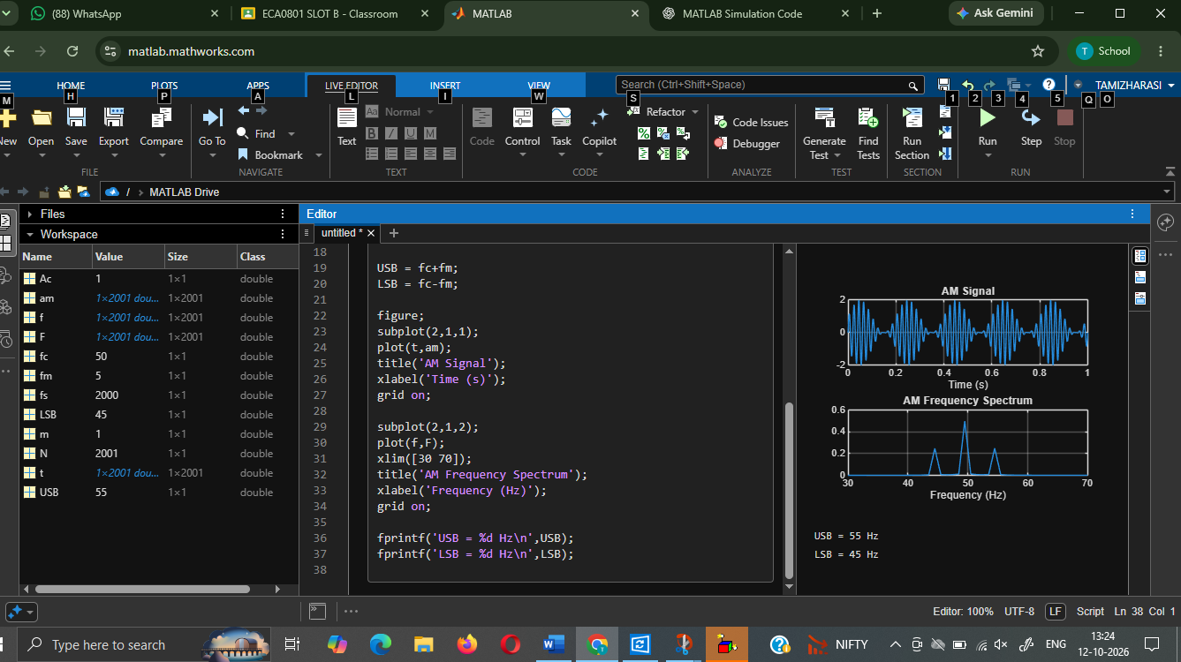

Objective 3 : To calculate the carrier power, sideband power, and total transmitted power of the AM signal for a given modulation index using MATLAB.

Software Required : MATLAB
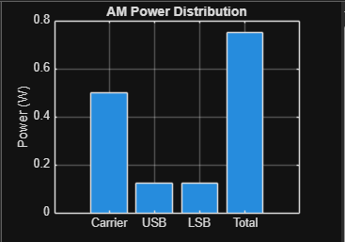

Program code :

clc;
clear;
close all;

Pc = 0.5;
m = 1;

Pusb = (m^2*Pc)/4;
Plsb = (m^2*Pc)/4;
Pside = Pusb+Plsb;
Pt = Pc+Pside;

bar([Pc Pusb Plsb Pt]);
set(gca,'XTickLabel',{'Carrier','USB','LSB','Total'});
ylabel('Power (W)');
title('AM Power Distribution');
grid on;

fprintf('Carrier Power = %.3f W\n',Pc);
fprintf('USB Power = %.3f W\n',Pusb);
fprintf('LSB Power = %.3f W\n',Plsb);
fprintf('Total Sideband Power = %.3f W\n',Pside);
fprintf('Total Transmitted Power = %.3f W\n',Pt);

OUTPUT :
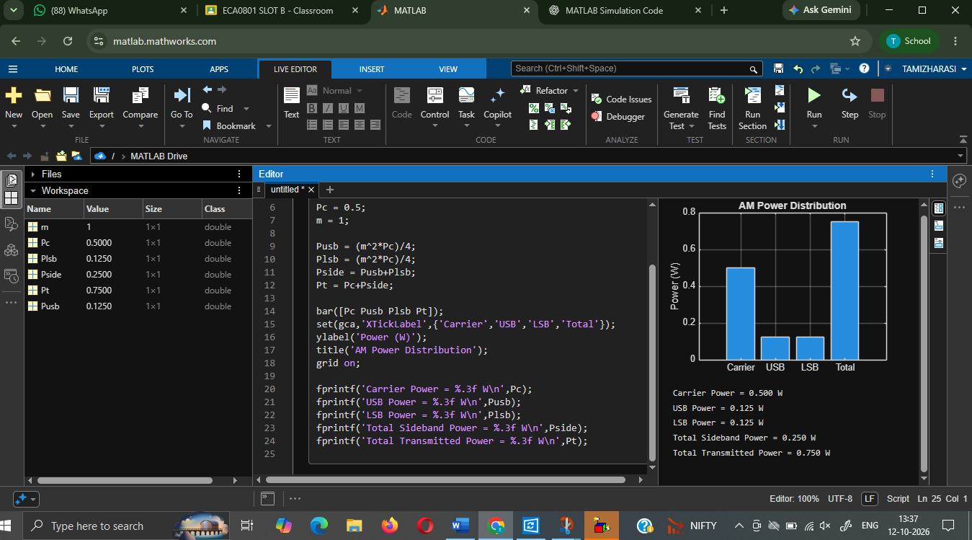

Objective 4 : To analyze the effect of varying the modulation index on sideband power distribution and overall transmission efficiency through MATLAB simulation.
Software Required : MATLAB

Program Code :
clc;
clear;
close all;

Pc = 0.5;
m = [0.2 0.5 0.8 1.0];

Pusb = (m.^2*Pc)/4;
Plsb = Pusb;
Pside = Pusb+Plsb;
Pt = Pc+Pside;
eff = (Pside./Pt)*100;

figure;
subplot(2,1,1);
plot(m,Pside,'o-');
title('Sideband Power vs Modulation Index');
xlabel('Modulation Index');
ylabel('Total Sideband Power (W)');
grid on;

subplot(2,1,2);
plot(m,eff,'o-');
title('Transmission Efficiency vs Modulation Index');
xlabel('Modulation Index');
ylabel('Efficiency (%)');
grid on;

disp('Modulation Index:');
disp(m);
disp('Total Sideband Power (W):');
disp(Pside);
disp('Transmission Efficiency (%):');
disp(eff);

OUTPUT :
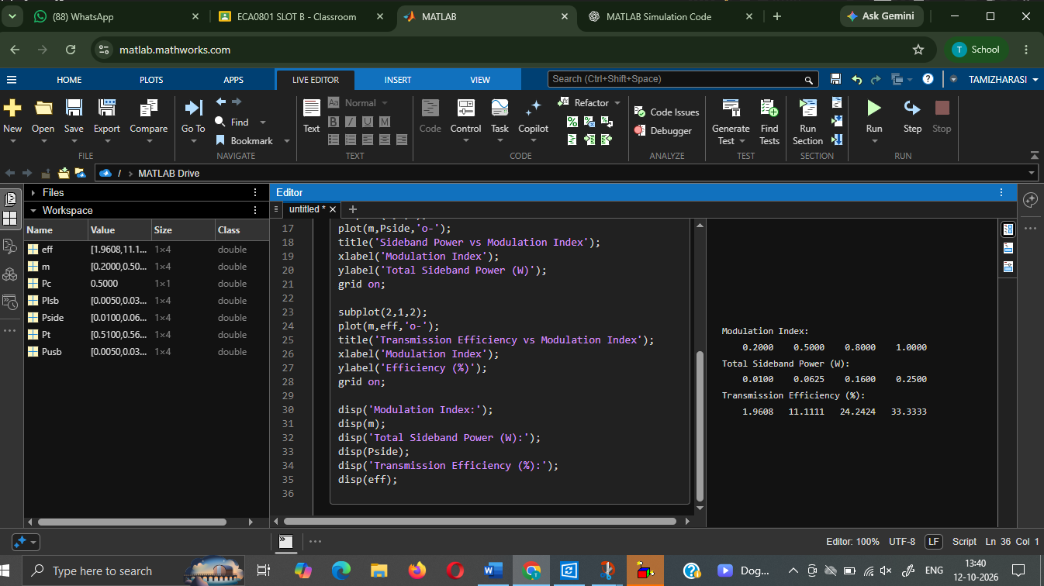

SAMPLE LAB EXAM QUESTIONS
- Generate an AM signal in MATLAB using a carrier frequency of 10kHz, modulating frequency of 1kHz, carrier amplitude of 10V, and modulation index m=0.5. Plot the AM waveform and frequency spectrum. Determine and verify the LSB, carrier and USB frequencies.
Program Code :

clc;
clear;
close all;

Ac = 10;
fc = 10000;
fm = 1000;
m = 0.5;
fs = 20*fc;
t = 0:1/fs:4/fm;

am = Ac*(1+m*sin(2*pi*fm*t)).*sin(2*pi*fc*t);

N = length(am);
f = (-N/2:N/2-1)*fs/N;
F = abs(fftshift(fft(am)))/N;

LSB = fc-fm;
USB = fc+fm;

figure;
subplot(2,1,1);
plot(t,am);
title('AM Waveform');
xlabel('Time (s)');
ylabel('Amplitude (V)');
grid on;

subplot(2,1,2);
plot(f,F);
xlim([fc-3*fm fc+3*fm]);
title('AM Frequency Spectrum');
xlabel('Frequency (Hz)');
ylabel('Magnitude');
grid on;

fprintf('LSB = %d Hz\n',LSB);
fprintf('Carrier = %d Hz\n',fc);
fprintf('USB = %d Hz\n',USB);

OUTPUT :
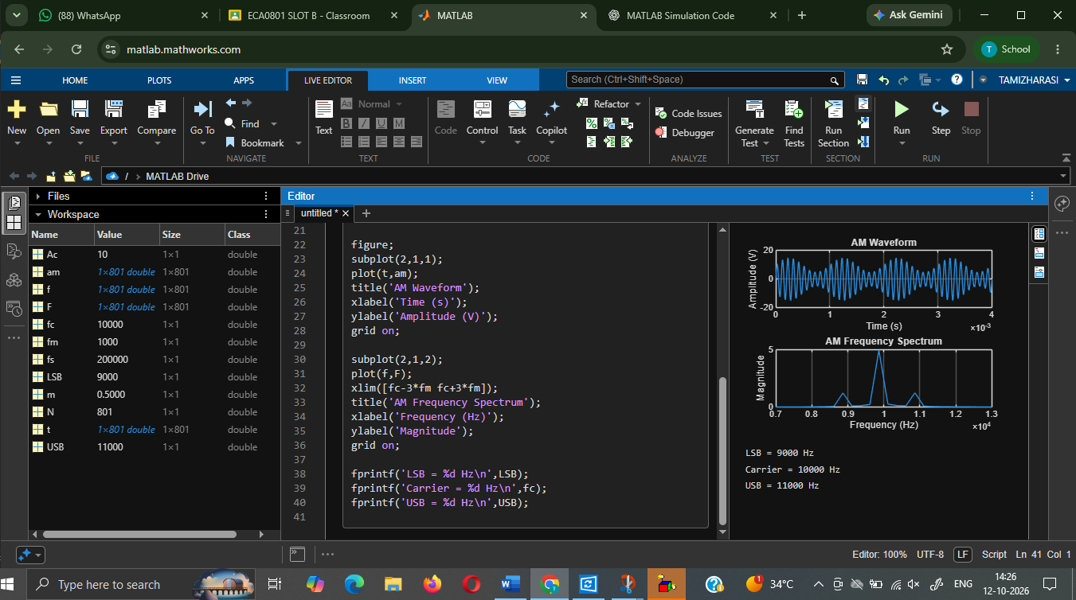

- For an AM signal with carrier amplitude 10V, load resistance 1Ω, and modulation index m=0.5, calculate the carrier power, USB power, LSB power and total transmitted power using MATLAB. Determine the transmission efficiency and compare the theoretical and simulated values.

Program code :

clc;
clear;
close all;

Ac = 10;
R = 1;
m = 0.5;

Pc = Ac^2/(2*R);
Pusb = (m^2*Pc)/4;
Plsb = (m^2*Pc)/4;
Pside = Pusb+Plsb;
Pt = Pc+Pside;
eff = (Pside/Pt)*100;

figure;
bar([Pc Pusb Plsb Pt]);
set(gca,'XTickLabel',{'Carrier','USB','LSB','Total'});
ylabel('Power (W)');
title('AM Power Distribution');
grid on;

fprintf('Carrier Power = %.3f W\n',Pc);
fprintf('USB Power = %.3f W\n',Pusb);
fprintf('LSB Power = %.3f W\n',Plsb);
fprintf('Total Sideband Power = %.3f W\n',Pside);
fprintf('Total Transmitted Power = %.3f W\n',Pt);
fprintf('Transmission Efficiency = %.2f %%\n',eff);

OUTPUT :
