6. Thermal Curtain:

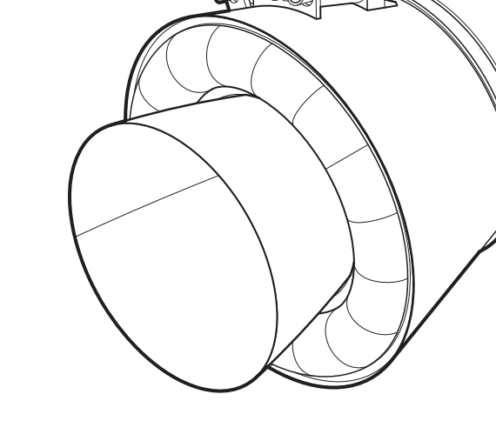

[Replaced by sketches made by sushant and suresh]

The solid rocket boosters rely on thermal curtains to play a crucial role in their operation. These curtains are specifically installed around the thrusters of the boosters. Referred to as Aft Skirt Thermal Curtains (ASTC), these thermal curtains are composed of a flexible, high-temperature material that combines cloth and insulation. Their primary purpose is to safeguard the hardware situated within the aft skirt of the shuttle's solid rocket booster [number1].

The existing ASTC comprises nine layers of insulating materials, measuring 2.58 inches in thickness. It is constructed in twenty-four individual segments, which are meticulously sewn together by hand during the installation process onto the aft skirt. The total weight of the current ASTC is estimated to be approximately six hundred pounds. [number1].

Possible challenges during modelling:

* From the diagram we can clearly see that the thermal curtains have the shape of a toroid which I think would be challenge to design.
* From the diagram we are not able to conclude the attachment design of the thermal curtain with the booster. So the modelling of that interface which joins the thrusters and the boosters with the curtains could be a challenge.
* The dimensions of the torus-shaped-curtains could be a challenge as it may change according to the aesthetics of the final product.

10. Crew Compartment:

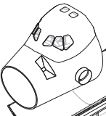

[Replaced by sketches made by sushant and suresh]

The crew compartment module, situated at the front of the orbiter, is a pressurized space divided into three sections for working, living, and storage purposes. It consists of the flight deck, the middeck/equipment bay, and an airlock. To facilitate docking, Spacelab operations, and extravehicular activities, a docking module and transfer tunnel with an adapter can be attached to the aft bulkhead of the crew module in the payload bay [number2].

The crew module is designed with two levels. The forward flight deck accommodates the commander's seat on the left and the pilot's seat on the right. It is specifically used for piloting the orbiter and follows the typical pilot/copilot arrangement. Each seat is equipped with flight controls and enables emergency return by a single individual. The flight deck also incorporates displays that provide necessary assistance to the pilot and copilot [number2].

The middeck serves as a storage area and is equipped with provisions for four crew sleep stations. It also houses stowage compartments for items such as lithium hydroxide canisters, miscellaneous equipment, the waste management system, a personal hygiene station, and a work/dining table [number2].

The airlock is a component of the crew compartment module that allows access for extravehicular activities or spacewalks. It can be positioned in various locations: inside the Orbiter crew module within the middeck area attached to the aft bulkhead, outside the cabin also connected to the bulkhead, or on top of a tunnel adapter that connects the pressurized Spacehab module to the Orbiter cabin [number2].

Possible challenges during modelling:

* From the diagram we can clearly see that the curves and the 3D projections can easily provide lot of challenges.
* The modelling of the nose should be done carefully as the extrusion of it makes the final compartment look good and it is responsible for the orbiters aerodynamics.
* Looking at the diagram we can say that the windows in front of the flight deck can cause a problem while designing as it is not on some standard geometrical surface.

15. Maneuvering engines:

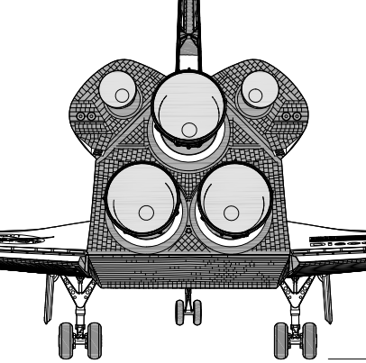

The orbit maneuvering engines provide the propulsive thrust to increase or decrease the velocity of the space shuttle orbiter while in earth’s orbit. These orbit maneuvering engines are controlled by OMS – Orbital Maneuvering System to perform orbital maneuvering when in the orbit or perform high intensive maneuvering in order to slide out of the orbit for re-entry into the earth’s atmosphere. These engines work like normal rocket engines but needs a different composition of the fuel since there is no oxygen in the space to burn the fuel.

Possible challenges during modelling:

* From the diagram given we can see that there could be challenge in modelling the curtain-like folds of the thrusters.
* The complexity of the engines are fully revealed only when we take a closer look inside the thrusters. The concentric frustums could be a challenge during modelling.
* Designing the attachment of the thrusters with the orbiter could be a challenge, because the shape of the bottom of the orbiter should be concise in way to contain the three main engines as well as the two maneuvering engines.

16. Body of the orbiter:

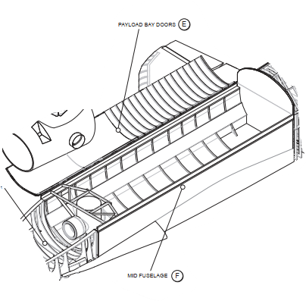

[Replaced by sketches made by sushant and suresh]

The mid fuselage of the Orbiter serves multiple functions beyond its role as the payload bay. It provides support for the payload bay doors, hinges, and tie-down fittings, as well as the forward wing glove and various components of the Orbiter system. Each payload bay door is equipped with four radiator panels, which can be tilted and unlatched when the doors are opened. This configuration allows for heat radiation from both sides of the panels, except for the four aft radiator panels that radiate heat from the upper side only. Some payloads are not directly attached to the Orbiter itself, but rather to specialized carriers that are secured to the Orbiter. These carriers can include the inertial upper stage, pressurized modules, or specially designed cradles to accommodate different types of payloads [number2].

Possible challenges during modelling:

* The modelling of the body of the orbiter can be quite a challenge as it is not as simple as it looks. The body is not a simple cylinder but a morphed-one with narrowed-face on the top and tapered-lateral-faces.
* The challenge may also occur while designing the wings which are extruded/ projected from the body of the orbiter as the extrusion will not be from a linear plane but a curved surface.
* We may also face a difficult challenge when we try to smooth out the interface between crew compartment and the mid fuselage. The same problem may occur with the main engines and mid fuselage interface.

For reference citations use these links corresponding to the in-text citations:

[number1] <https://ntrs.nasa.gov/citations/19940012650>

[number 2] <https://www.nasa.gov/returntoflight/system/system_Orbiter.html>