Name : Vincent Ang Jun Ying Tammie Tan Shu Fen

Group : IDEK

**Proposal/Report : Assignment 1 (Finite State Machine)**

Design 2 FSMs ( minimum 3 states) for game scene by circling states, conditions in written descriptive statements in space below. Draw the State Transition Diagram.

**FSM #1 (Cashier)**

**States**

Cashier **Buys** Supplies

Cashier **Greet** Customer (Probability Based)

: If Female "Mrs", "Mdm", "Ms"

: If Male "Mr", "Sir"

**Conditions**

Cashier BuysSupplies **Before Shop Opens**

Cashier Greet Customers When **Customer** **Enter Shop**

**State Transition Diagram**

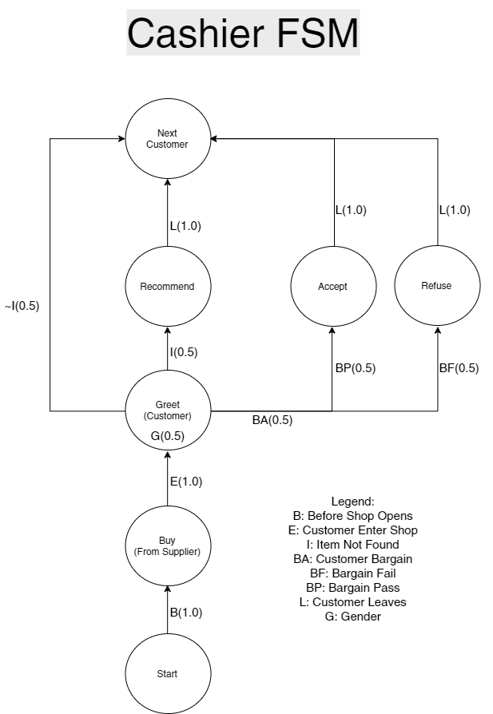

**FSM # 2 (Customer)**

**States**

Customer **Enter** Shop (Gender Probability Based)

: 50% Male

: 50% Female

Customer **Request** Item (Probability Based)

Customer **Leave** Shop

**Conditions**

Customer Enter Shop If **Shop Not Full**

Customer Request Item If **It's Their Turn**

Customer Leave Shop If They Are **Done Shopping** OR **Item Not Found**

**State Transition Diagram**

AI .png

**FSM #3 System**

**States**

Clock:

Clock **Starts**

Clock **Increases**

Clock **Stops**

Clock **Resets**

Day:

Day **Starts**

Day **Ends**

Day **Increases**

Currency:

**Lose** Money

**Gain** Money

Materials:

**Gain** Materials

**Lose** Materials

Supplier:

**Supply** Materials

**Conditions**

Clock:

Clock Starts When **Game Is Started**

Clock Increases If **Not Closing Time** (Increases by 5 each second)

Clock Stops When **Time Reaches 9 Hours**

Clock Resets At **Start Of A New Day**

Day:

Day Starts When **Game Is Started OR When Day Ends**

Day Ends When **Time Reaches 12**

Day Increases When **Day Ends**

Currency:

Lose Money When You **Buy Supplies**

Gain Money When You **Sell Items**

Materials:

Gain Materials When You **Buy Supplies**

Lose Materials When You **Sell Items**

Supplier:

Supply Materials When **Shop Is Still Closed**

**State Transition Diagram**

