INDEX

S. No. | Contents | Page No.
1 | Stage 1 – Create Employees Table | 2
2 | Stage 2 – Insert Employee Records | 3–4
3 | Stage 3 – SELECT Queries | 4–5
4 | Stage 4 – WHERE and Comparison Operators | 5–7
5 | Stage 5 – Logical Operators | 7–8
6 | Stage 6 – Special Operators | 8–10
7 | Stage 7 – ORDER BY | 10–12
8 | Stage 8 – Aggregate Functions | 12
9 | Stage 9 – GROUP BY | 13–14
10 | Stage 10 – HAVING | 14–15
11 | Stage 11 – Challenge Questions | 15–19
12 | Stage 12 – Verification | 19–20

DATABASE SETUP:
CREATE DATABASE JYO;
USE JYO;
# This database is created to perform employee data analysis using different SQL concepts such as constraints, filtering, sorting, aggregate functions, grouping, HAVING clauses.
Stage 1: Create the Employees Table
Query 1: CREATE TABLE employees (
emp_id INT PRIMARY KEY,
emp_name VARCHAR(100) NOT NULL,
email VARCHAR(100) NOT NULL UNIQUE,
department VARCHAR(50) NOT NULL,
job_role VARCHAR(50) NOT NULL,
salary DECIMAL(10,2) CHECK (salary>0),
age INT CHECK(age>=18),
city VARCHAR(50) DEFAULT 'Vijayawada'
);
Query 2: DESC employees;
Output:
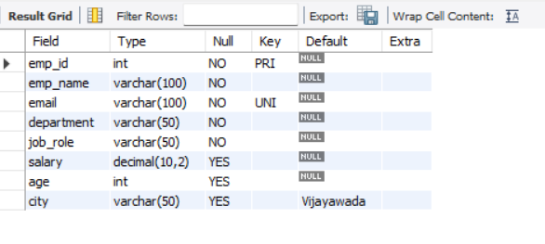
Stage 2: Insert Employee Data
# To insert 20 realistic employee records with different departments, cities, salaries, ages, and job roles. Use all 20 records in a single section.
INSERT INTO employees (emp_id, emp_name, email, department, job_role, salary, age, city) VALUES
(101, 'Rahul Sharma', 'rahul.sharma@gmail.com', 'IT', 'Software Developer', 60000, 24, 'Hyderabad'),
(102, 'Priya Reddy', 'priya.reddy@gmail.com', 'HR', 'HR Executive', 45000, 26, 'Vijayawada'),
(103, 'Arjun Kumar', 'arjun.kumar@gmail.com', 'Finance', 'Financial Analyst', 55000, 28, 'Bangalore'),
(104, 'Sneha Patel', 'sneha.patel@gmail.com', 'Marketing', 'Marketing Executive', 50000, 25, 'Chennai'),
(105, 'Vikram Singh', 'vikram.singh@gmail.com', 'Sales', 'Sales Executive', 45000, 27, 'Hyderabad'),
(106, 'Anjali Verma', 'anjali.verma@gmail.com', 'IT', 'Software Tester', 55000, 23, 'Pune'),
(107, 'Karthik Rao', 'karthik.rao@gmail.com', 'Finance', 'Accountant', 50000, 30, 'Vijayawada'),
(108, 'Divya Nair', 'divya.nair@gmail.com', 'HR', 'Recruiter', 45000, 29, 'Bangalore'),
(109, 'Rohan Mehta', 'rohan.mehta@gmail.com', 'Marketing', 'Content Strategist', 60000, 26, 'Chennai'),
(110, 'Meera Iyer', 'meera.iyer@gmail.com', 'Sales', 'Business Development Executive', 55000, 24, 'Pune'),
(111, 'Suresh Babu', 'suresh.babu@gmail.com', 'IT', 'Data Analyst', 65000, 31, 'Hyderabad'),
(112, 'Kavya Singh', 'kavya.singh@gmail.com', 'HR', 'HR Manager', 70000, 35, 'Vijayawada'),
(113, 'Aman Gupta', 'aman.gupta@gmail.com', 'Finance', 'Senior Accountant', 65000, 33, 'Bangalore'),
(114, 'Pooja Das', 'pooja.das@gmail.com', 'Marketing', 'SEO Specialist', 50000, 27, 'Chennai'),
(115, 'Naveen Kumar', 'naveen.kumar@gmail.com', 'Sales', 'Sales Manager', 70000, 34, 'Pune'),
(116, 'Lakshmi Devi', 'lakshmi.devi@gmail.com', 'IT', 'Project Manager', 80000, 36, 'Hyderabad'),
(117, 'Manoj Reddy', 'manoj.reddy@gmail.com', 'Finance', 'Finance Manager', 80000, 38, 'Vijayawada'),
(118, 'Swathi Krishna', 'swathi.krishna@gmail.com', 'Marketing', 'Graphic Designer', 55000, 25, 'Bangalore'),
(119, 'Ajay Varma', 'ajay.varma@gmail.com', 'Sales', 'Sales Associate', 40000, 22, 'Chennai'),
(120, 'Neha Joshi', 'neha.joshi@gmail.com', 'IT', 'UI UX Designer', 60000, 28, NULL);
Stage 3: SELECT Queries
Query 1: Display all employee records
# This query is used to display all the details of employees from the employees table.
SELECT *FROM employees;
Output:
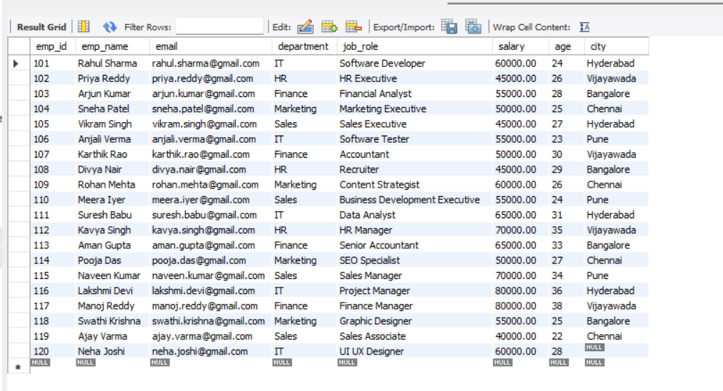
Query 2: Display specific columns: Employee Name, Department, Salary, and City
# This query is used to display only the required details of employees.
# Here, we are displaying employee name, department, salary, and city.

SELECT emp_name, department, salary, city FROM employees;
Output :
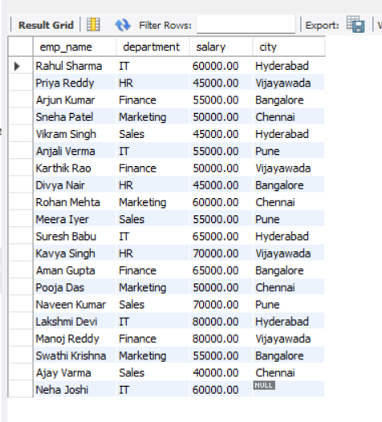
- Retrieve employees based on specific conditions
# This query is used to find employees who are working in the IT department and whose salary is greater than 50000.
# The AND operator is used because both conditions should be satisfied.

SELECT * FROM employees WHERE department = 'IT' AND salary > 50000;
Output:
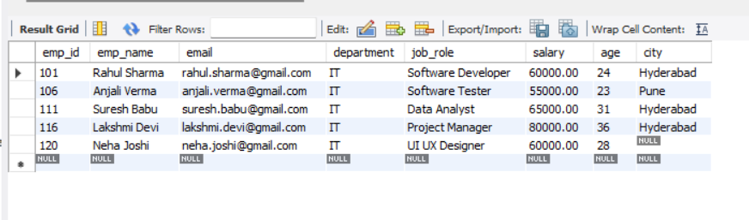
Stage 4: WHERE and Comparison Operators
1)EQUAL to (=) : Display employees whose salary is exactly 65000.
# The equal to operator is used to find employees whose salary exactly matches the given value.
SELECT * FROM employees WHERE salary = 65000;
Output :
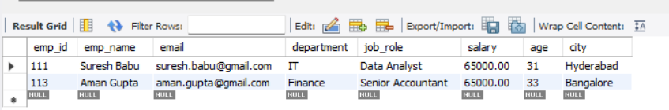
2. Greater than( >) : Display employees earning more than 60000.
# The greater than operator is used to find values that are higher than the given value.
SELECT * FROM employees WHERE salary > 60000;
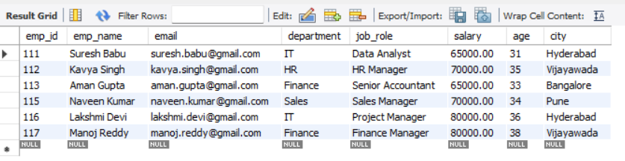
3.Less than (<) : Display employees whose age is below 25.
# The less than operator is used to find values that are lower than the given value.
SELECT * FROM employees WHERE age < 25;
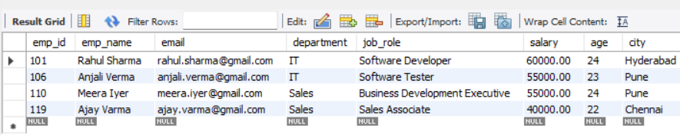
4.Greater than or Equal to (>= ) : Display employees earning greater than or equal to 80000.
# The greater than or equal to operator is used to find values that are either greater than or exactly equal to the given value.
SELECT * FROM employees WHERE salary >= 80000;
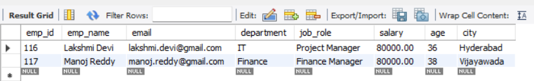
- Less than or Equal to (<= ): Display employees whose age is less than or equal to 30.
# The less than or equal to operator is used to find values that are either smaller than or exactly equal to the given value.
SELECT * FROM employees WHERE age <= 30;
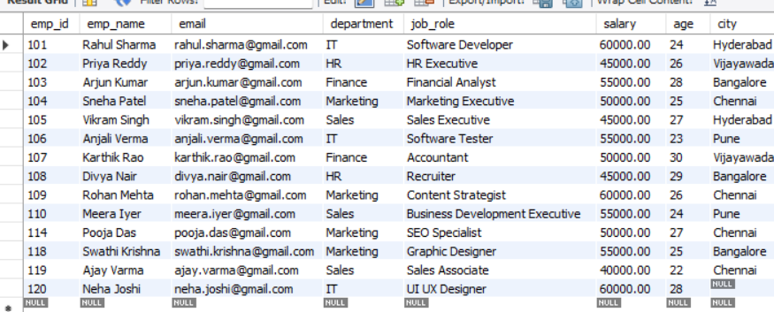

6. Not Equal to (<> & !=): Display employees whose department is not HR.
# The not equal operator is used to exclude a particular value. Here, I am displaying employees who are not working in the HR department.
# Both != and <> can be used for not equal in SQL.
SELECT * FROM employees WHERE department != 'HR';
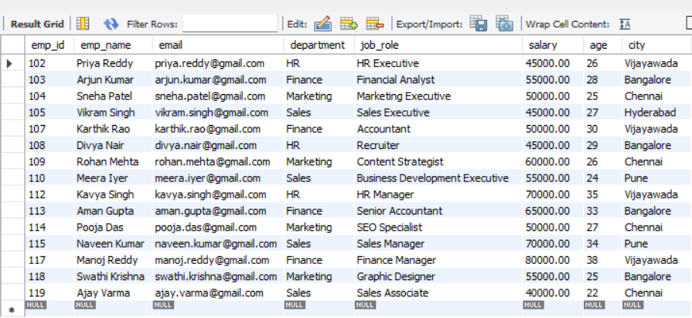
# In this stage, I learned how to use the WHERE clause with different comparison operators to filter employee records. These operators help me retrieve records based on conditions such as equal to, greater than, less than, and not equal to.
Stage 5: Logical Operators
1. AND Operator : Find employees from the IT department AND earning above 60,000.
# The AND operator is used when both conditions should be true. I am finding employees who are from the IT department
SELECT * FROM employees WHERE department = 'IT' AND salary > 60000;
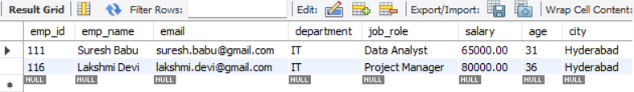
2. OR Operator : Find employees who belong to either the IT department OR HR department.
# The OR operator is used when at least one of the given conditions should be true
SELECT * FROM employees WHERE department = 'IT' OR department = 'HR';
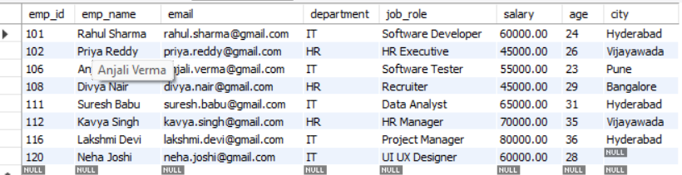
- NOT Operator : Find employees who are NOT from the IT department.
# The NOT operator is used to exclude records that satisfy a condition.
SELECT * FROM employees WHERE NOT department = 'IT';
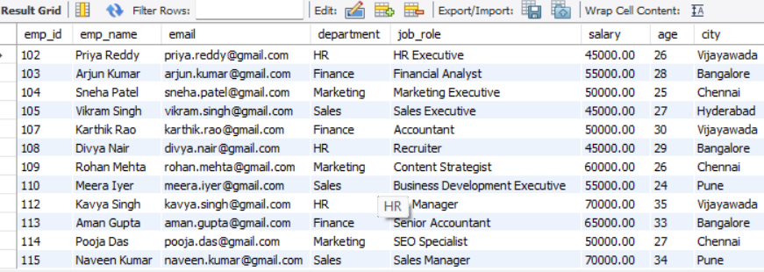
Stage 6: Special Operators
- BETWEEN : Find employees whose salary is between 60,000 and 65,000.
# BETWEEN is used to find values within a specific range.
SELECT * FROM employees WHERE salary BETWEEN 60000 AND 65000;
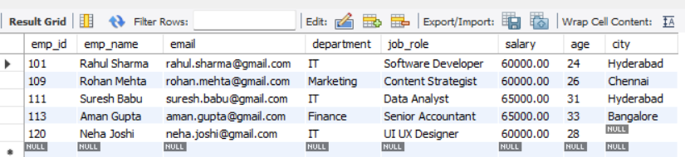
- IN : Find employees belonging to selected departments such as Hyd,Vij,Banglore.
# IN is used to check for multiple selected values.
SELECT * FROM employees WHERE city IN ('Hyderabad', 'Vijayawada', 'Bangalore');
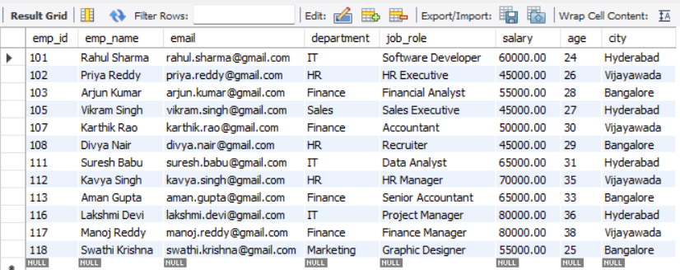
- NOT IN : Find employees who are not from IT or HR departments.
# NOT IN is used to exclude multiple values from the result.

SELECT * FROM employees WHERE department NOT IN ('IT', 'HR');
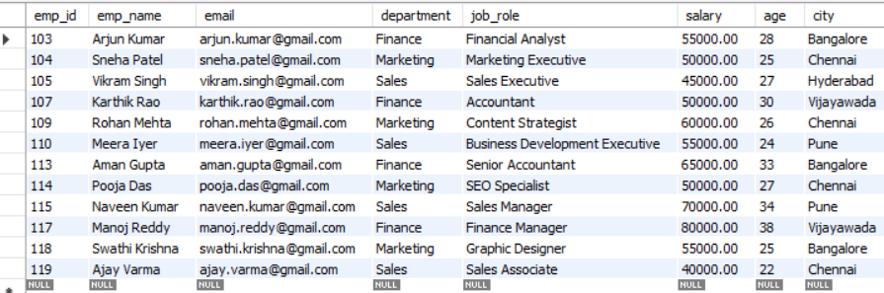
4. LIKE : LIKE is used to search for patterns.
Employee names starting with 'A'
# LIKE is used to search for a particular pattern in text, such as employee names starting with a specific letter.
SELECT *FROM employees WHERE emp_name LIKE 'A%';
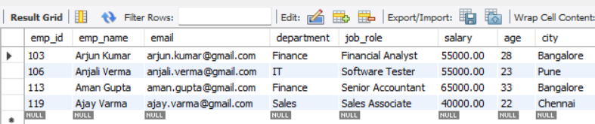
- IS NULL : Find employees whose city value is NULL.
# IS NULL is used to find records where a value is missing,
SELECT * FROM employees WHERE city IS NULL;
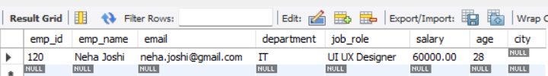
- IS NOT NULL : Find employees whose city information is available.
# while IS NOT NULL is used to find records where a value is available
SELECT * FROM employees WHERE city IS NOT NULL;
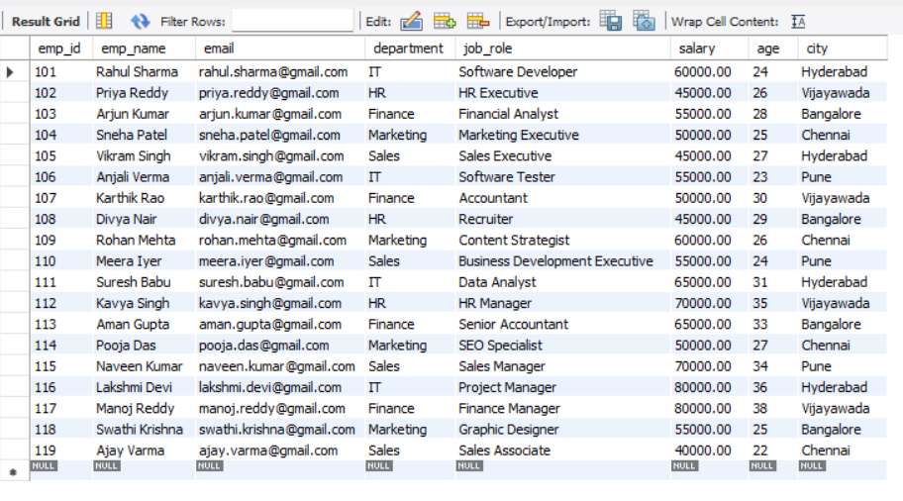
# In this stage, I learned how to use special operators in SQL , to filter records in different ways.
# These operators make it easier to search and filter the required employee records from the table.
Stage 7: ORDER BY
ORDER BY is used to sort records in ascending or descending order.
- Sort employees by salary in ascending order
# ASC is used to sort the records from smaller to larger values -- or in alphabetical order.
SELECT * FROM employees ORDER BY salary ASC;
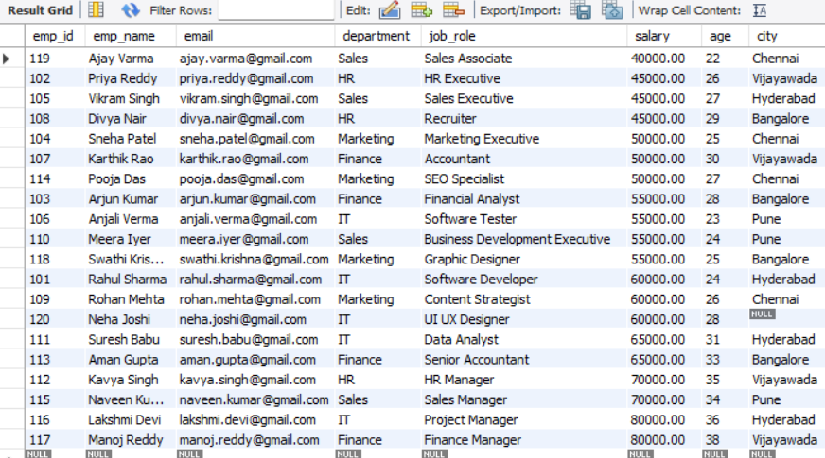
- Sort employees by salary in descending order
# DESC is used to sort the records from larger to smaller values -- or in reverse alphabetical order
SELECT * FROM employees ORDER BY salary DESC;
3. Sort employees by age in descending order
SELECT * FROM employees ORDER BY age DESC;
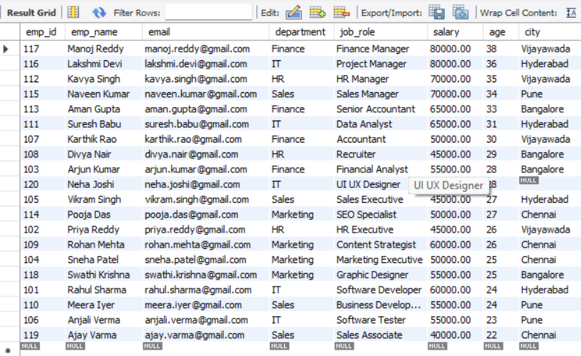
4. Sort employees by department
SELECT * FROM employees ORDER BY department ASC;
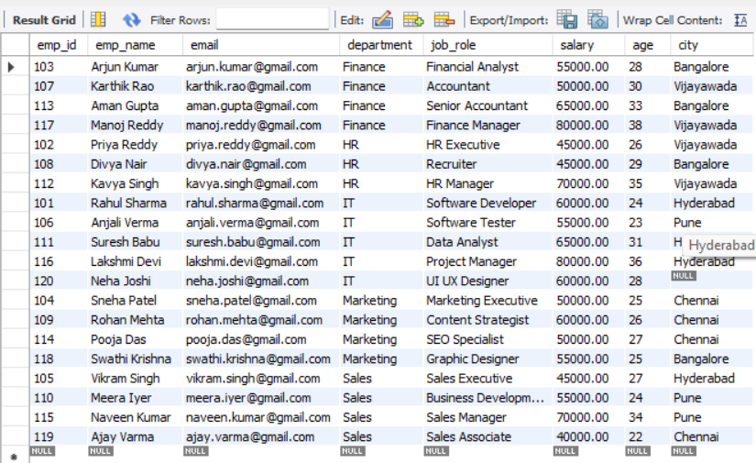
** Sort employees by multiple columns
For example, first sort by department in ascending order, then employees with the same department by salary in descending order.
SELECT * FROM employees ORDER BY department ASC, salary DESC;
# In this stage, I learned how to use the ORDER BY clause to arrange employee records in a particular order. I also learned that ORDER BY can be used with different columns such as salary, age, and department. We can also sort using multiple columns.

Stage 8: Aggregate Functions
Aggregate functions perform calculations on multiple rows and return a single result.
- COUNT() – Total Number of Employees
# This counts all employee records in the table.
SELECT COUNT(*) AS total_employees FROM employees;
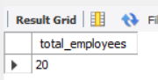

- SUM() – Total Salary Paid
# This calculates the total of all employee salaries.
SELECT SUM(salary) AS total_salary FROM employees;
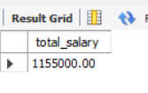
- AVG() – Average Salary
# This calculates the average salary of all employees.
SELECT AVG(salary) AS average_salary FROM employees;
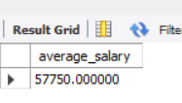
- MIN() – Lowest Salary
# This finds the lowest salary in the table.
SELECT MIN(salary) AS minimum_salary FROM employees;
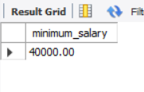
- MAX() – Highest Salary
# This finds the highest salary in the table.
SELECT MAX(salary) AS maximum_salary FROM employees;

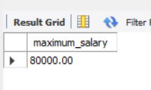
Stage 9: GROUP BY
# GROUP BY is used to group rows that have the same value in a particular column. Then aggregate functions like COUNT(), AVG(), MIN(), MAX(), and SUM() can be applied to each group.
Department-wise analysis:
- Count employees in each department.
- Calculate average salary for each department.
- Find minimum salary in each department.
- Find maximum salary in each department.
- Calculate total salary by department.
SELECT department,
COUNT(*) AS total_employees,
AVG(salary) AS average_salary,
MIN(salary) AS minimum_salary,
MAX(salary) AS maximum_salary,
SUM(salary) AS total_salary
FROM employees GROUP BY department;
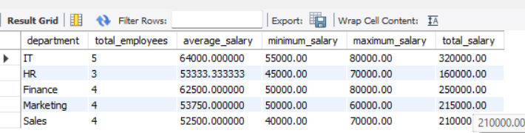
City-wise Analysis
- Count employees in each city
# GROUP BY will also show employees whose city is NULL as a separate group.
SELECT city, COUNT(*) AS total_employees FROM employees GROUP BY city;
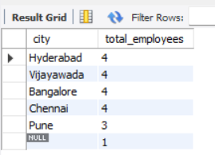
2. Calculate average salary by city
SELECT city, AVG(salary) AS average_salary FROM employees GROUP BY city;
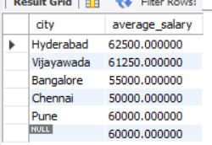

3. Find maximum salary by city
SELECT city, MAX(salary) AS maximum_salary FROM employees GROUP BY city;
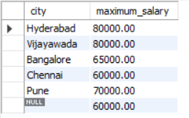
Stage 10: HAVING
# HAVING is used to filter grouped results, usually after using GROUP BY.
1. Find departments having more than a specified number of employees
SELECT department, COUNT(*) AS total_employees
FROM employees GROUP BY department HAVING COUNT(*) > 3;
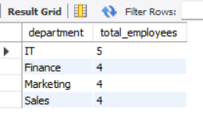
2. Find departments with an average salary above a specified amount
SELECT department, AVG(salary) AS average_salary
FROM employees GROUP BY department HAVING AVG(salary) > 55000;
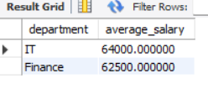
3. Find cities having more than a specified number of employees
SELECT city, COUNT(*) AS total_employees FROM employees GROUP BY city HAVING COUNT(*) > 2; 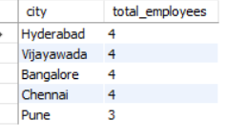
4. Find departments where the maximum salary is above a specified amount
SELECT department, MAX(salary) AS maximum_salary
FROM employees GROUP BY department HAVING MAX(salary) > 70000;
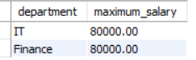
Stage 11: Challenge Questions
- Find the second-highest salary
# This query first finds the highest salary. Then it finds the maximum salary that is less than the highest salary.
SELECT MAX(salary) AS second_highest_salary
FROM employees WHERE salary < (
SELECT MAX(salary) FROM employees);
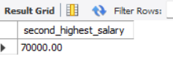
- Find employees earning above the average salary
# The subquery calculates the average salary of all employees. Then ,the main query compares each employee's salary with the average.
SELECT *
FROM employees WHERE salary > (
SELECT AVG(salary) FROM employees);
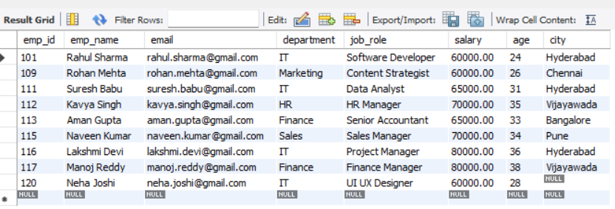
- Find the employee(s) with the highest salary
# The subquery finds the highest salary using MAX(). The main query finds the employees whose salary having highest salary.
SELECT * FROM employees WHERE salary = (SELECT MAX(salary) FROM employees);
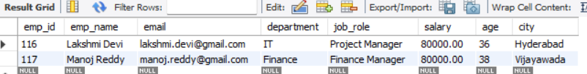
- Find the employee(s) with the lowest salary
# The subquery finds the lowest salary using MIN(). -- The main query finds the employees whose salary is lowest.
SELECT * FROM employees WHERE salary = (
SELECT MIN(salary) FROM employees);
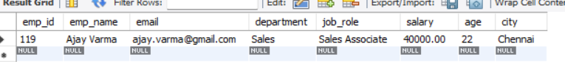
- Find the department with the highest average salary
# First, the query calculates the average salary for each department. Then the departments are arranged from highest average salary to lowest. LIMIT 1 displays the department with the highest average salary.
SELECT department, AVG(salary) AS average_salary
FROM employees GROUP BY department
ORDER BY average_salary DESC
LIMIT 1;
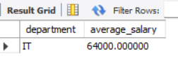
- Find the department with the highest number of employees
# COUNT() is used to find the number of employees in each department. The departments are then sorted from highest count to lowest count.
SELECT department, COUNT(*) AS total_employees
FROM employees GROUP BY department
ORDER BY total_employees DESC
LIMIT 1;
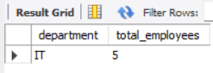
7. Find employees who earn more than the average salary of their department
SELECT * FROM employees e WHERE salary > (
SELECT AVG(salary) FROM employees
WHERE department = e.department
);
# It checks that employees department.
# Calculates the average salary of that department.
# Displays the employee only if their salary is greater than that average.
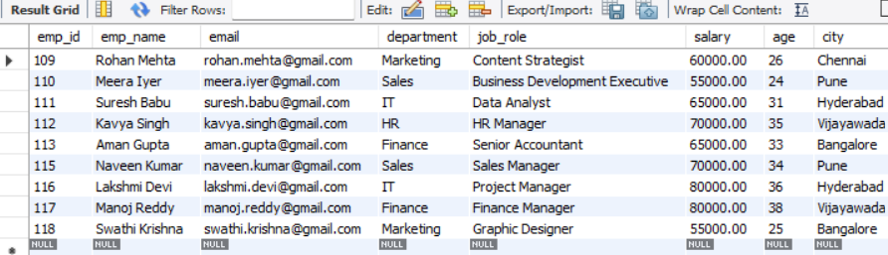

8. Find the second-highest salary in each department

# The inner query finds highest salary in that department.

# WHERE salary < highest salary removes the highest salary.

# MAX(salary) finds the highest remaining salary.GROUP BY department gives the result for each department.
SELECT department, MAX(salary) AS second_highest_salary
FROM employees e1
WHERE salary < (
SELECT MAX(salary) FROM employees e2 WHERE e2.department = e1.department)
GROUP BY department;

Or

# DENSE_RANK() is useful because if multiple employees have the same salary, they receive the same rank.

SELECT department, salary AS second_highest_salary
FROM (
SELECT department,salary,
DENSE_RANK() OVER (
PARTITION BY department ORDER BY salary DESC
) AS salary_rank
FROM employees) AS ranked_salaries
WHERE salary_rank = 2;
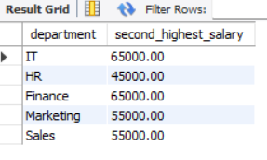

9. Find cities with the highest number of employees
# First, the inner query counts the employees in each city. The outer query finds the highest employee count.HAVING is used to display the city or cities that have this highest number of employees.

SELECT city, COUNT(*) AS total_employees
FROM employees GROUP BY city
HAVING COUNT(*) = (
SELECT MAX(employee_count)
FROM (
SELECT COUNT(*) AS employee_count
FROM employees
GROUP BY city
) AS city_counts);
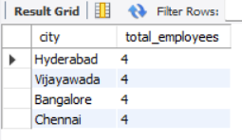
10. Find departments where the total salary is greater than a specified amount
# SUM() calculates the total salary for each department. GROUP BY is used to calculate the total separately for each department. HAVING filters the departments based on their total salary.

SELECT department, SUM(salary) AS total_salary
FROM employees GROUP BY department
HAVING SUM(salary) > 250000;
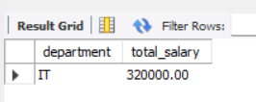

Stage 12: Final Deliverables
To Verify

Query 1: Verify Table Structure
DESC employees;

Query 2:By Display all employee records

SELECT * FROM employees;

Query 3: Verify Total Employees
SELECT COUNT(*) AS total_employees FROM employees;

