Bhola - Barishal - Khulna Gas Pipeline
Screening optimisation of pipe diameter (route via Laharhat, 173 km)
Screening study prepared 2026-11-05. 316 design options evaluated. Placeholder India 2026 unit rates used as a regional proxy; a calibration against GTCL's Tk 4,500 crore budget implies capital rates x3.77 (the optimum does not change). AACE Class 5 (placeholder rates)

1 Summary
- Lowest lifecycle cost: 24" X65 at 68.95 barg MAOP, 83.2 US$ M present value.
- CAPEX 73.6 US$ M; lifecycle cost split 68.7 PV CAPEX and 14.5 PV OPEX.
- Tariff for a 12% post-tax return: 0.224 US$/MMBtu.
- Compression or pumping first needed in operating year 10; peak station power 2.83 MW.
- The 30" option costs 97.2 US$ M, 16.8 % more than the optimum.
- Under cost and throughput uncertainty, 24" X65 @ 68.9 barg is cheapest in 75% of Monte Carlo samples.
- Across 11 sensitivity cases the optimum is 20" X70 @ 1000 psig or 24" X65 @ 1000 psig or 26" X70 @ 1000 psig.

2 Scope and method
- Pressure design to ASME B31.8 (gas) or B31.4 (liquids) with OISD / PNGRB T4S design factors, a D/t <= 96 handling limit and walls rounded up to a 0.1 mm mill step, per location class.
- Location classes from building density per ASME B31.8 840.2 (as adopted by PNGRB T4S / OISD-STD-226) where applicable.
- Buried-pipe checks per the American Lifelines Alliance Guidelines for the Design of Buried Steel Pipe where soil data was given; concrete weight coating sized for buoyancy on wet lengths.
- Steady-state hydraulics for every operating year; compressor or pump stations sited and phased in when first needed; energy from average flow, station sizing from peak flow.
- CAPEX from a bill of quantities and unit rates with taxes, engineering, owner's costs and contingency; OPEX from energy, O&M, manpower, in-line inspection and insurance.
- Lifecycle cost = present value of CAPEX + OPEX - residual value over the concession, in real terms with end-of-year discounting; tariff = constant charge for the target post-tax return.

3 Inputs and assumptions
Input | Value
Throughput | 180 MMSCFD for 19 years (client note; TBS / GTCL)
Route | Bhola junction - Laharhat - Barishal (63 km) - Jhalokathi - Pirojpur - Bagerhat - Khulna (110 km)
Barishal offtake | 33% of flow at >= 25.0 barg
Khulna delivery | >= 40.0 barg
Supply pressure | 62.0 falling to 35.0 barg
MAOP options | 1000 psig / 1440 psig
Concession | BOO, 2 yr construction, 10% real discount rate
Remaining recoverable gas | 1.256 Tcf (Bapex via TBS): 19.1 yr at 180 MMSCFD, 13.2 yr if island use continues

- River HDD 6 km (leg 1) and 3 km (leg 2); wetland 40 % / 30 %; towns as Class 3 bands (all engineering assumptions, see case.yaml).
- Deltaic soft clay with the water table at the surface: ALA buried-pipe checks and concrete weight coating on wet lengths.
- Gas-turbine compressors; fuel gas valued at INR 25/scm.
- Note vs public GTCL proposal: 173 km (30") vs 205 km (24"/30"); the note's reserve figure in 'trillion' cubic feet should read billion cubic feet.

4 Results by pipe size
Best grade and MAOP for each size. Money in US$ M; lifecycle cost (LCC) is the present value of CAPEX plus OPEX over the concession.
NPS | Grade | MAOP barg | Wall mm (C1/C2/C3) | CAPEX US$ M | PV OPEX US$ M | LCC US$ M | Compression
16" | X60 | Not feasible: gas velocity above the limit
18" | X70 | 99.28 | 6.5 / 7.8 / 9.4 | 74.4 | 31.7 | 110.9 | 4 stn from yr 1
20" | X70 | 68.95 | 5.3 / 6.1 / 7.3 | 62.1 | 20.7 | 88.0 | 2 stn from yr 2
24" | X65 | 68.95 | 6.5 / 7.8 / 9.4 | 73.6 | 14.5 | 83.2 | 1 stn from yr 10
26" | X70 | 68.95 | 6.9 / 7.9 / 9.4 | 79.9 | 13.7 | 86.7 | 1 stn from yr 12
28" | X65 | 68.95 | 7.6 / 9.1 / 10.9 | 86.5 | 13.4 | 91.6 | 1 stn from yr 13
30" | X70 | 68.95 | 8 / 9.1 / 10.9 | 93.7 | 13.2 | 97.2 | 1 stn from yr 14
36" | X65 | 68.95 | 9.8 / 11.7 / 14.1 | 116.6 | 13.4 | 116.7 | 1 stn from yr 15

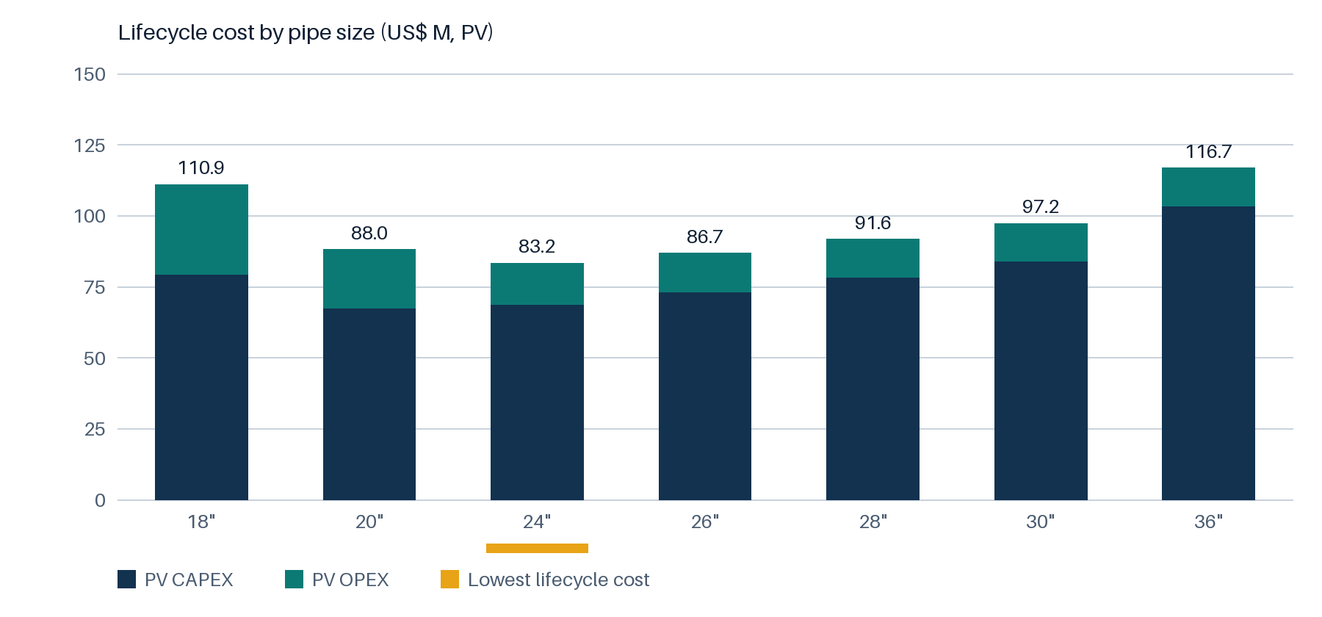
Bars: present value of CAPEX (navy) and OPEX (teal); amber marks the lowest lifecycle cost.

5 Recommended design for further study
24" API 5L X65 PSL2 at 68.95 barg MAOP. Walls Class 1-2: 6.5 mm, Class 2: 7.8 mm, Class 3: 9.4 mm (governed by hoop stress). Pipe 17,356 t. CAPEX 73.6 US$ M (AACE Class 5 (placeholder rates)). Tariff for the target return 0.224 US$/MMBtu; levelised cost 0.172 US$/MMBtu.
CAPEX group | US$ M
line pipe | 16.33
coating | 5.39
construction | 7.34
crossings | 5.94
facilities | 14.49
systems | 1.97
land | 1.55
Taxes | 9.26
Engineering / PMC | 3.60
Owner's costs | 1.06
Contingency | 6.69
Total CAPEX | 73.63
Line-item quantities and rates are in the accompanying workbook (CAPEX sheet).

6 Sensitivity
The design is re-optimised in each case.
Case | Best design | LCC US$ M | Compared LCC US$ M | Premium
Base (19 yr, 180 mmscfd) | 24" X65 @ 1000 psig | 83.2 | 97.2 | +16.8 %
Island local use continues: 13 yr | 24" X65 @ 1000 psig | 83.8 | 97.1 | +15.9 %
Upside reserves: 25 yr | 24" X65 @ 1000 psig | 82.3 | 97.0 | +17.9 %
Throughput 260 mmscfd | 26" X70 @ 1000 psig | 93.5 | 100.1 | +7.0 %
Discount rate 12 % | 24" X65 @ 1000 psig | 77.9 | 92.1 | +18.2 %
Supply holds at 62 barg | 20" X70 @ 1000 psig | 65.1 | 93.0 | +42.8 %
Supply falls to 25 barg | 24" X65 @ 1000 psig | 91.9 | 103.7 | +12.8 %
River HDD x2 | 24" X65 @ 1000 psig | 88.5 | 103.9 | +17.3 %
No Barishal offtake | 24" X65 @ 1000 psig | 82.7 | 93.8 | +13.4 %
HDD unit cost x5 | 24" X65 @ 1000 psig | 107.5 | 127.5 | +18.7 %
Capital rates x3.8 (calibrated to GTCL budget) | 24" X65 @ 1000 psig | 279.5 | 336.0 | +20.2 %

7 Risk (Monte Carlo)
Lifecycle cost percentiles under unit-rate and throughput uncertainty, with the share of samples in which each design is the cheapest.
Design | P10 US$ M | P50 US$ M | P90 US$ M | Cheapest | Infeasible
18" X70 @ 99.3 barg | 92.9 | 116.7 | infeasible | 0% | 25%
20" X70 @ 68.9 barg | 79.6 | 92.6 | 110.8 | 25% | 0%
24" X65 @ 68.9 barg | 82.5 | 88.1 | 94.4 | 75% | 0%
26" X70 @ 68.9 barg | 86.5 | 91.7 | 97.4 | 0% | 0%
28" X65 @ 68.9 barg | 91.3 | 96.7 | 102.5 | 0% | 0%
30" X70 @ 68.9 barg | 96.9 | 102.6 | 108.9 | 0% | 0%
36" X65 @ 68.9 barg | 115.9 | 123.0 | 131.0 | 0% | 0%
20,000 Monte Carlo samples. Throughput scenarios: low x0.8 (25%), base x1 (50%), high x1.2 (25%). Rate factors (triangular low-mode-high): line_pipe 0.85-1-1.3, construction 0.85-1-1.4, stations 0.85-1-1.3, other_capex 0.9-1-1.25, energy 0.7-1-1.5, o_and_m 0.9-1-1.2. Groups sampled independently; infeasible samples (e.g. velocity limit exceeded) count as the worst outcome.

8 Limitations and next steps
- Placeholder India 2026 unit rates used as a regional proxy; a calibration against GTCL's Tk 4,500 crore budget implies capital rates x3.77 (the optimum does not change).
- AACE Class 5 (placeholder rates)
- Converted at an assumed INR 88 per US$.
- Confirm design flow and its duration (grid transit, upside reserves) with Petrobangla / GTCL.
- Obtain the Bapex field pressure forecast; it sets when compression is needed.
- Survey river crossings (CEGIS / ILF erosion data) and select crossing methods.
- Replace placeholder rates with Bangladesh rates and re-run.
- Confirm offtake split and delivery pressures at Barishal and Khulna.

