**13_CSharp_Classes_Assignment-2_210125_Tamoghna_Choudhury**

We judge a person if he is outstanding or not by the achievement in his/her profession. A professor and a student have different criteria for being called outstanding.

Refer the class diagram snippet shown below and create the corresponding classes. Refer the business rules mentioned below and come up with a solution.

Professor is outstanding if he has published more than 4 books. Student is outstanding if his percentage is greater than 85.

The print() method of Professor displays the name and books published by professor. The display() method of Student displays the name and percentage of student.

In the application main method create 5 objects of Person type, this can be few Student Objects and remaining can be Professor Objects.

Every object has to be referred using Person reference (upcasting). To refer the objects use an array of Person.

Traverse through the Person array and display the person details only if the person is out-standing.

The name and percentage should be displayed if the person referred is a Student. If the Person referred is a Professor, display name and books published.

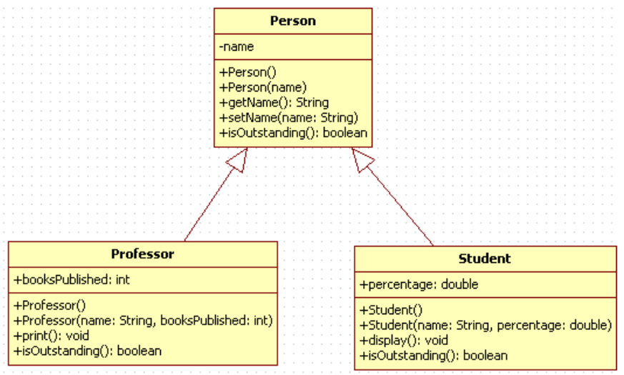

|  |  |
| --- | --- |
| **Solution** |  |