28_GIT_Assignment-1_613786_Pravin_Gupta

Do the Following Tasks

- Create a Git Account using http://www.github.com or http://172.18.2.18 (From VM)
Id:TamoghnaK
Password :Share@1144
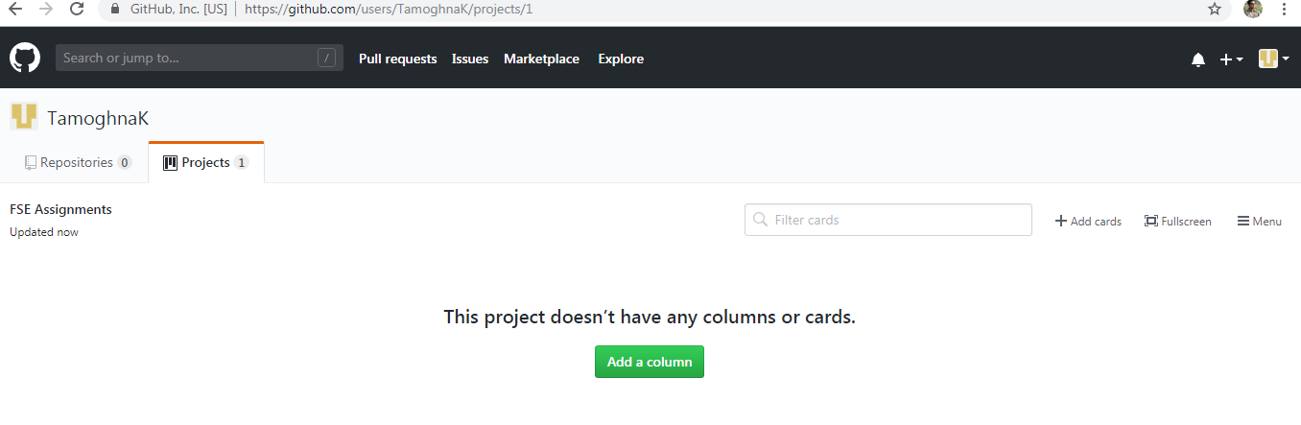

2. Practice following
A.Create your own GIR Repos (Public and Private)
B.Perform Operations on GIT Repos like commit, push, pull
C.Create branches and commit to master.

https://github.com/TamoghnaK/Assignment21
Assignment21=Public Repository.

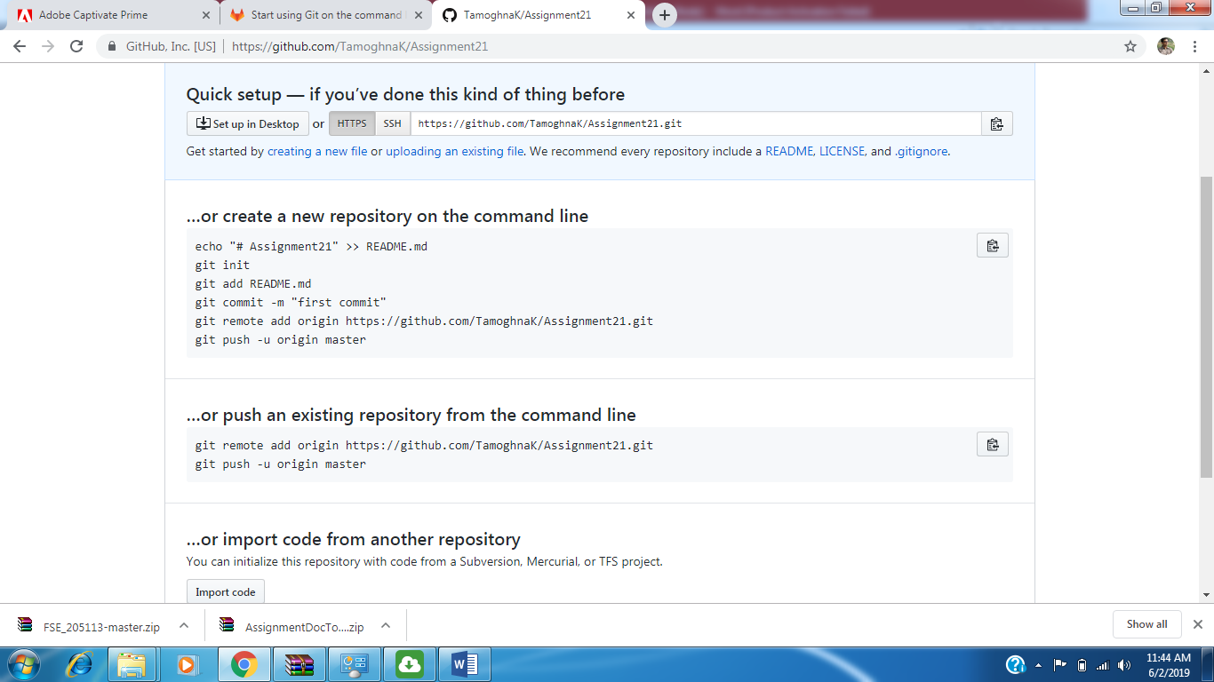

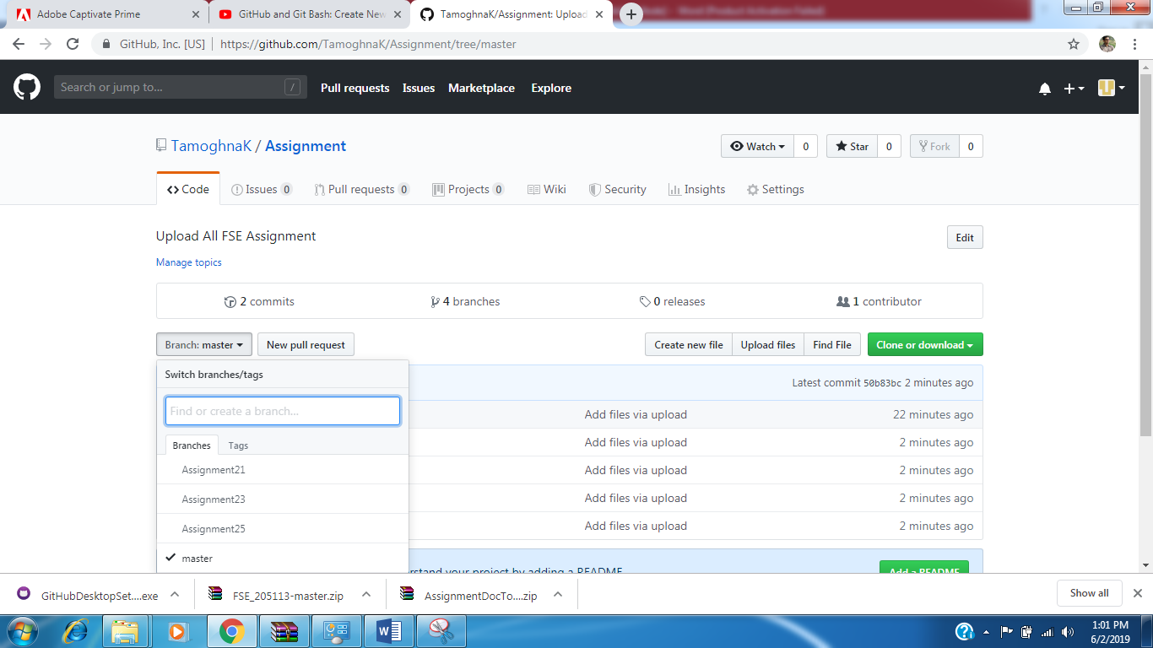

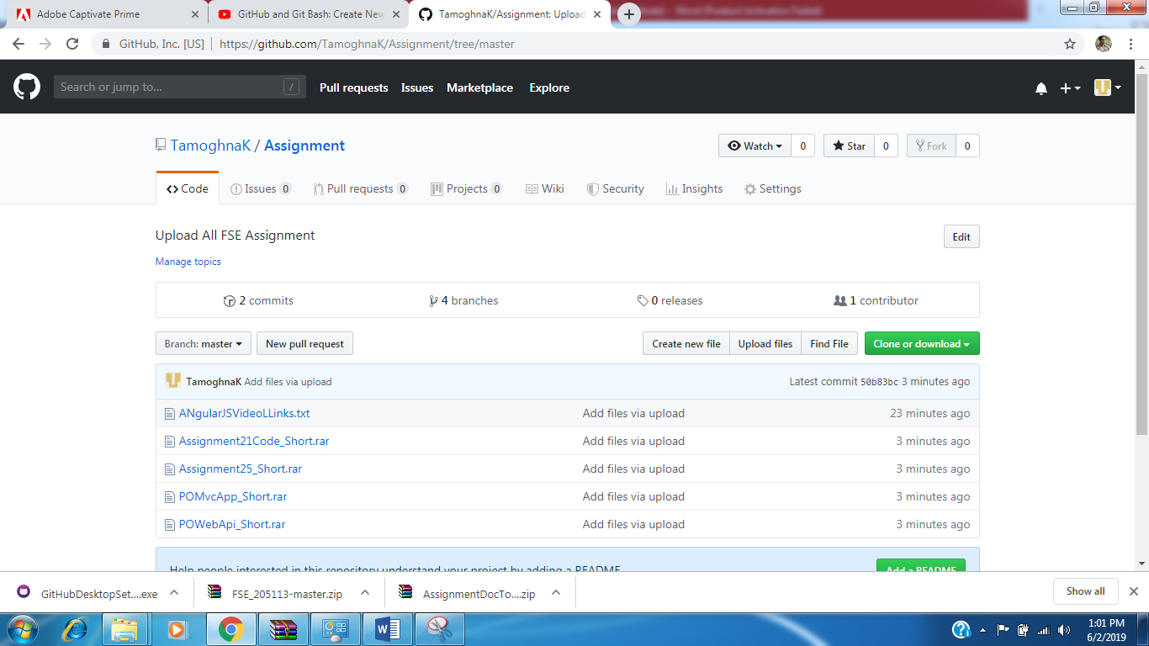

3. Upload Twitter_Clone Application from VS2017 or 2015 to GIT Repo, which you created in Assignment 25(Practice commit, Push and Pull tasks)

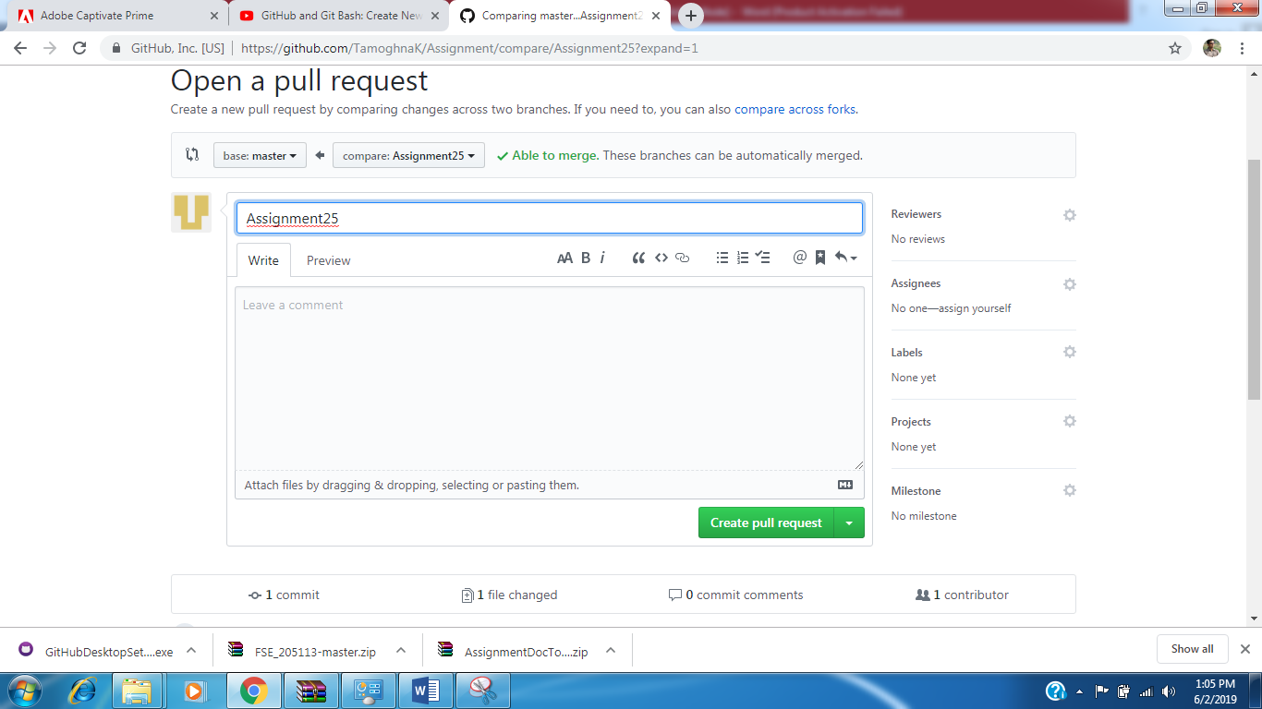

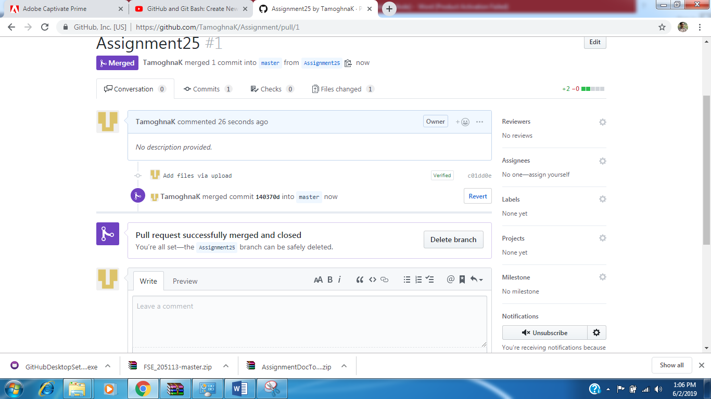
4.Upload WCF Service Application from VS2017 or 2015 to GIT Repo, which you created in Assignment 21(Practice commit, Push and Pull tasks)

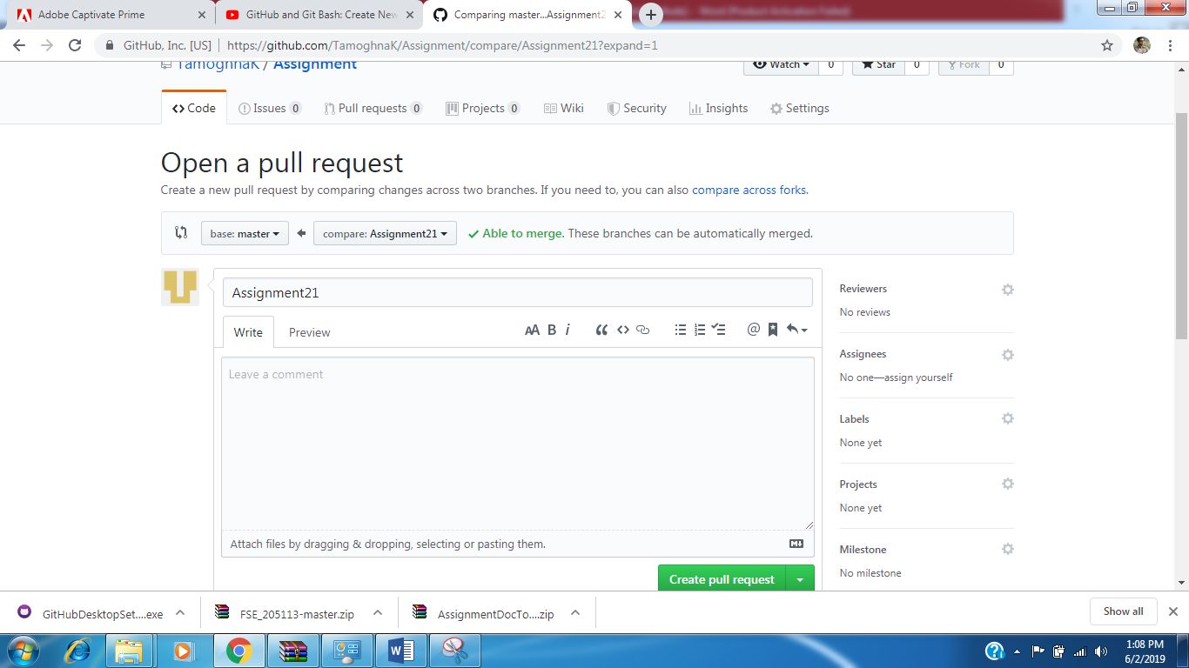
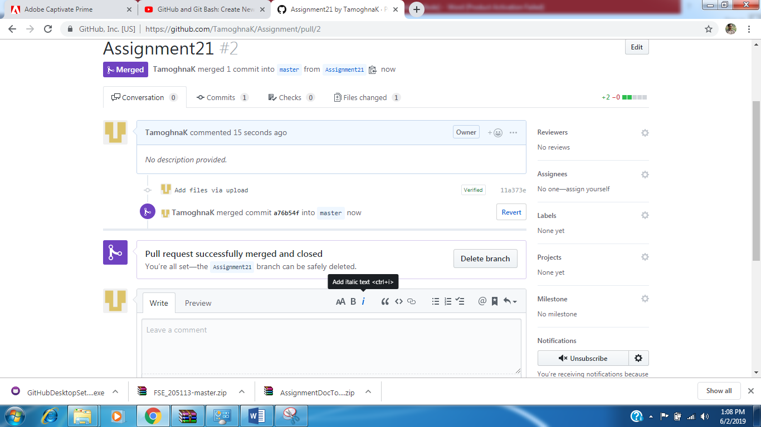

5. Upload POPS Application from VS2017 or 2015 to GIT Repo, which you created in Assignment 23(Practice commit, Push and Pull tasks)

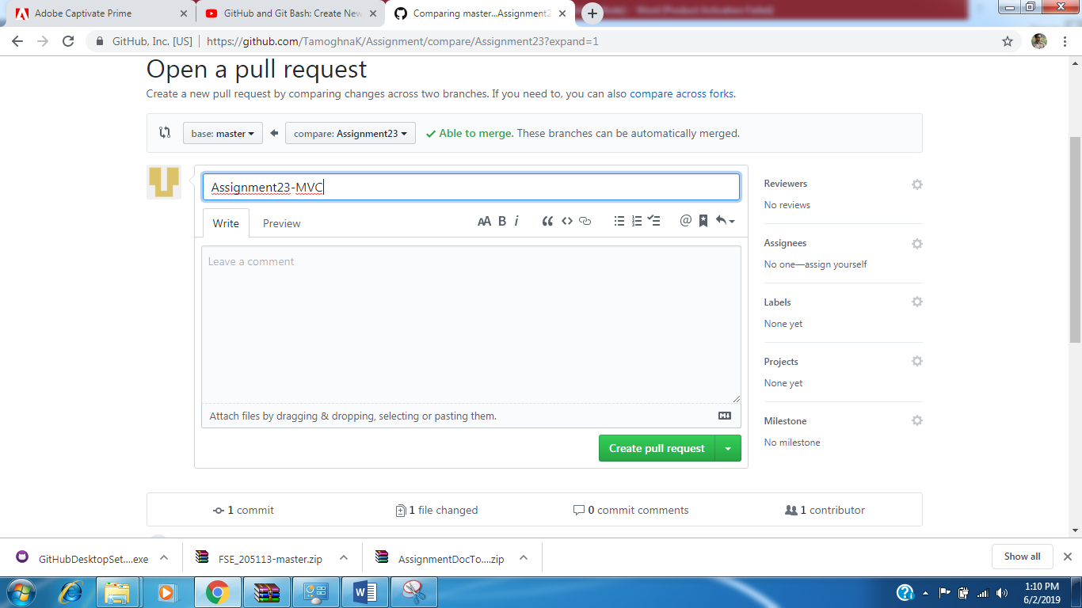

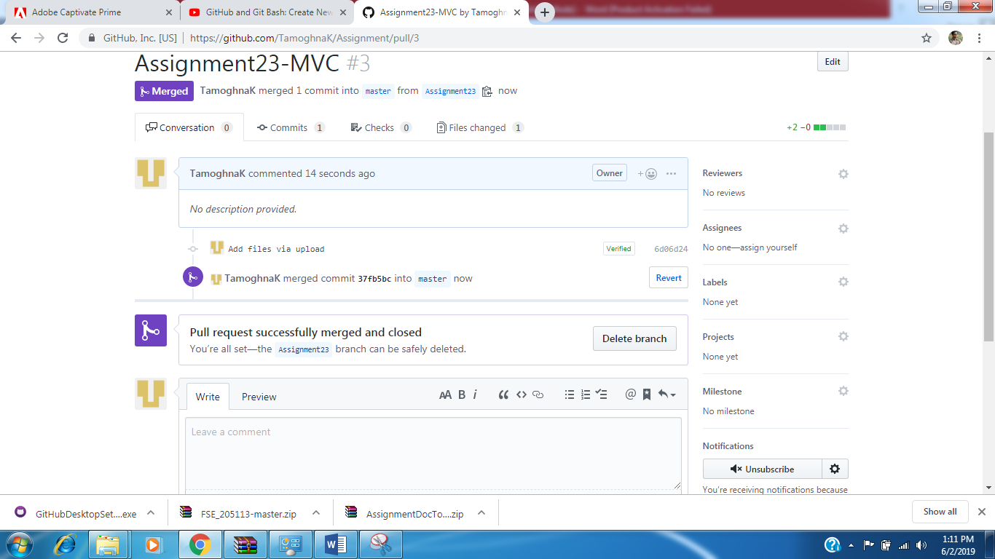

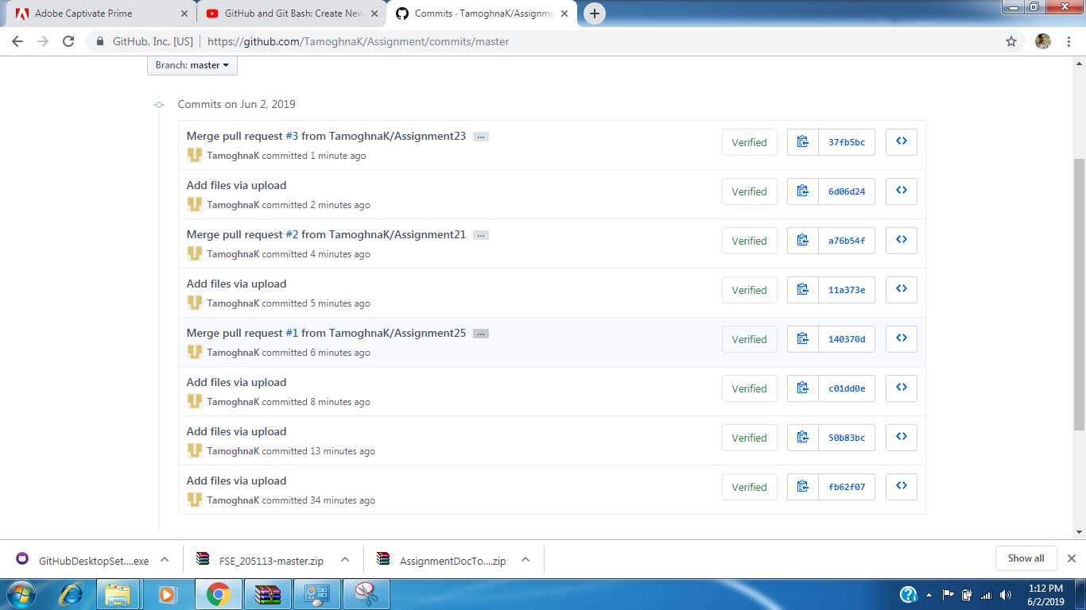

Note: Upload screen shots of each task to LMS as Output of this assignment

