27_DEPLOYMENT_Assignment-1_210125_Tamoghna_Choudhury

DO the following tasks
- Configure the IIS in your local machine
- To check IIS configuration, go to RUN and type inetmgr

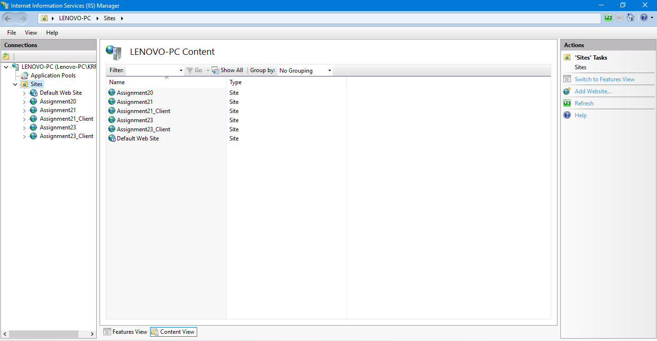

- Deployed the Twitter Clone Application which you crated in Assignment_20. After deployment application should run from IIS.

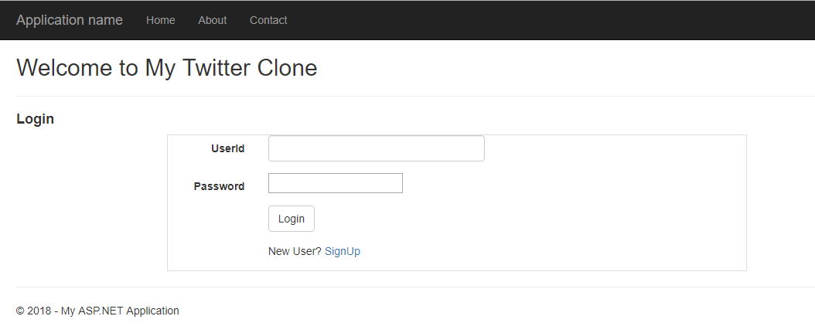

- Deployed the WCF Service Application which you created in Assignment_21 and consume to MVC client.MVC client also should run from IIS.

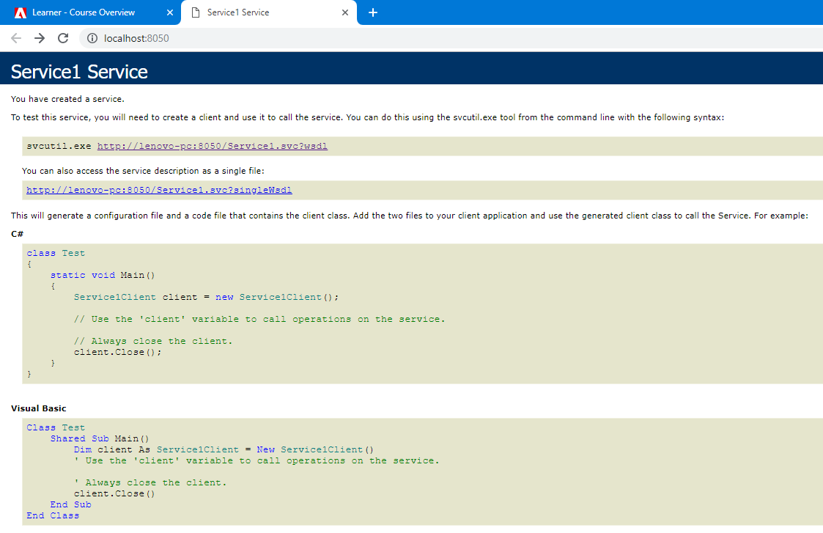

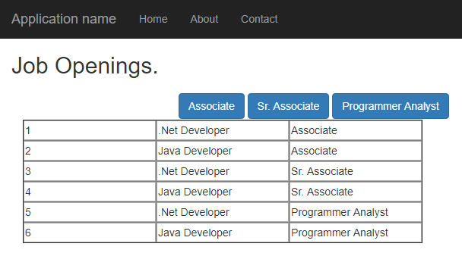

- Deployed the WEBAPI Service Application which you created in Assignment_23 (Make sure it should run from IIS after deployment) and consume to MVC client.MVC client also should run from IIS.

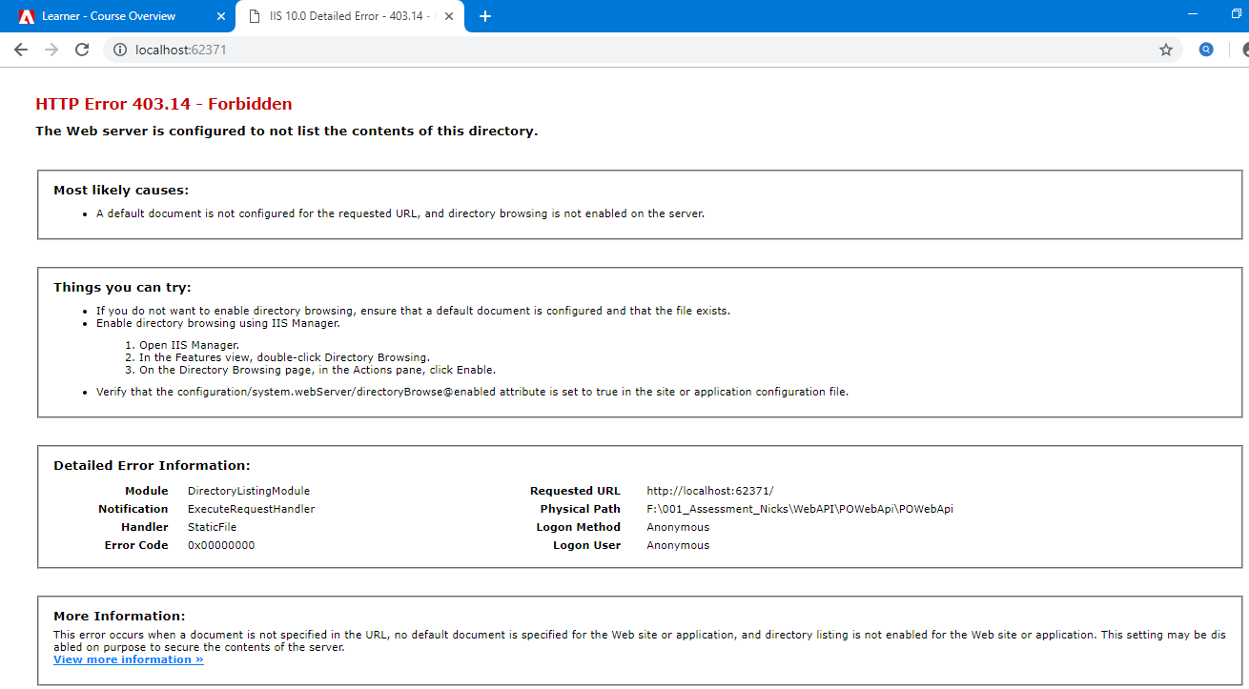

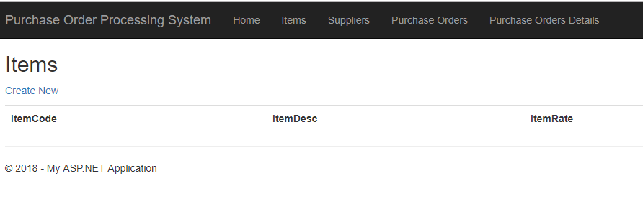

Note: Upload screen shots of each task to LMS as Output of this assignment

