15_SQL_Assignment1_613786_PravinGupta

1.Create the tables Customers and Orders with the following columns.
( do not declare the corresponding primary and foreign keys )
<<Answer>>
IF NOT EXISTS(SELECT 1 FROM SYS.OBJECTS WHERE TYPE = 'U' AND NAME = 'CUSTOMERS')
BEGIN
CREATE TABLE CUSTOMERS
(
CUSTOMERID CHAR(5) NOT NULL
, COMPANYNAME VARCHAR(40) NOT NULL
, CONTACTNAME CHAR(30) NULL
, CADDRESS VARCHAR(60) NULL
, CITY CHAR(15) NULL
, PHONE CHAR(24)
, FAX CHAR(24)
)
END

IF NOT EXISTS(SELECT 1 FROM SYS.OBJECTS WHERE TYPE = 'U' AND NAME = 'ORDERS')
BEGIN
CREATE TABLE ORDERS
(
ORDERID INTEGER NOT NULL
, CUSTOMERID CHAR(5) NOT NULL
, ORDERDATE DATETIME NULL
, SHIPPEDDATE DATETIME NULL
, FREIGHT MONEY NULL
, SHIPNAME VARCHAR(40) NULL
, SHIPADDRES VARCHAR(60) NULL
, QUANTITY INTEGER NULL
)
END

2. Using the ALTER TABLE statement, add a new column named shipregion to the Orders table.
The fields should be nullable and contain integers.
<<Answer>> ALTER TABLE ORDERS ADD SHIPREGION INT NULL

3. Using the ALTER TABLE statement, change the data type of the column shipregion from INTEGER to CHARACTER with length 8. The fields may contain null values.
<<Answer>> ALTER TABLE ORDERS ALTER COLUMN SHIPREGION CHAR(8) NULL

4. Delete the formerly created column shipregion.
<<Answer>> ALTER TABLE ORDERS DROP COLUMN SHIPREGION

5. Using the SQL Server Management Studio, try to insert a new row into the Orders table with the following values:
( 10, ‘ord01’, getdate(), getdate(), 100.0, ‘Windstar’, ‘Ocean’ ,1)
<<Answer>>
INSERT INTO ORDERS
(
ORDERID, CUSTOMERID
, ORDERDATE, SHIPPEDDATE, FREIGHT, SHIPNAME, SHIPADDRES, QUANTITY
)
VALUES
(10, 'ORD01', GETDATE(), GETDATE(), 100.0, 'Windstar', 'Ocean', 1)

6. Using the ALTER TABLE statement, add the current system date and time as the default value to the orderdate column of the Orders table.
<<Answer>>
ALTER TABLE ORDERS ADD CONSTRAINT DF_ORDERS_ORDERDATE DEFAULT (CURRENT_TIMESTAMP) FOR ORDERDATE

7. Rename the city column of the Customers table. The new name is Town.
Ans: → EXEC sp_rename 'CUSTOMERS.CITY', 'TOWN'

8. Create the following Tables and insert the shown data (This table will be used in the subsequent Lab sessions)
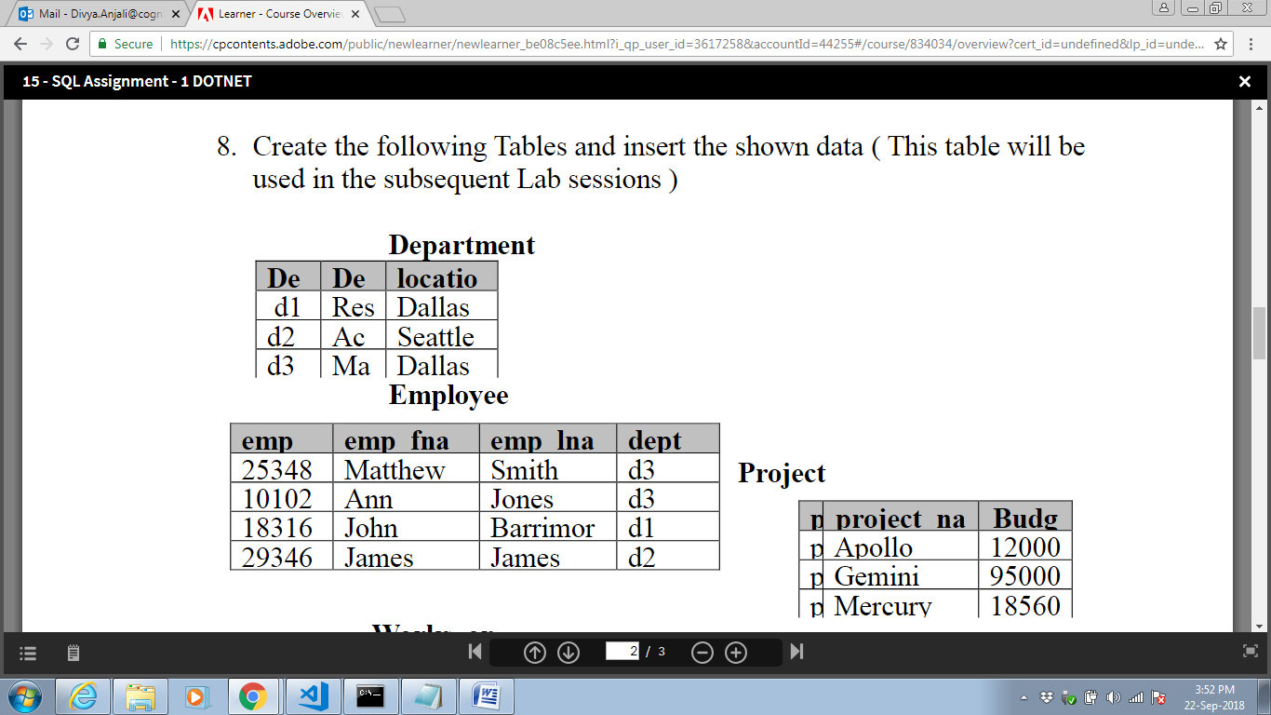

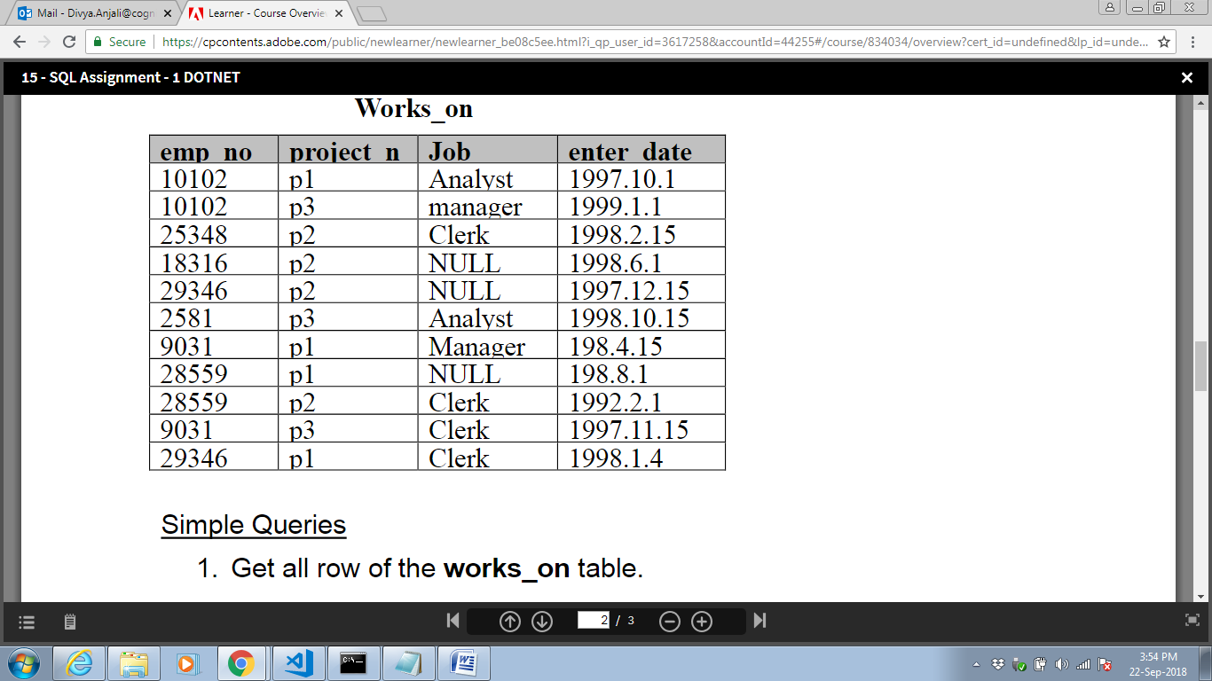
IF NOT EXISTS(SELECT 1 FROM SYS.OBJECTS WHERE TYPE = 'U' AND NAME = 'DEPARTMENT')
BEGIN
CREATE TABLE DEPARTMENT
(
DEPT_NO CHAR(2) NOT NULL
, DEPTNAME VARCHAR(40) NOT NULL
, LOCATIO VARCHAR(30) NULL
)

INSERT INTO DEPARTMENT (DEPT_NO, DEPTNAME, LOCATIO)
VALUES ('d1', 'Res', 'Dallas')
, ('d2', 'Ac', 'Seattle')
, ('d3', 'Ma', 'Dallas')

END

IF NOT EXISTS
(
SELECT 1 FROM SYS.OBJECTS
WHERE TYPE = 'U' AND NAME = 'EMPLOYEE'
)
BEGIN
CREATE TABLE EMPLOYEE
(
EMP_NO INT NOT NULL
, EMP_FNAME VARCHAR(40) NOT NULL
, EMP_LNAME VARCHAR(40) NOT NULL
, DEPT VARCHAR(40) NOT NULL
)

INSERT INTO EMPLOYEE (EMP_NO, EMP_FNAME, EMP_LNAME, DEPT)
VALUES (25348, 'Matthew', 'Smith', 'd3')
, (10102, 'Ann', 'Jones', 'd3')
, (18316, 'John', 'Barrimor', 'd1')
, (29346, 'James', 'James', 'd2')
END

IF NOT EXISTS
(
SELECT 1 FROM SYS.OBJECTS
WHERE TYPE = 'U' AND NAME = 'PROJECT'
)
BEGIN
CREATE TABLE PROJECT
(
PROJECTID CHAR(2) NOT NULL
, PROJECT_FNAME VARCHAR(40) NOT NULL
, BUDG DECIMAL(36,0) NOT NULL
)

INSERT INTO PROJECT (PROJECTID, PROJECT_FNAME, BUDG)
VALUES ('P1', 'Apollo', 12000)
, ('P2', 'Gemini', 95000)
, ('P3', 'Mercury', 18560)
END

IF NOT EXISTS
(
SELECT 1 FROM SYS.OBJECTS
WHERE TYPE = 'U' AND NAME = 'WORKS_ON'
)
BEGIN
CREATE TABLE WORKS_ON
(
EMP_NO INT NOT NULL
, PROJECT_NO CHAR(2) NOT NULL
, JOB VARCHAR(12) NULL
, ENTER_DATE DATE NOT NULL
)

INSERT INTO WORKS_ON (EMP_NO, PROJECT_NO, JOB, ENTER_DATE)
VALUES (10102, 'P1', 'Analyst', '1997-10-01')
, (10102, 'P3', 'Manager', '1999-01-01')
, (25348, 'P2', 'Clerk', '1998-02-15')
, (18316, 'P2', NULL, '1998-06-01')
, (29346, 'P2', NULL, '1997-12-15')
, (2581, 'P3', 'Analyst', '1998-10-15')
, (9031, 'P1', 'Manager', '1988-04-15')
, (28559, 'P1', NULL, '1988-08-01')
, (28559, 'P2', 'Clerk', '1992-02-01')
, (9031, 'P3', 'Clerk', '1997-11-15')
, (29346, 'P1', 'Clerk', '1998-01-04')
END

Simple Queries
1. Get all row of the works_on table.
<<Answer>> SELECT * FROM WORKS_ON

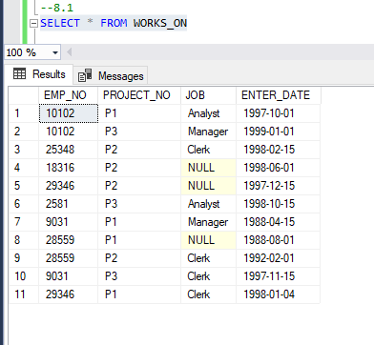
2. Get the employee numbers for all clerks
<<Answer>> SELECT WO.EMP_NO FROM WORKS_ON WO WHERE WO.JOB = 'Clerk'

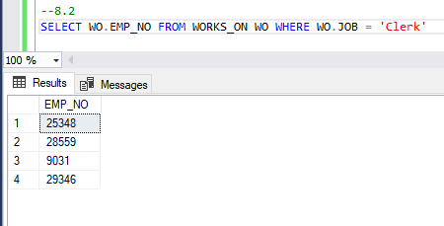

3. Get the employee numbers for employees working in project p2, and having employee numbers smaller than 10000.
Solve this problem with two different but equivalent SELECT statements.
<<Answer>>
SELECT WO.EMP_NO, *
FROM WORKS_ON WO
WHERE WO.PROJECT_NO = 'P2'
UNION ALL
SELECT WO.EMP_NO, *
FROM WORKS_ON WO
WHERE WO.EMP_NO < 10000
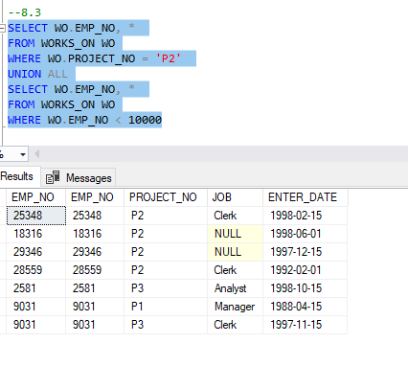
4. Get the employee numbers for all employees who didn’t enter their project in 1998.
emp_no emp_fname emp_lname dept_no
25348 Matthew Smith d3
10102 Ann Jones d3
18316 John Barrimore d1
29346 James James d2
<<Answer>>
SELECT *
FROM EMPLOYEE EM
WHERE EM.EMP_NO IN
(
SELECT WO.EMP_NO
FROM WORKS_ON WO
WHERE DATEPART(YEAR,WO.ENTER_DATE) <> 1998
)

5. Get the employee numbers for all employees who have a leading job (i.e., Analyst or Manager) in project p1
<<Answer>> SELECT *
FROM EMPLOYEE EM
WHERE EM.EMP_NO IN
(
SELECT WO.EMP_NO
FROM WORKS_ON WO
WHERE WO.JOB IN ('Analyst', 'Manager')
)

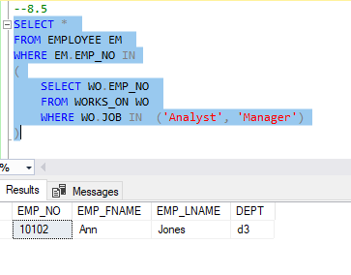
6. Get the enter dates for all employess in project p2 whose jobs have not been determined yet.
<<Answer>> SELECT * FROM WORKS_ON WO WHERE WO.PROJECT_NO = 'P2' AND WO.JOB IS NULL

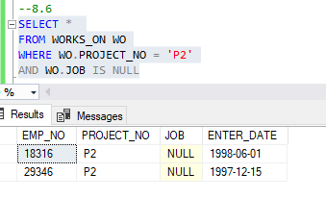
7. Get the employee numbers and last names of all employees whose first names contain two letter t’s.
<<Answer>> SELECT EM.EMP_NO, EM.EMP_LNAME FROM EMPLOYEE EM WHERE EM.EMP_FNAME LIKE '%T%T%'

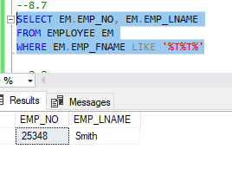
8. Get the employee numbers and first names of all employees whose last names have a letter o
or a as the second character and end with the letters es.
<<Answer>> SELECT EM.EMP_NO, EM.EMP_FNAME FROM EMPLOYEE EM WHERE EM.EMP_LNAME LIKE '_[AO]%ES'

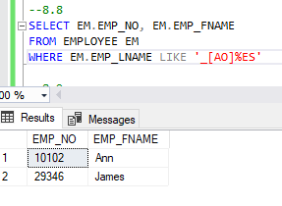
9. Get the employee numbers of all employees whose departments are located in Seattle.
<<Answer>> SELECT * FROM EMPLOYEE EM
WHERE EM.DEPT IN (SELECT DP.DEPT_NO FROM DEPARTMENT DP WHERE DP.LOCATIO = 'Seattle' )
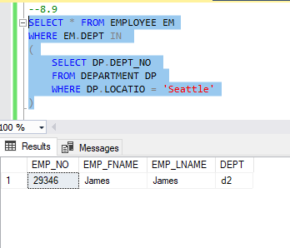
10. Find the last and first names of all employess who entered their projects on 04.01.1998
<<Answer>>

SELECT EM.EMP_LNAME, EM.EMP_FNAME
FROM EMPLOYEE EM
WHERE EM.EMP_NO IN
(
SELECT WO.EMP_NO
FROM WORKS_ON WO
WHERE WO.ENTER_DATE = '1998-01-04'
)

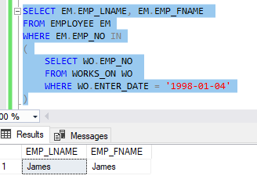
11. Group all departments using their locations.
<<Answer>> SELECT * FROM DEPARTMENT DP ORDER BY dp.LOCATIO

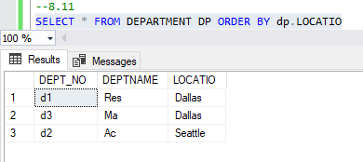
12. Find the biggest employee number.
<<Answer>> SELECT MAX(EM.EMP_NO) AS MAX_EMP_NO FROM EMPLOYEE EM

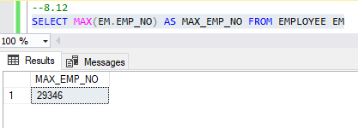

13. Get the jobs that are done by more than two employees.
<<Answer>> SELECT WO.JOB
FROM WORKS_ON WO
WHERE WO.JOB IS NOT NULL
GROUP BY WO.JOB
HAVING COUNT(WO.EMP_NO) > 2

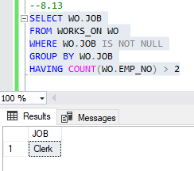
14. Find the employee numbers of all employees who are clerks or work for department d3.
<<Answer>> SELECT *
FROM EMPLOYEE EM
WHERE EM.DEPT = 'D3'
OR EM.EMP_NO IN
( SELECT WO.EMP_NO FROM WORKS_ON WO WHERE WO.JOB = 'Clerk')

