For M=4

1. Function Code:

% Initialization of the function

function x = GaussQ( n)

% x = GaussQ( number)

%

% This function generates the value of Qfunction of a given number.

%

% Input: ( n ) = number

%

% Output : Q function applied value of n

% Date created: 07/06/2016 Author: Tamoghna Chattopadhyay

%

% -----------------------------------------------------------------

% Function body

x = 0.5 * erfc(n/sqrt(2));

return;

1. Main Code:

clear all

clc

M = 4; %Number of possible messages

gdB = 0:.01:20; %gamma_b in dB

g = 10 .^ (gdB/10); %actual value of gamma_b

for i = 1:length(g)

Pb_MPAM(i) = (2 * (M-1) * GaussQ ( sqrt( (6 * g(i) * log2(M))/ (M*M - 1 )))) / (M * log2(M));

Pb_MPSK(i) = (2 * GaussQ ( (sqrt( 2 * g(i) * log2(M))) * sin (pi/M))) / log2(M);

Pb_MQAM(i) = (4 * GaussQ ( sqrt( (3 * g(i) * log2(M))/ (M - 1 )))) / log2(M);

end

%Obtain Plots

semilogy(gdB,Pb_MPAM,'r.','LineWidth',3);

hold on;

grid;

semilogy(gdB,Pb_MPSK,'b--','LineWidth',3);

semilogy(gdB,Pb_MQAM,'k-','LineWidth',3);

legend(strcat(num2str(M),'-MPAM'),strcat(num2str(M),'-MPSK'),strcat(num2str(M),'-MQAM'));

title('Comparison of Probability Errors');

xlabel('\gamma_b (dB)');

ylabel('P_b');

hold off;

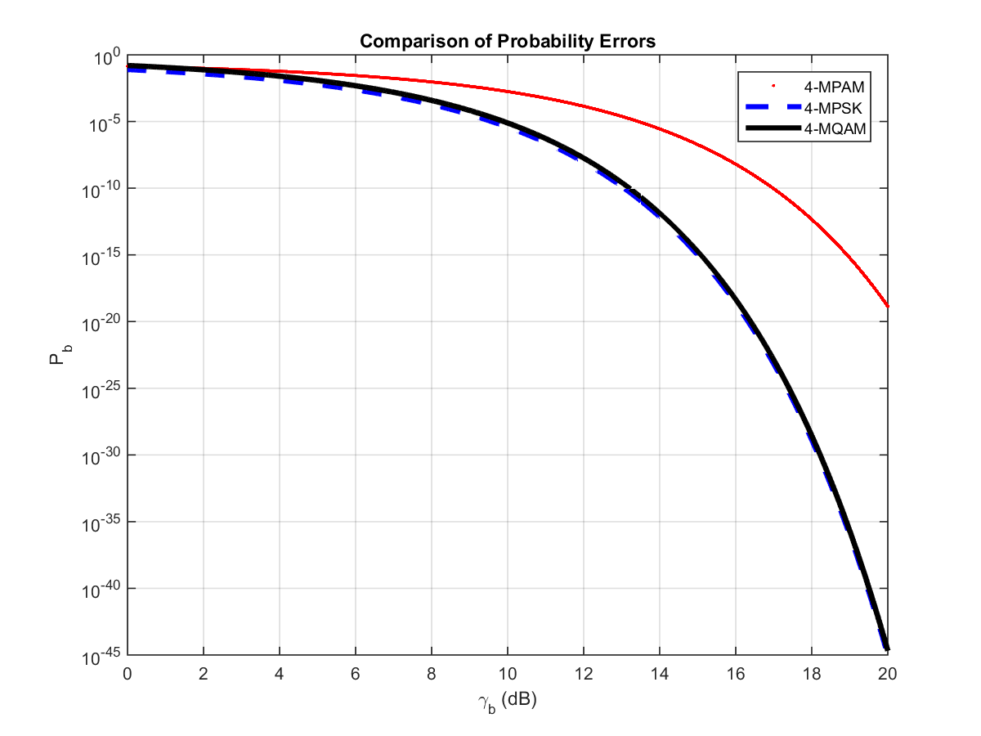

For M=8

1. Function Code:

% Initialization of the function

function x = GaussQ( n)

% x = GaussQ( number)

%

% This function generates the value of Qfunction of a given number.

%

% Input: ( n ) = number

%

% Output : Q function applied value of n

% Date created: 07/06/2016 Author: Tamoghna Chattopadhyay

%

% -----------------------------------------------------------------

% Function body

x = 0.5 * erfc(n/sqrt(2));

return;

1. Main Code:

clear all

clc

M = 8; %Number of possible messages

gdB = 0:.01:20; %gamma_b in dB

g = 10 .^ (gdB/10); %actual value of gamma_b

for i = 1:length(g)

Pb_MPAM(i) = (2 * (M-1) * GaussQ ( sqrt( (6 * g(i) * log2(M))/ (M*M - 1 )))) / (M * log2(M));

Pb_MPSK(i) = (2 * GaussQ ( (sqrt( 2 * g(i) * log2(M))) * sin (pi/M))) / log2(M);

Pb_MQAM(i) = (4 * GaussQ ( sqrt( (3 * g(i) * log2(M))/ (M - 1 )))) / log2(M);

end

%Obtain Plots

semilogy(gdB,Pb_MPAM,'r.','LineWidth',3);

hold on;

grid;

semilogy(gdB,Pb_MPSK,'b--','LineWidth',3);

semilogy(gdB,Pb_MQAM,'k-','LineWidth',3);

legend(strcat(num2str(M),'-MPAM'),strcat(num2str(M),'-MPSK'),strcat(num2str(M),'-MQAM'));

title('Comparison of Probability Errors');

xlabel('\gamma_b (dB)');

ylabel('P_b');

hold off;

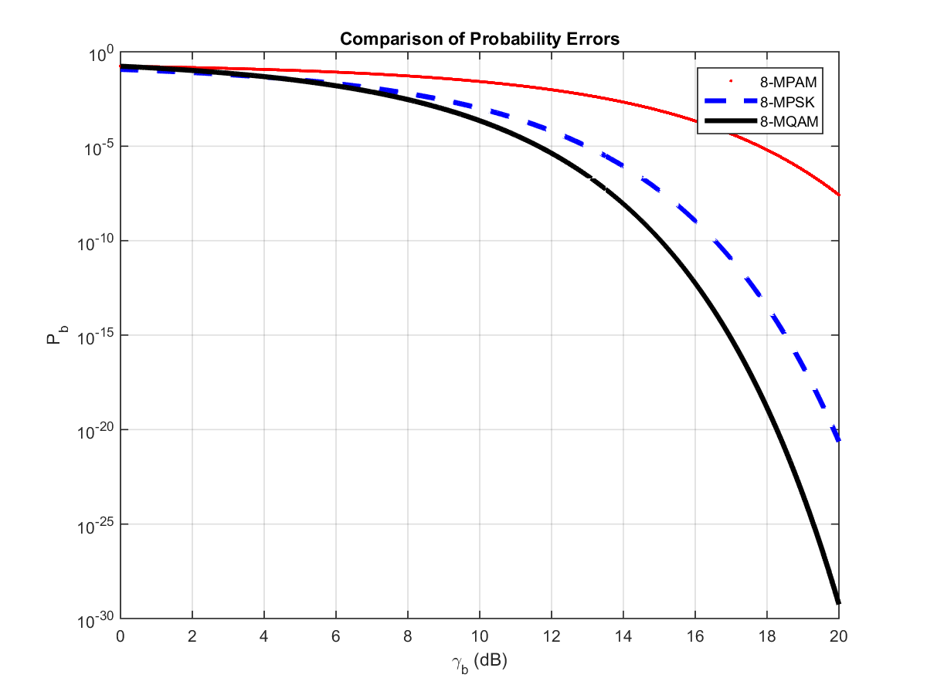

For M=16

1. Function Code:

% Initialization of the function

function x = GaussQ( n)

% x = GaussQ( number)

%

% This function generates the value of Qfunction of a given number.

%

% Input: ( n ) = number

%

% Output : Q function applied value of n

% Date created: 07/06/2016 Author: Tamoghna Chattopadhyay

%

% -----------------------------------------------------------------

% Function body

x = 0.5 * erfc(n/sqrt(2));

return;

1. Main Code:

clear all

clc

M = 16; %Number of possible messages

gdB = 0:.01:20; %gamma_b in dB

g = 10 .^ (gdB/10); %actual value of gamma_b

for i = 1:length(g)

Pb_MPAM(i) = (2 * (M-1) * GaussQ ( sqrt( (6 * g(i) * log2(M))/ (M*M - 1 )))) / (M * log2(M));

Pb_MPSK(i) = (2 * GaussQ ( (sqrt( 2 * g(i) * log2(M))) * sin (pi/M))) / log2(M);

Pb_MQAM(i) = (4 * GaussQ ( sqrt( (3 * g(i) * log2(M))/ (M - 1 )))) / log2(M);

end

%Obtain Plots

semilogy(gdB,Pb_MPAM,'r.','LineWidth',3);

hold on;

grid;

semilogy(gdB,Pb_MPSK,'b--','LineWidth',3);

semilogy(gdB,Pb_MQAM,'k-','LineWidth',3);

legend(strcat(num2str(M),'-MPAM'),strcat(num2str(M),'-MPSK'),strcat(num2str(M),'-MQAM'));

title('Comparison of Probability Errors');

xlabel('\gamma_b (dB)');

ylabel('P_b');

hold off;

