Q1

**Synthetic 1 dataset**

Final Weight Vector: 35.1000 -43.9945 45.6809

Train_error : 0.01

Test_error: 0.03

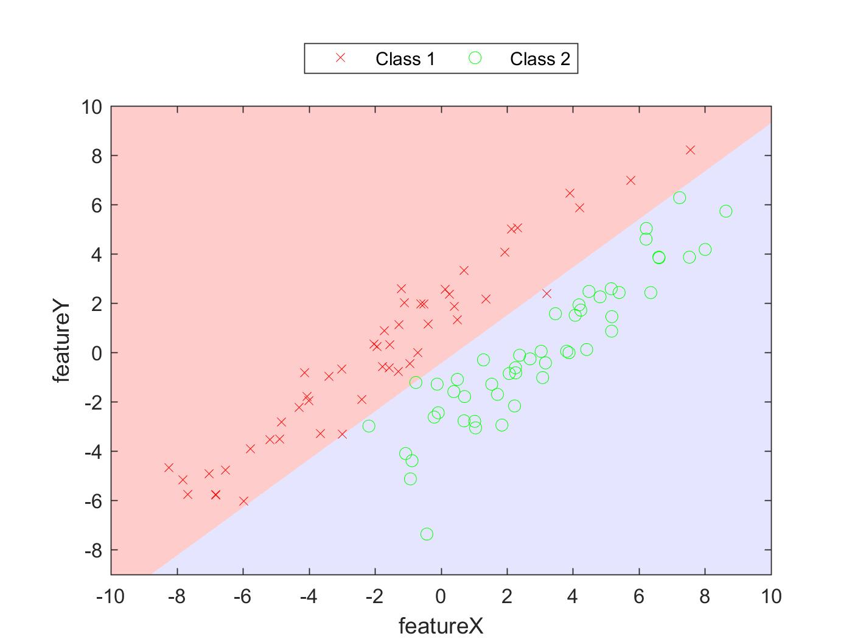

The error for training data and test data was 0.21 and 0.24 respectively in HW2(a). In this case, the classifier works much better and gives a much lesser error. Thus we can say that the perceptron is a much better classifier algorithm than the MDTCM algorithm.

**Synthetic 2 dataset**

Final Weight Vector: 6.1000 -3.6526 20.5332

Train_error : 0.02

Test_error: 0.03

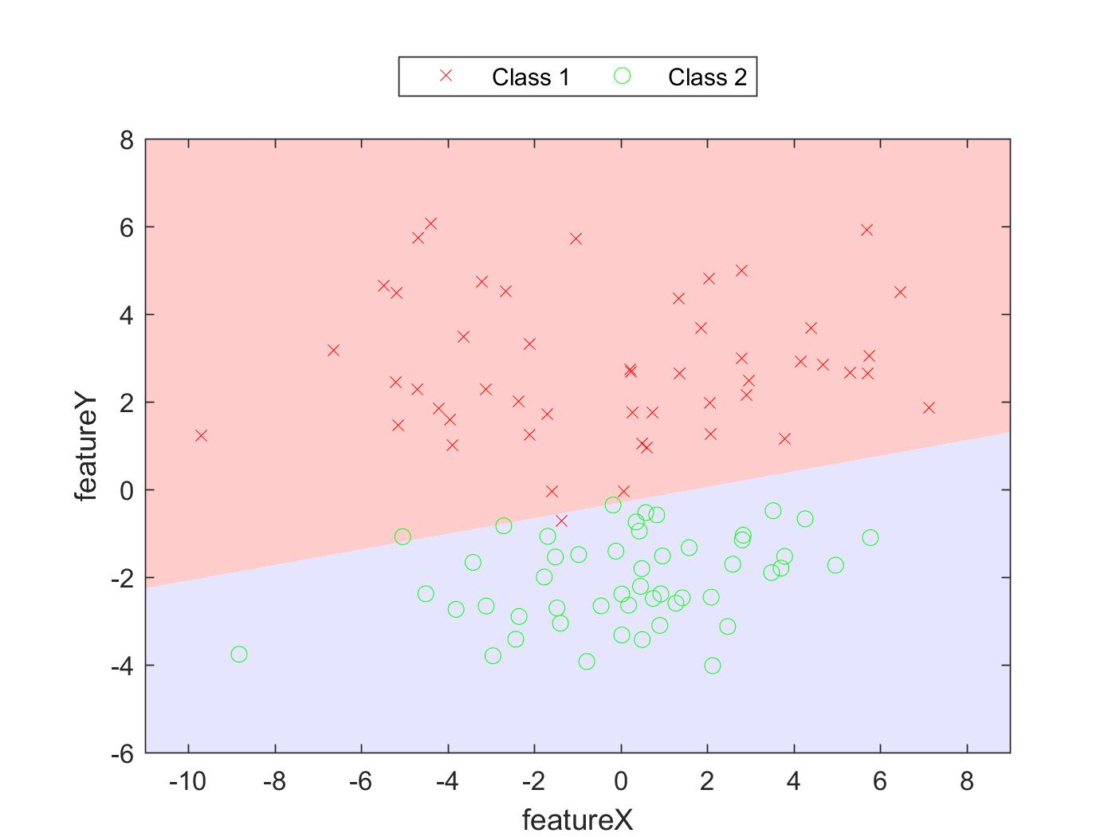

The error for training data and test data was 0.03 and 0.04 respectively in HW2(a). In this case, the classifier works better and gives a lesser error. Thus we can say that the perceptron is a much better classifier algorithm than the MDTCM algorithm.

**Synthetic 3 dataset**

Final Weight Vector: 0.1000 -6.9558 6.0228

Train_error : 0

Test_error: 0.01

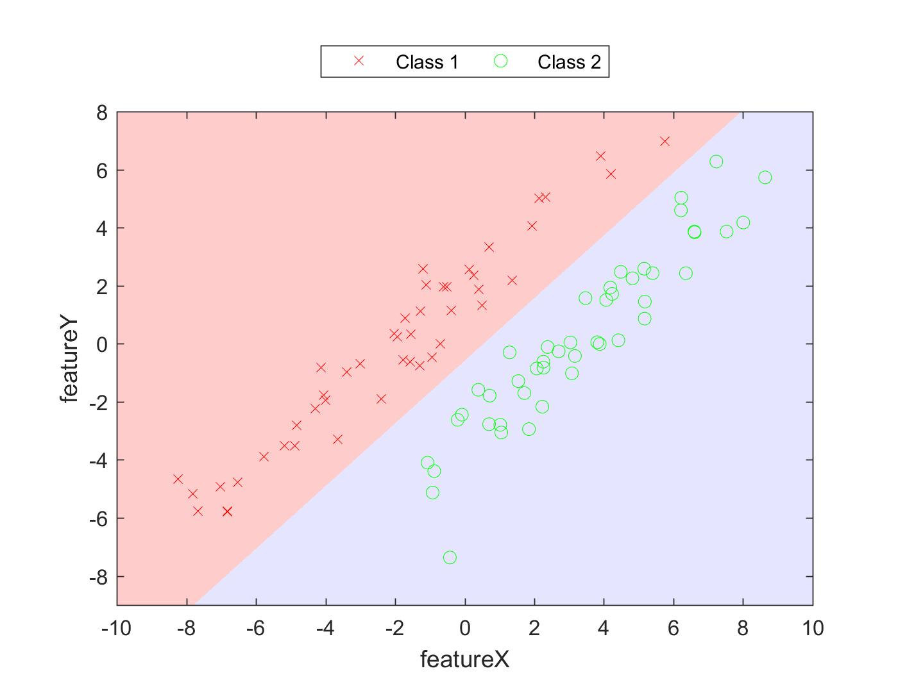

The perceptron algorithm gives a reduced error rate, thus showing that it can better adjust the weight vectors for the features, resulting in better decision boundary.