**GUJARAT TECHNOLOGICAL UNIVERSITY**

 Chandkheda, Ahmedabad

Affiliated

**BIRLA VISHVAKARMA MAHAVIDYALAYA**

A

REPORT ON

**Temperature Sensor using Instrumental Amplifier**

**Under the subject of**

Analog Circuit And Design

Level II, SEMESTER- IV

DEPARTMENT OF ELCTRONICS ENGINEERING

**SUBMITTED BY:**

1. Tamoghna Chattopadhyay(130070110070)
2. Vohra Maksud C.(120070110074)
3. Jay Tanna (130070110071)
4. Rahul Vasava (130070110073)

**Prof. Chetan Jaiswal**

**(Faculty Advisor)**

**Dr. T. D. Pawar**

**HEAD OF THE DEPARTMENT**

**ACADEMIC YEAR (2014-2015)**

**BIRLA VISHVAKARMA MAHAVIDYALAYA**

**VALLABH VIDYANAGAR**

**DEPARTMENT OF ELECTRONICS ENGINEERING**



**CERTIFICATE**

This is to certify that the Analog Circuit design project entitled **“Temperature Indicator using Instrumentation Amplifier ”** has been carried out by **Tamoghna Chattopadhyay (**130070110070**), Vohra Maksud C.(**120070110074**), Jay Tanna(**130070110071**)** and **Rahul Vasava(130070110073)** under my guidance and supervise, on for the award of the degree of Bachelor of Engineering in Information Technology (Semester - IV) at Birla Vishvakarma Mahavidyalaya, Vallabh Vidyanagar during the academic year **2014-15**.

**Date: -**

**Guide: Head of Department:**

Prof Chetan Jaiswal Dr. TD Pawar

EL Department, EL Department,

BVM, BVM,

Vallabh Vidyanagar Vallabh Vidyanagar

**ACKNOWLEDGEMENT**

We take this opportunity to express our profound gratitude and deep regards to our **Head of Department Dr T.D.Pawar** for giving us the opportunity to undertake this project work.

We would like to express our heartfelt gratitude towards our guides Prof **Chintan Jaiswal sir** for his exemplary guidance, monitoring and constant encouragement throughout the course of this thesis. The blessing, help and guidance given by him time to time shall carry us a long way in the journey of life on which we are about to embark.

We are obliged to staff members of Electronics Department for the valuable information provided by them in their respective fields. We are grateful for their cooperation during the period of our assignment.

Lastly, we thank almighty, our parents, brother, sisters and friends for their constant encouragement without which this assignment would not be possible.

**INDEX**

|  |  |  |
| --- | --- | --- |
| Sr. no. | Title | Page no. |
| 1 | Acknowledgement | 3 |
| 2 | Introduction | 5 |
| 3 | Working of Instrumentation Amplifier | 7 |
| 4 | Application of Instrumentation Amplifier | 7 |
| 5 | Advantages of Instrumentation Amplifier | 8 |
| 6 | Disadvantages of Instrumentation Amplifier | 8 |
| 7 | Circuit Diagram of Temperature Sensor | 9 |
| 8 | Operation of a temperature indicator | 10 |
| 9 | Components required | 11 |
| 10 | Multisim simulation | 11 |
| 11 | Reference | 12 |

**INTRODUCTION:**

* Differential amplifier with high input resistance is used in instrumentation amplifier .
* The instrumentation amplifier is a closed loop device with carefully set gain. It is a dedicated differential amplifier with externally high input impedance.
* It has a common mode rejection capability( i.e. it is able to reject a signal that is common to both terminal.)
* Instrumentation amplifiers are used to interface low level devices such as stain gauges, pressure transducers, analog to digital conversion.

An instrumentation amplifier must satisfy the following requirements:

1. Precise amplification of low level signal.
2. Low noise.
3. Low thermal drift.
4. High input resistance.
5. Accurate closed loop gain.
6. Low power dissipation.
7. High CMRR.
8. High slew rate.
9. Easy adjustment of gains.

The circuit diagram of Instrumentation Amplifier is shown in the figure below.

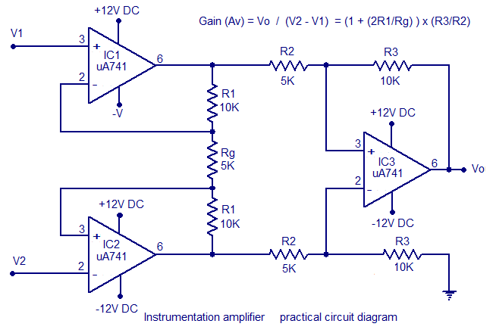

**WORKING OF INSTRUMENTATION AMPLIFIER :**

* The instrumentation amplifier consists of two stages. The input first stage offers very high impedance to both input signals and allows setting gain with a single resistor.
* The second stage is a differential amplifier with output, negative feedback and ground connections are all brought out.
* The input stage consists of two matched op amp. Each stage consists of two matched op amp. Each input V1 and V2 is applied to non inverting input terminal of its op amp.
* This op -amp provides very high input resistance. The output of op amp is connected through a string of resistors.
* The two resistors are R and Rg. Output voltage,

**Vo = (V2-V1) (1+2R/Rg)**

* Therefore decrease in value of Rg will increase the output voltage Vo. To increase in value of gain the value of Rg has to be decreased.

**APPLICATION OF INSTRUMENTATION AMPLIFIER:**

The different applications of an instrument amplifier are:

* Audio applications involving weak audio signal or noisy environment
* Medical instruments
* High frequency signal amplification in cable RF
* Current/voltage monitoring
* Data acquisition
* Temperature indicator and controller
* Pressure monitoring and control.

In order to measure and control different physical quantities like pressure, temperature etc. we have to use an instrumentation amplifier with a transducer bridge. Depending on the quantity to be measured or controlled, a different transducer is required to be used.

**ADVANTAGES OF INSTRUMENTATION AMPLIFIER :**

An instrumentation amplifier is beneficial for several reasons-

* High input impedance, unlike the lower input impedance of a differential amplifier by itself.
* High CMRR.
* Good for smaller, insignificant input signals
* Gain of the non-inverting amplifier can be varied by the rheostat.
* Even a small value of input voltage can be amplified using instrumentation amplifier.

**DISADVANTAGE OF INSTRUMENTATION AMPLIFIER :**

* For transmission purpose for long range, noise also gets superimposed along the original wave. Therefore specific cables are used to reduce noise.
* A transducer bridge circuit is required for measurement and control of different physical quantities.

**CIRCUIT DIAGRAM OF TEMPERATURE SENSOR :**

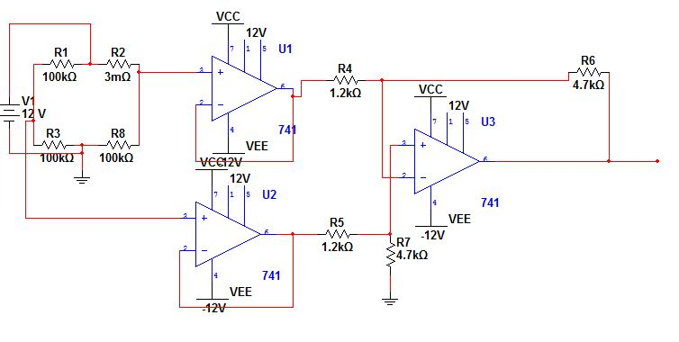

**OPERATION OF A TEMPERATURE INDICATOR :**

* The temperature transducer RT is connected in a bridge circuit, the output of which is connected to the input of the differential instrumentation amplifier. The resistance RT is called as thermistor, which is a temperature dependent resistor.
* The bridge circuit is driven by an external dc voltage source Vdc. Output of the bridge that is Vab  varies with changes in temperature.
* At some reference condition, the bridge is balanced. So, Vab = 0.
* For achieving bridge balance, it is necessary that:

R4 * R6 =R5 * RT

* The output of bridge circuit is then applied to the differential instrumentation amplifier. A1 and A2 are unity gain buffers. This means they are non inverting amplifiers with gain equal to 1. They help to reduce the loading of the bridge circuit. We get voltage Vab as the output of the buffer state.
* This voltage is then amplified by the last amplifier stage A3. Gain of this stage is given by

AVF= - RF / R1

* Hence output of the differential instrumentation amplifier is,

Vo = (- RF / R1) * Vab

* Output of the instrumentation amplifier can then be applied to an indicator or a digital display which will display the measured temperature.

**COMPONENTS REQUIRED:**

The components required are:

* Resistor – 1.2kΩ x2
* Resistor – 4.7kΩ x2
* Resistor – 110Ω x2
* Thermistor 472 - 110Ω
* 741 Op amp x3

**MULTISIM SIMULATION:**

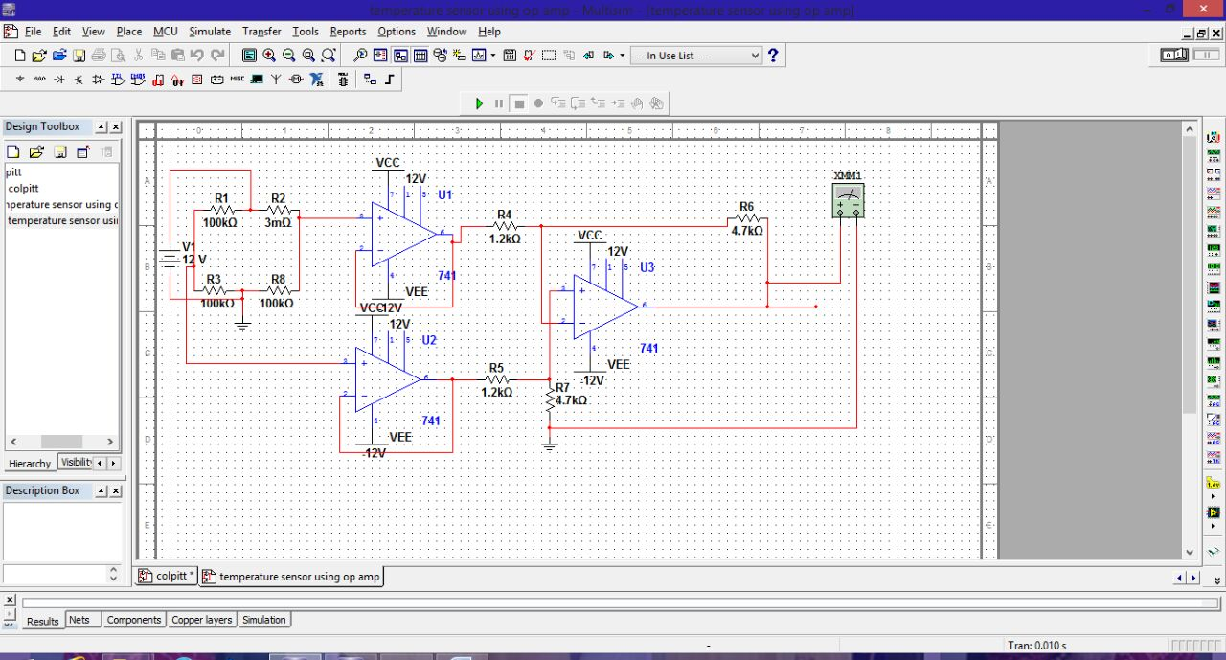

**REFERENCES:**

* www.electronics-tutorials.ws › Oscillator
* [www.circuitsgallery.com/2012/08/wien-bridge-oscillator.html](http://www.circuitsgallery.com/2012/08/wien-bridge-oscillator.html)
* [www.ecircuitcenter.com/Circuits/opwien/opwien.htm](http://www.ecircuitcenter.com/Circuits/opwien/opwien.htm)l
* mycircuitstudy.blogspot.com › Oscillator › tutorial
* Millman’s Electronic Devices and Circuits