**GEHP**

Gas driven heat pumps can be used to replace the normal heat pumps. In the engine set-up for LNG vessel, it is important to ensure that the heating carrier, i.e water is getting circulated effectively; complete conversion of water vapour at the end of the cycle to water for the next cycle can be done by pumps. The heat pump can be gas driven, which makes multiple positive impacts. Unlike Electric Heat Pumps, which increase electricity usage and demands for separate powering in LNG vessel, GHPs use gaseous fuel (already available) to operate air conditioning systems and provide better energy savings. Conspicuous changes in efficiency occurs, as we replace the conventional pumps with gas-driven ones.

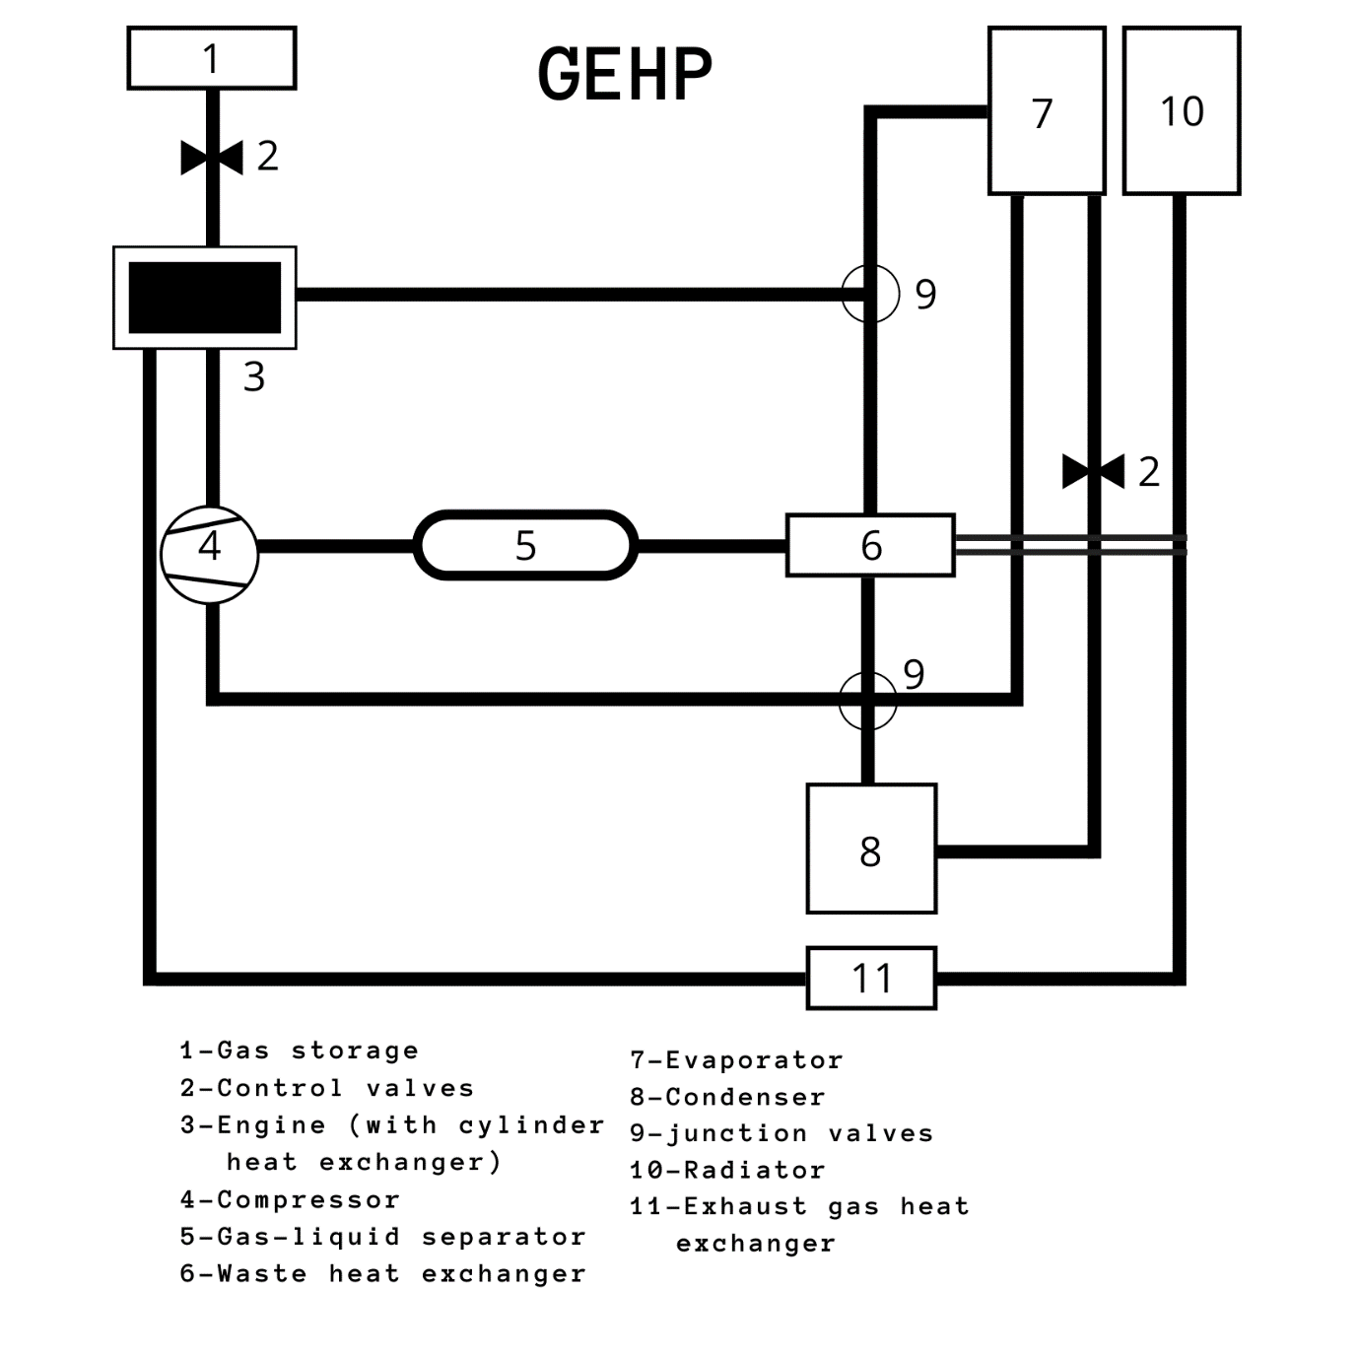

The proposed set-up is as shown in the diagram. The natural gas supply unit (1) is considered as the main input unit from where the gas required for engine initiation is sent. The refrigerant discharged from the compressor (4) enters the condenser (8) where the hot refrigerant exchanges heat with the water. Subcooled refrigerant is passed through the expansion valve (2), into the evaporator (7) for expansion. Then the refrigerant reaches the waste heat recovery exchanger (6) where it further absorbs heat from the engine coolant. Further, it passes through the separator (5) and finally reaches back to the compressor (4) for a new cycle to start. Meanwhile, engine coolant (e.g. Ethyl glycol) absorbs heat both from heat exchanger (11) and the engine cylinder (3). After the coolant receives the engine waste heat, it is directed to the heat pump waste heat recovery exchanger (6). The radiator (10) is an auxiliary heat exchanger for engine cooling and is separately connected to the above-mentioned circuit.

Fuel type Natural gas

Compressor 1 x 60.5 cc/rev, open-drive, belt-driven scroll type

Compressor

Speed 1350 to 3825 rpm

Refrigerant

Type R410A

Design

Cooling rating 16.5 kW (4.7 ton)

Design

Heating rating 20.2 kW (5.75 ton)

The particulars that are mentioned are not for the industrial GEHP, but can be considered as a prototype. Measured data for R410A (temperature, pressure) can be used in efficiency analysis and enthalpy calculations. The basic strategy here is to obtain flow rate using existing data, which can be further used to determine the GEHP performance.

Efficiency:

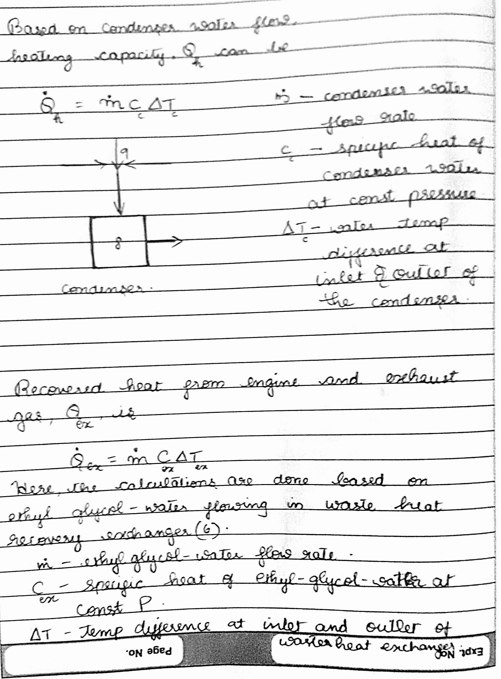

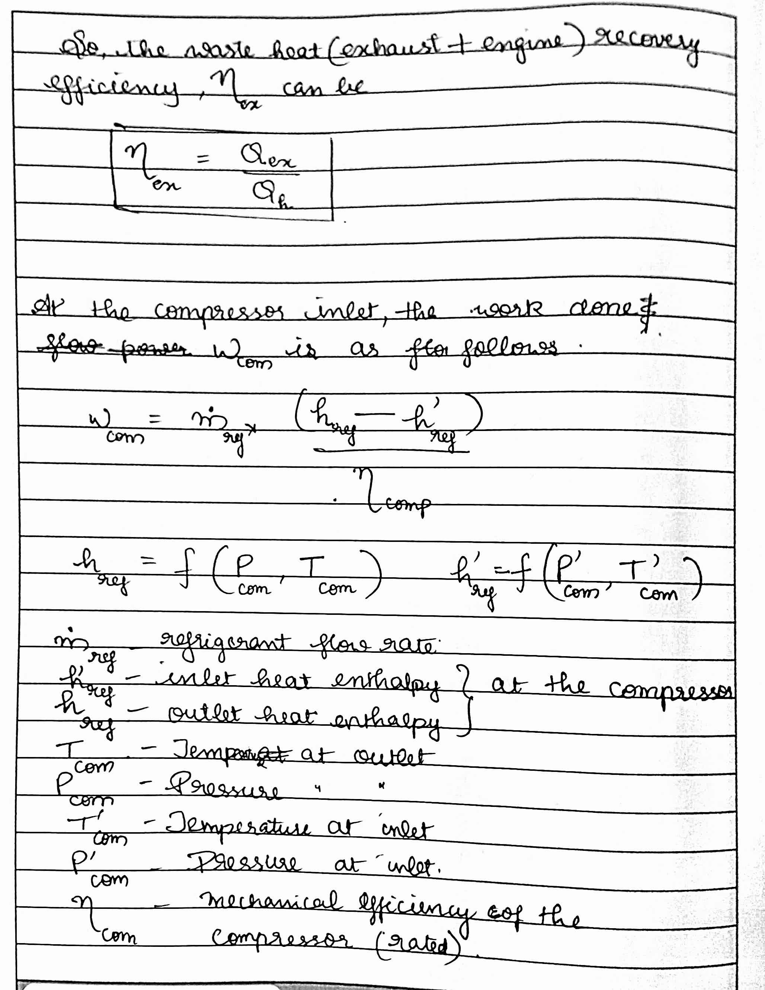

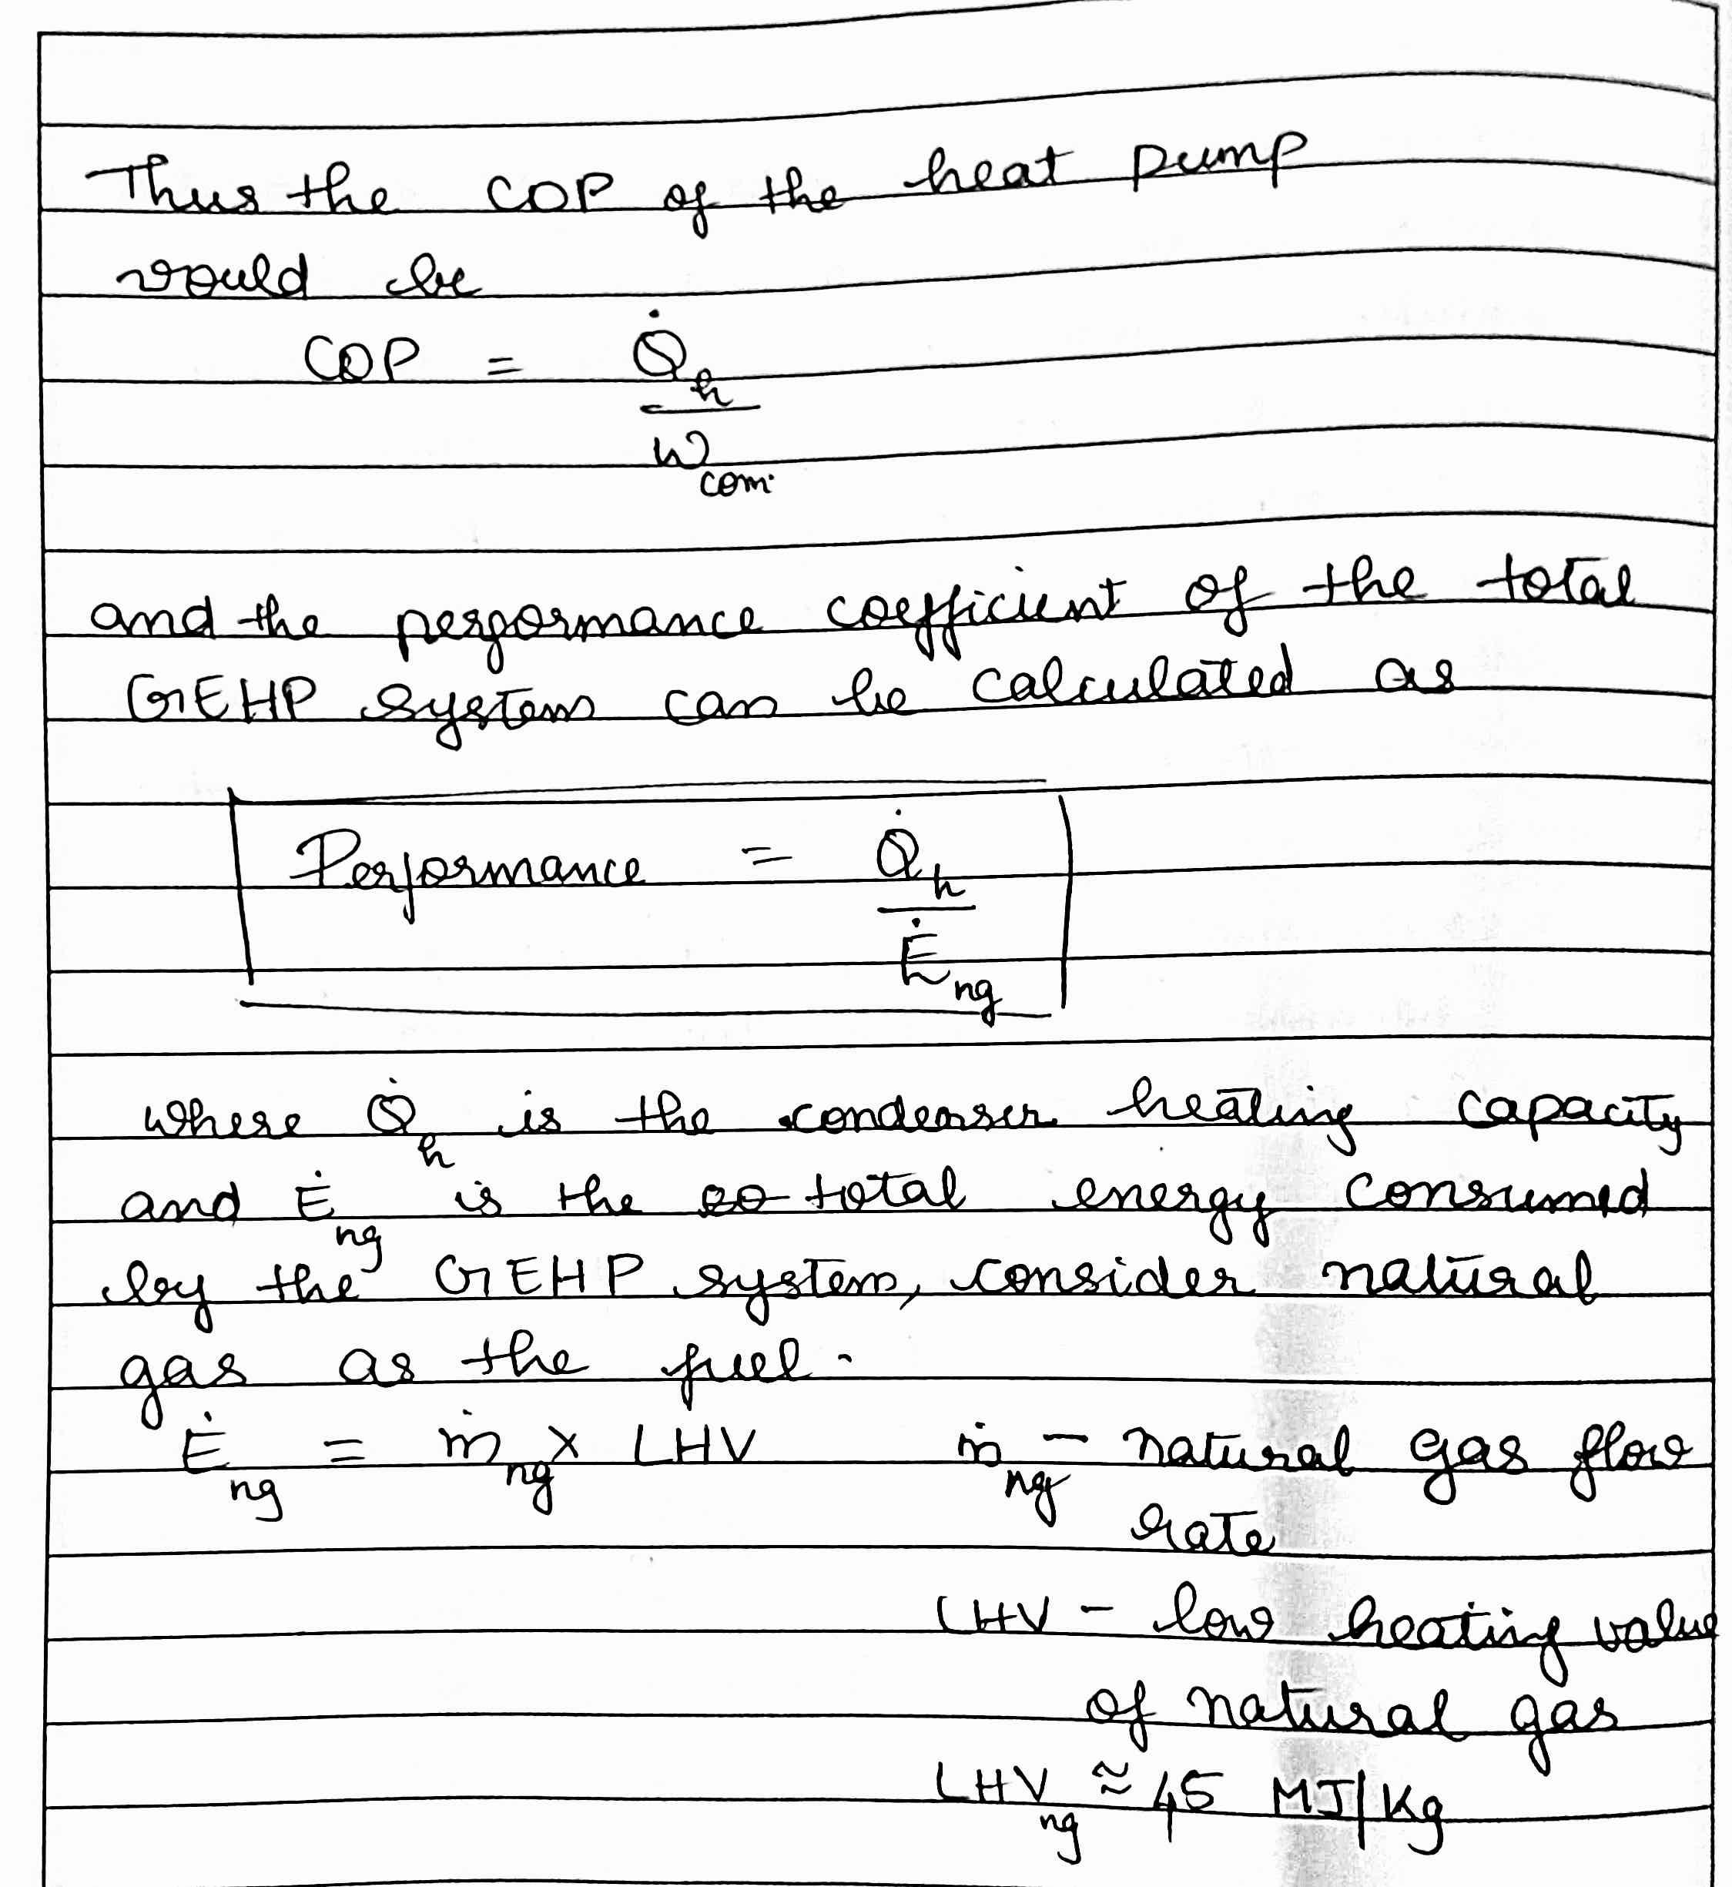

Cost:

|  |  |  |
| --- | --- | --- |
| CAPITAL COST | INSTALLATION COST | MAINTENANCE |
| * pump equipment * pipework * Special refrigerant storage * Controls and meters * 1-1.5 Lakhs INR | * System design * Installation of the heat   pump, tanks and pipework.   * Electrical connection | * Gas fuel   (1100 INR/ton in 2016)   * Refrigerant replacement |

According to the 2016 RHI report, the cost estimates can be summarised as given in the table.