**MACHINE LEARNING IN AGRICULTURE**

**-**-Mintu Raj Mushahary

(1804609017)

B. Tech NAOE

IMU Vishakhapatnam

**HOSTS:** Emmanuel Blanchard (Snr. Application Engineer, University of Cambridge) has been working in the field of AI development for the past 20 years

Daniel lim(Snr. Account manager, mathworks) has been organizing free webinars and helping educationists and knowledge enthusiasts provide a forum to discuss possible growth aspects of Machine Learning in various fields.

**AGENDA :**With the advent of technology and growing demand for food, it’s becoming increasingly crucial to adopt sophisticated machine learning models to improve agriculture, a concept known as precision agriculture.”

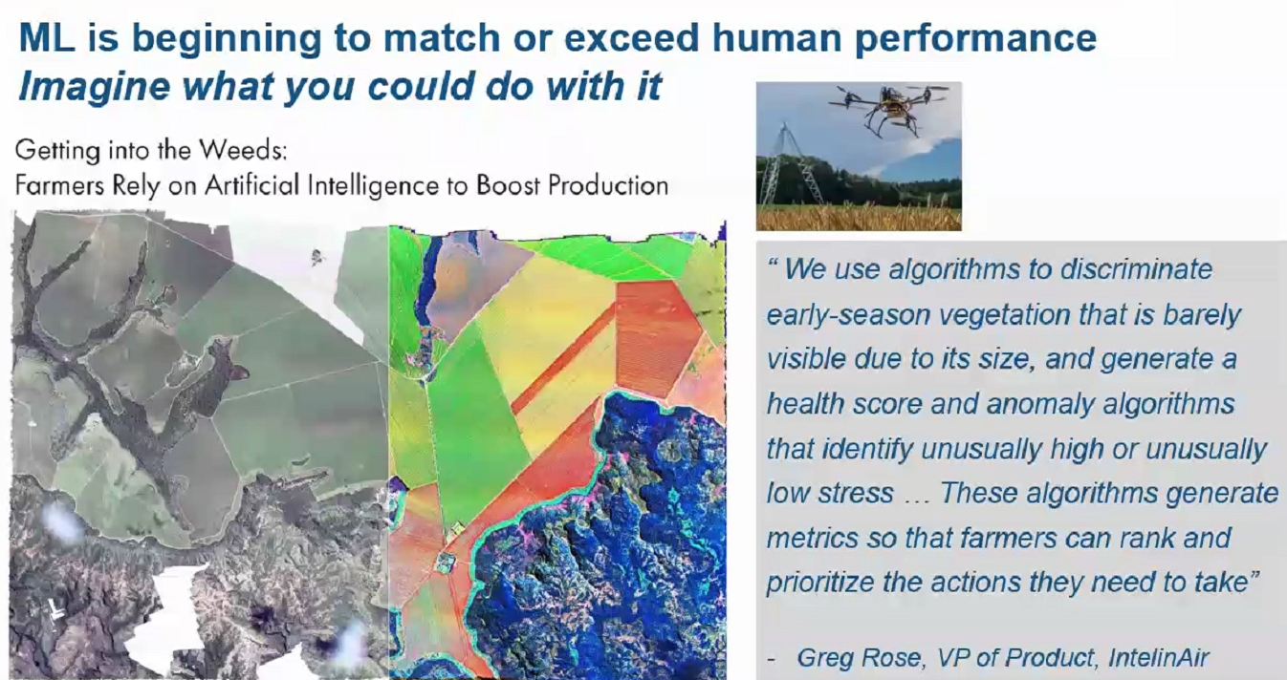

**Precision agriculture:** Many farmers have turned to usage of aerial imagery to monitor individual plants in large farms. Algorithms relying on machine learning for pattern recognition can identify issues and Data diagnosis of the physiological conditions of plants.

For example, usage of algorithms to discriminate early season vegetation that is barely visible due it’s size, generating a healthscore that can assist farmers in identifying the next step to be taken.

It shall boost efficient production and farmers can achieve greater financial returns, simultaneously reducing usage of fertilizers and cutting natural runoff, thereby promoting eco friendlier modes of farming.

**WHAT IS MACHINE LEARNING?**

Ability to learn from data without being explicitly programmed, by recognizing patterns. Equations cannot always be used to describe complex problems. Being able to design intelligent algorithms that can identify the solution on its own is the idea of machine learning.

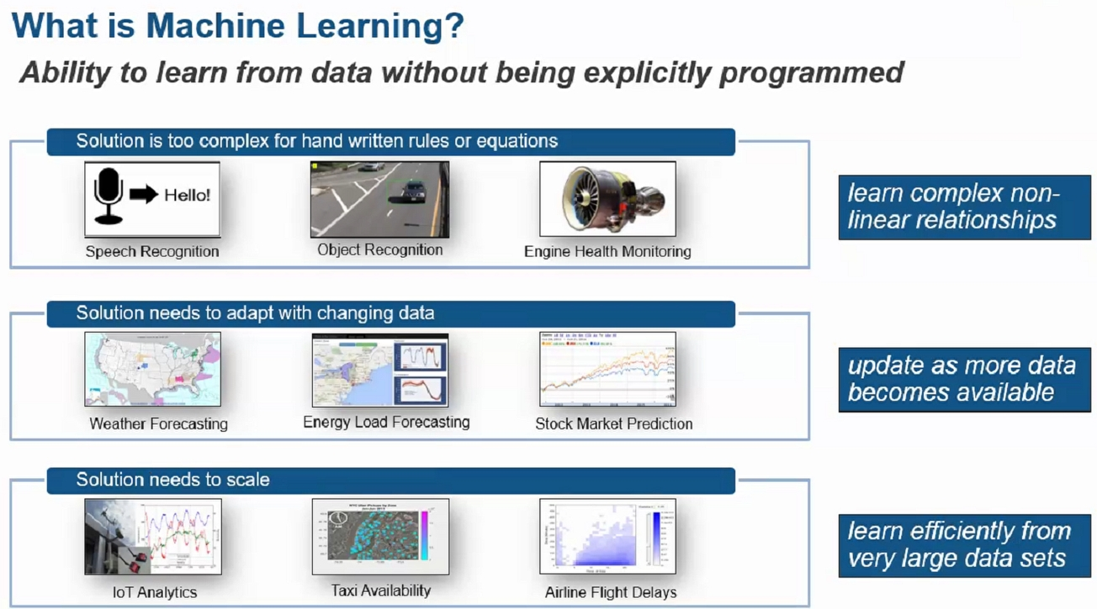

**HOW TO ACHIEVE IT:** Several professionals who aren’t into computer programming can achieve exuberance in their profession with the usage of ‘easy to use' softwares and their inbuilt tools that provide end to end work flow. **MATLAB** is one such platform that helps you customize your own working model without any prerequisite skills in computer programming.

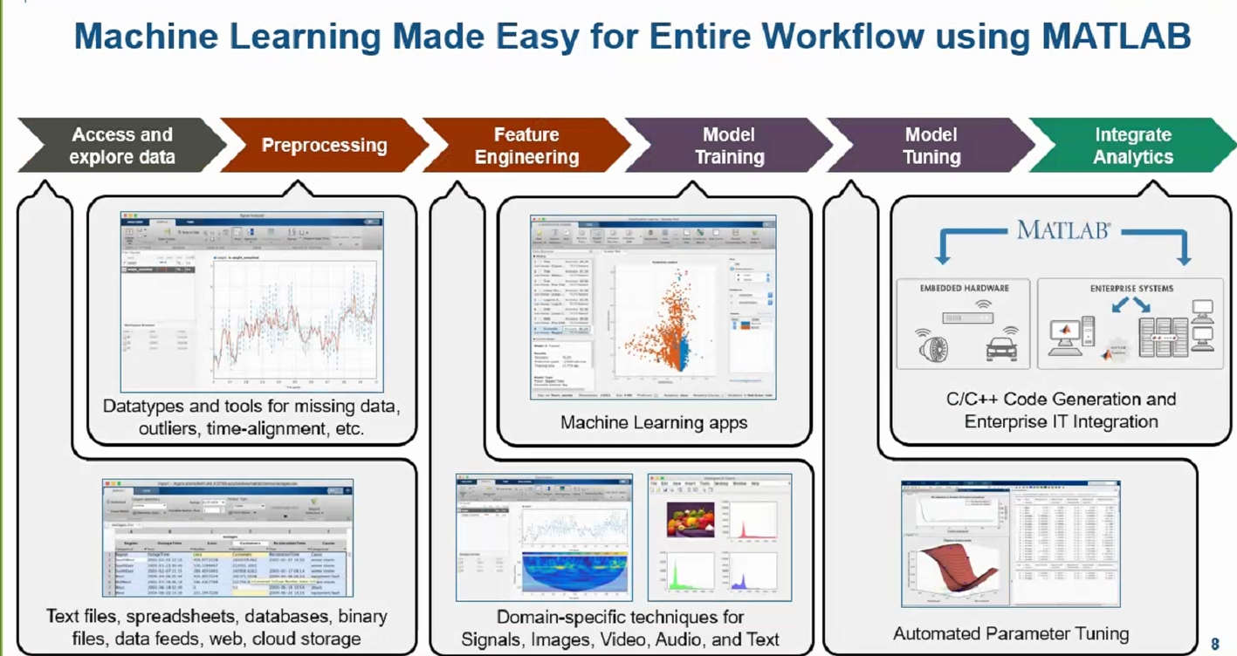

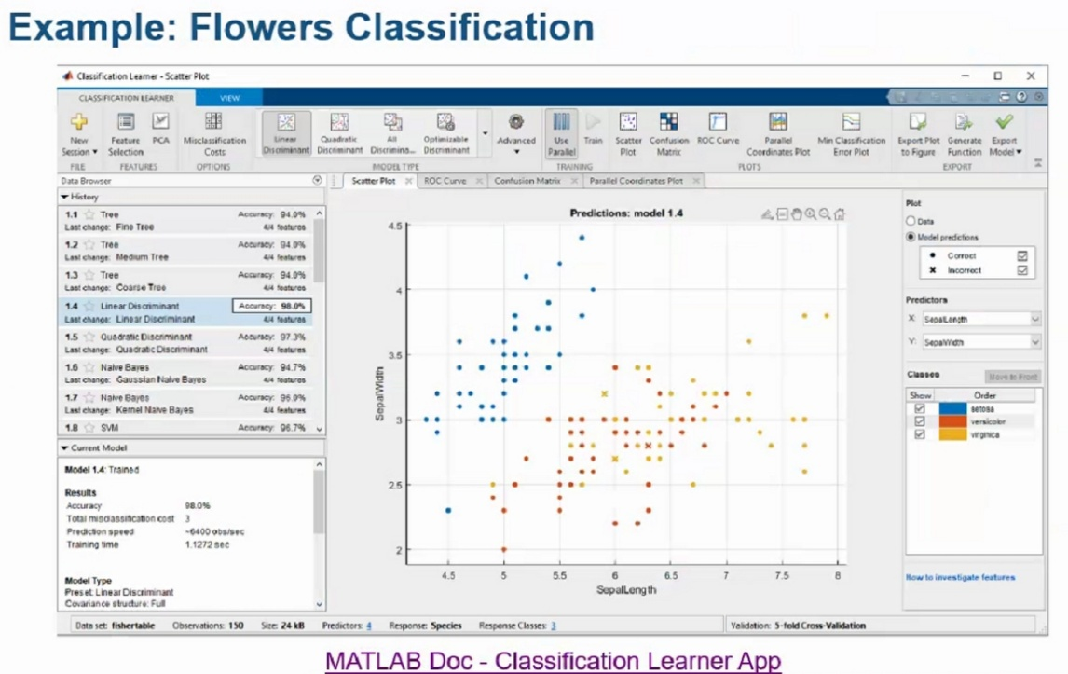 **MAKING A MACHINE LEARNING PROJECT:**

Step I: We open **MATLAB** and load a table containing flowers and measurements (flower classification table from mathworks)

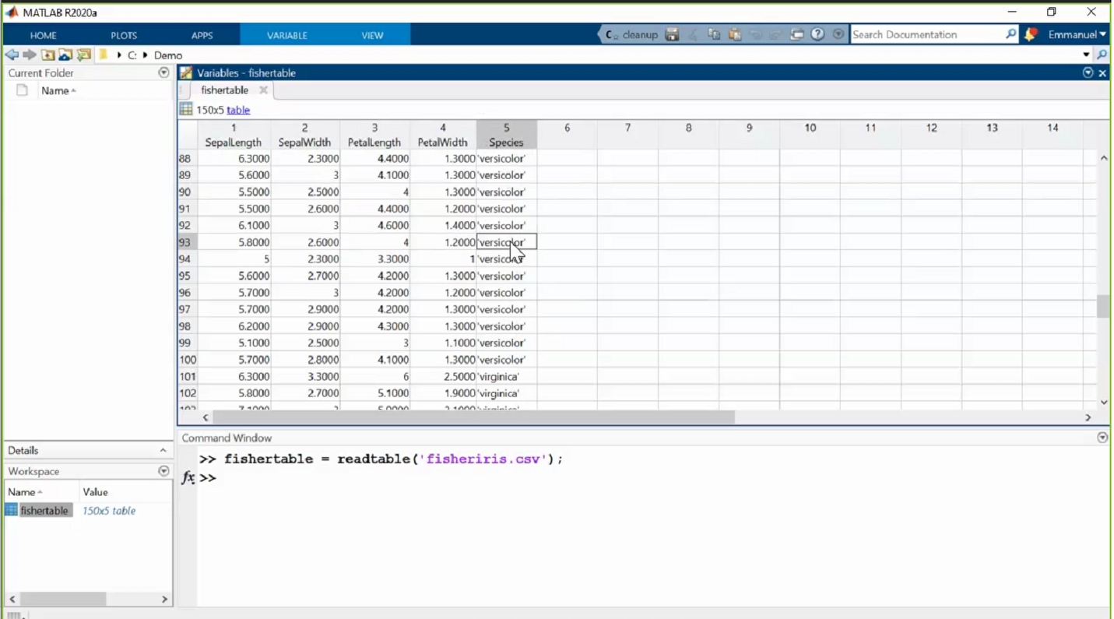

Step II: Open classification learner app.

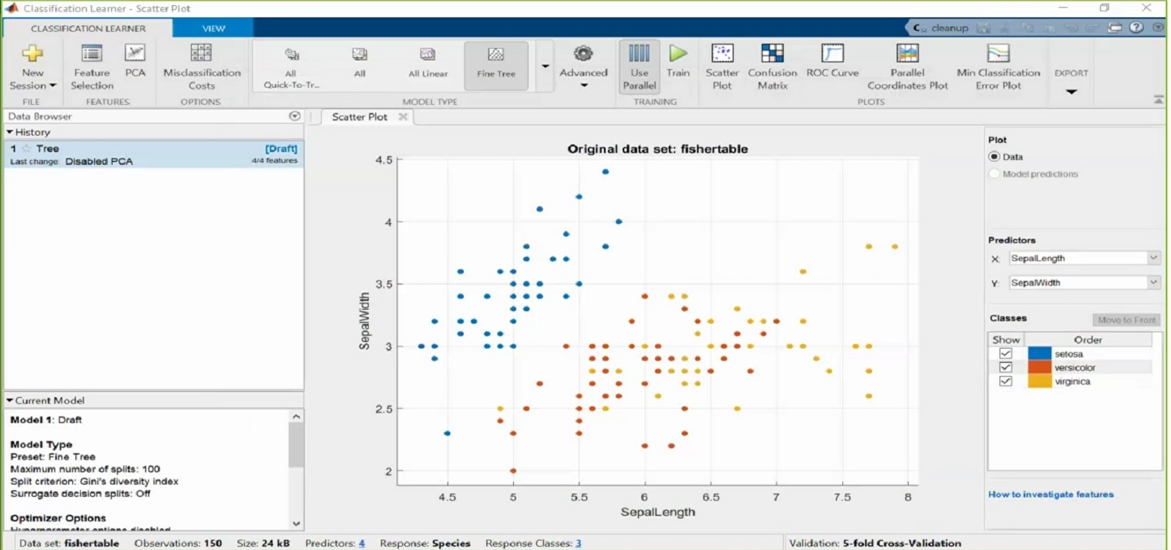

Step III: Import the data from workspace

Step IV: Choose Cross validation method and start session

Step V: Change the Y predictor to petal length

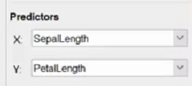

Step VI: Choose “all quick to train” classifier for a simplified classification.

Step VII: Click train

By now your computer runs several algorithms and tests their accuracy

Step VIII: Choose the one with highest accuracy

The bottom left corner gives us test time and precision.

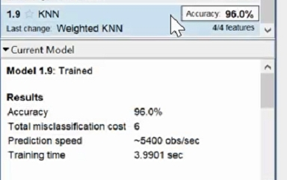

Step IX: Check the confusion matrix for errors

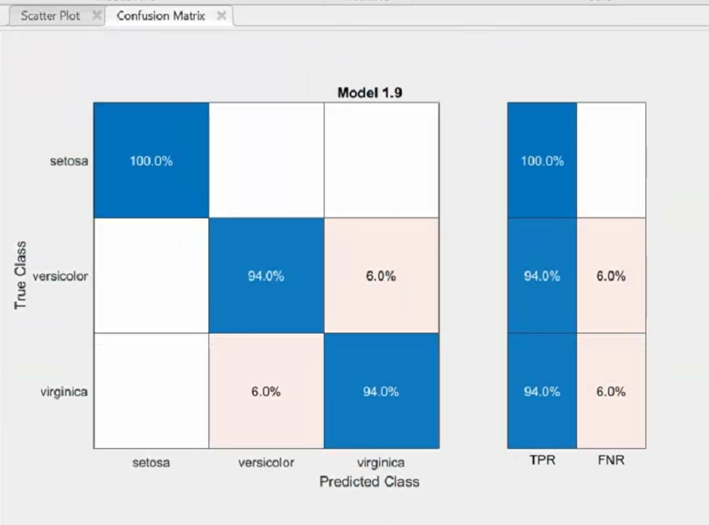

From our observations we see that: setosas are correctly identified 100% of the time. Versicolor is wrongly identified as virginica 3 times. And Virginica is wrongly identified as versicolor 3 times.

Step X: Now choose “Optimizable KNN” among NEAREST NEIGHBOR CLASSIFIERS

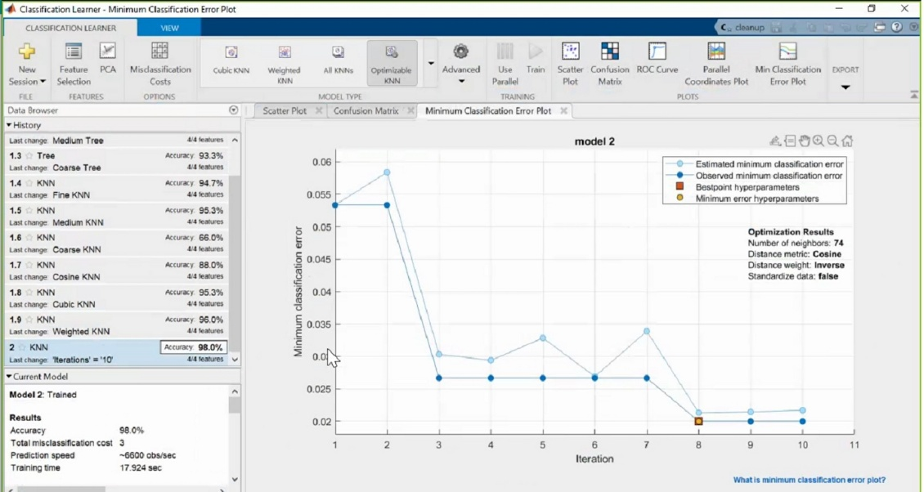Step XI: Reduce “Iterations “ to 10 in optimizer options and train the model.

Now we have the most accurate model.

Step XII: Export your model!

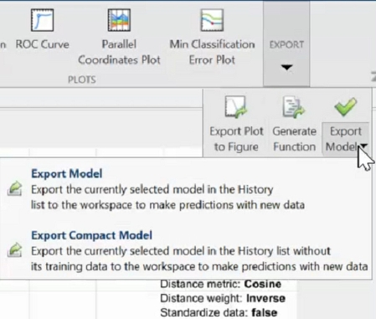

**EXAMPLES OF SUCCESSES: Meat and Livestock Australia (MLA)** in association with **University of Melbourne** developed an app that can automate recognition of cattle features for data extraction.

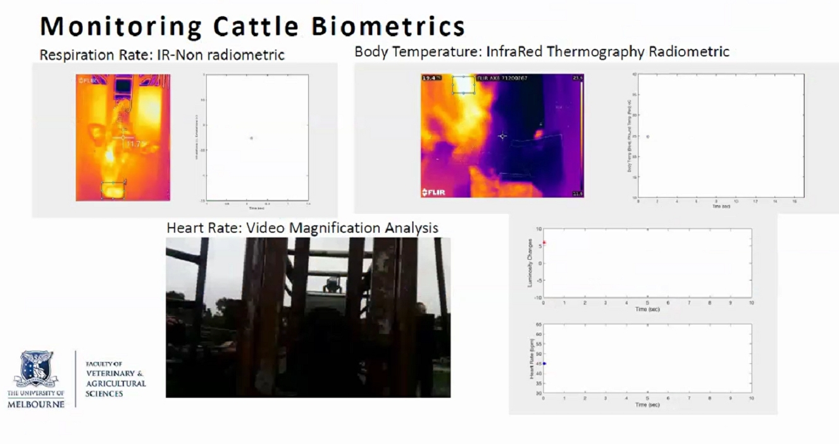

The app can also monitor cattle biometrics like respiration rate, heart rate and body biometrics from infrared imagery.

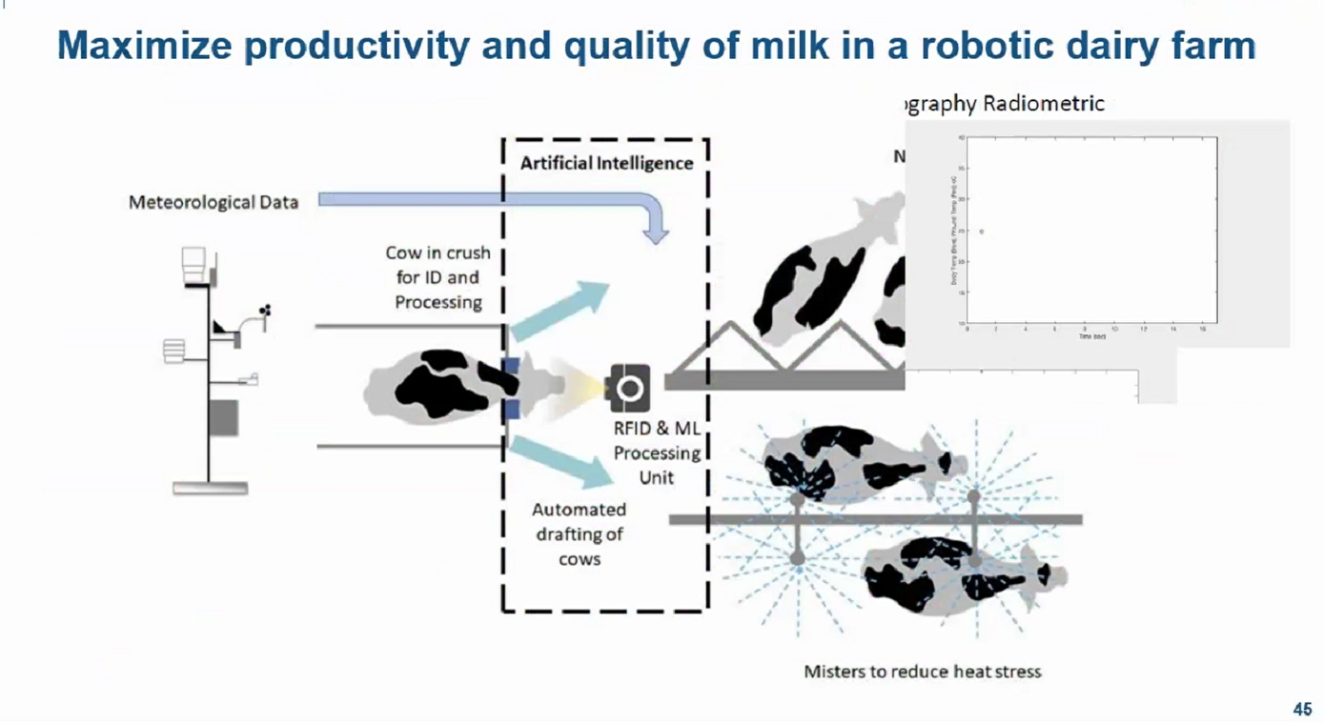It can also help assess the quality and productivity of meat and milk.

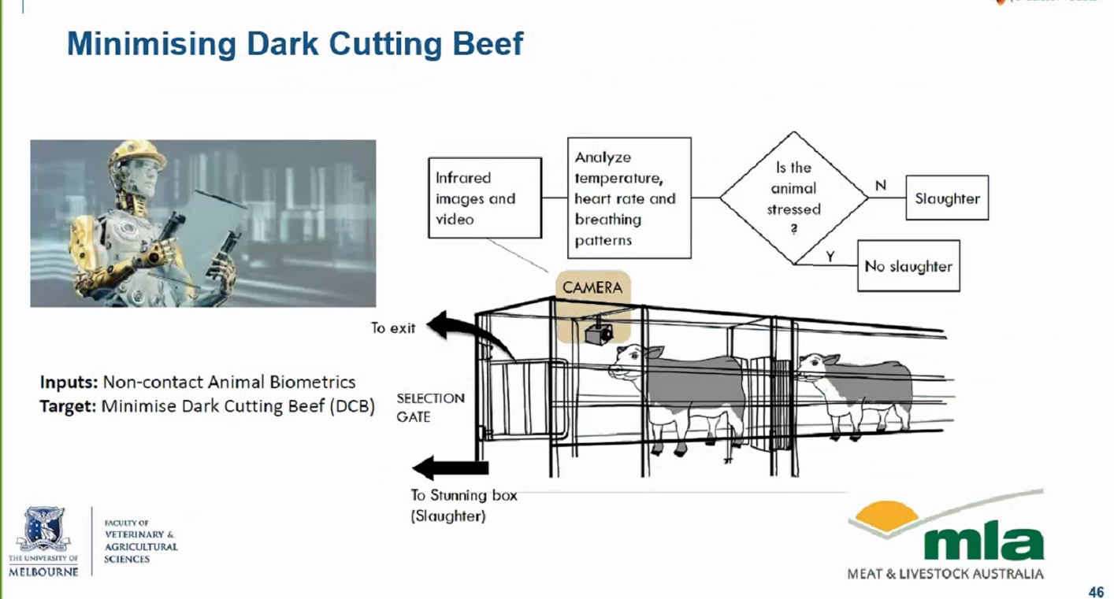

**CHALLENGES:** For major agricultural powerhouses like India and South America, the challenge of providing internet and sophisticated technological tools to every rural farmer and producer still remains.

Therefore the government and corporates need to take initiatives to provide all the required resources and services at minimal costs.

**NO PLAGIARISM STATEMENT:**

I certify that this report is my own work, based on my personal study and/or research and that I have acknowledged all material and sources used in its preparation, whether they be webinars, panel discussions, books, articles, reports, lecture notes and any other kind of document. I also certify that this assignment/report has not previously been submitted for assessment and that I have not copied in part or whole or otherwise plagiarised the work of other students and/or persons.

Name: Mintu Raj Mushahary (Regn. No: 1804609017)

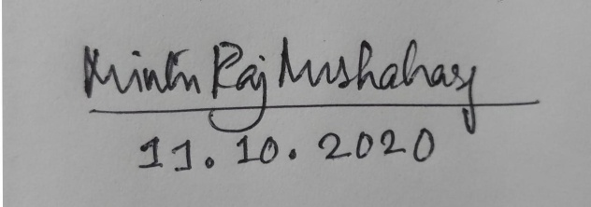Signature with date: