

**NAME : SHRIJAN PRAVEEN TAYDE**

**REGISTRATION NO : 1804609025**

**COURSE : B.TECH 3RD YEAR (NAOE)**

**REVIEW TOPIC NAME :**

**BASEL CONVENTION**

**,ON THE CONTROL OF TRANSBOUNDARY MOVEMENTS OF HAZARDOUS WASTES AND THEIR DISPOSAL AND REGIONAL INSTRUMENT**

**BASEL CONVENTION**

**,ON THE CONTROL OF TRANSBOUNDARY MOVEMENTS OF HAZARDOUS WASTES AND THEIR DISPOSAL AND REGIONAL INSTRUMENT**

Eventually, all chemicals will become waste.

As agreed by the international community, “wastes” are substances or objects that are disposed of, intended to be disposed of, or required to be disposed of under provisions of national law.

“Hazardous wastes” are a division of waste that includes a goodrange of waste capable of causing harm to human health, the environment, or both in many cases. These comprises wastes that are explosive, flammable, liable to spontaneous combustion, poisonous, infectious, corrosive, toxic, that emit flammable gases upon contact with water, and those that are capable of deriving another harmful substance after it’s disposal. Once generated, hazardous wastes require proper handling and disposal if their unfavourable impacts on human health and the environment are to be avoided.

**THE ORIGINS OF THE BASEL CONVENTION**

The Basel Convention on the Control of Transboundary Movements of Hazardous Wastes and their Disposal (“Basel Convention”) is the most vital legally binding international agreement associated with hazardous and other wastes.

The origins of the Basel Convention are often traced to

the 1972 United Nations Conference on the Human Environment,

(“1972 Stockholm Conference”), which was held to deal with pollution and other environmental problems which threatened the health and wellbeing of people and posed risks of damage to ecosystems and species important to life.

**1987 CAIRO GUIDELINES**

The Cairo Guidelines and Principles for the Environmentally Sound Management of Hazardous Wastes (“1987 Cairo Guidelines”) were subsequently developed, within the framework of UNEP, with a view to assist governments in the evolving process of formulation of national policies and measures for the environmentally sound management and disposal of hazardous wastes.

This draft became the Basel Convention, which was adopted on 22 March 1989, and entered into force on 5 May 1992. As of 15 January 2021 it has 188 Parties.

They also include wastes containing harmful compounds likearsenic, cadmium, mercury, lead, acidic solutions, organic phosphorus, halogenated organic solvents, and phenols. Such wastes originate from a variety of sources, including a plethora of production processes, medical care in hospitals, and domestic waste, such as electronic waste.

These definitions indicate that wastes requiring control result from the day-to-day human activities that make societies function. As the world becomes more developed and advanced, societies becoming larger, with more affluent consumption patterns, a wide range of industrial, commercial, construction, agricultural, medical, and even domestic activities have increased at an exponential rate, the inexorable consequence being an accelerated rate of waste generation.

**ADVERSE EFFECT**

Due to its detrimental effects on human health and therefore theenvironment, concerns have arisen over the amount of hazardous and other wastes generated throughout the world, and the challenges inherent in making sure that they are managed in an environmentally sound manner. In many countries, large quantities of wastes have been generated that may outstrip the countries' capacity to properly dispose of them.

**LIABILITY AND COMPENSATION**

Another feature of the Convention is set out in Article 12 on liability and compensation for damage resulting from the transboundary movement and disposal of hazardous and other wastes. Deliberations about the development of a Protocol began in 1993, mainly in response to concerns by developing countries about their lack of funds and insufficiency in technologies for coping with illegal dumping or accidental spills of hazardous wastes.

The Basel Protocol on Liability and Compensation for Damage resulting from Transboundary Movements of Hazardous Wastes and their Disposal was adopted at the fifth meeting of the Conference of the Parties in 1999.

As of 15 January 2021, it has 12 ratifications, requiring another 8 before it enters into force.

The objective of the Protocol is to supply for a comprehensive regime for liability also as adequate and prompt compensation for damage resulting from the transboundary movement of hazardous wastes and other wastes, including incidents occurring due to illegal traffic in those wastes.

The Protocol addresses who is financially responsible within the event of an event . Each phase of a transboundary movement, from the purpose at which the wastes are loaded on the means of transport to their export, international transit, import, and final disposal, is considered.

The Protocol shall enter into force on the 90th day after the date of deposit of the 20th instrument of ratification, acceptance, formal confirmation, approval or accession.

**CONCLUSION**

Awakening environmental awareness and a corresponding tightening of environmental regulations in the industrialized world in the 1970s and 1980s led to increasing public resistance to the dumping of hazardous wastes – and to an escalation of disposal costs.

This in turn led some operators to seek cheap disposal options for hazardous wastes in the developing world. It was against this background that the Basel Convention was negotiated in the late 1980s. Its thrust at the time of its adoption was to combat “toxic trade,” as it was termed.

The Convention entered into force in 1992 and we expect further development to help us ensure better healthy human lives, a pure and thriving environment and lastly a harmonious symbiosis.

**FACTS RELATED TO BASEL CONVENTION**

1. Radioactive waste is not covered by Basel’s Convention.
2. Discharges from normal operations of the ship are not covered.
3. Hazardous waste like explosives, toxic or poisonous substances is governed by the Convention.

**PLAGIARISM DECLARATION**

I certify that this book review is my own work, based on my personal study and/or research. I also certify that this assignment has not previously been submitted for assessment and that I have not copied in part or whole or otherwise plagiarised the work of other students and/or persons.

Name: SHRIJAN PRAVEEN TAYDE

Registration No. : 1804609025

Signature with Date: SPT (4th July 2021)

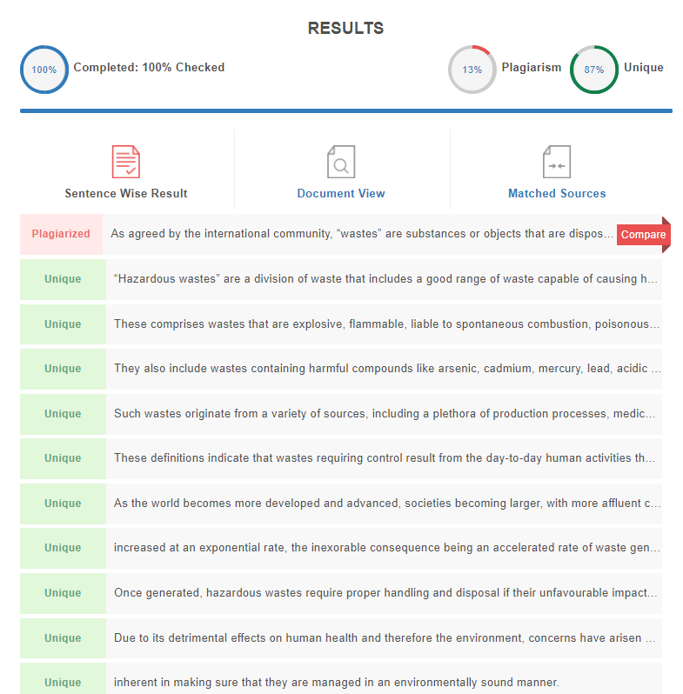

**REFERENCES**

<http://www.basel.int/>

<https://en.wikipedia.org/wiki/Basel_Convention>

<https://sustainabledevelopment.un.org/index.php?page=view&type=30022&nr=1860&menu=3170>