Talent Radar – AI-Assisted Resume Screening & Candidate Ranking Platform

The domain of the Project: Artificial Intelligence — Machine Learning & Natural Language Processing, applied to HR Technology (Resume Screening & Candidate Ranking)

COURSE NAME: AI&ML

Team Mentors (and their designation):

Mrs. Rajalakshmi C

Team Member:
Tamojyoti Maitra

Period of the project

14th March 2026 to 13th September 2026

Declaration
The project titled “Talent Radar – AI-Assisted Resume Screening & Candidate Ranking Platform” has been mentored by Rajalakshmi C, organised by SURE Trust, from March 2026 to April 2026, for the benefit of the educated unemployed rural youth for gaining hands-on experience in working on industry relevant projects that would take them closer to the prospective employer. I declare that to the best of my knowledge the members of the team mentioned below, have worked on it successfully and enhanced their practical knowledge in the domain.

Team Member:
TamojyotiMaitra
(Tamojyoti Maitra)

Mentor’s Name Mentor’s Name
Rajalakshmi C Rajalakshmi C

Prof. Radhakumari
Executive Director & Founder
SURE Trust

Table of contents
- Executive summary
- Introduction
- Project Objectives
- Methodology & Results
- Social / Industry relevance of the project
- Learning & Reflection
- Future Scope & Conclusion

Executive Summary
Project Overview
Talent Radar is an AI-assisted recruitment screening platform that helps a recruiter or hiring manager screen a batch of resumes against a single job description (JD) and get back a ranked, explainable shortlist instead of reading every resume by hand. The system parses both the JD and every uploaded resume into structured fields, scores each candidate against the JD using a hybrid of textual relevance and explicit skill/experience/education checks, and drafts interview questions per candidate — sharpened by an optional AI model, but fully functional without one.
The platform currently recognises 146 distinct skills grouped into 11 categories (programming languages, cloud & DevOps, data science & ML, security, business & analytics, and others), which drives both the skill-matching logic and the colour-coded presentation of results in the interface.
Objectives
1. Automate first-pass screening — replace manual resume reading with structured parsing and scoring of an entire candidate batch at once.
2. Make the score explainable, not a black box — build the overall score from four separately visible sub-scores that a recruiter can inspect and reweight.
3. Surface skill gaps explicitly — list exactly which required skills a candidate is missing, not just an aggregate percentage.
4. Turn screening output into interview prep — generate technical, skill-gap, and behavioural interview questions directly from each candidate's profile.
5. Work without depending on a paid AI model — keep scoring, ranking, and question generation fully functional offline, with an LLM as an optional enhancement only.

Methods
The system uses a hybrid scoring pipeline that fuses four independently computed signals into one weighted overall score:
Component | Role
TF-IDF relevance (30%) | Cosine similarity between the full resume and JD text, using scikit-learn's TfidfVectorizer, to capture overall topical overlap.
Skill match (40%) | Percentage of the JD's detected required skills that are explicitly present on the resume, via word-boundary matching against a 146-skill master list.
Experience (20%) | Candidate's parsed years of experience compared against the JD's stated (or recruiter-overridden) minimum.
Education (10%) | Whether the candidate's parsed education meets the JD's stated degree requirement.

Key engineering decisions:
• Recruiter-adjustable weights — the 40/30/20/10 default weighting is not fixed; a recruiter can move sliders in the sidebar to re-weight skill match, relevance, experience, and education live, and the ranking recalculates immediately.
• Manual JD overrides — a role-title field and a minimum-experience number input let a recruiter correct or supply values the automatic JD parser could not confidently detect.
• Robust experience-requirement parsing — the JD parser checks six pattern variants in sequence — ranges (“3-5 years”), “minimum of”/“at least” phrasing, “3+ years”, “Experience: 3 years”, and spelled-out numbers (“three years”) — so it isn't limited to one fixed phrasing.
• Category-conflict-free skill matching — every skill match uses a word-boundary regular expression, so a short skill name such as “R” or “Go” cannot false-positive inside an unrelated word.
• Offline-first interview questions — questions are always available from a rule-based template bank organised by the same 11 skill categories; an optional NVIDIA-hosted LLM call can sharpen the phrasing, wrapped in a try/except so any failure falls back to the offline templates silently.

Key Findings
1. A single signal is not enough — TF-IDF relevance alone missed candidates who used different wording for the same skill, while pure skill-keyword matching missed candidates who were a strong contextual fit but phrased their experience differently; combining both, weighted alongside experience and education, produced more defensible rankings than either alone.
2. Regex-based experience extraction needed real iteration — an early version only matched one phrasing pattern and silently returned zero years for JDs and resumes phrased any other way; expanding to six ordered patterns, including spelled-out numbers, closed most of the gap.
3. Transparent scoring changes how the output is trusted — showing four separate sub-scores and letting the weights be adjusted turned the tool from “trust this number” into “here is how this number was built,” which is a materially different and more defensible claim for a recruiter to act on.
4. The optional-LLM design held up under failure — with no NVIDIA API key configured, the interview-question feature still produced complete, relevant, per-category questions with zero errors.

Recommendations
1. Add a labelled evaluation set — convert a batch of manually reviewed JD/resume pairs into a small labelled relevance benchmark to catch scoring regressions as the matching logic evolves.
2. Move from TF-IDF to sentence embeddings — semantic (sentence-transformer) similarity would catch cases TF-IDF's exact-word-overlap approach misses, such as “built REST APIs” matching “backend service development.”
3. Expand skill coverage — 146 skills across 11 categories is a solid foundation but does not cover every domain (e.g., specialised manufacturing or healthcare skills); the master list should grow with real usage.
4. Add persistence — currently a screening session lives only in the browser session; saving results would let a recruiter return to a shortlist across multiple sittings.

Introduction
1.1 Background and Context
Resume screening is one of the most repetitive, time-pressured tasks in hiring. A recruiter opening a role often receives far more applications than can be carefully read, and the first pass through that stack — deciding who moves to an interview and who doesn't — is done under time pressure, with judgment that naturally drifts over a long, repetitive task.
This is especially true for small and mid-size companies and independent recruiters, who screen resumes without access to an expensive, full-featured Applicant Tracking System (ATS). Their options are largely limited to manual reading, or pasting resumes one at a time into a general-purpose AI chat tool — which is flexible, but not repeatable or comparable across a full batch of candidates.
The problem is not a shortage of qualified candidates in a given pool — it is a shortage of a fast, consistent, and explainable way to compare all of them against the same job description at once.
1.2 Problem Statement and Goals
The core problem: there is no lightweight, transparent tool that lets a recruiter screen a batch of resumes against one job description and get back a ranked, explainable shortlist — without an expensive ATS contract and without an opaque single “match score.”
The primary goal of Talent Radar is to build a screening tool that inverts the usual manual process: instead of a recruiter reading every resume start to finish, the system reads every resume once, scores it transparently against the JD, and surfaces exactly what's missing — leaving the final hiring judgment fully in the recruiter's hands.
Specifically, the project set out to achieve five objectives:
1. Batch, natural document input — accept a JD and any number of resumes in PDF, DOCX, or plain text, without requiring a specific format.
2. Transparent, tunable scoring — produce an overall fit score built from named, independently visible sub-scores, with weights the recruiter can adjust.
3. Explicit skill-gap output — show which required skills each candidate has and which they're missing, not just a single aggregate percentage.
4. Gap-driven interview preparation — turn each candidate's specific matches and gaps directly into a tailored set of interview questions.
5. Zero-cost, offline-capable operation — guarantee full functionality — scoring, ranking, and question generation — without requiring any paid API, with an LLM available purely as an optional enhancement.

1.3 Scope and Limitations
In Scope
• Hybrid scoring engine — TF-IDF relevance, explicit skill overlap, experience comparison, and education comparison, combined into one weighted overall score.
• Structured parsing — name, email, phone, skills, years of experience, and education extracted from resumes; role title, required skills, minimum experience, and required education extracted from the JD.
• Recruiter controls — adjustable scoring weights, a role-title override, and a minimum-experience override in the sidebar.
• Leaderboard and per-candidate detail — a ranked, colour-coded leaderboard by fit tier, with per-score gauge charts and a CSV export of the results.
• Interview question generation — offline template-based questions by default, with an optional NVIDIA-hosted LLM call for sharper phrasing.

Out of Scope / Limitations
• Skill coverage — the master skill list currently covers 146 skills across 11 categories; a resume or JD using skills outside this list will not have them detected.
• No live application handling — the tool screens and ranks; it does not receive, store, or route job applications.
• No ATS integration — there is no synchronisation with an external Applicant Tracking System or job board.
• English-only parsing — the regex-based extraction logic is designed around English-language resumes and JDs.
• Deterministic, not learned, matching — skill and education matching use rule-based pattern matching rather than a trained classifier, so unusual phrasing can be missed even when a real skill is present.

1.4 Innovation Component
Talent Radar's contribution is not any single algorithm — TF-IDF and rule-based parsing are both well-established techniques — but four specific design choices in how they're combined and exposed to the user:
1. Four-signal transparent scoring. Instead of a single opaque “match” number, the overall score is a named, inspectable combination of relevance, skill match, experience, and education — and every one of those weights is adjustable live, so the ranking reflects what actually matters for a specific role rather than a fixed formula.
2. Skill gaps as a first-class output. The system does not stop at a percentage; it explicitly lists which required skills are missing per candidate, colour-coded by category, so a recruiter instantly knows what to probe for in an interview.
3. Gap-driven interview question generation. Each candidate's matched and missing skills automatically drive a tailored set of technical, skill-gap, and behavioural interview questions, turning the screening output directly into interview preparation rather than stopping at a ranked list.
4. Offline-first, optional-LLM architecture. All core scoring, ranking, and question generation run locally with scikit-learn and rule-based templates; an NVIDIA-hosted LLM is purely an optional enhancement for sharper question phrasing, wrapped so that any failure — a missing key, a network error, a malformed response — falls back to the offline path silently, never breaking the tool.

Project Objectives
2.1 Goals
The project's overarching goal is to build Talent Radar, a working, explainable, and tunable resume-screening tool for recruiters and hiring managers. This overarching goal is decomposed into the following clearly defined objectives:
Objective 1 — Batch Document Ingestion
Goal: Accept one job description and any number of resumes, each in PDF, DOCX, or plain text, without requiring the user to reformat anything. Rationale: Recruiters receive resumes in whatever format a candidate submits; requiring a specific format would defeat the purpose of a fast first-pass tool.
Objective 2 — Transparent, Weighted Scoring
Goal: Combine TF-IDF relevance, skill overlap, experience, and education into a single overall score using named, independently visible sub-scores and recruiter-adjustable weights (default 30/40/20/10). Rationale: A single opaque match percentage cannot be interrogated or trusted; a recruiter needs to see, and where necessary override, what's actually driving a candidate's rank.
Objective 3 — Explicit Skill-Gap Detection
Goal: For every candidate, list exactly which of the JD's required skills are present and which are missing, matched against a 146-skill list spanning 11 categories using word-boundary regex to avoid false positives. Rationale: An aggregate score alone tells a recruiter how well someone fits, but not why — the gap list is what actually gets probed in an interview.
Objective 4 — Robust Requirement Parsing
Goal: Extract a JD's minimum experience requirement across as many real-world phrasings as possible — ranges, “minimum of”/“at least”, “X+ years”, and spelled-out numbers — with a manual override available whenever automatic detection is uncertain. Rationale: JDs phrase experience requirements very inconsistently, and a single fixed pattern reliably misses several common phrasings.
Objective 5 — Gap-Driven Interview Preparation
Goal: Automatically generate technical, skill-gap, and behavioural interview questions per candidate, driven directly by their matched and missing skills. Rationale: Interview questions are often generic; tying them to a specific candidate's actual profile turns screening output directly into usable interview prep.
Objective 6 — Zero-Cost, Offline-First Operation
Goal: Guarantee that scoring, ranking, the leaderboard, and interview-question generation all work completely with no AI-model dependency, with an NVIDIA-hosted LLM available strictly as an optional, fail-safe enhancement. Rationale: A recruiter should never be blocked from using the core tool by a missing API key, a network issue, or a cost decision.

2.2 Expected Outcomes
# | Outcome | Success Criterion
1 | A running Streamlit application that screens a batch of resumes against one JD | A user can upload a JD and several resumes and receive a ranked, scored leaderboard
2 | Transparent, adjustable scoring | Moving a weight slider changes the ranking live, and every candidate shows all four sub-scores
3 | Accurate skill-gap detection | Matched and missing skills are listed per candidate and are colour-coded by category
4 | Robust experience parsing | JDs phrased with ranges, minimums, “X+ years”, or spelled-out numbers are all correctly parsed, with a manual override available as a fallback
5 | Working interview-question generation | Every candidate receives technical, skill-gap, and behavioural questions, with or without an LLM key configured
6 | Exportable results | The ranked leaderboard can be exported as a CSV file

2.3 Deliverables
Software Deliverables
• app.py — Streamlit frontend and orchestration: sidebar controls, file uploads, weight sliders, the leaderboard, per-candidate detail, gauge charts, and CSV export.
• resume_parser.py — Structured extraction of name, email, phone, skills, experience, and education from resume text.
• jd_parser.py — Structured extraction of role title, required skills, minimum experience, and required education from JD text.
• matcher.py — TF-IDF relevance scoring, skill-overlap scoring, experience scoring, and education scoring.
• ranker.py — Weighted overall-score computation, candidate ranking, and fit-tier / colour assignment.
• question_generator.py — Offline template-based interview questions by category, plus the optional, fail-safe NVIDIA LLM enhancement.
• skills_data.py — The master list of 146 skills across 11 categories, category colours, and degree keywords.

Reporting Deliverables
• This report — Executive Summary, Introduction, Objectives, Methodology, Social/Industry Relevance, Learning & Reflection, and Conclusion chapters.
• A short demo walkthrough — covering a strong-fit, moderate-fit, and weak-fit candidate against the same JD, for mentor review.

2.4 Non-Objectives (Explicitly Out of Scope)
• Filing or tracking job applications on a candidate's behalf
• Live integration with an external ATS or job board
• Training or fine-tuning a custom machine-learning model
• Multi-language resume or JD parsing (planned future work)

Methodology and Results
3.1 Methods / Technology Used
Talent Radar uses a hybrid scoring pipeline that fuses four independently computed signals into one ranked result set:
Signal | Method | Role
Relevance (30%) | TF-IDF vectorisation (scikit-learn TfidfVectorizer) + cosine similarity between resume and JD text | Captures overall topical overlap, even when exact skill keywords differ
Skill match (40%) | Word-boundary regex matching against a 146-skill master list | Exact, auditable check of which required skills are actually present
Experience (20%) | Regex-based years extraction, compared to the JD's stated or overridden minimum | Full score once the candidate meets or exceeds the requirement
Education (10%) | Degree-keyword matching against the JD's required education | Full, partial, or no credit depending on whether a match is found

Key techniques:
• Weighted score combination — overall_score = 0.30·relevance + 0.40·skills + 0.20·experience + 0.10·education, with all four weights exposed as sidebar sliders.
• Six-pattern JD experience extraction — patterns are tried in order — ranges, “minimum of”/“at least”, “X+ years”, “Experience: X years”, and a general “X years ... experience” pattern — with spelled-out numbers (“three years”) mapped to digits before matching.
• Word-boundary skill matching — every skill is matched with a regex requiring non-alphanumeric characters on both sides, so short skill names cannot false-positive inside unrelated words.
• Fit-tier classification — the overall score maps to one of five labelled, colour-coded tiers (Excellent / Strong / Moderate / Weak / Poor Fit) using fixed thresholds, used consistently across the leaderboard and candidate cards.
• Fail-safe optional LLM — interview-question generation always has a working offline path; an NVIDIA-hosted model is attempted only if a key is configured, wrapped in a try/except so any failure falls back silently.

3.2 Tools / Software Used
Tool | Purpose
Python | Primary programming language
Streamlit | Web application framework (UI, sidebar, session state, file upload)
scikit-learn | TF-IDF vectorisation and cosine similarity for relevance scoring
Plotly | Leaderboard bar chart and per-candidate score gauge charts (go.Indicator)
pandas | Results table construction and CSV export
pypdf / python-docx | Resume and JD text extraction from PDF and DOCX files
re (Python stdlib) | All parsing — name, email, phone, skills, experience, education
NVIDIA API (optional) | Hosted LLM used only to sharpen interview-question phrasing

3.3 Data Collection Approach
Rather than sourcing real candidate resumes, the project was tested against a deliberately constructed synthetic dataset, built specifically to exercise the scoring and ranking logic under known conditions:
1. Role definitions — 30 distinct job roles were defined across engineering, data, cloud, security, design, and business domains, each with a curated set of core, adjacent, and unrelated skills, a target minimum experience, and a required degree.
2. Job descriptions — one JD text file was generated per role, phrased as a realistic posting with a title line, a requirements section, and a “nice to have” section.
3. Resumes — three resumes were generated per role at three deliberate fit levels — strong fit (most core skills, meets or exceeds experience), moderate fit (roughly half the core skills, borderline experience), and weak fit (mostly unrelated skills, below the required experience) — so the ranking behaviour could be checked against a known expected order.
This gave a 30-role × 3-resume test matrix (90 resumes total) that was used to verify that strong-fit candidates consistently ranked above moderate- and weak-fit candidates for the same JD, and to catch parsing failures across a wide variety of realistic role types.

3.4 Project Architecture
+----------------------------- USER LAYER ------------------------------+
| Streamlit Web UI (app.py) |
| +- Sidebar: JD upload/paste, role title + min-experience override, |
| | resume upload, scoring-weight sliders |
| +- Leaderboard: ranked, colour-coded candidate cards |
| L- Candidate detail: 4 score gauges, matched/missing skills, CSV |
+-------------------------------+----------------------------------------+
| JD text + resume files
v
+----------------------------- PARSING ----------------------------------+
| resume_parser.py: name, email, phone, skills, experience, education |
| jd_parser.py: title, required skills, min experience, required degree |
+-------------------------------+----------------------------------------+
v
+------------------------- MATCH & SCORE ---------------------------------+
| matcher.py: TF-IDF relevance | skill overlap | experience | education |
+-------------------------------+----------------------------------------+
v
+------------------------ RANK & WEIGHT -----------------------------------+
| ranker.py: weighted overall score, sort descending, fit-tier + colour |
+-------------------------------+----------------------------------------+
v
+---------------------- PREP & RENDER --------------------------------------+
| question_generator.py: offline templates by skill category, |
| optional NVIDIA LLM enhancement (fail-safe) |
+-----------------------------------------------------------------------------+

Module responsibilities:
• app.py — Streamlit front end and orchestration: session state, sidebar controls, the full ingest-to-render pipeline call, leaderboard and detail rendering.
• resume_parser.py / jd_parser.py — regex-based structured field extraction for resumes and job descriptions respectively.
• matcher.py — the four independent scoring functions (relevance, skill, experience, education).
• ranker.py — weighted score combination, sorting, and fit-tier / colour assignment.
• question_generator.py — offline template-bank question generation plus the optional, fail-safe LLM call.
• skills_data.py — the master skill list, category mapping, category colours, and degree keywords shared across the app.

3.5 Final Project Working Screenshots
Screenshot 1 — Home Screen and Sidebar (JD Upload, Min. Experience Override)
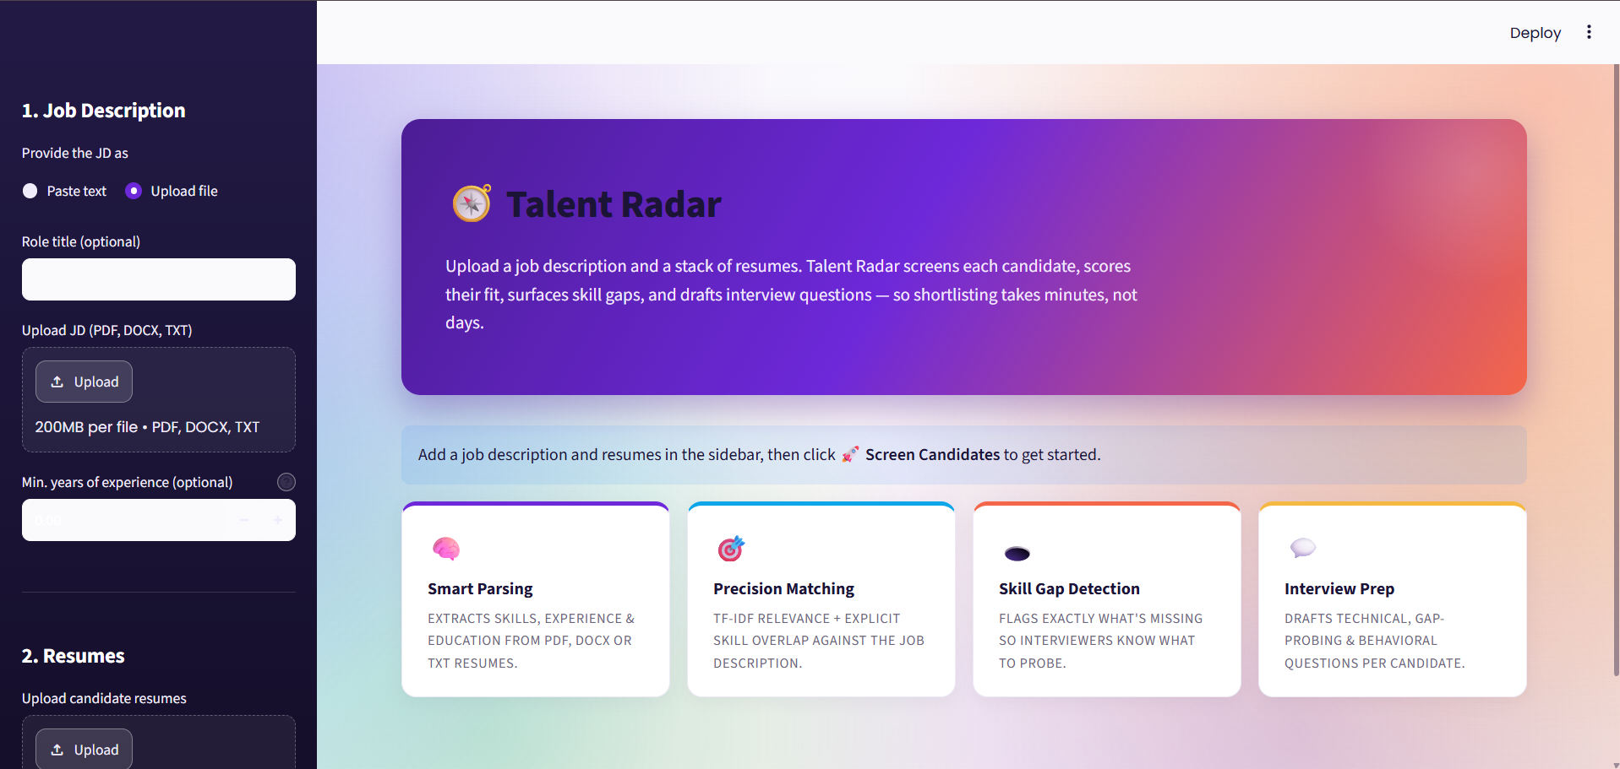
The landing screen: JD upload, optional role title and minimum-experience override, and the four feature cards (Smart Parsing, Precision Matching, Skill Gap Detection, Interview Prep).

Screenshot 2 — Uploading a Batch of Resumes
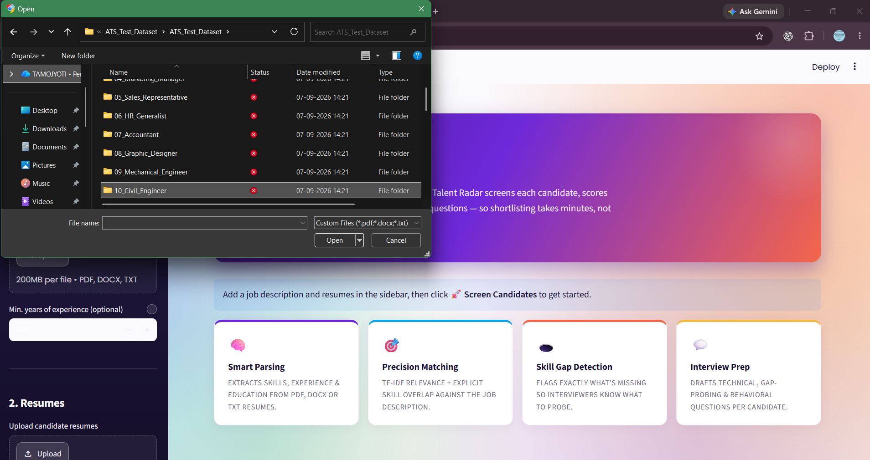
Selecting multiple candidate resumes at once from a role-organised test dataset folder, demonstrating batch ingestion of PDF/DOCX/TXT files.

Screenshot 3 — Ranked Leaderboard and Scoring Weights
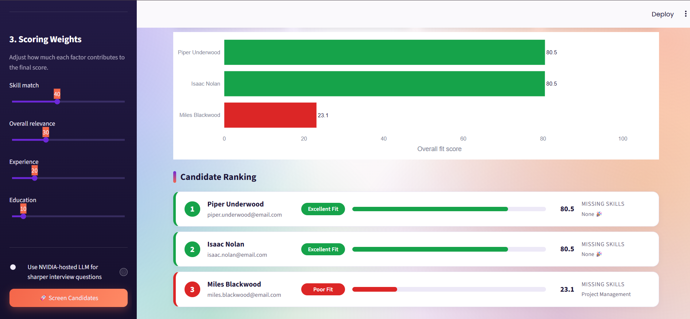
The sidebar's adjustable scoring weights (Skill match 40, Relevance 30, Experience 20, Education 10) alongside the resulting overall fit-score bar chart and colour-coded candidate ranking — two Excellent Fit candidates and one Poor Fit candidate with an explicit missing-skill flag.

Screenshot 4 — Candidate Detail: Skill Gaps, Interview Questions, and Score Gauges
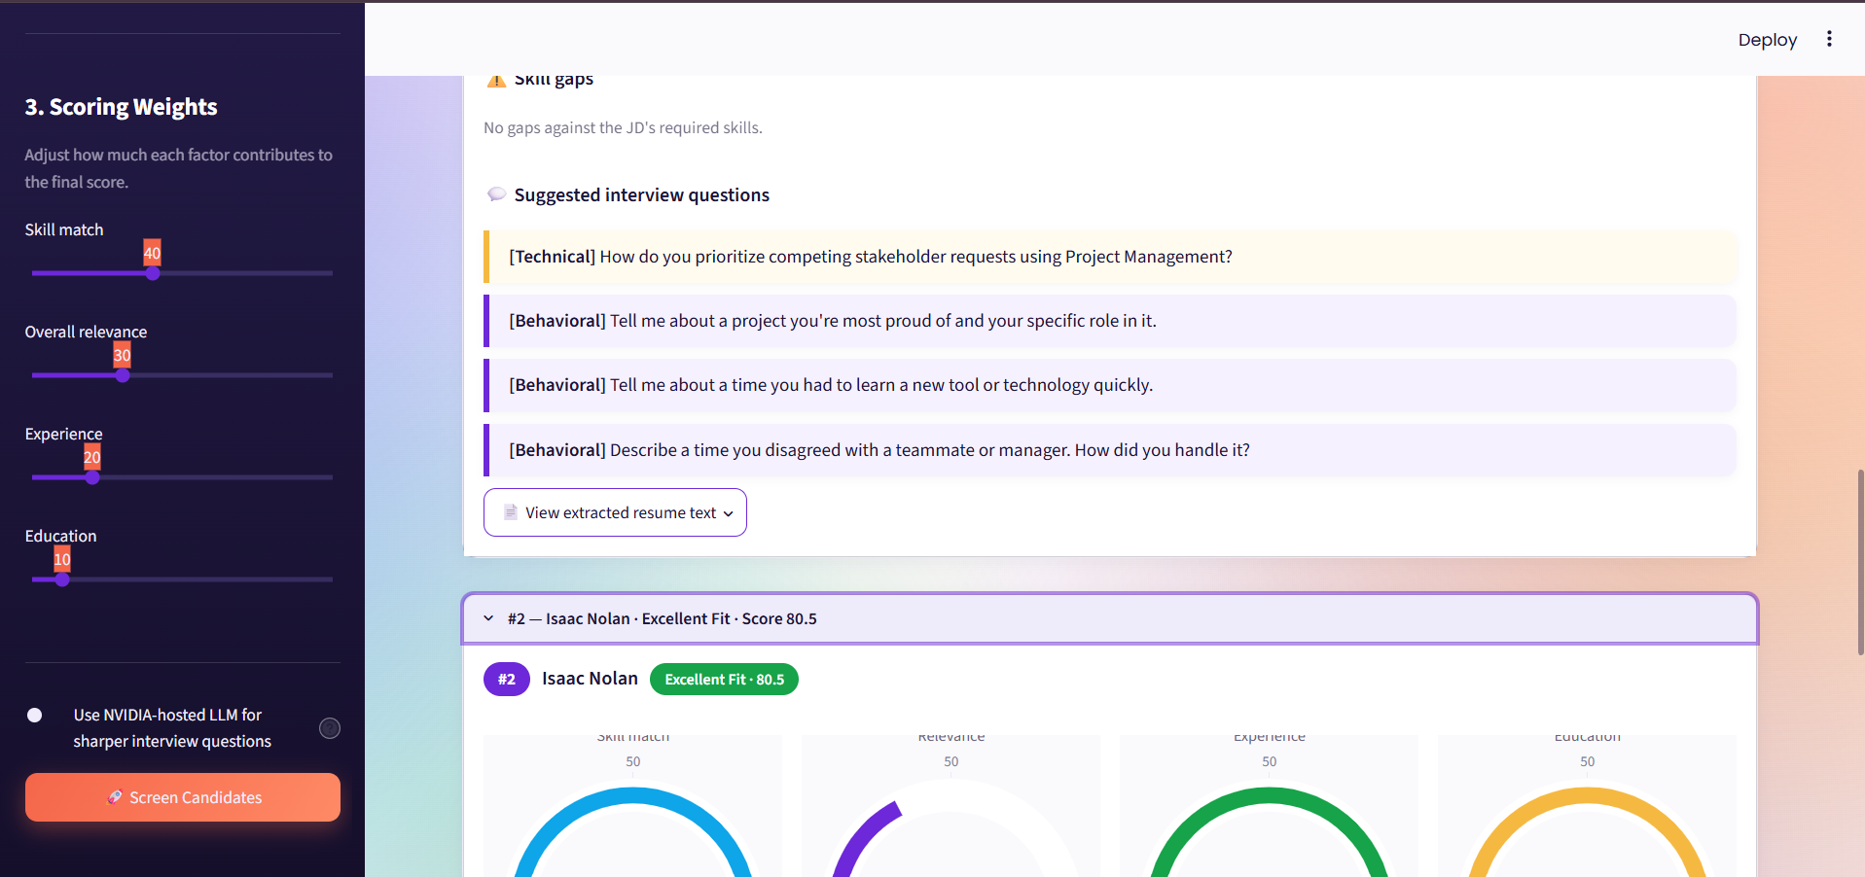
Per-candidate detail view showing a skill-gap check, auto-generated technical and behavioural interview questions, and the four individual score gauges (skill match, relevance, experience, education) that feed the overall weighted score.
3.6 Project GitHub Link
PROJECT_LINK

Social / Industry Relevance of the Project
Resume screening sits at the entry point of nearly every hiring process, which means improving it has an outsized effect on both sides of the hiring relationship — the organisation trying to fill a role, and the candidates whose applications are being judged.

Relevance to Recruiters and Small Businesses
• Time savings at the point of greatest volume — the first pass through a stack of resumes is the most repetitive and time-consuming stage of hiring; automating structured comparison against a JD frees a recruiter's time for the parts of hiring that genuinely need human judgment — interviews and final decisions.
• Access for teams without an ATS — small businesses, independent recruiters, and early-stage startups often cannot justify an enterprise ATS contract; a free, self-hosted tool brings structured screening within reach of exactly the teams least likely to otherwise have it.
• Consistency across a hiring cycle — a rule-based, weighted score applies the same criteria to every candidate in a batch, reducing the day-to-day drift in judgment that affects manual review.

Relevance to Candidates
• Explainable rejection or advancement — because the score is built from named, visible sub-scores rather than an opaque model output, a recruiter using this tool can, in principle, explain to a candidate specifically which skills or experience gaps affected their evaluation, rather than offering no explanation at all.
• Reduced risk of a single point of failure — combining relevance, skill match, experience, and education means a candidate is not penalised purely for how one part of their resume happens to be phrased.

Relevance to the AI/ML Industry
• A concrete example of hybrid, non-black-box AI system design — the project demonstrates that a genuinely useful screening tool does not require a large trained model; combining classical NLP (TF-IDF) with deterministic rules and a clearly optional generative-AI layer is a design pattern applicable well beyond recruitment — anywhere a transparent, auditable decision is preferred over an opaque one.
• A practical illustration of cost-conscious AI product design — building the core value of the product (scoring and ranking) entirely offline, with an LLM as a strictly optional enhancement, is directly relevant to any team weighing inference costs against product reliability.

Learning and Reflection
6.1 Learnings — Technology
Hybrid Scoring Over a Single Signal
The clearest technical lesson of the project: no single scoring signal is sufficient on its own. TF-IDF relevance captures topical overlap but can be fooled by resumes that use different words for the same underlying skill; keyword-based skill matching is precise but misses anything phrased unusually. Combining relevance, explicit skill overlap, experience, and education — each weighted and each independently visible — produced rankings that held up better under inspection than any one signal alone.
Job-Description Phrasing Is Genuinely Inconsistent
An early version of the experience-requirement parser matched exactly one phrasing pattern and silently returned zero years for anything phrased differently. Expanding the pattern set to six ordered variants, including spelled-out numbers, was the single change that most improved parsing reliability across the synthetic test batch, and it reinforced a general lesson: real-world text does not follow one template, and extraction logic has to be designed around the range of actual phrasing, not the phrasing that happened to be in the first test case.
Word-Boundary Matching Matters for Short Skill Names
Skills like “R”, “Go”, and “C” are short enough to appear as substrings inside unrelated words or other skill names (for example, “C” inside “C++”). Using a regex with explicit non-alphanumeric boundary checks on both sides of each skill prevented these false positives, which would otherwise have quietly inflated skill-match scores.
Designing an Optional Feature to Be Genuinely Optional
Wrapping the LLM call in a try/except that falls back to the offline template bank taught a broader lesson about dependency design: an “optional” feature is only actually optional if its failure mode is invisible to the user. The first version of this logic let an API exception propagate up and break question generation entirely; isolating the LLM attempt into its own function with a guaranteed fallback made the feature safe to leave enabled without risking the tool's core reliability.
Weighted Scoring as a User-Facing, Not Just Backend, Concept
Exposing the four scoring weights as sidebar sliders — rather than hardcoding them — meant the scoring formula had to be treated as a first-class, user-visible part of the interface, not an implementation detail. This pushed the ranking code toward being a small, pure function that recomputes cleanly whenever a weight changes, rather than something entangled with the rest of the pipeline.

6.2 Learnings — Management & Process
• Build a known-answer test set before trusting the ranking. Generating a synthetic dataset with deliberate strong/moderate/weak-fit resumes per role made it possible to check the ranking against an expected order, rather than eyeballing whether results “looked reasonable.”
• Fix the root cause, not the symptom. When an early test showed a clearly overqualified candidate ranking below a weaker one, the instinct was to adjust the weights; the actual cause was a parsing failure — the experience pattern not matching that resume's phrasing — and no amount of re-weighting would have fixed an input that was silently being read as zero years.
• Treat optional integrations as failure-first, not success-first. Designing the LLM path by first asking “what happens when this fails” — rather than “what happens when this works” — produced a more robust feature than starting from the happy path and adding error handling afterward.
• Keep the core loop simple even as features grow. Adding the weight sliders, the manual overrides, and the CSV export each risked complicating the central ingest-parse-score-rank-render flow; keeping each new feature as an addition at the edges of that flow, rather than a change to its core, avoided regressions.

6.3 Overall Experience
Building Talent Radar was a useful exercise in the difference between a demo and a tool someone could actually rely on. The scoring math itself — a weighted sum of four sub-scores — is simple; almost all of the real engineering effort went into making the inputs to that math trustworthy: parsing experience requirements correctly across inconsistent phrasing, matching skills without false positives, and making sure an optional AI feature could never take the whole tool down with it.
The most instructive moment was tracing a wrong ranking back to a silent parsing failure rather than a scoring bug — a direct lesson that a pipeline is only as trustworthy as its weakest upstream step, no matter how carefully the downstream scoring logic is written.
Overall rating of the experience: positive and practically grounded — the project stayed small enough to fully understand end to end, while still surfacing real engineering trade-offs around transparency, robustness, and designing a feature to fail safely.

Conclusion and Future Scope
7.1 Recap of Objectives and Achievements
Talent Radar set out to solve a specific, practical problem: a recruiter with a stack of resumes and one job description has no fast, transparent way to compare every candidate against it at once. The project's goal was to invert the usual manual process — read every resume once, score it transparently, and surface exactly what's missing — while keeping the final hiring decision fully in the recruiter's hands.
# | Objective | Achievement
1 | Batch document ingestion | PDF, DOCX, and plain text accepted for both the JD and any number of resumes
2 | Transparent, weighted scoring | Overall score built from four visible, independently weighted sub-scores, adjustable live via sidebar sliders
3 | Explicit skill-gap detection | Matched and missing skills listed per candidate, matched against a 146-skill, 11-category list with word-boundary regex
4 | Robust requirement parsing | Six ordered experience-extraction patterns, including spelled-out numbers, plus a manual override
5 | Gap-driven interview prep | Technical, skill-gap, and behavioural questions generated per candidate from their actual matches and gaps
6 | Zero-cost, offline-first operation | Full functionality verified with no LLM key configured; optional NVIDIA model fails safely if attempted

Final deliverables: a working Streamlit application, a hybrid four-signal scoring engine, recruiter-adjustable weighting, a fail-safe offline-first interview-question generator, and a synthetic 30-role test dataset used to verify ranking behaviour end to end.

7.2 Future Scope
Near-Term
1. Semantic (embedding-based) matching. Replace or supplement TF-IDF with sentence-transformer embeddings to catch cases where a resume and JD describe the same skill in different words.
2. A labelled evaluation benchmark. Convert the synthetic test matrix into a formal, labelled relevance set so future changes to the scoring logic can be checked against it automatically.
3. Expand the skill list. Grow beyond 146 skills to cover domains not yet represented, based on real usage.

Medium-Term
4. Result persistence. Save screening sessions so a recruiter can return to a shortlist across multiple sittings, rather than losing it when the browser session ends.
5. Multi-JD comparison. Let a recruiter screen the same resume pool against several open roles at once, useful for agencies working multiple client openings simultaneously.
6. Bias and fairness auditing. Add tooling to check whether scoring weights or skill detection produce systematically different outcomes across resume styles, as a transparency and trust feature.

Long-Term
7. Lightweight ATS integration. Optional connectors to common ATS or job-board exports, so screening results can flow back into an existing hiring workflow rather than living only in this tool.
8. Multi-language parsing. Extend structured extraction beyond English-language resumes and JDs.
9. Analytics dashboard. Aggregate, anonymised insight into which skills and experience levels are most commonly missing across a hiring cycle, to inform sourcing strategy.

Closing Statement
Talent Radar demonstrates that a genuinely useful, trustworthy resume-screening tool does not require a large trained model or an expensive ATS contract — a transparent, weighted combination of classical NLP and rule-based parsing, with generative AI used only as an optional, fail-safe enhancement, is enough to turn a manual, inconsistent first pass through a resume stack into a fast, explainable, ranked shortlist. The project ends this phase not as a finished product but as a working foundation — one where every scoring decision can be inspected, adjusted, and explained, rather than simply trusted.

