Functioning of the sensors

Sensor 4
There seem to be weird results returned by some sensors. One of the sensors that displays weird behavior is sensor 4. Sensor 4 is the sensor most located to the north. The readings for all chemicals measured by sensor 4 seem to drift upward (Reading sensor 4). The suspected reason for this drift is an error, because no other sensor seems to display this pattern. The error might be caused by a broken air filter, that gets more broken over time, and lets more of the chemicals through over time, causing higher readings over time, but this is only speculation. Illustration 1 contains the bottom part of the complete scatter plot. If we look at the mean reading of each test period (april, august, december), we see the drift reflected. Mean reading sensor 1: april = 0.31 parts/million, august = 1.11 parts/million, and december = 1.99 parts/million. We can see the mean (approximately) doubling for each period.

Reading sensor 4 Reading sensor 8 (for comparison)
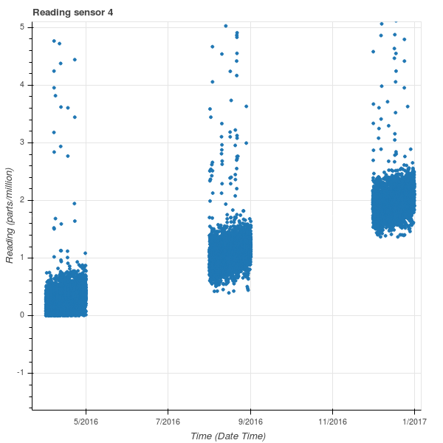
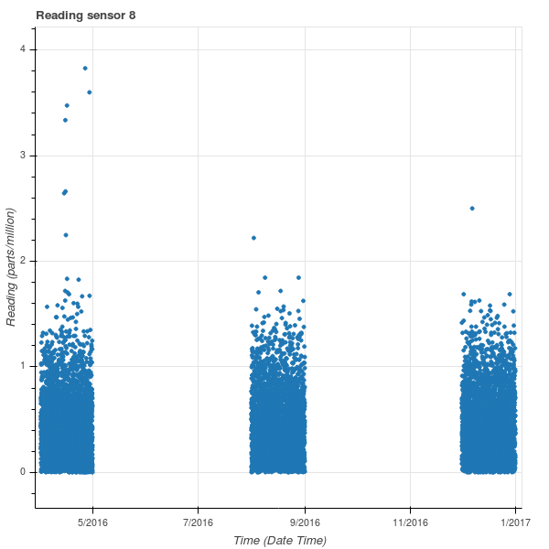

Sensor 9
Another sensor that displays weird behavior is sensor 9. Sensor 9 is the sensor most located to the east. The readings for all chemicals measured by sensor 9 seem to suddenly spread upward midway through the second test period (Reading sensor 9). The sudden spread takes place between the 22nd and 25th of august. The suspected reason for this upward spread is an error, because no other sensor seems to display this pattern. The error might be caused by a changing environment (the removal of a building for instance) making it more likely for chemicals to reach the sensor, causing a bigger likelihood of higher readings, but this is only speculation. If we look at the standard deviation of the sensor, we can see that the deviation before the 22nd of august is 0.27, and the standard deviation after the 25th of august is 0.44. The standard deviation almost doubles.

Reading sensor 9 Reading sensor 8 (for comparison)
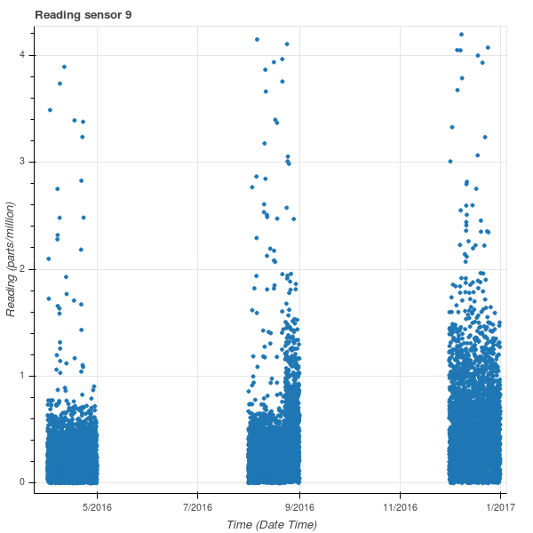

Sensor 5
Another sensor that displays weird behavior is sensor 5. The readings for all chemicals measured by sensor 5 seem to slowly spread upward. (Reading sensor 5). The suspected reason for this upward spread is an error, because no other sensor seems to display this pattern. The error might be caused by a slowly changing environment (slowly felling a patch of woodland) making it more and more likely for chemicals to reach the sensor, while less and less trees are in the way, causing a bigger likelihood of higher readings. This is only speculation. If we look at the standard deviation of the sensor, we can see that the standard deviation in april is 0.27, in august it is 0.46, and in december it is 0.52. We can see that the standard deviation gets bigger and bigger over time.
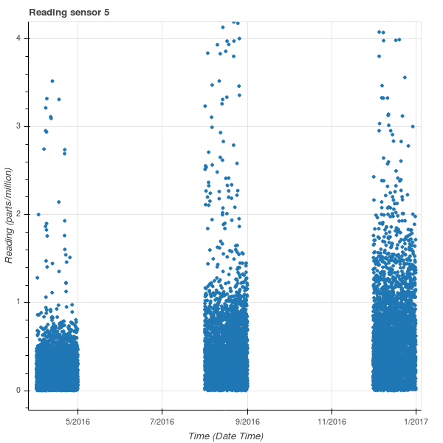
Reading sensor 5 Reading sensor 8 (for comparison)

Sensor 3

It looks like sensor 3 has its readings more spread out than the other sensors (Reading sensor 3). This goes for all chemicals measured by sensor 3. The error might be caused by a defect in the sensor, causing the sensor to measure less precise, resulting in a higher standard deviation. But this is only speculation. If we look at the standard deviations of the sensor readings for each test period (april, august, december), we can see that these standard deviations are much higher than deviations measured by other sensors. The standard deviations of sensor 3: april = 0.90, august = 0.86, and december = 0.90. Compared to the standard deviations of sensor 8: april = 0.35, august = 0.32, and december = 0.33, we can see that the standard deviations of sensor are more than twice the standard deviations of sensor 8.

Reading sensor 3 Reading sensor 8 (for comparison)
