Functioning of the sensors
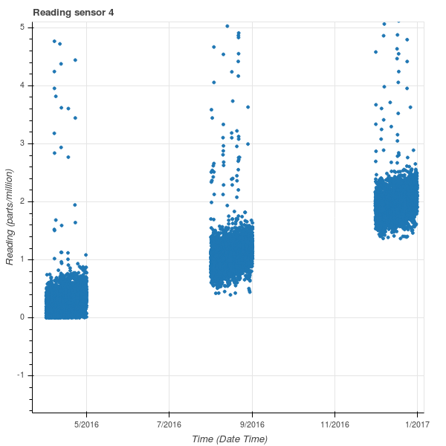
Illustration 1: Reading sensor 4
There seem to be weird results returned by some sensors. One of the sensors that displays weird behavior is sensor 4. Sensor 4 is the sensor most located to the north. The readings for all chemicals measured by sensor 4 seem to drift upward (Illustration 1). The suspected reason for this drift is an error, because no other sensor seems to display this pattern. The error might be caused by a broken air filter, that gets more broken over time, and lets more of the chemicals through over time, causing higher readings over time, but this is only speculation. Illustration 1 contains the bottom part of the complete scatter plot.

