BUSINESS INTELLIGENCE FOR THE HOTEL INDUSTRY
(A CASE STUDY OF BOWEN UNIVERSITY GUEST HOUSE)

BY
JOSHUA TAMUNOKURO BLUE-JACK
(SSE/016/16103)

A PROJECT SUBMITTED
TO

COMPUTER SCIENCE PROGRAMME,
COLLEGE OF COMPUTING AND COMMUNICATION STUDIES,
BOWEN UNIVERSITY, IWO, OSUN STATE NIGERIA.

IN PARTIAL FULFILMENT OF THE REQUIREMENTS FOR
THE AWARD DEGREE OF BACHELOR OF SCIENCE (B.Sc.) IN
COMPUTER SCIENCE

AUGUST, 2020
CERTIFICATION
This is to certify that this project, BUSINESS INTELLIGENCE FOR HOTEL INDUSTRY, was carried out by JOSHUA .T. BLUE-JACK with matriculation number SSE/016/16103 of the Computer Science and Information Technology program under the supervision.

..................................................... ………………................................. Mr. Adeyemo Date
(Supervisor)

………………………………………………………….. ………………………………………………………...
Dr. O.G. Lala Date
(Programme Coordinator)

DEDICATION
This project work is dedicated to God Almighty, for being my source of wisdom during the course of this project and also my family, for their endless support throughout this programme.

ACKNOWLEDGEMENT(s)
I acknowledge the Almighty God for his guidance throughout this project, my parents Mr. and Mrs. Blue-Jack for all the care, financial support, love shown and prayers throughout my educational journey, my sisters for all the encouragements, to my supervisor Mr. Adeyemo may all your effort not go unrewarded.
I would like to acknowledge the Coordinator of Computer Science and Information Technology Dr.O.G Lala, staff members: Dr. Emuoyibofarhe, Dr. S. Adebayo, Dr. O.M. Awoniran, Dr. R.f. Famutimi, Mr.B.P. Ayanniyi, Dr.(Mrs) T.O. Olorunfemi, Dr. Akinwumi, Dr. Oyelami, Mr. Olatunji E. K, Dr. Ibitoye A. O, Dr. Abiodun, Dr. H.O. Aworinde Halleluyah, Mr. Agbonkhese C., Mr. Alao, Mrs. Olaniran, Mr. Akinpelu J.A, Mrs. Okedigba, and all other non–academic staff members of the Computer Science and Information Technology Department, I appreciate all efforts put towards impacting knowledge to me during the course of my four years degree programme.

TABLE OF CONTENTS
Title Page……………………………………………………………………………….i
Certification…………………………………………………………………………….ii
Dedication………………………………………………………………………………iii
Acknowledgements……………………………………………………………………..iv
Table of Contents……………………………………………………………………….v
List of Figures…………………………………………………….……………………ix
Abstract…………………………………………………………………………………xii
CHAPTER ONE……………………………………………………………………....1
INTRODUCTION……………………………………………………………………..1
1.1 Background of Study………………………………………………….…………….1
1.2 Statement of Problem………………………………………………….……………2
1.3 Aims of the Study……………………………………………………….…………..3
1.4 Objectives of the Study………………………………………………..…………….3
1.5 Methodology……………………………….…………………….………………….3
1.6 Significance of the Study………………………………………..…………………..4
1.7 Scope of the Study…………………………………………………..………………4
1.8 Proper Report Arrangement…………………………………………...…………….4
1.9 Definition of terms…………………………………………………………………..4

CHAPTER TWO………………………………………………………………………..5
LITERATURE REVIEW………………………………………………………….…...5
2.0 Preamble….…………………………………………………………………………..5
2.1 Customer Feedback………………………………………………………………......5
2.2 Customer Feedback Metric…………………………………..………………..……..7
2.2.1 Customer Satisfaction….…………………………………….…………….7
2.2.2 Net Promoter Score………………………………………………………...8
2.2.3 Customer Effort Score…………………………………………………….10
2.3 Feedback Loop……………..………………………………………………………..10
2.4 Customer Feedback System…..……………………………………………………..13
2.5 Customer Experience Management.....…..………………………………………….14
2.6 Business Intelligence………………………………………………………………...18
2.6.1 Components of Business Intelligence……………………………………...19 2.6.2 Benefits of Business Intelligence……...…………………….……………..22
2.7 Elasticsearch………………………………………………………………………….24
2.7.1 Kibana………………………….…………………………………………..25
2.8 Introduction to Computer Reservation Systems……………………………………..26
2.8.1 Online Hotel Reservation System…………….…………………………....27
2.8.2 Types of Reservation………………………………………………………28
2.8.3 Factors Affecting Reservation……………………………………………..29
2.9 Empirical Review………………………..…….…………………………….……..30
2.9.1 Online Hotel Booking Systems…………………………………………..30
2.9.2 Hotel Information Management System…………………………………31
2.9.3 Faculty Feedback Management System………………………………….32
CHAPTER THREE…………………………………………………………………...33
3.1 Overview………..……………………………………………………..……………33
3.2 Proposed System………………………………………………………………..…..33
3.3 Feedback System……………………………………………………………………34
3.4 System Architecture……………………………....…………………………………35
3.5 System Design……………………………………………………………………….37
3.5.1 Flowcharts………………………………………………………………....37
3.5.2 Use Case…………………………………………………………………...40
CHAPTER FOUR…………………………………………...………………………....43
4.1 Implementation tools…………………………………..….…………………………43
4.2 Hardware and Software Requirements……………...……………………………….44
4.2.1 Minimum Hardware Requirements………………………………………..44
4.2.2 Minimum Software Requirements………………………………………...44
4.3 System Testing…..…………………………………………………………………..45
4.3.1 Reservation System Landing Page………………………………………...45
4.3.2 Booking Page……………………………………………………………...46
4.3.3 Customer Feedback Form Landing Page………………………………….49
4.3.4 Customer Feedback Form…………………………………………………50
4.3.5 Admin Login Page…………………………………………………………51
4.3.6 System Admin Landing Page……………………………………………...52
4.3.7 System Admin Feedback Records…………………………………………53
4.3.8 Kibana Dashboard………………………………………………………….55
CHAPTER FIVE……………………………………………………………………….62
5.1 Summary……………………………………………………………………………..62
5.2 Contribution to Knowledge…………………………………………………………..62
5.3 Conclusion……………………………………………………………………………62
5.4 Recommendation……………………………………………………………………..63

REFERENCES……………………………………………………………………………………64

LIST OF FIGURES
Figure Page
2.1 Net Promoter Score……………………………………………………………….9
2.2 Closed Feedback Loop……………………………………………………………12
2.3 Ten Stage Road Map for Improving Customer Experience……...……………….16
2.4 Benefits of Business Intelligence………………………………………………….23
3.1 Architecture of Feedback System………………..………………………………..34
3.2 System Architecture…….…………………………………………………………36
3.3 Booking of Room Flow Chart for User..…….…………………………………….38
3.4 System Administrator Flow Chart…….……………………………………….......39
3.5 Use Case Diagram for Customers ………………………………………………...41
3.6 Use Case Diagram for System Admin….. ………………………………………..42
4.1 Reservation System Landing Page…………………………………………………45
4.2 Customer Booking Page……………………………………………………………46
4.3 Sign Up/Login Page for Customer……………….…………………………………47
4.4 Booking Form…………………………………….………………………………....48
4.5 Customer Feedback Form Landing Page……….…………………………………...49
4.6 Customer Feedback Form………………………….………………………………..50
4.7 System Admin Login Page……………………….………………………………….51
4.8 System Admin Landing Page after Logging in…..………………………………….52
4.9 System Admin Feedback Records………….………………………………………..53
4.10 System Admin Booking……………………………………………………………54
4.11 Dashboard of Total Hotel Reservations made by Customers………………………55
4.12 Dashboard for Hotel Reservations in tabular format……………………………….56
4.13 Dashboard Display of top emails and room type……………………………………57
4.14 Dashboard display of Total Number of feedbacks submitted…………………….....58
4.15 Dashboard display of Feedback Type and Service Type………………………….....59
4.16 Dashboard Display of Feedback Room Type and Room Number……………….......60
4.17 Dashboard Display Feedback in Tabular Form………………………………………61

TABLES
Table Page
1.1 Inverted Index……………………………………………………………………………24

ABSTRACT
The hospitality industry includes the Hotel Industry, which is what this project aims to address. The competitive nature of the hotel industry has risen over the years and in order to thrive, well informed decisions must be made. Hotel managers now seek for ways to win over as much customers as they can, in doing so they try as much as possible to have knowledge about their customers and their customers’ preferences in order to tailor the activities to suit them. Thus, gathering data from customers becomes paramount and most times these data come in sentential formats and large amount, which could be exhausting to go through. Therefore gathering of customer feedback and obtaining insights cross-sectionally from these feedback becomes a major problem. This project designs and develops a web based business intelligence system on reservation systems using elasticsearch to help managers. With this system, managers would easily gather and analyze customer feedback through a dashboard to provide a summary of the data, giving useful insights and better business management.

CHAPTER ONE
INTRODUCTION
  - Background of Study
The use of information technology and information systems in our world today has become inevitable, to the point that one could almost not function effectively without it. According to Gharegozi et al (2011), Information Technology is the design, creation, utilization, support and, management of computer-based information systems in fostering the transaction of information products and services. Therefore, the use of hotel reservation systems have made drastic changes, improvements and have brought efficiency to the booking process of accommodation in hotels, motels, etc. as the case may be to the customer, giving a competitive edge to those who have incorporated it into their system.
However, the field of tourism, hospitality, and travel recently recognized over the years the need for a client-centric approach that pays attention to the customer needs, wants, and preferences as determinants to enhance quality, customer satisfaction and memorability of the tourist experience (Correia et al.,2013; Prayag et al., 2013). Therefore, as much effort is put into pleasing the customer, hotel managers tend to develop strategies to gather data on customer preferences in order to stay afloat in the tourism industry. So, in order to understand customer preferences, Data is often sort for by managers to serve as a source of insight to aid in decision-making processes to improve how a hotel operates. As such, Big Data has also started to be a significant source for Business Intelligence activities aimed at creating, delivering and capturing customer value (Verhof et al., 2016). Due to the fact that big data allows for a large number of sources to be examined, it provides answers to questions concerning people’s opinion, reviews, and preferences and at the same time serve as a powerful tool to address problems, develop innovative approaches useful in the advancement of knowledge ultimately generating both policy and managerial decision support (Gerard et al.,2016).
Business Intelligence systems are mainly used by firms to gather, analyze and visualize data for their business and aids in making decisions to gain a competitive advantage and to have an understanding of what is going on in one's business. Business Intelligence originally evolved from Decision support systems (DSS) which are information-based system that supports business or organizational decision-making activities in choosing amongst alternatives (Burstein and Holsapple, 2008; Sauter, 2011) and these Decision Support Systems typically comprise of computer-aided models, Data warehousing (DW), Online Analytical Processing (OLAP) and executive information systems (Kimball et.al.,2008).
For this project, the major goal is to address the absence of a feedback mechanism system on hotel reservation systems, which will allow customers to make reviews about the hotel services and to provide a tool for the hotel managers to derive useful information from the reviews gotten through Business Intelligence (BI) dashboards called Kibana.
  - Statement of Problem
Hotel managers often seek ways to improve the services rendered to customers but sometimes find it difficult due to the absence of a customer feedback system. Also, the need for managers to get real-time data about customer’s preferences and behavior has become a pressing issue in the hotel industry. Thus, customers who probably were not pleased with the services provided by a hotel give a negative word of mouth to future customers without the knowledge of the hotel. This negative word of mouth and reviews that are unknown to the particular hotel reduces their customer base, leads to loss of income and tarnishes the image of the hotel. This project will provide a feedback mechanism to customers on the system, to make comments on the services provided by the hotel and for managers to see and with the aid of business intelligence dashboards using Kibana will enable in the visualizing of the comments made easily using various charts, gaining insights to both negative and positive comments and in turn develop strategies to improve the quality of hotel services and increase their competitive edge.
  - Aims of the Study
The aim of this project is to develop a feedback mechanism for hotel reservations systems and help make the work of managers a lot easier when tracking the areas in the hotel that need improvement through Business Intelligence.
  - Objectives of the Study
In order to achieve the aim of this project, the following are the specific objectives:
- To design and represent the proposed system with Unified Modeling Language (UML) diagrams.
- To implement the design.
- To test the system.
  - Methodology
To achieve the earlier stated objectives the following tools will be used
MySQL (Structured Query Language): which is an open-source relational database management system, was used to handle the storage, retrieval, and management of the database for this application.
Django: is a python framework that was used to handle the web development of this project
Elasticsearch: This a search and analytic engine that was used to the real-time search and data for this project
Kibanna: This is a data visualization dashboard that was used with elastic search for this project
Python: This is a programming language that was used to pull data from the data source to elasticsearch for this project
  - Significance of the Study
This project is to help hotel managers receive reviews from customers about the hotel services in real-time on hotel reservation systems, visualize reviews made, thus giving information on what to improve within the organization to enable them to give a competitive edge and stay afloat in the tourism industry.
  - Scope of the Study
This project will focus on the development of a customer feedback mechanism on reservation systems for hotels. The scope of this project will be limited to the hotel industry.
  - Proper Report Arrangement
In this project, previous literature studies and processes relating to this project were reviewed in Chapter 2. Chapter 3 includes all the methods used during this project, the reasons behind the approach choice and the system analysis and design of the project. Chapter 4 addresses all implementations carried out during this project.
Lastly, chapter 5, contains the summary, conclusion and recommendations.
Definition of Terms
Customer: A person who visits a hotel for either pleasure, work or other personal activities.
Online Reservation System: A software used to manage bookings.
Database: central data storage that contains all data obtained.
Feedback: These are comments gathered from customers about services or products.
Business Intelligence: this involves the use of technologies to gather, analyze and visualize data for business

CHAPTER TWO
LITERATURE REVIEW
2.0 Preamble
This Chapter discusses the basic ideas behind this project (i.e. Conceptual Review) and the past research carried out by other authors related to this study (i.e. Empirical Review).

CONCEPTUAL REVIEW
2.1 Customer Feedback
Feedback refers to comment, review or reaction to a service rendered or product, which could be positive or negative depending on the quality of the service or product provided. According to a study by Nail & Zabin (2010) on Customer Feedback Management, stated that feedback is used in a corporate world as a measure for customer experiences and key material for more improvement in customer experience management, which invariably means that for every feedback gotten there is a potential piece of improvement to enhance customer experience. For a more customer-centric approach, feedback is used as a tool to identify loopholes or errors in products or services to customers and improve the learning experience on the best ways to satisfy clients to gain their loyalty. Normally, feedbacks are given repetitively from various sources in organizations to help serve as a benchmark for managers to evaluate the position in which an organization is, at the moment and to help indicate the direction to which an organization should follow, in order to avoid wastage of organizational resources.
According to Deloitte (2018), the tourism industry has been identified as one of the fastest-growing sectors with about 1.6 trillion bookings with a large margin of increase in competitiveness amongst tourist organizations, it is, therefore, important to make every effort to please clients, therefore making it very important to put in place a systematic feedback outlet to customers, to serve as vital input on new development processes (Fundin and Bergam, 2003). Additionally, according to Soderlund (1998), customer feedback are usually either positive bias or negative bias, stating that a feedback is negative when customers’ expectation does not match perceived performance and that a feedback was positive only when customer expectation matched perceived performance which is true and supported by Holmes and Lett (1997). However, in as much as positive comments made by customers could be pleasant, negative comments are sometimes disregarded by some service renderers or product manufacturers which is wrong. Negative comments should be used constructively to an organization's advantage rather than neglecting them (Zairi, 2000).
Furthermore, studies have been carried out to identify the most preferred feedback approach in different areas and many hotels in the hospitality industry are beginning to realize the importance of customer feedback and the influence it has on improving their services. According to Pravillika (2019), some of the importance of customer feedback include:
- Enables the measurement of customer satisfaction: Service Quality of a hotel could be determined by customer's feedback, therefore giving the room for customer feedback serves as a benchmark that hotels use to rate their level of satisfied and unsatisfied customers.
- Gives room for more improvement on products and services provided by the hotel: Without customer feedback hotels will not know where they need to improve. With the various opinions gathered on the services provided, a hotel will be able to know the exact areas that need improvement and also indicate the areas where they are doing well.
- Encourages a more customer-centric approach to satisfying customers: For hotels to satisfy their customers, there is a need to understand their customer preferences. Customer feedback serves as a source of insight into those customer preferences, helping hotels to set up strategies to satisfy their customers.
- Increases customer base: Once a customer is satisfied with the services provided by a hotel, he/she will give positive word-of-mouth to future customers which increases the hotel’s referrals which leads to a vast increase in customers
- Increases customer loyalty: Customer Loyalty could refer to the result of repetitive satisfaction a customer derives from a hotel’s services. Satisfied customers will always come back, while the unsatisfied customers will not, meaning the satisfied customers who always come back are the loyal ones. Therefore with feedback, the amount of loyal customers could be measured.
2.2 Customer Feedback Metrics
Customer feedback metrics are units of measurement used by managers or business owners to evaluate feedback gotten from customers. These metrics usually help to determine the value of the service provided to customers or the level of satisfaction derived from using an organization’s product.
The commonly used metrics for Customer Feedback include; Net Promoter Score (NPS), Customer Effort Score (CES), Customer Satisfaction (CSAT), Social Media and churn metrics. For the cause of this study, Customer Satisfaction (CSAT), Net Promoter Score (NPS) and Customer Effort Score (CES) will be examined.
2.2.1 Customer Satisfaction (CSAT)
Customer Satisfaction is largely dependent on the high level of quality in company products or services. Customer Satisfaction (CSAT) is a metric used to evaluate the customers overall level of satisfaction, either from a company’s services, products or interaction with the front desk employees. Satisfaction usually reflects in the feedback gotten from customers, when managers want to know if the services provided by their company met customer needs. This satisfaction ratings could be sorted out into different groups and could be used to identify Key Performance Indicators (KPI). Thus, more insight on ways to satisfy customers is identified (Oliver 1999).
There are numerous benefits which could be derived from measuring customer satisfaction in a company, notwithstanding according to Konečnik Ruzzier et al (2014) customer satisfaction (CSAT) helps to give a business insight on futuristic happening, contributes effectively during SWOT analysis and aids in decision making.
2.2.2 Net Promoter Score (NPS)
For any business, growth is essential. Thus, business leaders and managers judiciously pay rapt attention to the amount of customers their business is able to attract, and the best way of increasing a business customer base is through satisfied and loyal customers who are willing to refer another customer to a particular business. According to a research carried out by Frederick F. Reichheld (2003) on Net Promoter Score, it was stated that one of the effective and reliable ways to make profitable growth was to increase loyal customers. This study was initiated due to persistent search for metric to measure satisfaction, experience and accountability. All efforts made by organizations to find out techniques to accurately measure customer satisfaction were all to no avail. Thereafter, more intense and subsequent research were carried out by Frederick F. Reichhled and a Bain group. Soon after that, a question was developed which made head way. This question was to find out how likely it was for a customer to recommend a company to a friend, data from Satmetrix was used to carry out test for this research which was successful. The adoption of Net Promoter Score (NPS) was as a result of the ever increasing competition in the marketing and customer growth. NPS proved to be the best metric to determine an organization level of growth after a period of time.
Therefore, Net Promoter Score (NPS), simply put is a metric used to measure customer satisfaction, identify loyal customers and areas in a business that need to be improved. A customer is usually asked to rate his/her experience while interacting on a scale of zero to ten (0-10). The scale is divided into three namely;
Detractors (Score 0-6): This means that a customer was not satisfied with a company’s services and is unlikely to recommend a company’s service to another person.
Passives (Score 7-8): This means that a customer did not find anything interesting about a company’s service. Meaning he/she could easily be won over by other competitors in the market
Promoters (Score 9-10): This means a customer was indeed satisfied with a company and most likely will refer a friend/colleague to a company.
Hence, the Net Promoter Score is calculated by subtracting the percentage of detractors from the percentage of promoters.

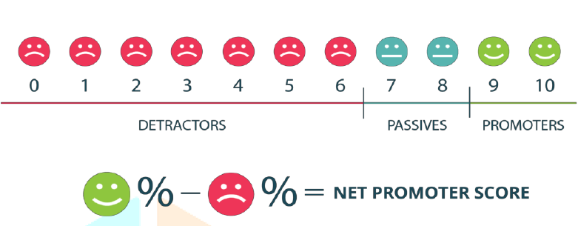
Fig 2.1: Net Promoter Score (Rajasekaran , M. N., & Dinesh, M. N., 2018)

2.2.3 Customer Effort Score (CES)
According to Jana Barrett (2019), Customer Effort Score is a feedback metric used to measure the level of difficulty or ease customers experience while interacting with a product or service. The Customer Effort Score (CES) was introduced after a review by Harvard Business in an article which aimed at rectifying problems experienced by customers faster and efficiently. Although Net Promoter Score (NPS) and Customer Satisfaction (CSAT) were able to capture key insights which were helpful at improving services and products, Customer Effort Score (CES) was particular about capturing the overall behavior of customers. In order words, Customer Effort Score (CES) was able to detect whether or not a customer finds it easy interacting with a product or service. Due to the fact that customer loyalty is obtained as a result of the ease customer experiences during contact with products or services, Customer Effort Score (CES) was found to more reliable to capture a more holistic view of customers’ experience.
Customer Effort Score (CES) is usually gotten by asking customers a single question to know if their interaction with a company’s service or product was helpful, this score is graded on a scale of 1-7. Thus if a negative response is given, a follow-up question is asked to know how it could be improved.
2.3 Feedback Loop
The feedback loop is a continuous process that involves the use of customer feedback to make suitable business decisions.
This feedback loop begins with the data collection phase which usually involves the analysis and communication of data collected to management levels who have the authority to initiate and make changes in customer experience management. However, if changes initiated do not benefit the customers at large, such changes will be revisited and proper adjustment will be made (Nail and Zabin, 2010).
After decisions have been made, it must be communicated to management levels to make their inputs about the changes made, once these changes have been implemented customers will then be allowed to give feedback, causing the loop to start all over again. Then communication is recommended to maintain the loop.

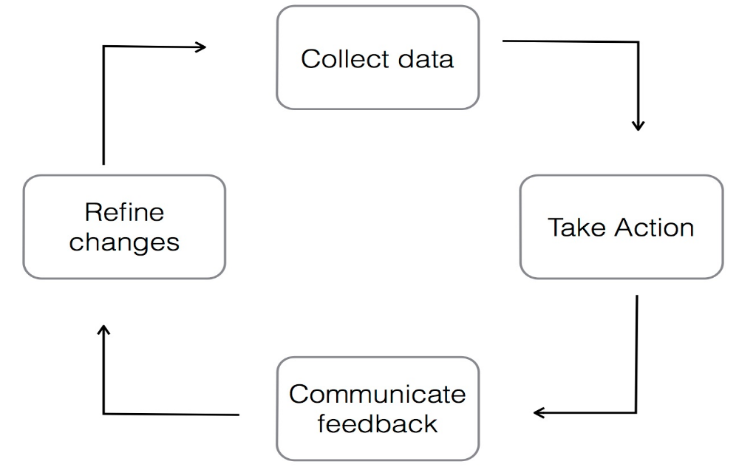
Fig 2.2: Closed-Loop Feedback (Dang, Hien, 2014)

2.4 Customer Feedback System
Customer Feedback systems are channels of communication between the organizations and the customer. It has proven to be a means through which customer opinions are translated into insights for growth and customer loyalty (Hien Dang, 2014). In as much as organizations are willing to develop a more customer-centric approach to their services, customer feedback systems serve as the right tool to facilitate that process. Feedback systems are widely used even outside the tourism industry such as food manufacturing companies who want to know what their customers think about their newly produced products, electronics manufacturing companies as well make use of feedback systems in order to help understand users’ difficulty when using their devices. This information gotten from feedback systems could either be compliments or complaints. Thus the role of a feedback system efficiently performs analysis on the feedback gotten to know exactly what action to take to meet the majority of customer demands. Information gotten from feedback analysis is expected to be implemented as soon as possible because in cases where customers make a complaint they expect to get a response to the complaint made (Barlow and Moller, 2010), which in turn is one of the factors that influence customer loyalty. Lack of response to feedback made by can lead to negative word-of-mouth from customers to future customers which reduces the chances of referrals which is bad for the growth of an organization.
According to a study by Mavis Dah et al. (2016) in Ho, Ghana the major feedback channels in use were Suggestion Boxes, Telephone, Personal Emails, Website, One-on-One Contact, Guest Comment Cards, Social Media, Customer Surveys/Online Survey and In-Room Questionnaires. It was deduced that the most effective and most used feedback channel is Suggestion Boxes. However, the most preferred feedback channel by customers was One-on-One Contact. Thus hotel managers must do well to identify the most effective and preferred feedback channel by customers. Multiple channels must be provided for customers to choose from in order to express satisfaction or dissatisfaction of a Hotel’s services.
2.5 Customer Experience Management (CEM)
Customer Experience Management is a corporate strategy to adapt all behavior and operating processes to customer needs according to Hossam El-Din Younes et al. (2013). Customer experience is commonly represented by the initial contact and engagement of a customer with a company's services. One of the factors leading up to customer loyalty is the recollection of the experience received by a customer. The idea behind Customer Experience Management (CEM) is the ability of customers to learn about an organization during his/her interaction with an organizations staff, then if an organization handles the customers’ experiences well, it can maximize the organizations chances of developing profitable relationships with the customer. Today businesses adopt different strategies to provide customer-centered services, and experiences with customers allow organizations to recognize each customer's unique interest is the best way for them to do that. Due to the competitive and innovative nature of the businesses, customer experience management (CEM) is usually used as a primary method for managing business operations. Customer experience encompasses customer emotions and benefits perceived by customers during interaction with a company or hotel, which in turn influences their behavior, and therefore, in order to understand the emotional and experimental benefits, Customer Experience Management (CEM) is used as a strategy to understand customers.
Before now organizations and business enterprises used Customer Relationship Management (CRM) as a tool in tracking the interaction customers make with the services or product online in order to understand customer behavior such as their purchases, the amount spent, products or services they spend much time on, the average amount spend, just to develop strategies to keep their sales at a considerable level or increase sales made. However, the strategies behind Customer Relationship Management (CRM) began to fail which lead to the introduction of Customer Experience Management (CEM). Customer Experience Management (CEM) was concerned more about the customer’s experience, the satisfaction level and how customers experience could be managed to gain their loyalty. A cross evaluation of each customer’s experience served as valid points for organizations and businesses to take note of and improve. The data used by managers to evaluate customer experience was normally gotten from surveys, feedbacks from customers which they are always happy to give according to Forbes.
However, the big question still remains how customer experience can be improved. In a study by Johnston, Robert and Kong, Xiangyu (2011) on “Roadmap for Improvement”, according to that study, a ten stage road map for improving experience were proposed.

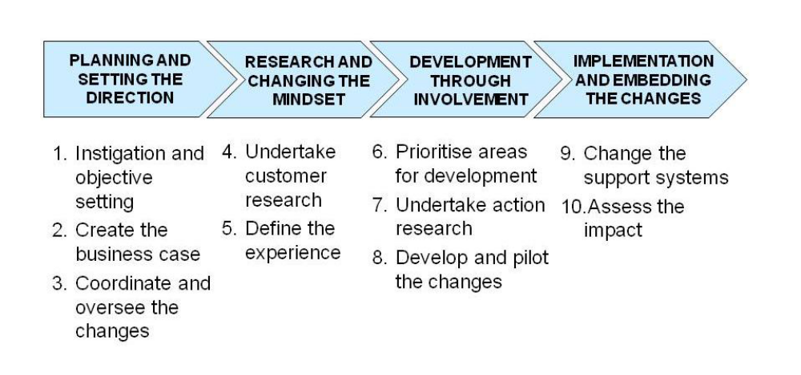
Fig 2.3: Ten Stage Road Map for Improving Customer experience (Robert and Kong, Xiangyu (2011)

This broad stages were developed in order to answer questions regarding: the need for improvement, the customer experience to be provided, the Plan to be used to improve customer experience and the effects of the changes made to customers.
- On the first stage, which is Instigation and Objective Setting, deals with the motive behind a specific change desired to be implemented by business leaders or managers to improve customer experience, although sometimes the holistic aim of implementing the change may not be known at the early stages, but definitely along the way, the motive behind the change and the strategies to be used become clearer. Also the specific business areas where changes are to be implemented need to be identified at this stage.
- Coordinating and oversee the changes involved appointing an individual amongst the team handling the changes to control the activities during the implementation of changes and report to higher authorities concerning what had been done.
- Undertake Customer research, this involves the collection of data from customers through interactions, on what customers’ expectations were about their services and the areas customers felt needed improvement. It also involved tutoring of manger and staff on the importance of making changes in business.
- Define Experience involved the experience team making statement which described their various views from customers on what they felt the services an organization should supply that would be more profitable.
- Prioritize areas for development: with the various views of customers, the experience teams become more away on the areas they need to pay more attention to. Therefore this involved putting all changes to be made on a scale of preference and working on the changes that have the highest priority in order to satisfy customers.
- Undertake action, research encouraged identifying of customer emotions while using services or products from an organization. Experience team try to study the behavior of understand the customers expected feelings at every point of the way
- Develop and pilot changes: This actions were carried out repetitively. Here the staff and managers would be asked to pick out problems usually faced by customers, the project teams will now help provide valid changes and test those changes across various departments within an organization, thereafter feedback will be demanded from customers. If changes are accepted with positive remarks from customers, the experience teams take up approaches to apply the changes across all departments.
- Change the support systems: this is the improving of an organization’s processes and systems in order to fit the changes made by the experience team to avoid customer inconveniences on understanding the new changes.

2.6 Business Intelligence (BI)
Business Intelligence is an approach in business to use several techniques such as data collection, analytics, and visualization to support operations and strategic-decision making activities. Business Intelligence is now used as the general term that involves data mining, data ware housing, reporting as well as online analytical processing (OLAP) (Williams,2016). Thus, In order to understand past, present and predictive views of a business, Business Intelligence (BI) technologies are used to easily identify those business trends and critical success factors for competitive advantage. Additionally, in order to identify and create business opportunities from trends found, this business intelligence technologies have proven adequate to make use of large amount of structured and unstructured big data usually gotten from internal and external sources to create useful insights for making decisions in areas such as pricing, production, advertising marketing and customer demand. Thus creating intelligence which cannot be gotten from a singular set of data. (Coker, 2014)
Business Intelligence (BI), however is believed to have originated from Decision Support System (DSS) (Arnott and Pervan, 2005), but due to its ever changing requirements BI developers often found difficult to compare DSS and EIS to Business Intelligence (BI). A Business Intelligence (BI) system could begin with concise decision making functionality but after a while its functionality could begin to increase and change due to its broad information sources. The term Business Intelligence (BI) has replaced the Decision Support Systems, Executive Information Systems (EIS) and Management Information system (MIS) (Thomsen, 2003) reason being that BI systems are able to gather data, store data and manage knowledge with analytical tools in order to present complex information to decision makers, thus Business Intelligence (BI) has a fast response time to producing of information when data is inputted compared to DSS and EIS.
2.6.1 Components of Business Intelligence (BI)
Data Warehouse and data marts, this supports the reproduction of data by handling multiple records for integration, cleaning, formation and querying tasks. It contains live and updateable set of data which can be used for tactical decision making on a subject matter. The sources of data could be historical data, operational databases, external data (i.e. the internet) or information from an existing warehouse environment or it could also have relational database sources which is data that supports a particular line of business. Usually, this data can reside on various platforms containing structured (e.g. spreadsheets, tables) and unstructured information (plaintext files, pictures) and other multimedia information, retrieval of data from operational databases into data warehouses is known as Extraction, Transformation and Load (ETL).
Data marts refers to a collection of data on a particular subject area summarized and organized for DSS needs for a given department (Inmon, 1999). Most individual departments have their set of hardware, software, data and programs which make up their data mart, in other words every department usually has their interpretation of what a data mart is or looks like and it is specific to its own needs. These data marts have operational data similar to data warehouses which assist business managers or experts strategize based on the analysis gotten from past trends and experiences. The only difference is that data marts are created and predicted based on specific needs for a particular group and configuration of data selected. Furthermore, there could be more than one data mart in an organization.
Secondly, On-line analytic processing (OLAP), this refers to ways which business owners can gain better understanding of their data with sophisticated tools which allow for efficient measures of direction in organizations. On-line analytic processing (OLAP) provides a summarized and multidimensional view of business data which is used for analysis, reporting, modeling and planning for optimizing the business. On-line analytic processing (OLAP) techniques and tools could collaborate with data warehouses designed for intelligence systems. When this intelligence systems query data, they do so to discover trends and analyze critical success factors and the reports gotten from these systems provide aggregated views in order to create awareness for managers on the state of their business. However, there are other Business Intelligence (BI) tools which could be used for storage and analysis of data such as data mining, decision support systems and forecasting, knowledge management, information visualization and dash boarding, management information system.
Real Time Business Intelligence (BI), this suggests the real time distribution of metrics in real time through email, messaging systems and interactive displays. In the past, traditional Business Intelligence (BI) did not proactively respond to situations and take critical timely business decisions in real time but nowadays that not only is analysis done in real time but also response to analysis result are to be performed in real time and at the same time change parameters of business processes. However an architecture to enhance Business Intelligence (BI) that covers the complete process to interpret, predict, automate and respond to business environments and reduce the time needed for business decisions were introduced by Nguyen Manh et al. (2005). This architecture was an Information Technology (IT) event driven architecture to run Business Intelligence (BI) applications that enabled real-time analytics across corporate business process, which notified the business of recommendations and effectively closing the gap Business Intelligence (BI) systems and business processes.
Corporate Performance Management (CPM), simply allows for the integration of the different tools that provide analysis (i.e. portals, scorecards, dashboards) in which the aggregate of the results gotten form a big picture and clear understanding of one’s business.
Advanced analytics, is any activity that involves data mining, for casting or predictive analytics, this takes advantage of statistical analysis techniques to predict or provide certainty measures on facts.
Lastly Data Sources, as earlier stated data sources can be operational databases, relational databases, historical data, and external data (e.g. from market research companies or from the internet) or information from already existing data warehouse environment, these data can be stored on different platforms which contain structured (i.e. spreadsheets) and unstructured information (i.e. plaintext file, pictures and other multidimensional information )
Business Intelligence (BI) has been considered of having great impact to making effective business decisions, helping organizations performance to improve and create competitive advantage (Liebwitz 2006). In order to keep customers in highly competitive markets, companies are forced to go to the extreme in order to gain customer loyalty, information however becomes key to managers and business experts to take productive steps in ensuring customer satisfaction is ascertained and also attract more customer. Thus, the need to establish relationship with customers becomes important and BI however has proven to efficient in monitoring customer satisfaction, improving organizations marketing strategies, operations and services.
The application of business intelligence (BI) can expand the knowledge of an organization whose goal in be an “intelligent organization”. (P. Adamczewski, 2012). Thus intelligent organization who are constantly learning operate based on what is known as knowledge management (Koronios and Yeoh, 2010) which in turn improve the efficiency and productivity.
2.6.2 Benefits of Business Intelligence (BI)
According to Azeroual, O., & Theel, H. (2019), benefits of business intelligence include:
- Business Intelligence helps to facilitate the presentation of the outcomes of data in a more understandable formats such as graphics, images etc.
- Handles the processing and analysis of information using various methods
- Enlightens business managers on the tasks and inefficiencies with the aid of realistic abstractions (.i.e. models)
- Enables timely access to fast and efficient analysis of information
- Business Intelligence (BI) encourages knowledge management amongst business managers in organizations
- Aids in efficient decision making activities from reliable sources of information
- Business Intelligence (BI) data warehouses serve as databanks for company’s data and information
- Newly implemented Business Intelligence (BI) systems are inter-operable with other exiting information and analysis infrastructures
- BI follows accurate cooperate control processes

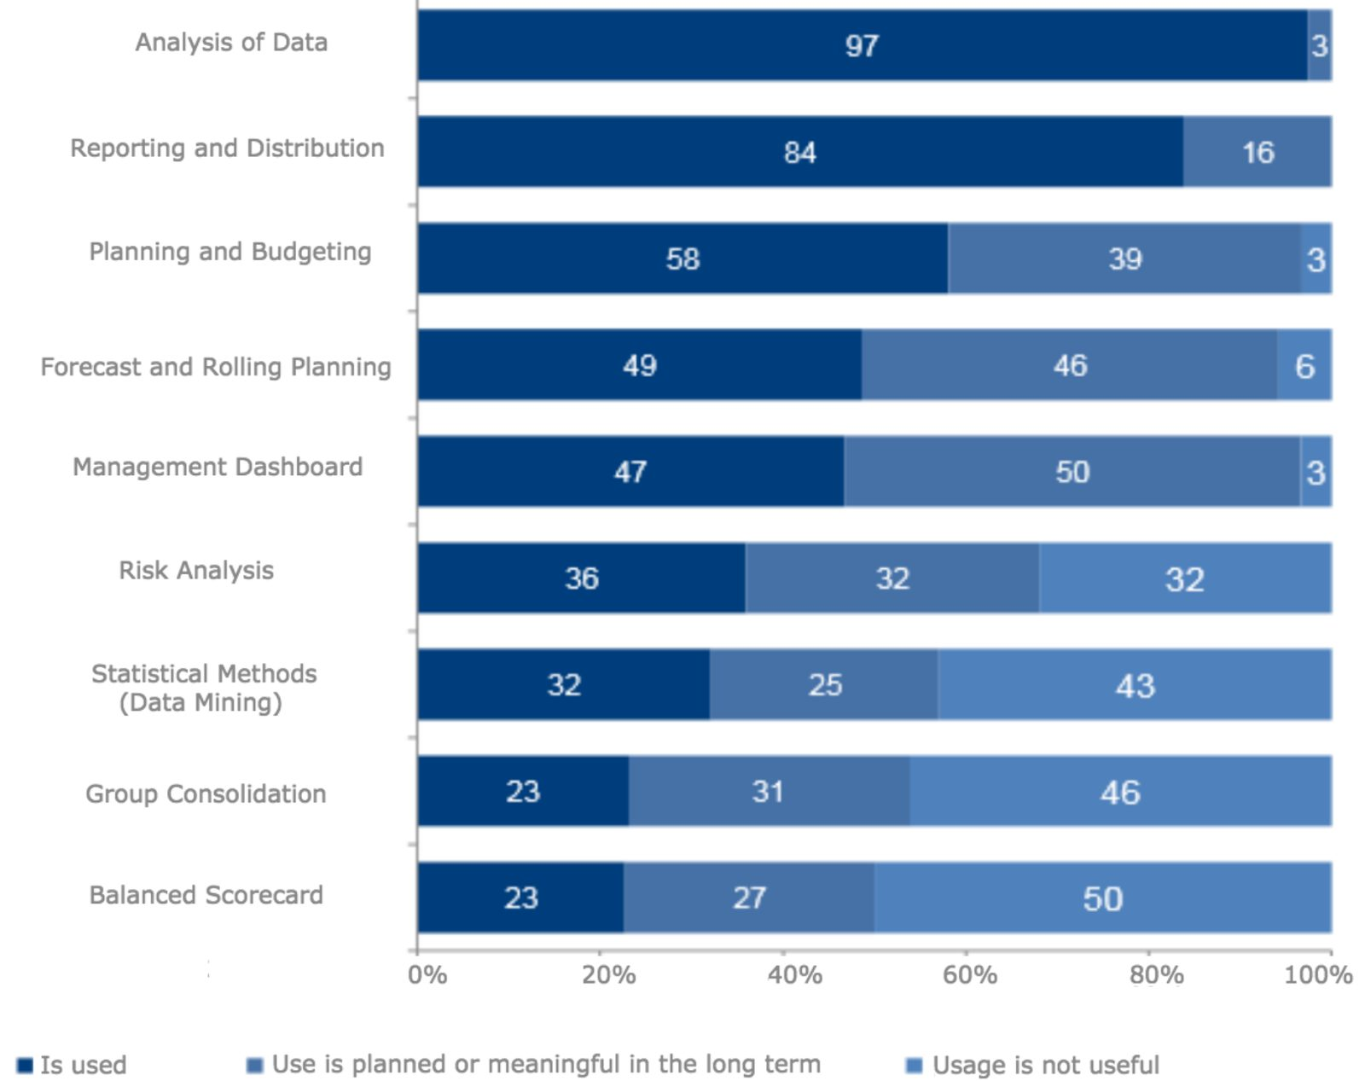
Fig 2.4. Benefits of Business Intelligence (BARC. (2012))

2.7 Elasticsearch
Elasticsearch is an open source and real time distributed RESTful search engine built on Apache Lucene. The basic idea behind the use of Elasticsearch was to aid in the handling of full-text searches at an easier and faster pace. Additionally, Apache’s Lucene is an open source Java library used for full-text search. Thus, elasticsearch can be thought of as the best emerged interface to Lucene to handle big data (Divya and Goyal, 2013)
In a study by Divya and Goyal (2013), elasticsearch was defined as a new database built to handle big data volumes with very high availability and to distribute itself across many machines to be fault-tolerant and scalable, maintaining a simple but powerful API that gives access to the database by any application built with any language.
Elasticsearch operates using a data structure called inverted index, which enables the fast search responses for documents. The data structure Inverted index stores up the keywords that are contained in a document and identifies the list of documents in which a keyword occurs.

Keyword | Document
Django | 2,3
John | 4
Hello, Django | 1,2,3

Table 1. Inverted Index

There are however basic concepts to the proper functioning of Elasticsearch, which include:
- Node: A node refers to a server which is part of a cluster, participates in the indexing and search capabilities of the cluster, and stores data. A node is given a name by default at the point of initialization.
- Cluster: A cluster is a group of one or more nodes (servers) that hold all of the data together and provide organized indexing and search capabilities across all nodes. A single name default to identify a cluster is "Elastic search." This name is important because only if the node is set up to join the cluster by its name can a node be a part of a cluster.
- Index: An index is a group of documents which have features very similar. Elastic search stores one or more indices of its data.
- Document: A document is simply a unit of information, which contains fields, multiple values and a unique name.
- Shards: Clustering enables the storage of quantities of information that surpass a single server's abilities. Elastic search spreads data to several physical Lucene indices to meet this requirement, these indices are called Shards, and all parts of the index are called sharding. This can be done automatically by elastic search, and all parts of the index (shards) are available to the user as one big index.
- Replica: Sharding allows more data to be put into Elastic search which can be done with a single node. The idea is to simply create an additional shard copy, which can be used just as original primary shard for queries.
2.7.1 Kibana
Kibana is an open-source visualization application used to analyze large amounts of data in the form of line graphs, bar charts, area maps, coordinate maps, etc. These visualizations are used to study changes or errors in patterns. Kibana works with data from elasticsearch and Logstash which forms the ELK stack.
The L in ELK stack stands for logstash. Most times, logstash is responsible for retrieving and processing the data from multiple data-source, indexes it gives it an index and pushes the data to Elasticsearch when needed. Logstash pipeline contains input-to-output data flow stages in Logstash. The input data is fed into the pipeline and processed in an event form. During the process stage which is known as Filter is where the processing of events are handled. One may use Logstash's predefined Regular expression Patterns to create sequences for differentiating in events between the fields and requirements for approved input events. Finally, at the output stage in logstash the processed data is converted to form that is required by the destination plugin. Then the data is submitted to an output destination in the appropriate format for the user or end device.
Kibana possesses a lot of functions, but to mention a few:
- Visualization: Kibana provides translates data gotten from elasticsearch and uses different charts to represent them. Visualizations include pie charts, bar charts, heat maps, line graphs
- Dashboards: Kibana dashboards provide different sections in which the different visualizations produced are displayed
- Reporting: Kibana could be used as a reporting tool by converting dashboards visualizations into CSV formats that can be sent to others
2.8 Introduction of Computer Reservation Systems
Traditionally, reservation systems were developed for airline companies, who had problems storing and retrieving large amounts of reservation data, which included the flight schedules, ticket price, reservation availability and all reservations made. Thus software had to be developed for controlling reservations for airlines, for reservation staff to efficiently monitor seat availability (Sion et al., 2013).
In an event that reservation request is made by travel agents, the information could easily be sourced for from the airline company and thereafter make reservations easily with a computer connected to the specific database of the airline company.
With the presence of reservation systems, airline managers saw the importance and effectiveness of allowing travel agents to access the main systems directly, thus, airlines began to make terminals available in their various agencies for travel agents, to source for information and make reservations.
In little time, reservation system had proved to be effective than the previous method (i.e. the manual method), these reservation systems led to the rapid reduction in the time it took to source for information and the cost of communication. Travel agents could now access reservation availability and cost concurrently, improving the quality of service.
The emergence of this technology was beneficial to all airlines because it was less expensive to distribute the tools needed to facilitate direct access to the airline database than it was to hire more staff members. Besides, company managers found out that the travel agent was in support of the idea of airline companies use reservation systems. This helped to expand their market, creating more revenue and the economic entrepreneurship spirit obtained from the price reduction. Replacing terminals in agencies in such a way that flight agents are linked to ensure a better future for flight bookings. (Sion et al., 2013)
2.8.1 Online Hotel Reservation System (OHRS)
Hotel Reservation systems which are also known as Computer Reservation Systems (CRS), is a computerized system that manages the information of the hotel, guest house or lodging facility. According to Kim et al., 2005, the role of reservation systems in tourist companies has proven to be positive. Due to the fact that establishing an online presence and incorporating business e-commerce models adds to the companies’ efficiency and profitability (Poon, 1993). The use of online reservation systems in the hotel accommodation sector, air-ticketing sector and lots more has helped in one way or another to enhance growth of e-commerce and caused a reasonable scientific research on the relationships between tourism industries and information technology and marketing strategies A Computer Reservation System (CRS) provides assistance to hotel owners to properly manage all online marketing and sales where they could upload their services and their prices so that other sales channels could see them. The list of major Computer Reservation System (CRS) modules is content, information stored on a CRS, and reporting. Content includes Reservations, Profiles, Groups and Blocks, Tariff and Stock Control, Administration, Global Distribution System, Web Interface. Data typically stored in a Computer Reservation System (CRS) includes room types, rate plans architecture, room rates and conditions (guarantee, deposit, cancelation rules, minimum length of stay, maximum length of stay, closed to arrival, unauthorized arrival, unauthorized departure), room inventory, generic hotel data (address, telephone number, fax number), booking details. A number of standard reports are provided by the Computer Reservation System (CRS) Reporting module. System reports can be automatically generated and run on a daily, weekly, monthly, annual basis.
2.8.2 Types of Reservation Systems
Generally, there are two types of reservation, which are: Guaranteed reservation and Non-guaranteed reservation
- Guaranteed Reservation: Guaranteed reservation is a reservation with a specially registered hotel confirmation that it guarantees the customer to obtain the number requested by him at the time required. The beauty of guaranteed reservation is that if the guest cannot use it, the guest can decide to cancel the order number. Some examples of guaranteed reservations include advanced booking reservations, booking under the credit card guarantee, booking on invoice.

- Non-guaranteed Reservation
A conditional booking or simple agreement between the guest and the hotel in which the hotel agrees to keep the room until 6 pm on the arrival date. If within the cancelation hours, the guest fails to reach, the room will be released for resale.
2.8.3 Factors Affecting Reservation
1. Confirmation: This is a legal document specifying the acceptance and approval of the room request made by guests and the hotel. It can be a reservation that is either guaranteed or not guaranteed. If a guest does not check-in or check-out on time, this affects room occupancy.
2. Cancellation: this means that the room that was previously reserved will again be available for resale for personal reasons or normal law, in such cases the customer may have to pay a fee and the remainder of the amount paid will be refunded.
3. Overbooking: this refers to the tendency of booking rooms that are beyond the available capacity of the hotel. This is often used as a strategy to maximize room revenue to prevent no-show or last-minute cancellation. This process must be carried out carefully, in an event of overbooking or rooms, the guest will be moved to the same standard hotel that had been paid for.
4. Walk-in: Here guests arrive at hotels without reservation hoping to get one, they are often called Chance guests. This type of reservation should be handled carefully and accommodated by walk-in formalities with advance deposit. In events that there is no accommodation for walk-in guests, they are referred to hotels nearby.
5. No-show: This occurs when a guest does not come physically to pick up a reservation or for formal cancellation. In such a case, a hotel charges guests with compensation fee and then a refund will be made to the guest.
6. Over and under stay: When a guest stays in hotel rooms beyond the set departure date it is called overstay. While guest who checks out before the set departure date is called under stay
2.9 Empirical Review
For the empirical review, past literature that has been collected relating to this study were examined, in order to deduce the central knowledge gotten during the course of research.
2.9.1 Online Hotel Booking Systems
A study on Online Hotel Booking Systems by Iwuoha Joseph Ikechukwu (2012), developed a user-friendly website after having undergone studying at the Imo Concord Hotel. The system was developed to aid users in their search for information on hotels with decent prices, it also incorporated a secure payment system, which was intended to enhance the availability and productivity of the Imo Concord hotel services. For this project, the Structured System Analysis and Design methodology and UML diagrams were used to design the process flow of the different features in the application. The tools used includes:
- Apache 2.2 for the running of the server
- MySQL5.0 for the Database management
- PHP which was used to handle the communication between the web server and the database
In conclusion to the study carried out by Iwuoha Joseph Ikechukwu (2012), the problem of the middleman on reservations systems were eliminated, a more efficient marketing tool was produced for the Imo concord hotel, an upgrade of market presence of the Imo concord hotel was achieved and a more reliable application for customers use was developed. Challenges faced during this study were:
- Difficulties in obtaining information from the Imo Concord Hotel for the development of the application
- The development of a responsive website that was readily available for customers was a major problem during this research.
It was however stated that more effort should be made to extend the functionalities of the reservation system in areas such as: shopping carts, business proxies, cash registers and merchant accounts
2.9.2 Hotel Information Management
A project by Alabi Oluwaseun Faruq and Babatunde Gideon Opeyemi (2014) handled the development of a Hotel Management System, which enabled users to make transactions such as view rooms and make reservations. Administrators were given the user privilege to monitor the various transactions carried out on daily basis by users. The project made use of the various technologies including:
- Visual Studio was used as the Integrated Development Environment (IDE)
- Microsoft SQL Server, 2008 was used as the Database Engine
The module included in this project included; the accommodation module, catering module, finance and account module, front-desk module and personnel staff record module. The limitations faced during this study were:
- This management system was designed for only online use.
- An online payment option was not implemented during this study.
- The capturing of customer signature was unable to be covered during this project due to cumbersome processes known to the researcher.
- Lastly, this project was only limited to specific areas including: Reception, accommodation, finance and account, catering, food ordering, administrative, security, and general services transactions.
2.9.3 Faculty Feedback Management System
Akash et al (2018) in an International Journal of Advanced Engineering and Research Design (IJAERD), developed a faculty feedback management system to alleviate the manual process used in institutions. In order to effectively handle improvements in the quality of student-teacher relationships, a feedback system was implemented to allow students to give feedback about their teachers either negative or positive in order to know the areas of weakness, hence leading to valid changes and necessary improvements. This feedback system was designed in a way that students can login, give their feedback and the system records the student as anonymous in order to give room for fair evaluation. The Admin was given the user privilege to export the feedback reports after a period of time. The tools used during this project were mainly PHP and My-SQL.
Additionally the feedback system had the various entities:
- Courses: indicating the various programs taken by students in the institution
- Ratings: this was used to store scores that were to be given under each question
- User Account: this recorded all login details.
- Branch and Branch-Sem: this stored data with similar characteristics.

CHAPTER THREE
METHODOLOGY
3.1 Overview
According to Oxford Advanced Learners Dictionary, a methodology refers to principles used to perform a particular activity. Methodologies are employed by researchers to facilitate the further findings which increases knowledge concerning a particular research work. This chapter focuses on describing all methods used for the proposed system and how the proposed system intends to achieve its stipulated aims and objectives. All approaches used were briefly explained including the various Unified Modeling Language (UML) diagrams used to illustrate process flow of the proposed system.
3.2 Proposed System
The proposed system is a web based system that is accessible by any customer and authorized system administrators. It will give customers access to available room reservations, provide a convenient way of sorting room categories according to the customers’ preference when trying to book a room. More importantly this system intends to provide a more dynamic feedback system for customers and most especially the management who seek more information about customer experience by providing more visualization tools (i.e. pie charts, bar charts, graphs, real time figures on profit made etc.) that shows a descriptive summary of the hotel’s activities such as profit made, comments gotten from customer as well as reservations made which would make the managers work more efficient and easier.

3.3 Feedback System
From figure 3.1, once the customer feedback has been submitted and stored in the database, with the help of python, the data is read from the database into elasticsearch, so elasticsearch then gives the data an index, and stores each feedback as a document. With the aid of the inverted index data structure in elasticsearch, the documents would be retrieved quickly and the documents are then fed to kibana , which creates the visualizations needed by the system admin.

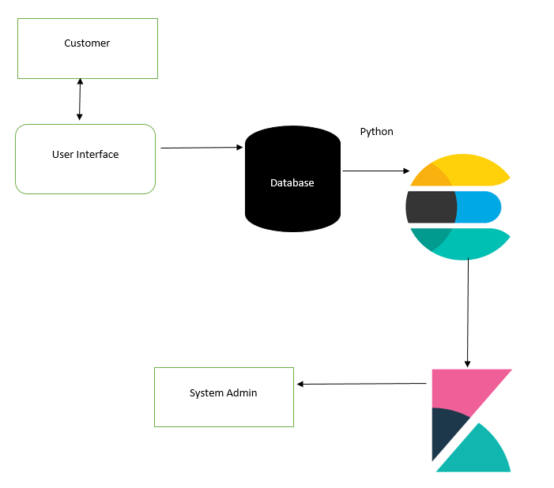
Fig 3.1 Architecture of the Feedback System.
3.4 System Architecture
This web application has two users: The Customer and System Admin. The Customer will have access this system using a smart device preferably a computer as far the django server where the application resides is running. When customer gains access to the web application, the server then feeds the customer with information about the hotel and its services.
When the user has gone through the application and is ready to book a room, at the point of clicking the Book Room button, the use will be prompted to sign up, if the user is already logged in, the system will take the customer to a booking form where all details are expected to be filled and when done filling the form click the submit button and all details filled are store successfully and the page refreshes it.
Likewise, if a customer wants to give a feedback, if the customer is not logged in, the system will prompt the user to either login or sign up and user is left to choose from the options appropriately. If the customer is logged in, the system will prompt the user to fill the feedback form and when done, is expected to click the submit button and the page refreshes itself, indicating that the feedback has been submitted successfully into the database.
On the other hand, the system administrator at the point of accessing the system, must provide the unique username and password created earlier as prompted by the django server when the application was first ran.
After filling in the unique username and password, the system admin is given access to all bookings, contacts, feedbacks and rooms that have been created on the application. The system admin has the user privilege of creating and deleting a new user, feedbacks, contacts, rooms and booking on the application.

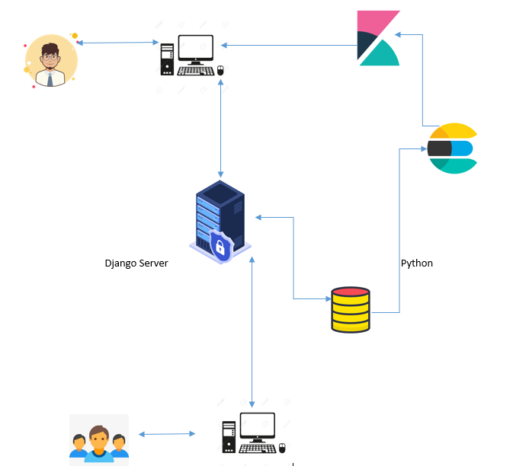
Fig 3.2 System Architecture

3.5 System Design
This shows how the system will operate through the use of architectures, modules and how the various modules complement each other. This designs are based on the requirements of the users of the application. The various designs are developed using use-case diagrams, flowcharts, architectures
3.5.1 Flow Charts
Flow chart represents the flow of steps in a program pictorially, where elements are represented by simple icons such as circles, rectangles, parallelogram, diamonds etc. This flow charts represents the sequence of activities and decision points that are carried out by the Guest/User and Administrator while using this site.

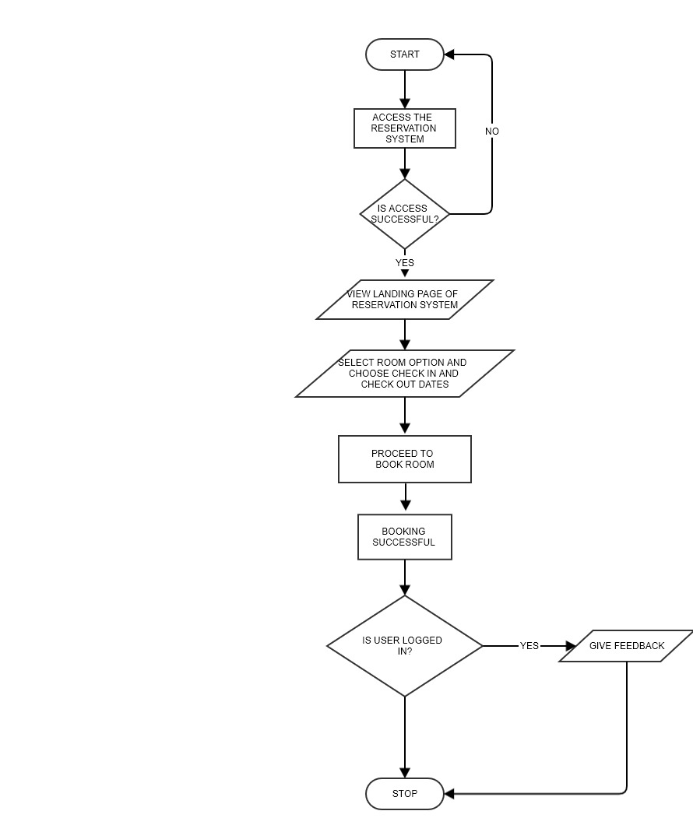
Fig 3.3: Booking of Room Flow Chart for User

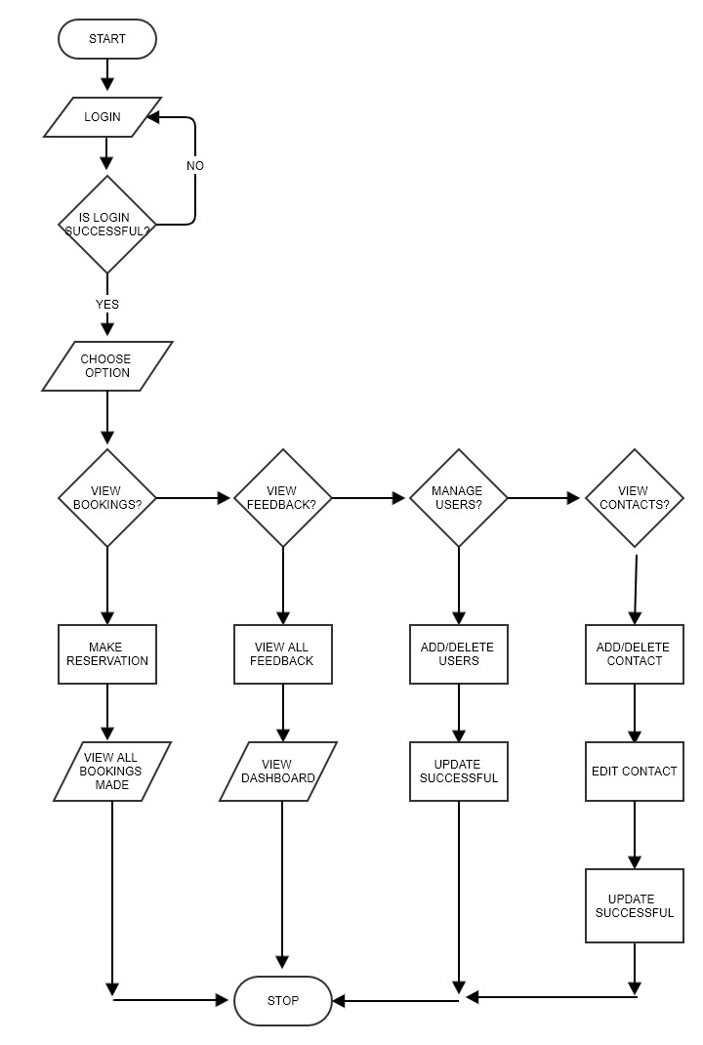
Fig 3.4: System Administrator Flow chart
3.5.2 Use Case
Use Case Diagram is usually used to show several scenarios that users can perform when interacting with the system. Every use case diagram should provide observable results to all actors of the system.

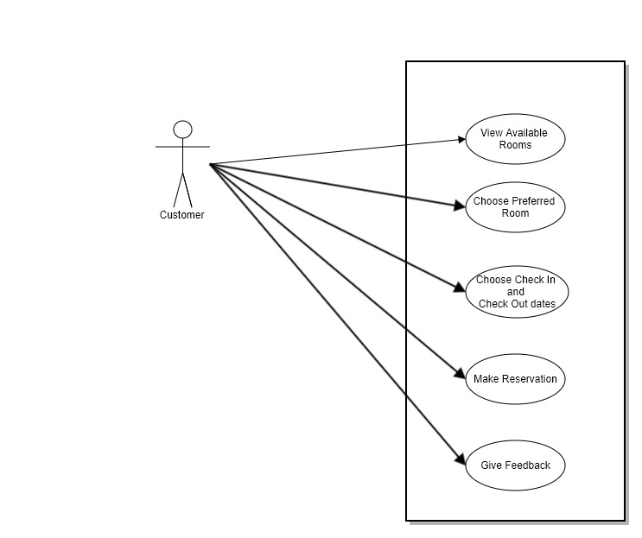
Fig 3.5 Use Case Diagram for Customer

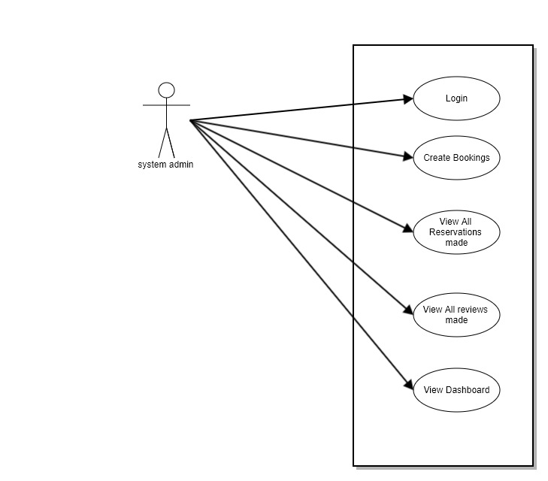

Fig 3.6 Use Case Diagram for System Admin

CHAPTER FOUR
IMPLEMENTATION, RESULTS AND DISCUSSIONS
4.1 Implementation Tools
This web application was developed using Bootstrap, Django, a python framework for web development, Elasticserach as the analytical and search engine, VS Code as the text editor, MySQL as the database and WAMP server to host the website locally.
BOOTSTRAP open source Cascading Style Sheets (CSS) framework, was used to carry out front end developments of this web application. Bootstrap is known for its ability to develop responsive websites.
JAVASCRIPT programming language was used to make this web application interactive
MYSQL database management system was used to handle everything related to the database for this application.
DJANGO a free and open source python framework for web development that was used to made the development of this web application easier, especially when dealing with data driven websites and the database. This framework uses a Model-View-Template (MVT) structure, such that python files called models and views along with a template directory which stores all html files, to handle requests from users and maps the appropriate Uniform Resource Locator (URL) linking to the requested page by the user.
ELASTICSEARCH an open source search engine that is built with a Java Library called Apache Lucene, an open source search engine library. This library is what is used to handle the indexing, storing and searching a lot faster. In elasticsearch data is sent over Hyper Text Transfer Protocols (HTTP) in JavaScript Object Notation (JSON) format.
PYTHON programming language, could used to develop website, web applications or desktop applications. For this project. Python was used to handle the backend of this web application, and also to read data from the database to elasticsearch.
KIBANA dashboard was used to visualize data gotten from elastisearch
4.2 HARDWARE AND SOFTWARE REQUIREMENTS
4.2.1 Minimum Hardware Requirements
To carry out this project, the following are minimum hardware requirements to be satisfied.
Processor Intel(R) Core(TM) i3-5005U CPU @2.00GHz
RAM 4.00 GB
Screen Resolution 1366 x 768
Hard disk 100GB
4.2.2 Minimum Software Requirements
The following are software requirements to carry out this projects.
Database Server MySQL WAMP Server
Operating System Windows 8 Enterprise 32bit or higher
Implementation tools Django, Bootstrap, Javascript, Elasticsearch, Visual Studio

4.3 SYSTEM TESTING SNAPSHOTS
4.3.1 Reservation System Landing Page
Given that the server for this application is running and the customer is able to get a good coverage of network, through the internet the digital device used, would access this landing page for this application, as shown in Fig 4.1. From this landing page customers could view the various rooms, make a reservation and make a review. 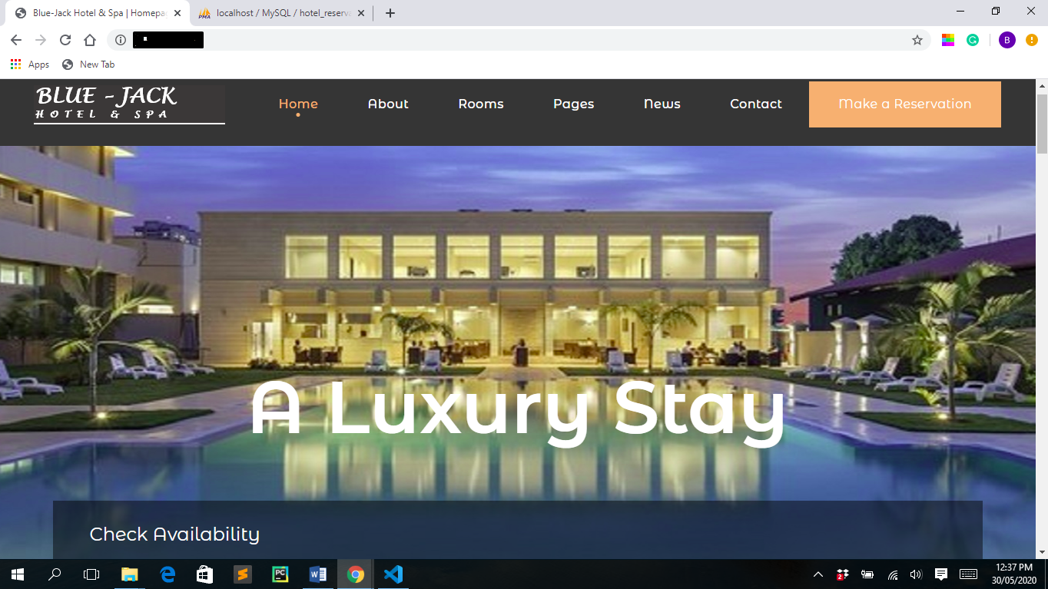
Fig 4.1: The Reservation System Landing Page

4.3.2 Booking Page
Figure 4.2 represents the booking area of the web application where a customer specifies the details of the reservation being made; this includes date pickers, number of adults, children and rooms. They Go button checks availability and books the room.

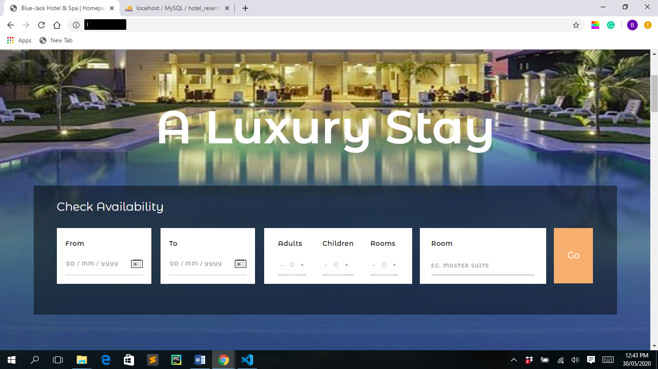
Fig 4.2 Customer Booking Page

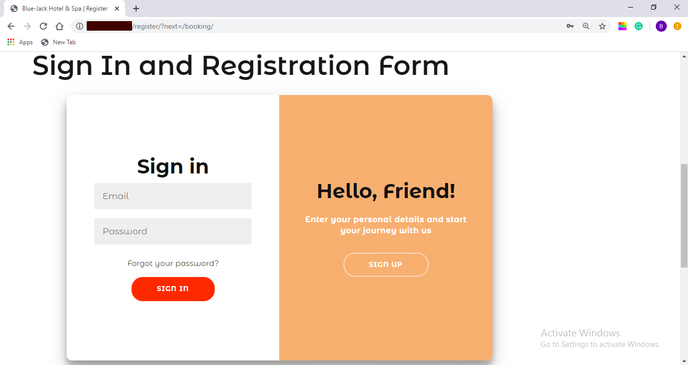
Fig 4.3 Sign Up/Login in Page for Customer

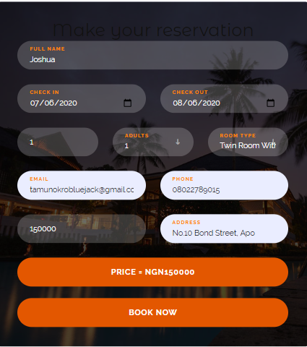
Fig 4.4 Booking Form

4.3.3 Customer Feedback Form Landing Page
When the feedback button from the navigation bar on the home page is clicked on, figure 4.3 represents the landing when a customer clicks on the feedback option, this displays a form a form for a user to fill
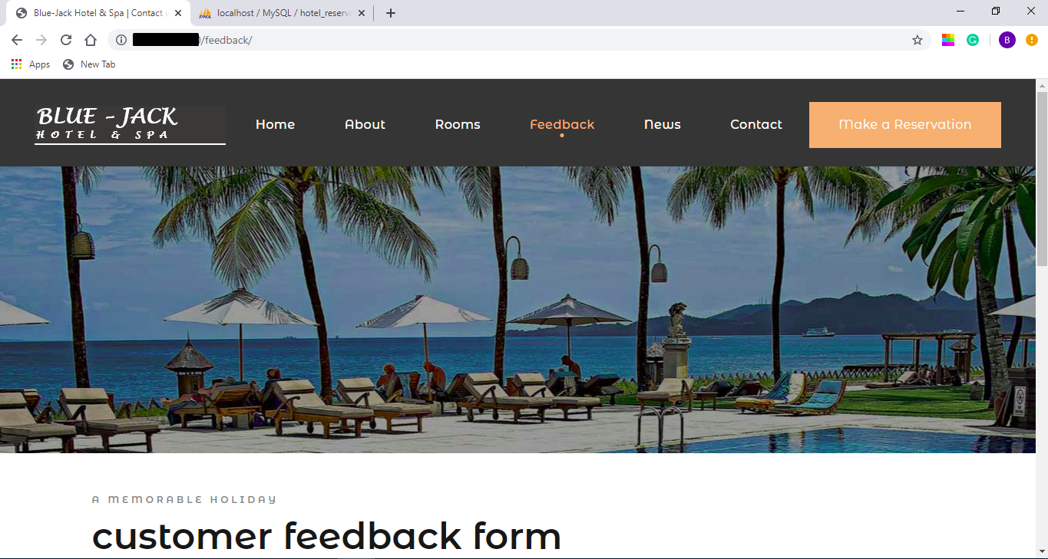
Fig 4.5 Customer Feedback Form Landing Page

4.3.4 Customer Feedback Form
As an extension of Fig 4.3, the Figure below shows the feedback form being tested, after all fields are filled appropriately and the submit button is clicked, the feedback is added to the feedback option on the system admin’s side
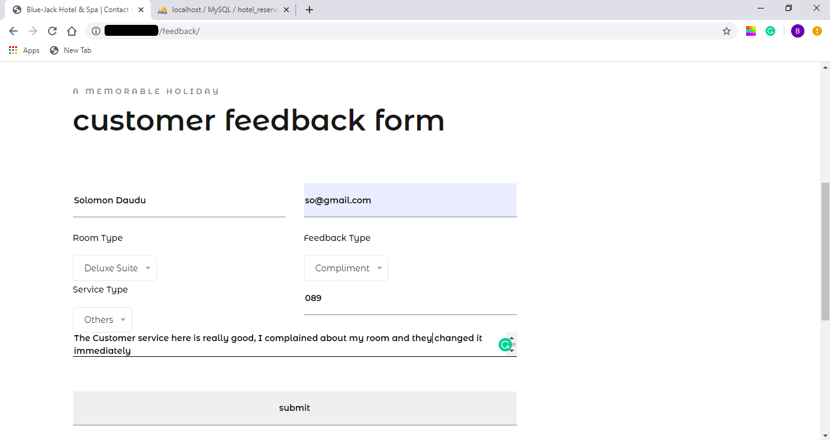
Fig 4.6 Customer Feedback Form

4.3.5 Admin Login Page
To access all the reservations made, feedback and Contact forms filled on the reservation system the system admin would have to provide formerly created username and password. After the username and password filled in by the system admin has been authenticated, the system grants the system admin access to into the system.
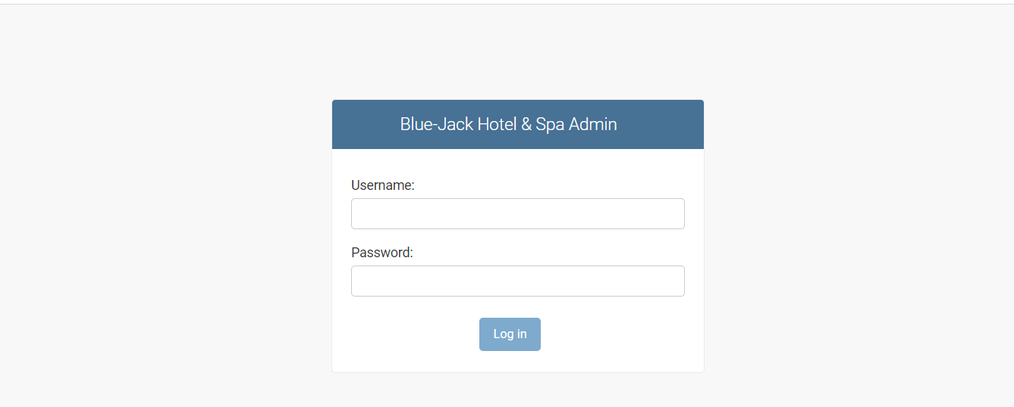
Fig 4.7: System Admin Login Page

4.3.6 System Admin Landing Page
After the system admin has been granted access into the system, the interface in Fig 4.6 is what is displayed. From the Figure below the system admin has three main options, which are View Customer Contacts, View Feedbacks and View Reservations. This options are to be filled by customers and submitted, however the system admin has the privilege to add to those options and submit on behalf of customers.

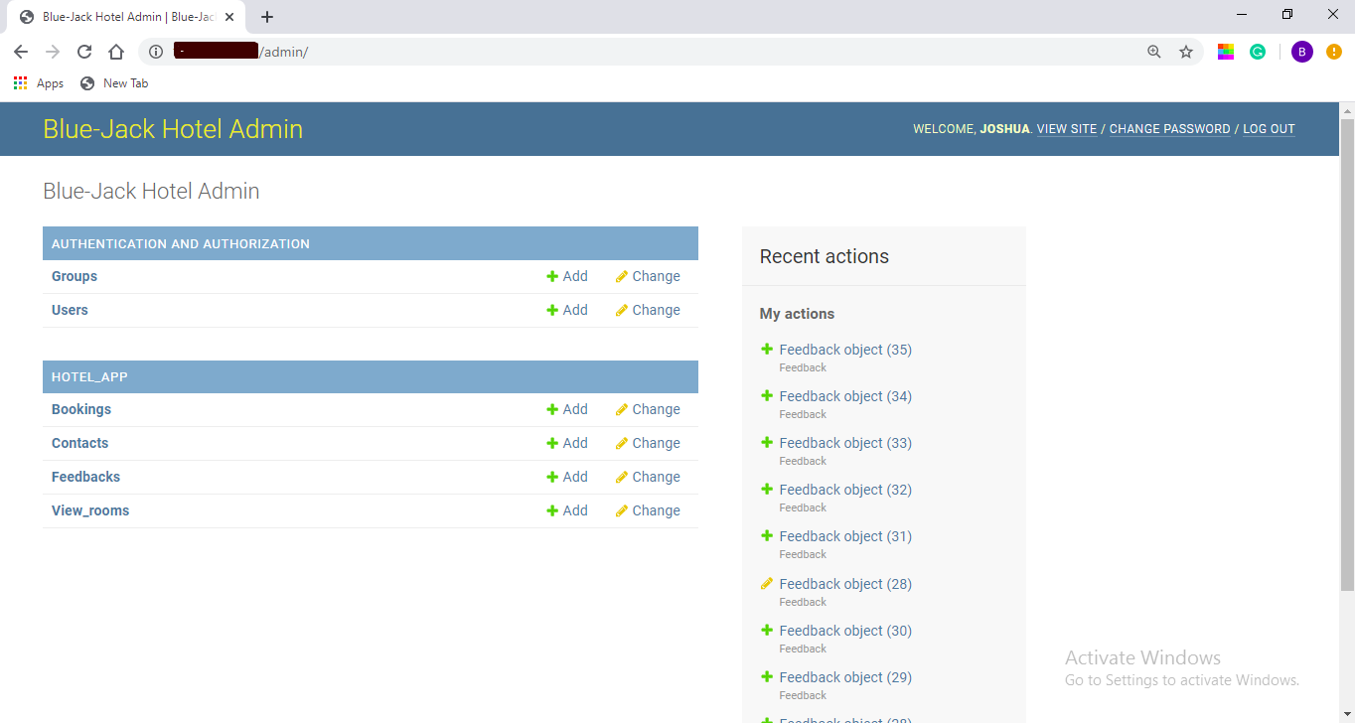
Fig 4.8: The System Admin Landing Page after Logging in

4.3.7 System Admin Feedback Records Page
Fig 4.7 shows the records of feedback from customers, when the system admin clicks on the feedback option after logging in.
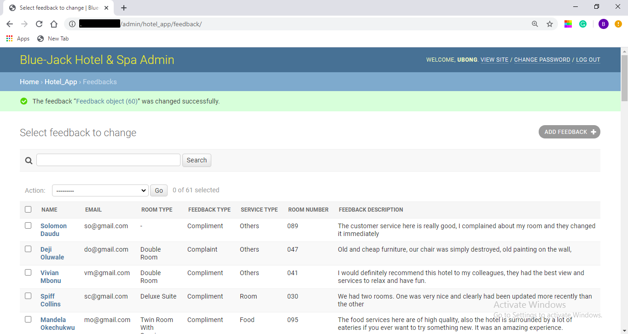
Fig 4.9 System Admin Feedback Records

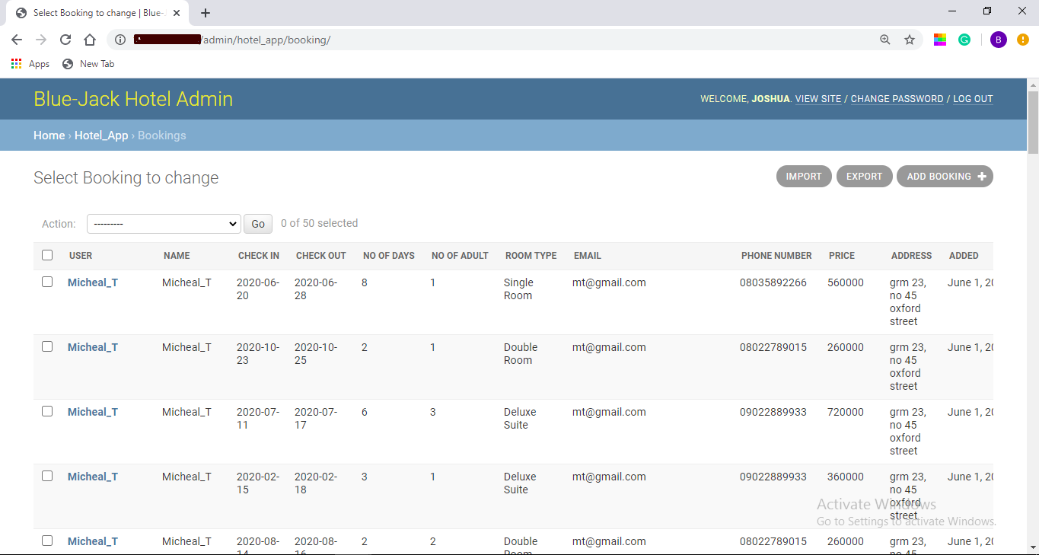
Fig 4.10 System Admin Booking Records

4.3.8 KIBANA DASHBOARD
An outlook of Kibana dashboard after hotel booking test data has been read into it

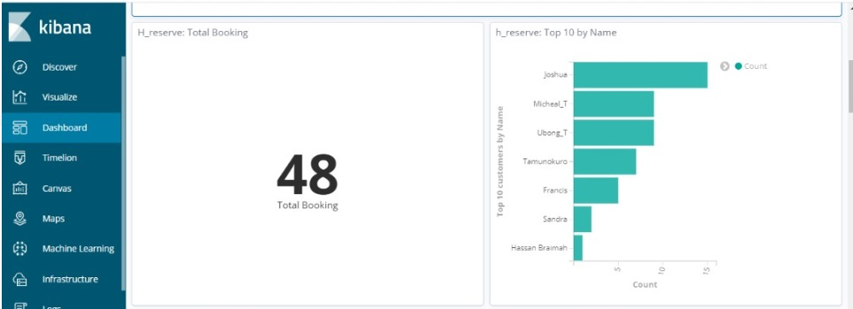
Fig 4.11 Dashboard of Total Hotel Reservations made by Customers

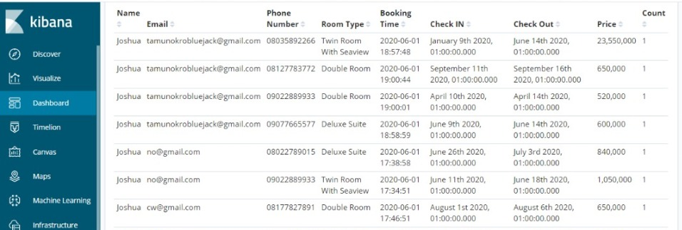
Fig 4.12 Dashboard for Hotel Reservations in tabular format

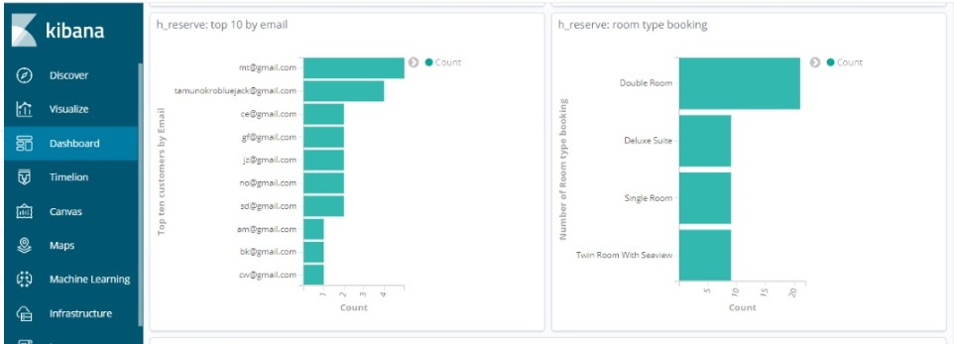
Fig 4.13 Dashboard Display of top emails and room type

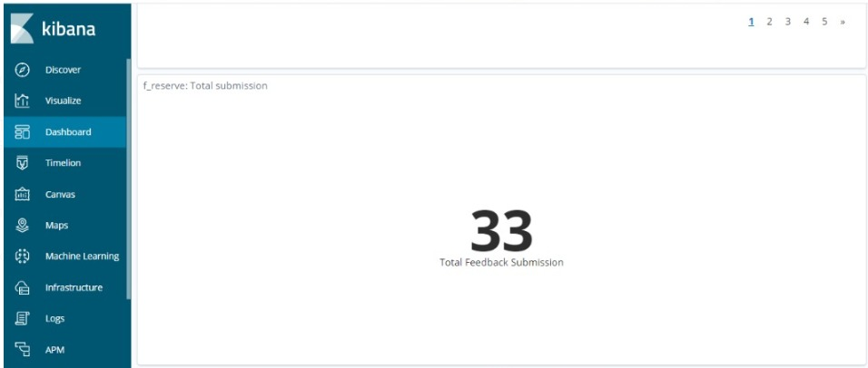
Fig 4.14 Dashboard display of Total Number of feedbacks submitted

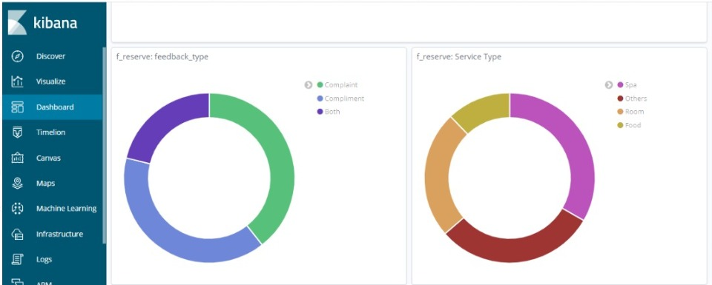
Fig 4.15 Dashboard display of Feedback Type and Service Type

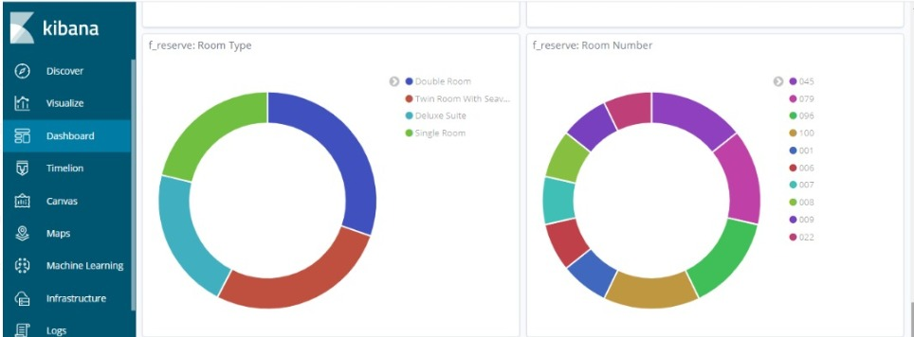
Fig 4.16 Dashboard Display of Feedback Room Type and Room Number

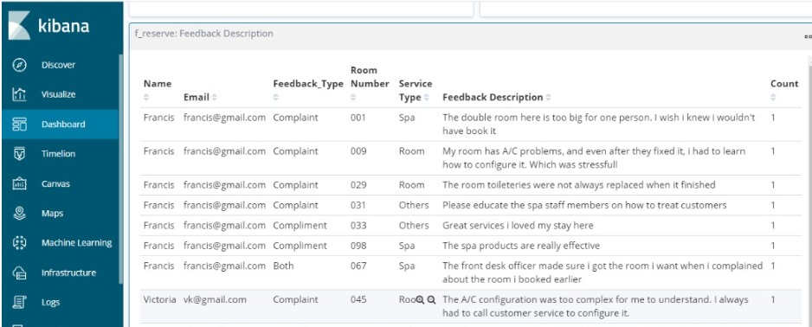
Fig 4.17 Dashboard Display Feedback in Tabular Form

CHAPTER FIVE
SUMMARY, CONCLUSION AND RECOMMENDATIONS
  - Summary
This project was developed for management sake in the hotel industry, to effectively handle the performance management in hotels by providing a dynamic dashboard from feedback gotten from customers. As a result of how competitive the hotel industry has grown to be many hotels have suffered severe loss due to less attention paid to customer feedback and performance management. The developed web-based system provides a means to combat such issues.
Thus as proposed earlier in the aims of this study, a feedback system was developed for hotel managers to keep track of the customer comments and other areas that need improvement. Using visualizations in the form of charts and maps to sort and analyze customer feedback, this system will aid managers in customer and performance management in their business.
  - Contribution to Knowledge
In extension to feedback systems developed prior to this time, this project offers an advanced approach to the development of feedback systems. It also brings to light how other web frameworks and technologies such as django, bootstrap, elasticsearch and kibana could be integrated together to build a much faster visibility tools that would be helpful in the hotel industry management space.
The developed web based business intelligence system explores how customer feedback could be used to obtain useful business insights in the ever growing and competitive hotel industry
5.3 Conclusion
The importance of data or in this case feedback in any business could not be emphasized enough, thus this project aligns itself under a branch of Data Science, Business Intelligence and Strategy, that shows how customer feedback could be used to develop business strategies especially in the hotel industry.
Thus, with the developed web based business intelligence system, hotel managers would now efficiently keep track of customers’ feedback, backing up and improving the services to be provided to their customers. The time taken to go through all comments made by customers will be minimized and a better performance management will be achieved.
  - Recommendations
As a result of the experience gained while carrying out this project, I recommend that the feedback system be developed further to accommodate more fields to enable more analysis on the customer feedback.

3cU2FsdXGVkX1C%2BtZfqHqFMv9dy9r7wjmQCXfy%2FFDE1n%2FC5JqWpE0%3Dh8qGvou5U2FsdGVkX1%2BzgW%2FGP%2Fh194M8UQSUlra4dpVYhJ0pPbd0QhCUDDv7vFUI9SU9m3htAvT4Dx42pVnpzVZndVKwi5BMaFvDZ3NwcGcXlBKtLQ%2BU72kwMVUJsziKSa9mAAjkipBCv0%2FksYDhNjmLgAewnZ1l5SJ6MPN3S1oFg74LGZ84Dlaz1Z1xKhbvGYVnuY1cCD8clWnY9KGAGT4zJy5m2jylSGBGo%2BEWDnJTGMwuXwRSZ5LVXkJ%2BpWJJj4VmiJLIz4lVA336zGgBNOv5I1sUGsYMjFXnClXbNVi30LhpIJ%2BxYeK1e0P%2BI4ZAS4rsLfAsoizGyVBn2gBznhWpl8OBf9KWgEwRsOfxat%2FVMFGvjd69%2BFnDy%2BdRtNDuUuIRZu1a8oHqMMZ5a3RtW9yRm%2F9CGwlJytbIuwGgx%2B6yT7z4sk40Au1Tc%2FKJohOHqGFcs%2B8kcRGfm0tW3ToDzBesfcIfV56RaSmFz4%2Ff0R%2B%2FEJvi87d1Bxo0Y9F3ba%2Fg%2BhoSeyydSOQ04tl3qwR92%2B1FJ2TaVm9nag12rm46YLW27HSdBYlt2YwqwAjWLSsevZbgQUa0KUvwIvh9Avib%2FuX0Iz3%2B26PkcH1dH4I27NAsiY1g3YLCoE0X4vfECPwK3%2BOu2aBC3hxi%2BE9i3AjDzcPjRXFwy3nOOPvM35xm5jWAgYA6tt%2BMr0ti338dBYxyrQyi0BV6f5Sr0E%2BDlS2o4vmf2%2BfQtkp7aKTDvxFCOSo6kWPMLlxg9wwMRKYr9poIvJ4WO2xMdRNQVj0mFHqTjaXXQaqPbHGp4FH4KZZVQKgnZGlGuyMoEnPxuzB4ead1LLSzSsEtHdB%2FIDl39DIS6Gq1CSl98tYamRIqiEMm1lMjKpsKizoAYD88LWpkT1zCaQLpuSh8yJwjyxItYxU5HhN8%2FXHOiUBWbEEZt3QzahqZmH6veWlzXb8Vn7pkqrvCwj3yyFxFU10u1PuYh9KQZzxvch9wdOuXkOhlk4TRVAK4ZXRq1uAafMrDLuTZScxx3ot%2Fuds5eX%2FpIjvI0JKwGBJ1AjnOY4gGjU4VEwDWItXKnVXwbnyqvxLN6%2FnbZr75c%2FQC%2ByUG8iiagg163594cjM6oh5UIAI7kvKNZ0z89X3xLp5X7J30auenK2jXrLXHKvrFzz3rCTnKxQw2Z2ZukfdgN5dsk%2FaRTGYTDL%2FOjj0QIELmTEcXAMgrb%2Fgp592pQtNptVZtnxSPQYVLitec56cefaglpBKAcLy0NBZh3dNt%2FfczCPb1LQXtaBIbPGiPCzouk%2BhV8%2FgtniFIei8qgI0s5lQoAkkkGxPVqOZ6ilVhcvpFAw4isXTRGudF2NvKZo4aCoejDjLcYaeChjMlUnmMdlISDhVLt8GDSO1D5Yn7fRQZngyYIlLwEbO3Hh1EgDw54%2FJga9eztwOUIa1f5SCV8%2BNjc%2Be%2BGgT5Xml%2BsJB9AnAoFyg4iTYoiFdCX5nk6Cs9%2FlsjvQeBh8aNI7CKENcTS3rtBMScKPtxJWWwDqXS7%2F6O5J1cYctJEoxlFNkY0cHabnbvBbKSMHC3cQBFYxMWVVIlDhkAVAmc9P42RZ7MXgwuEtb8qnbIdw5Q3qReYAUvdCAyq4wajbaNAau14JOj81i%2B7alspMpV0kSdX5VSqkQyZ%2Bil4XzbZZWo5GtqQsJdUaZsE3Lh3jRGEfXMwkPrfciEykefsjQYGssvZpg7AwUoDPN7pwKU9wK%2Bs5ftzzCTxy2J8sfpJ5AZsEG%2FEL8OhWkcb1iGV%2FGBJM39dzuYW2QQUXzHOQykdJb7FSdie8%2Fbx9k26mMQ1XQUGlFPj4dRXSHMWOkAqcDOhrXagXM8ZwKHV8EbFw1xq404N4Apk03v4hMJrrrILvbZeoLqQZuboEt2zyo9ovxVfzZdm%2BW7xTG3Q9aX%2F3U3yCymCZzQLsgE3caJ4eslORFYmasjdSITGWFOAjE30PORur2zyw7UFZCb4CG%2B4oPHdqnxzKL9dkgAhXIgFkiPiQ8KSE0DT%2FV%2BWj1iRpkjDKx2SFZO7Pyz9m%2BIFRuZJVSGgh1RlsxRwi3hl5Kwv%2B78iEfUSvmOL0jLmTdWEnpoxzadBrvaNMzNX6nr49CrFxtt32tutySW5MWltz4zk68ZS0TWgV%2BiHa5DT8CRVv7QqK2xQ4UNM2%2Fmqju%2BLSx2tIz7X1EYGcmWSapL5XBwtbBpKCa%2B%2F188y2rqI40swu%2FUghEOlGdiI8FL5v%2FNrpzt9sOiaaz6mf40IvkKl7NsQxmjZOu5i4%2BBV9lYi78Dm%2F7ie4PkTo6mvDeP32enhJQGo1jT1UElGlO2urahCj05U1Rx1mZ81OSwXWU6SuAV3TiIPyctrC4pXp%2Brs7KuC1QPnWZ6%2BgyQup3VsU8ytj8J2DjnBEtjetJ7caIT8gQ08zqNw%2BS5gzJM4jegrD6jKBct4Bw%2B75qz1A%2FiWveUMbBibtuJp02p4Mom7ty5BdRJtwCT0Ev8FT%2Bhy0CwyEwRKhGyOeu8T2E9QpkFt6cTRDCpXF4uepUKHWuuSoDkhhiDhQei4xTeH41RhEg2LNjDuUmfyCc1YrxZwmvQaB42cu05lI6HK7Es71DNGNfElZ1uElmB5KmU%2FqEWS6P%2B14ecbXFVonCYwFV5BTrAvnxnMGqBR0rbrbTjyRpmIQVHpL7gGyKfqAttseSojeUM%2FRWRb2K7dfqH5q8IOTvBggowUQjCqez%2FyTl6TIvBCm3pqxqurYAI41Y6p8hzUszxaV2Dt5WUnHvWDF4wESxh1TqmBzVEfLn16ygrX7Qo2LJvUM46ShyxV9P6AEVn75%2Bo2hAHspvNNAQzoDIXezTBY8mN3R8vsx4LeOIu2ABqkBT7glLlh7EBgZGZo3Mj42TlvlW%2B1CKRgK6YPYqV8rYw5Y%2FJFl1%2B2o3rXlj5%2B%2B2z944BS2ua2sQUdlrdhRlxXFERr67pHpV1THFMK8WrEeVp88fiSGCAQ6G4j9AHSNsxazqIUGXDkxsabTryhdEsvToi1b2V4goq3KyDb45XCxrHlesp96v2YUPZeJ1484P2x93FRktbHJj8Md4k9pjWgFmCHqmu3eDVfUa6IRiUz2nOC6w%2BM%2FgzNV9RuD8lkgEpTQcS1H2p1Yw1w1%2Fcemre9c8ejyEJ1D6ug2zlc0BOpmsOaz48gHHi778Gvn67%2FjWptJmPZBjgr0DazQsVXrr52cyFtUT%2FcLYsHMHD8lqmcWi%2F%2FTutG%2FmxSB4dgobai2JuvVxLjB8Ip%2FBBAWDxHviqfcYKtFh4yPsL0xzdWFdb4EESaKbWgCqHYX4RLTKRc7YIDuK5qC1lZwDM%2FGHauK0D2L1o0cvX%2Bw3gxXI0aNO3ARpXCTccKuFvZGEijph1S3rtRwzvNEPSVB6ESVW8eLwCCOyUJpmh421Lt6ulMal2FdcG38ekW4kBxyq351NGz4Daig6Vy3qMQAlT54LTV%2FSEn5lFgNOXVb%2BmArd9xoXldMMijBTn5JdG%2B0W%2F7srOf8CEfjKFQJwyqm%2BqFxbMkTfDkYhr3gvSQP%2By1FLhan13EBa6qNC29ef6kxhe1Sxi9qBu6KD3bO7JqVoUAFvTlpCl2lk3z4vkPOfTIiAt9PokBTiOwhR4Otq934MnKWriGYhfCEUEVwT5Eub3g%2Fwb5EiOwEcQQ0V71Q2fBSKpJ2XTpxr7oXDa4XG2NsKqr%2FHNpiZBTioDvSQ6AGnvDyGKJ29KA8Soq2ROCrBvmSQ5Zh73HOuWJ%2BG7556q1Yum6z9ufU7zYxld7fSCsby1r7tmWqe6ytN9nskqd1PXFMZDtIqmOSVJK8UlCVFucI%2FINSg3rTyF4pzG14lhOCjbL56ZqJCVi02Y%2BDMMtZlNf5Ro7ZFIWSKiqE%2FVV8IXQO7QVqBfoEfLmdEGwYYYur8U%2BU4nb1RsyjL6m7M6qpa7flvOOlcDQP0bBVutA5NIWFZdOHGIfKiJhDTGTSAwu2OXZFEnZbRwN4sb0YwgX4e009bYxFOVAFGzil5ojIkiVxsOn2YAl%2FC2ZwnRM%2BDN9WKBRwrYNlYooAKAp7HO80%2FWIYgSrD8BiZ3XJ%2Bx7FLbVPGWiEszvdzuFb1CsYypNlP%2FBhld33Ml78hZk%2Bdj2jk2Su9cbAeuWbFa8yqsVwnS0agvwW7CNGcInA1tx6p%2FgVXAqJXxLF5Q7FGwsLFPuMHL%2FTDydW0EliujYY6KE9n9Jy1pQjcALz8Nk7gTq3B3VJ6ahHsWiRGiE3iVr4VliaWXKxvPlmfK4AAeoCLPQfXvN0aBhlxbCxPKUhwRqvLK8XAjFwg36kFIUeVPqeXRP04J0eYGlQsUywEmt4BHdRGH9pStPXgpSH3tizCcBS%2FUrxaTiLzvAQ%2FWVQzB9IChi2hIFkg%2FjdUrTvOh6dJmUVNAG8xHadM2v681XOuRdH17bqRu7R1vQynGAWEJhavAJS%2BY2y7TTz4G6uufO3Lkj6V4cvPUyfzPY7Ktw4E0pSuduSEKda8WoT5qcwzyVhdaBgVlnrm7gGiYNTQ%2Bl9WptTLclzpZwyKdBVXiGrlY%2Bn3jyI%2FMza%2FK249QS0YGxk5higFNsn5VN0GPw7fZfzDgzGN%2BgRk3sO9PKt2%2BA5fkgRdBc7b68HzHf%2FEVZKH%2FXJNzA%2FY7K%2FujdybgncJd74K%2B51r7WghDxVdXuDhHo8LX8PLWZGNdniSniqbUyOzk7z7n6hCwVEncycUbbTaeOV%2B0%2FOzuvG4AR07jhiRSIhURJd13rOeIxpAp5UkpzS7mMrLkBJ5OAVVFi6XTRA4GAJ4wdeN7Cb7p6mxv%2BJlr%2Bx6QRQSGBpOvRUDETjKAY76o5ughHOZDEqMVe6LuAFZjeSFqV0hp0863VqvIDpV9zirD2IcIFxKdUdn%2BYjA%2BnNtg%2FGVsrhcewgVtWaGNweOks0ih89%2FzEUgobZSeq7SEdSkU0qAaQEPv8Ur1kYKcnPNFoE3XarWfz9Uj%2F5vqgvqk%2BI663Sss0curYQBvSbM0Fez7d9LYPV7OOiHrmTBRKaf%2Bh7HPcMrj4875%2Fd3ZWkp8VvYZqurJt1DJ6OUZ9dvMlQF%2Bveb15ndPvCmZk2xiTlahvaJCyPiGTUZwLO7IQfMb7ArWn7LK3a5w571MgH7lObiDS8U2omXITAyJrWvmqX8B6pT76j%2F0e3kIITE3Az4X%2BFLvrPKjO59rBfTrmgHYukvJDJhXDdFbOed7FJEN5TxIDzxqjDSbjyp7mI1Pmv6j4zZruvFpTdjVogyhgaYb7tL0R8bRVp5QjB4dT%2BfkVLGLbacFLf4M7fl4Ae%2FfKcVHsS%2BowU8dJvft39GRHTcWekeQgSXNpIvKE%2BvHgLyTMO0M7EEfhZ%2FMLi4aLxf110Qh76xIA8P8h7QeFMXs5Ls4l0Q4EU%2BucSk6Qzf9ENH%2FUvLbAY6B3iJZ8640ta6sYamC4%2Fi7tC5AWi3jnvV0nF4OgicbrebJNmERGW%2BAg3hCRkn2Xi%2FWwd3hifn21nVSAuOr6P6dJZ7I%2F1ZzuPckrlE4K66URCsN%2BWhw4r7ZMh0KqW7aWg0qlyWGxTwcQToVc0k2OmNkng0H4BrIfaO3iAEFAoW937JMxVNsxvsS9tZqegv6J49LrL23Lxo2sJBKicJwOvC8GaEnMdhYmFbenpAG2W7YDW4%2BBZk7fcj1%2F0K2FAjj9LTI62%2FrZ%2B2sWecJtQI9ykupFlrQSWvZCF100YofMWcLHW0B7Nk1yLn%2FUOiN7itukiDgq9vp9GN51jP0hxkK9NKr73FLVoCGe3hdzF1xqrxOcHIF7UhKuijFxArTvMtYp97EpLNJtzdQxz1iuREtgCnt43JxS%2FW7xnNyVSsCc6qJ448bITyNalGbqfEoNqFQpkz%2BIoSjeOf98cKQXgFKaDFqx0yB4uD6%2ByQV6nnB4jwoJyGSwBq9D01jdZaQuxWUtyqtyMe10HUt78bjQo6f7OvxbtnRKElTrYVTKUIB2I%2FBVgtXF%2BPpcY9NG7BwCDvUvh646O1%2FRMiLNMPs0kpYnJfmUteSRiOAS5La9RB1vdjDYpl7Q8WQ4PPmKeAyJnqlwkDfjeYzCsk9v8pyZdN0TF7cfLaT5pV9ukHlDIypKDxUYETyEd2dn3GrW3bs6kVtk%2FNBIn0jtqgKZfXUnYqx4RIqMiycsY9pGcuAfxkll54lGYEBczGFxgv3kcljfQTbCi%2BNaktTvonqd4YstcA22TbRNsEwW2G469N1ER%2BXb6UE9w56nzaAb1Qnp8ChniC%2Fw%2FUNZYUewlyurdMM1vkgsFLWyscODAC8MZebSP2ABErjdlgau58S5HdaR%2FQ%2Bik1ohZEfDb30ITWDWeCMN77U2qwyEPJ%2FPbmapxtji0Saglgesx6QMaru2XtScOz0y3k77uRajoKgrUbA6lK9fM5FGfvmZsqfh36Icja%2BXUho%2BaYkXS5nI%2FxGfjbGkYX%2BkujfJHHvZ73bo4QlmBkQE499jKpXpOe%2Byz%2Bzi0PYlu%2BkksdRZZFJrmTQ%2B%2Fx0gM1swvqPRhl6ciqxr4hMOEZJcdv9Jg7CaRLeOYRMr8Vwdqs99yEtzvv
REFERENCES
Adamczewski P. (2012), Systemy ERP-BI w rozwoju organizacji inteligentnych[in:] Systemy inteligencji biznesowej jako przedmiot badan ekonomicznych, red. C.M. Olszak, E. Ziemba, ,,Studia Ekonomiczne” nr 113, pp. 65-75
Adams, D.A., Nelson, R.R. & Todd, P.A. (1992). Perceived Usefulness, Ease of Use, and Usage of Information. MIS Quarterly, 16(2), 227-250
Ahlett, T. N.D. Managing complaints and feedback
Arnott, D., & Pervan, G. (2005). A Critical Analysis of Decision Support Systems Research. Journal of Information Technology, 20(2), 67-87.
Azeroual, O., & Theel, H. (2019). The effects of using business intelligence systems on an excellence management and decision-making process by start-up companies: A case study. arXiv preprint arXiv:1901.10555, 4(3), pp. 30-40
BARC. (2012), Business Intelligence in Mittelstand 2011/2012. Status quo, Ausblick und Empfehlungen, 2.Auflage, BARC-Institut, Würzburg, März 2012.
Barlow, J. & Moller, C. 2010. A complaint is a gift: Recovering customer loyalty when things go wrong. 2nd edition. San Francisco: Berrett-Koehler publishers, Inc.
Burstein, F. and Holsapple, C.W. (2008), Handbook on Decision Support Systems. New York: Springer.
Coker, F. (2014). Pulse: Understanding the Vital Signs of Your Business, Bellevue, WA: Ambient Light Publishing
Correia, A., Kozak, M., and Ferradeira, J. (2013), “From tourist motivations to tourist satisfaction.
Divya, M. S., & Goyal, S. K. (2013). ElasticSearch: An advanced and quick search technique to handle voluminous data. Compusoft, 2(6), 171.
Fundin A.P, Bergman B.L.S, (2003) “Exploring the customer feedback process”, Measuring Business Excellence, Vol. 7, No.2., pp 55-65
Gerard, G., Osinga, E.C., Lavie, D., and Scott, B.A. (2016), “Big data and data science methods for management research”, Academy of Management Journal, Vol. 59 No. 5, pp. 1493–1507
Giedrius Silys. (2017). Information System for Accommodation Service Searching and Management https://www.theseus.fi/bitstream/handle/10024/128361/Information%20System%20for%20accommodation%20service%20searching%20and%20management.pdf?sequence=1 [Accessed 28 December 2019]
Hien Dang (2014) Designing new feedback management system for Långvik hotels
Holmes, J.H and Lett, J.D (1997), “Product Sampling and word-of-mouth”, Journal of Advertising Research, Vol. 17 No.2, pp 35-40
Hossam El-Din Younes, Nevien Khourshed and Osama Badawy (2013), “Customer Experience Management Strategies and Knowledge Management to enhance higher Education practices”
https://www.getfeedback.com/resources/ces/why-customer-effort-score-ces/
Inmon, W.H. (1999) ‘Building the Operational Data Store’, Wiley Publishers-New York, 2nd edition.
International”, Journal of Culture, Tourism and Hospitality Research, Vol. 7 No. 4, pp. 411-424.
Jana Barrett (2019), Why Should You Care About the Customer Effort Score. Retrieved from
Johnston, R & Kong, X (2011). The Customer Experience: a road map for improvement: Managing Service Quality: An International Journal. 21(1), pp. 5-24
Kibana Tutorial available at: http://tutorialspoint.com/kibana (Accessed: 12 March 2020)
Kimball, R., Ross, M., Thronthwaite, W., Mundy, J., and Becker, B. (2008), The data warehouse lifecycle toolkit (2nd ed.), Indianapolis, Johne Wiley and Sons.
Konečnik Ruzzier, Maja Ruzzier, Mitja Hisrich, Robert (2014) Value, satisfaction and customer loyalty pp. 21-36
Logstash Tutorial point Retrieved from:https://www.tutorialspoint.com/logstash(Accessed: 12 March, 2020)
Mavis Dah, Helen Dumenya, Arnold (2016). Investigating Customer Feedback Channels in the Hotel Industry: the Case of Ho – Ghana 12(26), pp 353
Nafisat Usman Adams (2017) An Online Reservation System. Available at: https://www.academia.edu/36374126/Online_Hotel_Reservation_System_Management_.docx (Accessed: 11 October, 2019)
Nail, J. & Zabin, J. 2010. Customer feedback management. Illinois: Gleanster LLC.
Nguyen Manh, T., Schiefer, J. and Tjoa, (2005), “Data warehouse design 2: sense & response service architecture (SARESA): an approach towards a real –time business intelligence solution and its use for a fraud detection application”, Proceeding of the 8th ACM International Workshop on Data Warehousing and OLAP, DOLAP ” 05, ACM Press, New York, NY.
Oliver and J. E. Swan (1989), “Consumer Perceptions of Interpersonal Equity and Satisfaction in Transactions: A Field Survey Approach,” Journal of Marketing, 53 (April), 21-35.
Oliver, R.L. 1999. Whence consumer loyalty Journal of Marketing. Volume 63, pp 33-34
Poon, A. (1993) Tourism, Technology, and Competitive Strategies. Oxford: CAB International.
Pravallika (2019). “Importance of Customer Feedback Software In The Hotel Industry.” Customer Feedback App & Software, https://www.pihappiness.com/2019/11/importance-of-customer-feedback-software-in-the-hotel-industry/
Prayag, G., Hosany, S. and Odeh, K. (2013), “The role of tourists' emotional experiences and satisfaction in understanding behavioral intentions”, Journal of Destination Marketing and Management, Vol. 2 No. 2, pp. 118-127
Rajasekaran, M. N., & Dinesh, M. N. (2018). How Net Promoter Score Relates To Organizational Growth. International Journal of Creative Research Thoughts, 6(2), 2320-2882.
Redko, Andriy (2015) Elasticsearch Tutorial: Java Code Geeks pp 82
Sahay, B. S. Ranjan, Jayanthi (2008). Real time business intelligence in supply chain analytics, 16(1), 28-48. DOI 10.1108/09685220810862733
Sauter, V. (2011), Decision Support Systems for Business Intelligence (2nd edition), New Jersey, John Wiley and Sons.
Sion, B., Mihalcescu, C., & Marginean, A. (2013). The passage from airline reservation systems to the global distribution system.
Thomsen, E. (2003) “BI’s Promised Land”, Intelligent Enterprise, (6)4, pp. 21-25.
Tourism industry statistics for 2018 and beyond. https://www.tourwriter.com/travel-software-blog/2018-tourism-stats/ (Accessed: 5 March 2020)
Williams, S. (2016), Business Intelligence Strategy and Big Data Analytics, Cambridge (MA), Morgan Kaufmann.
Zairi, M, (2000) “Managing customer dissatisfaction through effective complaints management systems”, The TQM Magazine, Vol. 12, No. 5, pp. 331-5

APPENDIX
MODELS
from django.db import models
from django.contrib.auth.models import User
class Contact(models.Model):
name = models.CharField(max_length=100)
email = models.EmailField()
subject = models.CharField(max_length=100)
message = models.TextField(max_length=500, null=True, blank=True)
added = models.DateTimeField(auto_now_add=True, null=True, blank=True)
updated = models.DateTimeField(auto_now=True, null=True, blank=True)
class meta:
verbose_name = "Contact"
verbose_name_plural = "Contact"
def __str__(self):
return self.name
class Feedback(models.Model):
user=models.ForeignKey(User, null=True, on_delete=models.SET_NULL)
name = models.CharField(max_length=100)
email = models.EmailField()
ROOM_TYPE = (
('Twin Room With Seaview', 'Twin Room With Seaview'),
('Deluxe Suite', 'Deluxe Suite'),
('Double Room', 'Double Room'),
('Single Room', 'Single Room'),
)
room_type = models.CharField(max_length=100, choices=ROOM_TYPE, null=True)
FEEDBACK_TYPE = (
('Compliment', 'Compliment'),
('Complaint', 'Complaint'),
('Both', 'Both'),
)
feedback_type = models.CharField(max_length=100, choices=FEEDBACK_TYPE, null=True)
SERVICE_TYPE = (
('Food', 'Food'),
('Room', 'Room'),
('Spa', 'Spa'),
('Others', 'Others'),
)
service_type = models.CharField(max_length=100, choices=SERVICE_TYPE, null=True)
room_number = models.CharField(max_length=50, default=0)
feedback_description = models.TextField(max_length=200)
added = models.DateTimeField(auto_now_add=True, null=True, blank=True)
updated = models.DateTimeField(auto_now=True, null=True, blank=True)
class meta:
verbose_name = "Feedback"
verbose_name_plural = "Feedbacks"
def __str__(self):
return self.name
class View_room(models.Model):
Date_from = models.CharField(max_length=50)
Date_to = models.CharField(max_length=50)
adult = models.IntegerField(default=0)
children = models.IntegerField(default=0)
number_of_rooms = models.IntegerField(default=0)
rooms = models.CharField(max_length=50)
time = models.DateTimeField(auto_now_add=True, null=True, blank=True)
class meta:
verbose_name = "View room"
verbose_name_plural = " View rooms"
class Booking(models.Model):
user=models.ForeignKey(User, null=True, on_delete=models.SET_NULL)
name = models.CharField(max_length=50)
check_in = models.CharField(max_length=50)
check_out = models.CharField(max_length=50)
no_of_days = models.IntegerField()
ADULT = [
("1", "1"),
("2", "2"),
("3", "3"),
]
no_of_adult = models.CharField(max_length=20, choices=ADULT)
ROOM_TYPE = [
("Deluxe Suite", "Deluxe Suite"),
("Twin Room With Seaview", "Twin Room With Seaview"),
("Double Room", "Double Room"),
("Single Room", "Single Room"),
]
room_type = models.CharField(max_length=50)
email = models.EmailField()
phone_number = models.CharField(max_length=50)
price = models.IntegerField()
address = models.CharField(max_length=50, null=True, blank=True)
added = models.DateTimeField(auto_now_add=True, null=True, blank=True)
class Meta:
verbose_name = "Booking"
verbose_name_plural = "Bookings"
def __str__(self):
return self.name
VIEWS
from django.shortcuts import render, redirect
from django.http import HttpResponse, HttpResponseRedirect
from django.urls import reverse
from .models import *
from django.contrib.auth.decorators import login_required
from django.contrib.auth.models import User
from django.contrib.auth import authenticate, login, logout
from.admin import FeedbackResource, BookingResource, ContactResource, View_roomResource
def index(request):
return render(request, 'hotel_app/index.html')
@login_required(login_url='register')
def room(request):
return render(request, 'hotel_app/rooms.html')
def about_us(request):
return render(request, 'hotel_app/about-us.html')
@login_required(login_url='register')
def booking(request):
return render(request, 'hotel_app/booking.html')
def booking_data(request):
return render(request, 'hotel_app/booking_data.html')
def blog(request):
return render(request, 'hotel_app/blog.html')
def contact(request):
return render(request, 'hotel_app/contact.html')
@login_required(login_url='register')
def feedback(request):
return render(request, 'hotel_app/feedback.html')
def register(request):
return render(request, 'hotel_app/register.html')
def success_page(request):
context = {}
context['success'] = 'Thank you for contacting us, we will revert back to you shortly'
return render(request, 'hotel_app/contact.html', context)

def feedback_success(request):
context = {}
context['success'] = 'Thank you for your feedback, it means alot to us'
return render(request, 'hotel_app/feedback.html', context)
def booking_success(request):
context = {}
context['success'] = 'Booking was successful, thanks for choosing to stay with us !!!'
return render(request, 'hotel_app/booking.html', context)
def contact_form(request):
f = Contact(name = request.POST['names'],
email = request.POST['email'],
subject = request.POST['subject'],
message = request.POST['message'],)
return f
def contact_submit(request):
context = {}
if request.method == 'POST':
contact_model = contact_form(request)
contact_model.save()
return HttpResponseRedirect(reverse('successMessage'))
elif request.method == 'GET':
return render(request, 'hotel_app/contact.html')
def feedback_form(request):
F_type = Feedback(
user = request.user,
name = request.POST['names'],
email = request.POST['email'],
room_type = request.POST['room_type'],
feedback_type = request.POST['feedback_type'],
service_type = request.POST['service_type'],
room_number = request.POST['room_num'],
feedback_description = request.POST['feedback_desc'])
return F_type
def feedback_submit(request):
context = {}
if request.method == 'POST':
feedback_model = feedback_form(request)
feedback_model.save()
return HttpResponseRedirect(reverse('feedbackSuccessMessage'))
elif request.method == "GET":
return render(request, 'hotel_app/feedback.html')
def view_room_form(request):
context ={}
view_room = View_room( Date_from = request.POST['date_from'],
Date_to = request.POST['date_to'],
adult = request.POST['adult'],
children = request.POST['children'],
number_of_rooms = request.POST['no_rooms'],
rooms = request.POST['available_room'], )
return view_room
def View_room_submit(request):
context = {}
if request.method == 'POST':
View_room_model = view_room_form(request)
View_room_model.save()
return HttpResponseRedirect(reverse('rooms'))
elif request.method == "GET":
return render(request, 'hotel_app/index.html')
def user_reg_form(request):
u = User(
username = request.POST['username'],
email = request.POST['email'],
password = request.POST['password1'])
return u
def user_registration(request):
context = {}
if request.method == 'POST':
user_reg = user_reg_form(request)
user_reg.save()
return HttpResponseRedirect(reverse('register'))
else:
return render(request, 'hotel_app/register.html', context)
def login_process(request):
context = {}
if request.method == 'POST':
username = request.POST.get('username')
password = request.POST.get('password1')
print(username)
print(password)
user = authenticate(username=username, password=password)
if user:
if user.is_active:
login(request,user)
return HttpResponseRedirect(reverse('rooms'))
else:
return HttpResponseRedirect(reverse('register'))
else:
context['error'] = "Invalid Login credential, please kindly register if you dont have an account"
return render(request, 'hotel_app/register.html', context)
else:
return render(request, 'hotel_app/register.html', context)
def logOut(request):
logout(request)
return HttpResponseRedirect(reverse('index'))
def BookingForm(request):
b = Booking(
user =request.user,
name = request.POST['name'],
check_in = request.POST['check_in'],
check_out = request.POST['check_out'],
no_of_days = request.POST['no_days'],
no_of_adult = request.POST['no_adult'],
room_type = request.POST['room_type'],
email = request.POST['email'],
phone_number = request.POST['tel'],
address = request.POST['address'],
price = request.POST['price'],)
return b
def Booking_submit(request):
if request.method == 'POST':
booking_model = BookingForm(request)
booking_model.save()
return HttpResponseRedirect(reverse('bookingSuccessMessage'))
else:
return render(request, 'hotel_app/booking.html')
def export(request):
person_resource = PersonResource()
dataset = person_resource.export()
response = HttpResponse(dataset.csv, content_type='text/csv')
response['Content-Disposition'] = 'attachment; filename="persons.csv"'
return response

URL
from django.urls import path
from hotel_app import views
urlpatterns = [
path('', views.index, name='index'),
path('rooms/', views.room, name='rooms'),
path('about_us/', views.about_us, name='about'),
path('blog/', views.blog, name='blog'),
path('contact/', views.contact, name='contact'),
path('feedback/', views.feedback, name='feedback'),
path('booking_data/', views.booking_data, name='booking_data'),
path('register/', views.register, name='register'),
path('success/', views.success_page, name='successMessage'),
path('contact_submit/', views.contact_submit, name='contact_submit'),
path('feedback_success/',views.feedback_success, name='feedbackSuccessMessage'),
path('feedback_submit/', views.feedback_submit, name='feedback_submit'),
path('view_room_submit/', views.View_room_submit, name='view_room_submit'),
path('user_registration/', views.user_registration, name='user_registration'),
path('login_process/', views.login_process, name='login_process'),
path('logout/', views.logOut, name='logout'),
path('booking/', views.booking, name='booking'),
path('submit_booking/', views.Booking_submit, name='submit_booking'),
path('booking_success/', views.booking_success, name='bookingSuccessMessage'),
]
ADMIN
from import_export.admin import ImportExportModelAdmin
from django.contrib import admin
from import_export import resources
from hotel_app.models import Contact, Feedback, View_room, Booking
admin.site.site_header = "Blue-Jack Hotel Admin"
admin.site.index_title = "Blue-Jack Hotel Admin"
admin.site.site_title = "Blue-Jack Hotel Admin"
class FeedbackResource(resources.ModelResource):
class Meta:
model = Feedback
class BookingResource(resources.ModelResource):
class Meta:
model = Booking
class ContactResource(resources.ModelResource):
class Meta:
model = Contact
class View_roomResource(resources.ModelResource):
class Meta:
model = View_room
FeedbackResource = FeedbackResource()
dataset = FeedbackResource.export()
dataset.csv
BookingResource = BookingResource()
dataset = BookingResource.export()
dataset.csv
ContactResource = ContactResource()
dataset = ContactResource.export()
dataset.csv
View_roomResource = View_roomResource()
dataset = View_roomResource.export()
dataset.csv
class ContactAdmin(ImportExportModelAdmin):
list_display = ['name', 'email', 'subject', 'message', 'added']
admin.site.register(Contact, ContactAdmin)
class FeedbackAdmin(ImportExportModelAdmin):
list_display = ['user', 'name', 'email', 'room_type', 'feedback_type', 'service_type', 'feedback_description', 'added']
admin.site.register(Feedback, FeedbackAdmin)
class View_roomAdmin(ImportExportModelAdmin):
list_display = ['Date_from', 'Date_to', 'adult', 'children', 'number_of_rooms', 'rooms', 'time']
admin.site.register(View_room, View_roomAdmin)
class BookingAdmin(ImportExportModelAdmin):
list_display = ['user', 'name', 'check_in', 'check_out', 'no_of_days', 'no_of_adult', 'room_type', 'email', 'phone_number', 'price', 'address', 'added']
admin.site.register(Booking, BookingAdmin)

ELASTICSEARCH
import datetime
from elasticsearch import Elasticsearch
import csv
import json
from dateutil.parser import parse
from datetime import datetime, date
import pytz
es = Elasticsearch('http://10.**.**.***:9200')
def load_data():
with open('C:\\Users\\Joshua.Blue-Jack\\Desktop\\Excel\\feedback.json')as b:
data = json.load(b)
return data
def push_elastic():
data = load_data()
for key, value in enumerate(data):
print(key, value)
es.index(index="f_reserve", doc_type='test-type', body=value)
push_elastic()

