FEEDBACK MECHANISM FOR RESERVATION SYSTEMS USING ELASTIC SEARCH

BY
JOSHUA TAMUNOKURO BLUE-JACK
(SSE/016/16103)

A PROJECT SUBMITTED
TO

COMPUTER SCIENCE PROGRAMME,

COLLEGE OF COMPUTING AND COMMUNICATION STUDIES,
BOWEN UNIVERSITY, IWO, OSUN STATE NIGERIA.

IN PARTIAL FULFILMENT OF THE REQUIREMENTS FOR
THE AWARD DEGREE OF BACHELOR OF SCIENCE (B.Sc.) IN
COMPUTER SCIENCE

JANUARY, 2020

CERTIFICATION
This is to certify that this project, ONLINE RESERVATION SYSTEM FOR BOWEN UNIVERSITY GUEST HOUSE was carried out by BLUE-JACK .T. JOSHUA with matriculation number SSE/016/16103 of the Computer Science and Information Technology program under my supervision.

..................................................... ………………................................. Mr. Adeyemo Date
(Supervisor)

………………………………………………………….. ………………………………………………………...
Dr. O.G. Lala Date
(Programme Coordinator)

DEDICATION
This project work is dedicated to God Almighty, source of all wisdom and knowledge during the course of this project.

ACKNOWLEDGEMENT(s)
I acknowledge the Almighty God for his guidance throughout this project, my parents Mr. and Mrs. Blue-Jack for all the care, financial support, love shown and prayers throughout my educational journey, my sisters for all the encouragements, Mr. Jeffson Odiete for all the support given and my profound gratitude to my supervisor Mr. Adeyemo for taking time to guide me through this project.
I would like to acknowledge the Coordinator of Computer Science and Information Technology Dr.O.G Lala, staff members: Dr. Emuoyibofarhe, Dr. S. Adebayo, Dr. O.M. Awoniran, Dr. R.f. Famutimi, Mr.B.P. Ayanniyi, Dr.(Mrs) T.O. Olorunfemi, Dr. Akinwumi, Dr. Oyelami, Mr. Olatunji E. K, Dr. Ibitoye A. O, Dr. Abiodun, Mr. H.O. Aworinde Halleluyah, Mr. Agbonkhese C., Mr. Ayanniyi B.P., Mr. Alao, Mrs. Olaniran, Mr. Akinpelu J.A, Mrs. Okedigba, and all other non –academic staff members of the Computer Science and Information Technology Department, your effort will never go unrewarded for your resilience to impacting us aspiring Computer Scientists and preparing us adequately for the challenges that come with it.

TABLE OF CONTENTS
Title Page……………………………………………………………………………….i
Certification…………………………………………………………………………….ii
Dedication………………………………………………………………………………………iii
Acknowledgements……………………………………………………………………………..iv
Table of Contents……………………………………………………………………………….v
List of Figures…………………………………………………………………………………..viii
Glossary of Term………………………………………………………………………………..ix
Abstract………………………………………………………………………………………….x
CHAPTER ONE
INTRODUCTION……………………………………………………………………………...1
1.1 Background of Study……………………………………………………………………….1
1.2 Statement of Problem……………………………………………………………………….2
1.3 Aims of the Study…………………………………………………………………………..4
1.4 Objectives of the Study…………………………………………………………………….4
1.5 Methodology……………………………………………………………………………….4
1.6 Significance of the Study…………………………………………………………………..5
1.7 Scope of the Study…………………………………………………………………………5
1.8 Proper Report Arrangement……………………………………………………………….5
1.9 Definition of terms………………………………………………………………………...6
CHAPTER TWO
LITERATURE REVIEW……………………………………………………………………..7
2.1 Introduction……………………………………………………………………………….7
2.2 Theoretical Review……………………………………………………………………….8
2.2.1 Background for Technology Use in the Hospitality Industry…………………………..8
2.2.2 Theories Related to Consumer Behavior in Hospitality and Tourism ………………….9
2.2.2.1 Theory of Reasoned Action…………………………………………………………..11
2.2.2.2 Theory of Planned Behavior………………………………………………………….12
2.2.3 Customer Satisfaction Theories………………………………………………………...14
2.2.3.1 Equity Theory…………………………………………………………………………14
2.2.3.2.1 Transaction Specific Equity and Satisfaction……………………………………….15
2.2.4 Information Technology Theories………………………………………………………18
2.2.4.1 Technology Acceptance Model……………………………………………………….18
2.3 Conceptual Review………………………………………………………………………..21
2.3.1 Computer Reservation Systems…………………………………………………………21
2.3.2 Online Hotel Reservation System……………………………………………………….22
2.3.3 Types of Reservation……………………………………………………………………25
2.3.4 Factors Affecting Reservation…………………………………………………………..25
2.3.5 Hotel Management System……………………………………………………………...26
2.4 Empirical Review…………………………………………………………………………27
2.4.1 Review of related works………………………………………………………………..27
2.5 Summary………………………………………………………………………………….28
CHAPTER THREE
METHODOLOGY……………………………………………………………………………29
3.1 Methodology………………………………………………………………………………29
3.2 Existing System Analysis…………………………………………………………………29
3.3 Proposed System…………………………………………………………………………..29
3.4 Tools and Techniques……………………………………………………………………..30
3.4.1 Tools and Technology…………………………………………………………………..30
3.5 Waterfall Methodology……………………………………………………………………31
3.5.1 Waterfall Methodology Advantages and Disadvantages………………………………...31
3.5.2 Advantages of Waterfall Methodology…………………………………………………..31
3.5.3 Disadvantages of Waterfall Methodology……………………………………………….31
3.5.4 Waterfall Methodology Application……………………………………………………..33
3.6 Methods of Data Collection………………………………………………………………..33
3.6.1 One-on-One Interviews…………………………………………………………………..33
3.6.2 The Internet………………………………………………………………………………33
3.7 Three Tier System Architecture……………………………………………………………33
3.8 System Design……………………………………………………………………………..35
3.8.1 Flow Chart……………………………………………………………………………….35
3.8.2 Level 0 Data Flow Diagram……………………………………………………………..38
3.8.3 Activity Diagram………………………………………………………………………...40
3.8.4 System Architecture……………………………………………………………………..42
3.8.5 Use Case…………………………………………………………………………………44

REFERENCES………………………………………………………………………..46

LIST OF FIGURES
Figure Page
2.1 THEORY OF REASONED ACTION…………………………………………………….11
2.2 THEORY OF PLANNED BEHAVIOUR…………………………………………………13
2.3 COMPETING EQUITY, SATISFACTION AND LOYALTY MODELS……………….17
2.4 A VALIDATED ACCEPTANCE MODEL……………………………………………….20
2.5 CONTEXT DIAGRAM FOR RESERVATION SYSTEM………………………………..24
3.1 WATERFALL MODEL……………………………………………………………………32
3.2 THE THREE TIER ARCHITECTURE FOR THE RESERVATION SYSTEM………….33
3.3 FLOW CHART FOR SYSTEM ADMIN………………………………………………….36
3.4 FLOW CHART FOR GUEST/USER……………………………………………………...37
3.5 LEVEL 0 DATA FLOW DIAGRAM……………………………………………………..39
3.6 BOWEN GUEST HOUSE RESERVATION SYSTEM ACTIVITY……………..41
DIAGRAM
3.7 SYSTEM ARCHITECTURE DIAGRAM………………………………………...43
3.8 USE CASE DIAGRAM…………………………………………………………...45

GLOSARY OF TERMS
CRS Computer Reservation System
DBMS Database Management System
DFD Data Flow Diagram
DOI Diffusion of Innovation
GDS Global Distribution System
IS Information System
ISO International Organization for Standardization
IT Information Technology
OGHRS Online Guest House Reservation System
PEOU Perceived Ease of Use
PHP Hypertext Preprocessor
PU Perceived Usefulness
SQL Structured Query Language
TAM Technology Acceptance Model
TOE Technology Organization Environment
TPA Theory of Planned Behavior
TPS Transaction Processing System
TRA Theory of Reasoned Action
UML Unified Modeling Language
UTAUT Unified Technology Acceptance and Use Theory

ABSTRACT
Technology has changed the way businesses are carried out in the world today and the Hotel Industry has not remained the same since the introduction of reservation systems, for both users and System Administrators. Reservation systems have made the booking process in Hotels/motels easier and efficient. Thus, the Bowen University guest house has operated using the manual reservation system for a long time now, this project aims at developing an Online Reservation System, to improve the booking process for future visitors to the university.
One-on-One Interview with the University Guest House manager was carried out to understand the business process, frequent problems encountered and requirements for the development of this reservation system. Also, the Unified Modeling Language (UML) diagrams were used to develop the proposed design for the online reservation system

CHAPTER ONE
INTRODUCTION
  - BACKGROUND OF STUDY
The use of information technology and information systems in our world today has become inevitable, to the point that one could almost not function effectively without it. According to Gharegozi et al (2011), Information Technology is the design, creation, utilization, support and, management of computer-based information systems in fostering the transaction of information products and services. Therefore, the use of hotel reservation systems have made drastic changes, improvements and have brought efficiency to the booking process of accommodation in hotels, motels, etc. as the case may be to the customer, giving a competitive edge to those who have incorporated it into their system.
However, the field of tourism, hospitality, and travel recently recognized over the years the need for a client-centric approach that pays attention to the customer needs, wants, and preferences as determinants to enhance quality, customer satisfaction and memorability of the tourist experience (Correia et al.,2013; Prayag et al., 2013). Therefore, as much effort is put into pleasing the customer, hotel managers tend to develop strategies to gather data on customer preferences in order to stay afloat in the tourism industry. So, in order to understand customer preferences, Data is often sorted for by managers to serve as a source of insight to aid in decision-making processes to improve how a hotel operates. As such, Big Data has also started to be a significant source for Business Intelligence activities aimed at creating, delivering and capturing customer value (Verhof et al., 2016). Due to the fact that big data allows for a large number of sources to be examined, it enables answers to questions concerning people’s opinion, reviews, and preferences and at the same time serve as a powerful tool to address problems, develop innovative approaches useful in the advancement of knowledge ultimately generating both policy and managerial decision support (Gerard et al.,2016).
Business Intelligence systems are mainly used by firms to gather, analyze and visualize data for their business and aids in making decisions to gain a competitive advantage and to have an understanding of what is going on in one's business. Business Intelligence originally evolved from Decision support systems (DSS) which are information-based system that supports business or organizational decision-making activities in choosing amongst alternatives (Burstein and Holsapple, 2008; Sauter, 2011) and these Decision Support Systems typically comprise of computer-aided models, Data warehousing (DW), Online Analytical Processing (OLAP) and executive information systems (Kimball et.al.,2008).
For this project, the major goal is to address the absence of a feedback mechanism system on hotel reservation systems, which will allow customers to make reviews about the hotel services and enable the hotel managers to visualize this reviews using Elasticsearch, to gain more insights on how they can improve the services easily in order work smart and gain better market presence.
  - STATEMENT OF PROBLEM
Hotel Managers often seek ways to improve the services rendered to customers but sometimes find it difficult due to the absence of a customer feedback system. Also, the need for managers to get real-time data about customer’s preferences and behavior has become a pressing issue in the tourism and hospitality industry. Thus, customers who probably were not pleased with the services provided by a hotel give a negative word of mouth to future customers without the knowledge of the hotel. This negative word of mouth and reviews that are unknown to the particular hotel reduces their customer base, leads to loss of income and tarnishes the image of the hotel. This project will provide a feedback mechanism to customers on the system, to make comments on the services provided by the hotel for managers to see and with the aid of business intelligence dashboards using Kibana will enable in the visualizing of the comments made easily using various charts, gaining insights to both negative and positive comments and in turn develop strategies to improve the quality of hotel services and increase their competitive edge.
  - AIMS OF THE STUDY
The aim of this project is to develop a feedback mechanism for hotel reservations systems and help make the work of managers a lot easier when tracking the areas in the hotel that need improvement through visualizations.
  - OBJECTIVES OF THE STUDY
In order to achieve the aim of this project, the following are the specific objectives:
- To design and represent the proposed system with Unified Modeling Language (UML) diagrams.
- To implement the design.
- To test the system.
  - METHODOLOGY
To achieve the earlier stated objectives the following tools will be used
MySQL (Structured Query Language): which is an open-source relational database management system was used to handle the storage, retrieval, and management of the database for this application.
Django: is a python framework that was used to handle the web development of this project
ElasticSearch: This a search and analytic engine that was used to the real-time search and data for this project
Kibanna: This is a data visualization dashboard that was used for elastic search for this project
Logstash: This is a tunnel that was used to pull data from the data source to elasticsearch for this project

  - SIGNIFICANCE OF THE PROJECT
This project is to help hotel managers receive reviews from customers about the hotel services in real-time on hotel reservation systems, visualize reviews made, thus giving information on what to improve within the organization to enable them to give a competitive edge and stay afloat in the tourism industry.
  - SCOPE OF THE STUDY
This project will focus on the development of a customer feedback mechanism on reservation systems for hotels. The scope of this project will be limited to the hotel industry.
  - PROPER REPORT ARRANGEMENT
In this project, previous literature studies and processes relating to this project were reviewed in Chapter 2. Chapter 3 includes all the methods used during this project, the reasons behind the approach choice and the system analysis and design of the project. Chapter 4 addresses all implementations and the findings obtained during this project.
Lastly, chapter 5 concludes this project, summarizes this plan, refers to the reservation processes, guidelines, and problems encountered during research
  - DEFINITION OF TERMS
Customer: A person who visits a hotel for either pleasure, work or other personal activities.
Online Reservation System: A software used to manage bookings.
Database: central data storage that contains all data obtained.
Feedback: These are comments gathered from customers about services or products.

CHAPTER TWO
LITERATURE REVIEW
2.0 Preamble
This Chapter discusses the various theories related to this topic related to this project topic (i.e. Theoretical review), the basic idea behind this project (i.e. Conceptual Review) and the past research carried out by other authors related to this study (i.e. Empirical Review).
Conceptual Review
2.1 Customer Feedback
Feedback refers to comment, review or reaction to a service rendered or product, which could be positive or negative depending on the quality of the service or product provided. According to a study by Nail & Zabin (2010) on Customer Feedback Management, stated that feedback is used in a corporate world as a measure for customer experiences and key material for more improvement in customer experience management, which invariably means that for every feedback gotten there is a potential piece of improvement to enhance customer experience. For a more customer-centric approach, feedback is used as a tool to identify loopholes or errors in products or services to customers and improve the learning experience on the best ways to satisfy clients to gain their loyalty. Normally, feedbacks are given repetitively from various sources in organizations to help serve as a benchmark for managers to evaluate the position in which an organization is, at the moment and to help indicate the direction to which an organization should follow, in order to avoid wastage of organizational resources.
Thus, in the world today the tourism industry has been identified as one of the fastest-growing sectors with about 1.6 trillion bookings (Deloitte, 2018) with a large margin of increase in competitiveness amongst tourist organizations, it is, therefore, important to make every effort to please clients, therefore making it very important to put in place a systematic feedback outlet to customers, not necessarily for correction purpose but to serve as vital input on new development processes (Fundin and Bergam, 2003). Additionally, according to Soderlund (1998), customer feedback are usually either positive bias or negative bias, stating that a feedback is negative when customers’ expectation does not match perceived performance and that a feedback was positive only when customer expectation matched perceived performance which is true and supported by Holmes and Lett (1997). However, in as much as positive comments made by customers could be pleasant, negative comments are sometimes disregarded by some service renderers or product manufacturers which is wrong. Negative comments should be used constructively to an organization's advantage rather than neglecting them (Zairi, 2000).
However studies have been carried out to identify the most preferred feedback approach in different areas and many hotels in the hospitality industry are beginning to realize the importance of customer feedback and the influence it has on improving their services. According to Pravillika (2019), some of the importance of customer feedback include:
- Enables the measurement of customer satisfaction: Service Quality of a hotel could be determined by customer's feedback, therefore giving the room for customer feedback serves as a benchmark that hotels use to rate their level of satisfied and unsatisfied customers.
- Gives room for more improvement on products and services provided by the hotel: Without customer feedback hotels will not know where they need to improve. With the various opinions gathered on the services provided, a hotel will be able to know the exact areas that need improvement and also indicate the areas where they are doing well.
- Encourages a more customer-centric approach to satisfying customers: For hotels to satisfy their customers, there is a need to understand their customer preferences. Customer feedback serves as a source of insight into those customer preferences, helping hotels to set up strategies to satisfy their customers.
- Increases customer base: Once a customer is satisfied with the services provided by a hotel, he/she will give positive word-of-mouth to future customers which increases the hotel’s referrals which leads to a vast increase in customers
- Increases customer loyalty: Customer Loyalty could refer to the result repetitive satisfaction a customer derives from a hotel’s services. Satisfied customers will always come back, while the unsatisfied customers will not, meaning the satisfied customers who always come back are the loyal.
2.1.1 Customer Feedback Metrics
Customer feedback metrics are units of measurement used by managers or business owners to evaluate feedback gotten from customers. These metrics usually help to determine the value of the service provided to customers or the level of satisfaction derived from using an organization’s product.
The commonly used metrics for Customer Feedback include; Net Promoter Score (NPS), Customer Effort Score (CES), Customer Satisfaction (CSAT), Social Media and churn metrics. For the cause of this study, Customer Satisfaction (CSAT) and Net Promoter Score (NPS) will be examined.
Customer Satisfaction (CSAT)
Customer Satisfaction is largely dependent on the high level of quality in company products or services. Customer Satisfaction (CSAT) is a metric used to evaluate the customers overall level of satisfaction, either from a company’s services, products or interaction with the front desk employees. Satisfaction usually reflects in the feedback gotten from customers, when managers want to know if the services provided by their company met customer needs. This satisfaction ratings could be sorted out into different groups and could be used to identify Key Performance Indicators (KPI). Thus more insight on ways to satisfy customers is identified (Oliver 1999).
There are numerous benefits which could be derived from measuring customer satisfaction in a company, notwithstanding according to Konečnik Ruzzier et al (2014) customer satisfaction (CSAT) helps to give a business insight on futuristic happening, contributes effectively during SWOT analysis and aids in decision making.
Net Promoter Score (NPS)
For any business, growth is essential. Thus, business leaders and managers judiciously pay rapt attention to the amount of customers their business is able to attract, and the best way of increasing a business customer base is through satisfied and loyal customers who are willing to refer another customer to a particular business. According to a research carried out by Frederick F. Reichheld (2003) on Net Promoter Score, it was stated that one of the effective and reliable ways to make profitable growth was to increase loyal customers. This study was initiated due to persistent search for metric to measure satisfaction, experience and accountability. All efforts made by organizations to find out techniques to accurately measure customer satisfaction were all to no avail. Thereafter, more intense and subsequent research were carried out by Frederick F. Reichhled and a Bain group. Soon after that, a question was developed which made head way. This question was to find out how likely it was for a customer to recommend a company to a friend, data from Satmetrix was used to carry out test for this research which was successful. The adoption of Net Promoter Score (NPS) was as a result of the ever increasing competition in the marketing and customer growth. NPS proved to be the best metric to determine an organization level of growth after a period of time.
Therefore, Net Promoter Score (NPS), simply put is a metric used to measure customer satisfaction, identify loyal customers and areas in a business that need to be improved. A customer is usually asked to rate his/her experience while interacting on a scale of zero to ten (0-10). The scale is divided into three namely;
Detractors (Score 0-6): This means that a customer was not satisfied with a company’s services and is unlikely to recommend a company’s service to another person.
Passives (Score 7-8): This means that a customer did not find anything interesting about a company’s service. Meaning he/she could easily be won over by other competitors in the market
Promoters (Score 9-10): This means a customer was indeed satisfied with a company and most likely will refer a friend/colleague to a company.
Hence, the Net Promoter Score is calculated by subtracting the percentage of detractors from the percentage of promoters.

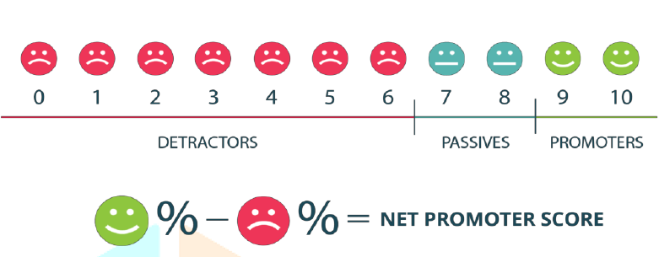
Fig 2.1: Net Promoter Score (Rajasekaran, M. N., & Dinesh, M. N., 2018)

Customer Effort Score (CES)
According to Jana Barrett (2019), Customer Effort Score is a feedback metric used to measure the level of difficulty or ease customers experience while interacting with a product or service. The CES was introduced after a review by Harvard Business in an article which aimed at rectifying problems experienced by customers faster and efficiently. Although Net Promoter Score (NPS) and Customer Satisfaction (CSAT) were able to capture key insights that are helpful at improving services and products, Customer Effort Score (CES) was particular about capturing the overall behavior of customers. In order words, CES was able to detect whether or not a customer found it easy interacting with a product or service. Due to the fact that customer loyalty is obtained as a result of the ease customer experiences during contact with products or services, Customer Effort Score (CES) was found to be more reliable to capture a more holistic view of customers’ experience.
Customer Effort Score (CES) is usually gotten by asking customers few questions to know if their interaction with a company’s service or product was helpful, this score is graded on a scale of 1-7. Thus if a negative response is given, a follow-up question is asked to know how services/products can be improved.
2.1.2 Feedback Loop
The feedback loop is a continuous process that involves the use of customer feedback to make suitable business decisions.
This feedback loop begins with the data collection phase which usually involves the analysis and communication of data collected to management levels who have the authority to initiate and make changes in customer experience management. However, if changes initiated do not benefit the customers at large, such changes will be revisited and proper adjustment will be made (Nail and Zabin, 2010).
After decisions have been made, it must be communicated to management levels to make their inputs about the changes made, once these changes have been implemented customers will then be allowed to give feedback, causing the loop to start all over again. Then communication is recommended to maintain the loop.

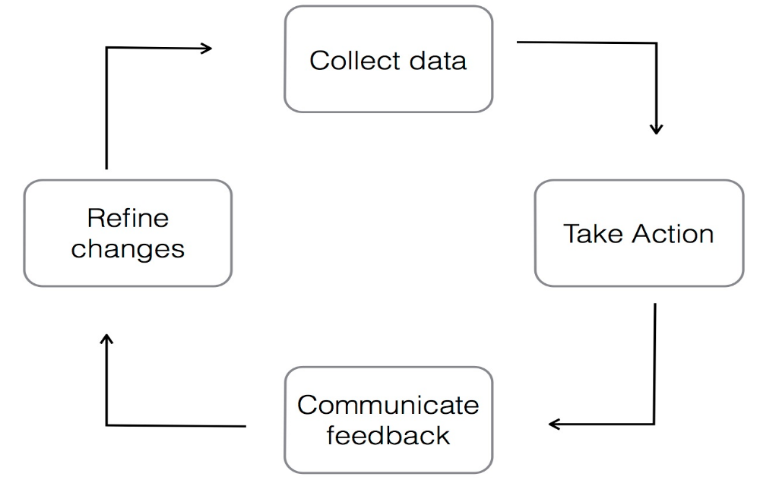
Fig 2.2: Closed-Loop Feedback (Dang, Hien, 2014)

2.1.2 Customer Feedback System
Customer Feedback systems are channels of communication between the organizations and the customer. It has proven to be a means through which customer opinions are translated into insights for growth and customer loyalty (Hien Dang, 2014). In as much as organizations are willing to develop a more customer-centric approach to their services, customer feedback systems serve as the right tool to facilitate that process. Feedback systems are widely used even outside the tourism industry such as food manufacturing companies who want to know what their customers think about their newly produced products, electronics manufacturing companies as well make use of feedback systems in order to help understand users’ difficulty when using their devices. This information gotten from feedback systems could either be information or compliment and criticism or complaints. Thus the role of a feedback system efficiently performs analysis on the feedback gotten to know exactly what action to take to meet the majority of customer demands. Information gotten from feedback analysis is expected to be implemented as soon as possible because in cases where customers make a complaint they expect to get a response to the complaint made (Barlow and Moller, 2010), which in turn is one of the factors that influence customer loyalty. Lack of response to feedback made by can lead to negative word-of-mouth from customers to future customers which reduces the chances of referrals which is bad for the growth of an organization.
According to a study by Mavis Dah et al. (2016) in Ho, Ghana the major feedback channels in use were Suggestion Boxes, Telephone, Personal Emails, Website, One-on-One Contact, Guest Comment Cards, Social Media, Customer Surveys / Online Survey and In-Room Questionnaires. It was deduced that the most effective and most used feedback channel is Suggestion Boxes. However, the most preferred feedback channel by customers was One-on-One Contact. Thus hotel managers must do well to identify the most effective and preferred feedback channel by customers. Multiple channels must be provided for customers to choose from in order to express satisfaction or dissatisfaction of a Hotel’s services.

2.2 Customer Experience Management (CEM)
Customer Experience Management is a corporate strategy to adapt all behavior and operating processes to customer needs according to Hossam El-Din Younes et al. (2013). Customer experience is commonly represented by the initial contact and engagement of a customer with a company's services. One of the factors leading up to customer loyalty is the recollection of the experience received by a customer. The idea behind Customer Experience Management (CEM) is the ability of customers to learn about an organization during his/her interaction with an organizations staff, then if an organization handles the customers experiences well, it can maximizes the organizations chances of developing profitable relationships with the customer. Today businesses adopt different strategies to provide customer-centered services, and experiences with customers allow organizations to recognize each customer's unique interest is the best way for them to do that. Due to the competitive and innovative nature of the businesses, customer experience management (CEM) is usually used as a primary method for managing business operations. Customer experience encompasses customer emotions and benefits perceived by customers during interaction with a company or hotel, which in turn influences their behavior, and therefore, in order to understand the emotional and experimental benefits, Customer Experience Management (CEM) is used as a strategy to understand customers.
Before now organizations and business enterprises used Customer Relationship Management (CRM) as a tool in tracking the interaction customers make with the services or product online in order to understand customer behavior such as their purchases, the amount spent, products or services they spend much time on, the average amount spend, just to develop strategies to keep their sales at a considerable level or increase sales made. However, the strategies behind Customer Relationship Management (CRM) began to fail which lead to the introduction of Customer Experience Management (CEM). Customer Experience Management (CEM) was concerned more about the customer’s experience, the satisfaction level and how customers experience could be managed to gain their loyalty. A cross evaluation of each customer’s experience served as valid points for organizations and businesses to take note of and improve. The data used by managers to evaluate customer experience was normally gotten from surveys, feedbacks from customers which they are always happy to give according to Forbes.
However, the big question still remains how customer experience can be improved. In a study by Johnston, Robert and Kong, Xiangyu (2011) on “Roadmap for Improvement”, according to that study, a ten stage road map for improving experience were proposed.

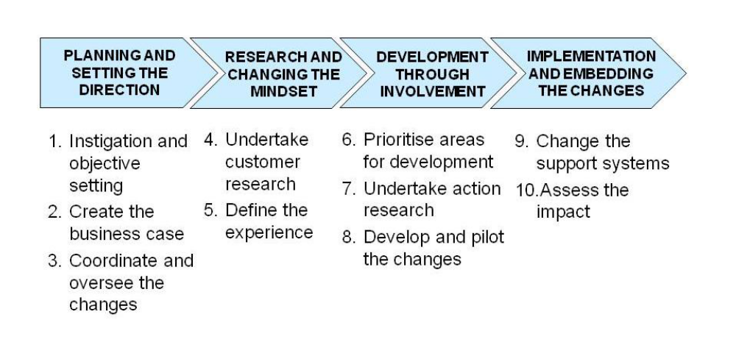
Fig 2.3: Ten Stage Road Map for Improving Customer experience (Robert and Kong, Xiangyu (2011)

This broad stages were developed in order to answer questions regarding: the need for improvement, the customer experience to be provided, the Plan to be used to improve customer experience and the effects of the changes made to customers.
- On the first stage, which is Instigation and Objective Setting deals with the motive behind a specific change desired to be implemented by business leaders or managers to improve customer experience, although sometimes the holistic aim of implementing the change many not be known at the early stages, but definitely along the way, the motive behind the change and the strategies to be used become clearer. Also the specific business areas where changes are to be implemented need to be identified at this stage.
- Coordinating and oversee the changes involved appointing an individual amongst the team handling the changes to control the activities during the implementation of changes and report to higher authorities concerning what had been done.
- Undertake Customer research involved the collection of data from customers through interactions, on what customers’ expectations were about their services and the areas customers felt needed improvement. It also involved tutoring of manger and staff on the importance of making changes in business.
- Define Experience involved the experience team making statement which described their various views from customers on what they felt the services an organization should supply that would be more profitable.
- Prioritise areas for development: with the various views of customers, the experience teams become more away on the areas they need to pay more attention to. Therefore this involved putting all changes to be made on a scale of preference and working on the changes that have the highest priority in order to satisfy customers.
- Undertake action research encouraged identifying of customer emotions while using services or products from an organization. Experience team try to study the behavior of understand the customers expected feelings at every point of the way
- Develop and pilot changes: This actions were carried out repetitively. Here the staff and managers would be asked to pick out problems usually faced by customers, the project teams will now help provide valid changes and test those changes across various departments within an organization, thereafter feedback will be demanded from customers. If changes are accepted with positive remarks from customers, the experience teams take up approaches to apply the changes across all departments.
- Change the support systems: this is the revamping of an organization’s processes and systems in order to fit the changes made by the experience team to avoid customer inconveniences on understanding the new changes.

2.3 Business Intelligence (BI)
Business Intelligence is an approach in business to use several techniques such as data collection, analytics, and visualization to support operations and strategic-decision making activities. Business Intelligence is now used as the general term that involves data mining, data ware housing, reporting as well as online analytical processing (OLAP) (Williams,2016). Thus, In order to understand past, present and predictive views of a business, BI Technologies are used to easily identify those business trends and critical success factors for competitive advantage. Additionally, in order to identify and create business opportunities from trends found, this business intelligence technologies have proven adequacy to make use of large amount of structured and unstructured big data usually gotten from internal and external sources to create useful insights for making decisions in areas such as pricing, production, advertising marketing and customer demand. Thus creating intelligence which cannot be gotten from a singular set of data. (Coker, 2014)
Business Intelligence (BI), however is believed to have originated from Decision Support System (DSS) (Arnott and Pervan, 2005), but due to its ever changing requirements BI developers often found difficult to compare DSS and EIS to Business Intelligence (BI). A Business Intelligence (BI) system could begin with concise decision making functionality but after a while its functionality could begin to increase and change due to its broad information sources. The term Business Intelligence (BI) has replaced the Decision Support Systems, Executive Information Systems and Management Information system (Thomsen, 2003) reason being that BI systems are able to gather data, store data and manage knowledge with analytical tools in order to present complex information to decision makers, thus Business Intelligence (BI) has a fast response time to producing of information when data is inputted compared to DSS and EIS.

2.3.1 Components of Business Intelligence (BI)
Data Warehouse and data marts, this supports the reproduction of data by handling multiple records for integration, cleaning, formation and querying tasks. It contains live and updateable set of data which can be used for tactical decision making on a subject matter. The sources of data could be historical data, operational databases, external data (i.e. the internet) or information from an existing warehouse environment or it could also have relational database sources which is data that supports a particular line of business. Usually, this data can reside on various platforms containing structured (e.g. spreadsheets, tables) and unstructured information (plaintext files, pictures) and other multimedia information, retrieval of data from operational databases into data warehouses is known as Extraction, Transformation and Load (ETL).
Data marts refers to a collection of data on a particular subject area summarized and organized for DSS needs for a given department (Inmon, 1999). Most individual departments have their set of hardware, software, data and programs which make up their data mart, in other words every department usually has their interpretation of what a data mart is or looks like and it is specific to its own needs. These data marts have operational data similar to data warehouses which assist business managers or experts strategize based on the analysis gotten from past trends and experiences. The only difference is that data marts are created and predicted based on specific needs for a particular group and configuration of data selected. Furthermore, there could be more than one data mart in an organization.
Secondly, OLAP (On-line analytic processing), this refers to ways which business owners can gain better understanding of their data with sophisticated tools which allow for efficient measures of direction in organizations. OLAP provides a summarized and multidimensional view of business data which is used for analysis, reporting, modeling and planning for optimizing the business. OLAP techniques and tools could collaborate with data warehouses designed for intelligence systems. When this intelligence systems query data, they do so to discover trends and analyze critical success factors and the reports gotten from these systems provide aggregated views in order to create awareness for managers on the state of their business. However, there are other BI tools which could be used for storage and analysis of data such as data mining, decision support systems and forecasting, knowledge management, information visualization and dash boarding, management information system.
Real Time BI, this suggests the real time distribution of metrics in real time through email, messaging systems and interactive displays. In the past traditional BI did not proactively respond to situations and take critical timely business decisions in real time but nowadays that not only is analysis done in real time but also response to analysis result are to be performed in real time and at the same time change parameters of business processes. However an architecture to enhance BI that covers the complete process to sense, interpret, predict, automate and respond to business environments and reduce the time needed for business decisions were introduced by Nguyen Manh et al. (2005). This architecture was an IT event driven architecture to run BI applications that enabled real-time analytics across corporate business process, which notified the business of recommendations and effectively closing the gap BI systems and business processes.
Corporate Performance Management (CPM), simply allows for the integration of the different tools that provide analysis (i.e. portals, scorecards, dashboards) in which the aggregate of the results gotten form a big picture and clear understanding of one’s business. Advanced Analytics, is any activity that involves data mining, for casting or predictive analytics, this takes advantage of statistical analysis techniques to predict or provide certainty measures on facts.
Lastly Data Sources, as earlier stated data sources can be operational databases, relational databases, historical data, and external data (e.g. from market research companies or from the internet) or information from already existing data warehouse environment, these data can be stored on different platforms which contain structured (i.e. spreadsheets) and unstructured information (i.e. plaintext file, pictures and other multidimensional information )
Business Intelligence (BI) has been considered of having great impact to making effective business decisions, helping organizations performance to improve and create competitive advantage (Liebwitz 2006). In order to keep customers in highly competitive markets, companies for forced to go to the extreme in order to gain customer loyalty, information however becomes key to managers and business experts to take productive steps in ensuring customer satisfaction is ascertained and also attract more customer. Thus the need to establish relationship with customers becomes important and BI however has proven to efficient in monitoring customer satisfaction, improving organizations marketing strategies, operations and services.
The application of business intelligence (BI) can expand the knowledge of an organization whose goal in be an “intelligent organization”. (P. Adamczewski, 2012). Thus intelligent organization who are constantly learning operate based on what is known as knowledge management (Koronios and Yeoh, 2010) which in turn improve the efficiency and productivity.
2.3.2 Benefits of Business Intelligence (BI)
According to Azeroual, O., & Theel, H. (2019), benefits of business intelligence include:
- Business Intelligence helps to facilitate the presentation of the outcomes of data in a more understandable formats such as graphics, images etc.
- Handles the processing and analysis of information using various methods
- Enlightens business managers on the tasks and inefficiencies with the aid of realistic abstractions (.i.e. models)
- Enables timely access to fast and efficient analysis of information
- Business Intelligence (BI) encourages knowledge management amongst business managers in organizations
- Aids in efficient decision making activities from reliable sources of information
- BI data warehouses serve as databanks f or company’s data and information
- Newly implemented Business Intelligence (BI) systems are inter-operable with other exiting information and analysis infrastructures
- BI follows accurate cooperate control processes

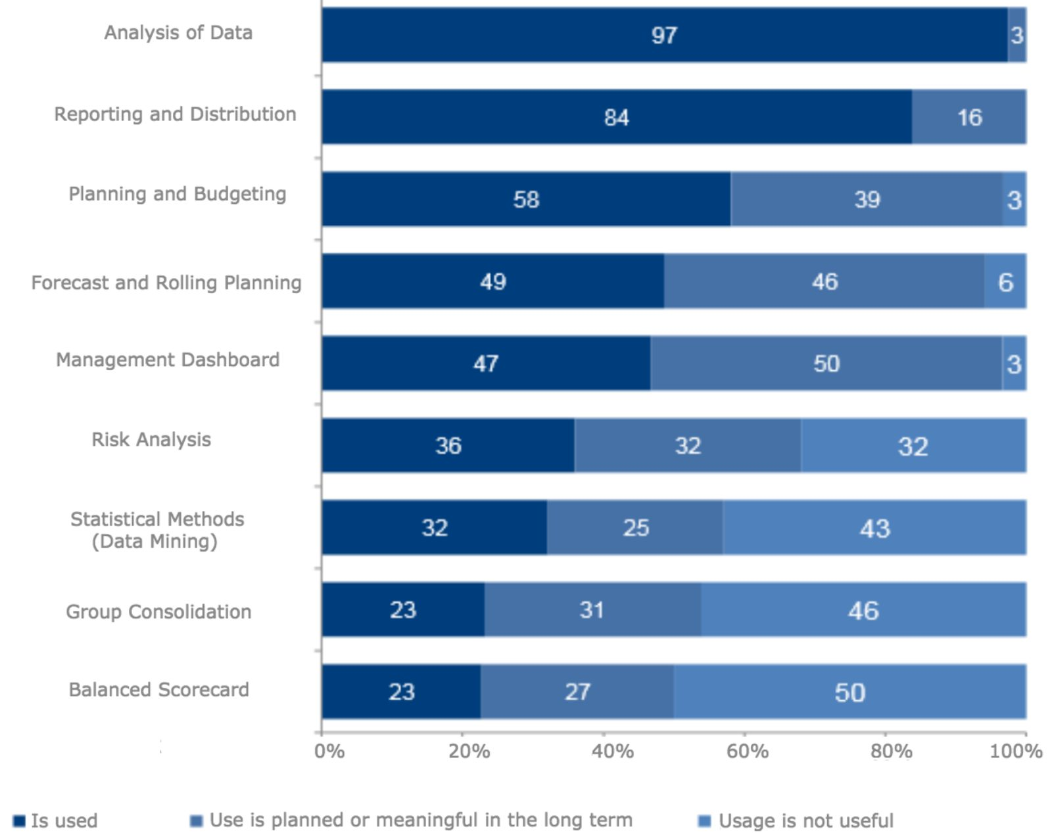
Fig 2.4. Uses of Business Intelligence (BARC. (2012))

2.4 Elasticsearch
Elasticsearch is an open source and real time distributed RESTful search engine built on Apache Lucene. The basic idea behind the use of Elasticsearch was to aid in the handling of full-text searches at an easier and faster pace. Additionally, Apache’s Lucene is an open source Java library used for full-text search. Thus elasticsearch can be thought of as the best emerged interface to lucene to handle big data (Divya and Goyal, 2013)
In this study by Divya and Goyal (2013), Elasticsearch was defined as a new database built to handle big data volumes with very high availability and to distribute itself across many machines to be fault-tolerant and scalable, maintaining a simple but powerful API that gives access to the database by any application built with any language.
Elasticsearch operates using a data structure called inverted index, which enables the fast search responses for documents. The data structure Inverted index stores up the keywords that are contained in a document and identifies the list of documents in which a keyword occurs.

Keyword | Document
Django | 2,3
John | 4
Hello, Django | 1,2,3

Table 1. Inverted Index

There are however basic concepts to the proper functioning of Elasticsearch, which include:
- Node: A node refers to a server which is part of a cluster, participates in the indexing and search capabilities of the cluster, and stores your data. A node is given a name by default at the point of initialization.
- Cluster: A cluster is a group of one or more nodes (called servers) that hold all of the data together and provide organized indexing and search capabilities across all nodes. A single name default to identify a cluster is "Elastic search." This name is important because only if the node is set up to join the cluster by its name can a node be a part of a cluster.
- Index: An index is a group of documents which have features very similar. Elastic search stores one or more indices of its data.
- Document: A document is simply a unit of information, which contains fields, multiple values and a unique name.
- Shards: Clustering enables the storage of quantities of information that surpass a single server's abilities. Elastic search spreads data to several physical Lucene indices to meet this requirement, these indices are called Shards, and all parts of the index are called sharding. This can be done automatically by elastic search, and all parts of the index (shards) are available to the user as one big index.
- Replica: Sharding allows more data to be put into Elastic search which can be done with a single node. The idea is to simply create an additional shard copy, which can be used just as original primary shard for queries.

2.4.1 Kibana
Kibana is an open-source visualization application used to analyze large amounts of data in the form of line graphs, bar charts, area maps, coordinate maps, etc. These visualizations are used to study changes or errors in patterns. Kibana works with data from elasticsearch and Logstash which forms the ELK stack.
The L in ELK stack stands for logstash. Logstash is responsible for retrieving and processing the data from multiple data-source, indexes it gives it an index and pushes the data to Elasticsearch when needed. Logstash pipeline contains input-to-output data flow stages in Logstash. The input data is fed into the pipeline and processed in an event form. During the process stage which is known as Filter is where the processing of events are handled. One may use Logstash's predefined Regular expression Patterns to create sequences for differentiating in events between the fields and requirements for approved input events. Finally, at the output stage in logstash the processed data is converted to form that is required by the destination plugin. Then the data is submitted to an output destination in the appropriate format for the user or end device.
Kibana possesses a lot of functions, but to mention a few:
- Visualization: Kibana provides translates data gotten from elasticsearch and uses different charts to represent them. Visualizations include pie charts, bar charts, heat maps, line graphs
- Dashboards: Kibana dashboards provide different sections in which the different visualizations produced are displayed
- Reporting: Kibana could be used as a reporting tool by converting dashboards visualizations into CSV formats that can be sent to others
2.5 Introduction of Computer Reservation Systems
Traditionally, reservation systems were developed for airline companies, who had problems storing and retrieving large amounts of reservation data, which included the flight schedules, ticket price, reservation availability and all reservations made. Thus software had to be developed for controlling reservations for airlines, for reservation staff to efficiently monitor seat availability (Sion et al., 2013).
In an event that reservation request is made by travel agents, the information could easily be sourced for from the airline company and thereafter make reservations easily with a computer connected to the specific database of the airline company.
With the presence of reservation systems, airline managers saw the importance and effectiveness of allowing travel agents to access the main systems directly, thus, airlines began to make terminals available in their various agencies for travel agents, to source for information and make reservations.
In little time, reservation system had proved to be effective than the previous method (i.e. the manual method), these reservation systems led to the rapid reduction in the time it took to source for information and the cost of communication. Travel agents could now access reservation availability and cost concurrently, improving the quality of service.
The emergence of this technology was beneficial to all airlines because it was less expensive to distribute the tools needed to facilitate direct access to the airline database than it was to hire more staff members. Besides, company managers found out that the travel agent was in support of the idea of airline companies use reservation systems. This helped to expand their market, creating more revenue and the economic entrepreneurship spirit obtained from the price reduction. Replacing terminals in agencies in such a way that flight agents are linked to ensure a better future for flight bookings. (Sion et al., 2013)
2.5.1 Online Hotel reservation Systems (OHRS)
Hotel Reservation systems which are also known as Computer Reservation Systems (CRS), is a computerized system that manages the information of the hotel, guest house or lodging facility. According to Kim et al., 2005, the role of reservation systems in tourist companies has proven to be positive. Due to the fact that establishing an online presence and incorporating business e-commerce models adds to the companies’ efficiency and profitability (Poon, 1993). The use of online reservation systems in the hotel accommodation sector, air-ticketing sector and lots more has helped in one way or another to enhance growth of e-commerce and caused a reasonable scientific research on the relationships between tourism industries and information technology and marketing strategies A Computer Reservation System (CRS) provides assistance to hotel owners to properly manage all online marketing and sales where they could upload their services and their prices so that other sales channels could see them. The list of major Computer Reservation System (CRS) modules is content, information stored on a CRS, and reporting. Content includes Reservations, Profiles, Groups and Blocks, Tariff and Stock Control, Administration, Global Distribution System, Web Interface. Data typically stored in a Computer Reservation System (CRS) includes room types, rate plans architecture, room rates and conditions (guarantee, deposit, cancelation rules, minimum length of stay, maximum length of stay, closed to arrival, unauthorized arrival, unauthorized departure), room inventory, generic hotel data (address, telephone number, fax number), booking details. A number of standard reports are provided by the Computer Reservation System (CRS) Reporting module. System reports can be automatically generated and run on a daily, weekly, monthly, annual basis.
2.5.2 Types of Reservation
Generally, there are two types of reservation, which are: Guaranteed reservation and Non-guaranteed reservation
- Guaranteed Reservation: Guaranteed reservation is a reservation with a specially registered hotel confirmation that it guarantees the customer to obtain the number requested by him at the time required. The client, in effect, ensures that the amount will be charged even if it cannot be used in the case of no show. Payment for an unused number will be paid to the customer if he was unable to cancel the hotel accommodation order in time. The beauty of guaranteed reservation is that if the guest cannot use it, the guest can decide to cancel the order number. Some examples of guaranteed reservations include advanced booking reservations, booking under the credit card guarantee, booking on invoice.
- Non-guaranteed Reservation
A conditional booking or simple agreement between the guest and the hotel in which the hotel agrees to keep the room until 6 pm on the arrival date. If within the cancelation hours, the guest fails to reach, the room will be released for resale.

2.5.3 Factors Affecting Reservation System
1. Confirmation: This is a legal document specifying the acceptance and approval of the room request made by guests and the hotel. It can be a reservation that is either guaranteed or not guaranteed. If a guest does not check-in or check-out on time, this affects room occupancy.
2. Cancellation: this means that the room that was previously reserved will again be available for resale for personal reasons or normal law, then the guest will have to pay any fee and the remainder of the amount paid will be refunded.
3. Overbooking: this refers to the tendency of booking rooms that are beyond the available capacity of the hotel. This is often used as a strategy to maximize room revenue to prevent no-show or last-minute cancellation. This process must be carried out carefully, in an event of overbooking or rooms, the guest will be moved to the same standard hotel that had been paid for.
4. Walk-in: Here guests arrive at hotels without reservation hoping to get one, they are often called Chance guests. This type of reservation should be handled carefully and accommodated by walk-in formalities with advance deposit. In events that there is no accommodation for walk-in guests, they are referred to hotels nearby.
5. No-show: This occurs when a guest does not come physically to pick up a reservation or for formal cancellation. In such a case, a hotel charges guests with compensation fee and then a refund will be made to the guest.
6. Over and under stay: When a guest stays in hotel rooms beyond the set departure date it is called overstay. While guest who checks out before the set departure date is called under stay
2.6 Empirical Review
For the empirical review, past literature that has been collected relating to this study were examined, in order to deduce the central knowledge gotten during the course of research.
2.6.1 Online Hotel Booking System
A study on Online Hotel Booking Systems by Iwuoha Joseph Ikechukwu (2012), developed a user-friendly website after having undergone studying at the Imo Concord Hotel. The system was developed to aid users in their search for information on hotels with decent prices, it also incorporated a secure payment system, which was intended to enhance the availability and productivity of the Imo Concord hotel services. For this project the Structured System Analysis and Design methodology and UML diagrams were used to design the process flow of the different features on the application. The tools used includes:
- Apache 2.2 for the running of the server
- MySQL5.0 for the Database management
- PHP which was used to handle the communication between the web server and the database
In conclusion to the study carried out by Iwuoha Joseph Ikechukwu (2012), the problem of the middleman on reservations systems were eliminated, a more efficient marketing tool was produced for the Imo concord hotel, an upgrade of market presence of the Imo concord hotel was achieved and a more reliable application for customers use was developed. Challenges faced during this study were:
- Difficulties in obtaining information from the Imo Concord Hotel for the development of the application
- The development of a responsive website that was readily available for customers was a major problem during this research.
It was however stated that more effort should be made to extend the functionalities of the reservation system in areas such as: shopping carts, business proxies, cash registers and merchant accounts
2.6.2 Hotel Information Management System
A project by Alabi Oluwaseun Faruq and Babatunde Gideon Opeyemi (2014) handled the development of a Hotel Management System, which enabled users to make transactions such as view rooms and make reservations and on the other give administrators the privilege to monitor the various transactions carried out on daily basis by users. The project made use of the various technologies including:
- Visual Studio was used as the Integrated Development Environment (IDE)
- Microsoft SQL Server, 2008 was used as the Database Engine
The module included in this project included; the accommodation module, catering module, finance and account module, front-desk module and personnel staff record module. The limitations faced during this study were:
- This management system was designed for only online use.
- An online payment option was not implemented during this study.
- The capturing of customer signature was unable to be covered during this project due to cumbersome processes known to the researcher.
- Lastly, this project was only limited to specific areas including: Reception, accommodation, finance and account, catering, food ordering, administrative, security, and general services transactions.

2.6.3 Faculty Feedback Management System
Akash et al (2018) in an International Journal of Advanced Engineering and Research Design (IJAERD), developed a faculty feedback management system to alleviate the manual process used in institutions. In order to effectively handle improvements in the quality of student-teacher relationships, a feedback system was implemented to allow students to give feedback about their teachers either negative or positive in order to know the areas of weakness, hence leading to valid changes and necessary improvements. This feedback system was designed in a way that students can login, give their feedback and the system records the student as anonymous in order to give room for fair evaluation. The Admin was given the user privilege to export the feedback reports after a period of time. The tools used during this project were mainly PHP and My-SQL.
Additionally the feedback system had the various entities:
- Courses: indicating the various programs taken by students in the institution
- Ratings: this was used to store scores that were to be given under each question
- User Account: this recorded all login details.
- Branch and Branch-Sem: this stored data with similar characteristics.

CHAPTER THREE
METHODOLOGY
3.1 Overview
According to Oxford Advanced Learners Dictionary, a methodology refers to principles used to perform a particular activity. Methodologies are employed by researchers to facilitate the further findings which increases knowledge concerning a particular research work. This chapter focuses on describing all methods used for the proposed system and how the proposed system intends to achieve its stipulated aims and objectives. All approaches used were briefly explained including the various UML diagrams used to illustrate process flow of the proposed system.
3.2 Proposed System
The proposed system is a web based system that is accessible by any customer, authorized system administrators and management officers. It will give customers access to available room reservations, provide a convenient way of sorting room categories according to the customers’ preference when trying to book a room. More importantly this system intends to provide a more dynamic feedback system for customers and most especially the management officers who seek more information about customer experience by providing more visualization tools (i.e. pie charts, bar charts, graphs, real time figures on profit made etc.) which would make the managers work more efficient and easier.
3.3 Requirement Specifications

3.4 System
The users will be able view all available rooms on the system, view rates and also book room/rooms of their choice. Also, the various services provided by the hotel will be accessed by the user for further inquiries. This system eliminates the difficulty experienced by customers to sort the variety of rooms provided on the system and allows customers to sort the rooms according to their preference with customizable dates, thus providing an easier method to compare the prices of the rooms. More importantly, on the landing page or at the end of making a reservation on the web system, users are obliged to make reviews concerning their experience while interacting with the system or services provided by the hotel, these reviews could be submitted after filling-in required customer details.
The system administrator is required to register on the system with a unique username and password for security purposes, as these sign-in details will be needed to log-into the system. The System administrator is given the user privilege of viewing reservations made by customers, the check in and check out dates, add and delete rooms, view room status to know if it is occupied or free by customers and could handle booking of rooms for walk-in customers at any time.
On this system, the management officer is required to register on the system with a unique username and password for security purposes, as these sign-in details will be needed to log-into the system. After logging onto the system, would be given access to all customer reservations made, customer details as well as chosen check-in and check-out dates through this, the management officer would also be able to identify peak periods in which the hotel entertained high number of guests from the low seasons which the hotel entertained few amount of customers. All reviews made will be directly accessible by the system administrator. The system admin will be able to visualize this reviews through bar charts, pie-charts etc. provided on the dashboard by kibana. These reviews would be easily sorted out based on dates, services provided, negative and positive. From the reviews made the system admin will be able to view net promoter score of the organization which would help indicate areas that need improvement for better customer experience, increase in profit and development of business strategies that would be beneficial to the organization in the long run.
From figure 3.1, after the customer has been able to access the reservation system, at any point the customer can make a review about hotel, thereafter the user submits the review made which is stored in the database. Once the review has been stored in the database, elasticsearch which sits on the server would access the review documents stored in the database when needed by the management officer. With the aid of the inverted index data structure in elasticsearch, the documents would be given an index which enables the fast and easy retrieval of the customer review documents. These documents are then conveyed from elasticsearch to kibana with the help of compactible plugins, which creates visualizations of the reviews made by customers and information needed to improve the hotels services.
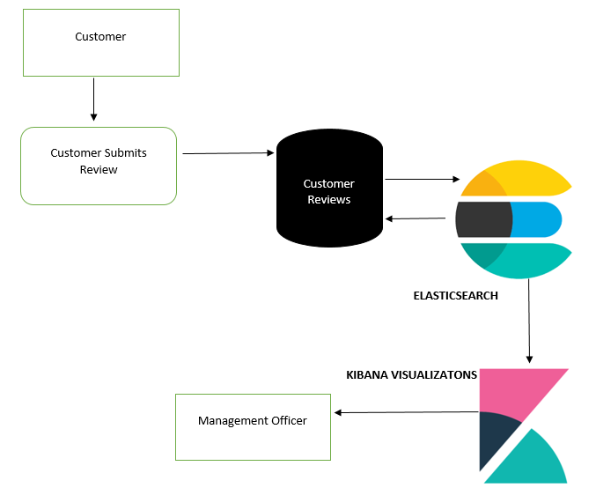
Fig 3.1 Architecture of the Feedback System.

3.5 System Design
This shows how the system will operate through the use of architectures, modules and how the various modules complement each other. This designs are based on the requirements of the users of the application. The various designs are developed using use-case diagrams, flowcharts, architectures
3.5.1 Flow Charts
Flow chart represents the flow of steps in a program pictorially, where elements are represented by simple icons such as circles, rectangles, parallelogram, diamonds etc. This flow charts represents the sequence of activities and decision points that are carried out by the Guest/User and Administrator while using this site.
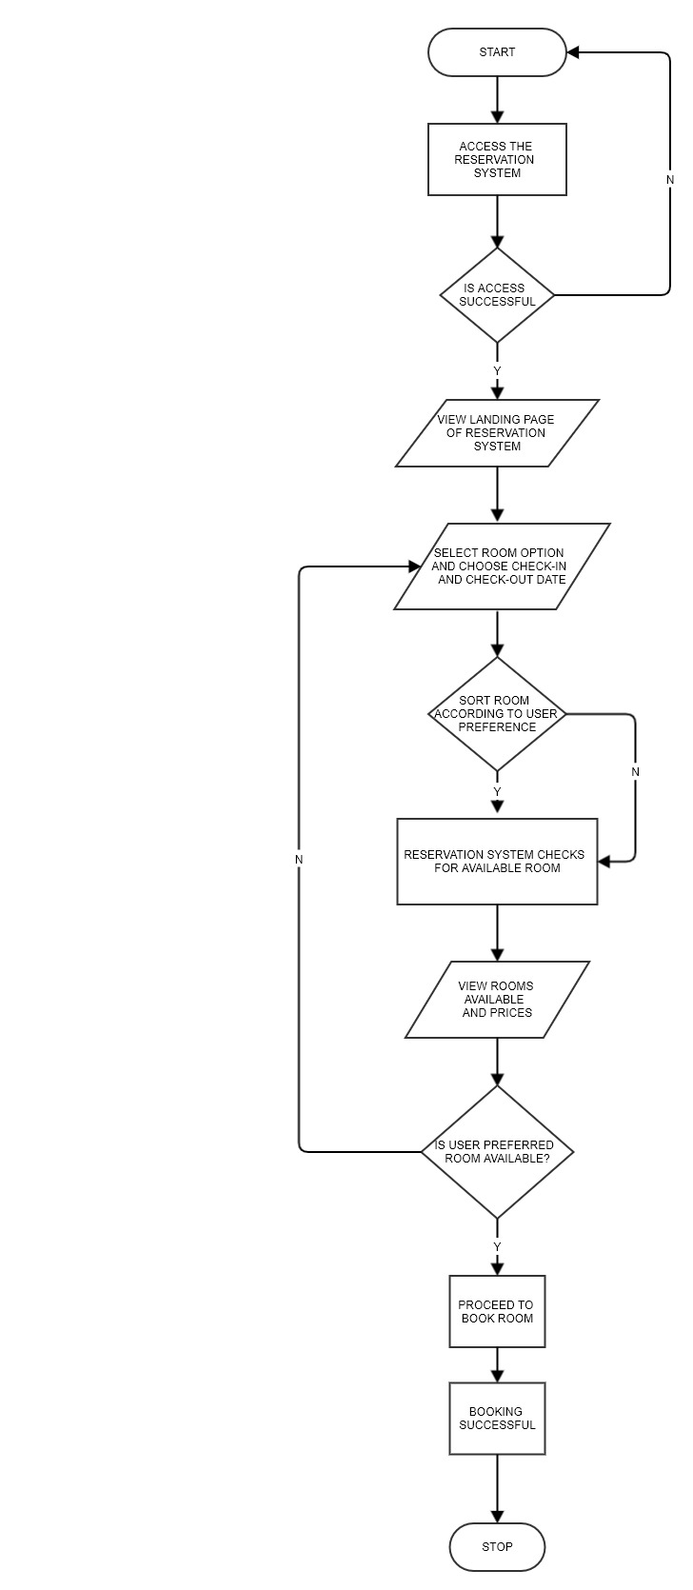 Fig 3.2: Booking of Room Flow Chart for User

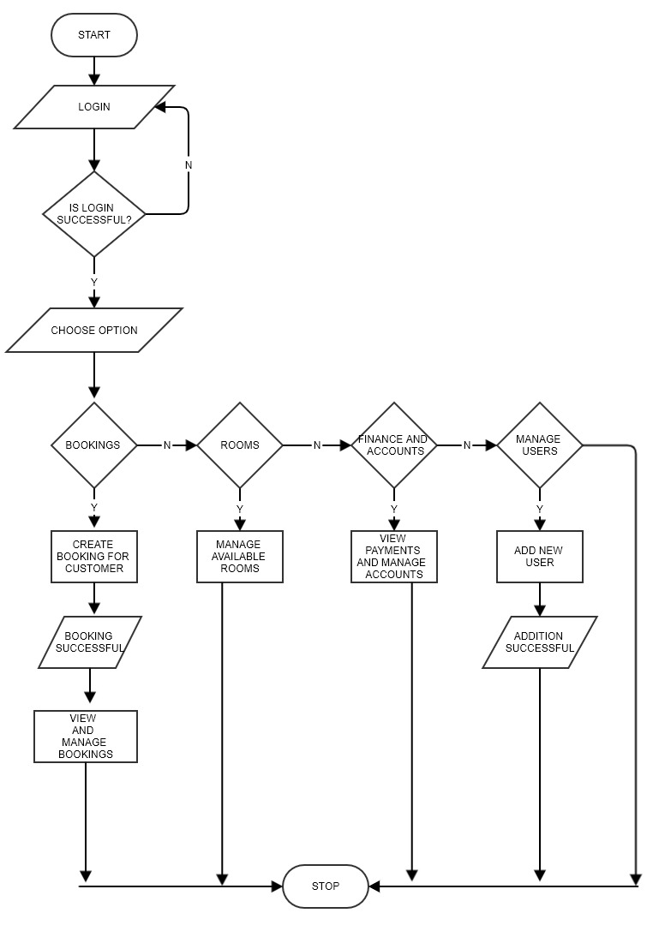Fig 3.3: System Administrator Flow chart

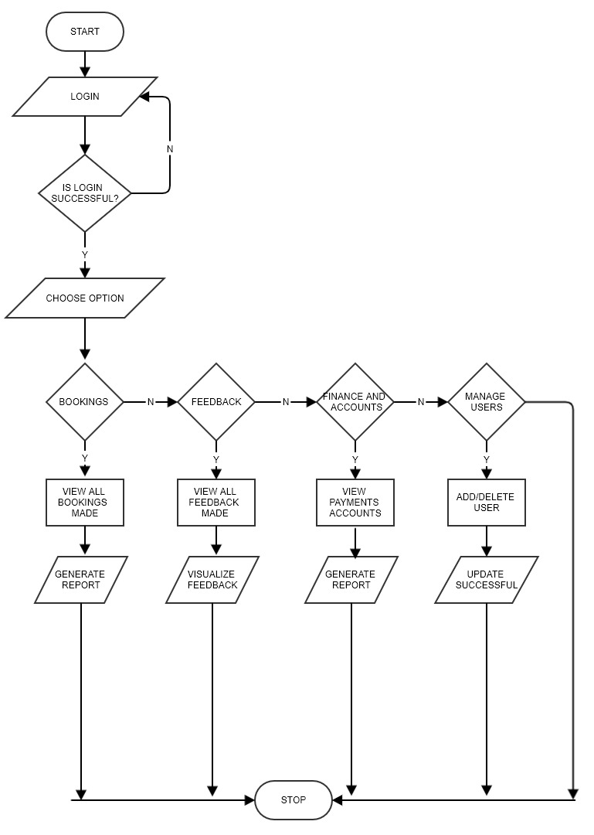
Fig 3.4 Management Officer Flowchart

    - SYSTEM ARCHITECTURE
This system architecture represents the conceptual model that shows the structure and behavior of a system.
From fig 3.5, the users of this system include: the customer, system administrator and management officer. The architecture of this system is quite simple. A customer could access the reservation system through a computer system when connected to the internet, with this system connected to the internet, customers could access the reservation system server to make reservation and any other transaction.
The System administrator would have the privilege of viewing all reservations made by customers, add or delete rooms, view check in and check-out dates, manage accounts and change user settings
The Management Officer oversees all activities carried out on the reservation system including managing all system admin accounts, all reservations made, accounts and profit made and most importantly the management officer has the privilege of accessing the feedback system, viewing all reviews made by customer.

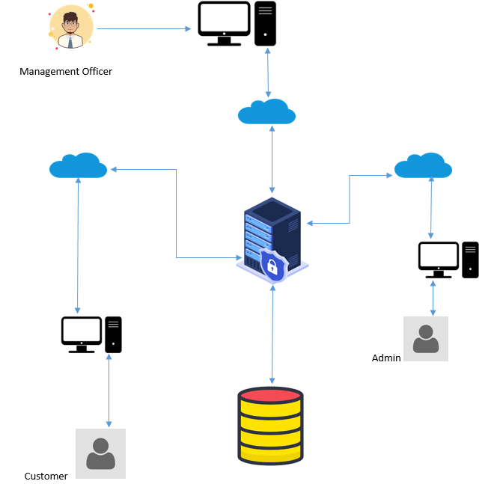

Fig 3.5 Reservation System Architecture

    - USE CASE
Use Case Diagram is usually used to show several scenarios that users can perform when interacting with the system. Every use case diagram should provide observable results to all actors of the system.
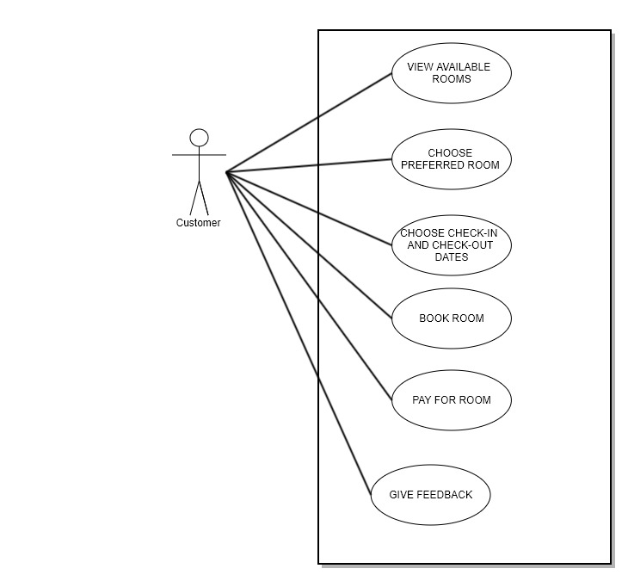
Fig 3.6 Use Case Diagram for proposed system

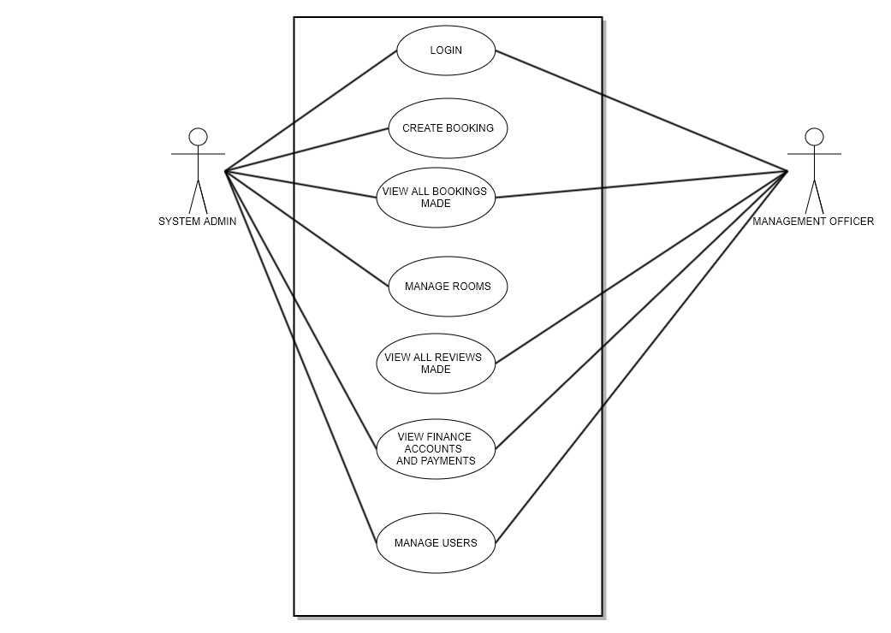
Fig 3.7 Use Case Diagram for Proposed System

3cU2FsdXGVkX1C%2BtZfqHqFMv9dy9r7wjmQCXfy%2FFDE1n%2FC5JqWpE0%3Dh8qGvou5U2FsdGVkX1%2BzgW%2FGP%2Fh194M8UQSUlra4dpVYhJ0pPbd0QhCUDDv7vFUI9SU9m3htAvT4Dx42pVnpzVZndVKwi5BMaFvDZ3NwcGcXlBKtLQ%2BU72kwMVUJsziKSa9mAAjkipBCv0%2FksYDhNjmLgAewnZ1l5SJ6MPN3S1oFg74LGZ84Dlaz1Z1xKhbvGYVnuY1cCD8clWnY9KGAGT4zJy5m2jylSGBGo%2BEWDnJTGMwuXwRSZ5LVXkJ%2BpWJJj4VmiJLIz4lVA336zGgBNOv5I1sUGsYMjFXnClXbNVi30LhpIJ%2BxYeK1e0P%2BI4ZAS4rsLfAsoizGyVBn2gBznhWpl8OBf9KWgEwRsOfxat%2FVMFGvjd69%2BFnDy%2BdRtNDuUuIRZu1a8oHqMMZ5a3RtW9yRm%2F9CGwlJytbIuwGgx%2B6yT7z4sk40Au1Tc%2FKJohOHqGFcs%2B8kcRGfm0tW3ToDzBesfcIfV56RaSmFz4%2Ff0R%2B%2FEJvi87d1Bxo0Y9F3ba%2Fg%2BhoSeyydSOQ04tl3qwR92%2B1FJ2TaVm9nag12rm46YLW27HSdBYlt2YwqwAjWLSsevZbgQUa0KUvwIvh9Avib%2FuX0Iz3%2B26PkcH1dH4I27NAsiY1g3YLCoE0X4vfECPwK3%2BOu2aBC3hxi%2BE9i3AjDzcPjRXFwy3nOOPvM35xm5jWAgYA6tt%2BMr0ti338dBYxyrQyi0BV6f5Sr0E%2BDlS2o4vmf2%2BfQtkp7aKTDvxFCOSo6kWPMLlxg9wwMRKYr9poIvJ4WO2xMdRNQVj0mFHqTjaXXQaqPbHGp4FH4KZZVQKgnZGlGuyMoEnPxuzB4ead1LLSzSsEtHdB%2FIDl39DIS6Gq1CSl98tYamRIqiEMm1lMjKpsKizoAYD88LWpkT1zCaQLpuSh8yJwjyxItYxU5HhN8%2FXHOiUBWbEEZt3QzahqZmH6veWlzXb8Vn7pkqrvCwj3yyFxFU10u1PuYh9KQZzxvch9wdOuXkOhlk4TRVAK4ZXRq1uAafMrDLuTZScxx3ot%2Fuds5eX%2FpIjvI0JKwGBJ1AjnOY4gGjU4VEwDWItXKnVXwbnyqvxLN6%2FnbZr75c%2FQC%2ByUG8iiagg163594cjM6oh5UIAI7kvKNZ0z89X3xLp5X7J30auenK2jXrLXHKvrFzz3rCTnKxQw2Z2ZukfdgN5dsk%2FaRTGYTDL%2FOjj0QIELmTEcXAMgrb%2Fgp592pQtNptVZtnxSPQYVLitec56cefaglpBKAcLy0NBZh3dNt%2FfczCPb1LQXtaBIbPGiPCzouk%2BhV8%2FgtniFIei8qgI0s5lQoAkkkGxPVqOZ6ilVhcvpFAw4isXTRGudF2NvKZo4aCoejDjLcYaeChjMlUnmMdlISDhVLt8GDSO1D5Yn7fRQZngyYIlLwEbO3Hh1EgDw54%2FJga9eztwOUIa1f5SCV8%2BNjc%2Be%2BGgT5Xml%2BsJB9AnAoFyg4iTYoiFdCX5nk6Cs9%2FlsjvQeBh8aNI7CKENcTS3rtBMScKPtxJWWwDqXS7%2F6O5J1cYctJEoxlFNkY0cHabnbvBbKSMHC3cQBFYxMWVVIlDhkAVAmc9P42RZ7MXgwuEtb8qnbIdw5Q3qReYAUvdCAyq4wajbaNAau14JOj81i%2B7alspMpV0kSdX5VSqkQyZ%2Bil4XzbZZWo5GtqQsJdUaZsE3Lh3jRGEfXMwkPrfciEykefsjQYGssvZpg7AwUoDPN7pwKU9wK%2Bsl5ftzzCTxy2J8sfpJ5AZsEG%2FEL8OhWkcb1iGV%2FGBJM39dzuYW2QQUXzHOQykdJb7FSdie8%2Fbx9k26mMQ1XQUGlFPj4dRXSHMWOkAqcDOhrXagXM8ZwKHV8EbFw1xq404N4Apk03v4hMJrrrILvbZeoLqQZuboEt2zyo9ovxVfzZdm%2BW7xTG3Q9aX%2F3U3yCymCZzQLsgE3caJ4eslORFYmasjdSITGWFOAjE30PORur2zyw7UFZCb4CG%2B4oPHdqnxzKL9dkgAhXIgFkiPiQ8KSE0DT%2FV%2BWj1iRpkjDKx2SFZO7Pyz9m%2BIFRuZJVSGgh1RlsxRwi3hl5Kwv%2B78iEfUSvmOL0jLmTdWEnpoxzadBrvaNMzNX6nr49CrFxtt32tutySW5MWltz4zk68ZS0TWgV%2BiHa5DT8CRVv7QqK2xQ4UNM2%2Fmqju%2BLSx2tIz7X1EYGcmWSapL5XBwtbBpKCa%2B%2F188y2rqI40swu%2FUghEOlGdiI8FL5v%2FNrpzt9sOiaaz6mf40IvkKl7NsQxmjZOu5i4%2BBV9lYi78Dm%2F7ie4PkTo6mvDeP32enhJQGo1jT1UElGlO2urahCj05U1Rx1mZ81OSwXWU6SuAV3TiIPyctrC4pXp%2Brs7KuC1QPnWZ6%2BgyQup3VsU8ytj8J2DjnBEtjetJ7caIT8gQ08zqNw%2BS5gzJM4jegrD6jKBct4Bw%2B75qz1A%2FiWveUMbBibtuJp02p4Mom7ty5BdRJtwCT0Ev8FT%2Bhy0CwyEwRKhGyOeu8T2E9QpkFt6cTRDCpXF4uepUKHWuuSoDkhhiDhQei4xTeH41RhEg2LNjDuUmfyCc1YrxZwmvQaB42cu05lI6HK7Es71DNGNfElZ1uElmB5KmU%2FqEWS6P%2B14ecbXFVonCYwFV5BTrAvnxnMGqBR0rbrbTjyRpmIQVHpL7gGyKfqAttseSojeUM%2FRWRb2K7dfqH5q8IOTvBggowUQjCqez%2FyTl6TIvBCm3pqxqurYAI41Y6p8hzUszxaV2Dt5WUnHvWDF4wESxh1TqmBzVEfLn16ygrX7Qo2LJvUM46ShyxV9P6AEVn75%2Bo2hAHspvNNAQzoDIXezTBY8mN3R8vsx4LeOIu2ABqkBT7glLlh7EBgZGZo3Mj42TlvlW%2B1CKRgK6YPYqV8rYw5Y%2FJFl1%2B2o3rXlj5%2B%2B2z944BS2ua2sQUdlrdhRlxXFERr67pHpV1THFMK8WrEeVp88fiSGCAQ6G4j9AHSNsxazqIUGXDkxsabTryhdEsvToi1b2V4goq3KyDb45XCxrHlesp96v2YUPZeJ1484P2x93FRktbHJj8Md4k9pjWgFmCHqmu3eDVfUa6IRiUz2nOC6w%2BM%2FgzNV9RuD8lkgEpTQcS1H2p1Yw1w1%2Fcemre9c8ejyEJ1D6ug2zlc0BOpmsOaz48gHHi778Gvn67%2FjWptJmPZBjgr0DazQsVXrr52cyFtUT%2FcLYsHMHD8lqmcWi%2F%2FTutG%2FmxSB4dgobai2JuvVxLjB8Ip%2FBBAWDxHviqfcYKtFh4yPsL0xzdWFdb4EESaKbWgCqHYX4RLTKRc7YIDuK5qC1lZwDM%2FGHauK0D2L1o0cvX%2Bw3gxXI0aNO3ARpXCTccKuFvZGEijph1S3rtRwzvNEPSVB6ESVW8eLwCCOyUJpmh421Lt6ulMal2FdcG38ekW4kBxyq351NGz4Daig6Vy3qMQAlT54LTV%2FSEn5lFgNOXVb%2BmArd9xoXldMMijBTn5JdG%2B0W%2F7srOf8CEfjKFQJwyqm%2BqFxbMkTfDkYhr3gvSQP%2By1FLhan13EBa6qNC29ef6kxhe1Sxi9qBu6KD3bO7JqVoUAFvTlpCl2lk3z4vkPOfTIiAt9PokBTiOwhR4Otq934MnKWriGYhfCEUEVwT5Eub3g%2Fwb5EiOwEcQQ0V71Q2fBSKpJ2XTpxr7oXDa4XG2NsKqr%2FHNpiZBTioDvSQ6AGnvDyGKJ29KA8Soq2ROCrBvmSQ5Zh73HOuWJ%2BG7556q1Yum6z9ufU7zYxld7fSCsby1r7tmWqe6ytN9nskqd1PXFMZDtIqmOSVJK8UlCVFucI%2FINSg3rTyF4pzG14lhOCjbL56ZqJCVi02Y%2BDMMtZlNf5Ro7ZFIWSKiqE%2FVV8IXQO7QVqBfoEfLmdEGwYYYur8U%2BU4nb1RsyjL6m7M6qpa7flvOOlcDQP0bBVutA5NIWFZdOHGIfKiJhDTGTSAwu2OXZFEnZbRwN4sb0YwgX4e009bYxFOVAFGzil5ojIkiVxsOn2YAl%2FC2ZwnRM%2BDN9WKBRwrYNlYooAKAp7HO80%2FWIYgSrD8BiZ3XJ%2Bx7FLbVPGWiEszvdzuFb1CsYypNlP%2FBhld33Ml78hZk%2Bdj2jk2Su9cbAeuWbFa8yqsVwnS0agvwW7CNGcInA1tx6p%2FgVXAqJXxLF5Q7FGwsLFPuMHL%2FTDydW0EliujYY6KE9n9Jy1pQjcALz8Nk7gTq3B3VJ6ahHsWiRGiE3iVr4VliaWXKxvPlmfK4AAeoCLPQfXvN0aBhlxbCxPKUhwRqvLK8XAjFwg36kFIUeVPqeXRP04J0eYGlQsUywEmt4BHdRGH9pStPXgpSH3tizCcBS%2FUrxaTiLzvAQ%2FWVQzB9IChi2hIFkg%2FjdUrTvOh6dJmUVNAG8xHadM2v681XOuRdH17bqRu7R1vQynGAWEJhavAJS%2BY2y7TTz4G6uufO3Lkj6V4cvPUyfzPY7Ktw4E0pSuduSEKda8WoT5qcwzyVhdaBgVlnrm7gGiYNTQ%2Bl9WptTLclzpZwyKdBVXiGrlY%2Bn3jyI%2FMza%2FK249QS0YGxk5higFNsn5VN0GPw7fZfzDgzGN%2BgRk3sO9PKt2%2BA5fkgRdBc7b68HzHf%2FEVZKH%2FXJNzA%2FY7K%2FujdybgncJd74K%2B51r7WghDxVdXuDhHo8LX8PLWZGNdniSniqbUyOzk7z7n6hCwVEncycUbbTaeOV%2B0%2FOzuvG4AR07jhiRSIhURJd13rOeIxpAp5UkpzS7mMrLkBJ5OAVVFi6XTRA4GAJ4wdeN7Cb7p6mxv%2BJlr%2Bx6QRQSGBpOvRUDETjKAY76o5ughHOZDEqMVe6LuAFZjeSFqV0hp0863VqvIDpV9zirD2IcIFxKdUdn%2BYjA%2BnNtg%2FGVsrhcewgVtWaGNweOks0ih89%2FzEUgobZSeq7SEdSkU0qAaQEPv8Ur1kYKcnPNFoE3XarWfz9Uj%2F5vqgvqk%2BI663Sss0curYQBvSbM0Fez7d9LYPV7OOiHrmTBRKaf%2Bh7HPcMrj4875%2Fd3ZWkp8VvYZqurJt1DJ6OUZ9dvMlQF%2Bveb15ndPvCmZk2xiTlahvaJCyPiGTUZwLO7IQfMb7ArWn7LK3a5w571MgH7lObiDS8U2omXITAyJrWvmqX8B6pT76j%2F0e3kIITE3Az4X%2BFLvrPKjO59rBfTrmgHYukvJDJhXDdFbOed7FJEN5TxIDzxqjDSbjyp7mI1Pmv6j4zZruvFpTdjVogyhgaYb7tL0R8bRVp5QjB4dT%2BfkVLGLbacFLf4M7fl4Ae%2FfKcVHsS%2BowU8dJvft39GRHTcWekeQgSXNpIvKE%2BvHgLyTMO0M7EEfhZ%2FMLi4aLxf110Qh76xIA8P8h7QeFMXs5Ls4l0Q4EU%2BucSk6Qzf9ENH%2FUvLbAY6B3iJZ8640ta6sYamC4%2Fi7tC5AWi3jnvV0nF4OgicbrebJNmERGW%2BAg3hCRkn2Xi%2FWwd3hifn21nVSAuOr6P6dJZ7I%2F1ZzuPckrlE4K66URCsN%2BWhw4r7ZMh0KqW7aWg0qlyWGxTwcQToVc0k2OmNkng0H4BrIfaO3iAEFAoW937JMxVNsxvsS9tZqegv6J49LrL23Lxo2sJBKicJwOvC8GaEnMdhYmFbenpAG2W7YDW4%2BBZk7fcj1%2F0K2FAjj9LTI62%2FrZ%2B2sWecJtQI9ykupFlrQSWvZCF100YofMWcLHW0B7Nk1yLn%2FUOiN7itukiDgq9vp9GN51jP0hxkK9NKr73FLVoCGe3hdzF1xqrxOcHIF7UhKuijFxArTvMtYp97EpLNJtzdQxz1iuREtgCnt43JxS%2FW7xnNyVSsCc6qJ448bITyNalGbqfEoNqFQpkz%2BIoSjeOf98cKQXgFKaDFqx0yB4uD6%2ByQV6nnB4jwoJyGSwBq9D01jdZaQuxWUtyqtyMe10HUt78bjQo6f7OvxbtnRKElTrYVTKUIB2I%2FBVgtXF%2BPpcY9NG7BwCDvUvh646O1%2FRMiLNMPs0kpYnJfmUteSRiOAS5La9RB1vdjDYpl7Q8WQ4PPmKeAyJnqlwkDfjeYzCsk9v8pyZdN0TF7cfLaT5pV9ukHlDIypKDxUYETyEd2dn3GrW3bs6kVtk%2FNBIn0jtqgKZfXUnYqx4RIqMiycsY9pGcuAfxkll54lGYEBczGFxgv3kcljfQTbCi%2BNaktTvonqd4YstcA22TbRNsEwW2G469N1ER%2BXb6UE9w56nzaAb1Qnp8ChniC%2Fw%2FUNZYUewlyurdMM1vkgsFLWyscODAC8MZebSP2ABErjdlgau58S5HdaR%2FQ%2Bik1ohZEfDb30ITWDWeCMN77U2qwyEPJ%2FPbmapxtji0Saglgesx6QMaru2XtScOz0y3k77uRajoKgrUbA6lK9fM5FGfvmZsqfh36Icja%2BXUho%2BaYkXS5nI%2FxGfjbGkYX%2BkujfJHHvZ73bo4QlmBkQE499jKpXpOe%2Byz%2Bzi0PYlu%2BkksdRZZFJrmTQ%2B%2Fx0gM1swvqPRhl6ciqxr4hMOEZJcdv9Jg7CaRLeOYRMr8Vwdqs99yEtzvv
REFERENCES
Adamczewski P. (2012), Systemy ERP-BI w rozwoju organizacji inteligentnych[in:] Systemy inteligencji biznesowej jako przedmiot badan ekonomicznych, red. C.M. Olszak, E. Ziemba, ,,Studia Ekonomiczne” nr 113, pp. 65-75
Adams, D.A., Nelson, R.R. & Todd, P.A. (1992). Perceived Usefulness, Ease of Use, and Usage of Information. MIS Quarterly, 16(2), 227-250
Adams, J. Stacy (1965), “Inequity in Social Exchange,” in Advances in Experimental Social Psychology, Vol. 2, Leonard Berkowitzed. New York: Academic Press, 267-99
Agarwal, R., Sambamurthy, V. & Stair, R.M. (2000). The Evolving Relationship Between General and Specific Computer Self-Efficacy – An Empirical Assessment Information Systems Research, 1(4), 418-430
Akash, Bath Kumar, Manoj Rana, Parvej (2018). International Journal of Advance Engineering and Research: International Journal of Advance Engineering and Research Development, 5(3), 434-439
Ajzen, I. (1985). From intentions to actions: A theory of planned behavior (pp.11-39).Heidelberg, Germany: Springer
Ajzen, I. (1991). The theory of planned behavior. Organizational Behavior and Human Decision Processes, 50, pp179-211. DOI:10.1016/0749-5978(91)90020-T
Ajzen, I., & Fishbein, M. (1980). Understanding attitudes and predicting social behavior. Englewood Cliffs, NJ: Prentice-Hall.
Amy K., Ruth N. Bolton, and Janet Wagner (1999), “A Model of Customer Satisfaction with Service Encounters Involving Failure and Recovery,” Journal of Marketing Research, 36 (August), 356-72
Andreassen, Tor Wallin and Line Lervik (1999), “Perceived Relative Attractiveness Today and Tomorrow as Predictors of Future Repurchase Intention,” Journal of Service Research, 2 (November), 164- 72.
Arnott, D., & Pervan, G. (2005). A Critical Analysis of Decision Support Systems Research. Journal of Information Technology, 20(2), 67-87.
Azeroual, O., & Theel, H. (2019). The effects of using business intelligence systems on an excellence management and decision-making process by start-up companies: A case study. arXiv preprint arXiv:1901.10555, 4(3), pp. 30-40
Bagozzi, Richard P. (1975), “Marketing as Exchange,” Journal of Marketing, 39 (October), 32-39. (1994), “Structural Equation Models in Marketing Research: Basic Principles,” in Principles of Marketing Research
BARC. (2012), Business Intelligence in Mittelstand 2011/2012. Status quo, Ausblick und Empfehlungen, 2.Auflage, BARC-Institut, Würzburg, März 2012.
Barlow, J. & Moller, C. 2010. A complaint is a gift: Recovering customer loyalty when things go wrong. 2nd edition. San Francisco: Berrett-Koehler publishers, Inc.

Bojnec, S., Z. Kribel (2004) Information and communication technology in tourism. In Intellectual Capital and Knowledge Management. Proceedings of the 5th International Conference of the Faculty of Management Koper, University of Primorska, 18–20 November 2004, Portoroz, Slovenia, pp.445-454, URL: http://www2.fmkp. si/zalozba/ISBN/961-6486-71-3/445-454.pdf
Burstein, F. and Holsapple, C.W. (2008), Handbook on Decision Support Systems. New York: Springer.
Buhalis, D., and M.C. Licata, M. C. (2002) The future eTourism intermediaries. Tourism Management, 23(3): 207-220.
Buick, I. (2003). Information technology in small Scottish hotels: Is it working. International Journal of Contemporary Hospitality Management, 15(4), 243-247. DOI:10.1108/09596110310475711
Camp, W. G. (2001). Formulating and Evaluating Theoretical Frameworks for Career
and Technical Education Research. Journal of Vocational Educational Research, 26 (1),
27-39
Camp, W. G. (2001). Formulating and Evaluating Theoretical Frameworks for Career
and Technical Education Research. Journal of Vocational Educational Research, 26 (1),
27-39
Camp, W. G. (2001). Formulating and Evaluating Theoretical Frameworks for Career
and Technical Education Research. Journal of Vocational Educational Research, 26 (1),
27-39
Camp, W. G. (2001). Formulating and Evaluating Theoretical Frameworks for Career and Technical Education Research. Journal of Vocational Educational Research, 26 (1), 27-39.
Coker, F. (2014). Pulse: Understanding the Vital Signs of Your Business, Bellevue, WA: Ambient Light Publishing

Correia, A., Kozak, M., and Ferradeira, J. (2013), “From tourist motivations to tourist satisfaction.
International”, Journal of Culture, Tourism and Hospitality Research, Vol. 7 No. 4, pp. 411-424.
Davis, F.D. (1986). A technology acceptance model for empirically testing new end-user information systems: Theory and results (unpublished doctoral dissertation). Massachusetts Institute of Technology: Cambridge, MA.
Davis, F.D. (1989). Perceived usefulness, perceived ease of use, and user acceptance of information technology. MIS Quarterly, 319-340.
Davis, F.D., Bagozzi, R.P., & Warshaw, P.R. (1989). User acceptance of computer technology: A comparison of two theoretical models. Management of Science, 35(8), 982-1003. DOI:10.1287/mnsc.35.8.982
Divya, M. S., & Goyal, S. K. (2013). ElasticSearch: An advanced and quick search technique to handle voluminous data. Compusoft, 2(6), 171.
Engel, J.F., Blackwell, R.D. and Miniard, P.W. (2001). Consumer Behavior. International Edition.9th edition. Dryden Press
Eugene W. Anderson, Mary W. Sullivan. (1993). The Antecedent and Consequence of Customer satisfaction for firms, 12(2), 125-212. https://doi.org/10.1287/mksc.12.2.125

Evans, K.R., Christiansen, T., & Gill, J.D. (1996). The impact of social influence and role expectations on shopping center patronage intentions. Journal of Academy of Marketing Science, 24(3), 208-218.
Fishbein, M., & Ajzen, I. (1975). Belief, attitudes, intention, and behavior. An introduction to theory and research. Boston, MA: Addison-Wesley.
Folkes, V.S. (1984). Consumer reactions to product failure: An attributional approach. Journal of Consumer Research, 10, 398-409. DOI:10.1086/208978
Folkes, V.S., Koletsky, S., & Graham, J. (1987). A field study of causal inferences and consumer reaction: The view from the airport. Journal of Consumer Research, 13, 534-539. DOI:10.1086/209086
Fornell, Michael D. Johnson, Eugene W. Anderson, Jaesung Cha, and Barbara Everitt Bryant (1996), “The American Customer Satisfaction Index: Nature, Purpose and Findings,” Journal of Marketing, 60 (October), 7-18.
Fred Reichheld "The Ultimate Question 2.0” (2006) written with Rob Markey – partner at global consultancy Bain & Company. Published by Harvard Business Press.
Fundin A.P, Bergman B.L.S, (2003) “Exploring the customer feedback process”, Measuring Business Excellence, Vol. 7, No.2., pp 55-65
Gefen, D. (2000). Structural Equation Modeling and Regression: Guidelines for Research Practice. CAIS, 4(7)
Gerard, G., Osinga, E.C., Lavie, D., and Scott, B.A. (2016), “Big data and data science methods for management research”, Academy of Management Journal, Vol. 59 No. 5, pp. 1493–1507
Giedrius Silys. (2017). Information System for Accommodation Service Searching and Management
https://www.theseus.fi/bitstream/handle/10024/128361/Information%20System%20for%20accommodation%20service%20searching%20and%20management.pdf?sequence=1 [Accessed 28 December 2019]
Heide, Jan B., and A. S. Miner (1992), “The Shadow of the Future: Effects of Anticipated Interaction and Frequency of Contact on Buyer-Seller Cooperation,” Academy of Management Journal, 35 (2), 265-91.
Hien Dang (2014) Designing new feedback management system for Långvik hotels
Holmes, J.H and Lett, J.D (1997), “Product Sampling and word-of-mouth”, Journal of Advertising Research, Vol. 17 No.2, pp 35-40
Homans, George C. (1961), Social Behavior: Its Elementary Forms. New York: Harcourt, Brace & World, pp 1-14
Hossam El-Din Younes, Nevien Khourshed and Osama Badawy (2013), “Customer Experience Management Strategies and Knowledge Management to enhance higher Education practices”

Huppertz J. W., S. J. Arenson, and R. H. Evans (1978), “An Application of Equity Theory to Buyer-Seller Exchange Situations,” Journal of Marketing Research, 15 (May), 250-60.
Huppertz J. W., S. J. Arenson, and R. H. Evans (1978), “An Application of Equity Theory toBuyer-Seller Exchange Situations,” Journal of Marketing Research, 15 (May), 250-60.
Hyde, K. F., & Lawson, R. (2003). The nature of independent travel. Journal of Travel Research, 42(1), 13-23.
Inmon, W.H. (1999) ‘Building the Operational Data Store’, Wiley Publishers-New York, 2nd edition.
Johnston, R & Kong, X (2011). The Customer Experience: a road map for improvement: Managing Service Quality: An International Journal. 21(1), pp. 5-24
Kim, W.G., & Kim, D.J. (2004). Factors affecting online hotel reservation intention between online and non-online customers. International Journal of Hospitality Management, 23(4), 381-395. DOI:10.1016/j.ijhm.2004.02.001
Kimball, R., Ross, M., Thronthwaite, W., Mundy, J., and Becker, B. (2008), The data warehouse lifecycle toolkit (2nd ed.), Indianapolis, Johne Wiley and Sons.
Konečnik Ruzzier, Maja Ruzzier, Mitja Hisrich, Robert (2014) Value, satisfaction and customer loyalty pp. 21-36
Law, R., & Jogaratnam, G. (2005). A study of hotel information technology applications. International Journal of Contemporary Hospitality Management, 17(2), pp. 170-180. DOI:10.1108/09596110510582369
Lederer, A.L., Maupin, D.J., Sena, M.P. & Zhuang, Y. (2000). The Technology Acceptance Model and the World Wide Web. Decision Support Systems, 29(3), 269-292.
Lohrke, F. T., G. McClure Franklin, C. Frownfelter-Lohrke (2006) The Internet as an information conduit: A transaction cost analysis model of US SME Internet use. International Small Business Journal 24(2), pp. 159–178
Mathieson, K. (1991). Predicting user intentions: Comparing the technology acceptance model with the theory of planned behavior. Information Systems Research, 2(3), 173-191. DOI:10.1287/isre.2.3.173 McGraw- Hill.
Mavis Dah, Helen Dumenya, Arnold (2016). Investigating Customer Feedback Channels in the Hotel Industry: the Case of Ho – Ghana 12(26), pp 353
Moutinho, L. (1987). Consumer behavior in tourism. European Journal of Marketing, 21(10), 5-44.
Nail, J. & Zabin, J. 2010. Customer feedback management. Illinois: Gleanster LLC.
Nguyen Manh, T., Schiefer, J. and Tjoa, (2005), “Data warehouse design 2: sense & response service architecture (SARESA): an approach towards a real –time business intelligence solution and its use for a fraud detection application”, Proceeding of the 8th ACM International Workshop on Data Warehousing and OLAP, DOLAP ” 05, ACM Press, New York, NY.
Njite, D., & Parsa, H.G. (2005). Structural equation modeling of factors that influence consumer internet purchase intentions of service. Journal of Service Research, 5(1), 43-59.
O’Connor, P., A. J. Frew (2002) The future of hotel electronic distribution: expert and industry perspectives. The Cornell Hotel and Restaurant Administration Quarterly 43(3), pp. 33-45
O’Connor, P. (2003). Online pricing: An analysis of hotel-company practices. Cornell Hotel and Restaurant Administration Quarterly, 44(1), 88-96.
O’Connor, P., & Murphy, J. (2004). Research on information technology in the hospitality industry. International Journal of Hospitality Management, 23(5), 473-484. DOI:10.1016/j.ijhm.2004.10.002
Oliver, R.L. 1999. Whence consumer loyalty Journal of Marketing. Volume 63, pp 33-34
Oliver and J. E. Swan (1989), “Consumer Perceptions of Interpersonal Equity and Satisfaction in Transactions: A Field Survey Approach,” Journal of Marketing, 53 (April), 21-35.
Oliver and Oliver (1989), “Equity and Disconfirmation Perceptions as Influences on Merchant and Product Satisfaction,” Journal of Consumer Research, 16 (December), 372-83.
Oliver and Wayne DeSarbo (1988), “Response Determinants in Satisfaction Judgments,” Journal of Consumer Research, 14 (March), 495-507.
Oliver, L. R. (1997). Satisfaction a behavioral perspective on the consumer, The McGraw-Hill Companies, Inc. New York
Oliver, R.L., & DeSarbo, W.S. (1988). Response determinants in satisfaction judgments. Journal of Consumer Research, 14, 495-507. DOI:10.1086/209131
Oliverira, T., & Martins, M.F. (2011). Literature review of information technology adoption models at the firm level. The Electronic Journal Information Systems Evaluation, 14(1),110-121.
Petty, R.E., Unnava, R.H., & Strathman, A.J. (Eds.). (1991). Theories of Attitude Change. Englewood Cliffs, NJ: Prentice-Hall.
Peshkin, A. (1993). The Goodness of Qualitative Research. Educational Researcher, 22(2), 23-29
Poon, A. (1993) Tourism, Technology, and Competitive Strategies. Oxford: CAB International.
Prayag, G., Hosany, S. and Odeh, K. (2013), “The role of tourists' emotional experiences and satisfaction in understanding behavioral intentions”, Journal of Destination Marketing and Management, Vol. 2 No. 2, pp. 118-127
Rajasekaran, M. N., & Dinesh, M. N. (2018). How Net Promoter Score Relates To Organizational Growth. International Journal of Creative Research Thoughts, 6(2), 2320-2882.
Redko, Andriy (2015) Elasticsearch Tutorial: Java Code Geeks pp 82
Rogers, E. (1995). Diffusion of innovations. New York, NY: Free Press.
Sauter, V. (2011), Decision Support Systems for Business Intelligence (2nd edition), New Jersey, John Wiley and Sons.
Shaw, C., & Ivens, J. (2002). Building great customer experiences (Vol. 241). London: Palgrave.
Soderland, M,. (1998) “Customer satisfaction and its consequences on customer behavior revisited” International Journal of Service Industry Management, Vol.9, No.2, pp 169-188
S. Barjtya, A. Sharma, & U. Rani. (2017). A detailed study of Software Development Life Cycle ( SDLC ) Models: International Journal Of Engineering And Computer Science ISSN, 6(7), 22097-22100
DOI: 10.18535/ijecs/v6i7.32
Sahay, B. S. Ranjan, Jayanthi (2008). Real time business intelligence in supply chain analytics, 16(1), 28-48. DOI 10.1108/09685220810862733

Sheldon, P. (1997) Information Technologies for Tourism. Oxford: CABInternational.
Shim, S., & Drake, M.F. (1990). Consumer intention to utilize electronic shopping. Journal of Direct Marketing, 4(3), 22-33. DOI:10.1002/dir.4000040305
Shim, S., Eastlick, M.A., Sherry, L.L., & Warrington, L.P. (2001). An online prepurchase intentions model: The role of intention to search. Journal of Retailing, 77(3), 397-416. DOI:10.1016/S0022-4359(01)00051-3
Siguaw, J. A., & Enz, C. A. (1999). Best practices in information technology. Cornell Hotel and Restaurant Administration Quarterly, 40(5), 58-71.
Sion, B., Mihalcescu, C., & Marginean, A. (2013). The passage from airline reservation systems to the global distribution system.
Tax, Stephen S., Stephen W. Brown, and Murali Chandrashekaran (1998), “Customer Evaluations of Service Complaint Experiences: Implications for Relationship Marketing,” Journal of Marketing, 62 (April), 60-77
Teo, T. S. H., Y. Pian (2003) A contingency perspective on Internet adoption and competitive advantage. European Journal of Information Systems 12(2), pp. 78–92
Taylor, S. & Todd, P. (1995a). Understanding Information Technology Usage: A Test of Competing Models. Information Systems Research, 6(2), 144-173
Taylor, S. & Todd, P. (1995b). “Assessing IT Usage: the Role of Prior Experience. MIS Quarterly, 19(4), 561-570
Tesone, D. V. 2005 Hospitality information systems and e-commerce. New York: John Wiley & Sons
Thomsen, E. (2003) “BI’s Promised Land”, Intelligent Enterprise, (6)4, pp. 21-25.
Tornatzky, L.G., & Fleischer, M. (1990). The process of technological innovation Lexington, MA: DC Health.
Venkatesh, V. & Davis, F.D. (2000). A Theoretical Extension of the Technology Acceptance Model: Four Longitudinal Field Studies. Management Science, 46(2), 186-204.
Venkatesh, V., Morris, M.G., Davis, G.B., & Davis, F.D. (2003). User acceptance of information technology: Toward a unified view. MIS Quarterly, 27(3), 425-478.
Verhoef, P.C., Kooge, E., and Walk, N., (2016), Creating Value with Big Data Analytics: Making Smarter Marketing Decisions, London, Routledge.

Weiner, B. (1985). Spontaneous causal thinking. Psychological Bulletin, 97(1), 74-84.doi:10.1037/0033-2909.97.1.74
Wen, I. (2009). Factors affecting the online travel buying decision: A review. International Journal of Contemporary Hospitality Management, 21(6), 752-765. DOI:10.1108/09596110910975990
Williams, S. (2016), Business Intelligence Strategy and Big Data Analytics, Cambridge (MA), Morgan Kaufmann.
Zairi, M, (2000) “Managing customer dissatisfaction through effective complaints management systems”, The TQM Magazine, Vol. 12, No. 5, pp. 331-5

Internet
Jana Barrett (2019), Why Should You Care About the Customer Effort Score. Retrieved from
https://www.getfeedback.com/resources/ces/why-customer-effort-score-ces/
Pravallika (2019). “Importance of Customer Feedback Software In The Hotel Industry.” Customer Feedback App & Software, https://www.pihappiness.com/2019/11/importance-of-customer-feedback-software-in-the-hotel-industry/
Kibana Tutorial available at: http://tutorialspoint.com/kibana (Accessed: 12 March 2020)
Logstash Tutorial point Retrieved from:https://www.tutorialspoint.com/logstash(Accessed: 12 March, 2020)
Taie, P.T. (2013) 10 advantages of PHP over other languages. Retrieved from: http://www.webnethosting.net/10-advantages-of-php-over-other-languages/ (Accessed: 7 October 2019).
Tourism industry statistics for 2018 and beyond. https://www.tourwriter.com/travel-software-blog/2018-tourism-stats/ (Accessed: 5 March 2020)
Nafisat Usman Adams (2017) An Online Reservation System. Available at: https://www.academia.edu/36374126/Online_Hotel_Reservation_System_Management_.docx (Accessed: 11 October, 2019)
Ahlett, T. N.D. Managing complaints and feedback

