System Architecture.
From Fig 3.5, this system has two main users, the customers and system administrator, the customer accesses the web application using a smart device, preferably a computer or laptop, the customer through a network will be able to access the server where the application resides and make room reservations and other transactions on this application such as making inquiries on available rooms and the rates and also making comments.
The server is responsible for hosting of all the web pages for this application and supplying all data needed from the database. The Database works hand-in-hand with the server to store all customer and system admin information, reservations made, comments made by the customer, room information and payment history.
The system administrator is allowed to access the web application at any time and at the point of accessing this web application is required to do so using a username and password, after the web application has granted the system admin access to the reservation system, the system admin is given access to view all reservations made by the customer, the status of all rooms available on the application, comments made and finance documents if any. The sole purpose of this application is to create a dynamic feedback system for the system admin to effectively monitor the activities of a reservation system most especially the comments made. Thus elasticsearch which sits on the server retrieves all data needed to provide that dynamic feedback system from the database when queried, and after the data has been parsed appropriately the data is then fed to kibana which creates the visualization of the data needed by the system admin providing a wholesome and understandable view of the reservation system’s data which properly informs the system admin on the various activities that had been carried out on the application.
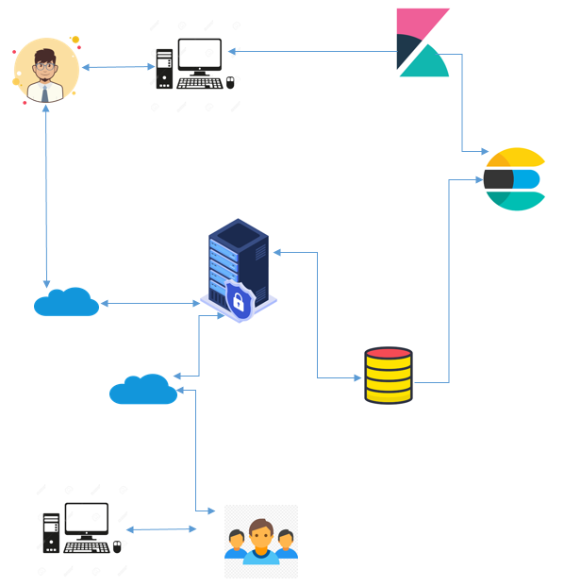
Fig 3.5 System Architecture

