CHAPTER THREE
METHODOLOGY
3.1 Overview
According to Oxford Advanced Learners Dictionary, a methodology refers to principles used to perform a particular activity. Methodologies are employed by researchers to facilitate the further findings which increases knowledge concerning a particular research work. This chapter focuses on describing all methods used for the proposed system and how the proposed system intends to achieve its stipulated aims and objectives. All approaches used were briefly explained including the various UML diagrams used to illustrate process flow of the proposed system.
3.2 Proposed System
The proposed system is a web based system that is accessible by any customer, authorized system administrators and management officers. It will give customers access to available room reservations, provide a convenient way of sorting room categories according to the customers’ preference when trying to book a room. More importantly this system intends to provide a more dynamic feedback system for customers and most especially the management officers who seek more information about customer experience by providing more visualization tools (i.e. pie charts, bar charts, graphs, real time figures on profit made etc.) which would make the managers work more efficient and easier.
3.3 Requirement Specifications

3.4 System
The users will be able view all available rooms on the system, view rates and also book room/rooms of their choice. Also, the various services provided by the hotel will be accessed by the user for further inquiries. This system eliminates the difficulty experienced by customers to sort the variety of rooms provided on the system and allows customers to sort the rooms according to their preference with customizable dates, thus providing an easier method to compare the prices of the rooms. More importantly, on the landing page or at the end of making a reservation on the web system, users are obliged to make reviews concerning their experience while interacting with the system or services provided by the hotel, these reviews could be submitted after filling-in required customer details.
The system administrator is required to register on the system with a unique username and password for security purposes, as these sign-in details will be needed to log-into the system. The System administrator is given the user privilege of viewing reservations made by customers, the check in and check out dates, add and delete rooms, view room status to know if it is occupied or free by customers and could handle booking of rooms for walk-in customers at any time.
On this system, the management officer is required to register on the system with a unique username and password for security purposes, as these sign-in details will be needed to log-into the system. After logging onto the system, would be given access to all customer reservations made, customer details as well as chosen check-in and check-out dates through this, the management officer would also be able to identify peak periods in which the hotel entertained high number of guests from the low seasons which the hotel entertained few amount of customers. All reviews made will be directly accessible by the system administrator. The system admin will be able to visualize this reviews through bar charts, pie-charts etc. provided on the dashboard by kibana. These reviews would be easily sorted out based on dates, services provided, negative and positive. From the reviews made the system admin will be able to view net promoter score of the organization which would help indicate areas that need improvement for better customer experience, increase in profit and development of business strategies that would be beneficial to the organization in the long run.
From figure 3.1, after the customer has been able to access the reservation system, at any point the customer can make a review about hotel, thereafter the user submits the review made which is stored in the database. Once the review has been stored in the database, elasticsearch which sits on the server would access the review documents stored in the database when needed by the management officer. With the aid of the inverted index data structure in elasticsearch, the documents would be given an index which enables the fast and easy retrieval of the customer review documents. These documents are then conveyed from elasticsearch to kibana with the help of compactible plugins, which creates visualizations of the reviews made by customers and information needed to improve the hotels services.
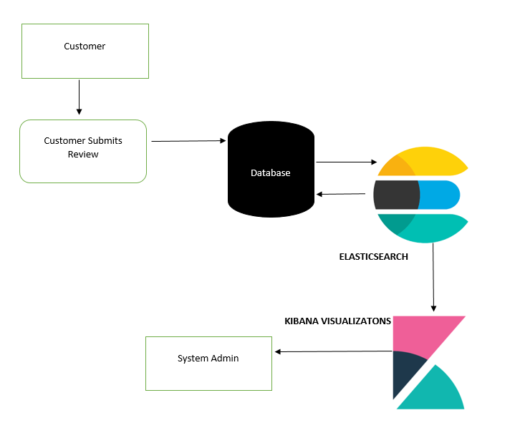
Fig 3.1 Architecture of the Feedback System.

3.5 System Design
This shows how the system will operate through the use of architectures, modules and how the various modules complement each other. This designs are based on the requirements of the users of the application. The various designs are developed using use-case diagrams, flowcharts, architectures
3.5.1 Flow Charts
Flow chart represents the flow of steps in a program pictorially, where elements are represented by simple icons such as circles, rectangles, parallelogram, diamonds etc. This flow charts represents the sequence of activities and decision points that are carried out by the Guest/User and Administrator while using this site.
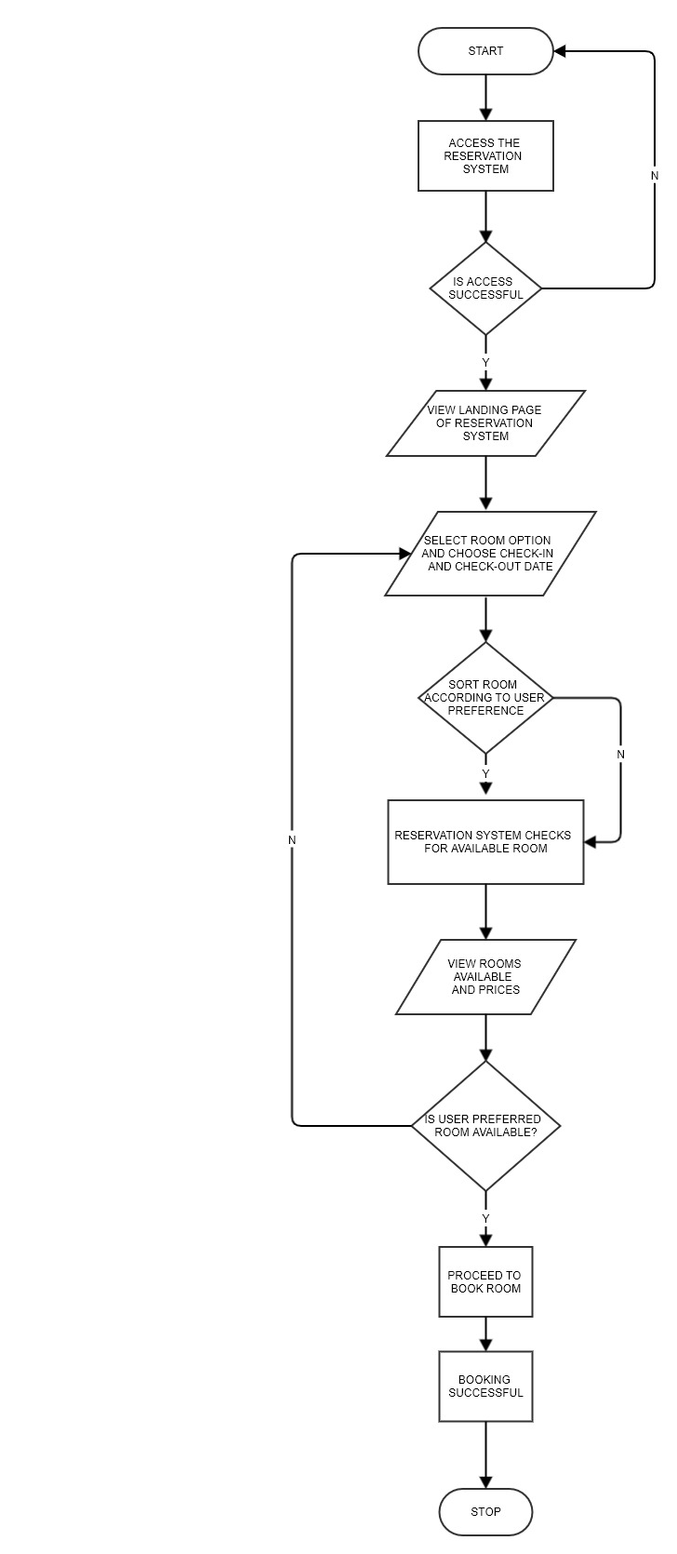
Fig 3.2: Booking of Room Flow Chart for User

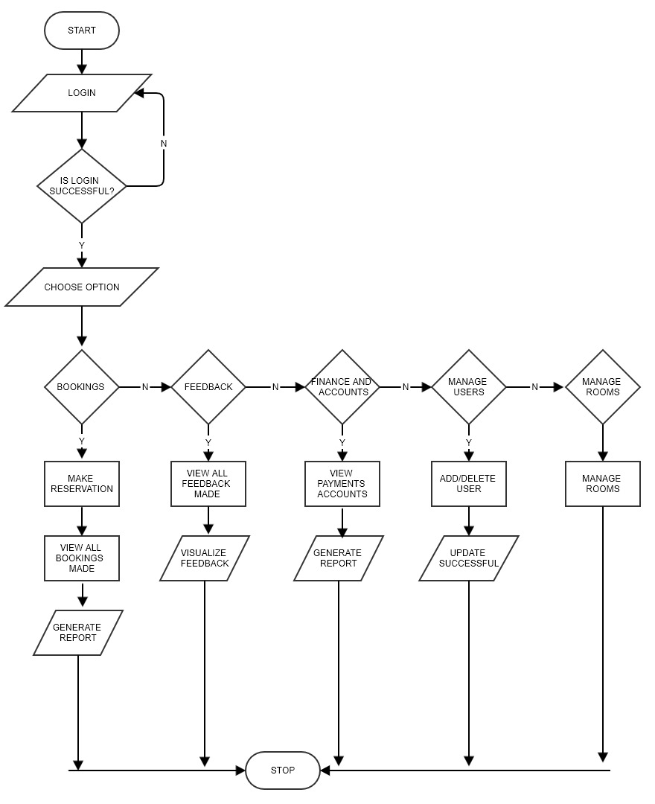Fig 3.3: System Administrator Flow chart

    - SYSTEM ARCHITECTURE
This system architecture represents the conceptual model that shows the structure and behavior of a system.
From fig 3.5, the users of this system include: the customer, system administrator and management officer. The architecture of this system is quite simple. A customer could access the reservation system through a computer system when connected to the internet, with this system connected to the internet, customers could access the reservation system server to make reservation and any other transaction.
The System administrator would have the privilege of viewing all reservations made by customers, add or delete rooms, view check in and check-out dates, manage accounts and change user settings
The Management Officer oversees all activities carried out on the reservation system including managing all system admin accounts, all reservations made, accounts and profit made and most importantly the management officer has the privilege of accessing the feedback system, viewing all reviews made by customer.

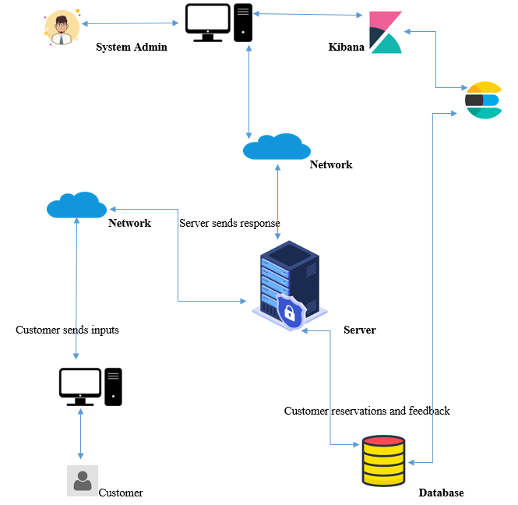

Fig 3.5 System Architecture

    - USE CASE
Use Case Diagram is usually used to show several scenarios that users can perform when interacting with the system. Every use case diagram should provide observable results to all actors of the system.
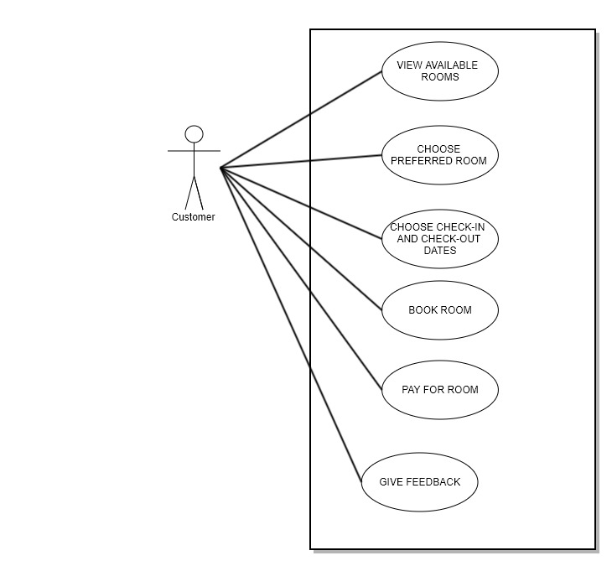
Fig 3.6 Use Case Diagram for proposed system

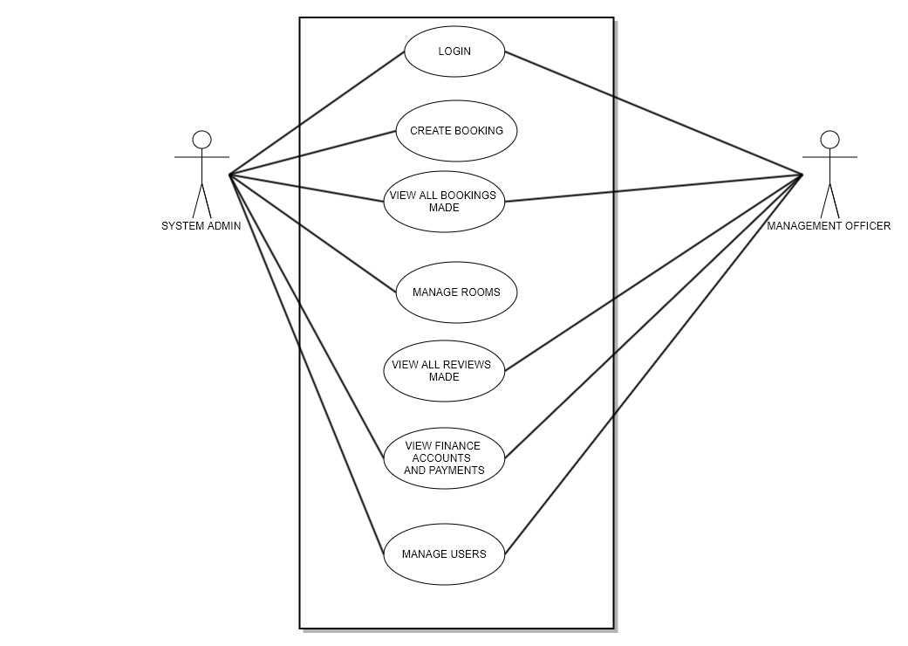
Fig 3.7 Use Case Diagram for Proposed System

