BUSINESS INTELLIGENCE FOR RESERVATION SYSTEMS

BY
JOSHUA TAMUNOKURO BLUE-JACK
(SSE/016/16103)

A PROJECT SUBMITTED
TO

COMPUTER SCIENCE PROGRAMME,

COLLEGE OF COMPUTING AND COMMUNICATION STUDIES,
BOWEN UNIVERSITY, IWO, OSUN STATE NIGERIA.

IN PARTIAL FULFILMENT OF THE REQUIREMENTS FOR
THE AWARD DEGREE OF BACHELOR OF SCIENCE (B.Sc.) IN
COMPUTER SCIENCE

JANUARY, 2020

CERTIFICATION
This is to certify that this project, ONLINE RESERVATION SYSTEM FOR BOWEN UNIVERSITY GUEST HOUSE was carried out by BLUE-JACK .T. JOSHUA with matriculation number SSE/016/16103 of the Computer Science and Information Technology programme under my supervision.

..................................................... ………………................................. Mr. Adeyemo Date
(Supervisor)

………………………………………………………….. ………………………………………………………...
Dr. O.G. Lala Date
(Programme Coordinator)

DEDICATION
This project work is dedicated to God Almighty, source of all wisdom and knowledge during the course of this project.

ACKNOWLEDGEMENT(s)
I acknowledge the Almighty God for his guidance throughout this project, my parents Mr. and Mrs. Blue-Jack for all the care, financial support, love shown and prayers throughout my educational journey, my sisters for all the encouragements, Mr. Jeffson Odiete for all the support given and my profound gratitude to my supervisor Mr. Adeyemo for taking time to guide me through this project.
I would like to acknowledge the Coordinator of Computer Science and Information Technology Dr.O.G Lala, staff members: Dr. Emuoyibofarhe, Dr. S. Adebayo, Dr. O.M. Awoniran, Dr. R.f. Famutimi, Mr.B.P. Ayanniyi, Dr.(Mrs) T.O. Olorunfemi, Dr. Akinwumi, Dr Oyelami, Mr. Olatunji E. K, Dr. Ibitoye A. O, Dr. Abiodun, Mr. H.O. Aworinde Halleluyah, Mr. Agbonkhese C., Mr. Ayanniyi B.P., Mr. Alao, Mrs. Olaniran, Mr. Akinpelu J.A,. Mrs. Okedigba, and all other non –academic staff members of the Computer Science and Information Technology Department, your effort will never go unrewarded for your resilience to impacting us aspiring Computer Scientists and preparing us adequately for the challenges that come with it.

TABLE OF CONTENTS
Title Page……………………………………………………………………………….i
Certification…………………………………………………………………………….ii
Dedication………………………………………………………………………………………iii
Acknowledgements……………………………………………………………………………..iv
Table of Contents……………………………………………………………………………….v
List of Figures…………………………………………………………………………………..viii
Glossary of Term………………………………………………………………………………..ix
Abstract………………………………………………………………………………………….x
CHAPTER ONE
INTRODUCTION……………………………………………………………………………...1
1.1 Background of Study……………………………………………………………………….1
1.2 Statement of Problem……………………………………………………………………….2
1.3 Aims of the Study…………………………………………………………………………..4
1.4 Objectives of the Study…………………………………………………………………….4
1.5 Methodology……………………………………………………………………………….4
1.6 Significance of the Study…………………………………………………………………..5
1.7 Scope of the Study…………………………………………………………………………5
1.8 Proper Report Arrangement……………………………………………………………….5
1.9 Definition of terms………………………………………………………………………...6
CHAPTER TWO
LITERATURE REVIEW……………………………………………………………………..7
2.1 Introduction……………………………………………………………………………….7
2.2 Theoretical Review……………………………………………………………………….8
2.2.1 Background for Technology Use in the Hospitality Industry…………………………..8
2.2.2 Theories Related to Consumer Behavior in Hospitality and Tourism ………………….9
2.2.2.1 Theory of Reasoned Action…………………………………………………………..11
2.2.2.2 Theory of Planned Behavior………………………………………………………….12
2.2.3 Customer Satisfaction Theories………………………………………………………...14
2.2.3.1 Equity Theory…………………………………………………………………………14
2.2.3.2.1 Transaction Specific Equity and Satisfaction……………………………………….15
2.2.4 Information Technology Theories………………………………………………………18
2.2.4.1 Technology Acceptance Model……………………………………………………….18
2.3 Conceptual Review………………………………………………………………………..21
2.3.1 Computer Reservation Systems…………………………………………………………21
2.3.2 Online Hotel Reservation System……………………………………………………….22
2.3.3 Types of Reservation……………………………………………………………………25
2.3.4 Factors Affecting Reservation…………………………………………………………..25
2.3.5 Hotel Management System……………………………………………………………...26
2.4 Empirical Review…………………………………………………………………………27
2.4.1 Review of related works………………………………………………………………..27
2.5 Summary………………………………………………………………………………….28
CHAPTER THREE
METHODOLOGY……………………………………………………………………………29
3.1 Methodology………………………………………………………………………………29
3.2 Existing System Analysis…………………………………………………………………29
3.3 Proposed System…………………………………………………………………………..29
3.4 Tools and Techniques……………………………………………………………………..30
3.4.1 Tools and Technology…………………………………………………………………..30
3.5 Waterfall Methodology……………………………………………………………………31
3.5.1 Waterfall Methodology Advantages and Disadvantages………………………………...31
3.5.2 Advantages of Waterfall Methodology…………………………………………………..31
3.5.3 Disadvantages of Waterfall Methodology……………………………………………….31
3.5.4 Waterfall Methodology Application……………………………………………………..33
3.6 Methods of Data Collection………………………………………………………………..33
3.6.1 One-on-One Interviews…………………………………………………………………..33
3.6.2 The Internet………………………………………………………………………………33
3.7 Three Tier System Architecture……………………………………………………………33
3.8 System Design……………………………………………………………………………..35
3.8.1 Flow Chart……………………………………………………………………………….35
3.8.2 Level 0 Data Flow Diagram……………………………………………………………..38
3.8.3 Activity Diagram………………………………………………………………………...40
3.8.4 System Architecture……………………………………………………………………..42
3.8.5 Use Case…………………………………………………………………………………44

REFERENCES………………………………………………………………………..46

LIST OF FIGURES
Figure Page
2.1 THEORY OF REASONED ACTION…………………………………………………….11
2.2 THEORY OF PLANNED BEHAVIOUR…………………………………………………13
2.3 COMPETING EQUITY, SATISFACTION AND LOYALTY MODELS……………….17
2.4 A VALIDATED ACCEPTANCE MODEL……………………………………………….20
2.5 CONTEXT DIAGRAM FOR RESERVATION SYSTEM………………………………..24
3.1 WATERFALL MODEL……………………………………………………………………32
3.2 THE THREE TIER ARCHITECTURE FOR THE RESERVATION SYSTEM………….33
3.3 FLOW CHART FOR SYSTEM ADMIN………………………………………………….36
3.4 FLOW CHART FOR GUEST/USER……………………………………………………...37
3.5 LEVEL 0 DATA FLOW DIAGRAM……………………………………………………..39
3.6 BOWEN GUEST HOUSE RESERVATION SYSTEM ACTIVITY……………..41
DIAGRAM
3.7 SYSTEM ARCHITECTURE DIAGRAM………………………………………...43
3.8 USE CASE DIAGRAM…………………………………………………………...45

GLOSARY OF TERMS
CRS Computer Reservation System
DBMS Database Management System
DFD Data Flow Diagram
DOI Diffusion of Innovation
GDS Global Distribution System
IS Information System
ISO International Organization for Standardization
IT Information Technology
OGHRS Online Guest House Reservation System
PEOU Perceived Ease of Use
PHP Hypertext Preprocessor
PU Perceived Usefulness
SQL Structured Query Language
TAM Technology Acceptance Model
TOE Technology Organization Environment
TPA Theory of Planned Behavior
TPS Transaction Processing System
TRA Theory of Reasoned Action
UML Unified Modeling Language
UTAUT Unified Technology Acceptance and Use Theory

ABSTRACT
Technology has changed the way businesses are carried out carried out in the world today and the Hotel Industry has not remained the same since the introduction of reservation systems, for both users and System Administrators. Reservation systems have made the booking process in Hotels/motels easier and efficient. Thus, the Bowen University guest house has operated using the manual reservation system for a long time now, this project aims at developing an Online Reservation System, to improve the booking process for future visitors to the university.
One-on-One Interview with the University Guest House manager was carried out to understand the business process, frequent problems encountered and requirements for the development on this reservation system. Also, the Unified modeling Language (UML) diagrams were used to develop the proposed design for the online reservation system.

CHAPTER ONE
INTRODUCTION
  - BACKGROUND OF STUDY
The use of information technology and information systems in our world today has become inevitable, to the point that one could almost not function effectively without it. According to Gharegozi et al (2011), Information Technology is the design, creation, utilization, support and, management of computer-based information systems in fostering the transaction of information products and services. Therefore, the use of hotel reservation systems have made drastic changes, improvements and have brought efficiency to the booking process of accommodation in hotels, motels, etc. as the case may be to the customer, giving a competitive edge to those who have incorporated it into their system.
However, the field of tourism, hospitality and travel recently recognized over the years the need for a client centric approach that pays attention to the needs, wants, and preferences as determinants to enhance quality, customer satisfaction and memorability of the tourist experience (Correia et al.,2013; Prayag et al., 2013). Therefore, as much effort is put into pleasing the customer, hotel managers tend to develop more strategies to gather data on customer preferences in order to stay afloat in the tourism industry. Therefore, in order to understand customer preferences, Big Data is often sort for by managers to serve as a source of insight to aid in decision making processes to improve how a hotel operates. As such, Big Data have also started to be a significant source for Business Intelligence activities aimed at creating, delivering and capturing customer value (Verhof et al., 2016). Due to the fact that big data allows for large amount of sources to be examined, it enables answers to questions concerning people’s opinion, reviews and preferences and at the same time serve as a powerful tool to address problems, develop innovative approaches useful in the advancement of knowledge ultimately generating both policy and managerial decision support (Gerard et al.,2016).
Business Intelligence systems are mainly used by firms to gather, analyze and visualize data for their business and aids in making decisions to gain a competitive advantage and to have an understanding of what is going on in ones business. Business Intelligence originally evolved from Decision support systems (DSS) which are information based system that supports business or organizational decision making activities in choosing amongst alternatives (Burstein and Holsapple, 2008; Sauter, 2011) and this Decision Support Systems typically comprise of computer-aided models, Data warehousing (DW), Online Analytical Processing (OLAP) and executive information systems (Kimball et.al.,2008).
For this project, the major goal is address absence of a feedback mechanism system on hotel reservation systems, which will allow customers to make reviews about the hotel services and enable the hotel managers to visualize this reviews to gain more insights on how they can improve the services to gain better market presence.
  - STATEMENT OF PROBLEM
Hotel Managers often seek ways to improve the services rendered to customers but sometimes find it difficult due to absence of a customer feedback system. Also the need for managers to get real time data about customer’s preferences and behavior has become a pressing issue in the tourism and hospitality industry. Thus, this customers who probably were not pleased with the services provided by a hotel give negative word of mouth to future customers without the knowledge of the hotel. This negative word of mouth and reviews which are unknown to the particular hotel reduces their customer base, leads to loss of income and tarnishes the image of the hotel. This project will provide a feedback mechanism to customers on the reservations system, to make comments on the services provided by the hotel for managers to see and with the aid of business intelligence dashboards will be able to visualize all the comments easily using various charts, gaining insights to both negative and positive comments and in turn develop strategies to improve the quality of hotel services and increase their competitive edge.
  - AIMS OF THE STUDY
The aim of this project is to develop a feedback mechanism for hotel reservations system using business intelligence
  - OBJECTIVES OF THE STUDY
In order to achieve the aim of this project, the following are the specific objectives:
- To design and represent the proposed system with Unified Modeling Language (UML) diagrams.
- To implement the design.
- To test the system.
  - METHODOLOGY
To achieve the earlier stated objectives the following tools will be used
MySQL (Structured Query Language) which is an open-source relational database management system was used to handle the storage, retrieval, and management of the database for this application.
Django: is a python framework that was used to handle the web development of this project
ElasticSearch: This a search and analytic engine that was used to the real time search and data for this project
Kibanna: This is a data visualization dashboard that was used for elastic search for this project
Logstash: This is a tunnel that was used to pull data from the data source to elasticsearch for this project
  - SIGNIFICANCE OF THE PROJECT
This project is to help hotel managers receive reviews from customers about the hotel services in real time on hotel reservation systems, visualize reviews made, thus giving information on what to improve within the organization to enable to give a competitive edge and stay afloat in the tourism industry.
  - SCOPE OF THE STUDY
This project will focus on the development of a customer feedback mechanism on reservation systems for hotels. The scope of this project will be limited to the hotel industry.
  - PROPER REPORT ARRANGEMENT
In this project, previous literature studies and processes relating to this project were reviewed in Chapter 2. Chapter 3 includes all the methods used during this project, the reasons behind the approach choice and the system analysis and design of the project. Chapter 4 addresses all implementations and the findings obtained during this project.
Lastly, chapter 5 concludes this project, summarizes this plan, refers to the reservation processes, guidelines, and problems encountered during research
  - DEFINITION OF TERMS
Tourist: A person who visits a hotel for either pleasure, work or other personal activities
Online Reservation System: A software used to manage bookings.
Data base: central data storage that contains all data obtained
Business Intelligence: Use of technologies, processes and tools to capture and analyze data to business information
ElasticSearch: open source analytics and full text search engine
Kibanna: Kibanna is an elasticsearch open source data visualization dashboard
Logstash: Logstash is a lightweight, open-source data processing system, which can be used for storing, processing and sending data to a particular location.
CHAPTER TWO
LITERATURE REVIEW
2.0 PREAMBLE
This Chapter discusses the various theories related to this topic related to this project topic (i.e. Theoretical review), the basic idea behind this project (i.e. Conceptual Review) and the past research carried out by other authors related to this study (i.e. Empirical Review).

2.1 BUSINESS INTELLIGENCE
Business Intelligence refers to an approach in business to use several techniques such as data collection, analytics, and visualization to support operations and strategic-decision making activities. Business Intelligence is now used as the general term that involves data mining, data ware housing, reporting as well as online analytical processing (OLAP) (Williams,2016). Thus, In order to understand past, present and predictive views of a business, BI Technologies are used to easily identify those business trends and critical success factors for competitive advantage. Additionally, in order to identify and create business opportunities from trends found, this business intelligence technologies have proven adequacy to make use of large amount of structured and unstructured big data usually gotten from internal and external sources to create useful insights for making decisions in areas such as pricing, production, advertising marketing and customer demand. Thus creating intelligence which cannot be gotten from a singular set of data. (Coker, 2014)
Business Intelligence (BI), however is believed to have originated from Decision Support System (DSS) (Arnott and Pervan, 2005), but due to its ever changing requirements BI developers often found difficult to compare DSS and EIS to Business Intelligence (BI). A Business Intelligence (BI) system could begin with concise decision making functionality but after a while could its functionality began to increase and change due to its broad information sources but the term Business Intelligence (BI) has replaced the Decision Support Systems, Executive Information Systems and Management Information system (Thomsen, 2003) reason being that BI systems are able to gather data, store data and manage knowledge with analytical tools in order to present complex information to decision makers, thus Business Intelligence (BI) has a fast response time to producing of information when data is inputted compared to DSS and EIS. Some of the components of Business Intelligence (BI) are:
Data Warehouse, this supports the reproduction of data by handling multiple records for integration, cleaning, formation and querying tasks. It contains live and updateable set of data which can be used for tactical decision making on a subject matter. The sources of data could be historical data, operational databases, external data (i.e. the internet) or information from an existing warehouse environment or it could also have relational database sources which is data that support in a particular line of business. Usually, this data can reside on various platforms containing structured (e.g. spreadsheets, tables) and unstructured information (plaintext files, pictures) and other multimedia information.
2.1.1BRIEF AETIELOGY OF BUSINESSS INTELLIGENCE

2.1 THEORETICAL REVIEW

2.1 THEORETICAL REVIEW
This refer to the theories designed to describe, predict, and interpret phenomena and, in many cases, question and expand existing knowledge within the boundaries of essential boundary assumptions. The theoretical framework is the system capable of holding or promoting a research study concept. This theoretical review examines customer behavior in the use of technology.

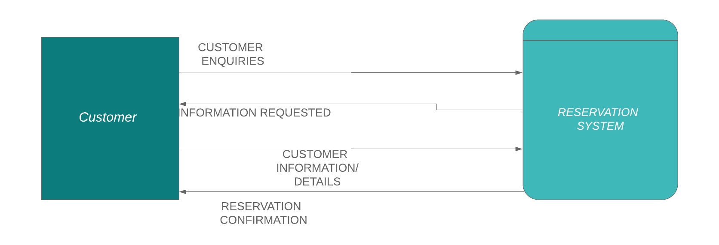
FIG 2.5: CONTEXT DIAGRAM FOR A RESERVATION SYSTEM
Source: Online Hotel Reservation System, 2014

2.3.3 TYPES OF RESERVATION
Generally, there are two types of reservation, which are: Guaranteed reservation and Non-guaranteed reservation
- Guaranteed Reservation: Guaranteed reservation is a reservation with a specially registered hotel confirmation that it guarantees the customer to obtain the number requested by him at the time required. The client, in effect, ensures that the amount will be charged even if it cannot be used in the case of no show. Payment for an unused number will be paid to the customer if he was unable to cancel the hotel accommodation order in time. The beauty of guaranteed reservation is that if the guest cannot use it , the guest can decide to cancel the order number. Some examples of guaranteed reservations include advanced booking reservations, booking under the credit card guarantee, booking on invoice.
- Non-guaranteed Reservation
A conditional booking or simple agreement between the guest and the hotel in which the hotel agrees to keep the room until 6 pm on the arrival date. If within the cancelation hours, the guest fails to reach, the room will be released for resale.
    - FACTORS AFFECTING RESERVATION
- Confirmation: This is a legal document specifying the acceptance and approval of the room request made by guests and the hotel. It can be a reservation that is either guaranteed or not guaranteed. If a guest does not check-in or check-out on time, this affects room occupancy.
- Cancellation: this means that the room that was previously reserved will again be available for resale for personal reasons or normal law, then the guest will have to pay any fee and the remainder of the amount paid will be refunded.
- Overbooking: this refers to the tendency of booking rooms that are beyond the available capacity of the hotel. This is often used as a strategy to maximize room revenue to prevent no-show or last-minute cancellation. This process must be carried out carefully, in an event of overbooking or rooms, the guest will be moved to the same standard hotel that had been paid for.
- Walk-in: Here guests arrive at hotels without reservation hoping to get one, they are often called Chance guests. This type of reservation should be handled carefully and accommodated by walk-in formalities with advance deposit. In events that there is no accommodation for walk-in guests, they are referred to hotels nearby.
- No-show: This occurs when a guest does not come physically to pick up a reservation or for formal cancellation. In such a case, a hotel charges guests with compensation fee and then a refund will be made to the guest.
- Over and under stay: When a guest stays in hotel rooms beyond the set departure date it is called overstay. While guest who checks out before the set departure date is called under stay

    - HOTEL MANAGEMENT SYSTEM
The tourism sector is one of the most essential sectors for the economic growth of the country, no doubt the good facilities, kind attitude, and management have a major role in their attraction. Thus hotels, guesthouses, lodges, etc. should have adequate manpower as well as facilities to provide quality service to their guests.
Hotels serve as shelter for guests in which they could receive services provided, which must have been paid for before gaining accommodation. In order to adequately manage guest details and all information regarding the Hotel, Hotel Management Systems are used, which in turn makes the work of managers a lot easier, leading to work efficiency and prosperity of organizations.
The term Hotel Management System includes the management for the attraction, smooth handling of items, and proper management of every aspect relevant to the hotel. Especially reservations, registers, accounts, payment methods for services, additional activities should be handled carefully and efficiently maintained in order to satisfy the guest and to ensure that there is no benefit leakage to the hotel. The better the service, the greater the appeal and the greater the benefit not only to the hotel but also to the nation indirectly.

  - EMPIRICAL REVIEW
For the empirical review, past literature that has been collected relating to this study were examined, in order to deduce the central knowledge gotten during the course of research.
2.4.1 REVIEW OF RELATED WORKS
Reservation systems have played a big role in opening up socio-economic opportunities as the Hotel industry advances. Asides the hotel industry, reservation systems have impacted other industries such as airlines, car rentals, travel accounting, etc. So far the tourism sector has been able to succeed more with the introduction of Central Reservation Systems since the 1960s, making it easier for travel agents to source for inquiries and make reservations. Today customers do not need to go through the stress of standing on long queues or having to wait a long time just to make inquiries about reservation availability, rather all guests or travel agents using the internet can make reservations directly with just a few clicks on their mobile devices or computers, and all that is thanks to the Global Distribution System (GDS) connecting multiple central reservation systems and showcasing their different prices to customers.
An overview of the journals collected for this study has shown that online reservation systems give a competitive edge to companies that incorporate it into their system, creating a bond between the hotel company and the customer that he/she is guaranteed a room. Therefore giving way for more customers, profit and most important growth as an organization. According to a survey carried out by Adams(2017) on reservation systems for Transcorp Hilton, Abuja and Eko Hotel, Lagos, it was found that similarities existed between the two reservation systems; to mention but a few: easy navigation and easy to interact with. Judging by the ISO 916 product quality characteristics, easy navigation and easy to interaction meet two out of six of the product quality characteristic (i.e. Efficiency and Usability). Thus it is important that reservation systems are able to meet the product quality characteristics in order to meet the needs of the customers which is indeed paramount.
However, the quest to replace the manual process of booking with the Online Hotel Reservation system remains the top priority of hoteliers, ensuring the proper storage, retrieval and proper safekeeping of customer details.
  - SUMMARY
The manual booking process used before now showed inefficiency in handling the demand of customers, which brought about the use of Central Reservation Systems into the tourism sector, which without a doubt has shown some level of efficiency. Therefore, Companies that have embraced this system have been able to thrive. Thus it is important companies who have not embraced this system do so quickly, applying all principles properly in order to gain a competitive business edge.

CHAPTER THREE
METHODOLOGY
3.1 METHODOLOGY
A methodology is a development system of methods that are used to plan, structure and control the process of developing an information system. (Benda & Robertson 2006). Methodologies are the basis of knowledge growing for researchers. A large number of researchers implement different research methodologies that enhance the development of research work. Below are the methodologies employed for the development of this project.
3.2 EXISTING SYSTEM ANALYSIS
The Bowen University Guest House makes use of a manual reservation, where customers interested in making reservations or sourcing for inquiries either call the guest house administrator or sends student/staff member to find out more about the university guest house services or charges. Customers who are fortunate enough to through to anyone who could them source for information normally have it quite easy while others who are unable to get tangible information sometimes get frustrated and lose interest.
Asides that guest house administrators are forced to manually record customer details with paper and pen which is inefficient and slow. Also, administrators, find it hard to keep track of large data of customer transactions after a period of time, which in turn leads to poor management on their path. The university guest house is also deprived of customer feedback of services provided to customers and staff members resident in the guest house. Lastly, administrators can only attend to one customer at a time, which makes the checking-in process a lot slower.

3.3 PROPOSED SYSTEM
The proposed system introduces the use of an online reservation system, which will make the sourcing of information convenient for customers at the same time, makes it easier for customers or even staff members to book a room for themselves. This reservation system will have a database to store all customer and staff members' information as well as transaction details. This will make it easier for the admin to properly manage customer information and a reliable customer feedback platform which will help to improve services provided by the university guest house.
3.4 TOOLS AND TECHNIQUE
3.4.1 TOOLS AND TECHNOLOGY
JAVASCRIPT: JavaScript is an ECMA Script language standard implementation and is mainly used as a client-side JavaScript, introduced as part of a web browser to improve user interfaces and interactive websites (McFarland, 2008). It provides programmatic access within a host system to computational objects.
HYPERTEXT PROCESSOR (PHP): PHP is a general scripting language that was originally designed to create dynamic web pages for web development. PHP code is embedded in the HTML source document for this purpose and interpreted by a web server with a PHP processor module producing the document on the web page (Pan, Chen, and Nguyen, 2012).
STRUCTURED QUERY LANGUAGE: (SQL) is a programming language for the database designed for data management and recovery. It is devoted to updating deleting and requesting data from the database. In this project, SQL is used to create a database that stores information (data) of the user. Structured Query Language (SQL) is easy to use, open-source, and user-friendly.
BOOTSTRAP: Bootstrap is a free and open-source front end development framework for developing and designing websites and web apps. Bootstrap was built on HTML, CSS and JavaScript to make easier the development of responsive, mobile-first sites and apps.

3.5 WATERFALL METHODOLOGY
The waterfall approach was the first SDLC Model to be used widely in Software Engineering to ensure the success of the project. In the "The Waterfall" approach, the whole process of software development is divided into separate phases. In the Waterfall model, typically, the outcome of one phase acts as the input for the next phase sequentially. All the phases are cascaded to each other in which progress is seen as flowing steadily downwards (like a waterfall) through the phases. The next phase is started only after the defined set of goals is achieved for the previous phase and it is signed off, so the name "Waterfall Model". In this model, phases do not overlap
3.5.1 WATERFALL METHODOLOGY ADVATAGES AND DISADVANTAGES
3.5.2 ADVANTAGES
- Well defined stages
- Easy to understand
- Proper verification and validation to prevent errors
3.5.3 DISADVANTAGES
- Going back the previous stage is not encouraged
- Reduced customer involvement
- Rigid response to change at a later period of development

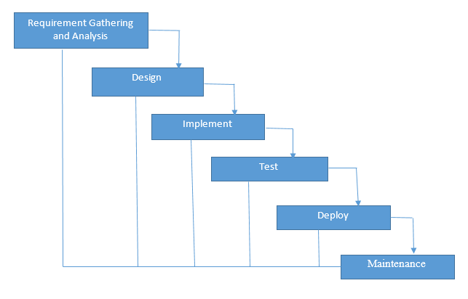
FIG 3.1: WATERFALL MODEL

3.5.4 WATERFALL METHODOLOGY APPLICATION
1. When the project is short and requirements are clear
2. Proper requirement documentation.
3. When the final product is definite

3.6 METHODS OF DATA COLLECTION
3.6.1 ONE-ON-ONE INTERVIEW WITH GUEST-HOUSE MANAGER: A One-on-One interview with the Bowen University Guest House Administrator was held to find out how the reservation process is like for customers, issues raised that were of great concern. During our interaction a few necessary requirements for the development of the Online Reservation System were obtained.
3.6.2 THE INTERNET: In depth research was carried to obtain papers and tot gather information related to Reservation Systems.
3.7 THREE- TIER SYSTEM ARCHITECTURE
The system design is 3-tier, the presentation tier, middle tier and data tier. The different tires include presentation tier, middle tier and data tier. Presentation tier refers to the user interface and will be designed using Bootstrap, the middle tier which could be referred to as the business logic will be developed with Hypertext Preprocessor (PHP) and JavaScript, this middle tier will serve as an intermediary between the Presentation tier and the data tier. Lastly the data tier which is the data storage, will handle the data management of the application and will be developed with MySQL (Structured Query Language).

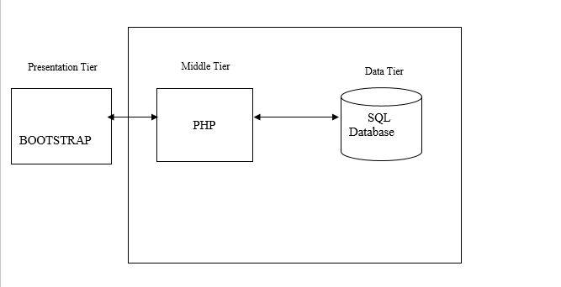
FIG 3.2: THE THREE TIER ARCHITECTURE FOR THE GUEST HOUSE RESERVATION SYSTEM

3.8 SYSTEM DESIGN
System design stage states how the design of the system will be constructed with high emphasis on the model and approach through which the system would be developed. It describes the flow of processes to accomplish the logical design of the system which includes the architectural, modules showing the use case, sequential and activity diagrams interfaces and the inputs designs to meet the user specified expectations.
Here, based on the requirements gotten and analysis of the existing system and the proposed system, the system design for this project was done using a number of methods which include: flowcharts and Unified Modeling Language (UML) (.i.e. use case diagrams, DFD diagrams, and Activity diagrams etc.)
3.8.1FLOW CHART
Flow chart represents the flow of steps in a program pictorially, where elements are represented by simple icons such as circles, rectangles, parallelogram, diamonds etc. This flow charts represents the sequence of activities and decision points that are carried out by the Guest/User and Administrator while using this site.

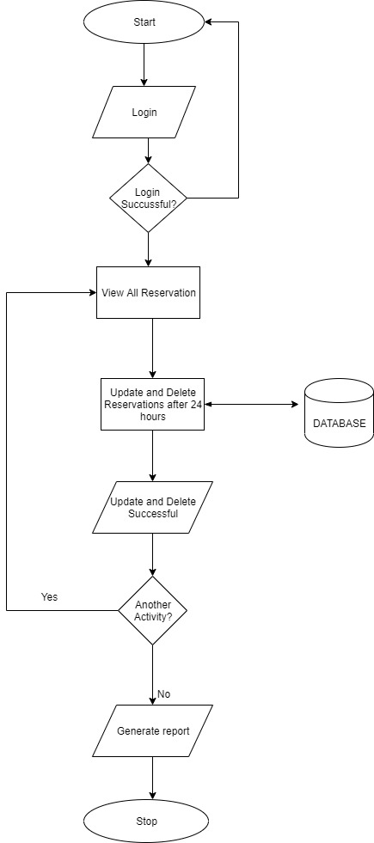
FIG 3.3: FLOW CHART FOR SYSTEM ADMINISTRATOR
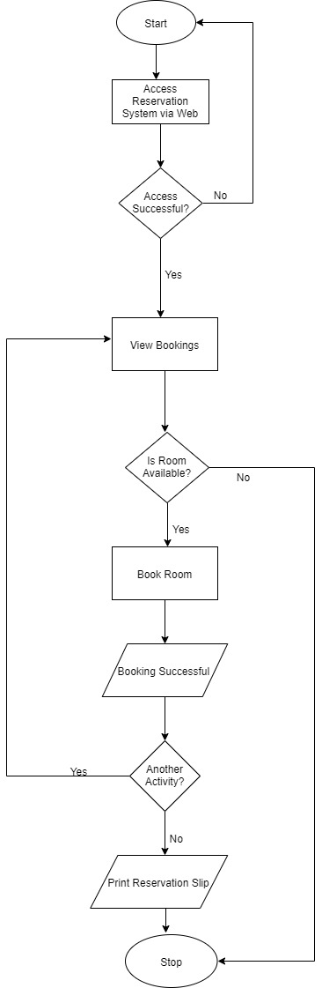
FIG 3.4: RESERVATION FLOW CHART FOR GUEST/USER

    - LEVEL 0 DATA FLOW DIAGRAM
Level 0 Data flow diagram shows the interaction between the system and its external entities. It can also be called Context Diagram. This Data Flow Diagram represents the graphical representation of the flow of the data in this system.

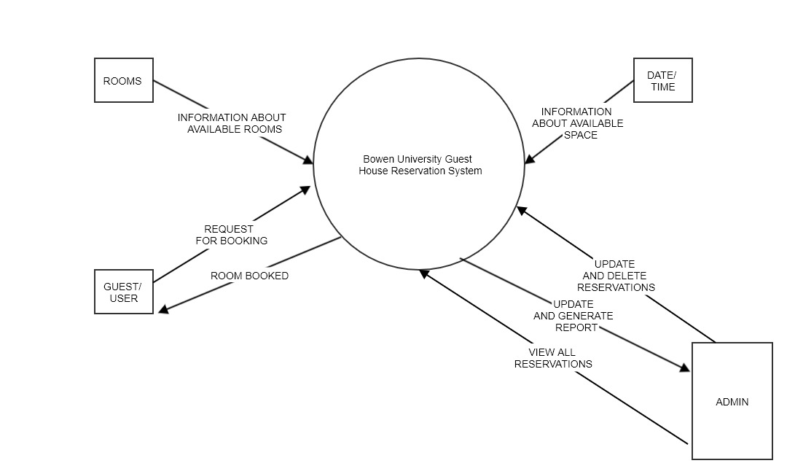
FIG 3.5: LEVEL 0 DATA FLOW DIAGRAM

    - ACTIVITY DIAGRAM
Activity Diagrams provide concrete, easy-to-follow visual representation of the business process of an application. This activity diagram shows the business process of this reservation system for the Guest/user.

22geometry%22%2F%3E%3C%2FmxCell%3E%3CmxCell%20id%3D%2219%22%20style%3D%22edgeStyle%3DorthogonalEdgeStyle%3Brounded%3D0%3BorthogonalLoop%3D1%3BjettySize%3Dauto%3Bhtml%3D1%3BexitX%3D0.5%3BexitY%3D1%3BexitDx%3D0%3BexitDy%3D0%3B%22%20edge%3D%221%22%20source%3D%227%22%20parent%3D%221%22%3E%3CmxGeometry%20relative%3D%221%22%20as%3D%22geometry%22%3E%3CmxPoint%20x%3D%22415%22%20y%3D%22480%22%20as%3D%22targetPoint%22%2F%3E%3C%2FmxGeometry%3E%3C%2FmxCell%3E%3CmxCell%20id%3D%2220%22%20style%3D%22edgeStyle%3DorthogonalEdgeStyle%3Brounded%3D0%3BorthogonalLoop%3D1%3BjettySize%3Dauto%3Bhtml%3D1%3BexitX%3D0.5%3BexitY%3D1%3BexitDx%3D0%3BexitDy%3D0%3B%22%20edge%3D%221%22%20source%3D%2211%22%20parent%3D%221%22%3E%3CmxGeometry%20relative%3D%221%22%20as%3D%22geometry%22%3E%3CmxPoint%20x%3D%22415%22%20y%3D%22800%22%20as%3D%22targetPoint%22%2F%3E%3C%2FmxGeometry%3E%3C%2FmxCell%3E%3C%2Froot%3E%3C%2FmxGraphModel%3E
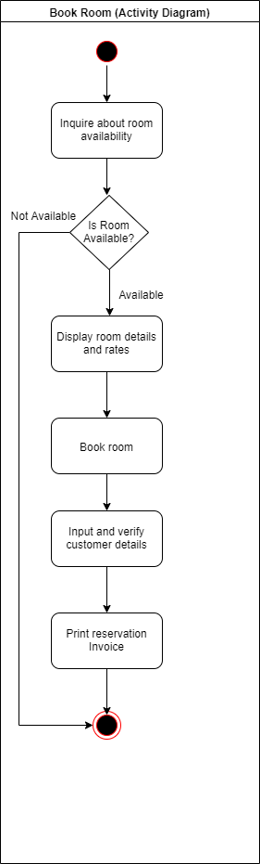
FIG 3.6: BOWEN GUEST HOUSE RESERVATION SYSTEM ACTIVITY DIAGRAM

    - SYSTEM ARCHITECTURE
This system architecture represents the conceptual model that shows the structure and behavior of a system.
From the figure below a Guest/User will be able to access the reservation system through a network on a computer or any smart device, views the available rooms on the reservation system for a stated Check-in date and Check-out date, the guest will be allowed to book the room and the guests information will be stored in the Database. If there is no available room the guest will not be allowed to book a room. On the other hand a System Admin will be able to either Sign Up or Login into this Reservation system, he/she has the user privilege of viewing all reservations, update and delete reservations, generate reports stored in the database. The System Admin will also be given the privilege to carry out all the user activities (i.e. check for available rooms, book rooms)

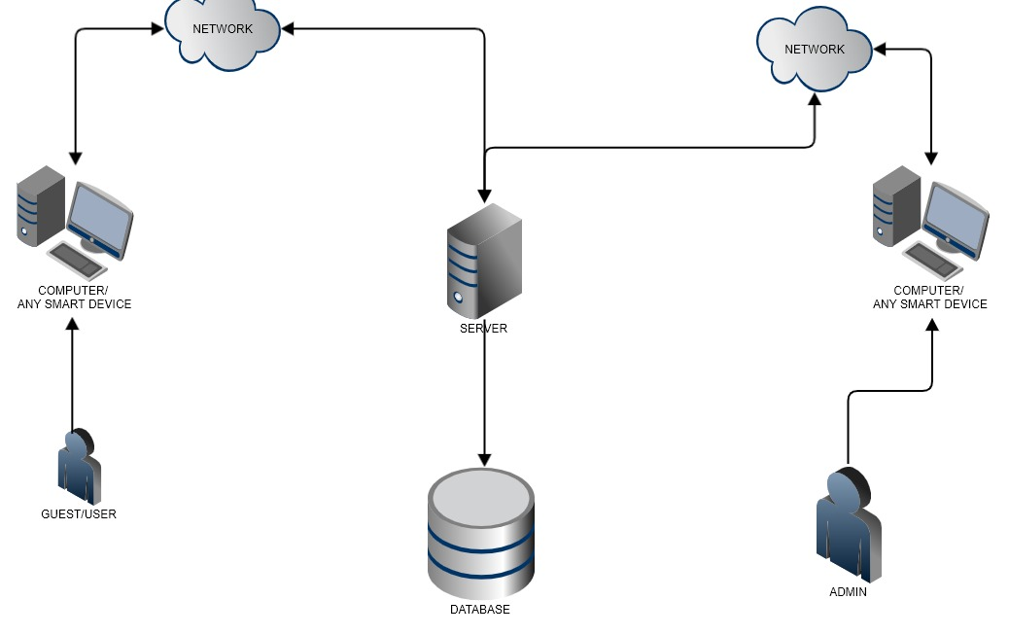
FIG 3.7: SYSTEM ARCHITECTURE DIAGRAM

    - USE CASE
Use Case Diagram is usually used to show several scenarios that users can perform when interacting with the system. Every use case diagram should provide observable results to all actors of the system.

3cU2FsdXGVkX1C%2BtZfqHqFMv9dy9r7wjmQCXfy%2FFDE1n%2FC5JqWpE0%3Dh8qGvou5U2FsdGVkX1%2BzgW%2FGP%2Fh194M8UQSUlra4dpVYhJ0pPbd0QhCUDDv7vFUI9SU9m3htAvT4Dx42pVnpzVZndVKwi5BMaFvDZ3NwcGcXlBKtLQ%2BU72kwMVUJsziKSa9mAAjkipBCv0%2FksYDhNjmLgAewnZ1l5SJ6MPN3S1oFg74LGZ84Dlaz1Z1xKhbvGYVnuY1cCD8clWnY9KGAGT4zJy5m2jylSGBGo%2BEWDnJTGMwuXwRSZ5LVXkJ%2BpWJJj4VmiJLIz4lVA336zGgBNOv5I1sUGsYMjFXnClXbNVi30LhpIJ%2BxYeK1e0P%2BI4ZAS4rsLfAsoizGyVBn2gBznhWpl8OBf9KWgEwRsOfxat%2FVMFGvjd69%2BFnDy%2BdRtNDuUuIRZu1a8oHqMMZ5a3RtW9yRm%2F9CGwlJytbIuwGgx%2B6yT7z4sk40Au1Tc%2FKJohOHqGFcs%2B8kcRGfm0tW3ToDzBesfcIfV56RaSmFz4%2Ff0R%2B%2FEJvi87d1Bxo0Y9F3ba%2Fg%2BhoSeyydSOQ04tl3qwR92%2B1FJ2TaVm9nag12rm46YLW27HSdBYlt2YwqwAjWLSsevZbgQUa0KUvwIvh9Avib%2FuX0Iz3%2B26PkcH1dH4I27NAsiY1g3YLCoE0X4vfECPwK3%2BOu2aBC3hxi%2BE9i3AjDzcPjRXFwy3nOOPvM35xm5jWAgYA6tt%2BMr0ti338dBYxyrQyi0BV6f5Sr0E%2BDlS2o4vmf2%2BfQtkp7aKTDvxFCOSo6kWPMLlxg9wwMRKYr9poIvJ4WO2xMdRNQVj0mFHqTjaXXQaqPbHGp4FH4KZZVQKgnZGlGuyMoEnPxuzB4ead1LLSzSsEtHdB%2FIDl39DIS6Gq1CSl98tYamRIqiEMm1lMjKpsKizoAYD88LWpkT1zCaQLpuSh8yJwjyxItYxU5HhN8%2FXHOiUBWbEEZt3QzahqZmH6veWlzXb8Vn7pkqrvCwj3yyFxFU10u1PuYh9KQZzxvch9wdOuXkOhlk4TRVAK4ZXRq1uAafMrDLuTZScxx3ot%2Fuds5eX%2FpIjvI0JKwGBJ1AjnOY4gGjU4VEwDWItXKnVXwbnyqvxLN6%2FnbZr75c%2FQC%2ByUG8iiagg163594cjM6oh5UIAI7kvKNZ0z89X3xLp5X7J30auenK2jXrLXHKvrFzz3rCTnKxQw2Z2ZukfdgN5dsk%2FaRTGYTDL%2FOjj0QIELmTEcXAMgrb%2Fgp592pQtNptVZtnxSPQYVLitec56cefaglpBKAcLy0NBZh3dNt%2FfczCPb1LQXtaBIbPGiPCzouk%2BhV8%2FgtniFIei8qgI0s5lQoAkkkGxPVqOZ6ilVhcvpFAw4isXTRGudF2NvKZo4aCoejDjLcYaeChjMlUnmMdlISDhVLt8GDSO1D5Yn7fRQZngyYIlLwEbO3Hh1EgDw54%2FJga9eztwOUIa1f5SCV8%2BNjc%2Be%2BGgT5Xml%2BsJB9AnAoFyg4iTYoiFdCX5nk6Cs9%2FlsjvQeBh8aNI7CKENcTS3rtBMScKPtxJWWwDqXS7%2F6O5J1cYctJEoxlFNkY0cHabnbvBbKSMHC3cQBFYxMWVVIlDhkAVAmc9P42RZ7MXgwuEtb8qnbIdw5Q3qReYAUvdCAyq4wajbaNAau14JOj81i%2B7alspMpV0kSdX5VSqkQyZ%2Bil4XzbZZWo5GtqQsJdUaZsE3Lh3jRGEfXMwkPrfciEykefsjQYGssvZpg7AwUoDPN7pwKU9wK%2Bsl5ftzzCTxy2J8sfpJ5AZsEG%2FEL8OhWkcb1iGV%2FGBJM39dzuYW2QQUXzHOQykdJb7FSdie8%2Fbx9k26mMQ1XQUGlFPj4dRXSHMWOkAqcDOhrXagXM8ZwKHV8EbFw1xq404N4Apk03v4hMJrrrILvbZeoLqQZuboEt2zyo9ovxVfzZdm%2BW7xTG3Q9aX%2F3U3yCymCZzQLsgE3caJ4eslORFYmasjdSITGWFOAjE30PORur2zyw7UFZCb4CG%2B4oPHdqnxzKL9dkgAhXIgFkiPiQ8KSE0DT%2FV%2BWj1iRpkjDKx2SFZO7Pyz9m%2BIFRuZJVSGgh1RlsxRwi3hl5Kwv%2B78iEfUSvmOL0jLmTdWEnpoxzadBrvaNMzNX6nr49CrFxtt32tutySW5MWltz4zk68ZS0TWgV%2BiHa5DT8CRVv7QqK2xQ4UNM2%2Fmqju%2BLSx2tIz7X1EYGcmWSapL5XBwtbBpKCa%2B%2F188y2rqI40swu%2FUghEOlGdiI8FL5v%2FNrpzt9sOiaaz6mf40IvkKl7NsQxmjZOu5i4%2BBV9lYi78Dm%2F7ie4PkTo6mvDeP32enhJQGo1jT1UElGlO2urahCj05U1Rx1mZ81OSwXWU6SuAV3TiIPyctrC4pXp%2Brs7KuC1QPnWZ6%2BgyQup3VsU8ytj8J2DjnBEtjetJ7caIT8gQ08zqNw%2BS5gzJM4jegrD6jKBct4Bw%2B75qz1A%2FiWveUMbBibtuJp02p4Mom7ty5BdRJtwCT0Ev8FT%2Bhy0CwyEwRKhGyOeu8T2E9QpkFt6cTRDCpXF4uepUKHWuuSoDkhhiDhQei4xTeH41RhEg2LNjDuUmfyCc1YrxZwmvQaB42cu05lI6HK7Es71DNGNfElZ1uElmB5KmU%2FqEWS6P%2B14ecbXFVonCYwFV5BTrAvnxnMGqBR0rbrbTjyRpmIQVHpL7gGyKfqAttseSojeUM%2FRWRb2K7dfqH5q8IOTvBggowUQjCqez%2FyTl6TIvBCm3pqxqurYAI41Y6p8hzUszxaV2Dt5WUnHvWDF4wESxh1TqmBzVEfLn16ygrX7Qo2LJvUM46ShyxV9P6AEVn75%2Bo2hAHspvNNAQzoDIXezTBY8mN3R8vsx4LeOIu2ABqkBT7glLlh7EBgZGZo3Mj42TlvlW%2B1CKRgK6YPYqV8rYw5Y%2FJFl1%2B2o3rXlj5%2B%2B2z944BS2ua2sQUdlrdhRlxXFERr67pHpV1THFMK8WrEeVp88fiSGCAQ6G4j9AHSNsxazqIUGXDkxsabTryhdEsvToi1b2V4goq3KyDb45XCxrHlesp96v2YUPZeJ1484P2x93FRktbHJj8Md4k9pjWgFmCHqmu3eDVfUa6IRiUz2nOC6w%2BM%2FgzNV9RuD8lkgEpTQcS1H2p1Yw1w1%2Fcemre9c8ejyEJ1D6ug2zlc0BOpmsOaz48gHHi778Gvn67%2FjWptJmPZBjgr0DazQsVXrr52cyFtUT%2FcLYsHMHD8lqmcWi%2F%2FTutG%2FmxSB4dgobai2JuvVxLjB8Ip%2FBBAWDxHviqfcYKtFh4yPsL0xzdWFdb4EESaKbWgCqHYX4RLTKRc7YIDuK5qC1lZwDM%2FGHauK0D2L1o0cvX%2Bw3gxXI0aNO3ARpXCTccKuFvZGEijph1S3rtRwzvNEPSVB6ESVW8eLwCCOyUJpmh421Lt6ulMal2FdcG38ekW4kBxyq351NGz4Daig6Vy3qMQAlT54LTV%2FSEn5lFgNOXVb%2BmArd9xoXldMMijBTn5JdG%2B0W%2F7srOf8CEfjKFQJwyqm%2BqFxbMkTfDkYhr3gvSQP%2By1FLhan13EBa6qNC29ef6kxhe1Sxi9qBu6KD3bO7JqVoUAFvTlpCl2lk3z4vkPOfTIiAt9PokBTiOwhR4Otq934MnKWriGYhfCEUEVwT5Eub3g%2Fwb5EiOwEcQQ0V71Q2fBSKpJ2XTpxr7oXDa4XG2NsKqr%2FHNpiZBTioDvSQ6AGnvDyGKJ29KA8Soq2ROCrBvmSQ5Zh73HOuWJ%2BG7556q1Yum6z9ufU7zYxld7fSCsby1r7tmWqe6ytN9nskqd1PXFMZDtIqmOSVJK8UlCVFucI%2FINSg3rTyF4pzG14lhOCjbL56ZqJCVi02Y%2BDMMtZlNf5Ro7ZFIWSKiqE%2FVV8IXQO7QVqBfoEfLmdEGwYYYur8U%2BU4nb1RsyjL6m7M6qpa7flvOOlcDQP0bBVutA5NIWFZdOHGIfKiJhDTGTSAwu2OXZFEnZbRwN4sb0YwgX4e009bYxFOVAFGzil5ojIkiVxsOn2YAl%2FC2ZwnRM%2BDN9WKBRwrYNlYooAKAp7HO80%2FWIYgSrD8BiZ3XJ%2Bx7FLbVPGWiEszvdzuFb1CsYypNlP%2FBhld33Ml78hZk%2Bdj2jk2Su9cbAeuWbFa8yqsVwnS0agvwW7CNGcInA1tx6p%2FgVXAqJXxLF5Q7FGwsLFPuMHL%2FTDydW0EliujYY6KE9n9Jy1pQjcALz8Nk7gTq3B3VJ6ahHsWiRGiE3iVr4VliaWXKxvPlmfK4AAeoCLPQfXvN0aBhlxbCxPKUhwRqvLK8XAjFwg36kFIUeVPqeXRP04J0eYGlQsUywEmt4BHdRGH9pStPXgpSH3tizCcBS%2FUrxaTiLzvAQ%2FWVQzB9IChi2hIFkg%2FjdUrTvOh6dJmUVNAG8xHadM2v681XOuRdH17bqRu7R1vQynGAWEJhavAJS%2BY2y7TTz4G6uufO3Lkj6V4cvPUyfzPY7Ktw4E0pSuduSEKda8WoT5qcwzyVhdaBgVlnrm7gGiYNTQ%2Bl9WptTLclzpZwyKdBVXiGrlY%2Bn3jyI%2FMza%2FK249QS0YGxk5higFNsn5VN0GPw7fZfzDgzGN%2BgRk3sO9PKt2%2BA5fkgRdBc7b68HzHf%2FEVZKH%2FXJNzA%2FY7K%2FujdybgncJd74K%2B51r7WghDxVdXuDhHo8LX8PLWZGNdniSniqbUyOzk7z7n6hCwVEncycUbbTaeOV%2B0%2FOzuvG4AR07jhiRSIhURJd13rOeIxpAp5UkpzS7mMrLkBJ5OAVVFi6XTRA4GAJ4wdeN7Cb7p6mxv%2BJlr%2Bx6QRQSGBpOvRUDETjKAY76o5ughHOZDEqMVe6LuAFZjeSFqV0hp0863VqvIDpV9zirD2IcIFxKdUdn%2BYjA%2BnNtg%2FGVsrhcewgVtWaGNweOks0ih89%2FzEUgobZSeq7SEdSkU0qAaQEPv8Ur1kYKcnPNFoE3XarWfz9Uj%2F5vqgvqk%2BI663Sss0curYQBvSbM0Fez7d9LYPV7OOiHrmTBRKaf%2Bh7HPcMrj4875%2Fd3ZWkp8VvYZqurJt1DJ6OUZ9dvMlQF%2Bveb15ndPvCmZk2xiTlahvaJCyPiGTUZwLO7IQfMb7ArWn7LK3a5w571MgH7lObiDS8U2omXITAyJrWvmqX8B6pT76j%2F0e3kIITE3Az4X%2BFLvrPKjO59rBfTrmgHYukvJDJhXDdFbOed7FJEN5TxIDzxqjDSbjyp7mI1Pmv6j4zZruvFpTdjVogyhgaYb7tL0R8bRVp5QjB4dT%2BfkVLGLbacFLf4M7fl4Ae%2FfKcVHsS%2BowU8dJvft39GRHTcWekeQgSXNpIvKE%2BvHgLyTMO0M7EEfhZ%2FMLi4aLxf110Qh76xIA8P8h7QeFMXs5Ls4l0Q4EU%2BucSk6Qzf9ENH%2FUvLbAY6B3iJZ8640ta6sYamC4%2Fi7tC5AWi3jnvV0nF4OgicbrebJNmERGW%2BAg3hCRkn2Xi%2FWwd3hifn21nVSAuOr6P6dJZ7I%2F1ZzuPckrlE4K66URCsN%2BWhw4r7ZMh0KqW7aWg0qlyWGxTwcQToVc0k2OmNkng0H4BrIfaO3iAEFAoW937JMxVNsxvsS9tZqegv6J49LrL23Lxo2sJBKicJwOvC8GaEnMdhYmFbenpAG2W7YDW4%2BBZk7fcj1%2F0K2FAjj9LTI62%2FrZ%2B2sWecJtQI9ykupFlrQSWvZCF100YofMWcLHW0B7Nk1yLn%2FUOiN7itukiDgq9vp9GN51jP0hxkK9NKr73FLVoCGe3hdzF1xqrxOcHIF7UhKuijFxArTvMtYp97EpLNJtzdQxz1iuREtgCnt43JxS%2FW7xnNyVSsCc6qJ448bITyNalGbqfEoNqFQpkz%2BIoSjeOf98cKQXgFKaDFqx0yg2B4uD6%2ByQV6nnB4jwoJyGSwBq9D01jdZaQuxWUtyqtyMe10HUt78bjQo6f7OvxbtnRKElTrYVTKUIB2I%2FBVgtXF%2BPpcY9NG7BwCDvUvh646O1%2FRMiLNMPs0kpYnJfmUteSRiOAS5La9RB1vdjDYpl7Q8WQ4PPmKeAyJnqlwkDfjeYzCsk9v8pyZdN0TF7cfLaT5pV9ukHlDIypKDxUYETyEd2dn3GrW3bs6kVtk%2FNBIn0jtqgKZfXUnYqx4RIqMiycsY9pGcuAfxkll54lGYEBczGFxgv3kcljfQTbCi%2BNaktTvonqd4YstcA22TbRNsEwW2G469N1ER%2BXb6UE9w56nzaAb1Qnp8ChniC%2Fw%2FUNZYUewlyurdMM1vkgsFLWyscODAC8MZebSP2ABErjdlgau58S5HdaR%2FQ%2Bik1ohZEfDb30ITWDWeCMN77U2qwyEPJ%2FPbmapxtji0Saglgesx6QMaru2XtScOz0y3k77uRajoKgrUbA6lK9fM5FGfvmZsqfh36Icja%2BXUho%2BaYkXS5nI%2FxGfjbGkYX%2BkujfJHHvZ73bo4QlmBkQE499jKpXpOe%2Byz%2Bzi0PYlu%2BkksdRZZFJrmTQ%2B%2Fx0gM1swvqPRhl6ciqxr4hMOEZJcdv9Jg7CaRLeOYRMr8Vwdqs99yEtzvvIr9S9JuiI%2FpVz%2BaY2NCdJPDAoAqZ5Rl1eh%2FDattB26Z7Rc9ADkVa2m4F5YqdIC6aUAoqa4yHsM4XAfy44Pfnz48%2F37KUvjPWRUer01Mi%2FReMFLfXE%2B4Ho0LD8L202PmI5A4jhRz5aLLUpVCGbcU43PrM7lLPwnao0gNHbv85GsIxB8PmRLV%2BlccLx6djrxGOBNcI%2FEX%2BhIetZgYIqafabDJqi5l5K41n9O6SJmzQVhdejFfRqm5YzdmKU1KFJrOvHrjYk4%2FYHAwwAXFsp0G%2BaLrXvV00EuXdNLMw9JqOVUcNB9gmxfJH43gyiy%2BhhRSOUqCYN3s9nLsv2ACiN06Z61AgI6F3ta0Bc6N%2FMGVibp8T5C9a%2FsW6wgyafUyQSb99J3d8EaZE%2F7TJ44JON9l5%2FBiBBl43tfcD4TGpwqgK726fQd%2FUNOwt3AJjS7JygxGaxtqvlAiXinLwqT7iCEXstdea5EuqiiCmQzHW0HdmE%2BCRqmSWOJkPraLvYoATKERewy%2Bf07PJ9RHu7n%2Bo%2FC1PE5xuA%2BD1eRC8fAe4Bj2XW0HqJYOO7xGOwnJ6LAeCM6GE8%2Blj%2FCKBNO2b0ekSdM%2BBhLYXZiQoO8kE7rAtgh6YbeOSiq%2BwFFBkjcCxj0BCocBvdRVjZvI0khOJ92uWXFpQJfhgnVj%2Fct1%2BB6jKPNSNp1MWu9iTZyde9y0im6UfTcGDYyU2mrG0ZJ05iSNhjklvd2V7%2FLrC2E%2FXX1O3HW5fgnQzOSAZTMQrpaU7iy6pjxlR66YO9ggXHLmSGMFY4l5Xw6u4CF6xIf0ZeIXONwGOZVvwHmPhIVJEaMIt25X1NeJpjMX2wg2yG0TbQ9eT50wgclBiQU6wZEvCsjc%2BoWr2sGE48KZFpcRTFEMW%2BNUUPFrLUWIGOjj8k2QjP5UO0kLLbInwa90%2FWTypHxcyPIyYlujdk0LwafXNUFiqiLRccSRh8sQpfQukUcTu7%2F92bIbFUqcuc1Z9fN1NxJxAr2QeFhB20Iig64qiTC5kkPk0idRuS2Gh0t5l%2B0bCNbMH612vguXDW9tJI%2FIHPMkm%2BFh4z0kPnntjkoniXw%2BMXgxWse4YMdH43dcyyQXHJw1t%2FkwD59CTbAC2YrvYzhn9KeJzPm8N0a5M46qXzt5D6bDLDxQ7O%2BtzWwqMF4cwX0KuT5tbpPJj7ab%2BQZguHGfDQByt8NA3LYNZS0lxA0denAHwWI1FdG8z5o2RG50p7cfkHQomil9XP99LgkI54Zjx3SgUrcXBb4QuETLlvr%2BG8MBBYzl3KLcPzkCS%2Fw%2FIC1JbCJ%2FkII0Mw4ASxYPZzJpRtlMaVVIFjOTmR0CSeCR%2FiPcUTTBFHWmv9nGe5nVHHU2QuOUDfXDs8p0N671L4EahnfNEghyGxBbpwWd7IBnQ52eDVv%2Bsnd3wISEuZJF2%2FXcD3qzwdkqGLo1hSijVl0FDhIlxh7nKiVTbt6%2BEzCaImbcqzbNOhrTKIy5bf4npX6GLpSyZRtw6wHtmCYRAhCufA6d3odA1aUIfMkosAY8iFRD2Uriw1TFz6BFOwYveWMD5nuSke45m1NQdexvZnUy3pxQ54QgQboMN8l%2FuNec6aR2bmmxXc0u%2FHwUQEFmY3S35kTIg6OmN%2BP%2FOjeBpxxeZzfADY8cgOOIcJ7IPYqQQQ8EfzBOGwNG%2FjuTAFpqsF7KGvstHya9NFWfSUxPXH0aMxpNR29dYuyrtvEDVqvGRkrVCwRCYxalmWPquSQJkX8of88Xio5ZcmOWIBnJiH6MCYtAK1fEn4cVn2MVqbcy66ZADk0FkeLyRh0rnypTuMRFfjtQekjTvFlqbWFuYs%2FRKOMKYayMZqDmFOe0QVqqxyRYreEPCpM2PbOG%2BSdhjiZYiknIz%2BVwcPA1sTKUsX1Vr9VrQe%2Bh3nxIcOI%2Fiixaa%2BCUWjBsbVFjPdvJeRVn7yMGKTa%2BS%2F0vz8YcwKCAj%2F5wvYMsDGfQfnl0SHcgN9fIVk6PHWeN1%2FPirBi%2Fv16zd4AOpHSc%2Bv46C7zE4%2F88M09R%2BRBl5PBRMFUYByD3PCFX3j33oRv8a%2FZc8ca6JyzM2vvhMUnxAA3Op5n%2B6NumCrZbBm3rsLHUKJJ%2FImTnxx92aL%2FF%2FH8nbm6zzzfWwlX2ArhB9kZJabrJIJIwdX5A2W%2FSvHMwsWLZXMhsdxYmS8Ufhb7uXoWmIlHwaPaV5RESuHzqSVvThPMyl3QqXQxyHEFTyHEGUa1407fdXv35qctgpjBz7pa%2FhUOL2a6uykl9eVf9Ud6xBRVGDkGwboszau8P1qQfmuWXTZu4L0kJB2gTzOu%2FmHXyhGubD4grW5OBkrVtETqsQZFLPQ1u56G51ZXWb6H%2Ff%2FxOCqNXwwkeFJ11ffYojgeE%2BdN7s1DUsp%2FriSNUK9YFuSFN2gWYHx3WHNhQqe%2BKkgZLfMVX6alUp%2FHLuZMEQb3zH2IkwTAQVkgpUFtNngvbssiN6MWU2I%2F77gPEYvwl611WUsymSrQA48X42GM2YF%2FxjSKYxWDiro4Ks5IiQ6rKlYC65j%2Fh2cAQsgHCZVFTk0DHjk3NCEBU%2Bnm1IjPE2gMUQ7DFZMLKBgy8GCjnNnZ209%2FhUJDQpU6q8V5er11nw9uPn5stuDaozCdiCt3jN1U%2Fb5Yo9sRursAQU2YvC5yZF8Lvscu4OelmDPrslNat8zBxjberOSj28vV6zOmYVsyfNv4BJ%2BjJAz6%2BlFi6iL86DqFpEV%2FIP7trWv05CiSO%2Fse3vJfQjgEQsZAyzpXLgQLvUwDIOWtenpkHMVeoeqh5uhkxnBfr2e04VU1PWqEQ%2BUNJbUZlAGrhiOXNKPEVYrlm3lgisw99ffDD2fJ7AKLnESX9FyB21HHkGR7Nh9RIhKL8ezKhSNrImvGtB7OIAlJLIpOtp0ts2Aht9SnLjyd5XNqCzaPEGOVOZSJ6iZ7ITzw6cT3sFnhU%2BydxBgNB%2FHaAN7exqpeSw1Y6z0uxPD7VqKgP7%2FKqCrDhjyi5KE9%2FPoLoIPO%2BxVdICFKQT98Hb1FBIB8cz4Ocqu4H05KNgTrqKI7u3GPUWXNLA28H9lKH%2F25USpwCj4VmU7MSpt5b4UrYLi58Z0toFabGo8DLmsYGHWJXlXuT3rJdkQ3JNHC87mg9s527cN1yqwRI5l7I2nmegkz56GhtG2J6APAJnRktj7I3RX07DcL%2BGvgO2aEd6KRdPURFd6OY5kgvilpSHfToU2G3tv32qnLNbdkcRqhOBRBg4Wyx9a0Ngw6Xb5OI682LBh8eG8d0p8hjcO1ELlp7gkcHGoUgUei4FjuWv0euNFQdw2g03JjXGmp5bBPTHEsXL9GsLHPekae2LMTC9AaR6YaHv0lwa0Uqhzq5rxSamE8w6r9Bj%2Bi2TZdFiroFvPEmKtx56BjNhn5ifJ4GWyfyxDd9AXvG%2FqQOMMg%2F7GTXwAGKe9skLoizA1AeMUeHFUbWNk0ES7MQXlIyzpG0Aykak2r6mDgxBnEk0do%2Fjsyooe2yu2Edcg26xqwDLOYVXr0BK1jUTfNRjUJMc7Uf0zk8Cuo0ptJsmEPxYVTm7a8Nc1Rt2hs2kxSHG97sx45mBUKFUi2ZkerNEZVLGHeeJXrygNRH5kMxRQ04RCH1sPRjYWpa%2B5Q25csybi5MUS9uZphWf9y40HDxl2cSBk5qswTcpzx7bs0N63Z7vpHkVp8RVnJc0SXki%2FRpOxLsCzTKDMqgIXh5qtzf33n5SIxE%2Ff7VEAdAflrwcdwwzzP2ii7gsGvenzUb4iOyr4v5FCUhuztX2PJmnuQWH6tiORY20dHF0cQ745kpAh6M%2FgP2qvuL3kfQNymQMma39cP6fynDkkR7tsNS6s5EBQmlf98biZ%2Bxh5Gj1BCp76nlnxLDtlxfRsekbozpBqpwanxdWcUSA10JMWDlro0et1cxFV7c735czLyqWhKdwUwW4VRRXq4psbLiMY%2Fn0Ioj6J3IGBKP%2BTOAoSGmvujUhWG2%2FZFr6G5QD20mmygKAumvfWd4PDIYNKj%2FRtdyowkcOkOKSAtDoPUzlYFJXaprL7kgpXZSgyvToX0hmrf38dgZvS8M6%2B%2BuAFOXO7t4rrMvGLPbYgQmqaceQguqgekdwgLhkPcSjUAvN7E45h5LkF3CNHmIsNyPkqzwNSaztpmF7cUPVZHpCU9lk2CsIgouEhWFZWNWNac1952m7yFxvNCKt7bAy6sBrMItbW6lgKK7iFcd6Ppo1b%2B%2FEQaZCX3kHneVJJ5NbvaBEe9ud7iNK2TwHm%2BQ2VhDN2S7MkhEgY2HQSIPyckCK2jv2QCBt%2Bxq4mQ8VpT4oxPmMk1oJMZymKyct%2FB6QCDVqo6jyaAfqIskgVXW4V0PLowehT5Ad5KpigI2Y1yseG4ZnUR5UC3KLY0pch6I2RHx0KBF%2B39TShwmRiRtUSteklc6FqMGZp6r3CYTqzgZsjogPKOaQ9deFTzPEKIUkr2uLrROosO0NzUjYAIIhhEQ4nFdulF6ZP4pg%3D%3D13vwm23f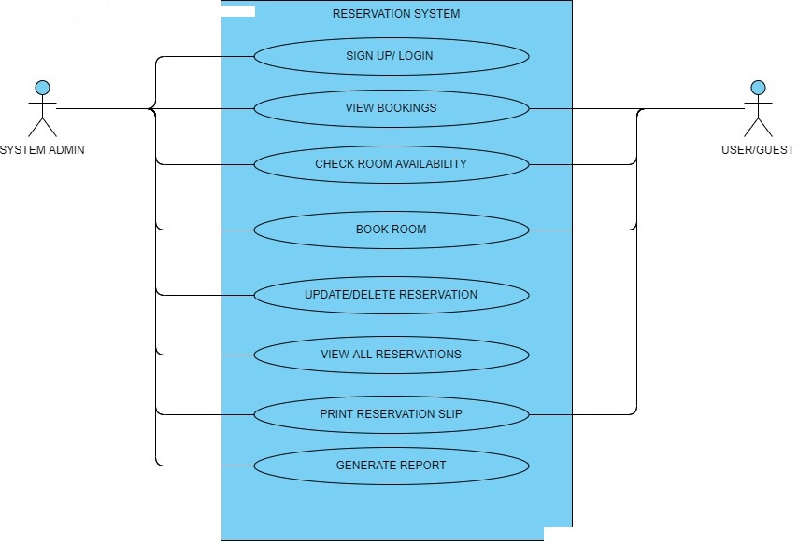
FIG 3.8 USE CASE DIAGRAM

REFERENCES
Adams, D.A., Nelson, R.R. & Todd, P.A. (1992). Perceived Usefulness, Ease of Use, and Usage of Information. MIS Quarterly, 16(2), 227-250
Adams, J. Stacy (1965), “Inequity in Social Exchange,” in Advances in Experimental Social Psychology, Vol. 2, Leonard Berkowitzed. New York: Academic Press, 267-99
Agarwal, R., Sambamurthy, V. & Stair, R.M. (2000). The Evolving Relationship Between General and Specific Computer Self-Efficacy – An Empirical Assessment Information Systems Research, 1(4), 418-430
Ajzen, I. (1985). From intentions to actions: A theory of planned behavior (pp.11-39).Heidelberg, Germany: Springer
Ajzen, I. (1991). The theory of planned behavior. Organizational Behavior and Human Decision Processes, 50, pp179-211. DOI:10.1016/0749-5978(91)90020-T
Ajzen, I., & Fishbein, M. (1980). Understanding attitudes and predicting social behavior. Englewood Cliffs, NJ: Prentice-Hall.
Amy K., Ruth N. Bolton, and Janet Wagner (1999), “A Model of Customer Satisfaction with Service Encounters Involving Failure and Recovery,” Journal of Marketing Research, 36 (August), 356-72
Andreassen, Tor Wallin and Line Lervik (1999), “Perceived Relative Attractiveness Today and Tomorrow as Predictors of Future Repurchase Intention,” Journal of Service Research, 2 (November), 164- 72.
Arnott, D., & Pervan, G. (2005). A Critical Analysis of Decision Support Systems Research. Journal of Information Technology, 20(2), 67-87.
Bagozzi, Richard P. (1975), “Marketing as Exchange,” Journal of Marketing, 39 (October), 32-39. (1994), “Structural Equation Models in Marketing Research: Basic Principles,” in Principles of Marketing Research
Bojnec, S., Z. Kribel (2004) Information and communication technology in tourism. In Intellectual Capital and Knowledge Management. Proceedings of the 5th International Conference of the Faculty of Management Koper, University of Primorska, 18–20 November 2004, Portoroz, Slovenia, pp.445-454, URL: http://www2.fmkp. si/zalozba/ISBN/961-6486-71-3/445-454.pdf
Burstein, F. and Holsapple, C.W. (2008), Handbook on Decision Support Systems. New York: Springer.
Buhalis, D., and M.C. Licata, M. C. (2002) The future eTourism intermediaries. Tourism Management, 23(3): 207-220.
Buick, I. (2003). Information technology in small Scottish hotels: Is it working. International Journal of Contemporary Hospitality Management, 15(4), 243-247. DOI:10.1108/09596110310475711
Camp, W. G. (2001). Formulating and Evaluating Theoretical Frameworks for Career
and Technical Education Research. Journal of Vocational Educational Research, 26 (1),
27-39
Camp, W. G. (2001). Formulating and Evaluating Theoretical Frameworks for Career
and Technical Education Research. Journal of Vocational Educational Research, 26 (1),
27-39
Camp, W. G. (2001). Formulating and Evaluating Theoretical Frameworks for Career
and Technical Education Research. Journal of Vocational Educational Research, 26 (1),
27-39
Camp, W. G. (2001). Formulating and Evaluating Theoretical Frameworks for Career and Technical Education Research. Journal of Vocational Educational Research, 26 (1), 27-39.
Coker, F. (2014). Pulse: Understanding the Vital Signs of Your Business, Bellevue, WA: Ambient Light Publishing

Correia, A., Kozak, M., and Ferradeira, J. (2013), “From tourist motivations to tourist satisfaction.
International”, Journal of Culture, Tourism and Hospitality Research, Vol. 7 No. 4, pp. 411-424.
Davis, F.D. (1986). A technology acceptance model for empirically testing new end-user information systems: Theory and results (unpublished doctoral dissertation). Massachusetts Institute of Technology: Cambridge, MA.
Davis, F.D. (1989). Perceived usefulness, perceived ease of use, and user acceptance of information technology. MIS Quarterly, 319-340.
Davis, F.D., Bagozzi, R.P., & Warshaw, P.R. (1989). User acceptance of computer technology: A comparison of two theoretical models. Management of Science, 35(8), 982-1003. DOI:10.1287/mnsc.35.8.982
Engel, J.F., Blackwell, R.D. and Miniard, P.W. (2001). Consumer Behavior. International Edition.9th edition. Dryden Press
Eugene W. Anderson, Mary W. Sullivan. (1993). The Antecedent and Consequence of Customer satisfaction for firms, 12(2), 125-212. https://doi.org/10.1287/mksc.12.2.125

Evans, K.R., Christiansen, T., & Gill, J.D. (1996). The impact of social influence and role expectations on shopping center patronage intentions. Journal of Academy of Marketing Science, 24(3), 208-218.
Fishbein, M., & Ajzen, I. (1975). Belief, attitudes, intention, and behavior. An introduction to theory and research. Boston, MA: Addison-Wesley.
Folkes, V.S. (1984). Consumer reactions to product failure: An attributional approach. Journal of Consumer Research, 10, 398-409. DOI:10.1086/208978
Folkes, V.S., Koletsky, S., & Graham, J. (1987). A field study of causal inferences and consumer reaction: The view from the airport. Journal of Consumer Research, 13, 534-539. DOI:10.1086/209086
Fornell, Michael D. Johnson, Eugene W. Anderson, Jaesung Cha, and Barbara Everitt Bryant (1996), “The American Customer Satisfaction Index: Nature, Purpose and Findings,” Journal of Marketing, 60 (October), 7-18.
Gefen, D. (2000). Structural Equation Modeling and Regression: Guidelines for Research Practice. CAIS, 4(7)
Gerard, G., Osinga, E.C., Lavie, D., and Scott, B.A. (2016), “Big data and data science methods for management research”, Academy of Management Journal, Vol. 59 No. 5, pp. 1493–1507.

Giedrius Silys. (2017). Information System for Accommodation Service Searching and Management
https://www.theseus.fi/bitstream/handle/10024/128361/Information%20System%20for%20accommodation%20service%20searching%20and%20management.pdf?sequence=1 [Accessed 28 December 2019]
Heide, Jan B., and A. S. Miner (1992), “The Shadow of the Future: Effects of Anticipated Interaction and Frequency of Contact on Buyer-Seller Cooperation,” Academy of Management Journal, 35 (2), 265-91.
Homans, George C. (1961), Social Behavior: Its Elementary Forms. New York: Harcourt, Brace & World.
Huppertz J. W., S. J. Arenson, and R. H. Evans (1978), “An Application of Equity Theory to Buyer-Seller Exchange Situations,” Journal of Marketing Research, 15 (May), 250-60.
Huppertz J. W., S. J. Arenson, and R. H. Evans (1978), “An Application of Equity Theory toBuyer-Seller Exchange Situations,” Journal of Marketing Research, 15 (May), 250-60.
Hyde, K. F., & Lawson, R. (2003). The nature of independent travel. Journal of Travel Research, 42(1), 13-23.
Kim, W.G., & Kim, D.J. (2004). Factors affecting online hotel reservation intention between online and non-online customers. International Journal of Hospitality Management, 23(4), 381-395. DOI:10.1016/j.ijhm.2004.02.001
Kimball, R., Ross, M., Thronthwaite, W., Mundy, J., and Becker, B. (2008), The data warehouse lifecycle toolkit (2nd ed.), Indianapolis, Johne Wiley and Sons.

Law, R., & Jogaratnam, G. (2005). A study of hotel information technology applications. International Journal of Contemporary Hospitality Management, 17(2), 170-180. DOI:10.1108/09596110510582369
Lederer, A.L., Maupin, D.J., Sena, M.P. & Zhuang, Y. (2000). The Technology Acceptance Model and the World Wide Web. Decision Support Systems, 29(3), 269-292.
Lohrke, F. T., G. McClure Franklin, C. Frownfelter-Lohrke (2006) The Internet as an information conduit: A transaction cost analysis model of US SME Internet use. International Small Business Journal 24(2), pp. 159–178
Mathieson, K. (1991). Predicting user intentions: Comparing the technology acceptance model with the theory of planned behavior. Information Systems Research, 2(3), 173-191. DOI:10.1287/isre.2.3.173 McGraw- Hill.
Moutinho, L. (1987). Consumer behavior in tourism. European Journal of Marketing, 21(10), 5-44.
Njite, D., & Parsa, H.G. (2005). Structural equation modeling of factors that influence consumer internet purchase intentions of service. Journal of Service Research, 5(1), 43-59.
O’Connor, P., A. J. Frew (2002) The future of hotel electronic distribution: expert and industry perspectives. The Cornell Hotel and Restaurant Administration Quarterly 43(3), pp. 33-45
O’Connor, P. (2003). Online pricing: An analysis of hotel-company practices. Cornell Hotel and Restaurant Administration Quarterly, 44(1), 88-96.
O’Connor, P., & Murphy, J. (2004). Research on information technology in the hospitality industry. International Journal of Hospitality Management, 23(5), 473-484. DOI:10.1016/j.ijhm.2004.10.002
Oliver and J. E. Swan (1989), “Consumer Perceptions of Interpersonal Equity and Satisfaction in Transactions: A Field Survey Approach,” Journal of Marketing, 53 (April), 21-35.
Oliver and Oliver (1989), “Equity and Disconfirmation Perceptions as Influences on Merchant and Product Satisfaction,” Journal of Consumer Research, 16 (December), 372-83.
Oliver and Wayne DeSarbo (1988), “Response Determinants in Satisfaction Judgments,” Journal of Consumer Research, 14 (March), 495-507.
Oliver, L. R. (1997). Satisfaction a behavioral perspective on the consumer, The McGraw-Hill Companies, Inc. New York
Oliver, R.L., & DeSarbo, W.S. (1988). Response determinants in satisfaction judgments. Journal of Consumer Research, 14, 495-507. DOI:10.1086/209131
Oliverira, T., & Martins, M.F. (2011). Literature review of information technology adoption models at the firm level. The Electronic Journal Information Systems Evaluation, 14(1),110-121.
Petty, R.E., Unnava, R.H., & Strathman, A.J. (Eds.). (1991). Theories of Attitude Change. Englewood Cliffs, NJ: Prentice-Hall.
Peshkin, A. (1993). The Goodness of Qualitative Research. Educational Researcher, 22(2), 23-29
Poon, A. (1993) Tourism, Technology, and Competitive Strategies. Oxford: CAB International.
Prayag, G., Hosany, S. and Odeh, K. (2013), “The role of tourists' emotional experiences and satisfaction in
understanding behavioral intentions”, Journal of Destination Marketing and Management, Vol. 2 No. 2,
pp. 118-127
Rogers, E. (1995). Diffusion of innovations. New York, NY: Free Press.
Sauter, V. (2011), Decision Support Systems for Business Intelligence (2nd edition), New Jersey, John Wiley and Sons.

S. Barjtya, A. Sharma, & U. Rani. (2017). A detailed study of Software Development Life Cycle ( SDLC ) Models: International Journal Of Engineering And Computer Science ISSN, 6(7), 22097-22100
DOI: 10.18535/ijecs/v6i7.32

Sheldon, P. (1997) Information Technologies for Tourism. Oxford: CABInternational.
Shim, S., & Drake, M.F. (1990). Consumer intention to utilize electronic shopping. Journal of Direct Marketing, 4(3), 22-33. DOI:10.1002/dir.4000040305
Shim, S., Eastlick, M.A., Sherry, L.L., & Warrington, L.P. (2001). An online prepurchase intentions model: The role of intention to search. Journal of Retailing, 77(3), 397-416. DOI:10.1016/S0022-4359(01)00051-3
Siguaw, J. A., & Enz, C. A. (1999). Best practices in information technology. Cornell Hotel and Restaurant Administration Quarterly, 40(5), 58-71.
Sion, B., Mihalcescu, C., & Marginean, A. (2013). The passage from airline reservation systems to the global distribution system.
Tax, Stephen S., Stephen W. Brown, and Murali Chandrashekaran (1998), “Customer Evaluations of Service Complaint Experiences: Implications for Relationship Marketing,” Journal of Marketing, 62 (April), 60-77
Teo, T. S. H., Y. Pian (2003) A contingency perspective on Internet adoption and competitive advantage. European Journal of Information Systems 12(2), pp. 78–92
Taylor, S. & Todd, P. (1995a). Understanding Information Technology Usage: A Test of Competing Models. Information Systems Research, 6(2), 144-173
Taylor, S. & Todd, P. (1995b). “Assessing IT Usage: the Role of Prior Experience. MIS Quarterly, 19(4), 561-570
Tesone, D. V. 2005 Hospitality information systems and e-commerce. New York: John Wiley & Sons
Thomsen, E. (2003) “BI’s Promised Land”, Intelligent Enterprise, (6)4, pp. 21-25.
Tornatzky, L.G., & Fleischer, M. (1990). The process of technological innovation Lexington, MA: DC Health.
Venkatesh, V. & Davis, F.D. (2000). A Theoretical Extension of the Technology Acceptance Model: Four Longitudinal Field Studies. Management Science, 46(2), 186-204.
Venkatesh, V., Morris, M.G., Davis, G.B., & Davis, F.D. (2003). User acceptance of information technology: Toward a unified view. MIS Quarterly, 27(3), 425-478.
Verhoef, P.C., Kooge, E., and Walk, N., (2016), Creating Value with Big Data Analytics: Making Smarter Marketing Decisions, London, Routledge.

Weiner, B. (1985). Spontaneous causal thinking. Psychological Bulletin, 97(1), 74-84.doi:10.1037/0033-2909.97.1.74
Wen, I. (2009). Factors affecting the online travel buying decision: A review. International Journal of Contemporary Hospitality Management, 21(6), 752-765. DOI:10.1108/09596110910975990
Williams, S. (2016), Business Intelligence Strategy and Big Data Analytics, Cambridge (MA), Morgan Kaufmann.

Internet
Taie, P.T. (2013) 10 advantages of PHP over other languages. Available at: http://www.webnethosting.net/10-advantages-of-php-over-other-languages/ (Accessed: 7 October 2019).
Nafisat Usman Adams (2017) An Online Reservation System. Available at: https://www.academia.edu/36374126/Online_Hotel_Reservation_System_Management_.docx (Accessed: 11 October, 2019)

