CHAPTER ONE
INTRODUCTION
1.1 BACKGROUND OF STUDY

The use of information technology and information systems in our world today has become inevitable, to the point that one could almost not function effectively without it. According to Gharegozi et al (2011), Information Technology is the design, creation, utilization, support and, management of computer-based information systems in fostering the transaction of information products and services. Reservation systems have made drastic changes, improvements and have brought efficiency to the booking process of accommodation in hotels, motels, etc. as the case may be, giving a competitive edge to those who have incorporated it into their system. Knowing fully well how important reliable information is to travelers in influencing their decisions when planning a vacation or trip to a foreign land. The shelter is a key factor put into consideration when planning. As different individuals have their different agenda for the trips or vacation they embark on, they tend to look out for hotels, motels, etc. that match their level of comfort considering the price range for a stipulated period of time.
However, establishments differ in size and the services they provide, most times Hotels and motels provide better services when it comes to the quality of rooms, facilities, and services and is preferred by individuals. Putting up all the information about the establishment on the internet has posed to be highly beneficial to the individual looking for shelter to aid decision making and also to the establishment, expanding their customer base and providing a reliable strategy to gain more income.
The Bowen University Guest House serves mainly as a shelter for staff members and a few visitors to the university, especially during ceremonies like matriculation and convocation, where there is usually a large influx of people into the school premises. The majority of these visitors who are not familiar with the Iwo community, sometimes seek accommodation for few days in the Bowen University Guest House, but in the process go through series of hurdles before getting a room booked for themselves. Due to the unavailability of reliable information and the exhaustive process, customers tend to lose interest in the process of making a reservation in the University Guest House. Making of several calls seeking enquires for the price range and services provided by the University Guest House could be exhaustive, slow and inefficient. That withstanding, the customer information, reservation details, availability of rooms and all other transactions are handled manually, which leads to redundancy of information, slow processing of customer transactions and inefficiency.
This project aims at automating the whole process for the Bowen University Guest House by developing an Online Reservation System. This reservation system will store all customer information and all activities carried out by the customer in a database for easy and faster retrieval. This system will be able to easily tell the availability of rooms in the guest house making it faster and easier for the administrators/clerks and customers. At the end of the booking process, a confirmation will be sent to the customer, to verify their activities. Other important inquiry details will be included on this reservation system, enhancing user interaction and better communication of vital information to customers.

  - STATEMENT OF PROBLEM
The major problem faced by customers is the inability of customers to easily make inquiries about the Bowen University Guest House when needed. Making these inquiries by calling staff members, Guest House administrators or students is inefficient, time-consuming and exhaustive to customers, and sometimes cause customers to lose interest in the whole process of booking accommodation in the University Guest House, this problem has led to huge loss of potential customers and money. The solution to this problem is to design and implement an Online Guest House Reservation System (OGHRS) for the university guest house.
Considering the location of the guest house, sometimes services provided by the guest house does not meet customer expectations due to lack of communication medium to customers. Thus, the University Guest House is denied customer feedback which is essential to the proper maintenance of the University Guest House.
Another major problem is the time taken for the administrators to attend to customers at the counter, this manual process causes customers to form long queues when trying to process their reservation information and payments.
Data Redundancy: this involves the recording and storage of large inconsistent data, this problem occurs when a manual method is employed in storing of customer information. This method is prone to errors and security problems, where unauthorized individuals could access customer information which ideally they should not have access to, but with the implementation of an online reservation system, passwords will be required to access customer information. The person can access the system by providing the correct password otherwise he is denied access (Kumar, 2004).
- Use of manual methods to record managerial activities.
- Inaccessible means of making a reservation online.
- The unavailability of reliable information to the customer while trying to make a reservation.
- Time-consuming means of recording customer details.
- Inefficient means of managing all customer transactions and customer feedback.

1.3 AIMS OF THE STUDY
The aim of this project is to design and implement an online reservation system for the Bowen University Guest House for customers.

  - OBJECTIVES OF THE STUDY
In order to achieve the aim of this project, the following are the specific objectives:
- To use a few Research Methods to capture relevant data necessary for the development of a functional reservation system.
- To design and represent the proposed system with Unified Modeling Language (UML) diagrams.
- Apply the design developed to the proposed online reservation system.
- To incorporate all information gathered to the online reservation system.

  - METHODOLOGY
PHP (Hypertext Pre-processor) will be used to handle the server-side development of this reservation system, PHP is a programming language that allows developers to create dynamic content that interacts with the database (Taie, 2013)
MySQL (Structured Query Language) which is an open-source relational database management system will be used to handle the storage, retrieval, and management of the database for this application.
JavaScript will be used to allow the client-side script to interact with the user and server-side.
Lastly, the Bootstrap framework will be used to handle everything concerning the designing of this reservation system.
In order to understand fully the business process of the Bowen University Guest House,
Observations and One-on-One interviews with the administrators of the guest house were carried out to capture relevant data for the purpose of this project.

  - SIGNIFICANCE OF THE PROJECT
Over the years, customers have had to call students, staff or possibly administrators of the University Guest House to make inquiries concerning the availability of rooms and services provided by the Guest House. The development of an Online Reservation System will serve as a platform for customers, providing reliable information about their services, costs, and availability of rooms in the Guest House and also give room for customer feedback. With the implementation of user privilege, the administrator will be able to view all customer transactions and complaints when made. The proposed system will improve the efficiency of managing customer transactions and help in the storage and retrieval of all customer details for the administrators. Lastly, Time wasted to record customer details will reduce drastically with the use of this system.

  - SCOPE OF THE STUDY
The focus of this project will be the development of a platform to automate all reservation transactions carried out by customers and provide a reliable source of information concerning the Bowen University Guest House. This project will be limited only to the Bowen University Iwo, Osun State, Nigeria.

  - PROPER REPORT ARRANGEMENT
In this study, previous literature studies on this subject have been analyzed within Chapter 2, examining how various authors carried out research on this particular topic. Chapter 3 includes all the methods used during this project, the reasons behind the approach choice and the system analysis and design of the project. Chapter 4 addresses all implementations and the findings obtained during this project.
Lastly, chapter 5 concludes this project, summarizes this plan, refers to the reservation processes, guidelines, and problems encountered during research

CHAPTER TWO
LITERATURE REVIEW
2.1 INTRODUCTION
The use of information technology, such as the internet, has transformed the way hospitality firms conduct business with customers in recent years. Web-based commerce, or e-commerce, has grown tremendously (Kim et.al 2006). Pan et.al (2007) have suggested online user-generated reviews of travel destinations, hotels, and tourism services that have become important sources of traveler information. Kim et.al (2006) the internet also claimed to be an increasingly popular channel for the hospitality of customers to make future trip reservations. According to Connolly and Olsen (2000), the reason for this trend was the insistence of customers on the ease of use, trouble-free service, and sufficient information that can be obtained during their trip planning process. Customers are pleased not only with the hotels ' high quality of service but also with the hotel's online reservation system's ease of managing their hotel booking process (Sparks & Browning, 2011). In terms of service quality, information technology, and social media in the hospitality industry, this section offers all background information necessary.
This Chapter extensively discusses the components needed to properly evaluate the usefulness of the computer reservation system. In order to critically analyze past research work carried out in line with reservation systems, this chapter is broken down into three broad sections, which are:
- Theoretical review
- Conceptual review
- Empirical review.
2.2 THEORETICAL REVIEW
These refer to the theories designed to describe, predict, and interpret phenomena and, in many cases, question and expand existing knowledge within the boundaries of essential boundary assumptions. The theoretical framework is the system capable of holding or promoting a research study concept. This theoretical review examines customer behavior in the use of technology.

2.2.1 BACKGROUND FOR TECHNOLOGY USE IN THE HOSPITALITY INDUSTRY
According to Oliveira and Martins (2011), information technology has been widely regarded as an important tool for enhancing a country's productivity and economic conditions. Besides, Information Technology was commonly agreed to still have a significant impact on a company's performance when applied. Furthermore, information technology stated by Buick (2003) has increased significantly in an expanding area.
Conventionally, the hospitality industry has often lagged behind most sectors in its implementation of information technology due to the special characteristics of the hospitality and tourism industries.
Buick (2003) stated, however, that the situation has recently changed due to the economic recovery, which boosted the hospitality industry's improvement. A study by O'Connor and Murphy (2004) analyzed and reviewed a dozen hospitality and tourism journals, which revealed Information Technology in the hospitality industry has concentrated on three areas: the impact of the internet on delivery, the effect of the internet on pricing, and the effect of the internet on interactions between customers and organizations. They concluded that reconsidering their chosen distributor was necessary for hoteliers and suggested a good strategy when selecting a proper distribution needed to know what to include in the channels. As a key point for a good strategy, they also addressed customer ownership. As far as pricing is concerned, O'Connor (2003) analyzed the actions of hotel chain brands by revealing that consumers frequently looked for multiple channels at the lowest price. O'Connor (2003) revealed that hotel companies were more likely to choose multiple channels of distribution and apply different prices for different channels. In conclusion, O'Connor(2003) indicated that hotel companies have done a poor overall job of managing their distribution channels, so it was necessary for hotel companies to implement better pricing policies to boost the intentions of customers to make reservations through brand websites. Ultimately, with regard to the relationship between hotel customers and information technology, O'Connor and Murphy (2004) summarized the results of previous research and concluded the search for data was one of the first steps in the decision-making process of a customer. Many previous studies explored the impact of information technology on the decision-making habits of hospitality clients.
Siguaw and Enz (1999) and Camison (2000) reported that the hotel industry has become more and more information-intensive in recent years. Also, Jogaratnam (2005) illustrated that the law of technology was functional in the hotel industry due to its role in making hotel staff more productive and providing better services to hotel customers

2.2.2 THEORIES RELATED TO CONSUMER BEHAVIOR IN HOSPITALITY and TOURISM
Engel et.al (2001) defined Consumer behavior as those activities directly involved in obtaining, consuming and disposing of products and services including the decision processes that precede and follow these actions. The definition emphasized the importance of the psychological process that consumers go through during purchase stages. Moutihnho (1987) stated that that consumer choice is the result of a mental process in which one alternative is specifically chosen from a range of options available. When system developers try to determine what actions users will take and decisions they make when interacting with the system. Through understanding the decision-making process, marketers seek to understand why, how and when consumers make decisions (Hyde & Lawson 2003).

2.2.2.1 UTILITY THEORY
The utility theory is a model used to determine consumer behavior while making decisions and quite a lot of research by different authors has been carried out to prove the basis on which consumers behave when making decisions. A recent research study has affirmed that the most frequently used model was Utility theory (Bray, 2008). A brief review of the research done by the various author was carried out for the purpose of this project.
Fishburn (1970) proposed that the utility model was based on consumers’ decision-making behavior. According to Zinkhan (1992), customers were considered ‘rational economic men’, in other words, the customer must be informed of all possible consumer choices, be able to properly analyze that option, and be able to choose the best course of buying. Recent consumer behavior research has revealed a wide range of factors that have changed the purchasing and decision-making habits of consumers due to economic growth and market climate optimization. Therefore, customers developed a wider range of desires such as the need for recognition, the need for knowledge quest, evaluation of alternatives, and building the need for buying intention, as well as the act of purchasing, consuming, and finally disposing of. Simon (1997) also suggested that it was not realistic for consumers to make' perfect' decisions (p.4) due to the lack of adequate information, motivation or time during their decision-making process. Simon (1997) further claimed that product social relations and values had an impact on the decision-making processes of consumers, preventing consumers from behaving as rational economic people. Simon (1997) further strengthened his argument by developing Herbert Simon’s satisfactory theory, showing consumers were more inclined to seek adequate, rather than optimal choices during consumer activity.

2.2.2.2 THEORY OF REASONED ACTION
The reasoned action theory (TRA; Ajzen and Fishbein 1980) emerged from social-psychological research on attitudes and the relationship between attitude and behavior. The model assumes that most socially relevant behaviors (including health behaviors) are under volitional control and that the intention of a person to conduct a behavior is both the immediate determinant and the single best predictor of that behavior. In addition, the aim is as sumed to be a feature of two fundamental determinants: behavioral attitude (the overall evaluation of the person's behavior) and subjective norm (the presumed expectations of other significant individuals about the quality of the actions in question). Generally speaking, if they judge it favorably and believe important others think they will do it, people will have good intentions to perform a given action. The relative importance of the two factors can vary in different behaviors and populations.
Theory of Reasoned Action (TRA) also defines the behavior and personal default determinants. Attitude is held to represent the outstanding moral values of the individual about the action's potential personal consequences. For example, a person who believes that performing a given behavior will lead to mostly positive personal outcomes will have a favorable attitude towards the behavior. Essentially, attitude is known to be a feature of the amount of the person's outstanding behavioral beliefs regarding the outcome of each action weighted by their estimation of that outcome. In a similar way, the subjective norm is a feature of a person's belief that a particular individual or group feels that he or she should or should not behave. A person who believes that the most important referents think that he or she should perform a behavior will feel social pressure to do so. Furthermore, the subjective norm is considered to be a feature of the salient moral values of the individual with respect to each referent, each weighted by their desire to comply with that reference. An approximate measure of the subjective norm can be generated by multiplying each normative creed by its corresponding incentive to comply with it and then summing it up over references. Many behaviors cannot simply be performed at will; for their successful execution, they require skills, opportunities, resources, or cooperation. The planned behavior theory (TPB; Ajzen 1991) was an attempt to extend the Theory of Reasoned Action (TRA) to include behaviors that are not wholly controlled by the will. Ajzen added a variable called perceived behavioral control to the TRA to accommodate such behaviors. It refers to the perceived ease or complexity of behavioral success and is supposed to represent past experience and potential obstacles. According to Ajzen, perceived behavioral regulation in the same way as the subjective norm is a function of normative beliefs is a function of command beliefs. It is believed that the intention is directly influenced. Higher perceived behavioral control should lead to stronger intentions for desirable behaviors. Perceived behavioral control, through two different mechanisms, can also have a direct predictive effect on behavior. First, a person with higher perceived behavioral control is likely to try harder and persevere longer than a person with lower perceived control. Second, people may have accurate perceptions of how much they actually control the behavior.
A number of TRA / TPB meta-analyzes have been performed. The findings show that between 40 and 50% of the variability is clarified on average when the intention is predicted from attitude and subjective norm, or attitude, subjective norm, and perceived behavioral control. If the behavior is predicted by purpose alone or intention and perceived behavioral regulation, the variation is clarified between 19 and 38 percent (Sutton 1998).
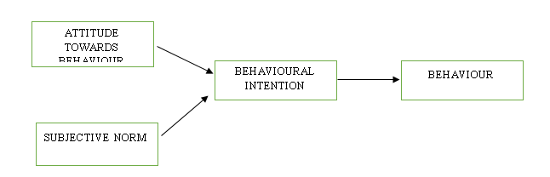
FIG 2.1 THEORY OF RESEASONED ACTION
Source: Customers’ perceptions of service quality, using an online reservation system, and online reviews affecting intention to use the system to book a hotel room, 2018

2.2.2.3 THEORY OF PLANNED BEHAVIOUR
Ajzen (1991) first suggested the concept of planned behavior, which claimed consumer intentions to perform various consumer-related behaviors were highly and reliably predicted by behavioral perceptions, social norms, and perceived behavioral influence. The desires of customers, together with their perceived behavioral control, resulted in significant variations in the purchasing behaviors of consumers.
Many theoretical frameworks have been developed to examine the relationship between customer attitudes towards the product and services they are going to buy and their behavioral intentions. The most well-known concepts are reasoned action theory and the theory of planned behavior theory (Wen, 2009).
The most important concern for researchers interested in consumer behavior was to determine how behaviors affected customer behavioral actions, based on Petty et.al(1991).
In the meantime, many other studies proposed that customers ' attitudes towards the product or service they were going to buy were more predictive of their actual buying habits under certain conditions (Evans et.al 1996; Njite et.al 2005; Shim et.al 1990; Shim et.al 2001).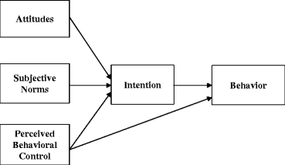
FIG 2.2 THEORY OF PLANNED BEHAVIOUR
Source: Customers’ perceptions of service quality, using an online reservation system, and online reviews affecting intention to use the system to book a hotel room, 2018

2.2.3 CUSTOMER SATISFACTION THEORIES
Traditionally, the literature on marketing and consumer behavior has suggested that customer satisfaction is a relative concept and is always judged by a standard (Olander, 1977). As a result, a number of different competing theories based on different standards were postulated in the course of its development to explain customer satisfaction. In general, the theories were categorized into three classifications: expectancy disconfirmation, equity, and attribution.

2.2.3.1 EXPECTANCY DISCONFIRMATION THEORY
Oliver (1980, 1997) conceptualized the disconfirmation of expectations paradigm, this emerged from a research topic of satisfaction antecedents (Anderson and Sullivan, 1993). A comparison of prior expectations with actual results is the standard approach to studying satisfaction. Thus, in this theory, the perception of the customer's overall satisfaction results from a comparison of expectations and results performance. Therefore, the performance of expectations and results are two important variables that can influence the measure of satisfaction judgment. Because the satisfaction of customers is one of the curial factors to predict the tendency of the customer to buy. It is also a major topic in consumer behavior analysis to investigate brand satisfaction. A company can increase satisfaction by increasing perceived consumer quality or decreasing expectations based on expectation disconfirmation theory.
Until buying, first, consumers' desires are met by a particular product or service in the cycle of satisfaction judgments. Second, consumption shows a perceived level of consumer quality that is affected by expectations when the gap between actual performance and expectations is considered below. Perceived performance can therefore increase or decrease directly with expectations. Third, perceived performance can either confirm the expectation of pre-acquisition (Anderson and Sullivan, 1993). Fourthly, the aspirations and perceived level of disconfirmation have a positive effect on satisfaction. When the performance of the outcome is an object, the perceived performance is difficult to increase. Thus, a viable alternative for the firm is to lower expectations (Kopalle and Lehmann, 2001).
In summary, expectations provide a level of satisfaction baseline or anchor. It is also known as the probability of assumptions as to what will be the outcome of an occurrence (Oliver, 1980).
2.2.3.2 EQUITY THEORY
Oliver (1997) describes equity as "fairness, right, or worthiness in contrast with other individuals, whether actual or imaginary, individual or collective, private or non-personal". The application of equity theory to advertising has long been recognized (Huppertz, Arenson, and Evans 1978). The underlying assumption, drawn from the theory of social exchange (Adams 1965; Homans 1961), is that interpersonal experiences are repetitive and evolve over time. In market exchange relationships, equity is closely related to the principle of reciprocity (Bagozzi 1975), indicating that it can be conceptualized as a fairly collective experience.
Nevertheless, measuring equity perceptions in a relatively transaction-specific fashion has been the tradition in marketing and consumer research (Huppertz, Arenson, and Evans 1978; Oliver and Swan 1989a, 1989b). Others compared equity's explanatory power to concepts of expectation, attribution, quality, and disconfirmation (Oliver and DeSarbo 1988). Bolton and Lemon (1999) explored compensation equity in ongoing trades, while Tax, Brown, and Chandrashekaran (1998) showed the importance of equity in partnership marketing service recovery situations. Yet little attention has been paid to the entire history of collective experiences, which is crucial to understanding desires and potential behavior (Andreassen and Lervik 1999; Heide and Miner 1992).
Following Bolton and Lemon (1999) and Oliver (1997), more focus is placed specifically on the distributive aspect of equity. Their definition of distributive equity is based on the principle of justice of Homans (1961), where the compensation of an individual in return should be proportional to their investments. Equity is the customer's assessment of what is right or fair based on a comparison of inputs (Bolton and Lemon 1999; Huppertz, Arenson, and Evans 1978). They, therefore, operationalize distributive equity using equality measures and obtained results relative to inputs made.
Previous research has demonstrated that distributive equity is a precedent for product or service satisfaction (Bolton and Lemon 1999; Oliver and Swan 1989a, 1989b). In exchange for a certain level of quality (or use in the cellular communication and entertainment service contexts of Bolton and Lemon), customers incur certain prices or costs. Distributive equity is the response of the consumer to outputs or fairness for these inputs. In turn, equity affects the overall evaluation of the product or service provider or the satisfaction of the customer by the customer. But as discussed below, this prediction and finding are based on a transaction-specific view of the constructs of equity and satisfaction.
Distributive equity acts in a similar fashion to perceived value (Fornell et al. 1996). However, researchers agree with Bolton and Lemon that value may be broader than distributive equity. Fornell et al. (1996) defined value as the quality ratio received for price or paid prices, whereas distributive equity is more the psychological reaction of the customer to inputs as opposed to outputs and resulting fairness.
2.2.3.2.1 TRANSACTION-SPECIFIC EQUITY and SATISFACTION
Based on the contextual transaction versus the aggregate existence of the structures involved, distributive equity play a very different role in driving satisfaction and loyalty. In line with previous studies, when equity and satisfaction are transaction-specific, we expect satisfaction to mediate the impact of equity on loyalty. In this case, loyalty is a construction of behavioral intentions. Equity affects satisfaction, affecting loyalty in turn. As shown in on the left side in the Figure below. The explanation is quite simply to avoid saturating the relationships of the structure in order to provide a stronger test of causality. Transaction-specific equity is, theoretically, a more bottom-up or concrete assessment.
Customers put forward so much to get so much in the context of a particular transaction or service episode. It is natural that this input is measured as the system unfolds versus production or expected equity. On the other hand, episode or transaction satisfaction is a retrospective assessment. Therefore, perceived equity will directly influence satisfaction.
The main difference between this model and previous ones is that it is no longer a separate generator of transaction-specific satisfaction to disconfirm expectations (Oliver and Swan 1989a). Rather, it becomes one of the satisfaction constructs of multiple reflective measures (Johnson, Anderson, and Fornell 1995).

Equity First Model Satisfaction-First Model
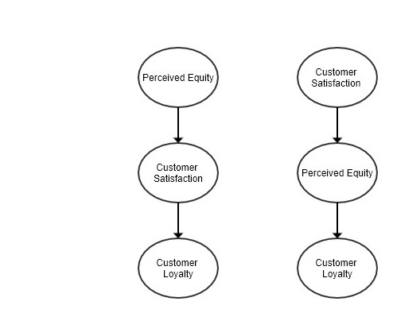
FIG 2.3 COMPETING EQUITY, SATISFACTION AND LOYALTY MODELS
Source: Customers’ perceptions of service quality, using an online reservation system, and online reviews affecting intention to use the system to book a hotel room, 2018
2.2.3.2.2 CUMULATIVE EQUITY and SATISFACTION
Although prior research has argued for and endorsed the equity-first model, saying they expect the cause and effect sequence to change as equity and satisfaction are calculated in a more aggregate manner. As shown on the right side of Figure 2.3, the satisfaction-first model, equity mediates the impact of satisfaction on loyalty. At the heart of the argument is that aggregate satisfaction is a more fundamentally reflective form of attitude type (Johnson, Anderson, and Fornell 2001). It is the stored overall assessment of the customer's buying and consuming experience with a product or service provider to date. This stored appraisal acts as an anchor in a fairly top-down evaluation process as long as consumers are reasonably happy with the goods and services they buy and consume. Perceived equity is no longer the point of departure in the system. Instead, equity becomes an analysis that is more likely to be made by consumers as they enter the purchase-consumption-repurchase period. Explicit assessments such as equity following Johnson (1998), help bridge the gap between decisions on satisfaction and repurchase. As a consequence, equity will influence loyalty more directly than satisfaction. Customers depend on their cumulative satisfaction when evaluating distributive capital in the satisfaction-first model, which in turn should have an effect on loyalty. In other words, in the sense of cumulative evaluations, equity is conceptually similar and more important to evaluating one's moral motives (loyalty).
Nonetheless, this statement presumes that consumers are fairly happy with a particular product or service. In other words, there is no need to track distributive equity constantly. This theory tries to differentiate between consumers who are unhappy and have clear grounds for complaining (as for the rates they pay or value they receive) and those who are fairly happy and have no grounds for complaining. For the simple reason that not all customers who are unhappy and potentially looking to leave complain, this theory concentrates on "reason to complain" versus dissatisfied customers.
The proposed arrangement may not hold if consumers are fairly disappointed and have a clear reason to complain. To the degree that you have a reason to complain, being disappointed means that the consumer no longer holding onto a collected, overall assessment of their experience. Instead, these consumers are in a more active process of problem-solving or bottom-up analysis (Howard 1977). In contrast to transaction-specific assessments, equity is the starting point for cumulative assessments, given the need for customers to more actively monitor outputs relative to inputs. Therefore, when consumers are fairly dissatisfied and have reason to complain, it is expected that equity and satisfaction behave just as they do in the case of transaction-specific satisfaction. Between Oliver and Swan (1989a, 1989b) and Bolton and Lemon (1999) for 5 of these clients, the equity should be a backdrop for satisfaction and eventual loyalty. This is consistent with the argument made by Smith, Bolton, and Wagner (1999) that a lack of equity among complaining customers is a major driver of satisfaction.
Overall, they predicted that the nature of the causal relationship between cumulative equity, satisfaction, and loyalty assessments is moderated by the level of satisfaction of the customer and the resulting reason for complaint.

2.2.4 INFORMATION TECHNOLOGY THEORIES
Deciding to incorporate reservation systems into an organization means that a level of understanding has been attained as to its functions and importance. Oliveira and Martins (2011) claimed that understanding the factors influencing the adoption of Information Technology (IT) as well as the theoretical frameworks based on the adoption of Information Technology (IT) was important. Many ideas have been used to examine the introduction of information technology based on previous work in information systems. For the purpose of this research The Technology acceptance model (TAM) (Davis, 1986; Davis, 1989; Davis et al., 1989) will be examined. Theory of Planned Behavior (TPB) (Ajzen, 1985; Ajzen, 1991), unified technology acceptance and use theory (UTAUT) (Venkatesh et al., 2003), Diffusion of Innovation (DOI) (Rogers, 1995), and the Technology Organization Environment (TOE) system (Tornatzky & Fleischer, 1990) are also commonly used models.

2.2.4.1 TECHNOLOGY ACCEPTANCE MODEL
The Technology Acceptance Model (TAM), developed by Davis (1986), is one of the theories most commonly used to describe user acceptance behavior. This model is based on the general theory of social psychology and the Theory of Reasoned Action (TRA) (Fishbein et.al 1975). Theory of Reasoned Action (TRA) argues that beliefs impact behaviors that contribute to expectations and thus produce behavior. In the original Technology Acceptance Model (TAM) Davis (1986, 1989) presented the constructs as follows: perceived usefulness (PU), perceived ease of use (PEOU), attitude, and behavioral intention to use. Perceived usefulness (PU) and Perceived ease of use (PEOU) form the beliefs of an end-user on technology among the constructs and thus predict their attitude toward the technology, which in effect predicts their acceptance.
Davis (1989) performed several experiments to confirm Technology Acceptance Model (TAM) as the dependent variable by using perceived ease of use (PEOU) and perceived usefulness (PU) as two independent variables and system use. He found that perceived usefulness (PU) was significantly associated with both self-reported use and self-predicted future usage. Perceived ease of use (PEOU) was also substantially correlated with current usage and potential us-age. Overall, he found that perceived usefulness (PU) had a significantly greater association with system usage than perceived ease of use (PEOU). Additional regression analysis indicated that perceived ease of use (PEOU) could be a precedent of perceived usefulness (PU) rather than a direct determinant of system use. Meaning that perceived ease of use (PEOU) has an impact on technology acceptance (TA) indirectly through perceived usefulness. Technology Acceptance Model (TAM) has received significant recognition and empirical support over the past decade (e.g., Davis, 1989; Mathieson, 1991; Taylor & Todd, 1995a). Estimates have shown that between 1989 and 2001 there were approximately 100 articles, journals, trials or technical reports related to the technology acceptance model (TAM). Technology Acceptance Model (TAM) was extensively tested in these studies using various sample sizes and user groups within or through organizations, analyzed using specific statistical tools and compared to competing models (Gefen, 2000). It has been extended to various end-user applications such as email (Adams et.al, 1992; Davis, 1989), word processor (Adams et.al, 1992; Davis et.al, 1989) spreadsheets (Agarwal et.al, 2000; Mathieson, 1991) and worldwide web (Lederer et.al, 2000), groupware (Taylor et.al, 1995b). However, much research has expanded the technology acceptance model (TAM) by integrating additional predictors such as gender, culture, experience, and efficacy of themselves. Researchers tend to show that TAM is real, useful and effeective (Venkatesh et.al 2000).

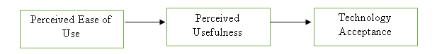
FIG 2.4 A VALIDATED ACCEPTANCE MODEL

2.3 CONCEPTUAL REVIEW
A conceptual framework is a system that the researcher believes the natural progression of the phenomenon to be investigated can better be explained (Camp, 2001). It is related to the principles, empirical research and relevant hypotheses used to support and systematize the researchers ' knowledge (Peshkin, 1993). Therefore, this conceptual review examines the basis behind the idea of this project.

2.3.1 COMPUTER RESERVATION SYSTEMS
Traditionally, reservation systems were developed for airline companies, who had problems storing and retrieving large amounts of reservation data, which included the flight schedules, ticket price, reservation availability and all reservations made. Thus software had to be developed for controlling reservations for airlines, for reservation staff to efficiently monitor seat availability (Sion et al., 2013).
In an event that reservation request is made by travel agents, the information could easily be sourced for from the airline company and thereafter make reservations easily with a computer connected to the specific database of the airline company.
With the presence of reservation systems, airline managers saw the importance and effectiveness of allowing travel agents to access the main systems directly, thus, airlines began to make terminals available in their various agencies for travel agents, to source for information and make reservations. Which led to a decrease in the cost of telecommunication in the 1970s.
In little time, reservation system had proved to be effective than the previous method (i.e. the manual method), these reservation systems led to the rapid reduction in the time it took to source for information and the cost of communication. Travel agents could now access reservation availability and cost concurrently, improving the quality of service.
The emergence of this technology was beneficial to all airlines because it was less expensive to distribute the tools needed to facilitate direct access to the airline database than it was to hire more staff members. Besides, company managers found out that the travel agent was in support of the idea of airline companies use reservation systems. This helped to expand their market, creating more revenue and the economic entrepreneurship spirit obtained from the price reduction. Replacing terminals in agencies in such a way that flight agents are linked to ensure a better future for flight bookings. (Sion et al., 2013)

2.3.2 GLOBAL DISTRIBUTION SYSTEM
Global Distribution System (GDS) refers to a network system in the tourism and hospitality industries that links multiple service providers with end-users or travel agents and enables them to book directly. Airlines, hotel rooms, car rentals, cruises, events, and activities are among the service providers.
Hotels and airlines began building Central Reservation Systems (CRS) during the 1960s to manage their individual business or inventory reservations. In the 1980s, the need to access reservations conveniently for all aspects of travel prompted various airlines and hotel chains to connect their inventory and sell it directly to travel agents. Global Distribution System (GDS) was set up as a spin-off service that would connect several companies ' different Computer Reservation Systems (CRS's). Companies in the same industry category were connected as were various industries such as airlines, hotel chains, and car rentals. GDS's have emerged as a business in their own right since the late 1990s, along with the development of the Internet, specializing in the delivery of travel for many different types of services (Buhalis and Licata 2002). Global Distribution System (GDS) with the largest market shares include Sabre, Galileo, Amadeus, and Worldspan emerged (Buhalis 2003).
American Airlines built Sabre together with IBM Inc. on a mainframe computer in the 1960s. Afterward, Sabre and American Airlines decided to split up in 2000. Travelocity, Expedia, lastminute.com and several other online travel agencies (OTAs) are currently operated by Sabre. Worldspan was founded in the early 1990s by combining Northwest Airlines, Delta Airlines and Trans World Airlines (TWA)'s individual reservation systems to sell seats to travel agencies. Worldspan was sold by the owner airlines in 2003 and later in 2007 to Travelport, also owned by Galileo and then Nine European air carriers formed Galileo in 1987.
The Global Distribution System (GDS) field is always in a state of rapid evolution from a historical perspective. Big Online Traveling Agencies (OTAs) including Expedia, Travelocity, and Orbitz are currently working with Global Distribution System (GDS). In supplying airline scheduling and personnel selection, the Global Distribution System (GDS) remains essential (Tesone 2005). Nonetheless, bypassing Globals Distribution System (GDS), individual airlines and hotel chains try to sell directly to their customers.
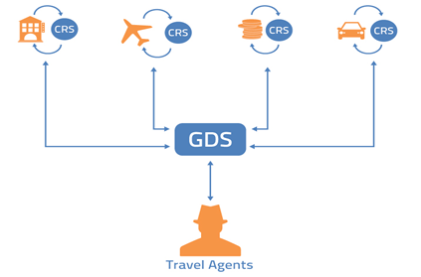
FIG 2.5: THEORETICAL FRAMEWORK OF A GLOBAL DISTRIBUTION SYSTEM
Source: Hotel Reservation System, 2015

2.3.3 ONLINE HOTEL RESERVATION SYSTEMS
Hotel Reservation systems which are also known as Computer Reservation Systems (CRS), is a computerized system that manages the information of the hotel, guest house or lodging facility. According to Kim et al., 2005, the role of these systems in tourist companies has proven to be positive. Due to the fact that establishing online presence and incorporating business e-commerce models adds to the companies’ efficiency and profitability (Poon, 1993; Sheldon, 1997; O’Connor, 1999; Buhalis, 1998, 1999, 2003; Teo and Pian, 2003; Bojnec and Kribel, 2004; Lohrke et al., 2006). The use of online reservation systems in the hotel accommodation sector, air-ticketing sector and lots more has helped in one way or another to enhance growth of e-commerce and caused a reasonable scientific research on the relationships between tourism industries and information technology and marketing strategies (e.g Connolly et al.,1998; Connolly 1999; Smith et al.,2001; O’Connor and Frew, 2002; Buhalis, 2003; O’Connor, 2003a, 2003b; Carroll and Siguaw, 2003; Ham 2004; Tesone). A Computer Reservation System (CRS) provides assistance to hotel owners to properly manage all online marketing and sales where they could upload their services and their prices so that other sales channels could see them. The list of major Computer Reservation System (CRS) modules is content, information stored on a CRS, and reporting. Content includes Reservations, Profiles, Groups and Blocks, Tariff and Stock Control, Administration, Global Distribution System, Web Interface. Data typically stored in a Computer Reservation System (CRS) includes room types, rate plans architecture, room rates and conditions (guarantee, deposit, cancelation rules, minimum length of stay, maximum length of stay, closed to arrival, unauthorized arrival, unauthorized departure, ...), room inventory, generic hotel data (address, telephone number, fax number), booking details. A number of standard reports are provided by the Computer Reservation System (CRS) Reporting module. System reports can be automatically generated and run on a daily, weekly, monthly, annual basis. It includes Expected Arrivals, Reservation, Property Forecast, Total Reservation Activity, Stay Activity, Monthly Booking Activity, Daily Booking Activity, and Property Detail.
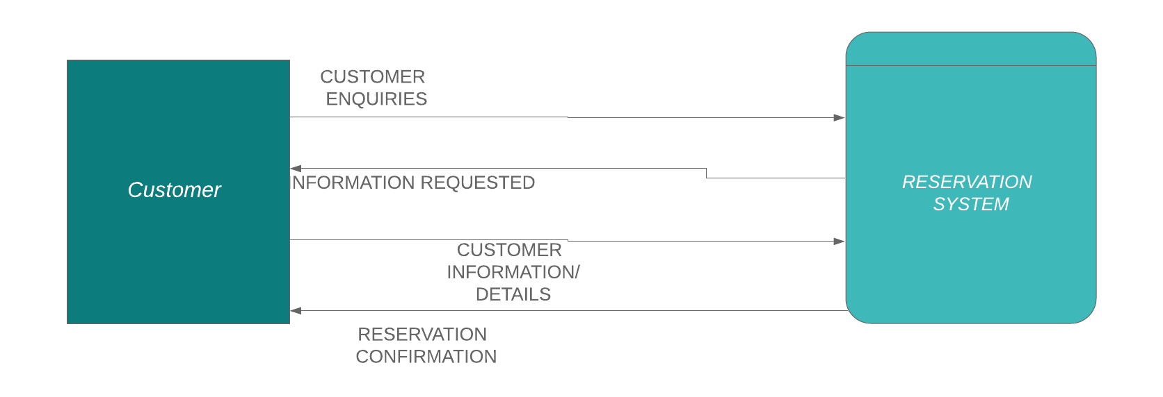
FIG 2.6: CONTEXT DIAGRAM FOR A RESERVATION SYSTEM
Source: Online Hotel Reservation System, 2014
2.3.3.1 TYPES OF RESERVATION
Generally, there are two types of reservation, which are: Guaranteed reservation and Non-guaranteed reservation
- Guaranteed Reservation: Guaranteed reservation is a reservation with a specially registered hotel confirmation that it guarantees the customer to obtain the number requested by him at the time required. The client, in effect, ensures that the amount will be charged even if it cannot be used in the case of no show (no show). Payment for an unused number will be paid to the customer if he was unable to cancel the hotel accommodation order in time. The beauty of guaranteed reservation is that if the guest cannot use it, the guest can decide to cancel the order number. Some examples of guaranteed reservations include advanced booking reservations, booking under the credit card guarantee, booking on invoice.

- Non-guaranteed Reservation
A conditional booking or simple agreement between the guest and the hotel in which the hotel agrees to keep the room until 6 pm on the arrival date. If within the cancelation hours, the guest fails to reach, the room will be released for resale.
      - FACTORS AFFECTING RESERVATION
- Confirmation: This is a legal document specifying the acceptance and approval of the room request made by guests and the hotel. It can be a reservation that is either guaranteed or not guaranteed. If a guest does not check-in or check-out on time, this affects room occupancy.
- Cancellation: this means that the room that was previously reserved will again be available for resale for personal reasons or normal law, then the guest will have to pay any fee and the remainder of the amount paid will be refunded.
- Overbooking: this refers to the tendency of booking rooms that are beyond the available capacity of the hotel. This is often used as a strategy to maximize room revenue to prevent no-show or last-minute cancellation. This process must be carried out carefully, in an event of overbooking or rooms, the guest will be moved to the same standard hotel that had been paid for.
- Walk-in: Here guests arrive at hotels without reservation hoping to get one, they are often called Chance guests. This type of reservation should be handled carefully and accommodated by walk-in formalities with advance deposit. In events that there is no accommodation for walk-in guests, they are referred to hotels nearby.
- No-show: This occurs when a guest does not come physically to pick up a reservation or for formal cancellation. In such a case, a hotel charges guests with compensation fee and then a refund will be made to the guest.
- Over and under stay: When a guest stays in hotel rooms beyond the set departure date it is called overstay. While guest who checks out before the set departure date is called under stay

    - TOOLS AND TECHNOLOGY
JAVASCRIPT: JavaScript is an ECMA Script language standard implementation and is mainly used as a client-side JavaScript, introduced as part of a web browser to improve user interfaces and interactive websites (McFarland, 2008). It provides programmatic access within a host system to computational objects.
HYPERTEXT PROCESSOR (PHP): PHP is a general scripting language that was originally designed to create dynamic web pages for web development. PHP code is embedded in the HTML source document for this purpose and interpreted by a web server with a PHP processor module producing the document on the web page (Pan, Chen, and Nguyen, 2012).
STRUCTURED QUERY LANGUAGE: (SQL) is a programming language for the database designed for data management and recovery. It is devoted to updating deleting and requesting data from the database. In this project, SQL is used to create a database that stores information (data) of the user. Structured Query Language (SQL) is easy to use, open-source, and user-friendly.
BOOTSTRAP: Bootstrap is a free and open-source front end development framework for developing and designing websites and web apps. Bootstrap was built on HTML, CSS and JavaScript to make easier the development of responsive, mobile-first sites and apps.

    - INFORMATION SYSTEM
As the world keeps advancing technologically, processing, storage, and distribution of information remain key. Movement from one place to another either for business or vacation is bound to occur every now and then making the demand for tourism services to increase daily, which in turn increases the business of transportation, renting and lodging facilities. Knowing that it is therefore important that accurate and timely information is available to guests who need to plan and make decisions concerning accommodation. For this reason, Management Information Systems (MIS) is indeed an important component for making inquiries, plans and decisions.
2.3.5.1 MANAGEMENT INFORMATION SYSTEM
Management Information Systems refer to large systems that enhance the decisions taken by decision-makers, proving them with the necessary information. Simply put, MIS is the study of information, and its influence on individuals, organizations, and society. Management Information System (MIS) generates, processes, stores and retrieves information within and outside organizations. Management Information System (MIS's) objective is to polish and make available information for decision making, planning, organizing and controlling the operations of units of an organization, thus causing synergy amongst all departments. (Sarngadharan & Minimol 2012, 32).
Management Information System (MIS) could be referred to as Information System (IS) which is a useful intermediary to the database. User inputs go straight to the database, and when needed the Information System (IS) manipulates the information.
      - INFORMATION SYSTEM COMPONENTS
Information system components include:
- Hardware-which is the physical device. O'Brien (2001)[12] describes hardware as physical devices and material used in the processing of information. In particular, it includes not only devices such as computers but also digital media, i.e. all physical objects that store data from paper sheets to magnetic disks. Others include keyboards, mouse machines, printers, scanners, etc.
- Software- Rochester et al. (1996)[21 ] argues that software contains all sets of instructions for information processing and consists of various types of programs that allow the hardware to perform different tasks. In addition, the software is classified into system software and application software. The system software is about keeping the computer system running while Application software is the general-purpose or written for a specific task such as stock control. It can be written using a programming language or a piece of software such as a database for more general purposes.
- Data-According to Rochester et al. (1996)[21], to all raw and unprocessed data that can be used readily. Cleary Without data, no database system can exist. The basic factor is based on the processing and information needs of an organization. Data elements and relationships need to be described precisely and the meanings need to be documented correctly in the data dictionary.
- People-users-These are needed for the operation of all information systems, according to O'Brien (2001)[11]. These include end-users and experts in the information system. End-users are people using a network of information. Specialists in the reservation information system help in information system development and operation. They include system analysts, computer operators, programmers, and others.
- Process-These are instructions on how to combine the above-mentioned components to process the information and produce the desired output. They consist of how to sign in to the Database Management System (DBMS), how to use various forms and manipulations throughout the entire project.
- Database-Merril Wells, (2002)[14] describes Database as a non-redundant data set that can be shared by different application systems. This was written in books or records prior to the advent of computers; these could be known as "manual" databases. After computers were implemented to sort data, a sea change has occurred in the nature and layout of a database. The creation and maintenance of databases is a systematic and continuous cycle that is driven by system software such as database management systems.
Database users report their database requirements using Data Definition Languages (DDL) and Data Manipulation Languages (DML) via Database Management Systems. The database management system would definitely provide an interface between the database user programs and content. The DDL and DML are used for the following during the development and subsequent maintenance of the content of the database, adding new information, expanding the database, removing absolute records, modifying data and increasing the ability of the database, connecting data items and many more.
      - INFORMATION SYSTEM TYPES
Transaction Processing System (TPS)
This is a computerized system that conducts and records the daily routine transactions that are required for business behavior. TPSs are information systems that process data resulting from business transactions. Example: system of payroll; instructions for output. Kanter (1997), [12 ].
Management Information Systems (MIS)
This primarily refers to internal information sources. MIS typically gathers and translates data from transaction processing systems into a collection of management reports. MIS, therefore, provides information for an organization's management. MIS information helps managers track the enterprise and guide it.
Decision-support Systems (DSS)
These are primarily designed to assist management in making decisions in cases where there is confusion about the potential outcomes of those decisions. DSS provides tools and techniques to aid in gathering relevant information and evaluating choices and alternatives. DSS also requires the use of complex spreadsheets and databases to build models of "what-if" Finley et al. (1994) [8].
Executive-support Systems (ESS)
This is meant to support senior management in making strategic decisions. It gathers analyzes and summarizes the company's key internal and external information. Usually, ESS involves a lot of data analysis and modeling techniques such as "what - if" research to aid in strategic decision-making. Stair, (1996) [22]
    - HOTEL MANAGEMENT SYSTEM
The tourism sector is one of the most essential sectors for the economic growth of the country, no doubt the good facilities, kind attitude, and management have a major role in their attraction. Thus hotels, guesthouses, lodges, etc. should have adequate manpower as well as facilities to provide quality service to their guests.
Hotels serve as shelter for guests in which they could receive services provided, which must have been paid for before gaining accommodation. In order to adequately manage guest details and all information regarding the Hotel, Hotel Management Systems are used, which in turn makes the work of managers a lot easier, leading to work efficiency and prosperity of organizations.
The term Hotel Management System includes the management for the attraction, smooth handling of items, and proper management of every aspect relevant to the hotel. Especially reservations, registers, accounts, payment methods for services, additional activities should be handled carefully and efficiently maintained in order to satisfy the guest and to ensure that there is no benefit leakage to the hotel. The better the service, the greater the appeal and the greater the benefit not only to the hotel but also to the nation indirectly.
  - EMPIRICAL REVIEW
For the empirical review, past literature that has been collected relating to this study were examined, in order to deduce the central knowledge gotten during the course of research.
2.4.1 REVIEW OF RELATED WORKS
Reservation systems have played a big role in opening up socio-economic opportunities as the Hotel industry advances. Asides the hotel industry, reservation systems have impacted other industries such as airlines, car rentals, travel accounting, etc. So far the tourism sector has been able to succeed more with the introduction of Central Reservation Systems since the 1960s, making it easier for travel agents to source for inquiries and make reservations. Today customers do not need to go through the stress of standing on long queues or having to wait a long time just to make inquiries about reservation availability, rather all guests or travel agents using the internet can make reservations directly with just a few clicks on their mobile devices or computers, and all that is thanks to the Global Distribution System (GDS) connecting multiple central reservation systems and showcasing their different prices to customers.
An overview of the journals collected for this study has shown that online reservation systems give a competitive edge to companies that incorporate it into their system, creating a bond between the hotel company and the customer that he/she is guaranteed a room. Therefore giving way for more customers, profit and most important growth as an organization. According to a survey carried out by Nafisat Usman Adams on reservation systems for Transcorp Hilton, Abuja and Eko Hotel, Lagos, it was found that similarities existed between the two reservation systems; to mention but a few: easy navigation and easy to interact with. Judging by the ISO 916 product quality characteristics, easy navigation and easy to interaction meet two out of six of the product quality characteristic (i.e. Efficiency and Usability). Thus it is important that reservation systems are able to meet the product quality characteristics in order to meet the needs of the customers which is indeed paramount.
However, the quest to replace the manual process of booking with the Online Hotel Reservation system remains the top priority of hoteliers, ensuring the proper storage, retrieval and proper safekeeping of customer details.
  - SUMMARY
The manual booking process used before now showed inefficiency in handling the demand of customers, which brought about the use of Central Reservation Systems into the tourism sector, which without a doubt has shown some level of efficiency. Therefore, Companies that have embraced this system have been able to thrive. Thus it is important companies who have not embraced this system do so quickly, applying all principles properly in order to gain a competitive business edge.

CHAPTER THREE
METHODOLOGY
3.1 METHODOLOGY
A methodology is a development system of methods that are used to plan, structure and control the process of developing an information system. (Benda & Robertson 2006). Methodologies are the basis of knowledge growing for researchers. A large number of researchers implement different research methodologies that enhance the development of research work. Below are the methodologies employed for the development of this project.
3.2 EXISTING SYSTEM ANALYSIS
The Bowen University Guest House makes use of a manual reservation, where customers interested in making reservations or sourcing for inquiries either call the guest house administrator or sends student/staff member to find out more about the university guest house services or charges. Customers who are fortunate enough to through to anyone who could them source for information normally have it quite easy while others who are unable to get tangible information sometimes get frustrated and lose interest.
Asides that guest house administrators are forced to manually record customer details with paper and pen which is inefficient and slow. Also, administrators, find it hard to keep track of large data of customer transactions after a period of time, which in turn leads to poor management on their path. The university guest house is also deprived of customer feedback of services provided to customers and staff members resident in the guest house. Lastly, administrators can only attend to one customer at a time, which makes the checking-in process a lot slower.
3.3 PROPOSED SYSTEM
The proposed system introduces the use of an online reservation system, which will make the sourcing of information convenient for customers at the same time, makes it easier for customers or even staff members to book a room for themselves. This reservation system will have a database to store all customer and staff members' information as well as transaction details. This will make it easier for the admin to properly manage customer information and a reliable customer feedback platform which will help to improve services provided by the university guest house.
3.4 TOOLS AND TECHNIQUE
3.4.1 SOFTWARE DEVELOPMENT LIFE CYCLE (SDLC)
Software Development Life Cycle (SDLC) is a collection of steps that are followed for the systematic development, design, and maintenance of a software project and ensures that all user requirement is fulfilled with least amount of resource consumption. This methodology makes it possible to develop high-quality software products on time implementing all customer requirements.
The Software Development Life Cycle (SDLC) phases include planning, defining, designing, building, testing and deployment. These phases have different procedures they undergo and inputs that are fed into the next phase
3.4.2 ADVANTAGES OF SOFTWARE DEVELOPMENT LIFE CYCLE (SDLC)
1. At the end of each phase, a review is carried out to enable proper management.
2. The structure of phases used enhances proper documentation of the logic behind every code written, which in turn makes it easier to understand by anyone.
3. The systematic approach allows for proper planning well ahead of future risks.
3.4.3 DISADVANTAGES OF SOFTWARE DEVELOPMENT LIFE CYCLE (SDLC)
1. The documentation process is usually expensive, stressful and time-consuming
2. Requirements must be strongly adhered to. There is no room for developer creativity.
3. Testing is normally carried out only in the testing phase with the end-user
3.4.4 AGILE SOFTWARE DEVELOPMENT
Agile software development emphasizes on feedback and change in which feedbacks are important to achieve desired results, Williams and Cockburn (2003). Agile software’s are characterized by their adaptability to change and high quality product delivery.

3.4.5 AGIILE SOFTWARE APLLICATION
1. When the scope of the project is liable to change
2. When the final product is not definite.
3. When systematic software enhancement is held in high esteem than quality.
3.4.6 AGILE SOFTWARE ADVANTAGES AND DISADVANTAGES
3.4.6.1 ADVANTAGES
1. It is cost effective
2. Encourages flexibility and adaptability
3. Guarantees Quality
3.4.6.2 DISADVANTAGES
1. Projects are liable to fall off track
2. Poor documentation of necessary details
3. Great commitment is required on the path of developers and clients
3.4.7 WATERFALL METHODOLOGY
The waterfall approach was the first SDLC Model to be used widely in Software Engineering to ensure the success of the project. In the "The Waterfall" approach, the whole process of software development is divided into separate phases. In the Waterfall model, typically, the outcome of one phase acts as the input for the next phase sequentially. All the phases are cascaded to each other in which progress is seen as flowing steadily downwards (like a waterfall) through the phases. The next phase is started only after the defined set of goals is achieved for the previous phase and it is signed off, so the name "Waterfall Model". In this model, phases do not overlap

3.4.8 WATERFALL METHODOLOGY ADVATAGES AND DISADVANTAGES
3.4.8.1 ADVANTAGES
- Well defined stages
- Easy to understand
- Proper verification and validation to prevent errors
3.4.8.2 DISADVANTAGES
- Going back the previous stage is not encouraged
- Reduced customer involvement
- Rigid response to change at a later period of development
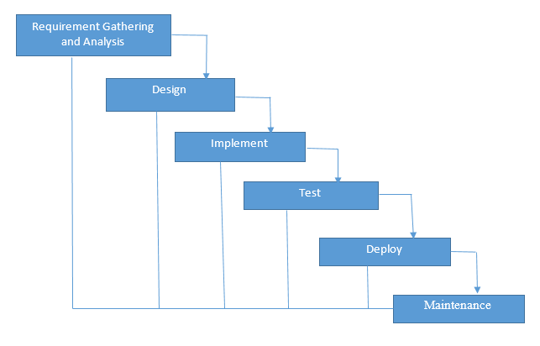
FIG 3.1: WATERFALL MODEL

3.4.7 WATERFALL METHODOLOGY APPLICATION
1. When the project is short and requirements are clear
2. Proper requirement documentation.
3. When the final product is definite
3.5 METHODS OF DATA COLLECTION
3.5.1 ONE-ON-ONE INTERVIEW WITH GUEST-HOUSE MANAGER: A One-on-One interview with the Bowen University Guest House Administrator was held to find out how the reservation process is like for customers, issues raised that were of great concern. During our interaction a few necessary requirements for the development of the Online Reservation System were obtained.
3.5.2 THE INTERNET: In depth research was carried to obtain papers related to Reservation Systems.
3.6 SYSTEM ARCHITECTURE
The system design is 3-tier, the presentation tier, middle tier and data tier. The different tires include presentation tier, middle tier and data tier. Presentation tier refers to the user interface and will be designed using Bootstrap, the middle tier which could be referred to as the business logic will be developed with Hypertext Preprocessor (PHP) and JavaScript, this middle tier will serve as an intermediary between the Presentation tier and the data tier. Lastly the data tier which is the data storage, will handle the data management of the application and will be developed with MySQL (Structured Query Language).

Presentation Tier

Middle Tier

Data Tier

Data Tier

BOOTSTRAP
SQL Database

PHP

FIG 3.1: THE THREE TIER ARCHITECTURE FOR THE GUEST HOUSE RESERVATION SYSTEM

3.7 SYSTEM DESIGN
Here, based on the requirements gotten and analysis of the existing system and the proposed system, the system design for this project was done using a number of methods which include: flowcharts and Unified Modeling Language (UML) (.i.e. use case diagrams, DFD diagrams, and Activity diagrams etc.)
    - FLOW CHART

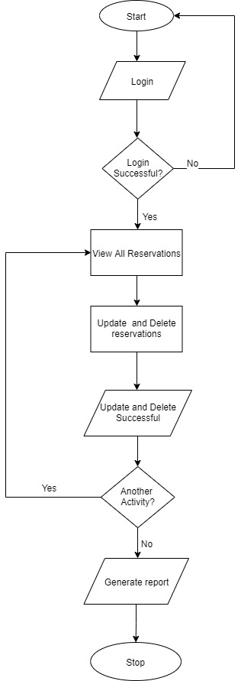
FIG 3.2: FLOW CHART FOR SYSTEM ADMINISTRATOR
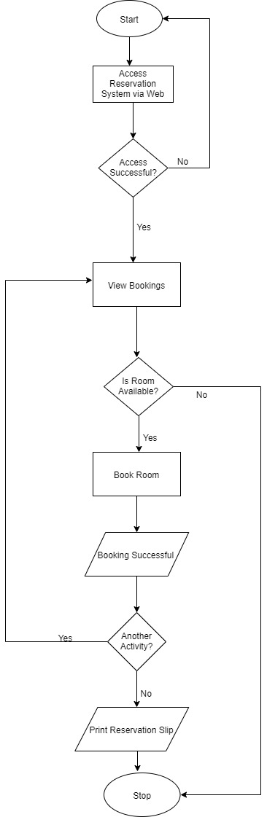
FIG 3.3: RESERVATION FLOW CHART FOR GUEST/USER

3.7.2 DATA FLOW DIAGRAM
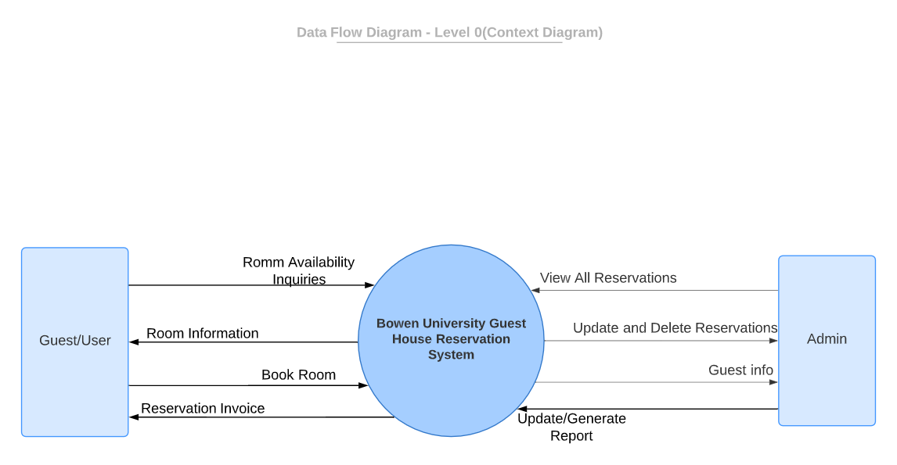
FIG 3.4: LEVEL 0 DATA FLOW DIAGRAM

3.7.3 ACTIVITY DIAGRAM
%3CmxGraphModel%3E%3Croot%3E%3CmxCell%20id%3D%220%22%2F%3E%3CmxCell%20id%3D%221%22%20parent%3D%220%22%2F%3E%3CmxCell%20id%3D%222%22%20value%3D%22Book%20Room%20(Activity%20Diagram)%22%20style%3D%22swimlane%3BwhiteSpace%3Dwrap%22%20vertex%3D%221%22%20parent%3D%221%22%3E%3CmxGeometry%20x%3D%22300%22%20y%3D%2230%22%20width%3D%22280%22%20height%3D%22930%22%20as%3D%22geometry%22%2F%3E%3C%2FmxCell%3E%3CmxCell%20id%3D%223%22%20value%3D%22%22%20style%3D%22ellipse%3Bshape%3DstartState%3BfillColor%3D%23000000%3BstrokeColor%3D%23ff0000%3B%22%20vertex%3D%221%22%20parent%3D%222%22%3E%3CmxGeometry%20x%3D%22100%22%20y%3D%2240%22%20width%3D%2230%22%20height%3D%2230%22%20as%3D%22geometry%22%2F%3E%3C%2FmxCell%3E%3CmxCell%20id%3D%224%22%20value%3D%22Inquire%20about%20room%20availability%22%20style%3D%22rounded%3D1%3BwhiteSpace%3Dwrap%3Bhtml%3D1%3B%22%20vertex%3D%221%22%20parent%3D%222%22%3E%3CmxGeometry%20x%3D%2255%22%20y%3D%22110%22%20width%3D%22120%22%20height%3D%2260%22%20as%3D%22geometry%22%2F%3E%3C%2FmxCell%3E%3CmxCell%20id%3D%225%22%20style%3D%22edgeStyle%3DorthogonalEdgeStyle%3Brounded%3D0%3BorthogonalLoop%3D1%3BjettySize%3Dauto%3Bhtml%3D1%3BexitX%3D0%3BexitY%3D0.5%3BexitDx%3D0%3BexitDy%3D0%3BentryX%3D0%3BentryY%3D0.5%3BentryDx%3D0%3BentryDy%3D0%3B%22%20edge%3D%221%22%20parent%3D%222%22%20source%3D%226%22%20target%3D%2213%22%3E%3CmxGeometry%20relative%3D%221%22%20as%3D%22geometry%22%3E%3CArray%20as%3D%22points%22%3E%3CmxPoint%20x%3D%2220%22%20y%3D%22250%22%2F%3E%3CmxPoint%20x%3D%2220%22%20y%3D%22781%22%2F%3E%3C%2FArray%3E%3C%2FmxGeometry%3E%3C%2FmxCell%3E%3CmxCell%20id%3D%226%22%20value%3D%22Is%20Room%20Available%3F%22%20style%3D%22rhombus%3BwhiteSpace%3Dwrap%3Bhtml%3D1%3B%22%20vertex%3D%221%22%20parent%3D%222%22%3E%3CmxGeometry%20x%3D%2275%22%20y%3D%22210%22%20width%3D%2285%22%20height%3D%2280%22%20as%3D%22geometry%22%2F%3E%3C%2FmxCell%3E%3CmxCell%20id%3D%227%22%20value%3D%22Display%20room%20details%20and%20rates%22%20style%3D%22rounded%3D1%3BwhiteSpace%3Dwrap%3Bhtml%3D1%3B%22%20vertex%3D%221%22%20parent%3D%222%22%3E%3CmxGeometry%20x%3D%2255%22%20y%3D%22340%22%20width%3D%22120%22%20height%3D%2260%22%20as%3D%22geometry%22%2F%3E%3C%2FmxCell%3E%3CmxCell%20id%3D%228%22%20value%3D%22Book%20room%22%20style%3D%22rounded%3D1%3BwhiteSpace%3Dwrap%3Bhtml%3D1%3B%22%20vertex%3D%221%22%20parent%3D%222%22%3E%3CmxGeometry%20x%3D%2255%22%20y%3D%22450%22%20width%3D%22120%22%20height%3D%2260%22%20as%3D%22geometry%22%2F%3E%3C%2FmxCell%3E%3CmxCell%20id%3D%229%22%20value%3D%22Input%20and%20verify%20customer%20details%22%20style%3D%22rounded%3D1%3BwhiteSpace%3Dwrap%3Bhtml%3D1%3B%22%20vertex%3D%221%22%20parent%3D%222%22%3E%3CmxGeometry%20x%3D%2255%22%20y%3D%22550%22%20width%3D%22120%22%20height%3D%2260%22%20as%3D%22geometry%22%2F%3E%3C%2FmxCell%3E%3CmxCell%20id%3D%2210%22%20style%3D%22edgeStyle%3DorthogonalEdgeStyle%3Brounded%3D0%3BorthogonalLoop%3D1%3BjettySize%3Dauto%3Bhtml%3D1%3BexitX%3D0.5%3BexitY%3D1%3BexitDx%3D0%3BexitDy%3D0%3B%22%20edge%3D%221%22%20parent%3D%222%22%20source%3D%228%22%20target%3D%229%22%3E%3CmxGeometry%20relative%3D%221%22%20as%3D%22geometry%22%3E%3CmxPoint%20x%3D%22115%22%20y%3D%22560%22%20as%3D%22targetPoint%22%2F%3E%3C%2FmxGeometry%3E%3C%2FmxCell%3E%3CmxCell%20id%3D%2211%22%20value%3D%22Print%20reservation%20Invoice%22%20style%3D%22rounded%3D1%3BwhiteSpace%3Dwrap%3Bhtml%3D1%3B%22%20vertex%3D%221%22%20parent%3D%222%22%3E%3CmxGeometry%20x%3D%2255%22%20y%3D%22660%22%20width%3D%22120%22%20height%3D%2260%22%20as%3D%22geometry%22%2F%3E%3C%2FmxCell%3E%3CmxCell%20id%3D%2212%22%20style%3D%22edgeStyle%3DorthogonalEdgeStyle%3Brounded%3D0%3BorthogonalLoop%3D1%3BjettySize%3Dauto%3Bhtml%3D1%3BexitX%3D0.5%3BexitY%3D1%3BexitDx%3D0%3BexitDy%3D0%3B%22%20edge%3D%221%22%20parent%3D%222%22%20source%3D%229%22%20target%3D%2211%22%3E%3CmxGeometry%20relative%3D%221%22%20as%3D%22geometry%22%3E%3CmxPoint%20x%3D%22115%22%20y%3D%22660%22%20as%3D%22targetPoint%22%2F%3E%3C%2FmxGeometry%3E%3C%2FmxCell%3E%3CmxCell%20id%3D%2213%22%20value%3D%22%22%20style%3D%22ellipse%3Bhtml%3D1%3Bshape%3DendState%3BfillColor%3D%23000000%3BstrokeColor%3D%23ff0000%3B%22%20vertex%3D%221%22%20parent%3D%222%22%3E%3CmxGeometry%20x%3D%22100%22%20y%3D%22766%22%20width%3D%2230%22%20height%3D%2230%22%20as%3D%22geometry%22%2F%3E%3C%2FmxCell%3E%3CmxCell%20id%3D%2214%22%20style%3D%22edgeStyle%3DorthogonalEdgeStyle%3Brounded%3D0%3BorthogonalLoop%3D1%3BjettySize%3Dauto%3Bhtml%3D1%3BexitX%3D0.5%3BexitY%3D1%3BexitDx%3D0%3BexitDy%3D0%3B%22%20edge%3D%221%22%20source%3D%223%22%20parent%3D%221%22%3E%3CmxGeometry%20relative%3D%221%22%20as%3D%22geometry%22%3E%3CmxPoint%20x%3D%22415%22%20y%3D%22140%22%20as%3D%22targetPoint%22%2F%3E%3C%2FmxGeometry%3E%3C%2FmxCell%3E%3CmxCell%20id%3D%2215%22%20style%3D%22edgeStyle%3DorthogonalEdgeStyle%3Brounded%3D0%3BorthogonalLoop%3D1%3BjettySize%3Dauto%3Bhtml%3D1%3BexitX%3D0.5%3BexitY%3D1%3BexitDx%3D0%3BexitDy%3D0%3B%22%20edge%3D%221%22%20source%3D%224%22%20parent%3D%221%22%3E%3CmxGeometry%20relative%3D%221%22%20as%3D%22geometry%22%3E%3CmxPoint%20x%3D%22415%22%20y%3D%22240%22%20as%3D%22targetPoint%22%2F%3E%3C%2FmxGeometry%3E%3C%2FmxCell%3E%3CmxCell%20id%3D%2216%22%20value%3D%22Not%20Available%26amp%3Bnbsp%3B%20%26amp%3Bnbsp%3B%26amp%3Bnbsp%3B%22%20style%3D%22text%3Bhtml%3D1%3Balign%3Dcenter%3BverticalAlign%3Dmiddle%3Bresizable%3D0%3Bpoints%3D%5B%5D%3Bautosize%3D1%3B%22%20vertex%3D%221%22%20parent%3D%221%22%3E%3CmxGeometry%20x%3D%22303%22%20y%3D%22251%22%20width%3D%22100%22%20height%3D%2220%22%20as%3D%22geometry%22%2F%3E%3C%2FmxCell%3E%3CmxCell%20id%3D%2217%22%20style%3D%22edgeStyle%3DorthogonalEdgeStyle%3Brounded%3D0%3BorthogonalLoop%3D1%3BjettySize%3Dauto%3Bhtml%3D1%3BexitX%3D0.5%3BexitY%3D1%3BexitDx%3D0%3BexitDy%3D0%3B%22%20edge%3D%221%22%20source%3D%226%22%20parent%3D%221%22%3E%3CmxGeometry%20relative%3D%221%22%20as%3D%22geometry%22%3E%3CmxPoint%20x%3D%22418%22%20y%3D%22370%22%20as%3D%22targetPoint%22%2F%3E%3C%2FmxGeometry%3E%3C%2FmxCell%3E%3CmxCell%20id%3D%2218%22%20value%3D%22Available%22%20style%3D%22text%3Bhtml%3D1%3Balign%3Dcenter%3BverticalAlign%3Dmiddle%3Bresizable%3D0%3Bpoints%3D%5B%5D%3Bautosize%3D1%3B%22%20vertex%3D%221%22%20parent%3D%221%22%3E%3CmxGeometry%20x%3D%22422%22%20y%3D%22336%22%20width%3D%2260%22%20height%3D%2220%22%20as%3D%22geometry%22%2F%3E%3C%2FmxCell%3E%3CmxCell%20id%3D%2219%22%20style%3D%22edgeStyle%3DorthogonalEdgeStyle%3Brounded%3D0%3BorthogonalLoop%3D1%3BjettySize%3Dauto%3Bhtml%3D1%3BexitX%3D0.5%3BexitY%3D1%3BexitDx%3D0%3BexitDy%3D0%3B%22%20edge%3D%221%22%20source%3D%227%22%20parent%3D%221%22%3E%3CmxGeometry%20relative%3D%221%22%20as%3D%22geometry%22%3E%3CmxPoint%20x%3D%22415%22%20y%3D%22480%22%20as%3D%22targetPoint%22%2F%3E%3C%2FmxGeometry%3E%3C%2FmxCell%3E%3CmxCell%20id%3D%2220%22%20style%3D%22edgeStyle%3DorthogonalEdgeStyle%3Brounded%3D0%3BorthogonalLoop%3D1%3BjettySize%3Dauto%3Bhtml%3D1%3BexitX%3D0.5%3BexitY%3D1%3BexitDx%3D0%3BexitDy%3D0%3B%22%20edge%3D%221%22%20source%3D%2211%22%20parent%3D%221%22%3E%3CmxGeometry%20relative%3D%221%22%20as%3D%22geometry%22%3E%3CmxPoint%20x%3D%22415%22%20y%3D%22800%22%20as%3D%22targetPoint%22%2F%3E%3C%2FmxGeometry%3E%3C%2FmxCell%3E%3C%2Froot%3E%3C%2FmxGraphModel%3E
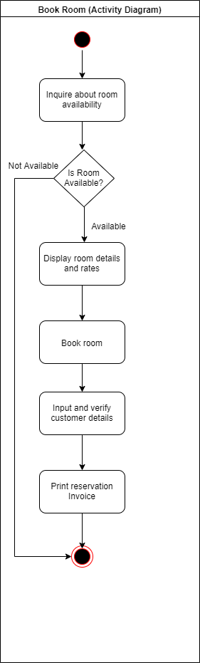
FIG 3.5: BOWEN GUEST HOUSE RESERVATION SYSTEM ACTIVITY DIAGRAM

3.7.4 SYSTEM ARCHITECTURE

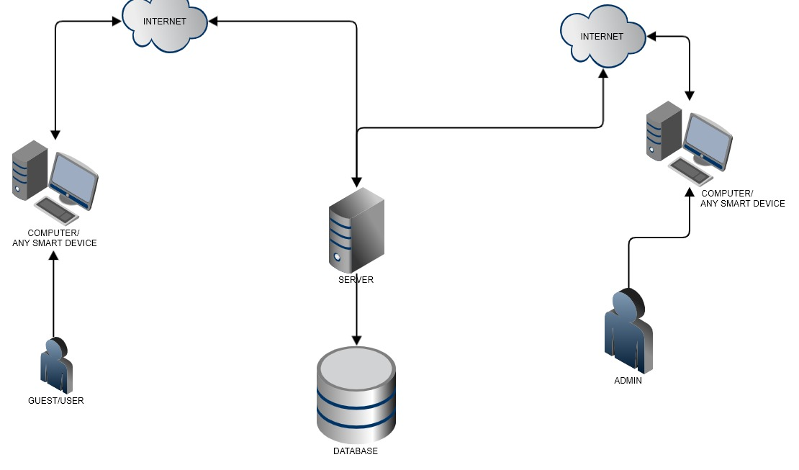
FIG 3.6: SYSTEM ARCHITECTURE DIAGRAM

3.7.5 USE CASE

RESERVATION SYSTEM
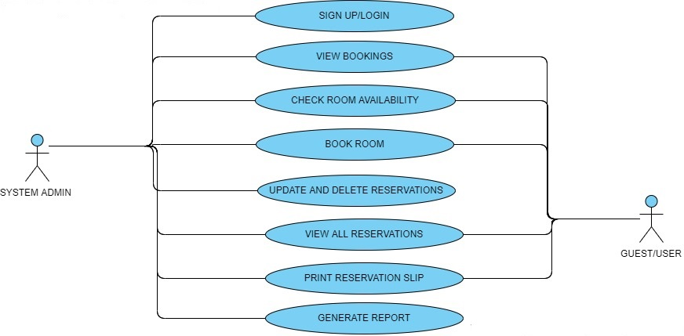
FIG 3.7 USE CASE DIAGRAM

REFERENCES
Adams, D.A., Nelson, R.R. & Todd, P.A. (1992). Perceived Usefulness, Ease of Use, and Usage of Information. MIS Quarterly, 16(2), 227-250
Adams, J. Stacy (1965), “Inequity in Social Exchange,” in Advances in Experimental Social Psychology, Vol. 2, Leonard Berkowitzed. New York: Academic Press, 267-99
Agarwal, R., Sambamurthy, V. & Stair, R.M. (2000). The Evolving Relationship Between General and Specific Computer Self-Efficacy – An Empirical Assessment Information Systems Research, 1(4), 418-430
Ajzen, I. (1985). From intentions to actions: A theory of planned behavior (pp.11-39).Heidelberg, Germany: Springer
Ajzen, I. (1991). The theory of planned behavior. Organizational Behavior and Human Decision Processes, 50, pp179-211. DOI:10.1016/0749-5978(91)90020-T
Ajzen, I., & Fishbein, M. (1980). Understanding attitudes and predicting social behavior. Englewood Cliffs, NJ: Prentice-Hall.
Amy K., Ruth N. Bolton, and Janet Wagner (1999), “A Model of Customer Satisfaction with Service Encounters Involving Failure and Recovery,” Journal of Marketing Research, 36 (August), 356-72
Anderson, W. E. & Sullivan, W. M. (1993) The Antecedents and Consequences of Customer Satisfaction for Firms. Marketing Science,12(2), pp.125-143.

Andreassen, Tor Wallin and Line Lervik (1999), “Perceived Relative Attractiveness Today and Tomorrow as Predictors of Future Repurchase Intention,” Journal of Service Research, 2 (November), 164- 72.
Bagozzi, Richard P. (1975), “Marketing as Exchange,” Journal of Marketing, 39 (October), 32-39. (1994), “Structural Equation Models in Marketing Research: Basic Principles,” in Principles of Marketing Research
Bolton, Ruth N. and Katherine N. Lemon (1999), “A Dynamic Model of Customers’ Usage of Services: Usage as an Antecedent and Consequence of Satisfaction,” Journal of Marketing Research, 36 (May), 171-86.
Bojnec, S., Z. Kribel (2004) Information and communication technology in tourism. In Intellectual Capital and Knowledge Management. Proceedings of the 5th International Conference of the Faculty of Management Koper, University of Primorska, 18–20 November 2004, Portoroz, Slovenia, pp.445-454, URL: http://www2.fmkp.
si/zalozba/ISBN/961-6486-71-3/445-454.pdf
Bray, J.P. (2008). Consumer behavior theory: Approaches and models (unpublished discussion paper). Bournemouth University: Bournemouth, England.
Buhalis, D., and M.C. Licata, M. C. (2002) The future eTourism intermediaries. Tourism Management, 23(3): 207-220.
Buick, I. (2003). Information technology in small Scottish hotels: Is it working. International Journal of Contemporary Hospitality Management, 15(4), 243-247. DOI:10.1108/09596110310475711
Camp, W. G. (2001). Formulating and Evaluating Theoretical Frameworks for Career
and Technical Education Research. Journal of Vocational Educational Research, 26 (1),
27-39
Camp, W. G. (2001). Formulating and Evaluating Theoretical Frameworks for Career
and Technical Education Research. Journal of Vocational Educational Research, 26 (1),
27-39
Camp, W. G. (2001). Formulating and Evaluating Theoretical Frameworks for Career
and Technical Education Research. Journal of Vocational Educational Research, 26 (1),
27-39
Camp, W. G. (2001). Formulating and Evaluating Theoretical Frameworks for Career and Technical Education Research. Journal of Vocational Educational Research, 26 (1), 27-39.
Connolly, D., & Olsen, M. (2000). Hospitality IT: What does the future hold? FIU Hospitality Review, 18(2), 22-36.
Davis, F.D. (1986). A technology acceptance model for empirically testing new end-user information systems: Theory and results (unpublished doctoral dissertation). Massachusetts Institute of Technology: Cambridge, MA.
Davis, F.D. (1989). Perceived usefulness, perceived ease of use, and user acceptance of information technology. MIS Quarterly, 319-340.
Davis, F.D., Bagozzi, R.P., & Warshaw, P.R. (1989). User acceptance of computer technology: A comparison of two theoretical models. Management of Science, 35(8), 982-1003. DOI:10.1287/mnsc.35.8.982
Engel, J.F., Blackwell, R.D. and Miniard, P.W. (2001). Consumer Behavior. International Edition.9th edition. Dryden Press
Eugene W. Anderson, Mary W. Sullivan. (1993). The Antecedent and Consequence of Customer satisfaction for firms, 12(2), 125-212. https://doi.org/10.1287/mksc.12.2.125

Evans, K.R., Christiansen, T., & Gill, J.D. (1996). The impact of social influence and role expectations on shopping center patronage intentions. Journal of Academy of Marketing Science, 24(3), 208-218.
Finley, P. N. (1994). Introducing decision support systems. Oxford, UK Cambridge, Mass., NCC Blackwell; Blackwell Publishers.
Fishbein, M., & Ajzen, I. (1975). Belief, attitudes, intention, and behavior. An introduction to theory and research. Boston, MA: Addison-Wesley.
Fishburn, P.C. (1970). Utility theory for decision making (No. RAC-R-105). Mclean, VA: Research Analysis Corp.
Folkes, V.S. (1984). Consumer reactions to product failure: An attributional approach. Journal of Consumer Research, 10, 398-409. DOI:10.1086/208978
Folkes, V.S., Koletsky, S., & Graham, J. (1987). A field study of causal inferences and consumer reaction: The view from the airport. Journal of Consumer Research, 13, 534-539. DOI:10.1086/209086
Fornell, Michael D. Johnson, Eugene W. Anderson, Jaesung Cha, and Barbara Everitt Bryant (1996), “The American Customer Satisfaction Index: Nature, Purpose and Findings,” Journal of Marketing, 60 (October), 7-18.
Gefen, D. (2000). Structural Equation Modeling and Regression: Guidelines for Research Practice. CAIS, 4(7)
Giedrius Silys. (2017). Information System for Accommodation Service Searching and Management
https://www.theseus.fi/bitstream/handle/10024/128361/Information%20System%20for%20accommodation%20service%20searching%20and%20management.pdf?sequence=1 [Accessed 28 December 2019]
Heide, Jan B., and A. S. Miner (1992), “The Shadow of the Future: Effects of Anticipated Interaction and Frequency of Contact on Buyer-Seller Cooperation,” Academy of Management Journal, 35 (2), 265-91.
Homans, George C. (1961), Social Behavior: Its Elementary Forms. New York: Harcourt, Brace & World.
Howard, John A. (1977), Consumer Behavior: Application of Theory. New York: McGraw-Hill.
Huppertz J. W., S. J. Arenson, and R. H. Evans (1978), “An Application of Equity Theory to Buyer-Seller Exchange Situations,” Journal of Marketing Research, 15 (May), 250-60.
Huppertz J. W., S. J. Arenson, and R. H. Evans (1978), “An Application of Equity Theory toBuyer-Seller Exchange Situations,” Journal of Marketing Research, 15 (May), 250-60.
Hyde, K. F., & Lawson, R. (2003). The nature of independent travel. Journal of Travel Research, 42(1), 13-23.
Johnson, Eugene W. Anderson, and Claes Fornell (1995), “Rational and Adaptive Performance Expectations in a Customer Satisfaction Framework,” Journal of Consumer Research, 21 (March), 128-40
Johnson, Michael D. (1998), Customer Orientation and Market Action. Upper Saddle River, NJ: Prentice-Hall.
Kantar, (1997). Managing with information. 4th edition
Kim, W.G., & Kim, D.J. (2004). Factors affecting online hotel reservation intention between online and non-online customers. International Journal of Hospitality Management, 23(4), 381-395. DOI:10.1016/j.ijhm.2004.02.001
Kim, W.G., Ma, X., & Kim, D.J. (2006). Determinants of Chinese hotel customers’ satisfaction and purchase intentions. Tourism Management, 27(5), 890-900. DOI:10.1016/j.tourman.2005.05.010
Kopalle, K. P. & Lehmann, R. D. (2001) Strategic Management of Expectations: The Role of Disconfirmation Sensitivity and Perfectionism. Journal of Marketing Research, 38(3), pp. 386-394.
Law, R., & Jogaratnam, G. (2005). A study of hotel information technology applications. International Journal of Contemporary Hospitality Management, 17(2), 170-180. DOI:10.1108/09596110510582369
Lederer, A.L., Maupin, D.J., Sena, M.P. & Zhuang, Y. (2000). The Technology Acceptance Model and the World Wide Web. Decision Support Systems, 29(3), 269-292.
Lohrke, F. T., G. McClure Franklin, C. Frownfelter-Lohrke (2006) The Internet as an information conduit: A transaction cost analysis model of US SME Internet use. International Small Business Journal 24(2), pp. 159–178
Mathieson, K. (1991). Predicting user intentions: Comparing the technology acceptance model with the theory of planned behavior. Information Systems Research, 2(3), 173-191. DOI:10.1287/isre.2.3.173 McGraw- Hill.
Merril Wells (2002) “Introductory Microsoft Access 2002”
Moutinho, L. (1987). Consumer behavior in tourism. European Journal of Marketing, 21(10), 5-44.
Njite, D., & Parsa, H.G. (2005). Structural equation modeling of factors that influence consumer internet purchase intentions of service. Journal of Service Research, 5(1), 43-59.
O’Connor, P., A. J. Frew (2002) The future of hotel electronic distribution: expert and industry perspectives. The Cornell Hotel and Restaurant Administration Quarterly 43(3), pp. 33-45
O’Connor, P. (2003). Online pricing: An analysis of hotel-company practices. Cornell Hotel and Restaurant Administration Quarterly, 44(1), 88-96.
O’Connor, P., & Murphy, J. (2004). Research on information technology in the hospitality industry. International Journal of Hospitality Management, 23(5), 473-484. DOI:10.1016/j.ijhm.2004.10.002
Oliver and J.E. Swan (1989b), “Equity and Disconfirmation Perceptions as Influences on Merchant and Product Satisfaction,” Journal of Consumer Research, 16 (December), 372-83.
Oliver and J. E. Swan (1989a), “Consumer Perceptions of Interpersonal Equity and Satisfaction in Transactions: A Field Survey Approach,” Journal of Marketing, 53 (April), 21-35.
Oliver and Oliver (1989b), “Equity and Disconfirmation Perceptions as Influences on Merchant and Product Satisfaction,” Journal of Consumer Research, 16 (December), 372-83.
Oliver and Wayne DeSarbo (1988), “Response Determinants in Satisfaction Judgments,” Journal of Consumer Research, 14 (March), 495-507.
Oliver, L. R. (1997). Satisfaction a behavioral perspective on the consumer, The McGraw-Hill Companies, Inc. New York
Oliver, R. L. (1980) A Cognitive Model of the Antecedents and Consequences of Satisfaction Decisions. Journal of Marketing Research, 17 (4), pp.460-69.
Oliver, R.L., & DeSarbo, W.S. (1988). Response determinants in satisfaction judgments. Journal of Consumer Research, 14, 495-507. DOI:10.1086/209131
Oliver, Richard L. (1997), Satisfaction: A Behavioral Perspective on the Consumer. New York:
Oliverira, T., & Martins, M.F. (2011). Literature review of information technology adoption models at the firm level. The Electronic Journal Information Systems Evaluation, 14(1),110-121.
Petty, R.E., Unnava, R.H., & Strathman, A.J. (Eds.). (1991). Theories of Attitude Change. Englewood Cliffs, NJ: Prentice-Hall.
Peshkin, A. (1993). The Goodness of Qualitative Research. Educational Researcher, 22(2), 23-29
Poon, A. (1993) Tourism, Technology, and Competitive Strategies. Oxford: CAB International.
Rochester, Jack B. (1996). "Tools for Knowledge Workers” Using Computers in Information. Indianapolis, IN Que Education and Training.
Rogers, E. (1995). Diffusion of innovations. New York, NY: Free Press.
S. Sutton, (2001). International Encyclopedia of the Social & Behavioral Sciences, pp 6499-6506. https://doi.org/10.1016/B0-08-043076-7/03872-9
S. Barjtya, A. Sharma, & U. Rani. (2017). A detailed study of Software Development Life Cycle ( SDLC ) Models: International Journal Of Engineering And Computer Science ISSN, 6(7), 22097-22100
DOI: 10.18535/ijecs/v6i7.32
Sarngadharan M. & Minimol M. C. 2010. Management information system. Delhi: Himalaya publishing house.
Sheldon, P. (1997) Information Technologies for Tourism. Oxford: CABInternational.
Shim, S., & Drake, M.F. (1990). Consumer intention to utilize electronic shopping. Journal of Direct Marketing, 4(3), 22-33. DOI:10.1002/dir.4000040305
Shim, S., Eastlick, M.A., Sherry, L.L., & Warrington, L.P. (2001). An online prepurchase intentions model: The role of intention to search. Journal of Retailing, 77(3), 397-416. DOI:10.1016/S0022-4359(01)00051-3
Siguaw, J. A., & Enz, C. A. (1999). Best practices in information technology. Cornell Hotel and Restaurant Administration Quarterly, 40(5), 58-71.
Simon, H. (1997). Administrative behavior: A study of decision-making processes in administrative organizations (4th ed.). New York, NY: The Free Press.
Sion, B., Mihalcescu, C., & Marginean, A. (2013). The passage from airline reservation systems to the global distribution system.
Sparks, B.A., & Browning, V. (2011). The impact of online reviews on hotel booking intentions and perception of trust. Tourism Management, 32, 1310-1323. DOI:10.1016/j.tourman.2010.12.011
Stair, Ralph M. (1996). Principles of Information Systems and Managerial Approach, 2nd ed. Cincinnati, OH: Boyd & Fraser.
Tax, Stephen S., Stephen W. Brown, and Murali Chandrashekaran (1998), “Customer Evaluations of Service Complaint Experiences: Implications for Relationship Marketing,” Journal of Marketing, 62 (April), 60-77
Teo, T. S. H., Y. Pian (2003) A contingency perspective on Internet adoption and competitive advantage. European Journal of Information Systems 12(2), pp. 78–92
Taylor, S. & Todd, P. (1995a). Understanding Information Technology Usage: A Test of Competing Models. Information Systems Research, 6(2), 144-173
Taylor, S. & Todd, P. (1995b). “Assessing IT Usage: the Role of Prior Experience. MIS Quarterly, 19(4), 561-570
Tesone, D. V. 2005 Hospitality information systems and e-commerce. New York: John Wiley & Sons
Tornatzky, L.G., & Fleischer, M. (1990). The process of technological innovation.Lexington, MA: DC Health.
Venkatesh, V. & Davis, F.D. (2000). A Theoretical Extension of the Technology Acceptance Model: Four Longitudinal Field Studies. Management Science, 46(2), 186-204.
Venkatesh, V., Morris, M.G., Davis, G.B., & Davis, F.D. (2003). User acceptance of information technology: Toward a unified view. MIS Quarterly, 27(3), 425-478.
Weiner, B. (1985). Spontaneous causal thinking. Psychological Bulletin, 97(1), 74-84.doi:10.1037/0033-2909.97.1.74
Wen, I. (2009). Factors affecting the online travel buying decision: A review. International Journal of Contemporary Hospitality Management, 21(6), 752-765. DOI:10.1108/09596110910975990
Zinkhan, G.M. (1992). Human nature and models of consumer decision making. Journal of Advertising, 21(4), II-III.

Internet
Taie, P.T. (2013) 10 advantages of PHP over other languages. Available at: http://www.webnethosting.net/10-advantages-of-php-over-other-languages/ (Accessed: 7 October 2019).

