
A Technical Report on
Student Industrial Work Experience Scheme (SIWES)
At
OFFICE MACHINES NIGERIAN LIMITED
(OMNL)

BY
Name: JOSHUA BLUE-JACK
Matric No: SSE/016/16103
Dept.: COMPUTER SCIENCE AND INFORMATION TECHNOLOGY
Faculty: SCIENCE AND SCIENCE EDUCATION
Level: 400

SUBMITTED TO:

SIWES CORDINATOR

BOWEN UNIVERSITY IWO, OSUN.
IN PARTIAL FULFILMENT FOR THE AWARD OF BACHELOR OF SCIENCE (B.SC) DEGREE IN COMPUTER SCIENCE AND INFORMATION TECHNOLOGY

Date: OCTOBER

DEDICATION
I dedicate this work to God Almighty for the grace given for successful completion of this Student Industrial Work Experience Scheme (SIWES) Training Programme efficiently, and for the good health He granted me throughout the period. I also dedicate this work to everyone who played a vital role to the successful completion of my programme.

ACKNOWLEDGEMENT
I remain forever indebted to special persons, without whose hospitality, love and support I would not have been granted the opportunity to undergo a training programme in a company such as Office Machines Nigerian Limited (OMNL).
I thank God Almighty for giving me the opportunity of doing my IT/SIWES at OMNL and the grace to finish successfully in one piece.
Special thanks goes to my Industrial Training based supervisors, Mr. Emeka Megwa and Mrs.Iveren Igbudu and the entire staff of Office Machines Nigerian Limited.
I also thank Industrial Training Fund (ITF) for the initiative taken to include this programme in place for undergraduates and my untold gratitude goes to Bowen University, Iwo for its role in making sure that her students participate in this opportunity to be exposed to work ethics and apply knowledge impacted in real life situations. To the wonderful Professors, Doctors, Lecturers and staff in the Department of Computer Science and Information Technology your effort will never go unrewarded for your resilience to impacting us aspiring Computer Scientists and preparing us adequately for the challenges that come with it.
To my family, I say a big thank you for all the love and financial support throughout this period. God Bless you.

ABSTRACT
The introduction of Students’ Industrial Work Experience Scheme (SIWES) into the normal schools’ curriculum has opened up an avenue for students to acquire a lot of experience, skills, information and knowledge during the period of attachment to the company/ industry in order to supplement the theoretical background of their chosen course of study and also to prepare them for the challenges the future holds and help them thrive when those challenges arise. This report presents the work done, knowledge and skills gained within the six (6) months SIWES training which I took at Office Machines Nigerian Limited, Abuja. My training was on the web design and development using Visual Studio Code, Hyper Text Markup Language (HTML), Cascaded Style Sheet (CSS), Bootstrap and JavaScript. I acquired practical knowledge on how to build a functional front end website from scratch to finish, applying some java script functions to it too. I was involved in the development of a Customer Handling System (CHS) for the Nigerian Electricity Regulatory Commission (NERC) in which I acquired practical knowledge on the stages involved in development of applications, the processes involved in conveying the user requests to the developer and the best practice in managing clients from the development stage to the deployment stage of an application. I also gained practical knowledge in Project Management and the several tools used to aid effective project management in an organization, Usability Security and work ethics in an office setting.

TABLE OF CONTENTS
COVER PAGE………………………………………………………………...………………i
TITLE PAGE………………………………………………………………...…………...…...i
DEDICATION…...…………………………………………………………………………...ii
ACKNOWLEDGEMEN……………………………………………………………………..iii
ABSTRACT…………………………………………………………………………….…….iv

CHAPTER ONE
  - INTRODUCTION…………………………………………………………………….1
  - OBECTIVES OF SIWES……………………………………………………………...1
  - BODIES INVOLVED IN MANAGEMENT OF SIWES……………………………..2
  - CONCLUSION………………………………………………………………………..2

CHAPTER TWO
BACKGROUND OF THE ORGANIZATION
2.1 INTRODUCTION
2.1.1 OFFICE MACHINES NIGERIAN LIMITED..………………………….3
2.1.2 LOCATION OF THE ORGANIZATION………………………………..4
2.1.3 CORE PROGRAMS AND OPERATION………………………………..4
2.1.4 AFFILIATION & PARTNERS…………………………………………...4
2.2 STRUCTURE OF THE ORGANIZATION………………………………………7
2.2.1 ORGANOGRAM…………………………………………………………7
2.2.2 VARIOUS DEPARTMENTS ………………………………………….....8
2.2.3 ROLES ON THE ORGANOGRAM………………………………………8

CHAPTER THREE
PROCESS, COMPONENT AND DESCRIPTION
3.1 INTRODUCTION …………………………………………………………………..10
3.2 SIWES ACTIVITIES………………………………………………………………...11
3.2.1 CUSTOMER COMPLIANT HANDLING SYSTEMS……………………...13
3.2.2 DEPLOYEMENT OF EDUCATION TRAINING ADMINISTRATION PLATFORM ………………………………………………………………….25
3.2.3 CENTRAL CALL DATA RECORDS DEPLOYMENT……………………..30
3.3 CONCLUSION………………………………………………………………………..34

CHAPTER FOUR
WORKING EXPERIENCE
4.1 INTRODUCTION……………………………………………………………….35
4.1.1 INEFFICIENCES TACKLED AND PROFERRED SOLUTIONS……..35

CHAPTER FIVE
SUMMARY, CHALLENGES ENCOUNTERED, RECOMMENDATION AND CONCLUSION
5.1 SUMMARY………………………………………………………………………....36
5.2 RECOMMENDATION……………………………………………………………...36
5.3 CONCLUSION……………………………………………………………………….36

REFERENCES……………………………………………………………………………….37

CHAPTER ONE
INTRODUCTION
1.1: INTRODUCTION
The Student Industrial Work Experience Scheme (SIWES) was created to bridge the gap between theory and practical knowledge among the students in institutions of higher learning in Nigeria. It was first initiated and founded by Industrial Training Fund (ITF) during its formative year (1973/1974).
Based on the increasing number of students, organizational logistics and increased financial burden, administering of this function became more immense hence the fund withdrew from the scheme in 1979. Between 1978 and 1983, the scheme was run by National Universities Commission (NUC) and National Board for Technical Education (NBTE) but was later refunded to Industrial Training Fund (ITF) in 1984 by the Federal Government.
The scheme is a skill acquiring programme designed to expose and prepare students of institutions of higher learning for the industrial work situation they are likely to meet after graduation. The skill also gives students the opportunity to familiarize themselves to the needed experience in handling equipment and machinery that are usually not always available in the institution.

1.2: OBJECTIVESOF SIWES
The objectives of ITF for SIWES as an instrument for industrialization and economic development are given as follows;
- It makes the transition from school to the world of work easy.
- It provides students with an opportunity to apply their knowledge in real work situation thereby bridging the gap between theory and practical knowledge,
- It serves as an industrial lesson office for guiding students in job placement opportunities.
- Grooms student on how to have good human relation with their co-workers, therefore tolerating and being patient with them.

1.3: BODIES INVOLVED IN THE MANAGEMENT OF SIWES.
- The bodies involved in the management of SIWES include;
- Industrial Training Fund (ITF)
- National Universities Commission (NUC)
- National Board for Technical Education (NBTE)

1.4: CONCLUSION.
In conclusion, the Student Industrial Work Experience Scheme (SIWES) is organized and coordinated by Industrial Training Found (ITF) in collaboration with the tertiary institution to improve student academics knowledge and to give students in tertiary institutions the opportunity of having proper practical experience in their various chosen course of study and to have working experience.

CHAPTER TWO
BACKGROUND OF COMPANY/ORGANIZATION
2.1 INTRODUCTION
2.1.1 OFFICE MACHINES NIGERIAN LIMITED
OMNL was incorporated on 15th day of January 2008 with registration number RC 725502. It has registered its stamp of class by executing various strategic projects across sectors such as Government, Oil & Gas, Energy, Manufacturing, Communication, Education and Healthcare. With a decade of staff professional experience in IT consultancy, procurement, research and audit we have created stakeholders satisfaction and excitement thereby helping customers innovate.
Office Machines Nigeria Limited (OMNL) is a leading Information Technology company and consultancy firm that provides innovative solutions to governments, companies and people in West Africa. Office Machines Nigerian Limited (OMNL) supports a range of software products and technologies including scalable open source operating systems, commercial software like Microsoft and Oracle. We have in-house expertise and partnerships to provide integration of best-of-breed technologies, enterprise architecture, and digital literacy through training, identity and asset management, service oriented architecture, e-government services, GIS application, business intelligence and facility management solutions.
OMNL is a Certified Information Value Chain Consulting and Capacity Building Firm specializing in Information Technology and Project Management. Our areas of focus are Information Security, Information Assurance, Project Management, e-business and Knowledge Capital Development. We focus on those often overlooked but distinguishing capabilities along the Information Value Chain that set apart excellent from mediocre performers and bring to bear our knowledge of global best practice within the context of our experience of the local operating environment. OMNL has accreditation to the ISO27001 (Global Information Security Management Standard). Office Machines Nigerian Limited (OMNL) operations spread across six countries and two continents. OMNL delivers an assortment of professional services in the areas of baseline research, data gathering, needs assessment, software asset management, business intelligence, business optimization, cloud and smart infrastructure, IT policy and standards, enterprise architecture, connected government framework, e-government solutions, data and information security. Its consultants bring international experience combined with knowledge of local environment to provide world-class services and solutions. With the advancement in technology, Office Machines Nigerian Limited consistently strive to reach greater heights through innovation, and creativity to ensure sustainable growth. OMNL maintains its regional headquarters in Nigeria and has operations in USA.

2.1.2 LOCATION OF THE ORGANIZATION
Office Machines Nigerian Limited is located at No. 8 Nairobi Street, Off Parakou Street, Wuse 2, Abuja.

    - CORE PROGRAMS AND OPERATION
- Consulting and Research Services.
With OMNL’s strong and experienced team, we have multi-industry capability in I.T. consultancy. Her experts leverage new technologies, to play significantly in business process design and automation of such using the state of the art technology in under listed services.
Activities include:
- IT Strategic Planning
- System Audit and IT Governance
- Enterprise Architecture
- Connected Government Framework
- Security Policy and Strategy
- Advisory Services
- Skills Assessment competence Development
- IT Policy and Strategy

- Software Licensing Acquisition and Advisory Services.
Services in this area cover the following:
- Software Assessment Management
- Technology and application bench mark
- Vendor selection and management
- EPA Models and Emergency Response
- E-Government Services.
- Birth and Death E-Registration
- E-Vacancy
- E-Directory
- E-Voting
- Electronic governance
- Digital Signature

- Business Process Management System.
They design and improve business process efficiency by automating it. As business become more complex and geographically dispersed, there is need to take advantage of the various functionalities offered by computing in streamlining processes, securing transactions, reducing overall operational cost, shortening service delivery times and providing greater visibility to business management.

- System Applications and Products.
Office Machines provides end-to-end services for all the overall project activities to ensure the delivery of value to clients. The activities include:
- Business Process optimization
- Solution design 7 technology selection
- Project Management
- System integration
- Data integrity services
- Change Management

- Asset Management Solution.
Office Machines management services for I.T system requires multi-skilled personnel or an organization to provide support services for a variety of installed equipment, software and infrastructure. We offer a specialized service to meet this need.

- Application Development.
Office Machines development methodology, development process, model, and life cycle is a framework used to structure, plan and control the process of developing bespoke information systems

- Skills Certification Courses.
- IT Proficiency and Digital Literacy Certification
- Accredited Masters System Engineer Certification
- Masters Systems Engineer Certification
- Microsoft Certified Systems Engineer (MCSE)
- Microsoft Certified Professional
- Cisco Certified Network Administrator
- IT Essentials
- Oracle Database Administrator
- Open Sources / Linux System Administrator
- SAP Implementation Consultant
- Certification

    - AFFILIATIONS AND PARTNERS
- DELL Computers.
- Hewlett-Packard Company (HP).
- CISCO Systems.
- Huawei Technologies Co. Limited.
- International Business Machines Corporation (IBM).
- Microsoft Corporation.
- Oracle Corporation.

  - STRUCTURE OF THE ORGANIZTION
2.2.1 ORGANOGRAM

FIG 2.1 ORGANOGRAM OF OFFICE MACHINES NIGERIAN LIMITED.

2.2.2 ROLES ON THE ORGANOGRAM

MANAGING DIRECTOR (MD): The MD oversees the overall performance and operations of the company, liaises with the Heads of various departments in the office on directives for the next step forward.

TECHNICAL LEAD: The Technical Lead is responsible for handling the technical aspects of current projects being handled. She liaises with the Technical Consultant and communicates with the office clients to capture their requests efficiently to be portrayed in the products or requests when delivering them to clients.

HEAD FINANCE/ACCOUNTS: The Head Finance/Accounts manages the office accounts, prepares repositions when necessary and ensures the payment of salaries.

BUSINESS DEVELOPMENT LEAD: The Business Development Lead is responsible for making promising business negotiations and developing strategies that will pave way for more profit for the company.

TECHNICAL CONSULTANT: The Technical Consultant works with the Technical Lead to provide the best technical strategies to enable the development of application and providing solutions to clients/user problems more efficient.

FINANCE CONSULTANT: The Finance Consultant liaises with the Head Finance and Accounts to give best advice on the company’s investments and plans efficient ways to manage the company’s money.

SALES/ MARKETING OFFICER: The Sales and Marketing Officer follows up on pending payments to be made to office accounts for the work done. Assists in preparing and submission of reports when necessary and does well to update the head of department including the MD

2.2.3 VARIOUS DEPARTMENTS

1. I.T and Projects Department
2. Finance and Accounting Department
3. Marketing Department

- I.T and Projects Department :
The I.T and Projects Department is responsible for the planning, development, support, management and follow-up of the company’s existing projects. They are also responsible for the assembling and testing of technological devices purchased, they work in teams in preparing reports for various projects. They help in assisting the members of staff with major or minor problems concerning the office facilities.

- Finance and Accounting Department:
The finance and accounting department focuses on the following up of payments for work done, securing of contracts, managing the office accounts, preparing of repositions when necessary and makes sure that all necessary office needs are met.

- Marketing Department:
The marketing department is solely responsible for biding of new contracts, preparation and submitting of documents necessary for bids and lastly, submission and follow-up of new business proposals

CHAPTER THREE
PROCESS, COMPONENTS AND DESCRIPTION
3.1 INTRODUCTION
For the duration of my internship programme, I was assigned to the IT and Projects Department within which I was primarily posted to the team handling the CUSTOMER COMPLIANT HANDLING SYSTEM for the Nigerian Electricity Regulatory Commission(NERC). I was then encouraged to spend time in advancing my web development skills as it would help supplement my basic understanding acquired from school even as I progress. This gave me the opportunity to spend adequate time practicing and taking tutorials on certified online platforms to gain knowledge, I was also exposed to best practices in handling the development of applications for organizations and the best ways to handle clients when developing these applications. The IT and Projects Department is involved with the application of science and management concepts in the optimal development, deployment and documentation of projects as pertains technology.
- The IT and Projects Department deals with the responsibility of building the software development teams and making sure that all client requirements are captured and implemented in the programs properly. This department is fully responsible for the technical and user training and support of clients as required. In a situation where there is need to source external skill-sets, the Service Lead in this department works tirelessly to find a persons with the required skills for the project at hand and is responsible for negotiating terms and conditions for their engagement on a particular project, making sure that both the client and development team are satisfied.
During the course of my internship, I was exposed to a variety of activities. In order to be as efficient and concise as possible, I will be characterizing my experiences based on the following classifications:
- WORKSTATION ACTIVITIES.
- CUSTOMER COMPLAINT HANDLING SYSTEM
- DEPLOYMENT OF EDUCATION TRAINING ADMINISTRATION (ETA) PLATFORM
- CENTRAL CALL DATA RECORD SYSTEM DEPLOYMENT

WORKSTATION ACTIVITIES: These are the activities and interactions which take place within the company. These involve HTML and CSS projects and some bootstrap projects, general meetings, conference calls, trainings which were conducted during the duration of my Internship. It consists mainly of the development, testing, review and costing of projects being handled within the office. Also, proper preparation of Service Level Agreements (SLA) and documentations of applications are all handled in-house.

ONSITE ACTIVITIES: These include official activities which took place outside the office building at the client locations like the Customer Complaint Handling System (CHS) application, Central Call Data Record Deployment and the Deployment of Education Training Administration (ETA) that was handled during the period of my attachment. They also include presentations to the Nigerian Electricity Regulatory Commission for the Customer Compliant Handling System (CHS), support services, outside office trainings when necessary and sign-off meetings with clients for work done. General meetings at Nigerian Communications Commissions (NCC) for the Central Call Data Records (CCDR), these activities took hours of planning and preparations to avoid expensive mistakes and to satisfy our clients. For the period of my attachment this took place in Nigerian Electricity Regulatory Commission.

3.2 SIWES ACTIVITIES

WORKSTATION ACTIVITIES

As stated previously, workstation activities are the activities and interactions which take place within the company. This involves general meetings, conference calls, trainings which were conducted during the duration of my Internship.

GENERAL MEETINGS

A meeting is usually held once a week every Monday morning. All staff in all departments of the company are in attendance and it is presided over by the Managing Director (MD). The aim is to give a report and accomplishments of the previous week from each staff and a list of activities and expected outcomes for the new week.
At the end of every work week, staff submit written reports to the MD for record purposes and necessary actions. All members of staff are expected to be in the General Meeting and reasons for absence must be communicated well ahead of time to the Head of Department.

CONFERENCE CALL

For the period of my attachment, I was involved in all conference calls made with the Software Development via Skype. The calls were mostly initiated by the Service Lead or the team working on a project being handled, on the progress made, errors encountered from either the clients’ side or during the course of review in-house. For projects presentation and training, Conference Calls (via Skype) were also used as a medium of communication.
TRAININGS

At various times, clients at different locations are invited to the OMNL offices for in-house training or workshops to help get them acquainted with the applications being developed. In some cases the IT team traveled to these different locations to conduct trainings for clients. During the training, clients get to interact with the development team and ask questions when a point was not clear to them. I gained knowledge and useful tips on how to engage the clients by giving them tasks to assess them when using the application and also assist them when they fail or get stuck. These trainings are usually headed by the Service Lead alongside some members of the Management staff.
The instructor lecturing a class of participants | A cross-section of participants in the training class
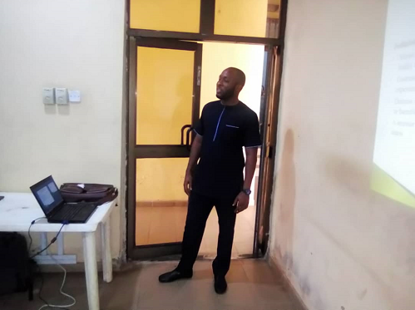 | 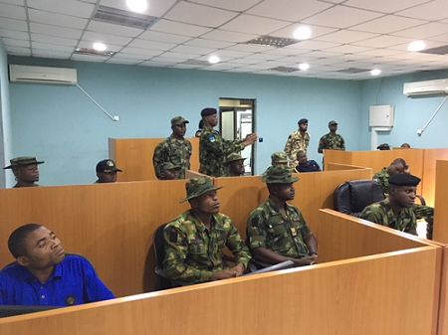
FIG 3.1 IMAGES FROM TRAINING EXERCISE
From left: Engr. Giwa, Mr. Chuks Onuoha, Staff SGT. Mustapha Ibrahim, Engr. Asaju (Director Special Duties). | The Director Special Duties watching a demonstration of the call handling process by a call agent.
 | 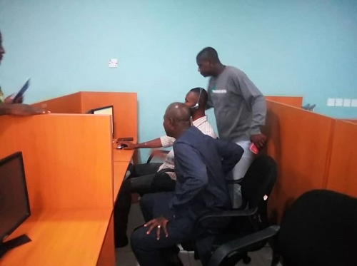
FIG 3.2 IMAGES FROM TRAINING EXERCISE
REVIEW AND TESTING

Testing is usually carried out periodically by the Service Lead and members of the IT team, to make sure that the application developed is functioning well and free of errors that breach the normal workflow of clients when using the application. These reviews are also done periodically, it is usually done when an error occurs in the process of using the application which is beyond client’s in-house troubleshooting capacity, or in the event that there is a new request made, a review will be carried out for costing and the feasibility of implementing such request will be carried out. I was involved in the application review and testing process of the Customer Compliant Handling System (CHS) for the Nigerian Electricity Regulatory Commission (NERC).

LECTURES AND PRESENTATIONS.
While in the company I received some lectures from my industry based supervisor on the best practices especially when dealing with clients. I was exposed to the various fields that are springing up rapidly and are taking over the Technology filed and had the opportunity also of asking questions on areas that did not seem clear prior to this internship period. Presentations on several occasions were made on tools that are important in an office environment.

Proceeding from here are projects handled during the period of my attachment

3.2.1 CUSTOMER COMPLIANT HANDLING SYSYTEM(CHS)
The application is a web based system for managing Electricity consumer complaints.
Description
The Customer Complaint Handling System (CHS) application is an online software application tool that enables the Nigerian Electricity Regulatory Commission (NERC) the electricity regulator to monitor the status of periodically submitted complaints by the Distribution Companies.
Its purpose is to augment the commission’s existing channels for lodging complaints. The system will provide customers with an easily accessible platform to lodge complaints. From an administrative perspective, the system will help the NERC and respective DisCos Customer Care Unit to capture complaint information provided by customers and facilitate the efficient resolution of complaints. It will also provide key stakeholders with relevant information and the ability to generate reports from the system’s accrued complaints data.

Specific Work Done
During the period of my attachment to Office Machines Nigeria Limited (OMNL), I was attached to the team handling the development of this application. I handled the designing of the new business process this application using flowchart and pictorial descriptions. I was also involved in all meetings, reviews, conference calls, testing and documentation of this application, of this in which I gained practical knowledge on the stages involved in development of applications.
This application was developed using the following:
Frameworks
ASP.NET MVC
ASP.NET
JavaScript Libraries and Functions
Html5shiv
Explorer Canvas
Modernizr
jQuery
Web Servers
IIS (IIS 10)
SQL Express
Document-Encoding
UTF-8
Document Standards
HTML5 DocType
X-UA-Compatible
JavaScript
Cascading Style Sheets
HTML5 Specific Tags
Cross Origin Resource Sharing (CORS)
Google Chrome IE Frame

CHS Illustration Diagram

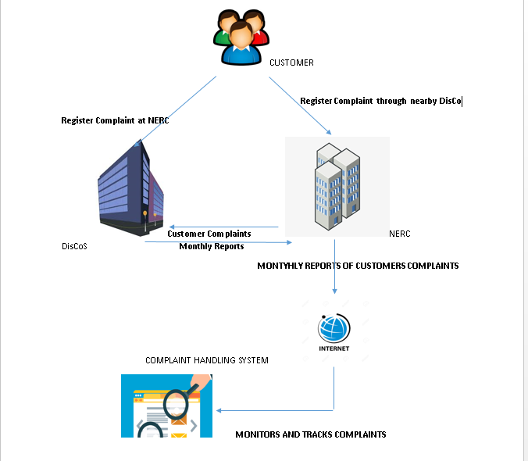

FIG 3.3 CHS ILLUSTRATION DIAGRAM.

CHS FLOW CHART DIGRAM
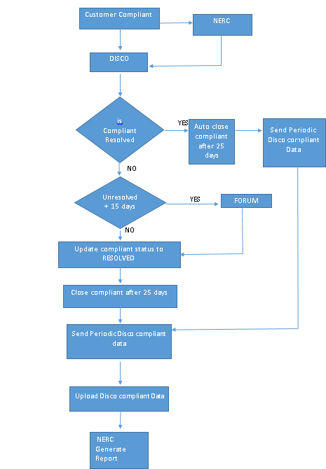

FIG 3.4 CHS FLOWCHART

The application has been custom developed to facilitate the following processes and functionalities:
- Complaints Data Entry
- Complaint Approval Workflow
- Complaint Status Tracking
- Complaint Report Generation
- Importation of Complaints Data from External Files

Software Benefits

Key functionalities
The solution have the following functionalities required to support effective Complaints Handling Service Delivery as already defined in the functional requirement document.
- Complaints Data Entry.
- Complaints Status tracking.
- Complaints Report Generation.
- Automatic Duplicate Checks for New Records.
- Importation of Complaints from external Files.
- Management of User Accounts.

Key Business Benefits
The software benefits include the following:
- Reduction of administrative costs and greater efficiency, achieved by automating and optimizing complaints handling processes.
- Comprehensive complaints handling management and decision-making support
- Increased productivity through support for enhanced collaborative relationships and networking amongst customers, DISCOs and NERC
- Simplified IT infrastructure and low cost of ownership, effected through integrated complaints handling functions delivered via an open platform.
- Seamless, accurate complaints reporting , including basic but critical data
3.2.2.1 ACCESSING THE APPLICATION
The NERC customer complaint handling system web application can be easily accessed from a web browser.
Any modern web browser should be suitable for this purpose. However, the application has only been tested on the following browsers:
- Google Chrome
- Internet Explorer 11
- Microsoft Edge
- Firefox
- Opera
After the application’s URL has been entered into the address bar of the web browsers, it then directs you to the home page of the application.
The current URL to access the application is http://complaints.nerc.gov.ng
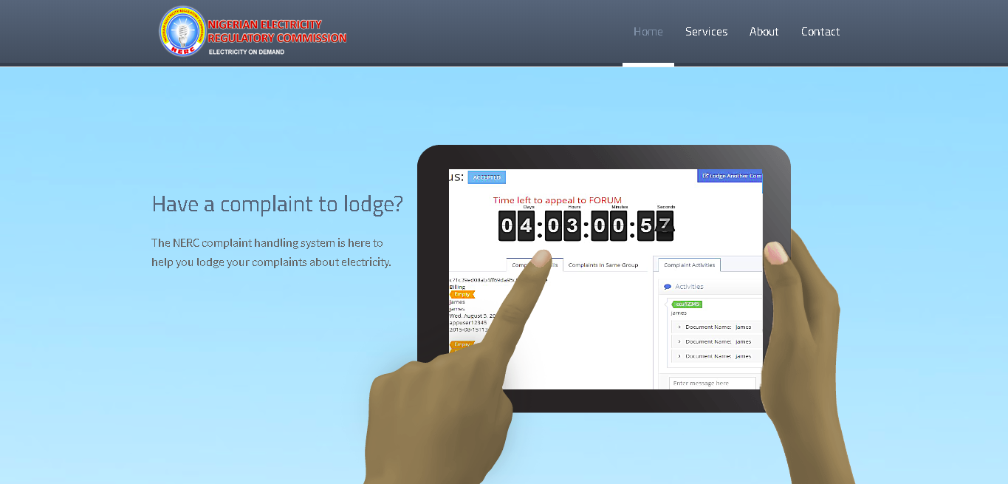
FIG 3.5 HOMEPAGE OF THE CHS APPLICATION.
Proceeding from here are few of many actions that can be carried out on this application
3.2.2.2 How to Log In
To log into the application, the user (CCU officer or NERC staff) must be provided with an existing username and password in the system. The CHS application to not open to customers to create accounts.
To Log In, from the home page
- Click the About item menu on the navbar
- Scroll down to see the Sign Up or Login In option below
- Click on Login
- The User will then be directed to a login page, Fill in log in details as prompted.

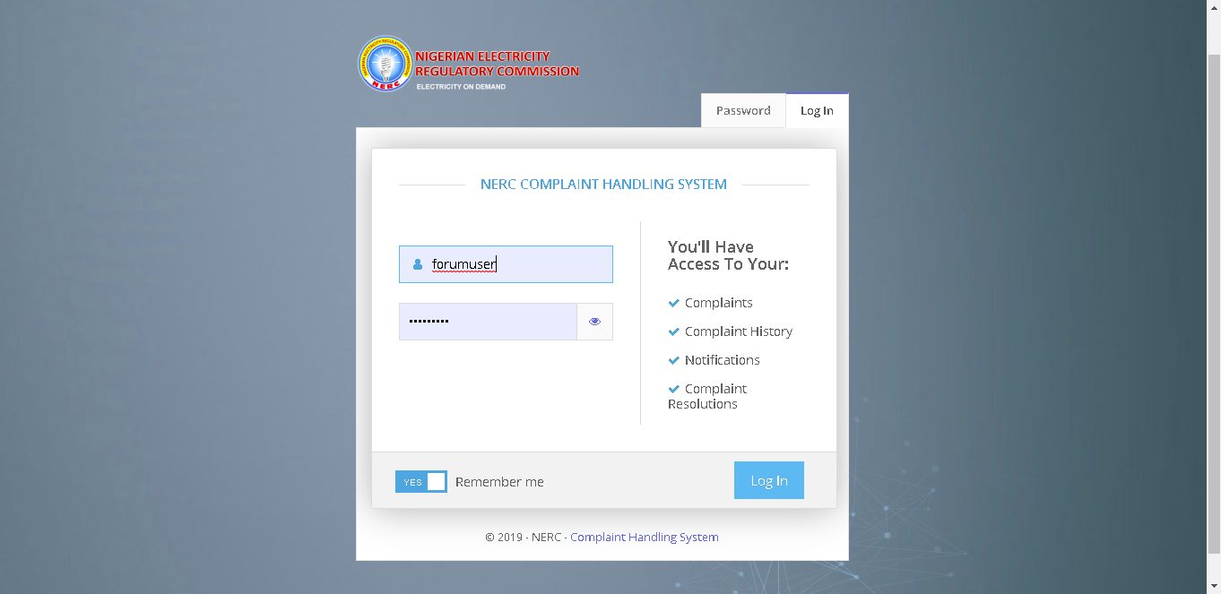
FIG 3.7 LOGIN PAGE
3.2.2.3 Understanding the Application Interface
Upon logging into the application the user is presented with the application’s dashboard page view. It is from the dashboard page that the user (i.e. CCU officer) would be able to make use of the complaint handling system’s various features and functionalities. The application interface is comprised of the following sections, which have been highlighted in the figure below:
- Application Menu
- User Description Bar
- User Menu/Top Bar
- Notifications Pane/Top Bar
- Page Title
- Page Content.
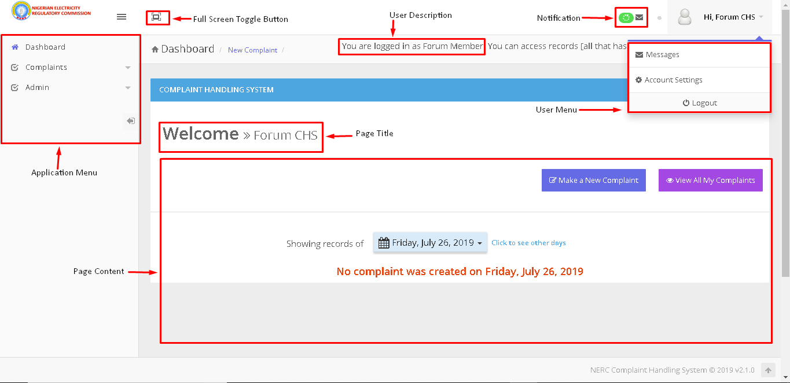
FIG 3.7 APPLICATION INTERFACE
3.2.2.4 Creating a complaint
To create a new complaint, a user will need to select the complaint module on the application’s side bar menu and then click on the CREATE COMPLAINT sub-menu. After which the user will be forwarded to the Create Complaint page.
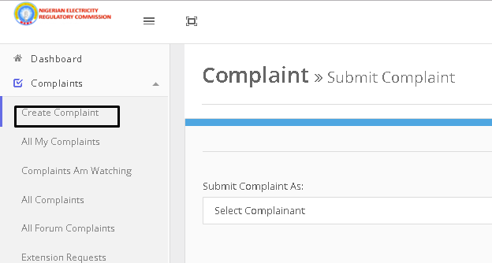
FIG 3.8 HOW TO CREATE A COMPLAINT

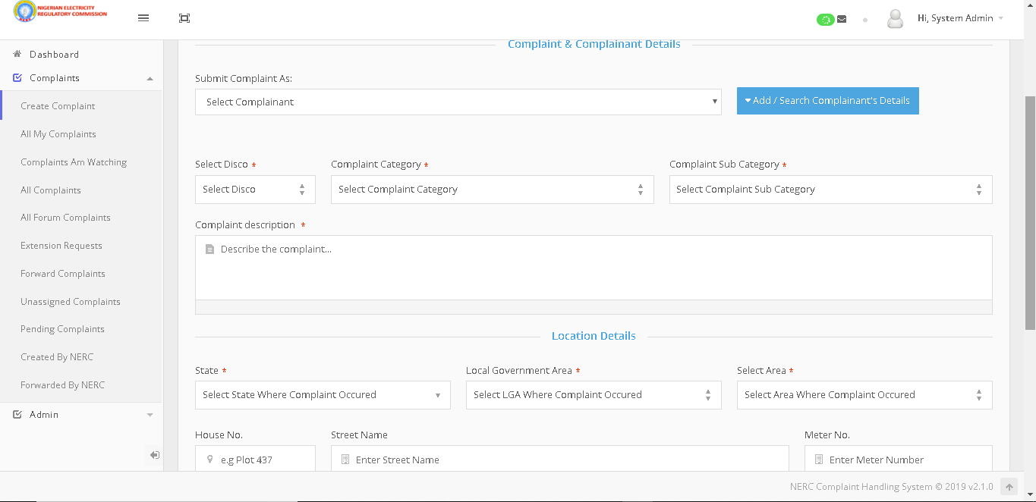
FIG 3.9 COMPLAINT FORM OUTLOOK ON THE CHS
3.2.2.5 To Submit a Complaint
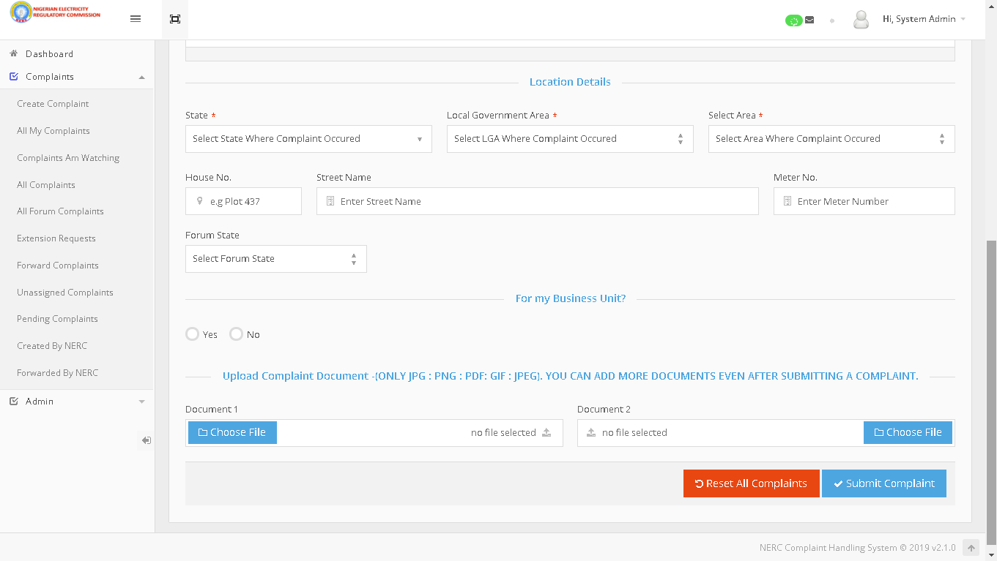
FIG 3.10 SUBMIT A COMPLAINT OUTLOOK ON THE CHS

- Enter the necessary complaint details into the corresponding form fields
- Upon completing the create complaint form, click on the Submit Complaint button that can be found at the bottom of the page
3.2.2.6 Generating and Analyzing Reports
To generate reports, a privileged user will need to select the Admin module on the application side bar menu and then click on the Admin: Reports sub-menu item. There are currently 13 different data report types on the system, with the capacity to add even more.
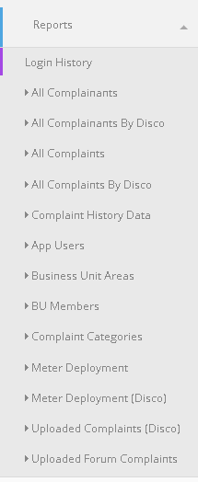 | - All Complainants  - All Complainants by Disco  - All Complaints  - All Complaints By Disco  - Complaint History Data  - App Users  - Business Unit Areas  - BU Members  - Complaint Categories  - Meter Deployment  - Meter Deployment (Disco)  - Uploaded Complaints (Disco)  - Upload Forum Complaints
FIG 3.11 DATA REPORT TYPES

To Generate a Data Report:
- Select the applicable data report menu item from the Admin: Reports module of the application’s side bar menu.
- The user will be presented with the selected report page, as seen in the figure below
- Select the desired time fame range using the data picker drop-down widget that can be found directly above the report viewer
- Select the desired data filter option using the filter buttons that can be found on the right-hand side of the report page
- To download or save the generated report as a PDF, Excel or Word document: click the Save icon that can be found at the top of the report viewer and select the desired format from the options presented.

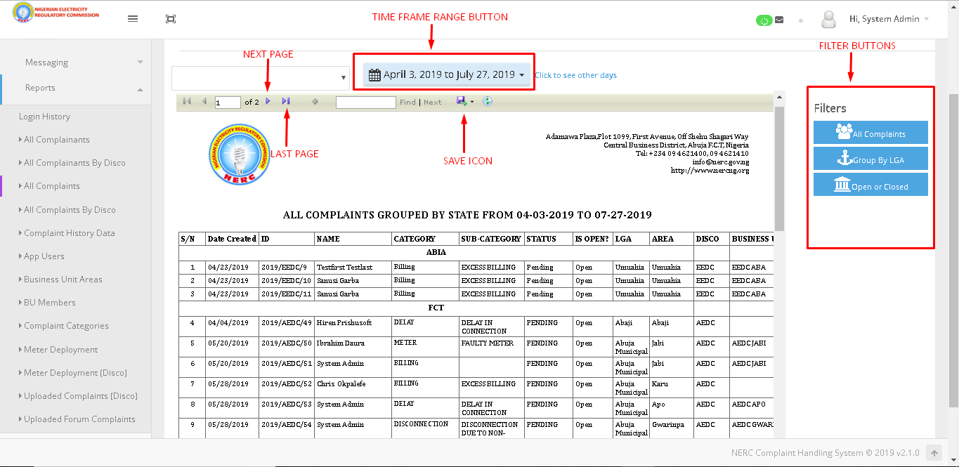
FIG 3.12 GENERATE REPORTS ON CHS APPLICATION

To Analyze Reports:
At the last page of every report, there is a pictorial depiction of report generated using a Bar chart and a Pie chart. To view this click on the last page button at the top of the report
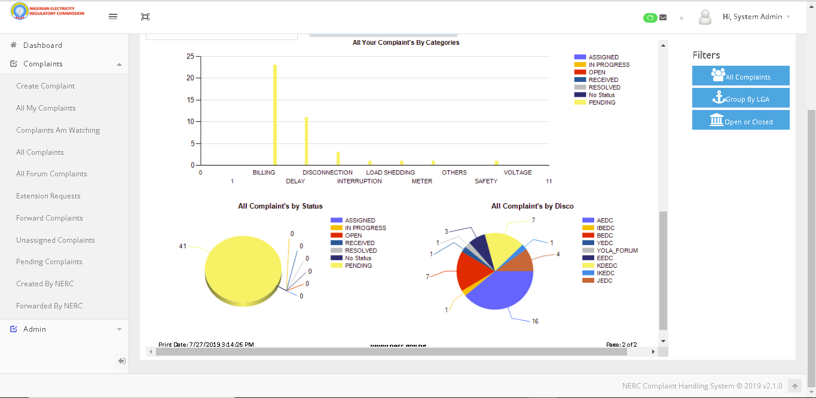
FIG 3.13 PICTORIAL REPRESENTATION OF A REPORT USING BARCHART AND PIE CHART.

3.2.2 DEPLOYMENT OF EDUCATION TRAINING ADMINISTRATION PLATFORM (ETA)
The deployment of Education and Training Administration (ETA) application at the Nigerian College of Aviation Technology Flying School (NCAT) in Zaria. There are several stages in the full deployment of the automation process. At the time of completing my training at the office, the activities were still going on. I was part of a four-person team handling the curriculum setup and system configuration. I was directly involved in setting up the curriculum line items, setting course pre-requisites and assigning course minimums to each of the courses offered (flight, ground and simulation training). During this process, there were several online training sessions with OMNL team, OMNL partners in the US and the NCAT team.

The ETA platform has the following features and much more:

Course Management
- Courses have subsets of Stages, Phases, Units, and Line Items (objectives)
  - Can assign Objectives and Completion Standards to all course components
  - Multiple syllabus rules can be associated with each course component
- Tracks students completion of Line Item training objectives
- Incomplete Line Items are automatically listed on next lesson grade sheet and tracked to satisfactory completion
- Prerequisite flow ensures correct training lesson sequencing
  - Management authorization required to perform training activities not in accordance with user defined syllabus design
- Assign unit durations, required resources, resource configurations, and instructor currencies and qualifications
- User defined grading standards (relative or absolute grading standards)
- Set line items (training objectives) as Required, Optional or Must Pass
- Set rules for authorized repeats for complete or incomplete training activities
- Tightly integrated with scheduling functions

Student Records
- Comprehensive training records of students in current and past courses
- Individual lesson grade sheets
- Record student test grades
- Track student currencies and qualifications including endorsements
- Real time student data
- Know whether a student is ahead or behind of training plan
- Project check ride dates and course completion date
- Determine up to the minute cost of completed training and projected costs through course completion
- View training information such as last activity, current activity and next activity
- Individual and customizable student training plans
- Track course minimums (dual, solo, night, cross-country) requirements in real time
- Automated audits of training records – completion of lessons, hours, training objectives

Instructor Performance
- Track instructor currencies and monitor expiration dates
- Track instructor qualifications
- View instructor pass rates for student check rides
- Warning and tracking of instructor flight hour violations
- Monitor individual instructor workload
- Automatically generates payroll entries for hourly instructors
- Management alerts for training activities that do not conform to syllabus
- Who, what and when audit trail for elements of every training activity (schedule, authorize, ramp out, ramp in and activity completion)

Instructor Performance.
- Track all training resources (Aircraft, Simulators, Buildings, Computers, Rooms, Vehicles, and Office Equipment.)
- Configuration of all entered resources
- Aircraft details include: Serial #, N #, Class, Complex, Capacity, Hobbs, Tach, Parking Spot, Turn Around Time
- Assign configurations of visual system, motion system, and avionics capabilities to flight simulators
- Assign unique configurations and/or capabilities to specific aircraft and tie to unique training requirements on individual training lessons
- Check status and availability of any training resource
- Track and manage resource utilization
- Interface with Talon maintenance system (RMS) to determine resource maintenance status and time or days remaining to next maintenance events
- Provides warnings or stops at operations dispatch for aircraft that are due maintenance events.

Scheduling
- View your schedule through the Internet
- Schedule unavailability (vacations, dental and doctor appointments)
- Schedule miscellaneous activities (safety meetings, instructor briefings)
- Instructors can schedule activities in advance
- Based on the training course, ETA determines the next activity that should be scheduled for each student
- Verifies required instructor currencies and qualifications prior to scheduling
- Verifies required student qualifications and currencies prior to scheduling
- Schedule personnel and resources for student training and non-student training events
- Training activities scheduled in accordance with syllabus design
- Resource availability integrated with scheduling functions
- Capability to schedule flight, simulator, oral or academic training activities
- Block Scheduling – Schedule instructors, students, and resources based on pre-defined “blocks of time”
Flight Following / Operations
- Real time schedule execution and tracking
- Notification of overdue aircraft
- Electronic student check-in and instructor authorization
- Aircraft\simulator check out and check in (can be interfaced to Talon’s maintenance system RMS)
- Automated billing with electronic Hobbs and Tach time trackers
- Computerized training lesson completion (pilot log, unit grade sheet, flight time or simulator minimums, and next lesson review)
- Electronic student grade sheet incorporates syllabus restrictions, rules and grading standards
- Maintains electronic log book for instructors and students
- Update currencies and qualifications
- Electronic passenger manifests
- Cross-country flight following
- Flight Information File review and sign off

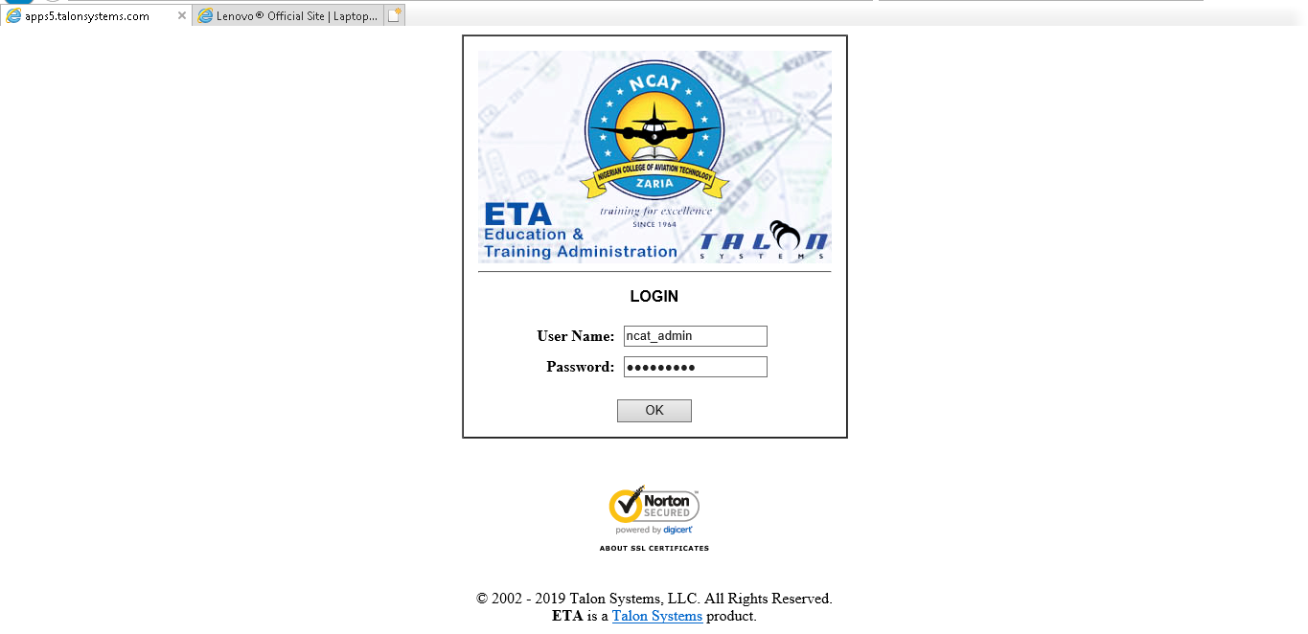
FIG 3.14 NCAT LOGIN PAGE

3.2.3.1 NCAT Course Minimums
From the home page click on Course Catalogue on the side menu bar
Select the D button beside a preferred course
From the New page displayed click on Course Minimums from the side menu bar

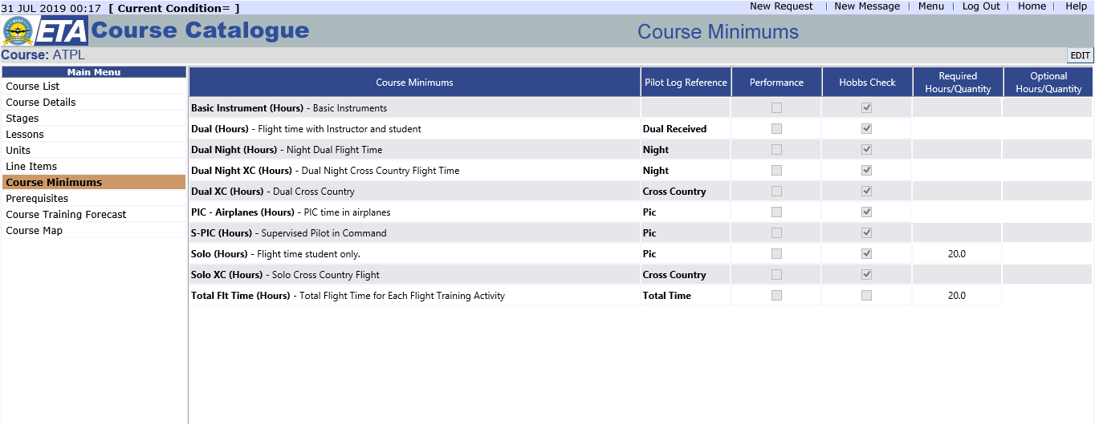
FIG 3.15 DISPLAY FOR COURSE MINIMUM PAGE

3.2.3.2 NCATCourse Pre-requisites
From the home page click on Course Catalogue on the side menu bar
Click the D button beside a preferred course
From the New page displayed click on Pre-requisite from the side menu bar
Click on E to add appropriate pre-requisite

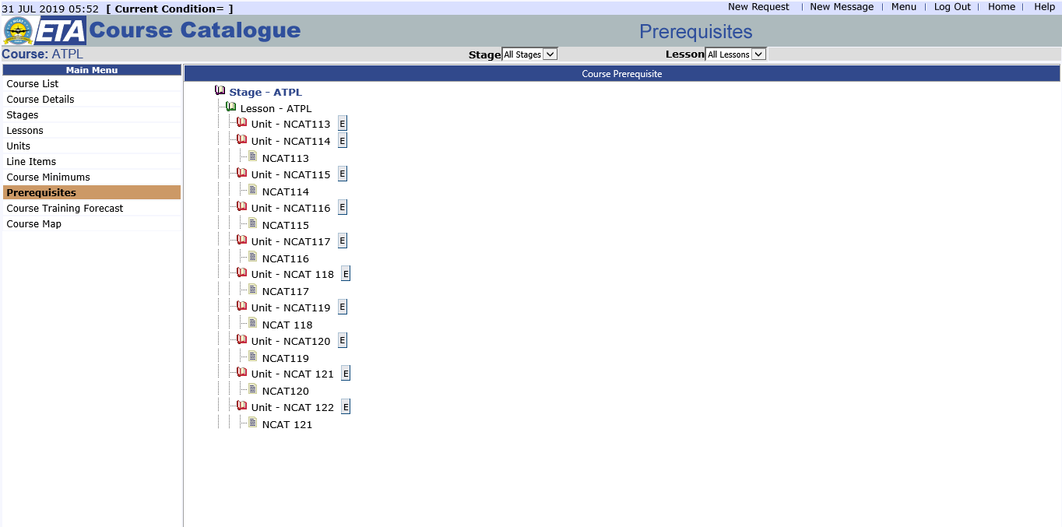

FIG 3.16 DIPLSAY FOR COURSE PRE-REQUISITE

3.2.3.3 NCATCourse Line Items
From the home page click on Course Catalogue on the side menu bar
Click the D button beside a preferred course
From the New page displayed click on Line Items from the side menu bar

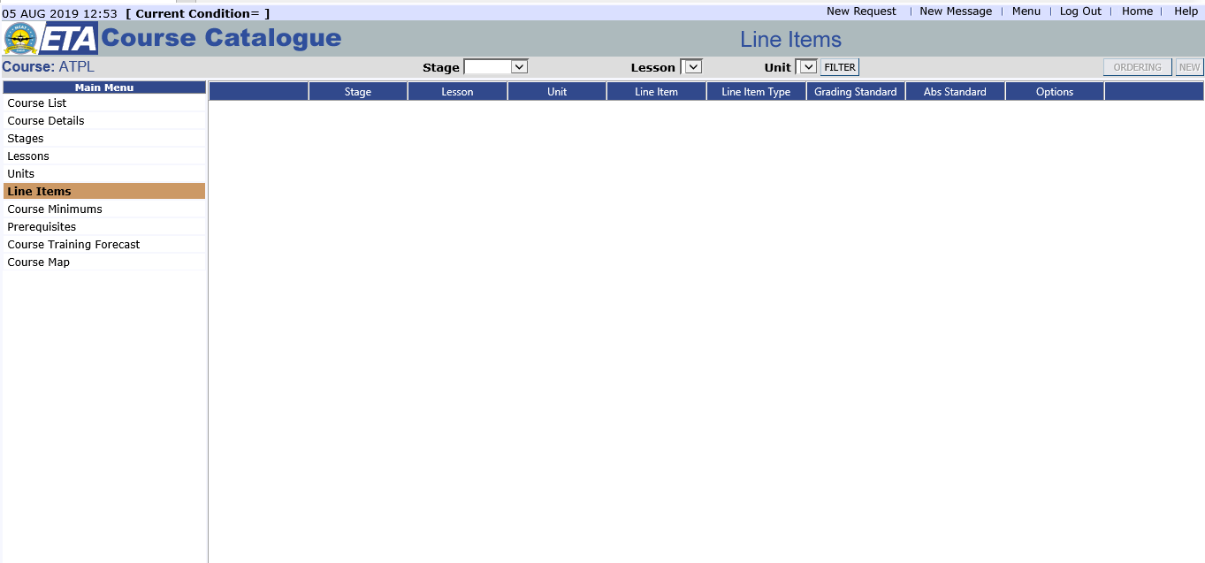

FIG 3.17 DIPLSAY FOR COURSE LINE ITEMS

3.2.3 CENTRAL CALL DATA RECORD (CCDR) DEPLOYMENT FOR THE NIGERIAN COMMUNICATIONS COMMISSIONS
The Central Call Data Record (CCDR) application was also one the projects I handled at the peak period of my SIWES program. I went through a short training from the IT team handling this project to understand much better the series of processes involved in the installation of this application. I handled the installation and set-up of IIS using the User Manual developed by a member of the team handling this particular project which I tested.
Installing IIS
To deploy IIS on your computer, confirm that IIS and Web Deploy are installed. By default, visual studio installs Web Deploy, but IIS is not enabled by default in Windows 10, Windows 8, or Windows 7 configuration. If you have already installed IIS and the default application pool is already set to .NET 4. To install IIS for this application it is recommended that you use Web Platform Installer (WPI) to install and Web Deploy. WPI would install a recommended IIS configuration that includes IIS and Web Deploy prerequisites.
For Windows 8 and higher, go through the following steps below to make sure that ASP.NET 4.7 is installed:
- Open Control Panel > Programs > Programs and Features > Turn Windows features on or off
- Expand Internet Information Services, World Wide Web Services, and Application Development Features.
- Confirm that ASP.NET 4.7 is selected.

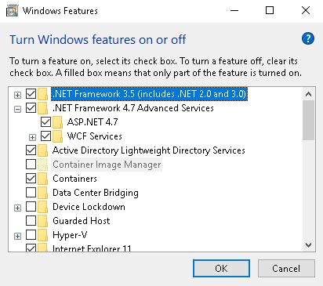
FIG 3.18 WINDOWS FEATURES FOR INSTALLING IIS

- Confirm that World Wide Web Services and IIS Management Console are selected. This installs IIS and IIS Manager.

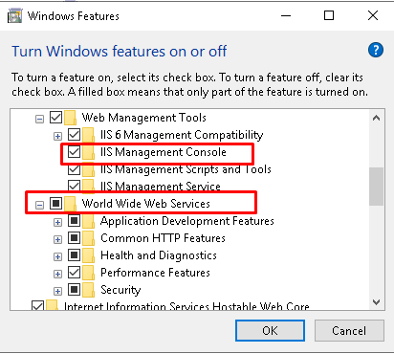
FIG 3.19 SETUP WINDOW SHOWING IIS FEATURES TO BE SELECTED

- Select OK. Then a Dialog box messages indicating installation is taking place will appear

If your computer host an existing website, you will need to create a new website and assign another port number as specified in the image below.

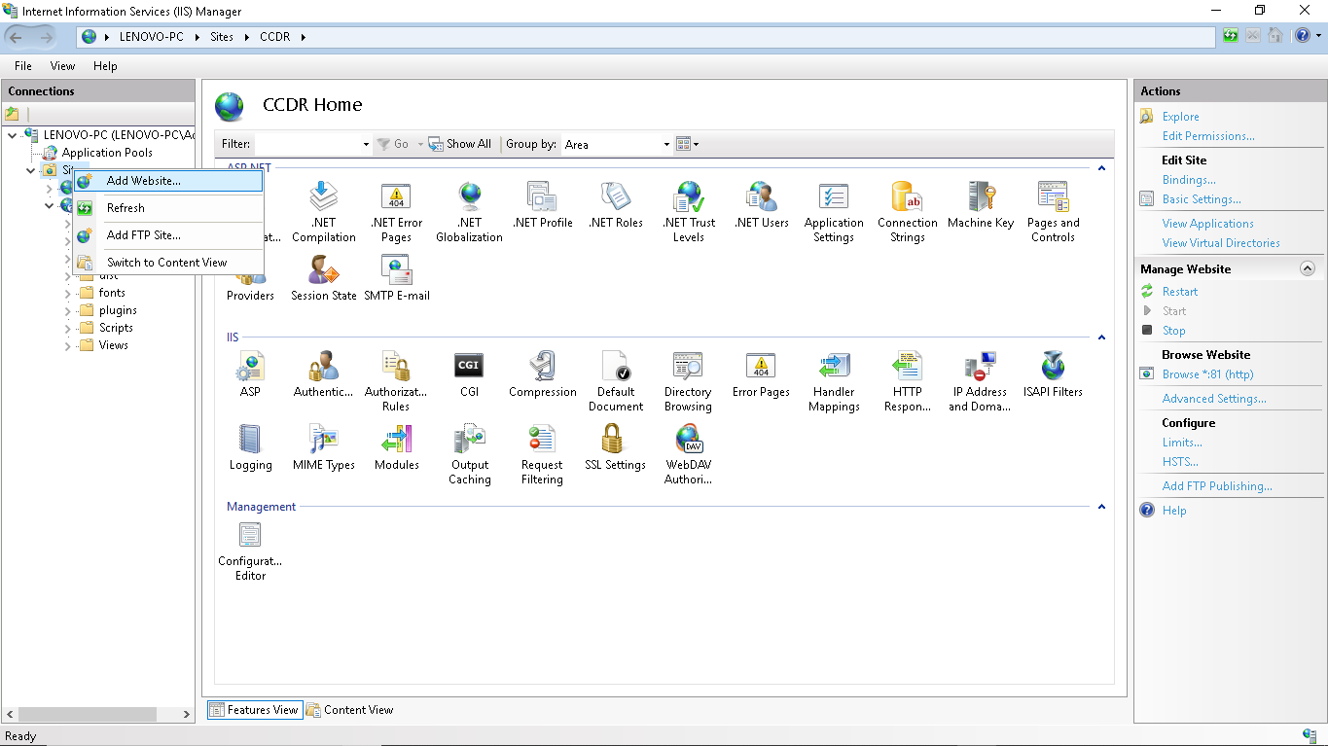
FIG 3.20 INTERNET INFORMATION SERVICES WINDOW TO ADD A NEW WEBSITE.
To add a new port number in cases where the default websites run on port 80, 8080. Click on the “Bindings” at the right hand menu. Click on displayed port number for the website and click edit, Change the number as in the image below.

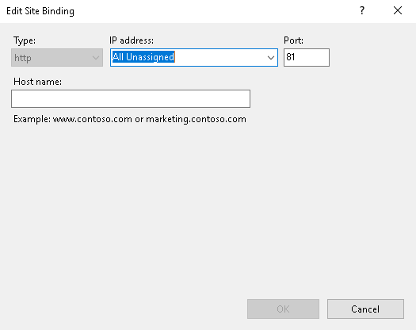
FIG 3.21 WINDOW TO ASSIGN A NEW PORT NUMBER

THE IIS SETUP
  - Launch the IIS manager
  - On the left hand menu, choose “sites” then select “default website” if no other website exists OR “add new website” if a website already exist apart from the CCDR by right clicking on sites:
  - Name your site appropriately
  - Edit the port number if another site is bound to default port
  - Set the path to your website by selecting the website on the list of “sites”
  - On the left menu, right click, go to Manage Website then click advanced settings
  - Select the physical path as the folder containing the web.config files need to be setup in your inetpub\wwwroot directory C:\inetpub\wwwroot)

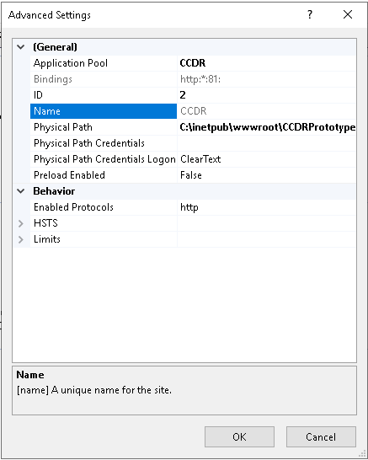
FIG 3.22 WINDOW TO SET PHYSICAL PATH FOR THE CCDR
  - When all is setup, click on the “browse *port number (http)” menu on the right. The default browser should launch the NCC CCDR web based application.

3.3: CONCLUSION
The SIWES experience has exposed me to the practical aspect of my discipline and have also prepared me to the work situation which I may likely meet in future. The programme has also given me the opportunity to bridge the gap between theory and practical aspect of my discipline, interacting with clients to understand their requirement much better ways of getting the best out clients during training sessions, practical ways of handling bottlenecks in the development process of an application, essential concepts as a Computer Scientists and the best practices in a work environment. Finally, the program also exposed me to the benefits of interacting with office colleagues, building a good relationship with them making learning and self-development easier to achieve.

CHAPTER FOUR
WORKING EXPERIENCE.
4.1: INRODUCTION
During my Internship experience, I did come across some difficulties and inefficiencies which are detailed below.

4.1.1: INNEFICIENCIES TACKLED AND PROFERRED SOLUTIONS.
- While working on flow charts for the Customer Complaint Handling System (CHS) for the Nigerian electricity Regulatory Commission (NERC), I encountered difficulty using Microsoft Word to develop the flow chart which was due to lack of exposure to software tools to aid in developing flow charts.
Due to this challenge I did some research on tools to aid in developing of flow charts to mention but a few:
- Gliffy Diagrams: This is a Google software diagramming and a collaboration tool used to create UML diagrams, floor plans, Venn Diagrams, flow charts and other kind of diagrams online
- Google Drawings: This is also a diagramming software for developing flow charts, organization chart, maps and other types of diagrams. It can also serve as a collaborative tool

- Secondly, it took me time to familiarize myself with some office terms and abbreviations in project management during the period of my SIWES programme. To mention but a few:
RFP: Request for Proposal
SLA: Service Level Agreement
TBC: To Be Confirmed
TBD: To Be Defined
PIR: Post Implementation Review
COB: Close of Business
PVR: Project Variation Request
BAU: Business as Usual
SOW: Statement of Work / Scope of work
Office Reimbursable

CHAPTER FIVE
CONCLUSION AND RECOMMENDATION

5.1 SUMMARY
The student industrial work experience scheme (SIWES) was an eye opening experience and an opportunity to get practical experience and exposure of the theoretical knowledge gained in school. The time spent at Office Machines Nigerian Limited (OMNL) an IT consulting firm was indeed an informative experience to expose me to the real life experiences of Computer Scientists. This period working on the Customer Complaint Handling System (CHS) for the Nigerian Electricity Regulatory Commission (NERC) with the IT and Projects Team has given me knowledge on best practices when dealing with clients, Change Management In Project, documentation of applications and presentation making to customers. It has also broaden my knowledge on the areas the IT industry is moving towards that may influence my carrier decisions later in the future.

5.2: RECOMMENDATION.
Based on my experience with OMNL, I there made the following recommendation:
- The company should have a detailed plan for what students are to achieve at the end of their SIWES programme.
- Also I suggest that all IT/SIWES students should be assigned a major project before the termination of the SIWES program. As doing such will advance Student’s ability to Research and be productive.
5.3: CONCLUSION
In conclusion, my admission into OMNL, provided me with first hand demonstration of processes which at one time had not been so clear to me due to limitations in theoretical explanation. It also gave me first-hand experience on the day to day activities of Computer Scientists working on projects day in day out who constantly demonstrated admirable work-ethic and vigor to not only complete a task, and do that well, but to also satisfy customers. My experience in a nutshell increased my profound respect for Computer Scientist.

REFERENCES:
OFFICE MACHINES NIGERIAN LIMITED. (2018). COMPLAINT HANDLING SYSTEM: USER GUIDE. ABUJA, NIGERIA: OMNL
OFFICE MACHINES NIGERIAN LIMITED. (2019). CENTRAL CALL DATA RECORD: USER GUIDE. ABUJA, NIGERIA: OMNL

