Number Theory:
- Linear Sieve 2
- Mobius Function 2
- Segmented Sieve 2
- Pollard Rho 2
- Miller Rabin 2
- Phi Function 3
- Discrete Log / Baby Step Giant Step 3
- Extended Euclid 3
- CRT 4
- Modular Inverse / Congruence 4
- nCr / nPr / Catalan / Stars and Bars 4
- Matrix Exponentiation 4
- Linear Diophantine Equation 4
Graph:
- Dijkstra 5
- Bellman Ford 5
- 2-SAT 5
- LCA 6
- Bridge Tree 6
- Articulation Point 7
- SCC / Tarjan 7
- Topological Sorting 7
- Cycle detection 7
- HLD 7
- Dinic Max Flow 8
- Hopcroft Karp 9
- Prim's MST 9
- Re-rooting DP 9
- Centroid Decomposition 10
- Treap 10
- Floyd Warshall 22
Data Structure:
- Fenwick Tree 11
- Segment Tree + Lazy 11
- Iterative Segment Tree 12
- Merge Sort Tree 12
- Sparse Table 12
- Trie 12
- Sqrt Decomposition 13
- Mo's Algorithm 13
- Ordered Set 14
- DSU 14
- Dynamic Bitset 14
String:
- Hashing Interval 15
- Hashing with Update 15
- Z Algorithm 15
- KMP 15
- Manacher 15
- Aho Corasick 15
- Suffix Array 16
Others:
- Next Greater Left 17
- Next Greater Right 17
- Next Lower Left 17
- Next Lower Right 17
- Count Inversion 17
- Majority Candidate in Range 17
Bit Manipulation:
- Xor Basis / Linear Basis 18
- Bitmask Formula 21
Geometry:
- 2D Geometry All in One 18
- Segment / Line Intersection 19
- Polygon Area / Perimeter 19
- Convex Hull 20
- Convex Diameter 20
- Point in Convex Polygon 20
- Integer Geometry / Pick's Theorem 20
Game Theory:
- Grundy Number 20
Extra / Math / Utility:
- Unordered Hashmap 21
- 128 Bit IO 21
- PBDS 21
- Derangement 21
- Stirling Number 21
- Egg Dropping DP 22
- FFT Multiply 22
- LCM Formula / LCM Counting 24
- Stress Testing 24
- Dijkstra 4

// *** optimize input output ***
ios_base::sync_with_stdio(false);
cin.tie(NULL); cout.tie(NULL);
== Sublime setup
{
"shell_cmd": "g++ \"${file}\" -o \"${file_path}/${file_base_name}\"",
"file_regex": "^(..[^:]*):([0-9]+):?([0-9]+)?:? (.*)$",
"working_dir": "${file_path}",
"selector": "source.c++",
"variants":
[
{
"name": "Run",
"shell_cmd": "g++ \"${file}\" -o \"${file_path}/${file_base_name}\" && \"${file_path}/${file_base_name}\"< input.txt > output.txt"
}
]
}
//Sublime(Linux)
{"cmd" : "g++ -std=c++14 $file_name -o $file_base_name && timeout 4s ./$file_base_name<input.in>output.in 2>error.in",
"shell" : true,
"selector" : "source.c",
"working_dir" : "$file_path",
"file_regex" : "^(.[^:]*):([0-9]+):?([0-9]+)?:? (.*)$",}

***DEBUG***
ofstream err("output.error");
#ifdef DEBUG
#define db(v) #v":" << (v)
#define clog err
#else
#define db(...) ""
#define clog if(0)cerr
#endif
template<class Con, class = decltype(begin(declval<Con>()))>
typename enable_if<!is_same<Con, string>::value, ostream&>::type
operator<<(ostream& out, const Con& v) {
out << "";
for(auto &i : v){
out << " " << i;
}
return out << "\n";
}
== Stress Testing
// generator file
mt19937_64 rng(chrono::steady_clock::now().time_since_epoch().count());
inline int gen_random(int l, int r) {
return uniform_int_distribution<int>(l, r)(rng);
}
int main() {
ios::sync_with_stdio(false);
cin.tie(NULL);
freopen("input.in", "w", stdout);
}
// checker file (bash)
g++ -std=gnu++17 -O2 gen.cpp -o gen
for ((i = 1; i <= 500; i++)); do
echo "Test $i"
./gen > input.txt
if diff -q <(./optimal < input.txt) <(./brute < input.txt) > /dev/null; then
continue
else
echo "Mismatch found!"
echo "Saving failing test to fail.in"
cp input.txt fail.in
echo "Input:"
cat input.txt
echo "Optimal:"
./optimal < input.txt
echo "Brute:"
./brute < input.txt
exit 0
fi
done
***Linear Sieve**
**linear Sieve

int hp[N]; bool isPrime[N];
vector<int> primes, mu(N);
void sieve(){
mu[1] = 1;
for(int i = 2; i < N; i++){
if(!hp[i]){
hp[i] = i; isPrime[i] = 1;
primes.push_back(i);
mu[i] = -1;
}
for(auto &p : primes){
if(p > hp[i] or i * p >= N)break;
hp[i * p] = p;
if(i%p == 0){
mu[i*p] = 0;
break;
}
else mu[i*p] = -mu[i];
}
}
}

***Mobius function***
Core :
[gcd(a, b) == 1] = Σ mu[d] where d | gcd(a, b)

cnt[d] = count of elements in array divisible by d

1) Ordered coprime pairs in range [1..n]
ans = Σ_{d=1 to n} mu[d] * (n / d)^2

2) Array coprime pairs
ans = Σ_{d=1 to maxA} mu[d] * nCr(cnt[d], 2)

3) Array pairs with gcd = g
ans = Σ_{d=1 to maxA/g} mu[d] * nCr(cnt[g * d], 2)

4) Array coprime triples
ans = Σ_{d=1 to maxA} mu[d] * nCr(cnt[d], 3)

5) Array triples with gcd = g
ans = Σ_{d=1 to maxA/g} mu[d] * nCr(cnt[g * d], 3)

6) Non-empty subsets with gcd = 1
ans = Σ_{d=1 to maxA} mu[d] * (2^cnt[d] - 1)

7) Non-empty subsets with gcd = g
ans = Σ_{d=1 to maxA/g} mu[d] * (2^cnt[g * d] - 1)

8) Count x <= m s.t. gcd(x, n) = 1
ans = Σ_{d|n} mu[d] * (m / d)

9) Euler phi using Mobius
phi(n) = Σ_{d|n} mu[d] * (n / d)

10) Square-free check
is_square_free(n) = mu[n] * mu[n]

int countOrderedCoprimePairs(){
int ans = 0;
for(int d = 1; d <= mx; d++){
ans += mu[d] * cnt[d] * (cnt[d] - 1) / 2;
}
return ans;
}
*** Segmented Sieve ***
vector<char> segmentedSieve(int L, int R) {
int lim = sqrt(R);
vector<char> mark(lim + 1, false);
vector<int> primes;
for (int i = 2; i <= lim; ++i) {
if (!mark[i]) {
primes.emplace_back(i);
for (int j = i * i; j <= lim; j += i)
mark[j] = true;
}
}
vector<char> isPrime(R - L + 1, true);
for (int i : primes)
for (int j = max(i * i, (L + i - 1) / i * i); j <= R; j += i)
isPrime[j - L] = false;
if (L == 1)
isPrime[0] = false;
return isPrime;
}
/*
vector<char> res = segmentedSieveNoPreGen(l, r);
for(int i=0 ; i<res.size() ; i++) if(a[i]) cout << (l + i) << ' '; cout << endl;
TC: n loglog(R) + sqrt(R)loglogsqrt(R); n = R - L + 1;
*/
***PollardRho***
namespace Pollard{
#define int long long
mt19937 rnd(chrono::steady_clock::now().time_since_epoch().count());
const int N = 1e6 + 100;
bool isPrime[N]; int hp[N];
vector<int> primes;
void init(){
for(int i = 2; i < N; i++){
if(!hp[i]){
hp[i] = i; isPrime[i] = 1;
primes.push_back(i);
}
for(auto &p : primes){
if(p > hp[i] or i * p >= N)break;
hp[i * p] = p;
}
}
}
int binExp(int a, int b, int mod = M){
int ans = 1; a %= mod;
for(; b; b >>= 1, a = (__uint128_t) a * a % mod){
if(b & 1)(ans = (__uint128_t) ans * a % mod);
}
return ans;
}
int mmiOfX(int b, int mod = M){ return binExp(b, mod - 2);}
bool is_composite(int n, int a, int d, int p){
int x = binExp(a, d, n);
if(x == 1 or x == n - 1)return false;
for(int i = 0; i < p - 1; i++){
x = (__uint128_t)x * x % n;
if(x == n - 1)return false;
}
return true;
}
**MILLER_RABIN**
bool is_prime(int n, int iter = 5){
if(n < 4)return n == 2 || n == 3;
int p = 0, d = n - 1;
while((d & 1) == 0){
d >>= 1;
p++;
}
mt19937_64 rn;
for(int i = 0; i < iter; i++){
int a = 2 + rn() % (n - 3);
if(is_composite(n, a, d, p))return false;
}
return true;
}
//Pollard rho
int func(int x, int c, int mod) {
return ((__uint128_t)x * x + c) % mod;
}
int rho(int n) {
if (n % 2 == 0) return 2;
while (true) {
int c = 1 + rnd() % (n - 1);
int x = 2 + rnd() % (n - 2);
int y = x;
int d = 1;
while (d == 1) {
x = func(x, c, n);
y = func(func(y, c, n), c, n);
int diff = abs(x - y);
d = __gcd(diff, n);
}
if (d != n) return d;
}
}
vector<int> factorize(int n){
if(n == 1)return {};
if(is_prime(n))return {n};
vector<int> v, w;
if(n < N){
while(n > 1){
int pm = hp[n];
while(n % pm == 0){
v.push_back(pm);
n /= pm;
}
}
return v;
}
int x = rho(n);
v = factorize(x);
w = factorize(n / x);
v.insert(v.end(), w.begin(), w.end());
return v;
}
void allDivsGen(int ind, int curVal, vector<pair<int, int>> &pmFact, vector<int> &ans){
if(pmFact[ind].first == -1){
ans.push_back(curVal);
return;
}
for(int i = 0; i <= pmFact[ind].second; i++){
allDivsGen(ind + 1, curVal, pmFact, ans);
curVal *= pmFact[ind].first;
}
}
map<int, vin> dp;
vector<int> allDivisors(int n){
auto it = dp.find(n);
if(it != dp.end())return it->second;
vector<int> ans;
vector<pair<int, int>> prime_factors;
vector<int> fact = factorize(n);
unordered_map<int, int> mp;
for(auto i : fact)mp[i]++;
for(auto i : mp)prime_factors.push_back({i.first, i.second});
prime_factors.push_back({-1, -1});
allDivsGen(0, 1, prime_factors, ans);
int x = ans.size();
return dp[n] = ans;
}
}
*** Phi function ***
int phi(int n) {
int result = n;
for (int i = 2; i * i <= n; i++) {
if (n % i == 0) {
while (n % i == 0)
n /= i;
result -= result / i;
}
}
if (n > 1)
result -= result / n;
return result;
}
***Returns minimum x for which a ^ x % m = b % m, a and m are not coprime.
int solve(int a, int b, int m) {
a %= m, b %= m;
int k = 1, add = 0, g;
while ((g = __gcd(a, m)) > 1) {
if (b == k)
return add;
if (b % g)
return -1;
b /= g, m /= g, ++add;
k = (k * 1ll * a / g) % m;
}
int n = sqrt(m) + 1;
int an = 1;
for (int i = 0; i < n; ++i)
an = (an * 1ll * a) % m;
unordered_map<int, int> vals;
for (int q = 0, cur = b; q <= n; ++q) {
vals[cur] = q;
cur = (cur * 1ll * a) % m;
}
for (int p = 1, cur = k; p <= n; ++p) {
cur = (cur * 1ll * an) % m;
if (vals.count(cur)) {
int ans = n * p - vals[cur] + add;
return ans;
}
}
return -1;
}
***Returns minimum x for which a ^ x % m = b % m, a and m are coprime. ***
int solve(int a, int b, int m) {
a %= m, b %= m;
int n = sqrt(m) + 1;
int an = 1;
for (int i = 0; i < n; ++i)
an = (an * 1ll * a) % m;
unordered_map<int, int> vals;
for (int q = 0, cur = b; q <= n; ++q) {
vals[cur] = q;
cur = (cur * 1ll * a) % m;
}
for (int p = 1, cur = 1; p <= n; ++p) {
cur = (cur * 1ll * an) % m;
if (vals.count(cur)) {
int ans = n * p - vals[cur];
return ans;
}
}
return -1;
}
*** Extended euclid ***
int G;
pair<int, int> e_gcd(int a, int b){
//ax + by = gcd(a, b); x, y = ?
if(!b){
G = a;
return {1, 0};
}
auto [x1, y1] = e_gcd(b, a%b);
int x = y1;
int y = x1 - (a / b)*y1;
return {x, y};
}
int mmiofX(int a, int mod){
return (mod + e_gcd(a, mod).first)%mod;
}
int congruence(int a, int b, int m){ //ax = b mod(m); x = ?
int g = gcd(a, m);
if(b % g)return 0;
a /= g, b /= g, m /= g;
int a1 = mmiofX(a, m);
int x = (b * a1)%m;
return x;
}
**CRT**
using T = int;
T G;
// ax + by = gcd(a, b); x, y = ?
// returns {x, y}; here G = gcd(a, b);
pair<T, T> e_gcd(T a, T b){
if(!b){
G = a;
return {1, 0};
}
auto [x1, y1] = e_gcd(b, a%b);
T x = y1;
T y = x1 - (a / b)*y1;
return {x, y};
}
// finds x such that x % m1 = a1, x % m2 = a2. m1 and m2 may not be coprime
// here, x is unique modulo m = lcm(m1, m2). returns (x, m). on failure, m = -1.
pair<T, T> CRT(T a1, T m1, T a2, T m2){
auto [p, q] = e_gcd(m1, m2);
if(a1 % G != a2 % G)return {0, -1};
T m = (m1 / G) * m2;
T x = (m + (a1*m2%m)*q%m + (a2*m1%m)*p%m) % m;
return {x, m};
}
*** nCr ***
int binExp(int a, int b, int mod = M){
int ans = 1; a %= mod;
for(; b; b >>= 1, a = (__uint128_t) a * a % mod){
if(b & 1)(ans = (__uint128_t) ans * a % mod);
}
return ans;
}
int bigMult(int a, int b, int mod = M){
int ans = 0;
for(; b; b >>= 1, a += a){
if(b&1)ans += a;
}
return ans;
}
int mmiOfX(int b, int mod = M){ return binExp(b, mod - 2);}

int fact[N], inv[N];
void init(){
fact[0] = inv[0] = 1;
for(int i = 1; i < N; i++){
fact[i] = fact[i - 1] * i % M;
}
inv[N - 1] = mmiOfX(fact[N - 1]);
for(int i = N - 2; i >= 0; i--){
inv[i] = inv[i + 1] * (i + 1) % M;
}
/*
for(int n = 1; n <= 66; n++){
nCr[n][0] = nCr[n][n] = 1;
for(int r = 1; r < n; r++){
nCr[n][r] = nCr[n - 1][r - 1] + nCr[n - 1][r];
}
}
*/
}
int nCr(int n, int r){return (__uint128_t) (fact[n] * inv[r] % M) * inv[n - r] % M; }
int nPr(int n, int r){return (__uint128_t) fact[n] * inv[n - r] % M; }
int catalan(int n){return nCr(2*n, n) * mmiOfX(n + 1) % M; }
int starsAndBars(int n, int k){return nCr(n + k - 1, n);}
//n stars and k bars
**Matrix exponentiation***
#define v2d vector<vector<int>>
v2d fib_base = {{1, 1}, {1, 0}}; //for Fibonacci number
v2d matrixMult(v2d &a, v2d &b){
int m = a.size(), n = a[0].size(), l = b[0].size();
v2d ans(m, vector<int> (l));
for(int i = 0; i < m; i++){
for(int j = 0; j < l; j++){
for(int k = 0; k < n; k++){
ans[i][j] += a[i][k] * b[k][j] % M;
ans[i][j] %= M;
}
}
}
return ans;
}
v2d matrixExpo(v2d v, int p){
v2d ans = v;
for(; p; p >>= 1, v = matrixMult(v, v)){
if(p&1)ans = matrixMult(ans, v);
}
return ans;
}
*** Diophantine***
int gcd(int a, int b, int& x, int& y) {
if (b == 0) {
x = 1;
y = 0;
return a;
}
int x1, y1;
int d = gcd(b, a % b, x1, y1);
x = y1;
y = x1 - y1 * (a / b);
return d;
}
bool find_any_solution(int a, int b, int c, int &x0, int &y0, int &g) {
if(a == 0 and b == 0) {
if(c) return false;
x0 = y0 = g = 0;
return true;
}
g = gcd(abs(a), abs(b), x0, y0);
if (c % g) return false;
x0 *= c / g;
y0 *= c / g;
if (a < 0) x0 = -x0;
if (b < 0) y0 = -y0;
return true;
}
void shift_solution(int & x, int & y, int a, int b, int cnt) {
x += cnt * b;
y -= cnt * a;
}
int find_all_solutions(int a, int b, int c, int minx, int maxx, int miny, int maxy) {
int x, y, g;
if (!find_any_solution(a, b, c, x, y, g)) return 0;
if (a == 0 and b == 0) {
assert(c == 0);
return 1LL * (maxx - minx + 1) * (maxy - miny + 1);
}
if (a == 0) {
return (maxx - minx + 1) * (miny <= c / b and c / b <= maxy);
}
if (b == 0) {
return (maxy - miny + 1) * (minx <= c / a and c / a <= maxx);
}
a /= g;
b /= g;
int sign_a = a > 0 ? +1 : -1;
int sign_b = b > 0 ? +1 : -1;
shift_solution(x, y, a, b, (minx - x) / b);
if (x < minx)
shift_solution(x, y, a, b, sign_b);
if (x > maxx)
return 0;
int lx1 = x;
shift_solution(x, y, a, b, (maxx - x) / b);
if (x > maxx)
shift_solution(x, y, a, b, -sign_b);
int rx1 = x;
shift_solution(x, y, a, b, -(miny - y) / a);
if (y < miny)
shift_solution(x, y, a, b, -sign_a);
if (y > maxy)
return 0;
int lx2 = x;
shift_solution(x, y, a, b, -(maxy - y) / a);
if (y > maxy)
shift_solution(x, y, a, b, sign_a);
int rx2 = x;
if (lx2 > rx2)
swap(lx2, rx2);
int lx = max(lx1, lx2);
int rx = min(rx1, rx2);
if (lx > rx)
return 0;
return (rx - lx) / abs(b) + 1;
}
// solution exist or not?
// how many solution exist?

*** Dijkstra ***
void dijkstra(){
int n, m;
cin >> n >> m;
vector<pair<int, int>> graph[n + 1];
vector<int> dist(n + 1, 1e18);
for(int i = 0; i < m; i++){
int x, y, w;
cin >> x >> y >> w;
graph[x].push_back({y, w});
graph[y].push_back({x, w});
}
int u = 1; // source node
dist[u] = 0;
set<pair<int, int>> s;
s.insert({0, u});
while(!s.empty()){
auto [w, u] = *s.begin();
s.erase(s.begin());
if(dist[u] < w)continue;
for(auto &[v, ww] : graph[u]){
if((w + ww) < dist[v]){
dist[v] = w + ww;
s.insert({dist[v], v});
}
}
}
}
*** Bellman ford ***
vector<pair<ll,ll>> g[N];
vector<ll> dist(N), par(N);
ll n, m;
void bellman_ford(ll src) {
for(ll i = 0; i <= n; i++) dist[i] = INF;
dist[src] = 0;
for(ll step = 0; step < n - 1; step++) {
//1 based indexing
for(ll i = 1; i <= n; i++) {
//it.ff = node, it.ss = weight
for(auto it : g[i]) {
if(dist[i] + it.ss < dist[it.ff]) {
par[it.ff] = i;
dist[it.ff] = dist[i] + it.ss;
}
}
}
}
}
void cycle_detect() {
ll cycle = 0;
for(ll i = 1; i <= n; i++) {
for(auto it : g[i]) {
if(dist[i] + it.ss < dist[it.ff]) {
cycle = it.ff;
break;
}
}
}
if(cycle == 0) {
cout << "NO" << endl;
} else {
cout << "YES" << endl;
for(ll i = 0; i < n; i++) cycle = par[cycle];
vector<ll> ans;
ans.pb(cycle);
for(ll i = par[cycle]; i != cycle; i = par[i]) {
ans.pb(i);
}
ans.pb(cycle);
reverse(all(ans));
for(auto it : ans) cout << it << " ";
cout << endl;
}
}
*** 2-sat ***
vector<ll> g[N], g2[N];
vector<ll> order, vis(N), comp(N);
vector<char> ans(N);
ll n, m;
void dfs(ll node) {
vis[node] = 1;
for(auto child : g[node]) {
if(!vis[child]) dfs(child);
}
order.pb(node);
}
void dfs2(ll node, ll cnt) {
comp[node] = cnt;
for(auto child : g2[node]) {
if(!comp[child]) dfs2(child, cnt);
}
}
void createComponentGraph() {
order.clear();
loop(i, 1, n) vis[i] = 0;
for(int node = 1; node <= 2 * m; node++) {
if(!vis[node]) dfs(node);
}
reverse(all(order));
ll cnt = 0;
for(auto it : order) {
if(!comp[it]) {
dfs2(it, ++cnt);
}
}
for(int node = 1; node <= m; node++) {
if(comp[node] == comp[2 * m - node + 1]) {
cout << "IMPOSSIBLE" << endl;
return;
}
// if x is in left of !x in topological order then x = 0, else x = 1
ans[node] = (comp[node] > comp[2 * m - node + 1] ? '+' : '-');
}
for(ll i = 1; i <= m; i++) {
cout << ans[i];
}
cout << endl;
}
void SAT2() {
cin >> n >> m;
for(ll i = 0; i < n; i++) {
char ch1, ch2;
ll u, v;
cin >> ch1 >> u >> ch2 >> v;
if(ch1 == '-') u = 2 * m - u + 1;
if(ch2 == '-') v = 2 * m - v + 1;
// u = x, 2 * m - u + 1 = !x
g[2 * m - u + 1].push_back(v);
g[2 * m - v + 1].push_back(u);
g2[u].push_back(2 * m - v + 1);
g2[v].push_back(2 * m - u + 1);
}
createComponentGraph();
}
***LCA***
const int N = 2e5 + 5, LG = 20;
vector<int> g[N];
int parent[N][LG + 1], dep[N];
// int mx[N][LG + 1], mn[N][LG + 1];
void dfs(int u, int p) { // take parameter mxi, mni for max min
parent[u][0] = p;
dep[u] = dep[p] + 1;
// mx[u][0] = mxi; mn[u][0] = mni;
for (int i = 1; i <= LG; i++) {
parent[u][i] = parent[parent[u][i - 1]][i - 1];
// mx[u][i] = max(mx[u][i - 1], mx[ parent[u][i - 1] ] [i - 1]);
// mn[u][i] = min(mn[u][i - 1], mn[ parent[u][i - 1] ] [i - 1]);
}
for (auto v: g[u]) if (v != p) {
dfs(v, u);
}
}
int LCA(int u, int v) {
if (dep[u] < dep[v])
swap(u, v);
for (int k = LG; k >= 0; k--)
if (dep[parent[u][k]] >= dep[v])
u = parent[u][k];
if (u == v) return u;
for (int k = LG; k >= 0; k--)
if (parent[u][k] != parent[v][k])
u = parent[u][k], v = parent[v][k];
return parent[u][0];
}
int kth(int u, int k) {
assert(k >= 0);
for (int i = 0; i <= LG; i++)
if (k & (1 << i))
u = parent[u][i];
return u;
}
int dist(int u, int v) {
int l = LCA(u, v);
return dep[u] + dep[v] - (dep[l] << 1);
}
// Kth from [u -> v], 0th node is u
int go(int u, int v, int k) {
int l = LCA(u, v);
int d = dep[u] + dep[v] - (dep[l] << 1);
assert(k <= d);
if (dep[l] + k <= dep[u])
return kth(u, k);
k -= dep[u] - dep[l];
return kth(v, dep[v] - dep[l] - k);
}
// dep[0] = -1
// dfs(u, 0)
// TC -> build: NlogN
// -> query: logN
*** Bridge Tree ***
int n, m;
vin g[N], t[N];
map<pair<int, int>, int> eid;
int timer, in[N], low[N];
bool is_bridge[N], vis[N];
void dfs(int u, int p){
in[u] = low[u] = ++timer;
vis[u] = true;
for(auto &v : g[u])if(v != p){
if(vis[v]){ //Back edge
low[u] = min(low[u], in[v]);
}else{ //Forward edge
dfs(v, u);
low[u] = min(low[u], low[v]);
if(in[u] < low[v]){
is_bridge[eid[{u, v}]] = true; //this edge is a bridge
} } }}
int comp[N], comp_sz[N], cid;
void compress(int u, int &cnt){
comp[u] = cid;
cnt++;
for(auto &v : g[u]){
int id = eid[{u, v}];
if(!comp[v] and !is_bridge[id]){
compress(v, cnt);
} } }
void reset(){
eid.clear();
timer = cid = 0;
for(int i = 0; i <= max(n, m); i++){
g[i].clear(); t[i].clear();
comp[i] = comp_sz[i] = 0;
in[i] = 0, low[i] = vis[i] = 0, is_bridge[i] = 0;
}}
void init(){
cin >> n >> m;
reset();
vector<pair<int, int>> edg(m + 1);
for(int i = 1; i <= m; i++){
int x, y;
cin >> x >> y;
g[x].push_back(y);
g[y].push_back(x);
edg[i] = {x, y};
eid[{x, y}] = eid[{y, x}] = i;
}
dfs(1, 0); //If graph contain only one CC
for(int i = 1; i <= n; i++){
if(!comp[i]){
++cid;
compress(i, comp_sz[cid]);
} }
for(int i = 1; i <= m; i++){
if(!is_bridge[i])continue;
int u = edg[i].first;
int v = edg[i].second;
u = comp[u]; v = comp[v];
t[u].push_back(v);
t[v].push_back(u);
} }
*** Articulation point ***
int timer;
set<int> art_point;
vector<int> in(N), low(N), vis(N);
void dfs(int u, int p = 0){
vis[u] = true;
in[u] = low[u] = timer++;
int cnt = 0;
for(auto &v : graph[u])if(v != p){
if(vis[v]){
low[u] = min(low[u], in[v]);
}else{
cnt++;
dfs(v, u);
if(low[v] >= in[u] and p){
art_point.insert(u);
}
low[u] = min(low[u], low[v]);
}
}
if(!p and cnt > 1){
art_point.insert(u);
}
}
void find_cutpoints(){
timer = 0;
in.assign(n + 1, 0);
low.assign(n + 1, 0);
vis.assign(n + 1, 0);
art_point.clear();
for(int i = 1; i <= n; i++){
if(!vis[i])dfs(i);
}
}
***SCC**
int n;
int timer = 0;
stack<int> st;
vector<vector<int>> scc, graph(N);
vector<int> in(N, -1), low(N, -1), inStack(N);
void dfs(int u){
in[u] = low[u] = timer++;
st.push(u);
inStack[u] = true;
for(auto &v : graph[u]){
if(in[v] == -1){
dfs(v);
low[u] = min(low[u], low[v]);
}else if(inStack[v]){
low[u] = min(low[u], in[v]);
}
}
if(low[u] == in[u]){
vector<int> cc;
while(true){
int v = st.top(); st.pop();
inStack[v] = false;
cc.push_back(v);
if(v == u)break;
}
scc.push_back(cc);
}
}
//make new graph considering each scc as a node
vector<pii> re_edges(vector<pii> &edges){
vector<int> cid(n + 1);
int m = 0;
for(auto &v : scc){ ++m;
for(auto i : v)cid[i] = m;
}
vector<pii> ans;
for(auto &[u, v] : edges){
if(cid[u] == cid[v])continue;
ans.push_back({cid[u], cid[v]});
}
sort(ans.begin(), ans.end());
ans.erase(unique(ans.begin(), ans.end()), ans.end());
return ans;
};
***Topological Sort***
ovoid topSort(){
int n, m;
cin >> n >> m;
vector<int> graph[n + 1], indeg(n + 1);
for(int i = 0; i < m; i++){
int x, y;
cin >> x >> y;
indeg[y]++;
graph[x].push_back(y);
}

queue<int> q;
for(int i = 1; i <= n; i++){
if(indeg[i] == 0)q.push(i);
}

while(!q.empty()){
int u = q.front(); q.pop();
cout << u << " ";
for(auto &v : graph[u]){
if(--indeg[v] == 0)q.push(v);
}
}
}
***Cycle Detection***
bool cycle(int u, vector<int> &vis, vector<int> &stack){
vis[u] = true;
stack[u] = true;
bool ans = false;
for(auto &v : graph[u]){
if(!vis[v]){
if(cycle(v, vis, stack))return true;
}else if(stack[v]){
return true;
}
}
stack[u] = false;
return false;
}
bool isCyclic(){
vector<int> vis(n + 1, 0), stack = vis;
for(int i = 1; i <= n; i++){
if(!vis[i]){
if(cycle(i, vis, stack))return true;
}
}
return false;
}
*** HLD ***
//Graph + LCA part
int n, m, q;
const int LG = 19;
vector<int> graph[N];
int par[N][LG + 1], sz[N], dep[N];
void init(int u, int p){
sz[u] = 1;
par[u][0] = p;
for(int i = 1; i <= LG; i++)par[u][i] = par[par[u][i - 1]][i - 1];
if(p)graph[u].erase(find(all(graph[u]), p));
for(auto &v : graph[u])if(v != p){
dep[v] = dep[u] + 1;
init(v, u);
sz[u] += sz[v];
auto &x = graph[u][0];
if(sz[v] > sz[x])swap(v, x);
}
}
int kth(int u, int k){
if(k < 0)k = 0;
while(k){
int lg = 31 - __builtin_clz(k); //log2(k)
k -= (1 << lg);
u = par[u][lg];
}
return u;
}
int lca(int u, int v){
if(dep[u] < dep[v])swap(u, v);
u = kth(u, dep[u] - dep[v]);
if(u == v)return u;
for(int i = LG; i >= 0; i--){
if(par[u][i] == par[v][i])continue;
u = par[u][i];
v = par[v][i];
}
return par[u][0];
}
//HLD part
int cur_pos = 0;
vector<int> head(N), pos(N);
void hld(int u = 1){
pos[u] = ++cur_pos;
for(auto &v : graph[u]){
if(v == graph[u][0])head[v] = head[u];
else head[v] = v;
hld(v);
}
}
//Segment Tree
vector<int> arr, t(4 * N + 1);
const int R = 0;
inline int pull(int a, int b){
return a + b;
}
#define lc node << 1
#define rc node << 1 | 1
void build(int node, int lo, int hi){
if(lo == hi){
t[node] = arr[lo];
return;
}
int mid = (hi + lo) >> 1;
build(lc, lo, mid);
build(rc, mid + 1, hi);
t[node] = pull(t[lc], t[rc]);
}
void update(int node, int lo, int hi, int l, int x){
if(hi < l or lo > l)return;
if(lo == hi){
t[node] = arr[lo] = x;
return;
}
int mid = (hi + lo) >> 1;
update(lc, lo, mid, l, x);
update(rc, mid + 1, hi, l, x);
t[node] = pull(t[lc], t[rc]);
}
int query(int node, int lo, int hi, int l, int r){
if(hi < l or lo > r)return R;
if(lo >= l and hi <= r)return t[node];
int mid = (hi + lo) >> 1;
auto q1 = query(lc, lo, mid, l, r);
auto q2 = query(rc, mid + 1, hi, l, r);
return pull(q1, q2);
}
void Update(int l, int x){
update(1, 1, n, l, x);
}
int Query(int l, int r){
return query(1, 1, n, l, r);
}
//HLD query
int query_up(int u, int v){
int ans = 0;
while(head[u] != head[v]){
int chain_head = head[u];
int cur = Query(pos[chain_head], pos[u]);
u = par[chain_head][0];
ans = pull(ans, cur);
}
int cur = Query(pos[v], pos[u]);
ans = pull(ans, cur);
return ans;
}
int query(int u, int v){
int l = lca(u, v);
int ans = pull(query_up(u, l), query_up(v, l)) - query_up(l, l); //(-) for sum query
return ans;
}
void reset(){
cur_pos = 0;
arr.assign(n + 1, 0);
for(int i = 0; i <= n; i++){
graph[i].clear();
pos[i] = head[i] = 0;
dep[i] = sz[i] = 0;
}
}
void solve(){
cin >> n;
int vals[n + 1];
for(int i = 1; i <= n; i++)cin >> vals[i];
for(int i = 1; i < n; i++){
int x, y;
cin >> x >> y;
graph[x].push_back(y);
graph[y].push_back(x);
}
init(1, 0);
head[1] = 1;
hld(1);
for(int i = 1; i <= n; i++)arr[pos[i]] = vals[i];
build(1, 1, n);
//enjoy here
}
*** MaxFlow(Dinic) ***
struct Dinic{
struct edge{
int u, v;
int cap = 0, flow = 0;
edge(int u = 0, int v = 0, int cap = 0) : u(u), v(v), cap(cap){}
int other(int x){return x == u ? v : u;}
int flowFrom(int x){return x == u ? flow : -flow;}
int rescap(int x){return x == u ? cap - flow : flow;}
void sendFlow(int x, int f){flow += (x == u) ? f : -f;}
};
int n = 0, clk = 0;
vector<edge> E;
vector<vector<int>> adj;
vector<int> vis, level, ptr;
Dinic(int n) : n(n), adj(n + 1), vis(n + 1){
level = ptr = vis;
};
inline void addEdge(int u, int v, int cap){
E.emplace_back(u, v, cap);
adj[u].push_back(E.size() - 1);
adj[v].push_back(E.size() - 1);
}
bool bfs(int s, int t){
clk++;
queue<int> q;
q.push(s);
level[s] = 0;
vis[s] = clk;
while(!q.empty()){
s = q.front(); q.pop();
if(s == t)break;
ptr[s] = 0;
for(auto i : adj[s]){
int v = E[i].other(s);
if(vis[v] == clk or E[i].rescap(s) == 0)continue;
vis[v] = clk;
level[v] = level[s] + 1;
q.push(v);
}
}
return vis[t] == clk;
}
int augment(int u, int flow, int t){
if(u == t or !flow)return flow;
for(int &i = ptr[u]; i < adj[u].size(); i++){
edge &e = E[adj[u][i]];
int v = e.other(u);
if(vis[v] != clk)continue;
if(e.rescap(u) == 0)continue;
if(level[v] != (level[u] + 1))continue;
int sent = augment(v, min(flow, e.rescap(u)), t);
if(sent){
e.sendFlow(u, sent);
return sent;
}
}
level[u] = -1;
return 0;
}
int maxFlow(int s, int t){
int res = 0;
while(bfs(s, t)){
while(int temp = augment(s, 1e18, t)){
res += temp;
}
}
return res;
}
};
**Hopcroft Karp(Max bipartite match)**
struct HopcroftKarp {
int n, m;
vector<vector<int>> g;
vector<int> matchL, matchR, dist;
HopcroftKarp(int n, int m) : n(n), m(m), matchL(n+1,0), matchR(m+1,0), dist(n+1), g(n+1) {}
void add_edge(int u, int v) { g[u].push_back(v); }
bool bfs() {
queue<int> q; bool found = false;
for(int i=1;i<=n;i++) {
if(!matchL[i]) { dist[i]=0; q.push(i); }
else dist[i]=INF;
}
while(!q.empty()) {
int u = q.front(); q.pop();
for(int v : g[u]) {
if(matchR[v] && dist[matchR[v]]==INF) {
dist[matchR[v]] = dist[u]+1;
q.push(matchR[v]);
}
if(!matchR[v]) found=true;
} }
return found;
}
bool dfs(int u) {
for(int v : g[u]) {
if(!matchR[v] || (dist[matchR[v]]==dist[u]+1 && dfs(matchR[v]))) {
matchL[u]=v; matchR[v]=u; return true;
} }
dist[u]=INF;
return false;
}
int maxMatching() {
int ans=0;
while(bfs())
for(int i=1;i<=n;i++)
if(!matchL[i]) ans+=dfs(i);
return ans;
}
};
*** Prims ***
void prims(){
int n, m;
cin >> n >> m;
vector<pair<int, int>> graph[n + 1];
for(int i = 0; i < m; i++){
int x, y, w;
cin >> x >> y >> w;
graph[x].push_back({y, w});
graph[y].push_back({x, w});
}
set<pair<int, int>> s;
s.insert({0, 1});
vector<bool> vis(n + 1);
int ans = 0;
while(!s.empty()){
auto [w, u] = *s.begin();
s.erase(s.begin());
if(vis[u])continue;
vis[u] = true;
ans += w;
for(auto &[v, w] : graph[u]){
if(!vis[v])s.insert({w, v});
}
}
cout << ans << endl;
}
*** Re-rooting DP***
// rerooting for tree
// create graph
// here...
// calculate for node 1(some fix node) as a root
void dfs(ll node, ll par) {
for(auto child : g[node]) {
if(child.ff != par) {
// call dfs from child
dfs(child.ff, node);
// add contribution of child to the node
// here...
} } }
void dfs2(ll node, ll par) {
// calculate contributon of node as a root, ans add to ans
// here...
for(auto child : g[node]) {
if(child.ff != par) {
// remove contribution from node first, then add contribution to child
// here...
// call dfs2 from child
dfs2(child.ff, node);
// remove contribution from child first, then add contribution to node
// here...
} } }
*** centroid decomposition **
#define int long long
vector<vector<int>> up(N, vector<int>(L));
vector<int> g[N];
vector<int> dep(N);
void dfs(int u, int p) {
up[u][0] = p;
dep[u] = dep[p] + 1;
for(int i = 1; i < L; i++) {
up[u][i] = up[up[u][i - 1]][i - 1];
}
for(auto it : g[u]) {
if(it != p) dfs(it, u);
} }
int lift(int u, int k) {
int i = 0;
while(k) {
if(k & 1) u = up[u][i];
i++;
k >>= 1;
}
return u;
}
int lca(int u, int v) {
if(dep[u] < dep[v]) swap(u, v);
u = lift(u, dep[u] - dep[v]);
if(u == v) return u;
for(int i = L - 1; i >= 0; i--) {
if(up[u][i] != up[v][i]) {
u = up[u][i];
v = up[v][i];
}
}
return up[u][0];
}
int dist(ll u, ll v) {
ll res = dep[u] + dep[v] - 2 * dep[lca(u, v)];
return res;
}
set<int> g2[N];
int sz[N], pa[N];
int dfs2(int u, int p) {
sz[u] = 1;
for(auto v : g2[u]) {
if(v != p) {
sz[u] += dfs2(v, u);
}
}
return sz[u];
}
int centroid(int u, int p, int n) {
for(auto v : g2[u]) {
if(v != p) {
if(sz[v] > n / 2) return centroid(v, u, n);
}
}
return u;
}
void build(int u, int p) {
int n = dfs2(u, p);
int c = centroid(u, p, n);
if(p == -1) p = c;
pa[c] = p;
vector<int> tmp(g2[c].begin(), g2[c].end());
for(auto v : tmp) {
g2[c].erase(v);
g2[v].erase(c);
build(v, c);
}
}
vector<int> ans(N);
void update(int u) {
int cur = u;
while(1) {
ans[cur] = min(ans[cur], dist(u, cur));
if(pa[cur] == cur) break;
cur = pa[cur];
}
}
int query(int u) {
int res = INF;
int cur = u;
while(1) {
res = min(res, ans[cur] + dist(u, cur));
if(pa[cur] == cur) break;
cur = pa[cur];
}
return res;
}
void solve() {
ll n, m;
cin >> n >> m;
//clear()
for(ll i = 0; i <= n; i++) {
g[i].clear();
g2[i].clear();
ans[i] = INF;
}
for(int i = 1; i < n; i++) {
ll u, v;
cin >> u >> v;
g[u].pb(v);
g[v].pb(u);
g2[u].insert(v);
g2[v].insert(u);
}
dfs(1, 0);
build(1, -1);
update(1);
while(m--) {
ll id, x;
cin >> id >> x;
if(id == 1) {
update(x);
} else {
cout << query(x) << endl;
}
}
cout << endl;
}
signed main () {
#ifdef FARHAN
freopen("input.txt", "r", stdin);
freopen("output.txt", "w", stdout);
#endif
FIO;
// TC(t)
solve();
return 0;
}

*** Treap ***
mt19937 rnd(chrono::steady_clock::now().time_since_epoch().count());
struct node{
int key, prior, cnt;
node *l, *r;
node(int id){
l = r = nullptr;
key = id;
prior = rnd();
cnt = 1;
}
};
struct treap{
node *root;
treap() {
root = nullptr;
}
void split(node *t, int pos, node *&l, node *&r){
if (!t) {
l = r = nullptr;
return;
}
if (t->key <= pos) {
if (t->r) t->cnt -= t->r->cnt;
split(t->r, pos, l, r);
if (l) t->cnt += l->cnt;
t->r = l; l = t;
} else {
if (t->l) t->cnt -= t->l->cnt;
split(t->l, pos, l, r);
if (r) t->cnt += r->cnt;
t->l = r; r = t;
}
}
node* merge(node *l, node *r){
if ((!l) || (!r)) return l ? l : r;
if (l->prior < r->prior) {
if(l->r) l->cnt -= l->r->cnt;
l->r = merge(l->r, r);
if (l->r) l->cnt += l->r->cnt;
return l;
}
if (r->l) r->cnt -= r->l->cnt;
r->l = merge(l, r->l);
r->cnt += r->l->cnt;
return r;
}
void insert(int id){
node *l, *r;
split(root, id, l, r);
root = merge(merge(l, new node(id)), r);
}
node* merge_treap(node *l, node *r) {
if ((!l) || (!r)) return l ? l : r;
if(l->prior < r->prior) swap(l, r);
node *L, *R;
split(r, l->key, L, R);
if (l->r) l->cnt -= l->r->cnt;
if (l->l) l->cnt -= l->l->cnt;
l->r = merge_treap(l->r, R);
l->l = merge_treap(L, l->l);
if (l->r) l->cnt += l->r->cnt;
if (l->l) l->cnt += l->l->cnt;
return l;
}
void combine(node *x) { //combine with another treap
root = merge_treap(root, x);
// int id = x->key;
// node *l, *r;
// split(root, id, l, r);
// root = merge(merge(l, x), r);
}
node* erase(int L, int R) {
node *l, *r, *mid, *mr;
split(root, L - 1, l, r);
split(r, R, mid, mr);
root = merge(l, mr);
mid->l = mid->r = nullptr;
return mid;
}
int dfs(node *t, int val){
if (!t) return 0;
if (t->key >= val)
return dfs(t->l, val);
int r = 1;
if (t->l) r += t->l->cnt;
r += dfs(t->r, val);
return r;
}
int query(int val){
return dfs(root, val);
}
};
*** Fenwick tree ***
template<typename T = int>
struct BIT{
int n;
vector<T> t;
BIT(int n = 2e5) : n(n){
t.resize(n + 2);
}
T query(int i){
if(i < 0)return 0;
int ans = 0;
for(; i; i -= i & -i)ans += t[i];
return ans;
}
T query(int l, int r){
return query(r) - query(l - 1);
}
void update(int i, T val){
for(; i <= n; i += i & -i)t[i] += val;
}
void update(int l, int r, T val){
update(l, val);
update(r + 1, -val);
}
};
*** Seg tree Lazy***
template<typename T = int>
struct ST{
#define lc node << 1
#define rc node << 1 | 1
int n;
vector<int> v;
vector<T> t, lazy;
ST(vector<int> v) : v(v){
n = v.size() - 1;
t.assign(4 * n, 0);
lazy.assign(4 * n, 0);
build(1, 1, n);
}
void build(int node, int lo, int hi){
if(lo == hi){
t[node] = v[lo];
return;
}
int mid = (lo + hi) >> 1;
build(lc, lo, mid);
build(rc, mid + 1, hi);
t[node] = pull(t[lc], t[rc]);
}
inline T pull(T a, T b){ //pull
return a + b;
}
inline void push(int node, int lo, int hi){ //lazy
if(lazy[node] == 0)return;
int val = lazy[node];
t[node] += (hi - lo + 1) * val;
lazy[node] = 0;
if(lo == hi)return;
lazy[lc] = lazy[lc] + val;
lazy[rc] = lazy[rc] + val;
}
void update(int node, int lo, int hi, int l, int r, int val){
push(node, lo, hi);
if(r < lo or l > hi)return;
if(lo >= l and hi <= r){
lazy[node] += val; //update
push(node, lo, hi);
return;
}
int mid = (lo + hi) >> 1;
update(lc, lo, mid, l, r, val);
update(rc, mid + 1, hi, l, r, val);
t[node] = pull(t[lc], t[rc]);
}
T query(int node, int lo, int hi, int l, int r){
push(node, lo, hi);
if(r < lo or l > hi)return 0; //return
if(lo >= l and hi <= r)return t[node];
int mid = (lo + hi) >> 1;
T q1 = query(lc, lo, mid, l, r);
T q2 = query(rc, mid + 1, hi, l, r);
return pull(q1, q2);
}
void update(int l, int r, int val){
update(1, 1, n, l, r, val);
}
T query(int l, int r){
return query(1, 1, n, l, r);
}
};
***Iterative Segment Tree**
template<typename T = int>
struct ST{
int n;
vector<T> v, t;
ST(vector<T> v) : v(v){
n = v.size() - 1; //1-based index
t.resize(2 * n + 2);
build();
}
const int R = 0;
inline int Pull(int a, int b){
return a + b;
}
void build(){
for(int i = 1; i <= n; i++)t[i + n] = v[i];
for(int i = n; i >= 1; i--){
t[i] = pull(t[i << 1], t[i << 1 | 1]);
}
}
void update(int i, T val){
i += n;
t[i] = val; //replace
for(i >>= 1; i >= 1; i >>= 1){
t[i] = pull(t[i << 1], t[i << 1 | 1]);
}
}
T query(int l, int r){
l += n; r += n;
T ans = R;
for(; l <= r; l >>= 1, r >>= 1){
if(l % 2 == 1)ans = pull(ans, t[l++]);
if(r % 2 == 0)ans = pull(ans, t[r--]);
}
return ans;
}
};
***Merge Sort Tree***
struct MST{
using vec = vector<int>;
int n; vec v;
vector<vec> t;
MST(vec v) : v(v){
n = v.size() - 1; //1-based index
t.resize(2 * n + 2);
build();
}
inline void merge(vec &ans, vec &a, vec &b) {
int i = 0, j = 0;
while(i < a.size() && j < b.size()) {
if(a[i] < b[j]) ans.push_back(a[i++]);
else ans.push_back(b[j++]);
}
while(i < a.size()) ans.push_back(a[i++]);
while(j < b.size()) ans.push_back(b[j++]);
}
void build(){
for(int i = 1; i <= n; i++)t[i + n].push_back(v[i]);
for(int i = n; i >= 1; i--){
merge(t[i], t[i << 1], t[i << 1 | 1]);
}
}
bool flg = false;
int count(const vec &v, int x){
if(flg){
return (int)(v.end() - upper_bound(v.begin(), v.end(), x));
}else{
return (int)(lower_bound(v.begin(), v.end(), x) - v.begin());
}
}
int query(int l, int r, int x, bool f){
flg = f; //flg = 0: strictly less then x ; flg = 1: strictly greater than x;
l += n; r += n;
int ans = 0;
for(; l <= r; l >>= 1, r >>= 1){
if(l % 2 == 1)ans += count(t[l++], x);
if(r % 2 == 0)ans += count(t[r--], x);
}
return ans;
}
};
// *** Sparse table ***
int t[N][18], v[N];
void build(int n){
for(int i = 1; i <= n; i++)t[i][0] = v[i];
for(int j = 1; (1 << j) <= n; j++){
for(int i = 1; i + (1 << j) - 1 <= n; i++){
t[i][j] = min(t[i][j - 1], t[i + (1 << (j - 1))][j - 1]);
}
}
}
int query(int l, int r){
int j = 31 - __builtin_clz(r - l + 1);
return min(t[l][j], t[r - (1 << j) + 1][j]);
}
***Trie**
struct Trie {
static const int B = 31;
struct node {
node *nxt[2];
int sz;
node() {
memset(nxt, 0, sizeof(nxt));
sz = 0;
}
} *root;
Trie() {
root = new node();
}
void insert(int val) {
node *cur = root;
cur->sz++;
for (int i = B - 1; i >= 0; i--) {
int b = val >> i & 1;
if (cur->nxt[b] == NULL)
cur->nxt[b] = new node();
cur = cur->nxt[b];
cur->sz++;
}
}
void remove(int x) {
node *cur = root;
cur->sz--;
for(int i = B - 1 ; i >= 0 ; i--) {
int b = x >> i & 1;
node *nxt = cur->nxt[b];
nxt->sz--;
if(nxt->sz == 0) {
// delete(nxt);
// cur->nxt[b] = NULL;
return;
}
cur = nxt;
}
}
int query(int x, int k){ // number of values s.t. val ^ x < k
node *cur = root;
int ans = 0;
for (int i = B - 1; i >= 0; i--) {
if (cur == NULL)
break;
int b1 = x >> i & 1, b2 = k >> i & 1;
if (b2 == 1) {
if (cur->nxt[b1])
ans += cur->nxt[b1]->sz;
cur = cur->nxt[!b1];
}
else
cur = cur->nxt[b1];
}
return ans;
}
int get_max(int x) { // returns maximum of val ^ x
node *cur = root;
int ans = 0;
for (int i = B - 1; i >= 0; i--) {
int k = x >> i & 1;
if (cur->nxt[!k])
cur = cur->nxt[!k], ans <<= 1, ans++;
else
cur = cur->nxt[k], ans <<= 1;
}
return ans;
}
int get_min(int x) { // returns minimum of val ^ x
node *cur = root;
int ans = 0;
for (int i = B - 1; i >= 0; i--) {
int k = x >> i & 1;
if (cur->nxt[k])
cur = cur->nxt[k], ans <<= 1;
else
cur = cur->nxt[!k], ans <<= 1, ans++;
}
return ans;
}
void del(node *cur) {
for (int i = 0; i < 2; i++)
if (cur->nxt[i])
del(cur->nxt[i]);
delete (cur);
}
} t;
// Trie t;
// t.insert(5);
// t.insert(10);
// int ans1 = t.query(3, 7); // Count numbers where (val ^ 3) < 7
// cin x. cur ^= x; t.query(cur, k). t.insert(cur);
// for this, don't use t.insert(0)
// int ans2 = t.get_max(3); // Max (val ^ 3)
// int ans3 = t.get_min(3); // Min (val ^ 3)
**SQRT**
const int N = 2e5 + 5;
const int sqN = 450;
long long a[N];
long long b[sqN];
int n, len; // n , len
void build() {
for(int i = 0 ; i < n ; i++) {
b[i / len] += a[i];
}
}
int query(int l, int r) {
int res = 0;
while(l <= r) {
if((l % len == 0) and ((l + len - 1) <= r)) {
res += b[l / len];
l += len;
}
else {
res += a[l++];
}
}
return res;
}
// SQRT impl. basis [l, r] range sum
// TC -> build: O(n)
// -> query: O(sqrtN)
**MO’s Algorithm**
const int BS = 400;
int n, m, v[N];
struct Q{int id, l, r; };
bool cmp(Q &a, Q &b){
if(a.l / BS == b.l / BS)return a.r > b.r;
return a.l / BS < b.l / BS;
}

int add(int i){
return v[i];
}
int rem(int i){
return v[i];
}

void Solve(){
cin >> n >> m;
for(int i = 1; i <= n; i++)cin >> v[i];
vector<Q> query(m);
for(int i = 0; i < m; i++){cin >> query[i].l >> query[i].r; query[i].id = i;}
sort(query.begin(), query.end(), cmp);

vector<int> ans(m);
int l = 0, r = 0, res = 0;
for(auto q : query){
while(r < q.r)res += add(++r);
while(r > q.r)res -= rem(r--);
while(l > q.l)res += add(--l);
while(l < q.l)res -= rem(l++);
ans[q.id] = res;
}
for(int i = 0; i < m; i++)cout << ans[i] << endl;
}

**ORDERED_SET**
#include<ext/pb_ds/assoc_container.hpp>
#include<ext/pb_ds/tree_policy.hpp>
using namespace __gnu_pbds;
template <class T>
using orderedSet =
tree<T, null_type, less<T>, rb_tree_tag, tree_order_statistics_node_update>;
**DSU**
struct Dsu{
vector<int> par, rank, sz;
Dsu(int n = 2e5): par(n + 1), rank(n + 1), sz(n + 1, 1){
iota(par.begin(), par.end(), 0);
}
int Find(int v){
return par[v] = (par[v] == v) ? v : Find(par[v]);
}
void Union(int a, int b){
a = Find(a);
b = Find(b);
if(a == b)return;
if(rank[a] < rank[b])swap(a, b);
if(rank[a] == rank[b])rank[a]++;
par[b] = a; sz[a] += sz[b];
}
};
** Dynamic Bitset***
struct Cool_Bitset {
vector<uint64_t> bits;
int64_t b, n;
Cool_Bitset(int64_t _b = 0) {
init(_b);
}
void init(int64_t _b) {
b = _b;
n = (b + 63) / 64;
bits.resize(n, 0);
}
void clear() {
b = n = 0;
bits.clear();
}
void reset() {
bits.resize(n, 0);
}
void _clean() {
// Reset all bits after `b`.
if (b != 64 * n)
bits.back() &= (1LLU << (b - 64 * (n - 1))) - 1;
}
bool get(int64_t index) const {
return bits[index / 64] >> (index % 64) & 1;
}
void set(int64_t index, bool value) {
assert(0 <= index && index < b);
bits[index / 64] &= ~(1LLU << (index % 64));
bits[index / 64] |= uint64_t(value) << (index % 64);
}
// Simulates `bs |= bs << shift;`
void left_shift(int64_t shift) {
int64_t div = shift / 64, mod = shift % 64;
if (mod == 0) {
for (int64_t i = n - 1; i >= div; i--)
bits[i] |= bits[i - div];
return;
}
for (int64_t i = n - 1; i >= div + 1; i--)
bits[i] |= bits[i - (div + 1)] >> (64 - mod) | bits[i - div] << mod;
if (div < n)
bits[div] |= bits[0] << mod;
_clean();
}
// Simulates `bs |= bs >> shift;`
void right_shift(int64_t shift) {
int64_t div = shift / 64, mod = shift % 64;
if (mod == 0) {
for (int64_t i = div; i < n; i++)
bits[i - div] |= bits[i];
return;
}
for (int64_t i = 0; i < n - (div + 1); i++)
bits[i] |= bits[i + (div + 1)] << (64 - mod) | bits[i + div] >> mod;
if (div < n)
bits[n - div - 1] |= bits[n - 1] >> mod;
_clean();
}
int64_t find_first() const {
for (int i = 0; i < n; i++)
if (bits[i] != 0)
return 64 * i + __builtin_ctzll(bits[i]);
return -1;
}
int64_t find_next(int x) const {
for (int i = x + 1; i < x + 64; i++)
{
if (get(i))
return i;
}
for (int i = x / 64 + 1; i < n; i++)
if (bits[i] != 0)
return 64 * i + __builtin_ctzll(bits[i]);
return -1;
}
Cool_Bitset& operator&=(const Cool_Bitset &other) {
assert(b == other.b);
for (int i = 0; i < n; i++)
bits[i] &= other.bits[i];
return *this;
}
};

*** Hashing Interval ***
mt19937 rng(chrono::steady_clock::now().time_since_epoch().count());
#define rng(x,y) uniform_int_distribution<int>(x,y)(rng)
#define ll long long
typedef uint64_t ull;
struct H {
ull x; H(ull _x=0) : x(_x) {}
H operator+(H o) { return x + o.x + (x + o.x < x); }
H operator-(H o) { return *this + ~o.x; }
H operator*(H o) { auto m = (__uint128_t)x * o.x;
return H((ull)m) + (ull)(m >> 64); }
ull get() const { return x + !~x; }
bool operator==(H o) const { return get() == o.get(); }
bool operator<(H o) const { return get() < o.get(); }
friend std::ostream& operator << (std::ostream &os, const H &h){ return os << h.x; }
friend std::istream& operator >> (std::istream &is, H &h){int x; cin >> x; return h.x = x, is;}
};
static const H C = (ll)rng(1e10,1e12); // (order ~ 3e9; random also ok)
struct Hash {
vector<H> ha, pw;
Hash(string& str) : ha(str.size() +1), pw(ha) {
pw[0] = 1;
for (int i = 0; i < str.size(); i++)
ha[i+1] = ha[i] * C + str[i],
pw[i+1] = pw[i] * C;
}
H range(int a, int b) { // hash [a, b)
return ha[b] - ha[a] * pw[b - a];
}
void insert(char a){
ha.push_back(ha.back()*C + a);
pw.push_back(pw.back()*C);
}
/*
bool isPalindrom(int l, int r){
int i = n - 1 - r;
int j = n - 1 - l;
return st.range(l, r + 1).x == rv.range(i, j + 1).x;
}
*/
};
*** Hashing with update***
mt19937 rng(chrono::steady_clock::now().time_since_epoch().count());
#define rng(x,y) uniform_int_distribution<int>(x,y)(rng)
#define H int
const H C = rng(8.8e8, 1e9);

struct HashST{
int n; string str;
vector<H> t, pw, inv;
HashST(string s){
str = "#" + s;
n = str.size() - 1;
pw.resize(n + 2); inv.resize(n + 2);
t.resize(2 * n + 2);
build();
}
void build(){
pw[0] = pw[1] = 1;
inv[0] = inv[1] = 1;
H iC = mmiOfX(C); //multiplicative inverse
for(int i = 1; i <= n; i++){
t[i + n] = pw[i] * str[i] % M;
pw[i + 1] = pw[i] * C % M;
inv[i + 1] = inv[i] * iC % M;
}
for(int i = n; i >= 1; i--){
t[i] = (t[i << 1] + t[i << 1 | 1]) % M;
}
}
void update(int i, char c){
str[i] = c; i += n;
t[i] = pw[i - n] * c % M;
for(i >>= 1; i; i >>= 1){
t[i] = (t[i << 1] + t[i << 1 | 1]) % M;
}
}
H query(int l, int r){
H div = inv[l];
l += n; r += n;
H ans = 0;
for(; l <= r; l >>= 1, r >>= 1){
if(l % 2 == 1)ans = (ans + t[l++])%M;
if(r % 2 == 0)ans = (ans + t[r--])%M;
}
return ans * div % M;
}
};
***Z Algorithm***
vector<int> z_algo(string s){
int n = s.size();
vector<int> z(n);
for(int i = 1, l = 0, r = 0; i < n; i++){
if(i <= r) z[i] = min(r - i + 1, z[i - l]);
while(i + z[i] < n && s[z[i]] == s[i + z[i]]) ++z[i];
if(i + z[i] - 1 > r) l = i, r = i + z[i] - 1;
}
return z;
}
***KMP**
vector<int> Lps(string &str){
int m = str.size();
vector<int> lps(m);
for(int i = 1, j = 0; i < m;){
if(str[i] == str[j]){
lps[i] = j + 1;
i++; j++;
}else{
if(j)j = lps[j - 1];
else lps[i] = 0, i++;
}
}
return lps;
}
bool kmp(string str, string p){
vector<int> lps = Lps(p);
int n = str.size(), m = p.size();
for(int i = 0, j = 0; i < n; ){
if(str[i] == p[j]){
i++; j++;
}else{
if(j)j = lps[j - 1];
else i++;
}
if(j == m)return true;
}
return false;
}
***Manachar***
string preprocess(string &str){
string res = "*";
for(auto &i : str){
res.push_back('#');
res.push_back(i);
}
res += "#7";
return res;
}
string LPS(string &inp){
string str = preprocess(inp);
int n = str.size(), c = 0, r = 0, mx = 0;
vector<int> lps(n, 0);
for(int i = 1; i < n - 1; i++){
int mirror_i = 2 * c - i;
if(i < r) lps[i] = min(r - i, lps[mirror_i]);
while(str[i + lps[i] + 1] == str[i - lps[i] - 1]) lps[i]++;
if(i + lps[i] > r){
c = i;
r = i + lps[i];
}
if(lps[i] > lps[mx])mx = i;
}
return inp.substr((mx - lps[mx]) / 2, lps[mx]);
}
***Aho corasic**
struct node{
node* nxt[26];
node* suffix_link;
node* output_link;
int cnt[26];
int ends;
node(){
for (int i = 0; i < 26; i++) {
nxt[i] = nullptr;
cnt[i] = 0;
}
suffix_link = nullptr;
output_link = nullptr;
ends = -1;
}
};
struct AhoCorasic{
node* root;
char ch;
int k;
AhoCorasic(){
root = new node();
ch = 'a';
k = 26;
}
void build_suffix_output_links(){
root->suffix_link = root;
queue<node*> q;
for (int i = 0; i < k; i++) if (root->nxt[i]) {
q.push(root->nxt[i]);
root->nxt[i]->suffix_link = root;
}
while (!q.empty()) {
node* cur = q.front();
q.pop();
for (int i = 0; i < k; i++) if (cur->nxt[i]) {
node* tmp = cur->suffix_link;
while ((!tmp->nxt[i]) && tmp != root) tmp = tmp->suffix_link;
if (tmp->nxt[i]) cur->nxt[i]->suffix_link = tmp->nxt[i];
else cur->nxt[i]->suffix_link = root;
q.push(cur->nxt[i]);
}
if (cur->suffix_link->ends >= 0) cur->output_link = cur->suffix_link;
else cur->output_link = cur->suffix_link->output_link;
}
}
void insert(string &words, int index){
node* cur = root;
for (int i = 0; i < words.size(); i++) {
if (!cur->nxt[words[i] - ch]) {
cur->nxt[words[i] - ch] = new node();
}
cur->cnt[words[i] - ch]++;
cur = cur->nxt[words[i] - ch];
}
cur->ends = index;
}
void build(vector<string>&s){
for (int i = 0; i < s.size(); i++)
insert(s[i], i);
build_suffix_output_links();
}
void search_end_indexs(string &text, vector<vector<int>>&arr){
node* cur = root;
int i = 0;
while (i < text.size()) {
if (cur->nxt[text[i] - ch]) {
cur = cur->nxt[text[i] - ch];
if (cur->ends >= 0) arr[cur->ends].pb(i);
node* mol = cur->output_link;
while (mol) {
arr[mol->ends].pb(i);
mol = mol->output_link;
}
} else {
while (cur != root && (!cur->nxt[text[i] - ch]))
cur = cur->suffix_link;
if (cur->nxt[text[i] - ch]) i--;
}
i++;
}
}
void dfs(node* cur){
if (cur -> nxt[0]) dfs(cur -> nxt[0]);
if (cur -> nxt[1]) dfs(cur -> nxt[1]);
}
void call_dfs(){
dfs(root);
}
void selfDestruct(node* cur) {
for(int i = 0; i < k; i++){
if(cur->nxt[i]) selfDestruct(cur->nxt[i]);
}
delete cur;
}
~AhoCorasic() {
selfDestruct(root);
}
};
***Suffix array nlogn***
template<char MIN_CHAR = '#', int ALPHA = 256>
struct SuffixArray{
int n;
string s;
vector<int> pos, sa, lcp;
SuffixArray(){}
SuffixArray(const string &_s){
s = _s + MIN_CHAR;
n = s.size();
pos.assign(n, 0);
sa.assign(n, 0);
lcp.assign(n - 1, 0);
buildSA();
buildLCP();
}
void buildSA(){
vector<int> cnt(max(ALPHA, (int)n), 0);
for(int i = 0; i < n; i++) cnt[s[i]]++;
for(int i = 1; i < ALPHA; i++) cnt[i] += cnt[i - 1];
for(int i = n - 1; i >= 0; i--) pos[--cnt[s[i]]] = i;

for(int i = 1; i < n; i++){
sa[pos[i]] = sa[pos[i - 1]] + (s[pos[i]] != s[pos[i - 1]]);
}

for(int k = 0; (1LL << k) < n; k++){
vector<int> npos(n), nsa(n), ncnt(n, 0);

for(int i = 0; i < n; i++) pos[i] = (pos[i] - (1LL << k) + n) % n;
for(int i = 0; i < n; i++) ncnt[sa[i]]++;
for(int i = 1; i < n; i++) ncnt[i] += ncnt[i - 1];
for(int i = n - 1; i >= 0; i--) npos[--ncnt[sa[pos[i]]]] = pos[i];

for(int i = 1; i < n; i++){
pair<int,int> cur = {sa[npos[i]], sa[(npos[i] + (1LL << k)) % n]};
pair<int,int> pre = {sa[npos[i - 1]], sa[(npos[i - 1] + (1LL << k)) % n]};
nsa[npos[i]] = nsa[npos[i - 1]] + (cur != pre);
}
pos = npos; sa = nsa;
}
}

void buildLCP(){
for(int i = 0, k = 0; i < n - 1; i++, k = max(k - 1, 0)){
int j = pos[sa[i] - 1];
while(s[i + k] == s[j + k])k++;
lcp[sa[i] - 1] = k;
}
}

int count(string pat){
int m = pat.size();
int lo = 1, hi = n - 1, lb;
while(lo < hi){
int mid = (lo + hi) >> 1;
if(s.compare(pos[mid], m, pat) < 0) lo = mid + 1;
else hi = mid;
}
if(s.compare(pos[lo], m, pat) != 0)return 0;
lb = lo;
hi = n - 1;
while(lo < hi){
int mid = (lo + hi + 1) >> 1;
if(s.compare(pos[mid], m, pat) <= 0) lo = mid;
else hi = mid - 1;
}
return lo - lb + 1;
}

int cntSubstr(){
int len = n - 1;
int ans = len * (len + 1) / 2;
for(int x : lcp) ans -= x;
return ans;
}
};
*** Next greater left ***
stack<ll> stlmax;
vector<ll> lmax(n, -1);
for(i = n-1; i >= 0; i--) {
while(!stlmax.empty() && a[stlmax.top()] < a[i]) {
lmax[stlmax.top()] = i;
stlmax.pop();
}
stlmax.push(i);
}
*** Next greater right ***
vector<int> nextGreater(vector<int> &v){
int n = v.size();
vector<int> ans(n, -1);
stack<int> st;
for(int i = 0; i < n; i++){
while(!st.empty() and v[i] > v[st.top()]){
ans[st.top()] = i;
st.pop();
}
st.push(i);
}
return ans;
}
*** Next lower left ***
stack<ll> stlmin;
vector<ll> lmin(n, -1); //0 based indexing
for(i = n-1; i >= 0; i--) {
while(!stlmin.empty() && a[stlmin.top()] > a[i]) {
lmin[stlmin.top()] = i;
stlmin.pop();
}
stlmin.push(i); //using index
}
*** Next lower right ***
stack<ll> strmin;
vector<ll> rmin(n, -1);
for(i = 0; i < n; i++) {
while(!strmin.empty() && a[strmin.top()] > a[i]) {
rmin[strmin.top()] = i;
strmin.pop();
}
strmin.push(i);
}
*** Count inversion ***
ll mergeArray(vector<ll>& a, ll low, ll mid, ll high) {
vector<ll> left(a.begin() + low, a.begin() + mid + 1);
vector<ll> right(a.begin() + mid + 1, a.begin() + high + 1);
ll n = sz(left), m = sz(right);
ll i = 0, j = 0, k = low, cnt = 0;
while(i < n && j < m) {
if(left[i] <= right[j]) {
a[k++] = left[i++];
} else {
a[k++] = right[j++];
cnt += (n - i);
}
}
while(i < n) a[k++] = left[i++];
while(j < m) a[k++] = right[j++];
return cnt;
}
ll inversion(vector<ll>& a, ll low, ll high) {
ll inv = 0;
if(low < high) {
ll mid = (low + high) / 2;
inv += inversion(a, low, mid);
inv += inversion(a, mid + 1, high);
inv += mergeArray(a, low, mid, high);
}
return inv;
}
// *** Max element count in range (l to r)
// for finding max occured element in range l to r
// it returns accurate value when the count of maximum element in range l to r is more than n / 2, where n = r - l + 1
// example : 1 2 3 1 1, ans = 1
// example : 1 2 1 2, ans may be 1 or 2
// example 1 2 3 2, ans may be 1, 2 or 3
pll seg[4*N];
pll merge(pll x, pll y) {
pll res;
if(x.ff == y.ff) {
res = {x.ff, x.ss + y.ss};
} else {
if(x.ss > y.ss) res = {x.ff, x.ss - y.ss};
else res = {y.ff, y.ss - x.ss};
}
return res;
}
pll query(ll node, ll start, ll end, ll l, ll r) {
if(start >= l && end <= r) return seg[node];
if(start > r || end < l) return {0, 0};
ll mid = (start + end) >> 1;
pll left = query(2 * node + 1, start, mid, l, r);
pll right = query(2 * node + 2, mid + 1, end, l, r);
return merge(left, right);
}
void update(ll node, ll start, ll end, ll ind, ll val) {
if(start == end) {
seg[node] = {val, 1};
return;
}
ll mid = (start + end) >> 1;
if(ind <= mid) update(2 * node + 1, start, mid, ind, val);
else update(2 * node + 2, mid + 1, end, ind, val);
seg[node] = merge(seg[2 * node + 1], seg[2 * node + 2]);
}
***Xor BASIS**
const int LG = 62;
struct Basis{
int sz = 0; vector<int> basis = vector<int>(LG + 1);
void insert(int x){
for(int i = LG; i >= 0; i--){
if(!(x & (1ll << i))) continue;
if(!basis[i]){
basis[i] = x; sz++; return;
}
x ^= basis[i];
}
}
bool can(int x){
for(int i = LG; i >= 0; i--){
x = min(x, x ^ basis[i]);
}
return x == 0;
}
int getMax(int ans = 0){
for(int i = LG; i >= 0; i--){
ans = max(ans, ans ^ basis[i]);
}
return ans;
}
void normalize(){
for(int i = 0; i <= LG; i++){
if(!basis[i]) continue;
for(int j = i - 1; j >= 0; j--)
if(basis[i] & (1ll << j)) basis[i] ^= basis[j];
}
}
// 0-indexed kth smallest xor value
// call normalize() before using
int kthSmall(int k){
if(k >= (1ll << sz)) return -1;
int ans = 0, id = 0;
for(int i = 0; i <= LG; i++){
if(!basis[i]) continue;
if(k & (1ll << id)) ans ^= basis[i];
id++;
}
return ans;
}
int kthLarge(int k){
if(k >= (1ll << sz)) return -1;
return kthSmall((1ll << sz) - 1 - k);
}
};
***2D Geometry All in one***
const double EPS = 1e-9;
const double PI = acos(-1.0);

int sign(double x){ return (x > EPS) - (x < -EPS); }

struct point{
double x, y;
point(){ x = y = 0; }
point(double _x, double _y){ x = _x; y = _y; }
point operator + (const point &p) const { return point(x + p.x, y + p.y); }
point operator - (const point &p) const { return point(x - p.x, y - p.y); }
point operator * (double k) const { return point(x * k, y * k); }
point operator / (double k) const { return point(x / k, y / k); }
bool operator == (const point &p) const { return sign(x - p.x) == 0 && sign(y - p.y) == 0; }
bool operator < (const point &p) const {
if(sign(x - p.x) != 0) return x < p.x;
return y < p.y;
}
};

double dot(point a, point b){ return a.x * b.x + a.y * b.y; }
double cross(point a, point b){ return a.x * b.y - a.y * b.x; }
double cross(point a, point b, point c){ return cross(b - a, c - a); }
double norm2(point a){ return dot(a, a); }
double norm(point a){ return sqrt(norm2(a)); }
double dist(point a, point b){ return norm(a - b); }
double angle(point a, point b){ return acos(max((double) -1.0, min((double)1.0, dot(a, b) / norm(a) / norm(b)))); }
double triangleArea(point a, point b, point c){ return fabs(cross(a, b, c)) / 2.0; }

point rotate(point a, double rad){
return point(a.x * cos(rad) - a.y * sin(rad), a.x * sin(rad) + a.y * cos(rad));
}

int orientation(point a, point b, point c){ return sign(cross(a, b, c)); }

bool onSegment(point a, point b, point p){
if(orientation(a, b, p) != 0) return false;
return p.x >= min(a.x, b.x) - EPS && p.x <= max(a.x, b.x) + EPS &&
p.y >= min(a.y, b.y) - EPS && p.y <= max(a.y, b.y) + EPS;
}

bool segmentIntersect(point a, point b, point c, point d){
int o1 = orientation(a, b, c), o2 = orientation(a, b, d);
int o3 = orientation(c, d, a), o4 = orientation(c, d, b);
if(o1 != o2 && o3 != o4) return true;
if(o1 == 0 && onSegment(a, b, c)) return true;
if(o2 == 0 && onSegment(a, b, d)) return true;
if(o3 == 0 && onSegment(c, d, a)) return true;
if(o4 == 0 && onSegment(c, d, b)) return true;
return false;
}

bool areLinesParallel(point a, point b, point c, point d){
return sign(cross(b - a, d - c)) == 0;
}

bool areLinesSame(point a, point b, point c, point d){
return areLinesParallel(a, b, c, d) && sign(cross(b - a, c - a)) == 0;
}

// line ab and line cd intersection, false if parallel
bool lineIntersection(point a, point b, point c, point d, point &ans){
point r = b - a, s = d - c;
double den = cross(r, s);
if(sign(den) == 0) return false;
ans = a + r * (cross(c - a, s) / den);
return true;
}

point projectpointLine(point a, point b, point p){
point ab = b - a;
if(sign(norm2(ab)) == 0) return a;
return a + ab * (dot(p - a, ab) / norm2(ab));
}

point reflectionpointLine(point a, point b, point p){
point q = projectpointLine(a, b, p);
return q * 2 - p;
}

double distpointLine(point a, point b, point p){
if(a == b) return dist(a, p);
return fabs(cross(b - a, p - a)) / norm(b - a);
}

point projectpointSegment(point a, point b, point p){
point ab = b - a;
if(sign(norm2(ab)) == 0) return a;
double t = dot(p - a, ab) / norm2(ab);
if(t < 0) return a;
if(t > 1) return b;
return a + ab * t;
}

double distpointSegment(point a, point b, point p){
return dist(p, projectpointSegment(a, b, p));
}

double distSegmentSegment(point a, point b, point c, point d){
if(segmentIntersect(a, b, c, d)) return 0;
return min({distpointSegment(a, b, c), distpointSegment(a, b, d),
distpointSegment(c, d, a), distpointSegment(c, d, b)});
}

double polygonArea(vector<point> &p){
double area = 0;
int n = p.size();
for(int i = 0; i < n; i++) area += cross(p[i], p[(i + 1) % n]);
return fabs(area) / 2.0;
}

double polygonPerimeter(vector<point> &p){
double ans = 0;
int n = p.size();
for(int i = 0; i < n; i++) ans += dist(p[i], p[(i + 1) % n]);
return ans;
}

bool ispointOnPolygon(vector<point> &p, point q){
int n = p.size();
for(int i = 0; i < n; i++)
if(onSegment(p[i], p[(i + 1) % n], q)) return true;
return false;
}

// 0 = outside, 1 = inside, 2 = boundary
int pointInPolygon(vector<point> &p, point q){
if(ispointOnPolygon(p, q)) return 2;
bool inside = false;
int n = p.size();
for(int i = 0, j = n - 1; i < n; j = i++){
point a = p[i], b = p[j];
bool ok = ((a.y > q.y) != (b.y > q.y)) &&
(q.x < (b.x - a.x) * (q.y - a.y) / (b.y - a.y) + a.x);
if(ok) inside = !inside;
}
return inside;
}
bool isConvex(vector<point> &p){
int n = p.size(), pos = 0, neg = 0;
for(int i = 0; i < n; i++){
int o = orientation(p[i], p[(i + 1) % n], p[(i + 2) % n]);
if(o > 0) pos = 1;
if(o < 0) neg = 1;
}
return !(pos && neg);
}
// Monotonic chain Convex Hull
// <= 0 removes collinear points
// < 0 keeps collinear boundary points
vector<point> convexHull(vector<point> p){
sort(p.begin(), p.end());
p.erase(unique(p.begin(), p.end()), p.end());
int n = p.size();
if(n <= 1) return p;
vector<point> h;
for(int i = 0; i < n; i++){
while(h.size() >= 2 && orientation(h[h.size() - 2], h.back(), p[i]) <= 0) h.pop_back();
h.push_back(p[i]);
}
int lower = h.size();
for(int i = n - 2; i >= 0; i--){
while((int)h.size() > lower && orientation(h[h.size() - 2], h.back(), p[i]) <= 0) h.pop_back();
h.push_back(p[i]);
}
h.pop_back();
return h;
}
// input must be convex hull in CCW/CW order
double convexDiameter(vector<point> &p){
int n = p.size();
if(n == 1) return 0;
if(n == 2) return dist(p[0], p[1]);
double ans = 0;
int j = 1;
for(int i = 0; i < n; i++){
int ni = (i + 1) % n;
while(fabs(cross(p[ni] - p[i], p[(j + 1) % n] - p[i])) >
fabs(cross(p[ni] - p[i], p[j] - p[i]))) j = (j + 1) % n;
ans = max(ans, dist(p[i], p[j]));
}
return ans;
}
// 0 = outside, 1 = inside, 2 = boundary
// polygon must be strictly convex and ordered
int pointInConvexPolygon(vector<point> &p, point q){
int n = p.size();
if(n < 3) return ispointOnPolygon(p, q) ? 2 : 0;
if(onSegment(p[0], p[1], q) || onSegment(p[0], p[n - 1], q)) return 2;
if(orientation(p[0], p[1], q) < 0 || orientation(p[0], p[n - 1], q) > 0) return 0;
int l = 1, r = n - 1;
while(l + 1 < r){
int mid = (l + r) >> 1;
if(orientation(p[0], p[mid], q) >= 0) l = mid;
else r = mid;
}
int o = orientation(p[l], p[(l + 1) % n], q);
if(o == 0) return 2;
return o > 0 ? 1 : 0;
}
// Integer Geometry / Pick's Theorem
struct Ipoint{
int x, y;
Ipoint(){}
Ipoint(int _x, int _y){ x = _x; y = _y; }
};

int polygonArea2(vector<Ipoint> &p){
int area = 0, n = p.size();
for(int i = 0; i < n; i++)
area += p[i].x * p[(i + 1) % n].y - p[i].y * p[(i + 1) % n].x;
return abs(area);
}
// excluding endpoints
int latticepointsOnSegment(Ipoint a, Ipoint b){
return __gcd(abs(a.x - b.x), abs(a.y - b.y)) - 1;
}
// boundary lattice points of polygon
int boundarypoints(vector<Ipoint> &p){
int ans = 0, n = p.size();
for(int i = 0; i < n; i++){
Ipoint a = p[i], b = p[(i + 1) % n];
ans += __gcd(abs(a.x - b.x), abs(a.y - b.y));
}
return ans;
}
// Pick's theorem: A = I + B / 2 - 1
// returns number of interior lattice points
int interiorpoints(vector<Ipoint> &p){
int A2 = polygonArea2(p), B = boundarypoints(p);
return (A2 - B + 2) / 2;
}
***Circle Geometry***
struct circle{
point o;
double r;
circle(){}
circle(point _o, double _r){ o = _o; r = _r; }
double area(){ return PI * r * r; }
double circumference(){ return 2.0 * PI * r; }
};
int circlePointRelation(circle c, point p){ // 0 = outside, 1 = on, 2 = inside
double d = dist(c.o, p);
if(sign(d - c.r) == 0) return 1;
return d < c.r ? 2 : 0;
}
circle circleFrom2Points(point a, point b){ // circle with AB as diameter
return circle((a + b) / 2.0, dist(a, b) / 2.0);
}
circle circleFrom3Points(point a, point b, point c){ // circumcircle of triangle ABC
double A = norm2(a), B = norm2(b), C = norm2(c);
double d = 2.0 * cross(a, b, c);
point o((A * (b.y - c.y) + B * (c.y - a.y) + C * (a.y - b.y)) / d,
(A * (c.x - b.x) + B * (a.x - c.x) + C * (b.x - a.x)) / d);
return circle(o, dist(o, a));
}
// line AB and circle intersection
vector<point> lineCircleIntersection(point a, point b, circle c){
point h = projectpointLine(a, b, c.o);
double d = dist(h, c.o);
if(d > c.r + EPS) return {};
point dir = (b - a) / norm(b - a);
if(sign(d - c.r) == 0) return {h};
double len = sqrt(max(0.0, c.r * c.r - d * d));
return {h - dir * len, h + dir * len};
}
// circle-circle intersection points
vector<point> circleCircleIntersection(circle a, circle b){
double d = dist(a.o, b.o);
if(sign(d) == 0) return {};
if(d > a.r + b.r + EPS) return {};
if(d + min(a.r, b.r) + EPS < max(a.r, b.r)) return {};
double x = (a.r * a.r - b.r * b.r + d * d) / (2.0 * d);
double h2 = a.r * a.r - x * x;
if(h2 < -EPS) return {};
point v = (b.o - a.o) / d;
point p = a.o + v * x;
double h = sqrt(max(0.0, h2));
point per(-v.y, v.x);
if(sign(h) == 0) return {p};
return {p - per * h, p + per * h};
}
// area of intersection between two circles
double circleCircleArea(circle a, circle b){
double d = dist(a.o, b.o);
if(d >= a.r + b.r) return 0;
if(d + min(a.r, b.r) <= max(a.r, b.r)){
double r = min(a.r, b.r);
return PI * r * r;
}
double x = (d * d + a.r * a.r - b.r * b.r) / (2.0 * d);
double y = d - x;
double A = a.r * a.r * acos(x / a.r) - x * sqrt(max(0.0, a.r * a.r - x * x));
double B = b.r * b.r * acos(y / b.r) - y * sqrt(max(0.0, b.r * b.r - y * y));
return A + B;
}
<*****Grandy Number****>
The game starts with a number- ‘n’ and the player to move divides the number- ‘n’ with 2, 3 or 6 and then takes the floor. If the integer becomes 0, it is removed. The last player to move wins.

int calculateMex(unordered_set<int> s){
{
int mex = 0;
while (s.find(mex) != s.end())
mex++;
return mex;
}
int calculateGrundy(int n)
{
if (n == 0)
return 0;
unordered_set<int> s; s.insert(calculateGrundy(n / 2));
s.insert(calculateGrundy(n / 3)); s.insert(calculateGrundy(n / 6));
return calculateMex(s);
}
**bitmask formula**
1. a + b = (a ^ b) + 2 * (a & b);
//here a , b is any integer number.
2. a + b gives the same parity as a ^ b
#define setbits(x) __builtin_popcountll(x)
#define zrbits(x) __builtin_ctzll(x)
#define unset_bit(x, inx) x = (x & ~(1ll << (inx)))
#define set_bit(x, idx) x = x | 1LL << idx
#define check_bit(x, idx) min(x & (1LL << idx), 1LL)
#define toggle_bit(x, idx) x = x ^ (1LL << idx)
**Unordered Hashmap**
struct custom_hash {
static uint64_t splitmix64(uint64_t x) {
x += 0x9e3779b97f4a7c15;
x = (x ^ (x >> 30)) * 0xbf58476d1ce4e5b9;
x = (x ^ (x >> 27)) * 0x94d049bb133111eb;
return x ^ (x >> 31);
}
size_t operator()(uint64_t x) const {
static const uint64_t FIXED_RANDOM = chrono::steady_clock::now().time_since_epoch().count();
return splitmix64(x + FIXED_RANDOM);
}
};

<*********128BitIO*************>
__int128 read() {
__int128 x = 0, f = 1;
char ch = getchar();
while (ch < '0' || ch > '9') {
if (ch == '-') f = -1;
ch = getchar();
}
while (ch >= '0' && ch <= '9') {
x = x * 10 + ch - '0';
ch = getchar();
}
return x * f;
}
void printi(__int128 x) {
if (x < 0) {
putchar('-');
x = -x;
}
if (x > 9) printi(x / 10);
cout << char(x % 10 + '0');
}
}
<*********** PBDS ************>
// 1. delete a given number from the list
os.erase(5);
// when you use less equal
erase(ms.find_by_order(ms.order_of_key(value)))
// 2. find a given number(7)
if (os.find(7) == os.end())
cout << "not found\n";
else
auto idx = os.find(7);
// 3. how many numbers are smaller than a given value(7)
cout << os.order_of_key(7);
// 4. delete the k'th smallest number
os.erase(os.find_by_order(k));
// 5. delete the smallest number from the list
os.erase(os.begin());
// 6. delete the greatest number from the list
os.erase(os.rbegin());
// 7. what is the smallest number which is greater than or equal to a given number(7)
cout << *os.lower_bound(7) << "\n";
// 8. what is the smallest number which is greater than to a given number(7)
cout << *os.upper_bound(7) << "\n";
<********Derangement*******>
int derangement(int n){
if(n < 2)return 0;
vector<int> dp(n + 1);
dp[2] = 1;
for(int i = 3; i <= n; i++){
dp[i] = (i - 1) * (dp[i - 1] + dp[i - 2]) % M;
}
return dp[n];
}
// Grandy numbers
The number of ways to put identical objects into labelled boxes is
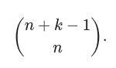
//*** stirling number first kind = box! * stirling number second kind(not 100% sure)
//Game Theory grandy number = mex{ for all reachables x from this state, grandy(x) }
// Pick’s Theorem
Area of a polygon, A = i + (b / 2) - 1
Where, i = number of points inside the polygon, b = number of points on the boundary
//Catalan number
N-th term = 2nCn / (n + 1) = 2nCn - 2nC(n+1)
1, 2, 5, 14, 42 …
// #python demo code
def solve(ct):
a, b = map(int, input().split())
tmp = a
mm = {}
nn = {}
for i in range(2, int(a**0.5) + 1):
while a % i == 0:
a //= i
if i in mm:
mm[i] += 1
else:
mm[i] = 1
if a > 1:
mm[a] = 1
nn = mm.copy()
for key, value in mm.items():
mm[key] = value * b
ans = []
prod = 1
for value in mm.values():
prod *= (value + 1)
for key, value in mm.items():
sum_value = (value * (value + 1)) // 2
baki = prod // (value + 1)
sum_value *= baki
ans.append(sum_value // nn[key])
ans.sort()
print(ans[0] % mod)
def main():
t = 1
# t = int(input())
for ct in range(1, t+1):
solve(ct)
if __name__ == "__main__":
mod = 998244353
main()
::::::::::::::
Sum of n odd numbers = n^2
Sum of n even numbers = n(n+1)
Sum of geometric series
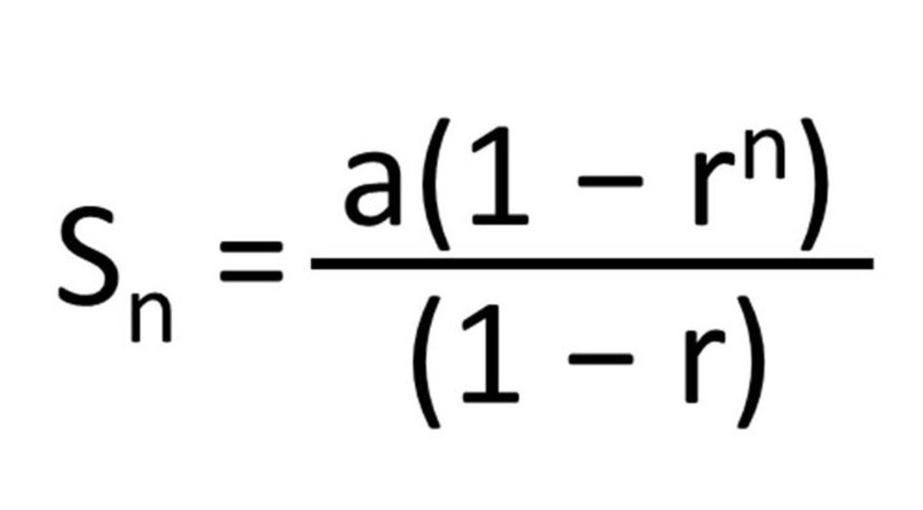
//assign x[n]=x[0] and y[n]=y[0] and increase n to n+1 before calling..
long double polygonArea(int x[],int y[],int n)
{
int area = 0;
for(int i=0;i<n;i++) {
area += x[i]*y[i+1]-x[i+1]*y[i];
}
long double ar = area;
ar/=2;
return ar;
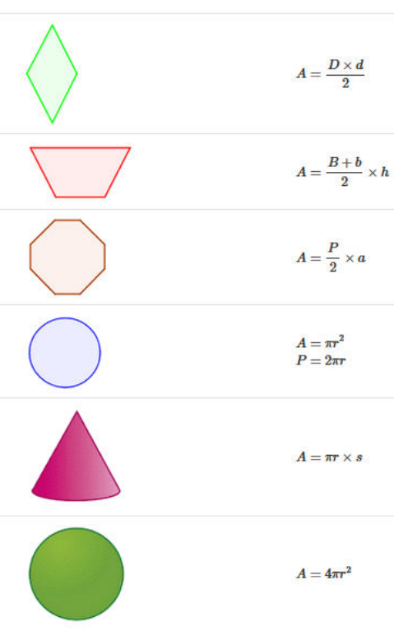
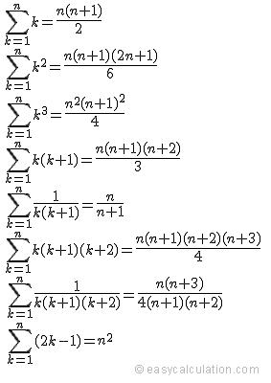***Binary Decomposition***
vector<int> decompose(int c){
vector<int> ans;
for(int i = 1; c; i <<= 1){
ans.push_back(min(c, i));
c -= ans.back();
}
return ans;
}
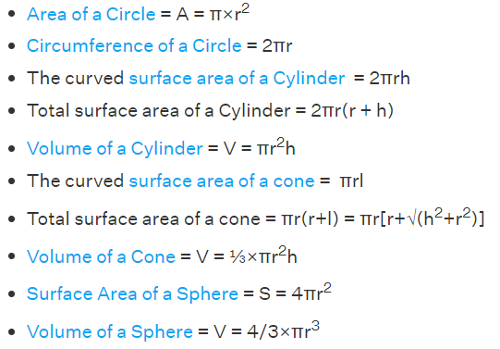
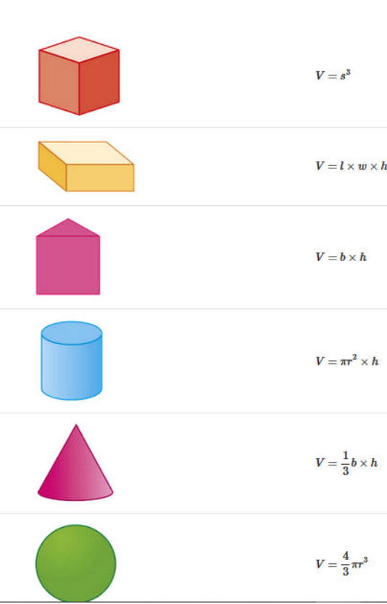
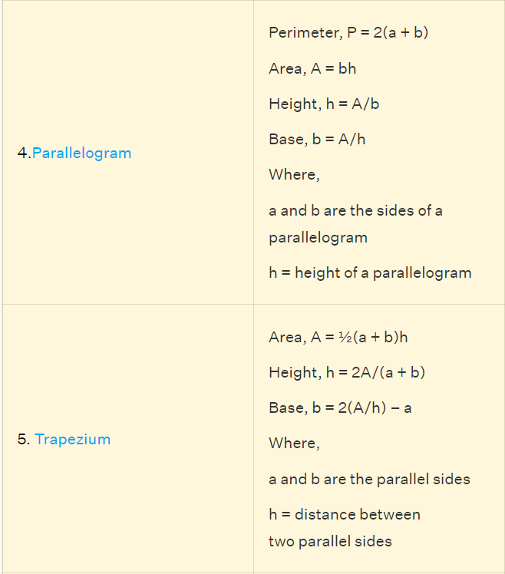

//***Egg Dropping DP***
int minTrials(int n, int k){
// Initialize array of size (n+1) and m as moves.
int dp[n + 1] = { 0 }, m;
for (m = 0; dp[n] < k; m++) {
for (int x = n; x > 0; x--) {
dp[x] += 1 + dp[x - 1];
}
}
return m;
}
/* Driver code */
int main(){
int n = 2, k = 36;
cout << "Minimum number of trials "
"in worst case with "
<< n << " eggs and " << k << " floors is ";
cout << minTrials(2, 36);
return 0;
}
// *** floyd warshal ***
vector<vector<ll>> dist(N, vector<ll>(N));
ll n, m, q;
void floyd_warshall() {
for(ll k = 1; k <= n; k++) {
for(ll i = 1; i <= n; i++) {
for(ll j = 1; j <= n; j++) {
dist[i][j] = min(dist[i][j], dist[i][k] + dist[k][j]);
}
}
}
}
void calculate() {
for(ll i = 1; i <= n; i++) {
for(ll j = 1; j <= n; j++) {
if(i == j) dist[i][j] = 0;
else dist[i][j] = INF;
}
}
for(ll i = 1; i <= m; i++) {
ll x, y, w;
cin >> x >> y >> w;
dist[x][y] = min(dist[x][y], w);
dist[y][x] = min(dist[y][x], w);
}
floyd_warshall();
}
*** FFT multiply ***
using cd = complex<double>;
const double PI = acos(-1);
void fft(vector<cd> &p, bool flg){
int n = p.size();
if(n == 1)return;
vector<cd> pe(n / 2), po(n / 2);
for(int i = 0; i < n / 2; i++){
pe[i] = p[2 * i];
po[i] = p[2 * i + 1];
}
fft(pe, flg);
fft(po, flg);
double ang = (flg ? -1 : 1) * 2 * PI / n;
cd w(1), wd(cos(ang), sin(ang));
for(int i = 0; i * 2 < n; i++){
p[i] = pe[i] + w * po[i];
p[i + n / 2] = pe[i] - w * po[i];
if(flg){
p[i] /= 2;
p[i + n / 2] /= 2;
}
w *= wd;
}
}
vector<int> mult(vector<int> &a, vector<int> &b){
vector<cd> fa(a.begin(), a.end()), fb(b.begin(), b.end());
int n = 1;
while(n < a.size() + b.size())n <<= 1;
fa.resize(n);
fb.resize(n);
fft(fa, false);
fft(fb, false);
for(int i = 0; i < n; i++)fa[i] *= fb[i];
fft(fa, true);
vector<int> res(n);
for(int i = 0; i < n; i++)res[i] = round(fa[i].real());
return res;
}
// Custom set
struct cmp {
bool operator() (int a, int b) const {
return a < b;
}};
// Custom map
struct mydata{
int a, b;
};
struct cmp{
bool operator() (const mydata& lhs, const mydata& rhs) const
{
return lhs.a > rhs.a;
}};
map<mydata, int, cmp> mp;
// Bitset functions
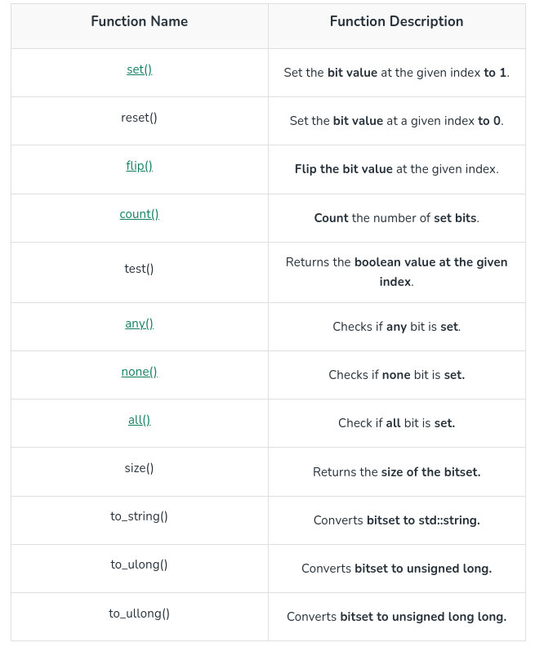
Bit functions
1. __builtin_popcount(x)
This function is used to count the number of one’s(set bits) in an integer.
2 . __builtin_parity(x)
This function is used to check the parity of a number. This function returns true(1) if the number has odd parity else it returns false(0) for even parity.
3.__builtin_clz(x)
This function is used to count the leading zeros of the integer.
4.__builtin_ctz(x)
This function is used to count the trailing zeros of the given
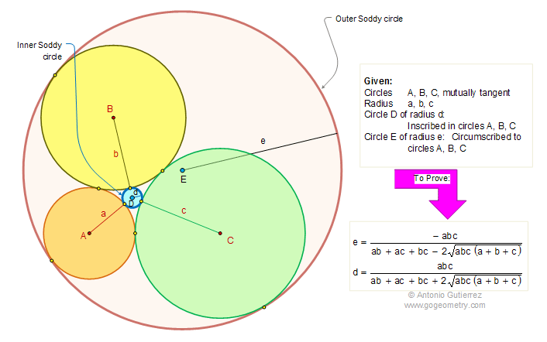
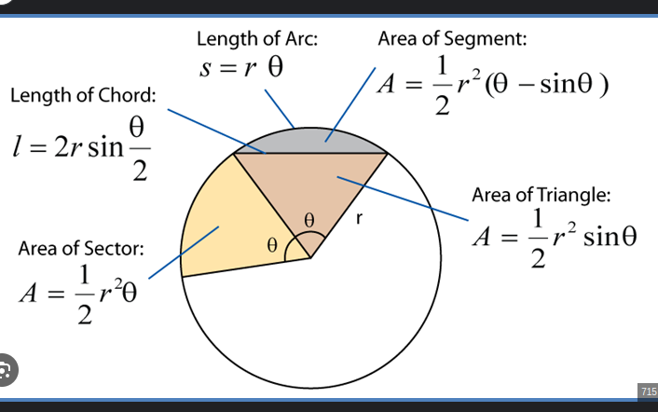
3.If 3 medians given then, the area of the triangle will be
Area = 4/3*sqrt(s*(s-a)*(s-b)*(s-c)))
// Random test case generator
freopen("input.txt", "w", stdout);
mt19937 rng(chrono::steady_clock::now().time_since_epoch().count());
#define rng(x,y) uniform_int_distribution<int>(x,y)(rng)

void print_array_randomly(vector<int> a){
while(a.size()) {
int x = rng(0, (int)a.size() - 1);
cout << a[x] << " ";
a.erase(a.begin() + x);
}
cout << endl;
}
// Lamda function
function<void(int,int)> x = [&] (int x, int y){
return 1;
};
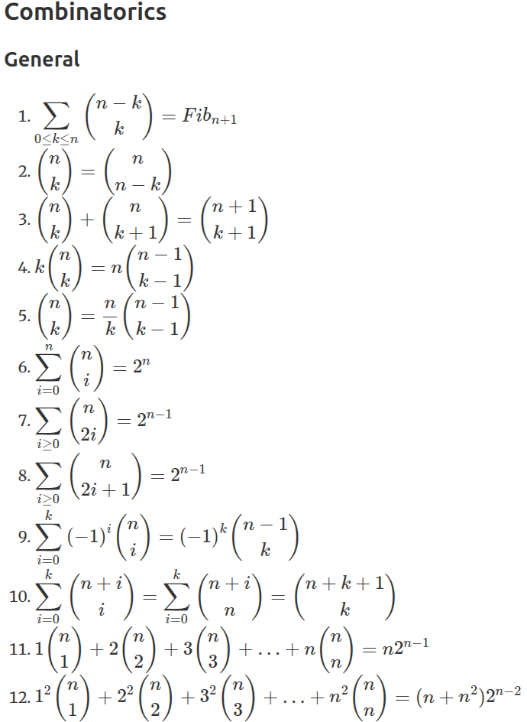
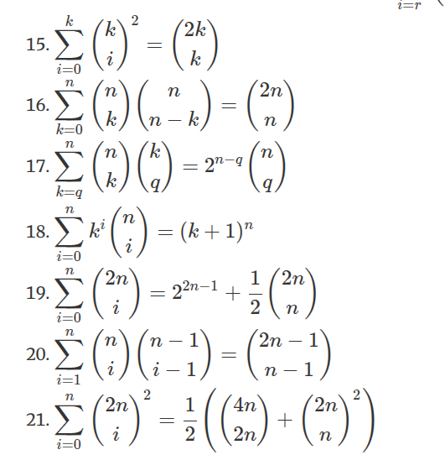
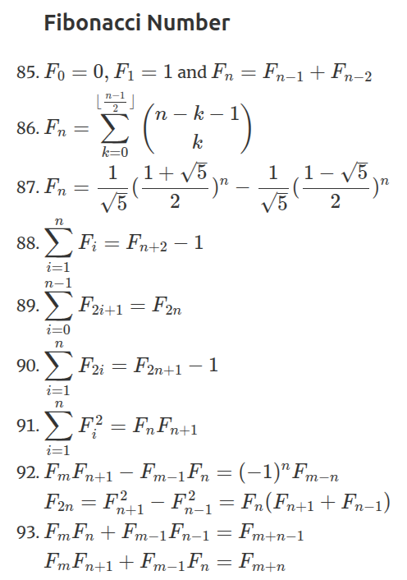
⭐ Pair forming LCM
ans = 0
i = 1...n
j = i...n
if (LCM(i, j) == n)
ans++;
equation: n/2 * (1 + (2*e1 + 1) * (2*e2 + 1) *...)
⭐ GCD Extreme
ans = 0
i = 1...N
j = i+1 ... N
ans += gcd(i, j)
equation: sum of d * phi(N/d)
⭐ LCM Extreme
ans = 0
i = 1...n
j = i+1 ... n
ans += lcm(i, j);
equation: n/2 * (1 + sum of (phi(d) * d) of all)
d means divisors of n
⭐ LCM Sum
ans = 0
i = 1...N
ans += lcm(i, N)
equation: n/2 * (1 + sum of (phi(d) * d) of all)
GCD and LCM
