VERIFIED RESULTS REPORT
RevGround Held-out TEST-197 / TEST-168
Human reliability, adjudicated lifecycle prevalence, and B/C evaluator comparison
Field | Value
Status | Verified; all reported TEST-set quantities recomputed
Audit date | 29 September 2026
Source partition | 197 transitions
Analytic cohort | 168 frozen claim-bearing packets
Provider calls | 0 during verification

Verdict: No false quantitative TEST-set result was detected. The model-specific paired effects are small and point in opposite directions; the supported conclusion is no consistent directional advantage, not statistical equivalence.

1. Cohort and provenance
The report uses TEST-197 for the frozen source partition and TEST-168 for the final claim-bearing analytic cohort. Keeping these names distinct avoids implying that all 197 source transitions received human labels or model decisions.
Stage | Count | Boundary
Source TEST partition | 197 | Frozen test transitions
Confirmed C | 188 | Nine objective language exclusions
Stage-A calls | 190 | 50 historical Batch 1 + 140 Batch 2
Accepted hints | 170 | Twenty preserved Stage-A failures
Final analytic cohort | 168 | 3 problems, 49 trajectories, 42 participants
Locked state replays | 252 | S_t and S_t+1 for 126 new packet cases
Source: frozen cohort profile, packet manifest, screening ledger, and integrity summary.

2. Human annotation reliability
Field | Agreement | Raw agreement | Cohen kappa
Original validity | 161/168 | 95.83% | 0.2170
Target state at t+1 | 145/168 | 86.31% | 0.7249
Lifecycle label | 145/168 | 86.31% | 0.7249
Instructional priority | 144/168 | 85.71% | 0.7117
Pre-adjudication A01/A02 agreement; kappa is unweighted.
All four core fields agreed jointly on 144/168 cases. The 24 unique disagreement cases comprise 23 lifecycle disagreements and one priority-only disagreement.

2.1 Final adjudicated gold
Label | Count | Share | Meaning
KEEP | 100 | 59.52% | Claim remains active
RETIRE | 65 | 38.69% | Supported claim resolved
RETRACT | 3 | 1.79% | Original claim not supported
UNSURE | 0 | 0.00% | Indeterminate
Among 165 hints supported at generation time, 65 were resolved by the next observed revision (39.39%).
Adjudication freeze: All 24 disagreement cases are present in the final JSON and JSONL exports, all required fields are populated, all evidence references are valid, and the blind packet remains unchanged.

3. Frozen primary matrix and predeclared recovery
The primary matrix is complete: 4 frozen model-condition runs and 672 first attempts. Primary files were not overwritten by recovery.
Model | Cond. | Primary 429 | Recovery calls | Accepted | Errors
DeepSeek V4.1 Flash | B | 90 | 90 | 83 | 7
DeepSeek V4.1 Flash | C | 53 | 53 | 24 | 29
Qwen3.8-27B | B | 51 | 51 | 28 | 23
Qwen3.8-27B | C | 27 | 27 | 8 | 19
Recovery policy: exactly one call per primary HTTP 429; 20 seconds between calls, 90 seconds after another 429; no retry or fallback; non-429 failures excluded.

4. Post-recovery model results
Model | Cond. | Usable | Abstain | Decisions | Correct | Accuracy
DeepSeek | B | 154 | 0 | 154 | 146/154 | 94.81%
DeepSeek | C | 135 | 3 | 132 | 127/132 | 96.21%
Qwen | B | 136 | 0 | 136 | 133/136 | 97.79%
Qwen | C | 141 | 4 | 137 | 132/137 | 96.35%
Decision accuracy is calculated on non-abstaining outputs under the frozen shared evaluator. Condition B is normalized as non-abstaining because it has no selective-decision field.

4.1 Safety-relevant lifecycle errors
Model | Cond. | False KEEP | KEEP recall | Wrongful removal | RETRACT recall
DeepSeek | B | 1/68 | 87/100 | 6/100 | 3/3
DeepSeek | C | 0/68 | 73/100 | 5/100 | 3/3
Qwen | B | 0/68 | 78/100 | 3/100 | 2/3
Qwen | C | 1/68 | 76/100 | 4/100 | 2/3

5. Paired common-decision comparison
Model | Paired n | Condition B | Condition C | C - B
DeepSeek V4.1 Flash | 124 | 117/124 (94.35%) | 119/124 (95.97%) | +1.61 pp
Qwen3.8-27B | 115 | 113/115 (98.26%) | 111/115 (96.52%) | -1.74 pp
Descriptively aggregating the model-specific paired sets gives 239 model-case comparisons. B and C are each correct on 230/239 (96.23%). Both conditions are simultaneously correct on 228 comparisons.
Each condition produces one false KEEP and eight wrongful removals in the descriptive aggregate. Because model-specific paired subsets differ and cases are clustered, this is not a formal pooled estimator.
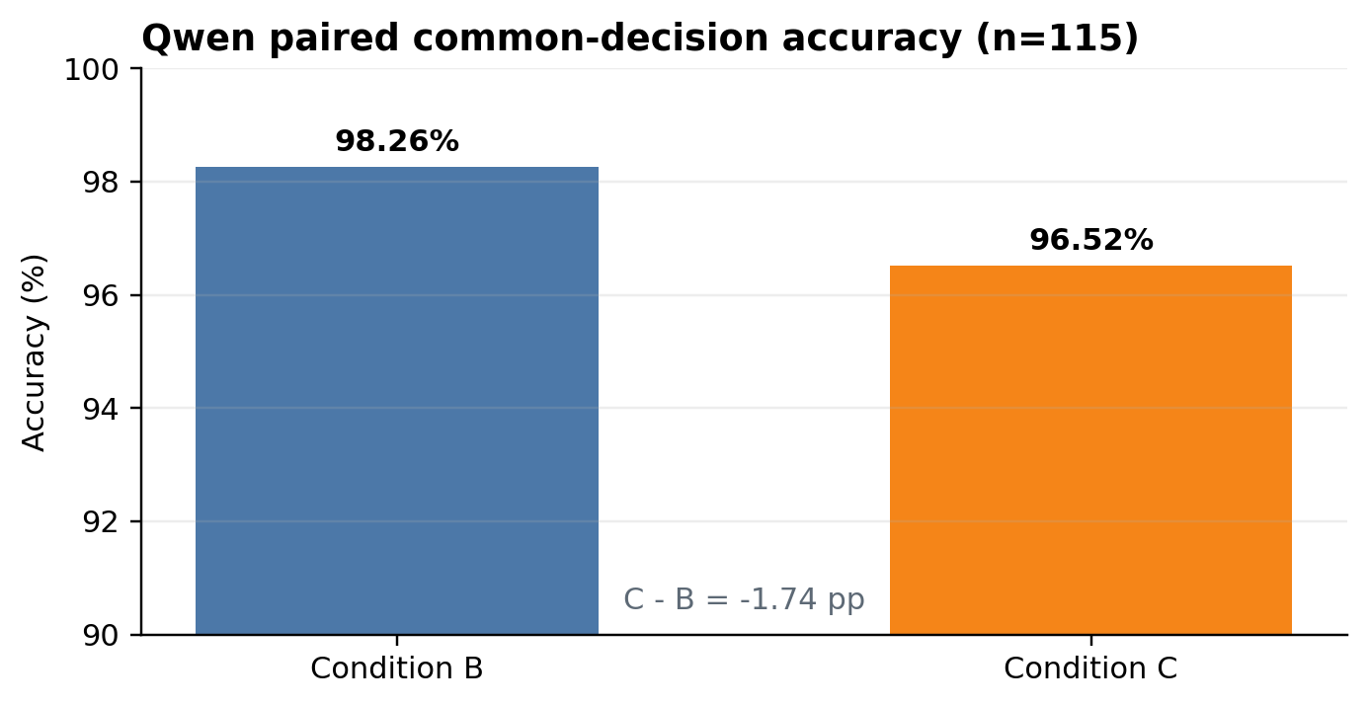
Figure 1. Qwen paired common-decision accuracy. The paired subset contains 115 cases.
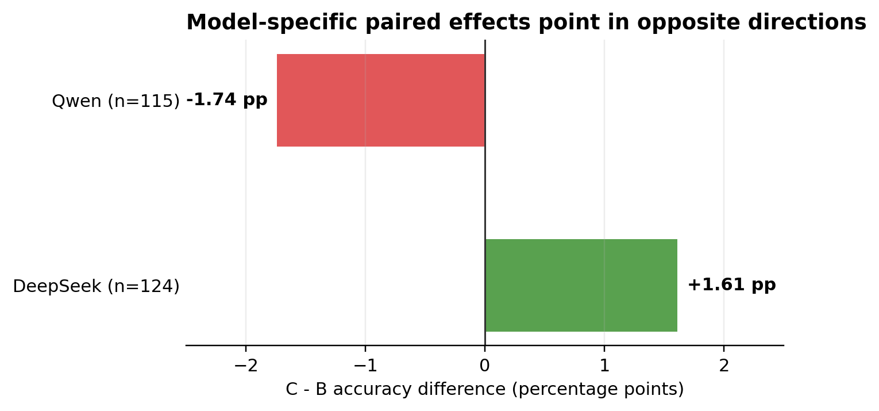
Figure 2. Cross-model paired C-B effect. Positive values favor C; negative values favor B.

6. Interpretation and reporting boundary
Supported conclusion: On the natural held-out cohort, explicit lifecycle structuring does not yield a consistent accuracy advantage over the matched-evidence auditor. DeepSeek moves modestly toward C; Qwen moves modestly toward B.
The paired point estimates are descriptive. No paired confidence interval, equivalence test, or null-hypothesis test is included, so the report does not claim statistical equivalence or proof of no effect.
Rare-label inference remains limited because the natural gold contains only three RETRACT and no UNSURE cases. Controlled Stress-20 results should remain in a separate diagnostic section and must not alter natural prevalence estimates.
Operational coverage and decision quality are distinct. Provider failures remain retained in the ledgers, while accepted explicit abstentions are excluded from decision-accuracy denominators under the frozen evaluator.

7. Reproducibility map
Artifact | Repository path
Human exports | results/heldout_test_197/annotations_frozen_v1/
Blind adjudication packet | results/heldout_test_197/adjudication_24_blind_v1/
Final adjudication | results/heldout_test_197/adjudication_24_final_v1/
Primary and recovery ledgers | results/heldout_test_197/evaluations/
Machine-readable audit | results/heldout_test_197/analysis/verified_test_results.json
Recomputation script | scripts/audit_heldout_test197_results.py
All reported values in this report are generated from the machine-readable audit output. No model predictions were exposed to the adjudicator packet.

