
DEPARTMENT OF INFORMATION TECHNOLOGY
24ITT32 – PROGRAMMING IN JAVA
INDIVIDUAL PROJECT ON
ACADEMIC MANAGEMENT SYSTEM

PROJECT REPORT
Submitted by
TAMILMALAR S
25ITR154

JAVA ASSIGNMENT
AIM:
To develop a Java-based Student Academic and Continuous Evaluation System for Kongu Engineering College (Autonomous), Regulation 2024, using JDBC and MySQL.
OBJECTIVE:
The objective of this project is to maintain student and course details in a database and support academic operations through a menu-driven Java application. It records course enrolments, attendance, continuous internal assessment marks and end-semester examination details. The stored information can be used to prepare semester mark sheets, identify attendance shortages and view department-wise performance.
FLOW CHART:
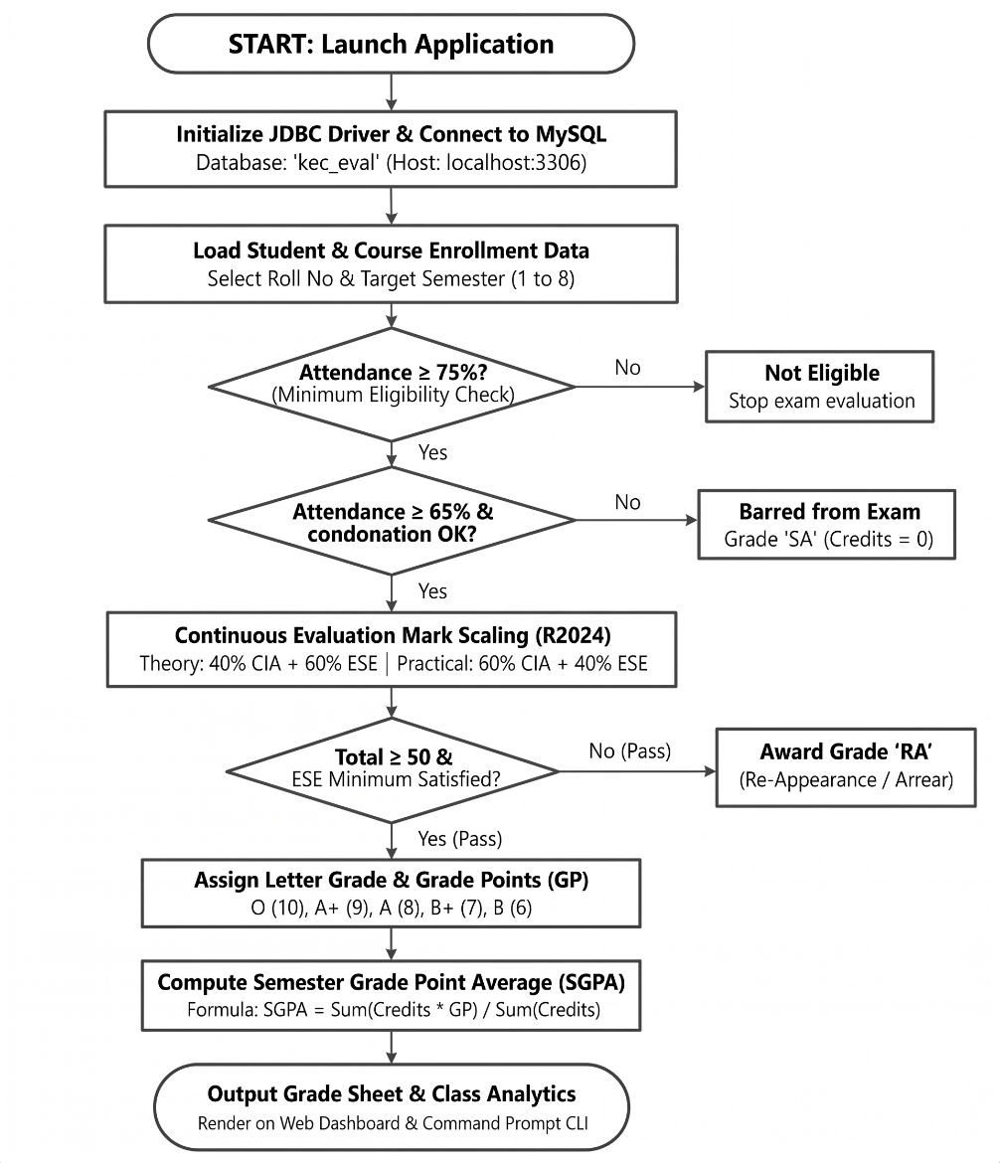
Figure 1. General flow of the academic evaluation application.

PROCEDURE:
1. Compile the Java source files with the MySQL Connector/J library available in the project classpath.
2. Configure the database connection for the local MySQL server and select the kec_eval_db database.
3. Create and verify the students, courses, enrollments and assessment_marks tables.
4. Run the Java application and confirm that the database connection is established before using the menu.
5. Register student details with roll number, name, department and current semester. Add course details with course code, title, credits and course type.
6. Enroll students in courses and maintain the number of classes held and classes attended.
7. Enter CIA, assignment/quiz/laboratory and ESE details against the relevant course enrolment.
8. Use the report options to display student semester marks, attendance defaulters and department-wise performance.
9. Verify stored records through SQL SELECT queries and compare the displayed information with the database values.
SOFTWARE REQUIREMENTS:
- Java Development Kit (JDK)
- MySQL Server and MySQL command-line client
- MySQL Connector/J JDBC driver
- Ubuntu Linux terminal
DATABASE USED:
Database name: kec_eval_db

DATABASE SCHEMA:
The application stores its information in four related tables. The following fields were verified from the MySQL database used for the output screenshots.
1. STUDENTS TABLE:
roll_no VARCHAR(15) PRIMARY KEY
name VARCHAR(100) NOT NULL
department VARCHAR(60) NOT NULL
current_semester INT NOT NULL
created_at TIMESTAMP
2. COURSES TABLE:
course_code VARCHAR(15) PRIMARY KEY
title VARCHAR(150) NOT NULL
credits INT NOT NULL
course_type VARCHAR(20) NOT NULL
created_at TIMESTAMP
3. ENROLLMENTS TABLE:
enrollment_id INT PRIMARY KEY, AUTO_INCREMENT
student_roll_no VARCHAR(15) NOT NULL
course_code VARCHAR(15) NOT NULL
semester INT NOT NULL
classes_held INT DEFAULT 0
classes_attended INT DEFAULT 0
medical_condonation TINYINT(1) DEFAULT 0
enrolled_at TIMESTAMP
4. ASSESSMENT MARKS TABLE:
mark_id INT PRIMARY KEY, AUTO_INCREMENT
enrollment_id INT UNIQUE
cia1 DECIMAL(5,2)
cia2 DECIMAL(5,2)
assignment_quiz_lab DECIMAL(5,2)
ese DECIMAL(5,2)
is_absent_ese TINYINT(1) DEFAULT 0
updated_at TIMESTAMP
The enrollment table connects student and course records. Assessment marks are associated with an enrolment through enrollment_id.

SOURCE CODE:
DBCONNECTION.JAVA:
import java.sql.Connection;
import java.sql.DriverManager;
import java.sql.SQLException;
public final class DBConnection {
private static final String DEFAULT_URL =
"jdbc:mysql://localhost:3306/kec_eval_db"
+ "?allowPublicKeyRetrieval=true&useSSL=false"
+ "&serverTimezone=Asia/Kolkata";
private DBConnection() { }
public static Connection getConnection() throws SQLException {
String url = System.getenv().getOrDefault(
"KEC_EVAL_DB_URL", DEFAULT_URL);
String user = System.getenv().getOrDefault(
"KEC_DB_USER", "kec_app");
String password = System.getenv().getOrDefault(
"KEC_DB_PASSWORD", "");
return DriverManager.getConnection(url, user, password);
}
}
The connection helper reads credentials from environment variables so that the database password does not need to be stored in the source code.

SOURCE CODE:
STUDENTDAO.JAVA – STUDENT RECORD OPERATIONS:
// Representative database operation using the project schema.
String sql = "INSERT INTO students " +
"(roll_no, name, department, current_semester) " +
"VALUES (?, ?, ?, ?)";
try (Connection con = DBConnection.getConnection();
PreparedStatement ps = con.prepareStatement(sql)) {
ps.setString(1, rollNo);
ps.setString(2, name);
ps.setString(3, department);
ps.setInt(4, semester);
return ps.executeUpdate() == 1;
}
COURSE RECORD FIELDS:
course_code
title
credits
course_type
created_at
Prepared statements are used for parameterised database operations. Student records are identified by roll_no and course records by course_code.

SOURCE CODE:
MAINAPP.JAVA – MENU AND REPORT OPERATIONS:
// Menu handler excerpt
private static void handleViewStudents() {
System.out.println("--- Registered Students List ---");
List<StudentDAO.Student> students = studentDAO.getAllStudents();
if (students.isEmpty()) {
System.out.println("[INFO] No students found in the database.");
return;
}
for (StudentDAO.Student s : students) {
System.out.printf("%s | %s | %s | Sem %d%n",
s.getRollNo(), s.getName(),
s.getDepartment(), s.getCurrentSemester());
}
System.out.println("Total Students: " + students.size());
}
ATTENDANCE REPORT QUERY:
SELECT e.student_roll_no, s.name, e.course_code,
e.semester, e.classes_held, e.classes_attended,
CASE WHEN e.classes_held = 0 THEN 0
ELSE ROUND(e.classes_attended * 100.0 /
e.classes_held, 2)
END AS attendance_percentage
FROM enrollments e
JOIN students s ON e.student_roll_no = s.roll_no
LIMIT 10;
The report queries join the related tables so that student names can be displayed alongside enrolment and assessment details.

DATABASE OUTPUT SCREENSHOTS:
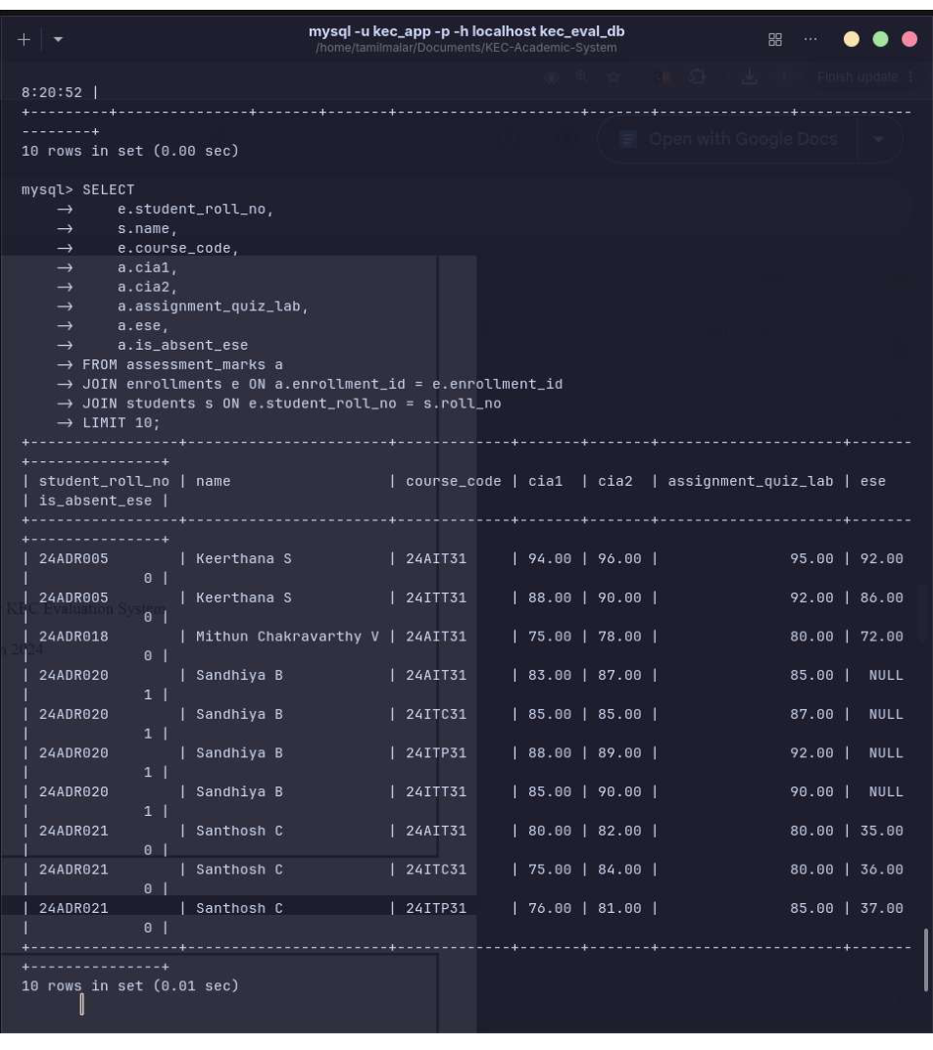
Figure 2. Assessment marks joined with student and course details.

ASSESSMENT MARKS – QUERY OUTPUT
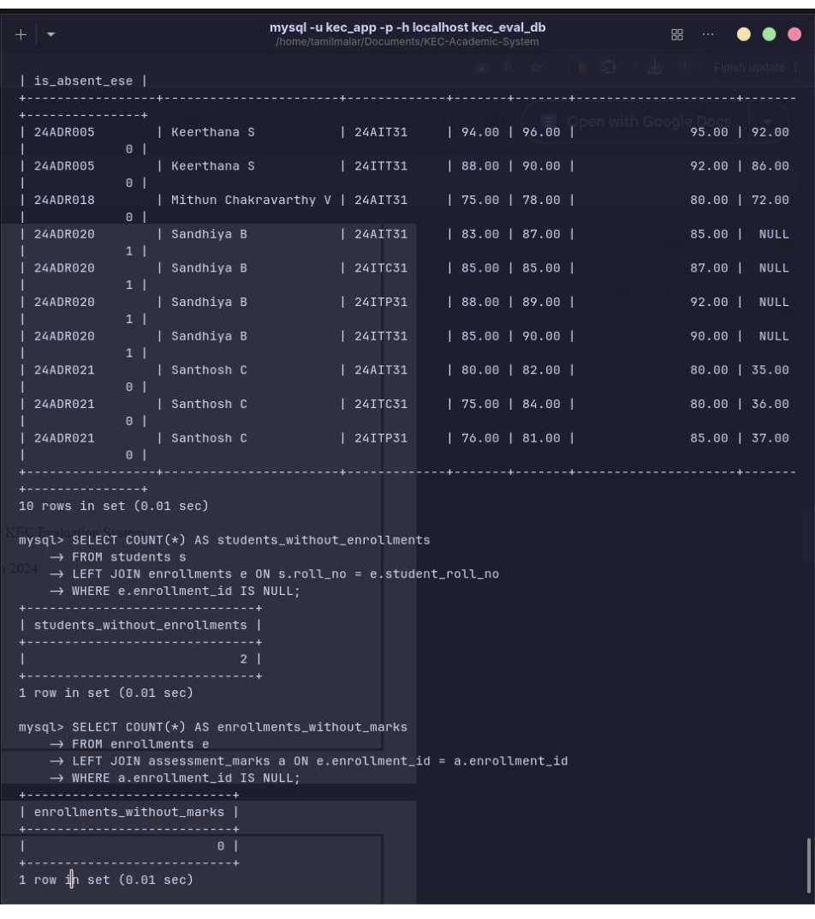
Figure 3. Remaining assessment records and enrolment checks.

ENROLMENT AND ASSESSMENT RECORDS
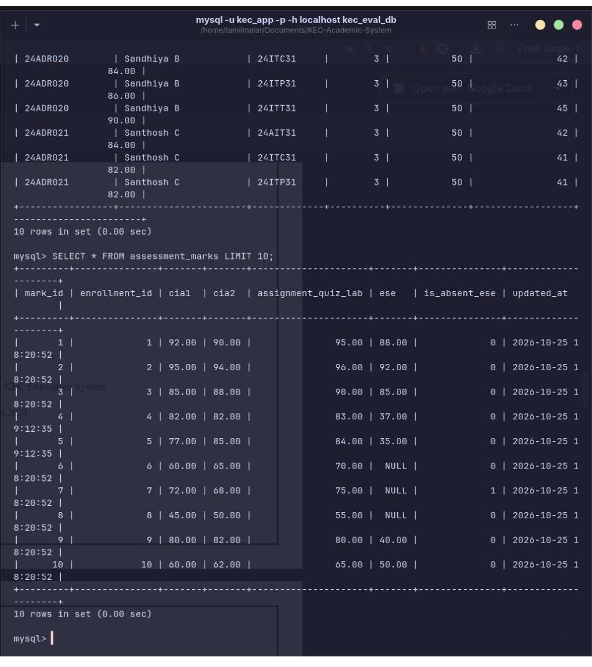
Figure 4. Enrolment and assessment table contents.

DATABASE COUNTS AND ENROLMENT DETAILS
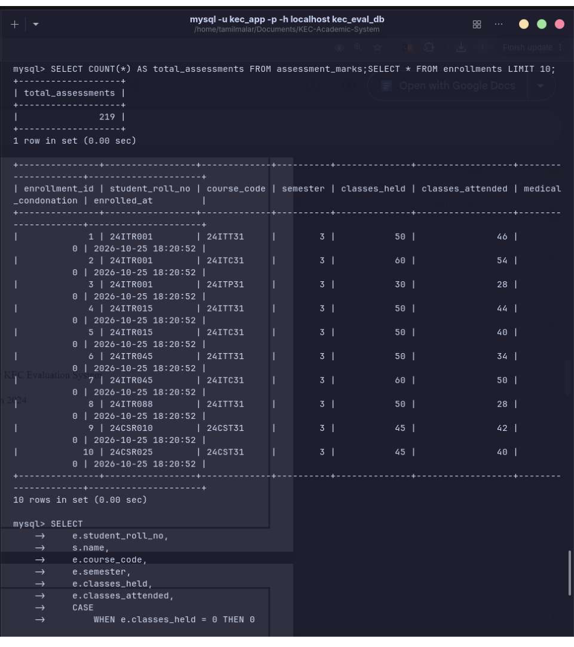
Figure 5. Record counts and enrolment information.

ATTENDANCE PERCENTAGE REPORT
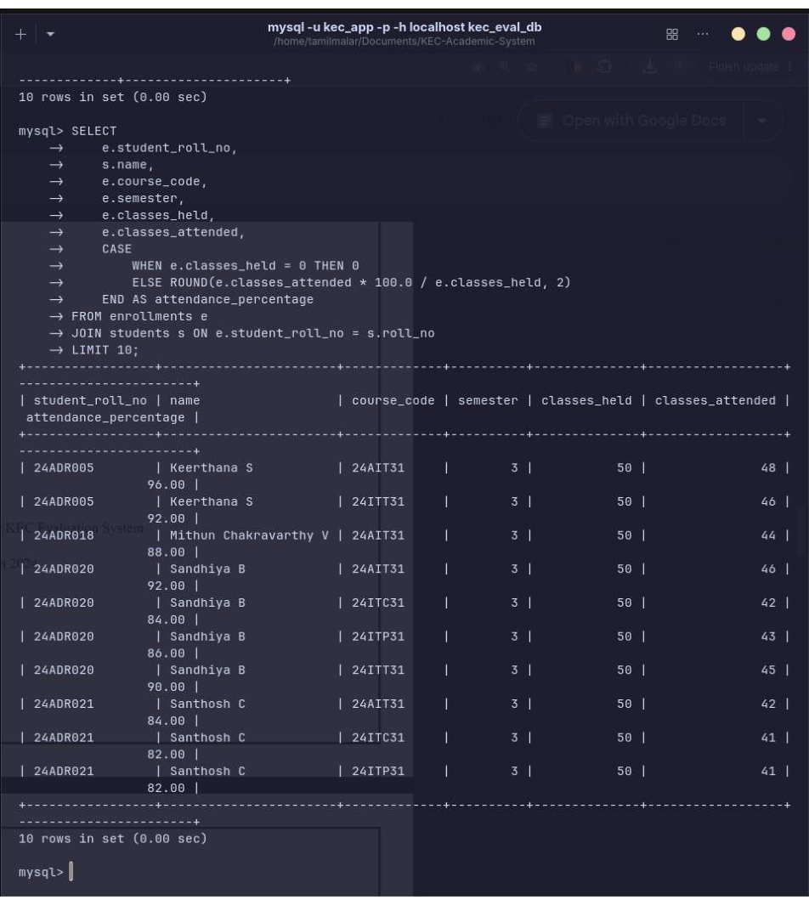
Figure 6. Attendance percentage calculated from classes held and attended.

STUDENT AND COURSE RECORDS
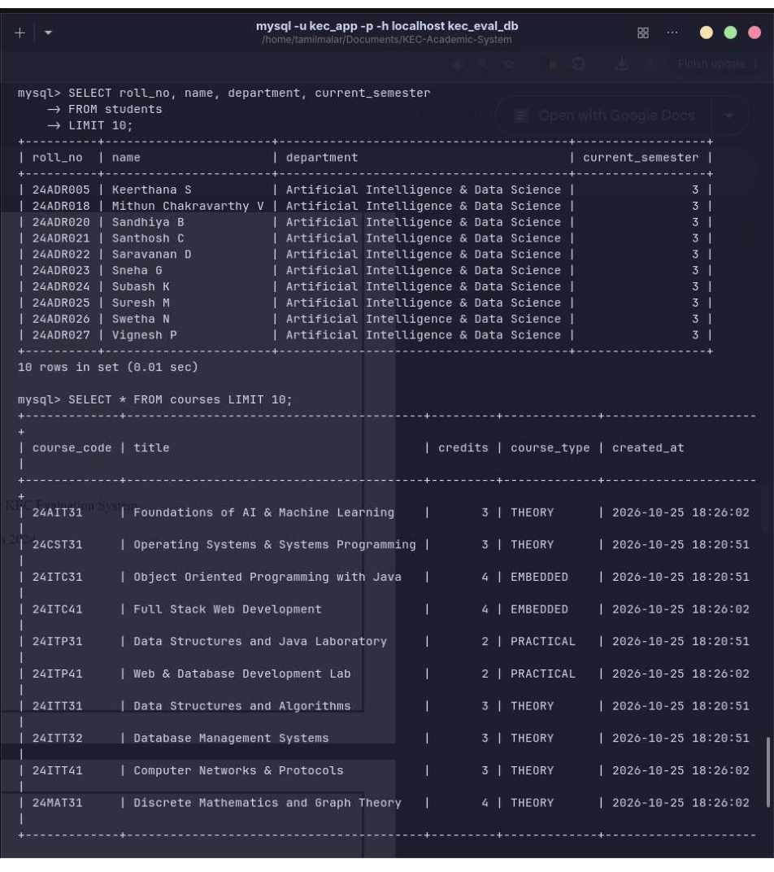
Figure 7. Student and course records retrieved from MySQL.

STUDENT / COURSE / ENROLMENT COUNTS
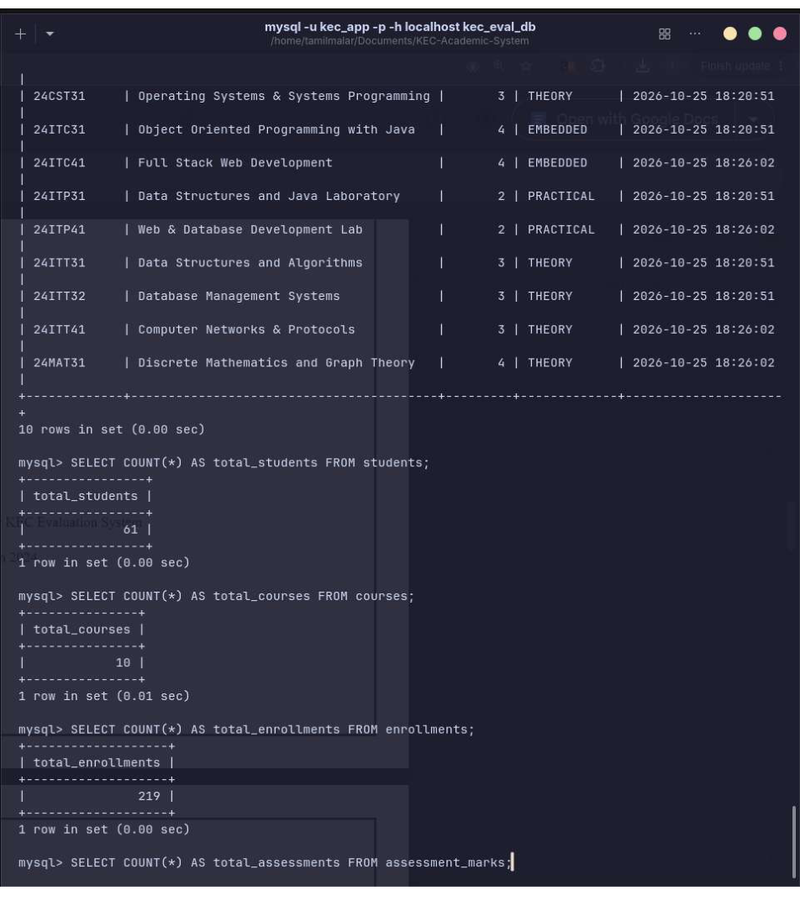
Figure 8. Verified database totals shown in the terminal.

ENROLMENT AND ASSESSMENT TABLE OUTPUT
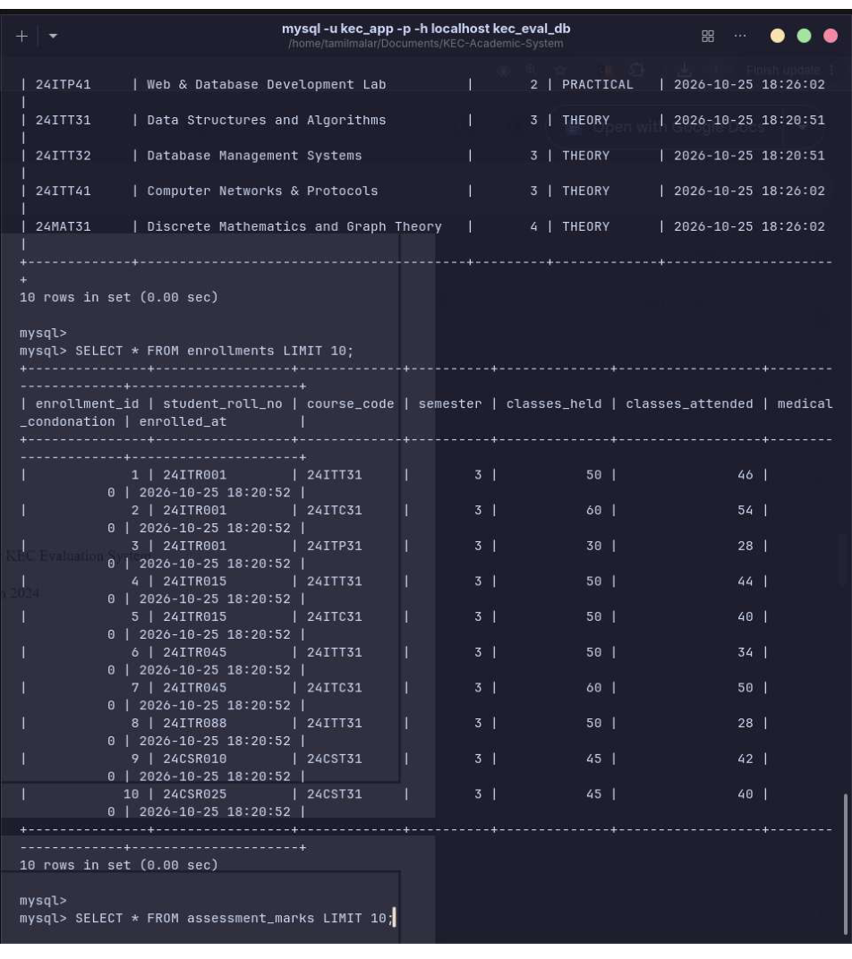
Figure 9. Enrolment and assessment table verification.

RESULT:
Thus, the Student Academic and Continuous Evaluation System for Kongu Engineering College (Autonomous), Regulation 2024, was implemented using Java, JDBC and MySQL. The database output screenshots show student and course records, enrolments, assessment marks, attendance calculations and record-count verification.
The tables used in the database are students, courses, enrollments and assessment_marks. The application can use these records to support student academic data management and evaluation reports.

OUTPUT VERIFICATION:
- Student records were retrieved using the roll_no, name, department and current_semester fields.
- Course records were retrieved using course_code, title, credits and course_type.
- Enrolment and assessment rows were displayed through SQL queries.
- The screenshots show 61 student records, 10 course records and 219 enrolment records at the time of capture.
Note: The figures above reflect the database state visible in the supplied screenshots; they may change if records are added or removed.

REFERENCES:
1. Oracle, Java SE Documentation – JDBC Basics. https://docs.oracle.com/javase/tutorial/jdbc/
2. Oracle, Java Platform Documentation. https://docs.oracle.com/en/java/
3. MySQL, MySQL 8.4 Reference Manual. https://dev.mysql.com/doc/refman/8.4/en/
4. MySQL, MySQL Connector/J Developer Guide. https://dev.mysql.com/doc/connector-j/en/
5. Kongu Engineering College (Autonomous), academic and course information.
6. Project database verification outputs captured from the local kec_eval_db MySQL database on 25 October 2026.
GITHUB:
Repository: https://github.com/Tamzz30/KEC-R2024-Student-Evaluation-System
Before submission, confirm that the repository URL is accessible and contains the final project files. Do not upload database passwords or other credentials.

