What Really Drives Calories Burned During Exercise?
A data-science project: research question, data cleaning, exploratory analysis and preprocessing in R
Student name: ____________________
Course / Instructor: ____________________
Date: 5 November 2026
Deliverables: this report and the R script calories_project.R
Summary
I wanted to know which things about a person and their workout actually determine how many calories they burn. I merged two files into 15,000 exercise sessions, checked them for quality problems, explored them with statistics and plots, and prepared them for a future modeling stage. The data are clean, but two of my own early assumptions turned out to be wrong. First, the 369 unusual body-temperature readings that a standard outlier rule flags are not errors; they are the first minutes of exercise, so I kept them. Second, age looked almost irrelevant at first (r = 0.15), yet once session length is held roughly constant it is clearly important (r = 0.56). The report explains each decision and ends where modeling would begin.

1. Topic and Research Question
I chose exercise and health because everyone has an intuition about it: a longer workout burns more, a heavier person burns more, a harder workout burns more. I wanted to see which of those intuitions survive contact with real numbers, and which do not.
Research question: Which characteristics of a person (age, sex, height, weight) and of their exercise session (duration, heart rate, body temperature) are most strongly associated with the number of calories burned, and how should the data be prepared so that calorie expenditure could be predicted in a later modeling stage?
The question has two parts on purpose. The first part is exploratory (what is related to what, and how strongly). The second part is about preprocessing (what must be done to the data so that a model could use it fairly). Both parts can be answered without building a model, which is where this project stops.
Before looking at any data I wrote down what I expected: (1) duration would be the biggest driver; (2) heavier and taller people would burn more calories; (3) men would burn more than women; (4) age would matter little. The report returns to these expectations in Section 6.

2. The Dataset

2.1 Source and structure
The data come from a Kaggle dataset shared by the user “fmendes” (the link is in DataSetLink.txt: kaggle.com/datasets/fmendes/fmendesdat263xdemos). It consists of two CSV files that describe the same 15,000 people:
- calories.csv: 2 columns (User_ID, Calories), 15,000 rows.
- exercise.csv: 8 columns (User_ID, Gender, Age, Height, Weight, Duration, Heart_Rate, Body_Temp), 15,000 rows.
Each row is one exercise session by one person, identified by User_ID. The two files must be joined on that key to link the characteristics of a session to the calories it burned.
Table 1. Variables in the merged dataset
Variable | Type | Meaning and unit
User_ID | Integer (identifier) | Unique ID of the person
Calories | Numeric | Calories burned in the session (presumably kcal) – the outcome of interest
Gender | Categorical | male / female
Age | Integer | Age in years (20–79)
Height | Numeric | Height in cm
Weight | Numeric | Weight in kg
Duration | Numeric | Length of the session in minutes (1–30)
Heart_Rate | Numeric | Heart rate during the session, beats per minute
Body_Temp | Numeric | Body temperature during the session, °C

2.2 Why this dataset suits the question
The dataset contains exactly what the question asks about: a measured outcome (Calories) alongside personal characteristics and session measurements. It is large (15,000 rows), so patterns are not driven by a few people. It mixes numeric and categorical variables, which gives a real reason to practise encoding and scaling. It also has no missing values, which let me concentrate on more subtle quality questions (outliers, redundancy between variables) instead of only filling gaps.
There is an important caveat that I describe in Section 6: the data are very regular, which suggests they may be simulated or heavily processed rather than raw measurements from a gym.

3. Data Inspection and Cleaning

3.1 Merging the two files
Before merging I checked that User_ID could safely be used as a key. There are no duplicated IDs in either file, and both files contain exactly the same set of IDs. A one-to-one merge therefore loses no one and creates no duplicate rows. The result has 15,000 rows and 9 columns.

3.2 Missing values, duplicates and data types
- Missing values: none in any column, so no imputation was needed.
- Duplicates: no duplicated User_IDs. Ignoring the ID, one pair of rows is identical in every measurement (a 28-year-old woman, 164 cm, 59 kg, 9 minutes, heart rate 90, temperature 39.5, 40 calories). They have different IDs and the values are ordinary, so with 15,000 records and fairly coarse measurements a coincidence is plausible. I kept both rows rather than delete a real person.
- Inconsistent entries: Gender contains only “male” (7,447) and “female” (7,553), with no spelling variants or mixed capitalisation.
- Data types: all numeric columns were already numeric. Gender was stored as text, so I converted it to a factor with “female” as the first level.

3.3 Are any values impossible?
A value can be statistically unusual and still be believable, or it can be impossible (a negative duration, a heart rate of 400). I tested each variable against generous physical limits to separate those two situations.
Table 2. Plausibility check
Variable | Observed min | Observed max | Limits I allowed | Violations
Age | 20 | 79 | 18 – 100 | 0
Height (cm) | 123 | 222 | 100 – 230 | 0
Weight (kg) | 36 | 132 | 30 – 250 | 0
Duration (min) | 1 | 30 | 0.5 – 300 | 0
Heart rate (bpm) | 67 | 128 | 40 – 220 | 0
Body temp (°C) | 37.1 | 41.5 | 35 – 43 | 0
Calories | 1 | 314 | 0 – 5000 | 0

Every value lies inside the allowed limits, so there are no data-entry errors of the impossible kind. The remaining question is whether the extreme values need any treatment.

3.4 Outliers: detect first, then decide
I used the standard 1.5 × IQR rule (flag anything below Q1 − 1.5·IQR or above Q3 + 1.5·IQR) to find candidates. The boxplots in Figure 1 show where they are.
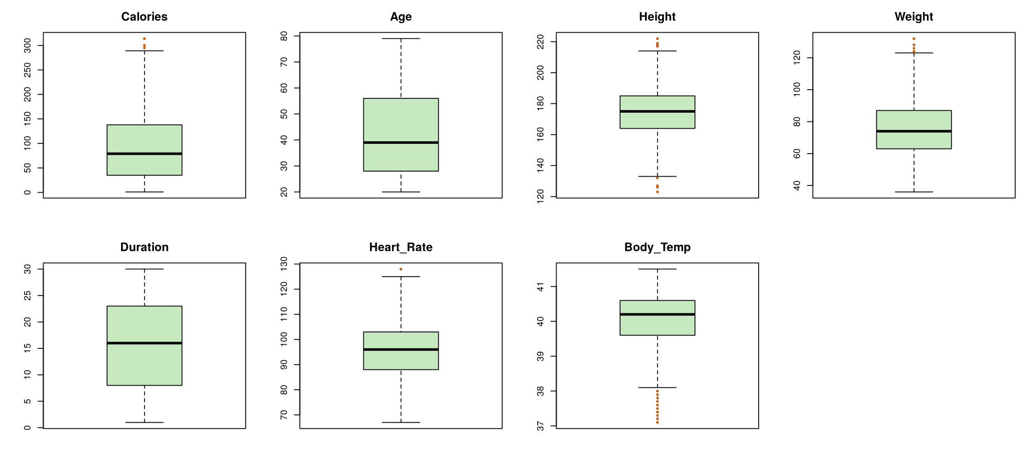
Figure 1. Boxplots of the seven numeric variables (orange points are flagged by the IQR rule)
Table 3. Outliers according to the IQR rule
Variable | Lower fence | Upper fence | Below | Above | % of rows
Calories | -119.5 | 292.5 | 0 | 4 | 0.03
Age | -14.0 | 98.0 | 0 | 0 | 0.00
Height | 132.5 | 216.5 | 8 | 6 | 0.09
Weight | 27.0 | 123.0 | 0 | 6 | 0.04
Duration | -14.5 | 45.5 | 0 | 0 | 0.00
Heart_Rate | 65.5 | 125.5 | 0 | 1 | 0.01
Body_Temp | 38.1 | 42.1 | 369 | 0 | 2.46

Most variables have almost nothing flagged: a handful of very tall or very short people, a few heavy people, and four very high calorie counts. All of these are believable human values (for example 222 cm is tall but real), so there is no reason to remove them.
Body temperature is different. It has 369 flagged readings, all at the low end. If I had applied the IQR rule automatically to every column, 389 rows would have disappeared. Before accepting that, I asked who these people were. All 369 turned out to be sessions of only 1, 2 or 3 minutes (211, 153 and 5 respectively). In fact 91.7% of all 1-minute sessions were flagged.
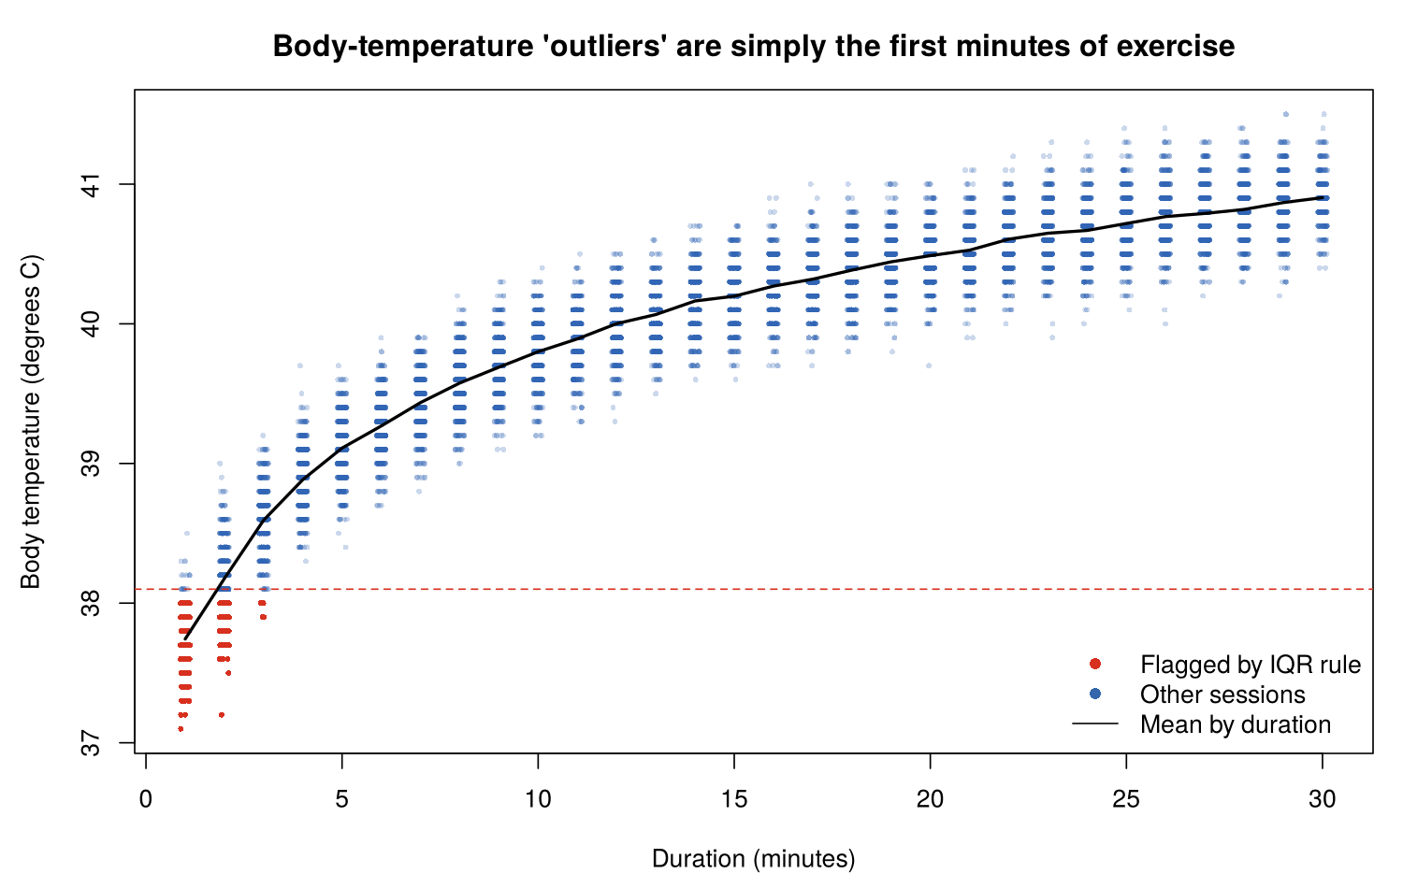
Figure 2. Low body-temperature “outliers” are the first minutes of exercise
Figure 2 explains this. Body temperature rises quickly during the first minutes of a workout and then levels off. A person who has just started has simply not warmed up yet. These are not measurement errors; they are the true beginning of a physiological curve.
Decision: I removed no rows. Deleting these observations would have wiped out nearly every very short session and made the data say nothing about the start of exercise, which is exactly where body temperature and calories are lowest. The unusual values will instead be handled by standardisation later and can be revisited at the modeling stage if a particular method is sensitive to them.

4. Exploratory Data Analysis

4.1 Distributions
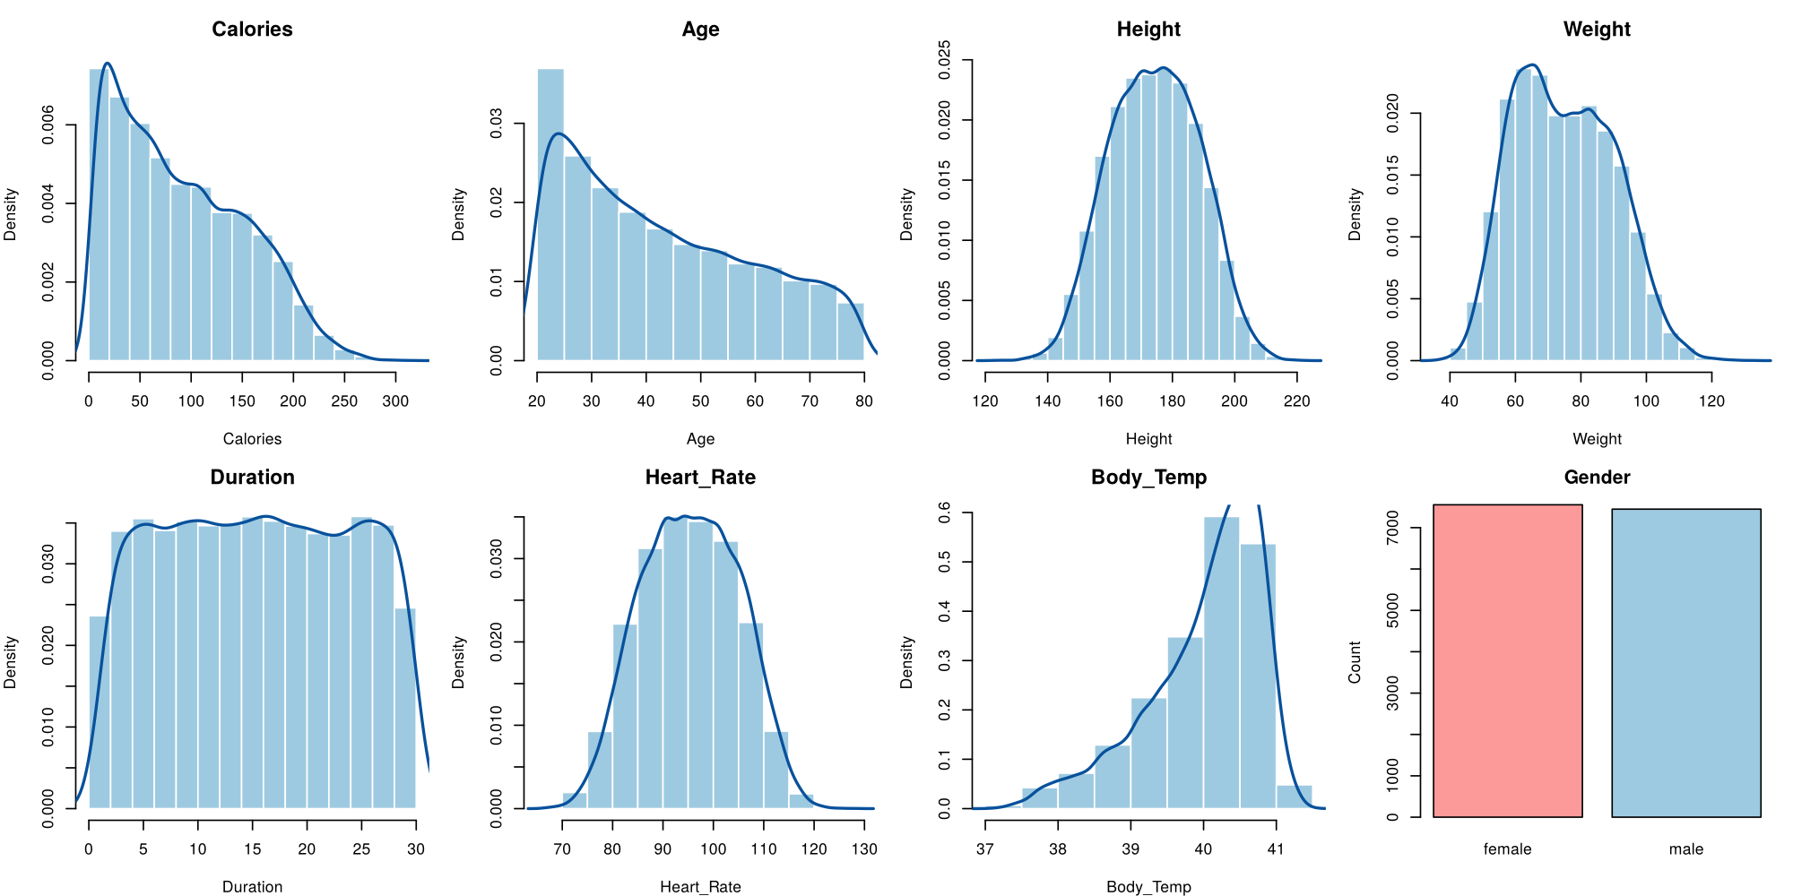
Figure 3. Distribution of each variable
Table 4. Summary statistics
Variable | Mean | SD | Min | Median | Max | Skewness
Calories | 89.54 | 62.46 | 1 | 79 | 314 | 0.51
Age | 42.79 | 16.98 | 20 | 39 | 79 | 0.47
Height | 174.47 | 14.26 | 123 | 175 | 222 | -0.01
Weight | 74.97 | 15.04 | 36 | 74 | 132 | 0.23
Duration | 15.53 | 8.32 | 1 | 16 | 30 | 0.00
Heart_Rate | 95.52 | 9.58 | 67 | 96 | 128 | -0.01
Body_Temp | 40.03 | 0.78 | 37.1 | 40.2 | 41.5 | -0.99

Several observations stand out:
- Duration is almost perfectly flat between 1 and 30 minutes (skewness 0.00). Real gym data would usually bunch up around typical lengths such as 30–60 minutes, so this is the first sign that the data may be simulated.
- Age is also flat-ish, running from 20 to 79 with somewhat more young people (skewness 0.47).
- Height, weight and heart rate look close to bell-shaped. Calories is right-skewed because many sessions are short and burn little.
- Body temperature is the most skewed variable (−0.99), with a long tail towards low values. Section 3.4 showed why.
- Gender is balanced (50.3% female, 49.7% male), so neither group dominates.

4.2 What is related to calories?
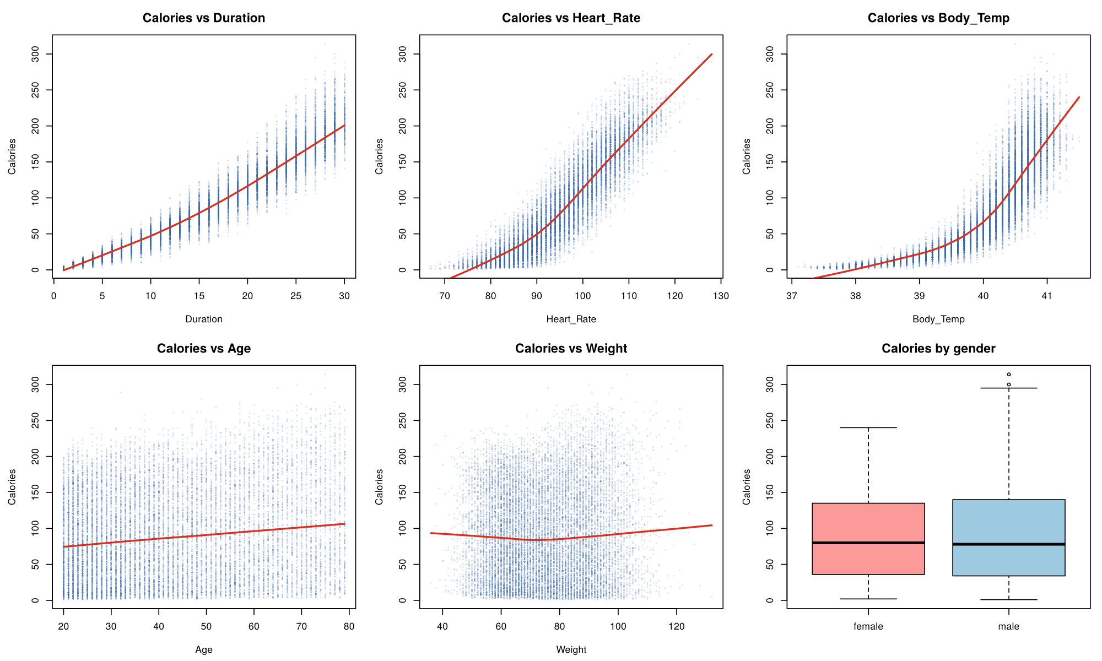
Figure 4. Calories against each candidate variable (red line: smoothed trend)
Duration, heart rate and body temperature all show a strong upward pattern with calories. The first of these is almost a straight line, but it curves upward: the longer someone exercises, the faster calories accumulate. Calories per minute averages 3.3 in the first minute and 6.9 in the 30th, because heart rate and temperature climb as the session goes on. Weight and gender, by contrast, show almost nothing.
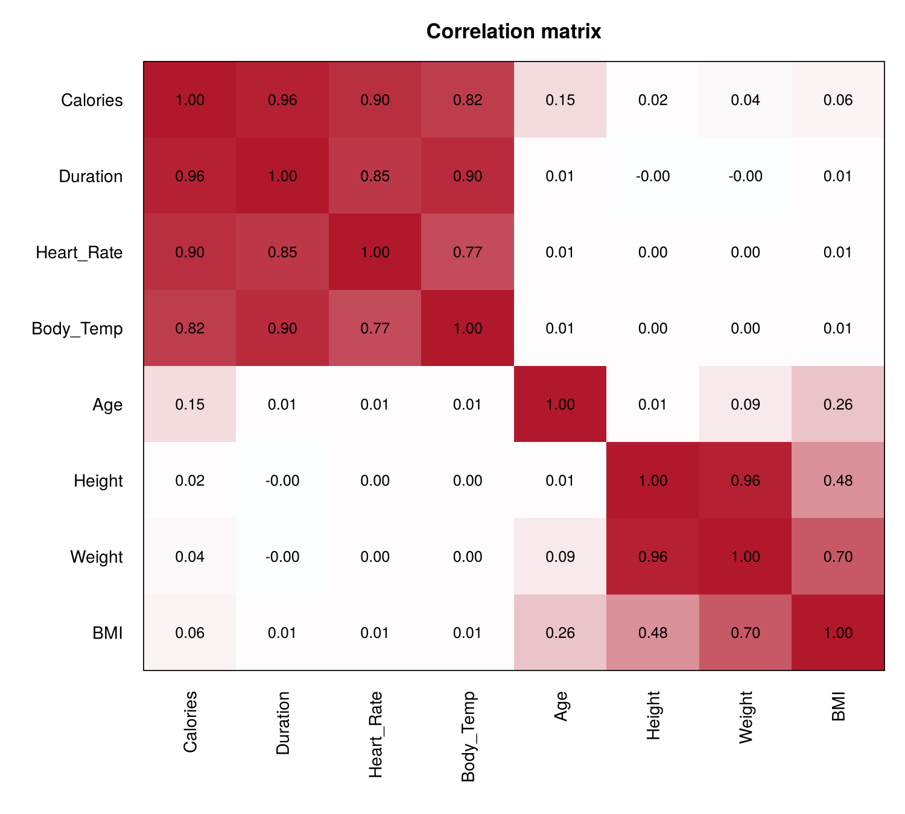
Figure 5. Correlation matrix (Pearson)
The correlation matrix confirms the picture and adds two structural findings that matter for preprocessing:
- Three variables carry most of the signal: Duration (0.96), Heart_Rate (0.90) and Body_Temp (0.82) with Calories.
- These three are strongly related to one another (Duration–Body_Temp 0.90, Duration–Heart_Rate 0.85, Heart_Rate–Body_Temp 0.77). They largely tell the same story, so a model would face redundancy between them.
- Height and Weight are almost the same variable (r = 0.96, Figure 7). Both are essentially unrelated to calories (0.02 and 0.04) and to the session variables (about 0).

4.3 Age: a pattern hidden by another variable
The overall correlation of Age with Calories is only 0.15, which at first sight says age barely matters. But Age is almost uncorrelated with Duration (0.01), so the huge variation caused by duration may simply be drowning out any age effect. To test this I compared sessions of similar length (14–16 minutes) and also looked at calories per minute for each age group.
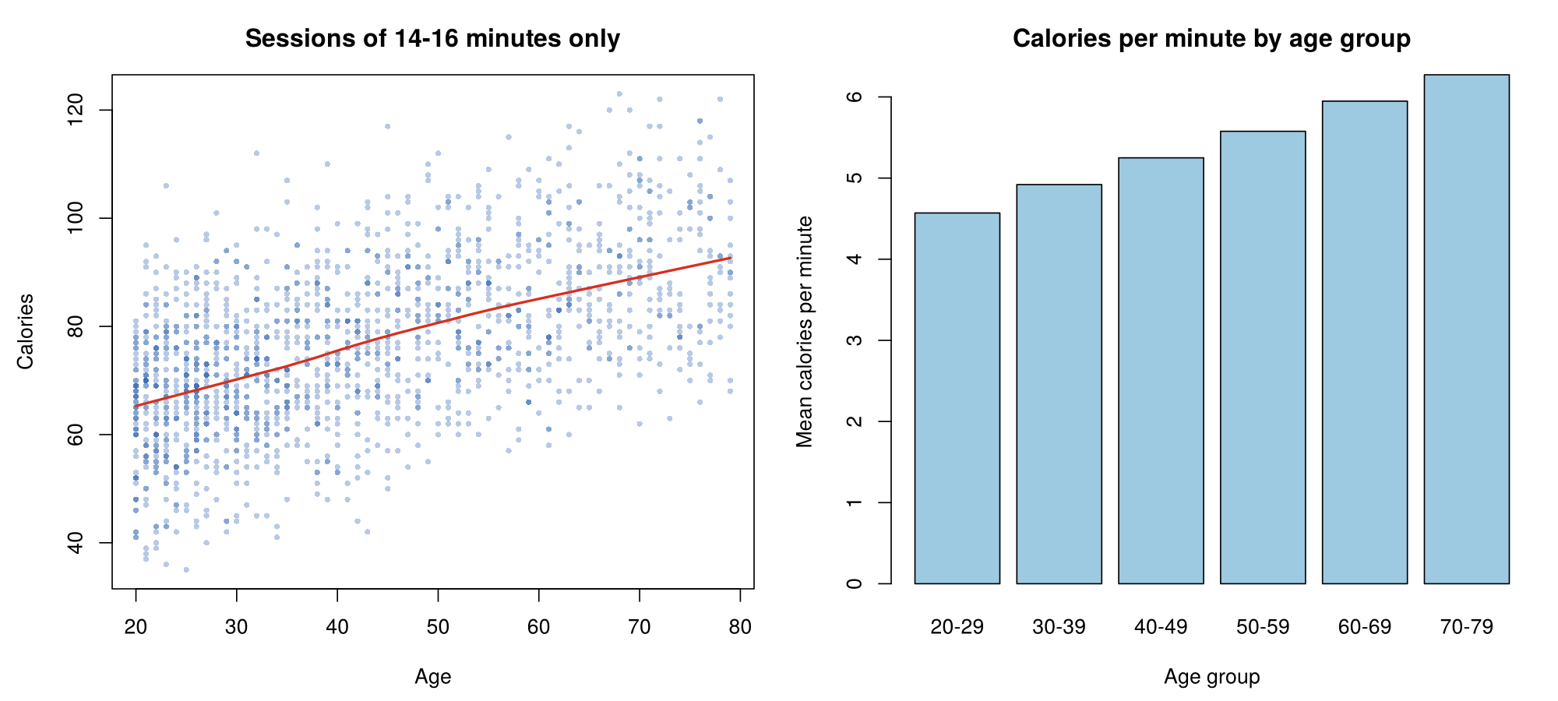
Figure 6. Left: calories against age for 14–16 minute sessions. Right: calories per minute by age group
Table 5. Calories by age group
Age group | Mean calories | Mean calories per minute
20–29 | 79.0 | 4.57
30–39 | 85.1 | 4.92
40–49 | 90.3 | 5.25
50–59 | 95.2 | 5.58
60–69 | 103.3 | 5.95
70–79 | 106.5 | 6.27

The hidden pattern is clear. For sessions of 14–16 minutes the correlation between age and calories rises from 0.15 to 0.56, and calories per minute climb steadily from 4.57 in the twenties to 6.27 in the seventies (about 37% higher). Age is therefore an important variable, and a weak overall correlation would have misled me into discarding it.

4.4 Gender, height and weight
Table 6. Group means by gender
 | Calories | Calories / min | Height (cm) | Weight (kg) | Duration (min) | Age
Female | 88.2 | 5.21 | 164.4 | 63.3 | 15.5 | 42.7
Male | 90.9 | 5.19 | 184.7 | 86.8 | 15.6 | 42.8

Men are on average 20 cm taller and about 24 kg heavier than women, yet their calories per minute are practically identical (5.19 vs 5.21) and their total calories differ by only 2.8. In other words, gender and body size add almost no information about calories in this dataset once the session itself is known.
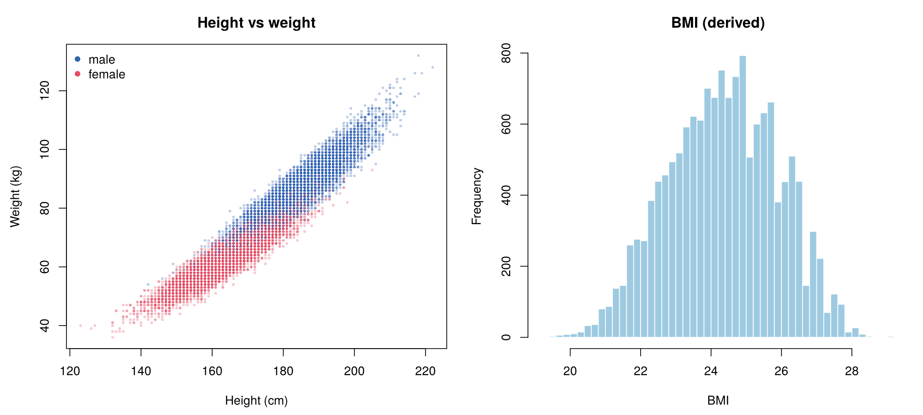
Figure 7. Left: height against weight, coloured by gender. Right: BMI distribution
Height and weight lie on a tight band, and the two genders separate along it. I derived BMI (weight in kg divided by height in metres squared) to express body size in one number. BMI ranges only from 19.2 to 29.1, which means there are no underweight or obese people in the data.

4.5 How EDA shaped the plan
- The outlier rule needed a judgement, not automatic deletion (Section 3.4).
- Age must stay in the data despite its low overall correlation.
- Duration, Heart_Rate and Body_Temp are redundant with each other, and Height and Weight are redundant with each other; this should be remembered at the modeling stage.
- The numeric variables are on very different scales (calories up to 314 against body temperature varying by only about 4 degrees), so scaling is needed.

5. Preprocessing
Each step below is applied because the exploration showed a reason for it. Steps that the data did not call for were deliberately left out.
Table 7. Preprocessing decisions
Step | What I did | Why
Drop User_ID | Removed the identifier after the merge | It is only a label; a random number could look like a pattern to a model
Keep all rows | No outlier removal | All values are plausible; the temperature outliers are real early-exercise readings
Encode Gender | Gender_male = 1 for male, 0 for female | Most algorithms need numbers; with two categories one 0/1 column is enough
Create BMI | Weight / (Height in m)² | Summarises body size in one number; Height and Weight alone are r = 0.96 duplicates
No log transform | Age left as it is | Skewness is only 0.47 and the variable is nearly flat, so a transformation would hurt interpretability and gain little
Train/test split | 80% / 20%, set.seed(42) | Keeps unseen data aside so a future model can be evaluated honestly
Standardise | z-score on the 7 continuous features, using training mean and SD | Puts variables on a comparable scale; test data use training statistics to avoid leakage

5.1 Feature creation
BMI was the only new feature kept. I also computed calories per minute, but it was used only to understand the age pattern. It is built from the outcome, so putting it among the input variables would leak the answer into the data; it was therefore left out of the final table.
I chose not to remove Height or Weight. They are redundant, but they are cheap to keep and removing variables is a modeling decision that depends on which method is used. I note the redundancy so the next stage can decide.

5.2 Train/test split
The dataset was divided randomly, with a fixed random seed so the result can be reproduced, into 12,000 training rows and 3,000 test rows. I checked that the two parts look alike:
Table 8. Are the training and test sets comparable?
Set | Rows | Mean calories | SD calories | % male
Train | 12,000 | 89.44 | 62.43 | 49.6
Test | 3,000 | 89.93 | 62.58 | 50.0

The outcome averages and spread, and the gender balance, are almost the same in both sets, so the split is fair.

5.3 Standardisation without leakage
Standardisation turns each value into the number of standard deviations from the mean. The means and standard deviations were computed from the training data only and then applied to the test data. If the test data had contributed to these numbers, information about them would have leaked into the preparation stage. The 0/1 Gender_male column was left unscaled. The result is checked below.
Table 9. Check after standardisation
Feature | Train mean | Train SD | Test mean | Test SD
Age | 0 | 1 | 0.016 | 1.009
Height | 0 | 1 | 0.007 | 0.971
Weight | 0 | 1 | 0.009 | 0.978
BMI | 0 | 1 | 0.018 | 0.992
Duration | 0 | 1 | 0.007 | 0.993
Heart_Rate | 0 | 1 | 0.012 | 0.990
Body_Temp | 0 | 1 | 0.013 | 0.984

The training features have mean 0 and SD 1 exactly, while the test features are very close to that, as expected when the same transformation is applied to a similar sample.
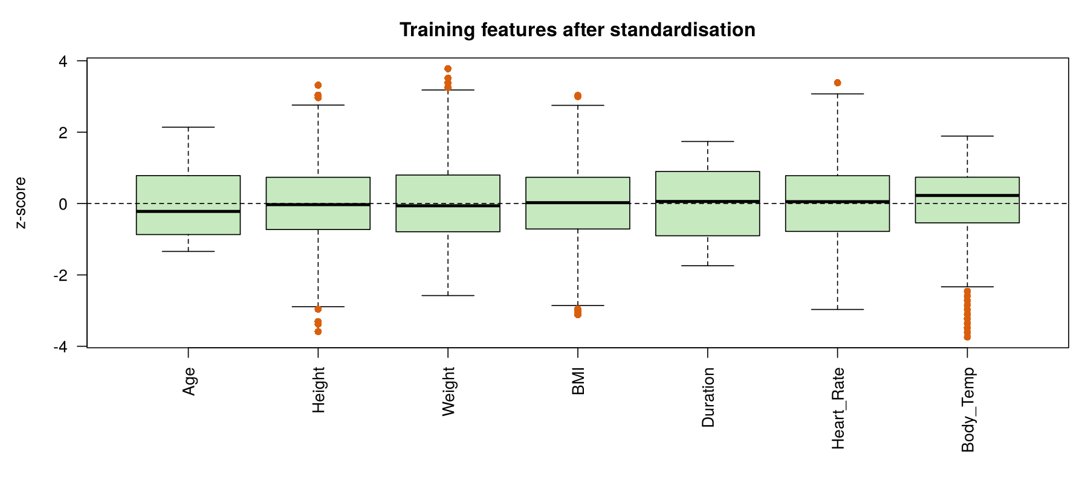
Figure 8. Training features after standardisation
The final files are ready for modeling: calories_clean.csv, X_train_scaled.csv, X_test_scaled.csv, y_train.csv and y_test.csv. The project stops here and no model has been built, trained or evaluated.

6. My Research Process

6.1 What I expected and what I found
Table 10. Expectations compared with observations
Expectation | What the data showed
Duration is the biggest driver | Confirmed (r = 0.96). Calories also accelerate with time, which I had not anticipated.
Heavier and taller people burn more | Not supported. Weight (0.04) and Height (0.02) are almost unrelated to calories.
Men burn more than women | Barely. 90.9 vs 88.2 calories in total and an identical rate per minute.
Age matters little | Wrong. It looked that way overall (0.15) but is strong at constant duration (0.56).

6.2 What surprised me
- Body size does not matter in this data. I assumed that a person who weighs 24 kg more would burn clearly more calories; the numbers say otherwise.
- The weak overall correlation with age was misleading. A single summary number hid a strong pattern because another variable dominated the variation.
- The most “unusual” values were not errors at all but the beginning of a normal curve.

6.3 Problems and how I handled them
- Automatic outlier removal. In an earlier practice version of this analysis, written in Python, I applied the IQR rule to every column, which removed 389 rows. When I looked at who those rows were, I changed my approach and kept them.
- Dropping age too early. In the same earlier notebook I had written that age looked unrelated to anything and that I would drop it. Checking sessions of equal length reversed that conclusion.
- Log transformation of age. I had log-transformed age before. Measuring the skewness (0.47) and seeing the flat shape of the distribution convinced me it was not necessary here.
- Avoiding leakage. Scaling, calories per minute and the split all had to be done in an order that kept the test data and the outcome out of the inputs.

6.4 Limitations
- The data look simulated. Duration is uniform from 1 to 30, Age is nearly uniform, BMI stays between 19 and 29, and calories follow smooth curves. Real data would be messier. Conclusions apply to this dataset and may not transfer to real people.
- Source not documented. The files do not say how the data were collected, so I cannot verify their origin or the unit of Calories.
- One short session per person. Sessions last 30 minutes at most, there is no exercise type or fitness level, so we cannot say anything about long or intense workouts.
- Heart rate and body temperature are consequences of effort, not independent causes. A model using them would be able to estimate calories after a session, but not plan one beforehand. This matters when defining the modeling task.
- Association is not causation, and correlation measures only linear patterns. Several relationships (such as calories against duration) are curved.
- Redundant variables remain. I flagged them but did not remove any, which is a decision for the modeling stage.

7. Conclusion
The research question can now be answered at the exploratory level. Calories burned are driven mainly by how long a session lasts and by how hard the body is working (heart rate and temperature). Age plays a real but hidden role: older people burn more per minute. Sex, height and weight contribute almost nothing once the session is known.
For preprocessing, the data needed relatively little repair, but the decisions about it mattered: keeping, not deleting, the low-temperature observations; keeping age; encoding gender; creating BMI; splitting before scaling; and scaling with training statistics only. The result is a clean, standardised, leakage-free dataset that is ready for a modeling stage, which I have intentionally not started.

Appendix: Files and How to Reproduce
- calories_project.R: the complete, commented script (loading, checks, outliers, EDA, preprocessing). Place calories.csv and exercise.csv in the working directory and run it with source("calories_project.R"). It uses base R only and creates the figures/ and tables/ folders.
- Outputs: calories_clean.csv, X_train_scaled.csv, X_test_scaled.csv, y_train.csv, y_test.csv.
- Random seed: set.seed(42) fixes the train/test split.

