**External Project Report on Computer Networking (CSE3034)**

**INSTITUTE OF TECHNICAL EDUCATION AND RESEARCH**

**(FACULTY OF ENGINEERING)**

i

**SIKSHA ‘O’ ANUSANDHAN (DEEMED TO BE UNIVERSITY), BHUBANESWAR,**

**ODISHA**

Topic - Design a LAN connection in an agency which has 15 users to communicate with help of switches and router.



Submitted by

|  |  |
| --- | --- |
| **Name 01 : TANMOY DAS** | **Reg. No.: 2041004073** |
| **Name 02 : YASH RAJ** | **Reg. No.:2041018031** |
| **Name 03 : ASHISH KUMAR** | **Reg. No.:2041011130** |
| **Name 04 : ANKIT KUMAR** | **Reg. No.:2041011129** |

**B. Tech. CSIT 5th Semester (Section C )**

# Declaration

# We, the undersigned students of B. Tech. of CSIT Department hereby declare that we own the full responsibility for the information, results etc. provided in this PROJECT titled “Design a LAN connection in an agency which has 15 users to communicate with help of switches and router” submitted to Siksha ‘O’ Anusandhan Deemed to be University, Bhubaneswar for the partial fulfillment of the subject Computer Networking (CSE 3034). We have taken care in all respect to honor the intellectual property right and have acknowledged the contribution of others for using them in academic purpose and further declare that in case of any violation of intellectual property right or copyright we, as the candidate(s), will be fully responsible for the same.

|  |  |
| --- | --- |
| **TANMOY DAS**  **Registration No.: 2041004073** | **YASH RAJ**  **Registration No.: 2041018031** |
| **ASHISH KUMAR**  **Registration No.: 2041011130** | **ANKIT KUMAR**  **Registration No.: 2041011129** |

**DATE: 23.01. 2023**

**PLACE: BHUBANESWAR**

Abstract

This project presents the design and implementation of a Local Area Network (LAN) connection for an agency with 15 users. The purpose of this project is to improve communication among the users by designing a LAN connection that utilizes switches and a router. The problem of poor communication among the users of the agency, leading to delays in the completion of tasks and decreased productivity, was addressed.

The methodology used in the project included identifying the number of users and their location, determining the type of devices that will be used, choosing the appropriate switch and router, configuring the switch and router to establish the LAN connection, and testing the LAN connection. The LAN was designed using a managed switch with 16 ports to connect all 15 users and a router to connect to the internet. Static IP addresses were assigned to all the devices. The switch was configured with VLANs and port security, and the router was configured for DHCP and NAT. The network was tested by pinging between devices and connecting to the internet.

The results of the project showed that the LAN connection was successfully established, and all 15 users were able to communicate with each other effectively. The network was stable and reliable, and the users were able to access the internet without any issues. The conclusion of the project is that the LAN connection designed for the agency has improved communication between the users and has increased productivity. The use of a managed switch and a router has ensured that the network is secure and stable. This project highlights the significance of a well-designed LAN connection in addressing the problem of poor communication within an agency and in increasing productivity and efficiency.

# Contents

|  |  |  |  |  |  |  |  |  |  |  |  |  |  |  |  |  |  |  |  |  |  |  |  |  |  |  |  |  |  |  |  |  |  |  |  |
| --- | --- | --- | --- | --- | --- | --- | --- | --- | --- | --- | --- | --- | --- | --- | --- | --- | --- | --- | --- | --- | --- | --- | --- | --- | --- | --- | --- | --- | --- | --- | --- | --- | --- | --- | --- |
| |  |  |  |  | | --- | --- | --- | --- | | **Serial**  **No.** | **Chapter**  **No.** | **Title of the Chapter** | **Page No.** | | 1. | 1. | Introduction | 01. | | 2. | 2. | Problem Statement | 02. | | 3. | 3. | Methodology | 03.-05. | | 4. | 4. | Implementation | 06.-07. | | 5. | 5. | Results & Interpretation | 08.-09. | | 6. | 6. | Conclusion | 10. | | 7. | 7. | References | 11. | |  |  |  |
|  |  |  |  |
|  |  |  |  |
|  |  |  |  |
|  |  |  |  |
|  |  |  |  |
|  |  |  |  |
|  |  |  |  |

**1. Introduction**

This project aims to design a Local Area Network (LAN) connection for an agency with 15 users. A LAN is a group of computers and associated devices that share a common communications line or wireless link. The main objective of this project is to facilitate communication between the users of the agency by designing a LAN connection that utilizes switches and a router.

The introduction should state the purpose of the project and give an overview of what the LAN connection design project is all about. It should also briefly mention the problem that the project aims to address, which in this case is poor communication among the users of the agency.

It could also mention some background information about LAN connection, such as its importance, use cases, and some common components used to design such network.

The introduction should also provide some context for the rest of the project, making it clear how the project will be structured and what the reader can expect to learn from it. By providing an overview of the project, the introduction will help the reader understand the significance of the problem and the importance of the solution that the project aims to develop.

# 2. Problem Statement

The problem statement is a clear and concise description of the issue that the LAN connection design project aims to address. In this case, the problem statement would be as follows: The agency currently has no LAN connection, and the users are facing difficulties in communicating with each other. The lack of a LAN connection results in poor communication among the users, leading to delays in the completion of tasks and decreased productivity. The agency needs a solution to improve communication among its users to increase productivity and efficiency. It's worth noting that, it's important to be as specific as possible when describing the problem, as it will help to guide the design and implementation of the LAN connection. The problem statement should include details about the current situation, the specific issues that users are facing, and the desired outcome of the project.

In this case, the problem is specific to the agency with 15 users, and it clearly states the current situation and the consequences of that situation. It also states the desired outcome, which is to improve communication among the users and increase productivity. This problem statement provides a clear and concise foundation for the LAN connection design project, which will guide the implementation and testing of the solution.

# Methodology

# The methodology for this project includes the following steps:

# Identify the number of users and their location within the agency.

# Determine the type of devices that will be used, such as computers and printers.

# Choose the appropriate switch and router for the LAN connection.

# Configure the switch and router to establish the LAN connection.

# Test the LAN connection to ensure that it is working correct

# Including various peripherals which are used for implementing the required local area network such as Switches, Routers, Pcs, and connection media.

# ROUTER

# A router is a special type of computer. It has the same basic components as a standard desktop PC. However, routers are designed to perform some very specific functions. Just as computers need operating systems to run software applications, routers need the Internetwork Operating System software (IOS) to run configuration files. These configuration files contain the instructions and parameters that control the flow of traffic in and out of the routers. The many parts of a router are shown below:

# 

# 

# The configuration

# 

# SWITCH

# Data to the connection that needs that data. Each Switch port has a unique MAC address. Connected host MAC addresses are learned and stored on a MAC address table. Switch 2960-24TT is used in this project. It has 24 fast Ethernet interface and 2 gigabit Ethernet Switches that can determine whether data should remain on a LAN or not, and they can transfer the Switches are Data Link layer devices.

# The configuration

# 

# PCs IP ADDRESSING

# Using the IP address of the destination network, a router can deliver a packet to the correct network. When the packet arrives at a router connected to the destination network, the router uses the IP address to locate the particular computer connected to that network. Accordingly, every IP address has two parts. IP Addressing is a hierarchical structure. An IP address combines two identifiers into one number.

# Implementation

TOPOLOGY IMPLEMENTED:

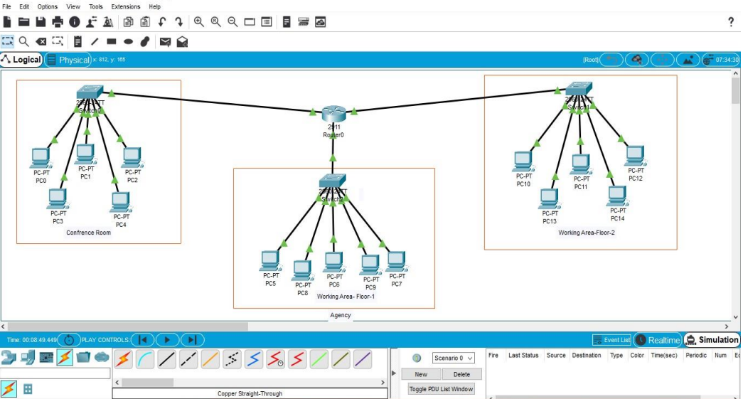

Fig 1.a : LAN Connection present in an agency having 15 Pcs, 3 Switches, and 1 Router.

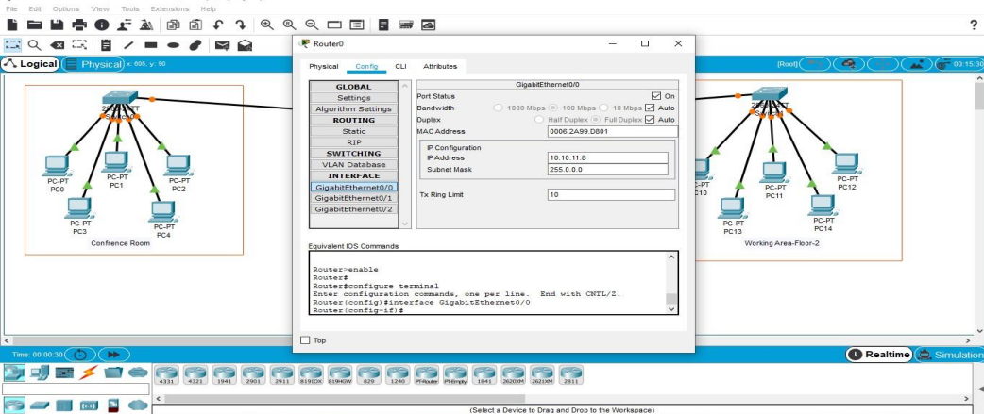

Fig 1. b Configuration of the IP address of a router

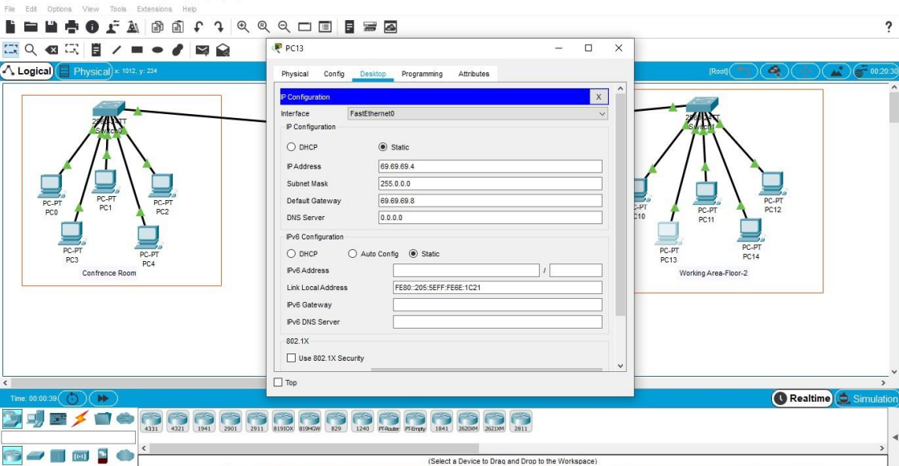

Fig 1. c Configuration of IP address for the respective peripheral pc

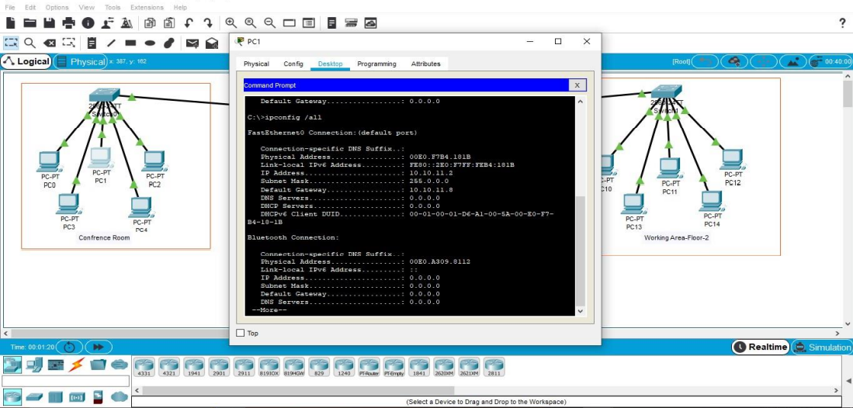

Fig 1.d: Configuration of the simulation using the ipconfig command

# Results & Interpretation

1. Figure 2.1

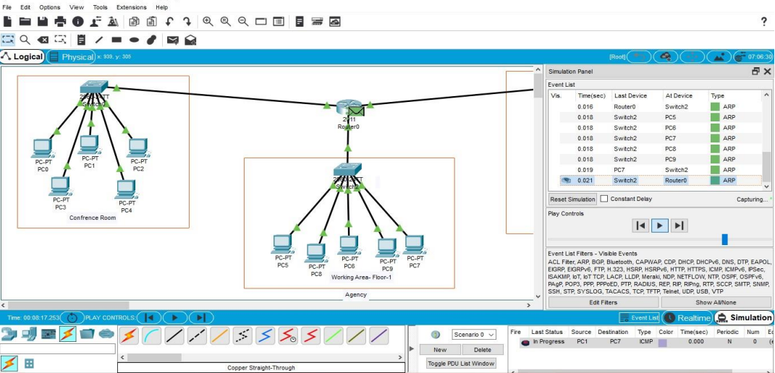

Figure 2.1 shows the progress of the simulation along with the successful connection among all the peripherals devices and end devices.

1. Figure 2.2

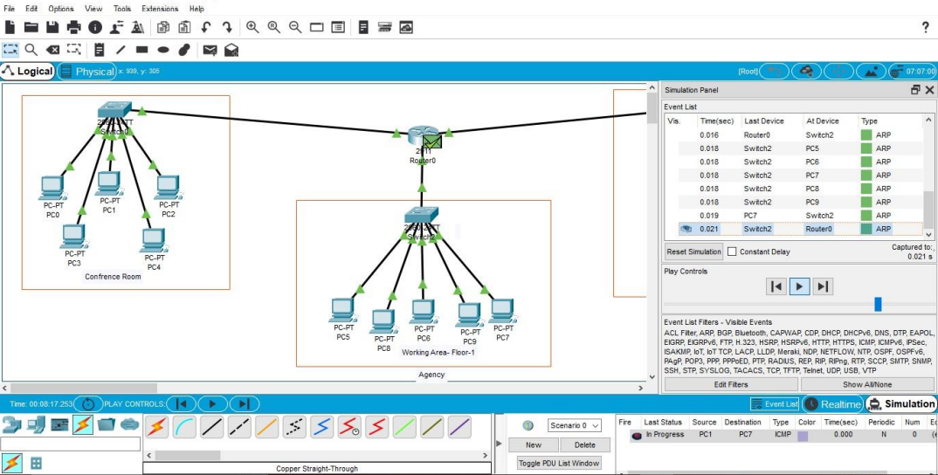

Figure 2.2 shows the success of the simulation along with the successfully sent message among the selected peripherals devices and end devices.

1. Figure 2.3

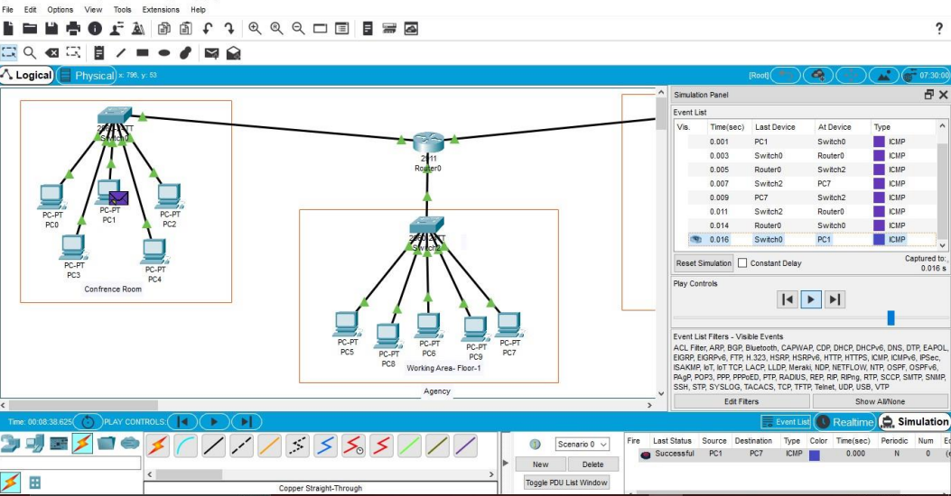

Figure 2.3 shows the successful simulation of the created topology.

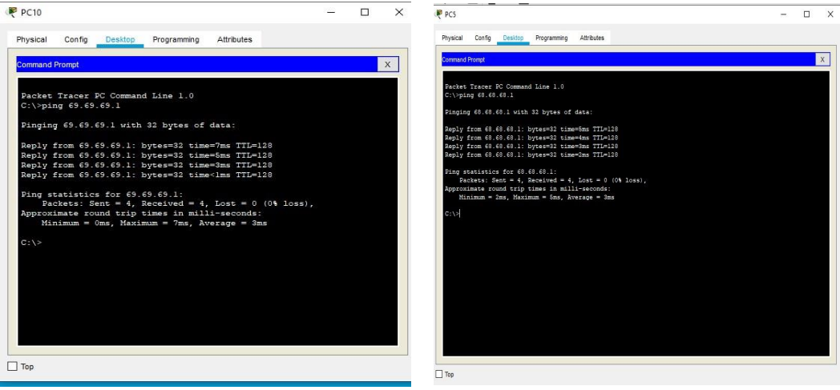

Figure 2.4 shows the average ping among the simulation of the given Local Area Network.

# Conclusion

# In this project, we used the latest cisco packet tracer version to create a LAN of 15 PCs for an agency, as this version includes numerous end devices. We used the router and switches for connecting these end devices via guided connecting mediums. We have created a Local Area Network (AN) that uses wired topology that has been implemented with some important concepts using a cisco packet tracer. It is observed that the network is performing well, this is because when we compared the ping test of the network designed to the ping test on the existing standards, the values were similar. Fig. 2.4 shows the ping test on the live network in existence. At last, We want to conclude that, according to me have a great experience while working on this software cisco packet tracer



# References

1. **Computer Networks, Andrew S. Tannenbaum, 4th Edition, Pearson India.**
2. **Introduction to Networks Labs and Study Guide, Allan Johnson, Cisco**
3. S. Raja Gopal, P. Saleem Akram , S. Sriram, T. Pavan Koushik, V. Mohana Krishna, ―Design and Analysis of Heterogeneous Hybrid topology for VLAN configuration―, International Journal of Emerging Trends in Engineering Research, Vol 7, No 11, PP 487 – 491, 2019.
4. Tim Reardon, Planning, Designing and operating local area networks, DISAM Journal, Summer, 1997
5. Our Course mentor : Mrs. DIANA PRADHAN, CSE DEPT. ITER- SOA UNIVERSITY