**Theory Assignment-3**

**Subject-WAD**

***Branch-B.Tech,CSIT Semester-6th***

1. Explain the utility of this.props.children.
2. What are similarities between props and states in React?
3. What is a state in React and how is it used?
4. How can you update the state of a component?
5. What is the significance of keys in React?
6. What is the difference between state data and props data in React?
7. What are the different phases of component lifecycle?
8. List out some of the component lifecycle methods in React.
9. Show with diagram from begin to end, the lifecycle methods during initial rendering of a component in React.
10. Show with diagram, the lifecycle methods during state change

of a component in React.

Solution

1. this.props.children is a way to access and render the child components passed to a React component. It allows a parent component to pass arbitrary children to a component, which can then render those children using the special props.children property.

2. Both props and state are used to pass data to a React component. They are both plain JavaScript objects and can be used to store any type of data. However, props are used to pass data from a parent component to a child component, while state is used to manage internal component data.

3.In React, a state is a JavaScript object that represents the internal data of a component. It is used to store and manage data that can change over time, such as user input or network responses. When a state value changes, React will automatically re-render the component with the updated data.

4.To update the state of a component in React, you can call the setState() method with a new state object. This will trigger a re-render of the component with the updated state data. It is important to note that you should never directly modify the state object, as this can lead to unpredictable behavior.

5. Keys are a special attribute that can be added to React elements when rendering arrays of elements. They help React to identify which items have changed, been added, or been removed from the array, and optimize the rendering process accordingly.

6.The main difference between state data and props data in React is that state is managed internally by a component, while props are passed from a parent component to a child component. State is used to manage internal data that can change over time, while props are used to pass data down the component tree.

7.The component lifecycle in React can be divided into three main phases: mounting, updating, and unmounting. The mounting phase occurs when a component is first created and added to the DOM. The updating phase occurs when a component's props or state changes and it needs to be re-rendered. The unmounting phase occurs when a component is removed from the DOM.

8.Some of the component lifecycle methods in React include: componentWillMount, componentDidMount, componentWillReceiveProps, shouldComponentUpdate, componentWillUpdate, componentDidUpdate, and componentWillUnmount.

9.The lifecycle methods during initial rendering of a component in React are as follows:

* constructor()
* static getDerivedStateFromProps()
* render()
* componentDidMount()

1. The lifecycle methods during state change of a component in React are as follows:

* static getDerivedStateFromProps()
* shouldComponentUpdate()
* componentWillUpdate()
* render()
* componentDidUpdate()

Regenerate response

9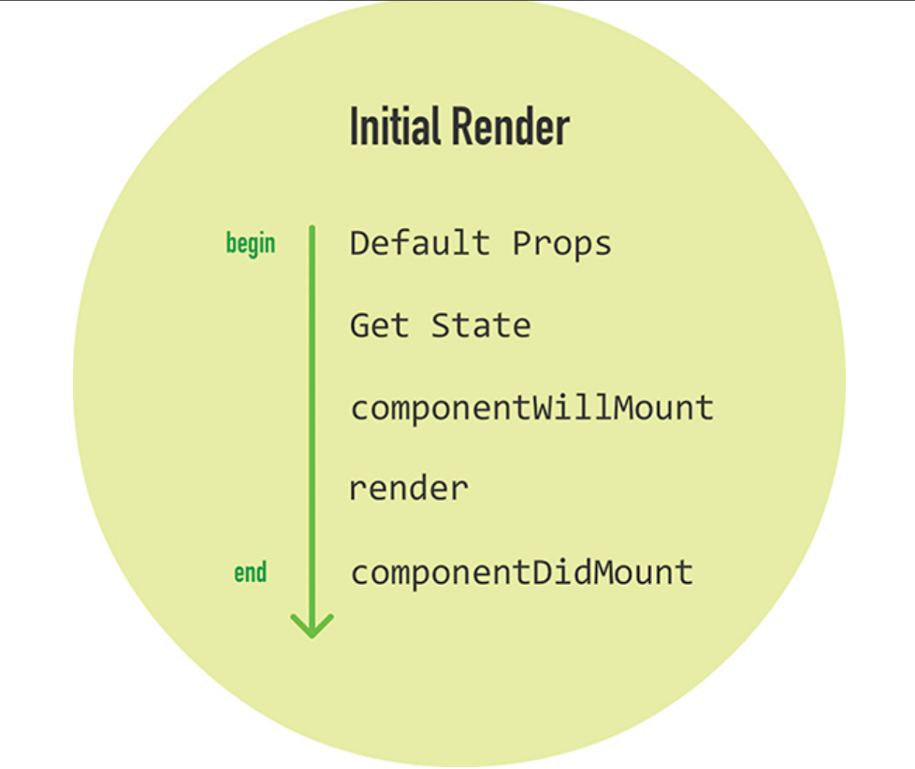

10