Software Requirements Specification
for

Managing departments and employees in company EPAM, Release 1.0

Version 1.0 approved

Prepared by Tetiana Malkhasian
December 14, 2020

Table of Contents
Table of Contents
Revision History
1. Introduction 1
1.1 Purpose 1
1.2 Project Scope and Product Features 1

2. Overall Description 1
2.1 Product Perspective 1
2.2 Operating Environment 2

3. Interface Requirements 2
3.1 Main 2
3.2 Departments 3
3.2.1 Department table...………………………………………………………………………...3
3.2.2 Form create department………………………………………………….………………..3
3.3 Employees 4
3.3.1 Form create employee……………………………………………………………………..4
3.3.2 Employees……………………………………………………………………….…5
3.4 About company………………………………………………………………………………….....6
3.4.1 About company with diagram………………………………………………………………..6
Appendix A: BD(2 tables) 7

Revision History
Name | Date | Reason For Changes | Version
Tetiana Malkhasian | 12/04/20 | initial draft | 1.0 draft 1
Tetiana Malkhasian | 12/14/20 | baseline following changes after inspection | 1.0 approved

Introduction

Purpose
This SRS describes the software functional and nonfunctional requirements for release 1.0 of the managing departments and employees in company EPAM. This document is intended to be used by the members of the project team that will implement and verify the correct functioning of the system. Unless otherwise noted, all requirements specified here are high priority and committed for release 1.0.

Project Scope and Product Features
Managing departments and employees will allow employee search by date of birth and the addition of the possibility of calculating the average salary when getting a list of departments.

Overall Description

Product Perspective
The context diagram in Figure 1 illustrates the external entities and system interfaces for release 1.0.

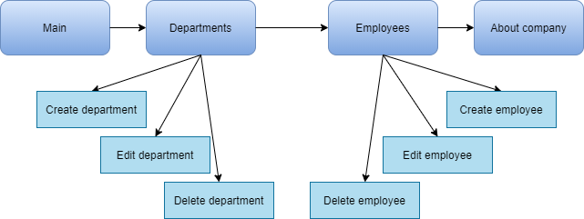

Figure 1. The context diagram Managing departments and employees.

Main | The main page and description company.
Departments | The table of departments and the average salary (calculated automatically) for these departments and change (add / edit / delete) the above data.
Employees | The table of employees with an indication of the salary for each employee, departments and a search field to search for employees born on a certain date or in the period between dates and change (add / edit / delete) the above data.
About company | About company and possibility career growth in the company.

Operating Environment
OE-1: The web application managing departments and employees shall operate with the following Web browsers: Microsoft Internet Explorer versions 5.0 and 6.0, Opera versions 72.0, Microsoft Edge versions 87.0

Interface Requirements

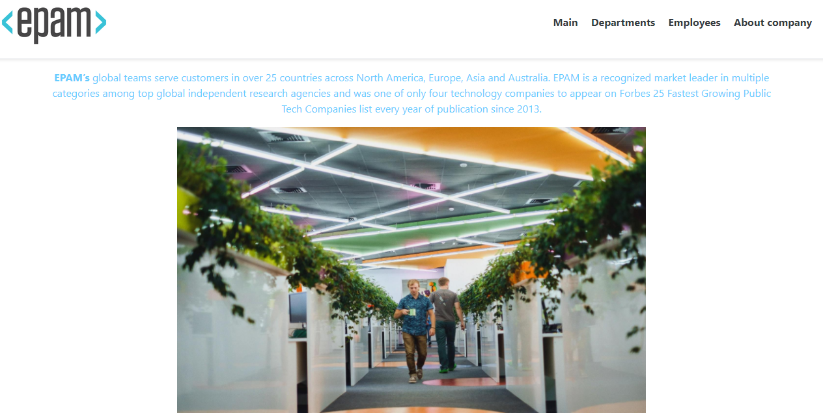
Main

3.1.1 Main page

Departments

3.2.1 Department table consists of:
№ - serial number
Department name
Description
Average salary (take from DB automatically)
Date create department (when add department generate automatically)
Create department (add new department)
Delete department
Edit department (edit any field in form)

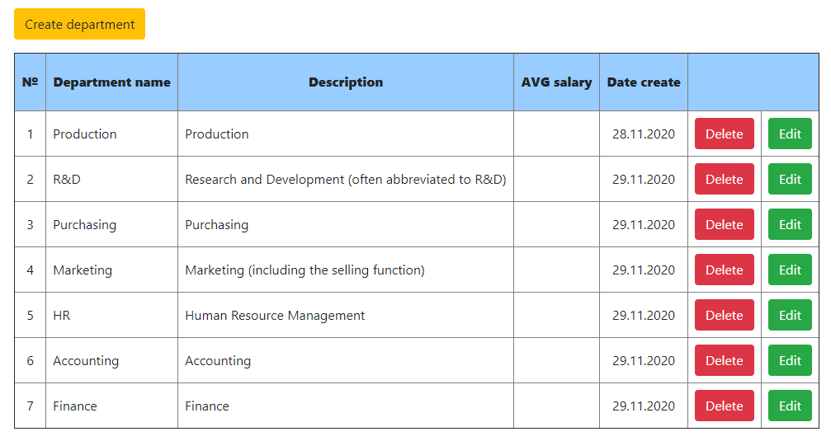

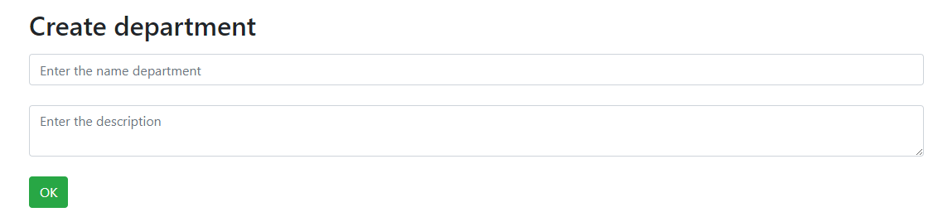

3.2.2 Form create department:
Department name (add new department)
Description (any description department)

Employees

3.3.1 Form create employee:
Employee name (add new name employee)
Employee fullname (add new fullname employee)
Amount (salary employee)
Date of birth (date of birth employee)
Department (choose from the list any department)

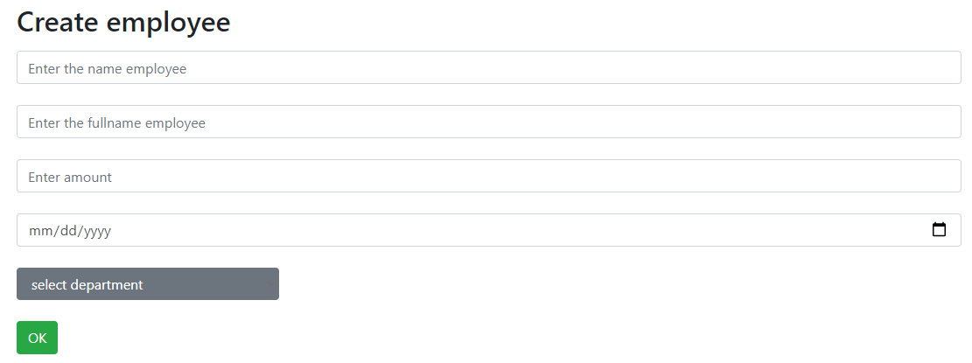

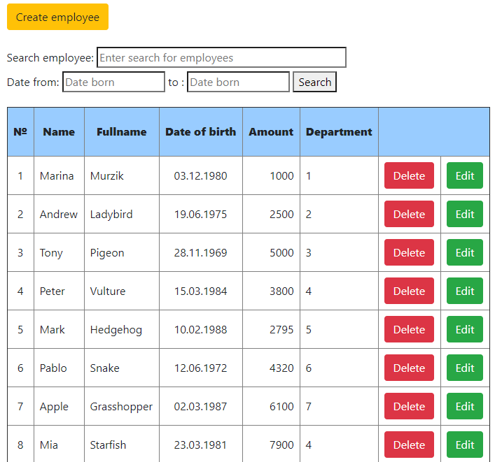

3.3.2 Employees:
Create employee (add new employee)
Search employee: - search by name employee
- Search by date of birth employee
№ - serial number
Employee name
Employee fullname
Date of birth
Amount (salary employee)
Department (take from table department automatically)
Delete employee
Edit employee (edit any field in form)

About company
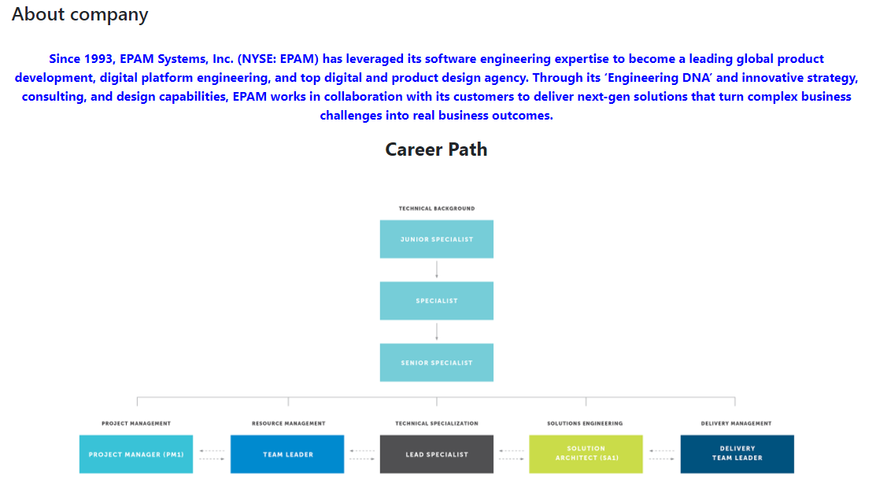

3.4.1 About company with diagram, career path and career development program

Appendix A: BD (1 table – Department, 2 table - Employee)

