**Machine Learning Project**

**Comparison of different methods of handling missing values and different classification algorithms**



**Submitted to Dr. Sushma Jain**

**Name - Tanya Srivastava**

**Roll No. - 101918031**

**Batch - COBS 2**

**Index**

| **Serial No.** | **Section** | **Page Number** |
| --- | --- | --- |
| **1** | Overview | 3 |
| **2** | Dataset Description | 4 |
| **3** | Data Visualization | 8 |
| **4** | Data Pre-processing | 13 |
| **5** | Classification Models | 20 |
| **6** | Results | 21 |
| **7** | Evaluation of Results | 22 |
| **8** | Code | 25 |

**Overview**

The flow of the project follows the following diagram. We first describe the dataset then focus the data visualization to get a better sense of the data. Data preprocessing involves various steps like

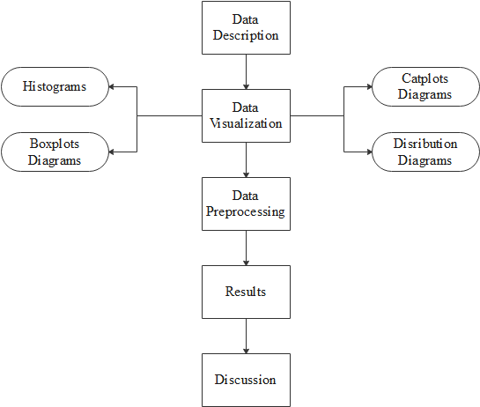

**Dataset Description**

The table below gives a brief description of the dataset used in this project.

| **Dataset** | pima-indians-diabetes.csv |
| --- | --- |
| **Number of attributes** | 8 |
| **Number of targets** | 1 |
| **Number of records** | 768 |
| **Type of Target** | Categorical |
| **Type of attributes** | Numerical |
| **Type of Problem** | Classification (Binary) |

The initial view of the data in a pandas data frame was as follows

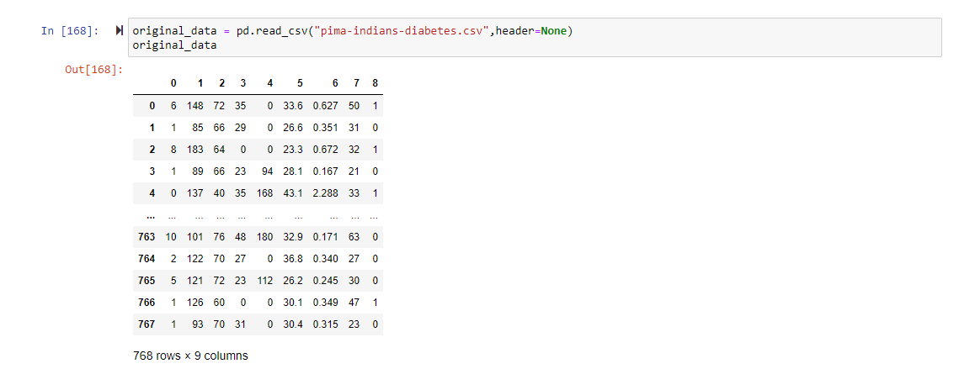

After labelling the attributes in the data frame, we get the following

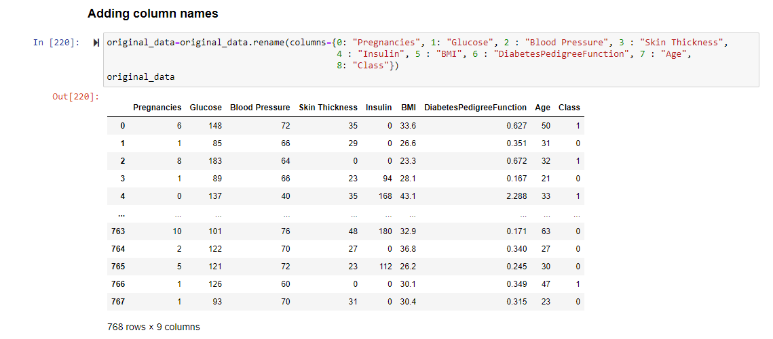

A more detailed analysis of the columns in the dataset (especially the datatype of the attribute and target) is presented as follows

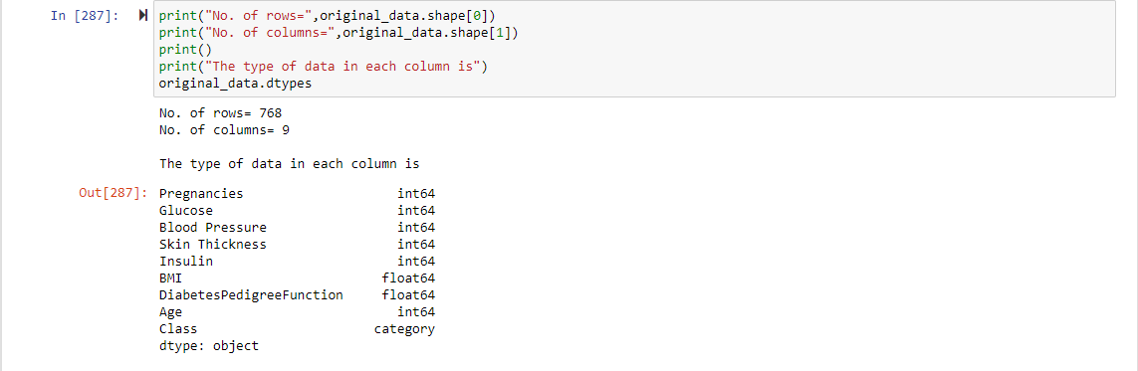

| **COLUMN NAME** | **DESCRIPTION** |
| --- | --- |
| **Pregnancies** | Number of pregnancies |
| **Glucose** | Self-explanatory, cannot be zero |
| **Blood Pressure** | Self-explanatory, cannot be zero |
| **Skin Thickness** | Self-explanatory, cannot be zero |
| **Insulin** | Self-explanatory, cannot be zero |
| **BMI** | Self-explanatory, cannot be zero |
| **DiabetesPedigreeFunction** | A function which scores likelihood of diabetes based on family history |
| **Age** | Self-explanatory |
| **Class** | 0 – The person doesn’t have diabetes  1 – The person has diabetes  Categorical Type |

**Data Visualization**

**Histograms**

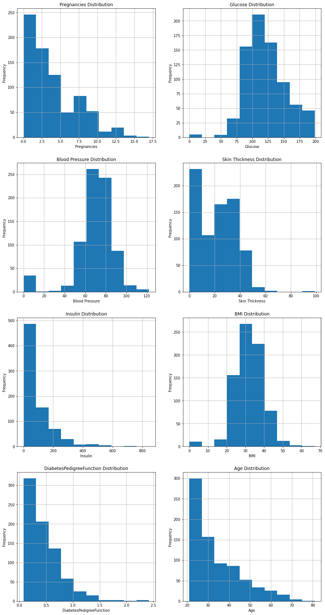

* 1. **Catplots**

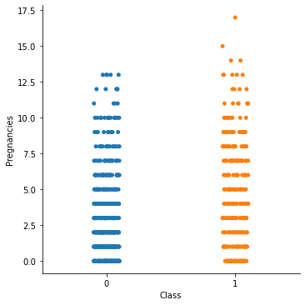 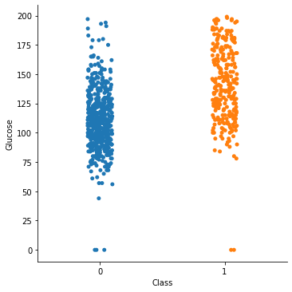

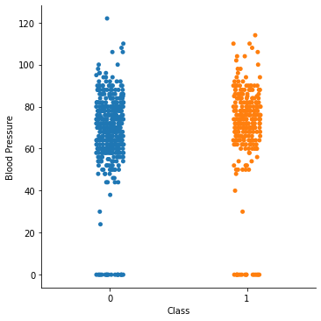 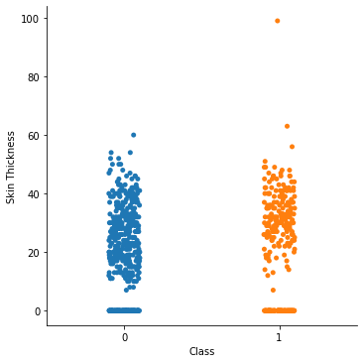

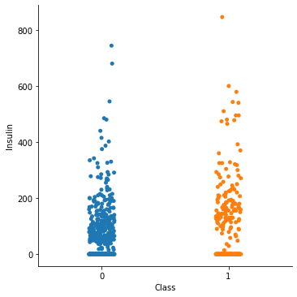 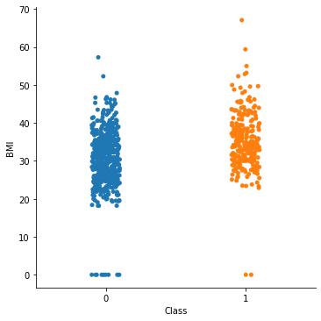

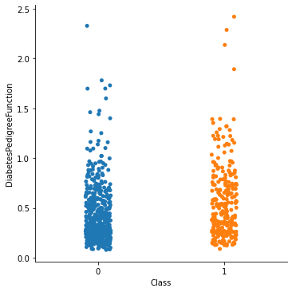 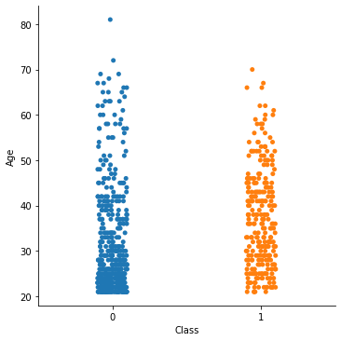

**Data Distribution**

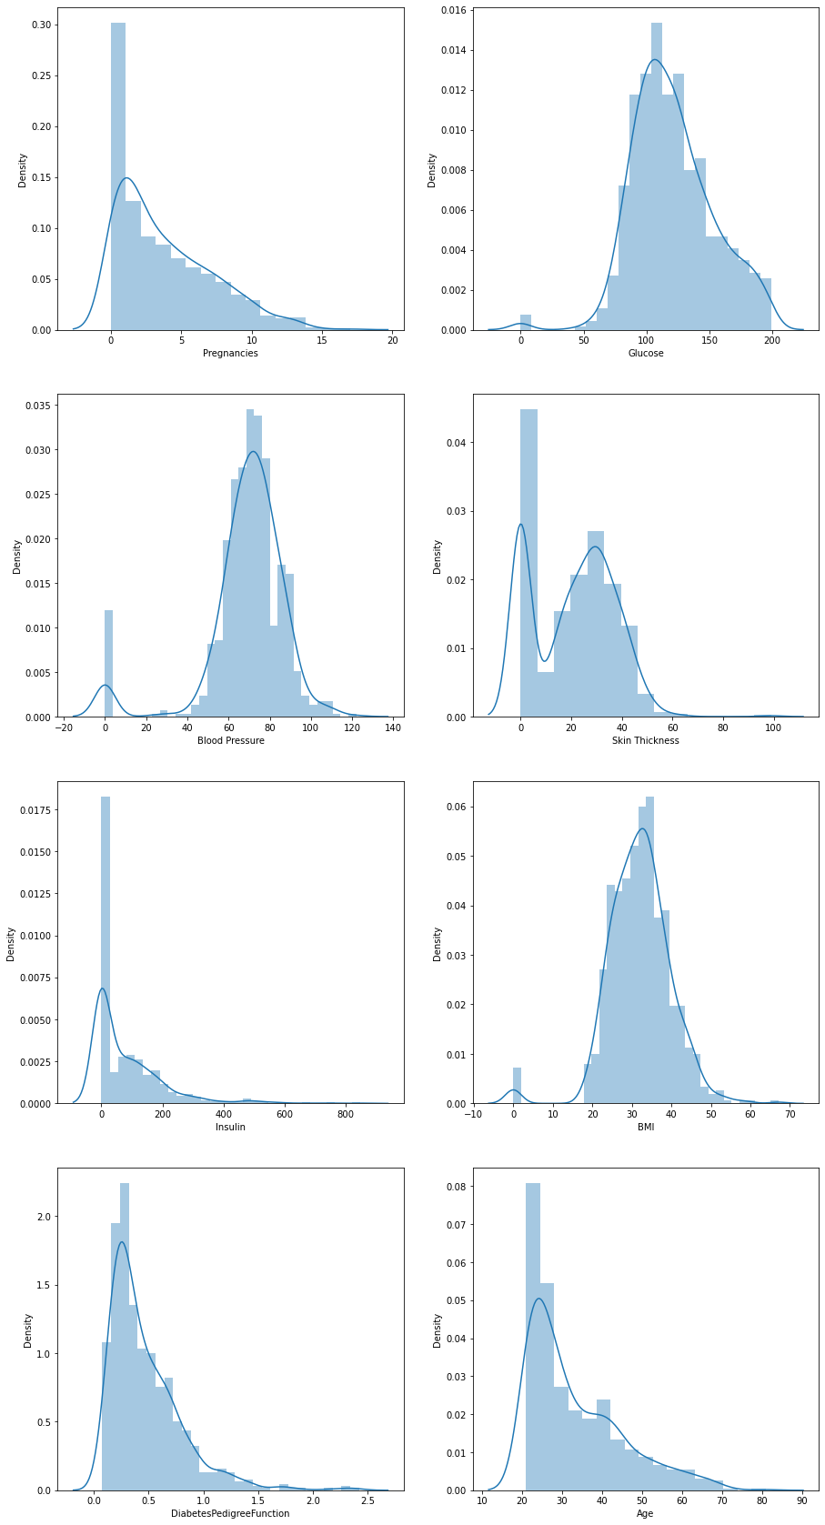



* 1. **Boxplots**

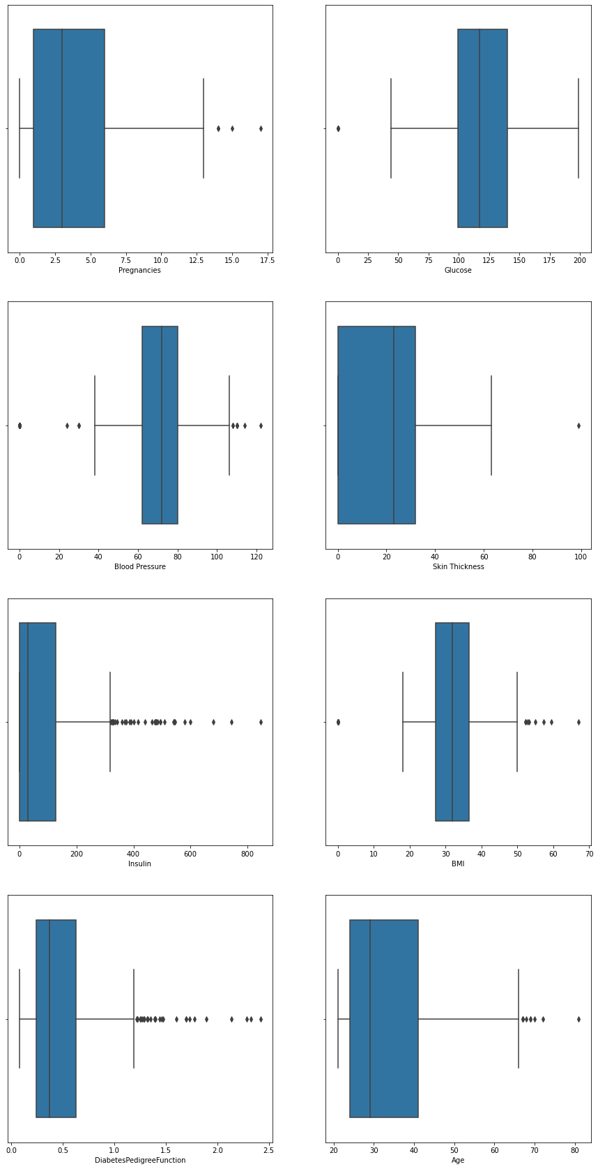



**Data Pre-processing**

The following diagram showcases the pre-processing pipeline used for this project.

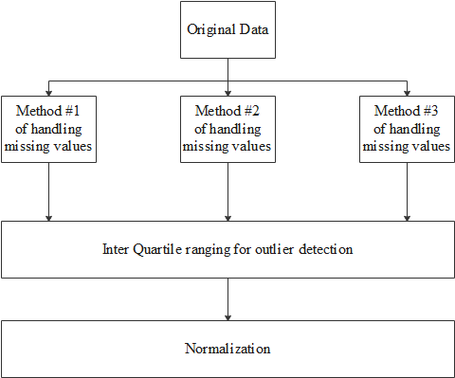

**Handling null values**

From the data visualization stage, we see many records having zero values in Glucose, Blood Pressure, Skin Thickness, Insulin and BMI which is not possible thus, these are null values. So, to make the handling of these missing values comparatively easier, we convert the zero values to null values. Then we see the number of missing values in each attribute.

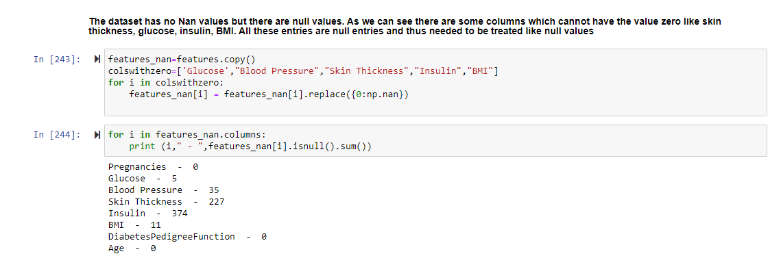

The number of missing values are-

| **COLUMN NAME** | Number of missing values |
| --- | --- |
| **Pregnancies** | 0 |
| **Glucose** | 5 |
| **Blood Pressure** | 35 |
| **Skin Thickness** | 227 |
| **Insulin** | 374 |
| **BMI** | 11 |
| **DiabetesPedigreeFunction** | 0 |
| **Age** | 0 |

For the sake of this project, we handle the missing values in 3 different ways to compare later. The three approaches are described below

1. We drop all records with missing Glucose, Blood Pressure and BMI and then we use interpolate() function for substituting the missing values for Skin Thickness and Insulin. After this, we are left with 724 records (initially there were 768 records). The code and the output are showcased in the following image.

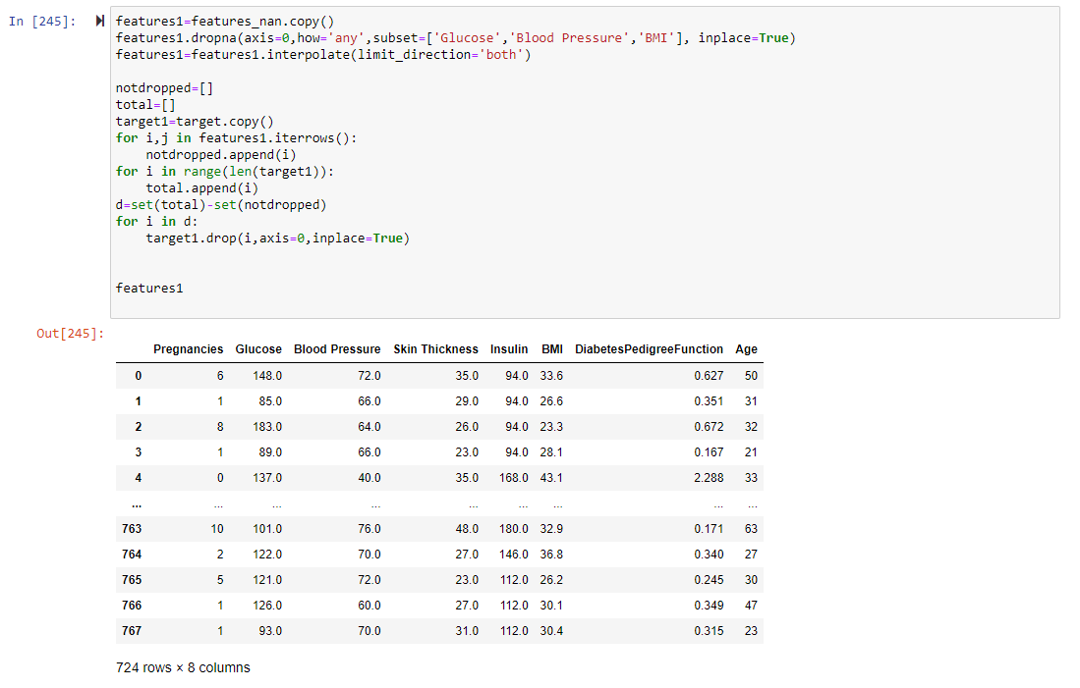

1. In the second approach, we substitute the missing values of glucose, Blood Pressure and BMI with their mean values and then interpolate the missing values for Skin Thickness and Insulin. Here, no records are dropped. The code and the output are showcased in the following image.

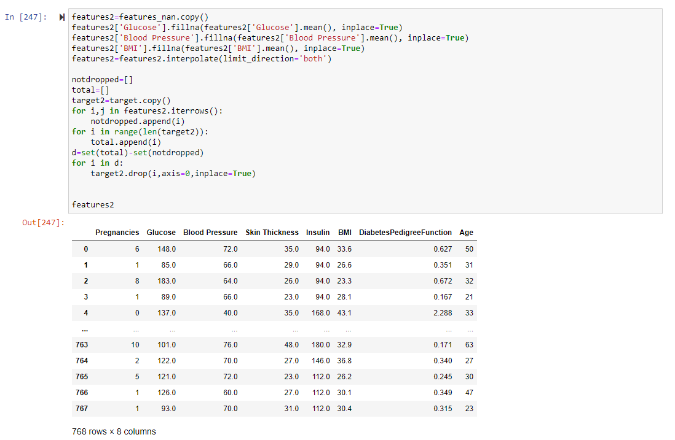

1. In the third approach, we interpolate all the values. Here, no records are dropped. The code and the output are showcased in the following image.

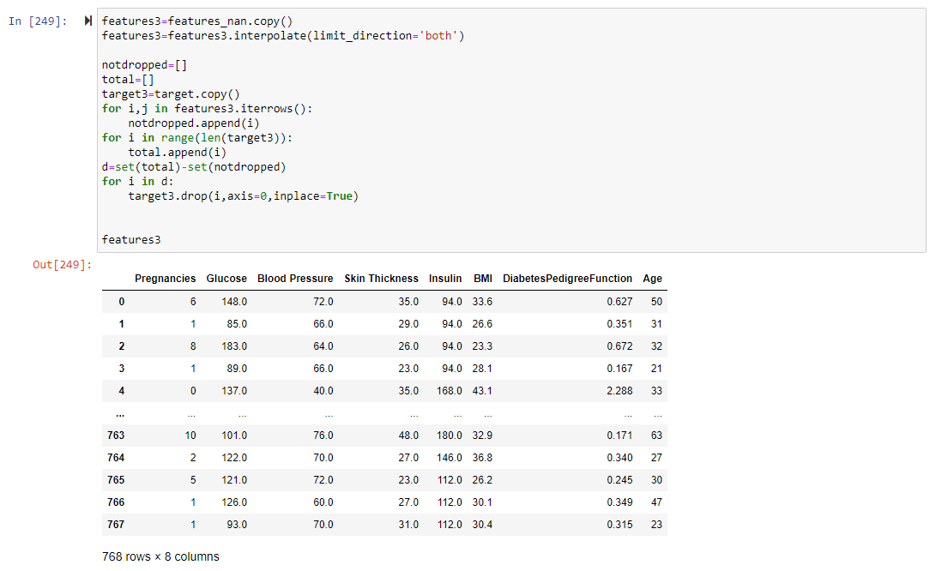

**Outlier detection and removal**

To remove the outliers, we use Interquartile Range (IQR) proximity rule. Let the 25 percentile and 75 percentile be represented by q25 and q75 and iqr=q75 – q25. The data points that fall below q25 – 1.5*iqr or above q75 + 1.5*iqr are classified as outliers. After the outlier removal, the boxplots of the data were the following (only the boxplot of the 1st approach).

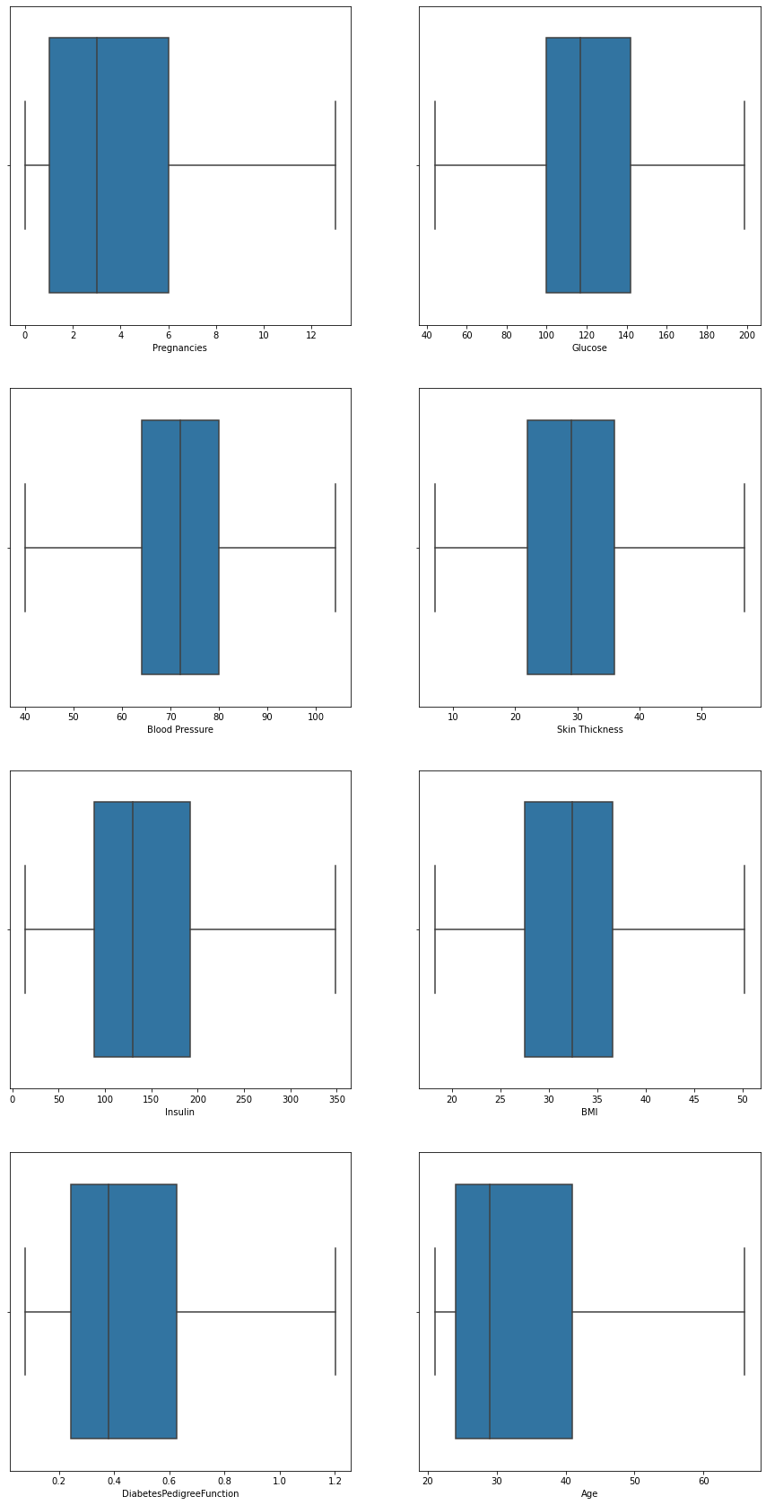





As we can see, there are no outliers now.

**Data Normalization**

We normalized the 3 data frames (the data frames that were made after applying 3 different approaches to handle missing data). The normalization of the 1st data frame is shown here.

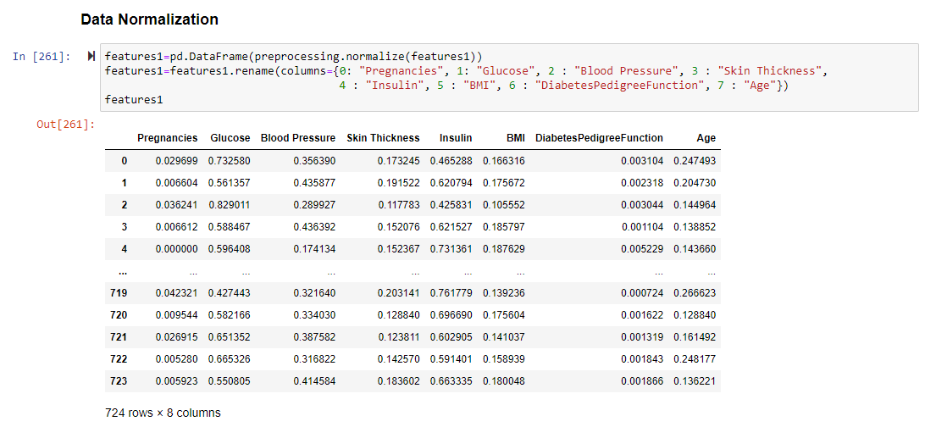

**Feature Selection**

We carry on the feature selection by

1. Finding the correlation of the target with all the attributes. If any attribute has an absolute value of correlation of more than (or equal to) 0.7, we drop that attribute. A visualization of the correlation is as follows (only shown for the first dataset).

1st data frame

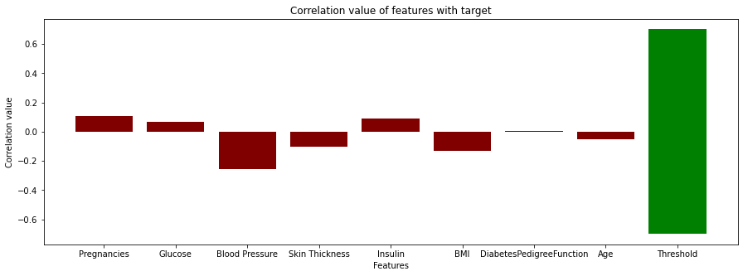

As none of the features were strongly correlated to the target values, none of them were dropped.

1. The second step was to find the correlation of features with each other. If any feature was strongly correlated with another feature (correlation > 0.7), it was dropped. A heatmap for the attribute’s correlation with each other for the 1st data frame id shown below.

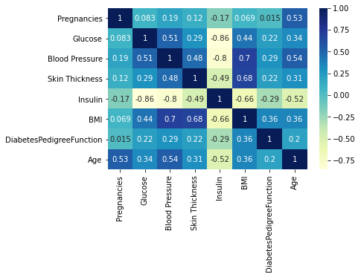

As we can see from the heatmap, Glucose, Blood pressure and Insulin have high absolute values of correlation within each other.

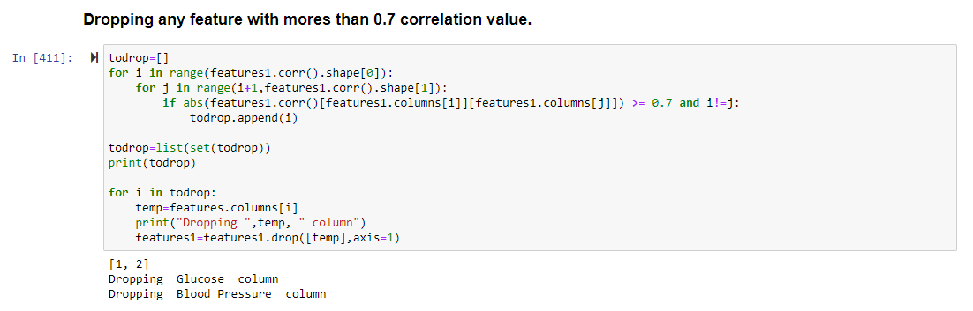

**Classification Models**

Since we have 3 different pre-processed data frames, we separate them into training and testing datasets. We take 75% of the data in each of the data frames as training data and the remaining as the testing data.

Here is the list of all the classification models compared

1. Decision Tree
2. Naive Bayes
3. ANN
4. SVM
5. Random Forest
6. KNN

We will be comparing these models on these parameters

1. Accuracy (k fold cross validation, k=10)
2. Fscore
3. Recall
4. Precision.

**Results**

**Data frame #1**

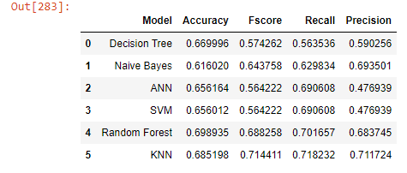

**Data frame #2**

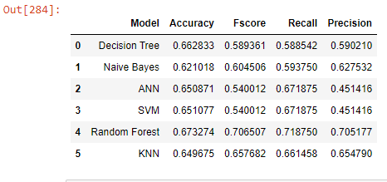

**Data frame #3**

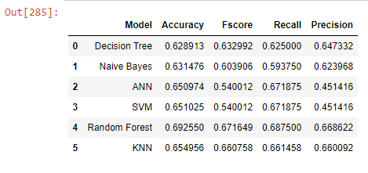

**Evaluation of results**

To properly evaluate the results, we use a number of graphs showcasing the accuracy of the models with the performance of the different preprocessed data frames. With these graphs, we answer these two fundamental questions

1. Which model performs the best across all data frames?
2. Which data frame performs the best across all models?

To answer the first question, we compare the models on the 4 evaluation parameters which are Accuracy, Fscore, Recall and Precision. When we compare the mean values (of the 3 data frames) of these 4 evaluation parameters, we begin to see a clear winner.

**Random Forest** is the most robust out of the 5 models we compared and gives a high value in all the 4 parameters across all the dataframes. Since we are evaluating a model which predicts the existence of diabetes or not, we choose **recall to be more important than precision** as getting false negatives is more costly than getting false positives. As we can see, random forest gives the highest recall value as well as the highest accuracy value.

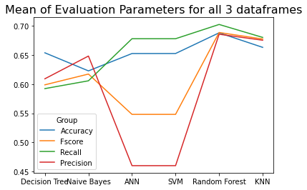

Now, we want to answer the second question. Which data frame performs the best across all models? As we have mentioned earlier, recall and accuracy are the most important metric for evaluating this problem. From the graphs showcased below, we see that data frame #1 has the highest accuracy but data frame #2 has the highest Fscore, Recall and Precision but the lowest accuracy. As accuracy is a more holistic measure of the effectiveness of the model, dataframe #1 and its associated missing value handling method is the best. **Method #1** involved dropping all records with missing Glucose, Blood Pressure and BMI and then using the interpolate() function for substituting the missing values for Skin Thickness and Insulin.

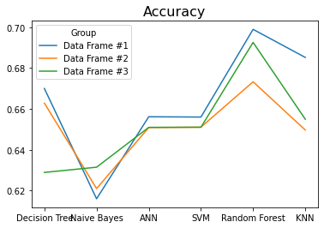

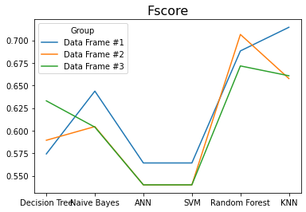

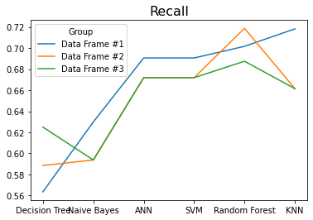

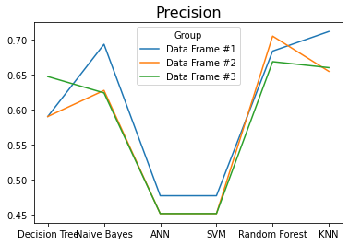

**Code**

#!/usr/bin/env python

# coding: utf-8

# ## Importing all needed modules and libraries

# ---

# In[373]:

import numpy as np

import pandas as pd

from sklearn import preprocessing

from sklearn.model_selection import train_test_split

from sklearn.neural_network import MLPClassifier

from sklearn.svm import SVC

import seaborn as sb

import matplotlib.pyplot as mp

from mpl_toolkits.mplot3d import Axes3D

import warnings

warnings.filterwarnings('ignore')

from sklearn.tree import DecisionTreeClassifier

from sklearn.naive_bayes import GaussianNB

from sklearn.neural_network import MLPClassifier

from sklearn.svm import SVC

from sklearn.metrics import accuracy_score

from sklearn.metrics import confusion_matrix

from sklearn.metrics import classification_report

from sklearn.ensemble import RandomForestClassifier

from sklearn.neighbors import KNeighborsClassifier

from sklearn.model_selection import KFold

from sklearn.model_selection import cross_val_score

from numpy import mean

from numpy import std

from sklearn.metrics import f1_score

from sklearn.metrics import recall_score

from sklearn.metrics import precision_score

# ## Data Description

# ---

# In[374]:

original_data = pd.read_csv("pima-indians-diabetes.csv",header=None)

original_data

# ### Adding column names

# In[375]:

original_data=original_data.rename(columns={0: "Pregnancies", 1: "Glucose", 2 : "Blood Pressure", 3 : "Skin Thickness",

4 : "Insulin", 5 : "BMI", 6 : "DiabetesPedigreeFunction", 7 : "Age",

8: "Class"})

original_data

# In[376]:

original_data = original_data.astype({"Class":'category'})

# In[377]:

print("No. of rows=",original_data.shape[0])

print("No. of columns=",original_data.shape[1])

print()

print("The type of data in each column is")

original_data.dtypes

# In[378]:

for i in original_data.columns:

print(original_data[i].describe())

print()

# ### Here we see that we have 8 attributes (all numerical type) and 1 target attribute. Now we shall see how many classes is in the target column.

# In[379]:

set(list(original_data.iloc[:,-1]))

# ### As we see, this will be a binary classification problem.

# # Data Visualizing

# ---

# ### Histograms

# In[380]:

fig=mp.figure(figsize=(15, 30))

for i in range(8):

ax=fig.add_subplot(4,2,i+1)

original_data[original_data.columns[i]].hist(bins=10,ax=ax)

ax.set_xlabel(original_data.columns[i])

ax.set_ylabel("Frequency")

ax.set_title(original_data.columns[i] + " Distribution")

# ### Plots

# In[381]:

ax=sb.catplot(x="Class", y=original_data.columns[0], data=original_data)

ax=sb.catplot(x="Class", y=original_data.columns[1], data=original_data)

ax=sb.catplot(x="Class", y=original_data.columns[2], data=original_data)

ax=sb.catplot(x="Class", y=original_data.columns[3], data=original_data)

ax=sb.catplot(x="Class", y=original_data.columns[4], data=original_data)

ax=sb.catplot(x="Class", y=original_data.columns[5], data=original_data)

ax=sb.catplot(x="Class", y=original_data.columns[6], data=original_data)

ax=sb.catplot(x="Class", y=original_data.columns[7], data=original_data)

# ### As we can see, there are many outliers in the data. (BMI, SkinThickness, Insulin and glucose cannot be zero). Thus outlier detection would have to be done.

# ### We seperate out the features and the target

# In[382]:

features=original_data.iloc[:,:-1]

target=original_data.iloc[:,-1]

# In[383]:

fig=mp.figure(figsize=(15, 30))

for i in range(8):

ax=fig.add_subplot(4,2,i+1)

sb.distplot(features[features.columns[i]])

# In[384]:

fig=mp.figure(figsize=(15, 30))

for i in range(8):

ax=fig.add_subplot(4,2,i+1)

sb.boxplot(features[features.columns[i]])

# ## Data Preprocessing

# ---

# ### We check null entries

# #### The dataset has no Nan values but there are null values. As we can see there are some columns which cannot have the value zero like skin thickness, glucose, insulin, BMI. All these entries are null entries and thus needed to be treated like null values

# In[385]:

features_nan=features.copy()

colswithzero=['Glucose',"Blood Pressure","Skin Thickness","Insulin","BMI"]

for i in colswithzero:

features_nan[i] = features_nan[i].replace({0:np.nan})

# In[386]:

for i in features_nan.columns:

print (i," - ",features_nan[i].isnull().sum())

# #### To handle null values, we will take 3 aproaches

# ### 1st Approach

# #### Drop all records with missing Glucose, Blood Pressure and BMI and using interpolate for Skin Thickenss and Insulin

# In[387]:

features1=features_nan.copy()

features1.dropna(axis=0,how='any',subset=['Glucose','Blood Pressure','BMI'], inplace=True)

features1=features1.interpolate(limit_direction='both')

notdropped=[]

total=[]

target1=target.copy()

for i,j in features1.iterrows():

notdropped.append(i)

for i in range(len(target1)):

total.append(i)

d=set(total)-set(notdropped)

for i in d:

target1.drop(i,axis=0,inplace=True)

features1

# In[388]:

for i in features1.columns:

print (i," - ",features1[i].isnull().sum())

# ### 2nd Approach

# #### Replace missing values for Glucose, Blood Pressure and BMI with the mean and interpolate values for Insulin and Skin Thickness.

# In[389]:

features2=features_nan.copy()

features2['Glucose'].fillna(features2['Glucose'].mean(), inplace=True)

features2['Blood Pressure'].fillna(features2['Blood Pressure'].mean(), inplace=True)

features2['BMI'].fillna(features2['BMI'].mean(), inplace=True)

features2=features2.interpolate(limit_direction='both')

notdropped=[]

total=[]

target2=target.copy()

for i,j in features2.iterrows():

notdropped.append(i)

for i in range(len(target2)):

total.append(i)

d=set(total)-set(notdropped)

for i in d:

target2.drop(i,axis=0,inplace=True)

features2

# In[390]:

for i in features2.columns:

print (i," - ",features2[i].isnull().sum())

# ### 3rd Approach

# #### Interpolate all values

# In[391]:

features3=features_nan.copy()

features3=features3.interpolate(limit_direction='both')

notdropped=[]

total=[]

target3=target.copy()

for i,j in features3.iterrows():

notdropped.append(i)

for i in range(len(target3)):

total.append(i)

d=set(total)-set(notdropped)

for i in d:

target3.drop(i,axis=0,inplace=True)

features3

# In[392]:

for i in features3.columns:

print (i," - ",features3[i].isnull().sum())

# #### Our data now has no null values.

# ### Outlier detection and removal

# https://www.analyticsvidhya.com/blog/2021/05/feature-engineering-how-to-detect-and-remove-outliers-with-python-code/

# https://www.asc.ohio-state.edu/goel.1//STATLEARN/PROJECTS/Presentations/Diabetes_PimaIndians.pdf

# In[393]:

fig=mp.figure(figsize=(15, 30))

for i in range(8):

ax=fig.add_subplot(4,2,i+1)

sb.distplot(features1[features1.columns[i]])

# In[394]:

fig=mp.figure(figsize=(15, 30))

for i in range(8):

ax=fig.add_subplot(4,2,i+1)

sb.distplot(features2[features2.columns[i]])

# In[395]:

fig=mp.figure(figsize=(15, 30))

for i in range(8):

ax=fig.add_subplot(4,2,i+1)

sb.distplot(features3[features3.columns[i]])

# In[396]:

fig=mp.figure(figsize=(15, 30))

for i in range(8):

ax=fig.add_subplot(4,2,i+1)

sb.boxplot(features1[features1.columns[i]])

# In[397]:

fig=mp.figure(figsize=(15, 30))

for i in range(8):

ax=fig.add_subplot(4,2,i+1)

sb.boxplot(features2[features2.columns[i]])

# In[398]:

fig=mp.figure(figsize=(15, 30))

for i in range(8):

ax=fig.add_subplot(4,2,i+1)

sb.boxplot(features3[features3.columns[i]])

# #### To remove outliers, we will employ IQR filtering.

#

# In[399]:

for i in features1.columns:

q25=features1[i].quantile(0.25)

q75=features1[i].quantile(0.75)

iqr=q75-q25

high=q75+1.5*iqr

low=q25-1.5*iqr

for j,k in features1.iterrows():

if features1[i][j]>high:

features1.at[j,i]=high

if features1[i][j]<low:

features1.at[j,i]=low

for i in features2.columns:

q25=features2[i].quantile(0.25)

q75=features2[i].quantile(0.75)

iqr=q75-q25

high=q75+1.5*iqr

low=q25-1.5*iqr

for j,k in features2.iterrows():

if features2[i][j]>high:

features2.at[j,i]=high

if features2[i][j]<low:

features2.at[j,i]=low

print()

for i in features3.columns:

q25=features3[i].quantile(0.25)

q75=features3[i].quantile(0.75)

iqr=q75-q25

high=q75+1.5*iqr

low=q25-1.5*iqr

for j,k in features3.iterrows():

if features3[i][j]>high:

features3.at[j,i]=high

if features3[i][j]<low:

features3.at[j,i]=low

# In[400]:

fig=mp.figure(figsize=(15, 30))

for i in range(8):

ax=fig.add_subplot(4,2,i+1)

sb.boxplot(features1[features1.columns[i]])

# In[401]:

fig=mp.figure(figsize=(15, 30))

for i in range(8):

ax=fig.add_subplot(4,2,i+1)

sb.boxplot(features2[features2.columns[i]])

# In[402]:

fig=mp.figure(figsize=(15, 30))

for i in range(8):

ax=fig.add_subplot(4,2,i+1)

sb.boxplot(features3[features3.columns[i]])

# ### Data Normalization

#

# In[403]:

features1=pd.DataFrame(preprocessing.normalize(features1))

features1=features1.rename(columns={0: "Pregnancies", 1: "Glucose", 2 : "Blood Pressure", 3 : "Skin Thickness",

4 : "Insulin", 5 : "BMI", 6 : "DiabetesPedigreeFunction", 7 : "Age"})

features1

# In[404]:

features2=pd.DataFrame(preprocessing.normalize(features2))

features2=features2.rename(columns={0: "Pregnancies", 1: "Glucose", 2 : "Blood Pressure", 3 : "Skin Thickness", 4 : "Insulin", 5 : "BMI", 6 : "DiabetesPedigreeFunction", 7 : "Age"})

features2

# In[405]:

features3=pd.DataFrame(preprocessing.normalize(features3))

features3=features3.rename(columns={0: "Pregnancies", 1: "Glucose", 2 : "Blood Pressure", 3 : "Skin Thickness", 4 : "Insulin", 5 : "BMI", 6 : "DiabetesPedigreeFunction", 7 : "Age"})

features3

# ### We find correlation if target with all the features

#

# In[406]:

fig=mp.figure(figsize=(15, 5))

features1.corrwith(target)

ax=fig.add_subplot(1,1,1)

mp.bar(features.columns,features1.corrwith(target), color ='maroon')

mp.bar("Threshold",0.7, color ='green',)

mp.bar("Threshold",-0.7, color ='green',)

mp.xlabel("Features")

mp.ylabel("Correlation value")

mp.title("Correlation value of features with target")

mp.show()

fig=mp.figure(figsize=(15, 5))

features2.corrwith(target)

ax=fig.add_subplot(1,1,1)

mp.bar(features.columns,features2.corrwith(target), color ='maroon')

mp.bar("Threshold",0.7, color ='green',)

mp.bar("Threshold",-0.7, color ='green',)

mp.xlabel("Features")

mp.ylabel("Correlation value")

mp.title("Correlation value of features with target")

mp.show()

fig=mp.figure(figsize=(15, 5))

features3.corrwith(target)

ax=fig.add_subplot(1,1,1)

mp.bar(features.columns,features3.corrwith(target), color ='maroon')

mp.bar("Threshold",0.7, color ='green',)

mp.bar("Threshold",-0.7, color ='green',)

mp.xlabel("Features")

mp.ylabel("Correlation value")

mp.title("Correlation value of features with target")

mp.show()

# #### Dropping any feature with mores than 0.7 correlation value.

# In[407]:

for i in range(len(features1.corrwith(target))):

if abs(features1.corrwith(target)[i])>=0.7:

features1.drop(columns=[i])

# In[408]:

for i in range(len(features2.corrwith(target))):

if abs(features2.corrwith(target)[i])>=0.7:

features2.drop(columns=[i])

# In[409]:

for i in range(len(features3.corrwith(target))):

if abs(features3.corrwith(target)[i])>=0.7:

features3.drop(columns=[i])

# ### None of the features were dropped

# ### We find correlation within features

# In[410]:

dataplot = sb.heatmap(features1.corr(), cmap="YlGnBu", annot=True)

mp.show()

dataplot = sb.heatmap(features2.corr(), cmap="YlGnBu", annot=True)

mp.show()

dataplot = sb.heatmap(features3.corr(), cmap="YlGnBu", annot=True)

mp.show()

# ### Dropping any feature with mores than 0.7 correlation value.

# In[411]:

todrop=[]

for i in range(features1.corr().shape[0]):

for j in range(i+1,features1.corr().shape[1]):

if abs(features1.corr()[features1.columns[i]][features1.columns[j]]) >= 0.7 and i!=j:

todrop.append(i)

todrop=list(set(todrop))

print(todrop)

for i in todrop:

temp=features.columns[i]

print("Dropping ",temp, " column")

features1=features1.drop([temp],axis=1)

# In[372]:

features1

# In[270]:

todrop=[]

for i in range(features2.corr().shape[0]):

for j in range(i+1,features2.corr().shape[1]):

if abs(features2.corr()[features2.columns[i]][features2.columns[j]]) >= 0.7 and i!=j:

todrop.append(i)

todrop=list(set(todrop))

for i in todrop:

temp=features2.columns[i]

todrop.remove(i)

print("Dropping ",temp, " column")

features2=features2.drop([temp],axis=1)

# In[271]:

todrop=[]

for i in range(features3.corr().shape[0]):

for j in range(i+1,features3.corr().shape[1]):

if abs(features3.corr()[features3.columns[i]][features3.columns[j]]) >= 0.7 and i!=j:

todrop.append(i)

todrop=list(set(todrop))

for i in todrop:

temp=features3.columns[i]

print("Dropping ",temp, " column")

features3=features3.drop([temp],axis=1)

# In[272]:

features3

# ## Classification Models

# In[273]:

x1train,x1test,y1train,y1test=train_test_split(features1, target1,random_state=88)

x2train,x2test,y2train,y2test=train_test_split(features2, target2,random_state=88)

x3train,x3test,y3train,y3test=train_test_split(features3, target3,random_state=88)

# In[274]:

tab1= [[0 for i in range(5)] for j in range(6)]

tab2= [[0 for i in range(5)] for j in range(6)]

tab3= [[0 for i in range(5)] for j in range(6)]

tabs=['tab1','tab2','tab3']

features=['features1','features2','features3']

targets=['target1','target2','target3']

xtrain=['x1train','x2train','x3train']

ytrain=['y1train','y2train','y3train']

xtest=['x1test','x2test','x3test']

ytest=['y1test','y2test','y3test']

models=['Decision Tree','Naive Bayes','ANN','SVM','Random Forest','KNN']

for i in tabs:

for j in range(len(models)):

eval(i)[j][0]=models[j]

# ## Decision Tree

# In[275]:

for i in range(3):

cv = KFold(n_splits=10, shuffle=True)

DT=DecisionTreeClassifier(random_state=9)

scores = cross_val_score(DT, eval(features[i]), eval(targets[i]), scoring='accuracy', cv=cv, n_jobs=-1)

DT.fit(eval(xtrain[i]),eval(ytrain[i]))

ypred=DT.predict(eval(xtest[i]))

temp=[scores.mean(),f1_score(eval(ytest[i]), ypred,average='weighted'),recall_score(eval(ytest[i]), ypred,average='weighted'),precision_score(eval(ytest[i]), ypred,average='weighted')]

eval(tabs[i])[0][1:5]=temp

# ## Naive Bayes

# In[276]:

for i in range(3):

cv = KFold(n_splits=10, shuffle=True)

NB=GaussianNB()

scores = cross_val_score(NB, eval(features[i]), eval(targets[i]), scoring='accuracy', cv=cv, n_jobs=-1)

NB.fit(eval(xtrain[i]),eval(ytrain[i]))

ypred=NB.predict(eval(xtest[i]))

temp=[scores.mean(),f1_score(eval(ytest[i]), ypred,average='weighted'),recall_score(eval(ytest[i]), ypred,average='weighted'),precision_score(eval(ytest[i]), ypred,average='weighted')]

eval(tabs[i])[1][1:5]=temp

# ## ANN

# In[277]:

for i in range(3):

cv = KFold(n_splits=10, shuffle=True)

ANN=MLPClassifier(hidden_layer_sizes=(2,3),random_state=5,verbose=False,learning_rate_init=0.01)

scores = cross_val_score(ANN, eval(features[i]), eval(targets[i]), scoring='accuracy', cv=cv, n_jobs=-1)

ANN.fit(eval(xtrain[i]),eval(ytrain[i]))

ypred=ANN.predict(eval(xtest[i]))

temp=[scores.mean(),f1_score(eval(ytest[i]), ypred,average='weighted'),recall_score(eval(ytest[i]), ypred,average='weighted'),precision_score(eval(ytest[i]), ypred,average='weighted')]

eval(tabs[i])[2][1:5]=temp

# ## SVM

# In[278]:

for i in range(3):

cv = KFold(n_splits=10, shuffle=True)

svc=SVC(kernel='linear')

svc.fit(x1train,y1train)

scores = cross_val_score(svc, eval(features[i]), eval(targets[i]), scoring='accuracy', cv=cv, n_jobs=-1)

svc.fit(eval(xtrain[i]),eval(ytrain[i]))

ypred=svc.predict(eval(xtest[i]))

temp=[scores.mean(),f1_score(eval(ytest[i]), ypred,average='weighted'),recall_score(eval(ytest[i]), ypred,average='weighted'),precision_score(eval(ytest[i]), ypred,average='weighted')]

eval(tabs[i])[3][1:5]=temp

# ## Random Forest

# In[279]:

for i in range(3):

cv = KFold(n_splits=10, shuffle=True)

rf=RandomForestClassifier(random_state=0)

scores = cross_val_score(rf, eval(features[i]), eval(targets[i]), scoring='accuracy', cv=cv, n_jobs=-1)

rf.fit(eval(xtrain[i]),eval(ytrain[i]))

ypred=rf.predict(eval(xtest[i]))

temp=[scores.mean(),f1_score(eval(ytest[i]), ypred,average='weighted'),recall_score(eval(ytest[i]), ypred,average='weighted'),precision_score(eval(ytest[i]), ypred,average='weighted')]

eval(tabs[i])[4][1:5]=temp

# In[280]:

len(ypred)

# ## KNN

# In[281]:

for i in range(3):

cv = KFold(n_splits=10, shuffle=True)

knn = KNeighborsClassifier(n_neighbors=3)

knn.fit(x1train,y1train)

scores = cross_val_score(knn, eval(features[i]), eval(targets[i]), scoring='accuracy', cv=cv, n_jobs=-1)

knn.fit(eval(xtrain[i]),eval(ytrain[i]))

ypred=knn.predict(eval(xtest[i]))

temp=[scores.mean(),f1_score(eval(ytest[i]), ypred,average='weighted'),recall_score(eval(ytest[i]), ypred,average='weighted'),precision_score(eval(ytest[i]), ypred,average='weighted')]

eval(tabs[i])[5][1:5]=temp

# ## Evaluation

# In[282]:

tab1=pd.DataFrame(tab1)

tab2=pd.DataFrame(tab2)

tab3=pd.DataFrame(tab3)

for i in tabs:

eval(i).rename(columns={0: "Model", 1: "Accuracy", 2 : "Fscore", 3 : "Recall", 4 : "Precision"}, inplace=True)

# In[283]:

tab1

# In[284]:

tab2

# In[285]:

tab3

# In[456]:

mean_Accuracy=(tab1['Accuracy']+tab2["Accuracy"]+tab3["Accuracy"])/3

mean_Fscore=(tab1['Fscore']+tab2["Fscore"]+tab3["Fscore"])/3

mean_Recall=(tab1['Recall']+tab2["Recall"]+tab3["Recall"])/3

mean_Precision=(tab1['Precision']+tab2["Precision"]+tab3["Precision"])/3

# In[459]:

mp.plot(tab1['Model'],mean_Accuracy, label='Accuracy')

mp.plot(tab1['Model'],mean_Fscore, label='Fscore')

mp.plot(tab1['Model'],mean_Recall, label='Recall')

mp.plot(tab1['Model'],mean_Precision, label='Precision')

mp.legend(title='Group')

mp.title('Mean of Evaluation Parameters for all 3 dataframes', fontsize=16)

mp.figure(figsize=(200,7))

mp.show()

# In[ ]:

# In[424]:

tab1.plot(x ='Model', y='Accuracy', kind = 'line', figsize=(10,5),title="DATA FRAME #1")

tab1.plot(x ='Model', y='Fscore', kind = 'line', figsize=(10,5),title="DATA FRAME #1")

tab1.plot(x ='Model', y='Recall', kind = 'line', figsize=(10,5),title="DATA FRAME #1")

tab1.plot(x ='Model', y='Precision', kind = 'line', figsize=(10,5),title="DATA FRAME #1")

# In[425]:

tab2.plot(x ='Model', y='Accuracy', kind = 'line', figsize=(10,5),title="DATA FRAME #2")

tab2.plot(x ='Model', y='Fscore', kind = 'line', figsize=(10,5),title="DATA FRAME #2")

tab2.plot(x ='Model', y='Recall', kind = 'line', figsize=(10,5),title="DATA FRAME #2")

tab2.plot(x ='Model', y='Precision', kind = 'line', figsize=(10,5),title="DATA FRAME #2")

# In[426]:

tab3.plot(x ='Model', y='Accuracy', kind = 'line', figsize=(10,5),title="DATA FRAME #3")

tab3.plot(x ='Model', y='Fscore', kind = 'line', figsize=(10,5),title="DATA FRAME #3")

tab3.plot(x ='Model', y='Recall', kind = 'line', figsize=(10,5),title="DATA FRAME #3")

tab3.plot(x ='Model', y='Precision', kind = 'line', figsize=(10,5),title="DATA FRAME #3")

# In[449]:

mp.plot(tab1['Model'],tab1['Accuracy'], label='Data Frame #1')

mp.plot(tab2['Accuracy'], label='Data Frame #2')

mp.plot(tab3['Accuracy'],label='Data Frame #3')

mp.legend(title='Group')

mp.title('Accuracy', fontsize=16)

mp.figure(figsize=(200,7))

mp.show()

# In[450]:

mp.plot(tab1['Model'],tab1['Fscore'], label='Data Frame #1')

mp.plot(tab2['Fscore'], label='Data Frame #2')

mp.plot(tab3['Fscore'],label='Data Frame #3')

mp.legend(title='Group')

mp.title('Fscore', fontsize=16)

mp.figure(figsize=(200,7))

mp.show()

# In[451]:

mp.plot(tab1['Model'],tab1['Recall'], label='Data Frame #1')

mp.plot(tab2['Recall'], label='Data Frame #2')

mp.plot(tab3['Recall'],label='Data Frame #3')

mp.legend(title='Group')

mp.title('Recall', fontsize=16)

mp.figure(figsize=(200,7))

mp.show()

# In[452]:

mp.plot(tab1['Model'],tab1['Precision'], label='Data Frame #1')

mp.plot(tab2['Precision'], label='Data Frame #2')

mp.plot(tab3['Precision'],label='Data Frame #3')

mp.legend(title='Group')

mp.title('Precision', fontsize=16)

mp.figure(figsize=(200,7))

mp.show()