# Create a vitural environment

python -m venv env

-this create a virtual environment file named ‘env’

-then activate the virtual environment

env\Scripts\activate

# Install the packages in “reqirement.txt”

pip install -r requirement.txt

# Copy the setting.py

https://github.com/techwithtim/Django-React-Full-Stack-App/blob/main/backend/backend/settings.py

# Create a ‘project’ named “backend”

django-admin startproject backend

# Inside ‘backend’ create a app named ‘api’

cd backend

manage.py startapp api

# Create a file “serializer.py” inside ‘api’ folder

And copy the following code

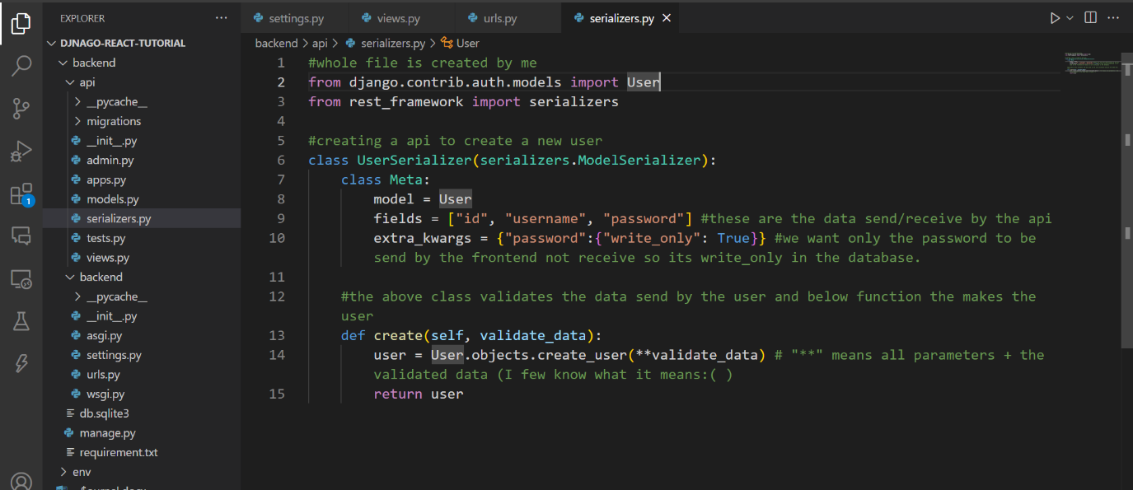

# Write the following in api/views.py

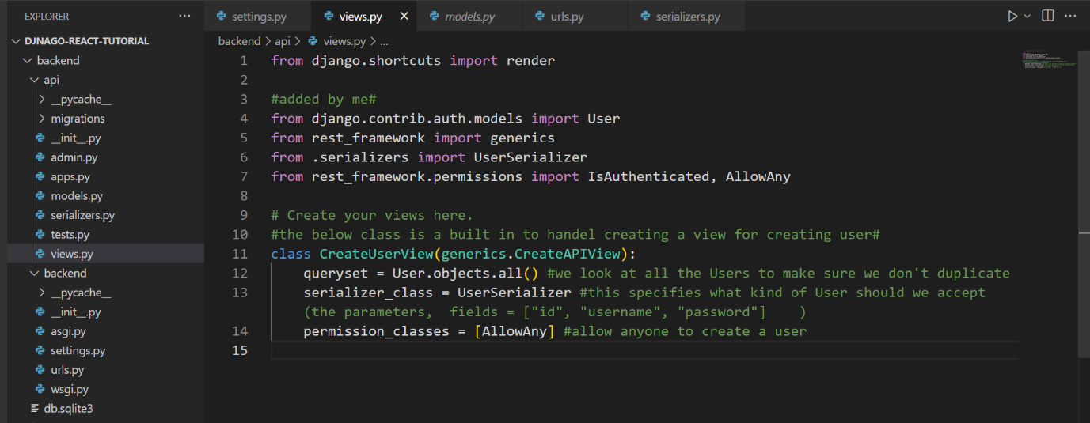

# Setup the urls in api/urls.py

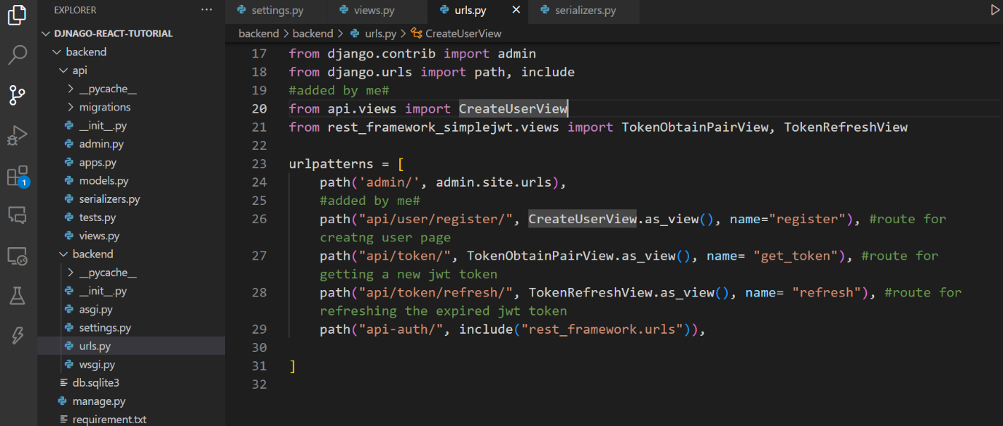

# Deployment

Create a .env file in “backend” folder.

Copy the following into the env.

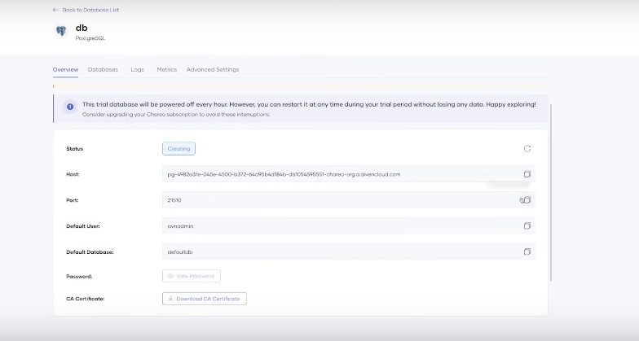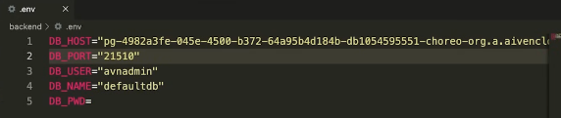

Change database in settings.py in backend.

