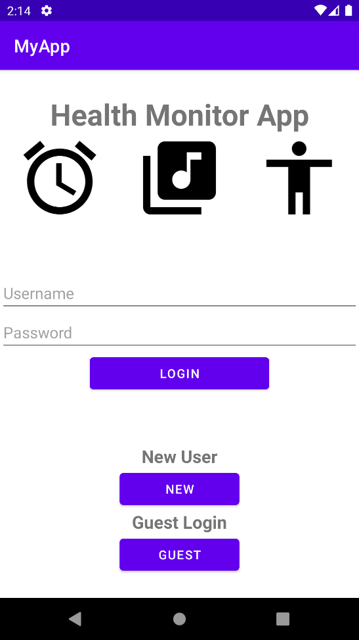This is the launcher activity of the app. User can login into the app through here. Users with an account can enter their username and password then click the login button to go to next page.

New users can register a new account using the New button while users who want to login as guest can use the Guest button.

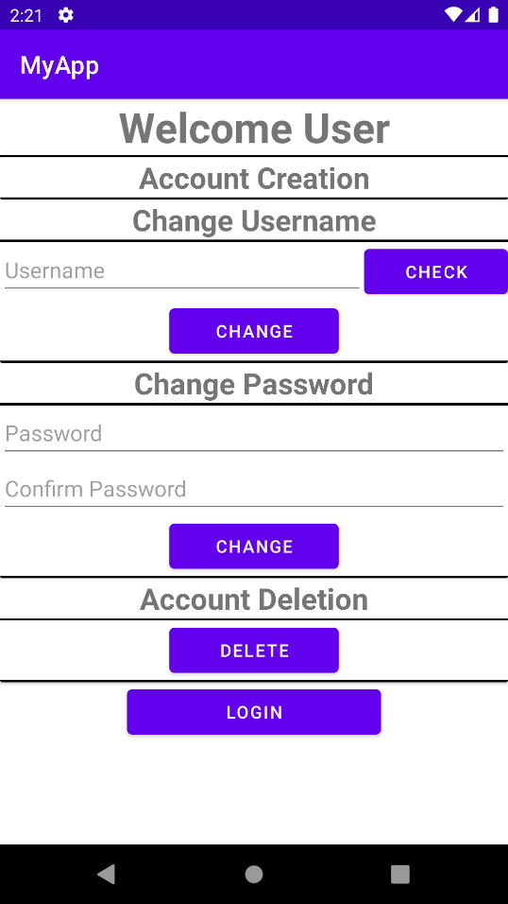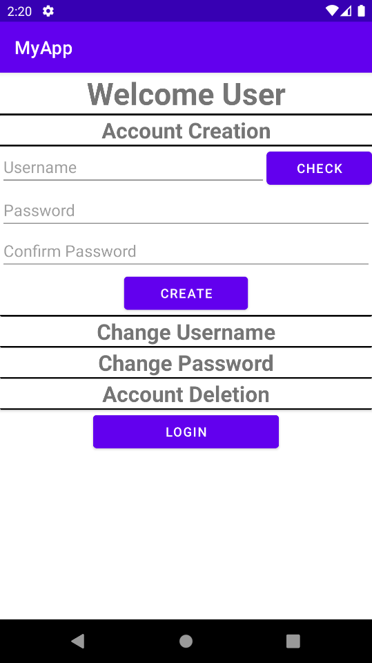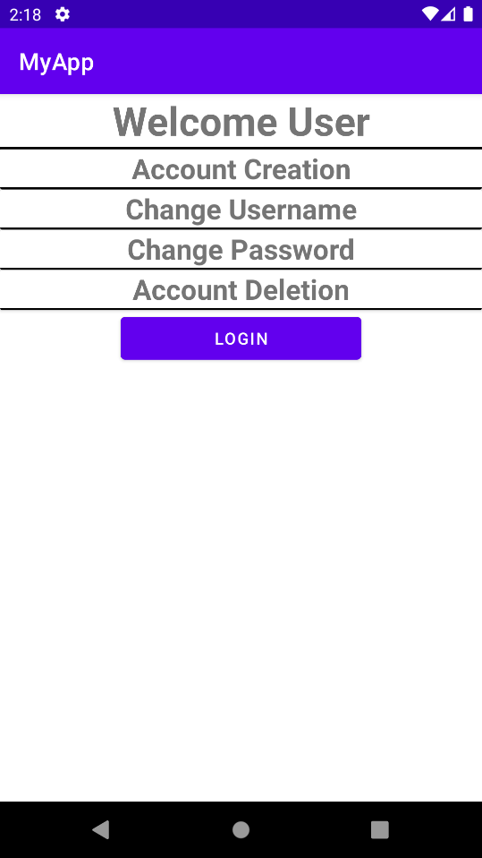This is the second activity of the app. New and existing users are redirected here. The 4 rows are clickable and will expand when clicked. Account creation is only available to new users. They must enter their desired username and check availability using the check button.

Existing users can choose to change their username, change their password, or delete their accounts. After everything is done, users can continue into the main app using the login button.

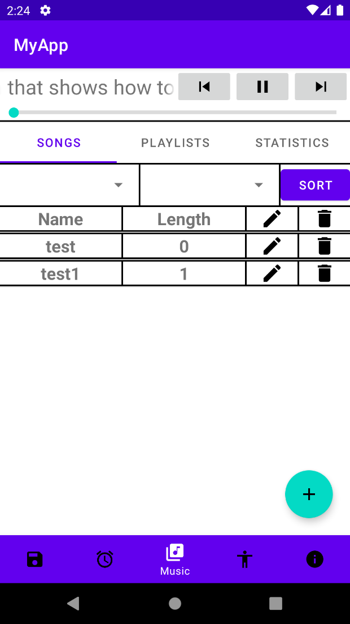This is the first main screen seen by the user. From the top, we have the mp3 player with image buttons and a progress bar to record song progress.

Then, we have a tab layout bar to show that there are 3 different tabs of the music activity. The 3 tabs are held inside a viewpager and are fragments of the music activity which are managed by a fragment adapter.

Then, we have 2 spinners and a sort button used to sort the data in a particular order. The first spinner chooses the attribute to be sorted while the second spinner chooses the order of the sorting.

Then, we have the list view holding all the different songs. The first column is the song name. The second column is the song length. The third and fourth are the edit and delete image view buttons.

Then, we have the floating button used to add new songs to the app. Finally, we have the bottom navigator used to navigate between the 5 main activities.

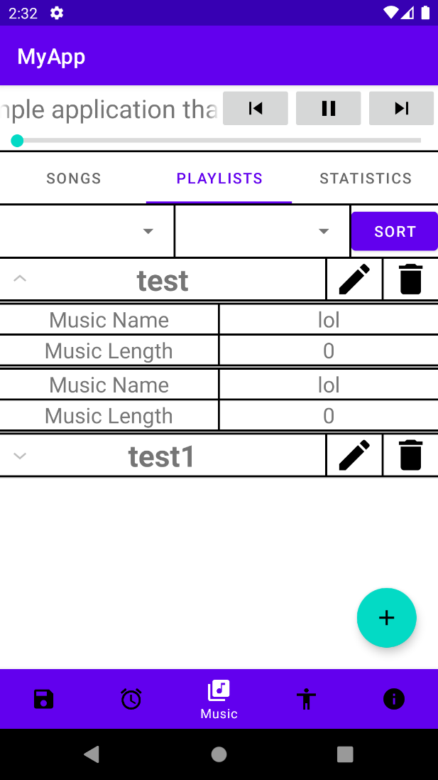This is the second tab of the music activity. This fragment holds the playlists of the user. Like the first tab, we have the mp3 player on top. All other tabs after this will most likely have the mp3 player and so it will not be mentioned again.

This page also has a spinner with a button to sort the data. Unlike the first page, the playlist data is stored inside a expandable list view as the number of songs in a playlist can vary. The playlist also has the edit and delete buttons and all further occurrences will not be mentioned.

The floating button is used to redirect users to another activity to create new playlists.

Finally, we have the bottom navigator on the bottom. This fact will not be mentioned again going forward.

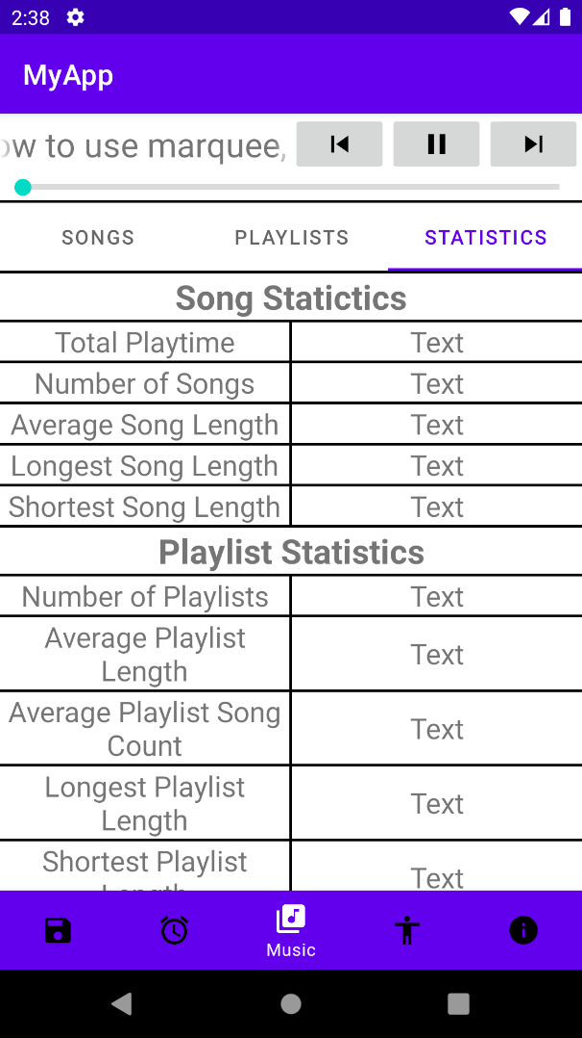This is the third and final tab of the music activity. This tab shows the statistics of the songs and playlists. It records information such as total playtime, average song length, longest and shortest song length, etc.

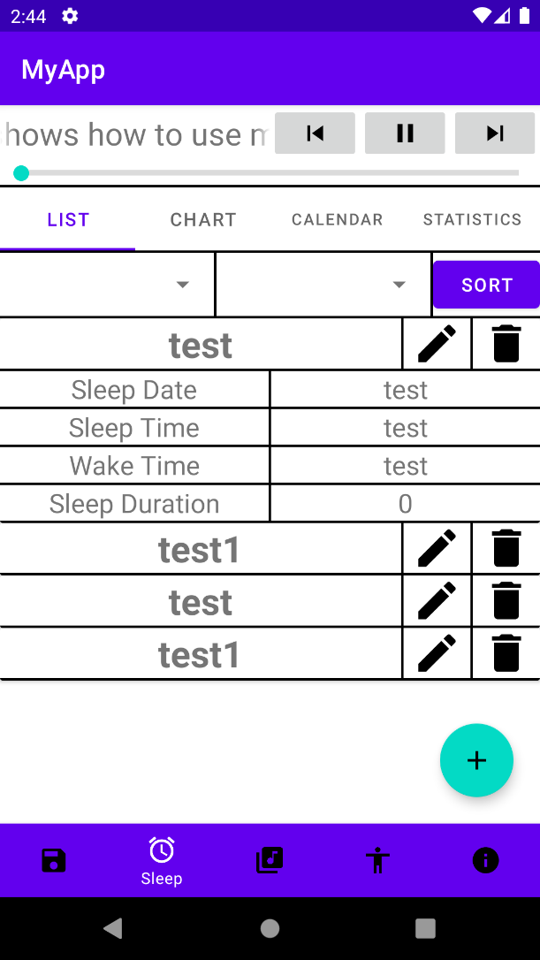This is the first tab of the sleep activity. It is also a fragment managed by a fragment adapter. It is shown with a viewpager and arranged in a tab layout like the music activity. The sleep activity has 4 different tabs or fragments.

The page also has a spinner and button to sort the data. The data is stored in a recycler view with cardviews. This allows the app to save screen space as the data is only shown when the user clicks the visible layout. The data can be hidden again by clicking the visible layout again.

The floating button allows users to add a new row in the recycler view. The data records the sleep and wake time of the user during a particular day and the sleep duration is also recorded automatically.

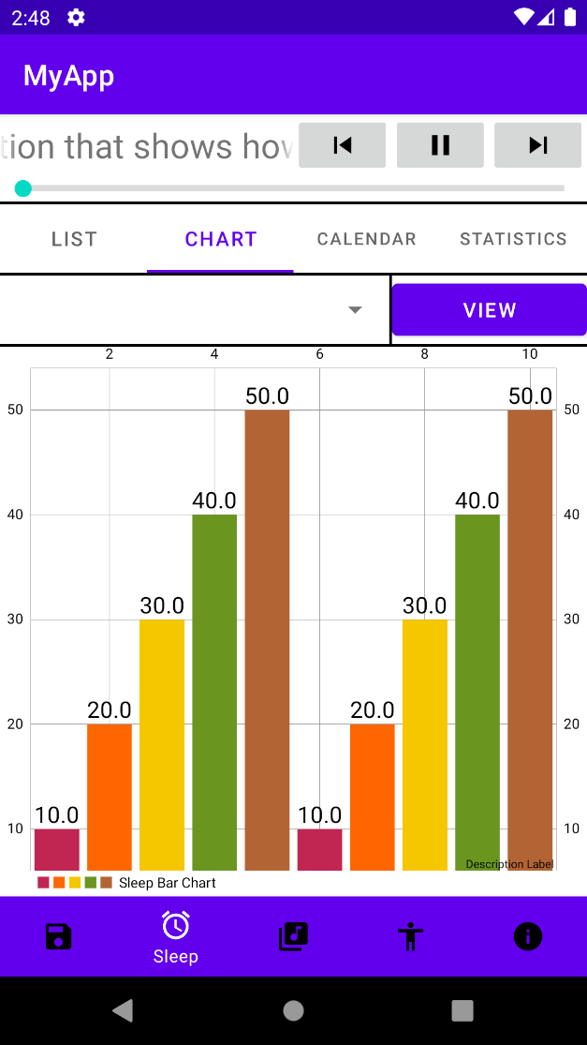This is the second tab of the sleep activity. It holds a bar chart to show the sleeping habits of the user than a list more clearly.

The spinner and button on top allow the user to graph different data such as the sleep and wake time and also the sleep duration of the user.

The bar chart is imported from github and is created by PhilJay.

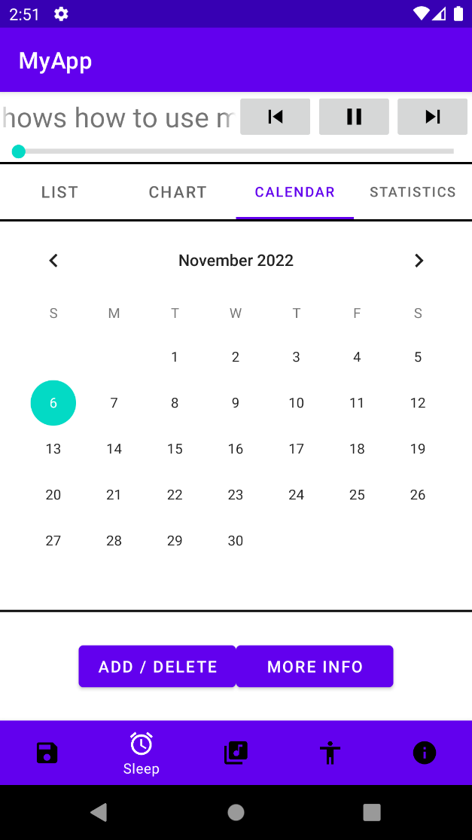This is the third tab of the sleep activity. It has a calendar view for the user to choose a data more easily.

If the day chosen does not have sleep information, the add button is displayed and more info button is greyed out. If sleep information is available, the delete button and more info button are both shown.

Users can view the sleep information using the more info button or add and delete data using the add or delete button.

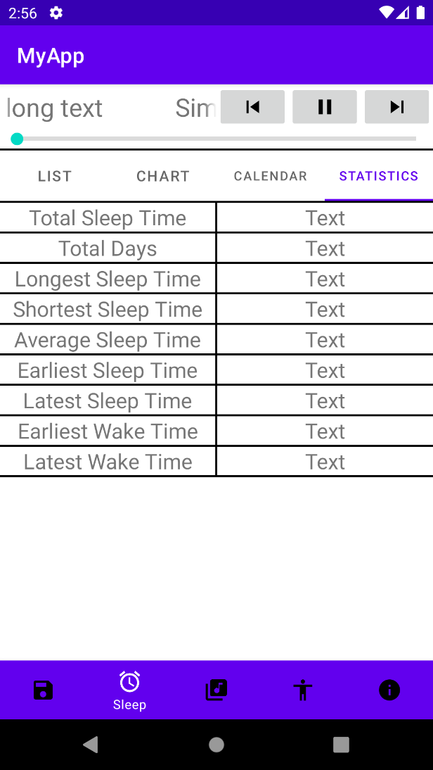This is the fourth and last tab of the sleep activity. This page shows the statistics about the sleep information of the user. The user can see data such as average sleep time, total sleep time etc.

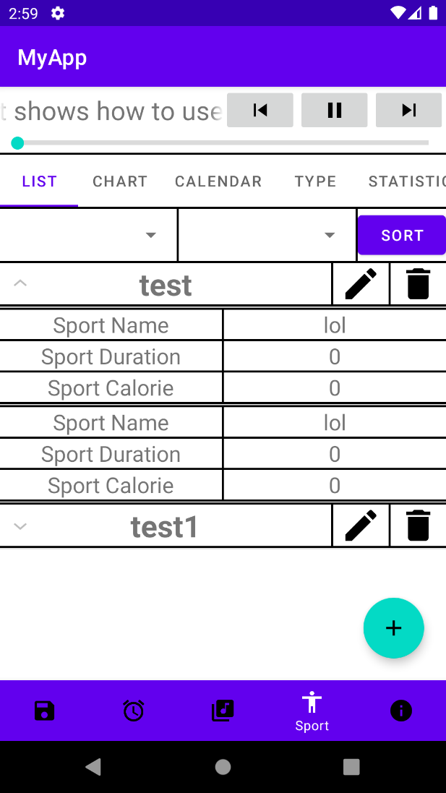This is the first of five tabs of the sport activity. This page records the different sports and exercises performed by a user in a particular day with information such as sport duration and calories burned. The data is stored in a expandable list view.

We have a spinner and button to sort the data. We also have a floating button to add new entries to the list.

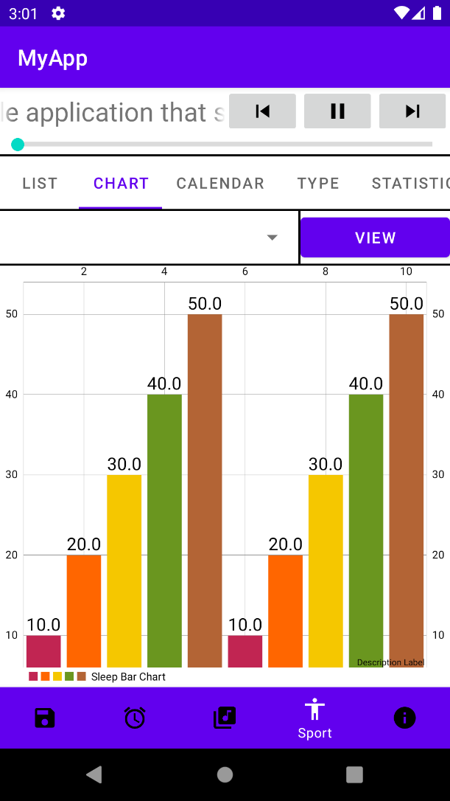This is the second tab of the sport activity. Like the bar chart in the sleep activity, we can also graph the progression of our daily exercise.

The spinner and button on top also allow us to graph different data such as exercise duration and calories burned.

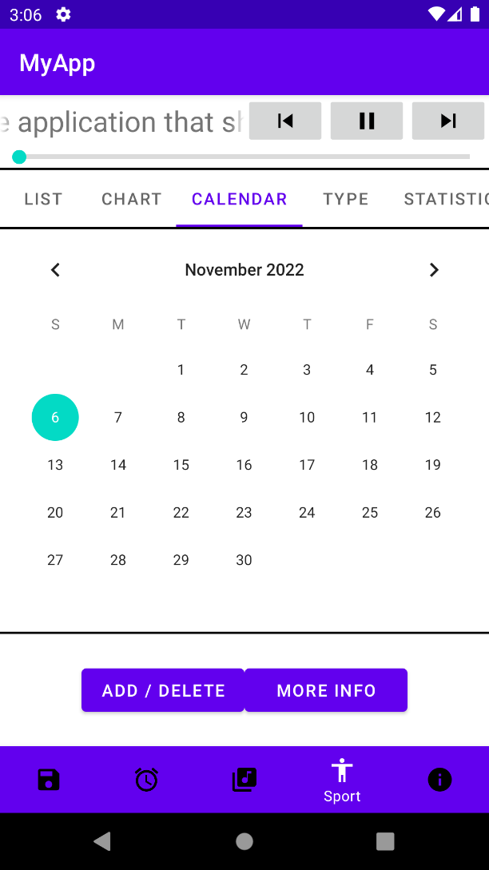This is the third tab of the sport activity. Like the calendar view of the sleep activity, we can easily choose a day to see if sport data is available.

We can then add, modify, or delete the data using the buttons provided below.

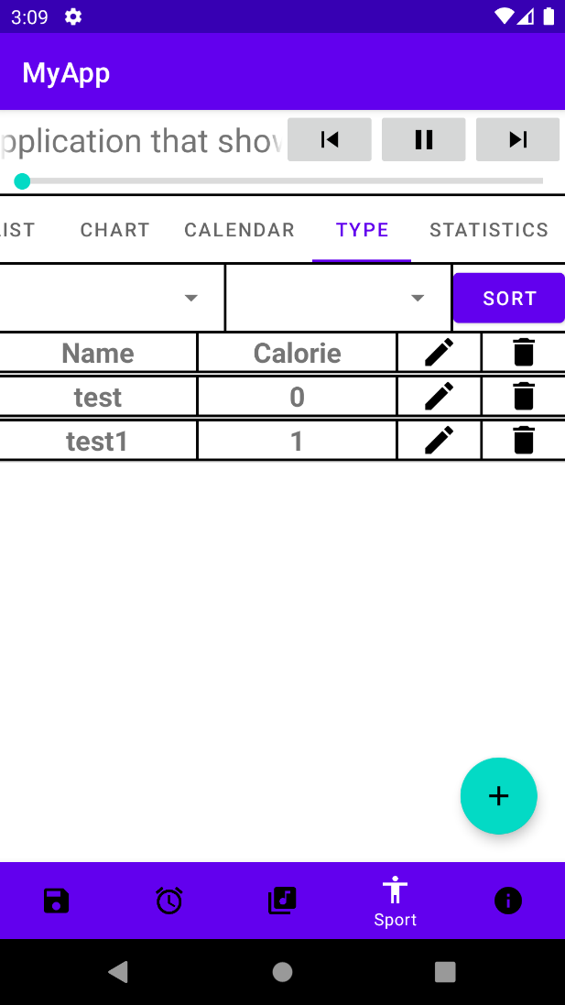This is the fourth tab of the sport activity. This page has a list view to show the different sport types and their respectively calories burned per minute. This information is used to calculate total calories burned by a user performing a certain activity for a certain amount of time.

The spinner and button above can be used to sort the different sport types by name or by calories per minute.

The floating button calls a custom dialog to allow the user to add a new sport type with its calories burned per minute data.

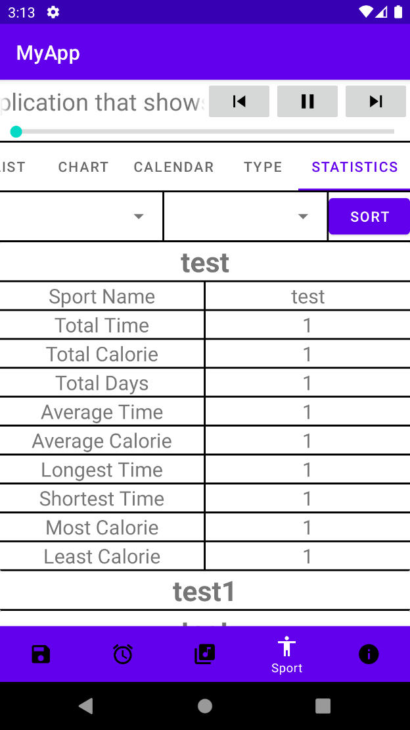This is the fifth and final tab of the sport activity. It has a recycler view with cardviews to hold the statistics of different sport types such as the total time performing that sport, the total calories burned performing the sport, the longest and shortest time performing the sport etc.

The spinner and button on top allow the user to sort the data according to their preference. The spinner is expected to be very long to accommodate the large number of choices for the data to be sorted.

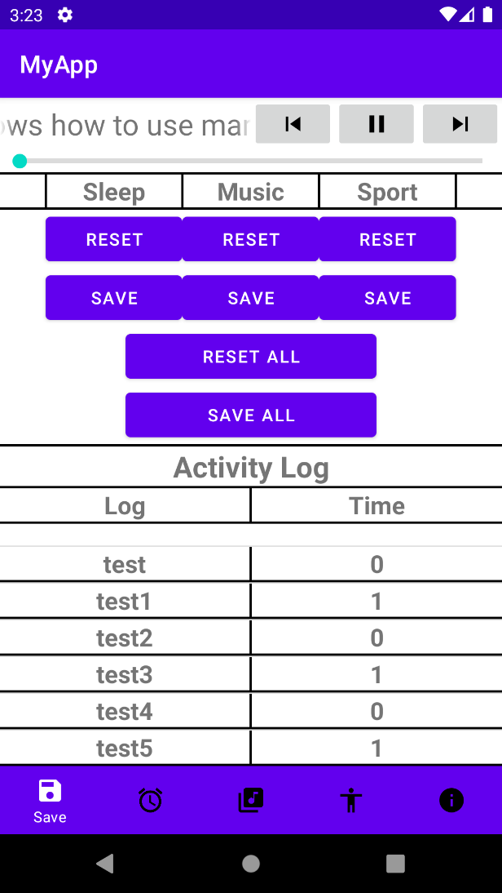This is the save activity of the app. The user can reset any changes made to the data or overwrite the old data with new data. This means that saving is manual in this app and users must remember to save any changes made before closing the app.

Users can save or reset each dataset individually or at once depending on the button pressed.

The app also records logs to show the actions performed by the user and the time the action was performed.

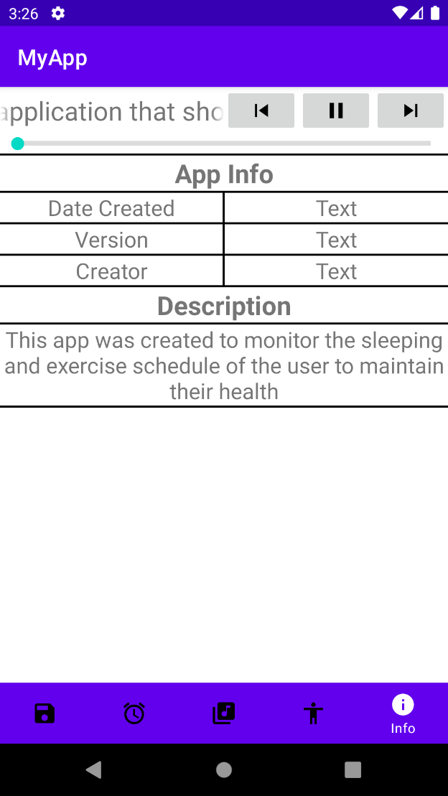This is the info activity of the app. It shows information such as the creator’s name, app version and the date the app was created. The page also has a short description about the app.

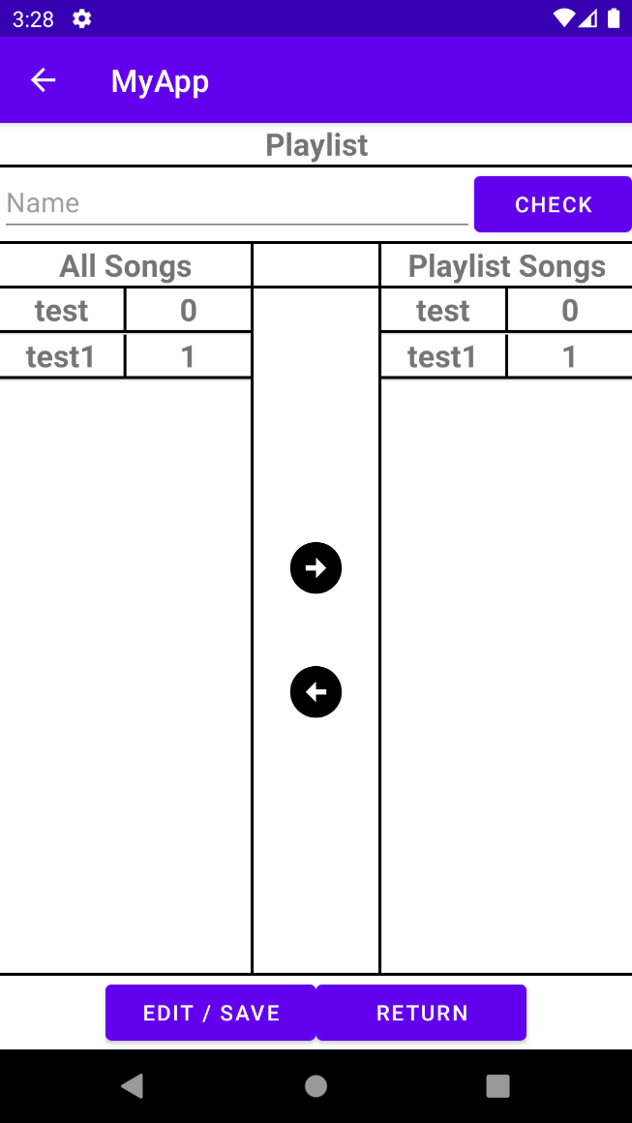This is the Playlist Creation activity. This page allows the user to create new playlists or edit existing ones. The page has two listviews. The left listview holds all the songs available in the app. The right listview are the songs selected to be placed into the new playlist. Songs can be moved using the arrows below.

The user must first check if the chosen name is available. Then, the user can start choosing their preferred songs in a new playlist. Finally, the user can save their choice using the save button below or return to the last page without creating a playlist using the return button.

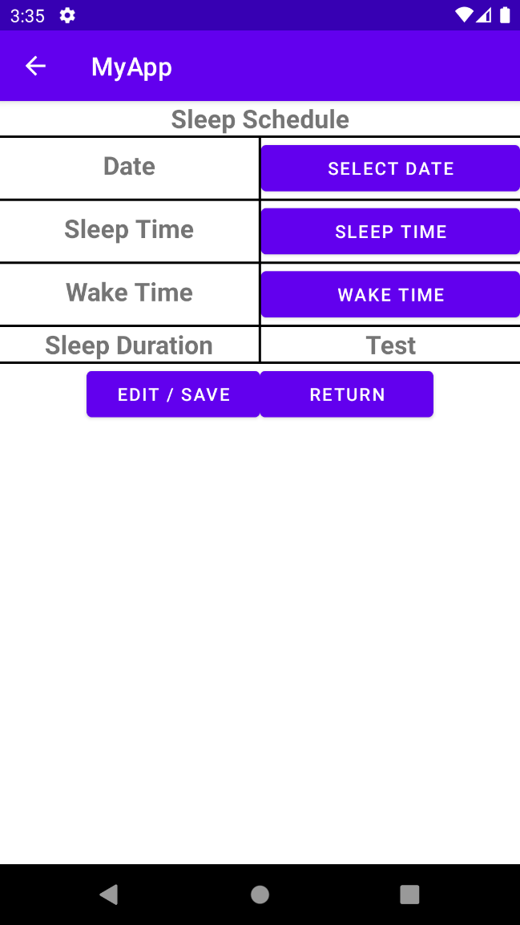This is the Sleep Schedule Creation activity. This page allows users to record their sleep schedule for a specific day.

When the select date button is clicked, a DatePickerDialog is called, and the player can choose their date. When the sleep time or wake time button is clicked, a TimePickerDialog is called, and the player can choose their sleep and wake time.

The sleep duration is calculated automatically from the sleep and wake time. The user can then save the newly created sleep schedule data. If the sleep and wake time are invalid, then the user is not able to save the data.

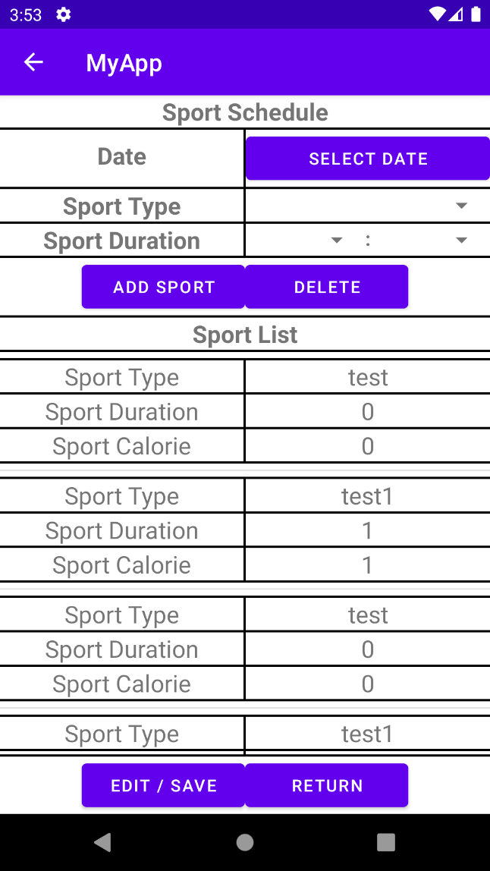This is the Sport Schedule Creation Activity. This page allows users to select the sports performed in a specific day.

Users must first choose a date to perform the sports. Then, the user can add their sports by choosing sport type and sport duration. The total sport duration cannot exceed 24 hours.

The chosen sport and their data are shown in a listview below. Users can delete incorrect data using the delete button. After all additions are made, the user can save the data using the save button.

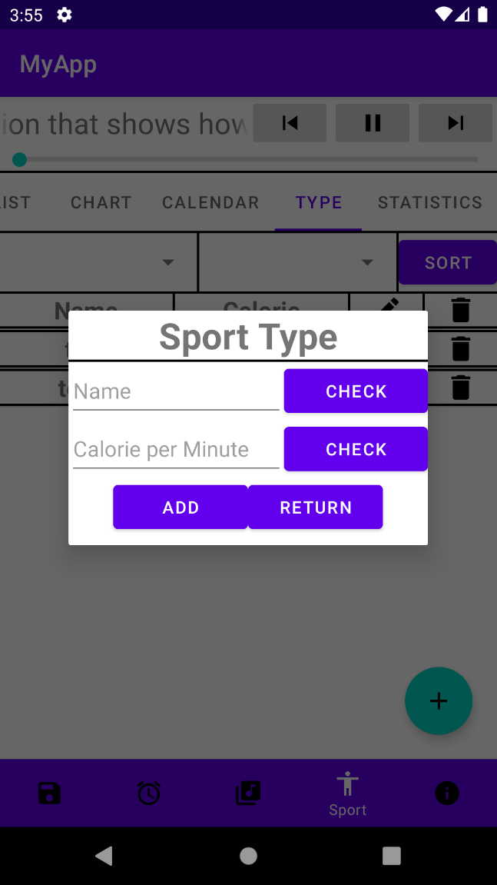This is the Sport Type Creation dialog. It allows the user to add new sport types with their associated calories per minute.

Before a user can add a new sport type, they must check to see if the given name is valid and if the given calories per minute is also valid.

If both entries are valid, then the new sport can be added to the system using the add button.