Software Requirements
Specification

for

SSPP (School-SAF Partnership Programme)

Version 1.0 approved

Prepared by Tan Gui Shan
SSPP Frontend Development Team
30 July 2026

Table of Contents
Revision History 5
1. Introduction 6
1.1 Purpose 6
1.2 Document Conventions 6
1.3 Intended Audience and Reading Suggestions 6
1.4 Product Scope 6
1.5 References 7
2. Overall Description 8
2.1 Product Perspective 8
2.2 Product Functions 8
2.2.1 Authentication and Access Tiers 8
2.2.2 Tier Classification and Rule B 9
2.2.3 Engagement Matching and Browsing 9
2.2.4 Two-Sided Confirmation 9
2.2.5 Roster Confirmation (Ambassador Teams) 9
2.2.6 Inventory and Stock Reservation 9
2.2.7 Stakeholder Admin Monitoring 9
2.3 User Classes and Characteristics 10
2.3.1 School 10
2.3.2 Army Unit (Provider) 10
2.3.3 Army Ambassador 10
2.3.4 Stakeholder Admin 10
2.4 Operating Environment 11
2.4.1 Client-Side Requirements (User End) 11
2.4.2 Server-Side Requirements (Back End) 11
2.4.3 External Software Coexistence 11
2.5 Design and Implementation Constraints 11
2.5.1 Technical Constraints 11
2.5.2 Regulatory and Security Constraints 11
2.5.3 Hardware Constraints 12
2.6 User Documentation 12
2.7 Assumptions and Dependencies 12
2.7.1 Assumptions 12
2.7.2 Dependencies 12
3. External Interface Requirements 13
3.1 User Interfaces 13
3.1.1 Standard UI Elements and Constraints 13
3.1.2 Accounts and Access User Interfaces 13
3.1.3 Browse and Team-Forming User Interfaces 13
3.1.4 Engagement and Roster User Interfaces 13
3.1.5 Stakeholder Admin Dashboard 13
3.1.6 Inventory / Stock Monitoring Interface 13
3.2 Hardware Interfaces 14
3.3 Software Interfaces 14
3.4 Communications Interfaces 14
4. System Features 15
4.1 Account and Access Management 15
4.1.1 Description and Priority 15
4.1.2 Stimulus/Response Sequences 15
4.1.3 Functional Requirements 15
4.2 Engagement Matching and Tier Classification 17
4.2.1 Description and Priority 17
4.2.2 Stimulus/Response Sequences 17
4.2.3 Functional Requirements 17
4.3 Two-Sided Confirmation and Provider Flow 18
4.3.1 Description and Priority 18
4.3.2 Stimulus/Response Sequences 18
4.3.3 Functional Requirements 19
4.4 Participation and Roster Confirmation (Ambassador Teams) 19
4.4.1 Description and Priority 19
4.4.2 Stimulus/Response Sequences 19
4.4.3 Functional Requirements 20
4.5 Inventory and Stock Reservation 20
4.5.1 Description and Priority 20
4.5.2 Functional Requirements 20
4.6 Stakeholder Admin Monitoring Dashboard 21
4.6.1 Description and Priority 21
4.6.2 Functional Requirements 21
4.7 Administration and Volunteer Oversight 22
4.7.1 Description and Priority 22
4.7.2 Functional Requirements 22
5. Other Nonfunctional Requirements 23
5.1 Performance Requirements 23
5.2 Safety Requirements 23
5.3 Security Requirements 23
5.4 Software Quality Attributes 24
5.5 Business Rules 24
6. Other Requirements 26
Appendix A: Glossary 26
6.1 Data Dictionary 26
6.2 Supplementary Use Case Models 29
6.3 Supplementary UI Mockup 30
6.3.1 Public Access & Onboarding 30
6.3.2 School View 38
6.3.3 Army Unit Views 49
6.3.4 Army Ambassador View 55
6.3.5 Stakeholder Admin Views 61
6.4 Class Diagram 70
6.5 Dialog Map 71
6.6 Key Boundary and Control Classes 72
6.7 System Architecture 73
6.8 Sequence Diagrams 74
6.8.1 Registration 74
6.8.2 Login 75
6.8.3 Submit Interest Form 76
6.8.4 Confirm Unit 77
6.8.5 Confirm Ambassador Team 78
6.8.6 Submit Open Request 79
6.8.9 Volunteer for Request 80
6.8.10 Confirm Volunteer 81
6.8.11 Withdraw Volunteer 82
6.8.12 Admin Escalation 83
Appendix C: Unique Feature Logic 84
6.9 Tier Eligibility and Rule B Computation 84
6.10 Two-Sided Confirmation State Machine 85

Revision History
Name | Date | Reason For Changes | Version
Tan Gui Shan | 30/7/2026 | Initial draft of SRS ported over from build documentation and delivered features | 1.0

1. Introduction

1.1 Purpose
This Software Requirements Specification (SRS) describes the functional and non-functional requirements for Release 1.0 of the SSPP (School-SAF Partnership Programme) frontend application. This document is intended to ensure traceability from requirements to the implemented React front end, and to serve as a reference for the eventual backend specification (schema, endpoints, and authentication design).

1.2 Document Conventions
This SRS follows the following conventions:
- Header 1: Times New Roman, size 18
- Header 2: Times New Roman, size 14
- Header 3: Times New Roman, size 12
- Header 4: Times New Roman, size 11
- Content: Arial, size 11
Italics are used for terms defined in the Data Dictionary (Appendix A). Headings such as "DM Serif Display" refer to the heading typeface used within the product UI, distinct from this document's own conventions.

1.3 Intended Audience and Reading Suggestions
This document is intended for developers, the Ministry/SAF stakeholder team, school coordinators, testers, and documentation writers. Section 4 (System Features) provides the detailed functional run-down of each module. Section 5 (Other Nonfunctional Requirements) provides the performance, safety, security, and quality targets the system must meet.

1.4 Product Scope
SSPP is a Singapore Government platform that matches schools with Singapore Armed Forces (SAF) units and individual SAF ambassadors to run student engagement programmes. The system classifies each potential engagement into one of three tiers (hands-on, sharing-plus-booth, or sharing-only) based on the type of provider and, for ambassador teams, the size of the team formed (Rule B). The platform manages the full engagement lifecycle: browsing and matching, two-sided confirmation, per-member roster confirmation for ambassador teams, and automated equipment/stock reservation, while giving the programme's Stakeholder Admin a monitor-only dashboard over reach, coverage, and outstanding follow-ups.

1.5 References
[1] “Quick start – react.” https://react.dev/learn (accessed Jul. 31, 2026).
[2] “Get started – Singapore Government Design System.” https://www.designsystem.tech.gov.sg/get-started/ (accessed July 31, 2026).
[3] “@govtechsg/sgds-web-component,” npm, July 21, 2026. https://www.npmjs.com/package/@govtechsg/sgds-web-component (accessed July 31, 2026).
[4] “Quick Start | Singpass Developer Docs,” Singpass Developer Docs. https://docs.developer.singpass.gov.sg/docs/getting-started/quick-start (accessed July 31, 2026).
[5] “Getting started,” Vitejs. https://vite.dev/guide/ (accessed July 31, 2026).
[6] “Installing with Vite - Installation,” Tailwind CSS. https://tailwindcss.com/docs (accessed July 31, 2026).
[7] Vercel, “Vercel documentation,” Vercel Documentation, Jun. 30, 2026. https://vercel.com/docs (accessed Jul. 31, 2026)

[8] “PDPC | PDPA Overview,” IMDA PDPC. https://www.pdpc.gov.sg/about/the-legislation/pdpa-overview (accessed Jul. 31, 2026)

2. Overall Description

2.1 Product Perspective
SSPP is a new, self-contained, mobile-responsive web application that streamlines the process of matching schools with SAF units and ambassadors for student engagement programmes. It is not a replacement for an existing system, nor part of an established product family; it is a purpose-built coordination tool that layers a domain-specific tiering and confirmation workflow on top of a standard government-style account and dashboard application.
The application follows the Singapore Government Design System (SGDS) look and feel using official SGDS web components, with DM Serif Display used for headings to give the interface a distinctive, trustworthy tone appropriate to a government-facing product. It operates within a distributed client-server architecture. The frontend is responsible for role-specific onboarding, browsing and team-forming, the confirmation and roster workflows, and the Stakeholder Admin dashboard. A future backend service (not yet specified) will own persistence, real identity/auth issuance, and the authoritative matching and stock-reservation logic; in the interim, engagement and roster state is held in a shared client-side state hook backed by localStorage so that the full workflow can be demonstrated end-to-end.

2.2 Product Functions
SSPP provides users with a way to discover, form teams for, and confirm student engagement sessions between schools and SAF providers, while enforcing the domain-specific tier and roster rules described below.

2.2.1 Authentication and Access Tiers
The authentication module distinguishes users by the domain of their email address and by role.
- Direct Access: Users registering with a *.gov.sg or *.edu.sg email address are granted direct access appropriate to their declared role (School, Army Unit, or Army Ambassador) without further approval.
- Volunteer Access: Users registering with any other email domain are treated as Volunteers and are placed in an approval queue; they gain access only once a Stakeholder Admin approves the account.
- Role-specific signup forms capture verified email and mobile fields relevant to each role (school particulars for Schools, unit particulars for Army Units, individual particulars for Army Ambassadors).

2.2.2 Tier Classification and Rule B
This is the core domain logic of SSPP, determining what kind of engagement a given provider (or ambassador team) is eligible to deliver.
- Tier 1 (Hands-on): Reserved for Army Units only. Hands-on engagements are never available from ambassadors, regardless of team size.
- Tier 2 (Sharing + Booth): Available to Army Units, and to Army Ambassador teams that satisfy Rule B (see below).
- Tier 3 (Sharing only): The default tier available to an individual ambassador or an ambassador team that does not meet the Rule B threshold.
- Rule B (Ambassador Booth Rule): An ambassador team with 4 or more members unlocks Tier 2 eligibility for that team, regardless of the individual mobility or availability constraints of any single member. Tier 1 remains units-only irrespective of team size.

2.2.3 Engagement Matching and Browsing
Schools and providers browse available engagement opportunities through filterable tabs. Army Ambassadors additionally use a multi-select interface to form a team, tracked via a sticky team bar, before the team's eligible tier is evaluated.

2.2.4 Two-Sided Confirmation
Once a match is proposed, both the School and the Provider must confirm the engagement. Providers (Army Units and Army Ambassadors) cannot decline an engagement outright; the only actions available to a provider are to confirm, or to await the counterpart's confirmation. This reflects the program's operating principle that participation commitments, once made through official channels, are not unilaterally withdrawn by the provider side within the tool.

2.2.5 Roster Confirmation (Ambassador Teams)
For engagements delivered by an ambassador team, each individual team member confirms their own attendance. The system tracks and displays a per-member Confirmed / Awaiting status on the engagement roster so the Organiser and School can see exactly who has committed.

2.2.6 Inventory and Stock Reservation
Equipment and stock required for confirmed engagements are reserved automatically, derived from the set of confirmed matches. Stock is never manually given out by an administrator as a matter of course; reservation quantities are computed from the matching data.

2.2.7 Stakeholder Admin Monitoring
The Stakeholder Admin role is monitor-only and is excluded from the matching loop. Its dashboard surfaces school counts by level with coverage bars, reach and completion metrics, a 7-day stale-school flag for schools without recent contact, and a line-by-line listing of upcoming engagements. The Admin separately approves out-of-domain (Volunteer) signups.

2.3 User Classes and Characteristics
There are four major types of users of the SSPP application. Each user type has a different level of access and job duties.

2.3.1 School
- Description: A school representative (teacher-in-charge or CCA coordinator) who browses providers and requests or confirms student engagement sessions.
- Technical Expertise:
  - Minimal to intermediate,
  - Comfortable with standard web forms
  - Dashboards.
- Responsibilities:
  - Browsing available providers/engagements,
  - Requesting engagements,
  - Confirming matched engagements
  - Viewing roster and confirmation status.
- Access: “.edu.sg” email domains receive direct access.

2.3.2 Army Unit (Provider)
- Description: A SAF unit that offers following:
  - Hands-on (Tier 1),
  - Sharing-plus-booth (Tier 2), or
  - Sharing-only (Tier 3) engagements directly, without team-size constraints.
- Technical Expertise: Minimal and expected to use a simple confirmation workflow.
- Responsibilities:
  - Listing available engagement slots
  - Confirming matched engagements (cannot decline).
- Access: “. gov.sg” email domains receive direct access.

2.3.3 Army Ambassador
- Description: An individual SAF ambassador who can be matched alone (Tier 3) or join a team of other ambassadors. A team of 4 or more unlocks Tier 2 eligibility for that team (Rule B).
- Technical Expertise:
  - Minimal
  - Interacts primarily through the browse/team-forming UI
  - Roster confirmation screen.
- Responsibilities: Forming or joining an ambassador team; confirming individual roster attendance for a matched engagement.
- Access: “. gov.sg” email domains receive direct access, other domains are treated as Volunteers pending admin approval.

2.3.4 Stakeholder Admin
- Description: Programme staff responsible for monitoring reach and coverage across schools and providers, and for approving Volunteer signups.
- Technical Expertise:
  - Advanced
  - Comfortable with dashboards, filters, and approval queues.
- Responsibilities:
  - Monitoring school coverage, reach, and completion metrics
  - Reviewing stale-school flags
  - Approving or rejecting Volunteer account requests.
- Constraints:
  - Monitor-only
  - Admin role is explicitly excluded from the matching, confirmation, and roster workflow between Schools and Providers.

2.4 Operating Environment

2.4.1 Client-Side Requirements (User End)
- Hardware Platform: Accessible on any device with a modern web browser, including smartphones, tablets, and desktop/laptop computers.
- Web Browsers: Optimised for the latest versions of Google Chrome, Microsoft Edge, Apple Safari, and Mozilla Firefox.

2.4.2 Server-Side Requirements (Back End)
- Hosting Environment: Intended for cloud-based government hosting infrastructure once the backend specification is finalised.
- Runtime Environment: React 19 + Vite front end; a Node.js-based backend service is planned but not yet implemented.
- Interim State Storage: Engagement and roster state is currently persisted client-side via the localStorage key sspp.engagements.v2, pending backend delivery.

2.4.3 External Software Coexistence
- SGDS Web Components: The UI is built with @govtechsg/sgds-web-component to present the official Singapore Government look and feel.
- Future Identity Provider: Singpass/MockPass integration is deferred to the backend specification phase; today, domain-tiered login logic simulates this distinction on the front end.
- Standard Web Protocols: The application is designed to operate over HTTPS with TLS in production.

2.5 Design and Implementation Constraints

2.5.1 Technical Constraints
- Design System Constraint: All UI must be built using SGDS web components (Option A, the official government look), not a custom component library, to satisfy the programme's branding requirements.
- Framework Constraint: The application is built with React + Vite + Tailwind CSS v4 + react-router-dom. Tailwind v4 utility generation must not be broken by unrelated CSS imports (see Section 5.4 and Appendix C for the specific utility.css conflict encountered and resolved during development).
- Dialog/Drawer Constraint: SGDS dialog and drawer web components under React 19 require imperative ref.show() / ref.hide() calls rather than prop-driven open state, due to how the underlying custom elements manage their own visibility.

2.5.2 Regulatory and Security Constraints
- Domain-Tiered Access: Only *.gov.sg and *.edu.sg email domains are eligible for direct (non-Volunteer) access; all other domains must be routed through the Volunteer approval queue.
- Data Privacy: As the application will eventually handle school and personnel contact information, it must be designed with the Personal Data Protection Act (PDPA) of Singapore in mind once backend persistence is implemented.

2.5.3 Hardware Constraints
- Network Dependency: The application requires an active internet connection to function and should handle offline/network-error states gracefully.

2.6 User Documentation
Documentation for SSPP is delivered directly within the application using clear, non-technical language appropriate for school coordinators and SAF personnel. A test-mode flag (VITE_TEST_MODE=true in .env.local) is available in non-production builds to bypass verification and domain checks for demonstration purposes; this flag must not be enabled in production.

2.7 Assumptions and Dependencies

2.7.1 Assumptions
- It is assumed that School and Army Unit users will register with valid *.edu.sg or *.gov.sg email addresses respectively where direct access is expected.
- It is assumed that ambassador team sizes reported to the system are accurate, since Rule B's 4-member threshold directly determines Tier 2 eligibility.
- It is assumed that a backend service providing real authentication, persistence, and identity tokens will be delivered in a subsequent phase, replacing the current localStorage-backed demo state.

2.7.2 Dependencies
- SGDS Web Components: Core functionality of the UI depends on the continued availability and API stability of @govtechsg/sgds-web-component.
- Backend Specification: Real provider identity wiring (marked TODO(real-auth) in the codebase) depends on the backend issuing identity tokens; the schema, endpoints, and auth design remain to be written.
- Stock Options List: The ambassador equipment-selection UI at confirm-time, and the activation of deriveStockFromMatches, depend on Gui Shan providing the finalised stock options list.
- MockPass/Singpass: Deferred as a backend-side concern for a later phase.

3. External Interface Requirements

3.1 User Interfaces

The SSPP user interface is designed with the Singapore Government Design System (SGDS) which gives the application a consistent and official look across all roles. Headings are set in DM Serif Display which helps to reinforce a trustworthy, institutional tone. Body Text is set in the SGDS default sans-serif stack.

3.1.1 Standard UI Elements and Constraints
- Navigation: Role appropriate navigation is presented after login and distinguishes School, Army Unit, Army Ambassador and Stakeholder Admin views.
- Error Handling: Validation and domain check errors are presented as SGDS-styled inline field errors and toast notifications.
- Action Buttons: Primary actions (e.g., "Confirm", "Request Engagement") use the SGDS primary brand colour; destructive or irreversible actions use a secondary confirmation step.

3.1.2 Accounts and Access User Interfaces
The signup flow presents role-specific forms (School, Army Unit, Army Ambassador) capturing verified email and mobile fields. On submission, the system checks the email domain: *.gov.sg and *.edu.sg addresses proceed directly to the role dashboard; all other domains are routed to a pending-approval state and the user is informed that a Stakeholder Admin must approve the account before login succeeds.

3.1.3 Browse and Team-Forming User Interfaces
Schools and Providers browse available engagements/providers through filterable tabs. Army Ambassadors are additionally presented with a multi-select interface for forming a team; selected ambassadors are tracked in a sticky team bar that remains visible while scrolling, showing the current team size and, once 4 or more members are selected, an indicator that Tier 2 (Rule B) has been unlocked for the team.

3.1.4 Engagement and Roster User Interfaces
Once a match is proposed, the engagement detail view shows the confirmation status for both the School and the Provider side. For ambassador-team engagements, the EngagementRoster component lists each team member with a per-member Confirmed / Awaiting badge, allowing the Organiser and School to track exactly who has committed to attend.

3.1.5 Stakeholder Admin Dashboard
The dashboard presents interactive cards summarising school counts by level with coverage bars, reach and completion metrics, and a stale-school flag (schools with no contact/activity in the last 7 days). An upcoming-engagements list is presented line-by-line. Cards are clickable and navigate to a filtered view of the underlying data (e.g., clicking the stale-schools card opens a filtered list of those schools).

3.1.6 Inventory / Stock Monitoring Interface
A stock/inventory monitoring page displays current reservation levels, automatically derived from confirmed matches. The reservation figures update as matches are confirmed or roster status changes.

3.2 Hardware Interfaces
SSPP is a platform-agnostic web product operating across desktop monitors, tablets, and mobile smartphones via a web browser abstraction layer. The software does not require GPS or other location-sensing hardware; all interaction is through standard touchscreen, keyboard, and mouse input. Visual output is rendered through a responsive design engine that adapts layout to the detected screen resolution and orientation, ensuring the browse, team-forming, and roster interfaces remain legible across all form factors.

3.3 Software Interfaces
SSPP functions as a coordination hub between School, Army Unit, and Army Ambassador accounts. Within the current release, the application interfaces with the following software components:
- SGDS Web Components (@govtechsg/sgds-web-component): Supplies form controls, datepickers, dialogs/drawers, and other UI primitives styled to the Singapore Government Design System.
- react-router-dom: Provides client-side routing between role dashboards, browse views, engagement detail views, and the admin dashboard.
- Shared Engagement State (useEngagements hook): A centralised state hook, currently backed by the localStorage key sspp.engagements.v2, providing a single source of truth for engagement and roster status across components pending real backend persistence.
- Planned Backend API: A RESTful or equivalent backend service (schema and endpoints not yet specified) will eventually own persistence, real authentication/identity issuance (replacing TODO(real-auth) stubs), and the authoritative implementation of deriveStockFromMatches.

3.4 Communications Interfaces
All data transmissions between the client-side browser and any backend services are intended to occur over HTTPS/TLS once a backend is introduced. Within the current front-end-only release, state changes are propagated synchronously through the shared useEngagements hook and persisted to localStorage; there is no network-based real-time synchronisation layer yet. When the backend is delivered, real-time or near-real-time propagation of confirmation and roster changes to all relevant parties (School, Provider, individual ambassadors) is expected to be a requirement of that specification.

4. System Features

4.1 Account and Access Management

4.1.1 Description and Priority
Manages entry points for all users: role-specific registration, domain-tiered direct access versus Volunteer approval, authentication, and profile/account management.
Priority: High

4.1.2 Stimulus/Response Sequences
Stimulus | Response
User submits signup form with a *.gov.sg or *.edu.sg email. | System creates the account and grants direct access to the corresponding role dashboard.
User submits signup form with a non-approved domain email. | System creates a Volunteer account in a pending-approval state and notifies the user that Admin approval is required.
Stakeholder Admin approves a pending Volunteer account. | System activates the account and grants it access according to its declared role.

4.1.3 Functional Requirements

FR-1 Role-Specific Registration
1.1 The system shall provide separate registration forms for the School, Army Unit, and Army Ambassador roles.
1.2 The system shall require a valid email address and mobile number for every registration, regardless of role.
1.3 The system shall validate that mandatory role-specific fields are present before account creation can proceed.
1.4 The system shall reject a registration request when any mandatory field is missing and shall display an appropriate validation error message.

FR-2 Domain-Tiered Access Determination
2.1 The system shall classify a registering email address as belonging to an approved domain (*.gov.sg or *.edu.sg) or to any other domain.
2.2 When the email domain is approved, the system shall grant the account direct access to the role dashboard immediately upon successful registration.
2.3 When the email domain is not approved, the system shall create the account with Volunteer status and place it in a pending-approval queue.
2.4 The system shall prevent a pending Volunteer account from accessing any role-specific or matching functions until approved.
2.5 The system shall notify a Volunteer applicant that their account is pending administrator approval.

FR-3 Volunteer Approval Queue
Priority: High
3.1 The system shall provide the Stakeholder Admin with a UserManagementPage listing all pending Volunteer accounts.
3.2 The system shall allow the Stakeholder Admin to approve or reject a pending Volunteer account.
3.3 Upon approval, the system shall activate the Volunteer account and grant access according to its declared role.
3.4 Upon rejection, the system shall prevent the rejected account from logging in and shall record the rejection.
3.5 The system shall restrict access to the Volunteer approval queue to users with Stakeholder Admin privileges.

FR-4 Authentication and Session Management
4.1 The system shall provide a login interface for existing accounts of all roles.
4.2 The system shall authenticate submitted credentials and, if valid, establish an authenticated session scoped to the user's role.
4.3 If submitted credentials are invalid, the system shall deny access and display an authentication error message.
4.4 The system shall allow an authenticated user to log out, terminating the session.
4.5 When VITE_TEST_MODE is enabled in a non-production build, the system shall bypass verification and domain checks to support demonstrations; this flag shall have no effect in a production build.

FR-5 Profile Management
5.1 The system shall allow an authenticated user to view their account profile information.
5.2 The system shall allow an authenticated user to update editable profile fields appropriate to their role.
5.3 The system shall validate updated profile data and reject invalid updates with an appropriate error message.

4.2 Engagement Matching and Tier Classification

4.2.1 Description and Priority
Implements the core domain logic that classifies each potential engagement into Tier 1, Tier 2, or Tier 3 based on provider type, and, for ambassador teams, the Rule B team-size threshold.
Priority: High

4.2.2 Stimulus/Response Sequences
Stimulus | Response
School or Provider browses engagement opportunities. | System displays filterable tabs of available opportunities appropriate to the browsing role.
Army Ambassador selects team members via the multi-select interface. | System updates the sticky team bar with the current team size and evaluates Rule B eligibility.
Ambassador team reaches 4 members. | System unlocks Tier 2 (sharing + booth) eligibility for that team and reflects this in the UI.

4.2.3 Functional Requirements

FR-1 Tier Semantics
Priority: High
1.1 The system shall recognise exactly three engagement tiers: Tier 1 (hands-on), Tier 2 (sharing and booth), and Tier 3 (sharing only).
1.2 The system shall restrict Tier 1 (hands-on) engagements to Army Units only.
1.3 The system shall never classify an Army Ambassador or ambassador team, regardless of size, as eligible for Tier 1.
1.4 The system shall make Tier 2 available to Army Units without restriction, and to Army Ambassador teams only when Rule B is satisfied.
1.5 The system shall treat Tier 3 as the default eligible tier for an individual ambassador or an ambassador team that does not satisfy Rule B.

FR-2 Rule B (Ambassador Booth Rule) Computation
Priority: High
2.1 The system shall count the number of ambassadors currently selected into a forming team via the multi-select browse interface.
2.2 The system shall unlock Tier 2 eligibility for a team once the team contains 4 or more ambassadors.
2.3 The system shall apply the Rule B threshold to the team as a whole and shall not require every individual member to independently meet a mobility or availability condition once the 4-member threshold is met.
2.4 The system shall recompute Rule B eligibility whenever the composition of the forming team changes (a member is added or removed).
2.5 The system shall visually indicate, via the sticky team bar, whether the current team has unlocked Tier 2 eligibility.

FR-3 Browse and Filtering
3.1 The system shall allow a School to browse available Army Unit and Army Ambassador opportunities through filterable tabs.
3.2 The system shall allow filtering of browse results by tier, availability, and provider type.
3.3 The system shall allow an Army Ambassador to select one or more other ambassadors to form a team from the browse interface.
3.4 The system shall persist the in-progress team selection in the sticky team bar until the user submits, clears, or navigates away from team formation.

FR-4 Engagement Proposal and Matching
4.1 The system shall allow a School to propose an engagement with a specific Army Unit, or with a specific Army Ambassador team, subject to that provider's eligible tier.
4.2 The system shall reject a proposed engagement whose requested tier exceeds what the selected provider or team is eligible for.
4.3 Upon successful proposal, the system shall create an engagement record with an initial status indicating that confirmation is pending from both sides.

4.3 Two-Sided Confirmation and Provider Flow

4.3.1 Description and Priority
Manages the life cycle confirmation of a proposed engagement between a School and a Provider (Army Unit or Army Ambassador team). Ensures Providers cannot decline an engagement.
Priority: High

4.3.2 Stimulus/Response Sequences
Stimulus | Response
School confirms a proposed engagement. | System records the School-side confirmation and updates the engagement status.
Provider confirms a proposed engagement. | System records the Provider-side confirmation; once both sides have confirmed, the engagement status changes to Confirmed.
Provider attempts to decline an engagement. | System does not expose a decline action to the Provider; only confirm and awaiting states are available.

4.3.3 Functional Requirements

FR-1 Two-Sided Confirmation Model
Priority: High
1.1 The system shall require independent confirmation from both the School and the Provider before an engagement is considered fully Confirmed.
1.2 The system shall display the current confirmation status of each side (School: Confirmed/Awaiting; Provider: Confirmed/Awaiting) on the engagement detail view.
1.3 The system shall change the overall engagement status to Confirmed only when both the School side and the Provider side have confirmed.

FR-2 Provider Cannot Decline
Priority: High
2.1 The system shall not provide a decline, reject, or cancel action to a Provider (Army Unit or Army Ambassador) for a proposed engagement.
2.2 The system shall restrict the Provider's available actions on a proposed engagement to confirming or leaving it in an Awaiting state.
2.3 The system shall allow only the School side, or an authorised Stakeholder Admin acting outside the matching loop for administrative correction, to cancel an engagement.

FR-3 Confirmation Error Handling
3.1 The system shall deny a confirmation action attempted by a user who is not a party to the relevant engagement.
3.2 When a confirmation action is denied, the system shall display an appropriate authorisation error message.

4.4 Participation and Roster Confirmation (Ambassador Teams)

4.4.1 Description and Priority
Provides per-member confirmation tracking for ambassador teams, so that the Organiser and School can see exactly which individual ambassadors have committed to a confirmed engagement.
Priority: High

4.4.2 Stimulus/Response Sequences
Stimulus | Response
Ambassador team engagement becomes Confirmed. | System opens per-member roster confirmation for each ambassador on the team.
Individual ambassador confirms their attendance. | System updates that member's roster badge to Confirmed and synchronises the roster view.

4.4.3 Functional Requirements

FR-1 Per-Member Roster Confirmation
Priority: High
1.1 The system shall provide an EngagementRoster view listing every member of an ambassador team assigned to a confirmed engagement.
1.2 The system shall allow each individual ambassador to confirm their own attendance for the engagement independently of other team members.
1.3 The system shall display a Confirmed or Awaiting badge for each roster member reflecting that member's current confirmation status.
1.4 The system shall update the roster view for all viewers (School, Organiser, other team members) when any member's confirmation status changes.

FR-2 Roster Visibility and Access
2.1 The system shall make the roster view visible to the School associated with the engagement and to all members of the assigned ambassador team.
2.2 The system shall prevent a user who is neither the associated School nor a member of the assigned team from viewing or modifying the roster.

4.5 Inventory and Stock Reservation

4.5.1 Description and Priority
Automatically derives equipment/stock reservation quantities from confirmed matches, replacing manual give-out with a matching-driven reservation model.
Priority: Medium

4.5.2 Functional Requirements

FR-1 Automated Stock Reservation
1.1 The system shall derive stock reservation quantities from the set of confirmed engagement matches rather than from manual administrator entry.
1.2 The system shall recompute stock reservations whenever an engagement's confirmation status or team composition changes.
1.3 The system shall display current reservation levels per stock item on the inventory monitoring page.

FR-2 Activation Precondition
2.1 The system shall keep the ambassador equipment-selection UI, and the deriveStockFromMatches computation, dormant until a finalised stock options list is provided.
2.2 Upon activation, the system shall present eligible ambassadors with an equipment-selection step at confirm-time and shall feed those selections into the stock reservation computation.

4.6 Stakeholder Admin Monitoring Dashboard

4.6.1 Description and Priority
Provides the Stakeholder Admin with a monitor-only dashboard summarising school coverage, reach, completion, and outstanding follow-ups, without participating in the matching workflow.
Priority: Medium

4.6.2 Functional Requirements

FR-1 Coverage and Reach Metrics
1.1 The system shall display school counts broken down by education level (e.g., Primary, Secondary, Junior College), each with a coverage bar.
1.2 The system shall display aggregate reach and completion metrics for engagements across the programme.
1.3 The system shall present an upcoming-engagements list, line-by-line, ordered by date.

FR-2 Stale-School Flagging
2.1 The system shall flag a school as stale when it has had no recorded contact or engagement activity within the preceding 7 days.
2.2 The system shall surface stale-school flags prominently on the dashboard.
2.3 The system shall allow the Stakeholder Admin to navigate from a summary card to a filtered list of the underlying schools or engagements (e.g., clicking the stale-schools card opens the filtered stale-school list).

FR-3 Monitor-Only Constraint
Priority: High
3.1 The system shall not allow the Stakeholder Admin to propose, confirm, or roster an engagement on behalf of a School or Provider.
3.2 The system shall exclude the Stakeholder Admin from the two-sided confirmation loop described in Section 4.3.

4.7 Administration and Volunteer Oversight

4.7.1 Description and Priority
Provides administrative tools for reviewing and approving Volunteer signups, separate from the day-to-day matching workflow.
Priority: Low

4.7.2 Functional Requirements

FR-1 Administrative Access Control
1.1 The system shall provide administration functions only to users with Stakeholder Admin privileges.
1.2 The system shall deny access to administration functions for any non-admin user and display an appropriate authorisation error message.

FR-2 Volunteer Signup Review
Priority: High
2.1 The system shall allow the Stakeholder Admin to review a pending Volunteer signup's declared role and submitted details.
2.2 The system shall allow the Stakeholder Admin to approve or reject a pending Volunteer signup.
2.3 The system shall record each approval or rejection decision for audit purposes.

5. Other Nonfunctional Requirements

5.1 Performance Requirements
ID | Description
REQ-P1 | The system shall load the browse listing (schools, units, or ambassadors as applicable) within 5.0 seconds for 95% of requests under standard network conditions.
REQ-P2 | The system shall recompute Rule B (Tier 2) eligibility for a forming ambassador team within 1.0 second of a change to team composition.
REQ-P3 | Roster confirmation status changes shall be reflected in the EngagementRoster view for all viewers within 10.0 seconds of the change, once real-time backend synchronisation is delivered.
REQ-P4 | The system shall support at least 200 concurrent active users without response-time degradation exceeding 20%.

5.2 Safety Requirements
ID | Description
REQ-SAFE1 | The system shall clearly distinguish Provider-side actions from School-side actions so that a Provider cannot be shown a decline/cancel control that does not exist for their role.
REQ-SAFE2 | In the event of a critical failure, the system shall fail gracefully by displaying a generic error/service-unavailable message rather than exposing raw stack traces or internal state.
REQ-SAFE3 | The system shall provide a mechanism for a School or Provider to report an issue with a matched engagement for Stakeholder Admin review.

5.3 Security Requirements
ID | Description
REQ-SEC1 | The system shall never store or transmit passwords in plaintext; credentials must be handled via salted cryptographic hashing once backend authentication is implemented.
REQ-SEC2 | Access to system functions shall be strictly controlled via Role-Based Access Control (RBAC), limiting users to School, Army Unit, Army Ambassador, or Stakeholder Admin permissions.
REQ-SEC3 | The system shall validate the registering email domain server-side (once a backend exists) to prevent a Volunteer from spoofing an approved *.gov.sg or *.edu.sg domain to obtain direct access.
REQ-SEC4 | The VITE_TEST_MODE verification-bypass flag shall be disabled in all production builds.

5.4 Software Quality Attributes
ID | Description
REQ-SQ1 Availability | The system shall maintain 99.0% uptime, measured weekly, excluding scheduled maintenance windows, once deployed to production hosting.
REQ-SQ2 Usability | A first-time School or Provider user shall be able to complete registration and locate the browse tab within 120 seconds without referring to a user manual.
REQ-SQ3 Compatibility | The user interface shall remain fully functional and visually consistent, per the SGDS specification, across modern browsers on both desktop and mobile viewports.
REQ-SQ4 Reliability | A failure in the Stock/Inventory monitoring module shall not corrupt or cause loss of persisted engagement or roster state.
REQ-SQ5 Maintainability | The codebase shall clearly mark real-vs-demo logic (e.g., — REAL, TODO(real-flow), TODO(real-auth) comments) so that dormant real-backend code paths can be activated without a rewrite.

5.5 Business Rules
ID | Description
BR-1 Tier 1 Exclusivity | Only Army Units may deliver Tier 1 (hands-on) engagements; ambassadors and ambassador teams are never eligible for Tier 1.
BR-2 Rule B Threshold | An ambassador team of 4 or more members unlocks Tier 2 (sharing + booth) eligibility for the team as a whole, regardless of individual member mobility or availability constraints.
BR-3 Provider Cannot Decline | A Provider (Army Unit or Army Ambassador) may confirm a proposed engagement but may not decline it through the system; only the School side or an authorised Admin correction can cancel a proposal.
BR-4 Admin Neutrality | The Stakeholder Admin is monitor-only and is excluded from the School–Provider matching and confirmation loop; its role is limited to dashboard monitoring and Volunteer approval.
BR-5 Domain-Tiered Login | Only *.gov.sg and *.edu.sg email domains are granted direct access; all other domains are treated as Volunteers requiring Admin approval.
BR-6 Roster Confirmation is Individual | For ambassador-team engagements, each team member confirms attendance individually; a team is not considered fully rostered until every member has confirmed.
BR-7 Reservation is Automated | Equipment and stock reservation is derived automatically from confirmed matches and is not manually allocated as the default operating mode.

6. Other Requirements
A future revision of this document will incorporate the finalised backend specification (schema, endpoints, authentication design) once available, along with real-time synchronisation requirements for confirmation and roster propagation across School, Provider, and Admin views.

Appendix A: Glossary

6.1 Data Dictionary
Term | Type | Definition | Constraints / Notes
SSPP | System | The School-SAF Partnership Programme platform that matches Schools with Army Units and Army Ambassadors for student engagement sessions, applying tier and roster rules while preserving a monitor-only Admin role. | N/A
School | Role / Entity | A registered user representing a school, who browses providers and requests or confirms engagements. | *.edu.sg receives direct access
Army Unit | Role / Entity | A SAF unit acting as a Provider that may deliver Tier 1, Tier 2, or Tier 3 engagements without team-size restriction. | *.gov.sg receives direct access
Army Ambassador | Role / Entity | An individual SAF volunteer who may be matched alone (Tier 3) or as part of a team; a team of 4+ unlocks Tier 2 via Rule B. | *.gov.sg receives direct access
Stakeholder Admin | Role / Entity | Programme staff with a monitor-only dashboard; approves Volunteer signups but does not participate in matching. | Excluded from matching loop
Volunteer | Role / State | An account registered with a non-approved email domain, pending Stakeholder Admin approval before gaining role access. | Requires admin approval
Provider | Role / Entity | Generic term for an Army Unit or Army Ambassador (team) delivering an engagement to a School. | Cannot decline a proposed engagement
Tier | Attribute / Enumeration | Classification of an engagement's format: Tier 1 (hands-on), Tier 2 (sharing + booth), Tier 3 (sharing only). | Enum: Tier 1, Tier 2, Tier 3
Tier 1 | State / Classification | Hands-on engagement format, restricted to Army Units only. | Never available to ambassadors
Tier 2 | State / Classification | Sharing plus booth engagement format, available to Army Units, and to ambassador teams satisfying Rule B. | Requires Rule B for ambassador teams
Tier 3 | State / Classification | Sharing-only engagement format; default tier for individuals or ambassador teams not meeting Rule B. | Default tier for ambassadors
Rule B (Ambassador Booth Rule) | Computed Rule | A rule stating that an ambassador team of 4 or more members unlocks Tier 2 eligibility for the team, regardless of individual mobility constraints. | Threshold = 4 members
Team | Entity | A group of Army Ambassadors formed via the multi-select browse interface for the purpose of jointly delivering an engagement. | Size drives Rule B eligibility
Sticky Team Bar | UI Component | A persistent UI element showing the in-progress ambassador team selection and current Rule B status while browsing. | Updates live as members are added/removed
Engagement | Entity | A scheduled student engagement session matched between a School and a Provider, tracked through proposal, confirmation, and roster stages. | Has School-side and Provider-side confirmation status
Two-Sided Confirmation | Process | The requirement that both School and Provider confirm an engagement before its overall status becomes Confirmed. | Both sides required
Provider Confirmation | Attribute | The Provider side's confirmation state for a proposed engagement (Confirmed or Awaiting); no decline option exists. | No decline action available
School Confirmation | Attribute | The School side's confirmation state for a proposed engagement. | School may cancel a proposal
Roster | Entity | The list of individual ambassador team members assigned to a confirmed engagement, each with an independent confirmation status. | Managed via EngagementRoster component
Roster Confirmation | Action / Use Case | The act of an individual ambassador confirming their own attendance for a confirmed team engagement. | Per-member, independent of other members
Confirmed / Awaiting Badge | UI Element | A visual indicator on the roster showing whether a given team member has confirmed attendance. | One badge per roster member
Stock Item | Entity | An inventory item (equipment/materials) that may be reserved for use in an engagement. | Managed via inventory monitoring page
Stock Reservation | Computed Entity | The quantity of a stock item automatically reserved based on the set of confirmed matches. | Derived via deriveStockFromMatches
deriveStockFromMatches | Function / Process | The (currently dormant) computation that derives stock reservation quantities from confirmed engagement matches; activates once the stock options list and equipment-selection UI are delivered. | Dormant pending stock options list
Domain Tier (Login) | Constraint / Value Object | The classification of a registering email domain as approved (*.gov.sg, *.edu.sg, direct access) or unapproved (Volunteer, requires approval). | Two-valued classification
Coverage Bar | UI Element | A visual bar on the Stakeholder Admin dashboard showing the proportion of schools at a given level that are engaged.
Stale School | Condition / State | A school with no recorded contact or engagement activity within the preceding 7 days. | 7-day threshold
useEngagements Hook | Software Component | The shared React state hook providing engagement and roster data to all components, currently backed by the localStorage key sspp.engagements.v2. | Interim persistence mechanism
SGDS | External Standard | The Singapore Government Design System; the official design language and web component library used throughout the SSPP UI. | Implemented via @govtechsg/sgds-web-component

Appendix B: Analysis Models

6.2 Supplementary Use Case Models
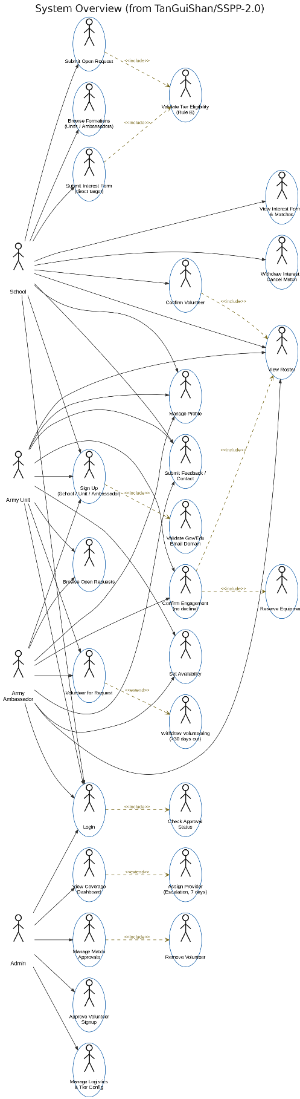

6.3 Supplementary UI Mockup
Screen-level mockups for each role (School, Army Unit, Army Ambassador, Stakeholder Admin) are maintained in the project's design files, covering: signup/login and domain-tier routing; browse and filter tabs; the ambassador multi-select team-forming screen with sticky team bar; the engagement detail and two-sided confirmation screen; the EngagementRoster per-member confirmation screen; the Stakeholder Admin dashboard (coverage bars, stale-school flags, upcoming engagements); and the inventory/stock monitoring screen.

6.3.1 Public Access & Onboarding
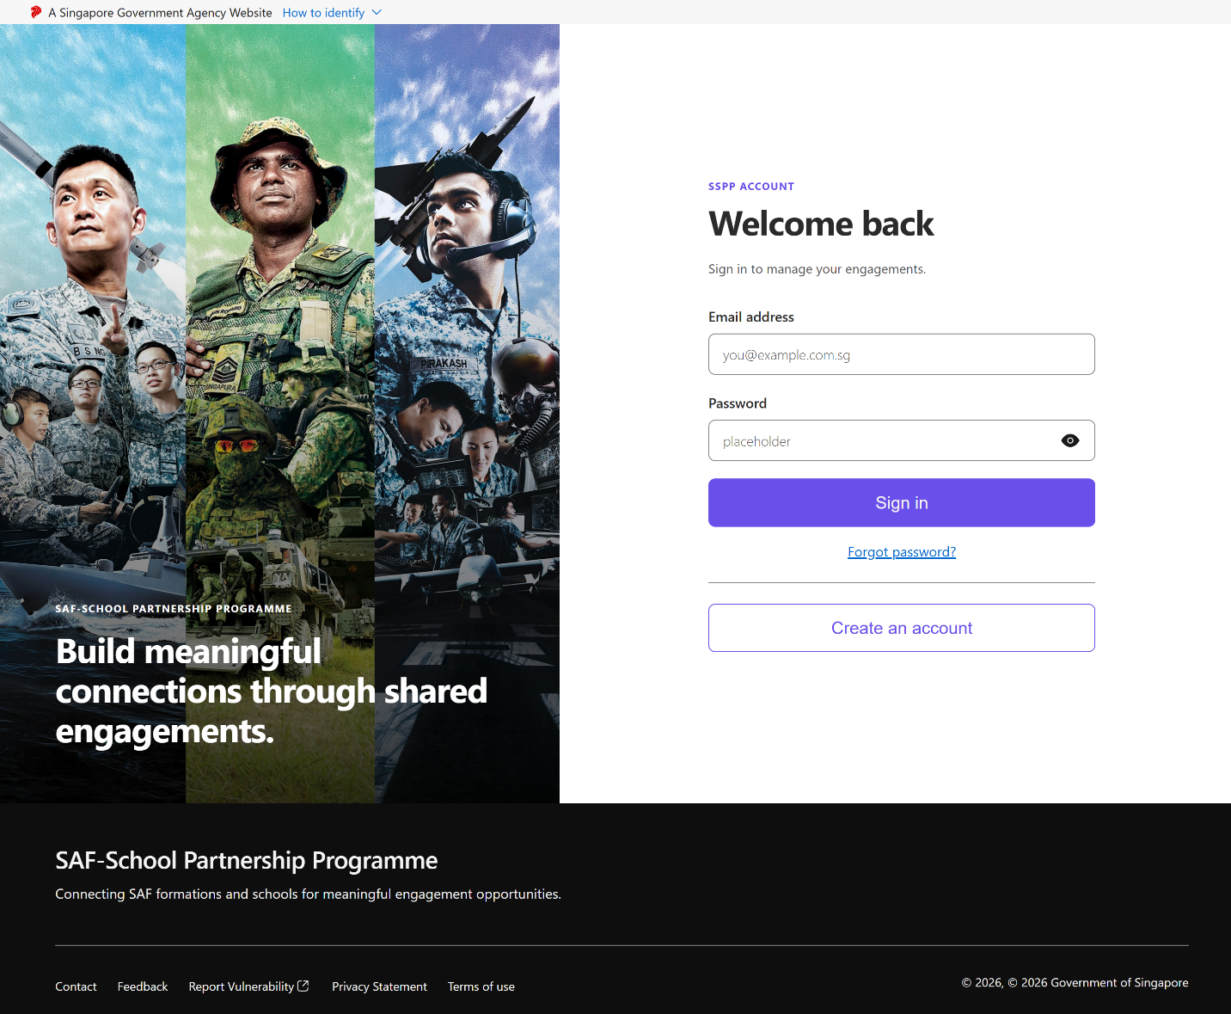
Login page
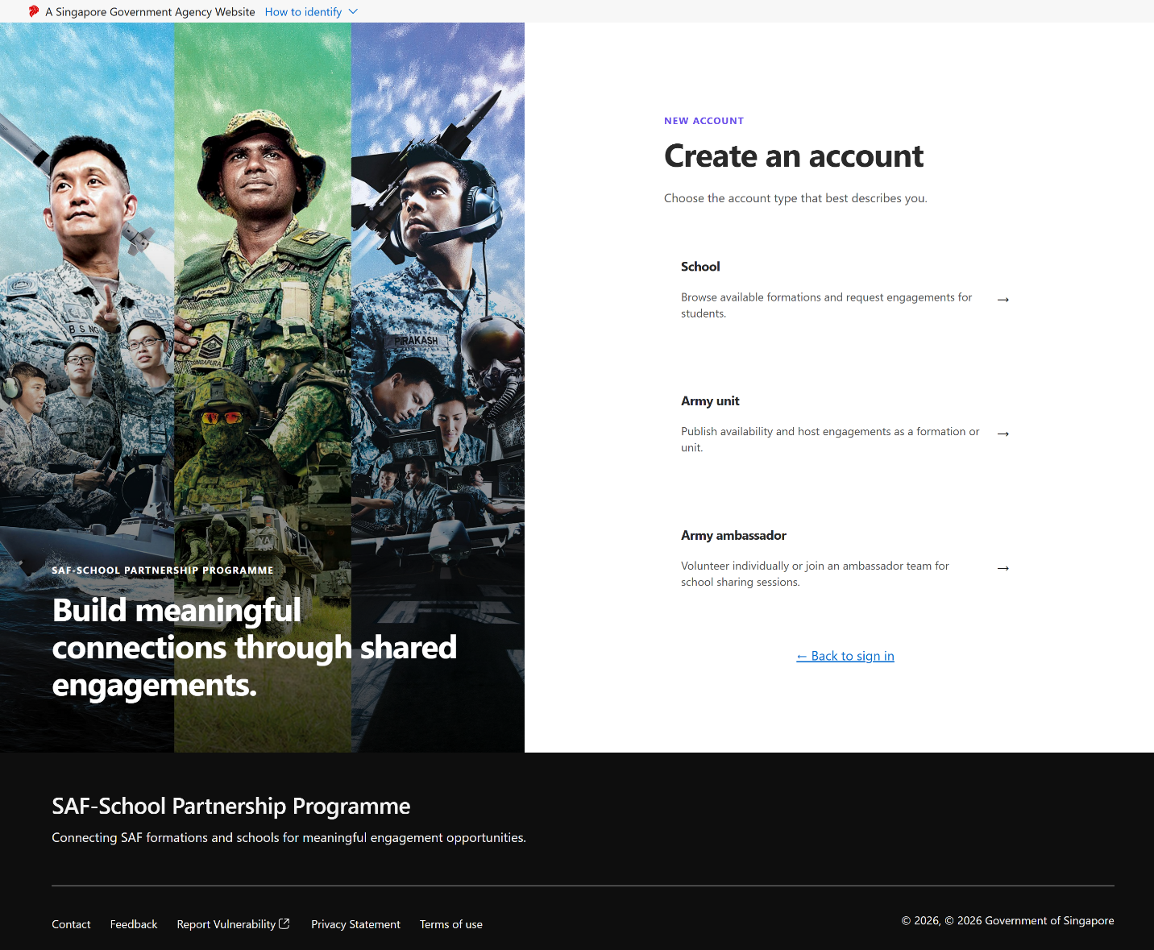
Pre-Signup (Role selection) page
After click “Create an account”.
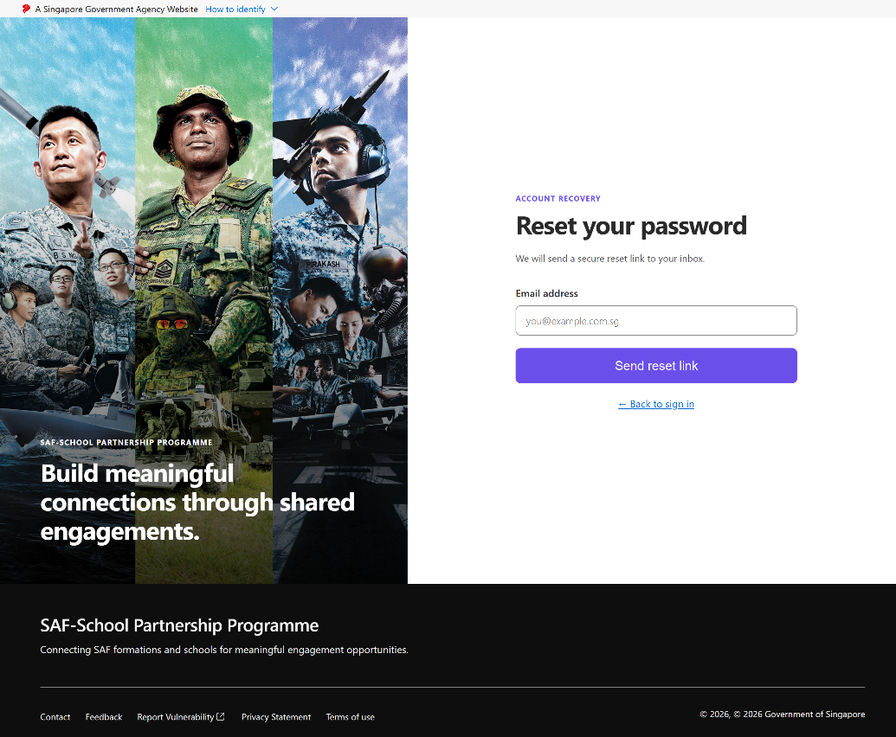
Forget Password page,
After clicking “Forget password” in the Login page.
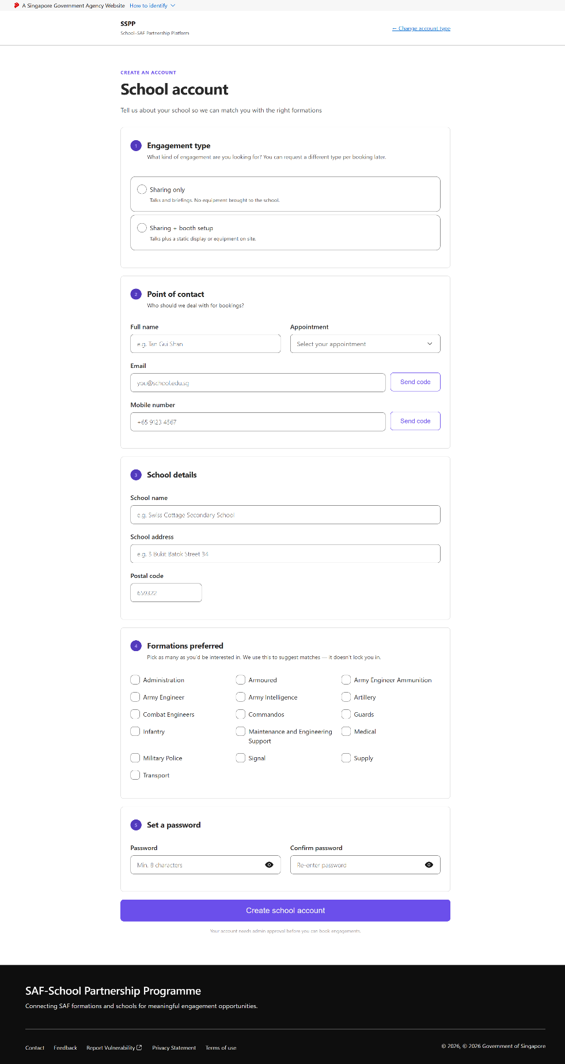
School signup page,
After clicking “School” in the pre-signup page.
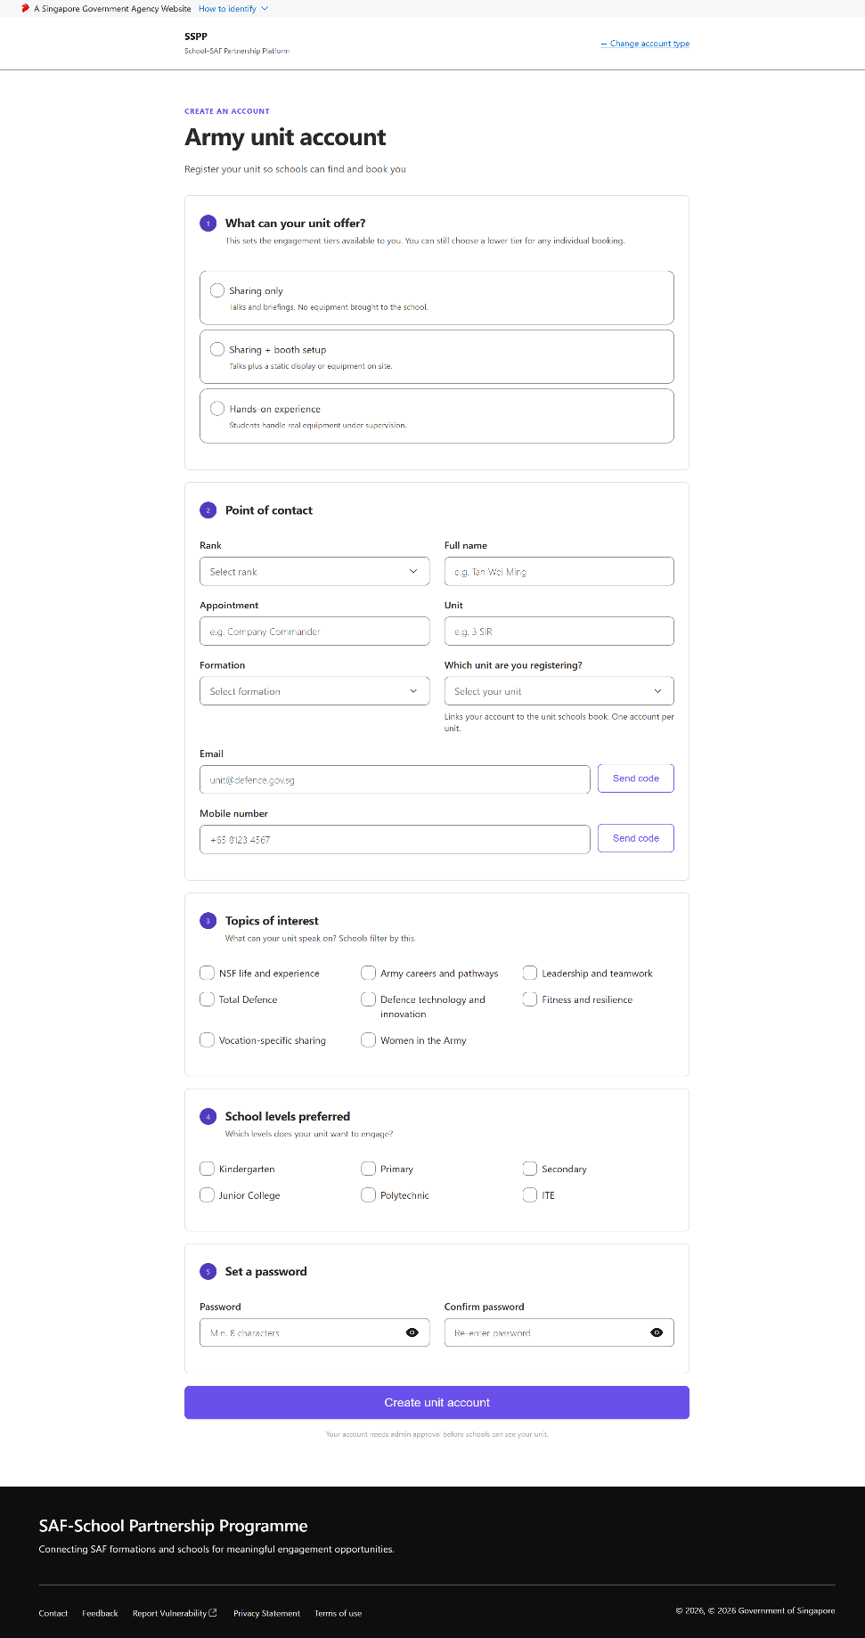
Army Unit signup page,
After clicking “Army Unit” in the pre-signup page.
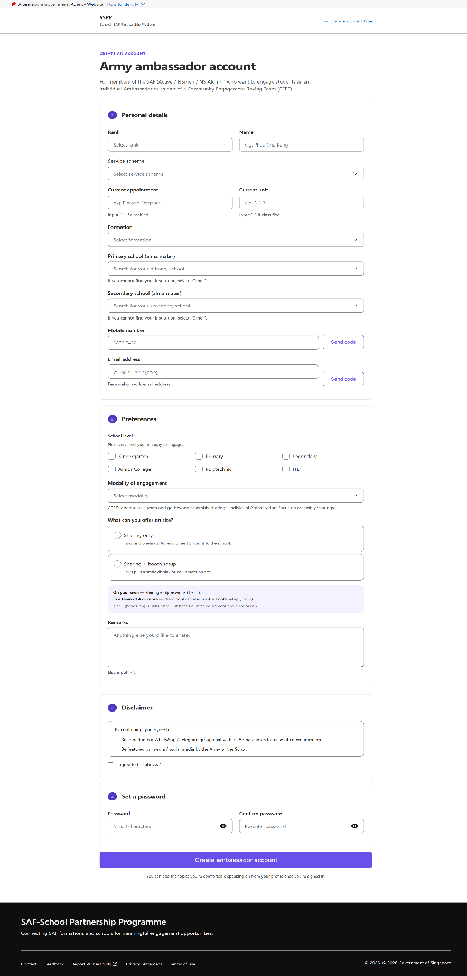
Army Ambassador signup page,
After clicking “Army Ambassador” in the pre-signup page.
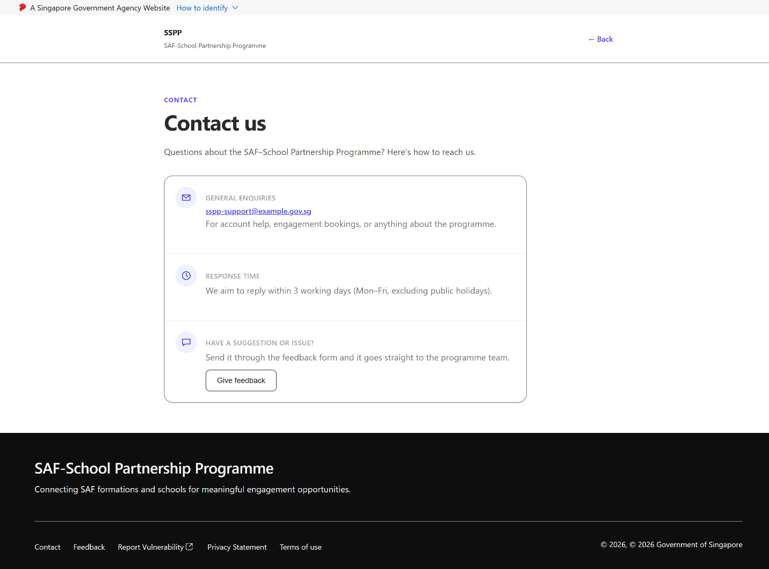
Contact page
After clicking “Contact” at the footnote.
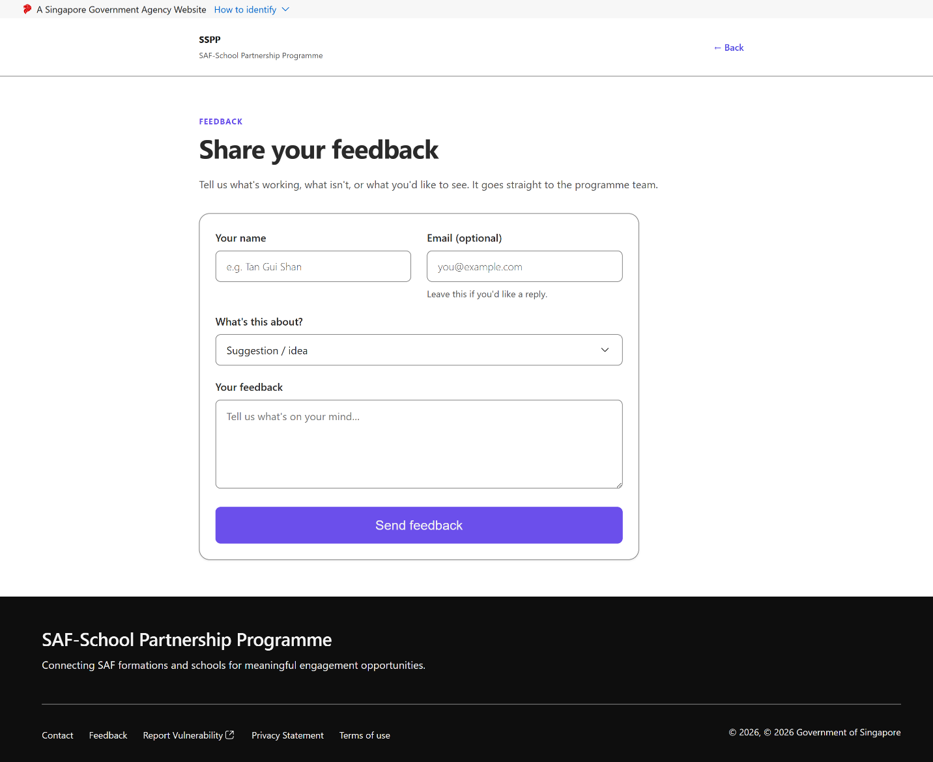
Feedback page
After clicking “Feedback” at the footnote.

6.3.2 School View
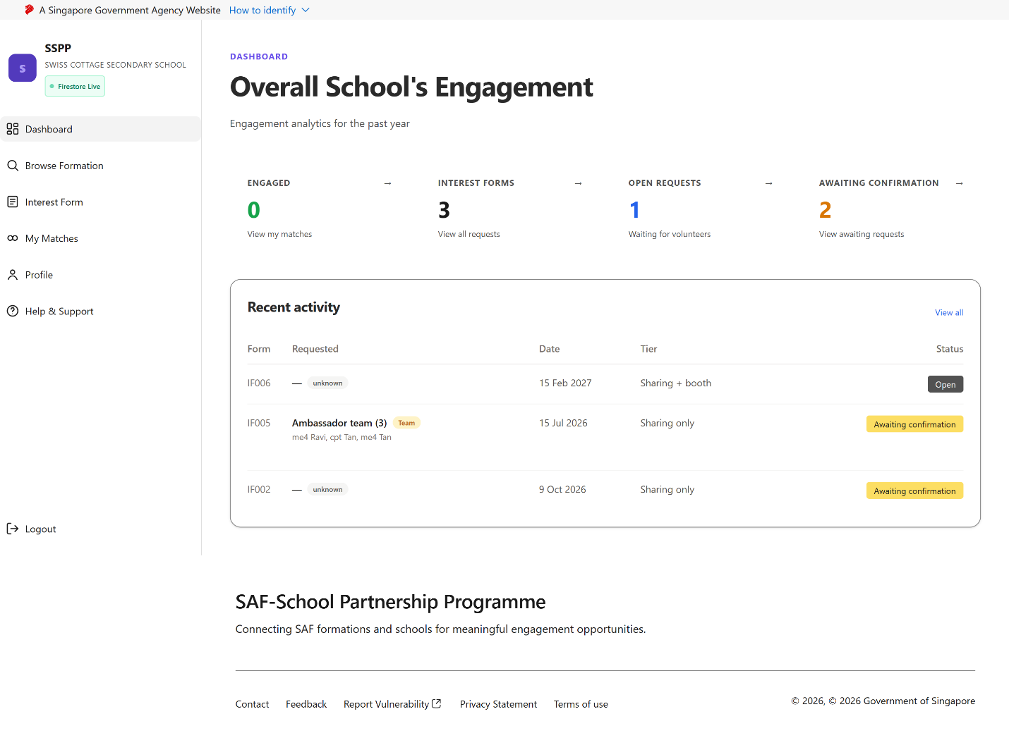
School Dashboard
Landing page immediately after a School account logs in.
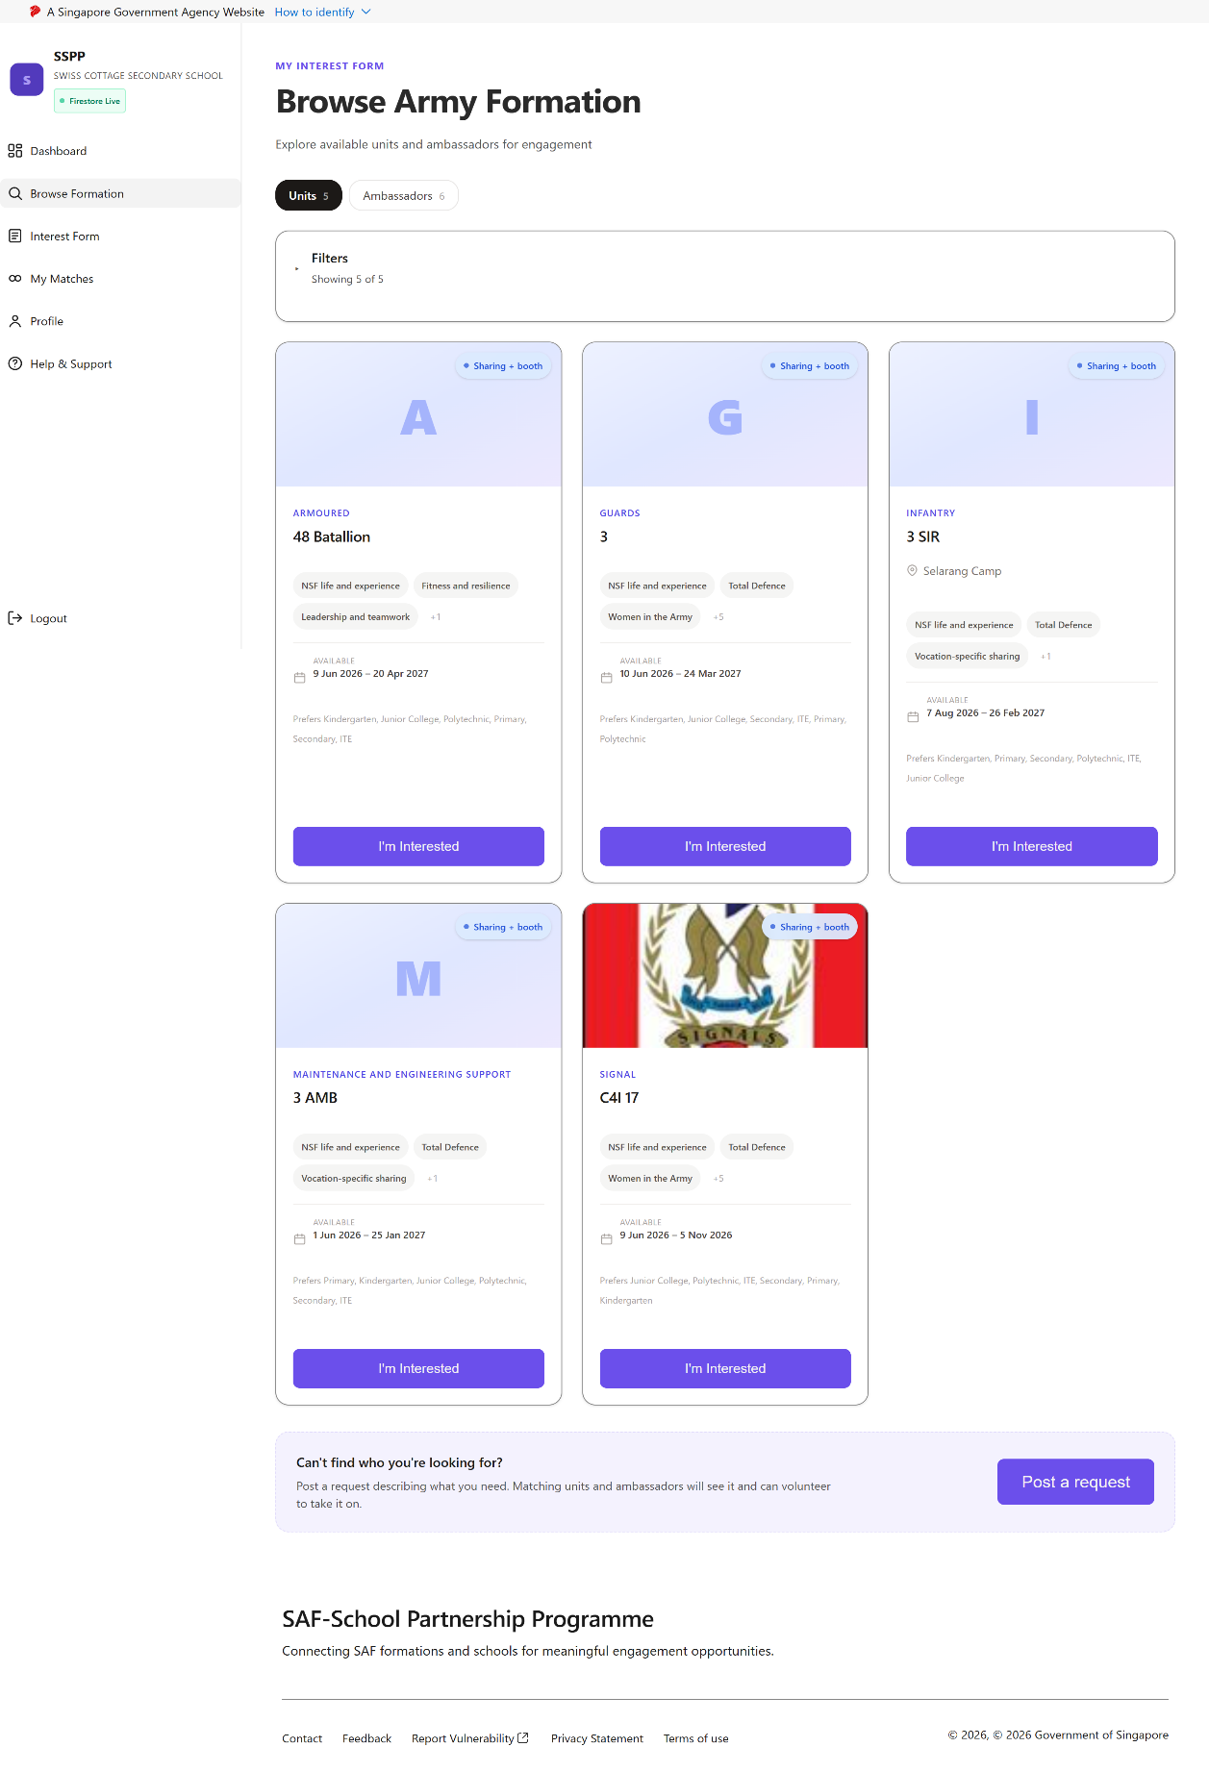
Browse Army Unit Page
After clicking “Browse Formation” at the left side bar.
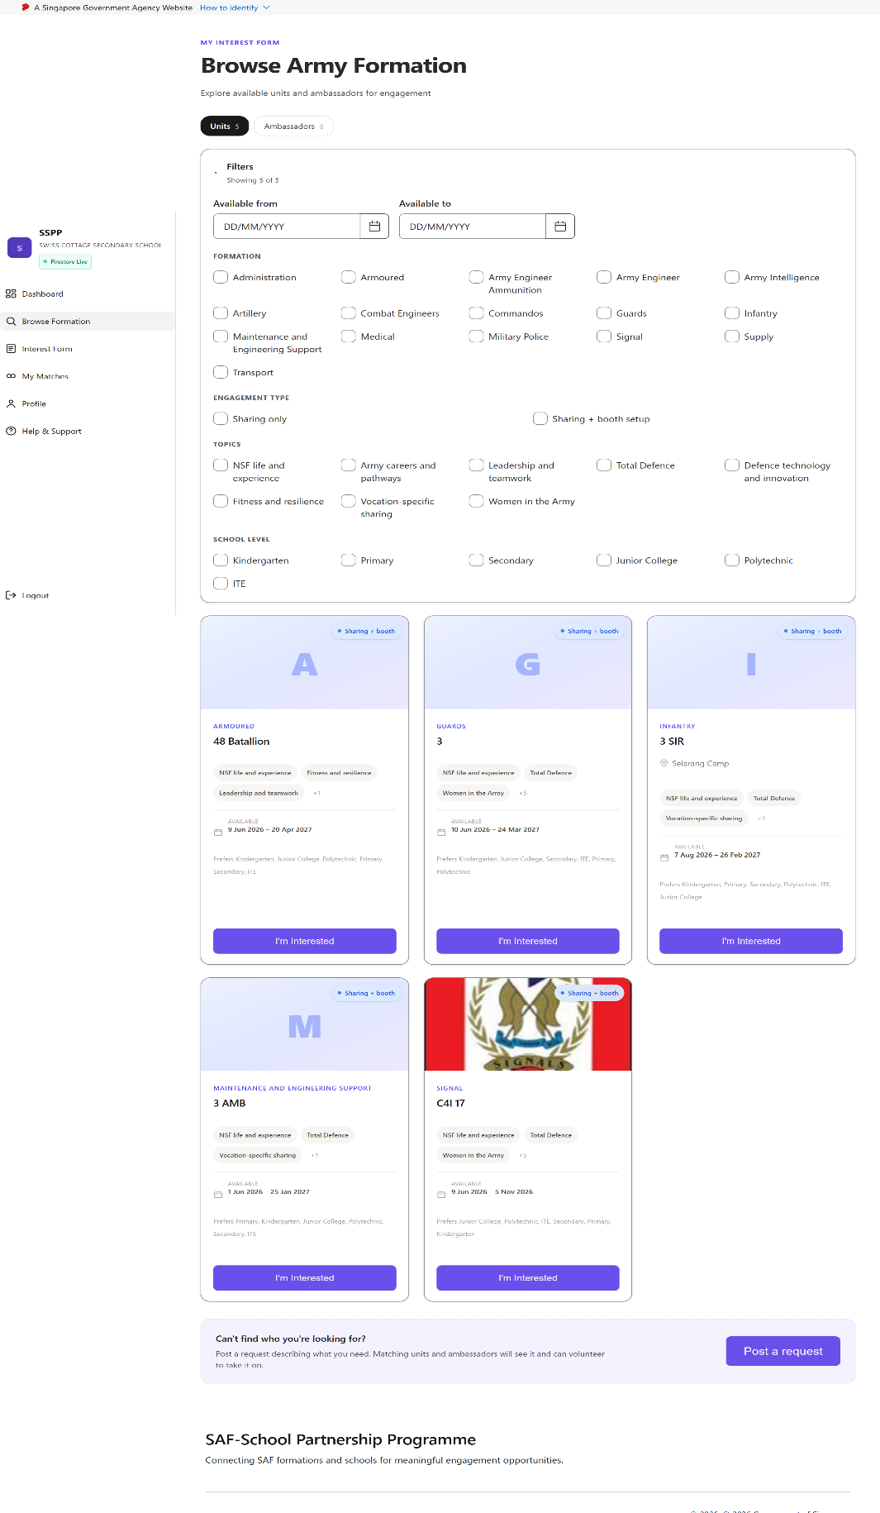
Browse Army Unit Page - Filter
Filter panel opened from the Browse Army Unit Page.
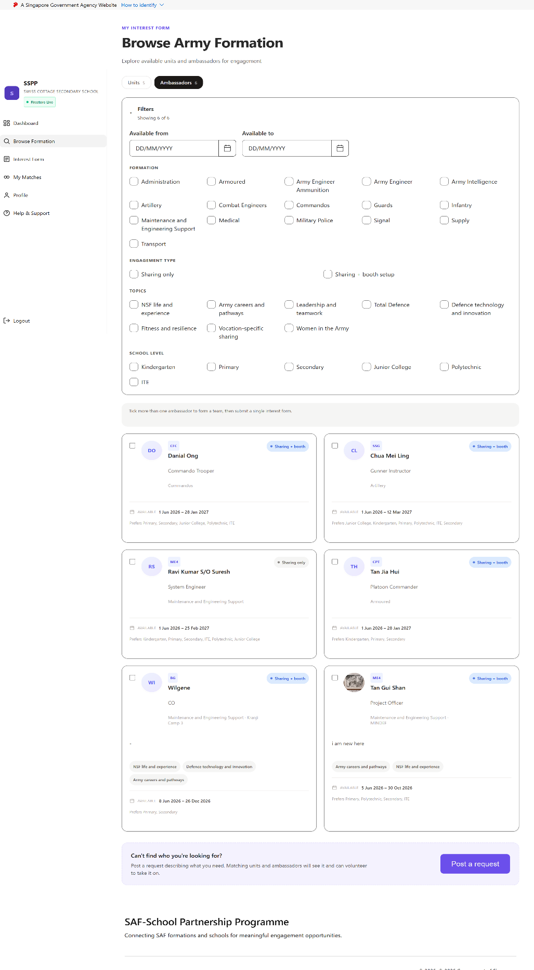
Browse Army Ambassadors Page - Filter
Filter panel opened from the Browse Army Ambassadors Page.
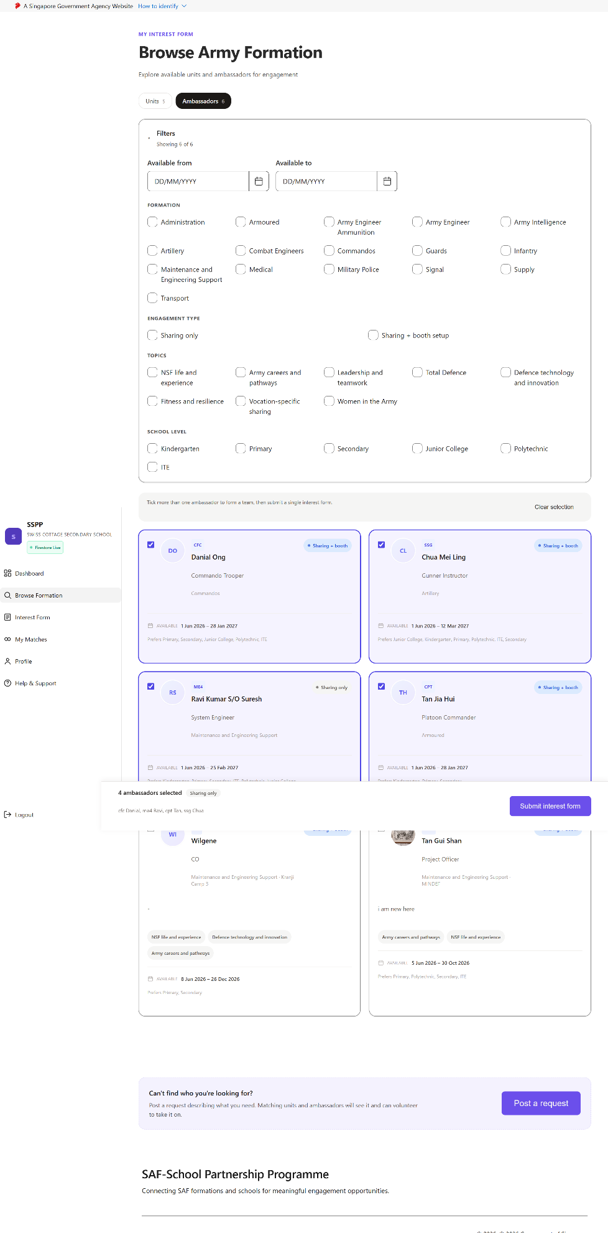
Browse Ambassadors – CERT selection
Selecting multiple ambassador cards on the Ambassadors tab;
the sticky team bar tracks the forming team and live Rule B (Tier 2) satus
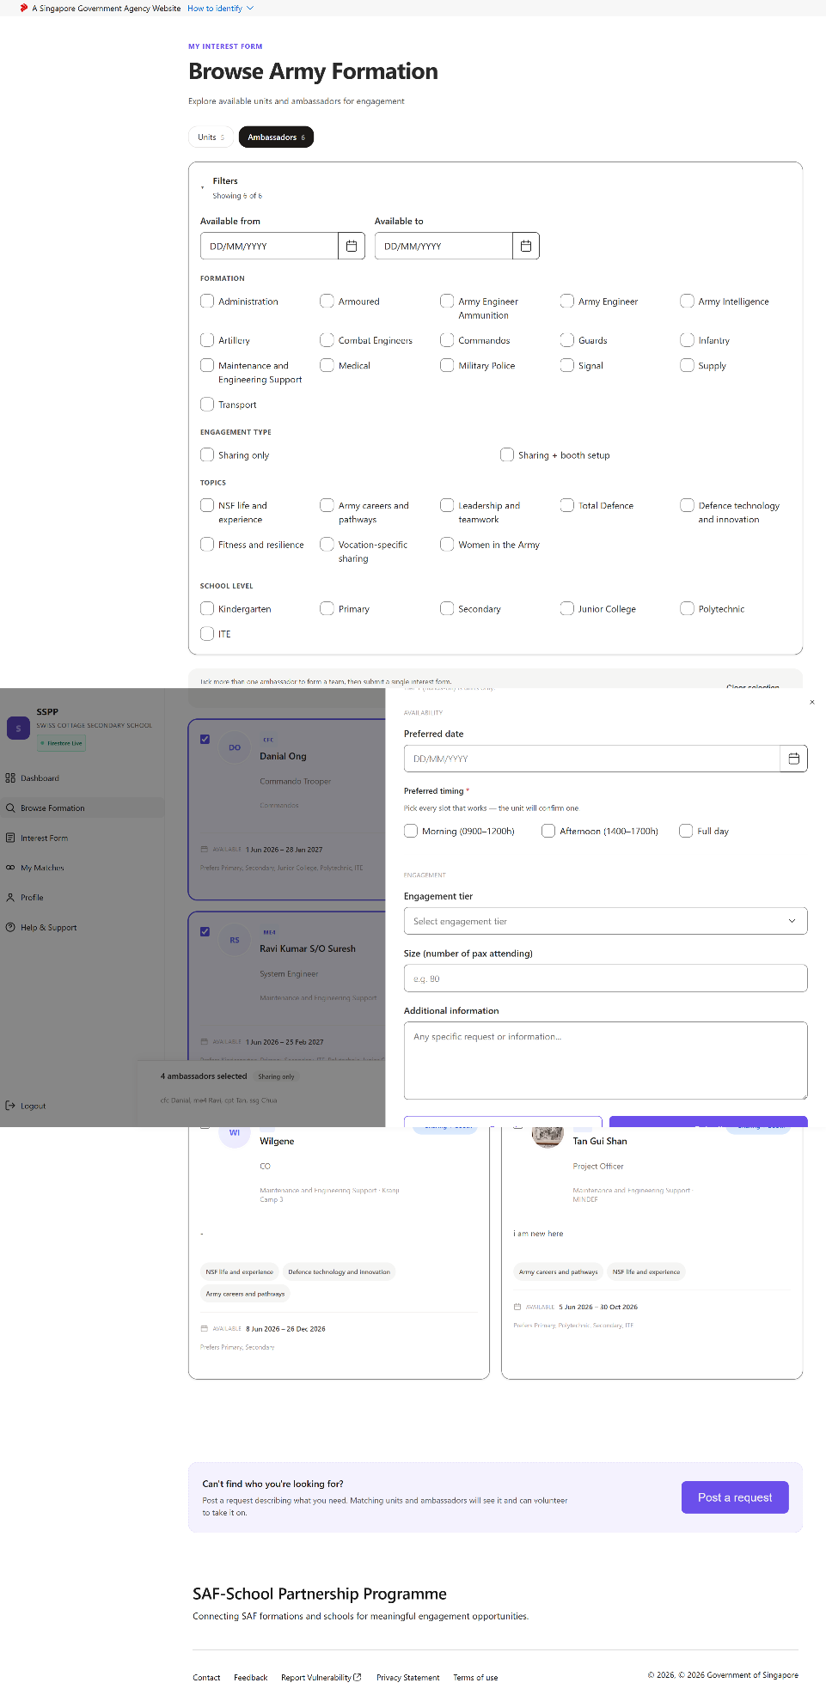
Ambassador Team – Interest Form
After clicking “I’m Interested”once a team has been formed on the Ambassador tab.
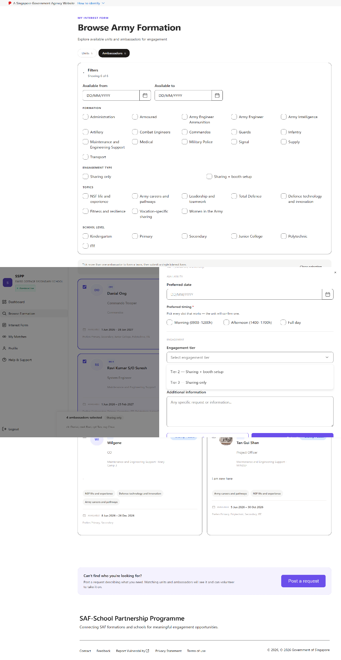
Ambassador Team – Interest Form (Tier Details)
Tier-detail step of the ambassador-team interest form, showing the tier the current team size has unlocked.
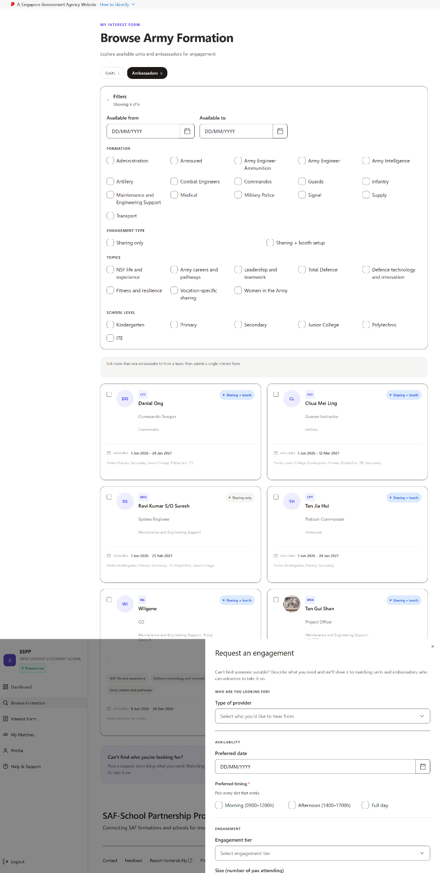
Post an Open Request
After clickcing “Post a request” at the bottom of the Browse Formation page, for a School that can not find a suitatble match.
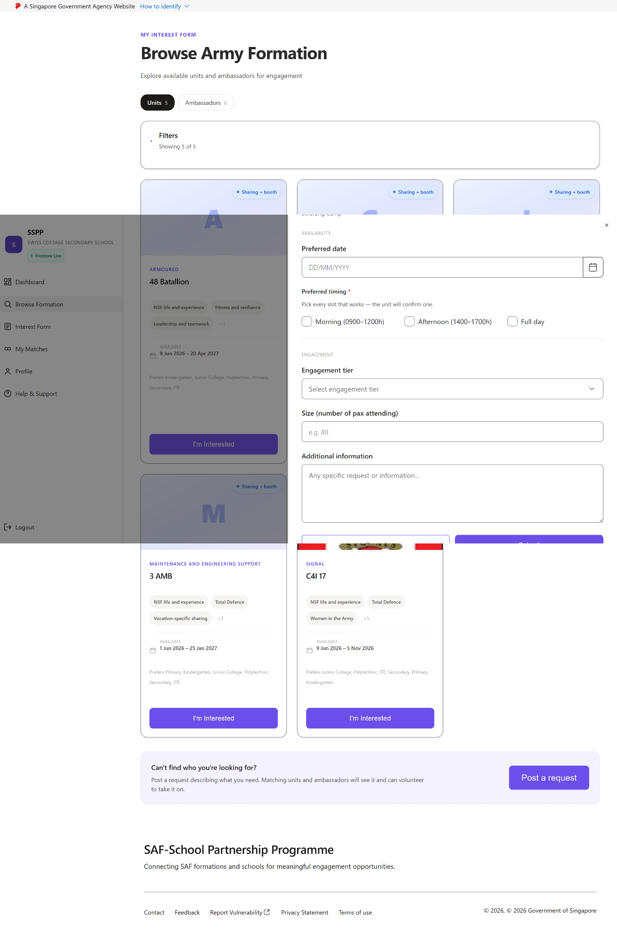
Interest Form – Army Unit
After clicking “I'm Interested” on a specific Army Unit card in Browse Army Units.
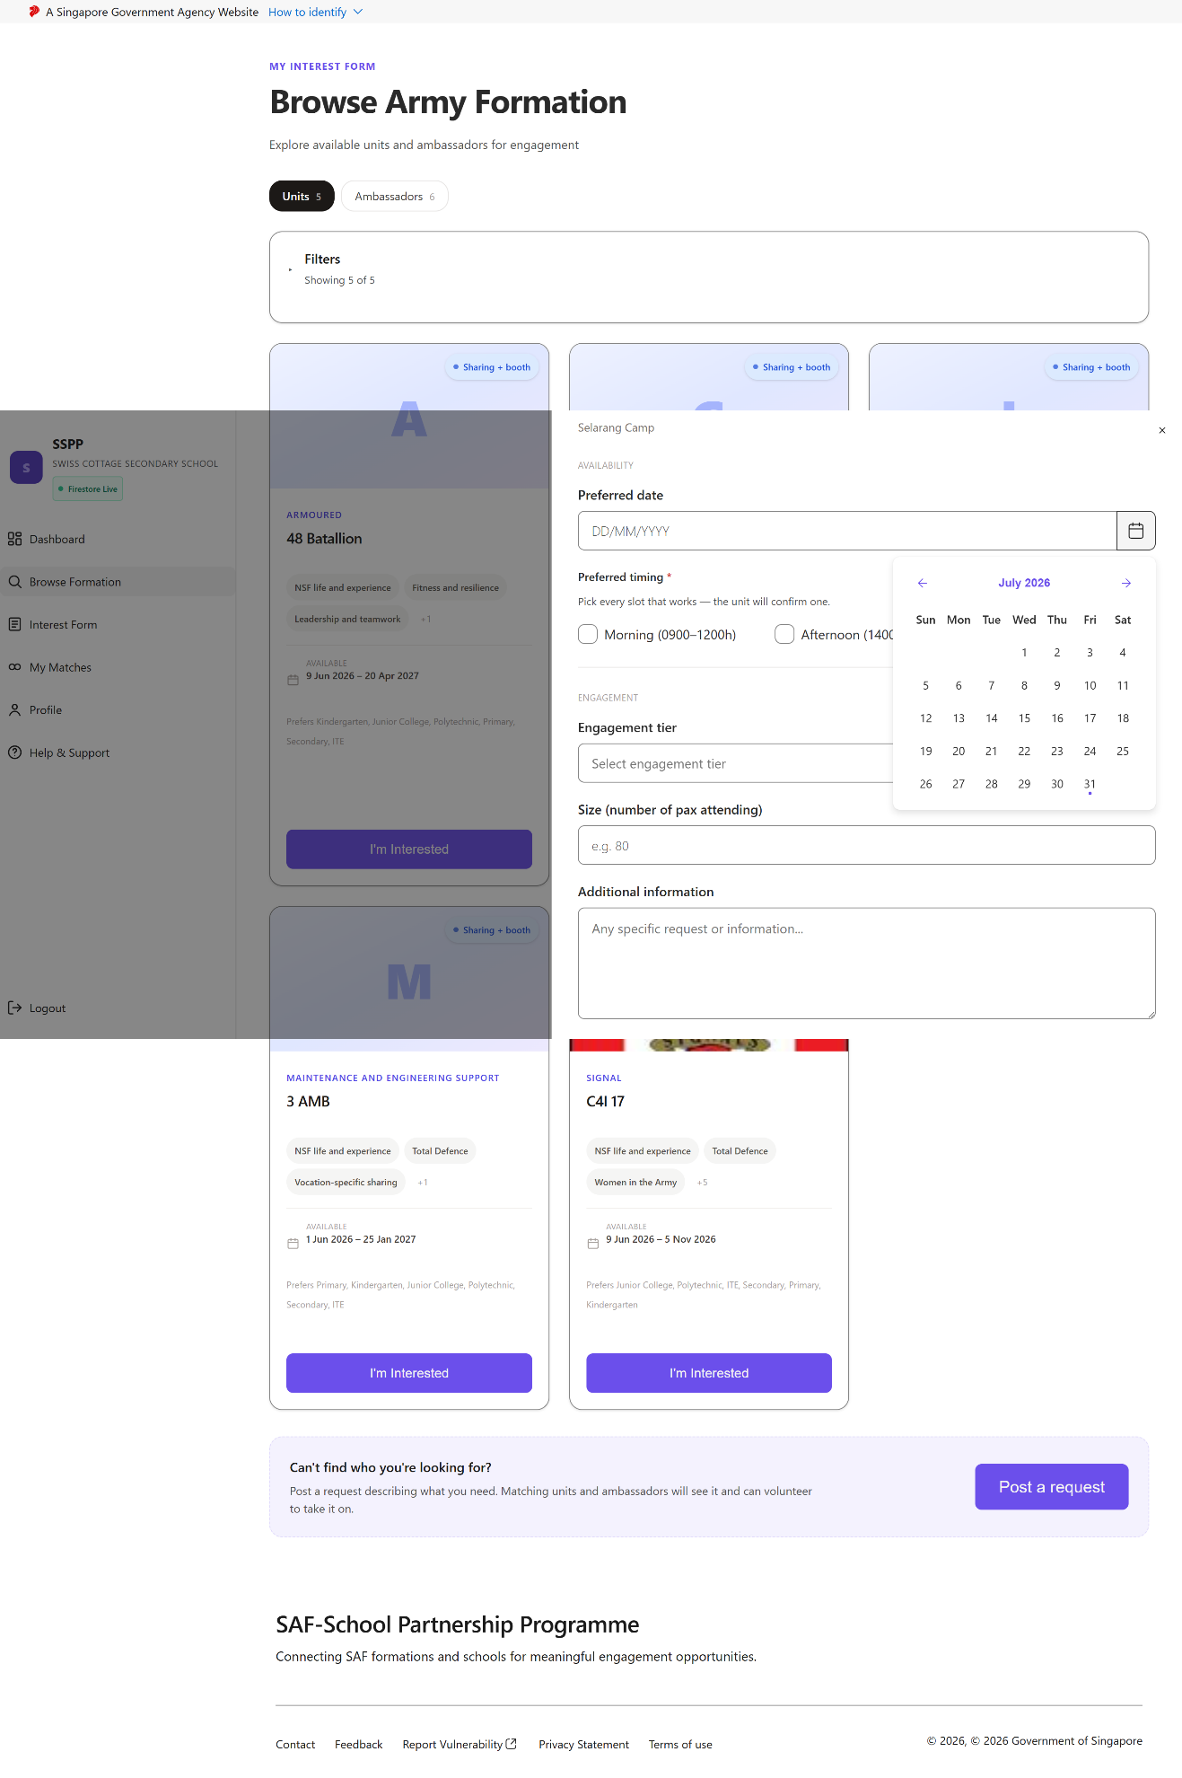
Interest Form – Calendar / Date Selection
Date-selection step within the Army Unit interest form.
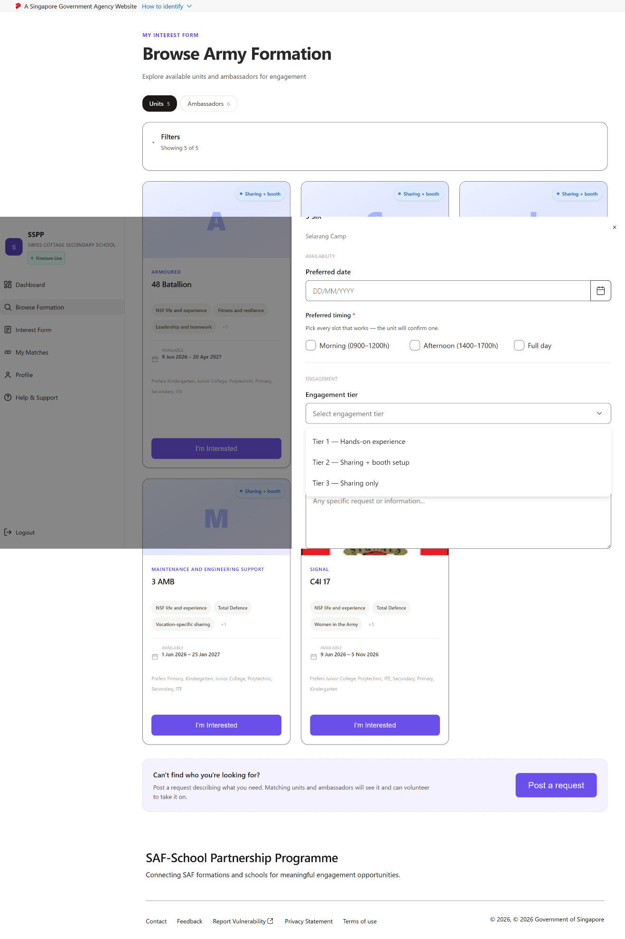
Interest Form – Tier Detail
Tier-detail step within the Army Unit interest form.
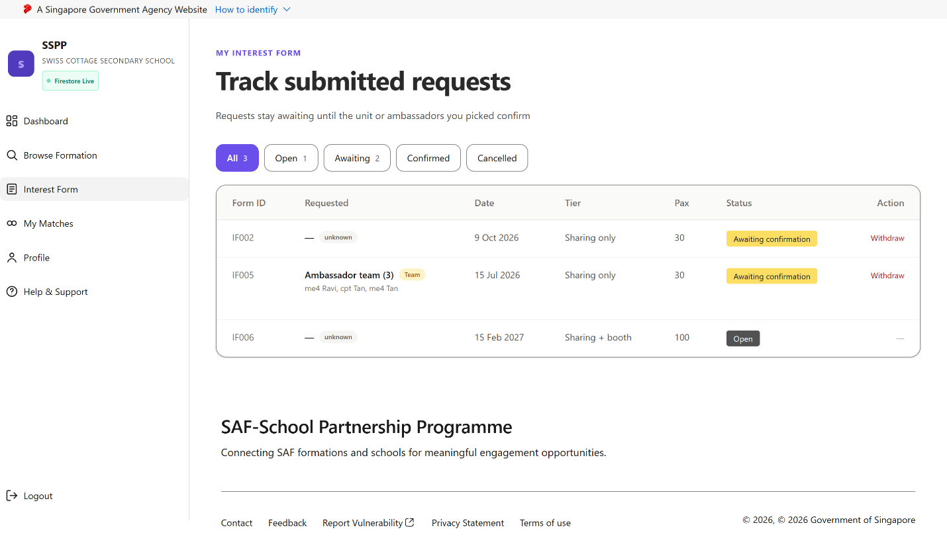
Interest Form Summary
Reached via “Interest Form” in the School sidebar — a consolidated view of all interest forms the School has submitted.

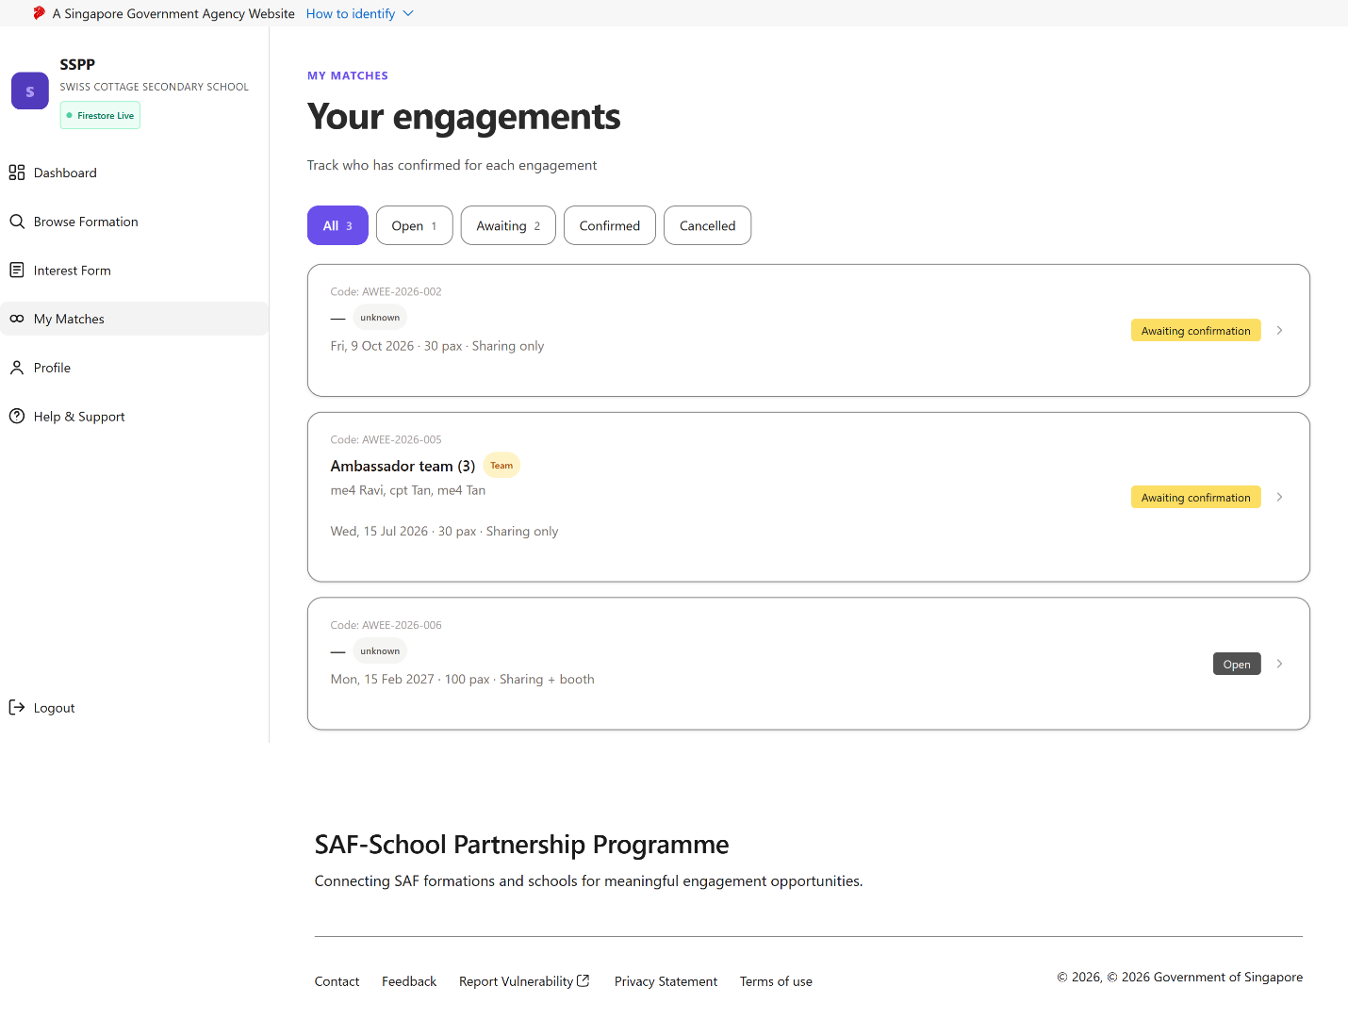
School Matches
Reached via “My Matches” in the School sidebar.

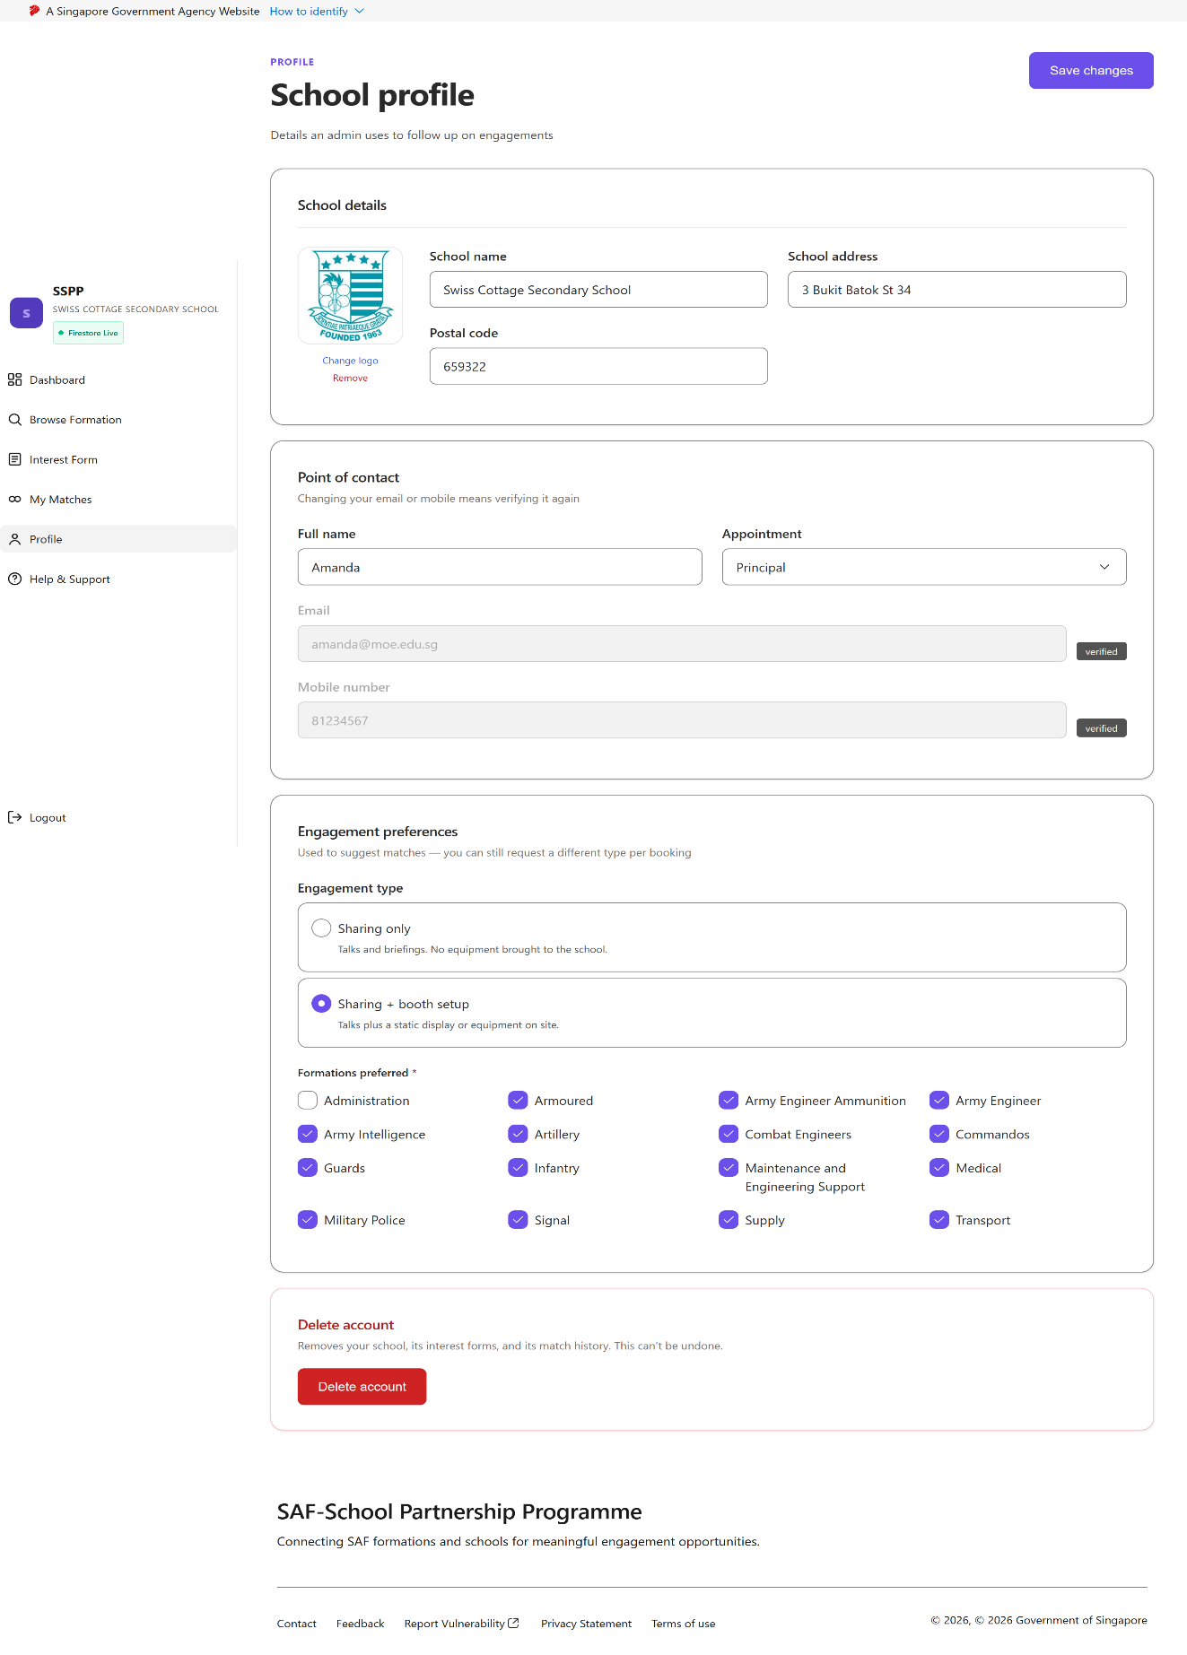
School Profile
Reached via “Profile” in the School sidebar.
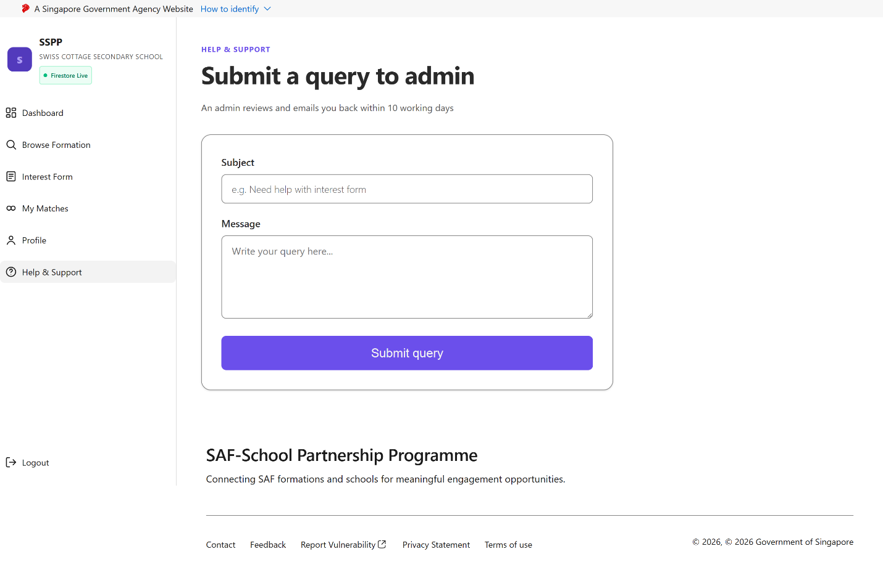
School Help & Support
Reached via “Help & Support” in the School sidebar.

6.3.3 Army Unit Views
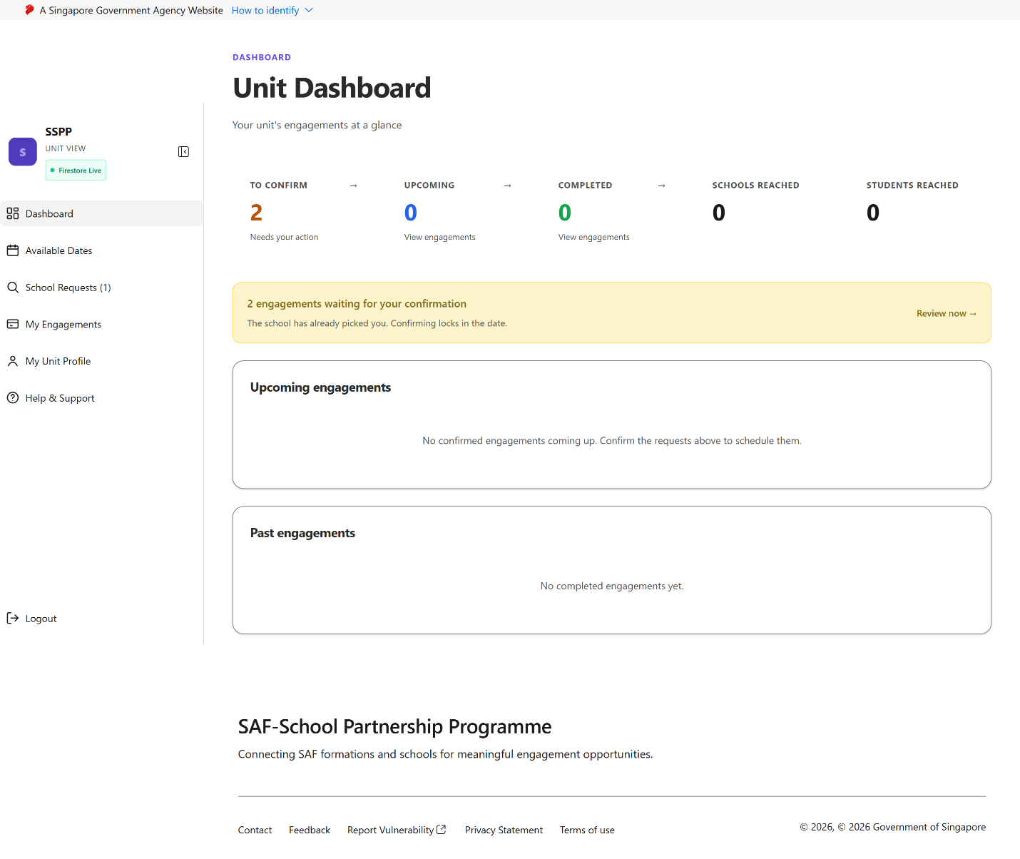
Army Unit Dashboard
Landing page immediately after an Army Unit account logs in.
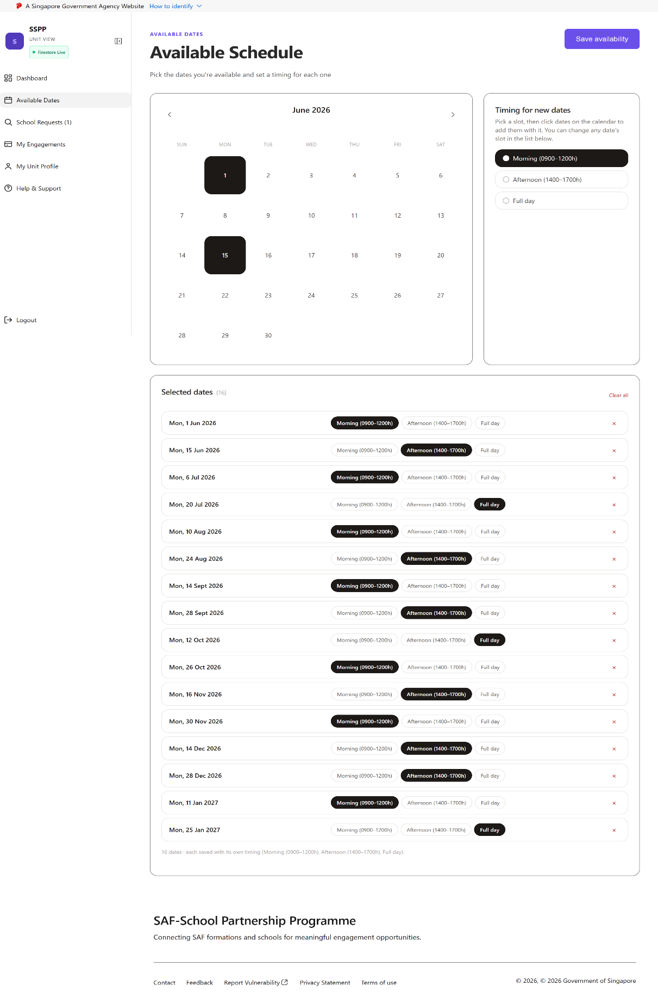
Army Unit – Available Dates
Reached via “Available Dates” in the Army Unit sidebar.
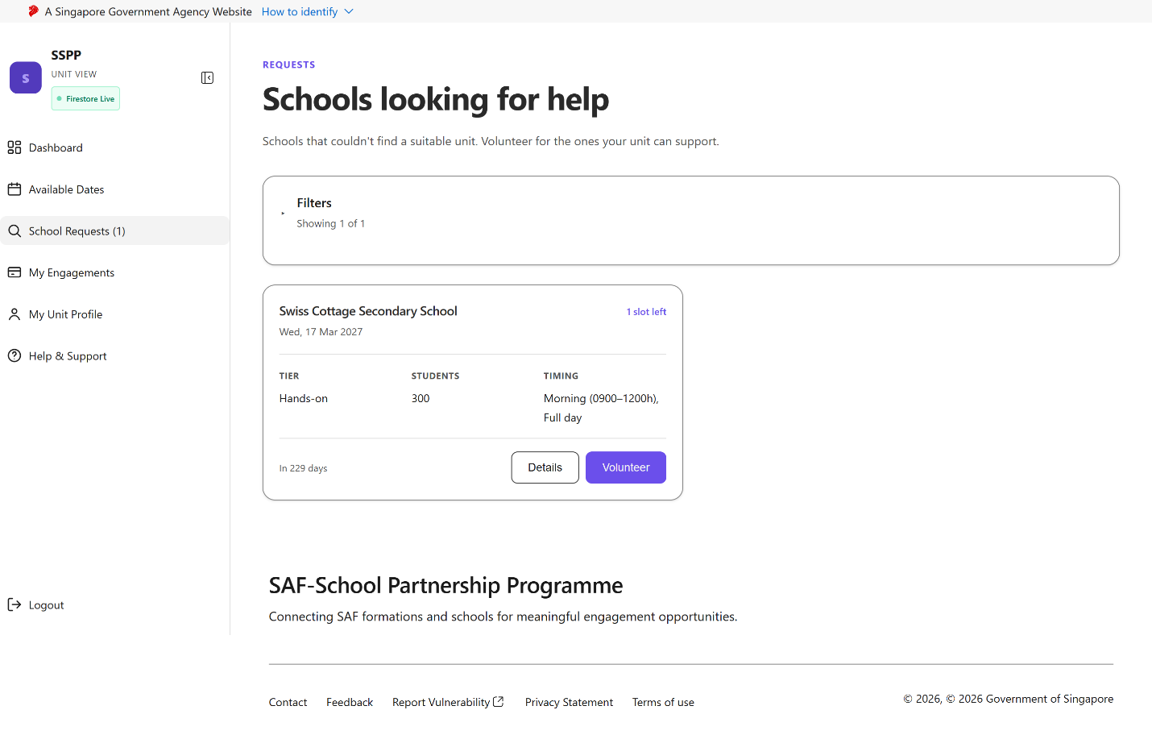
Army Unit – School Request
Reached via “School Requests” in the Army Unit sidebar — incoming interest from a School, awaiting the unit's confirmation.

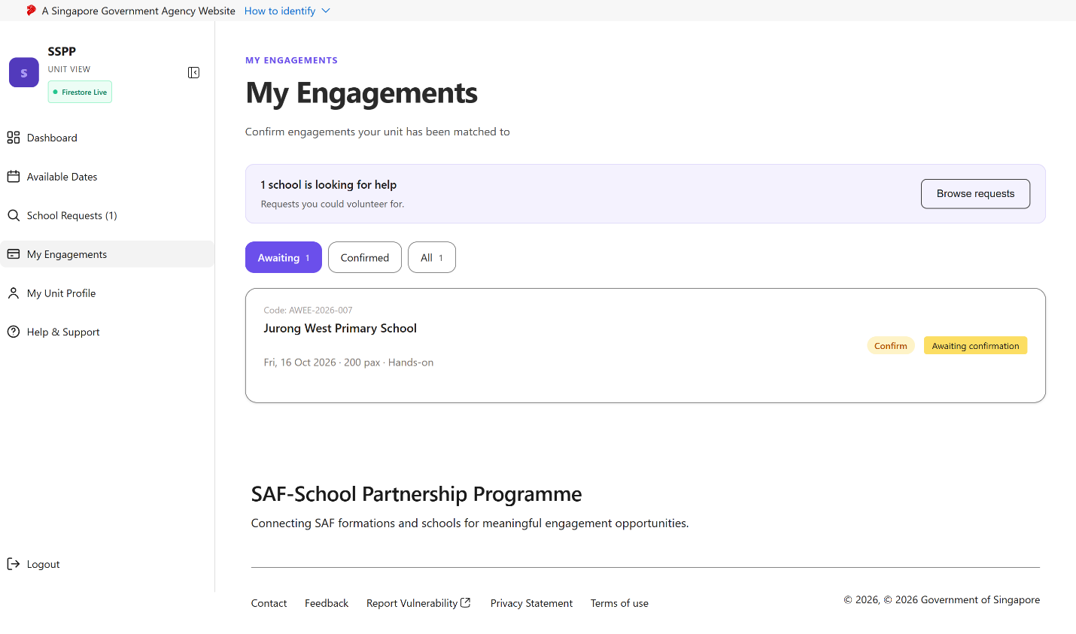
Army Unit – Engagements
Reached via “My Engagements” in the Army Unit sidebar.
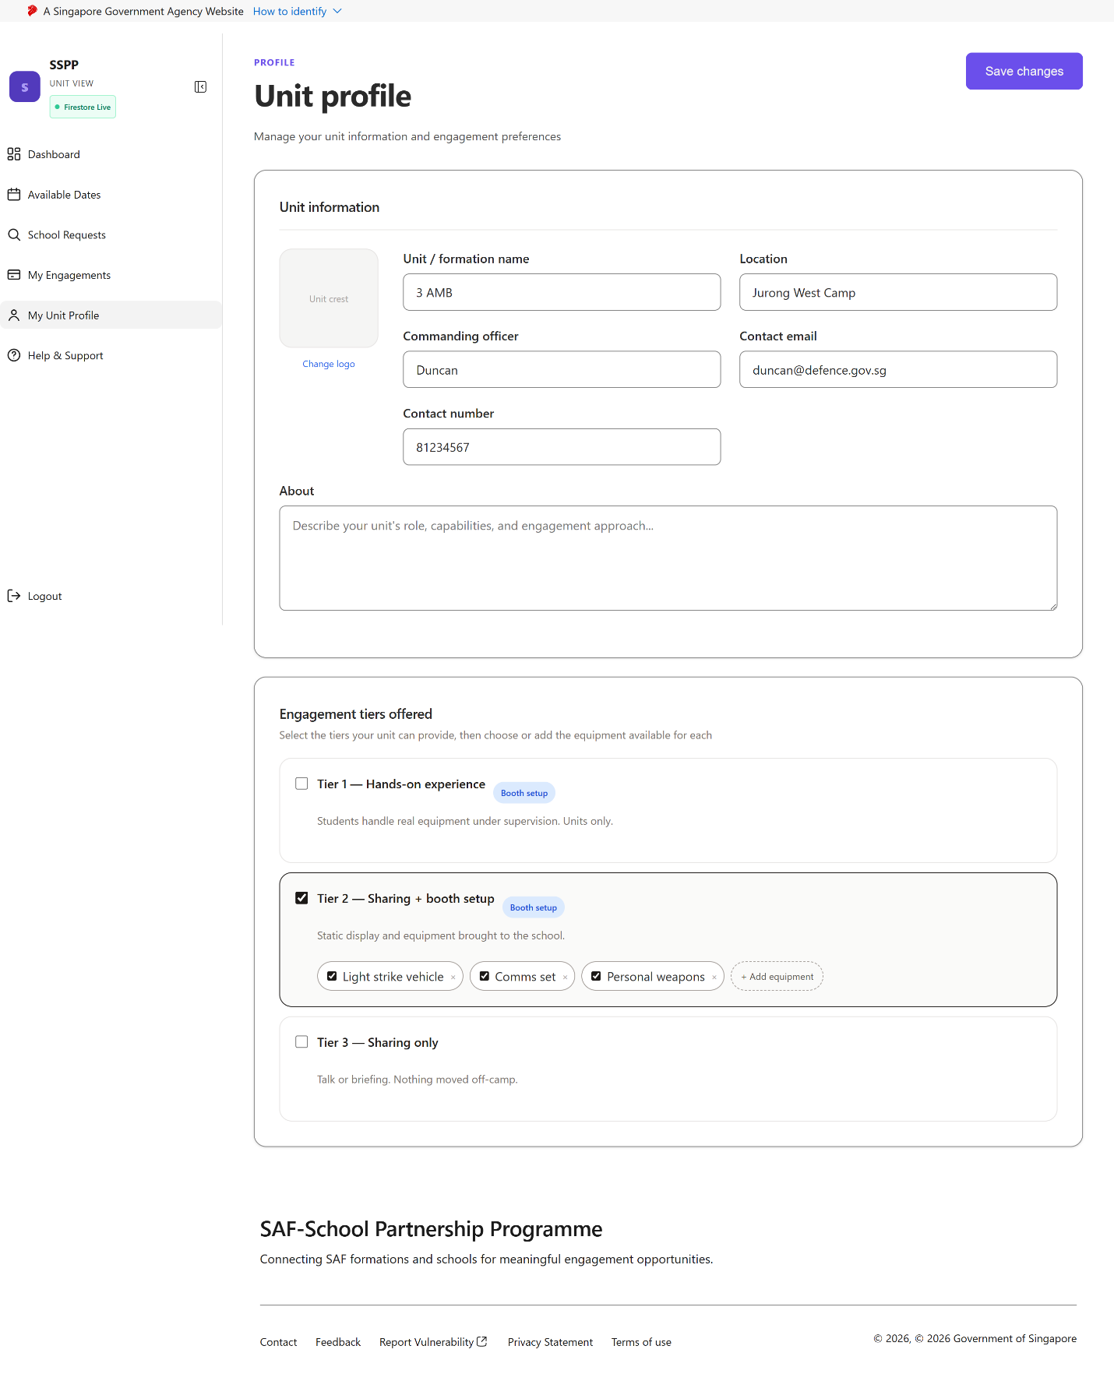
Army Unit Profile
Reached via “Profile” in the Army Unit sidebar.
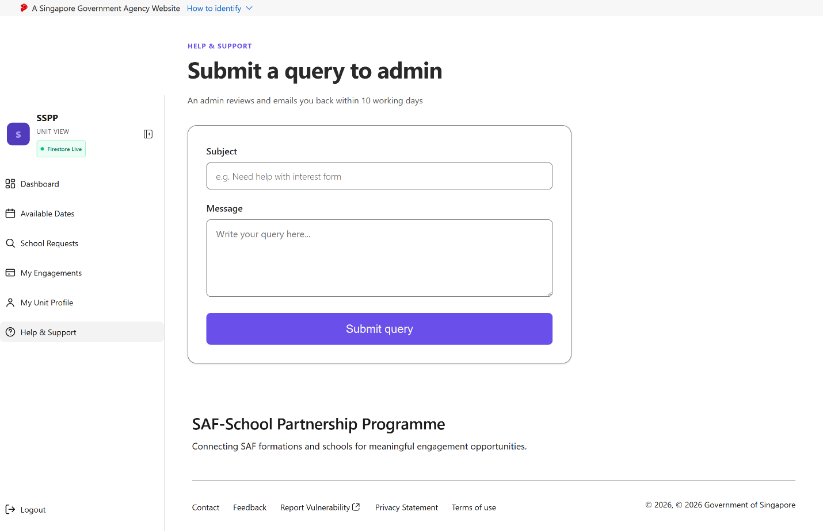
Army Unit Help & Support
Reached via “Help & Support” in the Army Unit sidebar.

6.3.4 Army Ambassador View
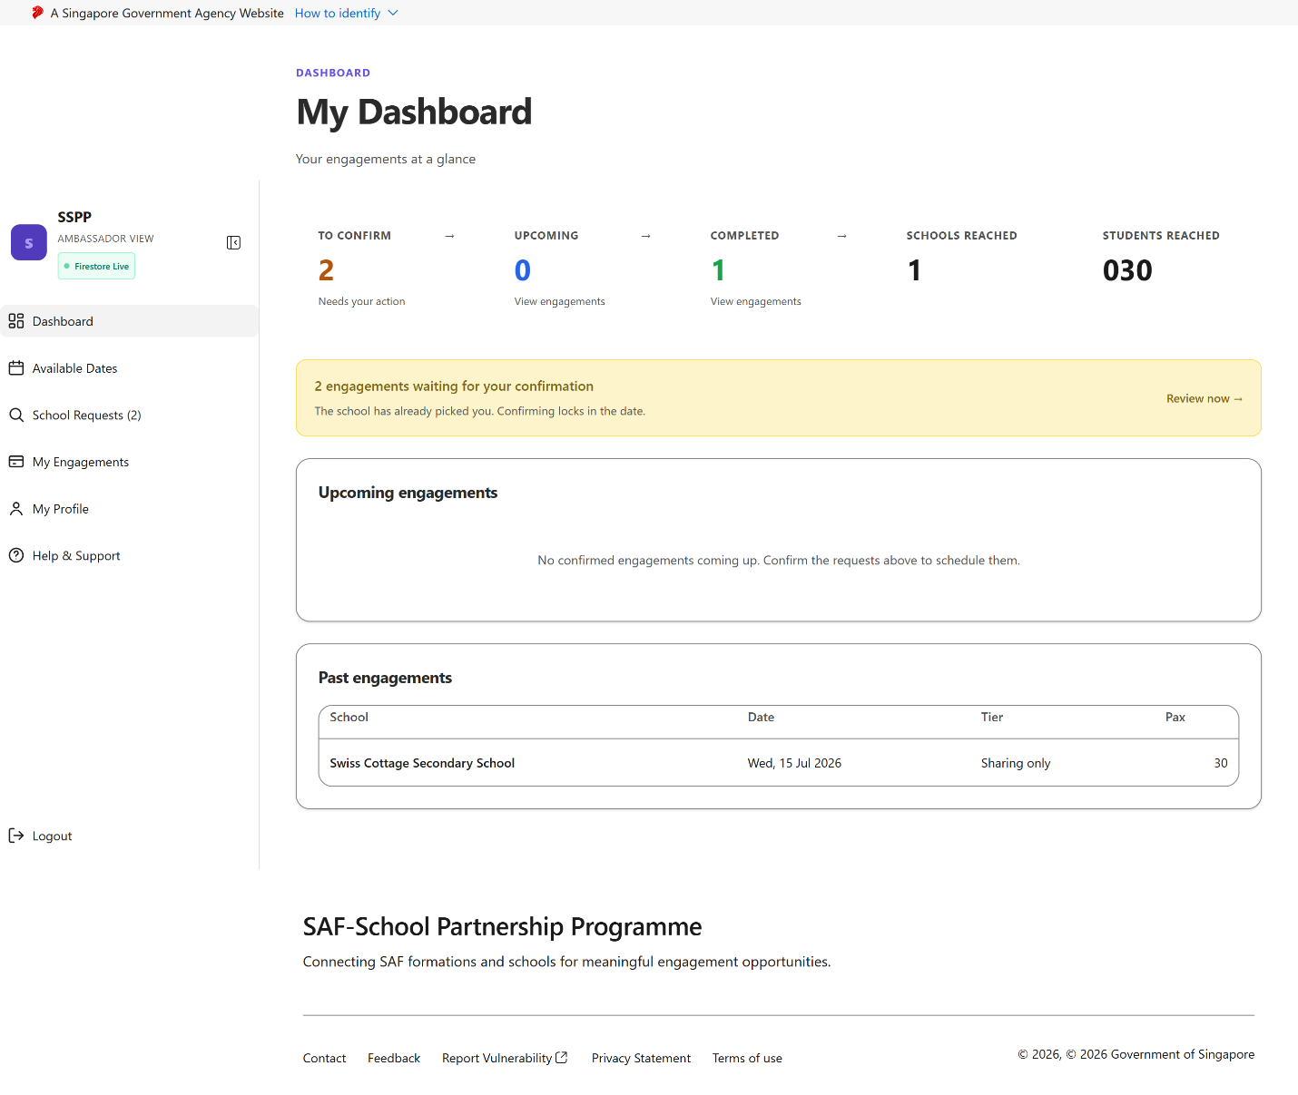
Army Ambassador Dashboard
Landing page immediately after an Army Ambassador account logs in.
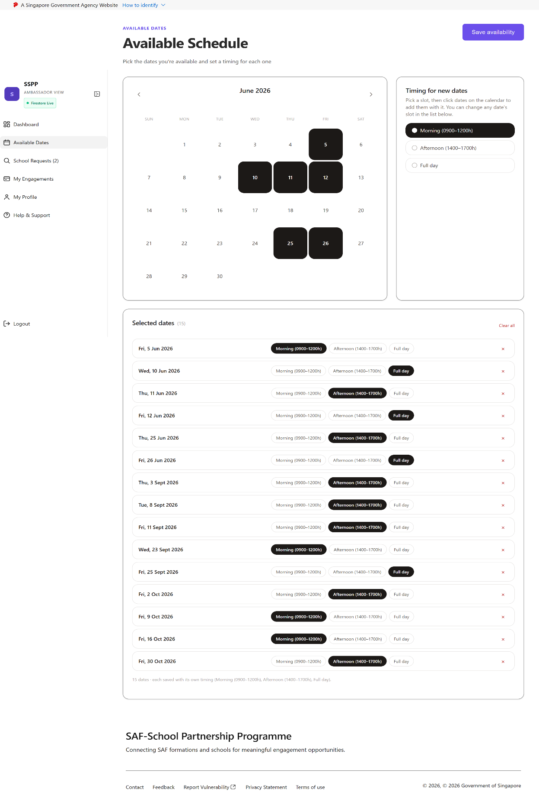
Army Ambassador – Available Dates
Reached via “Available Dates” in the Army Ambassador sidebar.
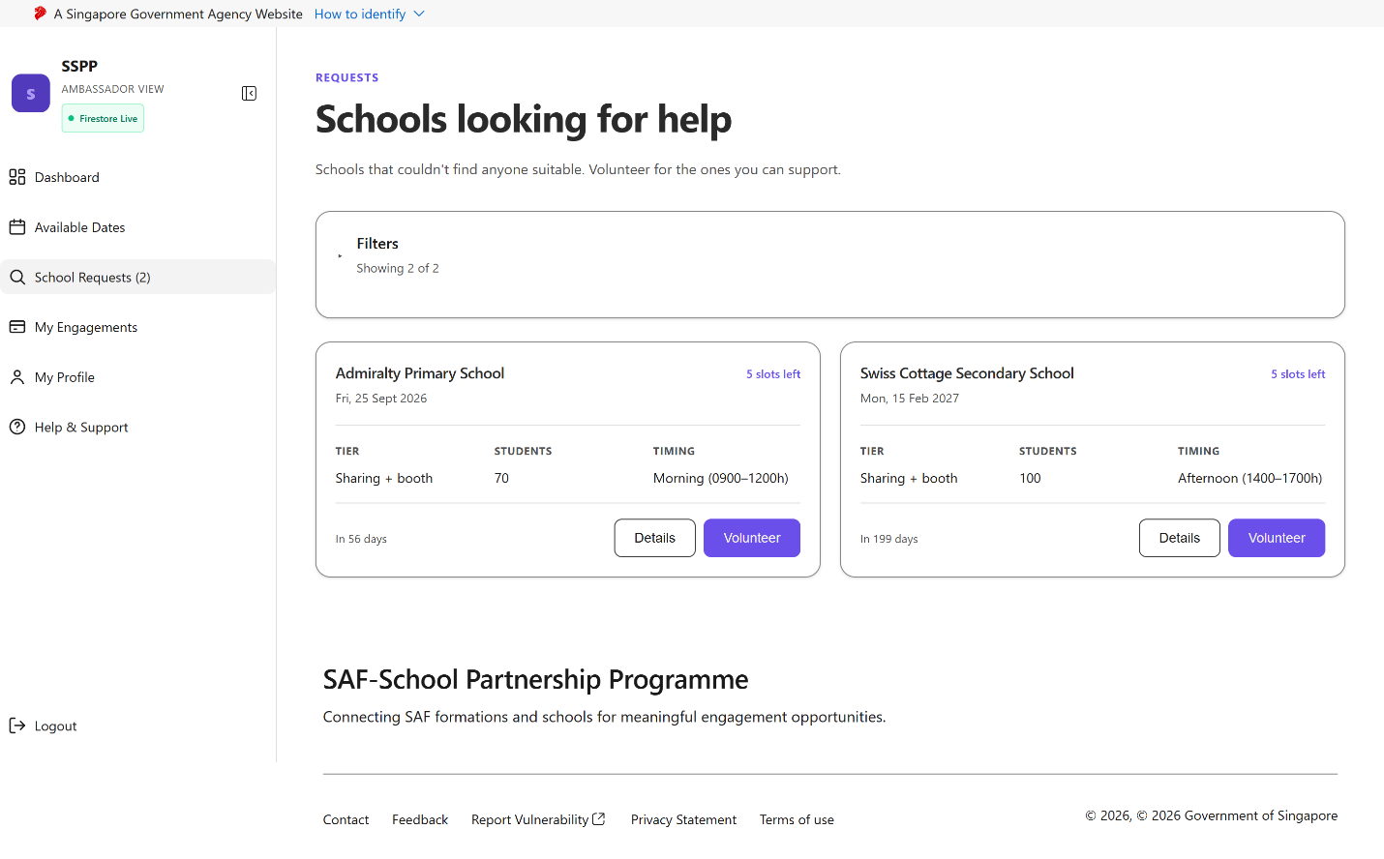
Army Ambassador – School Request
Reached via “School Requests” in the Army Ambassador sidebar, incoming interest from a School, awaiting this ambassador's confirmation.
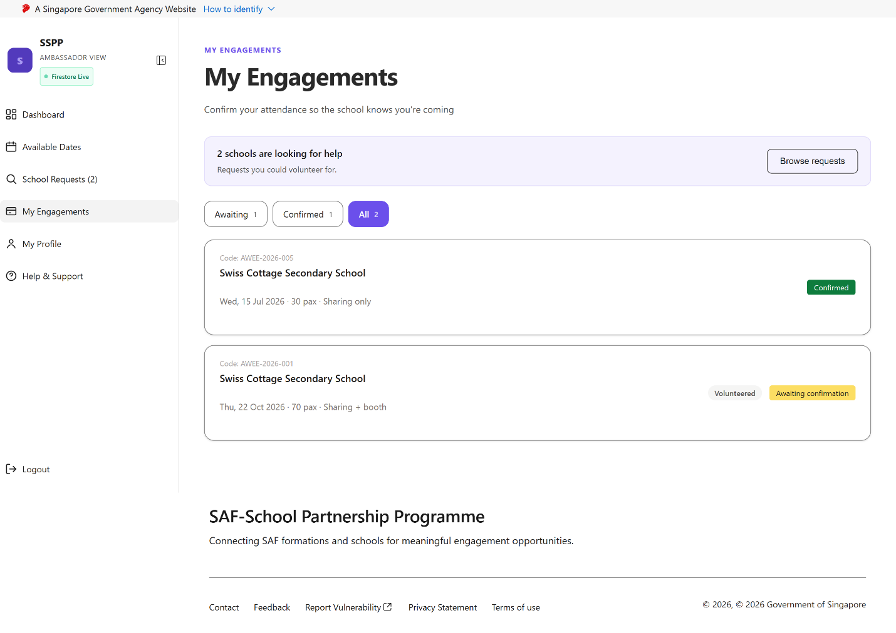
Army Ambassador – Engagements
Reached via “My Engagements” in the Army Ambassador sidebar.
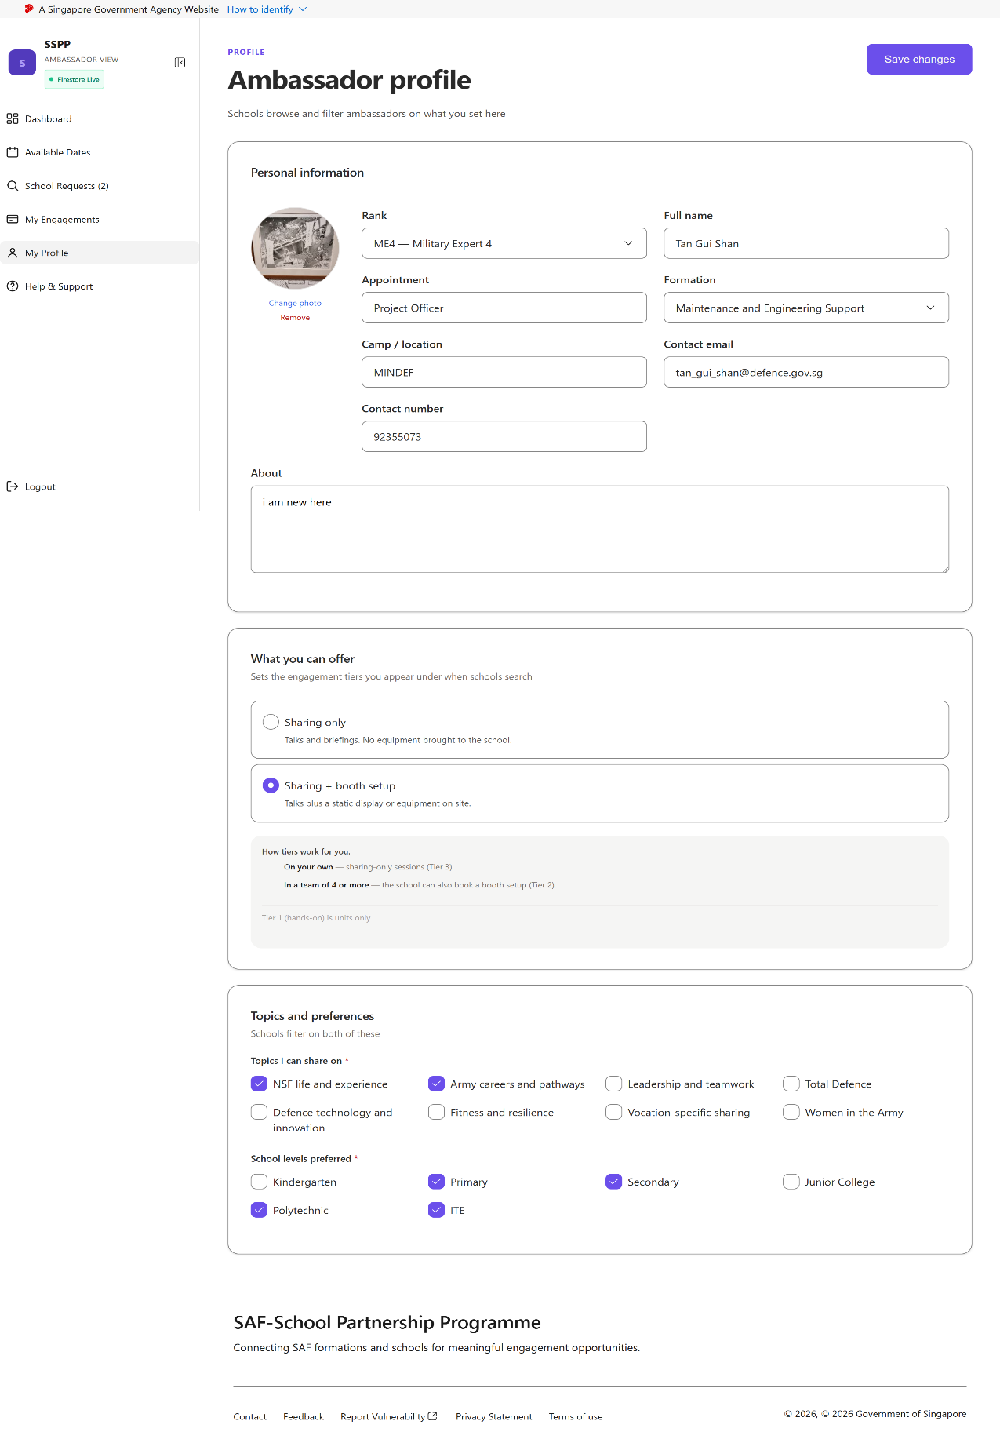
Army Ambassador Profile
Reached via “My Profile” in the Army Ambassador sidebar.
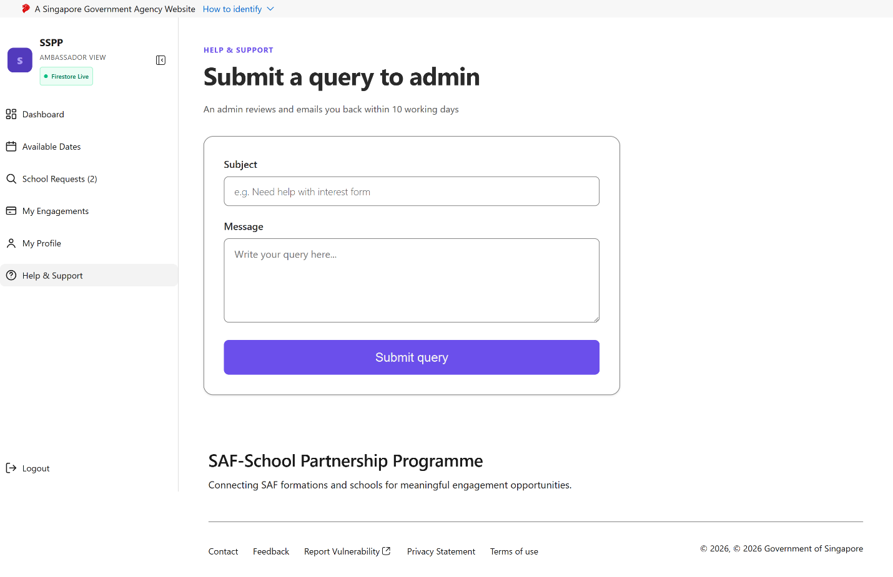
Army Ambassador Help & Support
Reached via “Help & Support” in the Army Ambassador sidebar.

6.3.5 Stakeholder Admin Views
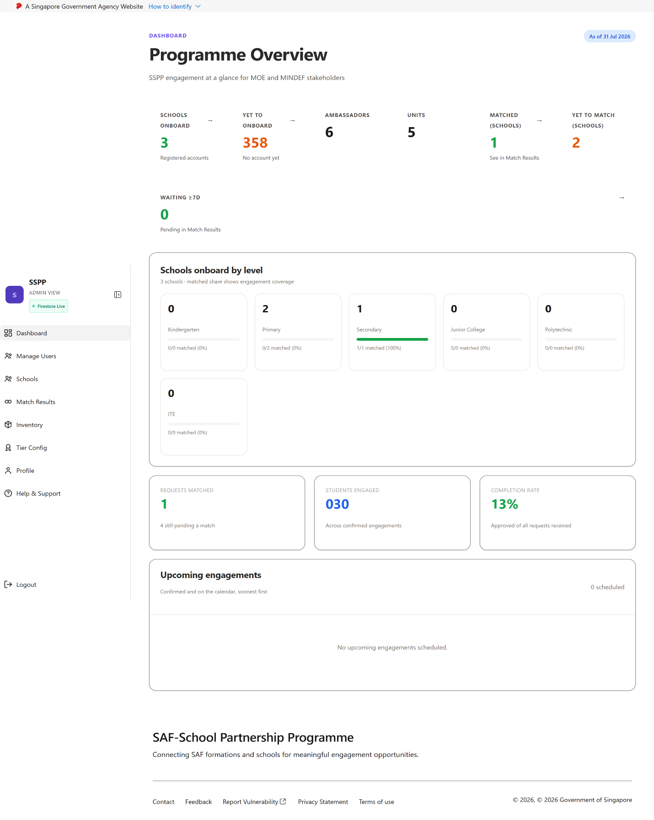
Stakeholder Admin Dashboard
Landing page immediately after a Stakeholder Admin account logs in.
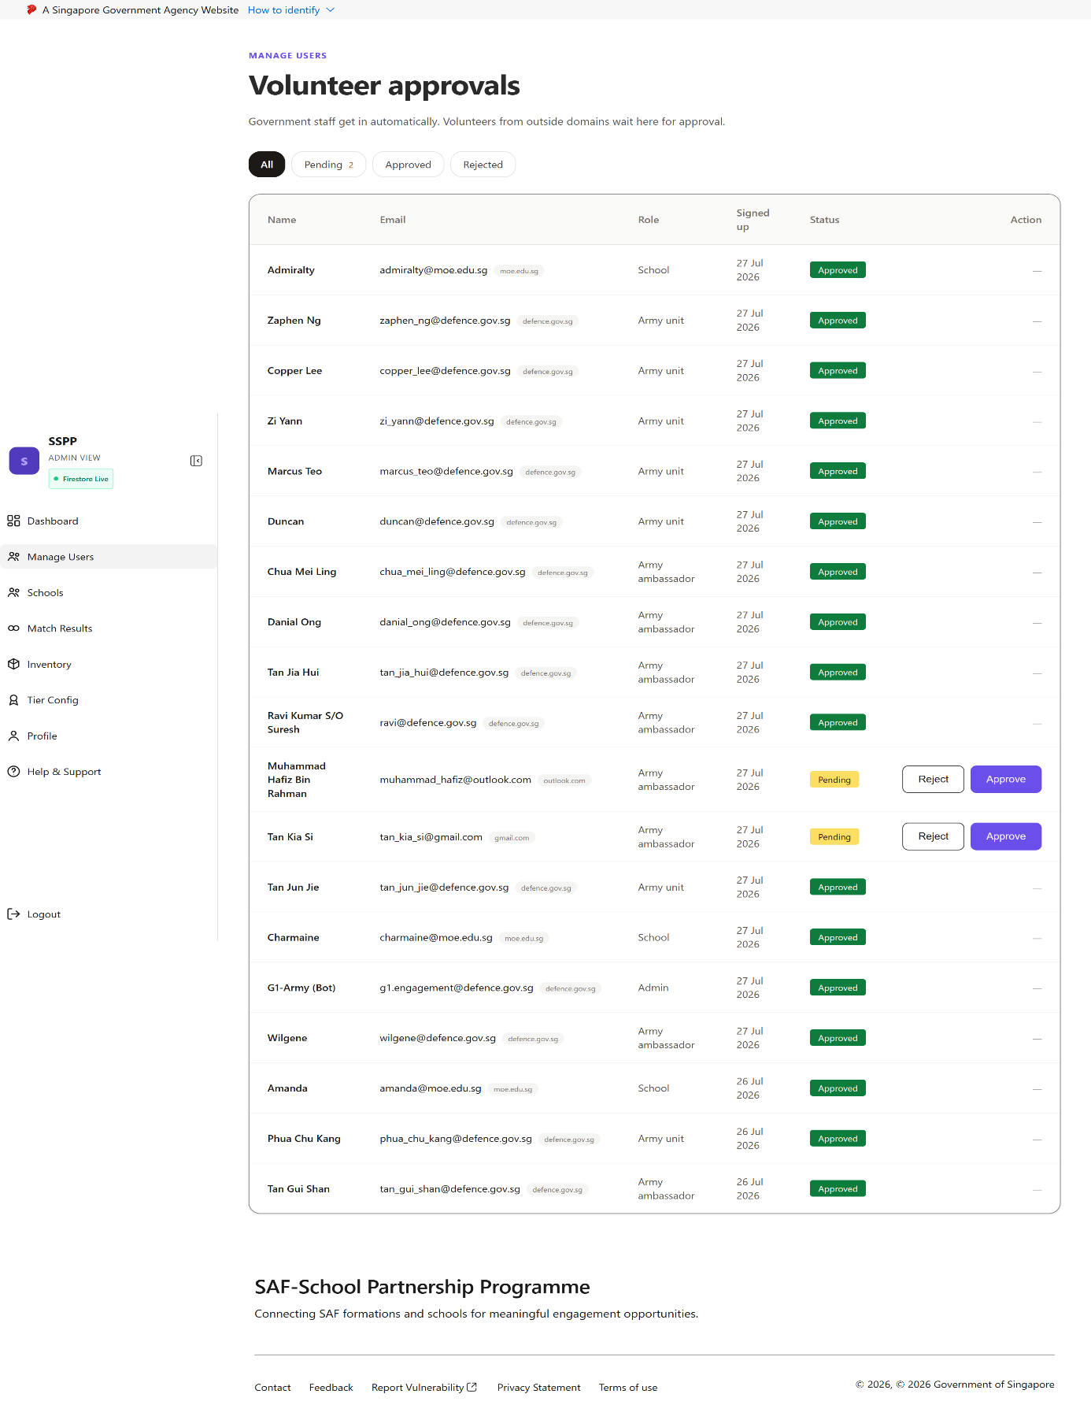
Manage Users – Volunteer Approvals
Reached via “Manage Users” in the Admin sidebar. If the volunteer/ambassador is using non-government email domain, then required admin to screen through.
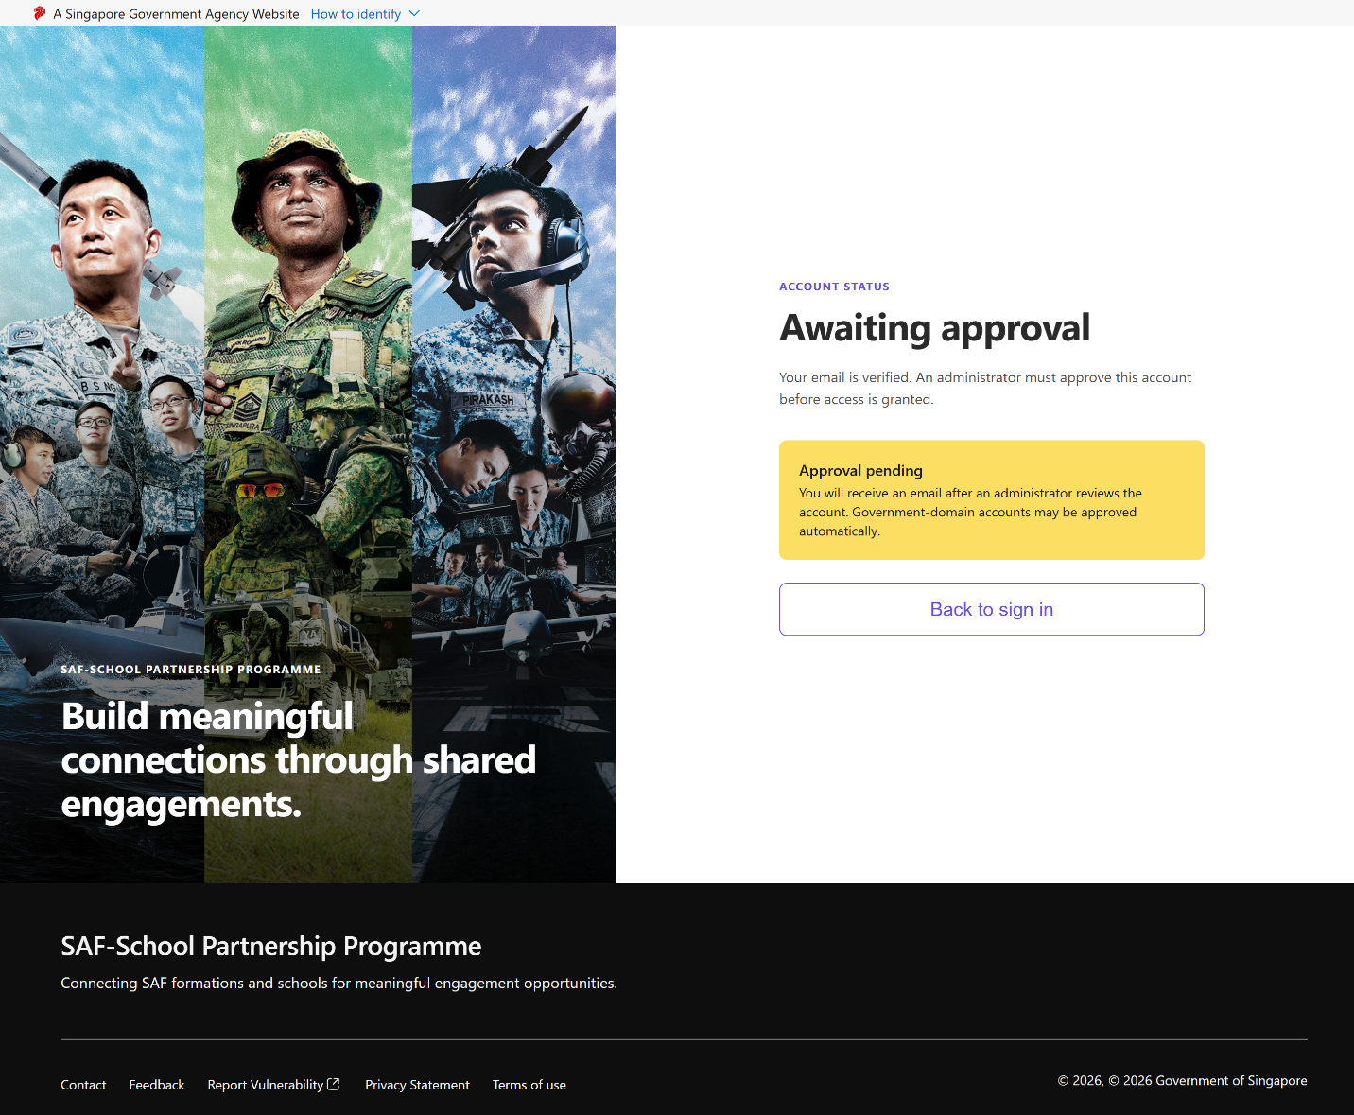
Login - Awaiting Approval
If the volunteer/ambassador is using non-government email domain, then required admin to screen through.
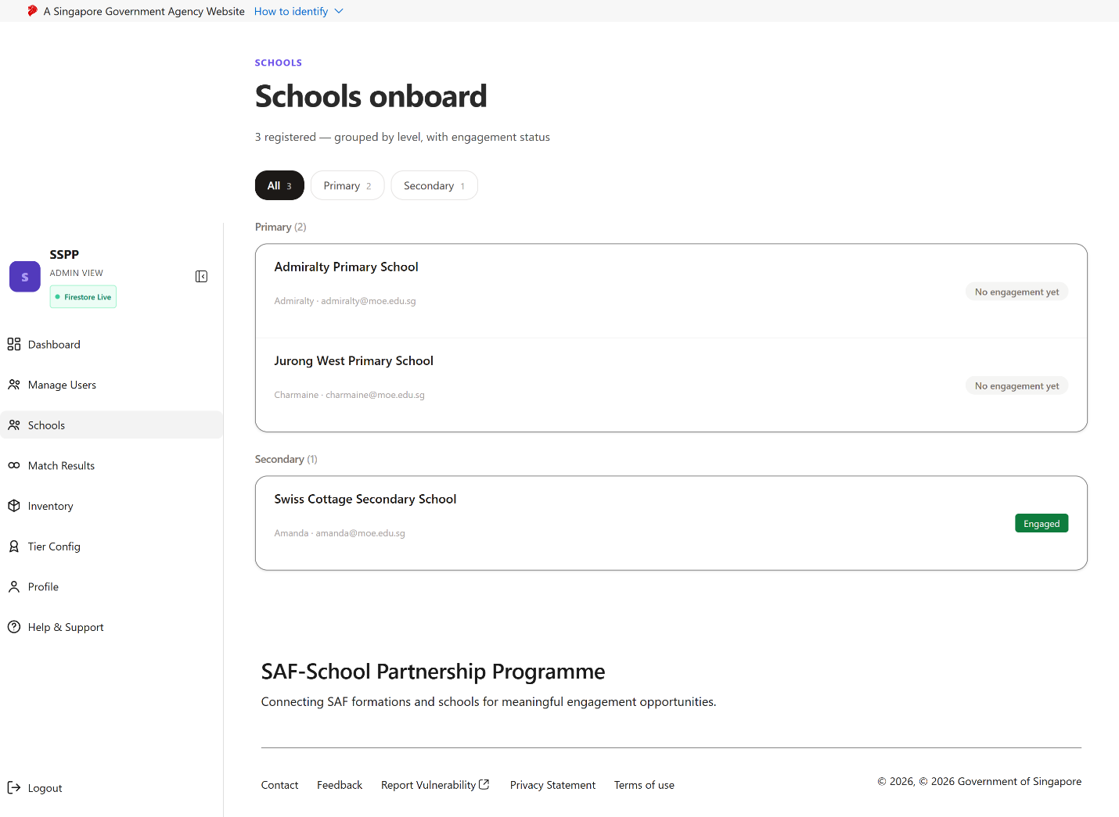
Schools Overview
Reached via “Schools” in the Admin sidebar.
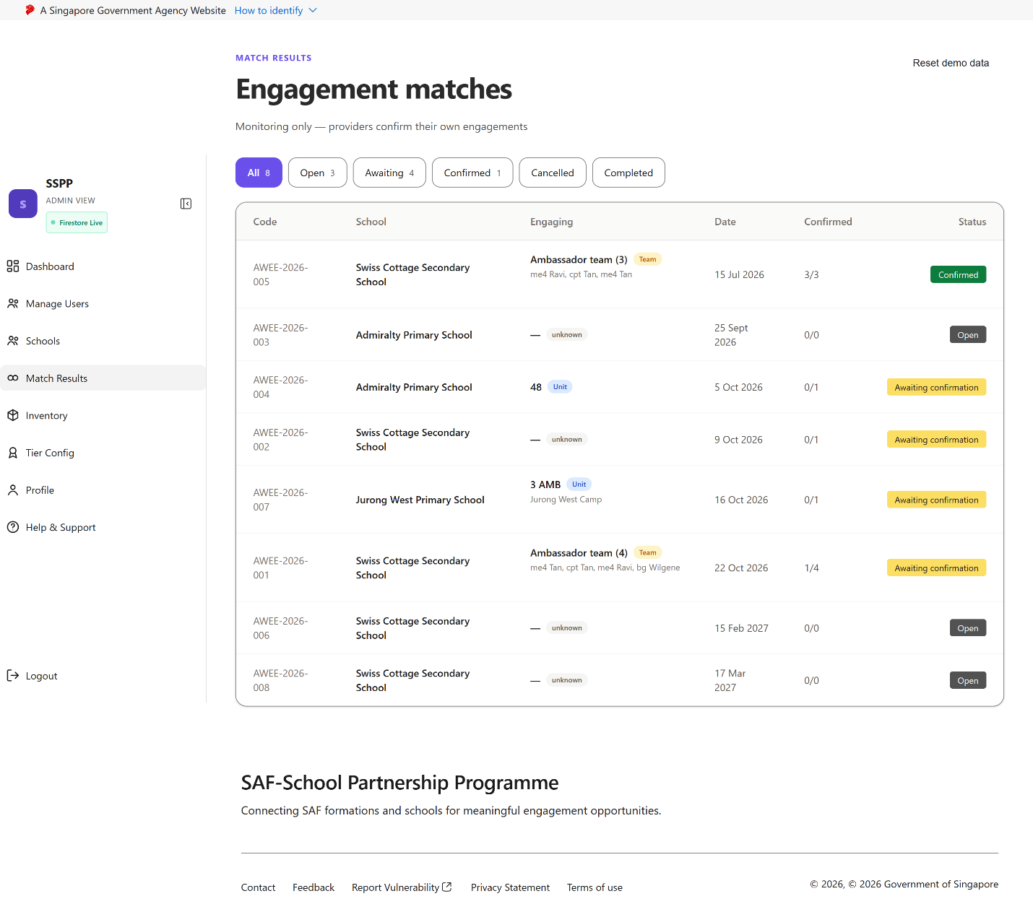
Match Results
Reached via “Match Results” in the Admin sidebar.
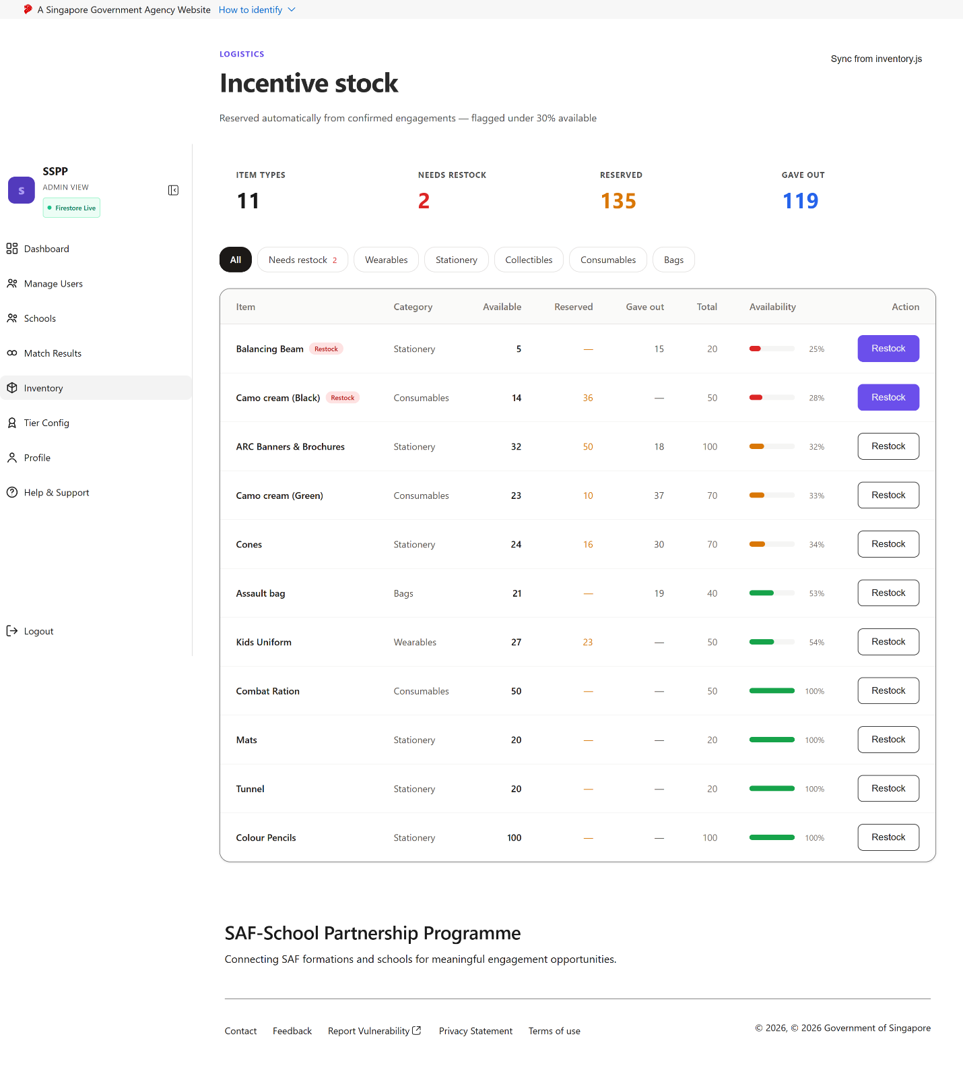
Inventory / Stock Monitoring
Reached via “Inventory” in the Admin sidebar.
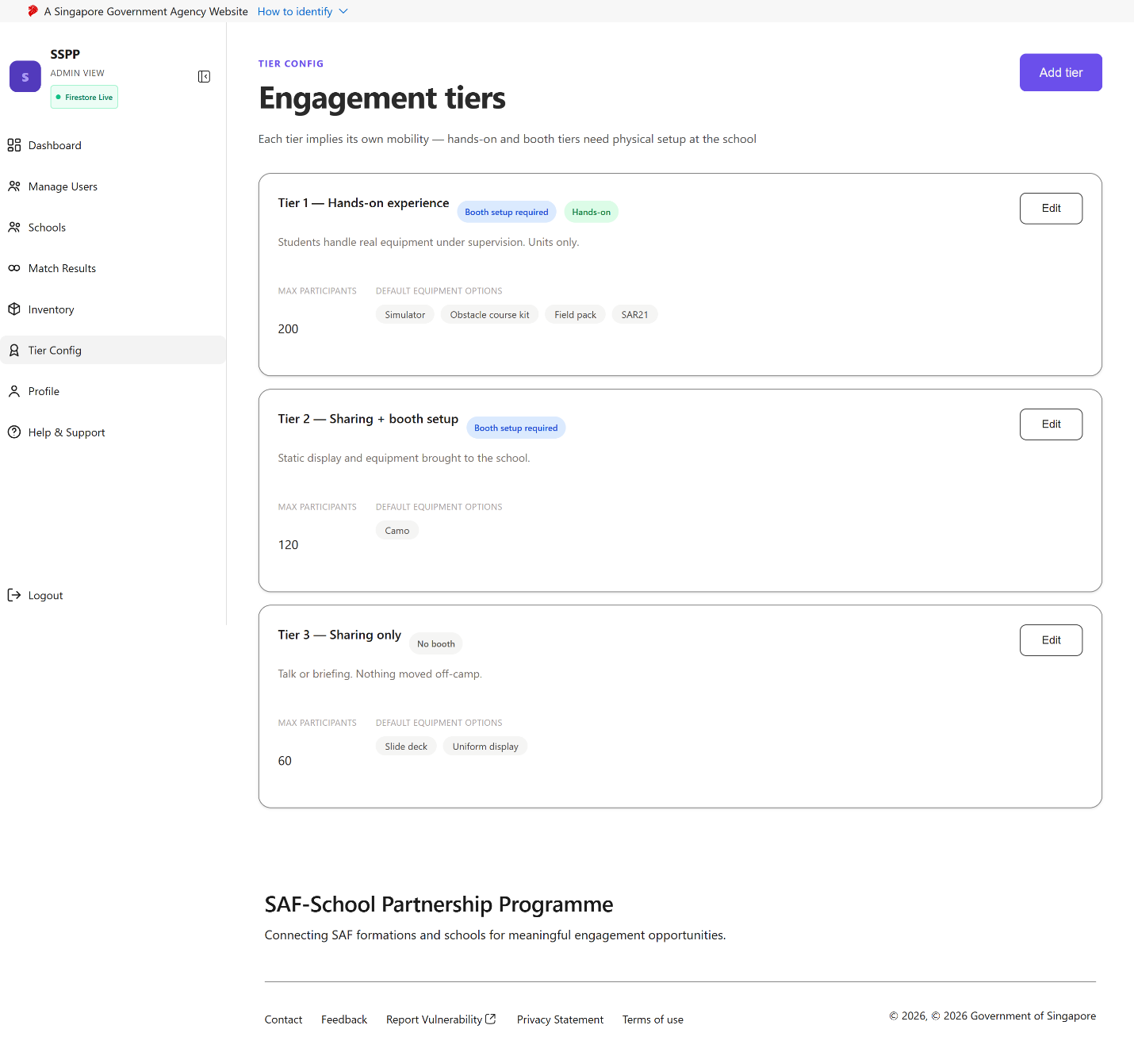
Tier Configuration
Reached via “Tier Config” in the Admin sidebar.
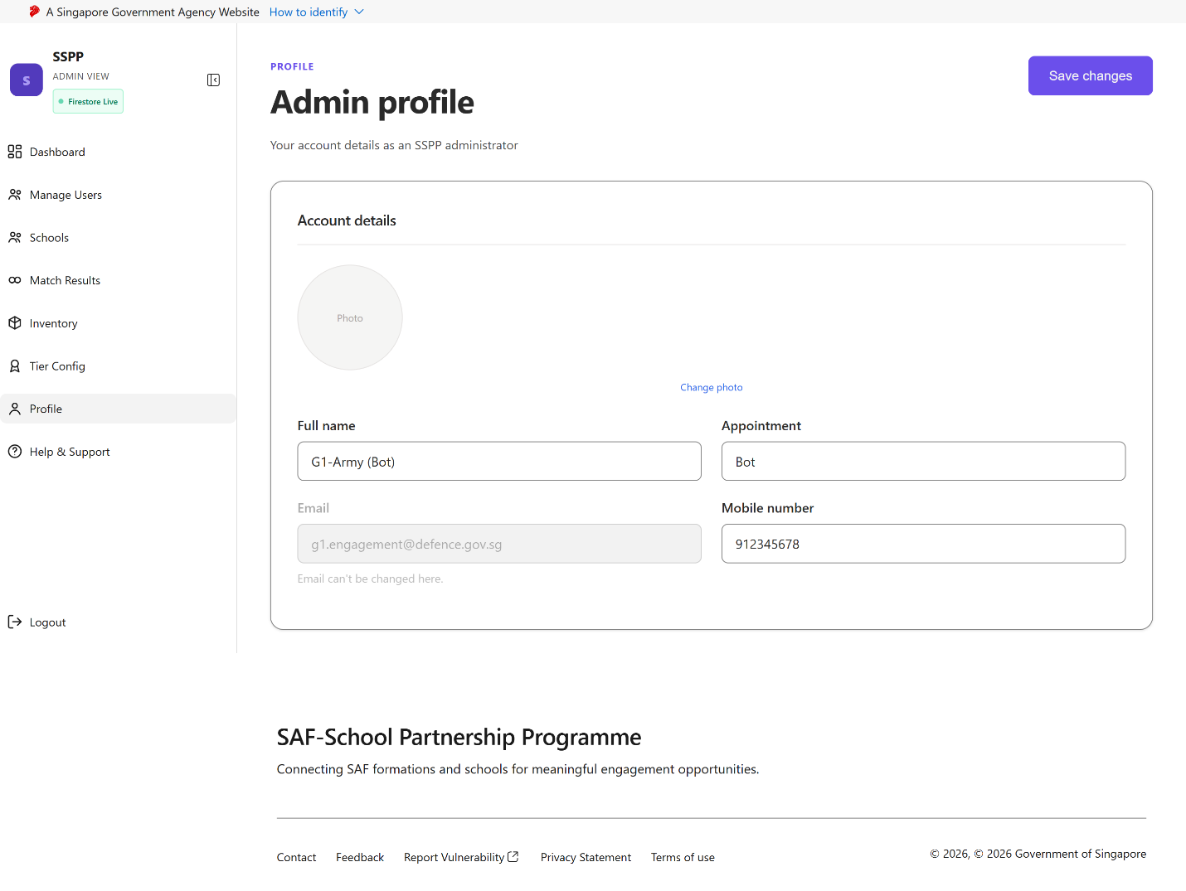
Admin Profile
Reached via “Profile” in the Admin sidebar.
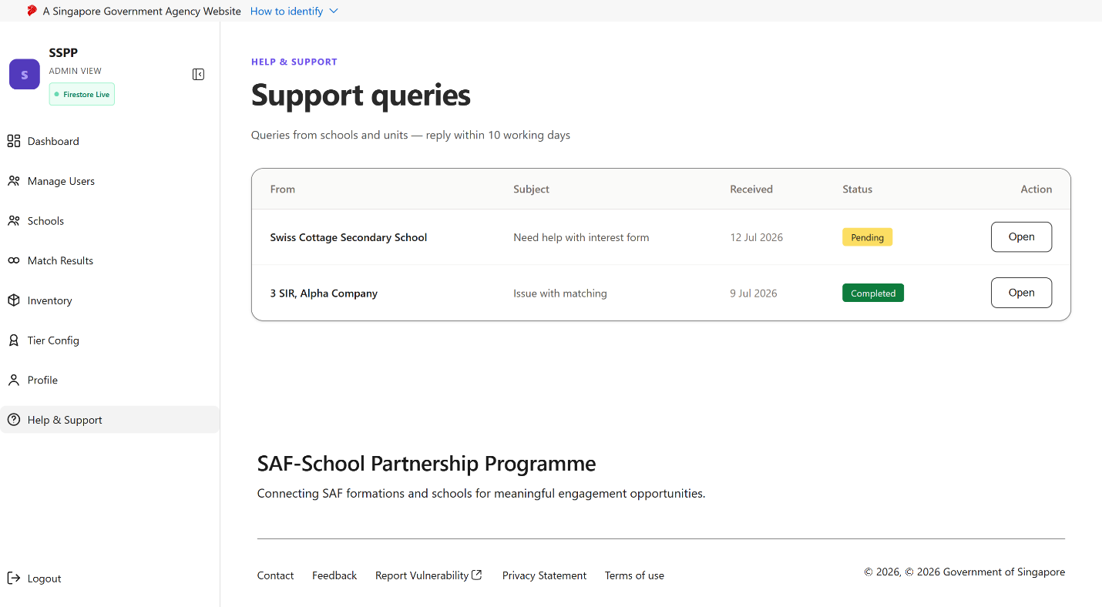
Admin Help & Support
Reached via “Help & Support” in the Admin sidebar.

6.4 Class Diagram
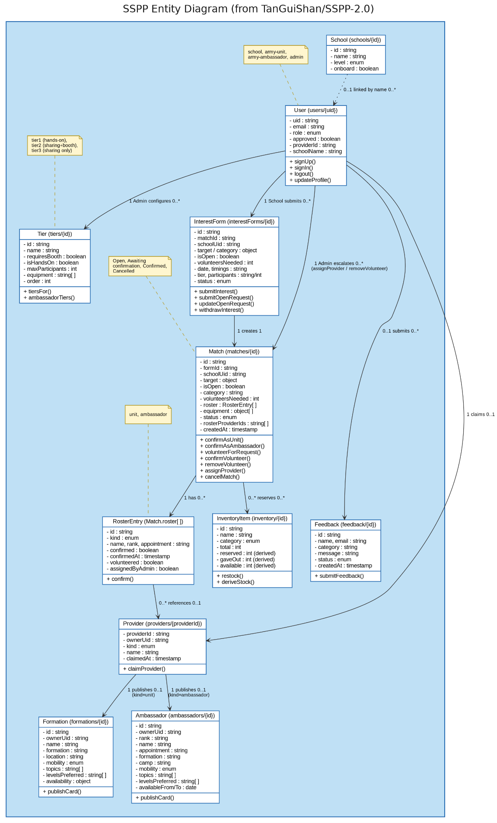

6.5 Dialog Map
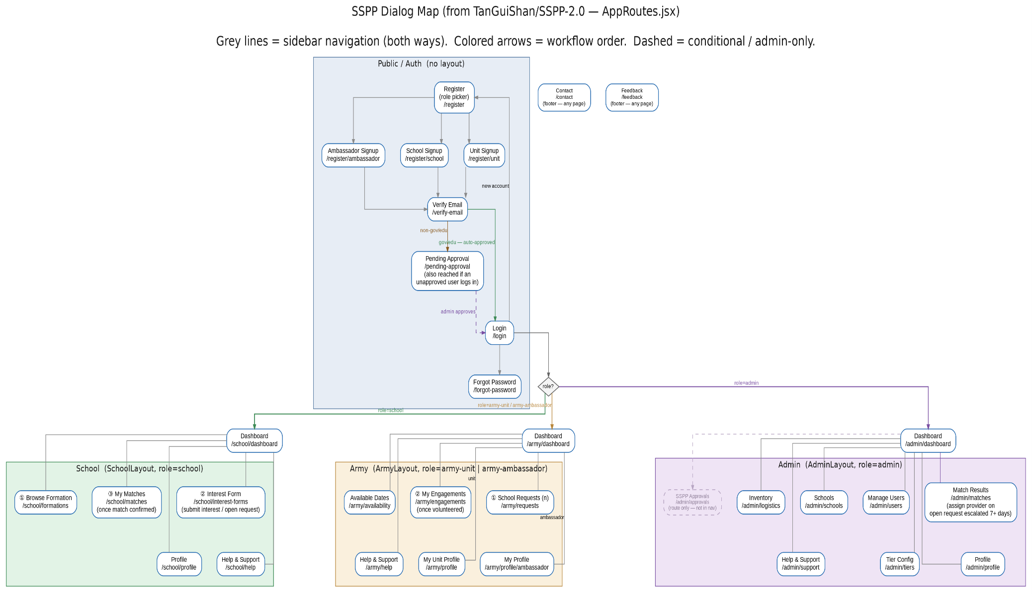

6.6 Key Boundary and Control Classes
- Boundary: SignupUI, LoginUI, BrowseUI, TeamFormingUI (sticky team bar), EngagementDetailUI, EngagementRoster, AdminDashboardUI, UserManagementPage, InventoryMonitoringUI.
- Control: AuthController (domain-tier routing, volunteer gating), MatchingController (tier eligibility, Rule B computation), ConfirmationController (two-sided confirm, no-decline enforcement for Providers), RosterController (per-member confirmation), InventoryController (deriveStockFromMatches), AdminController (coverage aggregation, stale-school flagging, volunteer approval).
- Entity: Account, Engagement, Team, RosterEntry, StockItem, StockReservation, School, CoverageSummary.

6.7 System Architecture
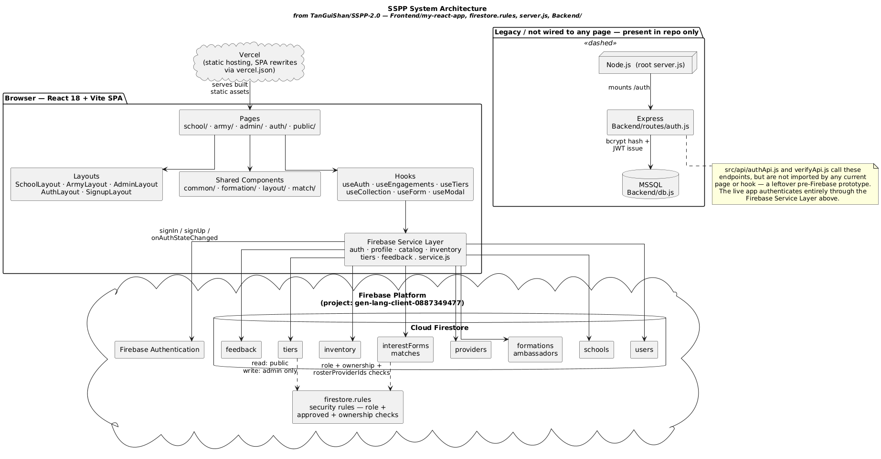

6.8 Sequence Diagrams
Representative sequences maintained alongside this SRS include:

6.8.1 Registration
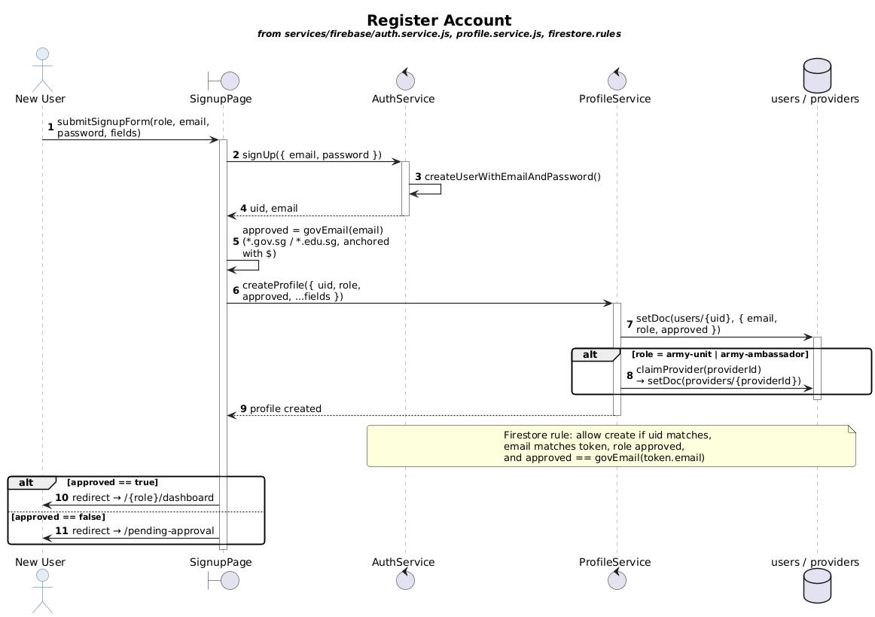

6.8.2 Login
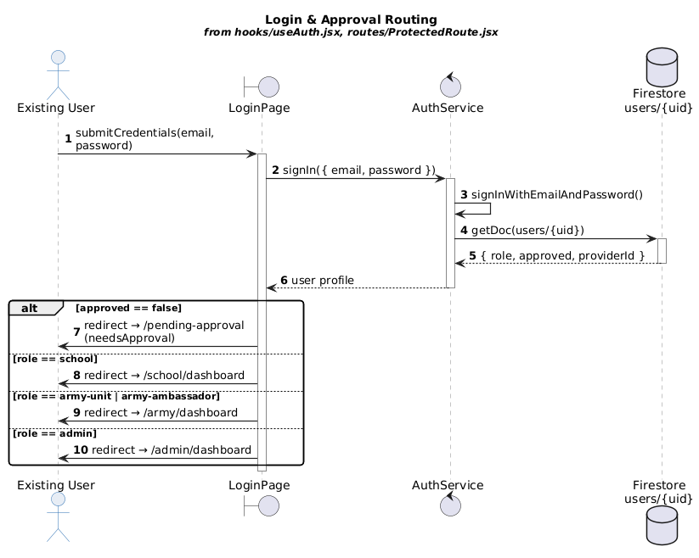

6.8.3 Submit Interest Form
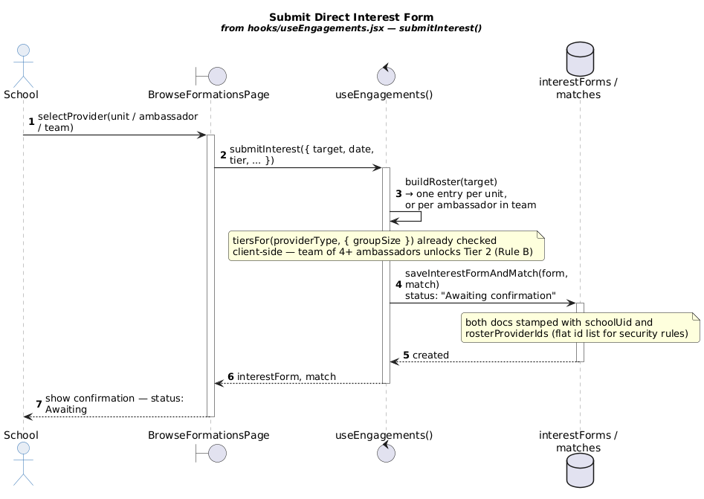

6.8.4 Confirm Unit
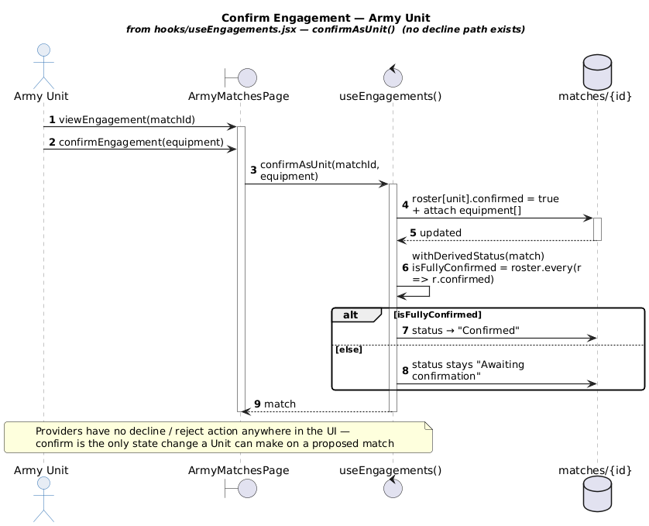

6.8.5 Confirm Ambassador Team
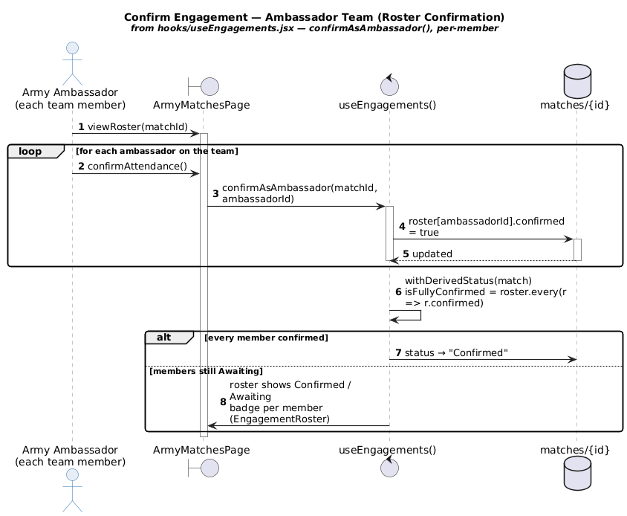

6.8.6 Submit Open Request
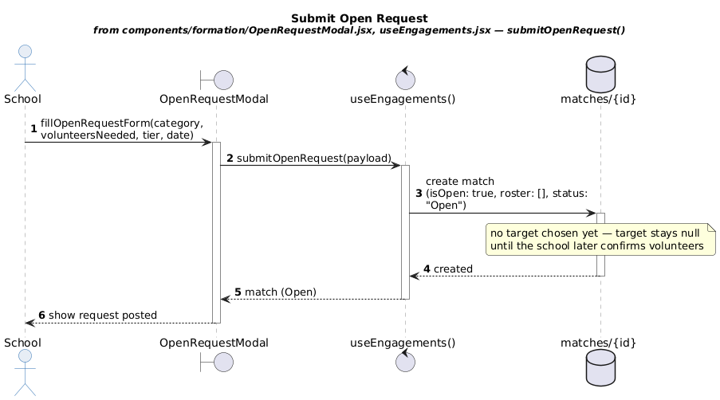

6.8.9 Volunteer for Request
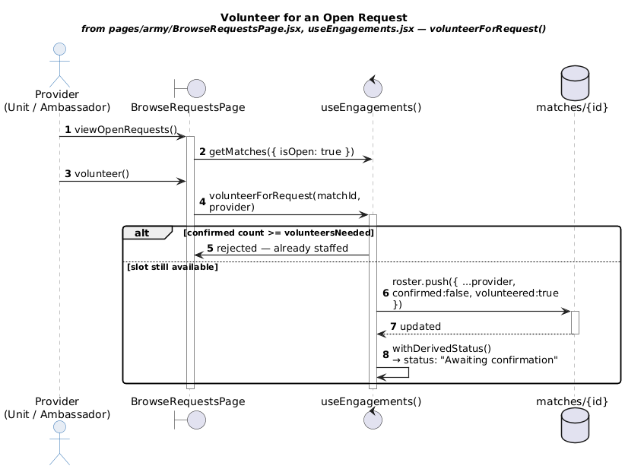

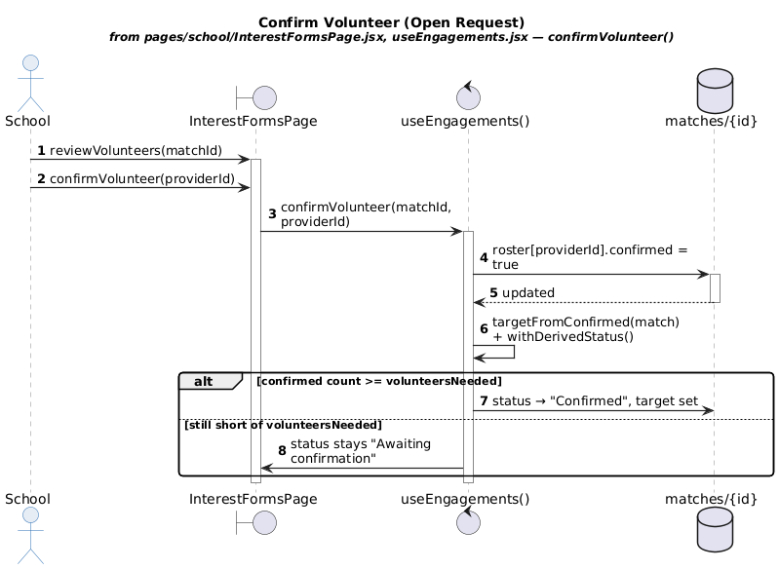
6.8.10 Confirm Volunteer

6.8.11 Withdraw Volunteer
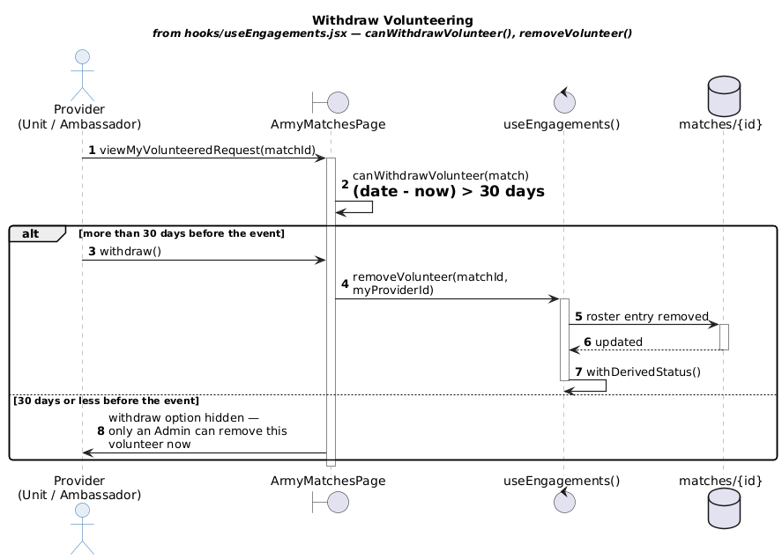

6.8.12 Admin Escalation
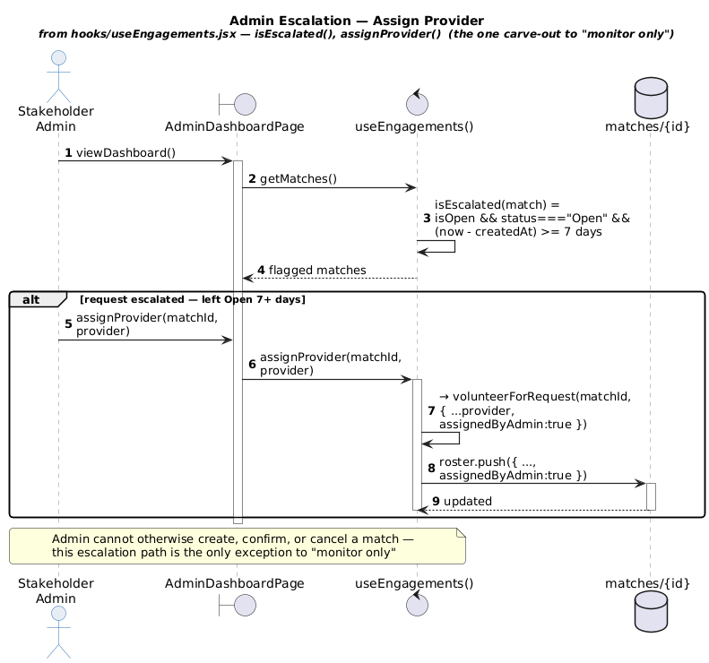

Appendix C: Unique Feature Logic

6.9 Tier Eligibility and Rule B Computation
The logic for determining the tier(s) available to a given provider or ambassador team is as follows:
- 1. If the provider is an Army Unit, it is eligible for Tier 1, Tier 2, and Tier 3, independent of any team-size consideration.
- 2. If the provider is a single Army Ambassador (team size n = 1), the ambassador is eligible only for Tier 3.
- 3. If the provider is an Army Ambassador team with team size n, the system evaluates Rule B: the team is Tier 2-eligible (in addition to Tier 3) if and only if n ≥ 4.
- 4. Regardless of n, an Army Ambassador team is never eligible for Tier 1; hands-on engagements remain exclusively an Army Unit capability.
- 5. Rule B eligibility is evaluated at the team level: once n ≥ 4 is satisfied, no additional per-member mobility, availability, or capability check gates the Tier 2 unlock for that team.
- 6. Rule B eligibility is re-evaluated live as members are added to or removed from the forming team via the multi-select interface, and the sticky team bar reflects the current eligibility state (Tier 3 only, or Tier 2 unlocked) at all times prior to submission.
Formally, letting n denote the number of members in an ambassador team and E(t) denote the set of tiers eligible for tier t ∈ {1,2,3}:
- For an Army Unit: E = {1, 2, 3}.
- For an Army Ambassador team of size n: E = {3} if n < 4, and E = {2, 3} if n ≥ 4.
This two-branch rule (E depends only on provider type and, for ambassador teams, the single threshold n ≥ 4) is intentionally simple by design: it must be explainable to School coordinators and SAF personnel without reference to individual member attributes, since Rule B is specifically defined to look past individual mobility constraints once the team is large enough to jointly staff a booth.

6.10 Two-Sided Confirmation State Machine

6.10.1 Match Status
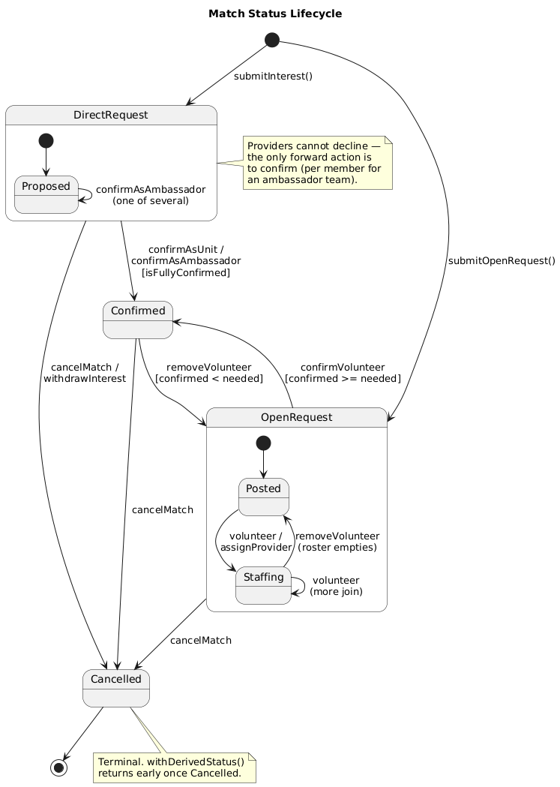

6.10.2 Account Approval

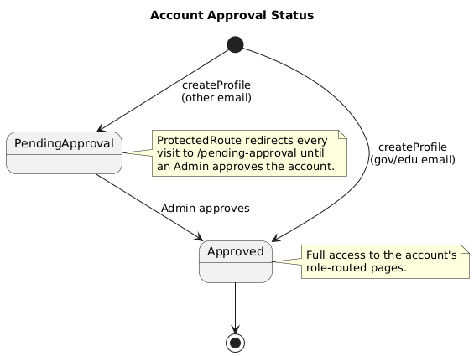
6.10.3 Roster Entry
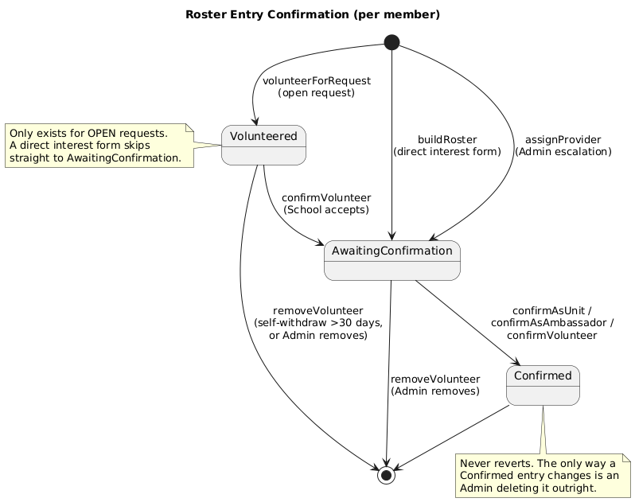

6.11 Roster Confirmation Aggregation
For a team of size n assigned to a Confirmed engagement, the system maintains n RosterEntry records, each independently toggled to Confirmed by its corresponding ambassador. The roster is considered fully confirmed when all n entries are Confirmed; the EngagementRoster view displays each entry's badge individually rather than only an aggregate, so that the School and Organiser can identify exactly which members remain Awaiting.

