Team Name: Rasp-bear-y Pi

Technology: Quest 2 Built-in Headset Tracking

|  |  |
| --- | --- |
| Name | Anticipated Role |
| Ladarius Course | Developer/World Building |
| Tanner Hess | Developer/Tech Support |
| Collin Newton | Developer/Narrative |
| Brayden Ball | Developer/Coding |

Environment Title: Bear Training Facility

The idea is to use some interesting assets in new interactive ways. Using motion tracking we will have attempt to have a bear respond to hand movements and objects within the environment. Maybe the bear will do what you want or the action of giving it food will make the bear do more. Who wouldn’t want to interact with a bear without being near one in VR?

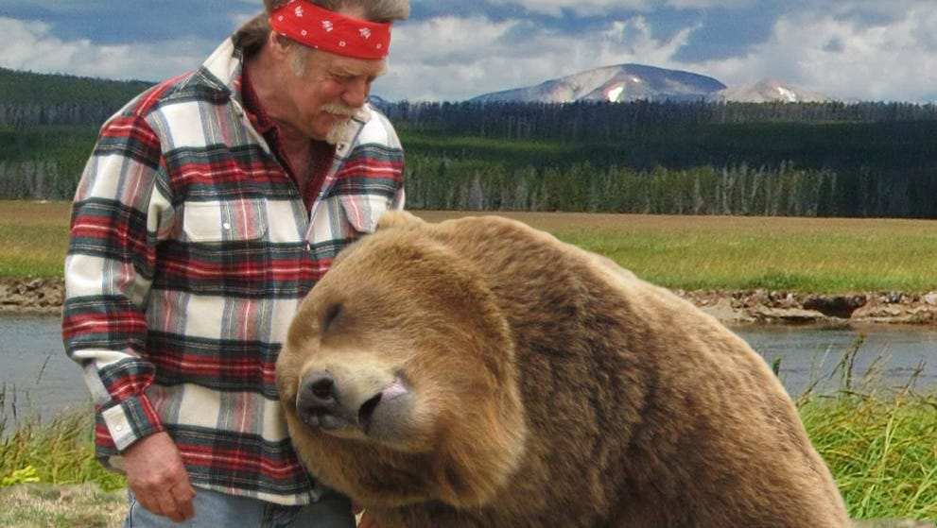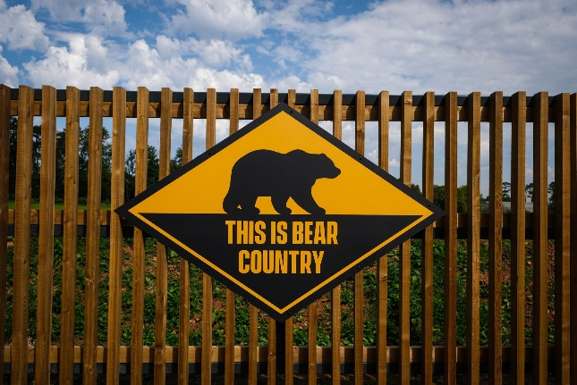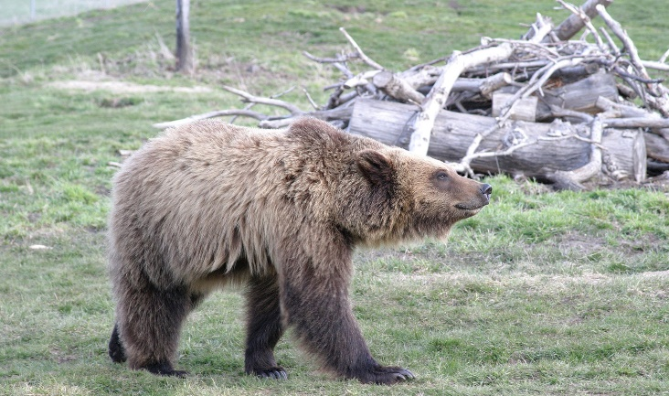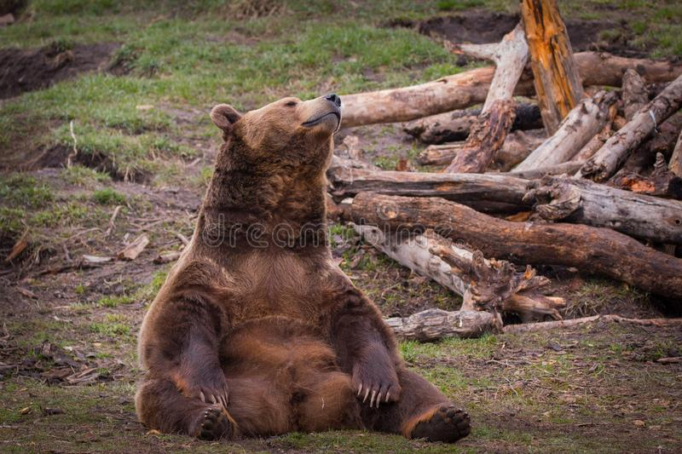

Narrative: One day while exploring the grand forest, you stumble upon an incredible creature. It a beautiful bear. None like you have ever seen. Luckily you know what to do. You’re experienced in this field. Getting to know and interact with a bear is nothing new to you! Use your knowledge (and maybe your handy notes) to tame this wonderful beast. There is nothing to be afraid of. You are an expert!