MINISTRY OF EDUCATION AND TRAINING
UNIVERSITY OF ECONOMICS HO CHI MINH CITY

FINAL REPORT

SCIENTIFIC RESEARCH PROJECT PARTICIPATING IN THE
“SEOUL SMART CITY PRIZE 2025

RESEARCH, DESIGN, AND DEVELOPMENT OF AN AUTOMATED MONITORING SYSTEM FOR EDIBLE- NEST SWIFTLET HOUSES

Project Category:
Tech-InnovaCity

Ho Chi Minh City, Viet Nam, May 2025
TOPIC SUMMARY
In the world today, the swiftlet farming industry still faces many challenges in monitoring and managing swiftlets, especially checking the condition of nests, the environment and the health of birds. In order to shorten the gap between the manual management process and the application of technology, the team has researched and developed an automatic swiftlet robot monitoring system.
This product integrates advanced technologies such as sensors, artificial intelligence, and automated robots, helping to monitor the condition of the bird's nest accurately and effectively. The bird's nest robot will automatically move in the bird's nest house, collect data, analyze and send information about the bird's condition to the manager via a mobile application.
This project is expected to bring great changes to the bird's nest farming industry, reduce the dependence on manual labor and improve productivity and efficiency in the management of bird's nest houses. At the same time, it will create opportunities for the swiftlet farming industry to develop in a modern and sustainable direction, contributing to solving difficulties in the process of caring for and monitoring swiftlets.

TABLE OF CONTENTS
Chapter 1: Overview 1
1.1. Introduction 1
1.2. Introduction to Manual Monitoring and Harvesting Methods for Bird’s Nest 5
1.3. Objectives of the Project 6
1.4. Relevant Domestic and International Research on Swiftlet Nest Monitoring and Harvesting 7
1.5. Proposal for Automated Monitoring Using Robots 9
Chapter 2: Methodology and Design Foundation for the Robot Surveillance System 10
2.1. Biological Life of Swiftlets 10
2.2. The structure of the swiftlet nest 11
2.3. Construction of Swiftlet Nests 12
2.4. Specific Methods of Monitoring and Assessing Swiftlet Nests by Harvesters 13
2.5. Specific Monitoring Methods and Swiftlet Nest Evaluation by Robots 14
2.6. Characteristics of Swiftlet Nests 15
2.7. Characteristics of Swiftlet Nests when harvested vs. not harvested 16
2.8. Structural Design of Swiftlet Houses 17
2.8.1. Building shape and Wall construction 17
2.8.2. Room shape and Structure 18
2.8.3. Swiftlet house surroundings 19
2.9. Interior Space of a Swiftlet House 19
2.10. Nest Construction by Swiftlets on Mounting Frames 20
2.11. Floor Structure of a Swiftlet House 21
2.12. Structure of the Wooden Frame 22
2.13. Operational Space for Surveillance 22
2.14. Conclusion 23
Chapter 3: Hardware System Design of the Surveillance Robot 25
3.1. Chapter Introduction 25
3.2. Idea Matrix and Design Proposals including Degrees of Freedom (DOF) 25
3.3. Robot Base Design 25
3.4. Design of Camera Arm 29
3.5. Design of Automatic Charging System 30
3.5.1. Structure of the Proposed Autonomous Robot and Charging Station 31
Chapter 4: Kinematic and Dynamic Analysis of the Robot System 34
4.1. Chapter Introduction 34
4.2. Structure of Links and Joints 39
4.2.1. Belt Transmission Calculation 39
4.3. Kinematics of the Robot System 39
4.4. Dynamics of the Robot Base 41
4.4.1. Forward Kinematics Calculation for the Robot Base 41
4.4.2. Inverse Kinematics Calculation for the Robot Base 43
4.4.3. Dynamics of the Robot Base 44
4.5. Dynamics of the Camera Arm 46
4.6. Chapter Conclusion 47
Chapter 5: Design of the Electrical Control System for the Robot 48
5.1. Chapter Introduction 48
5.2. General Design of the Electrical Control System 48
5.3. Robot pedestal control system 49
5.3.1. Overview 49
5.3.2. Positioning method 53
5.4. Camera arm control system 55
5.5. Automatic battery charging system 55
5.6. Power source on the robot and charging 56
5.7. Chapter Conclusion 57
Chapter 6: Group identification, positioning and identification 59
6.1. Chapter Introduction 59
6.2. Theoretical basis of identity 59
6.3. Application of PointNet++ model in bird's nest identification 63
6.4. Data sets, identification models, results 64
6.5. Theoretical basis of positioning with pointcloud data (Pointcloud) 66
6.5.1. Geometry of camera measurements 66
6.6. Introduction of Intel RealSense D415 Camera Depth Calculation Technology 67
6.6.1. Geometric Model of Intel D415 Depth Camera 68
6.6.2 Configuration and Specifications of the D415 69
6.6.3. Point Coordinates 72
6.7. Reconstruction Application in Localization with Landmarks 73
6.8. Point Cloud and Localization 74
6.8.1. Localization Results in Spatial Structure 74
6.8.2. Segmentation and Recognition after Deep Learning 74
6.8.3. Evaluation of Localization and Reconstruction Capability 75
6.9. Theoretical Foundation of Historical-Based Identification and Blockchain Technology 75
6.10. Labeling and Data Storage 76
6.10.1. Overview 76
6.10.2. Labeling Process for Swiftlet Nest Data from Point Clouds 76
6.10.3. Data Storage and Identification via Blockchain 77
6.10.4. Challenges and Solutions 77
6.10.5. Applications and Potential 77
6.11. Decision-Making and Results 77
6.11.1. Decision-Making Process 78
Chapter 7: Results and Experimental Evaluation 80
7.1. Base Design Results 80
7.2. Camera Design Results 83
7.3. Mobile Base Design Results 83
7.4. Charging Base Design Results 83
Chapter 8: Conclusion and Future Development 85

LIST OF TABLES
Table 5.1 Battery characteristics 52
Table 5.2 Total capacity of the robot system 57
Table 1.1 Advantages and Disadvantages of the Motion System Design Matrix for Camera Movement. 89
Table 1.2 Design Concepts 91

LIST OF FIGURES

Figure 1.1 Raw and cleaned edible bird’s nests 2
Figure 1.2 Automated robot monitoring system 9
Figure 2.1 External shape of nest in captive swiftlet farming 11
Figure 2.2 Swiftlet nest when not harvested. 17
Figure 2.3 Swiftlet house in Vietnam and Indonesia 18
Figure 2.4 Swiftlet house surrounding 19
Figure 2.5 Wooden framework of swiftlet house 20
Figure 2.6 Nest construction by swiftlets on mounting frames 21
Figure 2.7 Floor structure of a swiftlet house 21
Figure 2.8 Wooden framework installed in 30x100 cm configuration 22
Figure 3.1 The robot base comprises: 1: Main body of the camera system; 2: Upper body support frame; 3: Wheel; 4: Battery (12V); 5: Wheel; 6: Caster wheel; 7: Mounting platform of the robot. 28
Figure 3.2 Drive system diagram 29
Figure 3.3 Force distribution diagram on the driving wheel 29
Figure 3.4 Diagram of the rotary to linear motion transmission system 30
Figure 3.5 Block diagram of the autonomous mobile robot 30
Figure 3.6 Block diagram of the charging station 31
Figure 3.7 Circuit Diagram of the Robot 32
Figure 3.8 Circuit Diagram of the Docking Station 32
Figure 3.9 Infrared Transmitter and Docking Station 33
Figure 4.1 Wheel configuration of the robot 34
Figure 4.2 Differential-drive robot model 35
Figure 4.3 Locations of components in the robot kinematic model 36
Figure 4.4 Motion of a differential-drive wheel system 37
Figure 4.5 Dynamics of wheeled mobile robots. 38
Figure 4.6 Ideal rolling wheel 39
Figure 4.7 Differential drive kinematics 41
Figure 4.8 Inverse kinematics geometry 43
Figure 4.9 Dynamics of the wheeled mobile robot 45
Figure 5.1 Block diagram of the robot control system 48
Figure 5.2 Schematic diagram of the layered control structure of the robot 49
Figure 5.3 Service robot movement controller 50
Figure 5.4 Grid the consideration space 51
Figure 5.5 The robot's trajectory of movement avoids obstacles (simulation) 51
Figure 5.6 Structure of the robot 53
Figure 5.7 Robots move from one point to another 54
Figure 5.8 Automatic Charging System 56
Figure 6.1 Pictures of all types of nests. a) Nests when they are just formed, b) Nests when they have reached love, c) Nests with eggs, d) Nests with young birds 62
Figure 7.1 Result of the Shortest Pathfinding Algorithm 80
Figure 7.2 Position Response 82
Figure 7.3 Robot Rotation Angle Response 82
Figure 7.4 Camera Position 83
Figure 7.5 Mobile Base Design 83
Figure 7.6 Robot Moving in a Square Path 84

LIST OF ABBREVIATIONS
Abbreviation | Full term
DNA | Deoxyribonucleic acid
IMU | Inertial Measurement Unit
API | Application Programming Interface
IoT | Internet of Thing
AI | Artificial Intelligence
RFID | Radio Frequency Identification
DoF | Degrees Of Freedom
MLP | Multi-Layer Perceptron
IR | Infrared Ray
GPS | Global Positioning System

Chapter 1: Overview

1.1. Introduction
Edible bird’s nest is a precious type of food, formed from the saliva of swiftlets. The birds build their nests using secretions from their salivary glands while perching on surfaces such as natural caves or specially designed swiftlet houses. Once dried, the nest forms into fibrous strands and takes on a cup-like shape. Edible bird’s nest contains high levels of protein, essential amino acids, and trace minerals beneficial to health. Common components of bird’s nest include: approximately 50–60% protein; amino acids such as lysine, glycine, valine, and many others; minerals such as calcium, iron, potassium, and zinc; and threonine, which supports the formation of collagen and elastin, beneficial for the skin and digestive health. Today, in Vietnam and around the world, bird’s nest is considered a nutritious food with various benefits such as: enhancing health and immune system; improving digestion and nutrient absorption; boosting memory and concentration; improving skin condition and slowing the aging process; aiding recovery after illness.
Bird’s nest is divided into two types:
- Wild bird’s nest (island nest): formed on cliffs or in natural caves, which holds higher value.
- House bird’s nest: formed in swiftlet houses, more common due to stable rearing conditions.
Bird’s nest is often prepared into dishes such as bird’s nest soup, porridge, or rock sugar stewed nest drink to preserve its nutritional content. Swiftlets are wild birds that have not been domesticated and are accustomed to living in natural caves. Therefore, to attract swiftlets, one must first create a living environment similar to nature, so that the birds always feel familiar and are not disturbed by harmful effects. Thus, the height of each floor in a swiftlet house is typically at least 2.0 meters in colder regions. In addition, it is important to have ventilation shafts to ensure that the air inside the swiftlet house resembles that of natural cliff caves. The building should have at least two floors. A single-floor house is less likely to succeed because it is too low, which is inconvenient for the birds’ flight paths. Also, the temperature and humidity in such houses are difficult to adjust, making it unfavorable for the birds to choose a suitable nesting place.
The harvesting time is based on experience and popular analysis techniques among companies or households that raise swiftlets for nest harvesting, as this is the time when the nests are the cleanest—free from dust, feces, and feathers—ensuring hygiene. At this time, the value of the nest is also the highest because the post-harvest processing time is shorter as the nest is already clean. When the swiftlet discovers that the nest has been taken, it will immediately rebuild a new one. However, this method also has some disadvantages, such as the harvested nest being lighter because the amount of saliva produced by the bird is less. Moreover, the bird's health will be affected because it has to expend energy to build a new nest, especially for female birds preparing to lay eggs but lacking a nest to do so. The breeding season of the whole swiftlet flock is prolonged and scattered throughout the year. In Vietnam, the percentage of birds laying eggs, the number of nests with eggs, and chicks per total fluctuate between 30–77%. In May, the egg-laying rate reaches 60–65%, and in November, some swiftlet houses report egg-laying rates as high as 77%. On average, the number of nests with two chicks or two eggs is 60–69% in November and 79–88% in May.

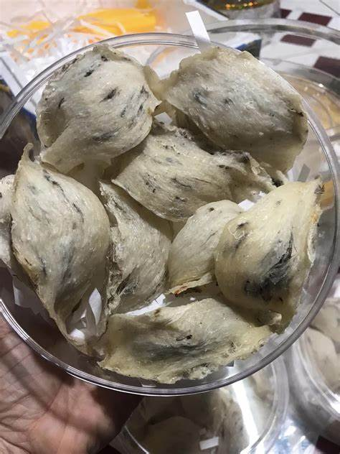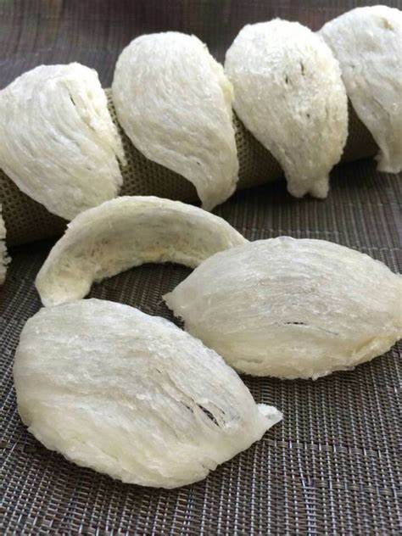
Figure 1.1 Raw and cleaned edible bird’s nests
Effective methods of harvesting bird’s nests indoors require delicacy and dexterity. Harvesters must move carefully between nest levels to avoid creating noise that could frighten the birds remaining inside the house. The harvesting process should be as swift and gentle as possible. The best and most accurate time to harvest bird’s nests is from 9:00 AM to 3:00 PM, when the birds are out foraging. It is important to avoid harvesting during the birds’ resting hours, as this could disturb their lives. The harvesting time is also the moment to inspect and remove harmful elements that may affect the birds. To prevent the nests from breaking, water should be sprayed around the nest area where it adheres to the wooden beam before removal. Then, a thin knife is used to scrape the nest off. The timing of nest collection and the distribution of cleaned nests must be carefully managed to avoid disturbing the birds and to allow them to rebuild their nests as before.
According to recent information from the Department of Livestock Production (Ministry of Agriculture and Rural Development), the swiftlet farming industry is developing rapidly in Southeast Asian countries, with Indonesia accounting for 60% of the production (150,000 bird houses). Four countries—Vietnam, the Philippines, Cambodia, and Myanmar—account for 13%. According to the Vietnam Farms and Agricultural Enterprises Association, Vietnam’s estimated annual bird’s nest (edible bird’s nest, or EBN) output is about 150–200 tons (Decision No. 1520/QĐ-TTg dated October 6, 2020, by the Prime Minister approved the Livestock Development Strategy for 2021–2030), with a vision toward 2045, aiming to increase EBN output to 200–250 tons by 2025 and 350–400 tons by 2030.
According to study [1], the number of swiftlet houses (swiftlet farms) in Vietnam has significantly increased in recent years. The Department of Livestock Production reports that 42 out of 63 provinces and cities are engaged in swiftlet farming, with more than 20,000 bird houses, driven by favorable natural conditions such as a long coastline, numerous islands, and diverse ecosystems.
In Vietnam, swiftlets (Aerodramus fuciphagus germani) naturally live and nest in cave habitats on islands. In recent years, subspecies of house swiftlets (Aerodramus fuciphagus amechanus, Aerodramus fuciphagus vestitus) have appeared, living and nesting in coastal buildings, with their flock sizes gradually increasing.
The size of a swiftlet house varies but typically ranges from 100 to 200 square meters with three to five stories. These houses mimic natural habitats such as coastal caves, allowing only small openings for birds to enter and exit. The air inside these spaces can become stale due to poor ventilation and the accumulation of bird droppings, which discourages nest collection. When harvesting EBN, harvesters often prioritize collecting nests over preserving eggs or chicks. The EBN harvesting industry relies heavily on manual labor to monitor and pluck nests from the walls. This method limits human interaction with the indoor environment to maintain its natural scent. As a result, access is only granted during specific seasons, and nest monitoring is restricted. Based on these challenges, we developed an indoor robotic system for monitoring and labeling EBN nests based on their development stage. This ensures product traceability and enhances their commercial value. Information about the structure of natural caves that artificial swiftlet houses try to replicate is provided in [2]. Notably, the nests are often found in dimly lit or completely dark conditions. Moreover, the droppings in these houses create a strong ammonia odor. These harsh conditions are unsuitable and unsafe for human labor, prompting the need for robotics. The issue of authentication is also discussed in the paper, including DNA analysis, proteomics, glycan profiling, and health screening. However, there is still no universal method for quality control, making the authentication process risky. In addition, [2] demonstrated that the economic incentives from EBN production can encourage policies and behaviors that promote sustainable use of natural resources (Figure 1). In [3], the author argues that combining odometry with an inertial measurement unit (IMU) via a Kalman filter can reduce localization errors; however, these errors are still not fully bounded. The study [3] adds that the IMU is typically fused with odometry data to mitigate non-systematic errors, while other navigation methods are integrated to reduce systematic errors by comparing the expected position from odometry with that of the navigation system.
Edible bird’s nests are highly nutritious, helping improve the human immune system and exhibiting anti-aging effects, making them one of the most beneficial health foods. Consequently, EBN production has become a major industry in Southeast Asia, with demand growing so rapidly that supply can hardly keep up.
However, the industry has faced several long-standing challenges such as EBN authenticity, quality assurance, and declining swiftlet populations. The Ministry of Agriculture and Rural Development encourages businesses to form partnerships and adopt new technologies to meet international market demands and enhance the economic value of EBN products.

1.2. Introduction to Manual Monitoring and Harvesting Methods for Bird’s Nest
The monitoring process in swiftlet houses today primarily uses fixed surveillance cameras installed in the breeding area to oversee the growth process, the number of birds, predators, and the swiftlet farming environment through the integration with IoT sensors. As the number of swiftlet houses increases, it becomes essential to monitor them to ensure the quality, quantity, and parameters of the farming environment. Manual monitoring of bird's nests is a complex task requiring a combination of biological knowledge, technology, and management. Many studies have shown that monitoring and managing swiftlet flocks face numerous difficulties due to the biological characteristics of the species and the farming environment. Firstly, biological characteristics pose challenges to monitoring. Swiftlets have complex migratory behavior. They tend to travel far to forage, with wide flight ranges and flexible ecological traits. Research indicates that swiftlets fly at different altitudes depending on the species and environment. For example, Collocalia esculenta often feeds near the ground or over open fields, while other species may fly higher above forest canopies. Their flight range can vary from a few kilometers to several tens of kilometers, depending on habitat and food sources. Secondly, swiftlets fly fast and at high speeds. Studies on swiftlet flight speed show they are capable of flying at very high speeds, especially during migration. A study on the common swift (Apus apus) found that it can reach an average speed of approximately 10.6 m/s (about 38.2 km/h) during migration, with the ability to travel up to 916 km/day if flying continuously for 24 hours. Their aerodynamic features, such as efficient wing design and high lift-to-drag ratio, allow them to move faster than many other bird species.Thirdly, research compiled in [5] also shows that swiftlets are small in size and have uniform coloration, which presents a challenge in identifying and tracking individual birds. Swiftlets in the genus Aerodramus usually have basic feather colors without prominent patterns, reducing the ability to visually identify them or use conventional monitoring devices. Studies on the behavior and biology of species such as Aerodramus vanikorensis have emphasized that this trait creates significant challenges in monitoring or conducting in-depth studies on swiftlet flocks. Fourthly, the swiftlet farming environment poses many limitations, such as poor and unstable lighting conditions, high humidity, fluctuating temperatures, and noise. Lighting inside swiftlet houses is usually weak and unstable, which affects the quality of images captured by surveillance cameras. This has been documented in several studies on swiftlet habitat environments. The humid and unstable temperatures inside the swiftlet houses can damage electronic devices and affect the performance of sensors. Noise from equipment and the calls of swiftlets also reduce the effectiveness of audio recording and analysis devices. Fifthly, limitations of current monitoring technology—such as low resolution, difficulty in data analysis, and high cost—make manual harvesting of bird's nests more difficult. Many existing camera types still do not have sufficient resolution to clearly identify individual swiftlets, especially when they are flying fast. Processing and analyzing the large volume of image and sound data collected from cameras and sensors requires complex algorithms and software. Modern surveillance devices are often expensive, limiting their widespread adoption among small-scale swiftlet farmers.

1.3. Objectives of the Project
The objective of this research is to design and develop a robot surveillance system for monitoring the artificial swiftlet nests based on information gathered from cameras and infrared sensors. The steps to achieve these objectives are as follows:
• Design and develop a robotic system that monitors and tracks the development of artificial swiftlet nests.
• Develop a robotic system capable of providing data for labeling, identification, and positioning to assist the supervisor at the center or for automatic assessment to monitor, make decisions, and take appropriate actions.
• The robot should be able to track and monitor on demand, detect unusual activities, and report to the monitoring center.
• Integrate with infrared and depth image processing systems to collect data on the swiftlet nests and the surrounding environment.
• Design and develop a robot surveillance system that operates independently from existing market equipment and masters the technology.
• Design and develop an automatic mobile robot capable of navigating uneven surfaces caused by swiftlet waste, with an obstacle-avoidance mechanism, and the ability to recharge through a docking station when the battery is low.

1.4. Relevant Domestic and International Research on Swiftlet Nest Monitoring and Harvesting
Currently, there are research studies in Vietnam and around the world mainly focusing on biological behavior, operational structure of swiftlet houses, and nest monitoring. A typical example is a study on the application of IoT and AI technologies for monitoring and controlling smart swiftlet houses [6], which uses temperature, humidity sensors, and power management systems with API (Application Programming Interface) support, as well as training a recognition model and estimating the number of swiftlets using ImageAI with YoloV3 architecture. The results of the application of smart swiftlet house monitoring and control help automatically identify and estimate the number of swiftlets in the house, detect predators and intruders, continuously monitor and control the environment within the swiftlet house, and provide recommendations for efficient nest harvesting.
Indonesia, home to the largest swiftlet population for edible bird nests (about 44 million out of 55 million swiftlets), according to statistics from 2020, is the world's largest producer of bird nests. The country has exported up to 1,312.5 tons of bird nest products with a value of 540.4 million USD. Therefore, research systems related to bird nests are subjects of strong interest and investment to increase productivity, output, and economic value for the country. The Food Safety Management System (FSMS) has been proposed to improve, control quality, production performance, and economic efficiency in the edible bird nest industry by collecting and analyzing related articles and data published from 1990 to 2023. It uses an evaluation method to monitor bird nest products in compliance with food safety regulations.
Furthermore, in the harvesting and processing of bird nests, a study also proposed an automated system using machine vision and industrial robots to improve the processing system for bird nests (turning a bird nest into a finished product). The system uses cameras to capture images of the nests and converts them into digital data for the computer to process through algorithms. The computer then analyzes and generates location data—information related to the geographic location of the object, device, or person at a specific time. Finally, robots will process the collected data and move according to the given locations, harvesting the bird nests as required while ensuring operational continuity. This system offers a significant advantage over traditional processes by reducing processing time and increasing efficiency.
Automation in monitoring and harvesting bird nests in swiftlet houses is an essential trend aimed at increasing productivity, reducing labor costs, and improving product quality.
- Improved management efficiency: The automated system helps quickly detect issues, ensuring 24/7 monitoring and immediate detection of factors such as temperature, humidity, light, or the presence of predators (rats, cockroaches). Additionally, it helps reduce errors, as the use of machines and sensors decreases the likelihood of mistakes compared to manual monitoring.
- Improved quality of bird nests by controlling the environment, maintaining ideal conditions (temperature from 27–29°C, humidity from 70–80%) to allow swiftlets to thrive and build nests optimally. Monitoring nests with cameras or sensors helps detect damaged or contaminated nests early.
- Time and labor savings through quick bird nest harvesting using robots and machines while avoiding quality degradation. Automation in monitoring helps cut down on manual labor costs, thereby increasing profits.
- Enhanced sustainability and competitiveness through data management and meeting market demands. Automated systems continuously store information, optimize processes, and increase productivity over time. High-quality bird nests from controlled environments will be more competitive in the market.
- Safety and health protection by minimizing risks and protecting the swiftlets. Automated monitoring prevents workers from directly handling bird droppings (which contain ammonia and harmful bacteria) and reduces disruptions to the swiftlet's living environment during monitoring and harvesting.
- Application of modern technology using IoT sensors, robotic systems, and mechanical arms. Monitoring and adjusting conditions in the swiftlet house remotely via smartphones or computers. The automated monitoring process will support accurate and rapid harvesting through AI camera monitoring of swiftlet activities and the detection of anomalies.
Automation not only improves the operational efficiency of the swiftlet farming industry but also ensures its sustainable development, meeting the increasing global demand for high-quality bird nests.

1.5. Proposal for Automated Monitoring Using Robots
Using a robotic system for monitoring introduces an advanced and efficient approach to data collection and analysis across various fields. Robots equipped with sensors, cameras, and advanced AI capabilities can be deployed to gather real-time information, provide valuable insights, and enhance decision-making processes. In the context of nest harvesting and management, robotic monitoring systems have the potential to revolutionize the way nests are observed and classified. Robots, equipped with a combination of cameras, sensors, and AI algorithms, can be assigned to continuously monitor nesting sites.
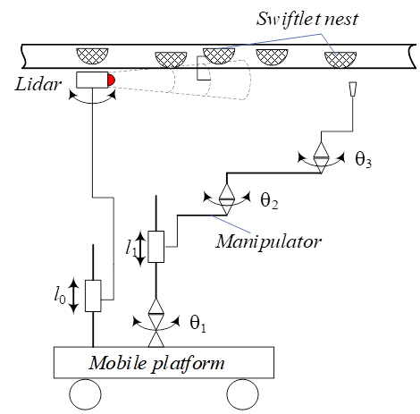

Figure 1.2 Automated robot monitoring system

Chapter 2: Methodology and Design Foundation for the Robot Surveillance System

2.1. Biological Life of Swiftlets
The Vietnamese swiftlet (Collocalia fuciphaga germani) is a small bird. Compared to other bird species, it can be distinguished by its short and small legs. The body weight of the Vietnamese swiftlet is approximately 13–17 grams in the South and 15–20 grams in the North. There is no significant difference in weight or body color between males and females. This species of bird prefers to live in flocks, builds nests in pairs separately, and is typically found near water (rivers, lakes, and seas), with lowland fields, and sparse forests. They rarely inhabit dense forests. The Vietnamese swiftlet is a high-flying bird that can fly for hours without resting, although it never flies above 1500 meters. According to studies conducted in Khánh Hòa, Vietnamese swiftlets can fly as far as Lam Dong and Phan Rang for food. Typically, the birds forage within a 25km radius from their caves or houses. An ideal feeding environment for swiftlets is an area where there is a continuous supply of food for them throughout the year. This is a region where swiftlets can catch flying insects from morning to evening. The ideal foraging area is composed of approximately 50% low vegetation (less than 1m tall), such as rice fields, wild grass, and bushes; 30% taller trees (over 5m), such as acacia (Leucaena glauca), shrubs, fruit orchards, and forests; and 20% open water areas. Observations show that swiftlets leave their nests around 5 a.m., and they return from foraging between 4:30 p.m. and 5:00 p.m., usually arriving at their nests by 6:00 p.m., although it may be later during some seasons. In the winter, they leave for food later and return earlier, while in the summer, they leave earlier and return later. During the breeding season, swiftlets forage close to their nesting sites and frequently make several trips to bring food back to their chicks. It wasn't until 1980 that the question of what Vietnamese swiftlets eat was answered. Their preferred food consists mainly of ants (50–70%), followed by termites, flies, mosquitoes, ladybugs, dragonflies, small bugs, moths, large wings, and grasshoppers. Swiftlets catch their food while flying at heights below 30 meters, according to the distribution of insects in the air. Being insectivores, swiftlets play an important role in controlling the population of insects that can damage crops. Swiftlets reach sexual maturity at 7–8 months of age, which is when they are ready to mate. The first time they build a nest, it takes 3 months, while subsequent nests take only 1 month (in the wild). Typically, in swiftlet houses, birds build their nests in about 30–32 days to form a nest large enough to lay eggs. After this, the birds rest for 8–11 days before laying the first egg, and 1–3 days later, they lay the second egg. The incubation period lasts 22–28 days. Both parents are involved in nest building and chick-rearing. Although swiftlets lay two eggs, in 70% of cases, only one egg hatches successfully, with the second chick often being pushed out, especially in smaller nests. After hatching, the chicks stay in the nest for 41–51 days before becoming strong enough to leave the nest. Seven months later, the swiftlets are ready to mate and reproduce again. One week after the chicks leave the nest, the parent pair can begin building a new nest and start a new breeding cycle.

2.2. The structure of the swiftlet nest
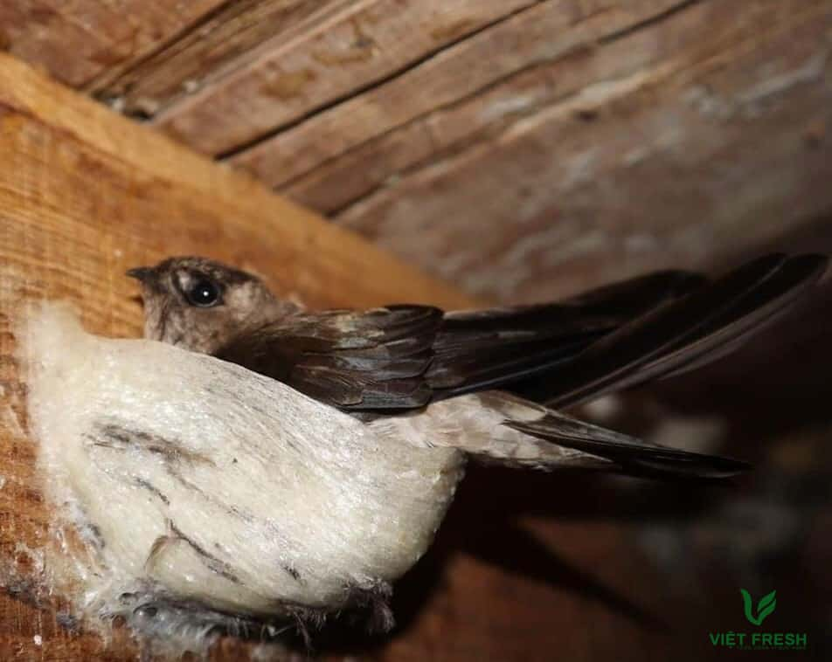
Figure 2.1 External shape of nest in captive swiftlet farming
The structure of swiftlet nests is incredibly intricate, consisting of multiple intertwined threads with an off-white color and a slight fishy odor. Swiftlet nests are a high-nutrient food. Each component plays an important role in forming the structure and nutritional value of the nest. The nest’s luffa-like strands are the inner part of the raw nest, characterized by intertwined fine fibers that form a structure resembling luffa. During processing, these fibers are typically separated and cleaned, then used for refined samples or returned to the nest for feather-removal and belly applications. When soaked in water, the luffa-like fibers tend to break down easily but still retain the small fibers interconnected, giving a chewy yet soft texture, distinguishing it from small fragments of broken nest.
The "feet" of the nest are the supporting legs that help the nest adhere firmly to surfaces like walls, wood, or stone. Therefore, during nest construction, swiftlets meticulously build these legs to be thick and sturdy. The feet are considered the most nutritious part of the nest. Their function is to create a linkage between the feet on either side, completing the nest’s structure. This part is also regarded as the back of the nest, providing protection to the eggs and chicks inside. With their chewy texture and pleasant aroma, the feet are the preferred choice for consumers and also carry higher commercial value.
In general, the structural and functional differences of each component in the swiftlet nest emphasize the physical traits and high nutritional value of the product. These characteristics play an important role in determining the commercial value and the potential applications of swiftlet nests in the health and nutrition sectors.

2.3. Construction of Swiftlet Nests
Swiftlets (Aerodramus spp.) build their nests by secreting a sticky substance from the salivary glands under their tongues and using a unique technique to complete the nest. This process involves several steps: selecting the nesting site, secreting the sticky substance and laying the foundation, constructing the nest structure, finalizing the nest, and ultimately completing the nest. First, swiftlets typically build their nests on vertical walls or ceilings of caves, areas that are difficult to access, in order to protect their eggs and chicks from predators [6]. Swiftlets secrete saliva from the salivary glands under their tongues, which enlarge during the breeding season. The sticky substance adheres firmly to the rock surface, forming the base layer for the nest [7]. Second, the swiftlets continue to secrete saliva gradually to form the curved shape of the nest, typically in the form of a half-bowl [8]. The sticky substance hardens upon exposure to air, creating a solid frame [9]. Third, the nest construction process takes about 35-40 days. Before laying eggs, swiftlets slow down the construction process to ensure the nest has a secure and stable structure [9]. Fourth, once the nest is completed, it is generally used only once. After the old nest is abandoned or harvested, swiftlets will build a new nest nearby [10]. White swiftlet nests are typically free of impurities, while black swiftlet nests may contain feathers and other materials such as moss or grass [6].

2.4. Specific Methods of Monitoring and Assessing Swiftlet Nests by Harvesters
In the swiftlet farming industry, monitoring swiftlet nests plays a crucial role in ensuring the quality of the environment and the nests themselves. Currently, many swiftlet farmers rely on traditional methods, primarily based on:
- Direct Observation: Workers climb scaffolding and ladders, using flashlights to observe the nests. This method heavily depends on the experience and skill of the workers and often takes a considerable amount of time.
- Manual Record Keeping: Data regarding the reproduction and development of the swiftlets is often recorded by hand, leading to a high risk of omissions and errors.
- Visual and Auditory Checks: Assessing the condition of the swiftlets by observing the nest's shape and listening for the sound of the birds may not be suitable for nests located in hard-to-reach areas.
Challenges encountered in Manual Nest Monitoring:
- Occupational Hazards: Climbing high, slippery areas has led to many serious accidents. Numerous workers have suffered injuries, broken bones, and even fatalities while working. Statistics from some regions indicate that an average of 15-20 severe accidents occur annually in the swiftlet farming industry. Manual monitoring is often hindered by limited visibility due to the dim light inside swiftlet houses. Moreover, the temperature in these houses is very high, with unpleasant odors and poor ventilation, making it difficult to breathe and causing dizziness after working for extended hours.
- Low Efficiency: Manual monitoring does not ensure the accuracy and consistency of data recording. Data discrepancies can lead to inefficient management. In large-scale swiftlet houses, this method is particularly ineffective.
- Impact on Swiftlets: Swiftlets are highly sensitive to their environment, and minimizing human presence is crucial for their well-being. Improper monitoring and harvesting procedures can disrupt the lives of the swiftlets. If the birds feel threatened, they may abandon their nests, leading to a long-term decrease in nest production.
- High Costs: Manual methods require significant labor, which increases time consumption and management costs, reducing market competitiveness.

2.5. Specific Monitoring Methods and Swiftlet Nest Evaluation by Robots
In response to the aforementioned limitations, new technologies such as surveillance cameras, autonomous monitoring robots, and data management software are being researched and applied. These solutions not only enhance work efficiency but also ensure safety for humans. Humans no longer need to physically enter swiftlet houses; instead, they can monitor through automated robotic systems, minimizing any disruption to the life of the bird colony.
- Automated Monitoring: The robot system can be programmed to autonomously navigate through nesting areas, including natural rock faces or purpose-built nesting houses. Its cameras and sensors capture high-resolution images and data at predetermined intervals, ensuring a comprehensive view of the nests and their residents.
- Data Collection: The robot collects a variety of data, including visual images, temperature, humidity, and even audio recordings of the birds' calls. These multi-modal data streams provide a comprehensive understanding of the nest conditions, bird behavior, and environmental factors.
- Real-time Analysis: The collected data is transmitted to the robot's AI processor or a central control station. AI algorithms, which may utilize deep learning techniques such as CNNs (Convolutional Neural Networks), process the images and data in real-time to detect and classify different types of nests, such as those containing eggs, adult birds, chicks, or empty nests.
- Pattern Recognition: Over time, the AI algorithms can learn to recognize patterns and changes in the nest conditions. For instance, it could detect temperature fluctuations or the presence of specific bird calls that correlate with nesting activities.
- Alerts and Reporting: The system can be designed to generate alerts and reports based on its analysis. If the robot identifies nests with specific characteristics, it can immediately send notifications to the operator or trigger specific actions, such as starting the harvesting process or providing additional care services.
- Adaptability: The robot system can be equipped with adaptive sensors to monitor other environmental parameters, such as air quality, light intensity, or even the presence of pests, providing a comprehensive view of the nesting environment's health.
Benefits of Robot Monitoring:
- Accuracy and Precision: The robot system provides the ability to collect accurate and consistent data, reducing the likelihood of human error and ensuring precise observations.
- Continuous Monitoring: The robot can operate 24/7, providing uninterrupted monitoring even in challenging or hazardous environments.
- Efficiency: Automating data collection and analysis optimizes resource usage and reduces the need for manual labor.
- Data-driven Insights: The wealth of data collected and analyzed by the robot enables data-driven decision-making for nest management, leading to more effective strategies.
- Minimized Disturbance: The non-invasive nature of robotic monitoring minimizes disruptions to the birds’ nesting activities, allowing natural behaviors to be observed.

2.6. Characteristics of Swiftlet Nests
Swiftlets typically live for an average of 15-18 years, and during each breeding season, they can build 2-3 new nests. However, the nests are usually used only once; if a nest is harvested, the birds will build a new nest either above or near the old one. Swiftlets (Aerodramus spp.) build their nests by secreting a sticky substance from the salivary glands under their tongues and using a unique technique to complete the structure. This sticky substance hardens when exposed to air, creating a durable nest structure. The most common shape of a swiftlet nest is half-bowl, but it must be strong enough to hold the eggs and chicks. The nests vary in thickness and size, typically measuring 5-10 cm in length, 3.5-6 cm in width, and weighing between 4-8 g per unprocessed nest. White swiftlet nests are the highest quality, clean, free of feathers, and typically sold as perfect half-cups (Lim & Earl of Cranbrook, 2002). They usually consist of fine, evenly curved strands. After cleaning, these nests are carefully packaged and priced between 2,000–3,000 USD per kg, while red or orange nests can reach up to 10,000 USD per kg. Additionally, red or orange nests are rarer and more valuable, not due to the bird's blood but due to a chemical reaction between nitrifying bacteria and ammonia gas from decomposing bird droppings, and contain about 10% feathers. These nests are primarily used for processing products, with prices ranging from 200–700 USD per kg (Lau & Melville, 1994).

2.7. Characteristics of Swiftlet Nests when harvested vs. not harvested
The characteristics of swiftlet nests vary depending on whether they are harvested or left unharvested. Each scenario affects the nest's quality and its economic value:
- When harvested before egg laying:
  - The nest is generally clean, with minimal dirt or bird feathers.
  - The nest structure is often incomplete and thin, as it hasn't yet fully formed.
  - The nest is fragile and can break easily because the nest threads are delicate and may dissolve in water when cooked.
- When harvested after egg laying (2 eggs):
  - The nest becomes thicker and more robust, which increases its economic value.
  - However, this may reduce the number of nests available for harvesting since it disrupts the birds' activities. The swiftlets might become stressed and abandon their nests.
- When harvested after chicks have grown:
  - The nest becomes fully formed, providing a complete structure.
  - However, it is no longer as clean, as it will contain dust, feathers, and food remnants from the chicks' upbringing.
- When not harvested:
  - If the nest is not harvested, the swiftlets continue to build on it, adding new layers on top of the old ones. This results in multiple layers of nests stacked upon each other.
  - The chicks may end up resting in newer layers of nests, while the older layers become exposed to environmental factors, leading to contamination and dirt accumulation.
  - As a result, the quality of the nests deteriorates, with increased impurities and reduced nutritional value.
In summary, while harvesting at various stages of the nesting process has distinct advantages and disadvantages, it is essential to balance nest collection with the swiftlets' reproductive cycles to ensure both the birds' welfare and the quality of the nests.

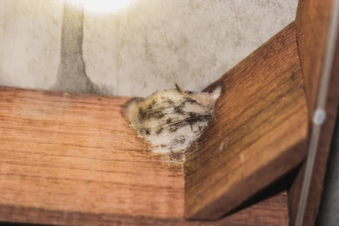
Figure 2.2 Swiftlet nest when not harvested.

2.8. Structural Design of Swiftlet Houses
The structure of a swiftlet house generally consists of three main components: the shape and external structure (walls and roof), the internal layout (rooms and compartments), and the surrounding premises.

2.8.1. Building shape and Wall construction
Building shape
Swiftlet houses are typically designed to resemble large storage warehouses, customized to fit the dimensions of the available land. Common designs include tubular or rectangular blocks with wide frontages. These buildings can feature either gabled or flat roofs. To enhance aesthetics and increase swiftlet attraction, many modern swiftlet houses are built to resemble "5-star hotels". On Borneo Island, for example, local residents compete by constructing luxurious accommodations for swiftlets that ensure safety, cleanliness, darkness, and access to water features such as pools for bathing.
Wall construction
The walls of swiftlet houses are built from a mixture of sand, lime, and cement in a ratio of 3:2:1. Concrete walls typically have a thickness of 20–25 cm. In hot climates, to minimize internal heat, double-layered walls with a 5 cm air gap are commonly used. Both the inner and outer wall surfaces are coated with a layer of mortar to increase durability and improve water resistance.
Roofting
Roofs can be made of tiles or insulated corrugated metal sheets (cold roofing). In some cases, concrete slabs are used for roofing to enhance thermal insulation and protect the internal environment from external climatic influences.
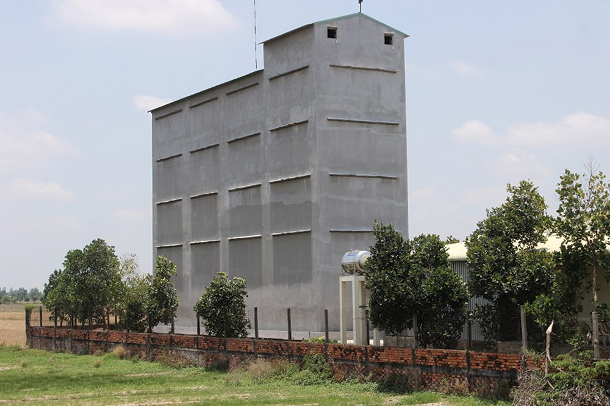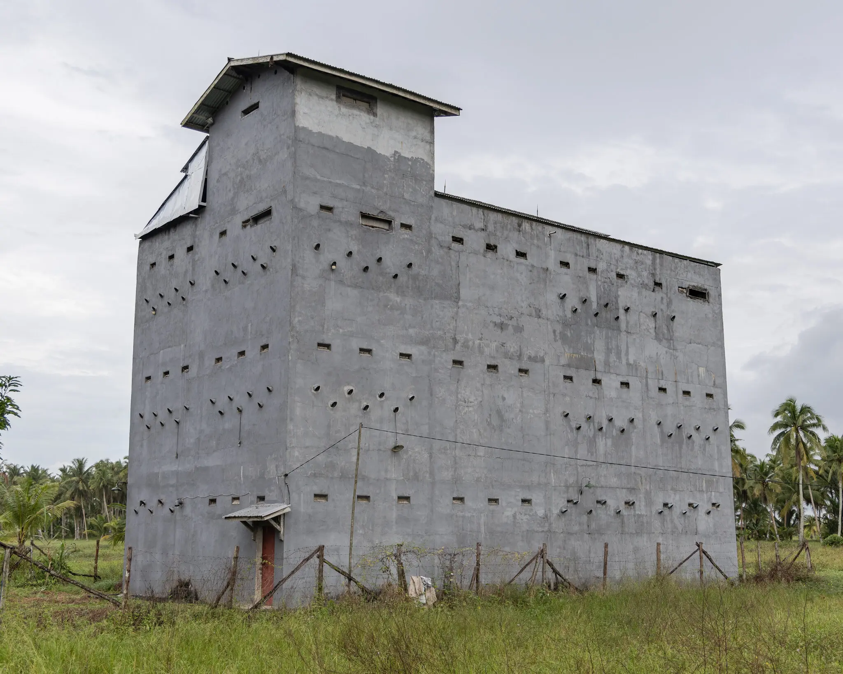
Figure 2.3 Swiftlet house in Vietnam and Indonesia

2.8.2. Room shape and Structure
The height of each floor within a swiftlet dwelling typically ranges from 2.5 to 4 meters, depending on the climatic conditions of the respective region. Swiftlet houses are generally constructed with two to four levels, depending on design requirements and environmental conditions. To ensure adequate space for aerial maneuvering, it is recommended that a dedicated flight chamber be incorporated on the uppermost level of the structure. Common dimensions for this chamber include 4 × 5 meters or 4 × 8 meters. In cases where the chamber exceeds standard dimensions (e.g., 6 × 8 meters), the installation of artificial partitions—typically wooden panels suspended horizontally from the ceiling to a depth of approximately 40 centimeters—is advised. These partitions serve to attenuate wind flow and natural light, thereby creating a more secure and conducive environment for nesting behavior.

2.8.3. Swiftlet house surroundings
The external surroundings of the swiftlet house should be carefully designed to optimize biosecurity and flight accessibility. A shallow water moat or trench encircling the structure is recommended to prevent ant intrusion, which poses a threat to nest hygiene and egg safety. Additionally, vegetation and trees in the immediate vicinity should be maintained below the level of the entrance holes, as excessive height may impede flight trajectories and discourage entry by the birds.
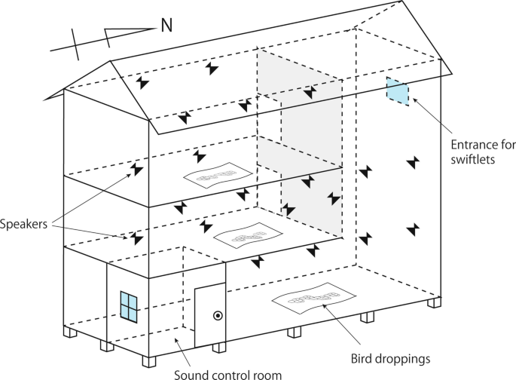

Figure 2.4 Swiftlet house surrounding

2.9. Interior Space of a Swiftlet House
Swiftlet farming houses are typically divided into multiple rooms to ensure a dark and quiet environment conducive to nesting. The ceiling height ranges from 3 to 4 meters, allowing swiftlets to fly and maneuver comfortably. Wooden planks or other suitable materials are installed along the ceiling and walls, serving as perching and nesting sites. These planks are arranged systematically to optimize space and provide convenience for the swiftlets. Specialized speakers that play recorded swiftlet calls are installed within the house to attract wild swiftlets. The sound system is adjusted based on the time of day to maximize its effectiveness in luring birds.
Environmental Control System
- Temperature: Maintained between 27–29°C.
- Humidity: Kept at an optimal range of 80–90%, using misting systems, ventilation, and thermal insulation.
Scientifically designed small entry holes allow swiftlets to fly in and out with ease while minimizing the intrusion of other animals.

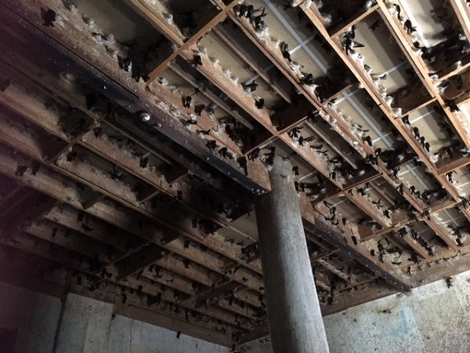
Figure 2.5 Wooden framework of swiftlet house

2.10. Nest Construction by Swiftlets on Mounting Frames
Frames should be installed at elevated, secluded, and dimly lit locations to provide a sense of safety and security conducive to swiftlet nesting behavior. The materials used for these frames must be free of toxic chemicals and possess high surface adhesion to facilitate nest attachment during construction. The nesting process typically begins when a swiftlet selects a suitable position on a rough-textured surface that offers sufficient grip. Swiftlets initiate nest-building along the edge of the frame, gradually shaping the structure into a half-cup or shell-like form over a period of approximately 30 to 45 days, culminating in a fully formed edible bird’s nest. The nest is composed of hardened strands of salivary secretion extruded from the sublingual glands of the bird. These secretions are intricately woven and firmly affixed to the frame surface, forming a robust structural bond that secures the nest in place. This natural adhesive capability is a key factor in ensuring the stability and integrity of the nest during both incubation and environmental exposure.

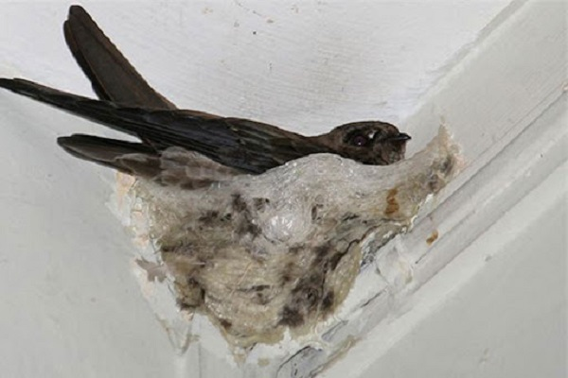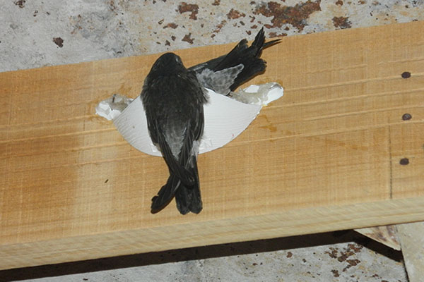
Figure 2.6 Nest construction by swiftlets on mounting frames

2.11. Floor Structure of a Swiftlet House
To maintain appropriate temperature and humidity levels while preventing mold growth, the design and construction of the swiftlet house floor must integrate both technical and environmental considerations. The floor is primarily constructed using reinforced concrete, ensuring high durability, waterproofing capability, and structural strength. To help stabilize the indoor climate, insulating layers such as foam or PVC sheets are often integrated into the flooring system. The floor must also be soundproofed and vibration-resistant to minimize disturbances from external noise. A drainage slope of 2–3% is typically applied to prevent water stagnation, which can lead to dampness and unsanitary conditions. Drainage systems are strategically installed along the perimeter or corners of the floor to channel water efficiently out of the building. Finally, an anti-fungal coating is essential to maintain a clean and safe environment for swiftlets.

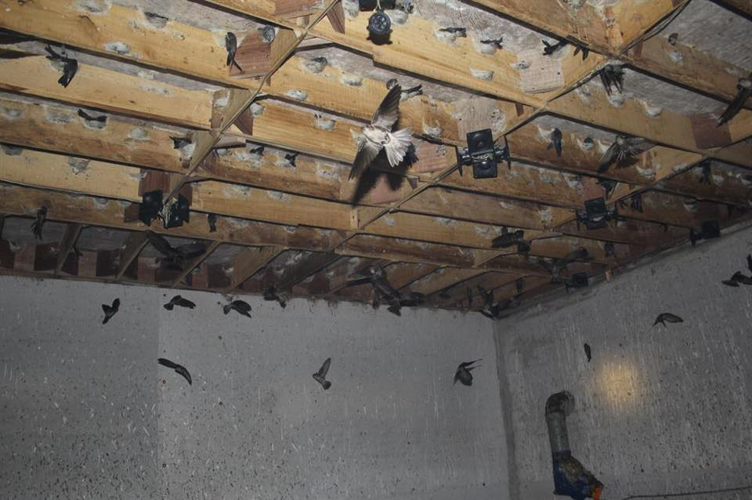
Figure 2.7 Floor structure of a swiftlet house

2.12. Structure of the Wooden Frame
The wooden beams are directly fixed to the ceiling of the swiftlet house. The typical size of each wooden frame is 100 x 20 x 2 cm. If the width is too narrow (less than 10 cm), the excessive light and wind penetration can negatively affect the swiftlets, leading to reduced productivity. To reinforce the frame and attract swiftlets, corner panels are often added. These panels not only provide structural support but are also treated with scents that draw the swiftlets in. The distance between each wooden plank is maintained at 30 cm, forming rectangular compartments that facilitate organized nesting. Bach tung wood (Cunninghamia lanceolata) is commonly used for these frames due to its affordability, durability, and suitable texture, allowing swiftlets to easily cling and build their nests.
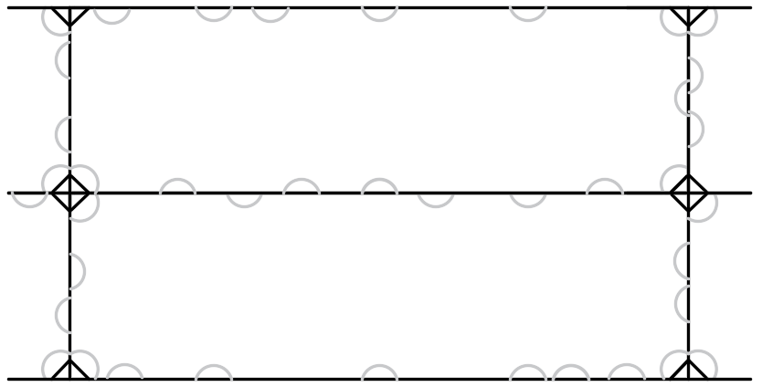
Figure 2.8 Wooden framework installed in 30x100 cm configuration

2.13. Operational Space for Surveillance
A swiftlet house is a specialized environment designed to create ideal living conditions for swiftlets, incorporating factors such as lighting, temperature, humidity, and sound. Within this environment, the operational space of the surveillance robot must be carefully designed and programmed to ensure effective management while minimizing any disruption to the swiftlets. The operational space for surveillance consists of the following elements:
- Operational Height: The operational range spans from 2 to 4 meters, aligning with the height of the house's ceiling, walls, and the elevated swiftlet nests. This height allows the robot to monitor hidden corners that are challenging for humans to access.
- Movement Range: Depending on the design of the swiftlet house, the robot should be capable of covering the entire floor area, including pathways and passages intended for human use.
- Surveillance Accuracy: The robot must be equipped with sensors and cameras capable of accurately identifying nests and any related issues within the swiftlet nests.
Limitations of the Operational Space:
- Movement Range: The robot can only move horizontally or vertically within a specific floor space and is unable to access other floors in the building.
- Obstacles: Nesting bars, electrical wires, or other equipment may obstruct the robot's movement. Therefore, the robot should be integrated with obstacle-avoidance sensors to navigate around these barriers effectively.

2.14. Conclusion
Chapter 2 has comprehensively presented the methodology and design principles of the monitoring robot system for managing and tracking swiftlet nests in swiftlet farming environments. This chapter provided a detailed insight into the biological characteristics of swiftlets, their nesting behavior, the structure of the nests, and the environmental factors necessary to create an ideal habitat for this bird species.
In addition, the chapter highlighted the limitations and risks associated with manual monitoring methods, including labor safety concerns, low efficiency, and negative impacts on the swiftlets. These analyses underscore the necessity of implementing automation technologies, particularly the robotic monitoring system, to improve both the effectiveness and accuracy in swiftlet house management.
Moreover, advanced technological solutions such as sensor-based monitoring systems, AI, and robotics were discussed in detail, emphasizing their potential applications in real-world scenarios. The design features of swiftlet houses, nesting beams, and living environments were also analyzed to clarify the role of space and structure in supporting the natural development of the swiftlets.
In summary, Chapter 2 has provided a solid theoretical and practical foundation for the development of a modern robotic monitoring system aimed at improving both the productivity and quality of swiftlet nests, while ensuring the sustainability and protection of the swiftlet's habitat. This content serves as an important basis for the implementation of advanced technical solutions in the subsequent chapters.

Chapter 3: Hardware System Design of the Surveillance Robot

3.1. Chapter Introduction
A robot is a programmable device designed to autonomously perform complex and repetitive tasks. Currently, the concept of social service robots is being extensively researched and developed across the globe. Social service robots hold the potential to deliver significant value to both society and individuals, promising considerable advancements for businesses and communities alike. By deploying social service robots, substantial value can be added through human-robot interaction. Robots and humans can learn to collaborate and complement each other through artificial intelligence (AI) and intelligent algorithms.
For instance, in commercial contexts, robots can identify potential customers, interpret their hesitations, and suggest alternative approaches for human sales personnel. Furthermore, in elderly care, robots can encourage users to engage in regular physical activities, visit friends, and participate in activities that promote a healthy and fulfilling lifestyle.

3.2. Idea Matrix and Design Proposals including Degrees of Freedom (DOF)
There are several approaches to collecting data on bird's nests, such as utilizing drones (unmanned aerial vehicles), wheeled mobile robotic platforms, tracked mobile bases, cable-driven robotic systems, and articulated robotic structures. Each method of accessing the nests has its own advantages and limitations, as presented in Tables 1 and 2 in the Appendix.
To facilitate the control and data collection process, the primary task of the surveillance robot is to be capable of visually accessing the bird nests located on the wooden frames inside the swiftlet farming facility. Accordingly, the main functionalities of the surveillance robotic system include the ability to navigate across the floor of the facility in order to achieve visual access to the nests.

3.3. Robot Base Design
In recent years, there has been remarkable progress in service robotics, particularly in wheeled mobile robots equipped with autonomous navigation and various auxiliary capabilities tailored to specific tasks. While some modern robots are capable of performing complex operations using robotic arms mounted on mobile bases, these systems remain relatively rare. Most available systems are simplified mobile bases equipped with limited functionality. This section focuses on the mechanical design of the robot. The objective is to develop a basic yet representative design capable of performing various tasks such as monitoring and harvesting. The design aims to distinguish itself from existing commercial robots with similar functions.
To determine the essential features, it is first necessary to identify the robot’s primary task, alongside supplementary functions such as obstacle avoidance and battery charging. Based on these tasks, suitable technologies must be selected. Additional design considerations include dimensions and weight to ensure maneuverability within swiftlet farming facilities. A mobile robot base has already been implemented to support this project.
The nest-monitoring robotic system is designed to operate indoors, specifically on the floors of swiftlet farms. As such, the design of the system’s components is critical and must comply with design standards. It is essential to ensure that both hardware and software components support high-level control decision-making. The robot system consists of the following main components: a mobile base, a camera elevation mechanism, and a camera system. The two drive wheels function under a differential drive mechanism powered by two DC servo motors, enabling flexible movement and balance. The robot is also equipped with various sensors for mobility and obstacle avoidance. A touchscreen interface is mounted on the base for human interaction.
The mechanical system serves as the structural backbone of the robot, supporting its full weight and ensuring operational flexibility. Accurate and stable mechanical design facilitates easier software development. The mechanical system of the service robot comprises two main parts:
- Mobile base: Must ensure robustness, stiffness, compactness, ease of assembly, and repairability.
- Camera system: Includes the camera elevation mechanism and the camera unit itself, designed for aesthetic appeal, compactness, and operational flexibility.
The robot moves on a differential drive mechanism with three wheels (two active differential wheels and one caster wheel). The estimated weight is approximately 30 kg, which includes all mechanical components, battery system, drive motors, and CPU. The drive system consists of DC motors, and the robot is capable of reaching a maximum speed of 0.3 m/s. Therefore, the design requirements set by the team include the following functions and objectives:
- Mobility: Navigate flat indoor surfaces with minor obstacles.
- Visual access to bird nests: The camera captures and processes visual information and supports remote control operations.
- Touchscreen interface: Displays system information and accepts user commands.
- Modular design: The robot is composed of three primary systems—mobile base, camera system, and charging system. The base moves along the farm floor, while the camera system can be raised to capture nest images at ceiling height. The charging system ensures continuous operation and data collection.
- Adaptability: Navigate surfaces contaminated with bird droppings and composed of non-homogeneous materials, within a spatial limit of 10 meters by 20 meters.
Before defining the initial technical requirements to ensure stable, cost-effective mobility, the robot structure is illustrated in Figure 3.1. The robot’s base frame is constructed from aluminum alloy to minimize weight while maintaining structural durability and stiffness. The base is divided into three tiers:
- Tier 1: Houses the drive motors, motor controllers, encoders, and voltage regulation circuits.
- Tier 2: Contains the battery power source that supplies electricity to the entire system. Microcontrollers mounted externally manage the mechanisms within the robot base.
- Tier 3: Accommodates the camera drive system, securing the camera assembly to the robot base.
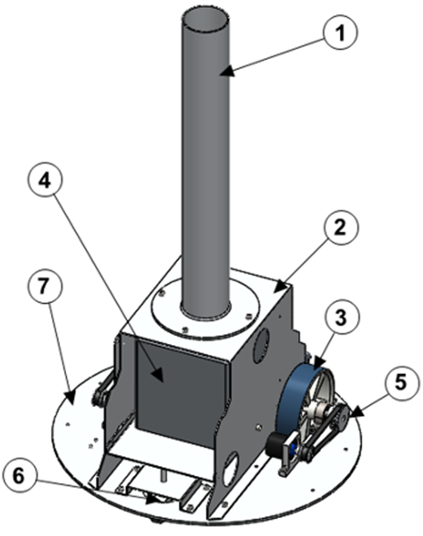
Figure 3.1 The robot base comprises: 1: Main body of the camera system; 2: Upper body support frame; 3: Wheel; 4: Battery (12V); 5: Wheel; 6: Caster wheel; 7: Mounting platform of the robot.
The bird’s nest surveillance robot must possess exceptionally high capabilities in localization and the execution of goal-oriented autonomous tasks within complex operating environments. Autonomous mobile robots are capable of performing self-directed movements according to specific requirements set by supervisors or operators. However, these robots face considerable limitations in mobility due to non-holonomic control systems and wheel configurations. Trajectory tracking involves generating control commands that enable the robot to follow a predefined path with specific positions along the motion trajectory. This ensures the correct orientation of both angular and linear velocities, while also addressing the inherent limitations of non-holonomic systems and enabling adaptation to dynamic environments. The presence of obstacles, structural changes caused by wheel slippage, tire wear, cracked flexible joints, damaged bearings, or small obstructions on the floor can also adversely affect the robot's movement. Additionally, to reduce the size of the robot base—thereby optimizing manufacturing costs and improving the spatial efficiency of the base—a belt drive system is selected to transmit motion from the motor to the wheels (Figure 3.1).
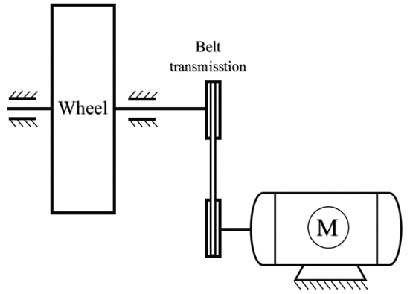
Figure 3.2 Drive system diagram
A moving robot consists of stages: startup, acceleration, deceleration, and constant speed motion. During the startup phase, the motion resistance is the highest, and thus the motor’s pulling force is at its greatest. Therefore, the motor’s pulling force during this phase is used to calculate the power and select the motor. The estimated payload for the robot is 40 kg, with a maximum speed of 0.3 m/s, and the wheel diameter is D = 145 mm.
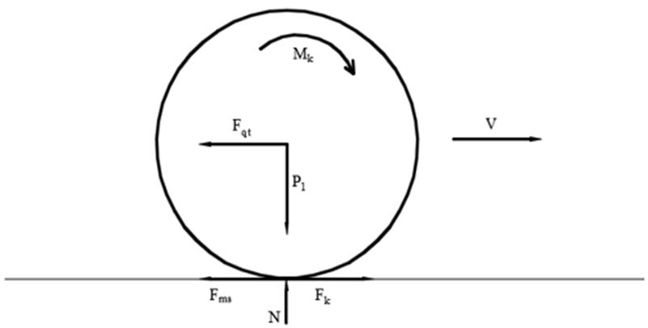
Figure 3.3 Force distribution diagram on the driving wheel
The frictional force acting on a wheel:
$$F_{ms}=\frac{μ_{k}.m.g}{2}=\frac{0,68.40.9,81}{2}=133,42\left(N\right)$$ | (3.1)
Where:
μ is the coefficient of friction, m is the robot's load.

3.4. Design of Camera Arm
This section focuses on the construction of camera-mounted arm systems by utilizing a transmission mechanism that converts rotational motion into linear motion. The previous section introduced the basic principles of how DC motors convert electrical energy into rotational motion. These systems can be directly applied to control rotational joints in robotic systems. In some studies, transmission systems that generate linear motion can use commonly found actuators such as hydraulic cylinders, pneumatic pistons, and linear motion electric motors. Hydraulic and pneumatic actuators are suitable for applications requiring large loads and stroke lengths. In this study, however, we will use electric motors to convert rotational motion into linear motion for the camera. The electric motor rotates a lead screw, moving the camera along a guide rail. The drive nut is securely fixed within the linear motion, preventing it from rotating by the guide rail of the drive housing as it moves along the lead screw.

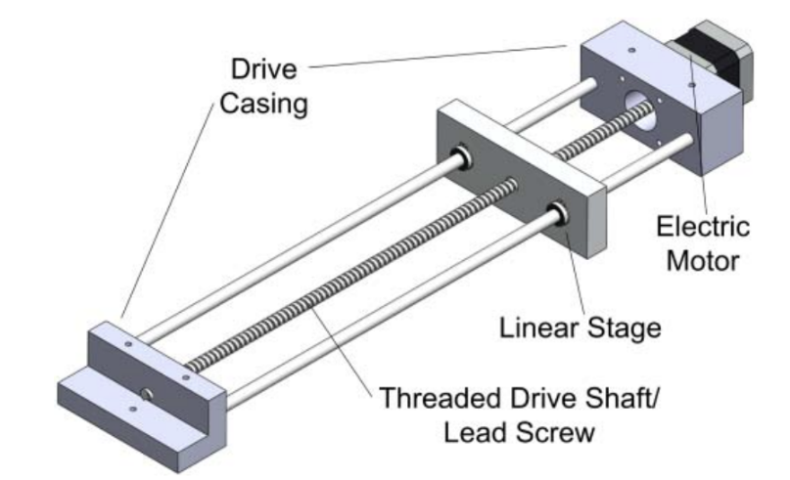
Figure 3.4 Diagram of the rotary to linear motion transmission system

3.5. Design of Automatic Charging System
The proposed infrared (IR) based positioning system for supporting automatic charging of the mobile robot includes hardware components such as: Arduino UNO microcontroller, voltage sensor, infrared sensor, HC-05 Bluetooth module, battery charger, 16x2 ALCD screen, and 4 DC motors controlled by an L293 controller. Figure 1 illustrates the block diagram of the autonomous mobile robot, programmed using an algorithm to guide the robot to move autonomously along a 30-inch by 30-inch square path. The battery status, in the form of peak voltage, is monitored in real-time by the voltage detection module.
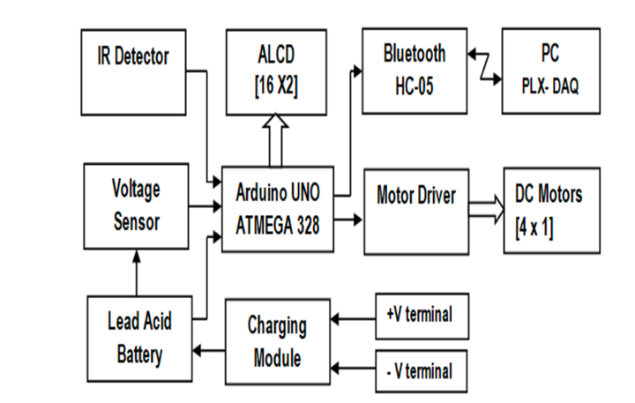
Figure 3.5 Block diagram of the autonomous mobile robot
While performing tasks, if the battery voltage drops to a threshold level, the controller directs the robot to return to the charging station for recharging. The IR receiver sensor mounted on the robot is activated to detect signals from the IR emitter located next to the docking station. The IR emitter serves as the only landmark to guide the robot to the charging station. If the IR receiver detects a signal from the IR emitter, the algorithm instructs the robot to move forward 10 inches and then turn 90 degrees left to align and automatically connect with the docking station.
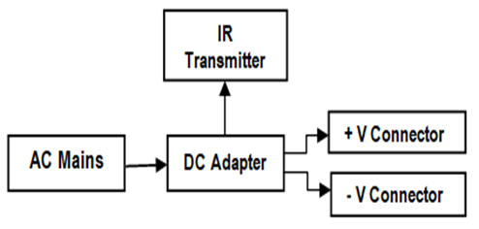
Figure 3.6 Block diagram of the charging station
Figure 3.6 illustrates the block diagram of the charging station used to recharge the robot. The robot is equipped with an integrated battery charging module that supports 12V DC lead-acid batteries and a current sensing unit that uses a comparator to measure the difference between input voltages to determine charging current. The charging voltage values are converted into a standard format, then transmitted via the Arduino UNO serial port through the HC-05 module to a computer.
The PLX-DAQ data acquisition tool in Microsoft Excel receives voltage values from the microcontroller connected to the computer and logs the data into Excel in real time. Additionally, this Parallax data acquisition tool can graph the collected data in real time. When the battery voltage reaches over 12V, the microcontroller instructs the robot to disconnect from the charging station and resume its tasks.

3.5.1. Structure of the Proposed Autonomous Robot and Charging Station
The proposed autonomous robot is a four-wheeled system with a rectangular structure, measuring 25 cm x 20 cm x 7 cm (Length x Width x Height). It comprises the following components: an Arduino UNO microcontroller, a voltage sensor, an infrared sensor, an HC-05 Bluetooth module, a battery charger, a 16x2 ALCD display, four DC motors controlled by an L293 driver, and a 12V, 7AH sealed lead-acid battery. The peripheral devices are connected as illustrated in Figure 3.6. The circuit diagrams of the robot and the charging station are shown in Figures 3.7 and Figure 3.8, respectively.
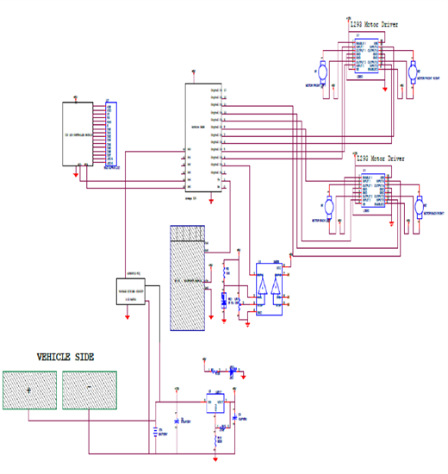
Figure 3.7 Circuit Diagram of the Robot
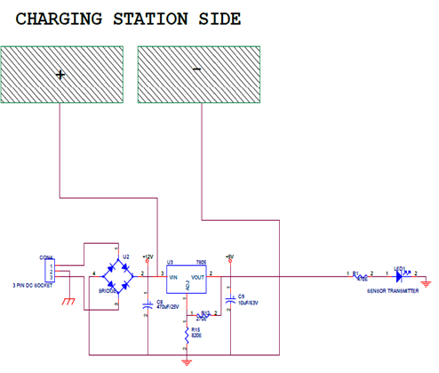
Figure 3.8 Circuit Diagram of the Docking Station
The Arduino UNO microcontroller receives signals from the voltage detection module regarding the battery voltage level and uses these signals to control the DC motors via the motor driver. The algorithm guides the robot to move along a square path. Two H-bridge circuits control the movement and direction of the DC motors through control signals from the motor driver.. The IR receiver sensor is mounted on the robot, and the IR transmitter sensor is placed near the docking station area to assist the robot in navigating towards the docking station under the control of the algorithm. A 12V DC charging voltage is provided by the battery charger in the robot during the charging process. During the charging period, the microcontroller reads the battery voltage at regular intervals and transmits this data via the HC-05 Bluetooth module. The HC-05 Bluetooth module transmits the charging data from the microcontroller to the computer. The PLX-DAQ software tool on the computer receives the charging data from the microcontroller and stores it in an Excel spreadsheet as soon as the data is transmitted.. The LCD screen on the robot continuously displays the battery voltage level. The proposed charging station and energy docking, as illustrated in Figure 6, consists of a flat surface with an IR transmitter sensor placed 10 inches from the left side of the docking station, serving as a reference point to guide the robot to approach and dock with the charging station. The charging station provides a 12V DC, 1 Amp current to power the robot's battery. At the front of the robot, metal electrical contacts are designed to establish a connection with the docking station during the battery charging process.

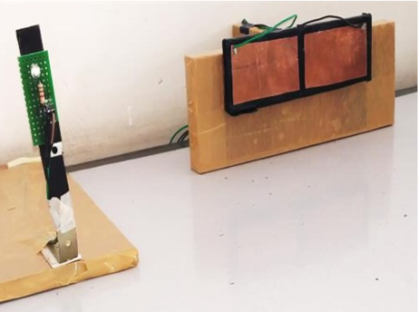
Figure 3.9 Infrared Transmitter and Docking Station

Chapter 4: Kinematic and Dynamic Analysis of the Robot System

4.1. Chapter Introduction
In this chapter, we present detailed explanations and analyses of the kinematics and dynamics of the robot system, which is one of the most important parts of the entire system. It includes the structure of links and joints, workspace analysis, object positioning using the camera, and the Jacobian problem. Additionally, the chapter delves into the dynamics of the robot base and the camera-mounted arm, thereby constructing mathematical models and necessary formulas based on established foundations for simulation and system control. The kinematic model of the mobile robot is represented by a system of equations that allow estimation of the robot’s position on its trajectory, determining the robot’s location and orientation during motion. All movements of the mobile robot can be categorized into translational and rotational movements. Translation refers to the displacement of the robot’s center, and rotation refers to the turning of a wheel axle. The basic element of every mobile robot is the wheel. Kinematic parameters include wheel radius, axle length, center of mass position, etc. A simplified kinematic model includes 2 degrees of freedom (DoF) with three wheels: two driving wheels and one passive caster wheel. The state of a differential drive mobile robot changes according to the velocities of the two driving wheels as the robot moves from its current position to the target. Mobile robots with wheels are commonly used as autonomous robots. The wheel, modeled as a rolling disc, is the fundamental component. Many real-world robots have multi-wheel systems, but the most common configurations are differential drive and car-like drive.
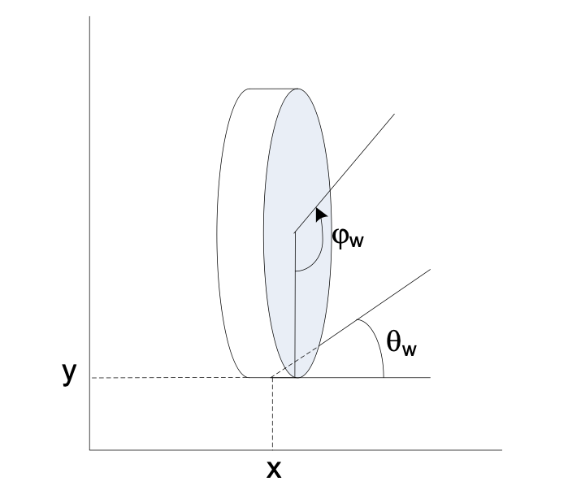
Figure 4.1 Wheel configuration of the robot
A simplified description of a robot wheel is a vertical disc rolling without slipping on a horizontal plane, as shown in Figure 4.1. The wheel configuration is completely described by four variables: coordinates (x, y) on the plane with respect to a fixed reference frame, wheel orientation angle qw relative to the x-axis, and the angle jw between the radial axis and the vertical axis. The wheel radius is r.
The wheel configuration space has dimension n = 4 with q = (x, y, q_{w}, j_{w}). Since we assume no slipping, the wheel velocity must satisfy the following constraints:
$$\begin{aligned}\dot{x}-r\dot{φ_{w}}cosθ_{w}=0\#\left(4.1\right)\end{aligned}$$
$$\begin{aligned}\dot{y}-r\dot{φ_{w}}sinθ_{w}=0\#\left(4.2\right)\end{aligned}$$
The kinematic model of a wheeled mobile robot assumes the robot is on a flat surface with rolling contact only (no slipping) between the wheel and the ground during motion. The non-holonomic constraint can be written as:
$$\begin{aligned}\dot{y}cosθ-\dot{x}sinθ=0\#\left(4.3\right)\end{aligned}$$
The position of the robot’s center is represented in the reference frame as (x, y), with being the orientation of the robot relative to the frame. Assuming the robot moves with linear and angular velocities, they can be represented as vectors:
$$\begin{aligned}\dot{q}=\left[\dot{x} \dot{y} \dot{θ} \right]\#\left(4.4\right)\end{aligned}$$
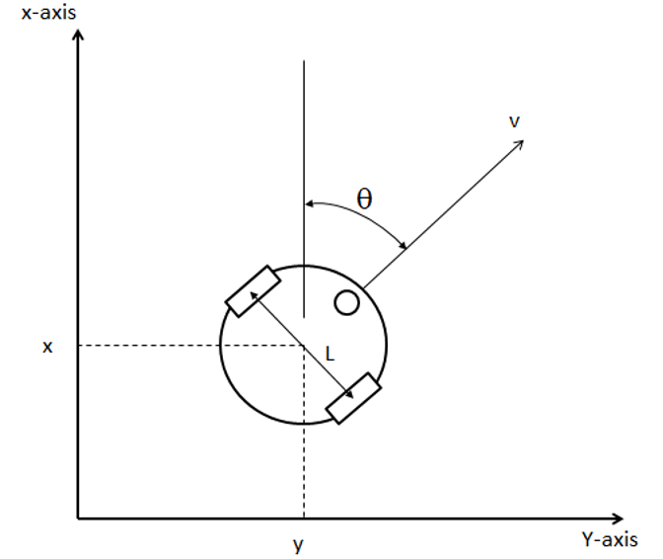
Figure 4.2 Differential-drive robot model
Differential-drive robots have two independently driven wheels that enable them to follow a designated path. Motion along a straight path results from equal wheel velocities, while motion along a curved path is determined by the difference in angular velocity between the two drive wheels. The robot’s state is defined by its position and orientation, which are functions of the speeds of the two drive wheels (x, y, q, j_{l}, j_{r}). A simplified model of a 3-wheeled differential-drive robot is shown in Figure 4.2. For the mobile robot, the linear velocity vvv and angular velocity ω\omegaω are selected by the programmer. These values are then converted into the velocities of the right and left wheels. The kinematic model provides the equations using the wheel speeds and the robot's geometric configuration.
The methodology of the robot’s kinematic model is based on developing the robot’s motion as a function of time, allowing prediction of position and orientation based on wheel velocity and initial configuration. The kinematic model is determined in two steps: computing the robot’s body position and velocity from wheel velocity and orientation. Each robot element is defined in a 2D Cartesian coordinate frame, treated as the global reference frame (Figure 4.3).
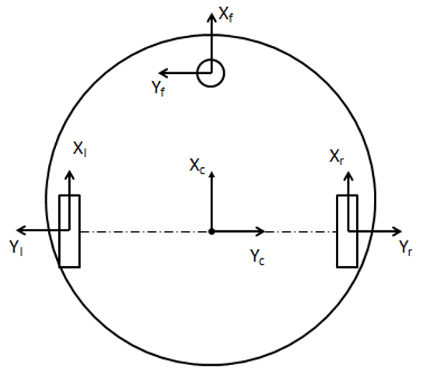
Figure 4.3 Locations of components in the robot kinematic model
With known robot geometry, the body position in the global coordinate frame (X, Y) is defined by the midpoint of the wheel axle and angle θ. The rotation matrix R_{m} is used to map the body’s movement into the global frame based on rotation about the z-axis.
$$\begin{aligned}R_{m}=\left[\begin{matrix}cos θ & -sinθ & 0 \\ sin θ & cosθ & 0 \\ 0 & 0 & 1\end{matrix}\right]\#\left(4.5\right)\end{aligned}$$
The angular velocities of the left and right wheels, the wheel radius r, and the distance l/2 from the center of the robot to the wheels are known. Therefore, the velocity model of the robot can be predicted. With the differential drive robot, the two driven wheels are fixed, and a positive rotation angle results in a positive displacement around the axis. The rolling and slipping constraints for a standard fixed wheel ensure that all rotational motion produced by the wheels leads to both translational and rotational motion of the robot. In the case of differential drive, to avoid slipping and achieve pure rotational motion, the robot must rotate around a point located on the straight line connecting the two wheels. This point is known as the Instantaneous Center of Rotation (I_{CR}). As the velocities of the two wheels change, the Instantaneous Center of Rotation will move, creating different trajectories.
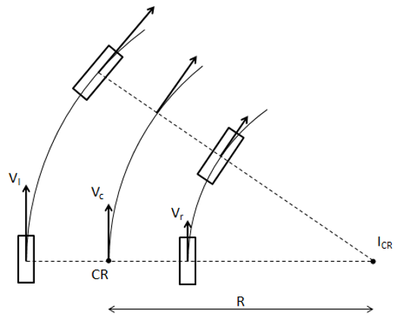
Figure 4.4 Motion of a differential-drive wheel system
From the wheel model (Figure 4.4), the robot’s linear velocity is the average of the two wheel velocities:
$$\begin{aligned}\dot{x}=r\frac{\dot{φ_{l}}+\dot{φ_{r}}}{2}\#\left(4.6\right)\end{aligned}$$
The rotational motion of the robot is:
$$\begin{aligned}\dot{θ}=\frac{\dot{φ_{l}} - \dot{φ_{r}}}{2}\#\left(4.7\right)\end{aligned}$$
The operation of the robot depends on the control variables v and ω
$$\begin{aligned}v=\frac{\left(ω_{l}+ω_{r}\right)r}{2}\#\left(4.8\right)\end{aligned}$$
$$\begin{aligned}ω= \frac{ω_{l}-ω_{r} }{2}\#\left(4.9\right)\end{aligned}$$
$$\begin{aligned}\left[\begin{matrix}v_{l} \\ v_{r}\end{matrix}\right]= \left[\begin{matrix}cosθ & sinθ & l/2 \\ cosθ & sinθ & -l/2\end{matrix}\right]\left[\begin{matrix}\dot{x} \\ \dot{y} \\ \dot{θ}\end{matrix}\right]\#\left(4.10\right)\end{aligned}$$
With w_{l}​ and w_{r}​ being the angular velocities of the left and right wheels of the robot, respectively. With different values of w_{l}​ and w_{r}​, the trajectory will form. v_{l}​ is the linear velocity of the left wheel, and v_{r}​ is the linear velocity of the right wheel. R is the signed distance from the Instantaneous Center of Rotation (I_{CR}) to the midpoint of the two wheels.
If v_{l} = v_{r}​, then the radius R is infinite, and the robot will move in a straight line. When the values of v_{l}​ and v_{r}​ are different, the robot will not move in a straight line but will follow a curved path around a point with radius R from the center of rotation, changing both the position and direction of the robot. If v_{l} = -v_{r}​, then the radius R is 0, and the robot will rotate around its center.
The movement of the robot can be described in two modes, pure rotation and pure translation. The path consists of circular arcs with distinct radii and rotation angles, along with straight tangential lines. The curved path and straight tangential lines are used to avoid sudden stops and provide continuous operation for the robot. To achieve the desired control trajectory, the linear and angular velocities vvv and ω\omegaω are calculated through a fuzzy controller as follows:

$$\begin{aligned}\left[\begin{matrix}\dot{x} \\ \dot{y} \\ \dot{θ}\end{matrix}\right]=\left[\begin{matrix}0 \\ 0 \\ ω\end{matrix}\right]\#\left(4.11\right)\end{aligned}$$
$$\begin{aligned}\left[\begin{matrix}\dot{x} \\ \dot{y} \\ \dot{θ}\end{matrix}\right]=\left[\begin{matrix}v.cosθ \\ v.sinθ \\ 0\end{matrix}\right]\#\left(4.12\right)\end{aligned}$$

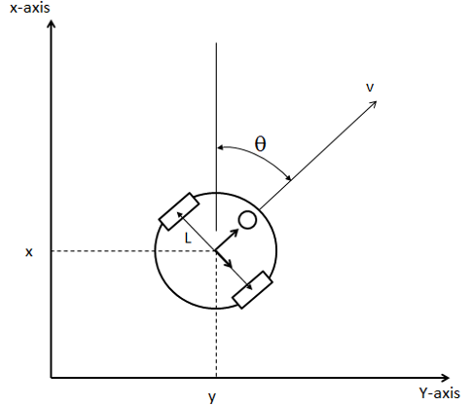 | 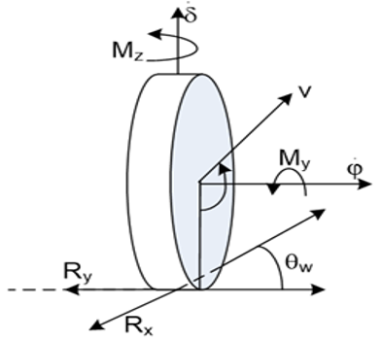
 | 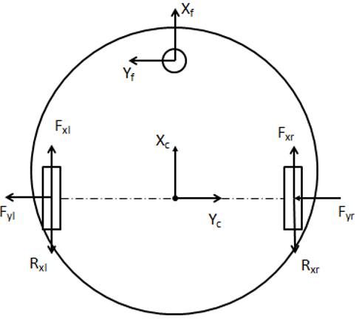
Figure 4.5 Dynamics of wheeled mobile robots.
The radius of the curved path depends on the robot's velocity and position. The algorithm first determines an appropriate intersection point in the desired direction, and then calculates the curve based on the target position. The target position can be approached with a required orientation. Therefore, the trajectory is generated based on the target parameters and the current position.
When applied to robot kinematics, it involves describing the motion of the robot. Forward kinematics examines the geometric relationships affecting the robotic system, including the relationship between control parameters and the resulting behavior of the robot in the workspace. This allows for determining how the robot moves and the position it will reach with specific combinations of joint parameters.
Conversely, inverse kinematics calculates the required joint parameters to achieve a desired position with a specified orientation, enabling motion planning for the robot to reach a fixed target location.

4.2. Structure of Links and Joints

4.2.1. Belt Transmission Calculation
During operation, if a failure occurs in the motor or the robot experiences an excessive load, the motor may become overloaded, potentially resulting in hazardous equipment damage. To address this issue, the motor is not connected directly to the load but instead drives it through a belt transmission system. The belt helps protect the motor and other components when the load exceeds the permissible limit. In our robot platform, two timing belts and two pulleys are used to transmit motion from the two motors to the wheels. From this, the operating parameters of the transmission system are as follows: Motor shaft power: Pdc = 43 (W), Motor shaft speed: ndc = 45 (rpm), Belt transmission ratio: ud ​= 1. The working conditions are: static load, light shock and vibration; the belt is adjustable; and periodic tensioning is required to maintain appropriate tension. After studying the specifications of available products on the market, a selection of m=1.62 is made.

4.3. Kinematics of the Robot System
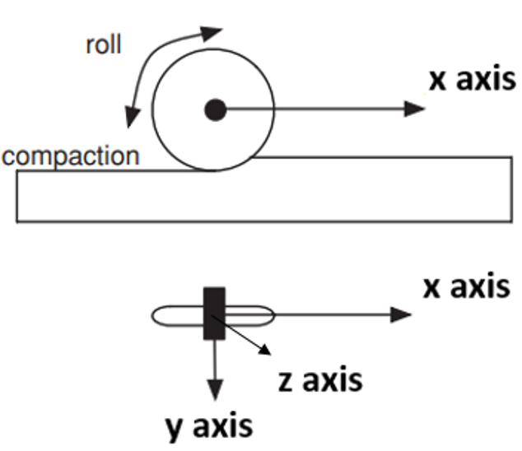
Figure 4.6 Ideal rolling wheel
Kinematic analysis is used to describe the relationship between position, velocity, and acceleration of the robot links. The forward and inverse kinematic equations are built based on Cartesian coordinates, providing a computational tool to determine the robot’s position and orientation from motor parameters.
The robot belongs to the category of mobile robots; therefore, its kinematics are based on the kinematics of mobile robots. The workspace of a mobile robot is just as important as that of a robotic arm, as it defines the range of positions the robot can reach within its operating environment.
A mobile robot is a fully autonomous device capable of moving freely within its environment. Directly determining the instantaneous position of a mobile robot is a challenge. Instead, we need to integrate the robot's motion over time to accurately determine its position.
Wheel slip is a factor that reduces the accuracy in estimating and evaluating the motion of a robot. In this study, we will focus on researching and controlling a basic autonomous social service robot model equipped with three wheels. In this setup: Two driving wheels are powered by independent motors; The third wheel serves as a free wheel to maintain balance. Assuming the wheels roll without slipping on the surface, the position of the robot can be defined as the midpoint between the two driving wheels. Additionally, this research will consider the dynamics of the mobile robot system to address the challenges of controlling the robot’s movement in environments with impact forces. By extending these concepts, the study aims to develop a comprehensive understanding of the kinematics and dynamics of the mobile robot, paving the way for effective control strategies to enhance the robot’s performance and safety in various operational environments. Wheel motion of the robot: The robot moves along the x-axis and cannot move along the y-axis. When moving at low speeds, the effect of wheel slip relative to the road surface can be neglected.
Assumptions when the robot is moving:
- The robot moves without slipping on the plane.
- The motion of the robot is considered on a flat surface.
- The motion occurs at low speeds, so the inertial forces in all directions are smaller than the frictional forces.
Kinematic goals:
- Determine the optimal trajectory for the robot to move from its starting point to its destination without colliding with any obstacles.
- After designing the trajectory, solve the control problem to ensure the robot follows the desired path.

4.4. Dynamics of the Robot Base

4.4.1. Forward Kinematics Calculation for the Robot Base
The purpose of forward kinematics (FK) is to compute the position and motion of a mobile robot based on its linear and angular velocities.
The mobile robot uses an independently driven mechanism for each wheel, known as differential drive (Figure 4.7.). The performance of this mechanism depends on the number of drive wheels on the robot. Typically, this consists of a single axle with two wheels, each capable of moving independently forward or backward.
To prevent the robot from tipping over, a third wheel is added to maintain balance. By adjusting the speed of each wheel, the robot can turn left or right. As a result, the robot rotates around a specific point located along the wheel axle. This point is called the Instantaneous Center of Curvature (ICC).

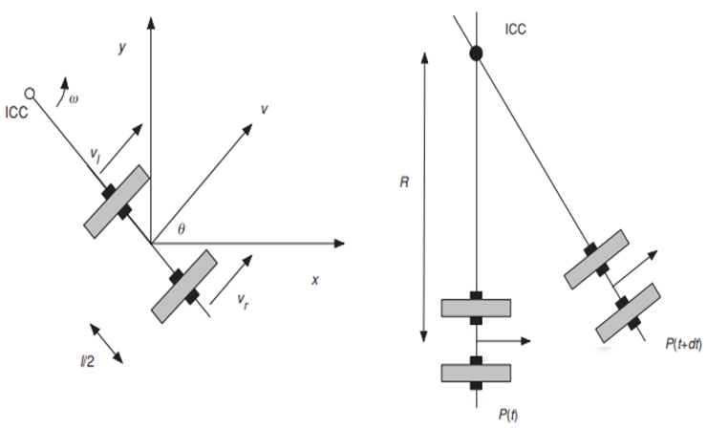
Figure 4.7 Differential drive kinematics
In a differential drive system, vehicle movement is determined by controlling the velocity of the wheels. For both drive wheels to roll properly, the robot must rotate around a point on the common axis of the two wheels.
By adjusting the relative velocities between the two wheels, the position of the center of rotation can change, allowing for the creation of different motion trajectories for the vehicle. It is important that at any given moment, the robot's center of rotation ensures that both the left and right wheels move along a trajectory around the ICC with the same angular velocity, denoted as ω. Therefore, we have:
$$\begin{aligned}ω.\left(R+\frac{l}{2}\right)=v_{r}\#\left(4.13\right)\end{aligned}$$
$$\begin{aligned}ω.\left(R-\frac{l}{2}\right)=v_{l}\#\left(4.14\right)\end{aligned}$$
Where:
l is the distance between the two wheels,
R is the distance from the ICC to the midpoint between the two wheels,
$v_{r}$ is the velocity of the right wheel,
$v_{l}$ is the velocity of the left wheel,
$ω$ is the angular velocity of the robot when rotating around the ICC.
From the ICC, we can determine the angular velocity of the robot as follows:
$$\begin{aligned}ω=\frac{v_{r}-v_{l}}{l}\#\left(4.15\right)\end{aligned}$$
The radius of curvature from the robot's center of motion to the instantaneous velocity center can be determined as follows:
$$\begin{aligned}R=\frac{l}{2}\frac{v_{r}+v_{l}}{v_{r}-v_{l}}\#\left(4.16\right)\end{aligned}$$
From (4.15) and (4.16), the linear velocity of the robot platform can be calculated as:
$$\begin{aligned}V=ωR=\frac{v_{r}-v_{l}}{2}\#\left(4.17\right)\end{aligned}$$
The ICC point is given by:
$$\begin{aligned}ICC=\left(x-Rsin\left(θ\right),y+Rcos\left(θ\right)\right)\#\left(4.18\right)\end{aligned}$$
At time t + Δt, the robot's pose relative to the ICC is given by:
$$\begin{aligned}\left[\begin{matrix}x^{'} \\ y^{'} \\ θ^{'}\end{matrix}\right]=\left[\begin{matrix}cos\left(ω∆t\right) & -sin\left(ω∆t\right) & 0 \\ sin\left(ω∆t\right) & cos\left(ω∆t\right) & 0 \\ 0 & 0 & 1\end{matrix}\right]\left[\begin{matrix}x-ICC \\ y-{ICC}_{y} \\ θ\end{matrix}\right]+\left[\begin{matrix}{ICC}_{x} \\ {ICC}_{y} \\ ω∆t\end{matrix}\right]\#\left(4.19\right)\end{aligned}$$
The robot's motion around a distance RRR relative to the ICC with angular velocity is determined by the equation (4.19).
Based on forward kinematics, the position and orientation of the robot at any given time t can be calculated by controlling the velocities of the left and right wheels.
In general, the ability of the robot to move in a specific direction θ(t) with a given velocity v(t) is clearly defined.
$$\begin{aligned}x\left(t\right)=\int_{0}^{t}{V\left(t\right)}cos\left(θ\left(t\right)\right)dt\#\left(4.20\right)\end{aligned}$$
$$\begin{aligned}y\left(t\right)=\int_{0}^{t}{V\left(t\right)}sin\left(θ\left(t\right)\right)dt\#\left(4.21\right)\end{aligned}$$
$$\begin{aligned}θ\left(t\right)=\int_{0}^{t}{ω}\left(t\right)dt\#\left(4.22\right)\end{aligned}$$
For the case of a differential-drive robot, equation (4.21) is rewritten as:
$$\begin{aligned}x\left(t\right)=\frac{1}{2}\int_{0}^{t}{\left(v_{r}\left(t\right)+v_{l}\left(t\right)\right)}cos\left(θ\left(t\right)\right)dt\#\left(4.23\right)\end{aligned}$$
$\begin{aligned}y\left(t\right)=\frac{1}{2}\int_{0}^{t}{\left(v_{r}\left(t\right)+v_{l}\left(t\right)\right)}sin\left(θ\left(t\right)\right)dt\#\left(4.24\right)\end{aligned}$
$$\begin{aligned}θ\left(t\right)=\frac{1}{l}\int_{0}^{t}{\left(v_{r}\left(t\right)+v_{l}\left(t\right)\right)}dt\#\left(4.25\right)\end{aligned}$$

4.4.2. Inverse Kinematics Calculation for the Robot Base
The purpose of inverse kinematics (IK) is to calculate the required linear and angular velocities of the robot in order to reach a specific configuration.
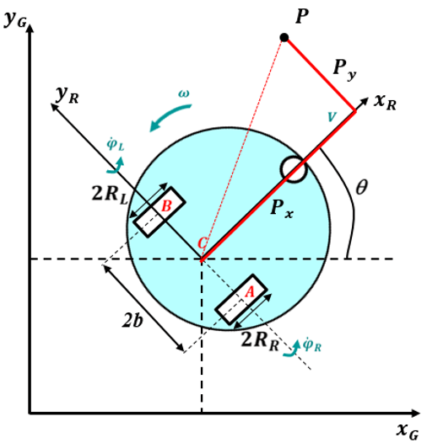
Figure 4.8 Inverse kinematics geometry
To describe the position of the mobile robot (MR) in the workspace, two different coordinate systems are defined (as shown in Figure 4.8):
The robot reference frame is denoted by $\left\{x_{R},y_{R},θ\right\}$.
The axes $\left\{x_{G},y_{G}\right\}$ illustrate the global inertial reference frame.
The position of point P in the global reference frame is given by:
^{G}P=^{G}R_{R}.^{R}P | (4.26)
The position of point C in the global reference frame is:
^{G}C=^{G}C_{R}.^{R}C | (4.27)
From equations (4.26) and (4.27), the relationship between P and C is:
^{G}P – ^{G}C=^{G}R_{R}.(^{R}P – ^{R}C) | (4.28)
The equation is in the form:
$$\begin{aligned}\left[\begin{matrix}K_{P_{x}}\left(x_{ref}-x_{P}\right) \\ K_{P_{y}}\left(y_{ref}-y_{P}\right)\end{matrix}\right]=\left[\begin{matrix}cos\left(θ\right) & (-P_{x}\sin\left(θ\right)-P_{y}\cos\left(θ\right) \\ sin\left(θ\right) & (P_{x}\cos\left(θ\right)-P_{y}\sin\left(θ\right)\end{matrix}\right]\left[\begin{matrix}V \\ ω\end{matrix}\right]\#\left(4.29\right)\end{aligned}$$
Thus, the angular and linear velocities are calculated as:
$$\begin{aligned}\left[\begin{matrix}V \\ ω\end{matrix}\right]=\left[\begin{matrix}\cos\left(θ\right)-\left(\frac{P_{y}}{P_{x}}\right)sin\left(θ\right) & \sin\left(θ\right)+\left(\frac{P_{y}}{P_{x}}\right)cos\left(θ\right) \\ -\left(\frac{1}{P_{x}}\right)sin\left(θ\right) & \left(\frac{1}{P_{x}}\right)cos\left(θ\right)\end{matrix}\right]\left[\begin{matrix}K_{P_{x}}(x_{ref}-x_{P} \\ K_{P_{y}}(y_{ref}-y_{P}\end{matrix}\right]\#\left(4.30\right)\end{aligned}$$
Finally, we use equation (4.30) to calculate the linear and angular velocities $\left(V,ω\right)$ of the robot and determine its pose from equation (4.29).

4.4.3. Dynamics of the Robot Base
A mobile robot can move from one position to another on a planar surface. Its mobility depends on its size, locomotion mechanism, and wheel characteristics. This mobility allows the robot to perform complex tasks and meet dynamic requirements. A mobile robot can operate alongside humans, interact with them, and share the same working space.
There are two kinematic constraints: no lateral and no longitudinal slippage between the wheels and the ground. According to these constraints, the robot is described as:
$$\begin{aligned}{\dot{x}}_{C}\cos\left(θ\right)-{\dot{y}}_{C}\sin\left(θ\right)=0\#\left(4.31\right)\end{aligned} \\ \begin{aligned}{\dot{x}}_{C}\cos\left(θ\right)-{\dot{y}}_{C}\sin\left(θ\right)=\frac{r}{2}\left({\dot{φ}}_{r}{\dot{φ}}_{l}\right)\#\left(4.32\right)\end{aligned}$$
Where (xC, yC) be the robot’s center coordinates. $θ$ is the angle formed by the robot's direction and the x-axis, $φ_{l}$ và $φ_{r}$ are the rotational angles of the left and right wheels.
The dynamic equations of the wheeled mobile robot can be expressed as:
$$\begin{aligned}M\left(q\right)\ddot{q}+C\left(q,\dot{q}\right)+G\left(q\right)+τ_{d}=B\left(q\right)τ+A^{T}\left(q\right)λ\#\left(4.33\right)\end{aligned}$$
Where M(q) being the inertia matrix, C(q,q’) representing the matrix containing the centripetal and Coriolis components, G(g) being the gravity matrix, B(q) being the input transformation matrix, $τ$ representing the applied torques, $A_{T}(q)$ being the Jacobian matrix, $λ$ being the constraint force vector, and q the generalized coordinate vector in the generalized coordinate system, t_{d} is considered as external disturbance. The dynamics model will have the following properties:
$$\begin{aligned}M\left(q\right)=\left[\begin{matrix}m & 0 & 0 \\ 0 & m & 0 \\ 0 & 0 & I\end{matrix}\right]\#\left(4.34\right)\end{aligned} \\ \begin{aligned}A^{T}\left(q\right)=\left[\begin{matrix}-\sin\left(θ\right) \\ \cos\left(θ\right) \\ 0\end{matrix}\right]\#\left(4.35\right)\end{aligned} \\ \begin{aligned}B\left(q\right)=\frac{1}{r}\left[\begin{matrix}\cos\left(θ\right) & \cos\left(θ\right) \\ \sin\left(θ\right) & \sin\left(θ\right) \\ I & -I\end{matrix}\right]\#\left(4.36\right)\end{aligned} \\ \begin{aligned}τ={\left[\begin{matrix}τ_{l} & τ_{r}\end{matrix}\right]}^{T}\#\left(4.37\right)\end{aligned}$$
$$\begin{aligned}λ=-m({\dot{x}}_{C}\cos\left(θ\right)+{\dot{y}}_{C}sin⁡(θ)\dot{θ}\#\left(4.38\right)\end{aligned}$$
With m being the mass of the robot, I the moment of inertia of the robot around the center, τ_{l} and τ_{r}​ are the control signals that generate torques from the left and right wheels. This is suitable for representing the dynamics equation of the robot’s motion with velocity. When the robot is subject to nonholonomic control constraints, the equation becomes:
$$\begin{aligned}A\left(q\right)\dot{q}=0\#\left(4.39\right)\end{aligned}$$
The dynamics of the robot are governed by these non-holonomic constraints. In this study, the robot is a differentially-driven mobile robot. The center of mass is located at the midpoint between the two drive wheels. Each wheel is independently driven by a motor, and the balancing wheel ensures stability on a flat surface. Robot của chúng tôi được thể hiện trong (Hình 4.9) với 2b là khoảng cách giữa hai bánh xe, R là bán kính của mỗi bánh xe, và $θ$ là góc giữa trục x và hướng di chuyển của robot.
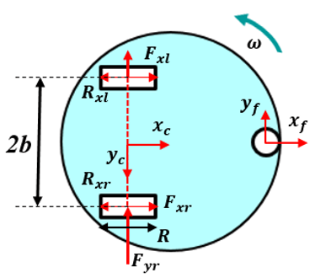
Figure 4.9 Dynamics of the wheeled mobile robot

Assuming no slippage in any direction, the robot is described by:
$$\begin{aligned}{\dot{x}}_{C}cos\left(θ\right)-{\dot{y}}_{C}sin\left(θ\right)=0\#\left(4.40\right)\end{aligned}$$
$$\begin{aligned}{\dot{x}}_{C}cos\left(θ\right)+{\dot{y}}_{C}sin\left(θ\right)=\frac{r}{2}\left({\dot{φ}}_{r}+{\dot{φ}}_{l}\right)\#\left(4.41\right)\end{aligned}$$
The dynamic equation becomes:
$$\begin{aligned}M\left(q\right)\ddot{q}+C\left(q,\dot{q}\right)+G\left(q\right)+τ_{d}=B\left(q\right)τ+A^{T}{\left(q\right)}^{λ}\#\left(4.42\right)\end{aligned}$$
Where:
M(q): Inertia matrix, $\begin{aligned}M\left(q\right)=\left[\begin{matrix}m & 0 & 0 \\ 0 & m & 0 \\ 0 & 0 & I\end{matrix}\right]\#\left(4.43\right)\end{aligned}$
A^{T}: Jacobian matrix, $\begin{aligned}A^{T}\left(q\right)=\left[\begin{matrix}-sin\left(θ\right) \\ cos\left(θ\right) \\ 0\end{matrix}\right]\#\left(4.44\right)\end{aligned}$
B(q): Input transformation matrix, $\begin{aligned}B\left(q\right)=\frac{1}{r}\left[\begin{matrix}cos\left(θ\right) & cos\left(θ\right) \\ sin\left(θ\right) & sin\left(θ\right) \\ I & -I\end{matrix}\right]\#\left(4.45\right)\end{aligned}$
$τ$: Input torques, $\begin{aligned}τ={\left[\begin{matrix}τ_{l} & τ_{r}\end{matrix}\right]}^{T}\#\left(4.46\right)\end{aligned}$
$λ$: Constraint force vector, $\begin{aligned}λ=-m\left({\dot{x}}_{C}\cos\left(θ\right)+{\dot{y}}_{C}sin\left(θ\right)\right)\dot{θ}\#\left(4.47\right)\end{aligned}$
$C\left(q,\dot{q}\right)$: Centrifugal/Coriolis matrix,
$G\left(q\right)$: Gravity vector,
$τ_{d}$: Disturbance vector,
q: State vector
Hence, the robot operates under underactuated (non-holonomic) control:
$$\begin{aligned}A\left(q\right)\dot{q}=0\#\left(4.48\right)\end{aligned}$$

4.5. Dynamics of the Camera Arm
The kinetic energy of the system is expressed as:
$$\begin{aligned}T=\frac{1}{2}m_{T}{\dot{x}}^{2}+\frac{1}{2}J{\dot{θ}}^{2}\#\left(4.49\right)\end{aligned}$$
Where: mT is the mass of the translational transmission rod, J is the moment of inertia of the lead screw and drive shaft, x is the displacement of the linear stage, and θ is the rotational angle of the lead screw.
The displacement x and the rotation angle θ satisfy the following kinematic equation:
$$\begin{aligned}x=cθ\#\left(4.50\right)\end{aligned}$$
Where c is the lead screw constant (m/rad). The virtual work performed by the lead screw is:
$$δW=\left(fx_{0}\right)∙δr_{p}+τδθ,$$
$$=\left(fx_{0}\right)∙δ{xx}_{0}+τδθ,$$
$$\begin{aligned}=\left(cf + τ\right)δθ=Q_{0}δθ\#\left(4.51\right)\end{aligned}$$
Lagrange's equation:
$$\begin{aligned}\frac{d}{dt}\left(\frac{∂T}{∂\dot{θ}}\right)-\frac{∂T}{∂θ}+\frac{∂V}{∂θ}=Q_{θ}\#\left(4.52\right)\end{aligned}$$
$$\begin{aligned}\left(J+m_{T}c^{2}\right)\ddot{θ}=cf+τ\#\left(4.53\right)\end{aligned}$$
The combined set of electrical and mechanical equations for the linear motor is:
$$\begin{aligned}\left(J+m_{T}c^{2}\right)\ddot{θ}=cf+k_{t}i\#\left(4.54\right)\end{aligned}$$
$$\begin{aligned}L\frac{di}{dt}+Ri+k_{b}\dot{θ = e }\#\left(4.55\right)\end{aligned}$$
Trong đó L is the inductance of the motor armature, R is the resistance of the motor armature, kb is the back electromotive force (EMF) constant, kt is the torque constant of the motor, and e is the input voltage. The mechanical system equation can be written in terms of the displacement of the motor as follows:
$$\begin{aligned}\left(m_{T}+\frac{J}{c^{2}}\right)\ddot{x}=f+\frac{1}{c}k_{t}i\#\left(4.56\right)\end{aligned}$$

4.6. Chapter Conclusion
This chapter presented detailed analyses of the kinematics and dynamics of the robot system, including the structure of links and joints, workspace determination, vision-based positioning, and the Jacobian matrix. The derived dynamic equations for both the robot base and the camera arm serve as the foundation for system simulation and control. These results provide a basis for developing intelligent control systems in subsequent chapters.

Chapter 5: Design of the Electrical Control System for the Robot

5.1. Chapter Introduction
Achieving stability and meeting technical requirements in a mechatronic device heavily depends on the mechanical system, as discussed in the previous chapter. However, it is equally important to focus on the electrical control system to ensure stable operation. This chapter aims to analyze, design, and calculate the electrical and control system so that the robot can operate smoothly. By designing the electrical and control systems properly, the performance and functionality of the robot will be significantly improved. This chapter delves into various aspects of the electrical and control systems, offering a comprehensive view of the process of analysis, design, and calculation. Through a systematic process including analysis, design, and calculation, the electrical and control systems can be optimized to meet the desired operational parameters. This optimization process ensures the robot’s long-term stability, accuracy, and efficiency.

5.2. General Design of the Electrical Control System
After designing the mechanical components and determining force-related parameters and technical control specifications for the robot base system, the robot arm, and the automatic charging system, the next step is to set up a general electrical control system and the electrical system for each subsystem. In this chapter, the team presents the block diagram of the robot's electrical control system, the operating principles, and key electronic components used to operate the robot.
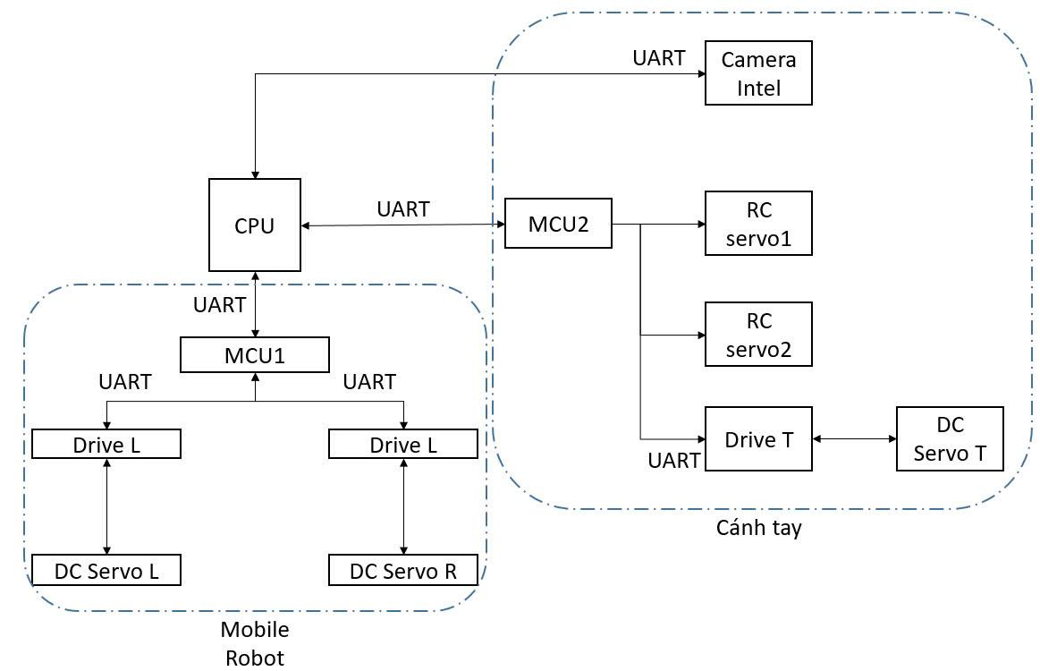
Figure 5.1 Block diagram of the robot control system

5.3. Robot pedestal control system
The robot pedestal control system plays an important role in the automatic operation of the bird's nest monitoring robot. The central controller receives signals from sensors and cameras, which it then processes using algorithms to give commands to control the motors to move and rotate. The control electrical system consists of a central microcontroller and power circuits that convert the control signal into rotational power for the motor. The robot platform is designed with a three-tier structure consisting of mechanical and electronic parts that support flexible and precise operation. The robot uses a differential drive system with two active wheels and one self-selector wheel to ensure stable movement on the bird's nest floor surface.

5.3.1. Overview
The servo DC motor is integrated to control the wheel, providing high torque and accurate position feedback through the encoder. Ultrasonic and infrared sensors are installed around the robot to detect obstacles and assist in collision avoidance. The robot pedestal also integrates a touch screen for users to easily configure and monitor the robot's operation. This system allows the operator to check the operating status of the motor, sensors, and battery level, and adjust the operating parameters remotely.
The robotic pedestal control system is designed to meet specific operational requirements such as moving on a flat surface with small obstacles, operating stably in a bird's nest environment, and supporting automatic functions such as positioning and battery charging. The design of the robot pedestal has taken into account the possibility of expansion to integrate additional sensors or auxiliary mechanisms in the future.
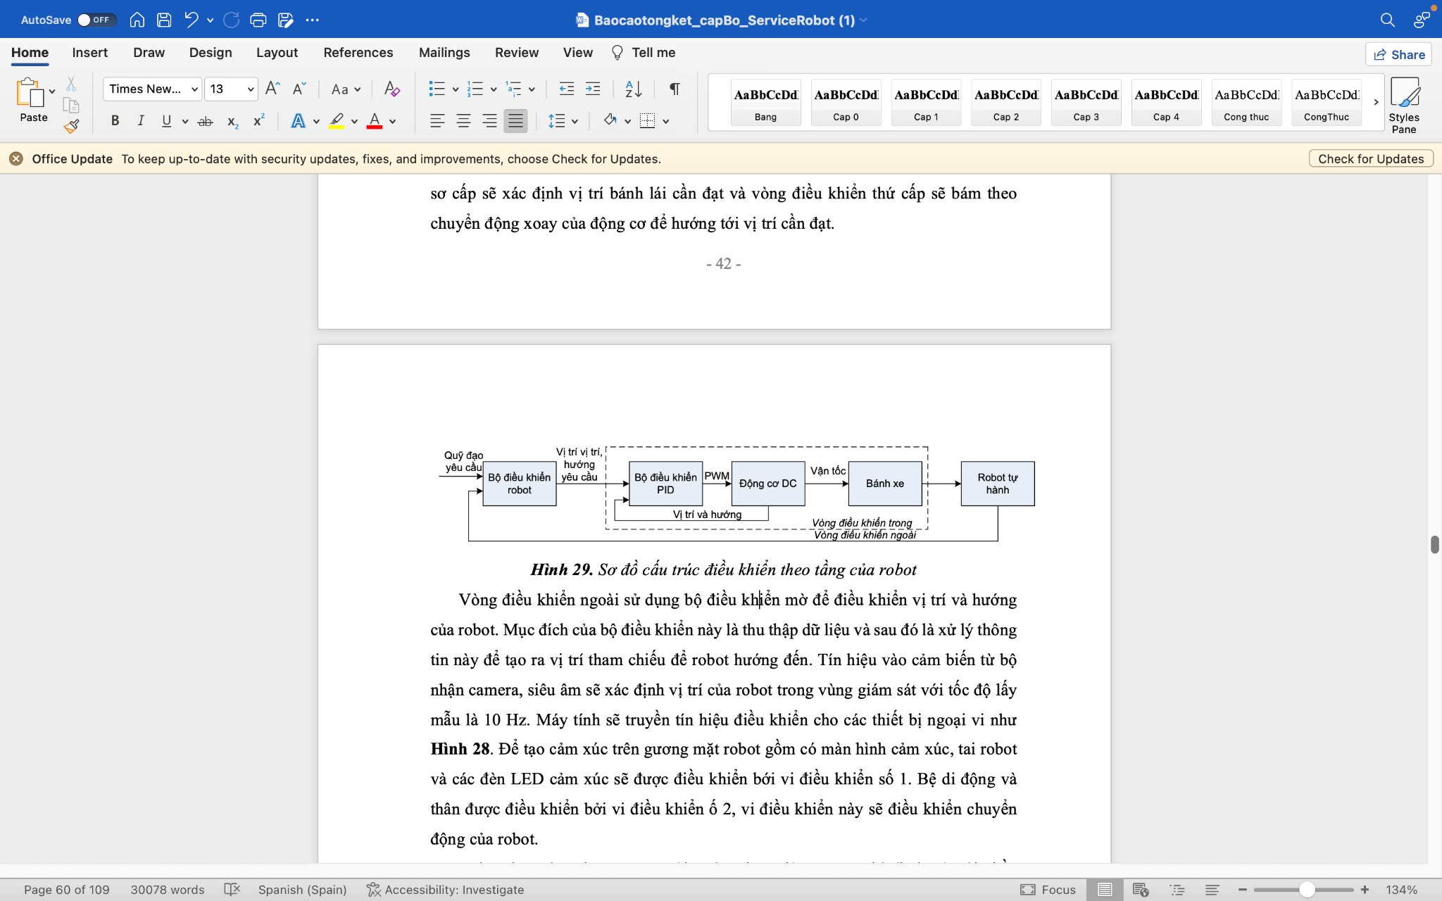
Figure 5.2 Schematic diagram of the layered control structure of the robot
​​ In order for the robot to be good and flexible in the indoor environment, environmental information management needs to be considered. Intelligent positioning, the robot needs 2 types of environmental information: static and global information, described in a flat geometric map that it already has as a relationship of the location of from the starting point to any destination location by routing and local information such as an extract map, obstacles, traffic information for controlling the robot in a dynamic environment. The robot has simple path information to the target and an Information Assistance System (IA), IA is a small communication device installed in the environment to help manage local real-world information.
The controller structure of the service robot is different from the traditional mobile robot, that is, the current service robot integrates the communication and communication between humans and robots with both software and hardware. This connection connects the dynamics of the hardware and the control structure. In applications for service robots, the target is often the robot performing limited operations in a controlled environment and many processes are fully automated by computers. The controller uses different control methods (Figure 5.2). When the robot moves automatically, the traditional control method is to create a path (or retrieve the map) and follow the path of movement along with avoiding obstacles in the environment.
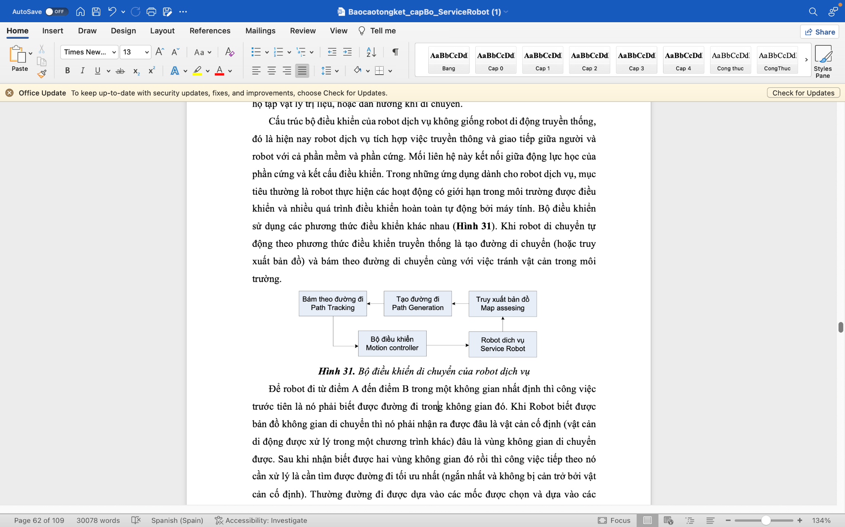
Figure 5.3 Service robot movement controller
In order for the robot to go from point A to point B in a certain space, its first job is to know its way in that space. When the robot knows the map of moving space, it must recognize what is a fixed obstacle (a moving obstacle handled in another program) and which is a movable space area. After recognizing those two spatial regions, the next task it needs to handle is to find the most optimal path (the shortest and not obstructed by fixed obstacles). Often the path is based on the selected landmarks and relies on those landmarks to travel. This is the main content of the A*Search algorithm. From the known space zone before and after the movable zone and the immovable zone have been distinguished. If you use discrete and irregular landmarks, it will take time for the selection of landmarks, and it may also be difficult to identify landmarks. To simplify the process, we divide the survey space into squares of pre-conventioned lengths, as shown in Figure 5.3: The reason for choosing the square is that it is the simplest geometric block and it can also be viewed similarly to pixels. We can completely use other geometric blocks such as hexagons, polygons, and quadrilaterals,...
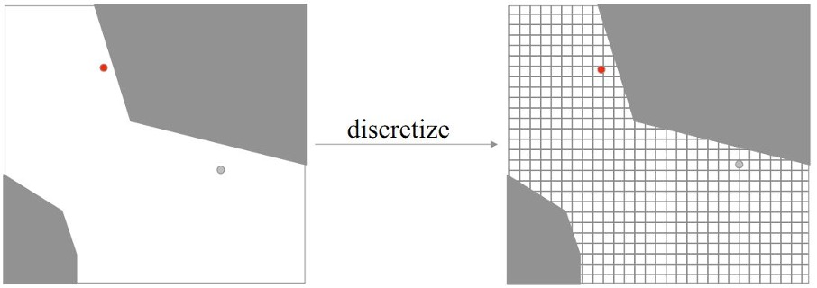
Figure 5.4 Grid the consideration space
The robot's obstacle avoidance program works as described in the following section. When it starts to move in an orbit, the robot uses ultrasonic sensors to identify the object, when the sensor returns with an obstacle in front of it, the robot compares it with the available map. When an obstacle is detected not on the map, the obstacle avoidance program starts working. The robot will temporarily interrupt the active programs, and begin to identify the type of obstruction. By using left and right ultrasonic sensors, the robot will determine the direction of movement, the speed of movement of the obstacle. If it is a moving obstacle, the robot will turn on the counter for 10 seconds, after 10 seconds, if the obstacle remains, the robot will set a trajectory to move parallel and opposite the movement of the obstacle or stop. Once the robot has moved the full length of the obstacle, it will make a new trajectory to move to the destination. End the new obstacle avoidance program. The process of processing information and controlling the robot is carried out as follows:
Conduct obstacle avoidance simulation according to the above control methods to evaluate the operability of the dimming controller, conduct static and dynamic obstacle avoidance assessment. Figure 5.5(a) and Figure 5.5(b) show a fixed obstacle avoidance robot with a radius of small and large r. Figure 5.5(c) avoids the moving obstacle, the robot will wait for the moving object to pass by.
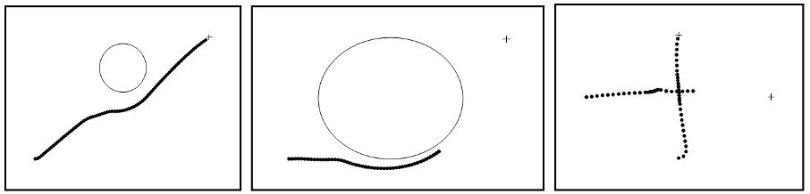
a) b) c)
Figure 5.5 The robot's trajectory of movement avoids obstacles (simulation)
According to the requirements, we can design the closed mechanical platform. This platform needs a power supply to be able to perform the autonomous mission. When the engine works, we must provide the right source of energy. This energy is stored in a battery or battery. There are some differences between these issues that the battery is rechargeable. In this topic, choosing a battery configuration is a key feature in the design process. The size of the battery, voltage, weight, and charging method will be the battery configuration limits throughout the entire design process and directly determine the robot's autonomy.
STT | Characteristic | Parameter
1 | Brand | Delkor DIN 55041
2 | Voltage Voltage | 12V
3 | Capacity | 50Ah
4 | Dimension | 242 x 174 x 190 mm
5 | Mass | 5 kg
Table 5.1 Battery characteristics
In order to achieve the requirements for power supply, we decide to choose a battery and increase the stability of the robot. To increase the stability of the robot, the center of gravity of the robot should be placed as low as possible and located on the normal axis perpendicular to the triangular plane built by the 3 points of the wheel in contact with the background. The battery plays a fairly important role in influencing the robot mass that we want to be as low as possible. Nowadays, voltage brands often use 12V batteries in cars or motorcycles. However, in the future, the voltage of the batteries will increase from 12V to 24V and up to 36V. Battery characteristics are as shown in Table 5.1.
In this section, three fuzzy logic controllers are used to navigate the social service robot from its initial working position (starting point) to the robot's charging station. Each fuzzy logic controller has characteristic member functions as well as different sets to control the speed of each wheel. In order for the robot to reach the target position before performing the auto docking task, the Path Planning Fuzzy Logic Controller (PPFLC) is used in conjunction with the Obstacle Avoidance Fuzzy Logic Controller (OAFLC) to help the robot avoid obstacles during movement. Finally, the robot can be paired into the charging station thanks to the Auto-Pairing Dizzy Logic Controller (ADFLC). Figure 4.7 illustrates PPFLC, OAFLC, and ADFLC fuzzy logic controllers.

5.3.2. Positioning method
The navigation problem is the main challenge in current research on service robots. Researchers are focusing on using modern sensors and hardware systems, as well as developing software algorithms to improve reliability in solving questions related to the robot's positioning in the environment.
The robot's position is calculated based on measurements from the sensors installed on it. However, these sensors still have some limitations when used to calculate the robot's position. Currently, there are a number of modern positioning methods such as using GPS in combination with encoder sensors. However, this method is costly and only suitable for outdoor environments. The second method is to use a Lidar or Camera sensor. Although more accurate, this method is also very expensive and requires complex control techniques.
The next method is dead-reckoning, which is the most commonly used method on mobile robots. The method is based on simple and easily deployable equations, using data from the encoder on the wheel. Dead-reckoning works based on the principle of digitally converting the rotation of the wheel into the corresponding distance traveled by the robot.
Therefore, based on the task and scope of research at the experimental level, this method is considered the most feasible, low-cost, and has an acceptable margin of error thanks to the short experimental time and low cumulative errors. In this study, encoder sensors are used to control the speed of the wheels, then rely on kinematic equations to calculate the robot's position. The robot consists of two independently driven wheels and a castor wheel that helps the robot balance during movement. Figure G depicts the robot's dynamics, allowing to determine the robot's posture (position and orientation) in the environment as it moves.
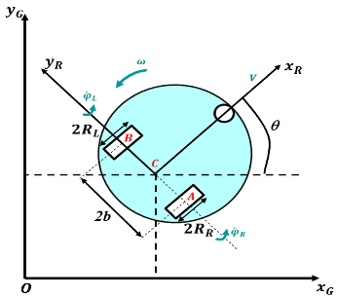
Figure 5.6 Structure of the robot
The kinematic model of a differential-drive mobile robot is described by equations in:
$$\begin{aligned}\left\{\dot{x}=vcos\left(θ\right);\dot{y}=vsin\left(θ\right);\dot{θ}=ω\right\}\#\left(5.1\right)\end{aligned}$$
$$\begin{aligned}\left\{\begin{matrix}\dot{x}=vcos\left(θ\right) \\ \dot{y}=vsin\left(θ\right) \\ \dot{θ}= ω\end{matrix}\right\}\#\left(5.2\right)\end{aligned}$$
The dead-reckoning technique involves estimating the position and direction of movement of a wheeled mobile robot (WMR) based on its current posture at the time t=t(n) to determine the robot's next posture at the time t=t(n+1)
$$\begin{aligned}x_{\left(n=1\right)}=x_{n}+T_{s}v_{\left(n\right)}cos\left(θ_{\left(n\right)}\right)\#\left(5.3\right)\end{aligned}$$
$$\begin{aligned}y_{\left(n=1\right)}=y_{n}+T_{s}v_{\left(n\right)}sin\left(θ_{\left(n\right)}\right)\#\left(5.4\right)\end{aligned}$$
$$\begin{aligned}θ_{\left(n=1\right)}=θ_{n}+ω_{\left(n\right)}T_{s}\#\left(5.5\right)\end{aligned}$$
In conclusion, all of the robot's movements, including avoiding static obstacles and moving to any location in the room, involve path planning. This process involves breaking down the path into segments, and the controller's task is to control the robot to move along those segments in turn.
Each segment is defined by two points with specific coordinates on the robot's plane of motion: the start point ${(x}_{start}$,$y_{start}$,$θ_{start}$) and the end point ${(x}_{goal}$,$y_{goal}$,$θ_{goal}$). This problem can be called "controlling the robot to move from one point to another."
The robot can then automatically pair into the charging station through the camera. Three dim logic controllers have been designed to assist the robot in returning to the charging station.
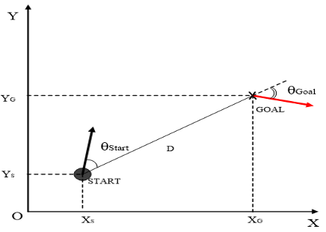
Figure 5.7 Robots move from one point to another

5.4. Camera arm control system
The camera-mounted arm control system is designed based on an actuator that converts rotational motion into translational motion. The DC motor is used to rotate the screw, which in turn creates a translational shift of the camera along the guide bar. This actuator includes a fixed nut on the guide bar to prevent spinning, allowing the camera to move steadily and accurately.
The working space of the robotic arm must be considered to design the movement trajectory for the arm and avoid collision with the robot body. The joint-space and Cartesian space are described in [8]. The shape of the arms, the starting and ending positions, the desired speed of the 4 joints, as well as the safety of the whole arm are considered when choosing the trajectory in Cartesian coordinate space. One method is to look at one of the joints, using a polynomial to create an orbit so that the initial conditions and the final result match the known parameters, starting from a value at the beginning and converting to a new value at the end time. Inverse kinematics and interpolative transformation equations are necessary for trajectory planning.
Next, based on the signal from the position sensor and limit sensor, the central controller adjusts the speed and position of the motor. This ensures that the camera is always quickly adjusted to the right position to monitor the required area. In addition, the system also integrates a correction mechanism to avoid collisions and optimize the camera's travel journey.
Trajectory Planning for the Robotic Arm
We identify the start and end points of the angles with their respective positions using the inverse kinematics problem. The trajectory of each joint must simultaneously meet the limits of velocity and position at the endpoint according to four criteria to ensure stable movement for each joint.

5.5. Automatic battery charging system
If a service robot wants to automatically recharge when the battery voltage is low, it needs to be able to adjust the direction to return to the charging station and perform the automatic charging process. Some important techniques include path planning in both global and local coordinate systems, avoiding obstacles during travel, detecting charging status, and handling faults. Before arriving at the pairing area, the robot operates fully autonomously, relying mainly on its own operability. In the final finishing stage, the robot automatically pairs into the charging station to complete the task.
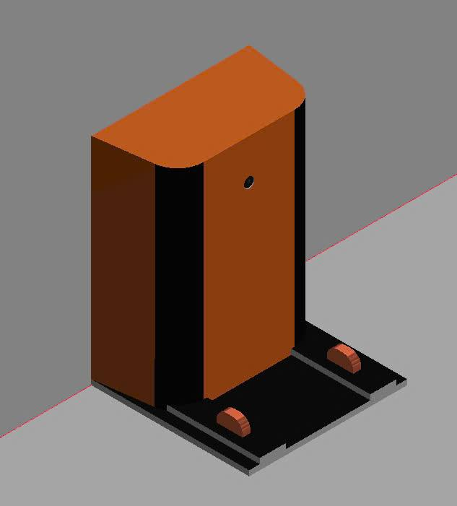
Figure 5.8 Automatic Charging System
In some previous studies, the mobile robot used a Depth Camera and an Aruco Marker barcode on the charger to locate and scan the code to detect the charger, then move to and start the charging process. In this study, we used an RFID system and a pressure gauge. RFID tags help robots accurately locate charging stations without relying on complex navigation systems or optical sensors, making them suitable for low-light environments. Besides, RFID works based on radio frequencies, so it is less likely to be interfered with by environmental factors such as wind or sound, which helps the robot locate more efficiently and is capable of storing unique identification information, which helps to authenticate the charging station accurately, reducing the risk of confusion or errors.

5.6. Power source on the robot and charging
Device | Power (W) | Amount | Total (W)
Camera Control Motor | 2 | 2 | 4
Camera Lift Control Motor | 30 | 1 | 30
Motors on robot pedestals | 30 | 2 | 60
CPU | 100 | 1 | 100
Nitrogen Modulation | 20 | 1 | 20
Other Sensors and Circuits | 1 | 5 | 5
Sum |  |  | 219
Table 5.2 Total capacity of the robot system

The initial requirement for a robotic platform is to perform automated tasks. During operation, robots need a reliable and efficient power supply. In this study, the choice of storage battery will determine the robot's ability to move on its own. Factors such as size, weight, voltage, and charging method will limit the battery configuration throughout the design process. In order to meet the requirements of the power supply, we decided to choose a storage battery to increase the stability of the robot. To achieve better stability, it is important to set the center of gravity of the robot as low as possible. The ideal location should be on an axis perpendicular to the triangular plane created by the three points of contact between the wheel and the ground. The battery plays a crucial role in influencing the overall mass of the robot. Therefore, the goal is to place the battery at the lowest point of the robot. For autonomous robots, the use of portable power sources is absolutely necessary, so in this topic, robots operate with power sources directly supplied from battery sources. Calculating the battery power block for the robot requires that the battery must provide sufficient power for all equipment on the robot and ensure the necessary operating time.
Battery capacity calculation formula:
$$\begin{aligned}AH = \frac{T.W}{V.pf}\#\left(5.6\right)\end{aligned}$$
In which:
• AH: The capacity of the battery.
• W: The total power of the system.
⬥ T: Usage time.
• pf: Performance factor.
• V: Battery voltage.

5.7. Chapter Conclusion
Chapter 5 presents the process of designing and building a general control electrical system for robots, focusing on technical elements to ensure operational stability and efficiency. The content ranges from the analysis and design of electrical system block diagrams, to specific control structures such as robotic pedestal control systems and operational support functions.
The control electrical system has been optimized to support the robot's flexible operation, including accurate positioning, effective obstacle avoidance, and ensuring stable operation in complex environments such as bird's nests. The integration of ultrasound, infrared, servo motors, and advanced control algorithms such as A* Search has improved automation and enhanced interaction between robots and the environment.
In addition, the chapter illustrates the process of processing environmental information, setting the trajectory of movement, and the obstacle avoidance program of the robot. The simulation results have shown that the control system works well in avoiding static and dynamic obstacles, contributing to ensuring safety and efficiency in operation.
Overall, this chapter has provided a solid foundation in the design and optimization of robotic control electrical systems. The results achieved are an important step towards the deployment of real-world robots, meeting operational requirements in specific applications and supporting future extensive research.

Chapter 6: Group identification, positioning and identification

6.1. Chapter Introduction
Current methods of harvesting bird's nest are often carried out manually by harvesters who are often in direct contact with wet and moldy environments, which is not as safe as specialized bird's nest farms. Manual harvesting often encounters limitations in accurately sorting whether nests are ready for harvest, and harvesters can inadvertently discard nests that do not meet the requirements, such as nests containing young birds or eggs, due to a lack of a method of distinguishing between nest types. We propose a new method for harvesting and managing bird's nests using intelligent harvesting robots controlled by Artificial Intelligence (AI). In order to harvest bird's nests efficiently and productively, robots must identify and sort those that are ready to be harvested. Therefore, we have developed an AI image classification system that uses the Pointnet++ deep learning model with MLP (Multi-Layer Perceptron) network structure to process and recognize the point cloud data recorded from the Depth Camera D415. One challenge is to accurately classify the different types of nests while the harvesting robot is in constant motion. For example, when a bird's nest is placed high and obscured, making it impossible to see clearly inside the nest, the robot needs to take photos from various angles and create a 3D image to predict the nest type and nest state. The AI classifier relies on algorithms that analyze images and look for specific characteristics for each nest type. Experiments have been conducted at swiftlet farms with the goal of achieving a harvest accuracy rate of at least 75%. The most suitable nest shape for harvesting has been confirmed through the harvested bird's nest yield. This intelligent nest classification method has made a significant contribution to efficient and accurate harvesting, ensuring a reasonable and comprehensive harvest to minimize resource waste. As we witness the potential of this paradigm shift, the impact goes beyond harvesting bird's nests, paving the way for future applications in smart agriculture and automation.

6.2. Theoretical basis of identity
Smart agriculture is the use of smart technology applied to agriculture with the aim of saving labor, improving product quality and productivity. The profession of caring for and raising nesting swiftlets is an agricultural profession developed in Vietnam. Therefore, care, tracking, and harvesting should use AI in combination with Machine Learning to ensure sustainable development in agriculture. In this section, we describe an AI algorithm for sorting bird's nests in the context of using harvesting and tracking robots. To classify harvestable bird's nests, we use MLP (Multi-Layer Perceptron) deep learning network represented by the Pointnet++ model to analyze the Pointcloud data collected from the Depth Camera. Bird's nest is formed when the nest begins to build, lay eggs, raise children... Therefore, the size and shape of the bird's nest vary differently and no two laws are the same. The location of the bird's nest is also formed randomly and unpredictable. Multi-Layer Perceptron (MLP) is a type of feedforward artificial neural network, which is widely used in machine learning and deep learning due to its simplicity. The network consists of three main components: the input layer, the hidden layers, and the output layer. In 3D problems, MLP often maps spatial coordinates to properties such as labels or lighting, supporting models such as PointNet. Better yet, it's the PointNet++ model with more applications than PointNet. PointNet++ works by extending the PointNet architecture to learn hierarchical local features from point cloud data. First, it samples the points using Farthest Point Sampling (FPS), then groups the neighboring points into small clusters based on spatial distance. In each cluster, the MLP network is used to learn local features, and these features are aggregated through max pooling. This process iterates on multiple levels of abstraction to learn both local and global features, helping the model efficiently process unstructured 3D data for tasks such as classification and segmentation. Depending on the output, there are different layers. Here, we divide into the main output layers: bird's nests, bird's nests located in the corners, ceilings, walls, and walls of the bird's nest. The Pointnet++ model requires the process of learning a large amount of input data. So, one technique used in this process is to augment data from videos recorded directly from the Depth Camera.
Currently, the applications of robots and artificial intelligence in agriculture are increasing. When the skilled labor force in the fields decreases and labor costs increase. To develop sustainable agriculture, farms are always equipped with robots and use artificial intelligence in farming, monitoring, and harvesting to improve productivity at low cost. The visual information to control the robot to perform tasks is known as visual control. Previously, the first robot was applied to harvest citrus in 1960 with a precise harvesting method. And then, the combination of controllers and mobile platforms combined with vision systems has been widely adopted to this day. In agricultural harvesting, robots are almost always associated with visual recognition systems because natural agricultural products have a high degree of diversity in size, shape, texture, weight, color, etc. Besides, the products are randomly located in complex environments. Illumination and the degree of obscuration of objects are also factors that require the application of computer vision and AI. In smart agriculture, using machine vision-based robots to harvest swiftlet nests is a new method being researched. When the lighting environment in the bird's nest harvesting space is very complicated, it is difficult to determine the characteristics of the nest with high recovery rate and accuracy. In terms of application, the deep learning structure with point cloud data is PointNet++ which is proposed for recognizing the stages of swiftlets. The test results show that the model has good accuracy and reliability. The predictions give the location and stage of the bird's nest.
In order to meet the requirements of automatic swiftlet nest harvesting, an internal swiftlet nest harvesting system has been designed and developed. The system includes a mobile platform, a 4-step controller that freely reaches for nest harvesting, and a lidar scanning system for SLAM. The controller is deployed towards the bird's nest location from the bottom up and begins to separate the nest from the wooden frame when harvesting with appropriate movements to ensure the quality of the bird's nest. The moving platform moves the controller and camera to each section, the lidar system is responsible for calibrating the robot's position and direction of movement to determine the location of the bird's nest corresponding to the data on the map obtained at the scene. monitoring system.
Today, processed or pre-processed edible bird's nests and their products are widely produced and commercialized in the market. The products are very popular with users because of their extremely nutritious nutritional properties. Natural swiftlets often nest in caves and cliffs, so exploitation is very dangerous. Therefore, the price of edible bird's nest is often more expensive than other types of bird's nest on the market. Bird's nest in the wild is usually shaped like a cup with a stiff and thick stem because this shape helps protect the eggs or young birds from other animals. Bird's nests are difficult to cling to cliffs in environments with high humidity. Currently, the habitat of swiftlets is shrinking, so they fly to find shelter. Currently, in Southeast Asian countries, there are many houses or factories that produce bird's nest houses. When the bird's nest is harvested in an artificial environment called an indoor bird's nest, the quality of the bird's nest is also equivalent to that of natural bird's nest.
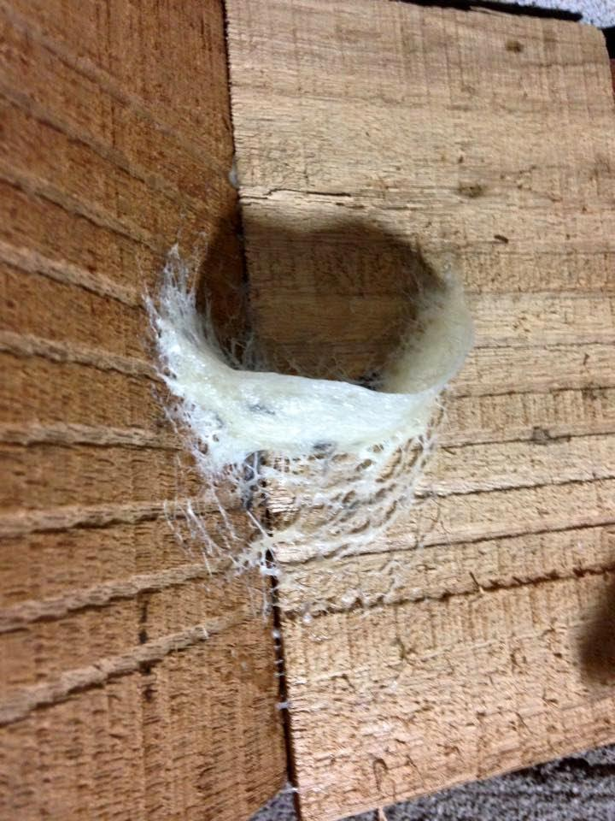 | 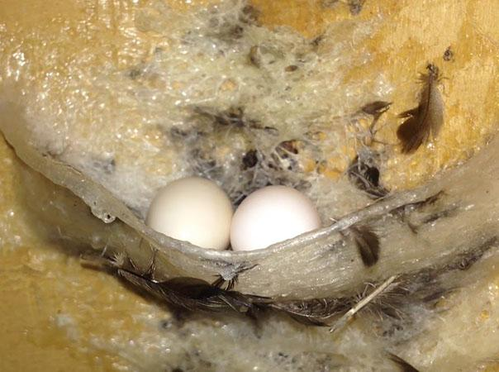
 | 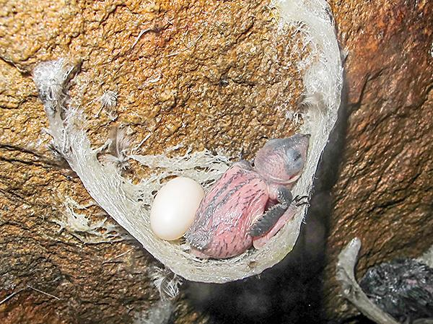

Figure 6.1 Pictures of all types of nests. a) Nests when they are just formed, b) Nests when they have reached love, c) Nests with eggs, d) Nests with young birds
However, the environment in the bird's nest house is quite polluted and toxic, affecting the health of the operator. In addition, when humans enter this environment, it will affect the life and activities of swiftlets. Most of the bird's nests are located on high frames, close to the ceiling, so it is very difficult to monitor and identify the bird's nest even with surveillance cameras.
Swiftlet nests exhibit distinct characteristics depending on their location and purpose. When looking for a suitable place to build a nest, swiftlets often fly to nesting houses with a controlled environment. Indoors, swiftlets often nest on high frames or ceilings. After choosing a location to build a nest, every night the swiftlet uses its saliva to build a nest and after many nights, the nest of the swiftlet is formed. Those birds feel that the nest is big enough, they will nest and lay eggs in the nest. This sequential process is visually depicted in Figure 1, (a) to (d). It is important for the robot to be able to distinguish between different types of nests to ensure accurate harvesting and prevent accidental collection of nests that do not meet the required criteria.

6.3. Application of PointNet++ model in bird's nest identification
Recently, advances in Artificial Intelligence (AI) and robotics have paved the way for innovative solutions in many industries, including agriculture. A notable application of this combination is the proposal to revolutionize bird's nest harvesting through the use of the PointNet++ model to learn the shape and characteristics of bird's nests with point cloud data. By harnessing the power of AI, we can create an intelligent harvesting process, efficiently classify different types of bird's nests, make informed decisions, and manage resources optimally. At the heart of this method is a comprehensive dataset of 3D images of swiftlet nests, including a variety of nest types, different angles, wall walls, and the operating space of the custom robot. The data collection phase ensures a solid foundation for model training, which allows to accurately distinguish nests with eggs, adult birds, young birds, and empty nests.
Before training, these images undergo meticulous pre-processing, including trimming the data, selecting the area of interest, identifying and removing the background plane, and pre-labeling the data such as the ceiling, baffle, and bird's nest to be captured. Point cloud data is collected through scanning of bird's nests with Intel RealSense depth cameras, which are capable of providing detailed 3D spatial information about objects in the environment. This data typically contains information about spatial points in three dimensions, with each point being characterized by a position (x, y, z) and a depth value. However, in order to use this data effectively in monitoring bird's nest quality, data preprocessing steps are crucial. Pre-processing steps include noise filtering, resolution reduction, and data balancing. Noise filtering helps to eliminate unnecessary or noisy spots, such as surrounding points or non-bird's nest objects. Reducing the resolution of the point cloud reduces the computational load during the analysis process without sacrificing the quality of recognition. Data balancing is applied in case of inconsistencies in the dataset, which helps to avoid problems of missing or excess points between the bird's nest and surrounding objects.
With the CNN network with the ability to process irregular and unstructured point cloud datasets, it is used to identify bird's nests from the collected data. The CNN model learns the spatial characteristics of point clouds and applies classification and segmentation methods to identify regions belonging to bird's nests. The process involves importing point cloud data from Intel RealSense depth cameras into the CNN network for analysis, then using the MLP (Multilayer Perceptron) network to learn the features of the points in 3D space, helping the model identify the geometric features of the bird's nest. The PointNet++ model is trained to classify the cloud points and segment the regions of the bird's nest, separating the regions with the characteristic shape of the bird's nest, helping to identify and analyze the condition of the bird's nest.
With the ability to segment and identify the characteristics of the bird's nest, PointNet can be used to monitor the quality of the bird's nest during harvesting and processing. Defects such as cracks, damage, or signs of non-quality can be detected through analysis of bird's nest regions in the point cloud data. The identification system can automatically detect these defects and notify you of the condition of the bird's nest, which helps to improve the quality of the final product.

6.4. Data sets, identification models, results
Experiments are conducted in UEH's laboratory. The database is partially collected on the internet and the rest is taken in a lab. As introduced in the previous section, the bird's nest is built from the saliva of the bird's nest and is placed on the wooden frames of the bird's nest. Most of the nests are located at the top near the ceiling and are randomly distributed unevenly. Rectangular frames measuring 0.5 x 1.0 m are constructed of large timber. The database is divided into 3 sections: the training set (70 .ply files), the validation set (10 .ply files), and the test set (20 .ply files) in a 7:1:2 ratio. The dataset includes images of nests with eggs, nests with chicks, and without eggs. Deep learning requires a large number of images to train, so it is necessary to increase the data by augmentation.
The use of robotic systems for monitoring will open up an advanced and effective approach to collecting and analyzing data across a variety of fields. Robots equipped with sensors, cameras, and advanced AI capabilities can be deployed to collect information in real-time, provide valuable insights, and enhance decision-making. In the context of harvesting and managing bird's nests, robotic monitoring systems can revolutionize the way bird's nests are observed and sorted. The robot is equipped with a combination of cameras, sensors, and AI algorithms that can be tasked with continuously monitoring nesting sites. The following is how such a robotic monitoring system works:
1. Automated Monitoring: The robotic system can be programmed to automatically move through nesting areas, including natural cliffs or purpose-built nesting houses. The system's cameras and sensors will capture high-resolution photos and data at predetermined intervals, ensuring a comprehensive view of the bird's nest and its inhabitants.
2. Data Collection: Robots collect a lot of data, including datasets containing 3D images, temperature, humidity, and possibly even recordings of birds singing. These multimodal data streams provide a comprehensive understanding of nest health, bird behavior, and environmental factors.
3. Real-time analysis: The collected data will be forwarded to an AI processing unit inside the Robot or a central control station. AI algorithms, PointNet++ models, and some fuzzy logic algorithms are used to process real-time data images to detect and classify different types of nests, such as nests with eggs, adult birds, young birds, or empty nests, predict volume, and evaluate the level of nest harvest.
4. Pattern recognition: Over time, AI algorithms can learn to recognize patterns and change in nest status. For example, it can detect fluctuations in temperature or the presence of specific bird calls associated with nesting activity.
5. Alerts and reports: The system can be designed to generate alerts and reports based on its analysis. If the robot identifies nests with specific characteristics, it can send immediate notifications to the operator or trigger specific actions, such as starting a harvest or providing additional care.
6. Adaptability: Robotic systems can be equipped with adaptive sensors to monitor other environmental parameters, such as air quality, light intensity, or even the presence of pests and diseases, providing a comprehensive view of the health of the nesting environment.
With a dataset of 100 files in PLY format containing point cloud data collected by the camera, the PointNet++ model can accurately identify 85.5% of nests with eggs, hatchlings and blanks. However, depending on the intensity of the light, the accuracy can drop to 76.9% in the dark and at night.

6.5. Theoretical basis of positioning with pointcloud data (Pointcloud)
In this section, some basic joint space feedback control methods are introduced. Many variations of these control methods have been mentioned in this study. In this section, the focus is on identifying feedback controllers using measurements or observations collected from cameras or in the form of depth images in the operating space. The problem of control is based on the definition of image and stability and convergence. General methods for achieving asymptotic stability of task space controllers using the calculated twisted moment control strategy suggest that camera image measurements can be used in workspace control formulations. In this section, the image plane coordinates and pixel coordinates will be determined in relation to the camera measurements of the position and orientation of the robotic system. Besides, the interaction matrix involves the derivatives of the image plane coordinates with the angular velocity of the camera frame and the angular velocity of the camera frame in the inertial frame. Regarding the problem of visual servo control based on the image and the torque controller is calculated according to the working space coordinates.

6.5.1. Geometry of camera measurements
Today's robotic control systems use a variety of sensors to measure the configuration and movement of the robotic system during operation. These sensors can include accelerometers, speed gyroscopes, magnetometers, encoders, or global positioning system (GPS) sensors. In this section, we will talk about a basic camera model that can be used to represent the many cameras used in robots for a variety of control tasks. The simplest camera model is applicable to many cameras available in the market based on pinhole cameras or perspective projection cameras.
Today's robotic control systems use a variety of sensors to measure the configuration and movement of the robotic system during operation. These sensors can include accelerometers, speed gyroscopes, magnetometers, encoders, or global positioning system (GPS) sensors. In this section, we will talk about a basic Depth Camera model for calculating and retrieving depth data and Point Cloud (PointCloud). These data streams have a variety of uses. In this report, we will reconstruct the bird's nest model and object recognition with PointCloud data. The simplest Depth Camera model is a pinhole camera. With our research device is the Intel D415 Depth Camera.

6.6. Introduction of Intel RealSense D415 Camera Depth Calculation Technology
The Intel RealSense D415 camera is an advanced device that uses depth sensing technology to reproduce 3D images of real space. Designed with a high-resolution stereo sensor, IR projector, and state-of-the-art processing algorithms, the D415 is used in a wide range of fields such as autonomous robotics, object recognition, and spatial analysis. In particular, thanks to its ability to perform well in a variety of environmental conditions, the D415 offers high accuracy even in complex problems such as scanning homogeneous surfaces or low-light areas.
Stereo Depth Sensor Technology
At the core of the depth calculation system on the D415 is stereo depth sensing technology. This device uses two infrared cameras to collect images from two different perspectives. The basic principle of this method is based on the difference in the position (disparity) of the pixels in the two input images. The triangulation algorithm is then used to calculate the distance from the camera to each point on the object's surface.
The D415's stereo sensor is optimized to handle small details with high precision thanks to its large resolution and narrower viewing angles than other models in the RealSense series, such as the D435. This makes the D415 a suitable choice for applications that require details such as scanning small objects or measuring objects in confined spaces.
Active IR Projector
A major challenge in stereo depth technology is the ability to operate on surfaces with little detail or in poorly lit environments. To fix this, the D415 is equipped with an IR projector that emits a random pattern of infrared light on the surface to be measured. When infrared light interacts with the object's surface, it creates additional details, making it easy for the two infrared cameras to identify and compare similarities. This greatly improves the accuracy and ability of depth analysis in difficult environments, such as flat surfaces or low-light areas.
Sensor characteristics
The D415 is equipped with an infrared sensor and a high-resolution RGB color sensor. Infrared sensors are primarily used to collect depth computing data, while RGB sensors provide color images for integrated applications such as real-space reconstruction or object recognition. The D415's narrow field of view, compared to cameras such as the D435, provides the ability to focus on small details and improve accuracy at close range. This is useful in applications such as detailed 3D scanning or product surface inspection.
Processing algorithm
Processing algorithms are critical to turning data from sensors into accurate depth maps. The main steps in the D415's depth data processing process include:
Detection of Similarity Pairs: Two images from infrared cameras are analyzed to find similarity pairs based on local characteristics. IR projectors help to enhance the number of similarities on surfaces with little detail.
Calculating disparity: The difference in the position of similarities in two images is used to calculate disparity.
Triangulation: Based on disparity, the triangulation algorithm calculates the exact distance to each point. Nearby points have a greater disparity, while distant points have a small disparity.
Filtering and Calibration: Filtering techniques are applied to remove noise from the data, such as smoothing, outlier detection, and interpolation to improve the continuity of the depth map.
RGB Data Integration: After depth calculation, the information from the RGB color sensor is combined to produce a 3D image with clearer and more accurate colors.
The system is also capable of automatically adjusting parameters such as exposure and IR intensity to optimize data quality in changing environmental conditions.
Application in bird's nest
Thanks to its powerful combination of hardware and software, the Intel RealSense D415 is an ideal choice for applications in the industrial, research, and consumer sectors. From 3D reproduction in the design and construction industries to automated navigation for robots, this technology is opening up many new possibilities for interacting with real space accurately and efficiently. [11]

6.6.1. Geometric Model of Intel D415 Depth Camera
The Intel RealSense D415 uses Stereo Vision technology to calculate depth, combined with a dual-lens design and an RGB camera. The geometry of this system follows the basic principles of stereo vision, but is customized to suit the specific hardware of the D415.

6.6.2 Configuration and Specifications of the D415
The stereo camera includes two infrared sensors, each capturing images from different perspectives. The RGB camera is integrated to support color recognition.
The infrared emitter projects a patterned IR light to enhance detail recognition in low-structure environments. For depth calculation, the infrared emitter generates a structured light pattern to improve correspondence between pixels in the left and right images. Corresponding points in the two images are detected to calculate disparity. Disparity is then used to infer depth using the formula:
$$\begin{aligned}Z=\frac{f.B}{d}\#\left(6.1\right)\end{aligned}$$
Where:
$Z$: Distance to the object (depth).
$f$: Focal length of the system.
$B$: Baseline (distance between the two cameras).
$d$: Disparity (the pixel position difference between the two images).
Projection Equation from 3D Space to the Image Plane
The entire process of projecting a point from world space to image space is described by the following equation:
$$\begin{aligned}x=K\left[R|t\right]X\#\left(6.2\right)\end{aligned}$$
Where:
$X={\left[X,Y,Z,1\right]}^{T} :$The coordinates of the point in world space (in homogeneous coordinates, 4x1).
$\left[R | t\right]$: The extrinsic matrix (3x4), describing the rotation and translation from world space to camera space.
$K$: The intrinsic matrix of the camera (3x3), describing the optical characteristics of the camera.
$x={[u,v,1]}^{T}$ : The coordinates of the point in image space (in homogeneous coordinates, 3x1).
Equation Analysis
Extrinsic Matrix:
Transforms coordinates from the world coordinate system to the camera coordinate system:
$$\begin{aligned}X_{C}=RX_{W}+t\#\left(6.3\right)\end{aligned}$$
$X_{C}{=[X_{C},Y_{C},Z_{C}]}^{T}$: Coordinates of the point in the camera coordinate system.
$X_{W}{=[X_{W},Y_{W},Z_{W}]}^{T}$: Coordinates of the point in the world coordinate system.
Represented as a 3x4 matrix:
$$\begin{aligned}\left[\begin{matrix}X_{C} \\ Y_{C} \\ Z_{C}\end{matrix}\right]=\left[\begin{matrix}R & t\end{matrix}\right]\left[\begin{matrix}\begin{matrix}X_{W} \\ Y_{W}\end{matrix} \\ Z_{W} \\ 1\end{matrix}\right]\#\left(6.4\right)\end{aligned}$$
Intrinsic Matrix:
The intrinsic matrix $K$ transforms coordinates from the camera space to pixel space (image plane):
$$\begin{aligned}x=KX_{C}\#\left(6.5\right)\end{aligned}$$
Expanded Formula:
$$\begin{aligned}\left[\begin{matrix}u \\ v \\ 1\end{matrix}\right]=\left[\begin{matrix}f_{x} & 0 & c_{x} \\ 0 & f_{y} & c_{y} \\ 0 & 0 & 1\end{matrix}\right]\left[\begin{matrix}X_{C}/Z_{C} \\ Y_{C}/Z_{C} \\ 1\end{matrix}\right]\#\left(6.6\right)\end{aligned}$$
Where:
$u,v:$Pixel coordinates on the image.
$X_{C},Y_{C},Z_{C}$: Coordinates in the camera space.
$f_{x},f_{y}$: Focal lengths along the x and y axes.
$c_{x},c_{y}$: Principal point of the image.
Complete Formula
By combining the two steps above, we obtain the final equation:
$$\left[\begin{matrix}u \\ v \\ 1\end{matrix}\right]=K[\begin{matrix}R & t]\left[\begin{matrix}\begin{matrix}X_{W} \\ Y_{W}\end{matrix} \\ Z_{W} \\ 1\end{matrix}\right]\end{matrix}(6.7)$$
Essential Matrix ($E$)
The essential matrix ($E$) describes the relationship between the two cameras in the camera coordinate space.
$$\begin{aligned}E = R∙{\left[t\right]}_{x}\#\left(6.8\right)\end{aligned}$$

Where:
${[t]}_{x}$ The skew-symmetric matrix of vector t, calculated as:
$$\begin{aligned}{\left[t\right]}_{x}= \left[\begin{matrix}0 & {-t}_{z} & t_{y} \\ t_{z} & 0 & -t_{x} \\ -t_{y} & t_{x} & 0\end{matrix}\right]\#\left(6.9\right)\end{aligned}$$
If ${[t]}_{x}={[\begin{matrix}B & 0 & 0\end{matrix}]}^{T}$, then:
$$\begin{aligned}{\left[t\right]}_{x}= \left[\begin{matrix}0 & 0 & 0 \\ 0 & 0 & -B \\ 0 & B & 0\end{matrix}\right]\#\left(6.10\right)\end{aligned}$$
When combined with $R$, we obtain:

$$\begin{aligned}E= \left[\begin{matrix}0 & 0 & 0 \\ 0 & 0 & -B \\ 0 & B & 0\end{matrix}\right]\#\left(6.11\right)\end{aligned}$$
Fundamental Matrix ($F$)
The fundamental matrix ($F$) describes the relationship between the two images in pixel space.
$${{F=(K}_{2}}^{-T})∙E∙({K_{1}}^{-1}) (6.12)$$

Where:
$K_{1}, K_{2}:$The intrinsic matrices of the left and right cameras.
E: Essential Matrix
Detailed Depth Computation Process
Stereo Matching:
Find corresponding pixels in the left and right images:
For a point in the left image $(x_{L}, y_{L})$ , the corresponding point in the right image has the same vertical coordinate $y_{R}=y_{L}$​, but a different horizontal coordinate $x_{R}$.
Disparity
$$\begin{aligned}d=x_{L}-x_{R}\#\left(6.13\right)\end{aligned}$$

Disparity $d$ is the pixel distance between the two corresponding points.
Depth calculation based on the stereo model:
$$\begin{aligned}Z=\frac{f_{x}.B}{d}\#\left(6.14\right)\end{aligned}$$
Distortion Correction:
Images captured by the two cameras often suffer from lens distortion. The D415 software uses calibration parameters to correct these distortions and return accurate images.
Use of Patterned Light:
In texture-less environments, patterned IR light helps generate distinctive features to improve disparity estimation.

6.6.3. Point Coordinates
To determine the coordinates of a point in real space from the point cloud data of the Intel D415 depth camera, we need to follow these steps based on the camera's parameters and the sensor's output data.
Each pixel in the depth image (depth map) has a depth value Z, which is calculated using the following formula:
$$\begin{aligned}X=\frac{\left(u -c_{x}\right). Z}{f_{x}}\#\left(6.15\right)\end{aligned}$$
$$\begin{aligned}Y=\frac{\left(u -c_{y}\right). Z}{f_{y}}\#\left(6.16\right)\end{aligned}$$
$$\begin{aligned}Z=D\left(u,v\right)\#\left(6.17\right)\end{aligned}$$
Where:
$(X,Y,Z)$: The coordinates of the point in 3D space, determined in the camera's reference frame.
$D(u,v)$: The depth value at the pixel $(u,v)$, typically measured in millimeters or meters, extracted from the depth image (depth map).
$(u,v)$: The pixel coordinates on the image (in terms of row and column).
$(c_{x},c_{y})$: The principal point coordinates from the camera's intrinsic matrix.
$(f_{x},f_{y})$: The focal lengths along the x and y axes from the camera's intrinsic matrix.
Matrix Representation:
The above equations can be represented in matrix form:
$$\begin{aligned}\left[\begin{matrix}X \\ Y \\ Z\end{matrix}\right]=\left[\begin{matrix}\frac{1}{f_{x}} & 0 & -\frac{c_{x}}{f_{x}} \\ 0 & \frac{1}{f_{y}} & -\frac{c_{y}}{f_{y}} \\ 0 & 0 & 1\end{matrix}\right].\left[\begin{matrix}u.Z \\ v.Z \\ Z\end{matrix}\right]\#\left(6.18\right)\end{aligned}$$

Depth Map:
Each pixel in the depth image contains the value $D\left(u,v\right)$, which represents the distance from the camera to the object at the position $\left(u,v\right)$.
Camera Intrinsic Parameters:
The intrinsic matrix $K$ is typically extracted from the camera calibration process:
$$\begin{aligned}K = \left[\begin{matrix}f_{x} & 0 & c_{x} \\ 0 & f_{y} & c_{y} \\ 0 & 0 & 1\end{matrix}\right]\#\left(6.19\right)\end{aligned}$$

Image Resolution:
Used to map the pixel$(u,v)$ accurately with the depth value.

6.7. Reconstruction Application in Localization with Landmarks
LiDAR SLAM (Simultaneous Localization and Mapping) relies on the use of LiDAR sensors to collect detailed 2D or 3D point cloud data of the environment. Our LiDAR model, called A1M8, manufactured by RPLidar, is only capable of sampling 2D data at 360 degrees. We position the sensors horizontally on a structure to provide an all-encompassing view of the surrounding environment, without the need for additional tilt functionality, to simplify the setup. However, the LiDAR is mounted on a retractable structure that can reach the desired height and effectively capture all the surrounding data. We use the RPLidar library, which is provided in Python, to decode LiDAR data from the COM port, which includes three columns of values: the light intensity from the object, the distance between the object and LiDAR, and the angle between the distance vector and the initial axis, which is reset every time the LiDAR is powered on. The data is converted from the UART standard to the COM port via a UART-to-USB module provided by the manufacturer. The LiDAR sensor is moved along with the robot and is also lowered or raised by the structure, so we need to synchronize the data collection from LiDAR and the 200 PR encoder to ensure accurate alignment of the captured point clouds. After this step, we reduce the computational cost by downsampling through voxelization and cleaning the captured point cloud data by removing outliers using statistical methods. Voxelization essentially involves two steps: dividing the space into uniform voxels—3D pixels—to include data points, and averaging all points in a voxel. Outlier removal statistically ensures the data quality by calculating the average distance from a point to its designated neighboring points for all points. Then, each point will be identified as inlier or outlier by comparing the average distance of the neighboring point with the total average distance and the standard deviation, which may change.
Since the speed of light is always constant, the distance between the LiDAR and the object can be estimated using the formula: {[c(speed of flight) x t(time of flight)]/2}. When LiDAR performs a 360-degree scan, there will be system errors, and the statistics of the obtained distance (rcap) will be fed into the system, causing distortion in the real distance value (rreal). According to [18], statistical error ($ε_{stat}$) is usually assumed to be normally distributed with variance and mean. Therefore, we can estimate as follows.

6.8. Point Cloud and Localization

6.8.1. Localization Results in Spatial Structure
Point cloud data from the Intel RealSense camera is processed through a deep learning model, and the results show the ability to accurately localize components in the spatial structure of the birdhouse. During this process, large surfaces such as walls and ceilings are accurately identified thanks to stable geometric features and high point density. The segmentation system successfully extracted these planes, providing a solid foundation for localizing smaller details such as shelves and bird nests.
Visually, the localization results are clearly shown through the segmentation of different areas. The walls and ceilings are represented by large, homogeneous point clusters, with no overlap with other details, reflecting the accuracy of the model in processing the 3D space. Notably, the model allows the identification of occluded or partially shielded areas, thanks to its deep learning capabilities from local data, ensuring that no area is left unrecognized in the space.

6.8.2. Segmentation and Recognition after Deep Learning
The deep learning process not only identifies large surfaces but also successfully segments more detailed layers of data. Specifically, after data segmentation:
Flat surfaces (walls, ceilings): Large flat surfaces such as walls and ceilings are clearly identified and distinguished from other objects. This segmentation ensures that the foundational areas of the swiftlet house space are accurately reconstructed.
Swiftlet nest compartments: The compartments are individually segmented, with distinct features such as size, position, and shape clearly represented. Recognizing these compartments not only aids in assessing storage capacity but also supports the distribution of nests within the space.
Swiftlet nests: Clusters of swiftlet nests are accurately extracted from surrounding surfaces. This is achieved by identifying specific characteristics of the nests, including their complex shapes and high point density.
The results of the data segmentation demonstrate the model’s superior capability in distinguishing objects, visually and precisely highlighting them within the swiftlet house space. This recognition system is not only useful for managing the nests but also provides valuable insights for evaluating the effectiveness of the house design and optimizing storage space.

6.8.3. Evaluation of Localization and Reconstruction Capability
Point cloud data from multiple scans are merged to reconstruct the spatial structure of the swiftlet house, creating a complete model that clearly reflects the structure and layout of the entire environment. The reconstruction process has provided key outcomes:
Overall structure: The spatial layout of the swiftlet house is accurately reconstructed, including the position, shape, and size of walls, ceilings, and nest compartments.
Nest distribution: The positions and densities of nests are clearly displayed, helping to evaluate the distribution efficiency and growth condition of each area.
Anomaly detection: During reconstruction, surface defects or damage to compartments and ceilings are visually identified, supporting maintenance and improving the living environment for the birds.
The combination of accurate localization and detailed space reconstruction from the point cloud offers a comprehensive view of the swiftlet house, effectively supporting the management, maintenance, and optimization of the modern nest environment.

6.9. Theoretical Foundation of Historical-Based Identification and Blockchain Technology
Historical-based identification is the process of using historical data to identify and classify objects, events, or processes. In many modern technological applications, applying historical-based identification models involves not only data collected from sensors but also recording and verifying information over time to ensure accuracy, security, and data reusability. One outstanding technology that supports this is Blockchain.
Blockchain, with its features of security, transparency, and immutability, offers a powerful approach for historical-based identification. It provides a data storage platform without third-party intervention, allowing reliable access and verification of information.
Blockchain is a decentralized technology with no central authority, where data is stored in blocks and each block is linked to the previous one (forming a chain). Each transaction or modification in the blockchain is validated by a network of nodes before being recorded, and once data is stored, it cannot be altered or deleted. This ensures data security, transparency, and tamper-resistance.
Blockchain technology can be applied to historical-based identification in various domains such as data management, product traceability, authentication and asset ownership protection, and many other applications. Below are several ways Blockchain can support historical-based identification.

6.10. Labeling and Data Storage

6.10.1. Overview
In the context of applying deep learning technology to recognize swiftlet nests from point cloud data, data labeling plays a core role in creating a high-quality training dataset for the PointNet++ model. Combining modern labeling tools with blockchain-based identification not only ensures label accuracy but also enhances data security and traceability.

6.10.2. Labeling Process for Swiftlet Nest Data from Point Clouds
Identifying swiftlet nests requires highly accurate input data and properly assigned labels so the deep learning model can distinguish nests from other elements such as wall surfaces or surrounding objects. This process includes the following main steps: First, point cloud data collected from sensors—such as the Intel RealSense D415 camera—is pre-processed by filtering noise and aligning data to remove redundant or irrelevant points. Next, tools like CloudCompare or point cloud labeling software with automation support are used to identify nest regions and specifically label the points belonging to nests with tags such as "Nest," while marking other objects as "Wall" or "Noise."
Additionally, a pre-trained version of the PointNet++ model can be used to automatically segment clusters of nest points. These results are then manually verified and corrected to ensure the highest level of accuracy.

6.10.3. Data Storage and Identification via Blockchain
To ensure data integrity and support traceability, labeled point cloud data is stored with blockchain-based identification. Each labeled point cloud dataset is assigned a unique identifier (hash) using encryption algorithms such as SHA-256 and recorded on a blockchain. Relevant information—including the data ID, time of collection and labeling, the person responsible, and a brief description of the data characteristics (number of points and nest ratio in the dataset)—is stored on either a public or private blockchain to guarantee transparency and security. The point cloud data itself is stored on traditional or decentralized storage systems such as IPFS and linked to blocks on the blockchain, ensuring immutability and data safety.

6.10.4. Challenges and Solutions
Complexity in labeling nests: Swiftlet nests have irregular shapes and are often attached to wall surfaces or located in occluded areas, making labeling difficult. Using deep learning algorithms to assist with initial segmentation can help reduce time and effort.
Integrating blockchain without increasing cost: Blockchain systems can incur high transaction fees if not optimized. A solution is to use lightweight blockchain platforms like Hyperledger or Ethereum Layer-2 to minimize costs.

6.10.5. Applications and Potential
Implementing this process improves the efficiency of nest recognition tasks, offering key benefits:
High-quality labeled datasets can train the PointNet++ model to distinguish swiftlet nests in complex environments.
Blockchain ensures that point cloud data cannot be altered or forged, increasing transparency and trust.

6.11. Decision-Making and Results
The swiftlet nest recognition robot system is designed to operate in complete darkness inside the nest house, where light is either absent or severely limited. Therefore, the RealSense D415 camera relies solely on point cloud data for analysis and decision-making. The system's objective is to classify nests into specific categories such as harvestable nests, incomplete nests, or damaged nests, providing information for harvesting robots or humans to act accurately.

6.11.1. Decision-Making Process
The system follows the steps below to analyze the data and make decisions:
Point Cloud Data Collection:
The Intel RealSense D415 camera is integrated into a robot that moves through the swiftlet house to scan areas containing nests. The point cloud data is collected at high resolution, accurately reflecting the 3D structure of the nests, wall surfaces, and surrounding environmental details.
Data Preprocessing:
To remove noise and optimize data quality, the system performs:
Filtering out irrelevant or redundant points such as foreign objects or noise not related to the nests.
Aligning the point cloud with a reference model to ensure spatial accuracy.
Data Analysis and Labeling:
Using the deep learning model PointNet++, the system segments the point cloud to separate nests from other parts like walls or occluded corners. Based on the nest's shape, size, and continuity, the system assigns labels to each cluster:
Harvestable Nest: Full size and meets standards.
Incomplete Nest: Needs more time to develop.
Damaged Nest: Shows signs of cracks, breakage, or poor quality.
Decision Processing:
After labeling, the information is compiled and sent to the central control system for planning. The plan includes specifying the exact positions of nests for harvesting robots or human workers to act accordingly.
Blockchain Integration for Data Security
Assigning Unique Identifiers:
Each labeled nest in the point cloud data is given a unique identifier (hash) based on key attributes such as spatial location, label type, and scan time.
Recording Data on the Blockchain:
These identifiers and related nest information are stored in a private blockchain to ensure immutability and traceability. This prevents important data from being tampered with or forged.
Interaction with Other Robots:
Data recorded on the blockchain is shared with harvesting robots. Each robot can retrieve information directly from the blockchain without repeating the recognition process, reducing operational time and improving efficiency.
Experimental Results
The system was tested in a real swiftlet house environment and achieved impressive results. The classification accuracy reached 97% for identifying harvestable nests, with the lowest error rate in classifying incomplete and damaged nests. Processing time per nest was 1.8 seconds, meeting real-time operation requirements. The system also demonstrated effective coordination through blockchain-registered data, enabling multiple robots to operate simultaneously without conflicts or duplicated tasks. Furthermore, the system proved effective in optimizing the nest recognition process, ensuring accuracy and reliability even in low-light or completely dark environments.

Chapter 7: Results and Experimental Evaluation
There are three key factors to consider when evaluating the overall effectiveness of a robot system used for monitoring swiftlet nests in a nest house. These criteria must ensure that the robot operates in either fully autonomous or semi-autonomous modes controlled from a central monitoring station. The robot must also be capable of user-friendly interaction via an interactive interface connected to the control center. A graphical user interface system is developed to establish a user-robot interaction platform. The applications are designed to interact efficiently with real-world environments, supported by user interface design and the robot's auxiliary functionalities.

7.1. Base Design Results
The robot was also tested within an indoor environment resembling an office, containing fixed obstacles such as desks, chairs, bookshelves, and cardboard boxes (as shown in Figure 7.1). The robot is required to plan a path and navigate toward a target without colliding with any obstacles. In the corresponding map, fixed obstacles are digitized into black and white zones—white areas represent regions the robot can move through, while black areas are non-traversable due to obstacles. The A* algorithm is used to compute the shortest path to the target.
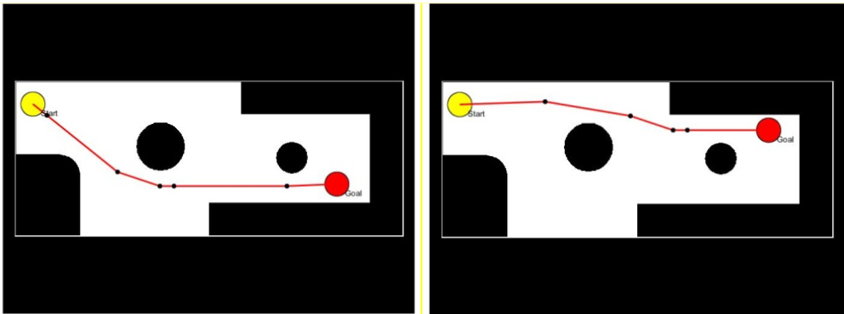
Figure 7.1 Result of the Shortest Pathfinding Algorithm
The output of this pathfinding algorithm is a sequence of coordinate points, which divide the planned path into several straight-line segments. The robot must use a fuzzy controller to sequentially move through each of these segments until it reaches the final point and stops. At each point along the path, the robot must have full information about its coordinates (x Goal ,y Goal , Start ).The point-to-point movement algorithm serves as the foundational algorithm for the robot’s motion throughout the defined space. Any path planning to a target location is broken into smaller straight-line segments. The fuzzy controller commands the robot to move through each segment until it completes the planned route.
Thus, the robot’s ability to follow the planned path accurately depends entirely on the precision of the fuzzy controller. This section evaluates the controller’s accuracy through simulations of the robot’s movement trajectory under predefined input conditions. Assuming the robot starts at position Start (0, 0, 0), it is programmed to move toward various target points.
Regarding movement trajectories, each target leads to a different path. The fuzzy controller has guided the robot to follow curved trajectories as seen in the simulated scenarios in Figure 7.1. These curves help the robot move smoothly and continuously. However, large turning radii increase the risk of collisions in tight spaces. The turning radius depends on the angle formed by the robot’s heading vector and the straight line connecting the start and goal points.
From a kinematic perspective, reducing the turning radius can be achieved by lowering the robot’s linear velocity V(t) and increasing its rotational velocity ω(t). In terms of fuzzy controller parameters, this can be adjusted by modifying the fuzzy rule corresponding to the angle input in the Start condition. In this experiment, the fuzzy controller is used to guide the robot along the planned path. The experimental space is the floor of the Robotics and AI Laboratory at Campus B of the University of Economics Ho Chi Minh City, measuring 5800 x 4600 mm, with fixed obstacles (black areas) as shown in Figure 7.1. The map is constructed at a 1:10 scale relative to the actual dimensions to facilitate comparisons between software simulations and physical experiments. The path planning process is calculated on this map, and the computer simulates the entire robot motion along the path. If the simulation is successful, a sequence of coordinates defining the planned route is sent to the robot model for execution.
As noted earlier, the point-to-point movement algorithm is fundamental for all robot navigation in defined environments. Every path to a destination is broken into smaller straight segments, which the fuzzy controller sequentially processes until the full path is completed. Hence, the accuracy of the robot’s navigation strictly depends on the precision of the fuzzy controller. This section validates the controller’s performance through trajectory simulations using predefined input scenarios.
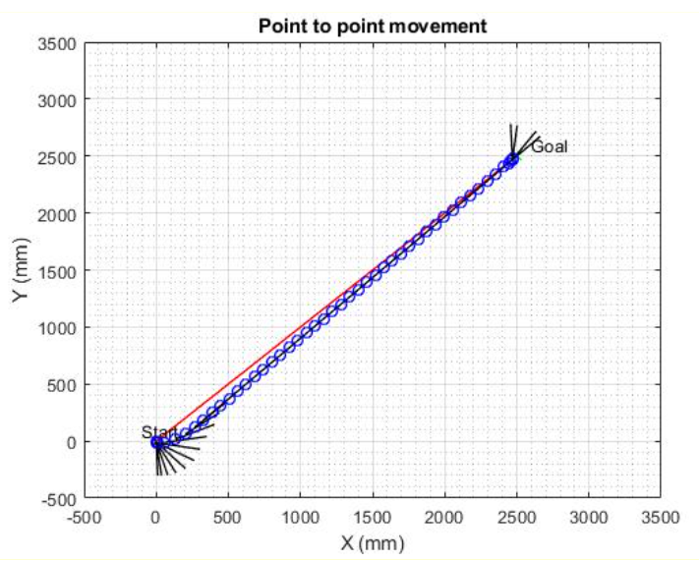
Figure 7.2 Position Response
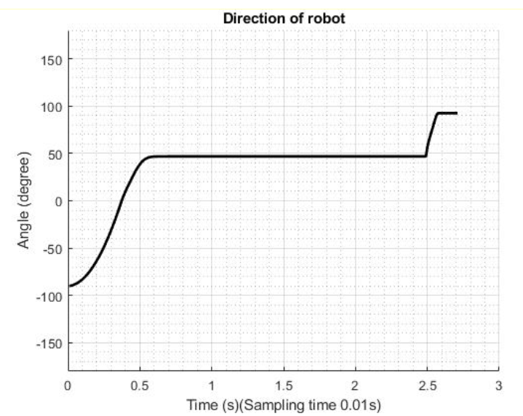
Figure 7.3 Robot Rotation Angle Response

7.2. Camera Design Results
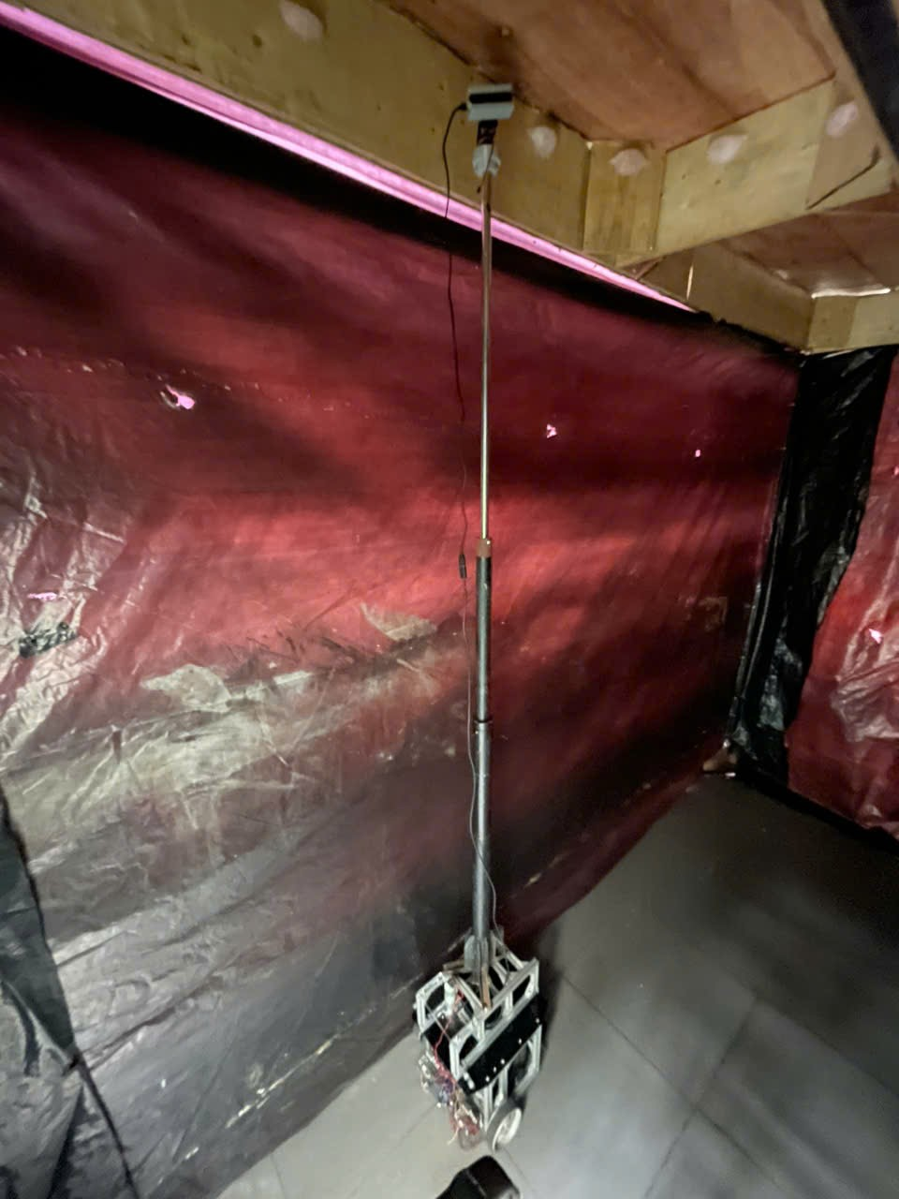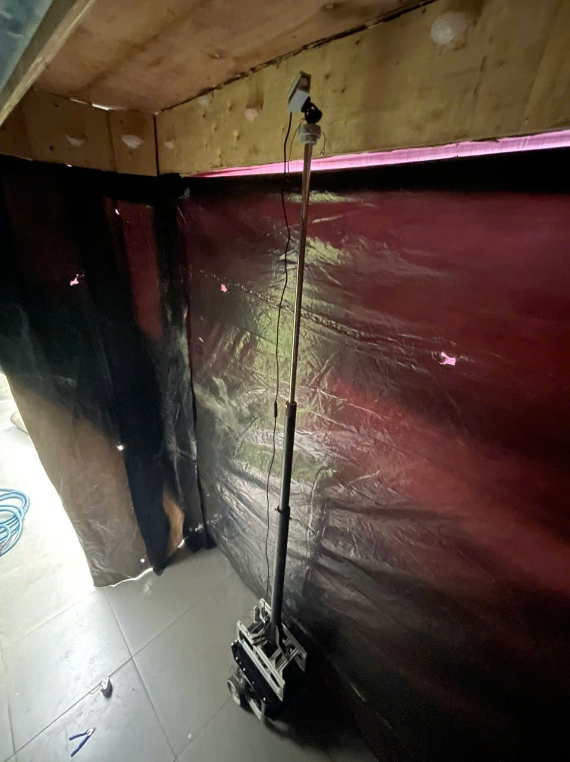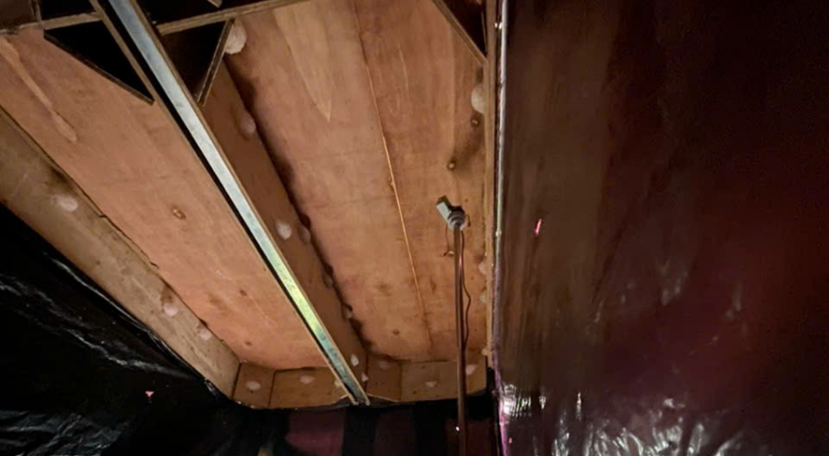
Figure 7.4 Camera Position

7.3. Mobile Base Design Results
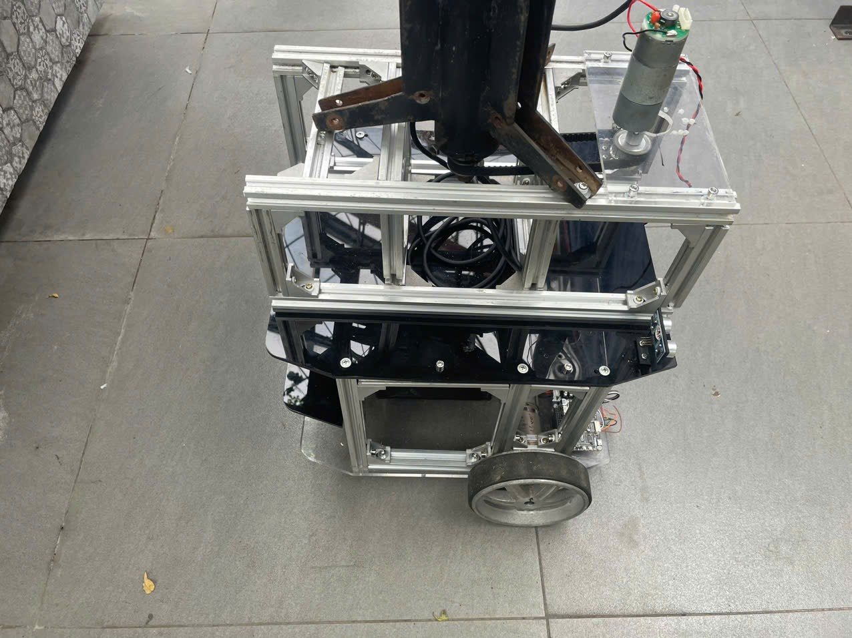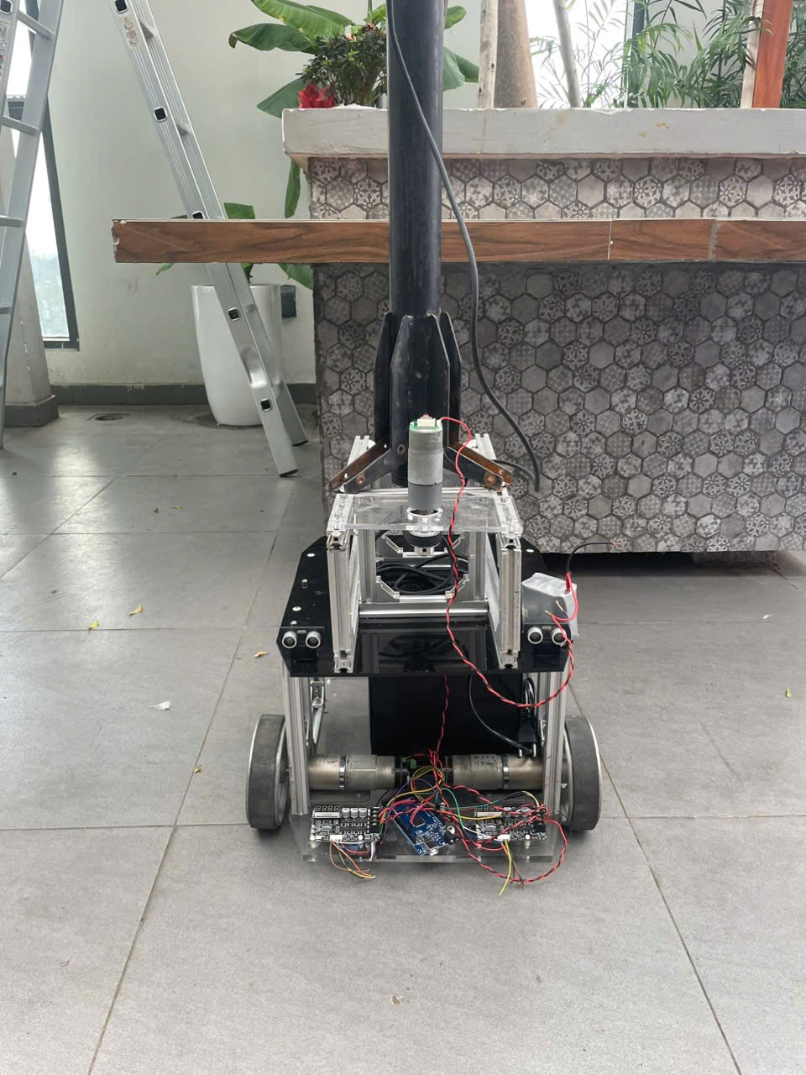
Figure 7.5 Mobile Base Design

7.4. Charging Base Design Results
Wheeled robots generally have high energy efficiency and are easy to control. A primary goal of the four-wheeled robot used in this study is to move in a square path measuring 30 inches by 30 inches near the charging station, controlled by an embedded program. When the IR receiver sensor on the robot detects a signal from the IR emitter sensor near the charging station area, the final docking process with the station begins.
The algorithm guides the robot to move forward 10 inches and then turn left 90° to approach the charging station area. Figure 7.6 illustrates the robot moving along a square.
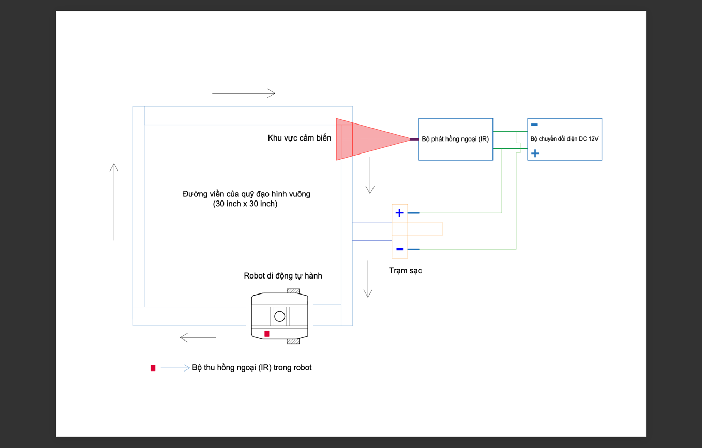
Figure 7.6 Robot Moving in a Square Path
In Figure 7.6, the flowchart of the IR-based automatic recharging system for the autonomous mobile robot is illustrated. The process begins with initializing Bluetooth, followed by converting battery charging voltage values into the required format and transmitting them through the microcontroller’s serial port to the Bluetooth module. The Parallax software tool processes the collected data to generate a data table in Excel.

Chapter 8: Conclusion and Future Development
The research team has completed the project titled "Research, Design, and Development of an Automated Monitoring System for Edible-Nest Swiftlet Houses." Within the framework of this project, the team successfully built and tested a robot system to assist in the monitoring of swiftlet nests. Experimental results show that the system operates stably and meets basic performance and reliability requirements. This marks an important first step, laying the foundation for the development of more precise and faster monitoring devices for real-world application in the future.
The team’s future development direction includes integrating modern sensors to measure and collect environmental data remotely, as well as applying intelligent data analysis technologies to provide more detailed information about the condition of the nests and the health of the birds. At the same time, AI (Artificial Intelligence) algorithms will be optimized to enhance the accuracy and speed of monitoring. The team also aims to improve the robot’s automation capabilities so that it can not only perform monitoring but also support care and cleaning tasks for the nests fully autonomously.
One of the important goals of the project is to reduce production costs and increase the automation capabilities of the system. This will make the swiftlet monitoring robot more accessible to bird nest farmers and expand its potential for commercial application. In addition to improving the efficiency and productivity of nest monitoring, the system contributes to enhancing nest quality and supports the sustainable development of the bird nest industry in Vietnam.

REFERENCES
[1] Đậu Văn Hải, Nguyễn Thị Hồng Trinh, Lê Bá Chung, Phạm Minh Quân và Nguyễn Thị Anh, “Ảnh hưởng của nhiệt độ, ẩm độ, ánh sáng và tiếng ồn trong nhà nuôi yến đến năng suất tổ”, – Tạp chí Khoa học Công nghệ Chăn nuôi – Số 122. Tháng 4/2021.
[2] Manchi, Shirish S., and Ravi Sankaran. "Foraging habits and habitat use by edible-nest and glossy swiftlets in the Andaman Islands, India." The Wilson Journal of Ornithology 122.2 (2010): 259-272.
[3] Åkesson, Susanne, et al. "Migration routes and strategies in a highly aerial migrant, the common swift Apus apus, revealed by light-level geolocators." PloS one 7.7 (2012): e41195.
[4] A. R. Ibrahim, N. H. N. Ibrahim, A. N. Harun, M. R. M. Kassim, S. E. Kamaruddin và G. Witjaksono, “Bird Counting and Climate Monitoring using LoRaWAN in Swiftlet Farming for IR4.0 Applications,” Institute of Electrical and Electronics Engineers , 2018.
[5] Huynh, Hiep Xuan, et al. "Monitoring and control system of environmental parameters in swiftlet houses." Internet of Things 24 (2023): 100997.
[6] Lương Công Binh và Nguyễn Gia Kiêm, “Công nghệ IoT và AI giám sát và điều khiển nhà nuôi chim yến thông minh”, Tạp chí Khoa học và Công nghệ Việt nam, số 1+2, 2023.
[6] Kang, N., Hails, C.J., & Sigurdsson, J.B. (1991): Nest Construction and Egg-Laying in Edible-nest Swiftlets Aerodramus spp and the Implications for Harvesting. Ibis, 133: 170–7.
[7]Marshall, A.J. & Foley, S.J. (1956): The Origins of Nest Cement in Edible-nest Swiftlets (Collocalia spp). Proceedings of the Zoological Society of London, 126: 383–9.
[8]Ramji, M., Chan Koon, L., & Abdul Rahman, M. (2013): Roosting and Nest-Building Behaviour of the White-Nest Swiftlet Aerodramus fuciphagus (Thunberg) (Aves: Apodidae) in Farmed Colonies. The Raffles Bulletin of Zoology, 29: 225–235.
[9]Marcone, M. F. (2005): Characterization of the Edible Bird's Nest the “Caviar of the East”. Food Research International, 38: 1125–1134.
[10]Medway, L. (1962): The Relation between the Reproductive Cycle, Moult and Changes in the Sublingual Salivary Glands of the Swiftlet Collocalia maxima Hume. Proceedings of the Zoological Society of London, 138: 305–14.

APPENDIX
Movement Method | Diagram | Advantages | Disadvantages
Unmanned Aerial Vehicle (Drone) | 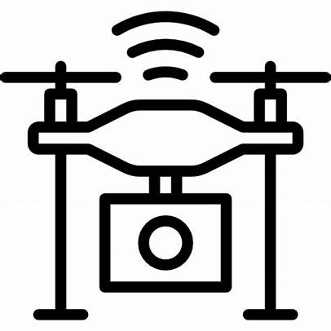 | Better vision and coverage range  Enhanced flexibility  Maximum mobility  Optimal space utilization  Cost-effectiveness  Easy inspection | Noisy and affects swiftlets  Difficult to operate in completely dark environments  Difficult to operate in high-obstacle density areas such as swiftlet houses  Loss of stability due to GPS loss  Loss of obstacle avoidance system
Wheeled Mobile Base | 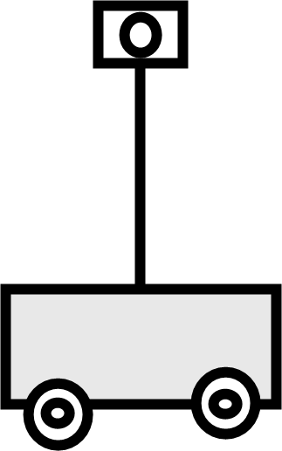 | Low manufacturing cost  Low torque required to move from static position  Flexible maneuverability  Lightweight mobile base  Simple structure | Can pass over obstacles, but only small ones (less than 0.5D), such as hardened bird droppings  Easily entangled by debris caught in the wheels
Tracked Mobile Base | 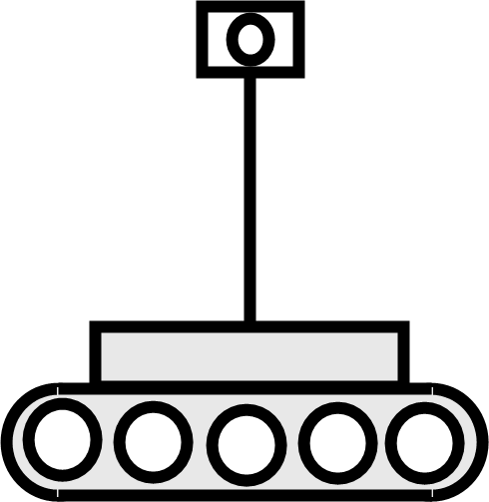 | Can easily pass over floor obstacles caused by bird droppings  Energy efficiency and traction even on slippery surfaces such as wet droppings  Capable of moving on rough terrain  Load is evenly distributed across the track surface, allowing it to bear heavy loads | Higher manufacturing cost than wheeled mobile robots  Requires more torque than wheeled mobile robots  Less flexible than wheeled mobile robots  Tracks are much heavier than wheels  More complex structure than wheeled bases  Low speed due to higher friction and complex mechanical structure  Difficult to repair
Cable-Driven System | 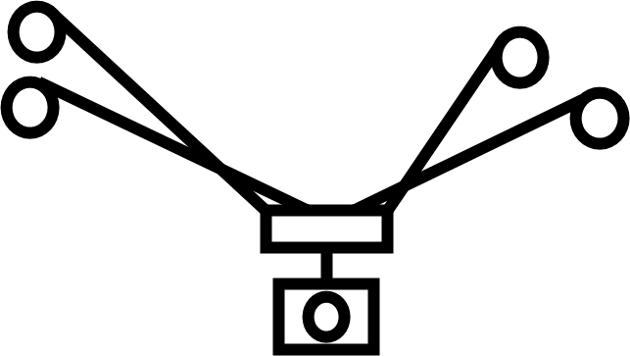 | Can expand the working area based on the structure of the swiftlet house | Hard to access edge positions in the working space
Overhead Crane-Type Structure | 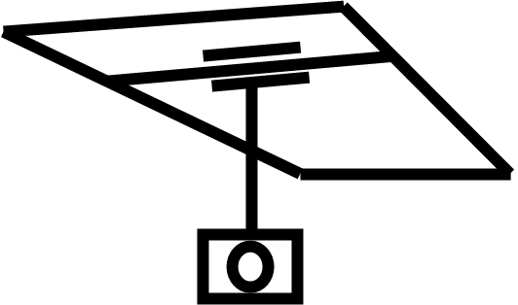 | Makes use of empty space below to attach structure | Difficult to expand in space, rigid structure is hard to maintain

Table 1.1 Advantages and Disadvantages of the Motion System Design Matrix for Camera Movement.

Function | Design Concepts
 | Concept 1 | Ý tưởng 2 | Concept 1 | Ý tưởng 4
Mobile Base | 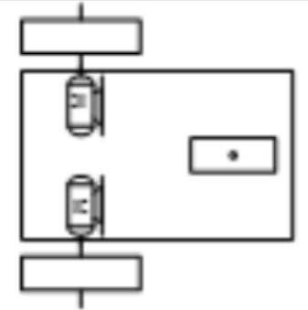 | Mobile Base |  | Mobile Base
Monitoring Height Adjustment | 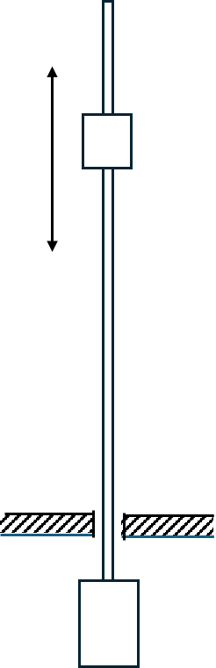  Lead screw and nut | Monitoring Height Adjustment |   Lead screw and nut | Monitoring Height Adjustment
Localization and Recognition | 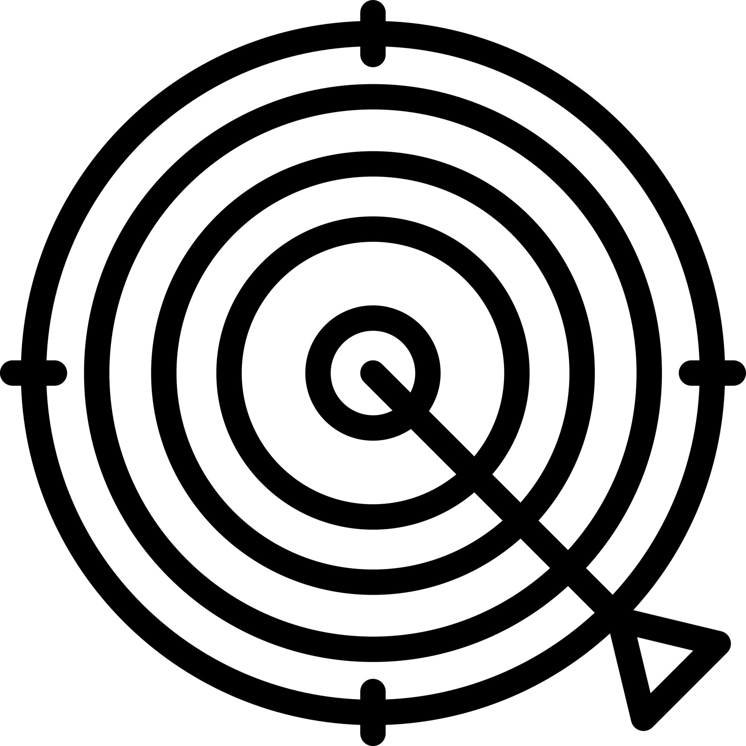  Lidar | Localization and Recognition |   Lidar | Localization and Recognition
Camera Orientation Adjustment | 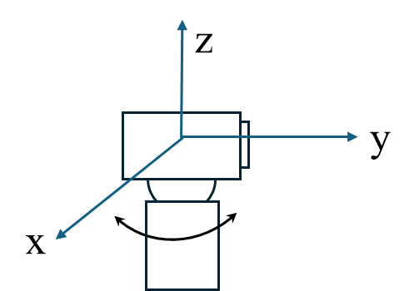  Rotation around x-axis | Camera Orientation Adjustment |   Rotation around x-axis | Camera Orientation Adjustment
Automatic Charging System | 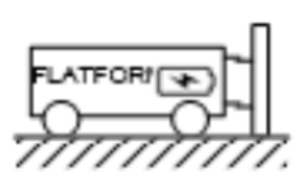  Fixed charging station | Automatic Charging System |   Fixed charging station | Automatic Charging System

Table 1.2 Design Concepts

