Instructions to run the file

Compile and Run all the files provided. The main class is in Test.java. Alternatively, a jar file is created, so using “java -jar CZ2001Project1.jar” on the command line is another way to run. A start.bat file is included to run the jar file using a Windows Operating System.

When prompted, enter sequence and query text files. They can be in .txt or .fna format.

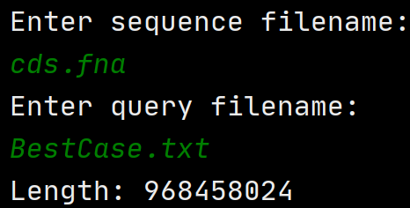

The program will run, print the sequence length, all the indexes of found substring, number of loops used (including pre-processing) and the time taken.

To improve performance, remove the line that prints indexes from the code and compile, as printing takes significant time and essentially removes most time differences.

Test cases are not included as they are very large.

If there are any issues faced, feel free to contact Tan Jun Hong (b190013@e.ntu.edu.sg)