**MINISTRY OF EDUCATION AND TRAINING**



**FPT UNIVERSITY**

Project report

**COMPUTER STORE WINFORM**

|  |  |
| --- | --- |
| Group 3 | |
| **Group members** | Nguyen Van Tan - TannvSE140923  Kieu Nhat Tan -TanknSE141107 |
| **Teacher** | Ho Hoan Kiem |

1. **OVERVIEW**
2. **The object of the project :**

Nowadays, the software management is very useful for stores. It bring a lot of pros for the people as : stored data, manage data or statistics data.

In our project, we will create a desktop application that allows users to help people manage their store. The system providers the following facilities :

* Manage products (create, read, update, delete, search)
* Manage bills (create, search)
* Manage staff (create, read, update, delete, search)

1. **Functional requirements :**

Following is a list of functionalities of the system.

* Guest can login to become admin or staff in the system.
* Admin and staff can create new products in the system.
* Admin and staff can update products in the system.
* Admin and staff can delete products in the system.
* Admin and staff can search products by product name in the system.
* Admin and staff can create new bills in the system.
* Admin and staff can search bills by phone number of customer in the system.
* Admin can create new staffs in the system.
* Admin can update new staffs in the system.
* Admin can delete staffs in the system.
* Admin can search staffs in the system.

1. **Hardware/Software requirement :** 
   1. **For user**
      1. **Hardware :**

- CPU : Intel i3 or higher

- RAM : 4BG or higher

**3.1.2 Software :**

- OS : Window 10

- Environment : .NET framework 4.8

* 1. **For software developer**

**3.2.1 Hardware :**

- CPU : Intel i3 or higher

- RAM : 4BG or higher

**3.2.2 Software :**

- OS : Window 10

- Environment : .Microsoft .NET framework 4.8

- Database management system : Microsoft SQL server 2019

- IDE : Microsoft visual studio 2019

**B . USE CASE DIAGRAM**

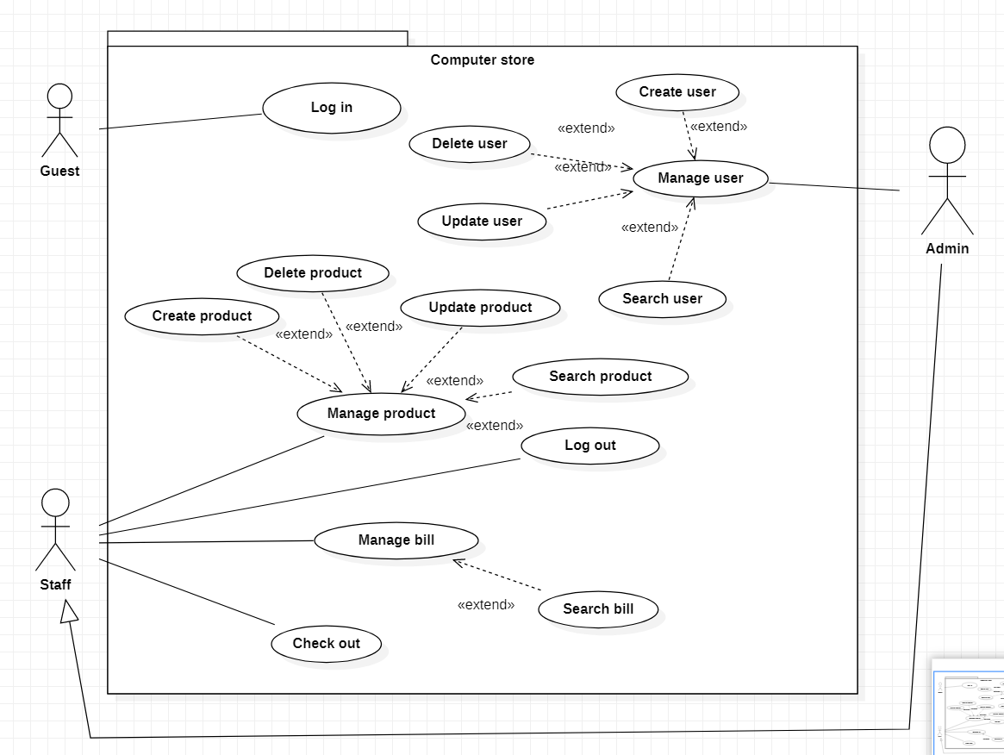

1. **Actor**

* **Guest** : guest is the person don’t authentication in the system, they can login to become admin or staff.
* **Staff** : Staff is a person working in store under control of admin
* **Admin** : Admin is boss of the store. They have full control of the system

1. **Use case description**

2.1 Login

|  |  |
| --- | --- |
| **Use case** | Login |
| **Short Description** | Log in system to become admin or staff |
| **Pre-Conditions** | No pre-condition |
| **Post-Conditions** | Go to home screen |
| **Main flow** | _Guest inputs the login information :   * Login ID. * Password.   _Guest clicks on the Login button.  _System check the Login ID and Password.  _If Login ID and Password are valid, system will move member to Homepage.  _ If the password or user id are wrong, system will be show a message box “Invalid username or password” |
| **Alternative flow(s)** | No alternative |

2.2 Log out

|  |  |
| --- | --- |
| **Use case** | Log out |
| **Short Description** | Log out in the system |
| **Pre-Conditions** | Login before |
| **Post-Conditions** | Go to login screen |
| **Main flow** | _ Admin or staff click button “Logout”  _Log out, go to the login screen and become guest |
| **Alternative flow(s)** | No alternative |

2.3 Create product

|  |  |
| --- | --- |
| **Use case** | Create product |
| **Short Description** | Create new product in the system |
| **Pre-Conditions** | Login before |
| **Post-Conditions** | Success : create new product  Fail : show error message |
| **Main flow** | _User clicks on the button “Add new”, the product form will show.  _User input product information and save this action.  _System check this information and save it. |
| **Alternative flow(s)** | _If any information create are invalid, system will notify the error.  _User will input information product again. |

2.4 Update product

|  |  |
| --- | --- |
| **Use case** | Update product |
| **Short Description** | Update product existed in the system |
| **Pre-Conditions** | Login |
| **Post-Conditions** | Success : update product  Fail : show error message |
| **Main flow** | _User select the product in data grid view.  _User clicks on the button “Update”, the product form will show with information of product selected.  _User input new information and save it.  _System check this information and save it. |
| **Alternative flow(s)** | _If any information update are invalid, system will notify the error.  _User will input information product again. |

2.5 Delete product

|  |  |
| --- | --- |
| **Use case** | Delete product |
| **Short Description** | Delete product existed in the system |
| **Pre-Conditions** | Login |
| **Post-Conditions** | Success : delete product |
| **Main flow** | _User select the product in data grid view.  _User clicks on the button “Delete”.  _Message confirm will show.  _User confirm and delete the product selected. |
| **Alternative flow(s)** | _User choose confirm option equal cancel.  _Product not delete. |

2.6 Search product

|  |  |
| --- | --- |
| **Use case** | Search product |
| **Short Description** | Search product existed in the system |
| **Pre-Conditions** | Login |
| **Post-Conditions** | Success : search product. |
| **Main flow** | _User input name product in text box.  _If any product have name contain string in text box, data grid view will show product valid. |
| **Alternative flow(s)** | _Not product name existed. Data grid view is empty. |

2.7 Add to cart

|  |  |
| --- | --- |
| **Use case** | Add to cart |
| **Short Description** | Add to cart into bill |
| **Pre-Conditions** | Login |
| **Post-Conditions** | Add to cart to bill |
| **Main flow** | _User input ID of product and select quantity product.  _If any id is existed, the product will insert into the bill.  _Data grid view will show new cart. |
| **Alternative flow(s)** | _Not product id existed. Show error message. |

2.8 Check out

|  |  |
| --- | --- |
| **Use case** | Check out |
| **Short Description** | Check out products in list cart |
| **Pre-Conditions** | Login, list cart not null |
| **Post-Conditions** | Save bill and list cart into database |
| **Main flow** | _User click button “Check out”.  _System will create new bill and create new bill details in the database. |
| **Alternative flow(s)** | _Not product existed in the list cart. Show error message.  _If out of stock any product. Show error message. |

2.9 Create user

|  |  |
| --- | --- |
| **Use case** | Create user |
| **Short Description** | Create new user in the system |
| **Pre-Conditions** | Login before with role “Admin” |
| **Post-Conditions** | Success : create new user  Fail : show error message |
| **Main flow** | _User clicks on the button “Add new”, the product form will show.  _User input user information and save this action.  _System check this information and save it. |
| **Alternative flow(s)** | _If any information create are invalid, system will notify the error.  _User will input information user again. |

2.10 Update user

|  |  |
| --- | --- |
| **Use case** | Update user |
| **Short Description** | Update user existed in the system |
| **Pre-Conditions** | Login with role “admin” |
| **Post-Conditions** | Success : update user  Fail : show error message |
| **Main flow** | _User select the user in data grid view.  _User clicks on the button “Update”, the product form will show with information of product selected.  _User input new information and save it.  _System check this information and save it. |
| **Alternative flow(s)** | _If any information update are invalid, system will notify the error.  _User will input information user again. |

2.11 Delete user

|  |  |
| --- | --- |
| **Use case** | Delete user |
| **Short Description** | Delete user existed in the system |
| **Pre-Conditions** | Login |
| **Post-Conditions** | Success : delete product |
| **Main flow** | _User select the product in data grid view.  _User clicks on the button “Delete”.  _System will delete the user selected. |
| **Alternative flow(s)** | No alternative |

2.12 Search user

|  |  |
| --- | --- |
| **Use case** | Search user |
| **Short Description** | Search user existed in the system |
| **Pre-Conditions** | Login |
| **Post-Conditions** | Success : search user. |
| **Main flow** | _User input id user in text box.  _If any product have name contain string in text box, data grid view will show product valid. |
| **Alternative flow(s)** | _Not user id existed. Data grid view is empty. |

2.13 Search bill

|  |  |
| --- | --- |
| **Use case** | Search user |
| **Short Description** | Search user existed in the system |
| **Pre-Conditions** | Login |
| **Post-Conditions** | Success : search bills. |
| **Main flow** | _User input phone of client in text box.  _If any bill have phone number contain string in text box, data grid view will show product valid. |
| **Alternative flow(s)** | _Not phone number existed. Data grid view is empty. |

**C. Class Diagram**

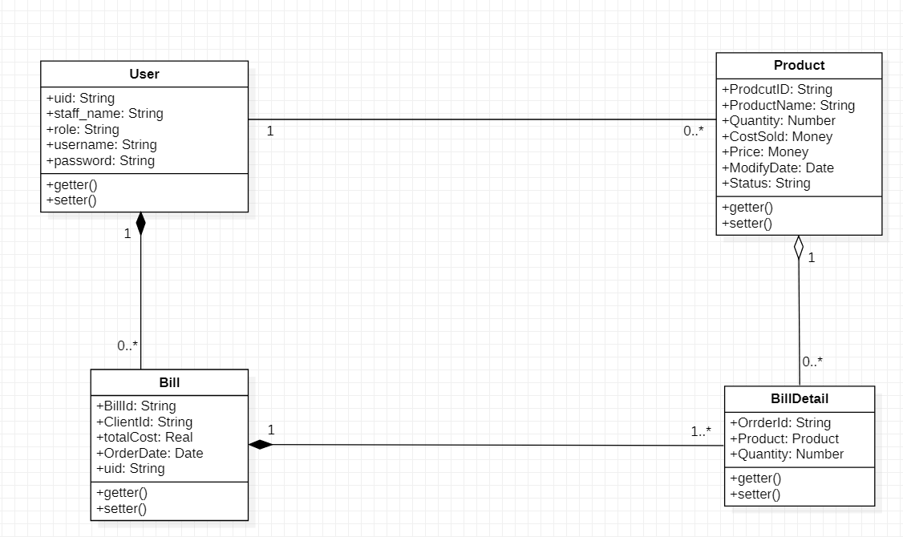

(+): Public

**D. Screen shot**

**1. Login :**

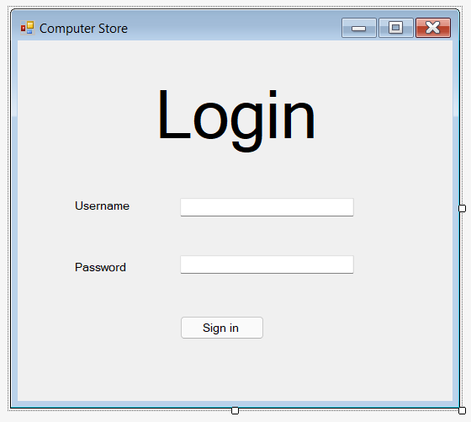

|  |  |  |  |
| --- | --- | --- | --- |
| **Name** | **Type** | **Validation** | **Description** |
| User Name | TextBox | String | Input Customer’s user name |
| Password | TextBox | String | Input Customer’s password |
| Login | Button | Click | Choose  Login |

1. **Staff options :**

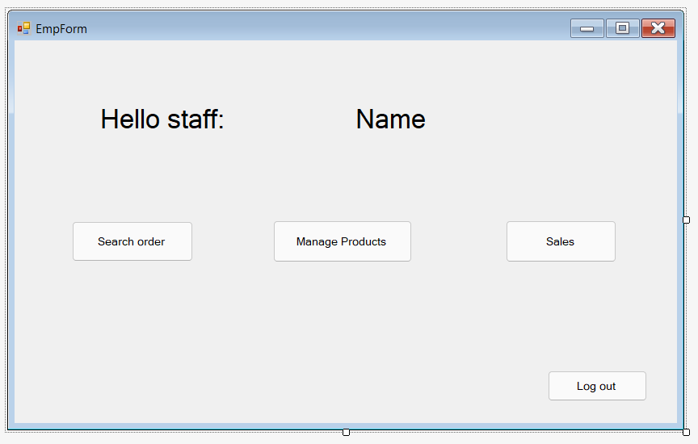

|  |  |  |  |
| --- | --- | --- | --- |
| **Name** | **Type** | **Validation** | **Description** |
| Search order | Button | Click | Choose search order |
| Manage products | Button | Click | Choose manage product |
| Sales | Button | Click | Choose  sales |
| Log out | Button | Click | Choose  log out |

1. **Search order :**

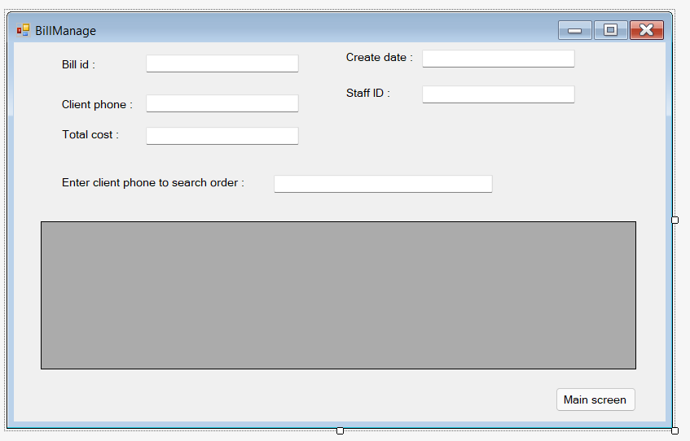

|  |  |  |  |
| --- | --- | --- | --- |
| **Name** | **Type** | **Validation** | **Description** |
| Main menu | Button | Click | Return main menu |
| Search order | Text box | Click | Choose manage product |

1. **Product manage**

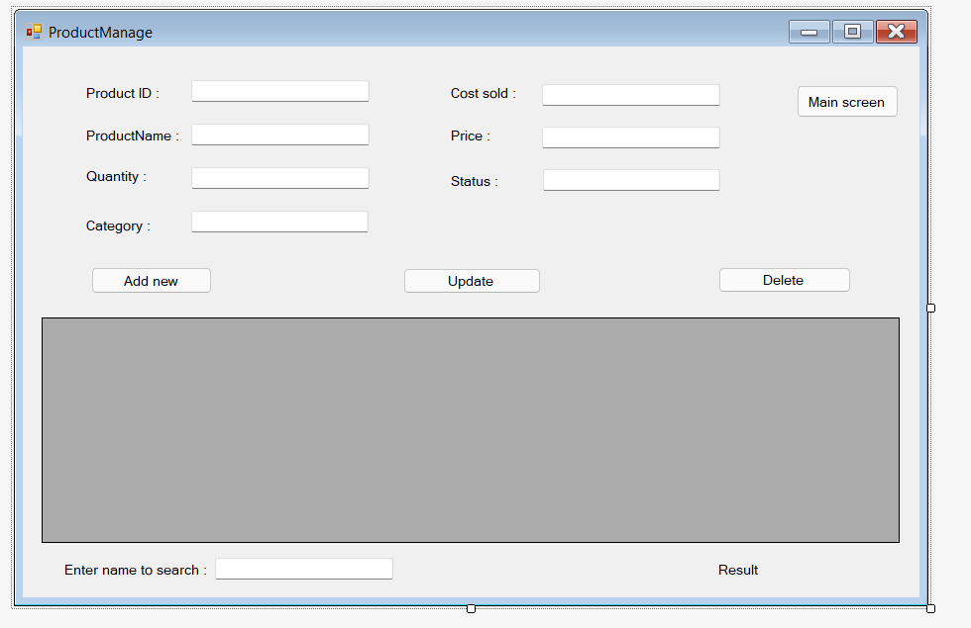

|  |  |  |  |
| --- | --- | --- | --- |
| **Name** | **Type** | **Validation** | **Description** |
| Product ID | Text box | Not null | Input product ID |
| Product name | Text box | Not null | Input product name |
| Quantity | Text box | Positive number | Input quantity |
| Category | Combo box | None | Select category |
| Cost sold | Text box | Positive number | Input cost sold |
| Price | Text box | Positive number | Input price |
| Status | Combo box | None | Select status |
| Add new | Button | Click | Choose add new product |
| Update | Button | Click | Update product |
| Delete | Button | Click | Delete product |
| Main screen | Button | Click | Return main screen |
| Name search | Text box | Not null | Input phone to search order |

1. **Sales :**

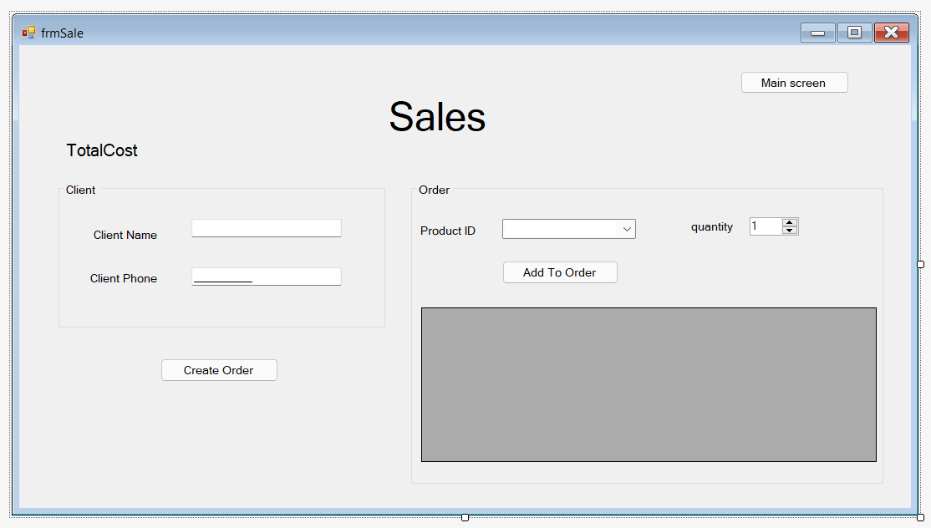

|  |  |  |  |
| --- | --- | --- | --- |
| **Name** | **Type** | **Validation** | **Description** |
| Client name | Text box | Not null | Input client name |
| Client phone | Text box | Not null | Input client phone |
| Product ID | Text box | Positive number | Input product ID |
| Quantity | Combo box | None | Select category |
| Create order | Button | Click | Create new order |
| Add to order | Button | Click | Add new product to list cart |
| Main screen | Button | Click | Return main menu |

1. **Manage user :**

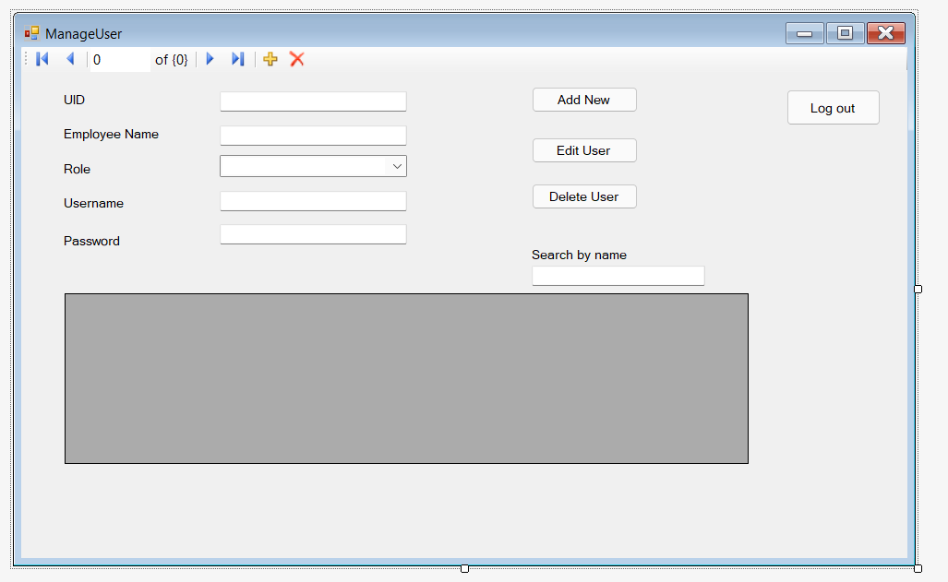

|  |  |  |  |
| --- | --- | --- | --- |
| **Name** | **Type** | **Validation** | **Description** |
| User ID | Text box | Not null | Input user ID |
| Employee name | Text box | Not null | Input employee name |
| Role | Text box | Positive number | Select role |
| User name | Combo box | None | Input user name |
| Password | Button | Click | Input password |
| Add new | Button | Click | Add new product to list cart |
| Edit user | Button | Click | Edit a user |
| Delete user | Button | Click | Delete a user |
| Log out | Button | Click | Return login form |

**7 . Product form :**

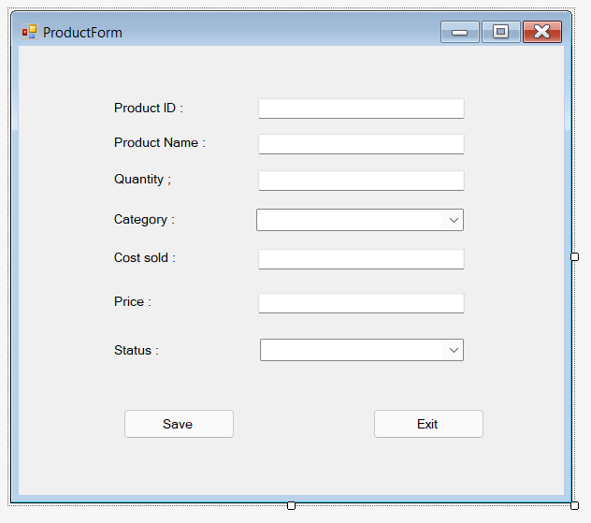

|  |  |  |  |
| --- | --- | --- | --- |
| **Name** | **Type** | **Validation** | **Description** |
| Product ID | Text box | Not null | Input product ID |
| Product name | Text box | Not null | Input product name |
| Quantity | Text box | Positive number | Input quantity |
| Category | Combo box | None | Select category |
| Cost sold | Text box | Positive number | Input cost sold |
| Price | Text box | Positive number | Input price |
| Status | Combo box | None | Select status |
| Save | Button | Click | Save product into database |
| Cancel | Button | Click | Return product manage form |

1. **User form :**

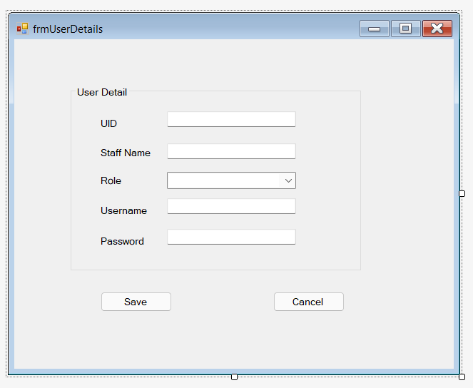

|  |  |  |  |
| --- | --- | --- | --- |
| **Name** | **Type** | **Validation** | **Description** |
| User ID | Text box | Not null | Input user ID |
| Staff name | Text box | Not null | Input employee name |
| Role | Text box | Positive number | Select role |
| User name | Combo box | None | Input user name |
| Password | Button | Click | Input password |
| Save | Button | Click | Save user |
| Cancel | Button | Click | Return manage user form |

E. Tasksheet

|  |  |  |
| --- | --- | --- |
| Task Name | Taken by | Status |
| UI of Manage User screen | Kieu Nhat Tan | Done |
| UI of Sales screen | Kieu Nhat Tan | Done |
| Create new user | Kieu Nhat Tan | Done |
| Edit user in system | Kieu Nhat Tan | Done |
| Search user by name | Kieu Nhat Tan | Done |
| Delete user in system | Kieu Nhat Tan | Done |
| UI of Login screen | Kieu Nhat Tan | Done |
| Login to system | Kieu Nhat Tan | Done |
| Create Order | Kieu Nhat Tan | Done |
| UI of Manage Products screen | Nguyen Van Tan | Done |
| UI of Manage bill screen | Nguyen Van Tan | Done |
| Create new product | Nguyen Van Tan | Done |
| Edit products | Nguyen Van Tan | Done |
| Delete products | Nguyen Van Tan | Done |
| Search products by name | Nguyen Van Tan | Done |
| Search bill by client phone | Nguyen Van Tan | Done |
| Log out | Nguyen Van Tan | Done |