UNIVERSITI TUNKU ABDUL RAHMAN
LEE KONG CHIAN FACULTY OF ENGINEERING AND SCIENCE
ACADEMIC YEAR 2025
Data Mining

Group Assignment1

Part 1 (EDA & Data Pre-Processing) – Due in week 7, Aug 04 (Mon), 6pm, email (report & Colab Notebook) to suls@utra.edu.my)
Part 2 and 3 (Models, evaluations & Deployment) - Due in week 12 (Sept 8 (Mon), 6pm, email (report & Colab Notebook) to ????@utar.edu.my)

This assignment is worth 30% of total course marks

Sample datasets:
There are 772 observations in the diabetes1.csv file.
There are 10 new patients to be processed in diabetes2.csv file.

Introduction

You have probably heard about diabetes a lot of times in your lifetime. It is that ubiquitous in prevalence. According to the International Diabetes Federation, over 3.4 million people died as a result of diabetes in 2024. This corresponds to 9.3% of global deaths from all causes. The countries with the largest numbers of adults with diabetes aged 20–79 years in 2024 are China, India, and the USA. The World Health Organization (WHO) further published this grave illness as one of the leading causes of deaths among females in 2021 (8th, specifically)
Now, what exactly is diabetes? Diabetes isn’t just about a condition from eating much sugar or carbs, as common myths would say.
Diabetes is a serious, chronic condition that occurs when the body cannot produce enough insulin or cannot effectively use the insulin it does produce, leading to high levels of glucose in the bloodstream. The main types include Type 1, Type 2, and gestational diabetes. Type 1 diabetes is an autoimmune disease leading to the destruction of insulin-producing cells in the pancreas, while Type 2 is primarily associated with insulin resistance. Gestational diabetes occurs during pregnancy and typically resolves after childbirth.

About Dataset

Context
This dataset is originally from the National Institute of Diabetes and Digestive and Kidney Diseases. The objective of the dataset is to diagnostically predict whether or not a patient has diabetes, based on certain diagnostic measurements included in the dataset. Several constraints were placed on the selection of these instances from a larger database. In particular, all patients here are females at least 21 years old of Pima Indian heritage.

Content
The datasets consists of several medical predictor variables and one target variable, Outcome. Predictor variables includes the number of pregnancies the patient has had, their BMI, insulin level, age, and so on.

Assignment Scenario:

The approach I adopt for the assignment is a realistic one… like a real life analytics company. You and your team are my employees. I have given you a task with minimal instructions on what to do and why. You need to think what is relevant in the context of the task , and what is not relevant. You will be penalized if you give me everything without considering what is relevant and what is not.
You and your team need to think and find out what are the steps to take, the sequence of those steps and why. I expect these in the report you submit.
Ultimately, determine if each of the 10 new patients (in the diabetes2.csv file) should is predicted to have heart condition/ problem.

Deliverables:

I need the following in your submission to < to be announced> :
1. A report on why this study on diabetes is important, the description and meaning/ relevance of each feature, the description of the steps and outputs of data pre-processing and analysis, findings, experiences, opinions, remarks,…of tasks you and your team performed.

2. A video recording presentation (of about 10 – 15 mins).
3. The complete python program(s) in COLAB…codes…(as I will run your codes)

Please, name your submission report as :
(<programme>)_ASSIGN1_<name of team lead>_<student.id of team lead>
Example (SE) Assign1 Student-name 1234567

The names and student ids of the team members must appear in the report.

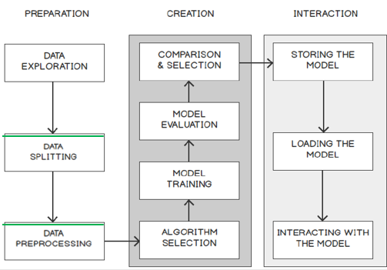
The Stages of Comprehensive Machine Learning Project above serves as a guide to you.

