

Test Case Design Exercise

# Objective:

Using black box testing technique you know and design the test case for feature “Find” (tab Find only) in application Notepad++ in 15min.

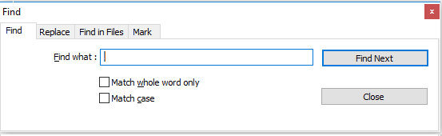

# Write your test case below:

|  |  |  |  |  |  |  |
| --- | --- | --- | --- | --- | --- | --- |
| Test Case ID | Pre-condition | Test Case Description | Test Step | Expected Result | Actual Result | Status |
| Test_Case001 |  | Verify UI of Find Tab | User access Find tab  User verify Find Tab correct with requirement design:  Font size  Text Box  Check Box  Button | Find design Match with requirement |  |  |
| Test_Case002 | User have access Find Tab | Verify feature Find can’t display list value of keywords user want to find and don’t select check box | User access Find Tab  User input keyword  User click button find next | System can’t find |  |  |
| Test_Case003 | User have access Find Tab | Verify feature Find display correct list value of keywords and user select check box “Match whole word only” | User access Find Tab  User input key word and click check box “Match whole only”  User click button find next | System display all value exactly have key word “Match whole word only” |  |  |
| Test_Case004 | User have access Find Tab | Verify feature Find display correct list value of keywords user select checkbox “Match Case “ | User access Find Tab  User input key word and click check box Match Case  User click button find next | System display all value key word “Match Case” |  |  |
| Test_Case005 | User have access Find Tab | Verify feature Find display correct list value of keywords and user select check box “Match whole word only” and “Match Case “ | User access Find Tab  User input key word and click check box “Match whole only” and “Match Case “  User click button find next | System display all value match exactly have key work |  |  |
| Test_Case006 | User have access Find tab | Verify feature Find don’t display when user empty search box and click button Find next | User access Find Tab  User blank textbox  User click button Find Next | System don’t display anything |  |  |
| Test_Case007 | User have access Find Tab | Verify Find tab will close when user click button close | User access Find tab  User click button close | System close Find Tab |  |  |
| Test_Case008 | User have access Find Tab | Verify Find tab will close when user click icon x | User access Find Tab  User click icon x | System close Find Tab |  |  |