VIETNAM NATIONAL UNIVERSITY HO CHI MINH
UNIVERSITY OF INFORMATION TECHNOLOGY
INFORMATION SYSTEM FACULTY
🙠🙢🕮🙡🙣


BI REPORT
Lecturer: Do Phuc & Nguyen Thi Kim Phung
MSIS4263.P22.CTTT

Nguyen Kieu My  Ly Tan Phat | 21522350  21522444
HO CHI MINH CITY, 2025

Contents
1. Introduction 5
2. SSIS process 5
2.1. Introduction to SSIS 5
2.2. Purpose of Using SSIS in Data Warehousing 5
2.3. Process of Choosing Data for the Data Warehouse 6
2.3.1. Identifying Data Sources 6
2.3.2. Dataset Structure 6
2.4. ETL Process 7
3. Analysing and reporting processes 12
3.1. Describe the schema (star/snow) and the process of building a cube. 12
3.1.1. Schema Description: Star vs. Snowflake 12
3.1.2. Chosen Schema and Justification 13
3.1.3. Star Schema Design for the Project 13
3.1.4. Cube Building Process Using SQL Server Analysis Services (SSAS) 14
3.2. Using analysis service (SSAS) 17
3.3. Using analysis service (MDX) and create reports (Power BI) 18
3.3.1. Roll up - Calculate total sales by category 18
3.3.2. Drill down - Calculate total sales by sub-category 19
3.3.3. Slice - Calculate total sales by customer and region in East 20
3.3.4. Dice - Find the sales by customer in Category = "Office Supplies" & SubCategory = "Art" 21
3.3.5. Pivot - Calculate total cost by each region in each category 23
3.3.6. Calculate the percentage of return rate from total order 24
3.3.7. Find return rate by region 25
3.3.8. Top 5 sub-categories that have high returned rate 27
3.3.9. Find the maximum of delivery time 29
3.3.10. Calculate return rate of each customer segmentation 29
3.4. Using analysis by Pivot table in Excel. 31
4. Data mining 32
4.1. Random Forest 32
4.2. CNN 35
5. Conclusion 37
6. Reference 38

List of Figures
Figure 1. Execute SQL Task Configuration 8
Figure 2. Control Flow in SSIS Package 8
Figure 3. Extract CSV file by Flat File Source 9
Figure 4. Multicast and sorting data 10
Figure 5. Sort Transformation Configuration 10
Figure 6. Overview of the ETL Data Flow pipeline 11
Figure 7. The successful ETL execution 12
Figure 8. Star Schema Design 13
Figure 9. Define connection by Data Source 14
Figure 10. DSV window showing selected fact and dimension tables 14
Figure 11. Identify measure groups 15
Figure 12. Add measure groups 15
Figure 13. Defining Dimension 16
Figure 14. Hierarchy editor showing hierarchy in dim_customer 16
Figure 15. Processing cube window showing successful status 17
Figure 16. Cube browsing with filter on 'Furniture' category in SSAS 17
Figure 17. MDX question 1 18
Figure 18. MDX result of question 1 19
Figure 19. Power BI question 1 19
Figure 20. MDX question 2 19
Figure 21. MDX result of question 2 20
Figure 22. Power BI question 2 20
Figure 23. MDX question 3 20
Figure 24. MDX result of question 3 21
Figure 25. Power BI question 3 21
Figure 26. MDX question 4 21
Figure 27. MDX result of question 4 22
Figure 28. Power BI question 4 22
Figure 29. MDX question 5 23
Figure 30. MDX result of question 5 23
Figure 31. Power BI question 5 23
Figure 32. MDX question 6 24
Figure 33. MDX question 6 24
Figure 34. MDX result of question 6 24
Figure 35. Power BI question 6 25
Figure 36. MDX question 7 25
Figure 37. MDX question 7 25
Figure 38. MDX question 7 26
Figure 39. MDX result of question 7 26
Figure 40. Power BI question 7 27
Figure 41. MDX question 8 27
Figure 42. MDX question 8 27
Figure 43. MDX question 8 28
Figure 44. MDX result of question 8 28
Figure 45. Power BI question 8 28
Figure 46. MDX question 9 29
Figure 47. MDX result of question 9 29
Figure 48. Power BI question 9 29
Figure 49. MDX question 10 29
Figure 50. MDX question 10 29
Figure 51. MDX question 10 30
Figure 52. MDX result of question 10 30
Figure 53. Power BI question 10 31
Figure 54. CNN accuracy 32
Figure 55. Top 10 factors 33
List of Tables
Table 1. Description of dataset 7

Introduction
In today’s fast-paced and competitive business environment, data-driven decision-making has become a vital component of success, particularly in supply chain and sales management. This Business Intelligence (BI) report explores a comprehensive dataset containing detailed records of supply chain operations and sales performance for a retail company. The goal is to uncover actionable insights that support operational efficiency, customer satisfaction, and strategic growth.
The dataset captures a wide range of business dimensions - from order processing and logistics, to customer segmentation, product categories, and financial performance. By leveraging this dataset, businesses can examine critical areas such as inventory flow, shipping performance, return rates, profitability, and regional sales distribution.
The report is structured to reflect a complete Business Intelligence workflow, including:
- Data Extraction, Transformation, and Loading (ETL) using SQL Server Integration Services (SSIS).
- Data Modeling with a suitable schema (Star/Snowflake) and OLAP Cube creation using SQL Server Analysis Services (SSAS).
- Analytical Queries using MDX, Power BI, and Excel Pivot Tables.
- Data Mining to explore predictive patterns using algorithms such as Decision Trees and CNN.
- Strategic Recommendations based on analytical findings.
By integrating SSIS, SSAS, Excel, and Power BI, this project showcases the full lifecycle of BI implementation - from data ingestion to deep analytics - empowering stakeholders to make smarter, faster, and more informed decisions in supply chain and retail operations.

SSIS process

2.1. Introduction to SSIS
SQL Server Integration Services (SSIS) is a powerful ETL (Extract, Transform, Load) tool provided by Microsoft SQL Server. It allows the automation of data movement and transformation from various sources into a centralized Data Warehouse system. SSIS is essential for preparing data for analytical processing and business intelligence reporting.

2.2. Purpose of Using SSIS in Data Warehousing
In this project, SSIS is employed to:
- Select and extract meaningful data from different sources.
- Clean, standardize, and transform data to ensure consistency.
- Integrate and load the data into Data Warehouse for supply chain analysis.
- Overview of SQL Server Integration Services (SSIS)

2.3. Process of Choosing Data for the Data Warehouse

2.3.1. Identifying Data Sources
Data is collected from multiple sources including:
- Online Transaction Processing (OLTP) systems
- Excel or CSV files containing sales and shipment records
- Potential integration with web services for additional information

2.3.2. Dataset Structure
Dataset is taken from a contest called "Unlock Operation Insights – Analyze Supply Chain Data!" on Tik Tok. On the other hand, the dataset contains 29 columns covering key aspects of supply chain operations:
RetailOrderID | Unique retail order identifier
OrderID | General order identifier
OrderDate | Date the order was placed
ShipDate | Actual Shipping date
ShipMode | Shipping method(Standard, Express, Same-Day)
CustomerID | Unique customer identifier
CustomerName | Full name of the customer
Segment | Customer segment (Consumer, Corporate, Home Office)
PostalCode | Zip/Postal code
Country | Country of the customer
City | City where the order was placed
State | State/Province of the customer
Region | Sales region
Latitude | Geographical latitude
Longitude | Geographical longitude
RetailSalesPeople | Retail sales representatives
ProductID | Unique product identifier
Category | Product category
SubCategory | Product sub-category
ProductName | Full product name
Returned | Return status(Yes/No)
Sales | Revenue generated from the order
Quantity | Number of units sold
Profit | Profit from the order
Cost | Original cost of the order
UnitCP | Cost price per unit
UnitSP | Selling price per unit
Days | Actual delivery days
Table 1. Description of dataset

2.4. ETL Process
Step 1: Control Flow Setup
We begin by designing the Control Flow in SSIS, which defines the high-level workflow of the ETL process. Here, we use an Execute SQL Task to prepare the environment (e.g., truncate target tables), followed by a Data Flow Task to perform the actual ETL operations.
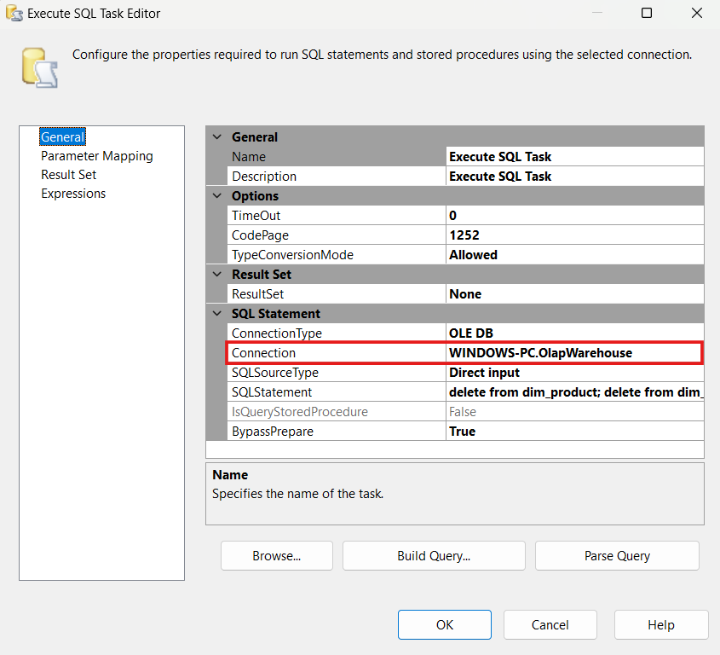
Figure 1. Execute SQL Task Configuration
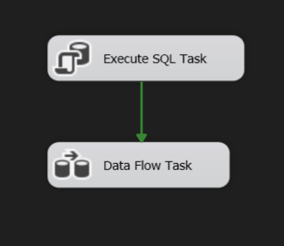
Figure 2. Control Flow in SSIS Package

Step 2: Extract – Data Extraction
Using SSIS components such as Flat File Source and OLE DB Source, data is extracted from Excel/CSV files and relational databases. This step ensures all necessary information is retrieved for further processing.
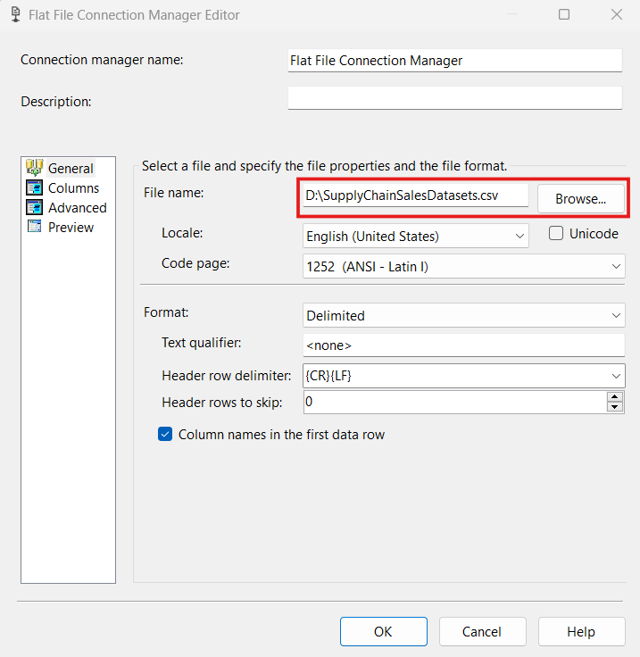
Figure 3. Extract CSV file by Flat File Source

Step 3: Multicasting and Sorting Data
The data from the source is multicast to different branches for transformation before being loaded into corresponding dimension and fact tables. Sort components are used to ensure data integrity before inserting into the database.
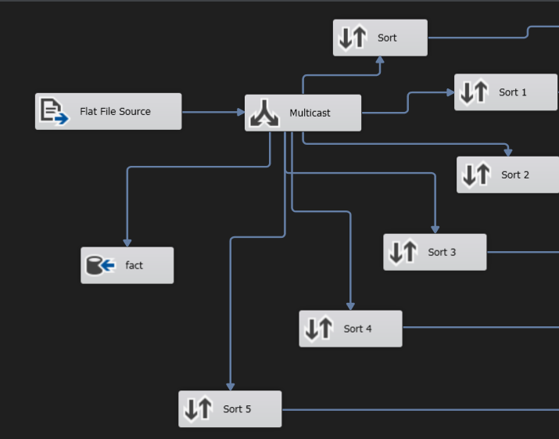
Figure 4. Multicast and sorting data
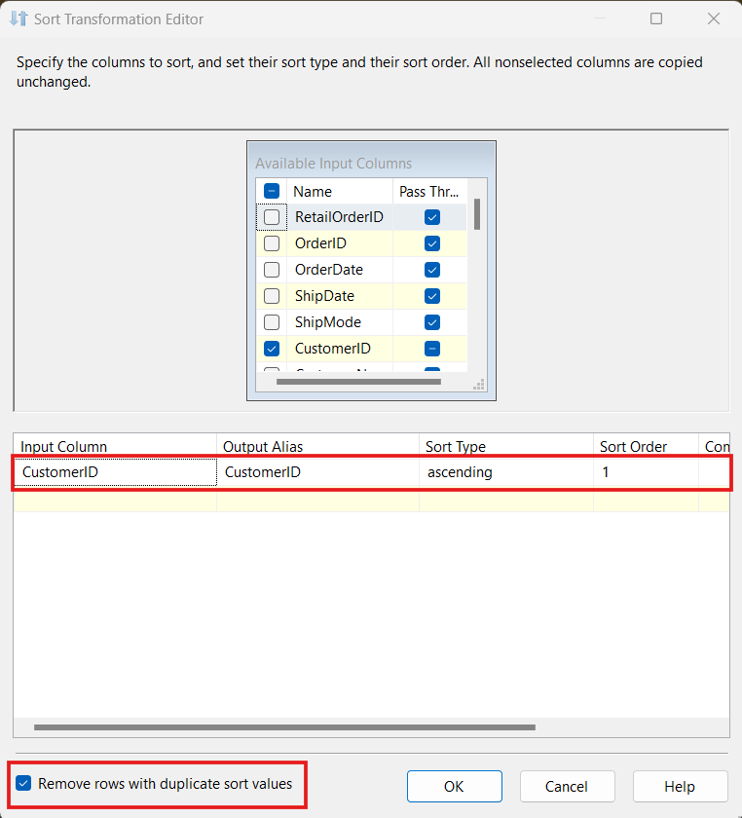
Figure 5. Sort Transformation Configuration

Example sort: The transformation sorts the data by CustomerID in ascending order and removes duplicate rows to ensure only distinct customers are loaded into the dimension table.
Step 4: Transform – Data Transformation
Each branch of the multicast stream is sorted and directed to corresponding OLE DB Destination components:
- dim_customer
- dim_product
- dim_order
- dim_retailSalesPeople
- dim_region
- dim_returned
- fact table for transactional records
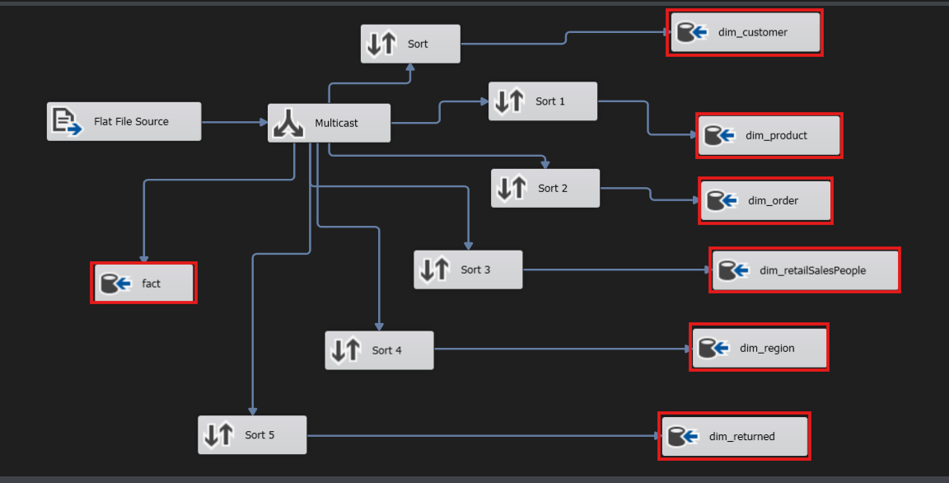
Figure 6. Overview of the ETL Data Flow pipeline

Step 5: Executing the SSIS Package and Verifying the Results
After completing the configuration of the data flow and mapping the appropriate destination tables, including dim_customer, dim_product, dim_order, dim_retailSalesPeople, dim_region, dim_returned, and the fact table — the SSIS package was executed to validate the correctness and efficiency of the ETL process.
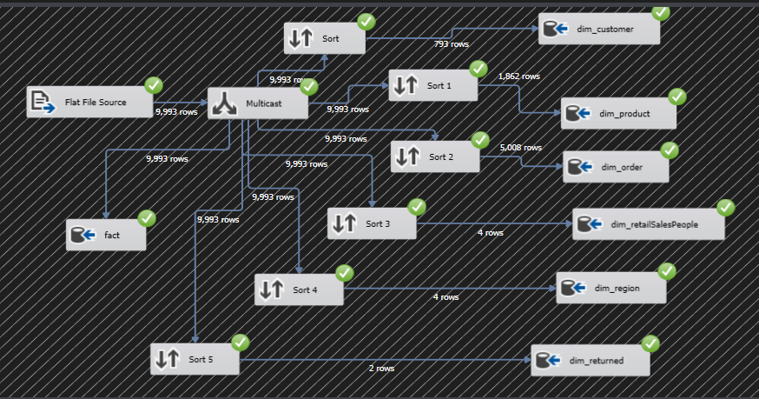
Figure 7. The successful ETL execution
The following image shows the entire Data Flow Task successfully executed. Each component in the process displays a green check mark, indicating that the data was processed and loaded into the corresponding destination tables without errors.
A total of 9,993 data rows were read from the source flat file and distributed through multiple transformation paths. Key statistics from the data flow include:
- dim_customer: 793 rows
- dim_product: 1,862 rows
- dim_order: 5,008 rows
- dim_retailSalesPeople: 4 rows
- dim_region: 4 rows
- dim_returned: 2 rows
- fact: 9,993 rows

3. Analysing and reporting processes

3.1. Describe the schema (star/snow) and the process of building a cube.

3.1.1. Schema Description: Star vs. Snowflake
In data warehousing, schema modeling is essential for organizing data efficiently to support analytical processing. Two common schema types are:
- Star Schema: This model consists of a central Fact Table surrounded by Denormalized Dimension Tables. It is simple, faster for querying, and ideal for performance-oriented OLAP applications.
- Snowflake Schema: This is a normalized version of the star schema where dimension tables are broken down into sub-dimensions, creating a more complex structure. It optimizes storage and is more suitable for environments where data integrity is crucial.

3.1.2. Chosen Schema and Justification
For this project, the Star Schema was selected due to its simplicity, high query performance, and ease of use in building OLAP cubes. The denormalized nature of dimension tables allows for faster aggregation and drill-down in reports.

3.1.3. Star Schema Design for the Project
The following schema was designed to support sales analysis, with a central Fact Table containing sales data, and surrounding Dimension Tables providing descriptive context:
- Fact table: fact
- Dimension Tables:
  - Dim_Customer
  - Dim_Product
  - Dim_Order
  - Dim_Region
  - Dim_RetailSalesPeople
  - Dim_Returned
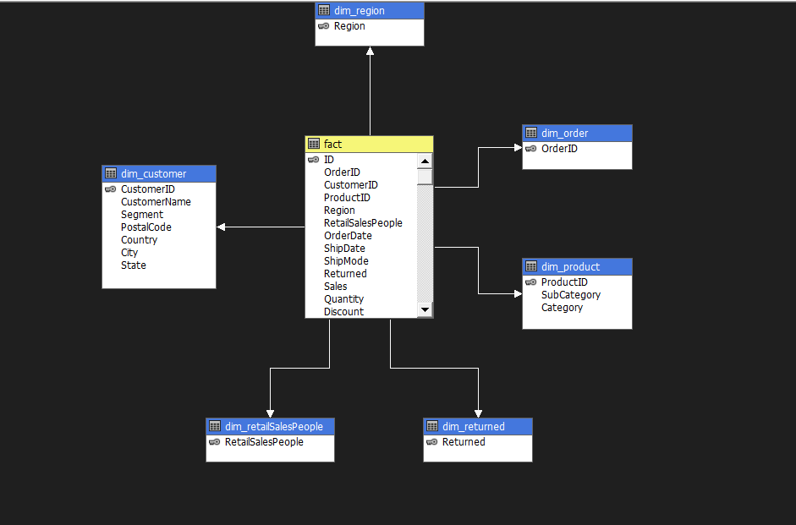
Figure 8. Star Schema Design

3.1.4. Cube Building Process Using SQL Server Analysis Services (SSAS)
- A Data Source was established to connect to the SQL Server database.
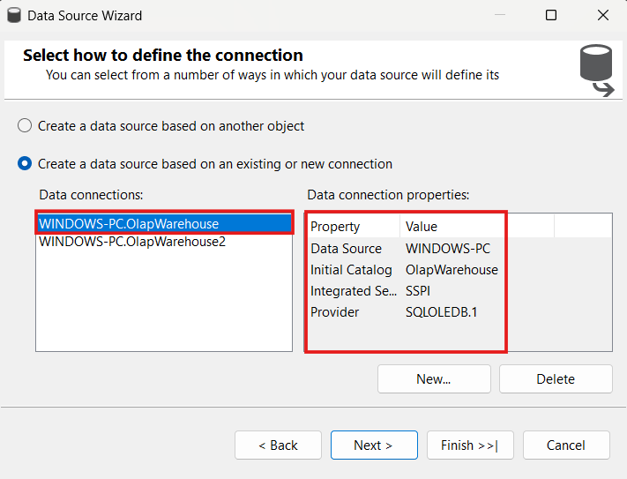
Figure 9. Define connection by Data Source
- A Data Source View (DSV) was created to visually manage the schema and choose relevant tables for the cube.
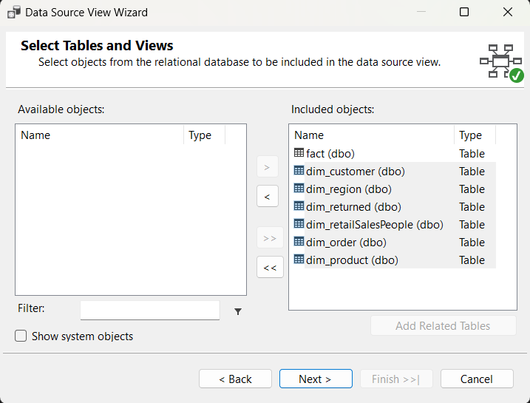
Figure 10. DSV window showing selected fact and dimension tables

- Creating Measure Groups
  - Measures such as Total Sales, Quantity Sold and Total Cost, … were added to the Measure Group
  - Aggregation functions like SUM and COUNT were applied based on business requirements.
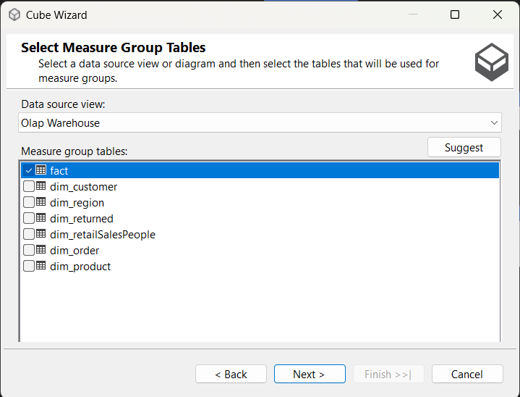
Figure 11. Identify measure groups
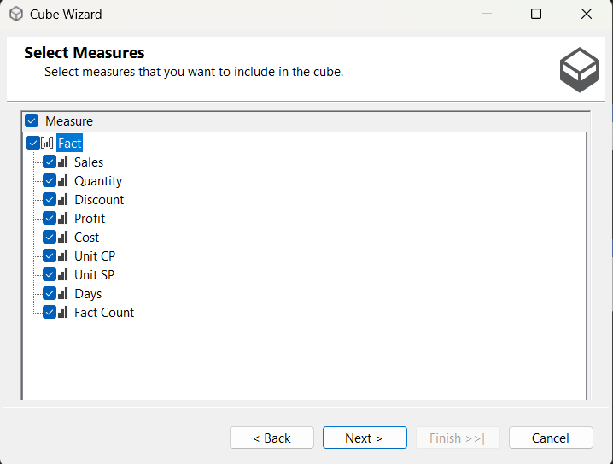
Figure 12. Add measure groups
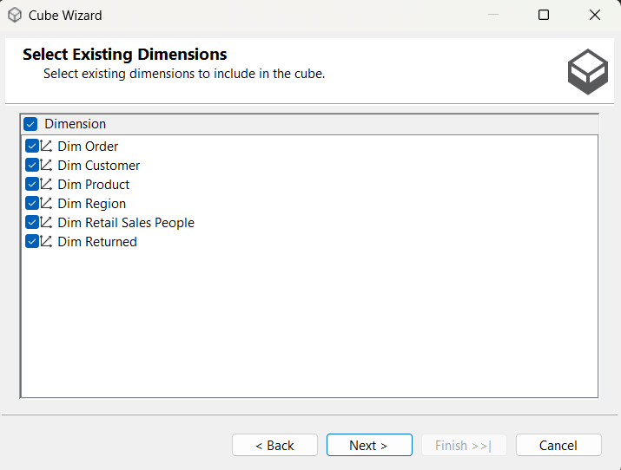
Figure 13. Defining Dimension
- Creating Hierarchies
  - dim_product: Category -> SubCategory
  - dim_customer: Country -> State -> City
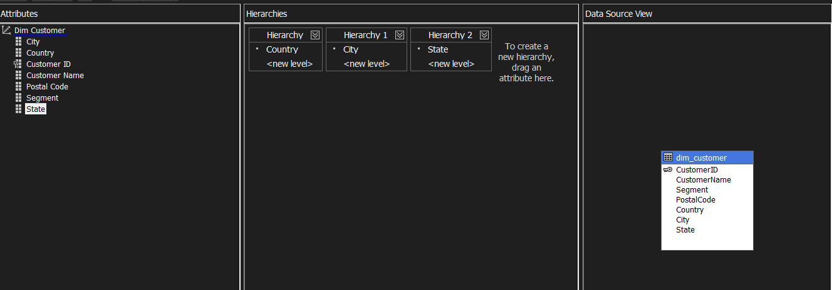
Figure 14. Hierarchy editor showing hierarchy in dim_customer
- Cube Deployment and Processing
  - The cube was deployed and processed to build the metadata and pre-aggregated structures.
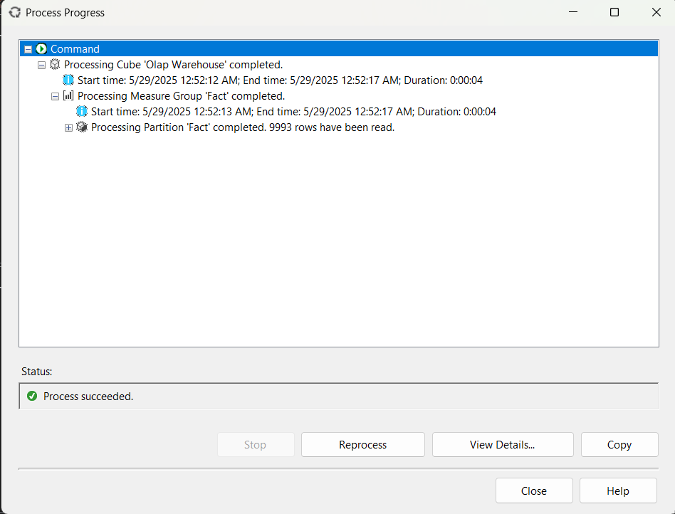
Figure 15. Processing cube window showing successful status

3.2. Using analysis service (SSAS)
After successfully deploying the cube, the next step is to validate and explore the cube using the Browser tab in SQL Server Analysis Services (SSAS). As shown in the figure below, we used the Browser to filter the Dim Product dimension by the Furniture category. The cube returns aggregated Cost values across different Region values, demonstrating the cube's ability to summarize and group data effectively. This process ensures that the dimension relationships and measure aggregations work as expected before creating final reports.
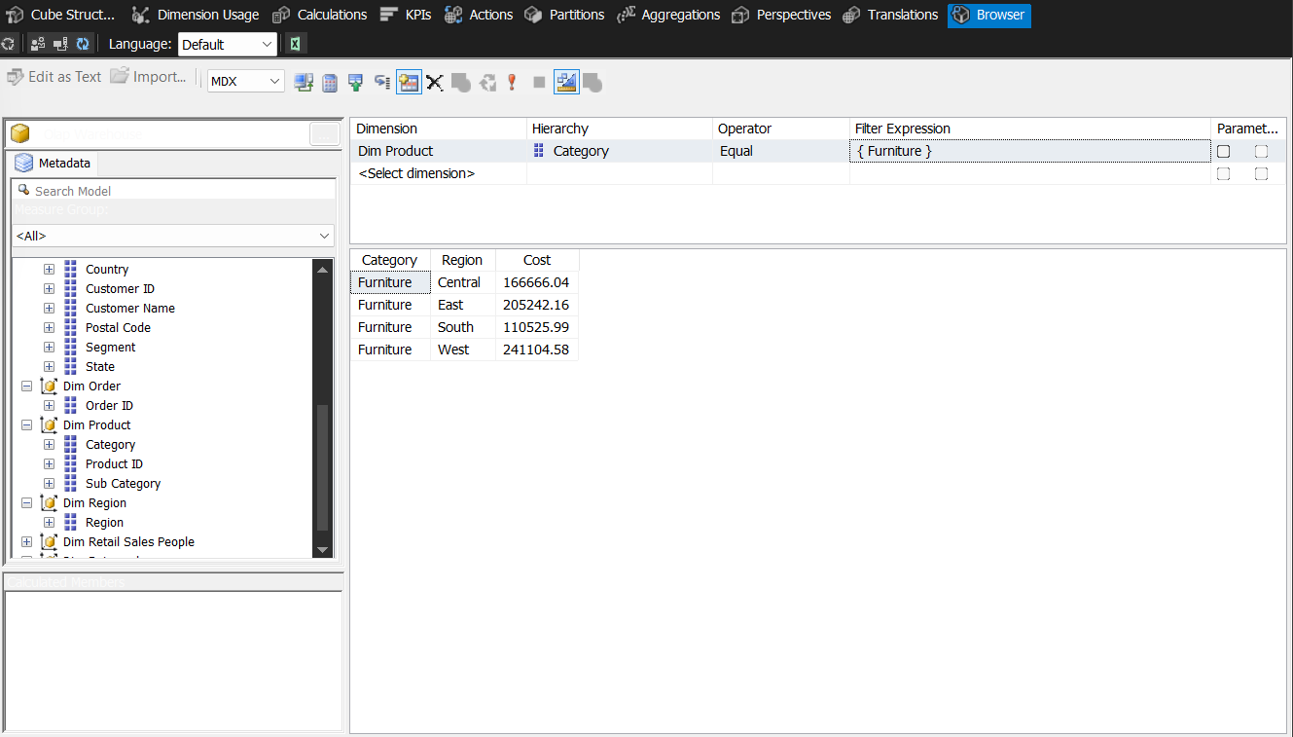
Figure 16. Cube browsing with filter on 'Furniture' category in SSAS

3.3. Using analysis service (MDX) and create reports (Power BI)
In the context of Business Intelligence, effective data analysis depends not only on well-modeled data but also on powerful tools that allow users to explore, query, and visualize business metrics from multiple perspectives. Two of the most widely used tools in this area are MDX (Multidimensional Expressions) and Power BI.
While MDX is a query language designed specifically for multidimensional data in OLAP cubes, enabling deep technical analysis with high flexibility and performance, Power BI provides an intuitive, visual interface for business users to create interactive dashboards and reports, enabling data exploration without needing programming knowledge.
By combining the power of MDX with the user-friendly capabilities of Power BI, organizations can support both technical analysts and business decision-makers in discovering actionable insights from complex datasets.
In this report, we demonstrate the practical use of MDX and Power BI through 10 key business questions derived from the retail and supply chain dataset. These questions cover multiple dimensions such as time, geography, customer segments, product categories, and financial performance, helping to uncover trends, detect anomalies, and support strategic decision-making.
10 Analytical Questions Using MDX and Power BI:
- Calculate total sales by category
- Calculate total sales by sub-category
- Calculate total sales by customer and region in East
- Find the sales by customer in Category = "Office Supplies" & Sub-Category = "Art"
- Calculate total cost by each region in each category
- Calculate the percentage of return rate from total order
- Find return rate by region
- Top 5 sub-categories that have high returned rate
- Find the maximum of delivery time
- Calculate return rate of each customer segmentation

3.3.1. Roll up - Calculate total sales by category
Figure 17. MDX question 1
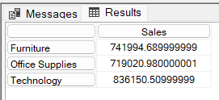
Figure 18. MDX result of question 1
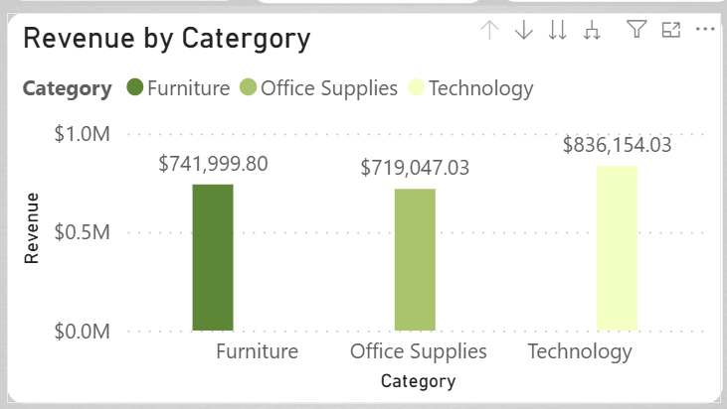
Figure 19. Power BI question 1

3.3.2. Drill down - Calculate total sales by sub-category
Figure 20. MDX question 2
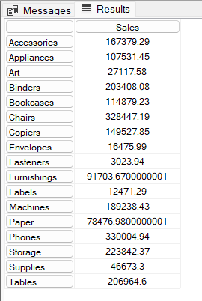
Figure 21. MDX result of question 2
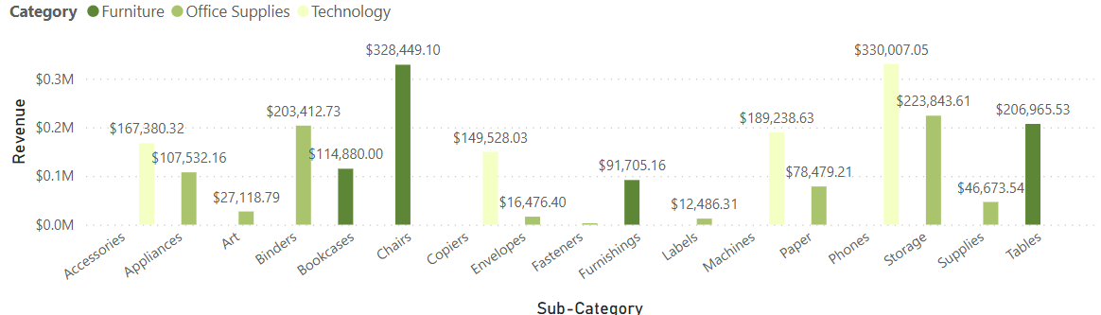
Figure 22. Power BI question 2

3.3.3. Slice - Calculate total sales by customer and region in East
Figure 23. MDX question 3
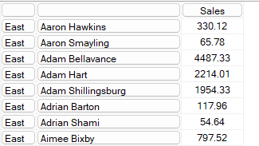
Figure 24. MDX result of question 3
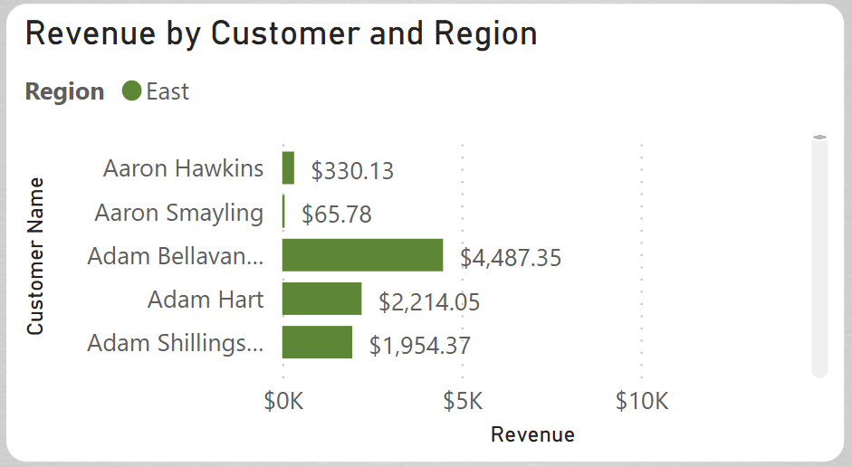
Figure 25. Power BI question 3

3.3.4. Dice - Find the sales by customer in Category = "Office Supplies" & SubCategory = "Art"
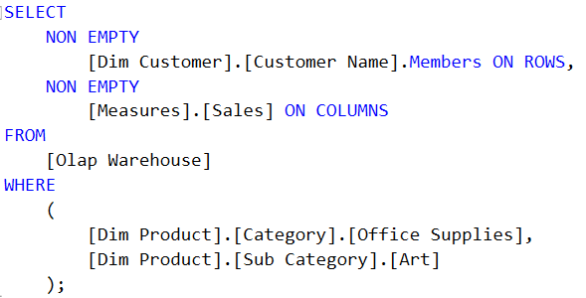
Figure 26. MDX question 4
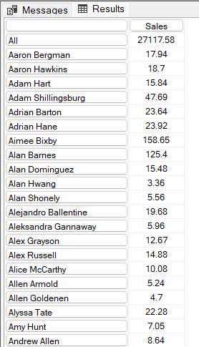
Figure 27. MDX result of question 4
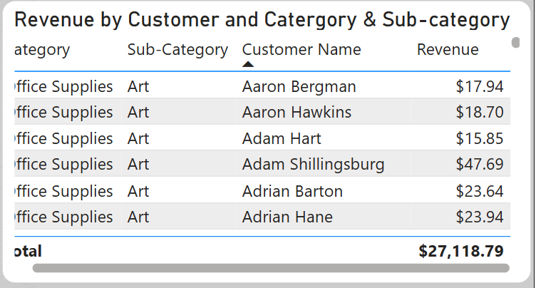
Figure 28. Power BI question 4

3.3.5. Pivot - Calculate total cost by each region in each category
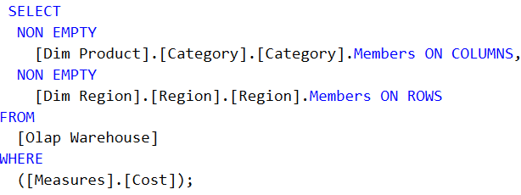
Figure 29. MDX question 5
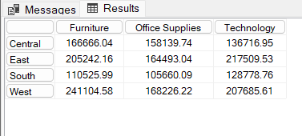
Figure 30. MDX result of question 5
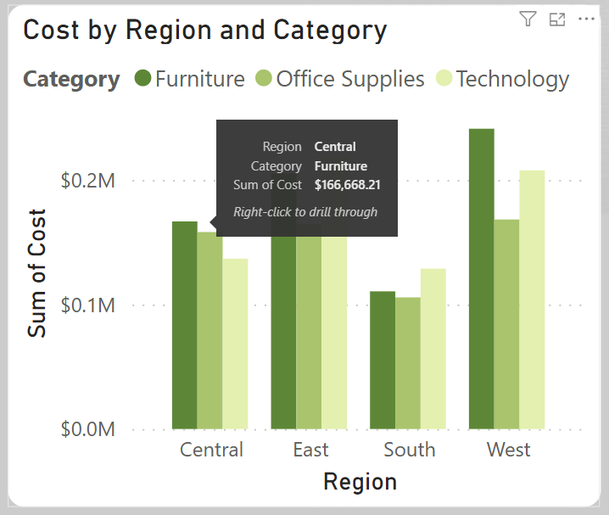
Figure 31. Power BI question 5

3.3.6. Calculate the percentage of return rate from total order
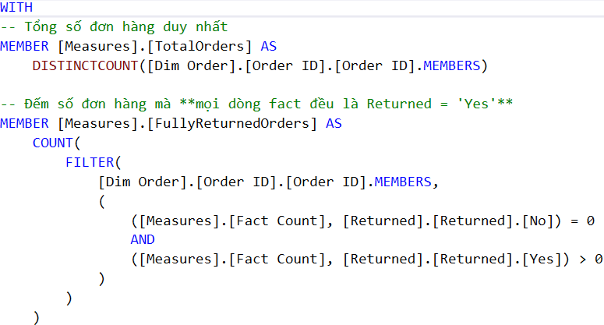
Figure 32. MDX question 6
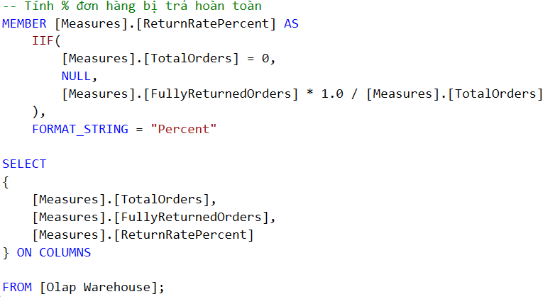
Figure 33. MDX question 6
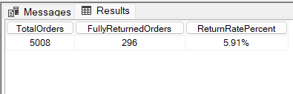
Figure 34. MDX result of question 6
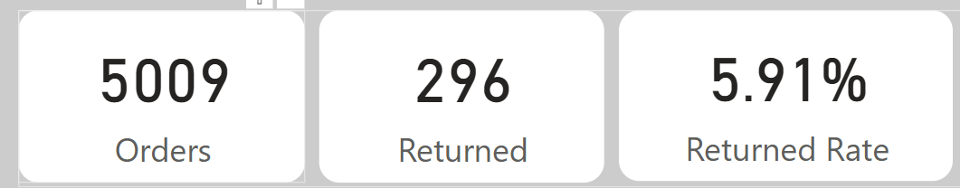
Figure 35. Power BI question 6

3.3.7. Find return rate by region
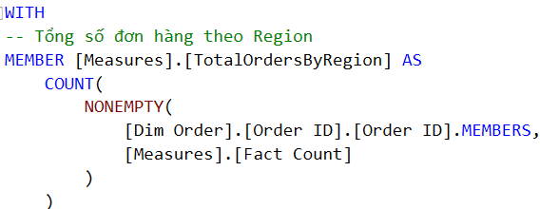
Figure 36. MDX question 7
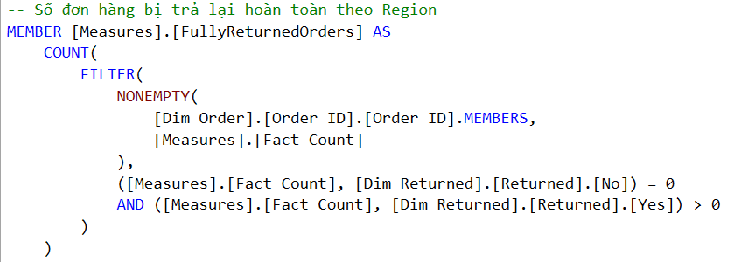
Figure 37. MDX question 7
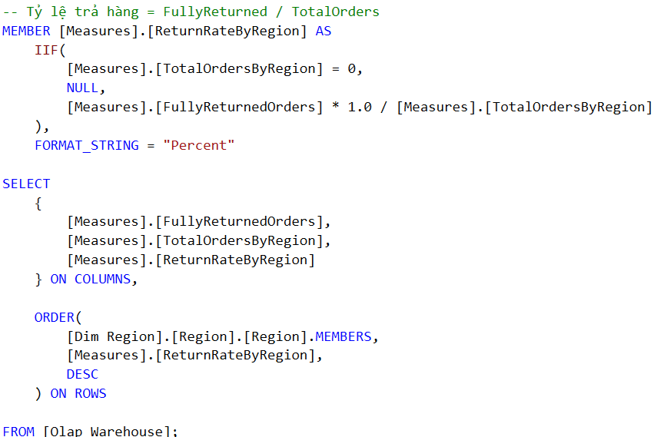
Figure 38. MDX question 7
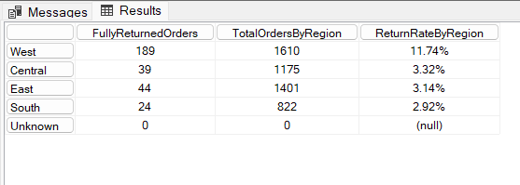
Figure 39. MDX result of question 7
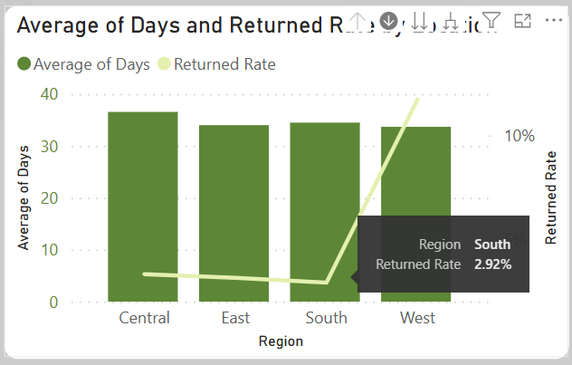
Figure 40. Power BI question 7

3.3.8. Top 5 sub-categories that have high returned rate
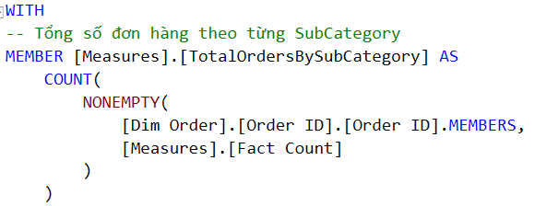
Figure 41. MDX question 8
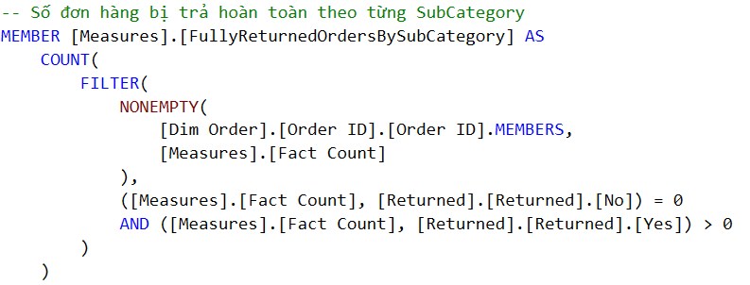
Figure 42. MDX question 8
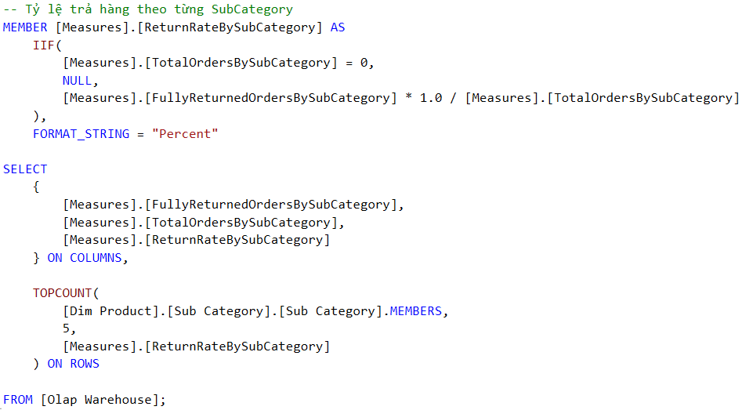
Figure 43. MDX question 8
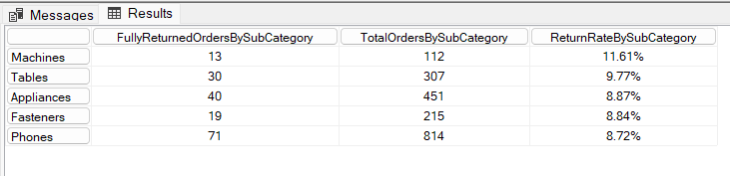
Figure 44. MDX result of question 8
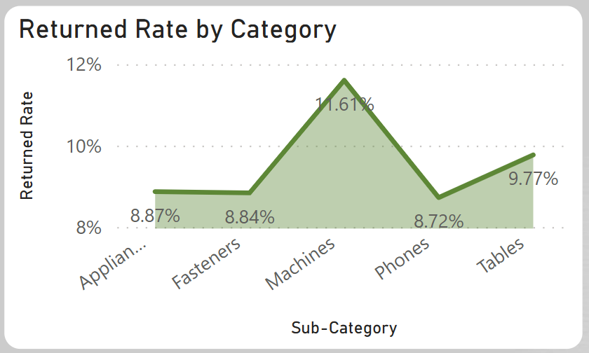
Figure 45. Power BI question 8

3.3.9. Find the maximum of delivery time
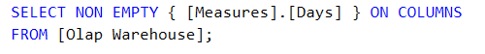
Figure 46. MDX question 9
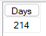
Figure 47. MDX result of question 9
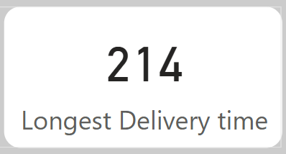
Figure 48. Power BI question 9

3.3.10. Calculate return rate of each customer segmentation
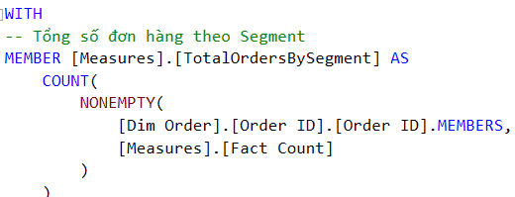
Figure 49. MDX question 10
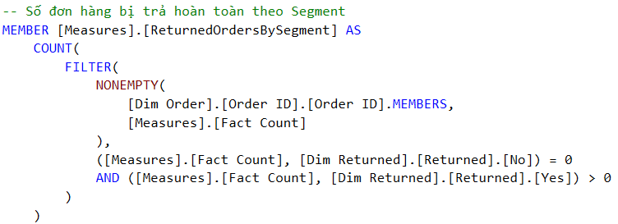
Figure 50. MDX question 10
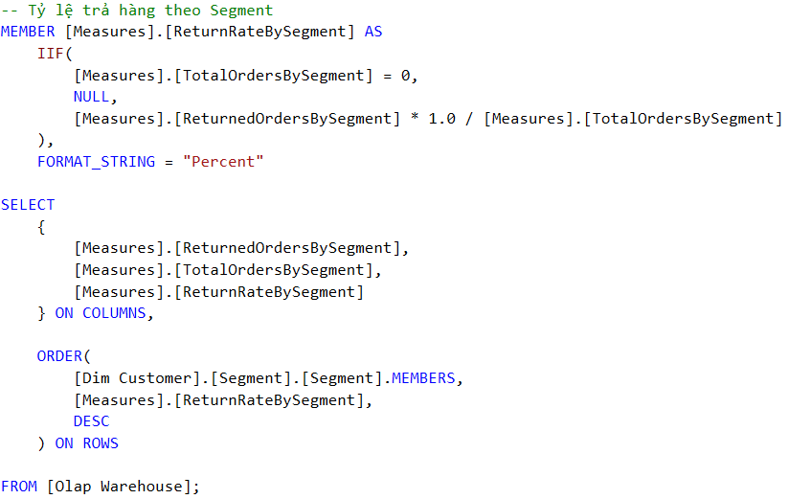
Figure 51. MDX question 10
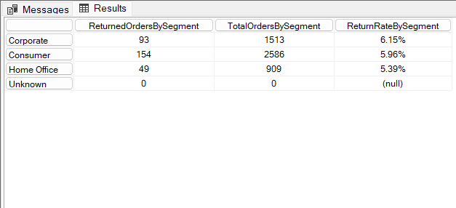
Figure 52. MDX result of question 10
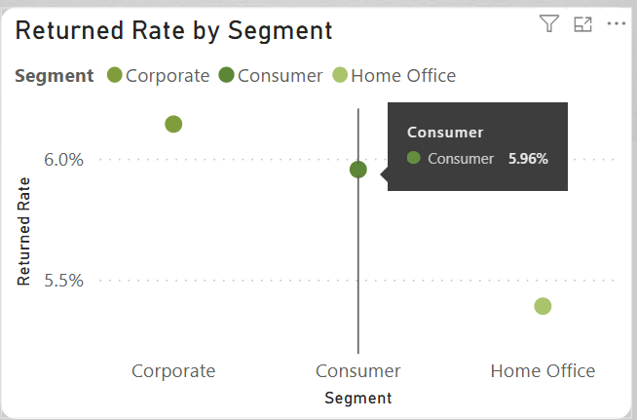
Figure 53. Power BI question 10

3.4. Using analysis by Pivot table in Excel.
To better understand the characteristics of returned versus non-returned orders, we analyzed the distribution and average values of key financial metrics—Sales, Profit, and Cost—based on the predicted return status (predict_return) using bar charts.
Interpretation:
- On average, returned orders have slightly higher Sales than non-returned ones (+6.81 USD).
- However, Profit is lower by approximately 3.42 USD, indicating reduced margin.
- Cost is higher for returned orders by about 7.16 USD.
These results imply:
- High-cost, low-profit items may be more prone to returns.
- Customers may feel that the value does not justify the cost, increasing dissatisfaction.
- A higher return rate in such products could also stem from complex logistics, unmet expectations, or quality issues.

Figure 54. Comparison of Average Sales, Profit, and Cost

4. Data mining

4.1. Random Forest
The main objective of this study is to apply the Balanced Random Forest (BRF) algorithm to solve the problem of data imbalance in predicting the probability of returned orders. The imbalance is evident in the Returned variable: there are more "Not Return" orders than "Return" orders. This algorithm is designed to balance the data during the training of the model, so that the model is not biased towards the majority class and can learn from both classes.
We use Balanced Random Forest (BRF), a variant of the Random Forest algorithm, to solve the imbalance problem. BRF uses bootstrap sampling with replacement, but with a special feature: in each decision tree, BRF balances the number of samples between the "Return" class and the "Not Return" class. This method helps the model learn from both classes without being biased towards the dominant class.
The processed data is divided into two parts: 70% for the training set and 30% for the testing set, ensuring an objective assessment of the model's accuracy. The input features include 18 important columns such as: 'Ship Mode', 'Customer Name', 'Segment', 'City', 'State', 'Region', 'Retail Sales People', 'Product Name', 'Sub-Category', 'Category', 'Sales', 'Quantity', 'Discount', 'Profit', 'Cost', 'Unit CP', 'Unit SP', 'Days',

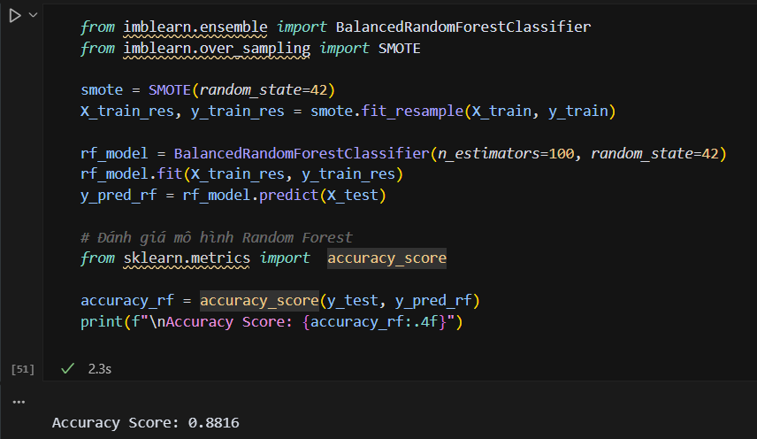
Figure 55. training model and print accuracy
In the test set (y_test), the number of "Not Return" orders (2,755) is much more dominant than "Return" orders (168). However, the model predicts "Not Return" (2,830) and "Return" (243), showing that although there is an improvement, the model still has a bias towards the "Not Return" class.
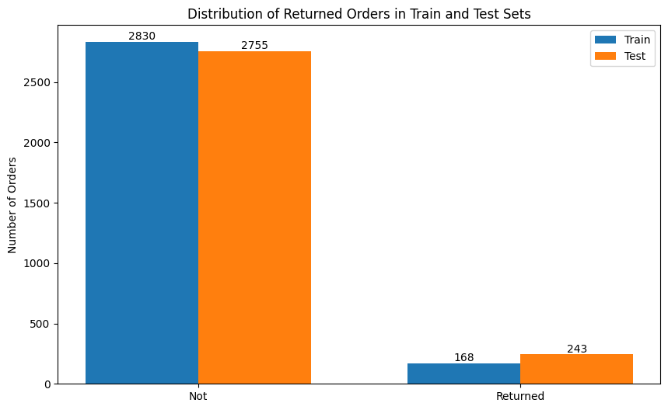
Figure 56. Compare result between test and predict dataset
Here are the top 10 important features in the Random Forest model according to the Feature Importance chart:
- Discount
- Sales
- Profit
- Cost
- Days
- UnitSP
- UnitCP
- SubCategory
- ShipMode
- Segment
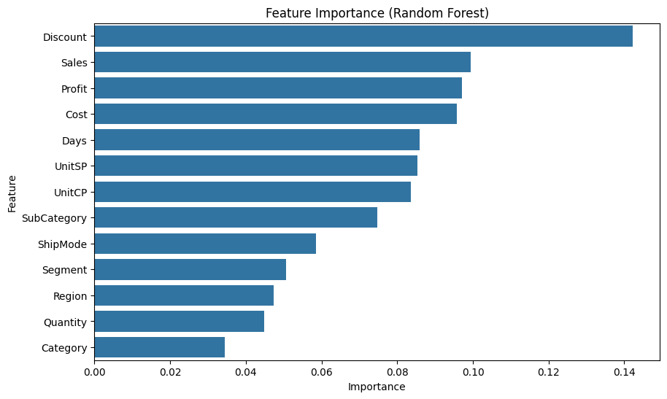
Figure 57. Top 10 important feature
According to the Random Forest model, Sales ranked among the top 10 most important features affecting return predictions—alongside Discount, Profit, Cost, and others.
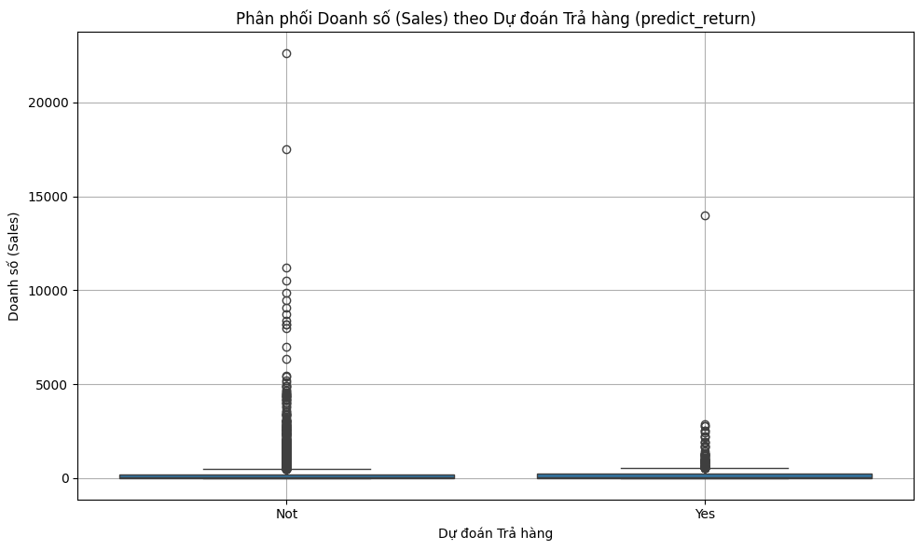
Figure 58. Distribution of Sales by Predicted Return Status
The boxplot below displays the distribution of Sales across two categories of predicted return status:
- “Not” (orders predicted not to be returned)
- “Yes” (orders predicted to be returned)
Observations from Distribution:
- Both groups show a right-skewed distribution with significant outliers.
- Non-returned orders have more frequent extremely high Sales values, including several orders above $20,000.
- Median sales values are similar (~$120–130), but the presence of more high-value sales in the non-returned group indicates a meaningful pattern.
=> This validates that Sales is not only statistically variable by group, but also plays a significant predictive role in determining whether a product will be returned.

4.2. CNN
The purpose of the CNN model in this study is to predict the probability of an order being returned, thereby helping retail businesses improve customer experience and optimize after-sales processes. The model is built on a retail dataset with binary labels Returned (Yes/Not), indicating whether the order is returned or not.
The processed data is divided into two parts: 70% for the training set and 30% for the testing set, ensuring an objective assessment of the model's accuracy. The input features include 18 important columns such as: 'Ship Mode', 'Customer Name', 'Segment', 'City', 'State', 'Region', 'Retail Sales People', 'Product Name', 'Sub-Category', 'Category', 'Sales', 'Quantity', 'Discount', 'Profit', 'Cost', 'Unit CP', 'Unit SP', 'Days',
The CNN model is implemented with two convolutional layers (Conv1D), using kernel size = 3, with 32 filters in the first layer and 64 filters in the second layer. This is followed by a Flatten layer, and two Dense layers where the last layer uses a sigmoid function to predict the probability. This structure helps the model learn complex patterns of associations between input features. On the hand, CNN model has the high accuracy (91.46%)
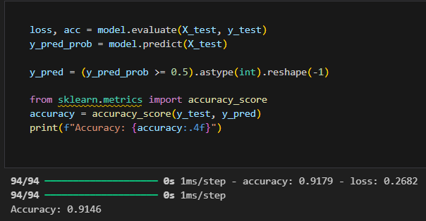
Figure 59. CNN accuracy
Notably, by analyzing the weights from the Dense layer before the output, we identified the 10 features that most strongly influence the likelihood of return. The most important factors include:
- State
- Days
- Segment
- Category
- Unit CP
- Sales
- Unit SP
- Profit
- Sub-Category
- Cost
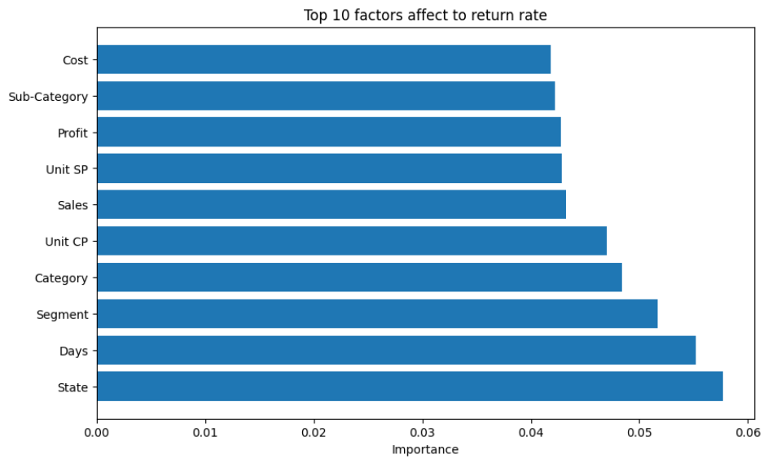
Figure 60. Top 10 factors
Suggestion:
- Consider adjusting shipping policies or customer support by region.
- Improve logistics to shorten delivery times.
- Personalize return policies and incentives by segment.
- Increase quality control, more detailed product descriptions.
- Check consistency between price and actual value received.
- Analyze the relationship between discounts and return rates.
- Ensure products are "worth the price" through clear descriptions, realistic images.
- Deepen analysis by sub-category.
- Improve information transparency, reduce hidden costs in transactions.

5. Conclusion
This Business Intelligence (BI) report has provided a comprehensive exploration of the supply chain and sales dataset of a retail company, covering every stage from data integration to advanced analytics and data mining. By utilizing tools such as SSIS, SSAS, Power BI, MDX, and Excel Pivot Tables, the report demonstrated how raw operational data can be transformed into valuable business insights.
Through the ETL process using SSIS, data was cleaned, standardized, and structured for analysis. A star schema was designed to support efficient querying and multidimensional analysis, and a data cube was built to allow for flexible exploration of metrics across time, location, customer segments, and products.
Key insights were generated using:
- OLAP analysis to understand regional performance, customer trends, and product profitability.
- Power BI dashboards to visualize return rates, shipping delays, and sales distribution.
- MDX queries for custom reporting and slicing of dimensions.
- Pivot Tables in Excel for ad-hoc, user-friendly analytics.
- Data mining techniques (Decision Trees and Clustering) to predict customer behavior and uncover hidden patterns.
Overall, the project showcases how Business Intelligence techniques can:
- Improve operational efficiency
- Enhance strategic planning
- Reduce logistical bottlenecks
- Drive customer-centric decision making
Looking forward, the organization can further extend this BI solution by integrating real-time data sources, incorporating machine learning models, and enabling mobile analytics for field teams. These advancements will continue to strengthen data-driven culture and maintain a competitive edge in the ever-evolving retail landscape.

6. Reference
[1] How do I make this calculated measure roll up properly in SSAS: https://stackoverflow.com/questions/508414/how-do-i-make-this-calculated-measure-roll-up-properly-in-ssas
[2] Visual Studio Crashing in SSAS while trying to add a Rol to my OLAP Cube: https://superuser.com/questions/1417243/visual-studio-crashing-in-ssas-while-trying-to-add-a-rol-to-my-olap-cube
[3] SSIS Tutorial For Beginners: https://www.youtube.com/watch?v=bmc-yBcWMw8
[4] Error installing SSIS Projects for VS 2019: https://learn.microsoft.com/en-us/answers/questions/1322608/error-installing-ssis-projects-for-vs-2019
[5] Basic DAX Functions: MIN(), MAX() and AVERAGE(): https://powerbitraining.com.au/basic-dax-functions-min-max-and-average/
[6] Basic Aggregate Functions in SQL (COUNT, SUM, AVG, MAX, and MIN): https://www.youtube.com/watch?v=jcoJuc5e3RE
[7] Filters trong Power BI: Tất cả những điều cần biết về bộ lọc: https://www.bacs.vn/vi/blog/cong-cu-ho-tro/filters-trong-power-bi-tat-ca-nhung-dieu-can-biet-ve-bo-loc 34075.html?srsltid=AfmBOopNNBalN_XqGnrFJMVjVYJ1XqDctSKOu7h3YfapXzIx6B-o0RAl
[8] Power BI PAGE NAVIGATION Panel With Bookmarks & Buttons: https://community.fabric.microsoft.com/t5/Power-BI-Community-Blog/Power-BI-PAGE-NAVIGATION-Panel-With-Bookmarks-amp-Buttons/ba-p/2112439
[9] Top các hàm DAX thường dùng trong Power BI kèm ví dụ: https://datapot.vn/top-cac-ham-dax-thuong-dung-trong-power-bi/?srsltid=AfmBOoqvFii_VrAFKWIbcoZgZWSWiNVuP1y4PC7ZLWHMYJerATNsvbMe
[10] Cách sử dụng Pivot Chart trong Excel: https://www.youtube.com/watch?v=9M0PgugeemU

