GROUP PROJECT REPORT
Social Media Blog Platform
MSS301 – Software Development Project

Prepared by social-blog-platform
Hoàng Tống Việt Đức – DE180939
Tạ Tấn Phong – DE180770
FPT Da Nang campus, 2026

Table of Contents
Table of Contents 2
Revision History 4
1. Project Introduction 5
1.1 Product Perspective 5
1.2 User Classes and Characteristics 5
Guest (unauthenticated visitor) 5
Registered User (Customer) 6
Administrator 6
2. Database Design 8
2.1 user-service database 8
2.2 article-service database 8
2.3 comment-service database 9
2.4 interaction-service database 9
2.5 follower-service database 9
2.6 notification-service database 10
3. System Architecture (Microservices Architecture) 11
3.1 Deployment / operating environment 11
3.2 The seven services 11
3.3 Inter-service communication: event-driven, not direct calls 12
3.4 Security 12
3.5 New technologies explored beyond the school curriculum 13
4. Implementation 14
4.1 Deployment Considerations 14
4.2 Screenshots and explanations 14
4.2.1 Authentication 15
4.2.2 Home feed & article reading 15
4.2.3 Writing & managing articles 15
4.2.4 Social features: comments, likes, follow 15
4.2.5 Messaging & notifications 16
4.2.6 Reels & Livestream 16
4.2.7 Profile, bookmarks, search, settings 16
4.2.8 Admin dashboard 16
5. References 18

Revision History
Name | Date | Reason For Changes | Version
Hoàng Tống Việt Đức | 01 May 2026 | Initial draft | 1.0 draft 1
Tạ Tấn Phong | 04 May 2026 | Add project introduction | 1.0 draft 1
Hoàng Tống Việt Đức | 2 June 2026 | Add database design & architecture | 1.0 draft 2
Tạ Tấn Phong | 20 July 2026 | Add implementation & screenshots | 1.0 draft 3
Tạ Tấn Phong | 23 July 2026 | Final change for submission | 1.0

1. Project Introduction

1.1 Product Perspective
Social Media Blog Platform (project code name “Axion”) is a hybrid blogging and social-networking web application that lets users write and publish long-form articles (similar to Medium) while also supporting short social interactions such as likes, comments, follows, direct messages, notifications, and short-video/live-streaming content (“Reels” and live broadcasting). The system was built as a portfolio-grade, production-style project to practice designing and operating a distributed backend using a microservices architecture, rather than a single monolithic application.
The product is composed of two independently deployable parts that were provided for this report:
- A React + TypeScript single-page web client (frontend-react) that end users and administrators interact with through a browser.
- A Java/Spring Boot microservices backend (backend) made up of seven independent services — user-service, article-service, comment-service, interaction-service, follower-service, notification-service, and api-gateway — each with its own database schema and its own deployable Docker image.
A native mobile client written in Flutter (axion_app) also exists in the source repository, but it is out of scope for this report because the group's assignment only covers the web platform (React frontend + Spring Boot backend).
The platform allows a visitor to browse public articles without an account, a registered user to write/publish articles, interact with content and other users, exchange direct messages and receive real-time notifications, and an administrator to moderate users, articles, and comments through a dedicated admin dashboard.

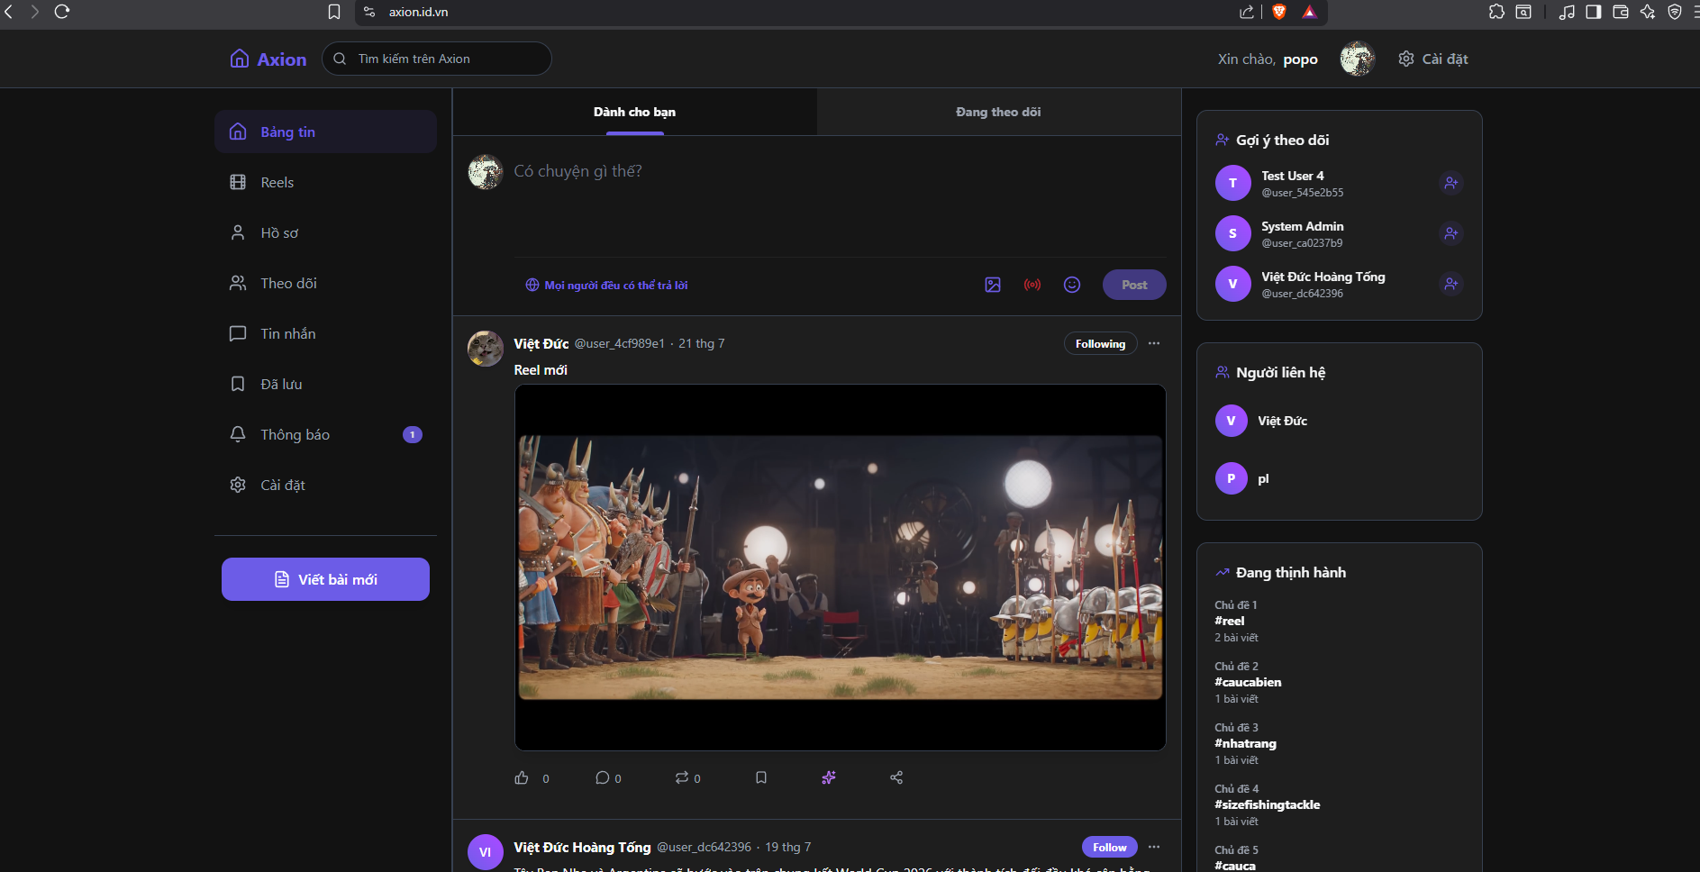

1.2 User Classes and Characteristics
The system defines three user classes, enforced in the backend through a JWT-based role claim (USER / ADMIN) issued by user-service and verified as an OAuth2 resource-server JWT by every other microservice, and enforced in the frontend through the ProtectedRoute and AdminRoute route guards.

Guest (unauthenticated visitor)
# | Function Name | Function Description
1 | Browse public feed | View published articles on the Home page without logging in (GET /api/v1/articles).
2 | Read an article | Open an article's detail page by its slug (GET /api/v1/articles/by-slug/{slug}).
3 | Search articles | Search published articles by keyword (GET /api/v1/articles/search).
4 | Register / Login | Create an account or sign in (email/password or Google OAuth) to unlock member features.

Registered User (Customer)
# | Function Name | Function Description
1 | Login (email/password, OTP or Google) | Authenticate via /api/v1/auth/login, /google-login, with RS256-signed JWT access + refresh tokens.
2 | Manage profile | View and update display name, username, bio, avatar, date of birth (/api/v1/users/me).
3 | Write / publish articles | Create, edit, publish/unpublish, delete own articles, upload media and tag posts.
4 | Comment & reply | Post, edit, delete comments and threaded replies on an article.
5 | Like / react | Like or unlike articles, comments, and media items (idempotent interactions).
6 | Follow / unfollow | Follow other authors and see a personalized “Following” feed.
7 | Direct messages | Send/receive real-time chat messages and see contacts & read state.
8 | Notifications | Receive real-time notifications (new follower, comment, reply, like, article) via SSE stream.
9 | Bookmarks | Save articles to read later.
10 | Reels & Livestream | Watch short-video reels and create/watch live broadcasts via RTMP/HLS.
11 | Ask AI | Ask an AI assistant about the content of an article (article ask-ai endpoint).

Administrator
# | Function Name | Function Description
1 | Login | Same authentication flow as Customer, but the JWT carries role = ADMIN.
2 | Manage users | List/search users, view stats, suspend, reactivate, or delete an account (/api/v1/admin/users).
3 | Manage articles | List/search all articles (incl. drafts), view stats, archive or delete any article.
4 | Manage comments | View comment moderation statistics (/api/v1/admin/comments/stats).
5 | Dashboard | View aggregate platform statistics on the Admin Dashboard page.
Business rule notes: a Customer can only edit or delete content they own (ownership is checked against the authorId/authorId claim inside each service); an Administrator can act on any user's content for moderation purposes; a Guest has read-only access to published content only.

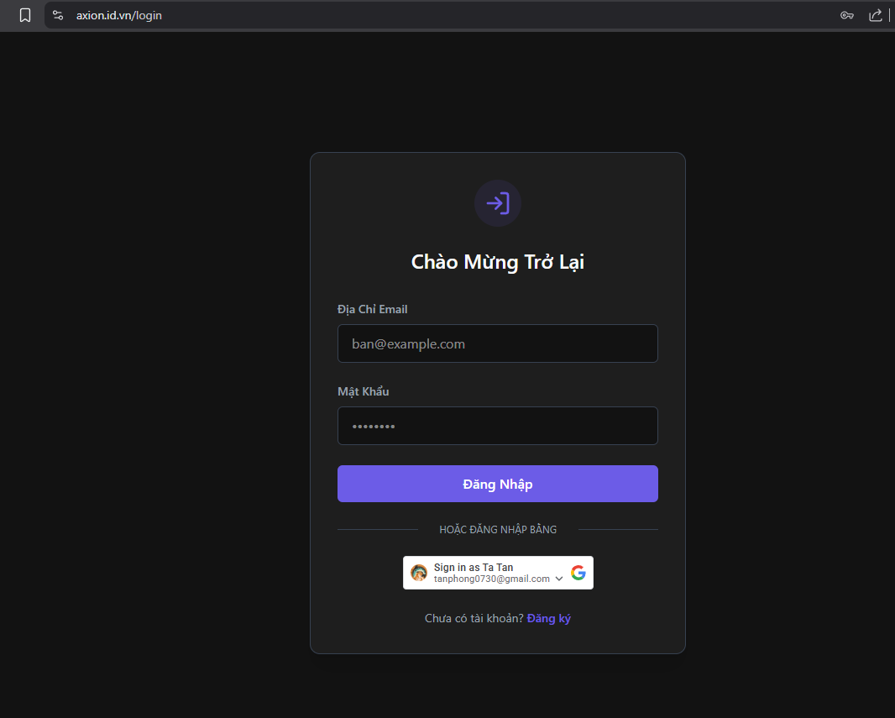
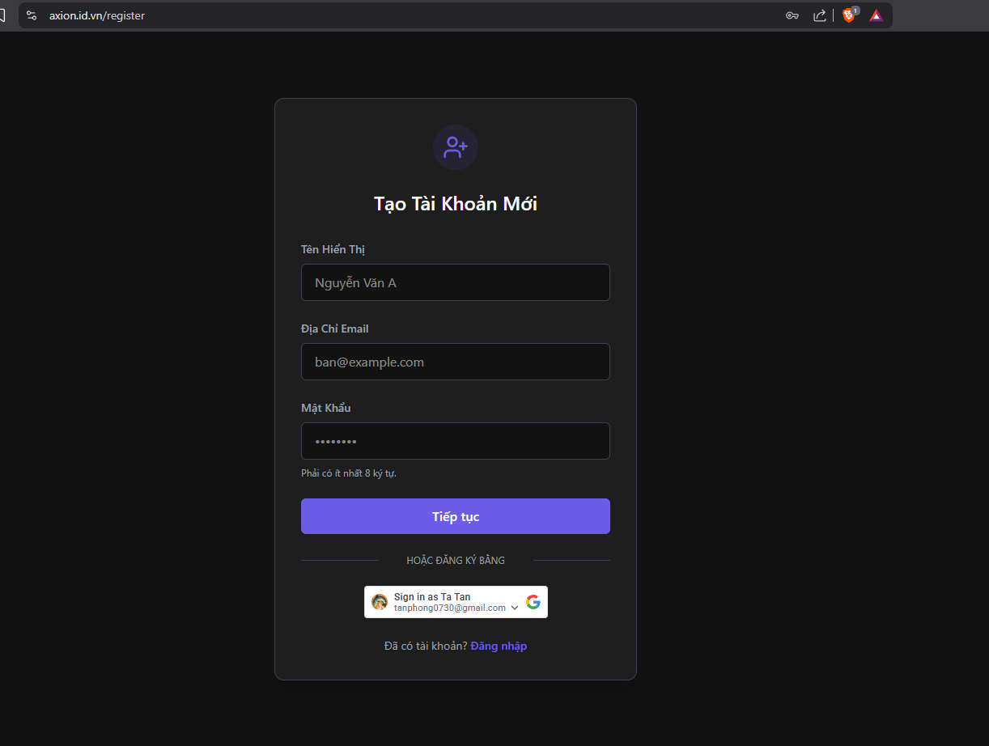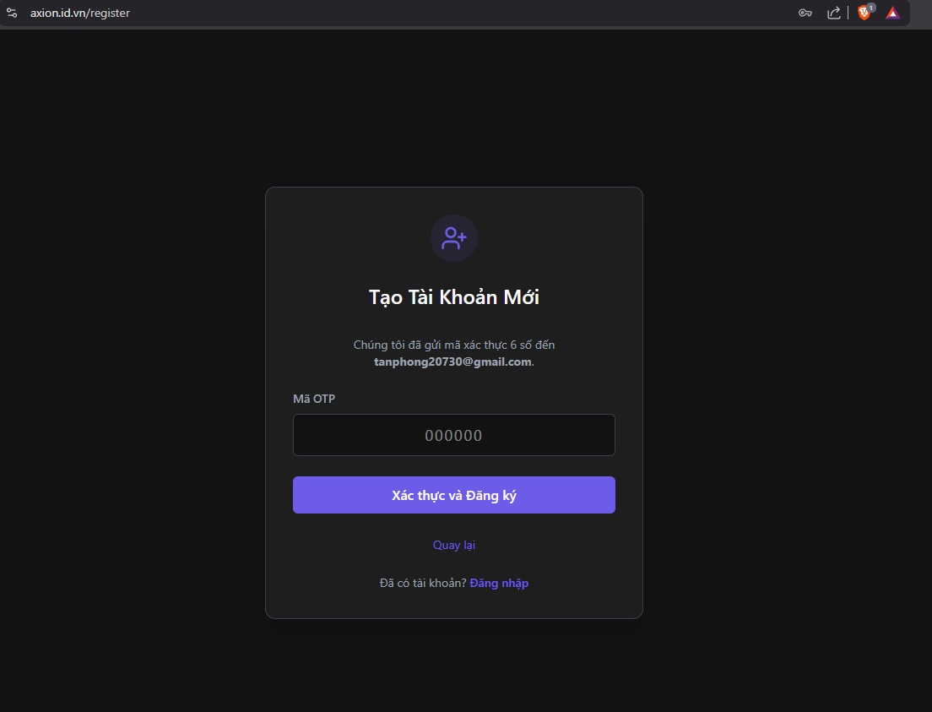

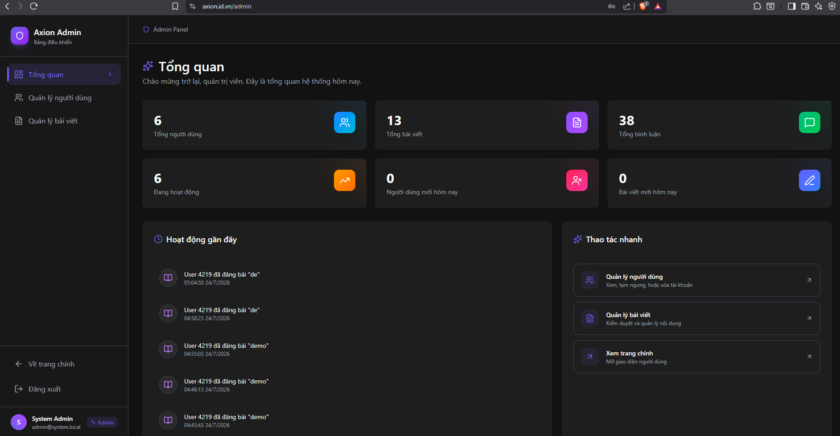2. Database Design
The platform follows the Database-per-Service pattern typical of microservices: each backend service owns a private PostgreSQL schema and no service is allowed to query another service's tables directly. Every service uses Flyway to version its schema and Spring Data JPA/Hibernate to map entities. Cross-service data that a service needs for read purposes (for example, article-service needing to know who a user follows) is not fetched synchronously; instead it is kept as a local read-only projection table that is asynchronously kept in sync through Kafka domain events (see Section 3 for the event flow). This avoids tight coupling and lets each service stay independently deployable and scalable.

2.1 user-service database
Table | Key Columns | Purpose
users | id (UUID, PK), email (unique), password_hash, display_name, username (unique), bio, avatar_url, role [USER|ADMIN], status [ACTIVE|SUSPENDED|DELETED], dob, created_at, updated_at | Core account & profile data, the source of truth for identity.
refresh_tokens | id (PK), user_id (FK→users), token_hash (unique), expires_at, revoked_at, created_at | Stores hashed refresh tokens for the JWT refresh-token rotation flow.
email_otps | id (PK), email, otp, expires_at, used | One-time codes used for email verification / passwordless login.
outbox_events | id (PK), aggregate_type, aggregate_id, event_type, event_version, payload, created_at | Transactional Outbox table — domain events waiting to be published to Kafka.

2.2 article-service database
Table | Key Columns | Purpose
articles | id (PK), author_id, title, slug (unique), summary, content (TEXT), status [DRAFT|PUBLISHED|ARCHIVED], created_at, updated_at, published_at, is_livestream, stream_key, live_status, live_started_at, live_ended_at | Article/blog-post aggregate; also doubles as a “live session” record when is_livestream = true.
article_tags | article_id (FK), tag | Element collection: one row per tag attached to an article.
follow_projection | follower_id + followed_id (composite PK), created_at | Local read-only copy of the follow graph (synced from follower-service events) used to build the personalized Following feed without a cross-service call.
processed_events / outbox_events | event_id (PK) / standard outbox columns | Idempotency ledger for consumed Kafka events + outbox for this service's own published events.

2.3 comment-service database
Table | Key Columns | Purpose
comments | id (PK), article_id, author_id, parent_id (self-reference for replies), target_url, content, status [ACTIVE|DELETED], created_at, updated_at | Comments and threaded replies; deletion is a soft-delete (content cleared, status = DELETED).
article_projection | article_id (PK), ... | Local read-only cache of article existence/owner, used to validate comment targets without calling article-service synchronously.
processed_events / outbox_events | — | Idempotency + outbox tables (transactional outbox pattern, same as every other service).

2.4 interaction-service database
Table | Key Columns | Purpose
interactions | id (PK, UUID), actor_id, target_type [ARTICLE|COMMENT|MEDIA], target_id, reaction_type (e.g. LIKE), created_at | Generic like/reaction record — one row per (actor, target) pair, reused for articles, comments, and media (Reels).
target_projection | target_id (PK), target_type, like_count | Aggregate/cache of like counters per target, updated as interactions are created/removed.
processed_events / outbox_events | — | Idempotency + outbox tables.

2.5 follower-service database
Table | Key Columns | Purpose
follows | id (PK), follower_id, followed_id, created_at, UNIQUE(follower_id, followed_id) | The canonical follow-graph edge list. The unique constraint makes follow idempotent.
user_projection | user_id (PK), active, display_name, updated_at | Local read-only cache of basic user info (for listing followers/following without calling user-service synchronously).
processed_events / outbox_events | — | Idempotency + outbox tables.

2.6 notification-service database
Table | Key Columns | Purpose
notifications | id (PK), source_event_id, recipient_id, actor_id, type [NEW_FOLLOWER|NEW_COMMENT|NEW_REPLY|NEW_LIKE|NEW_ARTICLE|NEW_MESSAGE], entity_type, entity_id, metadata (TEXT/JSON), created_at, read_at, UNIQUE(source_event_id, recipient_id) | Per-recipient notification inbox; the unique constraint guarantees each source event only ever creates one notification per recipient (idempotency).
chat_messages | id (PK), sender_id, recipient_id, content, created_at, is_read | Direct-message chat history between two users.
follow_projection | follower_id + followed_id, ... | Local cache of the follow graph, used to fan-out “new article” notifications to followers.
processed_events | — | Idempotency ledger for consumed Kafka events.
Every table above that stores identifiers (author_id, actor_id, follower_id, etc.) stores a UUID that refers to the users table owned by user-service — but as a plain value, not a foreign key, since PostgreSQL foreign keys cannot cross service/database boundaries in this architecture.

3. System Architecture (Microservices Architecture)
The system is deployed as a set of Docker containers behind a single public entry point. In local development the stack is started with docker-compose (PostgreSQL, Kafka, Redis, MinIO, and the SRS media server), and each Spring Boot service can additionally be run directly through Maven. In production the group deployed the stack to a VPS, fronted by a Caddy reverse proxy that also serves the built React static files.
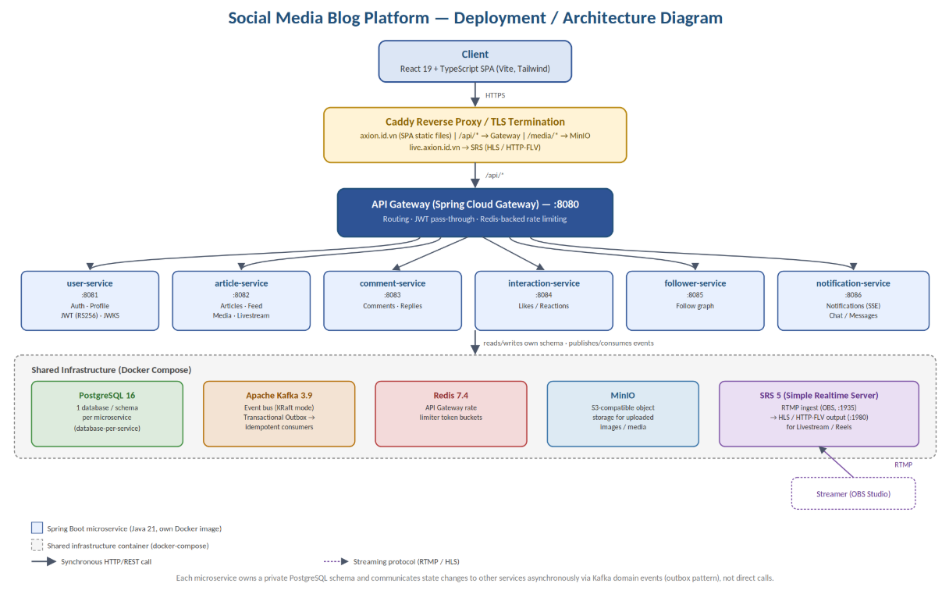

3.1 Deployment / operating environment
- Backend: Java 21, Spring Boot 3.x, Maven multi-module project (a shared parent pom.xml at the repository root, one child module per service).
- Each microservice is packaged into its own lightweight Docker image based on eclipse-temurin:21-jre-alpine and exposes a single internal port (article-service, for instance, listens on 8082).
- Frontend: React 19 + TypeScript, built with Vite, styled with Tailwind CSS 4; served as static files by Caddy in production.
- Reverse proxy: Caddy routes web traffic to the built SPA, forwards /api/* to the API Gateway (port 8080) on the backend VPS, forwards /media/* to MinIO (object storage, port 9000) to avoid mixed-content issues, and exposes a dedicated subdomain that proxies HTTP-FLV/HLS traffic to the SRS live-streaming media server.
- Infrastructure services (docker-compose): PostgreSQL 16 (one database per service, e.g. user_db), Apache Kafka 3.9 (event bus, KRaft mode — no separate Zookeeper), Redis 7.4 (API-Gateway rate limiting), MinIO (S3-compatible object storage for images/media uploads), and SRS 5 (Simple Realtime Server — accepts RTMP ingest from OBS and republishes as HLS for the Reels/Livestream feature).
- Geography / users: the platform targets a single-region deployment (VPS), so no multi-region data residency or timezone-partitioning concerns apply for this coursework project.

3.2 The seven services
Service | Port | Responsibility
api-gateway | 8080 | Single public entry point (Spring Cloud Gateway). Routes each request to the right downstream service and applies Redis-backed rate limiting per route (e.g. 1 req/s for auth writes, 5 req/s for article writes, 3 req/s for comment writes).
user-service | 8081 | Registration/login (password, email-OTP, Google OAuth), profile management, RS256 JWT issuance + JWKS endpoint, refresh-token rotation, admin user moderation.
article-service | 8082 | Article draft/publish lifecycle, tagging, public feed, search, trending, “following” feed, media upload, livestream session creation and SRS webhook handling, AI “ask about this article” endpoint.
comment-service | 8083 | Comments and threaded replies on articles, ownership checks, soft-deletion, moderation stats.
interaction-service | 8084 | Idempotent like/unlike for articles, comments, and media; aggregate like counts.
follower-service | 8085 | Idempotent follow/unfollow, paginated followers/following lists, follow-graph events.
notification-service | 8086 | Real-time notification inbox (Server-Sent Events stream), unread counters, event-driven notification creation, direct-message chat.

3.3 Inter-service communication: event-driven, not direct calls
Services do not call each other synchronously for state changes. Instead every service implements the Transactional Outbox pattern: when a service changes its own data (e.g. a user publishes an article, or a follow is created), it writes the resulting domain event into its own outbox_events table in the same database transaction as the business change. A background publisher then reliably relays these rows to Apache Kafka. Interested services consume the relevant Kafka topics and update their own local projection tables (follow_projection, user_projection, article_projection, target_projection). Each consumer records the event id in a processed_events table so that re-delivered Kafka messages are ignored — this makes every consumer idempotent even though Kafka only guarantees at-least-once delivery.
Example event flow — publishing an article: (1) the author calls POST /api/v1/articles/{id}/publish on article-service; (2) article-service updates the article row and inserts a NEW_ARTICLE row into its own outbox_events table in the same transaction; (3) the event is published to Kafka; (4) notification-service consumes it, looks up the author's followers in its local follow_projection table, and creates one notifications row per follower; (5) each follower's browser receives it instantly through the Server-Sent Events stream exposed by GET /api/v1/notifications/stream.

3.4 Security
- Authentication is stateless JWT (RS256). user-service is the only service that signs tokens; it exposes its public key at GET /.well-known/jwks.json.
- Every other service is configured as a Spring OAuth2 Resource Server that verifies incoming access tokens against that JWKS endpoint (or a configured JWT_JWK_SET_URI in non-local environments) — no service needs to share a secret key with user-service.
- Refresh tokens are stored server-side as salted hashes (refresh_tokens table) so a leaked database dump cannot be replayed directly, and can be individually revoked.
- CORS is profile-specific: local development allows localhost origins by default, while staging/prod require an explicit CORS_ALLOWED_ORIGINS environment variable.
- The API Gateway enforces Redis-backed rate limits on sensitive write endpoints (auth, article writes, comments, likes, follows, notification writes) to mitigate abuse and brute-force attempts.

3.5 New technologies explored beyond the school curriculum
- Spring Cloud Gateway with a Redis token-bucket RequestRateLimiter, configured per-route.
- The Transactional Outbox + idempotent-consumer pattern for reliable event publishing without a distributed transaction/2PC.
- Apache Kafka running in KRaft mode (no Zookeeper) as the event backbone between six independently-deployed services.
- SRS (Simple Realtime Server) for RTMP ingest (OBS Studio) and HLS/HTTP-FLV distribution to power the Livestream/Reels feature.
- MinIO as an S3-compatible object store for user-uploaded media, fronted by Caddy to avoid mixed-content (HTTP/HTTPS) issues.
- Server-Sent Events (SSE) for pushing real-time notifications to the browser without the overhead of a full WebSocket connection.

4. Implementation

4.1 Deployment Considerations
Each backend microservice builds to a single executable JAR (mvn -pl <module> package) and is containerized independently using its own Dockerfile (FROM eclipse-temurin:21-jre-alpine, EXPOSE <service-port>). This keeps images small and lets each service be redeployed, scaled, or rolled back without touching the others.
Two docker-compose files are provided: docker-compose.yml starts the shared infrastructure needed for local development (PostgreSQL, Kafka, Redis, MinIO, SRS), while docker-compose.prod.yml / vps-backend.compose.yml describe the production topology used on the group's VPS.
Frontend deployment: vite build produces static assets that Caddy serves directly. Caddy also acts as the reverse proxy and TLS terminator for three concerns on the same VPS: the SPA itself (axion.id.vn), the backend API (proxied to the API Gateway on port 8080), object storage/media (proxied to MinIO on port 9000, kept under /media/* to dodge mixed-content warnings), and the live-streaming subdomain (live.axion.id.vn, proxied to SRS's HTTP server on port 1980 for HLS playback).
Access & environments: all users access the platform over the public internet from a single geographic deployment (no multi-timezone routing needed for this project). Required environment variables (documented in .env.example) include database credentials, MinIO credentials, and — critically for production — JWT_ISSUER, JWT_KEY_ID, JWT_PRIVATE_KEY, JWT_PUBLIC_KEY (or JWT_JWK_SET_URI for resource services) so that the development-only JWT defaults are never used outside local development.
Data migration / capacity: each service manages its own schema evolution independently through Flyway migration scripts, so services can be redeployed on independent schedules. Because state is fully partitioned by service and communication is asynchronous via Kafka, individual services can be scaled horizontally (extra container replicas) without requiring changes to the others.
Handover notes: anyone preparing training material or onboarding new contributors should read, in order, README.md (module overview + local dev commands), SETUP_GUIDE.md, docs/security.md (JWT boundary & key rotation), docs/deployment.md, and docs/openapi/social-blog-api.yaml (the full REST contract) from the project repository.

4.2 Screenshots and explanations
This section walks through the main screens of the web client in the order a typical user would encounter them. Insert one screenshot per item below, captured from the running frontend-react application.

4.2.1 Authentication
Login.tsx and Register.tsx implement email/password sign-up, email-OTP verification, and Google sign-in, calling POST /api/v1/auth/register, /send-otp, /login and /google-login respectively.
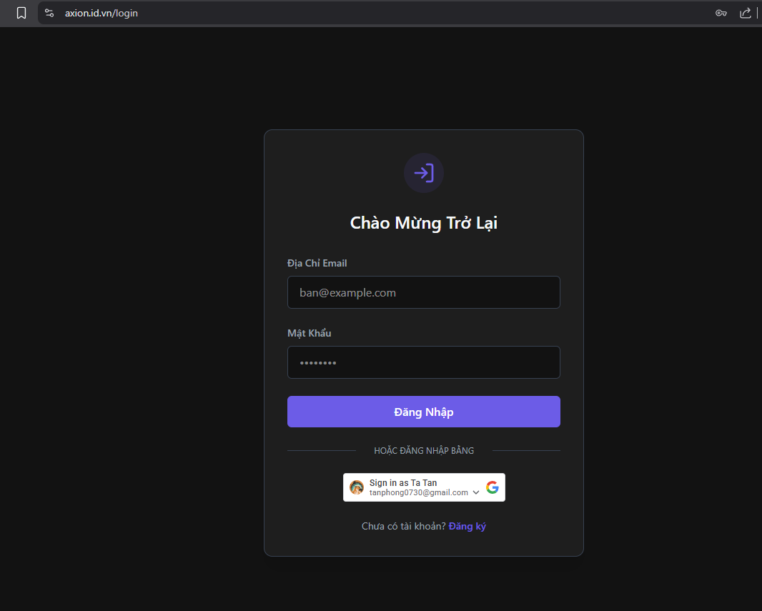
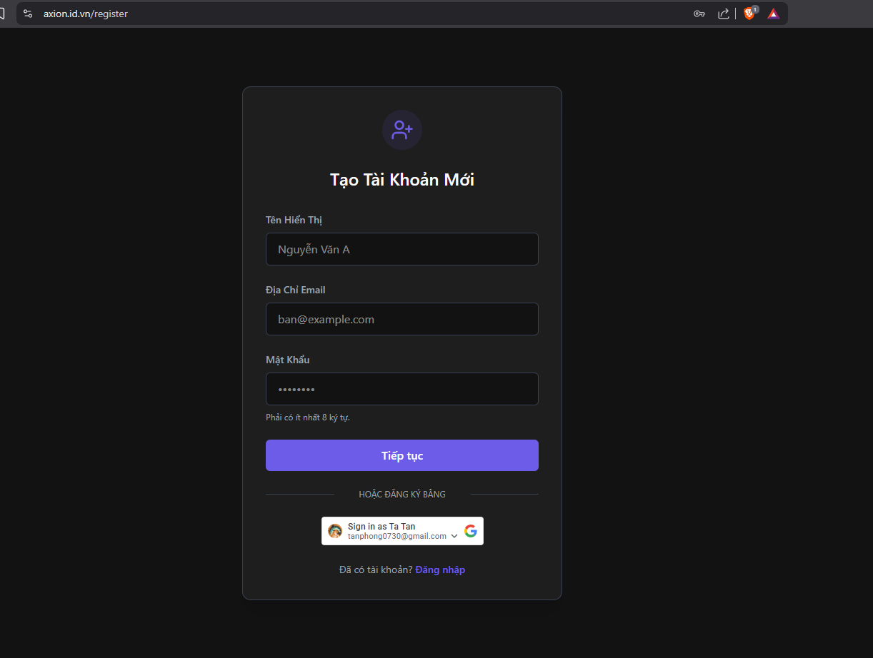

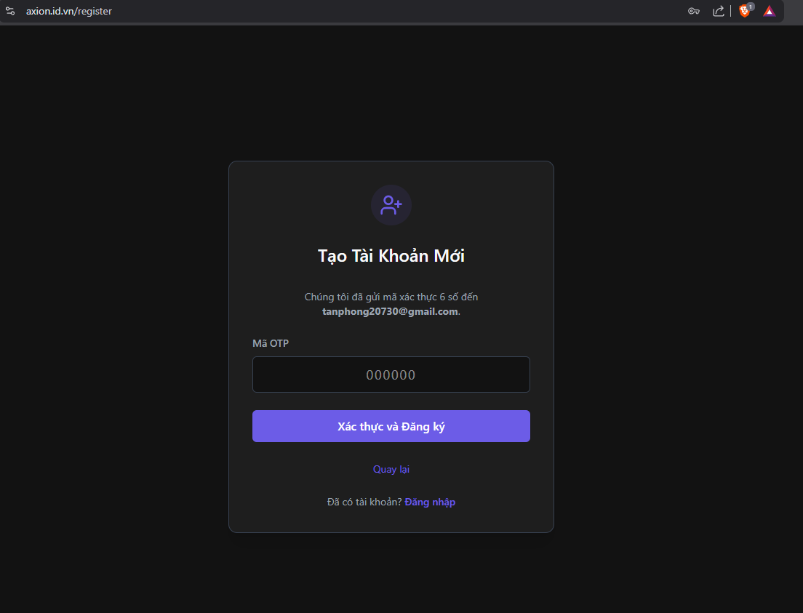4.2.2 Home feed & article reading
Home.tsx renders the main feed, mixing followed-author content with trending/public articles through the client-side feedMixer.ts utility; ArticleCard.tsx renders each preview card; ArticleDetail.tsx shows the full article, its like/comment counts, and the comment thread.
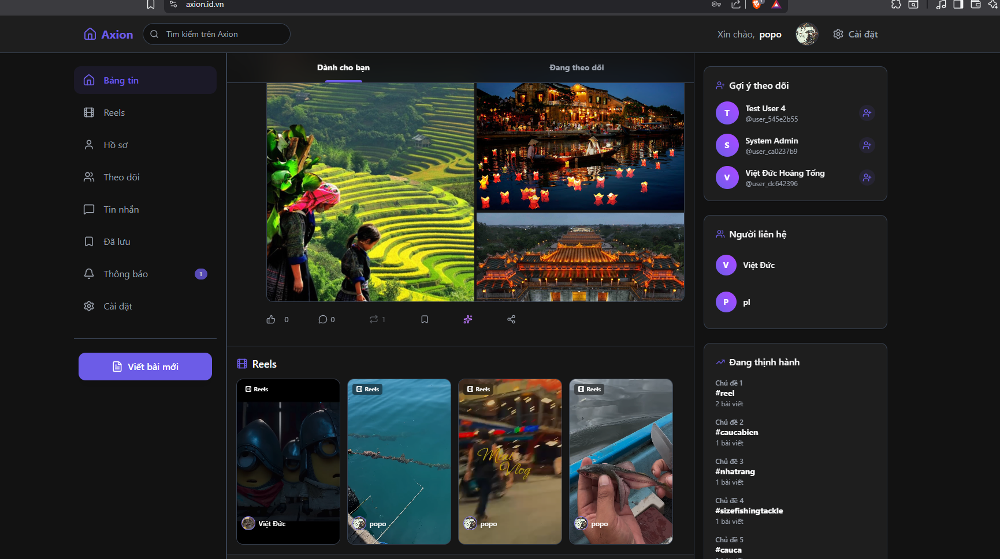

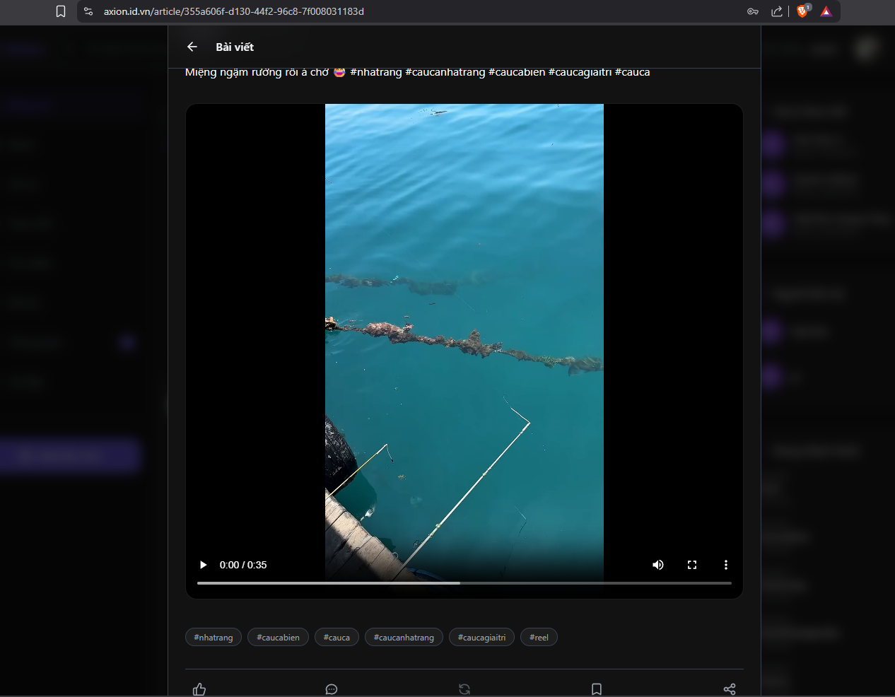4.2.3 Writing & managing articles
MyArticles.tsx lists a user's own drafts and published posts, with actions calling PUT /api/v1/articles/{id}, POST /{id}/publish and /{id}/unpublish, and DELETE /{id}.

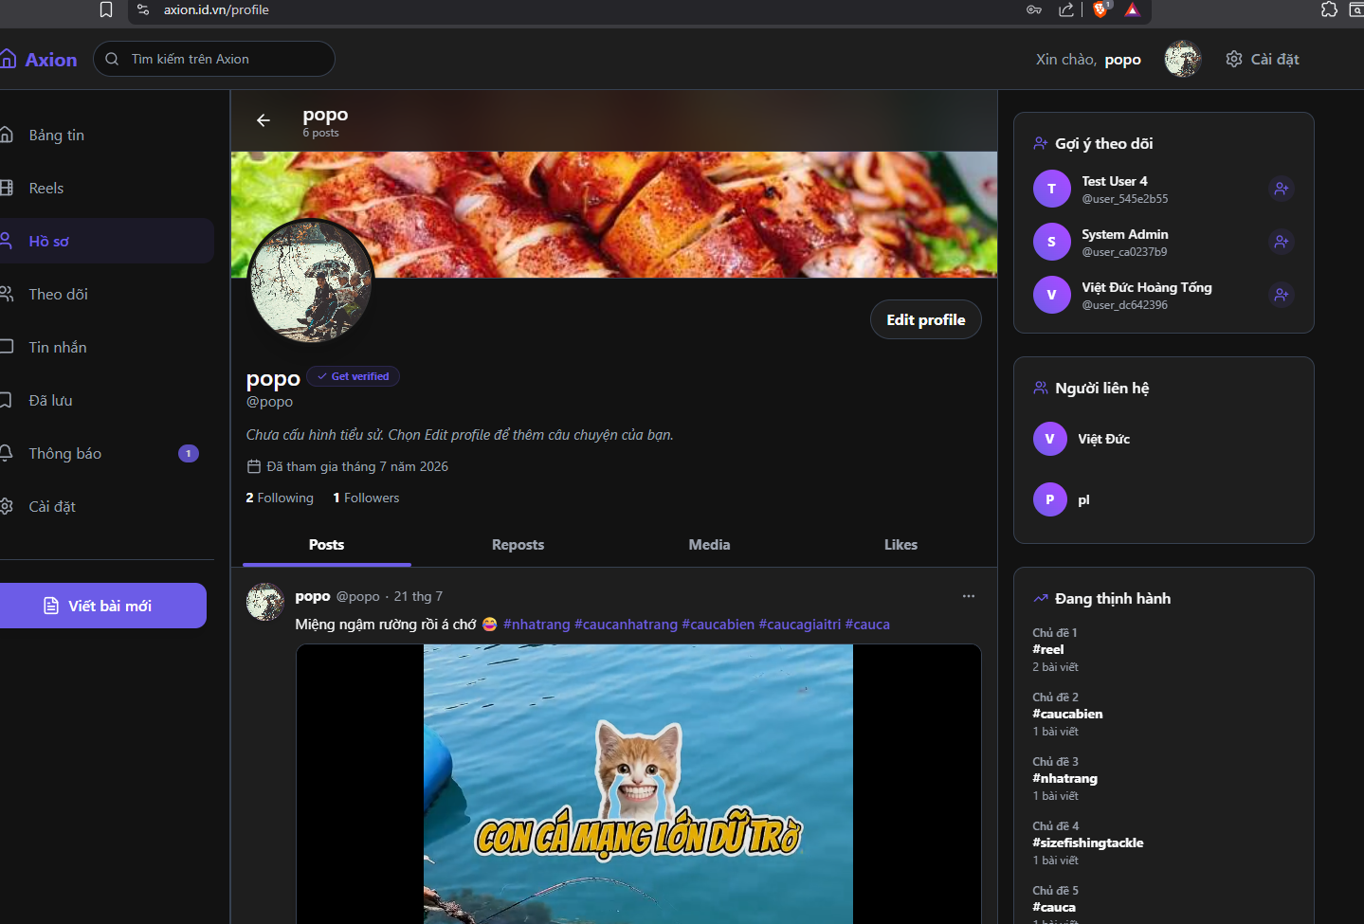4.2.4 Social features: comments, likes, follow
The comments/ component folder renders threaded comment UI backed by comment-service; like buttons across ArticleCard, ArticleDetail, and Reels call interaction-service's like/unlike endpoints; Following.tsx lists the accounts a user follows and calls follower-service.
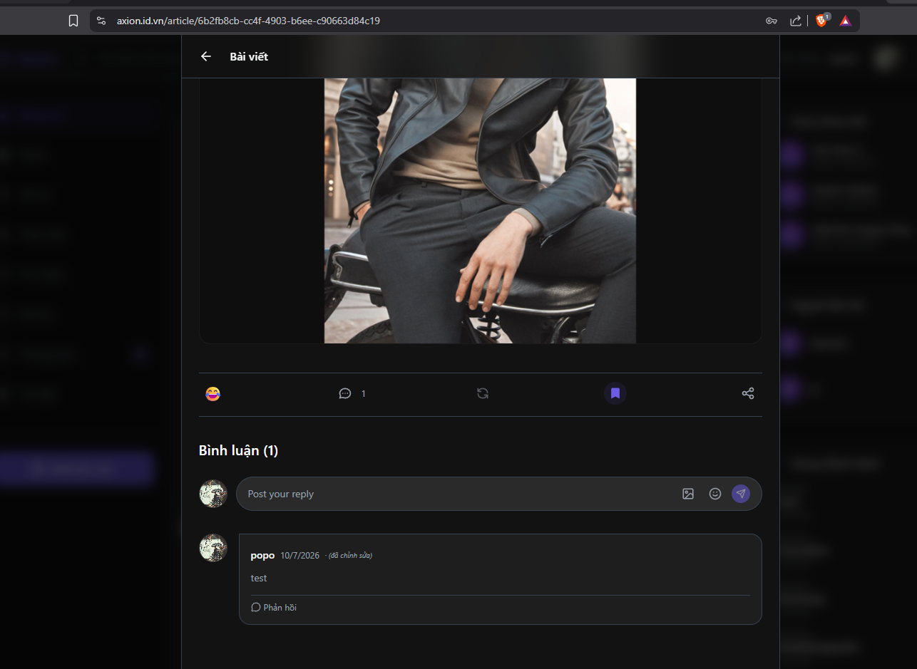

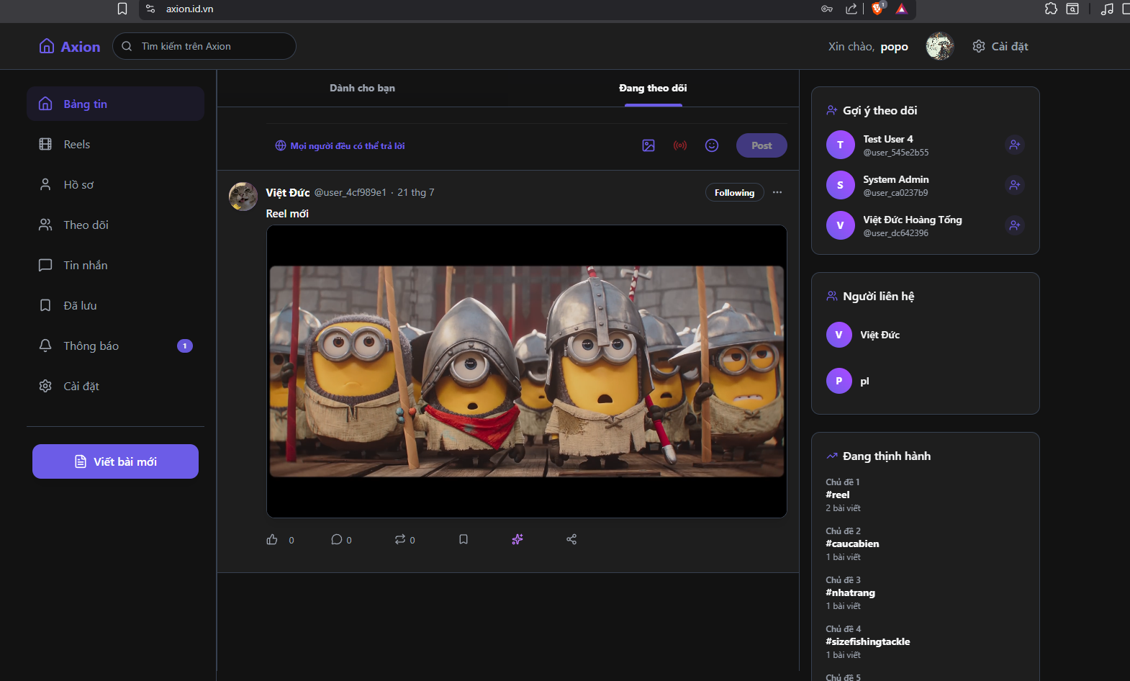4.2.5 Messaging & notifications
Messages.tsx implements the direct-message inbox and chat window against ChatController in notification-service; Notifications.tsx subscribes to the SSE stream at GET /api/v1/notifications/stream for real-time delivery.
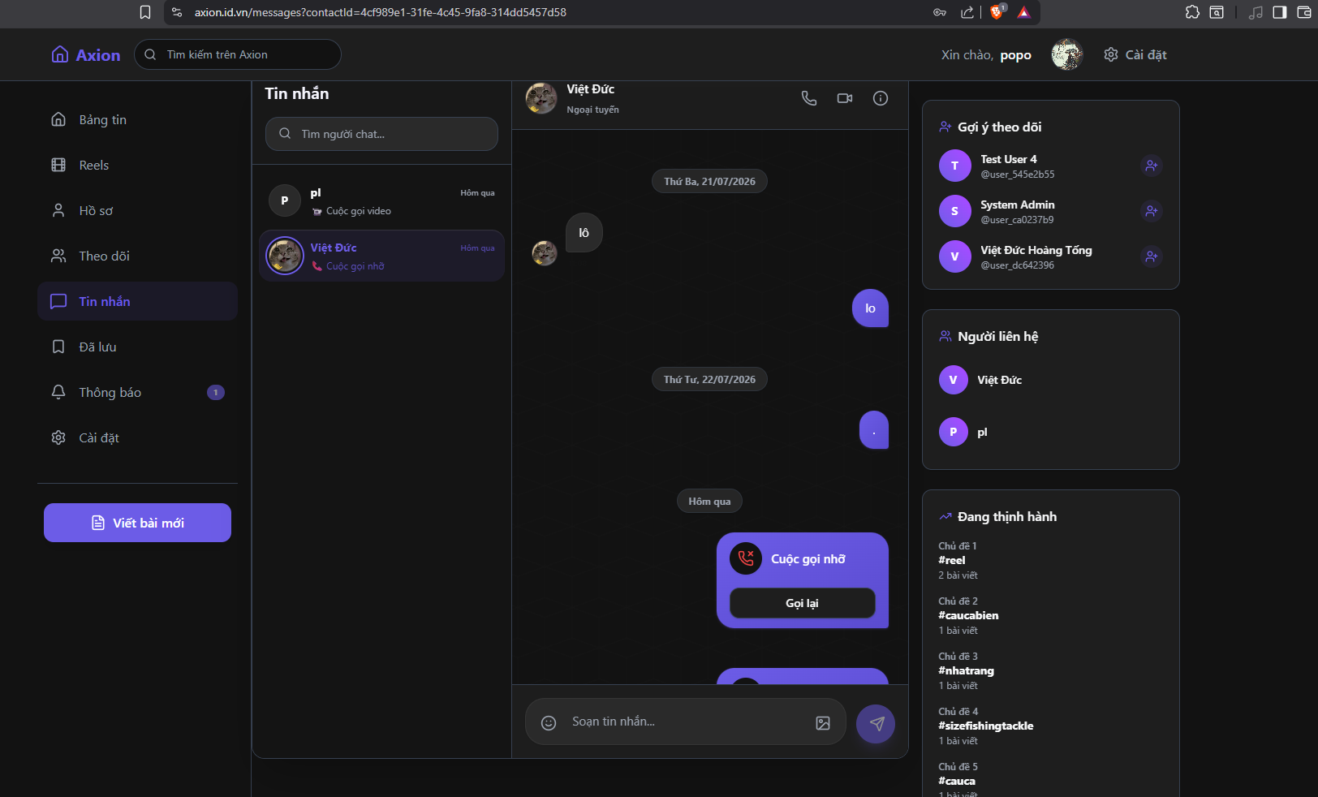

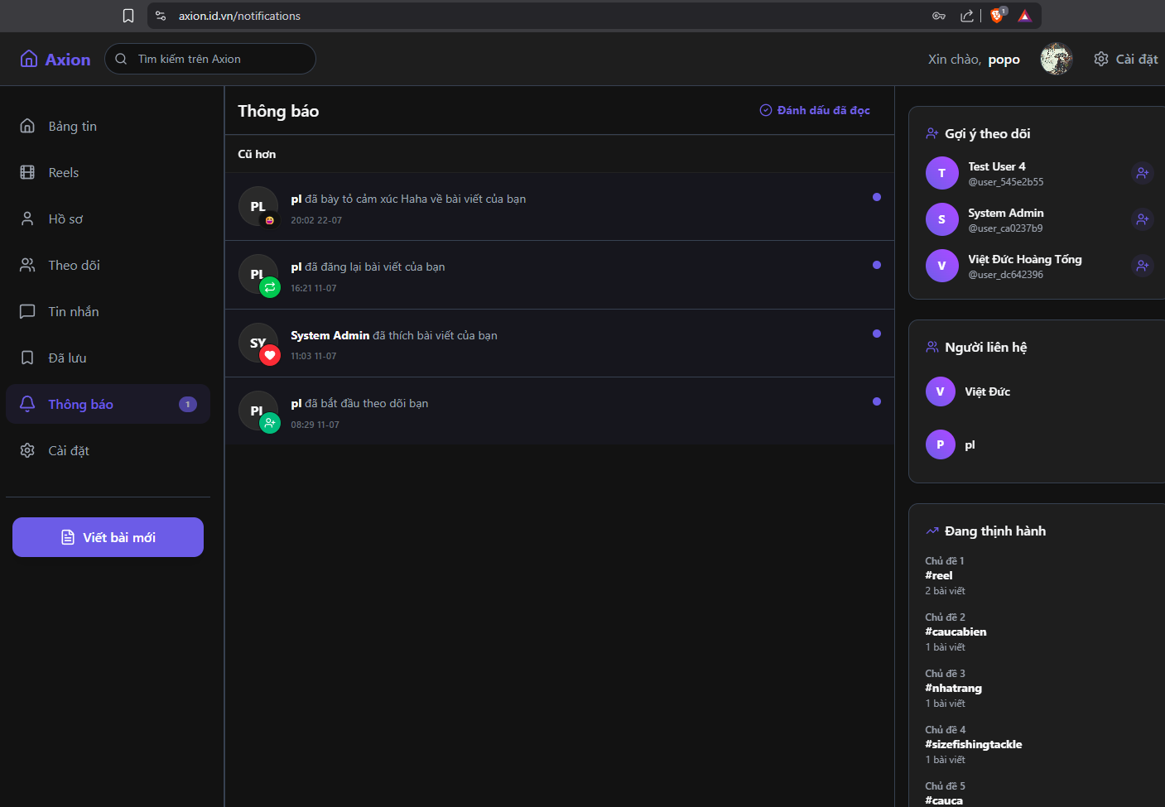4.2.6 Reels & Livestream
Reels.tsx and LivePlayer.tsx play short-video/live content; CreateLiveModal.tsx lets a user start a livestream session (obtaining an RTMP stream key from article-service, which is then pushed via OBS to the SRS media server and played back as HLS).
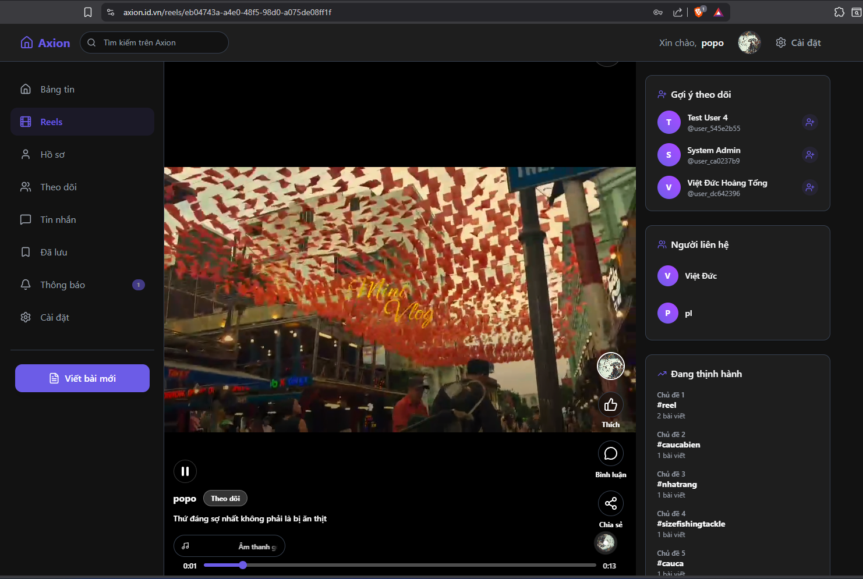

4.2.7 Profile, bookmarks, search, settings

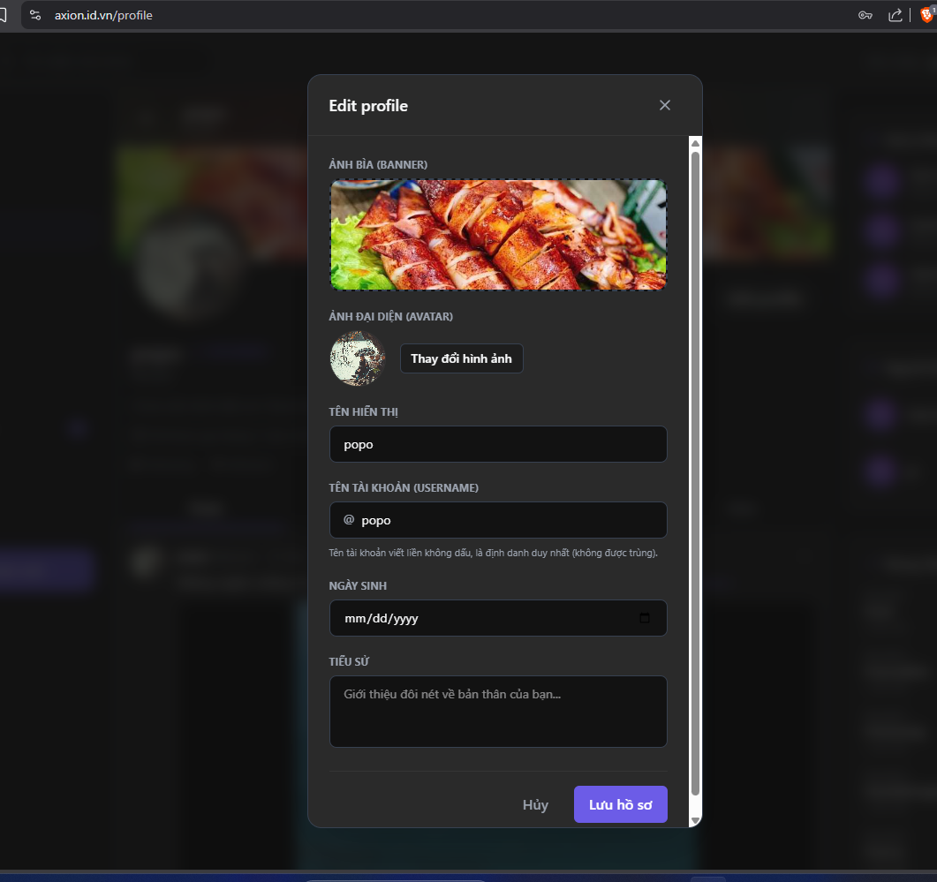
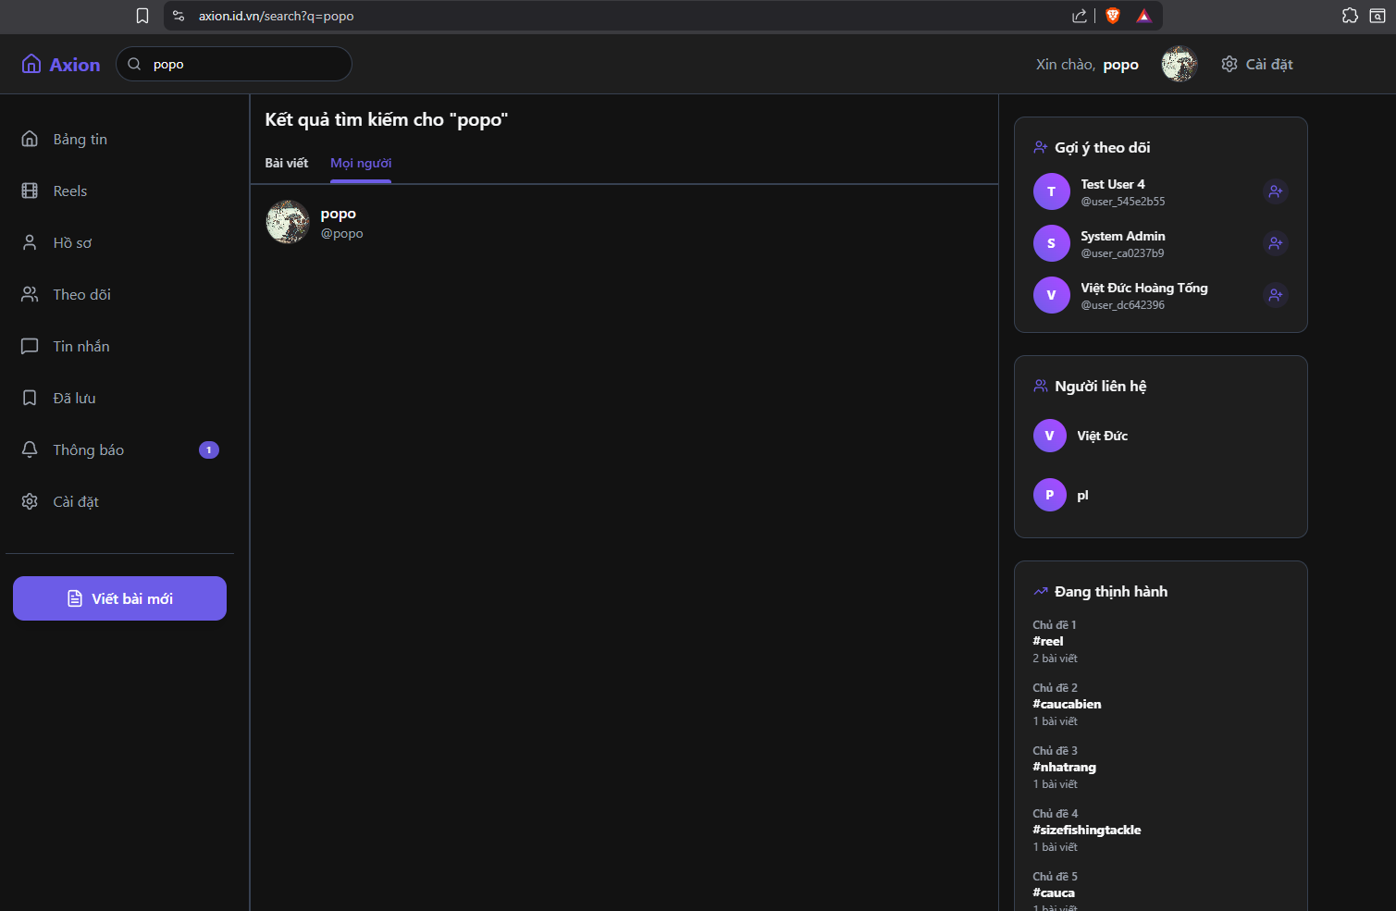
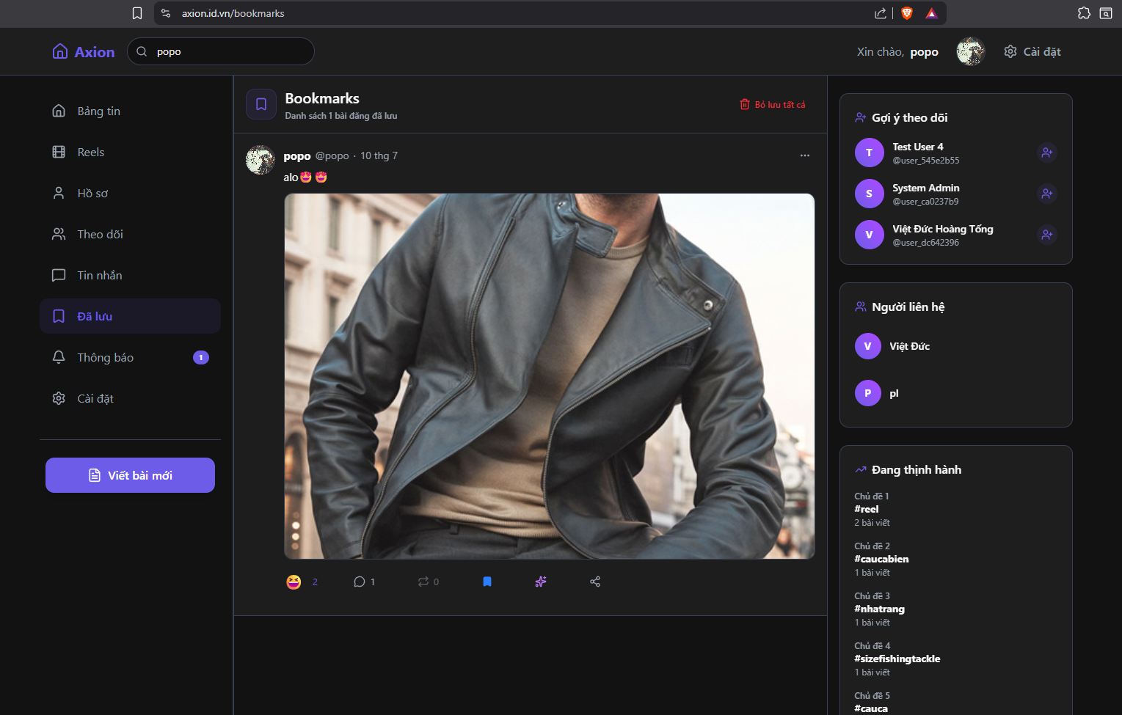
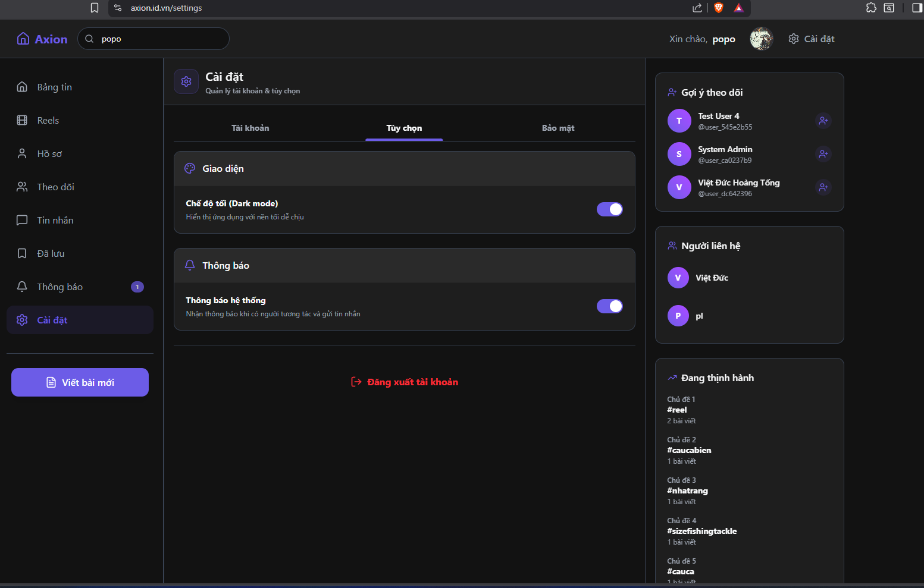

4.2.8 Admin dashboard
The admin/ page group is only reachable by users whose JWT role claim is ADMIN, enforced client-side by AdminRoute.tsx and server-side by /api/v1/admin/* endpoints.
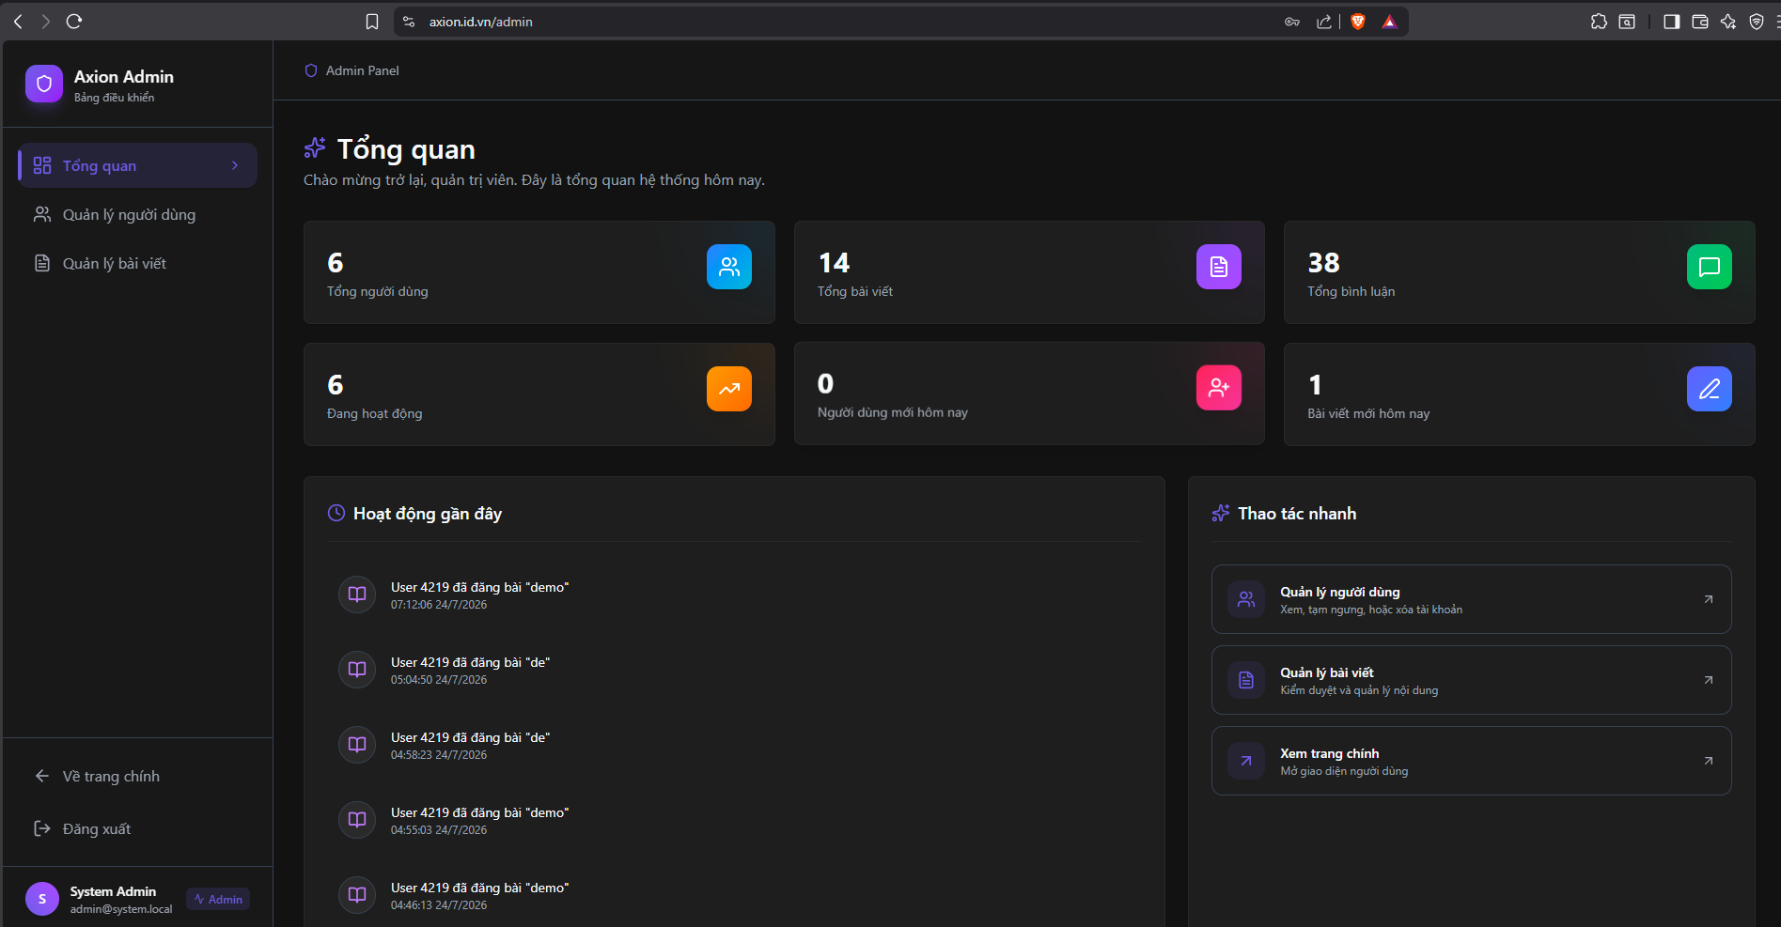
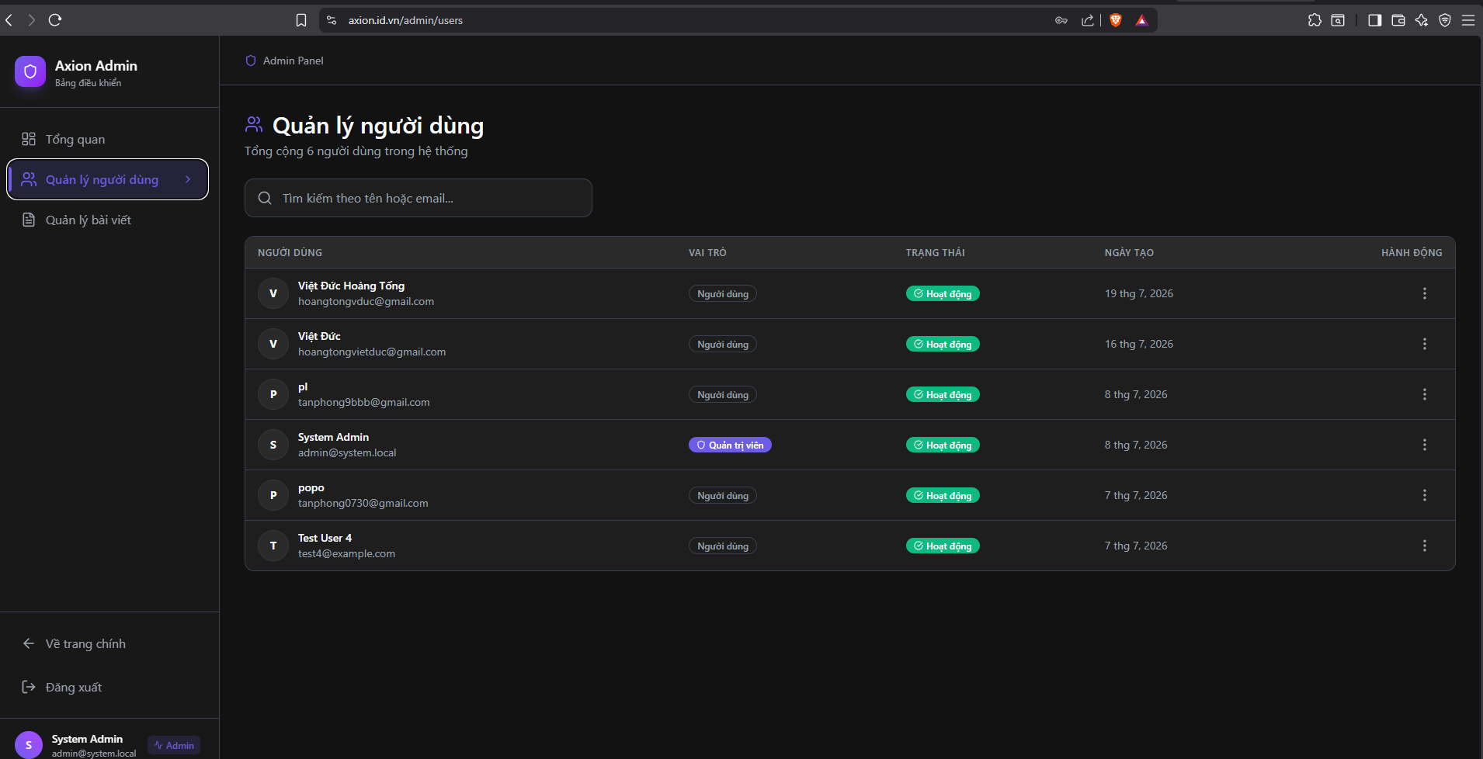
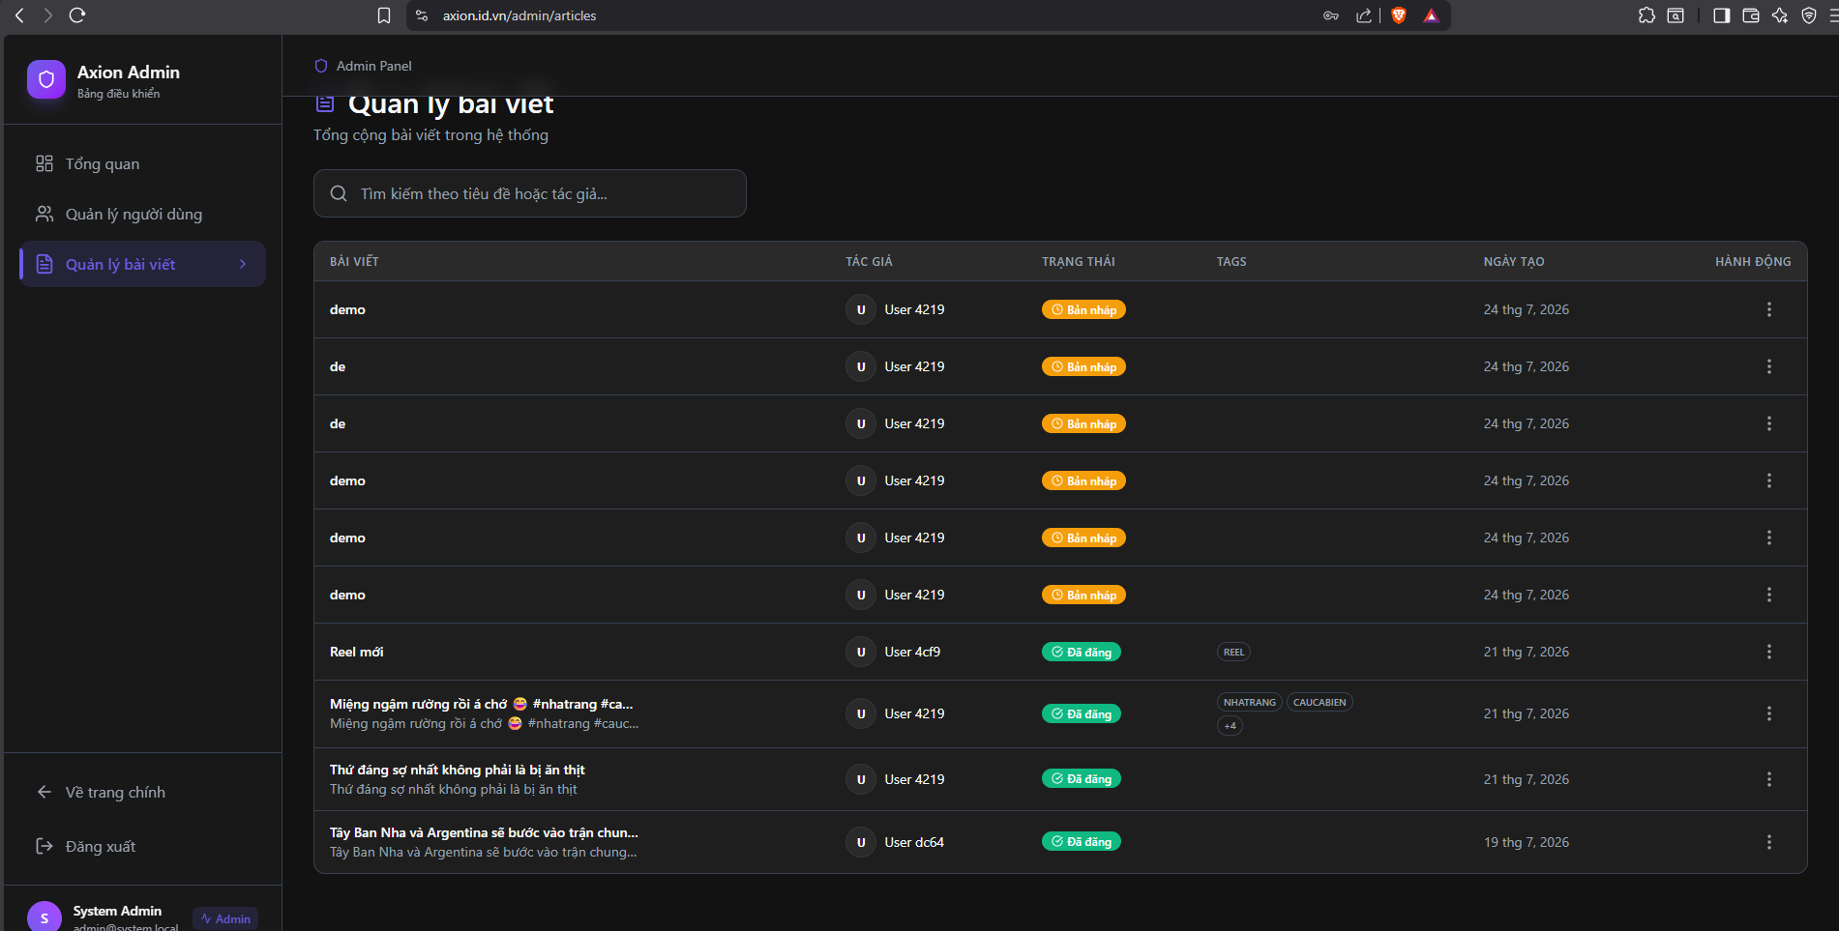

5. References
- Spring Boot / Spring Cloud Gateway Reference Documentation. https://docs.spring.io
- Apache Kafka Documentation. https://kafka.apache.org/documentation
- SRS (Simple Realtime Server) Documentation. https://ossrs.io
- React Documentation. https://react.dev
- MinIO Documentation. https://min.io/docs

