JOURNEY-BASED FUNCTIONAL SPECIFICATION

Month-End and Client Confirmation
  - Start-to-finish development journey, Treatment rules and handled scenarios
Status: Development-ready baseline; one product decision remains open
Authority: Latest explicit clarification overrides unclear or earlier meeting alternatives
Audience: Product, engineering, QA, implementation and operations

How to use this document: Follow the journeys in order. Each stage explains the standard path, the exceptions, and the scenarios that development and QA must handle. The highlighted Treatment section defines what happens to each invoice after CC validation.
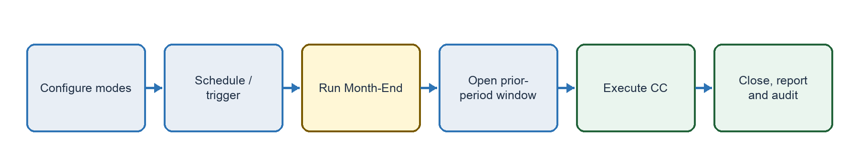
Figure 1. End-to-end operating journey.

Authoritative calculation used throughout the journey
Formula: Amount for the Month = Invoice Value − Confirmed Amount − Confirmed TDS.
Net Due = revised Amount for the Month − valid regular current-month collections. Net Due cannot be negative.
Closure threshold: Net Due equal to or below ₹5, including exactly ₹5, moves the invoice to Closed/Resolved. A Closed/Resolved invoice is never reopened through CC.

Journey 1. Configure the client
Stage outcome: The client has valid Month-End and CC modes, protected settings and a timezone before operations begin.

1.1 Required setup
- Select Manual or Automatic separately for Month-End and CC; both selections are mandatory during onboarding.
- Automatic Month-End uses a recurring day-of-month. If that date does not exist, use the last calendar day: day 31 becomes 30 April and 28/29 February; day 30 becomes 28/29 February.
- Automatic CC uses a separate configured date for each Month-End cycle. It must fall after its associated Month-End and before the next Month-End.
- Use the client-configured timezone; default to IST. Month-End may execute on a weekend or client holiday.
- Display Month-End/CC settings read-only under Edit Configuration. Every edit attempt requires Client Admin password re-entry and expires on Save or Cancel.
- Before Save, show previous/proposed values and an impact write-up; require a checkbox and I Agree. Audit user/time, old/new values and the acceptance fact, but not the full write-up. Trigger the configuration email defined in Journey 8.

1.2 Handled setup scenarios
- Manual → Automatic → Allow when schedule validation passes.
- Automatic → Manual before lock → Allow after protected edit confirmation.
- Automatic → Manual after lock → Reject; the protected run remains unchanged.
- Repeated edit attempt → Require password again; do not reuse the previous edit authorization.

Journey 2. Schedule and execute Month-End
Stage outcome: A successful Month-End creates the monthly bucket and becomes the dependency for CC.
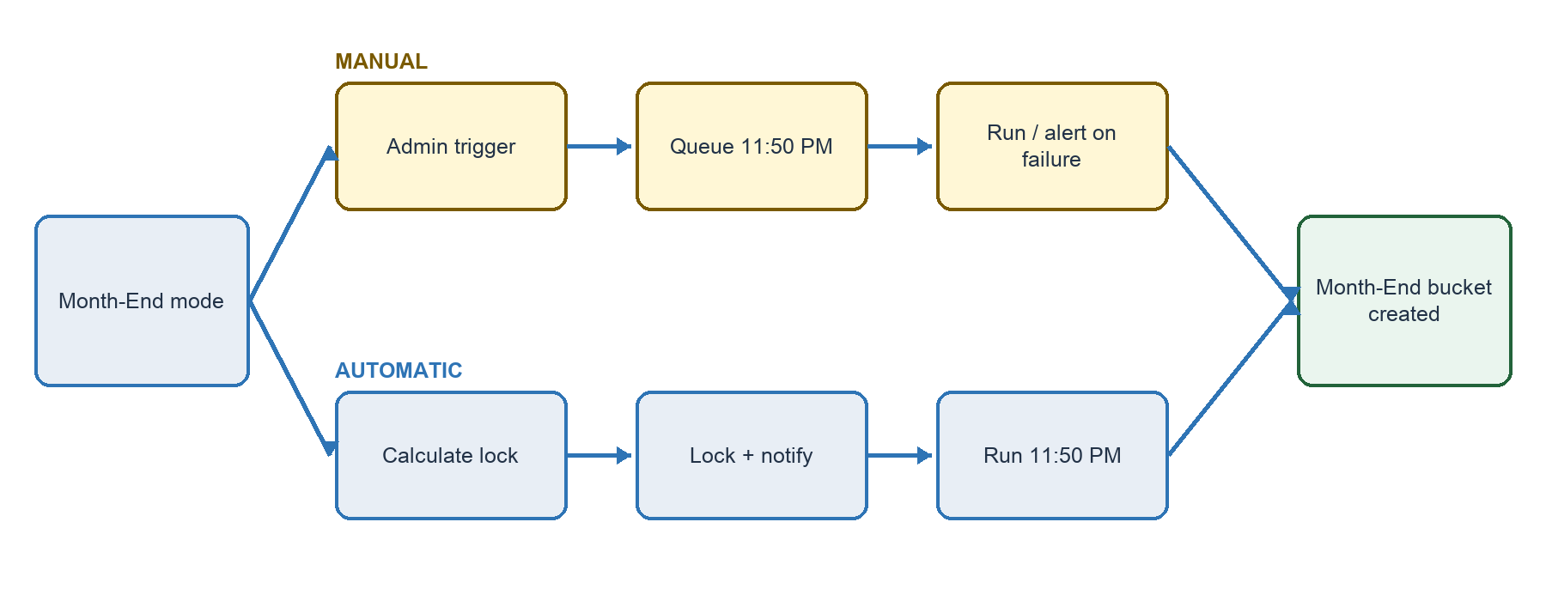
Figure 2. Manual and Automatic Month-End routes.

2.1 Manual route
Trigger at or before 11:50 PM: Queue Month-End for 11:50 PM the same day.
Trigger after 11:50 PM: Queue Month-End for 11:50 PM the following day.
Reminder stop: A successful queue event stops the Manual Month-End reminder sequence defined in Journey 8.
Execution failure: Resume the reminder sequence and trigger the failure notification defined in Journey 8.

2.2 Automatic route and lock
Execution: Run at 11:50 PM on the configured date.
Lock point: At 9:00 AM two working days before execution, lock both Month-End and CC configuration. Exclude weekends and client Holiday Master dates when finding those two working days.
Locked view: Keep the table visible read-only with lock and execution timestamps. Reject edit/schedule attempts. Provide no Pause or Cancel action.
Lock notice: Trigger the Automatic lock notification defined in Journey 8.

2.3 Reminder reference
Manual Month-End: Use the expected-date, daily cadence, escalation and stop/resume rules consolidated in Journey 8 — Notifications.

2.4 Handled Month-End scenarios
- Monday 31 August; 29–30 are weekend days → Lock both configurations on Thursday 27 August at 9:00 AM; execute Monday at 11:50 PM.
- Admin tries to schedule after lock → Reject because the protected configuration is already read-only.
- Month-End and CC share the same date → Run Month-End first; CC starts only after success. If Month-End fails, keep CC pending and trigger the dependency alert defined in Journey 8.

Journey 3. Operate between Month-End and CC
Stage outcome: Normal collection work continues, but the prior-period transfer-date window closes permanently when CC first executes.

3.1 Prior-period collection window
Bucket key: Transfer/Collection Date—not activity-entry date—determines the collection bucket.
Window open: After Month-End and before the first successful CC row, agents may enter normal collections with a Transfer Date inside the completed bucket.
Historical reporting: A collection entered on 5 September with Transfer Date 27 August belongs to August, updates August historical dashboards/trends and does not count in September MTD.
Window closed: After one successful CC row or No Impacted closure, reject all further Transfer Dates inside that completed bucket—even when the bucket is Executed with Errors.

3.2 Current-month normal collections
Regular processing: A normal collection with Transfer Date after Month-End remains allowed through the ordinary collection process and reduces current Net Due.
CC isolation: A CC row dated outside the prior bucket fails. CC must not overwrite, reverse or duplicate current-month normal activity.
Example: CC on 7 September sets August confirmed amount to ₹70,000 on a ₹1,00,000 invoice. A separate ₹10,000 normal collection dated 3 September remains a September activity. Amount for Month is ₹30,000 and Net Due is ₹20,000.

3.3 Handled collection scenarios
- Late August collection entered before CC → Allow, assign to August and update August history/trends.
- Late August collection attempted after any CC success → Reject because the prior-period window is closed.
- Current-month receipt exists before prior-month CC → Keep it separate; use it only to reduce current Net Due.
- Current-month receipt placed in CC file → Reject because Client Confirmation Date is outside the completed bucket.

Journey 4. Start Client Confirmation
Stage outcome: The correct Manual or Automatic route reaches validated invoice Treatments without breaking the Month-End dependency.
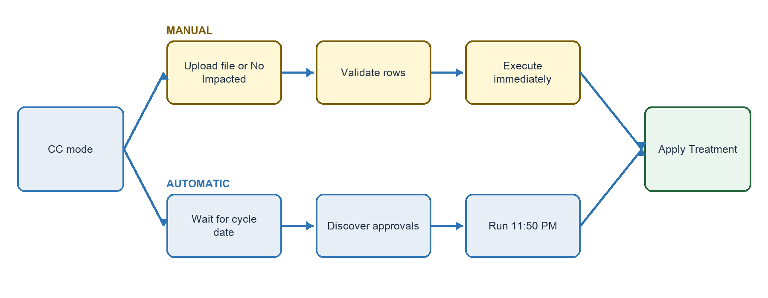
Figure 3. Manual and Automatic Client Confirmation routes.

4.1 Manual CC
Impacted file: Execute immediately when the Client Admin uploads and confirms a valid primary file; do not wait until 11:50 PM.
No impacted invoices: Show Close Client Confirmation – No Impacted Invoices. After confirmation, close the bucket immediately. Hide this action once a primary file is uploaded.
Target and reminders: Use Month-End date + 10 calendar days only as a reminder target. Apply the cadence, escalation and stop rules in Journey 8 — Notifications.

4.2 Automatic CC
Execution: Run at 11:50 PM on the configured cycle date; no impacted file is required and agent-reported values are accepted unless an approved Treatment applies.
Approval discovery: At job start, automatically find eligible approved Provisioning, Written Off and Cancelled requests. Approval before job start is included; approval after start moves to the next CC run and stays linked to the original invoice.
Automatic date mapping: Approval date becomes Client Confirmation Date and the job timestamp becomes Client Confirmation Execution Date and Time.

4.3 Bucket completion and blocking
Pending: If no row has succeeded and No Impacted has not been selected, the next Month-End is blocked. Show the pending bucket with direct Upload and No Impacted actions.
Executed with Errors: One successful row constitutes execution. Failed rows may be corrected before the next Month-End and do not block it.

Journey 5. Validate the Manual CC file
Stage outcome: Valid rows proceed independently to Treatment; invalid rows return with exact, correctable errors.

5.1 Required Excel fields
Customer Code: Required; must match the invoice.
Customer Name: Required; must match the invoice customer.
Invoice Number: Required; unique in the file and eligible for the latest completed bucket.
Client Confirmation Status: Confirmed, Provisioning, Written Off or Cancelled.
Confirmed Amount: Numeric and mandatory for Confirmed; genuinely blank for other statuses—zero also fails.
Confirmed TDS: Numeric and mandatory for Confirmed; enter 0 when applicable; genuinely blank for other statuses.
Client Confirmation Date: Required for every row and must fall within the latest completed Month-End bucket.

5.2 File journey
- Validate file structure and every row before applying row-level changes.
- Process valid rows independently; do not roll them back because another row fails.
- Return an error file containing every failed original row and a clear reason.
- Allow correction uploads only for invoices that failed in the primary file. Reject new invoices and invoices already processed successfully.
- Permit repeated corrections until the next Month-End executes; then make the old bucket read-only and handle unresolved invoices in a later cycle.
- If zero rows succeed, keep Pending. If some succeed, set Executed with Errors. If all applied rows succeed, set Executed.

5.3 Validation errors development must return
- Closed invoice — Invoice is already Closed/Resolved and cannot be processed through Client Confirmation.
- Amount exceeds invoice — Confirmed Amount plus Confirmed TDS cannot be greater than Invoice Value.
- Blank TDS — Confirmed TDS is mandatory for status Confirmed. Enter 0 when no TDS is confirmed.
- Amount on Treatment — Confirmed Amount and Confirmed TDS must be blank for Provisioning, Written Off and Cancelled.
- Date outside bucket — Client Confirmation Date must fall within the latest completed Month-End bucket: {start date} to {end date}.
- Approval unavailable/mismatch — Approved Issue Tracker request for the selected Client Confirmation treatment was not found.
- Ambiguous approval — Multiple approved Issue Tracker requests match this invoice and treatment. Resolve the duplicate approvals before Client Confirmation.
- Duplicate invoice — Invoice Number appears more than once in the upload file.
- Identity mismatch — Customer Code or Customer Name does not match the selected invoice.
- Already processed — Client Confirmation has already been successfully executed for this invoice in the current bucket.
- Invalid correction — Correction upload may contain only invoices that failed in the original Client Confirmation file.
- Unsupported status — Client Confirmation Status must be Confirmed, Provisioning, Written Off or Cancelled.

Journey 6. Apply the invoice Treatment
Stage outcome: Each validated invoice follows exactly one highlighted Treatment path, then writes the correct calculation, status, audit and reporting result.
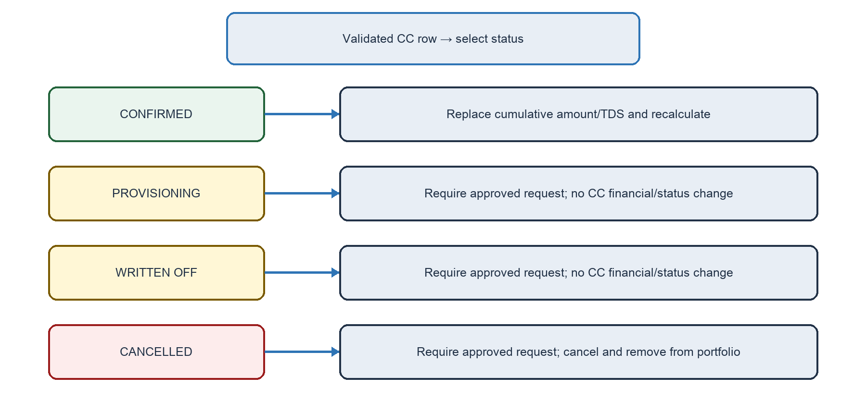
Figure 4. Treatment decision paths after CC validation.
TREATMENT A — CONFIRMED
Use when the client-confirmed amount or TDS must replace the agent-reported cumulative figures.
- Confirmed Amount and Confirmed TDS are calculation authority whether lower, higher or zero. Their sum cannot exceed Invoice Value.
- If TDS split is unknown, enter the full confirmed receipt as Confirmed Amount and enter Confirmed TDS = 0.
- Directly replace cumulative collected/TDS and recalculate Amount for the Month and Net Due. Do not create Collection, Part Collection, TDS, reversal or adjustment activities.
- Preserve the original agent activity in history. Add Client Confirmed Action to the invoice trail.
- Keep operational status unchanged unless Net Due ≤₹5, then set Closed/Resolved.

Handled Confirmed scenarios
- Invoice ₹1,00,000; agent ₹80,000; client ₹70,000; TDS ₹0 → Cumulative collected becomes ₹70,000; Amount for Month becomes ₹30,000; status changes only if Net Due ≤₹5.
- Known TDS: ₹80,000 amount + ₹10,000 TDS → Amount for Month becomes ₹10,000.
- Unknown TDS split: total receipt ₹90,000 → Store Confirmed Amount ₹90,000 and Confirmed TDS ₹0; Amount for Month becomes ₹10,000.
TREATMENT B — PROVISIONING
Use only when an approved Issue Tracker request for Provisioning matches the invoice.
- The Assigned Agent is the only role that may raise the request. One invoice and Treatment requires one request.
- The system finds the request; Request ID is not entered in the Excel file.
- CC makes no financial or operational change. Populate ODM, add CC audit/trail and consider the invoice successfully processed. A separate process handles provisioning.
TREATMENT C — WRITTEN OFF
Use only when an approved Issue Tracker request for Written Off matches the invoice.
- Apply the same approval matching, ambiguity and no-reuse controls as Provisioning.
- CC makes no financial or operational change. Populate ODM, add CC audit/trail and consider the invoice successfully processed. A separate process handles write-off.
TREATMENT D — CANCELLED
Use only when an approved Issue Tracker request for Cancelled matches the invoice.
- Set operational status to Cancelled, remove the invoice from the agent portfolio and leave financial amounts unchanged.
- Add CC and approval references to the invoice trail and populate ODM.

6.1 Approval controls common to Treatments B–D
- Match the same client, invoice and exact requested Treatment; status must be Approved before CC execution; the approval must not have been used by another successful CC.
- If no approval exists, it is pending/rejected, the Treatment differs, more than one approval matches, or it was already used, fail only that row and continue other valid rows.
- A failed row does not use the approval. After a successful row, prevent the same approval from being used again for any Treatment. Issue Tracker itself requires no new field/status; engineering chooses the internal guard.

6.2 Approval scenarios handled
- Excel says Cancelled but approval says Written Off → Fail with the selected-Treatment approval-not-found message; do not use the Written Off approval; continue other valid rows.
- Two approved requests match the same invoice and Treatment → Fail that invoice as ambiguous; Automatic or Manual CC continues for other invoices.
- Automatic approval completed before 11:50 PM job starts → Include in this run; approval date becomes CC Date.
- Approval completed after Automatic CC starts → Defer to the next CC run and retain the original invoice link.

Journey 7. Close, report and audit
Stage outcome: Every successful result is visible in the correct operational surface without duplicating activities or exposing failed rows in ODM.

7.1 Automatic closure Treatment
Threshold: During Manual or Automatic CC, an eligible invoice with Net Due ≤₹5 moves to Closed/Resolved. This applies to impacted invoices and automatically evaluated invoices.
No reopening: Any later CC row for a Closed/Resolved invoice fails; the invoice remains closed and never returns to a portfolio.

7.2 ODM output
New columns: Client Confirmation Status; Client Confirmation Remark; Client Confirmation Date; Client Confirmation Execution Date and Time.
Confirmed: Populate all four. Remark: Client Confirmation completed. Confirmed Amount: ₹{amount}; Confirmed TDS: ₹{tds}.
Provisioning: Populate all four. Remark: Client Confirmation completed as Provisioning against approved Issue Tracker request {request ID}.
Written Off: Populate all four. Remark: Client Confirmation completed as Written Off against approved Issue Tracker request {request ID}.
Cancelled: Populate all four. Remark: Client Confirmation completed as Cancelled against approved Issue Tracker request {request ID}.
Auto-close ≤₹5: Status = CC Done; CC Date blank; populate remark and execution time. Remark: Client Confirmation completed. Invoice automatically moved to Closed/Resolved because Net Due was ₹{net due}, within the ₹5 closure threshold.
Unaffected / failed / No Impacted: Leave all four ODM fields blank. ODM remains one activity row; existing history remarks are unchanged.

7.3 Platform activity and module audit
Confirmed invoice trail: Header: Client Confirmed Action; Amount for the Month: ₹{revised amount}; Net Due: ₹{revised amount}; generic metadata shows user and action date/time.
Unaffected/failed invoice: Do not create a successful invoice-level CC entry. Keep failure reason in the error file and module audit.
Module audit: Record configuration old/new values and I Agree fact; schedule/queue/lock; reminders; job lifecycle; primary/correction upload filename, user, time and counts; No Impacted closure; Automatic CC; blocked Month-End; bucket outcome.

7.4 Final handled scenarios
- Net Due equals exactly ₹5 → Close/Resolve and populate CC Done, automatic-close remark and execution time.
- Automatic CC; Net Due above ₹5; no approved Treatment → Leave invoice unchanged and leave all ODM CC fields blank.
- Primary file has valid and invalid rows → Commit valid Treatments, return invalid rows/reasons, mark Executed with Errors and allow next Month-End.
- Correction file introduces a new invoice → Reject the new invoice; allow only corrected rows that failed in the primary file.

Journey 8. Notifications
Stage outcome: Every email trigger, audience, cadence, escalation and stop condition is controlled from one notification journey.
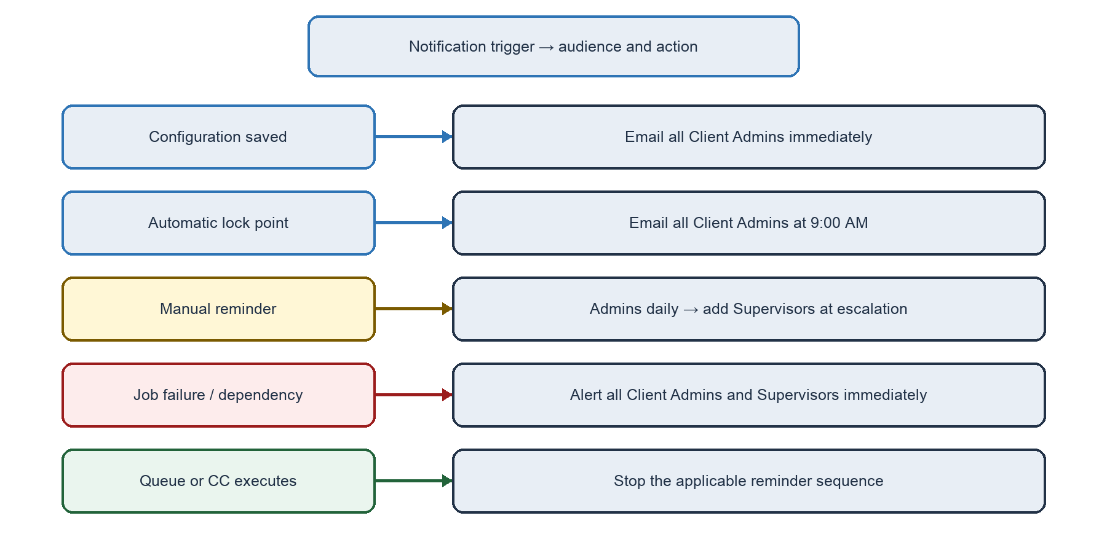
Figure 5. Consolidated notification trigger paths.

8.1 Configuration and scheduled-lock notifications
Configuration change: Immediately after a confirmed Month-End or CC configuration change, email all Client Admins. Identify the user, change date/time and previous/new values. The impact write-up is displayed before I Agree but is not stored or emailed.
Automatic lock notice: At 9:00 AM two working days before Automatic Month-End, email all Client Admins that Month-End is scheduled for {execution date} at 11:50 PM, both Month-End and CC configuration are now locked, and agents should report collections before execution.

8.2 Manual Month-End reminder sequence
- Determine the expected date as the first calendar month-end after onboarding for the first run, then 30 days after the previous successful Manual Month-End.
- At 9:00 AM two working days before the expected date, email all Client Admins; repeat daily at 9:00 AM.
- From the fifth calendar day after the first reminder, include every Supervisor for that client in the same daily reminder.
- Stop reminders immediately when Manual Month-End is successfully queued—not when it executes.
- If execution fails at 11:50 PM, resume the daily reminder sequence and send a separate immediate failure alert to all Client Admins and Supervisors.

8.3 Manual Client Confirmation reminder sequence
- Use Month-End date + 10 calendar days as a reminder target only; it is not a hard CC completion deadline.
- At 9:00 AM two working days before the target, email all Client Admins; repeat daily at 9:00 AM.
- From the day after the target date, include every Supervisor for that client in the daily reminder.
- Stop the sequence when the CC bucket first reaches Executed, Executed with Errors, or Closed – No Impacted Invoices.
- If the next Month-End is attempted while the previous CC remains Pending, block execution, show the pending bucket and direct actions in the interface, and continue the applicable CC reminder/escalation sequence.

8.4 Dependency and failure alerts
Same-date dependency: If Month-End and CC share a date, CC waits for committed Month-End success. If Month-End fails, do not run CC; immediately alert all Client Admins and Supervisors that CC remains pending because its dependency failed.
Audit: Record each reminder, escalation, lock notice and failure/dependency alert in the Month-End/CC module audit trail with type, recipients and sent date/time.

Journey 9. Control access, retries and delivery
Stage outcome: The feature remains safe under role restrictions, retries, partial failures and concurrent execution.

9.1 Roles
Client Admin: Configure Month-End/CC; trigger Manual Month-End; upload/close/correct Manual CC; select No Impacted; view invoice trail and complete module audit.
Assigned Agent: Raise Provisioning, Written Off or Cancellation requests; view invoice trail.
Supervisor: Receive escalations and view invoice trail; cannot configure or execute Month-End/CC.

9.2 Required safety behavior
- Make execution idempotent at bucket and invoice level; retries cannot duplicate calculations, status changes, ODM values, trail entries or approval use.
- Prevent concurrent CC processing of the same invoice. A later attempt must observe the committed result and fail as already processed when applicable.
- Do not start same-date CC until Month-End success is committed. A failed row must not partially change invoice values, status, ODM or approval use.
- On partial job failure, audit committed and failed rows separately and skip already successful invoices during retry.
- Store timestamps consistently and display them in the client timezone, default IST.

9.3 Observable states
Month-End configuration: Editable → Locked.
Month-End job: Queued → Running → Succeeded or Failed.
CC bucket: Pending; Executed; Executed with Errors; Closed – No Impacted Invoices.
CC row: Succeeded or Failed, with failure reason and correction eligibility until cutoff.

Open product decision
OPEN-01 — Approved Treatment omitted from Manual CC file: Manual CC is confirmed to process a Treatment only when explicitly included in the upload. A later response says an omitted eligible approval should be ‘added in the bucket, need to check.’ Until product confirms the exact behavior, do not auto-process it in Manual CC; keep it eligible for a later cycle and show it as pending in the module.

Source and interpretation note
The authoritative Hindi/Hinglish transcript was reviewed in full. Later explicit clarifications control where the transcript was garbled or contained alternatives. Unclear passages were not guessed. The earlier detailed evidence pack retains the fuller cleaned source record.

