**Task 1**

Part 1

First part includes generating Geometric Brownian Motion(GBM) and simulating 1000 runs. The following is the result of 5 realizations of the GBM:

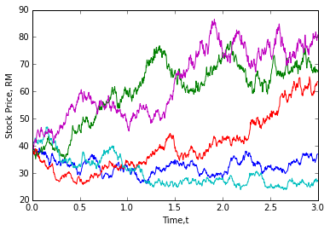

Expected Value: E[S(3)] = 54.181878144

Variance: Var[S(3)] = 696.245121673

P[S(3)> 39] = 0.68

E[S(3) | S(3) > 39] = 65.6829854995

Numpy function np.mean and np.var are used to find expectation value and variance of S(3). Next, using sum to find total number of S3>39 and dividing it by the length of the number using len. To find the E[S(3) | S(3) > 39], first find the sum of S3 array multiplying S3>39 array, then dividing it by the sum of S3>39.

Part 2

The second part is simulating mean reversal process and producing a 1000 runs of it. The following is the result of 5 realizations of the mean reversal process :

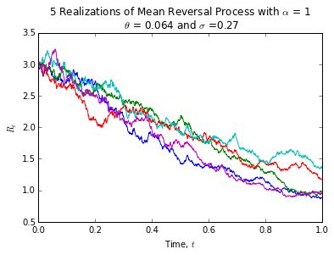

Expected Value: E[R(1)] = 1.13287929036

P[R(1)> 2] = 0.011

Same numpy function of np.mean is used to find the expectation value of R(1). In order to find P[R(1)> 2], again using sum to find the total number of R1>2 and dividing it by the n_path (1000).

**Task 2**

Part 1

There are a total of 30 components in the FTSE Bursa Malaysia KLCI Index.

|  |  |  |  |  |  |
| --- | --- | --- | --- | --- | --- |
| Stock Name | Stock Code | Stock Sector | Weightage in FTSEKLCI | PE Ratio | Net Market Capital (B,as billion) |
| Public Bank Bhd | 1295 | Banks | 11.6 | 15.21 | 73.368 |
| Malayan Banking | 1155 | Banks | 9.32 | 12.4 | 88.041 |
| Tenaga Nasional | 5347 | Alternative Electricity | 9.28 | 9.15 | 69.304 |
| CIMB Group Holdings | 1023 | Banks | 5.76 | 17.52 | 46.694 |
| Axiata Group Bhd | 6888 | Mobile Telecommunications | 5.62 | 24.3 | 55.349 |
| Sime Darby Bhd | 4197 | Diversified Industrials | 5.51 | 21.89 | 52.671 |
| Digi.com | 6947 | Mobile Telecommunications | 4.16 | 21.02 | 41.830 |
| Genting | 3182 | Hotels | 3.68 | 19.30 | 30.748 |
| PETRONAS Chemicals Group Bhd | 5183 | Commodity Chemicals | 3.55 | 21.83 | 50.640 |
| Maxis Bhd | 6012 | Mobile Telecommunications | 3.45 | 30.05 | 49.409 |
| Petronas Gas | 6033 | Exploration & Production | 3.4 | 22.79 | 42.741 |
| IHH Healthcare | 5225 | Health Care Providers | 3.28 | 63.15 | 48.758 |
| IOI | 1961 | Farming & Fishing | 2.99 | 73.65 | 26.731 |
| Telekom Malaysia | 4863 | Fixed Line Telecommunications | 2.96 | 32.34 | 24.195 |
| Genting Malaysia Bhd | 4715 | Hotels | 2.5 | 20.21 | 24.097 |
| MISC | 3816 | Marine Transportation | 2.45 | 15.99 | 35.264 |
| AMMB Holdings | 1015 | Banks | 2.38 | 8.82 | 16.970 |
| Kuala Lumpur Kepong | 2445 | Farming & Fishing | 2.28 | 29.21 | 23.983 |
| SapuraKencana Petroleum | 5218 | Oil Equipment & Services | 1.98 | 12.08 | 14.321 |
| PBB Group | 4065 | Food Products | 1.8 | 18.13 | 18.233 |
| British American Tobacco (Malaysia) | 4162 | Tobacco | 1.7 | 20.06 | 18.445 |
| Hong Leong Bank | 5819 | Banks | 1.67 | 11.19 | 24.572 |
| YTL Corp | 4677 | Multiutilities | 1.63 | 14.95 | 16.670 |
| UMW Holdings | 4588 | Automobiles | 1.37 | 20.41 | 11.987 |
| Astro Malaysia Holdings | 6399 | Broadcasting & Entertainment | 1.22 | 28.06 | 15.761 |
| Petronas Dagangan Bhd | 5681 | Intrgrated Oil & Gas | 1.21 | 37.05 | 20.445 |
| RHB Capital | 1066 | Banks | 1.06 | 9.18 | 19.129 |
| Westports Holdings | 5246 | Transportation Services | 0.93 | 26.84 | 14.356 |
| Hong Leong Financial | 1082 | Banks | 0.64 | 9.92 | 16.255 |
| KLCC Prop & Reits - Stapled Sec | 5235SS | Real Estate Holding & Development | 0.63 | 13.63 | 12.637 |

The information above was extracted on date 24/7/2015.

Part 2

I have chosen Digi.com (code:6947) and downloaded its daily data within 01/01/2011 to 20/07/2015 from Yahoo!Finance. The following is the output of 5-day moving average of Digi.com :

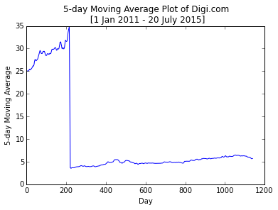

The 5-day moving average is calculated by dividing the total 5-day closing prices of Digi.com by 5 with the help of pd.rolling_mean function. The daily data of FTSEKLCI is also downloaded and correlation between Digi.com and FTSEKLCI is calculated.

Correlation between Digi.com and FTSEKLCI:

6947.KL ^KLSE

6947.KL 1.000000 0.832388

^KLSE 0.832388 1.000000